|  |
| --- |
|  |
|  |
|  |
|  |
|  |
|  |

|  |
| --- |
|  |

**TABLE OF CONTENTS**

**ABSTRACT**

* **LIST OF FIGURE**
* **LIST OF TABLES**
* **ACKNOWLEDGEMENT**

* **INTRODUCTION**
* **PAGE**
* **1.1 PROJECT OBJECTIVES**
* **1.2 PROJECT OVER VIEW**
* **1.3 PROJECT SCOPE**
* **1.4 STUDY OF SYSTEMS**
* **1.4.1 MODULES**
* **1.4.1.1 ADMIN**
* **1.4.1.2 MODERATOR**
* **1.4.1.3 USER**

**2. SYSTEM ANALYSIS**

**2.1 EXISTING SYSTEM**

**2.2 PROPOSED SYSTEM**

**2.3 SYSTEM REQUIREMENT SPECIFICATION**

**2.3.1 GENERAL DESCRIPTION**

**2.3.2 SYSTEM OBJECTIVES**

**2.3.3 SYSTEM REQUIREMENTS**

**2.3.3.1 NON FUNCTIONAL REQUIREMENT**

**2.3.3.2 FUNCTIONAL REQUIREMENT**

**3. SYSTEM DESIGN**

**3.1 INPUT AND OUTPUT DESIGN**

**3.1.1 INPUT DESIGN**

**3.1.2 OUTPUT DESIGN**

**3.2 DATABASE**

**3.3 SYSTEM TOOLS**

**3.3.1 FRONT END**

**3.3.2 BACK END**

**3.4 TABLES**

**3.5 E-R DIAGRAMS**

**3.6 DATA FLOW DIAGRAMS (DFD)**

**3.7 SCREEN SHOTS**

**3.8 SAMPLE CODE**

**4. CONCLUSION**

**REFERENCES**

**INRODUCTION**

INDRODUCTION

This project is aimed at developing Vijayapur Big Bazaar prototype for a retail business that is based on .Net Platform. This reports provides an introduction to Inventory Control describing the importance of time in managing inventory, its effect on business and how mobility can provide an advantage, the system’s general components and functionality, also present a demonstration prototype that was developed as a prove of concept, the technology used in the implementing and finally the conclusion with results, difficulties that were faced during the project, possible enhancement and future work.

The project uses the mobility feature to support access of authorized employee to inventory control information system. users, can be used to explore details of the inventory in stock, browse the clients and suppliers information, update the inventory based on the sale and purchasing details.

The ever-increasing wide spread use of mobile devices and internet, and the high demand for access to business information on a 24x7 basis thought mobile devices have motivated the need for an enhancement in the current inventory control systems to reduce the effect of :

.

**1.1 PROJECT OBJECTIVE:**

Inventory is a primary part of many of today’s businesses. Essentially, inventory is the storage of products that are sold to consumers to help the business make a profit. Further, in some instances, inventory also includes what the company uses to keep the business up and running for example, storage for cleaners would be considered inventory for a business that focuses on the business of cleaning.

**1.2 PROJECT OVER VIEW:**

There are several different forms of inventory and any business may rely on one or more forms. One form of inventory that a business may have is products that are ready for sale. For instance, some businesses buy their products from manufacturers and store them in warehouses: such facilities will require warehouse management of inventory. Such products are ready for sale immediately and require no assembly like, household items, furniture, and office suppliers are just a few of many items that can be part of ready for sale inventory.

Whether a business is storing products for later use or they are storing parts to be used later in the creation of products, the business owner must always know what they have on hand.

In not knowing, what one already has there is no way the business will function properly. Mismanagement of funds, profit loss, and theft are some of the most common consequences of poorly managed inventory

.

**1.3 PROJECT SCOPE:**

Inventory is a primary part of many of today’s businesses. Essentially, inventory is the storage of products that are sold to consumers to help the business make a profit. Further, in some instances, inventory also includes what the company uses to keep the business up and running for example, storage for cleaners would be considered inventory for a business that focuses on the business of cleaning.

There are several different forms of inventory and any business may rely on one or more forms. One form of inventory that a business may have is products that are ready for sale. For instance, some businesses buy their products from manufacturers and store them in warehouses: such facilities will require warehouse management of inventory. Such products are ready for sale immediately and require no assembly like, household items, furniture, and office suppliers are just a few of many items that can be part of ready for sale inventory. .

**1.4 STUDY OF THE SYSTEM**

**1.4.1 MODULES:** The system after careful analysis has been identified to be presented with the following modules and roles. The modules involved are:

* Administrator
* Users

**1.4.1.1 ADMINISTRATOR**

The administrator is the super user of this application. Only admin have access into this admin page. Admin may be the owner of the application. The administrator has all the information about all the users.

Register

Purchase

User

VOPS

Browse

A new user will have to register in the system by providing essential details in order to access our application. The admin must accept a new user by unblocking him.

* **Login**

A user must login with his user name and password to the system after registration.

* **Register**

User can register with fields like name, address, place, mobile no, email id and user id where user id is unique.

* **View**

User can view available pizza.

* **Purchase:**

User will purchase pizza.

.

**SYSTEM ANALYSIS**

System analysis is the process of gathering and interpreting facts, diagnosing problems and using the information to recommend improvements on the system. System analysis is a problem solving activity that requires intensive communication between the system users and system developers.

System analysis or study is an important phase of any system development process. The system is viewed as a whole, the inputs are identified and the system is subjected to close study to identify the problem areas. The solutions are given as a proposal. The proposal is reviewed on user request and suitable changes are made. This loop ends as soon as the user is satisfied with the proposal.

**2.1 EXISTING SYSTEM**

Regardless of the form of inventory that business has, inappropriate management of such inventory can result in over ordering of stock, under ordering, and loss. If a business owner does not know what they have in storage, they can end up over ordering stock. If the stock is perishable, the items that are in storage may go to waste and cost the business owner funds that can be put to better use. In addition, overstock of nonperishable items is no better: having too much stock can result in poor storage space and the need for additional storage for unnecessary stock. Since, in most instances storage space is a valuable asset and may even cost the business money in terms of rental space, the use of storage space must be utilized efficiently.

• Paper based work

• Less Security

• If any modifications or updations are required, it has to

searched and to be done it manually.

• It takes a lot of space for storage of records of customer and other

information regarding security.

**2.2 PROPOSED SYSTEM**

To develop a system that would recompiles the following:-

• Reduce the paperwork and storage area.

• Improve the output of operators.

• Improve accuracy in result.

• Allow easy navigation through information.

• Manage the man and machine resources efficiently.

• It has user friendly interface having quick authenticated access to documents.

• Easily scalable to grow with changing system requirement.

• Secured check in, check out & updates.

• Locate items easily by various parameters.

**2.3 SYSTEM REQUIREMENT SPECIFICATION**

**2.3.1 GENERAL DESCRIPTION**

**Product Description:**

The project is web based implemented Microsoft ASP .Net Version 3.5 as Frontend and Sql Server as backed.A web application which can provide the data security for the customer to access the web service. Web application should be able to help the customer for encrypt and decrypt data and also file security.

**Problem Statement:**

Existing system refers to the system that is being followed till now. Presently all the registrations are done manually.

**2.3.2 SYSTEM OBJECTIVES**

* To provide an Web application for data security.
* Only authorized user will access the application.

**2.3.3.1 NON FUNCTIONAL REQUIREMENTS**

i. **EFFICIENCY REQUIREMENT**

Only authorized user will access the application.

**ii. RELIABILITY REQUIREMENT**

The system should provide a reliable environment to both customers and admin. All orders should be reaching at the admin without any errors.

**iii. USABILITY REQUIREMENT**

The web application is designed for user friendly environment and ease of use.

**iv. IMPLEMENTATION REQUIREMEN**T

Implementation of the system using css and html in front end with Sql server as back end and it will be used for database connectivity. And the database part is developed by mssql..

**v. DELIVERY REQUIREMENT**

The whole system is expected to be delivered in three months of time with a weekly evaluation by the project guide

**2.3.3.2 FUNCTIONAL REQUIREMENTS**

**USER**

* **USER LOGIN**

Description of feature

This feature used by the user to login into system. A user must login with his user name and password to the system after registration. If they are invalid, the user not allowed entering the system.

**Functional requirement**

- Username and password will be provided after user registration is confirmed. - Password should be hidden from others while typing it in the field

* **REGISTER NEW USER**

A new user will have to register in the system by providing essential details in registration form..

Functional requirement

- System must be able to verify and validate information. - The system must encrypt the password of the customer to provide security.

Description of feature

The user will register with fields like name, address, place, contact no, email id, place and user id where user id is unique. User can encrypt Data this is will provide security to data. User can decrypt data using valid key. user can upload encrypted file.user can download encrypted file using valid key.

Functional requirement

- System must ensure that, only a registered customer can access our application.

**ADMIN**

* **MANAGE USER**

Description of feature

The administrator can view list of users.

* **User**

Register

Login

View pizza

Purchase

.

**SYSTEM DESIGN**

System design is the solution for the creation of a new system. This phase focuses on the detailed implementation of the feasible system. It emphasis on translating design. Specifications to performance specification. System design has two phases of development

* **Logical design Physical design**

During logical design phase the analyst describes inputs (sources), output s(destinations), databases (data sores) and procedures (data flows) all in a format that meets the user requirements. The analyst also specifies the needs of the user at a level that virtually determines the information flow in and out of the system and the data resources. Here the logical design is done through data flow diagrams and database design. The physical design is followed by physical design or coding. Physical design produces the working system by defining the design specifications, which specify

exactly what the candidate system must do. The programmers write the necessary programs that accept input from the user, perform

necessary processing on accepted data and produce the required report on a hard copy or display it on the screen.

**3.1 INPUT AND OUTPUT DESIGN**

**3.1.1 INPUT DESIGN:**

Input design is the link that ties the information system into the world of its

users. The input design involves determining the inputs, validating the data, minimizing the data entry and provides a multi-user facility. Inaccurate inputs are the most common cause of errors in data processing. Errors entered by the data entry operators can be controlled by input design. The user-originated inputs are converted to a computer based format in the input design. Input data are collected and organized into groups of similar data. Once identified, the appropriate input media are selected for processing. All the input data are validated and if any data violates any conditions, the user is warned by a message. If the data satisfies all the conditions, it is transferred to the appropriate tables in the database. In this project the student details are to be entered at the time of registration. A page is designed for this purpose which is user friendly and easy to use. The design is done such that users get appropriate messages when exceptions occur.

**3.1.2 OUTPUT DESIGN:**

Computer output is the most important and direct source of information to the user. Output design is a very important phase since the output needs to be in an efficient manner. Efficient and intelligible output design improves the system relationship with the user and helps in decision making. Allowing the user to view the sample screen is important because the user is the ultimate judge of the quality of output. The output module of this system is the selected notifications.

**3.2 DATABASE DATABASE DESIGN:**

Databases are the storehouses of data used in the software systems. The data is stored in tables inside the database. Several tables are created for the manipulation of the data for the system. Two essential settings for a database are

- the field that is unique for all the record occurrences.

-the field used to set relation between tables.

Normalization is a technique to avoid redundancy in the tables.

**3.3 SYSTEM TOOLS**

The various system tools that have been used in developing both the front end and the back end of the project are being discussed

TOOLS USED

Tools Used:

This project is developed using the Microsoft.NET Framework technologies mentioned below.

* Operating System PlatForm: Windows 7 Onwards.
* Devloped Tools : ASP.NET.
* Language : C#.
* Web Server : Microsofr IIS Server.
* Database Techonology : MS- SQL Server.
* Browser : Any Browser.

**The.NETFramework–anOverview:**  
The .net Framework is a Microsoft vision of ”software as service “ it is environment in which we can build create and deploy next generation components,teamed as a web Services

It includes the three major building blocks .Those are Common Language Run Time (CLR) for execution of application in any language. A set of Framework classes and a new version of Microsoft dyanamic server –side web technology ,ASP, in ASP.NET technologies, component technologies and dta technologies ever seen on Microsoft Platform.

The .NET Framework covers all the layers of softwares development right from operating system .IT provides richest level of integration among presentation

And also be architecture has been created to make it easy to develop internet applications, as it to develop the Touch screen environment.

Figure : The .Net Architecture – Three Layer

Presentation Layer (ASP.NET Pages)

Customers

Query

Data Access Layer

Database

DATA FLOW DIAGRAM

**3.6 DATA FLOW DIAGRAM**

A Data Flow Diagram (DFD) is a structured analysis and design tool that can be used for flowcharting. A DFD is a network that describes the flow of data and the processes that change or transform the data throughout a system. This network is constructed by using a set of symbols that do not imply any physical implementation. It has the purpose of clarifying system requirements and identifying major transformations. So it is the starting point of the design phase that functionally decomposes the requirements specifications down to the lowest level of detail. DFD can be considered to an abstraction of the logic of an information-oriented or a process-oriented system flow-chart. For these reasons DFD’s are often referred to as logical data flow diagrams.

**EXTERNAL ENTITY**

An external entity is a source or destination of a data flow. Only those entities which originate or receive data are represented on a data flow diagram. The symbol used is a rectangular box.

**PROCESS**

A process shows a transformation or manipulation of data flow within the system. The symbol used is an oval shape.

**DATAFLOW**

The data flow shows the flow of information from a source to its destination. Data flow is represented by a line, with arrowheads showing the direction of flow. Information always flows to or from a process and may be written, verbal or electronic. Each data flow may be referenced by the processes or data stores at its head and tail, or by a description of its contents.

**LOGIN DFD**

LOGIN DB

USER

IF YES

MAIN PAGE

**Fig 3.10: Login DFD**

* **REGISTRATION DFD**

Registration Db

user

Successful

Login page

**Fig 3.11: Registration DFD**

* **ADMIN DFD**

DB

User

DB

USE CASE DIAGRAM

**USE CASE DIAGRAM** :

* **LOGIN PAGE:**

**USE CASE DIAGRAM** :

NEW CUSTOMER

**E-R DIAGRAM**

**3.5 E-R DIAGRAMS**

* **LOGIN**

LOGIN

Password

Username

UserType

Userid

* **USER DETAILS**

User Details

country

state

Address

MobileNo

UserName

Userid

* **PRODUCT DETAILS**

Service

Buy Download

Add Product

Login

Register

**COMPLETE DIAGRAM**

Service

USER

DATABASE TABLES

TABLES

**LOGIN**

## Field Name Field Type AllowNull primary key Extras

|  |  |  |  |  |
| --- | --- | --- | --- | --- |
| Uid | int | No | Yes | auto_incriment |
| Uname | Varchar(50) | No | No |  |
| Upass | Varchar(50) | No | No |  |

**Fig 3.1: Login Table**

**USER DETAILS**

|  |  |  |  |  |
| --- | --- | --- | --- | --- |
| **FieldName** | **FieldType** | **AllowNull** | **primarykey** | Extras |
| Uid | Int | No | Yes |  |
| Uname | Varchar | No | No |  |
| Upass | Varchar | No | No |  |
| State | Varchar | No | No |  |
| Country | Varchar | No | No |  |
| Address | Varchar | No | No |  |
| Mobile No | Number | No | No |  |

**Fig 3.2: User Details Table**

CODING

**Login Page Coding**

using System;

using System.Collections;

using System.Configuration;

using System.Data;

using System.Linq;

using System.Web;

using System.Web.Security;

using System.Web.UI;

using System.Web.UI.HtmlControls;

using System.Web.UI.WebControls;

using System.Web.UI.WebControls.WebParts;

using System.Xml.Linq;

using System.Data.SqlClient;

public partial class Default3 : System.Web.UI.Page

{

protected void Button2_Click(object sender, EventArgs e)

{

Response.Redirect("register.aspx");

}

protected void Button1_Click(object sender, EventArgs e)

{

SqlConnection con = new SqlConnection(ConfigurationManager.ConnectionStrings["vops"].ConnectionString);

SqlCommand cmd = new SqlCommand("select userid,uname,password from tbluser where userid = '" + txtuserid.Text.ToString() + "' and password ='" + txtPassword.Text.ToString() + "'", con);

con.Open();

SqlDataReader dr = cmd.ExecuteReader();

try

{

dr.Read();

{

rijndael.setCurUser(txtuserid.Text.ToString());

Session["uid"] = dr[0].ToString();

Session["name"] = dr[1].ToString();

Response.Redirect("userhome.aspx");

}

}

catch (Exception ex)

{

lblError.Text = "Invalid Login";

}

}

protected void btnAbout_Click(object sender, EventArgs e)

{

Response.Redirect("abt.aspx");

}

protected void btnContact_Click(object sender, EventArgs e)

{

Response.Redirect("contact.aspx");

}

}

Screen Shots

**Login Page**:

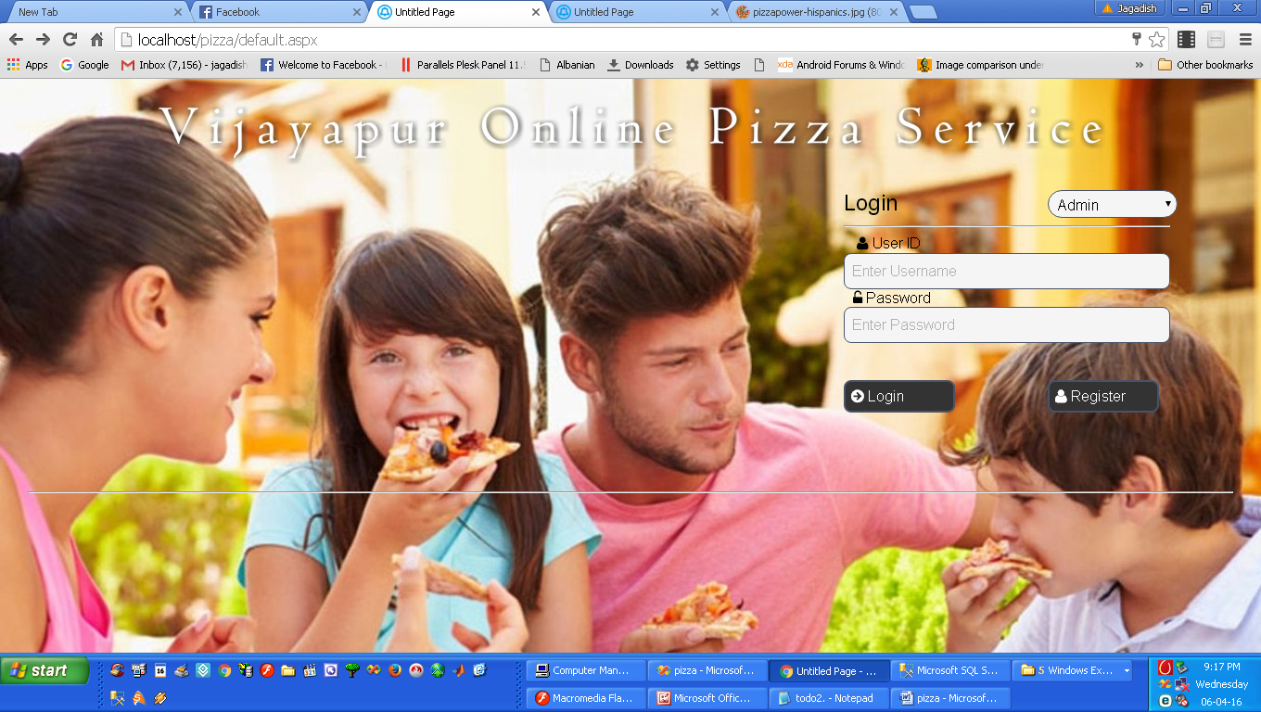

**Register page**

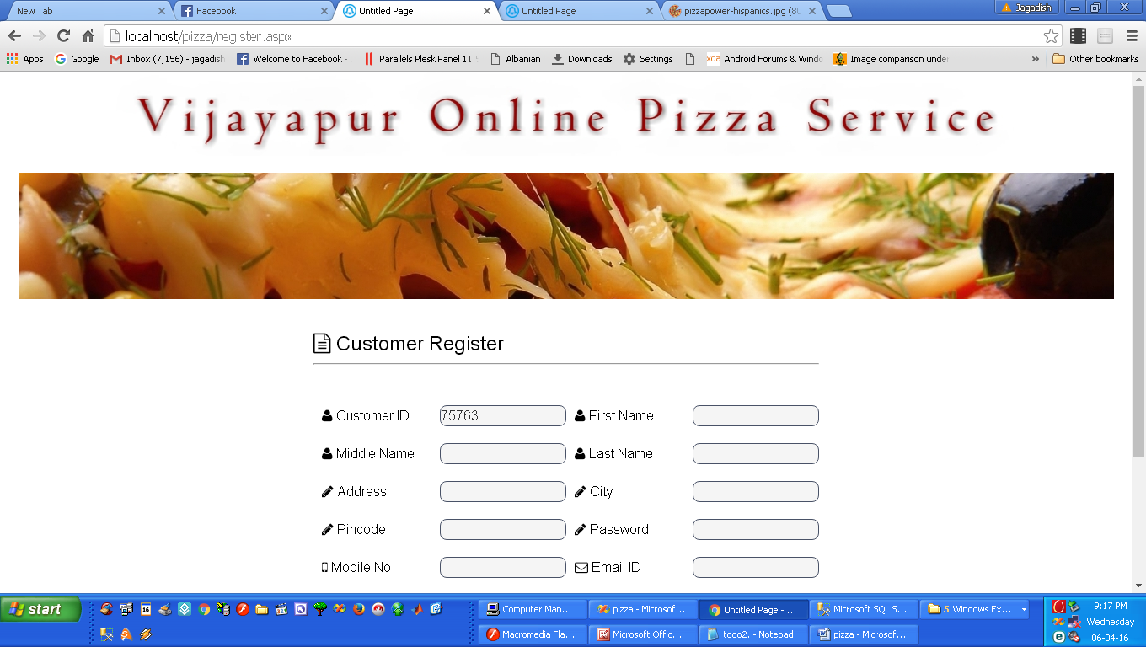

Admin Home Page

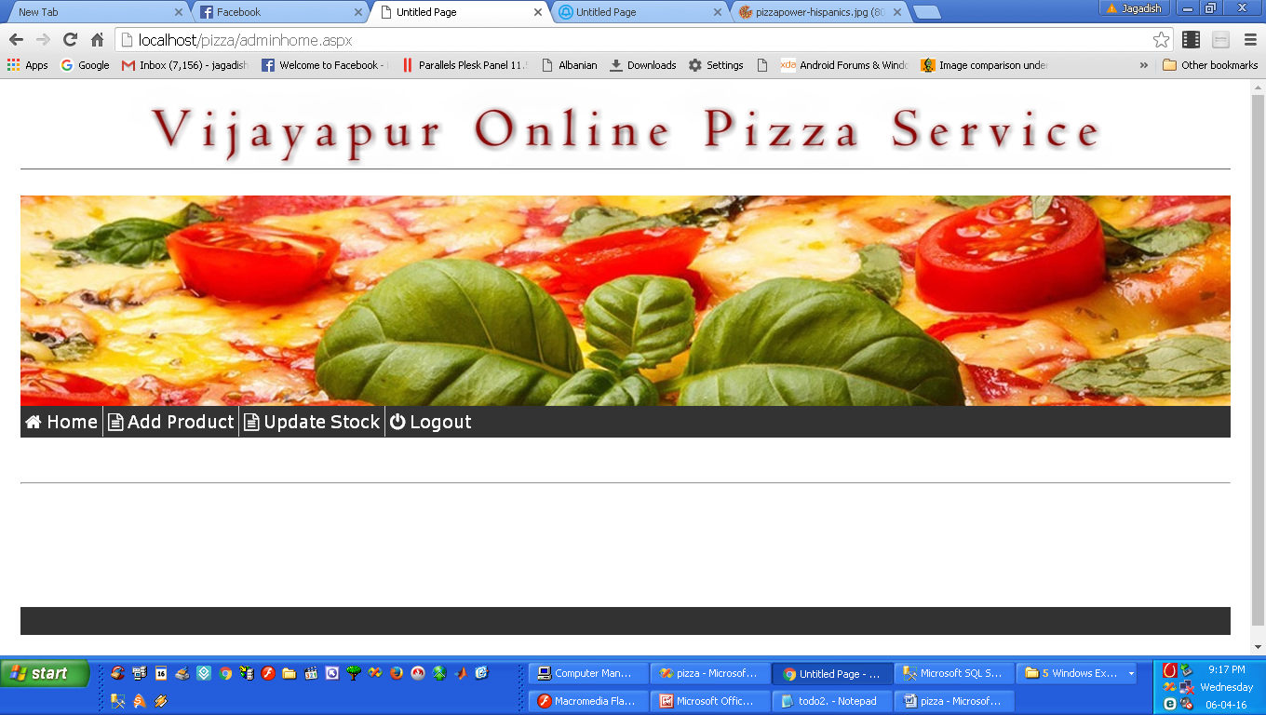

TESTING

TESTING AND RESULTS

Once the source code of the software has been generated, software must be tested to uncover and correct as many errors as possible before delivery to the customer .Testing assures the quality of the software product.

Testing also involves verification and validation (V&V) of the software product .Verification ensures that we are building the product right. So, verification refers to set of activities that run the system with simulated data to ensure that software correctly implements a specific function ,whereas validation, which ensures that we are the right product, refers to set of activities of using the software in live environment to meet customer needs

1.TESTING STRATEGIES

This software has undergone and cleared some of the important testing strategies as follows:

* **Unit testing:**

It is a white box testing technique , which focuses on smallest unit of software design the software component or module. Important control paths have been tested during the time of coding to uncover errors within the boundary of the modules. Unit testing ensured that the property flows in and out of the system.

* Integration testing

It is a white box testing technique that integrates all the modules and examines the software as a whole. It involves uncovering the errors associated with interfacing of modules. For example one module can have adverse effect on another or when they are combined may not

Produce desired results. Such error have been detected and eliminated.

* System testing

It is a series of different tests that in corporate all the system elements like software, hardware, people and information. Along with the developers, the potential users of the system fully exercise the newly developed system, to ensure its accepted behavior. All the system elements are properly put together to meet the desired purpose.

TEST CASES:

Following are some of the important

* **Security testing**

This testing technique attempts to verify that proper security mechanisms are built into the system. Some of the security features employed in the proposed system are,

Restricted data access is provided to the user depending on their roles and privileges.

Passwords are stored in an encrypted format.

Database is protected by password and can be accessed only by DBA.

* **Validation testing**

This black testing strategy assures that software functions in manner expected by the. It validates all the user requirements .Test data covering all user defined attributes is applied in this technique. The proposed system under consideration has been tested by using this technique and found to the working satisfactorily.

TEST CASES

Following are some of the important test cases and expected out comes as per the testing plan used as per the system.

**Test Case No. 1**

**Module**  General

**User Form**  Home Page-Login

**Input** Username and /or Password fields are left blank

**Expected Result** Display a message saying ,”Invalid Username or Password,please try again”

FUTURE SCOPE

OF PROJECT

**Scope of Project**

This project is aimed at developing a Online Mobile Shop (OMS) prototype for a retail business that is based on .Net Platform. This reports provides an introduction to Inventory Control describing the importance of time in managing inventory, its effect on business and how mobility can provide an advantage, the system’s general components and functionality, also present a demonstration prototype that was developed as a prove of concept, the technology used in the implementing and finally the conclusion with results, difficulties that were faced during the project, possible enhancement and future work.

The project uses the mobility feature to support access of authorized employee to inventory control information system. users, can be used to explore details of the inventory in stock, browse the clients and suppliers information, update the inventory based on the sale and purchasing details..

**Advantages**

1. Helpful for people.
2. Its user friendly
3. Easy to handle.

CONCLUSION

**CONCLUSION**

The ever-increasing wide spread use of mobile devices and internet, and the high demand for access to business information on a 24x7 basis thought mobile devices have motivated the need for an enhancement in the current inventory control systems to reduce the effect of :

- Manually checking inventory as it is a time-consuming process, inefficient and

subjected to human errors.

- The lack of inventory visibility leads to additional issue that affects customer

satisfaction, including empty shelves and out-of-stock items.

- Each individual shop generates order recommendation, checking the accuracy of these orders to eliminate under-stocking or over-stocking require employees to make many trips to the shelves

**ABRIVATIONS,FIGURES AND TABLES**

ABBREVATION

* VOPS : Vijayapur Online Pizza Service
* ASP : Active Server Page
* SQL: Structure Query Language
* DFD : Data Flow Diagaram

FIGURES

* Login Page
* Home Page
* View Mobile
* Purchase Mobile

BIBLOGRAPHY

BIBLIOGRAPHY

* Wrox ASP.NET Book
* Programming ASP.NET 3.5
* [www.asp.netcorner.com](http://www.asp.netcorner.com)
* [www.c#corner.com](http://www.c#corner.com)
* [www.aspforum.com](http://www.aspforum.com)

Screen Shots

