Lets install HELM

This is already done in the 1_Kubernetes

There are lot of already charts available developed by organizations, developers so we can leverage these charts in our cluster.

Now lets start building our own helm charts

All code available in section_16

Check video 236

Kubernetes on Cloud

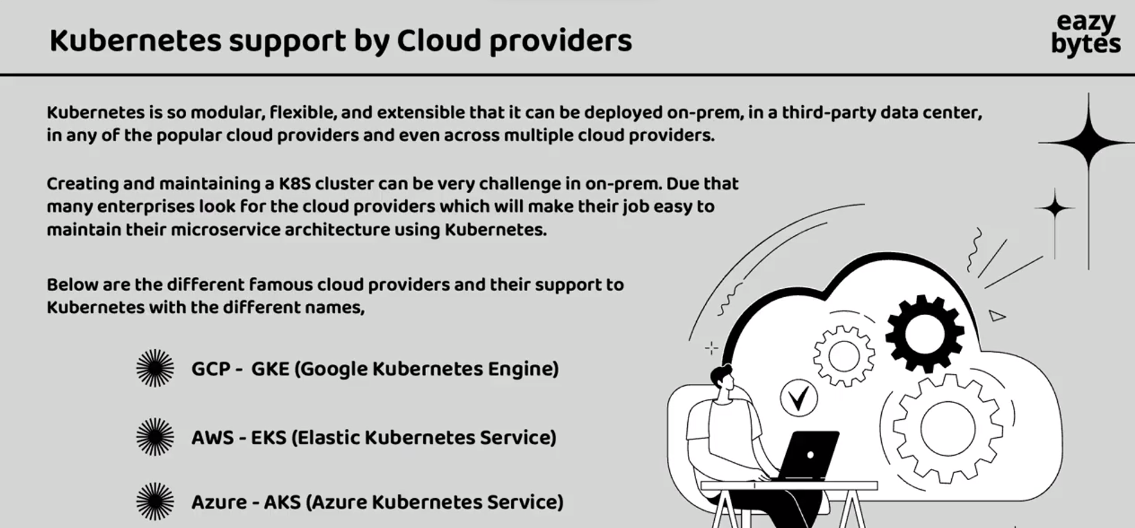

GCP provide a free 300$ credit hence will go with GCP for learning

Login in a cloud.google.com using gmail follow steps to create gcp profile. After login google is going to create default project called My First project.

Now we can download the google SDK on local system which will help to connect to Google Kubernetes cluster from our local system

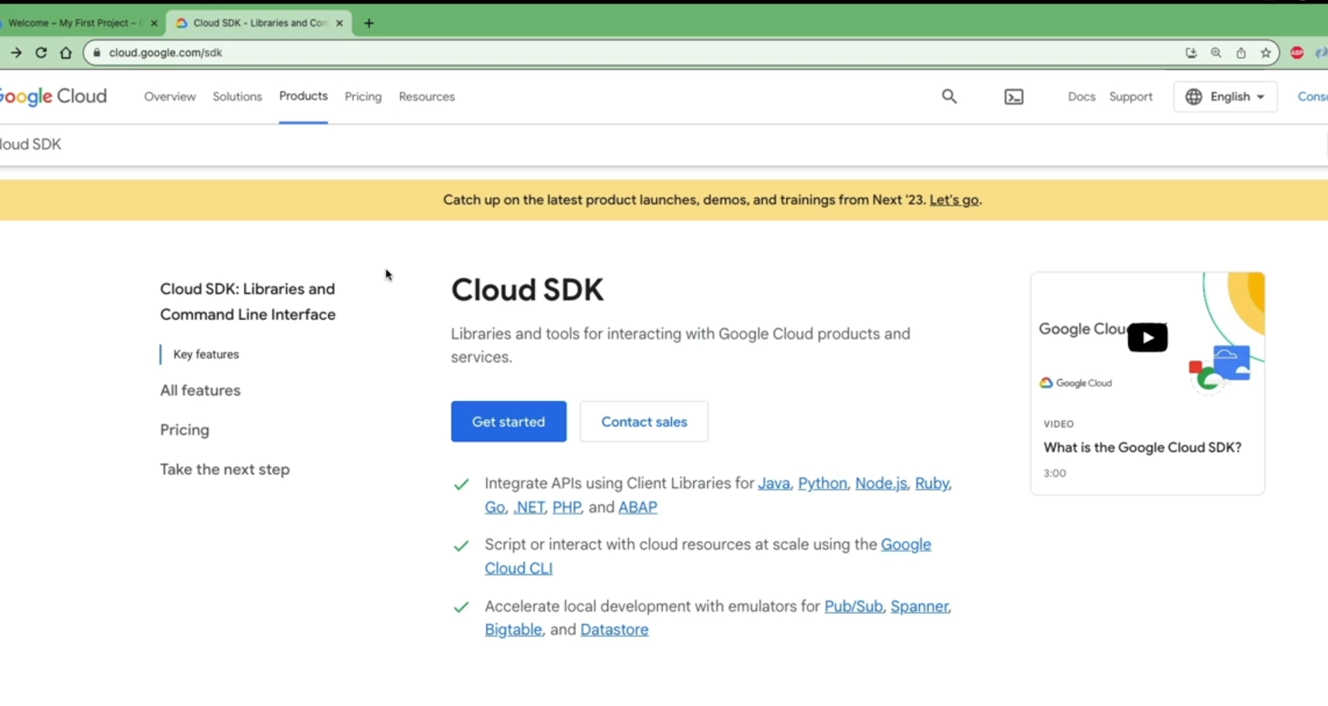

Once the installation is successful then run gcloud -version command to check version and then setup the project by gcloud init. Then it will ask to login

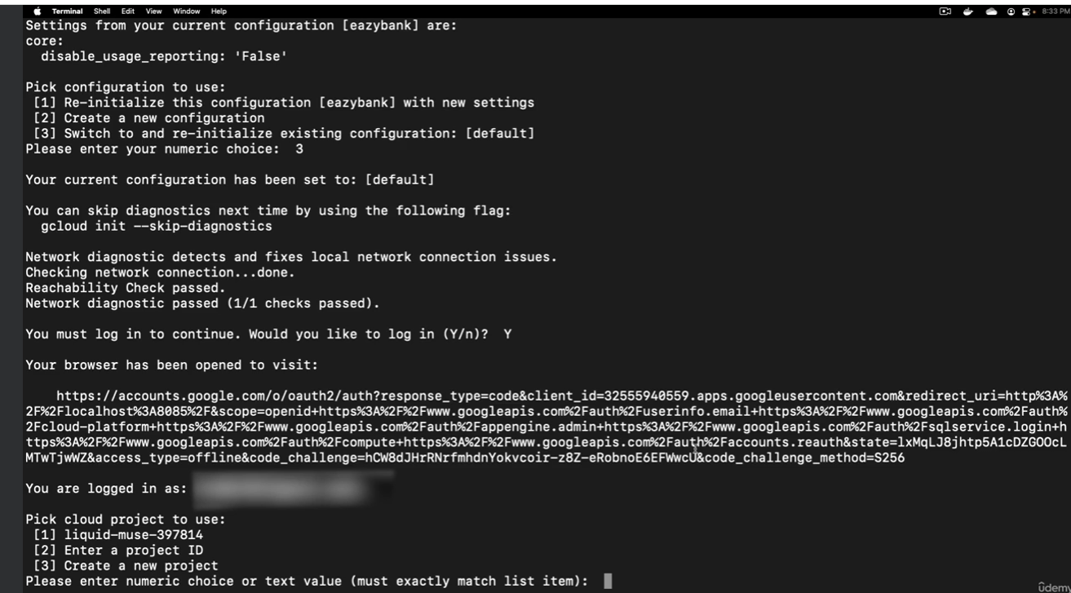

Now lets create Kubernetes cluster. On the google cloud Dashboard in the seach box search for Kubernetes engine then click on it

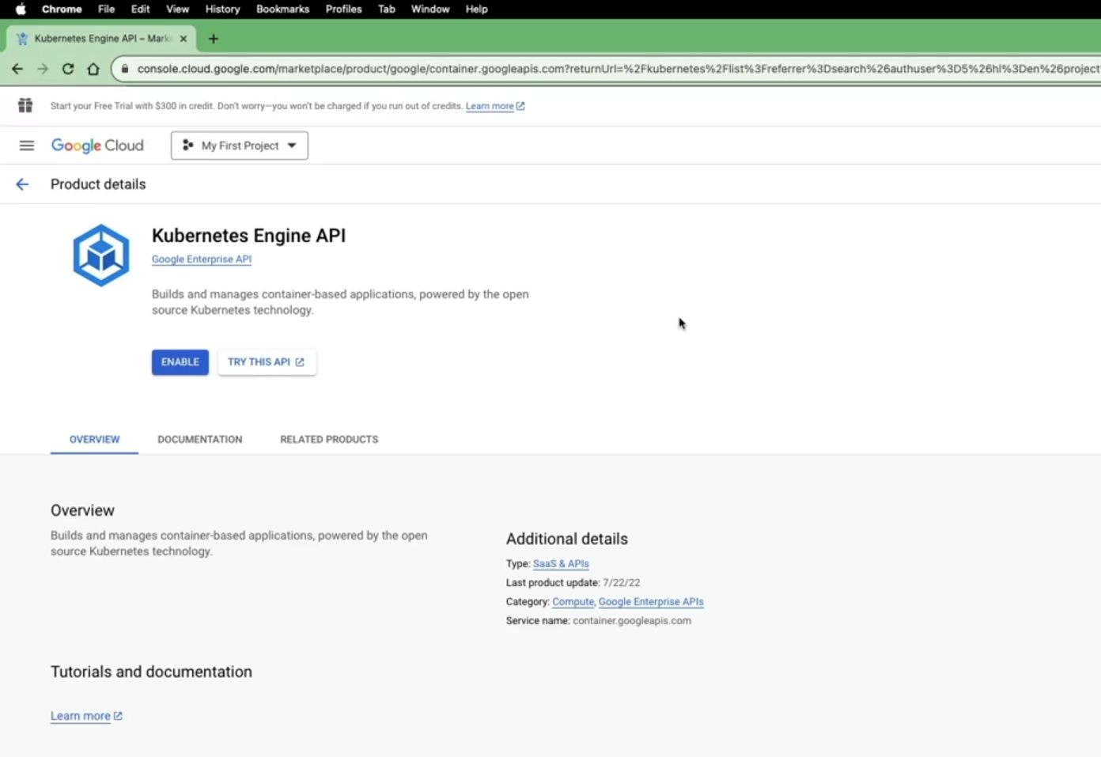

Then click enable and select billing enabled. Post that you will be landed on to a Kubernetes Engine then click create. Here you will have an option to create an autopilot cluster. So based upon the traffic the cluster capacity will be automatically be increased. But this will not allow us to explore more. Hence will choose standard cluster

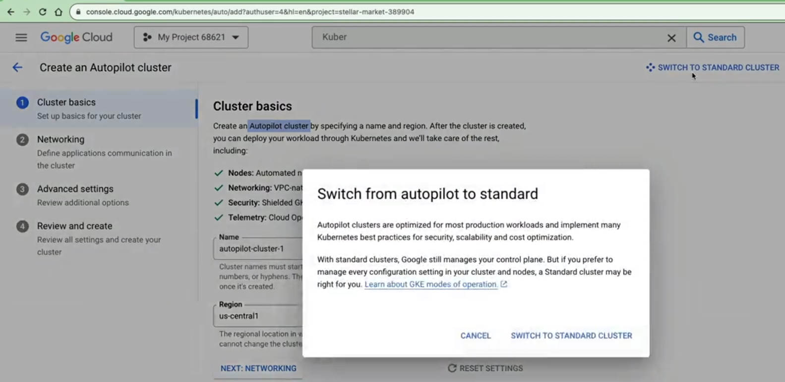

Then select all default values and click create

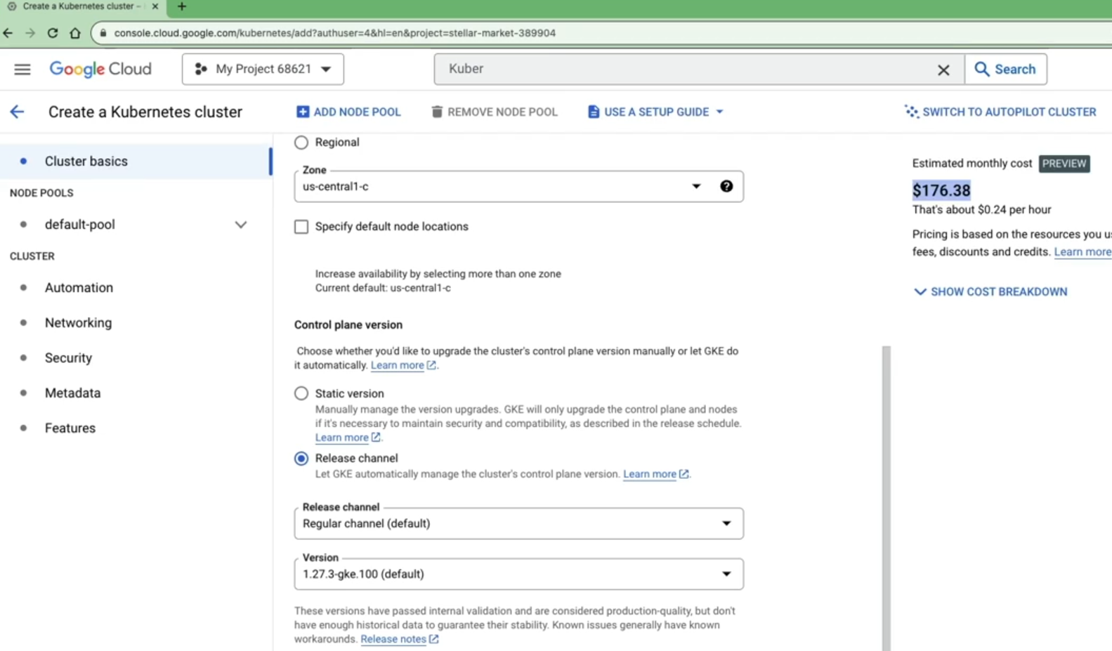

Google cloud will create a cluster for us

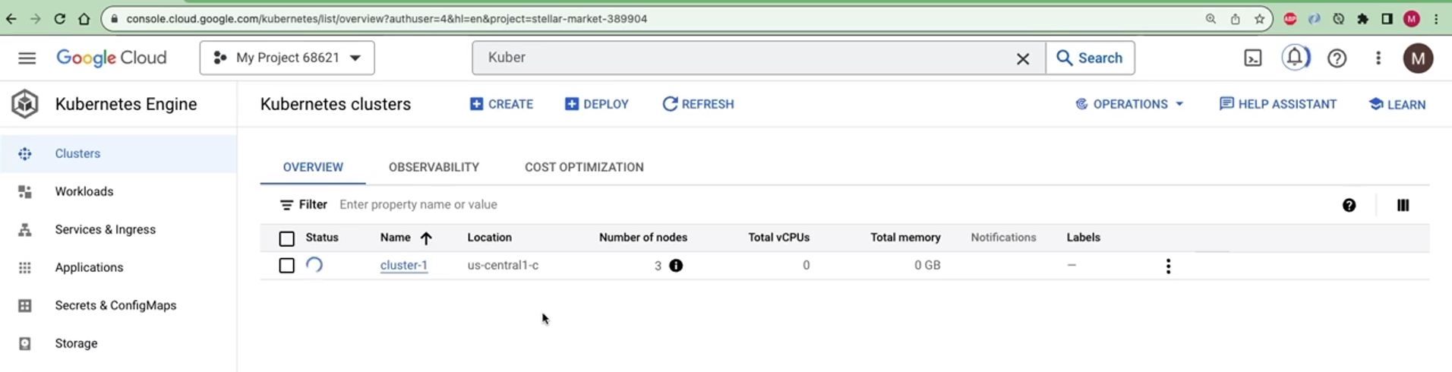

Click on the cluster and explore various options like Nodes, Pods, cpu utilization and all.

Then to connect this cluster with our local system click connect as below copy the command and run in cmd

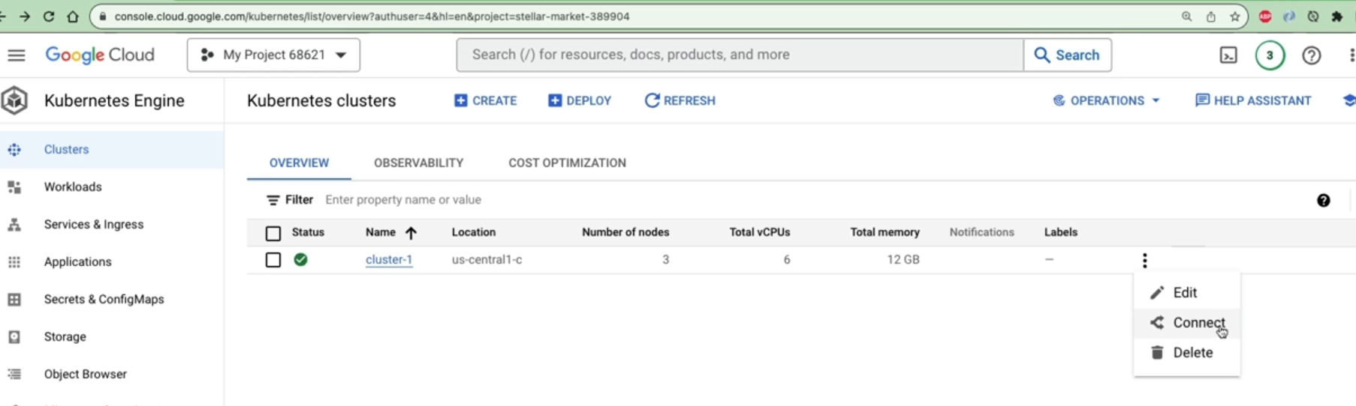

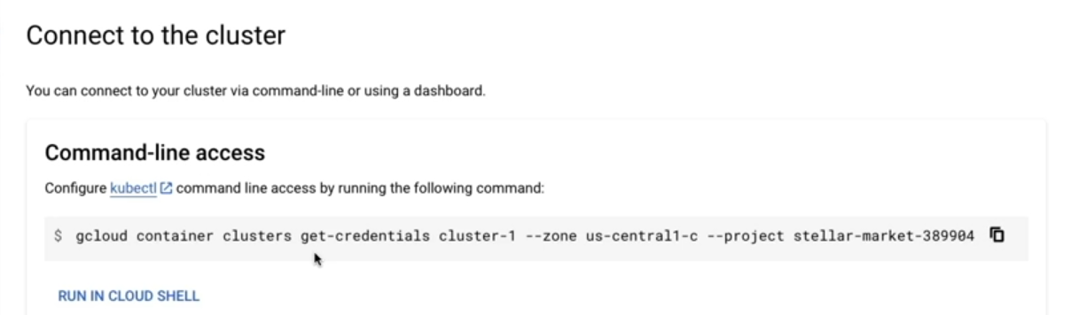

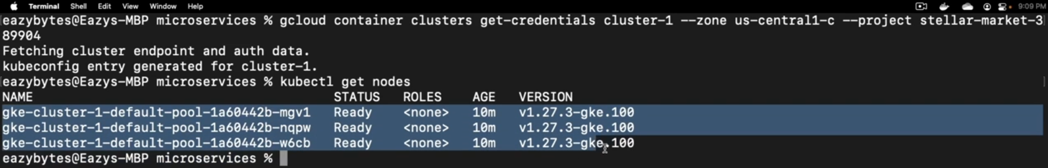

After running this command our docker-desktop will connect to google cloud k8 cluster you can also switch to your local cluster by selecting docker icon

