Docker Assignment-1

1. Create Repository1- with 3 branches 25Q1, 25Q2, 25Q3 and add index.html in each branch

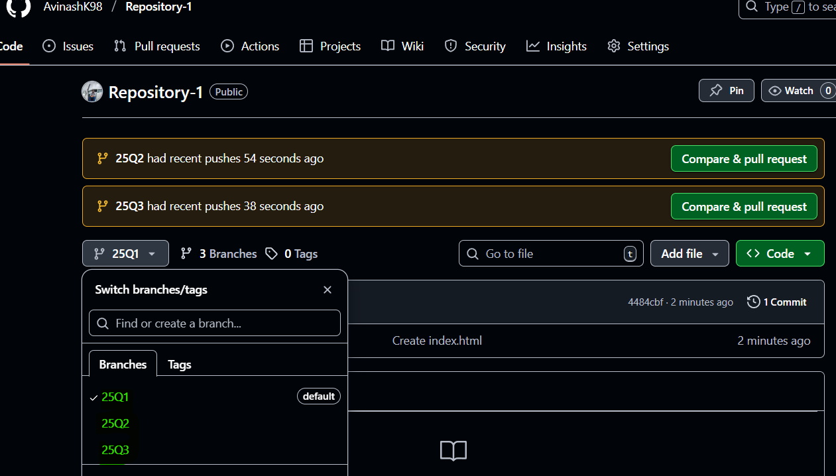

1. Install and start docker on Jenkins-Master

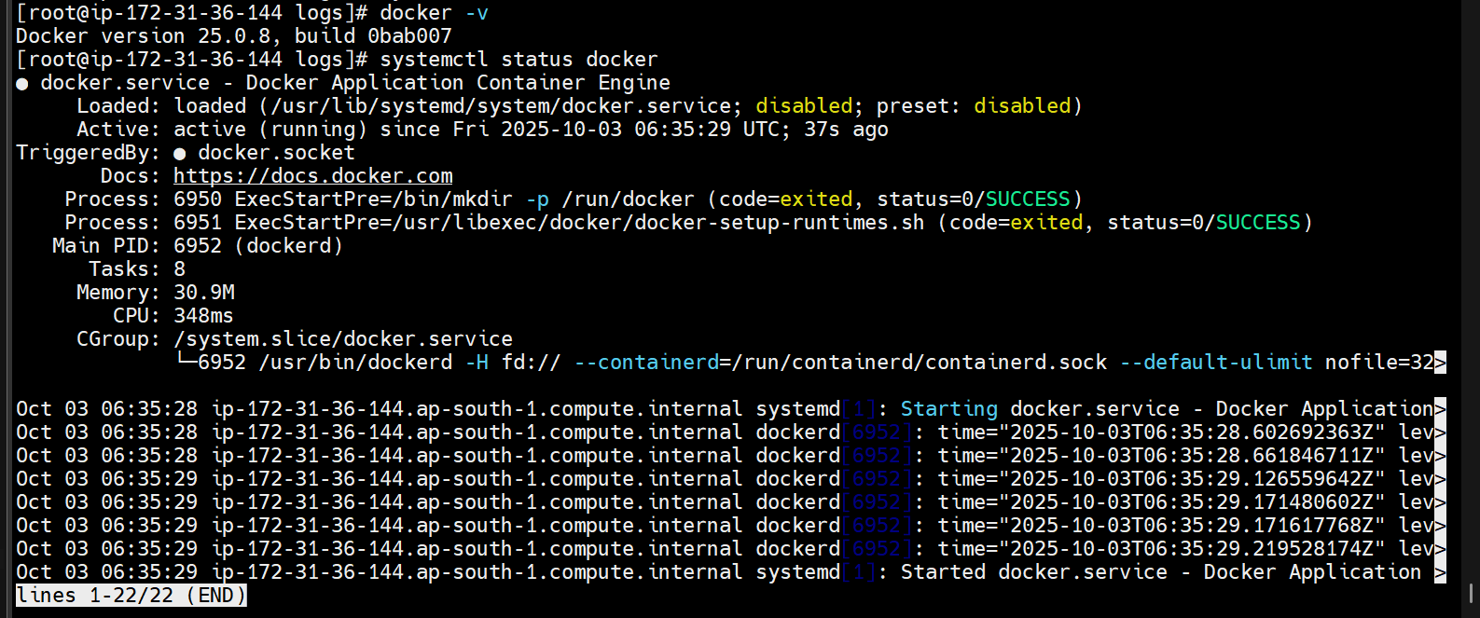

1. Setup a Jenkins Pipeline

Create a Jenkinsfile for 3 branch in github

as we have multiple branches so select Multibranch pipeline

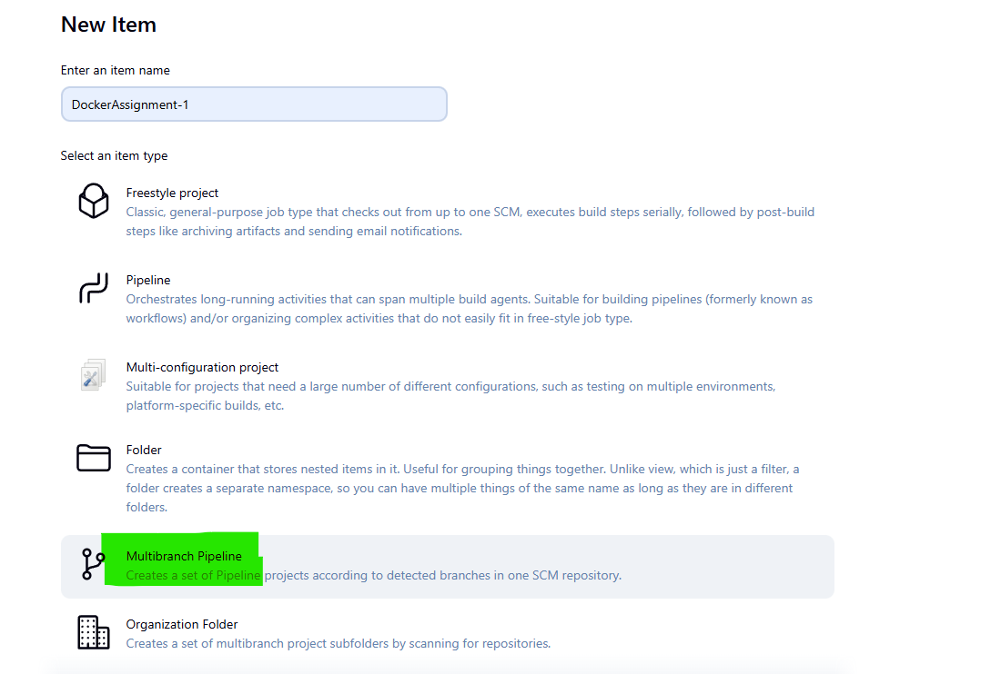

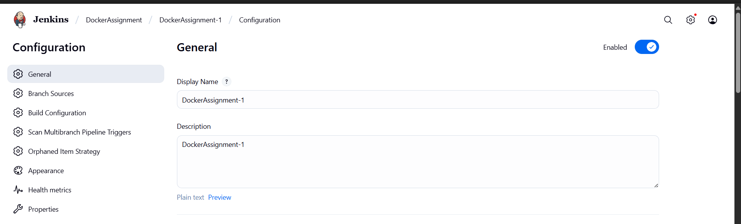

Provide url of github repository

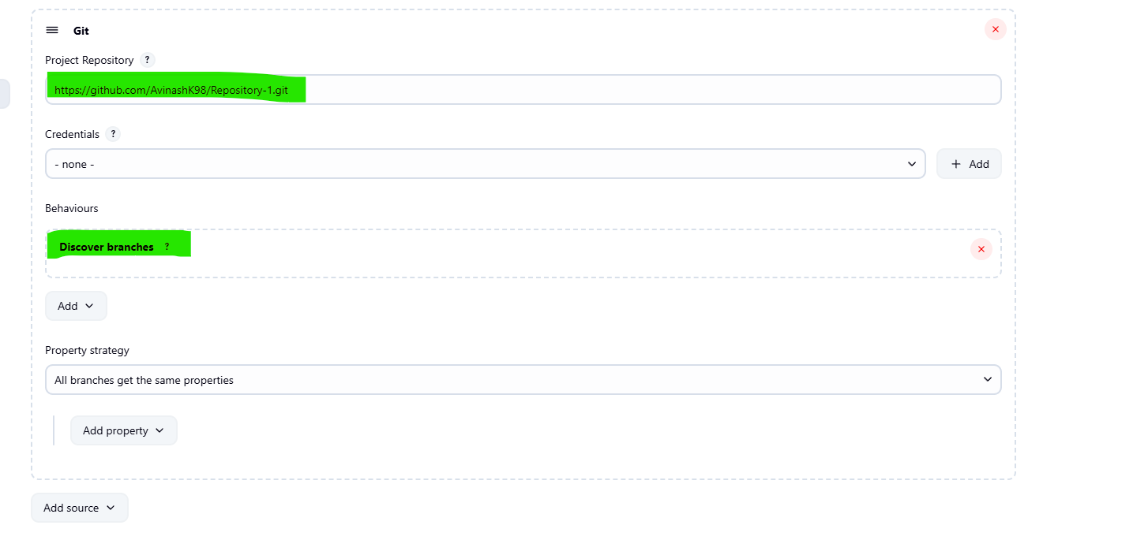

Use JenkinsFile for Build Configuration

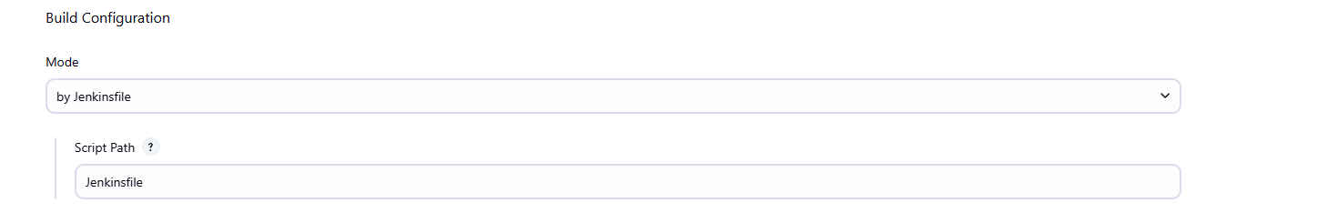

1. Now write a pipeline

Jenkinsfile for c1

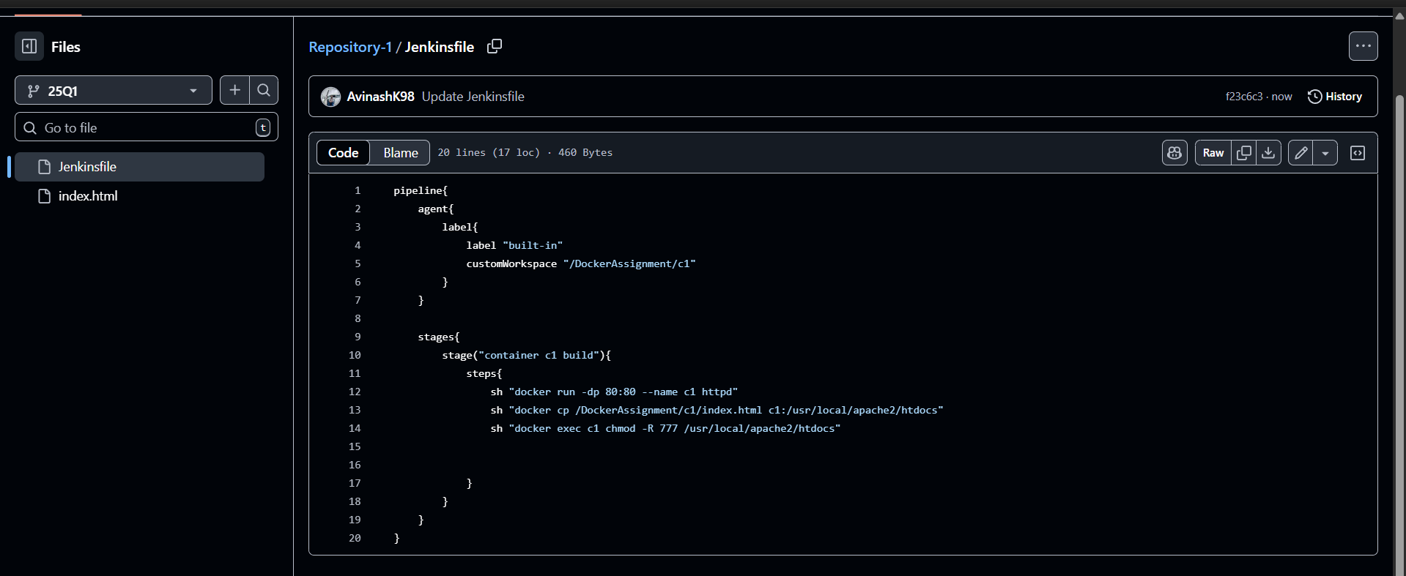

Jenkinsfile for c2

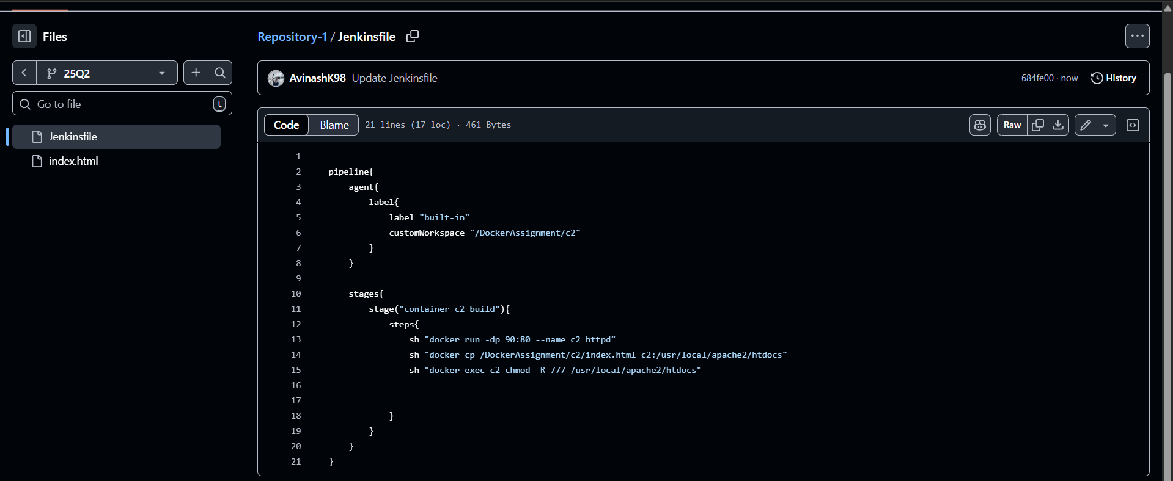

Jenkinsfile for c3

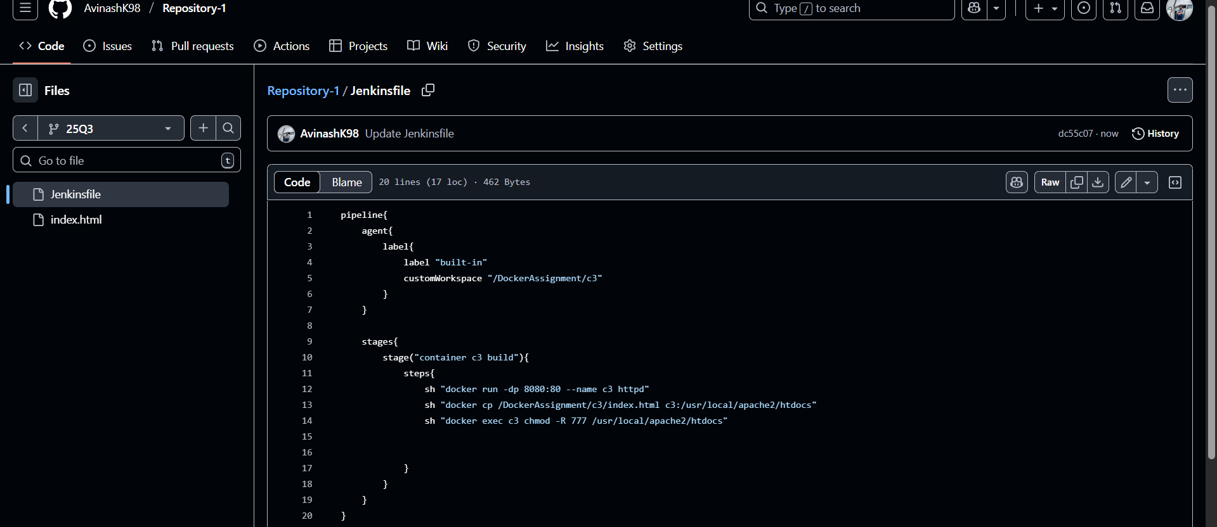

1. Now run the pipeline

Getting error in c3 due to 8080 port

already apache tomcat is running on default 8080 port

so need to change the apache tomcat’s port from 8080 to 8090

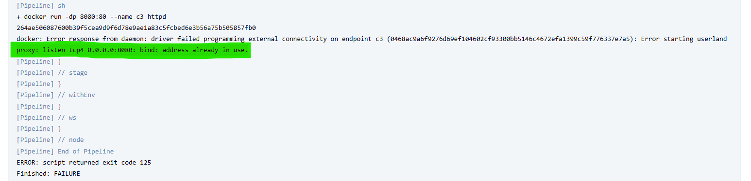

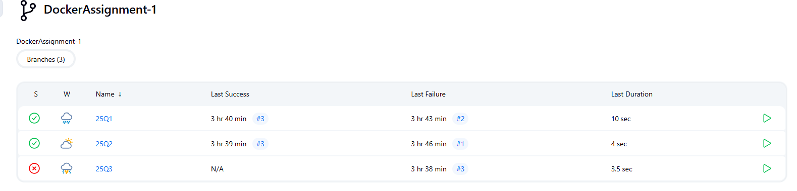

change the port in server.xml

path: /mnt/server/apache-tomcat-10.1.46/conf

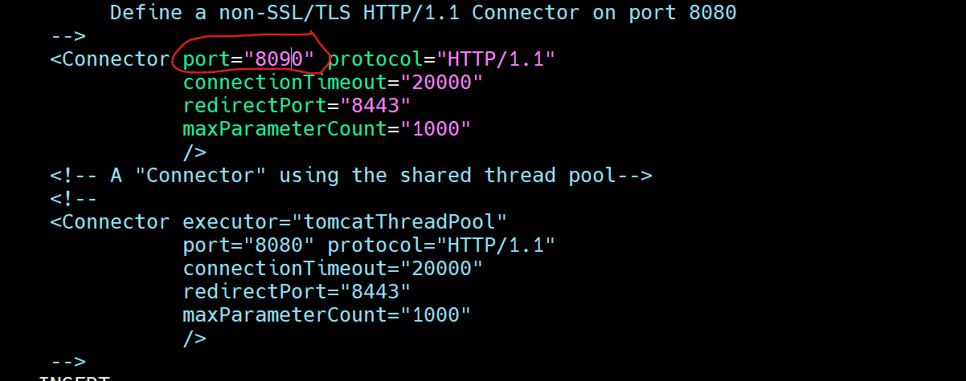

1. Now again run the pipeline

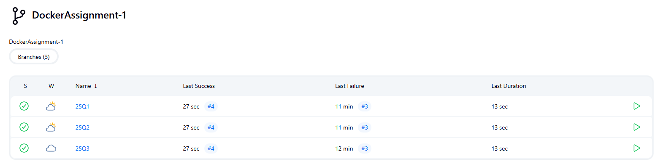

1. Test the index.html pages
2. Port 80

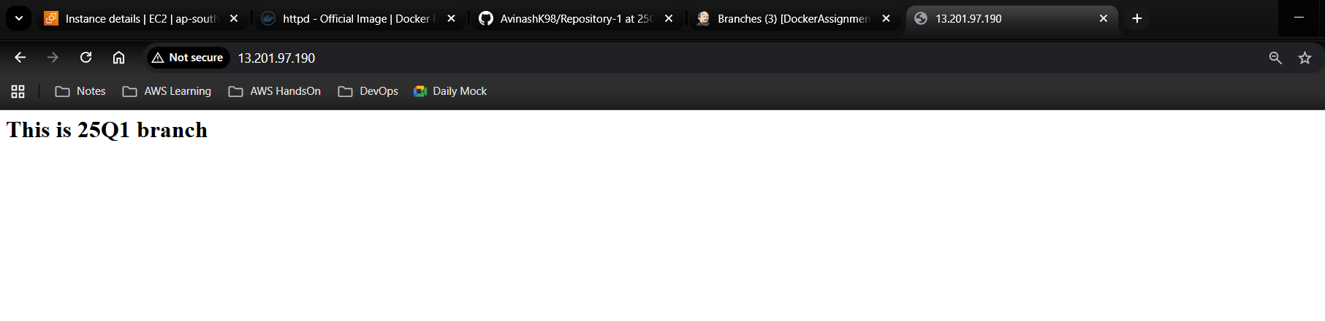

1. Port 90

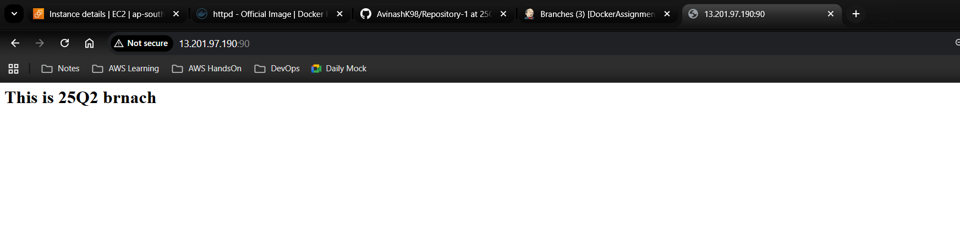

1. Port 8080

