Jenkins Assignemnt-5

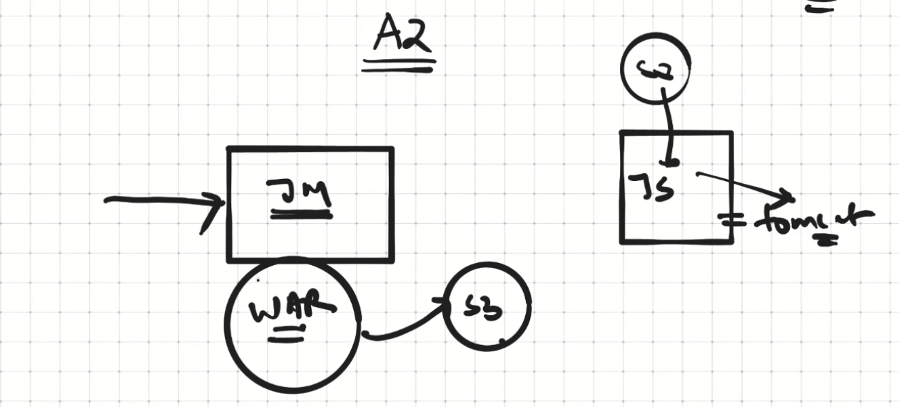

Create a war on Jenkins-Master

Upload the war on s3 bucket

deploy the war which is on s3 on the apache tomcat which is on slave

Solution:

Prepare a Jenkins-Master by Installing Java 17, git, Maven, Apache Tomcat 10, Jenkins Latest stable

Prepare a Slave machine by Installing Java 17, Apache Tomcat 10

create an s3 bucket

configure aws s3 on both the machines

1. Crate a connection between Jenkins-Master and Slave

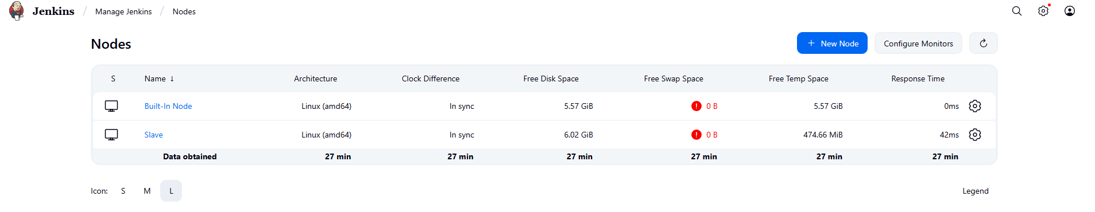

1. Create a Jenkins job to build an application using maven and upload it on s3 on Jenkins-Master

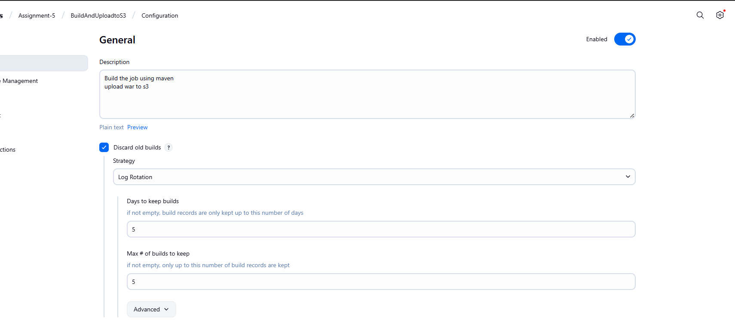

1. Running this job on Jenkins-Master

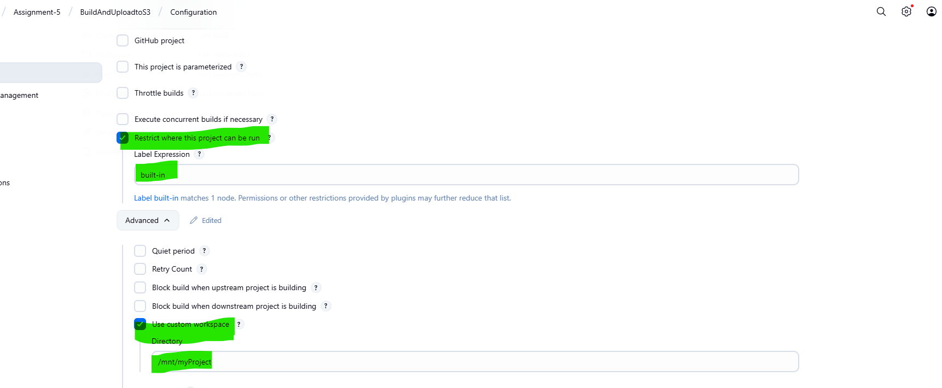

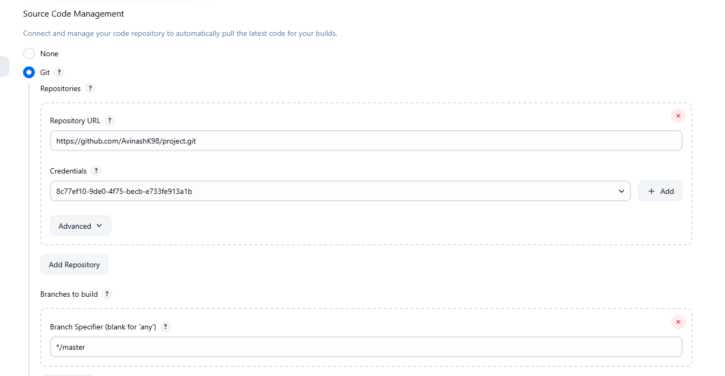

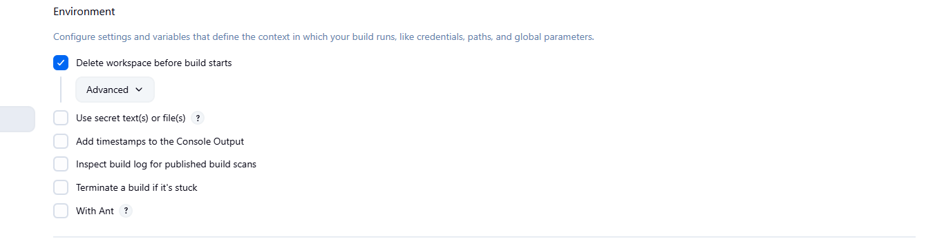

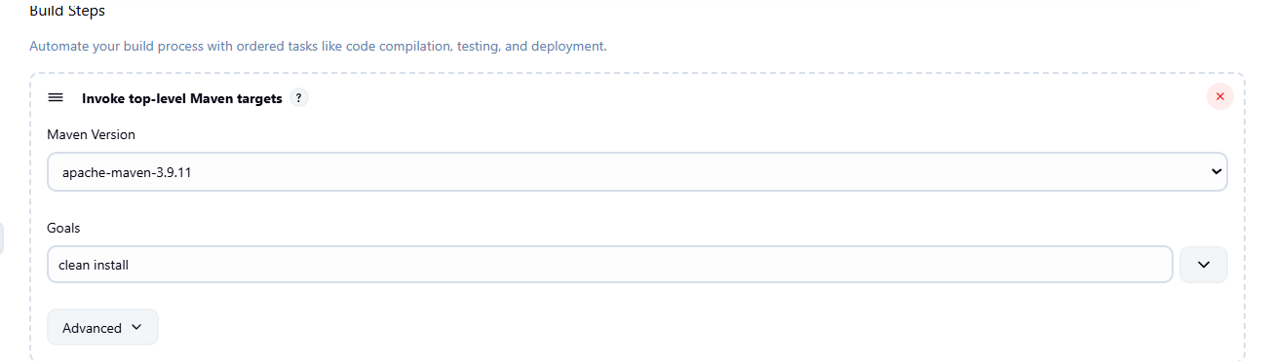

1. Use this command to copy the war file and upload it to s3 bucket

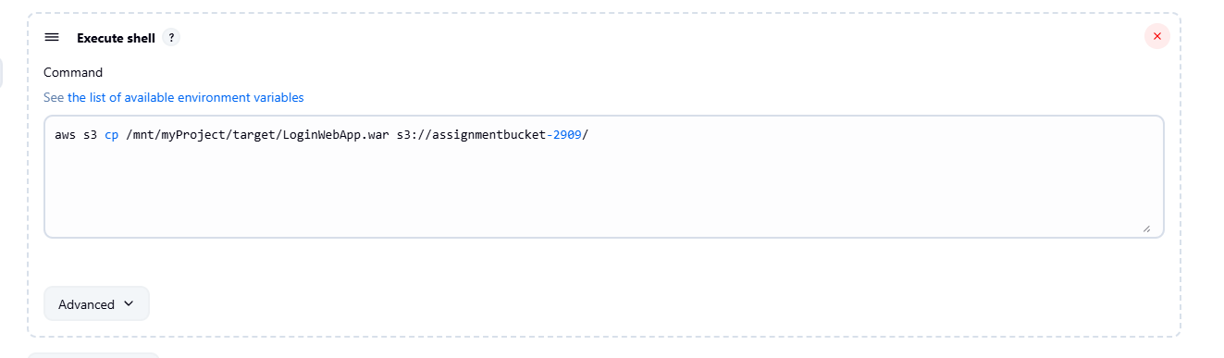

1. Create a Jenkins job for Slave machine to deploy the war file on apache tomcat

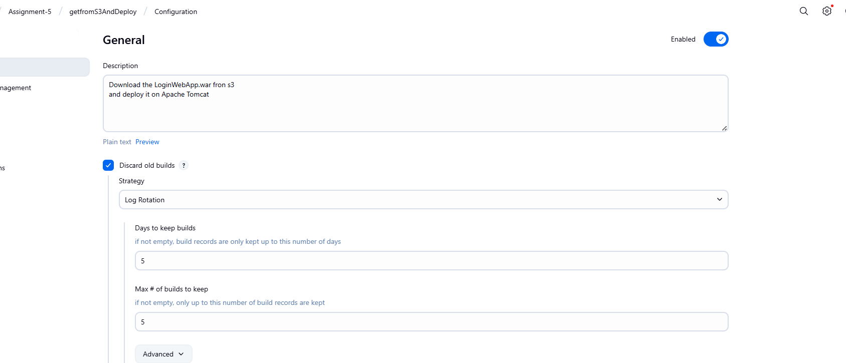

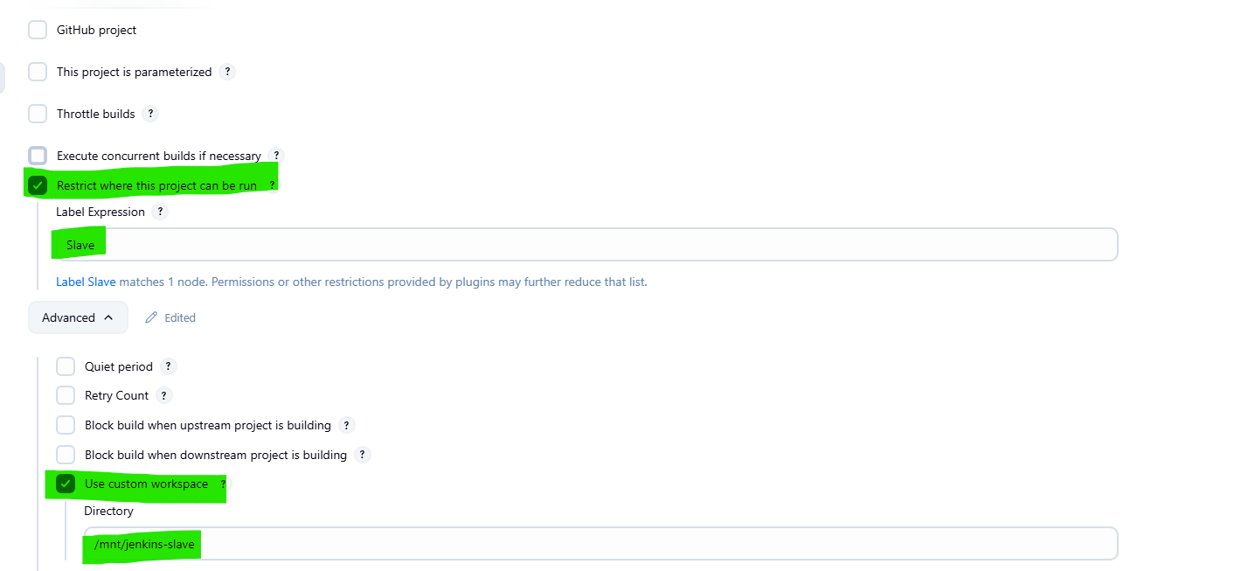

1. Use this command to copy the war file and deploy it on apache tomcat

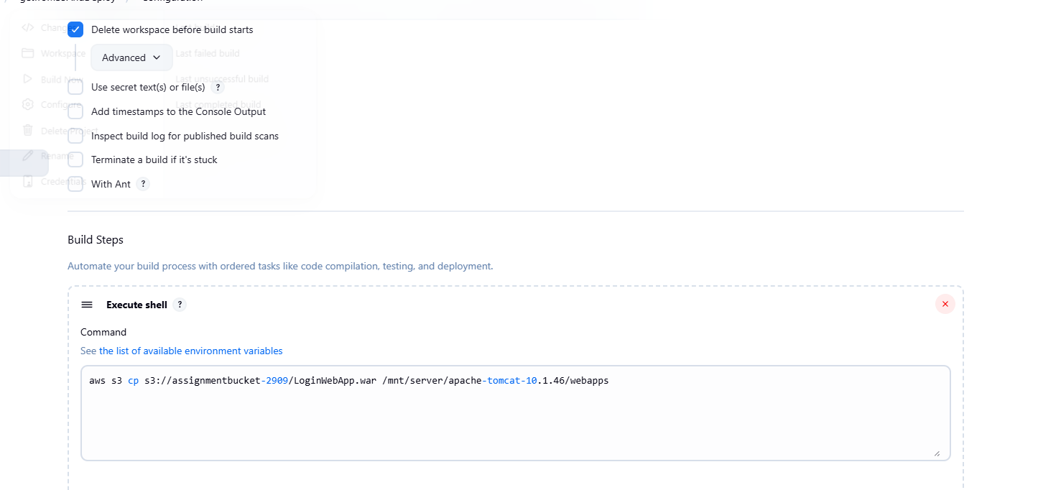

Do Apply and Save

1. Create a connection in such a way that, after completing the 1st job the 2nd job will get triggered automatically

1st job will clone the git repository, packaging the app using maven and uploading the war file on s3

2nd job will copy the war file from s3 and deploy it on apache tomcat

In the post build action of the 1st job mention the 2nd job

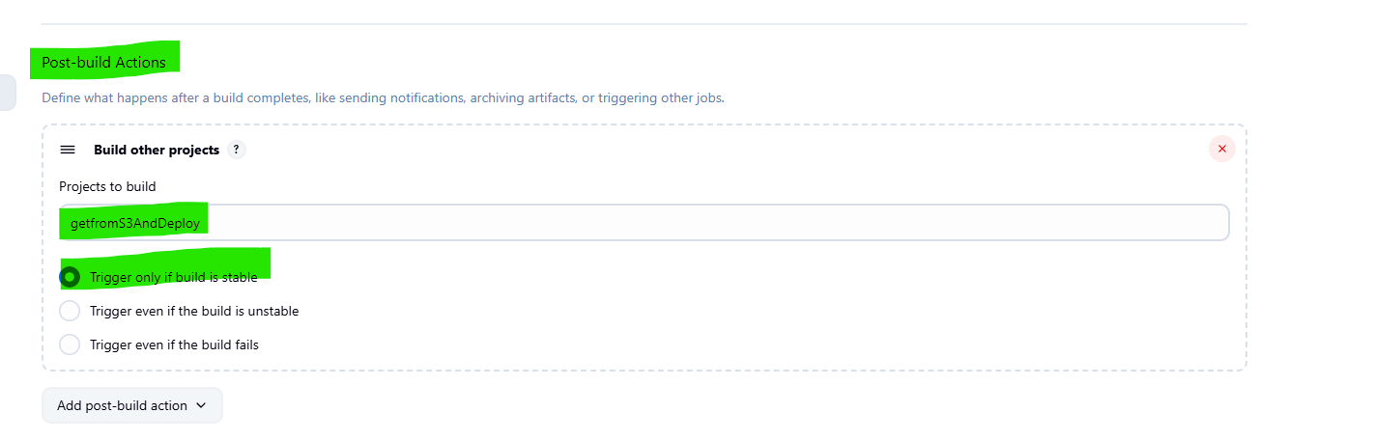

1. Run the job Master-Jenkins job

