**Jenkins Assignment: Deploying html page on httpd with the help of Jenkins job**

1. Launch an Instance and install java

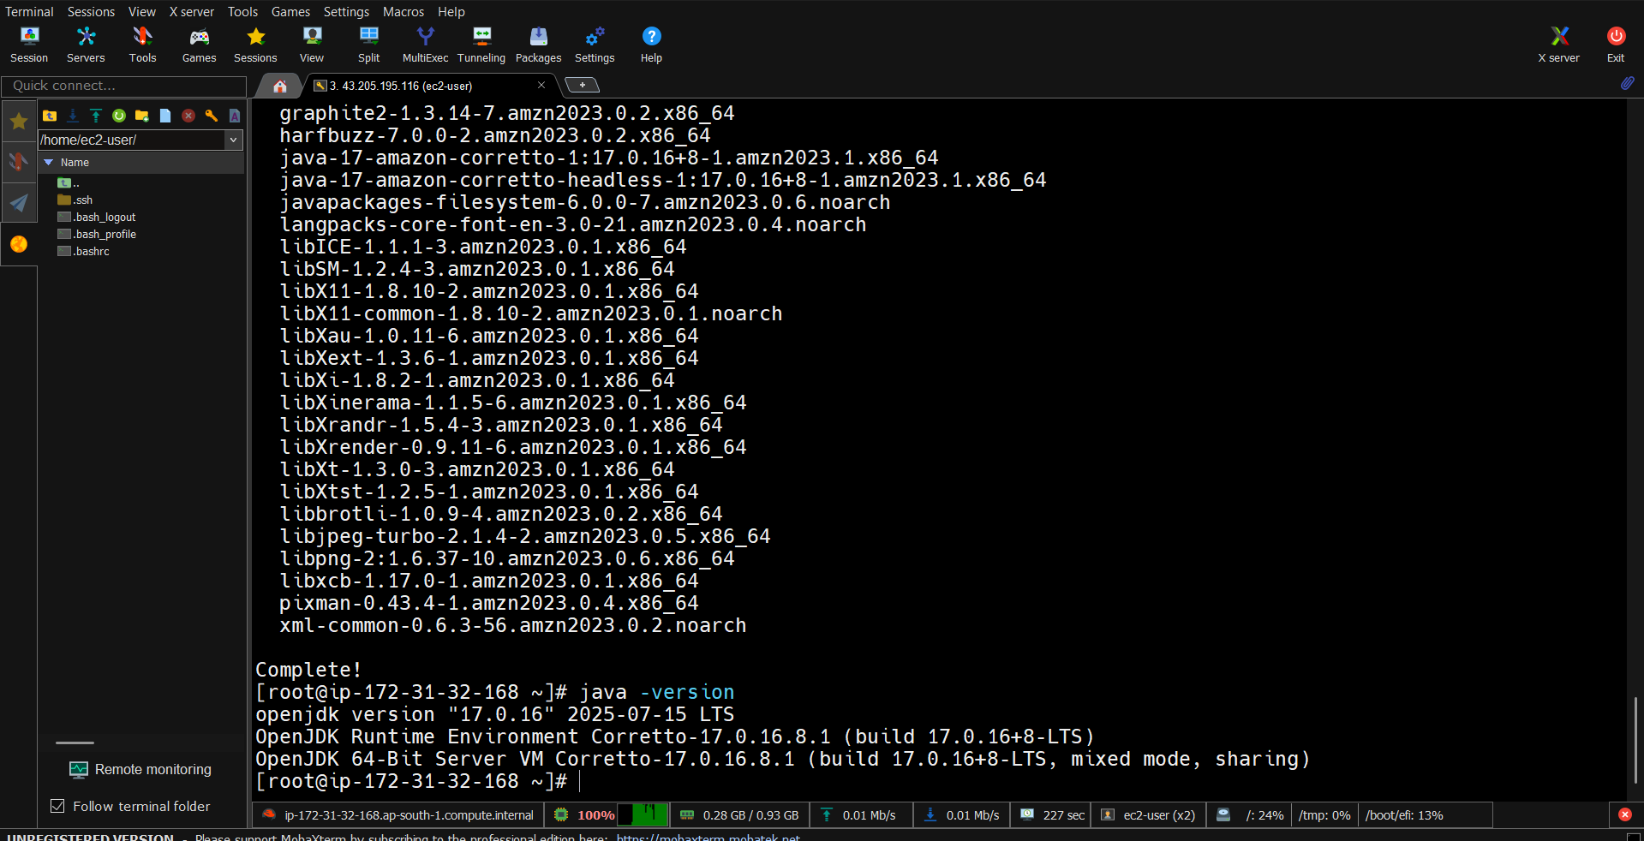

1. Download apache tomcat webserver from internet, unzip the .zip folder, delete the .zip folder and grant the rwx permission to the extracted folder

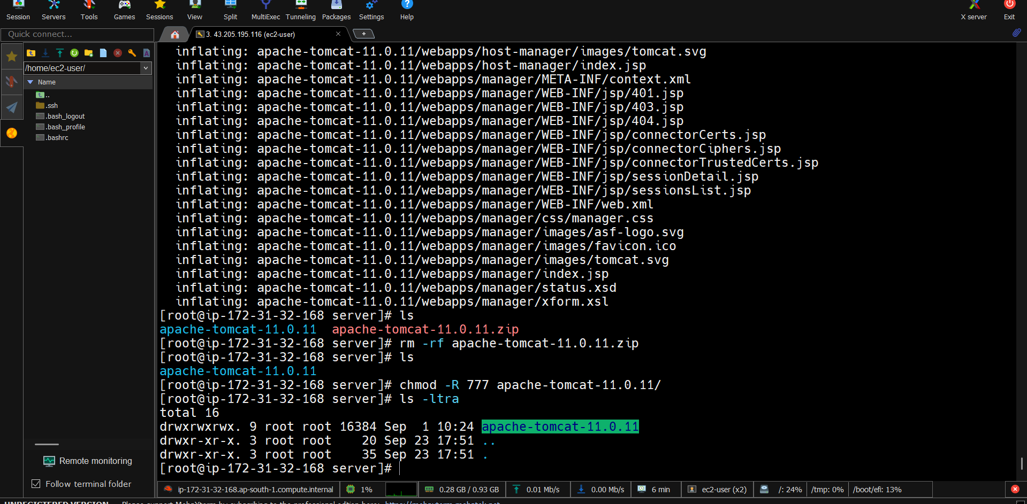

1. Download the Jenkins.war file from internet inside webapps folder. Here we are deploying Jenkins as a application on a tomcat server.

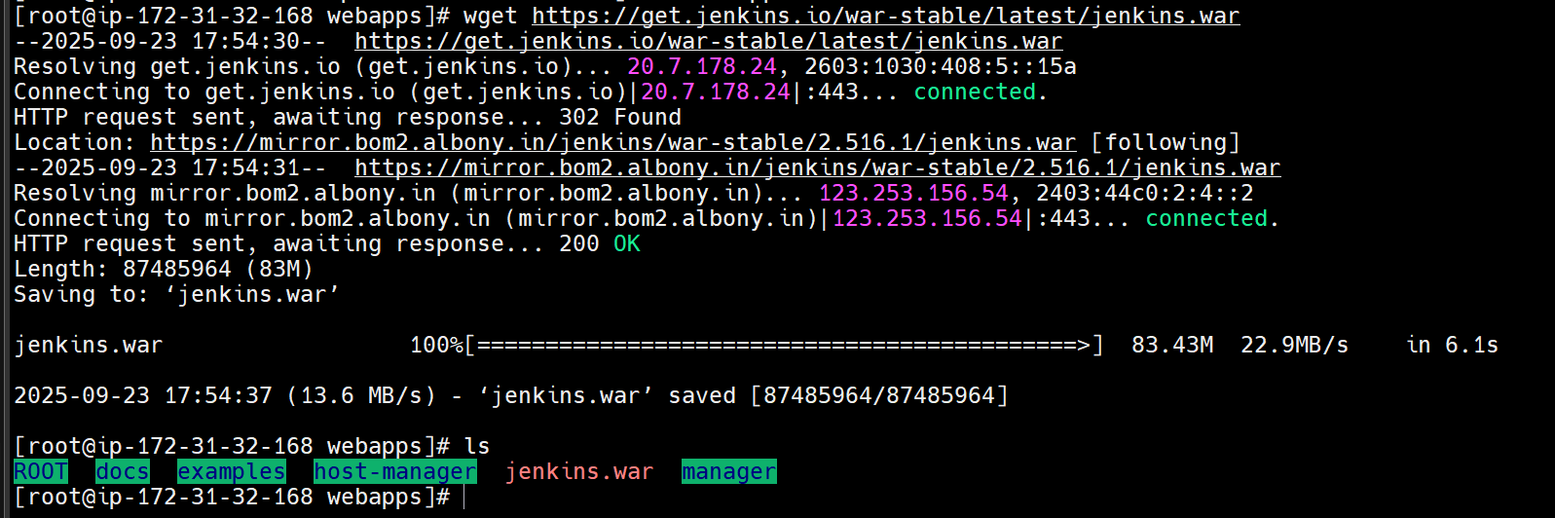

1. Start the tomcat server by executing startup.sh shell script which is inside bin folder

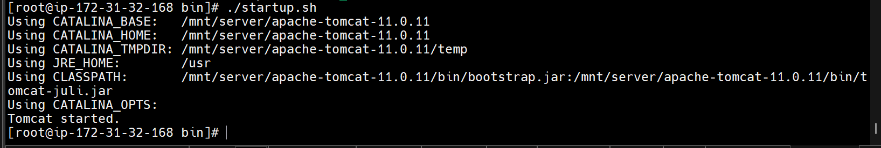

1. Access the Jenkins application by 43.205.195.116:8080/Jenkins but make sure to configure the security group (http port 80 and 8080 port in the inbound rule)

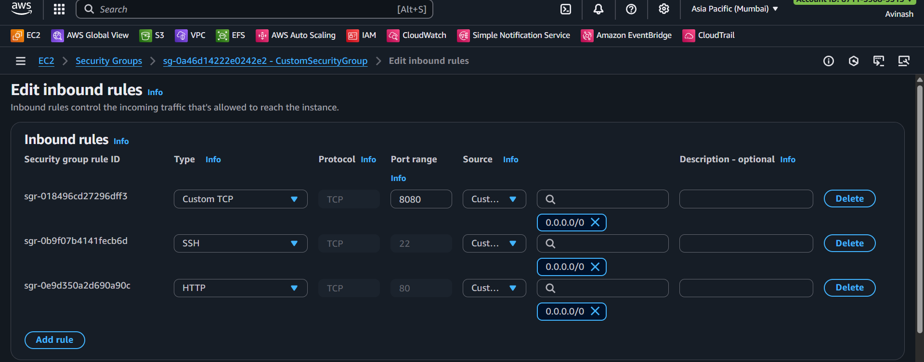

1. Unlock the Jenkins

Go to /root/.jenkins/secrets/initialAdminPassword this location and get the initial password

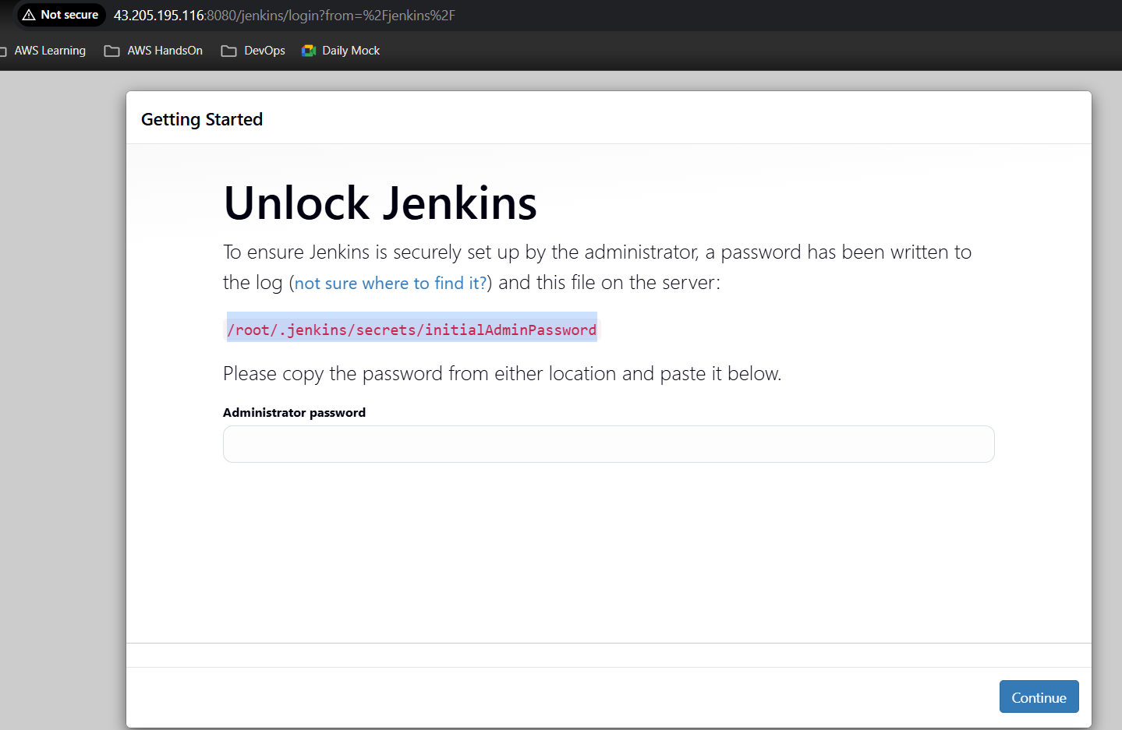



1. Install suggested plugins

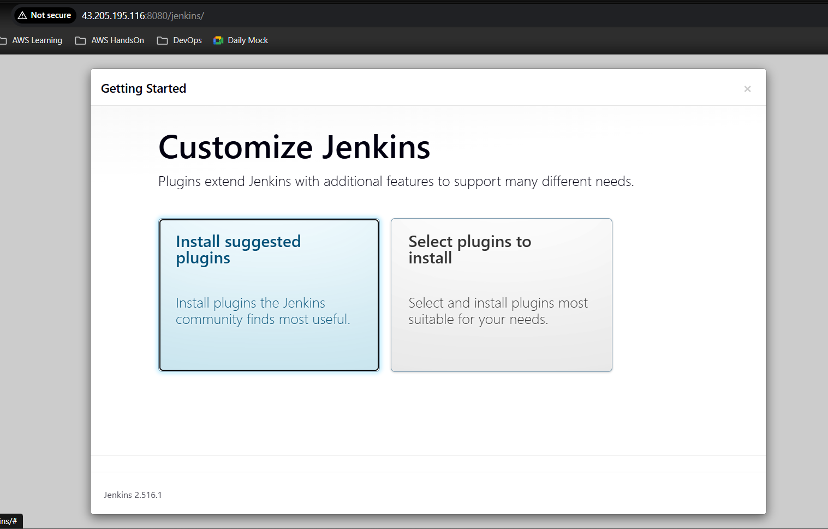

1. Create an Admin user

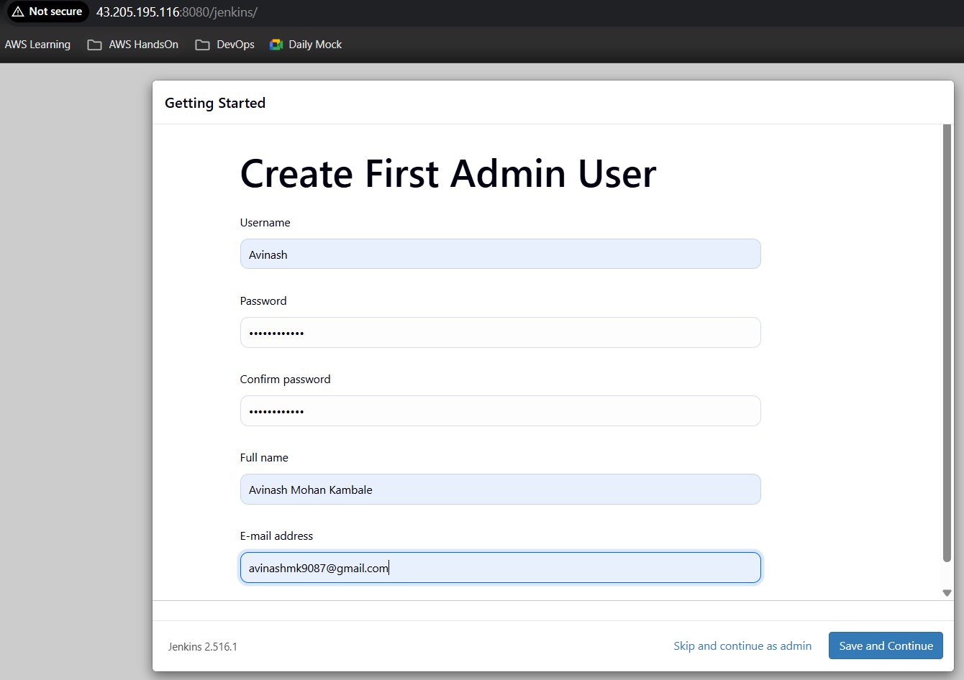

1. Creating a job by using Freestyle Project

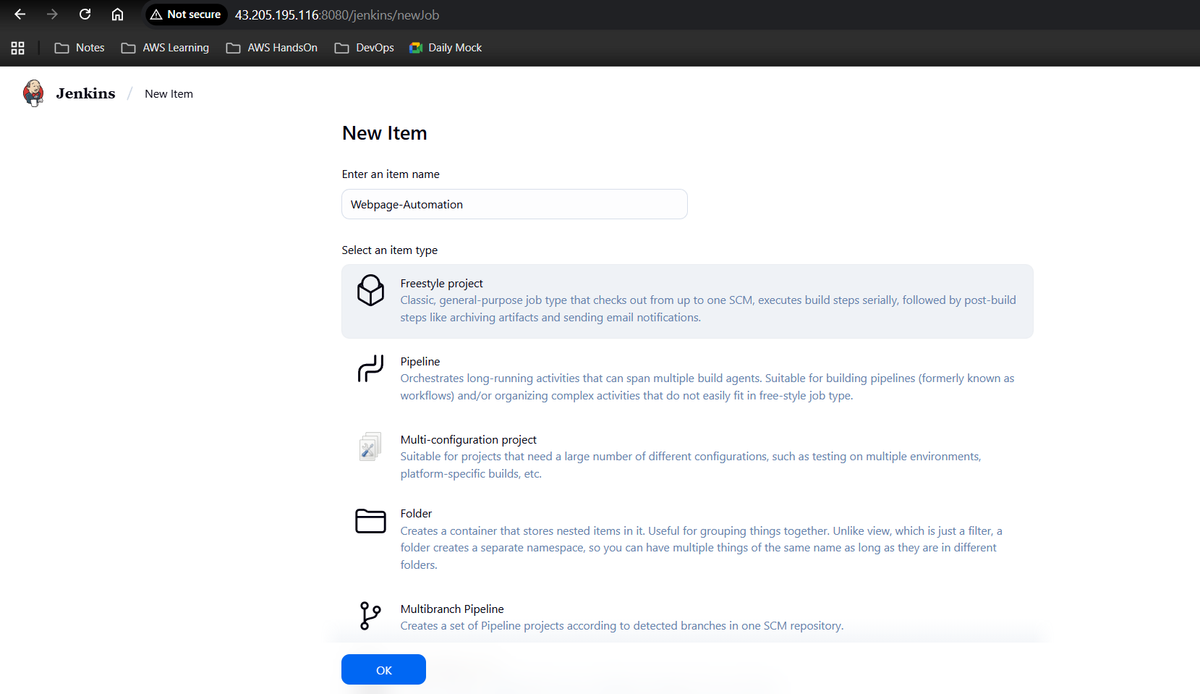

1. Provide the necessary description

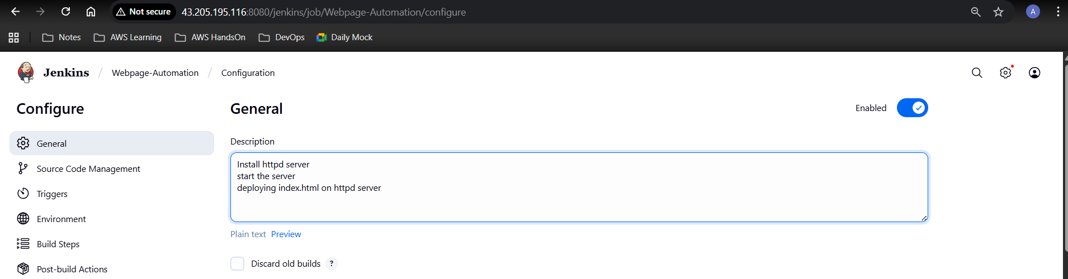

1. Building the steps by selecting Execute Shell

Write the shell script to do the task sequentially

Then click on Apply and Save

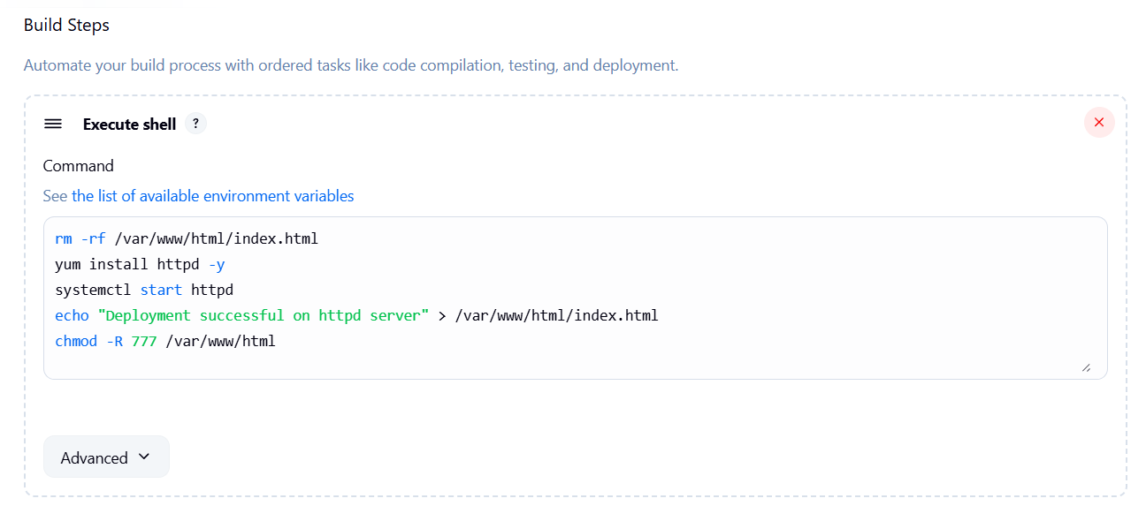

1. The job has been created

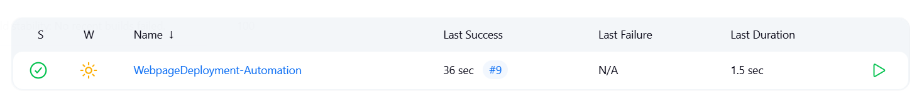

1. Check the output by going console output

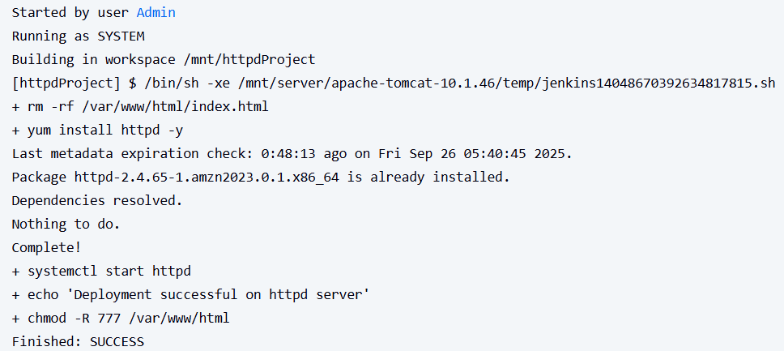

1. Check the status of the job

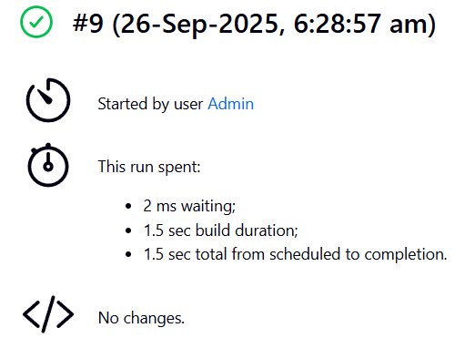

1. Check the html webpage is accessible or not by hitting public ip

