Jenkins Assignment-2

1. Create 3 Private Repositories in github

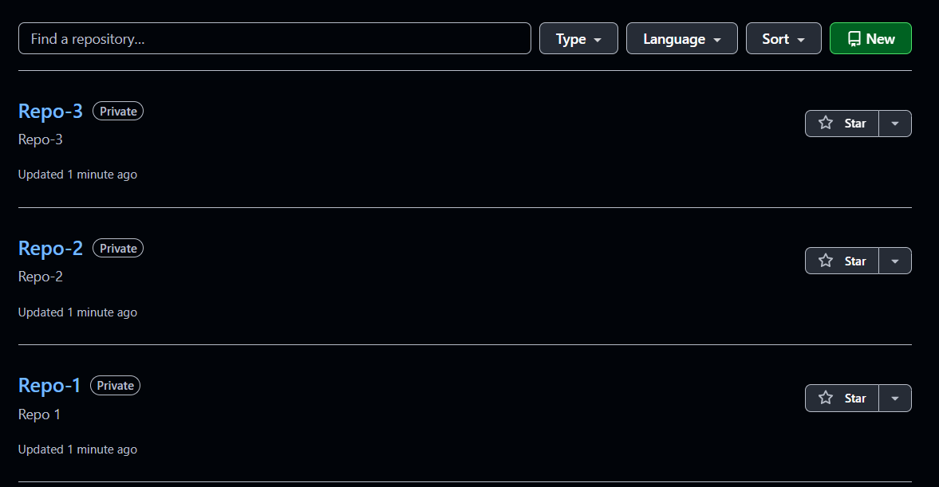

1. Add index.html in every Repository and in different branch

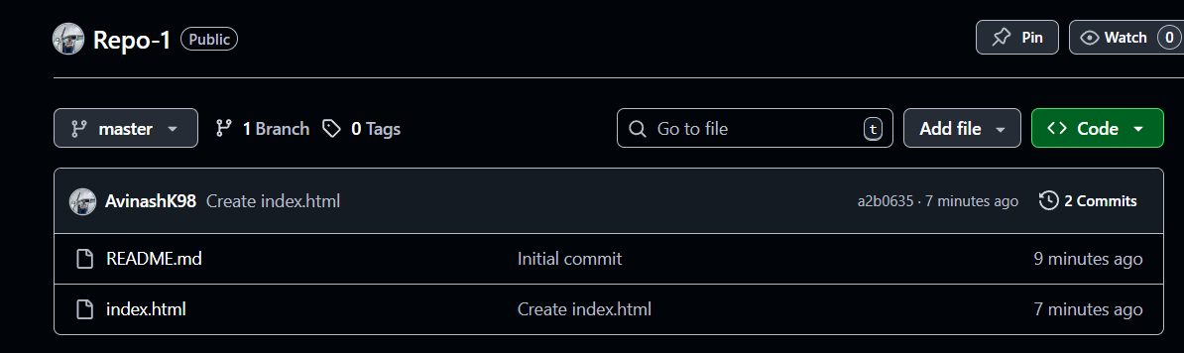

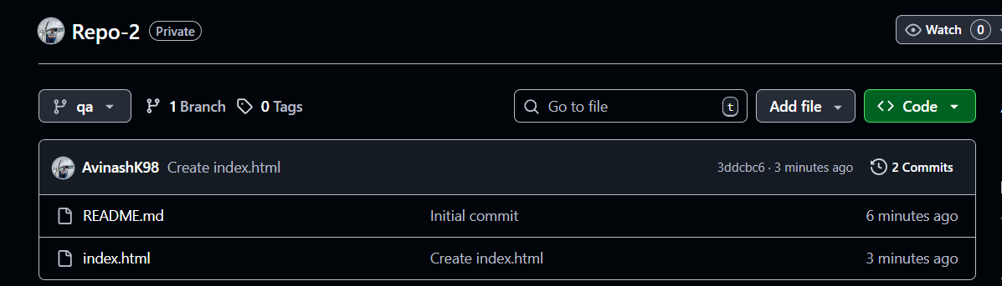

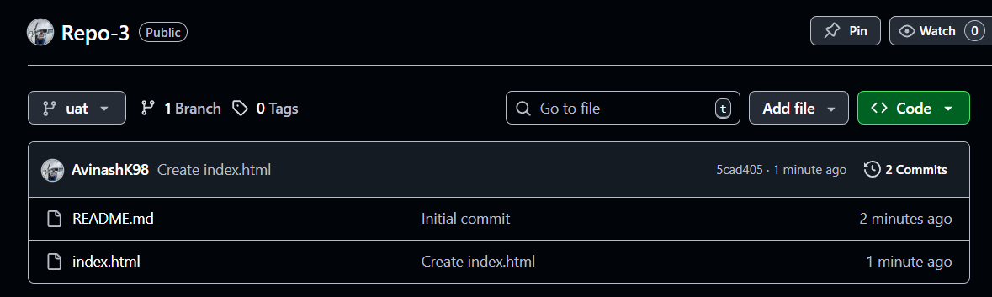

1. Setup the 1st Jenkins job for Repo-1 master branch

Provide the repo url, git credentials and specific branch to be cloned

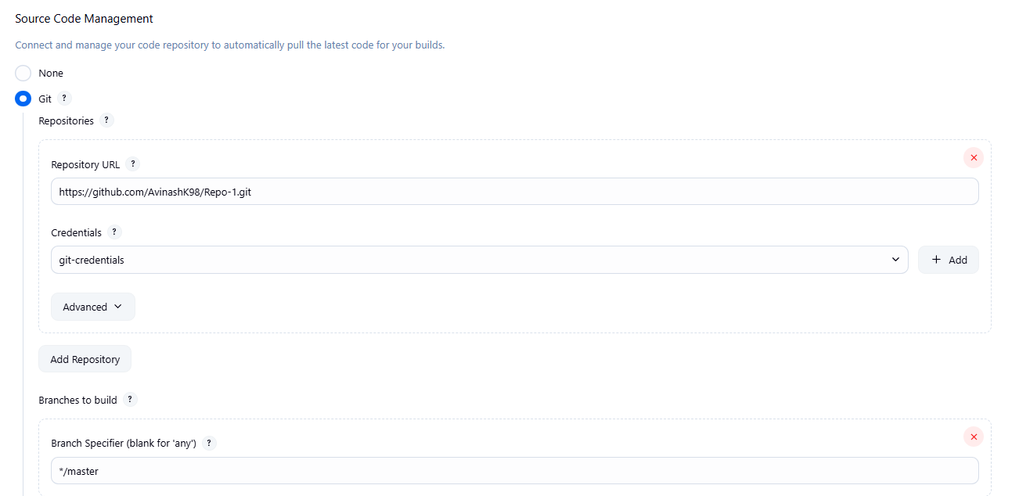

Check this option to clear the workspace before starting the build to avoid getting errors

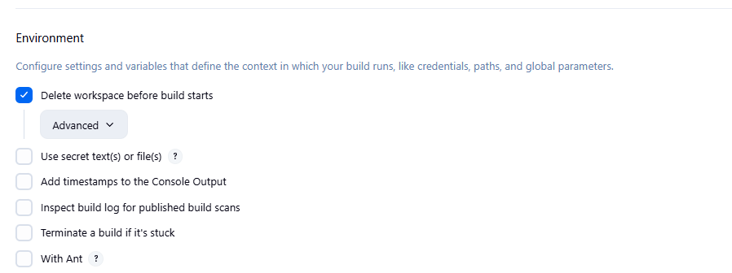

1. Need to take some action to copy the index.html from source to the httpd destination so it will always overwrite index.html upon running new job and will be having new index.html upon ending each job

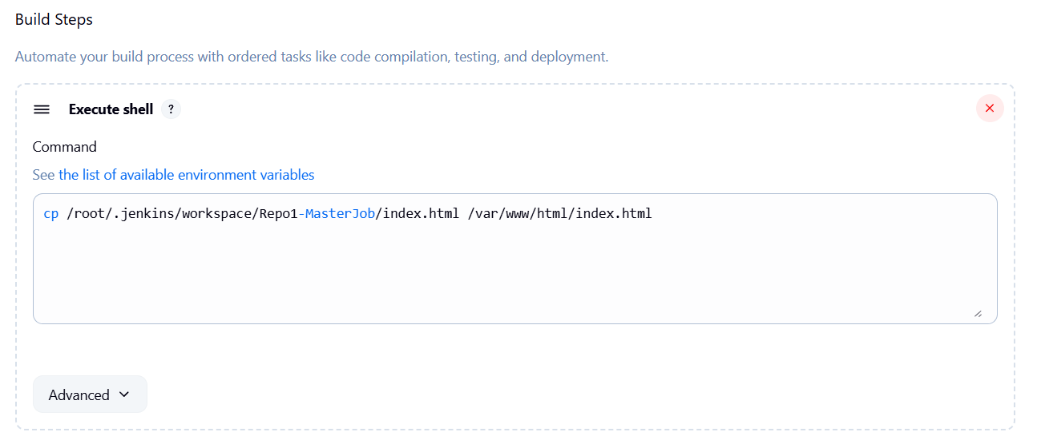

1. Apply and Save
2. Run the job, check console output

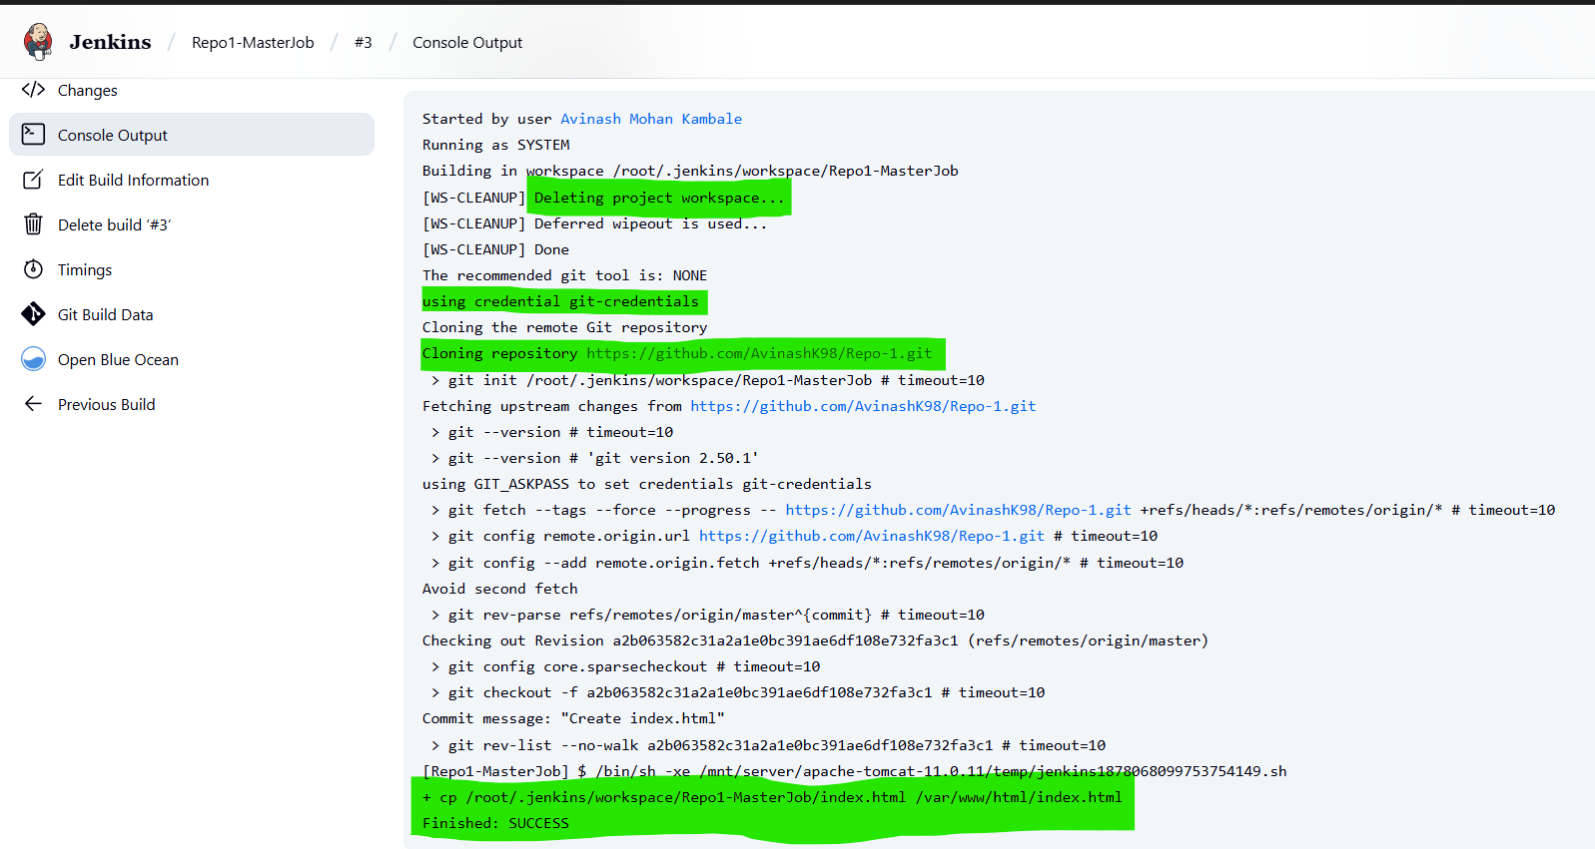

1. Hit the public url and check whether the index.html webpage properly displaying or not

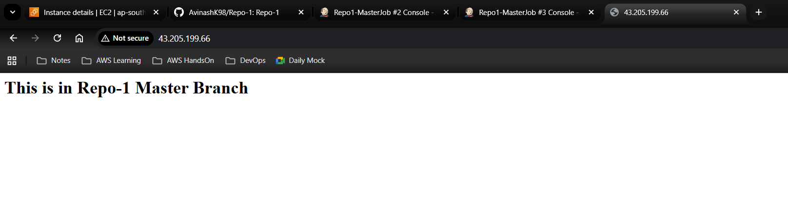

Upon completion of Job-1 the index.html page showing proper output

1. Setup the 2nd Jenkins job for Repo-2 qa branch

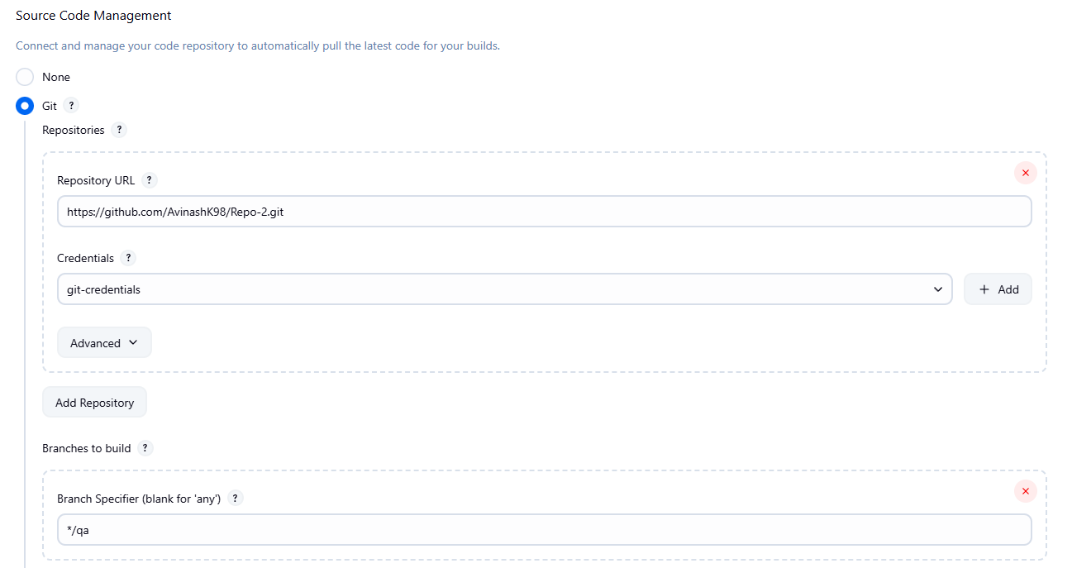

1. Do the necessary changes in shell script

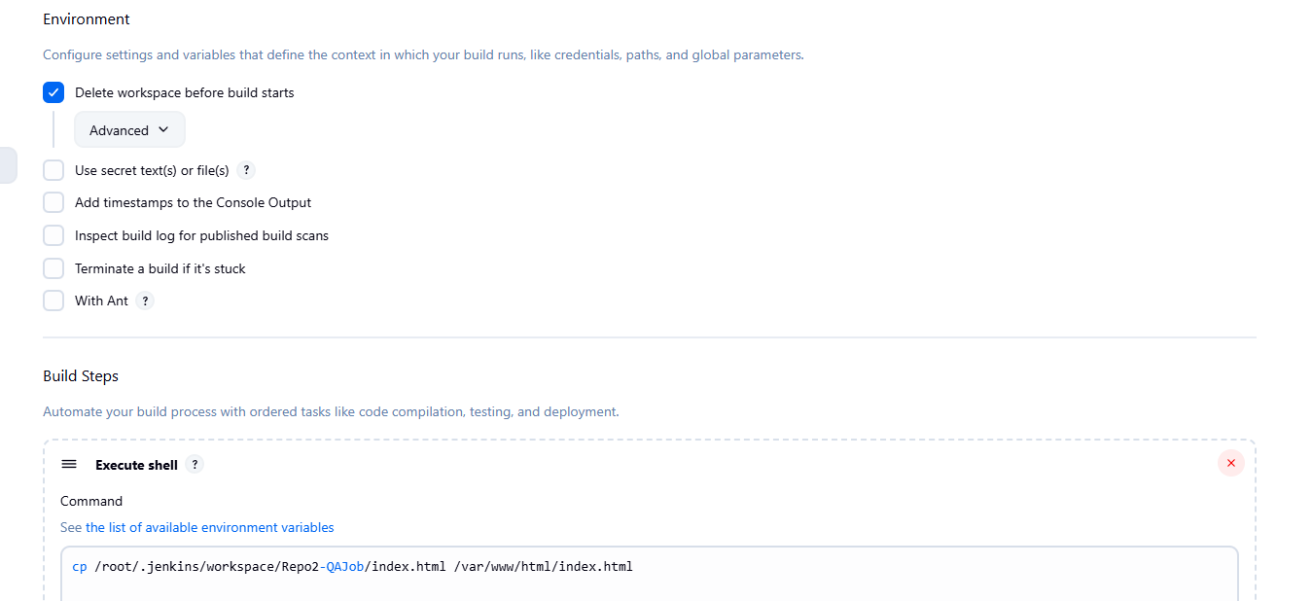

10. Apply and Save

11. Run the job, check console output

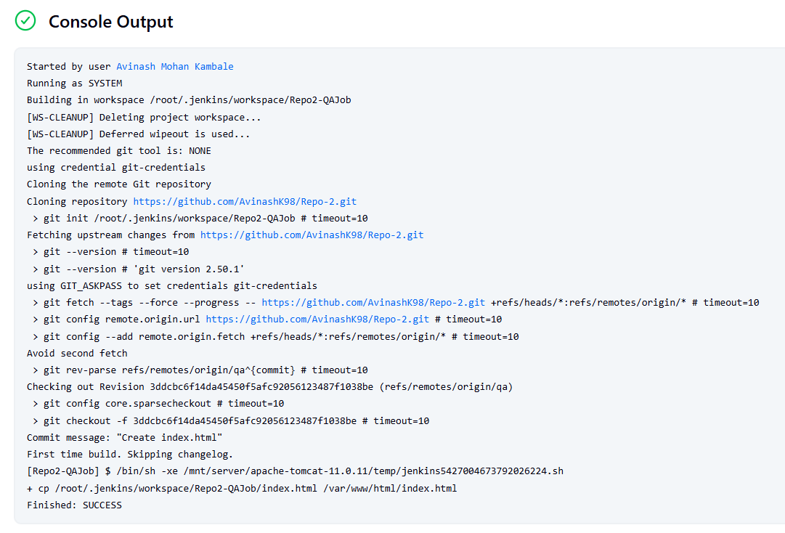

12. Just refresh the public url and check whether the changes reflected in the index.html or not

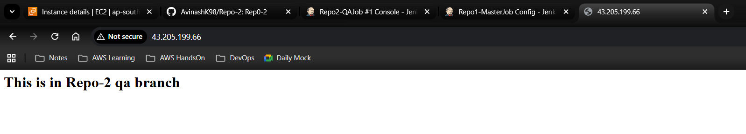

Upon completion of Job-2 the index.html page showing proper output

13. Setup the 3rd Jenkins job for Repo-3 uat branch

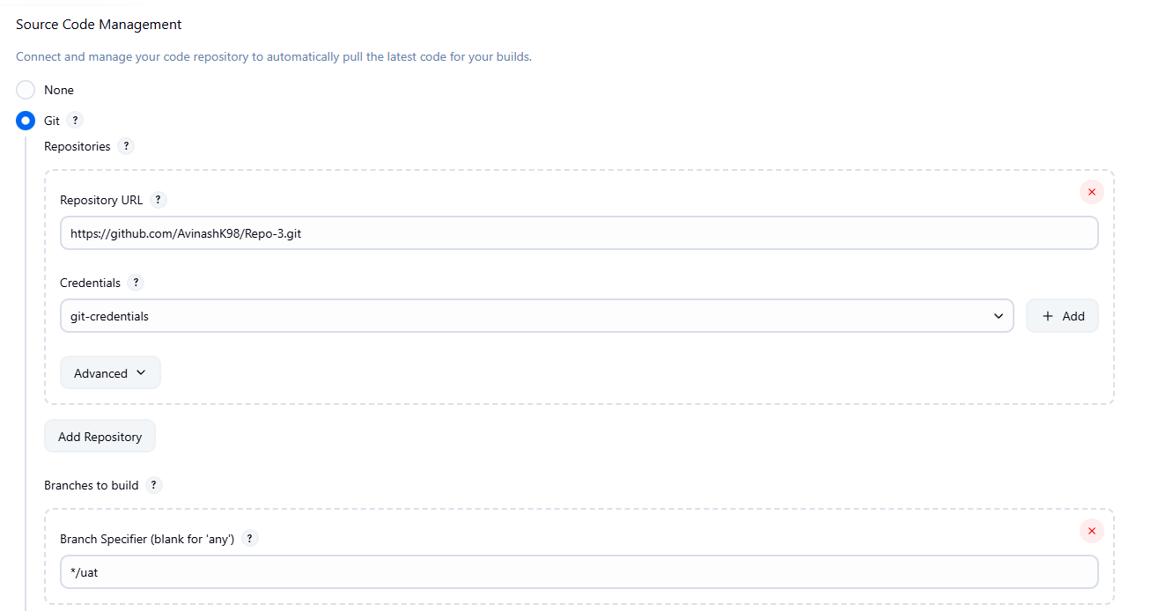

14. Do the necessary changes in shell script

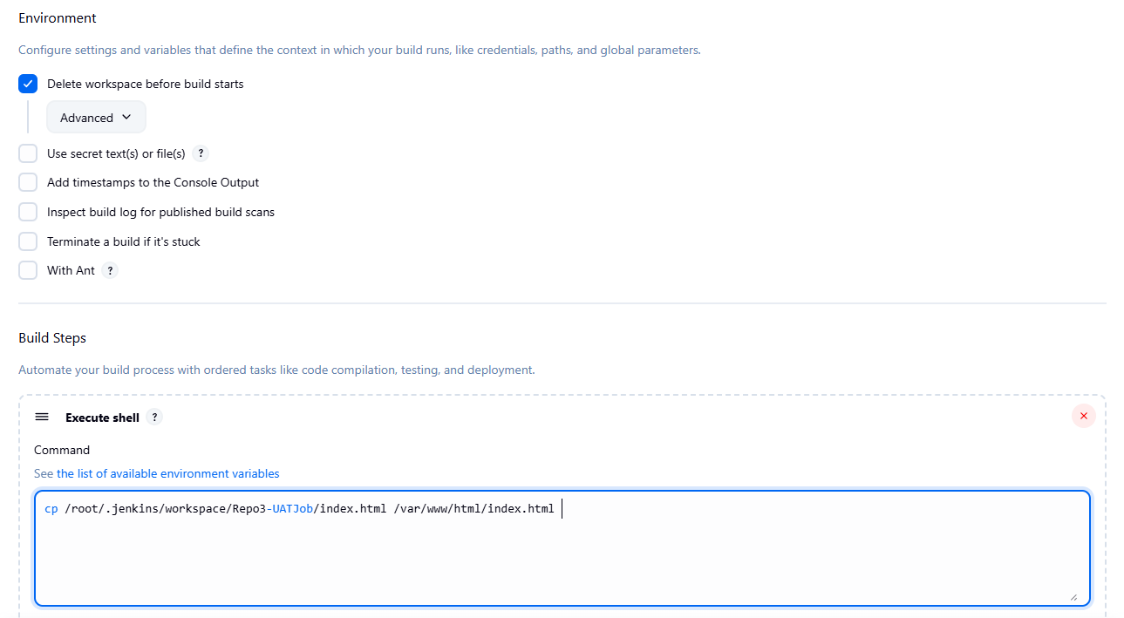

15. Apply and Save

16. Run the job, check console output

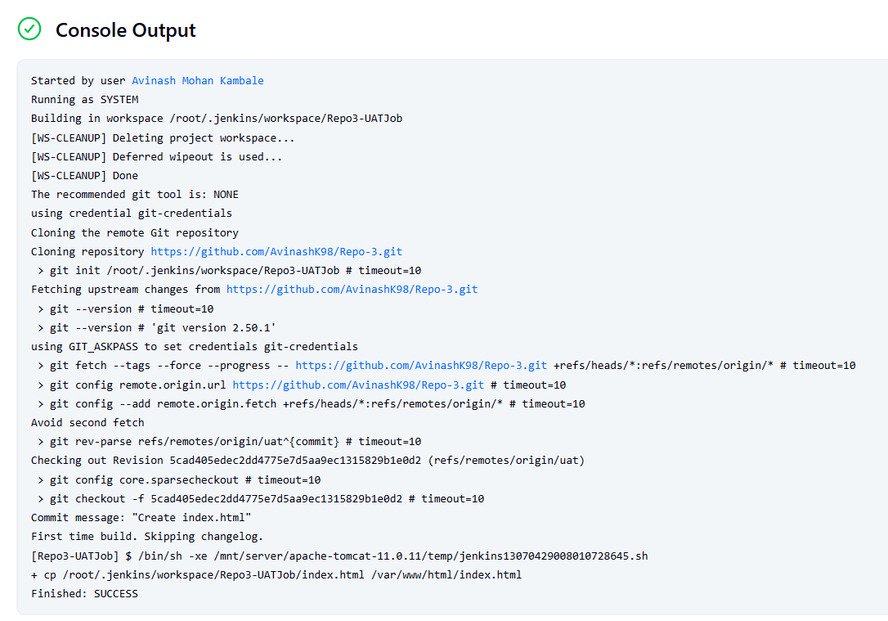

17. Just refresh the public url and check whether the changes reflected in the index.html or not

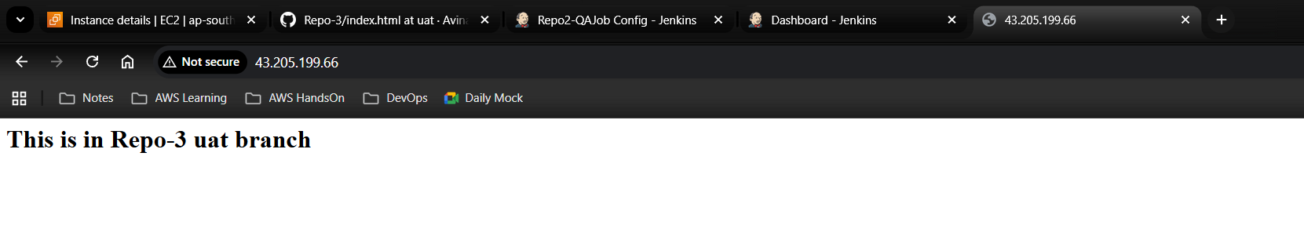

Upon completion of Job-3 the index.html page showing proper output

***Jenkins Jobs***

