Jenkins Assignment-3

We have 2 EC2 Instances

EC2 i) Jenkins-Master

EC2 ii) Tomcat-Server

We have to build our application on Jenkins-Master and deploy it on Tomcat-Server (Without using slave)

1. Launch an EC2 Instance (Jenkins-Master)
2. Install java 17
3. Install git
4. Install Maven 3.9.11
5. Configure the environment variable and path variable in /root/.bash_profile(Se we can run the maven commands from everywhere)
6. Logout and Login
7. Install Apache Tomcat 10, provide permissions, start the server
8. Deploy latest Jenkins on apache tomcat
9. Launch another EC2 instance Tomcat-Server
10. Install java 17
11. Install Apache Tomcat 10, provide permissions, start the server

The initial setup has been done

Step 1: Launch Jenkins

Step 2: Create a Job

Use custom workspace

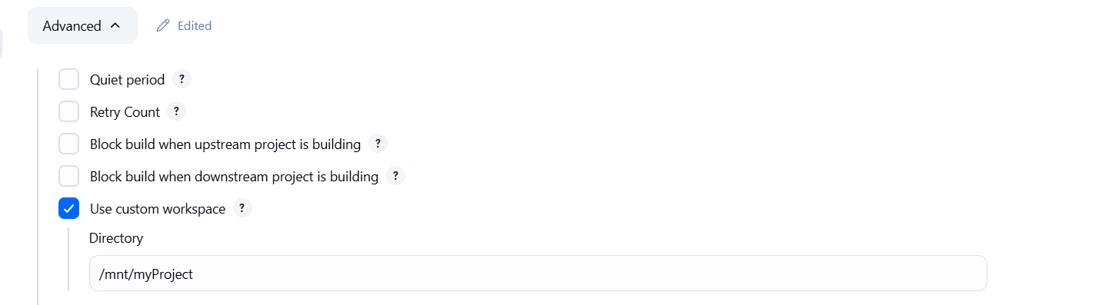

Provide the git hub repository url and credentials and specify the branch

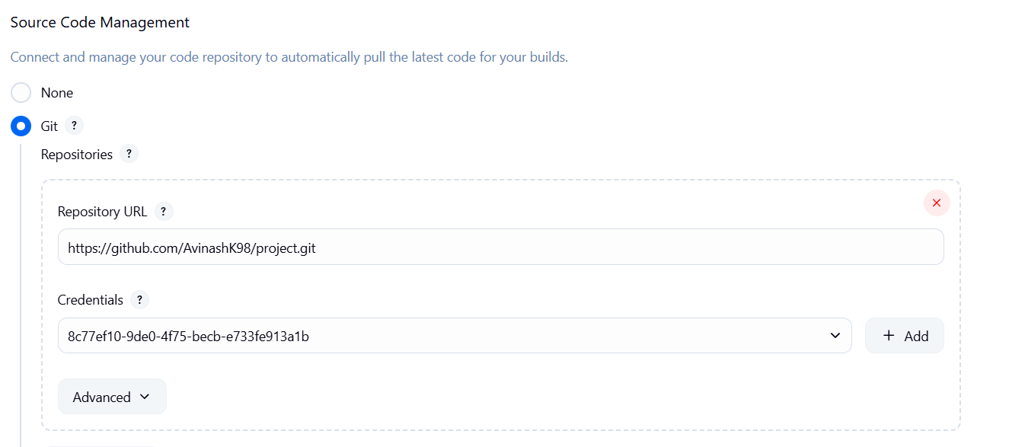

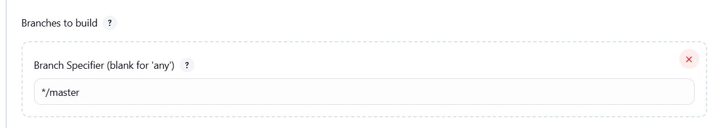

Step 3: Clearing the workspace before starting the build

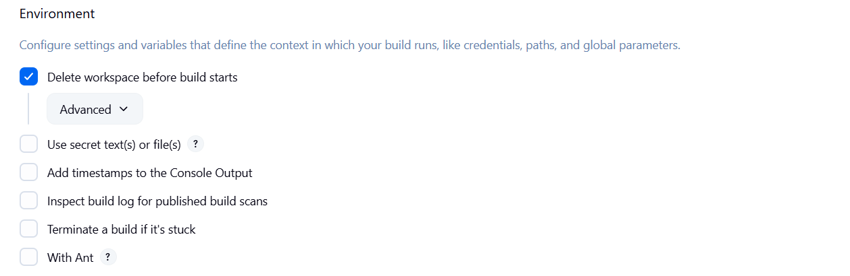

Step 4: Deleting the local maven repository

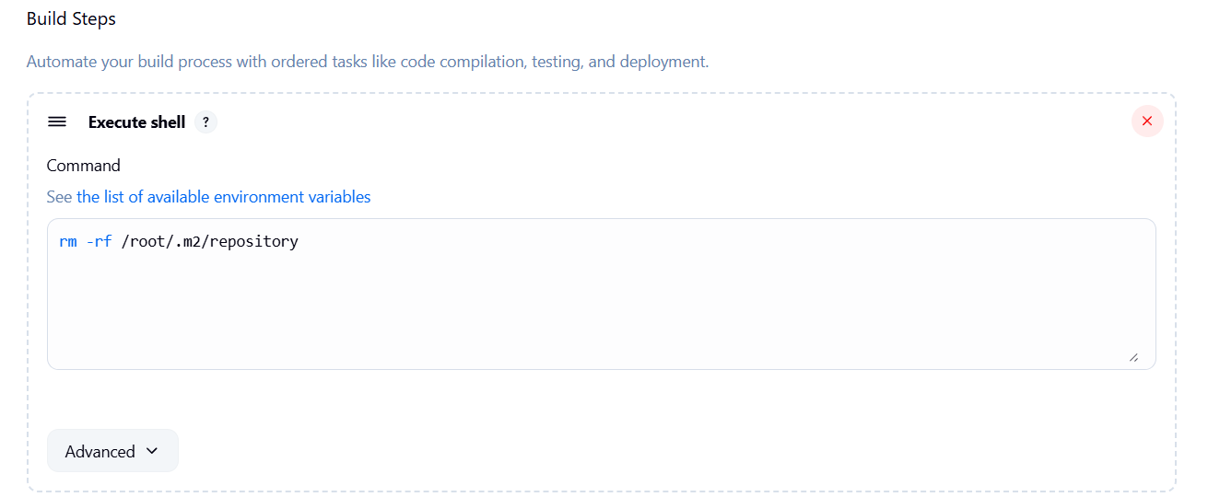

Step 5: Using maven to package the application

clean install to fresh build the application by cleaning the target directory

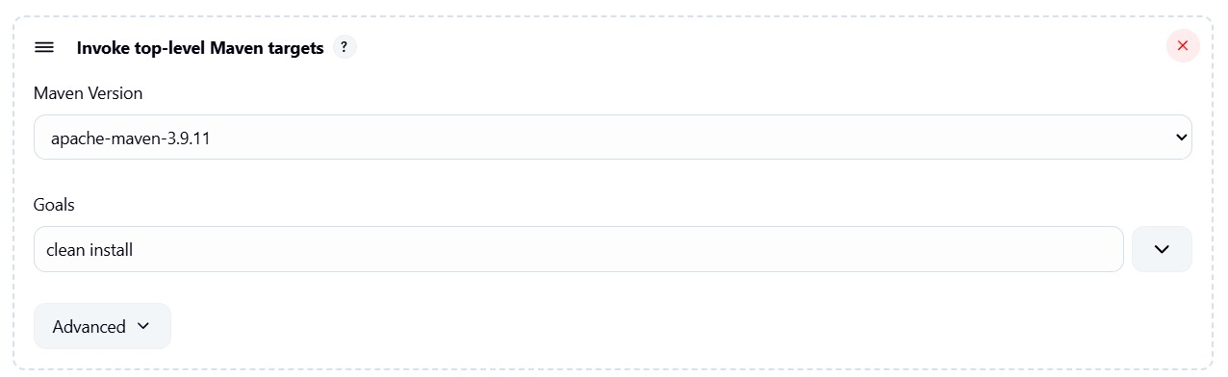

Step 6: Deploy the Application from Jenkins-Master to Tomcat-Server by using scp command

so that we need to create private key on Jenkins-Master and provide read permission by chmod 400

Create key folder in mnt and create a key

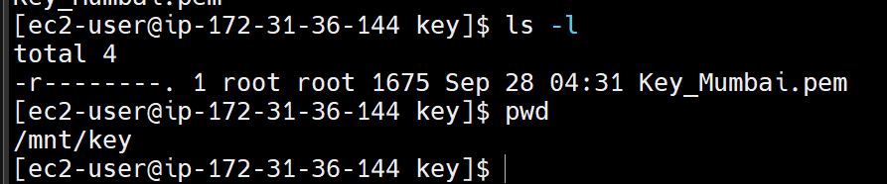

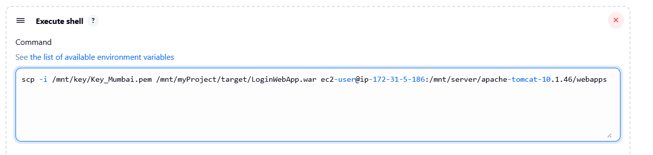

Step 7: Start the build in Jenkins

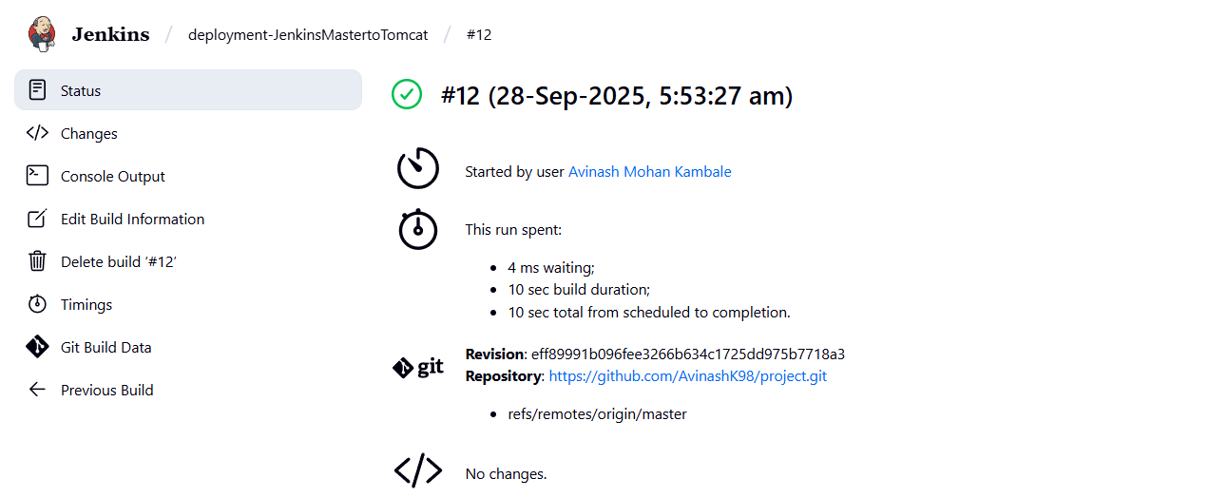

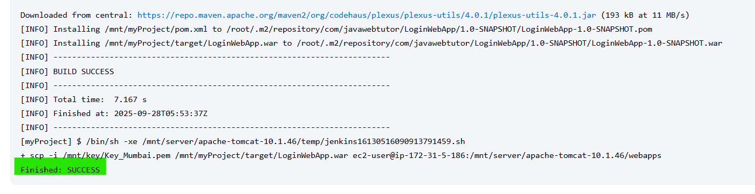

Step 8: Hit the Tomcat-Server machine’s public ip address to check whether the application has been deployed or not

