Jenkins Assignment-6

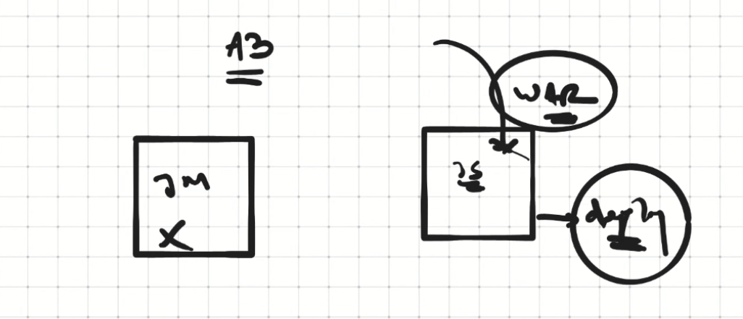

Need to create a war file on Slave Machine and deploy using apache tomcat

1. Create a connection between Jenkins-Master and Slave

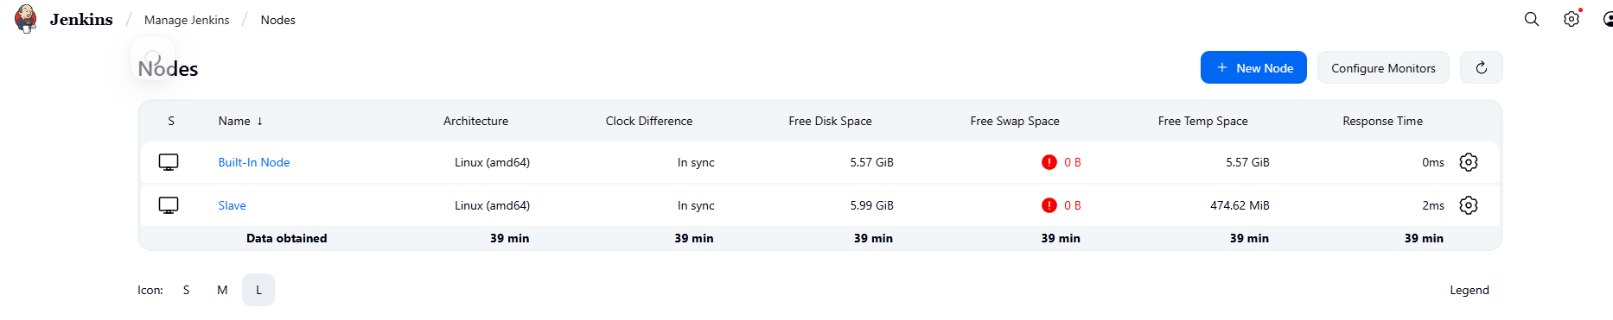

Install maven on slave machine and create environment and path variable in /root/.bash_profile

1. Create a Jenkins job

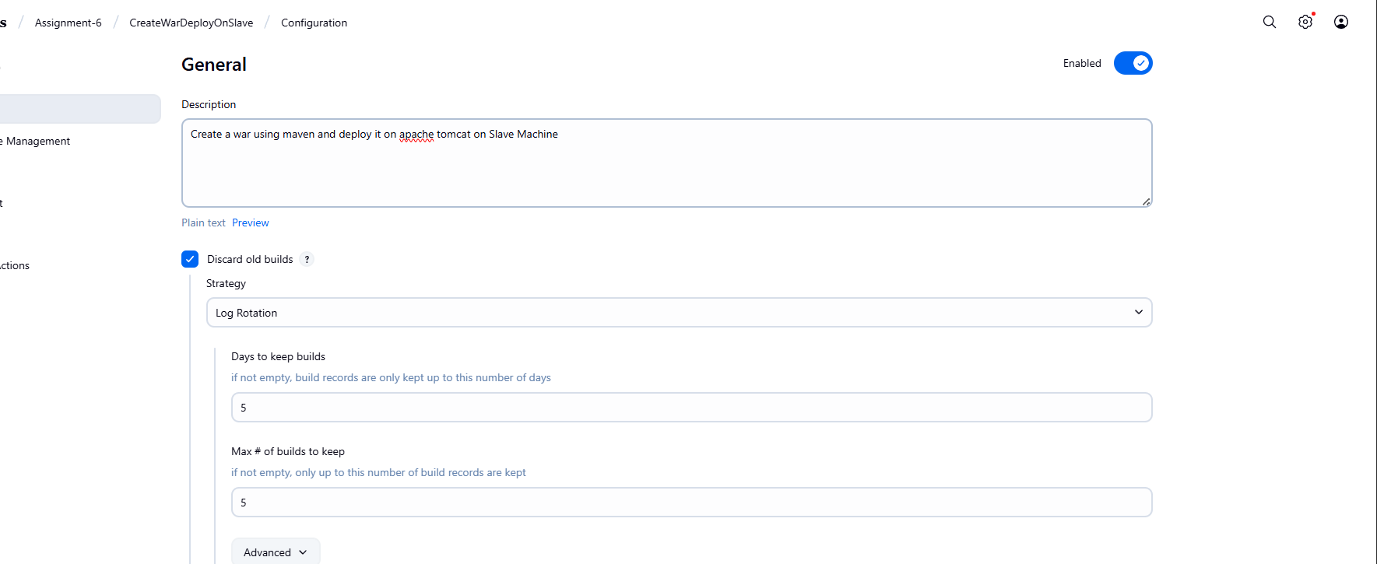

Run this project on slave machine and use custom workspace

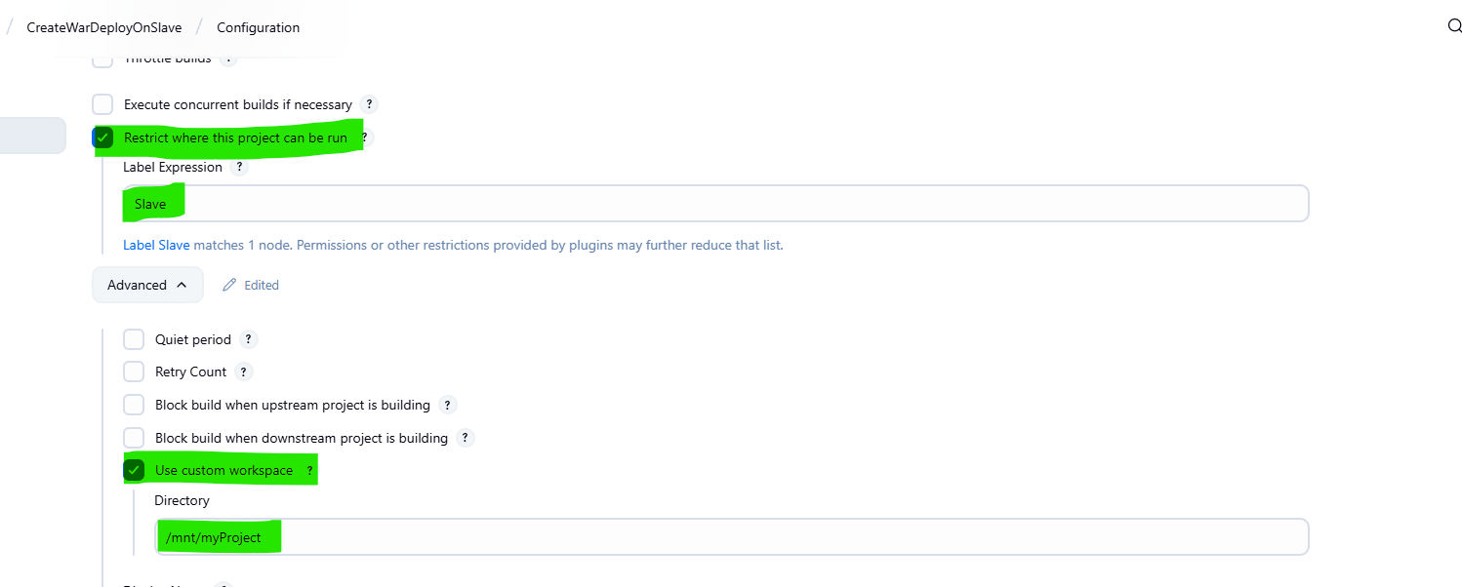

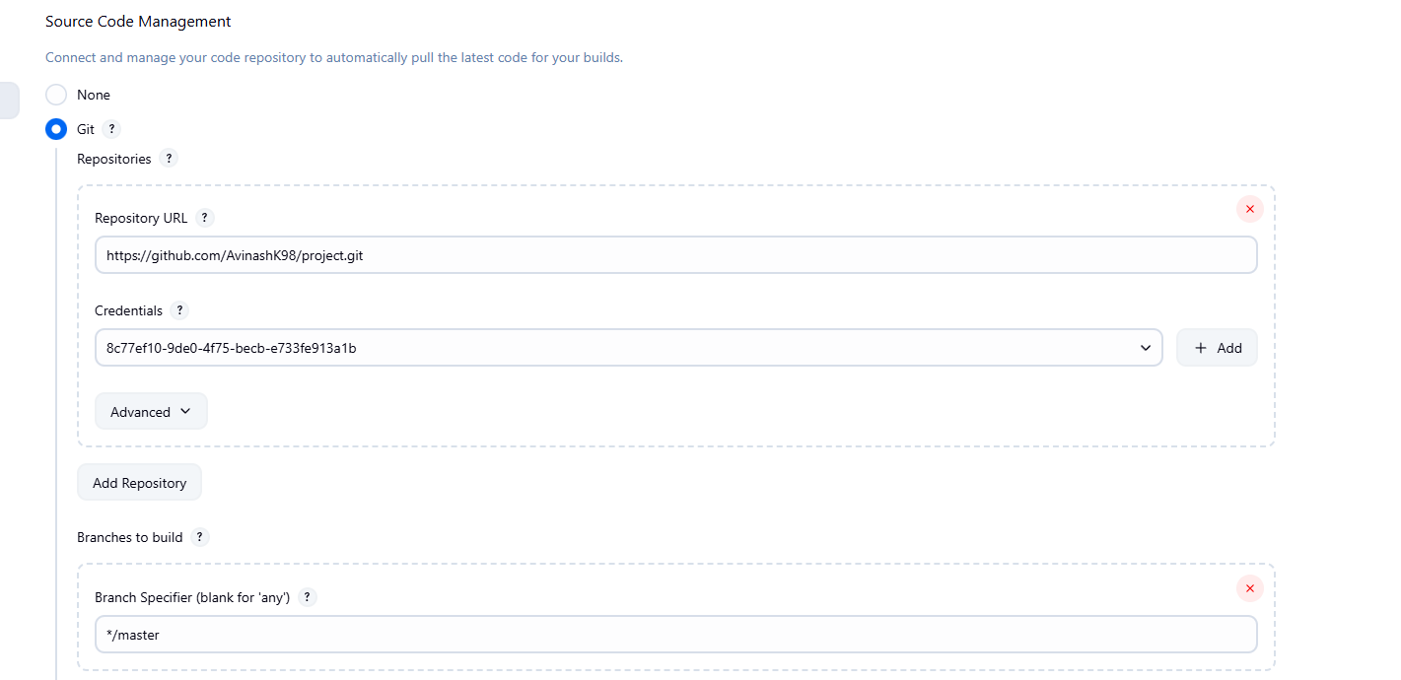

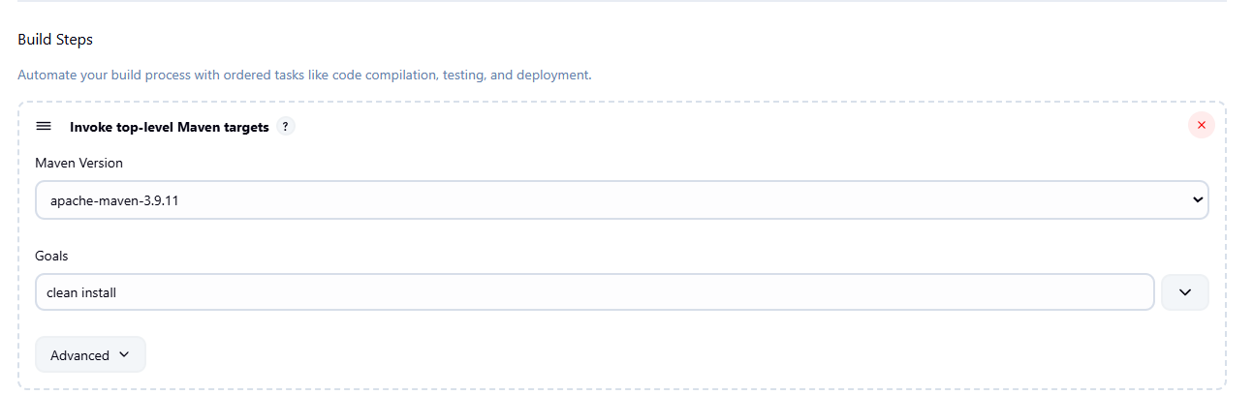

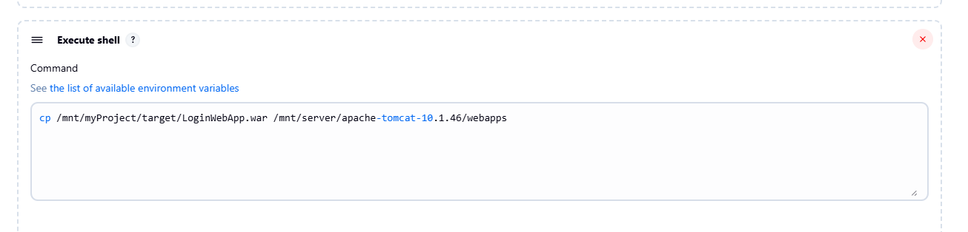

1. Run the job

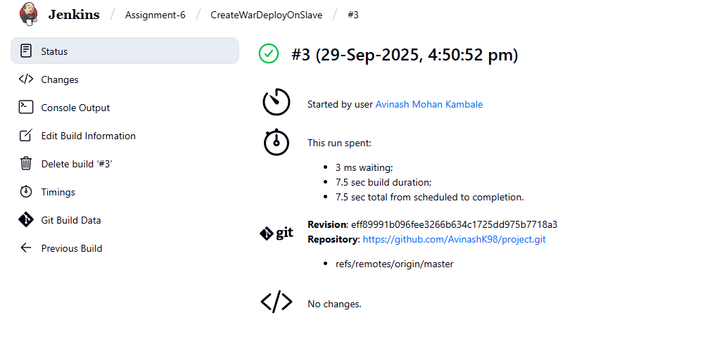

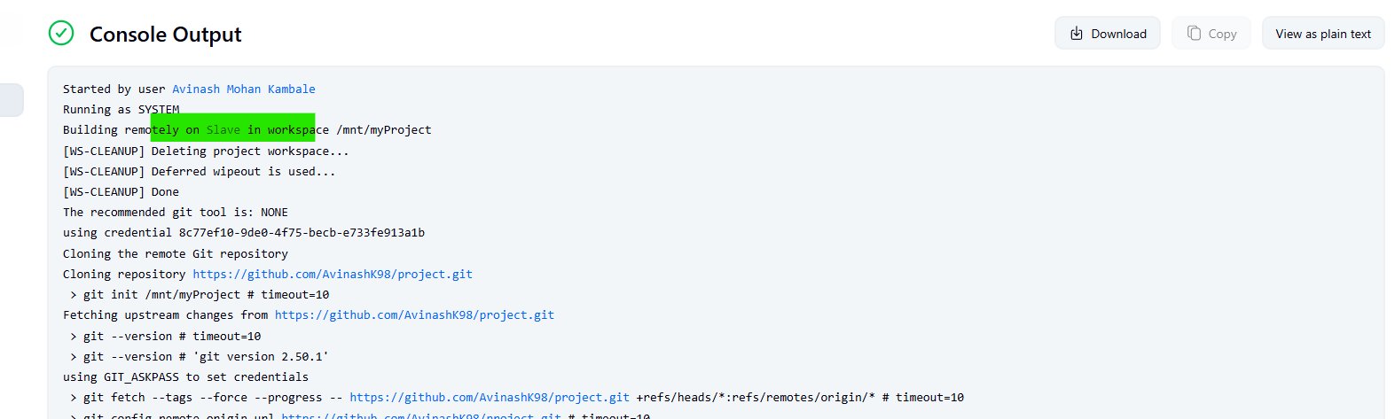

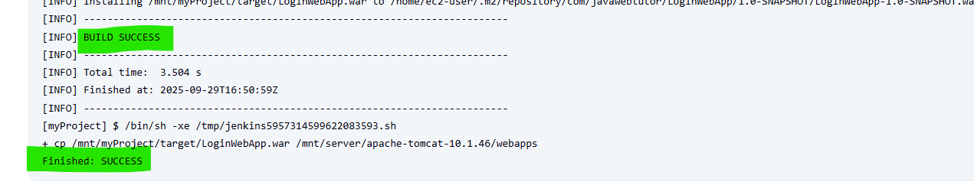

1. Hit the public ip and check whether the application has been deployed or not

