Subject Code: 19CSE461

Subject Name: NET-CENTRIC PROGRAMMING

Semester: VII

Roll No: CB.EN. U4CSE19331

Name: Kesineni Venkata Avinash

Official Email id: cb.en.u4cse19331@cb.students.amrita.edu

Semester: VII

GitHub URL: <https://github.com/AvinashKesineni/tripmanagement>

Online URL: <https://funny-sprinkles-21e191.netlify.app/>

Online URL For Forms : <https://funny-sprinkles-21e191.netlify.app/basic.html>

Googledrive URL: <https://drive.google.com/drive/folders/1FzFZKV8d98Q-IqMDF_sTDKl7Zhv0EBqs?usp=sharing>

**Lab 1:**

**Aim :**

To use HTML 5 and CSS 3 for the application and present the design aspects of the form.

To present data in terms of XML,XML DTD(Internal and External) ,XMl Schema

**Title of the Application:**

TRIP MANAGEMENT SYSTEM

**About the Application:**

Trip Management software helps users or travel agents to manage service providers, bookings, tracking and analyzing the inventory, It offers travel policies, travel inventory and reporting for managing corporate travel. It mainly focus on providing user a better information and giving best website to plan their tours and trips.

**Benefits:**

* Reduce Time to Manage Trips with reviews
* Tracking of users’ trips, bills
* Travel Spend Reporting
* Saving in-progress bookings and collaborating
* Easy booking, including self-booking for travelers

**Table 1:**

|  |  |  |  |  |
| --- | --- | --- | --- | --- |
| Application Name | Information related to the application  Technologies used:  For ex: Front End,Back end,stack technologies,Scripting Languages | Number of Web pages in the application | Unique features in the application | List of features that are unique for the users and its purpose |
| TripAdvisor | Java Script, Node.js, MongoDB, AWS, Azure, Docker, Serverless, Kubernetes-native, | 18 | provides access to the site's Hotel PriceComparison enabling travelers to easily compare booking options at a glance with up-to-the-minute hotel prices and availability. | Enables location-based searches to help travellers discover things to do near other points on a map |
| Travelocity | Microsoft Azure, Docker, Node JS, MySQL, React JS, Node JS | 15 | a group shopping tool, a message board, | wireless travel services as well as a redesigned home page for better interaction |

**Features of the application being developed**

|  |  |  |
| --- | --- | --- |
| Feature Name | Feature related to which application chosen | Feature related to User |
| Add Places | Admin Approval | Owner can add an accommodation / User can add a place such that it will be stored in database |
| Building Responsive webpage | Good Ui design for displaying hotels, restaurants, etc | Best UI for information and booking |
| Centralized Database | Database | To keep Consistency and centralized database of locations,places,etc. |

**Unique Features of the application being developed**

[Provide features that are new to the application that do not exist in earlier application]

|  |  |  |
| --- | --- | --- |
| Feature Name | Feature related to which application chosen | Feature related to User |
| Add Places | Admin Approval | Owner can add an accommodation / User can add a place such that it will be stored in database |
| Search Optimization | Searching based on location apis | User can easily search places with autocomplete feature |
| Travel Reporting | Manage Trips | User can track their Overall activites . |
| Different Payment Methods | Payment Methods | User can Avail Different Payment methods |

**Module Details and form Details**

|  |  |  |  |
| --- | --- | --- | --- |
| Module Name | Description  [As a paragraph] | Form Names-purpose of the form(Category-Master/Transaction form) | Specify the form name and CSS file name with the drive URL path |
| Registration | User can register through website by giving details | Login | login.html  login.css |
| Login | User can login by providing credentials | signup | signup.html |
| Update Profile | User can update their profile | updateprofile | updateprofile.html |
| Change Password | User can change password if they have forgotten | chngpwd | chngpwd.html  chngpwd.css |
| Booking | It is for Booking Purpose | booking | booking.html  booking.css |
| Payment | For paying money | payment | payment.html  payment.css |
| Feedback | Feedback form for improving user experience | feedback | feedback.html  feedback.css |
| Support | Users can avail help from filling this form | contactus | contactus.html  contactus.css |
| Add Places | Owner can add place for displaying on this website | addhotels | addhotels.html  addhotels.css |

**Table Details(Table 2)**

**User Table**

|  |  |  |
| --- | --- | --- |
| **Column Name** | **Data Type** | **Constraint** |
| Full Name | Varchar(50) |  |
| Email | Varchar(50) | Primary Key |
| DOB | date |  |
| phone | int |  |
| Password | Varchar(20) |  |

**Feedback Table**

|  |  |  |
| --- | --- | --- |
| **Column Name** | **Data Type** | **Constraint** |
| Review(Feedback) | Varchar(150) |  |
| Rating | int |  |
| Email | Varchar(50) | Foreign Key |

**Booking Table**

|  |  |  |
| --- | --- | --- |
| **Column Name** | **Data Type** | **Constraint** |
| Booking Id | Varchar(50) | Primary Key |
| Name | Varchar(50) |  |
| place | Varchar(50) |  |
| Check in | date |  |
| Check out | date |  |
| phone | int |  |
| No of people | int |  |
| Email | Varchar(50) | Foreign Key |

**Payment Table**

|  |  |  |
| --- | --- | --- |
| **Column Name** | **Data Type** | **Constraint** |
| Transaction Id | Varchar(50) | Primary Key |
| method | Vatchar(50) |  |
| Amount | Float |  |
| Booking Id | Varchar(50) | Foreign Key |
| Email | Varchar(50) | Foreign Key |

**Support Table**

|  |  |  |
| --- | --- | --- |
| **Column Name** | **Data Type** | **Constraint** |
| Name | Varchar(50) |  |
| Subject | Varchar(50) |  |
| Message | Varchar(250) |  |
| phoneno | int |  |
| Email | Varchar(50) | Foreign Key |

**Places**

|  |  |  |
| --- | --- | --- |
| **Column Name** | **Data Type** | **Constraint** |
| Place_Id | int | **Primary Key** |
| Place_Type(hotel/restaurant/etc) | Varchar(50) |  |
| Place_name(hotelname,etc) | Varchar(250) |  |
| Owner name | Varchar(50) |  |
| Features provided | Varchar(50) |  |
| Location_id | Varchar(100) | **Foreign Key** |

**Location**

|  |  |  |
| --- | --- | --- |
| **Column Name** | **Data Type** | **Constraint** |
| Location_Id | Varchar(100) | **Primary Key** |
| Location_Type(Street/City/etc) | Varchar(50) |  |
| Location_name | Varchar(250) |  |
| Zipcode | int |  |

Form Wise Details(Minimum 5 master forms and 3 forms per Master form) –refer Table 2

|  |  |  |  |  |  |
| --- | --- | --- | --- | --- | --- |
| Form Name | Description | Table Names related to the form | Features used in form related to HTML-5 (responsive design) | Features used in form related to CSS-3 (responsive design) | Form –Operations  (Add/Delete/Modify/View) |
| Registratio n | User can register through website by giving details | User Table | svg icons, input, etc. | flex, table ,hover effects | Add    View |
| Login | User can login by providing credentials | User Table |  | table ,hover effects, border effects | View |
| Update Profile | User can update their profile | User Table |  | table ,hover effects, border effects | Add  View  Modify |
| Change Password | User can change password if they have forgotten | User Table |  |  | Modify |
| Booking | Puspose of Booking | Booking Table |  |  | Add  View |
| Payment | Payment Purpose | Payment Table |  |  | Add  View  Modify |
| Feedback | Feedback form for improving user experience | Feedback  Table |  |  | Add  View |
| Support | Users can avail help from filling this form | Support table |  |  | Add  Modify |
| Add Places | Owner can add place for displaying on this website | Places, Locations |  |  | Add  View  Modify |

Report Details(Minimum 10 reports per application)

|  |  |  |  |
| --- | --- | --- | --- |
| Report Name | Purpose | Inputs to be provided | Expected Output |
| Username and Password | Issuing user id and password by management. | Username, Password | Creating a Unique username and strong password. |
| Booking | After selecting the particular hotel confirming it. | Confirm | Confirming the booking |
| Payment | After scheduling the meeting user should pay accordingly | Full name, email, address, credit card number, cvv number, date of expire | Amount successfully paid |
| Feedback | After Whole Trip, user can give the feedback. | Name, email, feedback | User can send the feedback of his experience. |
| Add a Place | For Adding a place which will increase the exploring | Place name,Address of place, postal code, Owner name, features provided, website url, | A New Place Added Successfully |

**Web Development Breakdown Diagram**

[Present the form names in a hierarchical manner]

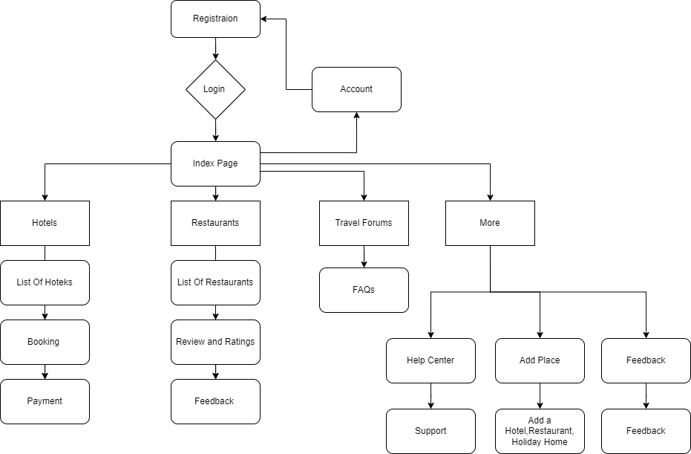

Explain the work flow of the diagram as it becomes functional as a application

Step 1: The users logs in with a user name and password

Step 2: The user can index page with navigation panel of buttons Hotels,Restaurants, Travel Forums, More, Account

Step 3: On clicking Hotels / Book now button option a list of hotels appear based on given location.

Step 4: By selecting a hotel and click on book button , A Booking form will appear

Step 5: On clicking Book now button on Booking form

Step 6: User then redirect to the payment page where he can pay amount user two modes of transformation either wallet or credit card.

Step 7: After payment the payment report will be sent to the user email.

Step 8: On Restaurants page a list of restaurants with reviews will be there for planning,

Step 9: In Travel Forums Frequently asked Questions were placed.

Step 10: Under More section HelpCenter, Add Places, Feedback are there

Step 11: On clicking Help Center, Support form will open

Step 12: On clicking Add places, user can add a place by giving details about places

Step 13: On clicking Feedback, feedback form will be opened

Step 14: Last icon on navigation panel move to profile page where user can update profile.

**Screenshots of the forms:**

**Login Form:**

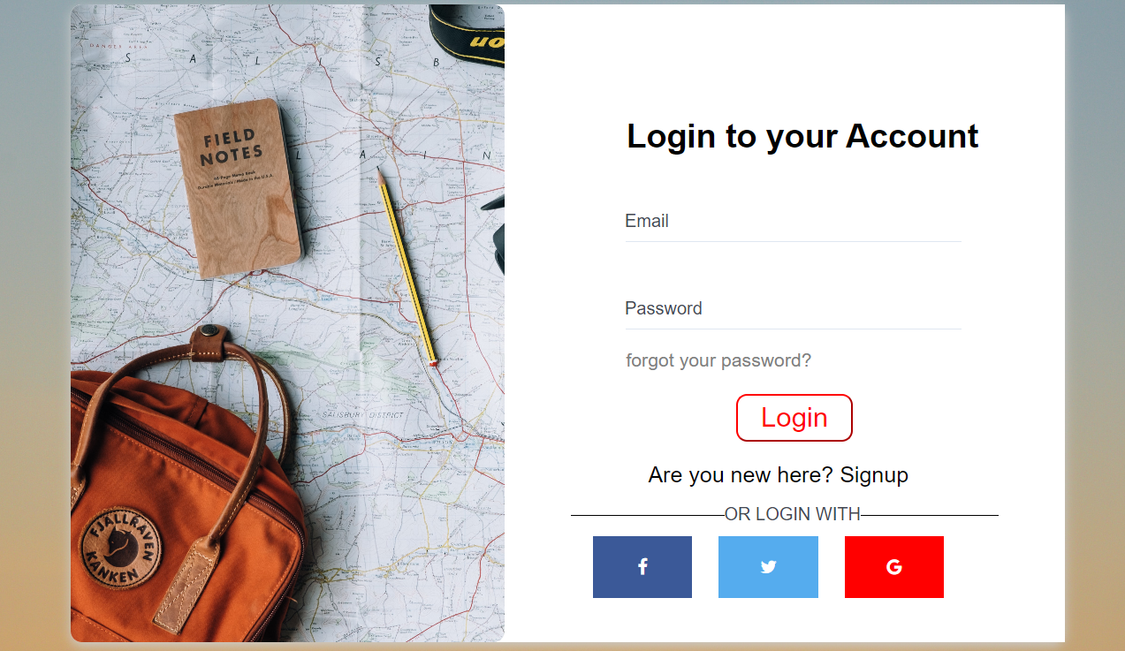

**Signup Form:**

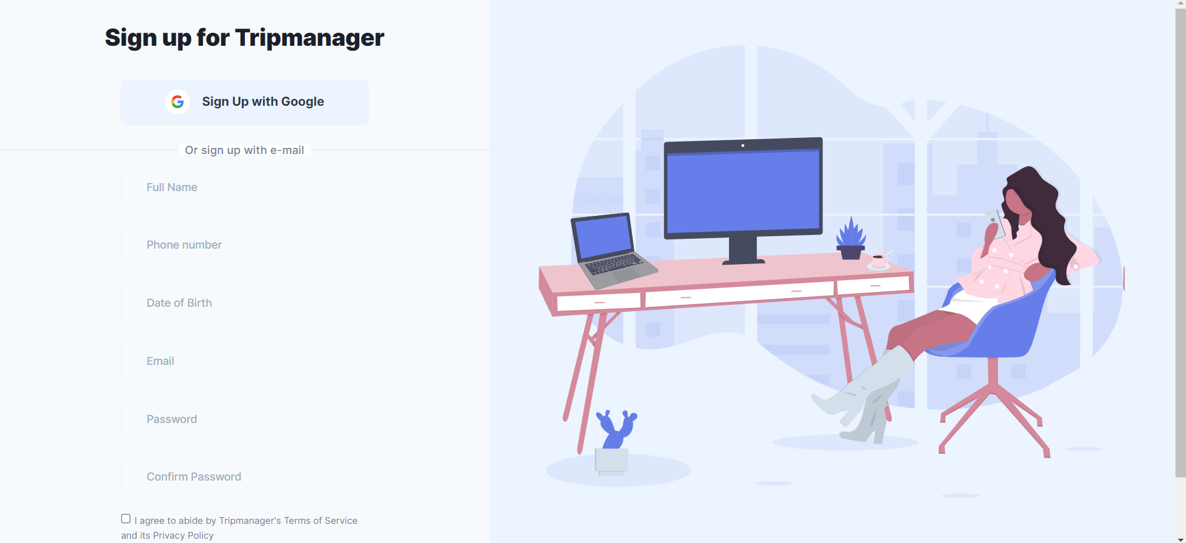

**Booking Form:**

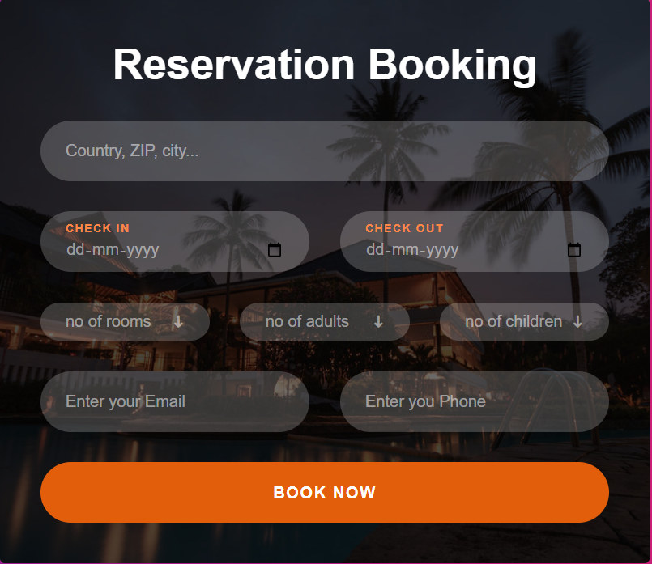

**Payment Form:**

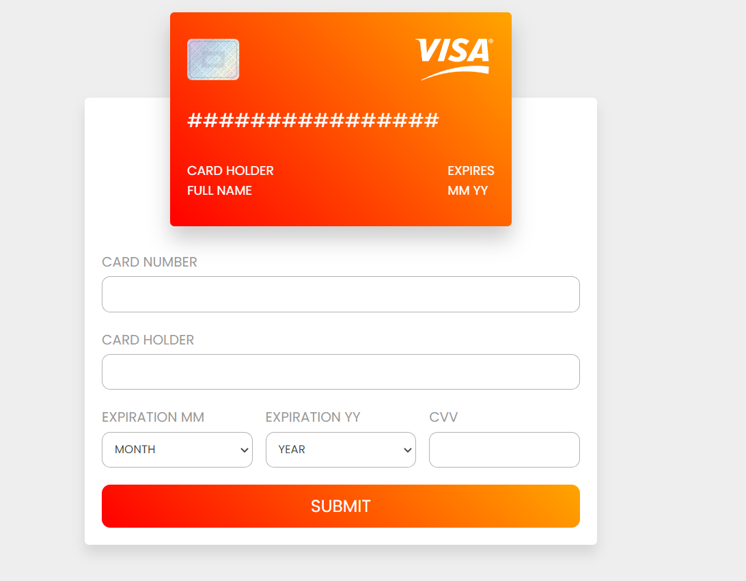

**Contact Us Form:**

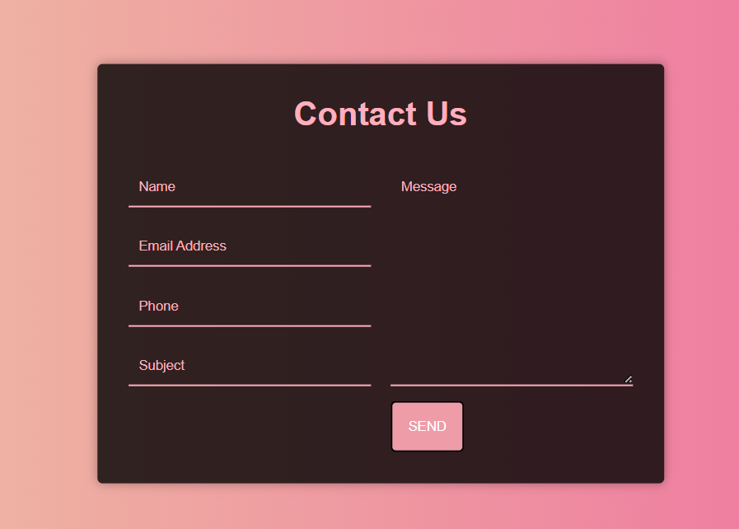

**Feedback Form:**

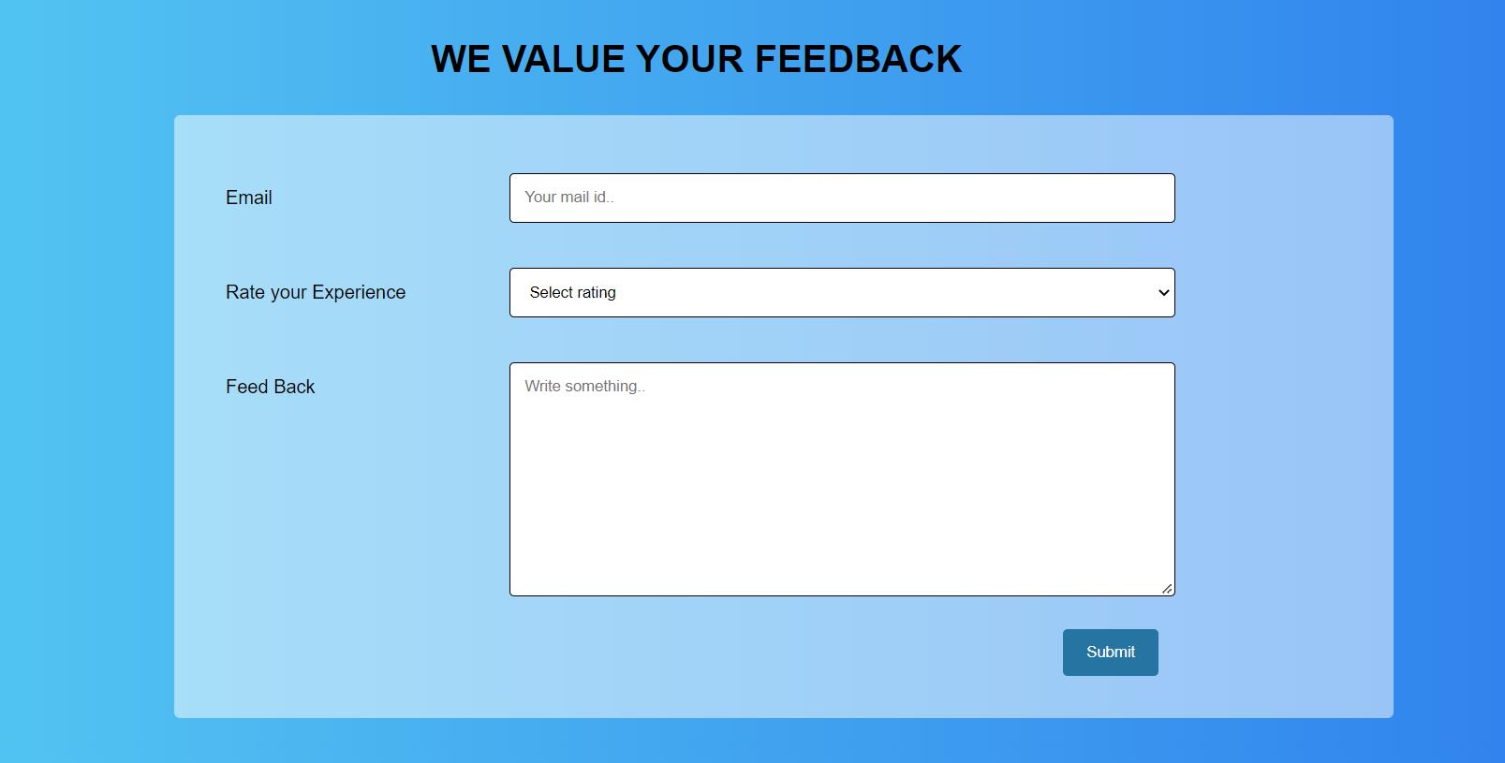

**Change Password Form:**

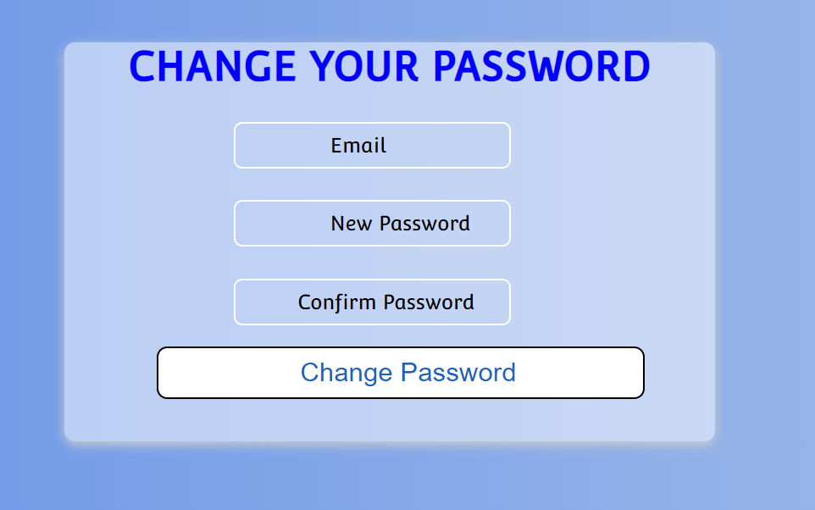

**Add Places form:**

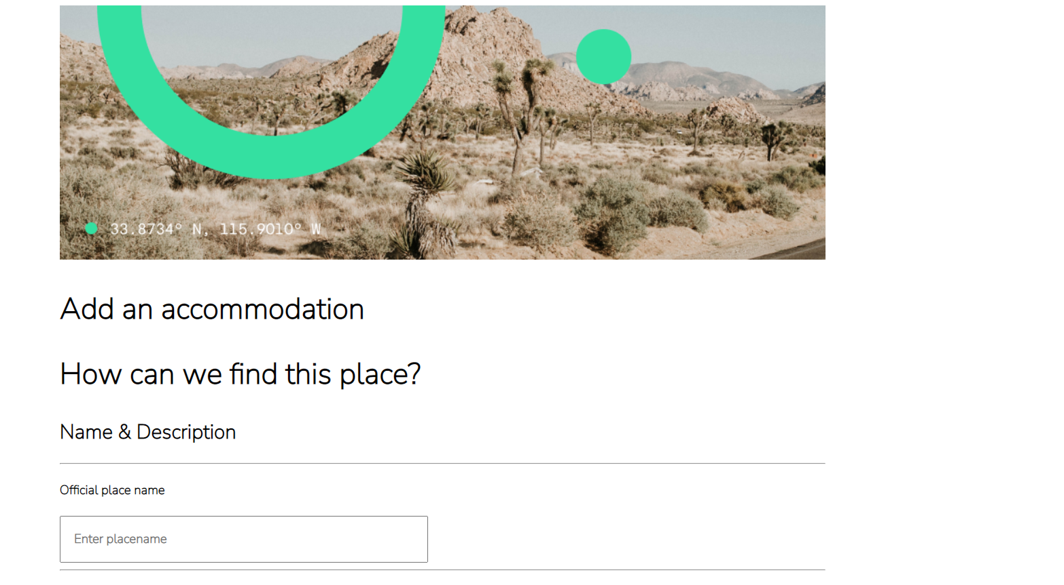 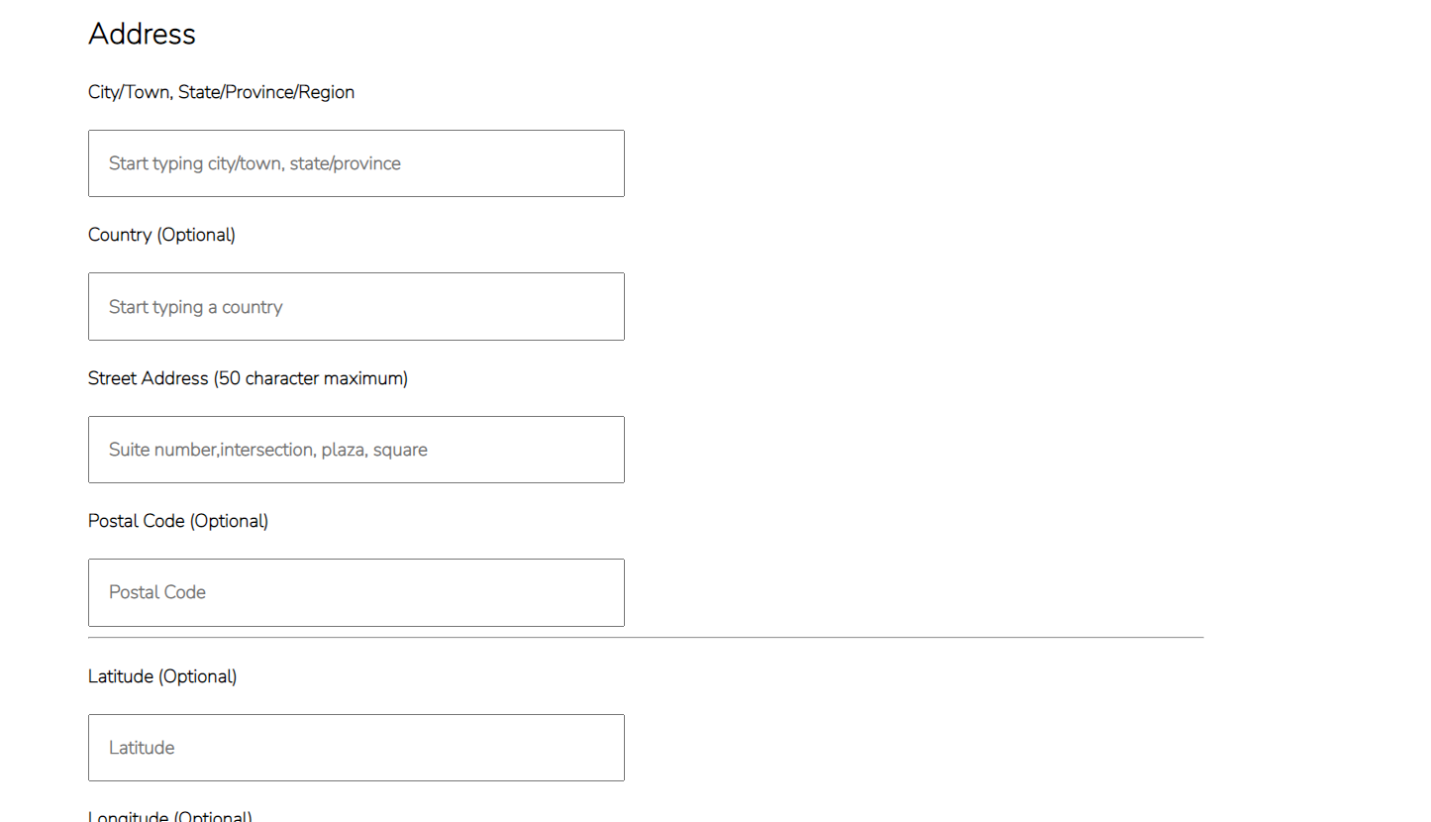 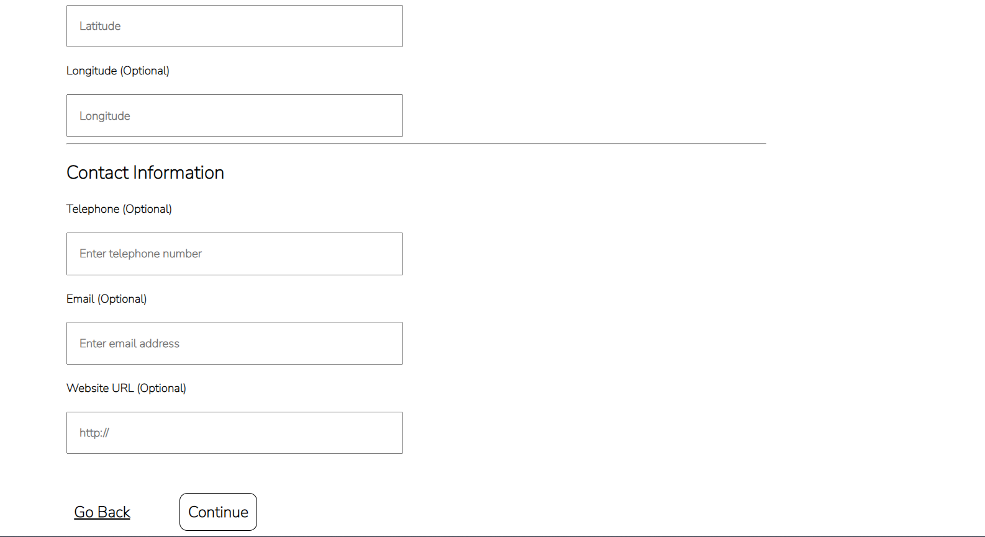 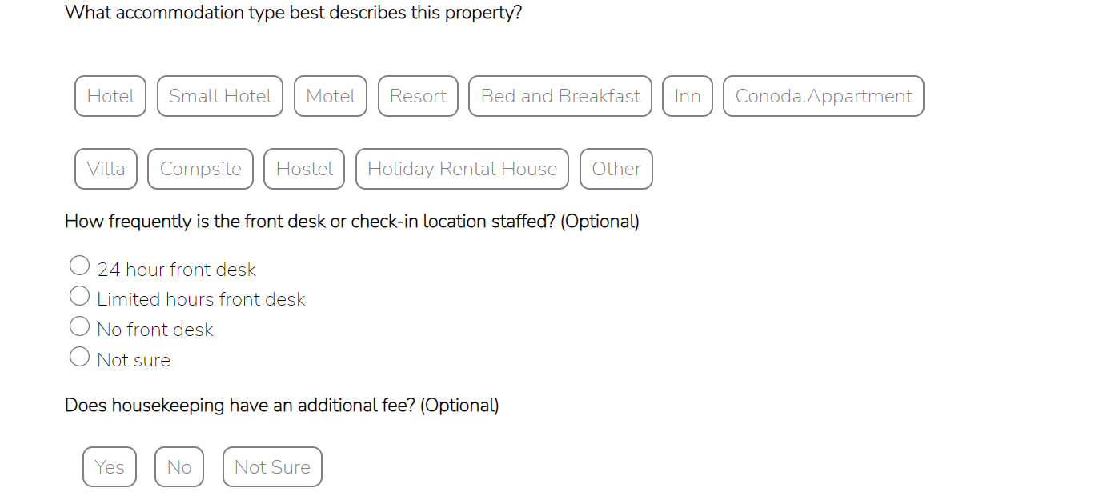 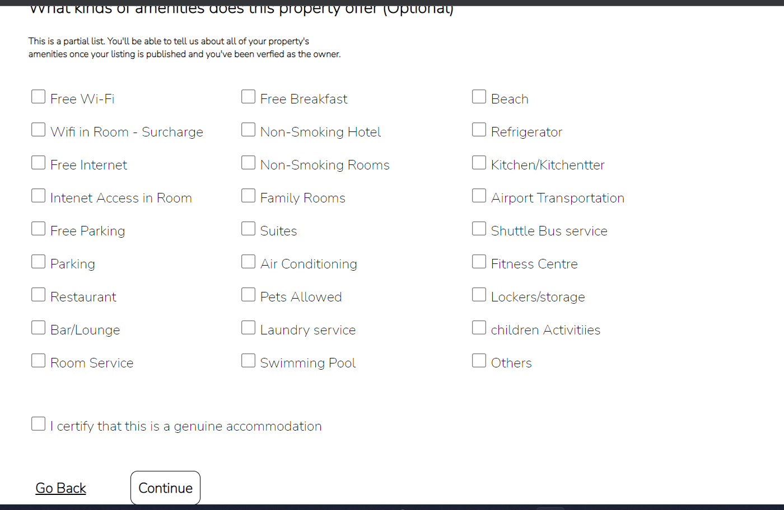

XML

Guidelines

<<Complete the following for two forms in the application. The forms should have at least

7 inputs>>

1.Refer the XML DTD concepts in slide 52,53 and provide all possible constraints listed in XML DTD(Internal,External)

2.Represent all possible constraints with all possible datatypes in XML Schema file.

|  |  |  |
| --- | --- | --- |
| Element Name | Data Type | Constraint |
| BookingID | PCDATA | Not null |
| FullName | PCDATA | a-z,A-Z |
| Place | PCDATA | a-z,A-Z |
| CheckIn | PCDATA | D/m/y |
| Checkout | PCDATA | D/m/y |
| Noof rooms | PCDATA | D/m/y |
| Noofadults | PCDATA | 0-5 |
| Noofchild | PCDATA | 0-9 |
| Phone no | PCDATA | [+91][0-9] |

Summary of Files

<<List all the HTML,CSS File,XML,XML DTD ,XML Schema files>>

|  |  |  |
| --- | --- | --- |
| FormName/CSS/XML/DTD/XSD Name | File Name | Additional Information |
| Login | login |  |
| Signup | signup |  |
| Bookinf | booking |  |
| Contact us / feedback | Feedback |  |
| payment | payment |  |
| update profile | profile |  |