**Lab-3**

**Roll No: CB.EN. U4CSE19331**

**Name: Kesineni Venkata Avinash**

**Official Email id: cb.en.u4cse19331@cb.students.amrita.edu**

**Semester: VII**

General Guidelines:

Evaluation

* Students have to submit the document as per the **template shared**
* There should be minimum 2 forms in the application
* The table should be filled in a descriptive manner related to how the application has been built

**URL of the application in internet:**

* GitHub URL: <https://github.com/AvinashKesineni/tripmanagement>
* Online URL: <https://funny-sprinkles-21e191.netlify.app/>
* Online URL For Forms : <https://funny-sprinkles-21e191.netlify.app/basic.html>

**Title of the Application:**

TRIP MANAGEMENT SYSTEM

**About the Application:**

Trip Management software helps users or travel agents to manage service providers, bookings, tracking and analyzing the inventory, It offers travel policies, travel inventory and reporting for managing corporate travel. It mainly focus on providing user a better information and giving best website to plan their tours and trips.

**Module Details and form Details**

|  |  |  |  |
| --- | --- | --- | --- |
| Module Name | Description  [As a paragraph] | Form Names-purpose of the form(Category-Master/Transaction form) | Specify the form name and CSS file name with the drive URL path |
| Registration | User can register through website by giving details | Login | login.html  login.css |
| Login | User can login by providing credentials | signup | signup.html |
| Update Profile | User can update their profile | updateprofile | updateprofile.html |
| Change Password | User can change password if they have forgotten | chngpwd | chngpwd.html  chngpwd.css |
| **Booking** | It is for Booking Purpose | booking | booking.html  booking.css |
| Payment | For paying money | payment | payment.html  payment.css |
| Feedback | Feedback form for improving user experience | feedback | feedback.html  feedback.css |
| Support | Users can avail help from filling this form | contactus | contactus.html  contactus.css |
| **Add Places** | Owner can add place for displaying on this website | addhotels | addhotels.html  addhotels.css |

**work Break Down Diagram:**

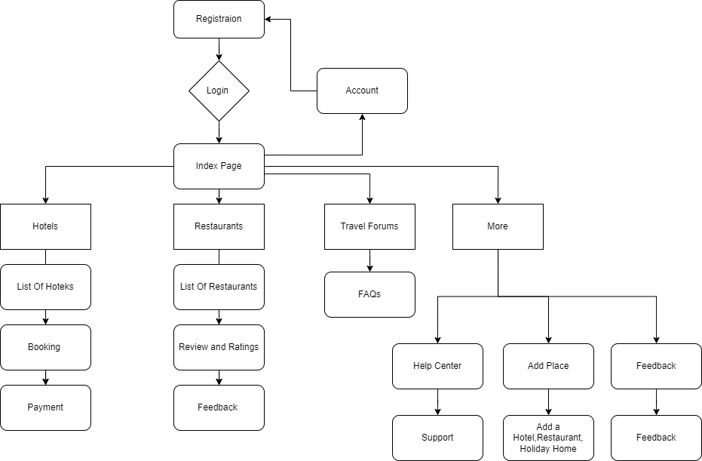

**how the application has used Mean Stack Development:**

Trip Management Application used mean stack for development and it is used for responsive web design in application. Angular JS is used for form validation ,real time validation of forms and responsiveness of the forms, Node Js is a backend run time environment used to develop and execute code for server, express js and mongodb. With express js we host webpage in localhost and used ejs render for data viewing and lot of other packages used for technology aspect. Mongodb is used as a NOSQL Database and CRUD operations are performed using mongoose package. Overall Mean stack development is perfect for building user responsive webpage.

**List of technologies/languages/framework/library used with purpose and version**

|  |  |
| --- | --- |
| **technologies/languages/framework/library** | **Purpose** |
| HTML5 | For frontend |
| CSS3 | Design For Frontend |
| JS | Full stack development (Frontend + backend) |
| Angular JS | To develop the client-side application |
| Node JS | Web framework for the server application |
| Express JS | A runtime environment for ExpressJS to run in the server |
| Mongo DB | NoSQL document database |

Write in your own words how the following concepts have been used in your application:

|  |  |
| --- | --- |
| HTML 5 | To develop basic DOM components |
| CSS | To style the UI components |
| Angular JS | To develop the Client-side application |
| Node JS | As a runtime for JavaScript to run at server side |
| Express JS | As a web framework to develop the server-side application and the REST API |
| XML | As a standard data transfer medium between the server and client |
| XML DTD | For Data Definition |
| XML Schema | For Describing Schema for XML |
| JSON | As a standard data transfer medium between the server and client |
| MongoDB | To develop the Client-side application |

|  |  |
| --- | --- |
| Number of Forms | 8 |
| Number of XML files | 1 |
| What is unique in your application? | Trip Manager provide best Experience for End User and Admin can access and modify  Data without difficulty |
|  |
| Form Names for Evaluating the concepts of AngularJS,NodeJS,ExpressJS | Angular_booking.html  Angular_addhotels.html  Fileread.js |
| Tables for Evaluating the MongoDB concepts | Booking,Hotels used for MongoDB |

|  |  |  |
| --- | --- | --- |
| **Concept used from HTML5** | File Name | Additional Information |
| Flex box | angular_booking.html | Implemented product list as a flex box |
| Form controls | Angular_booking.html | Implemented check boxes, text, numbers, email, radio buttons |
| Semantic tags | Registration.html | Main, header, center, footer etc |
| Table | Booking_admin.ejs | Table to display data |
| Media queries | Index.html | Responsive design |
| Flex box | index.html | Implemented product list as a flex box |

Weightage : 10 Marks

|  |  |  |
| --- | --- | --- |
| **Concept used from XML** | File Name | Additional Information |
| #PCDATA | Booking.dtd | Used for defining Parsed Char Data |
| #FIXED | Booking.dtd | Used for initializing fixed attribute |
| XML SCHEMA | Booking.xsd | Schema for XML |
| XS:ComplexType | Booking.xsd | Complex type attributes can be defined |
| XS:attribute | Booking.xsd | Attributes can be inserted |
| XML Stylesheet | Booking.xsl | Used for Stylesheet in XML |

Weightage : 10 Marks

|  |  |  |
| --- | --- | --- |
| **Concept used from JavaScript** | File Name | Additional Information |
| Const, let, var | * | Used to create constants and variables |
| Arrays | Models/* | Used to store multiple objects of database information |
| Objects | Fileread.js | Used the response and request objects to extract information |
| Template strings | Filread.js | Use to embed variables dynamically in a string |
| CommonJS Imports | * | To import and export modules |
| Arrow functions | * | Used in place of functions wherever possible |
| **Concept used from JSON** | File Name | Additional Information |
| Array | booking.json | To provide configuration information to the angular app |
| Object | booking.json | Config information to angular app |
| Schema | bookingschema.json | For defining schema for JSON |

Weightage : 20 Marks

|  |  |  |
| --- | --- | --- |
| **Concepts used from**  **Angular JS** | File Name | Additional Information |
| Angular html components | Angular_booking.html  Angular_addhotels.html | HTML components that will be rendered on the browser |
| Angular data models | Angular_booking.html  Angular_addhotels.html | Define the format of data that will be fetched from the server |
| Angular services | Angular_booking.html  Angular_addhotels.html | Defines logic that will fetch data and interact with the REST API |

Weightage : 20 Marks

|  |  |  |
| --- | --- | --- |
| **Concepts used from**  **NodeJS** | File Name | Additional Information |
| app | Fileread.js | To load express for handling get,post requests |
| file | Fileread.js | Used nodejs file handling library |
| path | Fileread.js | Used nodejs path parsing and handling libraries |
| dotenv | Fileread.js | To load ENV files into the application |
| Request and response | Fileread.js | Used the req and res objects to handle requests and responses |

Weightage : 20 Marks

|  |  |  |
| --- | --- | --- |
| **Concepts used from**  **ExpressJS** | File Name | Additional Information |
| Mongoose Models | models/ | Creating data models to store in DB |
| Environment Variables | Fileread.js | Load up ENV variables into the application |
| Middleware | Fileread.js, helpers/error-handler.js | JSON parser, error handler, authentication middleware, static file storage |
| Routing | Fileread.js | Used for routing from one web page to another web page |
| Mongoose Models | models/ | Creating data models to store in DB |

Weightage : 10 Marks

|  |  |  |
| --- | --- | --- |
| **Concepts used from**  **MongoDB** | File Name | Additional Information |
| insertone | Fileread.js | To Insert one Document into Database |
| Save | Fileread.js | To Insert many Documents at a time |
| Findall | Fileread.js | To Fetch All Documents from database |
| Delete | Fileread.js | To Delete a particular Document in Database |
| Find and Update one | Fileread.js | To Find and Update a particular row of a table |
| Find | Fileread.js | To search a document in database |

**Provide five features that can be added to application in future:**

1. Payment to book a hotel

2. Using Maps API to locate hotels and Trips

3. Add places should be added

4. Various other elements like Holiday homes,etc should be added

5. An option to book a travel ticket will be provided.