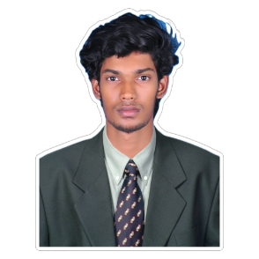

** A V I N A S H K R I S H N A N**

**----** B-TECH ARTIFICIAL INTELLIGENCE AND MACHINE LEARNING **--------**



|  |
| --- |
| **PROFILE** |

Pondicherry-08

|  |
| --- |
| Seeking for the role of AI Fresher where I would be utilize my skills, sense of responsibility and efficiency to help the organization grow. Enthusiastic eager to start a promising career. Looking for an entry-level position where I contribute to a team and gain valuable experience. |

[avinashkrishnan192004@gmail.com](mailto:avinashkrishnan192004@gmail.com)

9629017059

[linkedin.com/in/avinash-k-aiml](https://www.linkedin.com/in/avinash-k-aiml/)

19.04.2004

|  |
| --- |
| **TECHNICAL SKILLS** |

|  |
| --- |
| **EDUCATION** |

|  |
| --- |
| **Manakula Vinayagar Institute of Technology, kalitheerthalkuppam, puducherry-09**  B-Tech (Artificial Intelligence and Machine  Learning) 2021-2025 [Pursuing]  CGPA-7.9  **Vivekananda Higher Secondary School, Selaperumalpet, Puducherry-08**  HSC 2019-2021  82%  **Vivekananda Higher Secondary School, Selaperumalpet, Puducherry-08**  SSLC 2018-2019  78% |

|  |
| --- |
| **SOFT SKILLS** |

|  |  |
| --- | --- |
| Decision making | Java |
| Leadership | R Programing (basic) |
| Team Player | Microsoft word |

|  |
| --- |
| **WORKSHOP** |

|  |
| --- |
| Python programming conducted by TCS  Design thinking workshop conducted by YI Pondicherry |

|  |
| --- |
| **CERTIFICATION** |

|  |
| --- |
| AWS - Introduction to Machine Learning Foundation Introduction  SkillUP Machine Learning  Python basic HackerRank  C-basic HackerRank |

**PROJECTS**

|  |
| --- |
| DISEASE PREDICTION USING RBM**:**  This project uses RBMs to analyze patient data to predict various diseases. It involves data collection, cleaning, and prep, followed by RBM training for disease risk prediction.  LSTM-BASED REAL TIME SIGN LANGUAGE RECOGNITION**:** This project uses LSTMs to detect signs from a live video. LSTM is a type of neural network that can learn and recognize sign language gestures in real-time. |

**EXTRA CURRICULAR**

|  |
| --- |
| Traveling |

|  |
| --- |
| Editing |

|  |
| --- |
| **INTEREST** |

|  |
| --- |
| Machine learning |

|  |
| --- |
| Assistant secretary of Department AI&ML  Member of joint Department secretary |