

**BATCH 2021- 25**

**CSE - 3rd YEAR**

**PROJECT NAME :**

**Book nirvana**

**Submited by: TeamTechno**

**Submitted to : Lavish Arora**

***TEAM :-***

Avinash kumar |2110991887 |G-5 (Team leader)

Lakshay Tanwar |2110991981|G-5

Deepraj singh |2110992200|G-5

Sujeet|2110991846|G-5

Arpan Thapliyal|2110992031|G-5

***Table Of Content***

* Title Project
* Idea Description
* Features
* Future Aspects
* Some Stats
* Conclusion
* Reference/Links used

***Technologies Used :-***

1. **GPT-3.5 Turbo**: GPT-3.5 Turbo is a powerful language model developed by OpenAI. It can understand and generate human-like text based on the input it receives. It's often used for natural language processing tasks, chatbots, and various applications that involve understanding and generating text.

2. **MongoDB**: MongoDB is a NoSQL database that uses a document-oriented data model. It is designed to be scalable, flexible, and can handle large amounts of unstructured data. MongoDB is commonly used in web development for its ease of use and scalability.

3. **React**: React is a JavaScript library for building user interfaces. Developed and maintained by Facebook, it allows developers to build reusable UI components and efficiently update and render changes in the user interface based on data changes.

**4. Express.js:** Express.js is a web application framework for Node.js. It simplifies the process of building robust web applications and APIs by providing a set of features and tools for handling routes, middleware, and HTTP requests and responses.

5. **Node.js**: Node.js is a runtime environment that allows JavaScript to be executed on the server side. It's commonly used for building scalable network applications and is often used as the backend for web applications.

6. **Tailwind CSS**: Tailwind CSS is a utility-first CSS framework that provides low-level utility classes to build designs directly in your markup. It allows for rapid development and easily customizable designs without writing custom CSS.

7. **Firebase**: Firebase is a platform developed by Google for building mobile and web applications. It provides a range of services, including real-time databases, authentication, hosting, and more, making it easier for developers to build and scale applications.

***PROJECT APPROACH :-***

Backend API Setup: Initial development of CRUD operations for tasks.

UI Integration: Integration of the client interface with the existing backend for seamless task management.

Phases: Backend setup, UI design, planned UI enhancements.

***HOME PAGE :-***

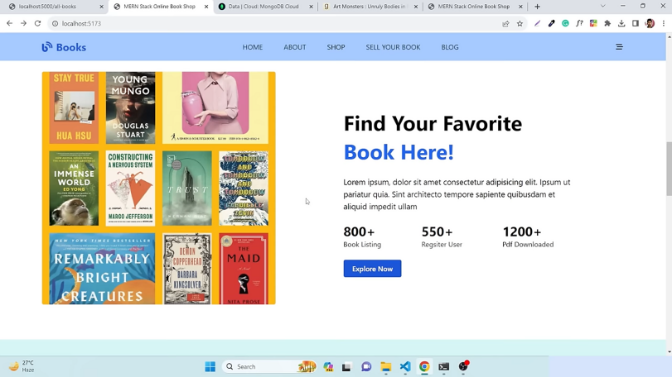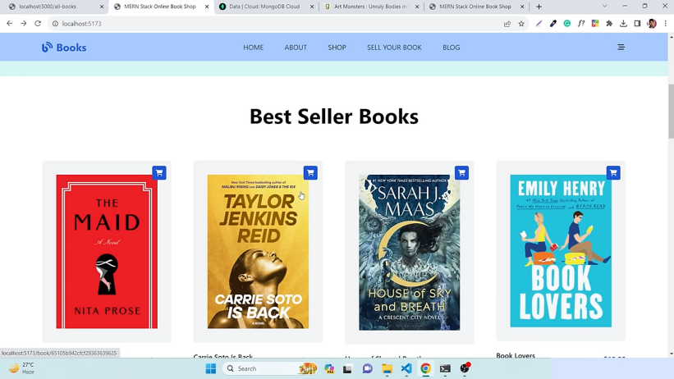

**Here*, are best selling books***

**Here*, find your favourate***

**books**

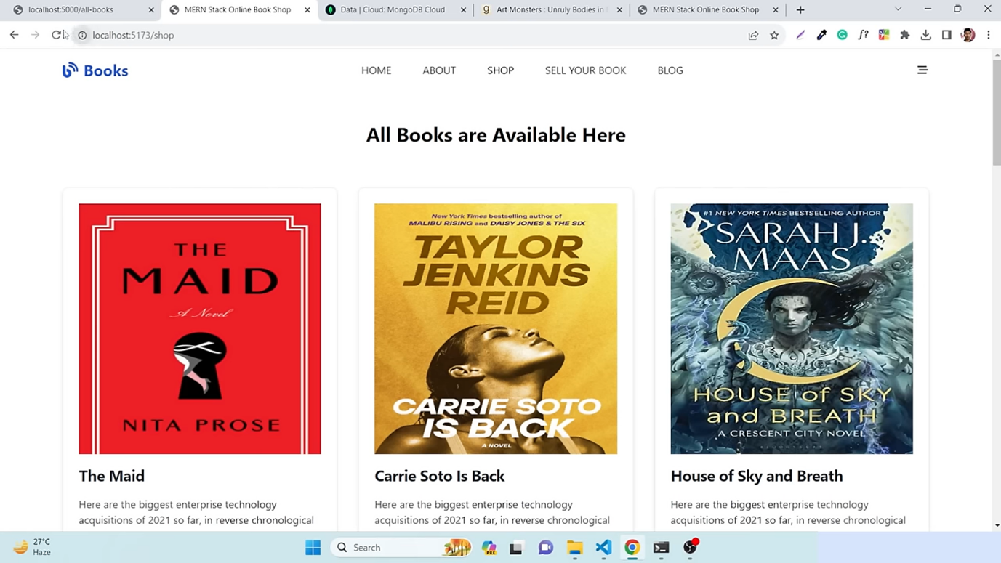

**Here , you can find all books that are in the store**

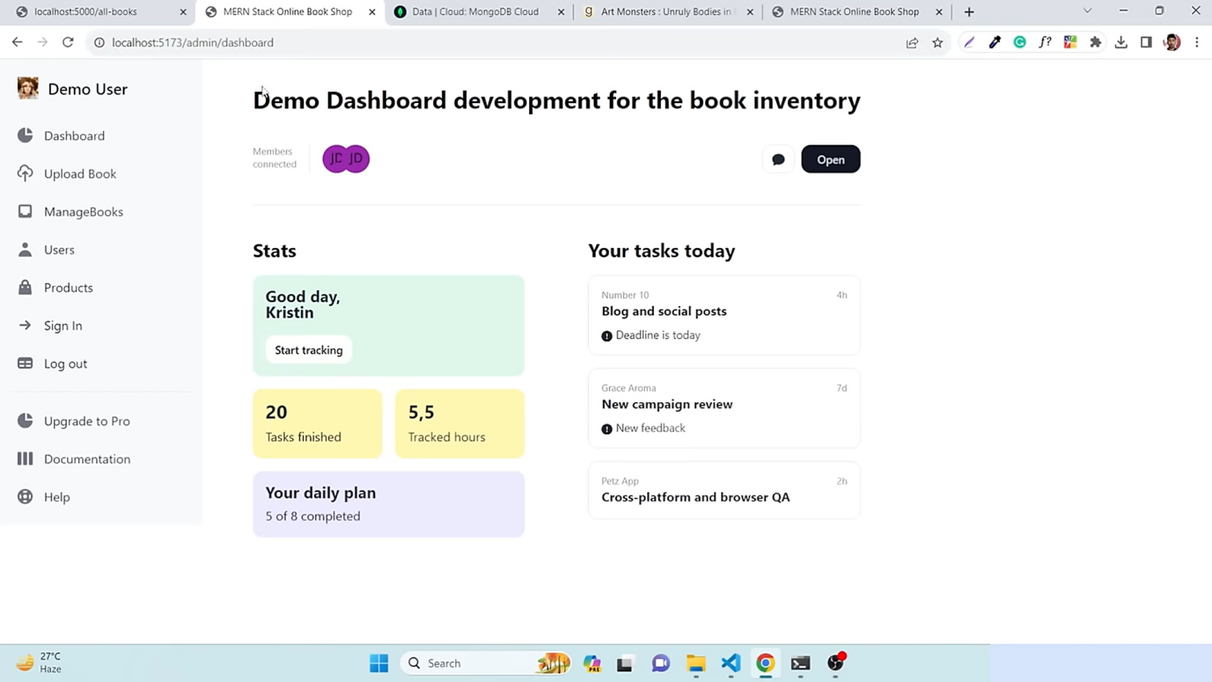

**This is main dashboard , where a user can checks his stats(like, task done, completed daily plan, hours tracked), task done.**

**At left you can find various functions, like, manage book, upload books, sign in ,logout etc.**

***UPLOAD BOOK :-***

**here , you can upload book , for that you have to give name,author name,book img, url, description, pdf link, then click upload.**

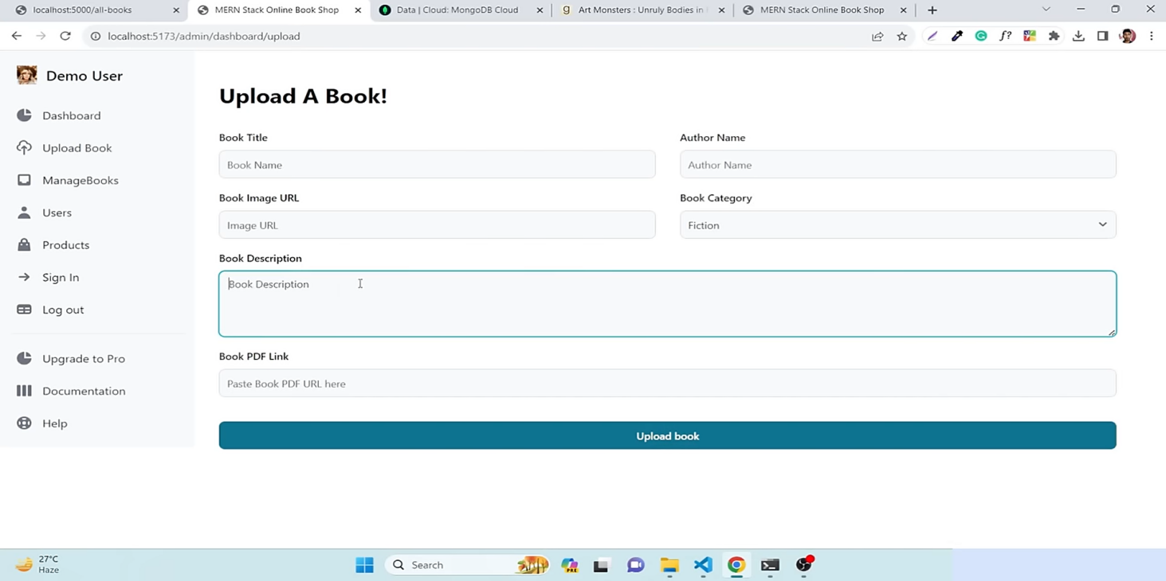

**The uploaded books will be added in backend database and your book will get shown at all books section.**

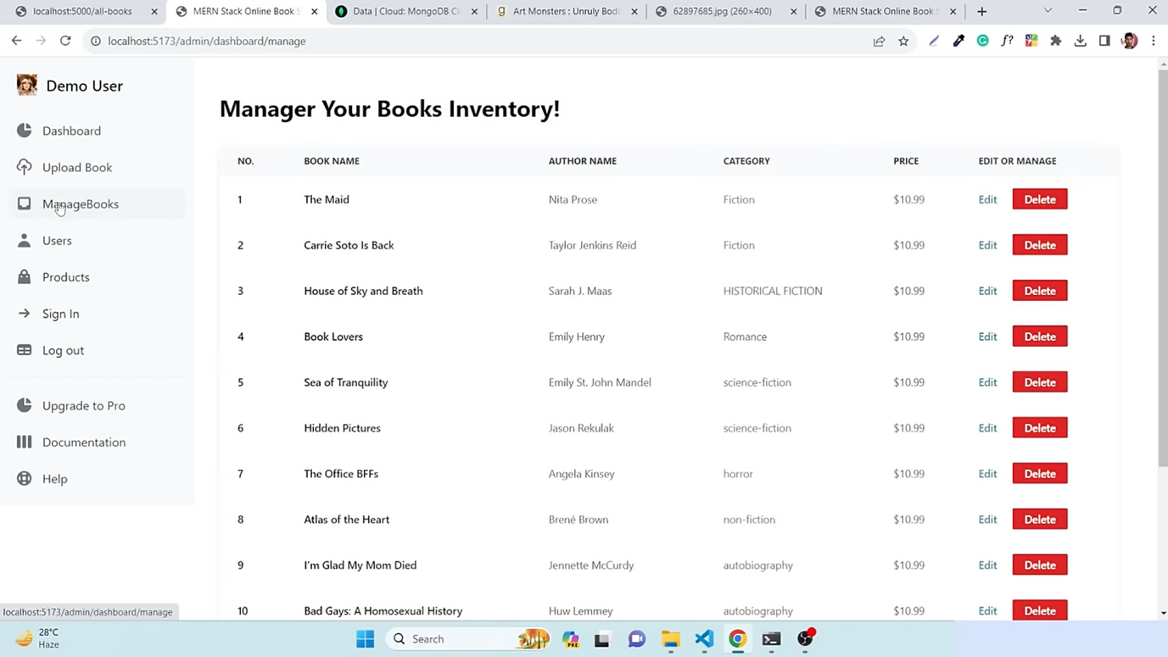

**This is where you can see ‘history’ of all the books you have , and you can edit or permanently delete the the books here.**

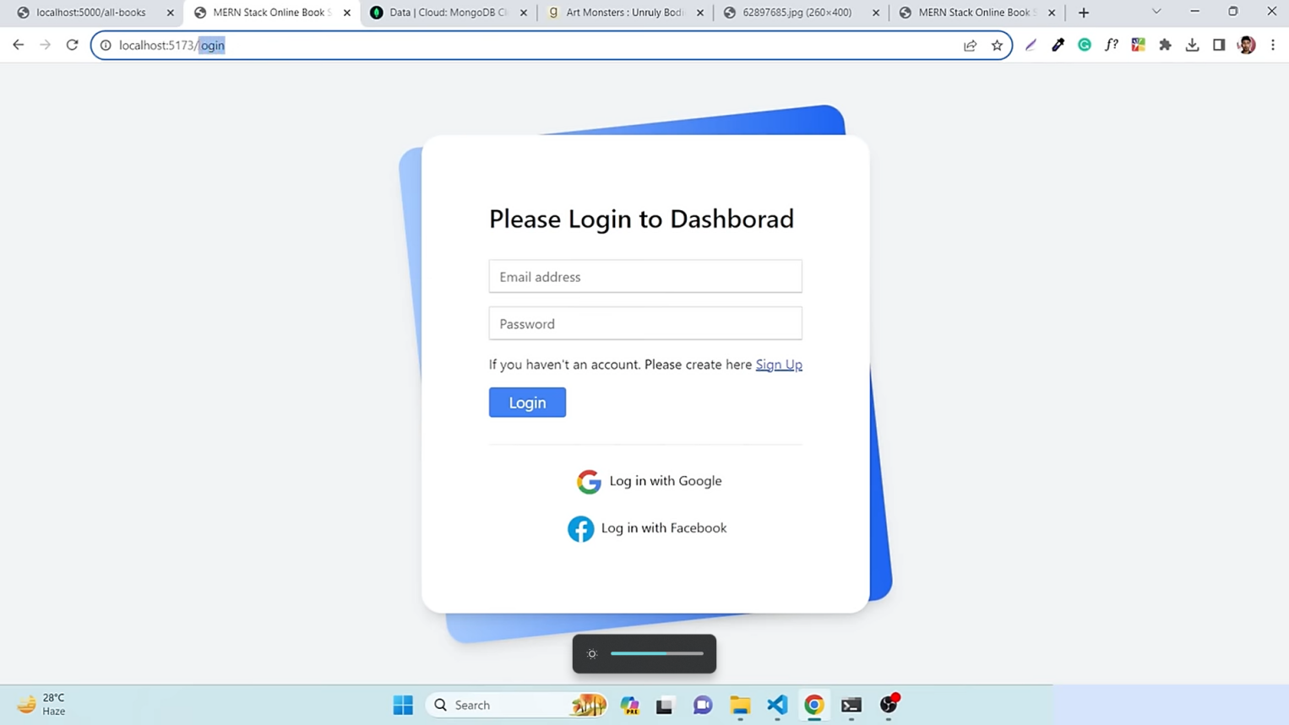

***LOGIN AND SIGNUP :-***

**Here are login and sign page if you want to sell books , if you are a existing user you can directly login but if you are new to this you have to sign up for that.**

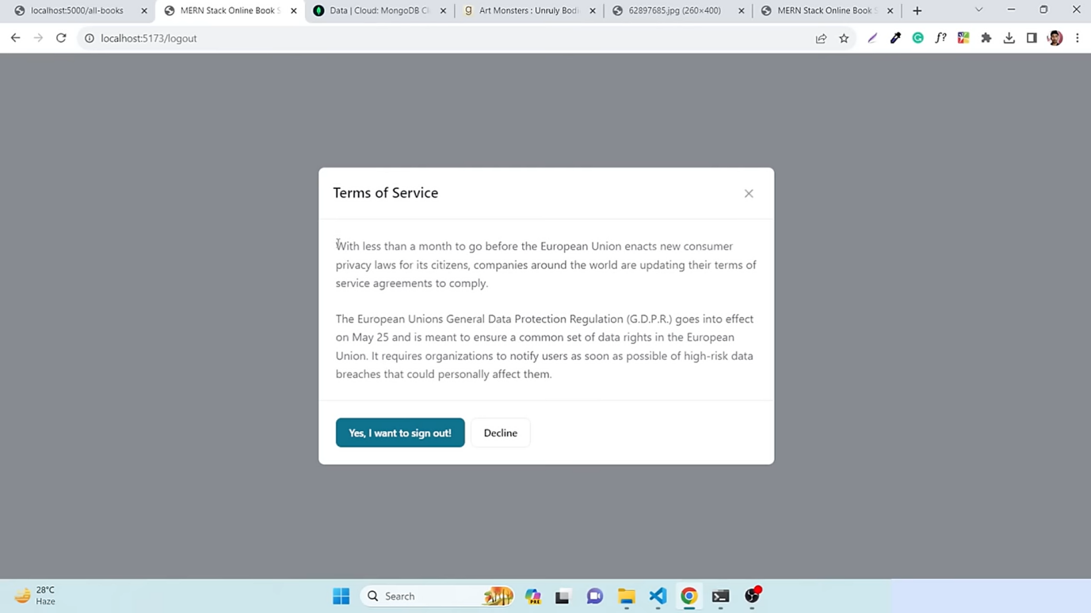

**And ,if at last you want to log-out you have to check yes after reading all the terms and conditions.**

***Learning:-***

***1. Technology Stack (All Team Members):***

- Briefly introduce each technology used in the project (MongoDB, React, Express.js, Node.js, Tailwind, and Firebase).

***2. Collaboration and Communication (All Team Members):***

- Highlight the importance of effective collaboration and communication within the team.

- Discuss any collaboration tools or methodologies used (e.g., version control systems like Git, communication tools like Slack).

***3. Problem-Solving and Challenges (All Team Members):***

- Share any challenges or roadblocks encountered during the project.

- Discuss how the team overcame these challenges and the problem-solving strategies employed.

***4. Database Management (Team Member responsible for MongoDB):***

- Discuss the structure of the MongoDB database and how it is integrated into the project.

- Highlight any challenges or lessons learned in managing data with MongoDB.

***5. Frontend Development (Team Member responsible for React):***

- Talk about the design principles and user interface considerations in React.

- Discuss any challenges faced during frontend development and how they were addressed.

***6. Backend Development (Team Member responsible for Express.js and Node.js):***

- Explain the role of Express.js and Node.js in the backend architecture.

- Discuss how these technologies handle server-side operations and communication with the frontend.

***7. Styling (Team Member responsible for Tailwind):***

- Describe the use of Tailwind CSS for styling and its impact on the visual aspects of the website.

- Share insights into the benefits and challenges of using Tailwind in the project.

***8. Authentication and Hosting (Team Member responsible for Firebase):***

- Discuss the integration of Firebase for authentication and hosting.

- Share any considerations made for security and user authentication.

***9. Continuous Learning (All Team Members):***

- Emphasize the continuous learning aspect of the project and how the team improved their skills throughout the development process.

- Discuss any new technologies or tools the team explored during the project.

***Challenges:-***

***"Embarking on the journey of creating a BOOK STORE brought its own set of challenges."***

* **Team Management**
* **Team coordination**
* **Changing Documentation of OpenAI**
* **Understanding New Technologies**
* **Shortage of Time**
* **Solving Complex Errors**

***FUTURE ASPECT :-***

**Looking ahead, the future aspects of the "Book Nirvana" website could involve various enhancements and strategic considerations to improve user experience, expand functionality, and ensure continued success. Some potential future aspects could include:**

1. **Personalization Features:** Implement personalized recommendations based on user preferences, browsing history, and purchase patterns. This could involve machine learning algorithms to enhance the user's discovery of new books aligned with their interests.

2. **Community Engagement:** Foster a sense of community by adding social features, such as book reviews, user-generated content, or discussion forums. Encourage users to share their favorite books, create reading lists, and interact with fellow book enthusiasts.

3. **Mobile App Development:** Consider developing a mobile application for "Book Nirvana" to reach a broader audience and provide users with a seamless experience on their smartphones and tablets.

4. **Enhanced Search and Filtering:** Improve search functionality with advanced filters, allowing users to easily find books based on specific criteria such as genre, author, publication date, or user ratings.

5. **Integration with External Platforms:** Explore partnerships or integrations with external platforms, such as Goodreads or social media, to expand the reach of "Book Nirvana" and provide users with a more interconnected reading experience.

6. **Subscription Services**: Introduce subscription models, allowing users to access a curated selection of books, exclusive content, or premium features for a recurring fee.

7. **Internationalization and Localization:** Consider expanding the website's reach by incorporating multi-language support and adapting content to cater to users from different regions, cultures, and languages.

8. **Accessibility Improvements:** Ensure that the website complies with accessibility standards, making it inclusive for users with disabilities. This could involve features like screen reader compatibility and optimized navigation.

9. **Data Analytics and Insights:** Utilize data analytics tools to gather insights into user behavior, preferences, and trends. Leverage this data to make informed decisions regarding content curation, marketing strategies, and overall site improvements.

10. **E-commerce Enhancements:** Continuously optimize the e-commerce aspects of the website, including checkout processes, payment options, and security measures, to provide a smooth and secure purchasing experience for users.

11. **Gamification Elements:** Introduce gamification elements to incentivize user engagement, such as loyalty programs, badges, or challenges that reward users for active participation and book exploration.

12. **Augmented Reality (AR) Integration:** Explore the integration of augmented reality features, allowing users to preview books, virtually place them in their surroundings, or engage in immersive reading experiences.

These future aspects can contribute to the growth, innovation, and sustained success of "Book Nirvana" as it evolves to meet the changing needs and expectations of its user base.

***CONCLUSION :***

**Building the book store with MongoDB, React, Express.js, Node.js, Tailwind CSS, and Firebase showcased the team's adeptness in full-stack development.**

**The flexibility of MongoDB's NoSQL data model was evident, while Firebase contributed real-time capabilities for a dynamic user experience. Tailwind CSS streamlined responsive UI design.**

**The project prompted consideration of scalability challenges, fostering insights into technology handling under growth. Effective collaboration, version control, and communication were emphasized. Integration hurdles were overcome, user feedback informed iterative improvements, and knowledge transfer within the team was facilitated.**

**The project underscored the importance of well-documented code and coding standards for maintainability, encapsulating a valuable learning experience with strengths and areas for future development identified.**

Reference/Links used

***https://github.com/avinash/book -store/bookNirvana-2110991887-***

***THANK YOU***