# Fruits.ai Project Assessment

## Introduction

Fruits.ai is an innovative platform designed to help users discover and integrate the best fruits into their daily routines. With an AI-driven chatbot, the project offers personalized fruit recommendations tailored to individual health needs. Whether you're seeking nutritional information or looking for dietary suggestions, Fruits.ai aims to enhance your fruit consumption experience through intelligent, data-driven solutions.

## Pages Content

### a. Login Page

The Login page serves as the gateway to Fruits.ai. Users can access the platform by entering their credentials. For admin access, use the email ID dummy@email.com and password dummy#1234. The page features a user-friendly form that validates credentials and provides error messages for incorrect entries. Upon successful login, users are redirected to the Home page.

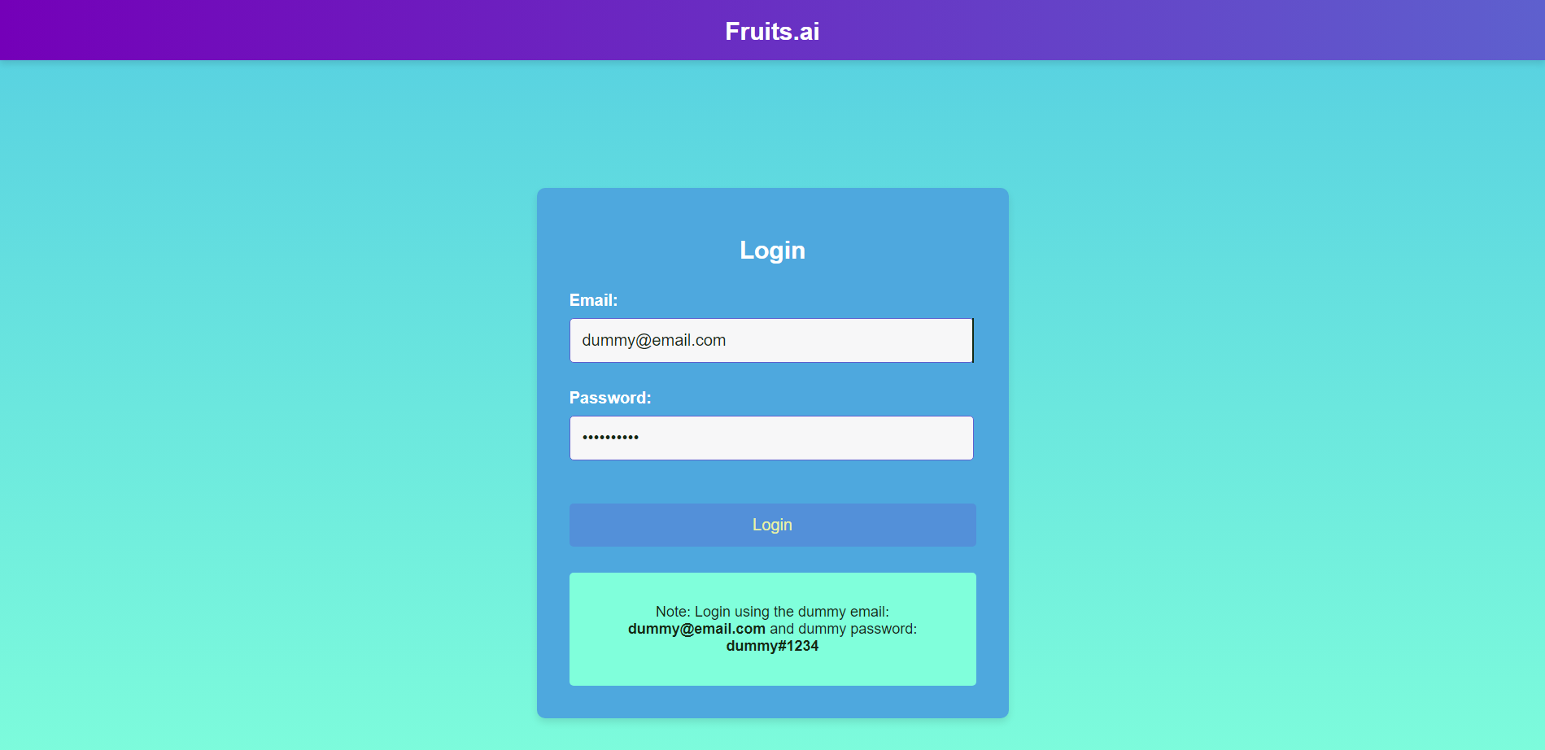

### b. Home Page

The Home page is the central hub of Fruits.ai. It introduces users to the platform's key features and offers a seamless navigation experience. Users can explore various sections, including the Chatbot, Translator, FAQ, and About pages. The Home page is designed with a clean, intuitive layout to ensure easy access to all functionalities.

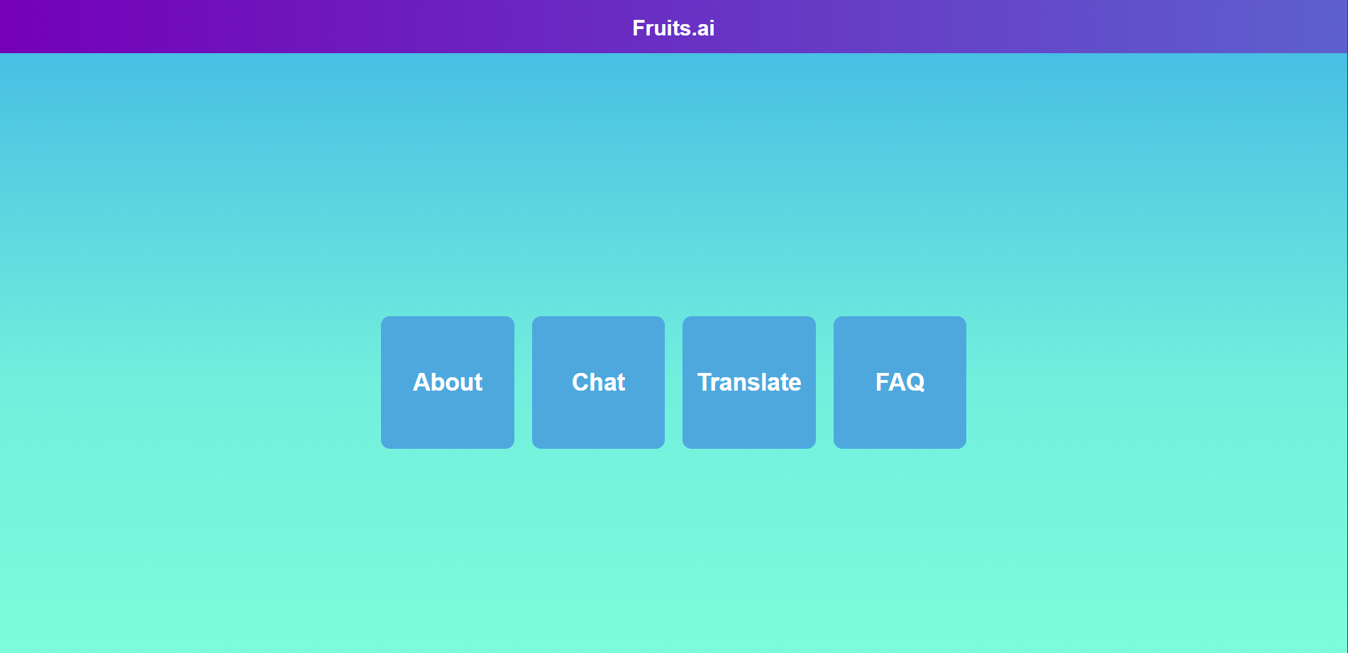

### c. Chatbot Page

The Chatbot page is where users interact with the AI-driven assistant. It allows users to ask questions like "Can I eat this fruit?" The chatbot provides responses based on a free API, helping users make informed decisions about their fruit consumption. The page features a text input area for user prompts and displays both the user's queries and the chatbot's responses. Users can delete prompts and responses as needed.

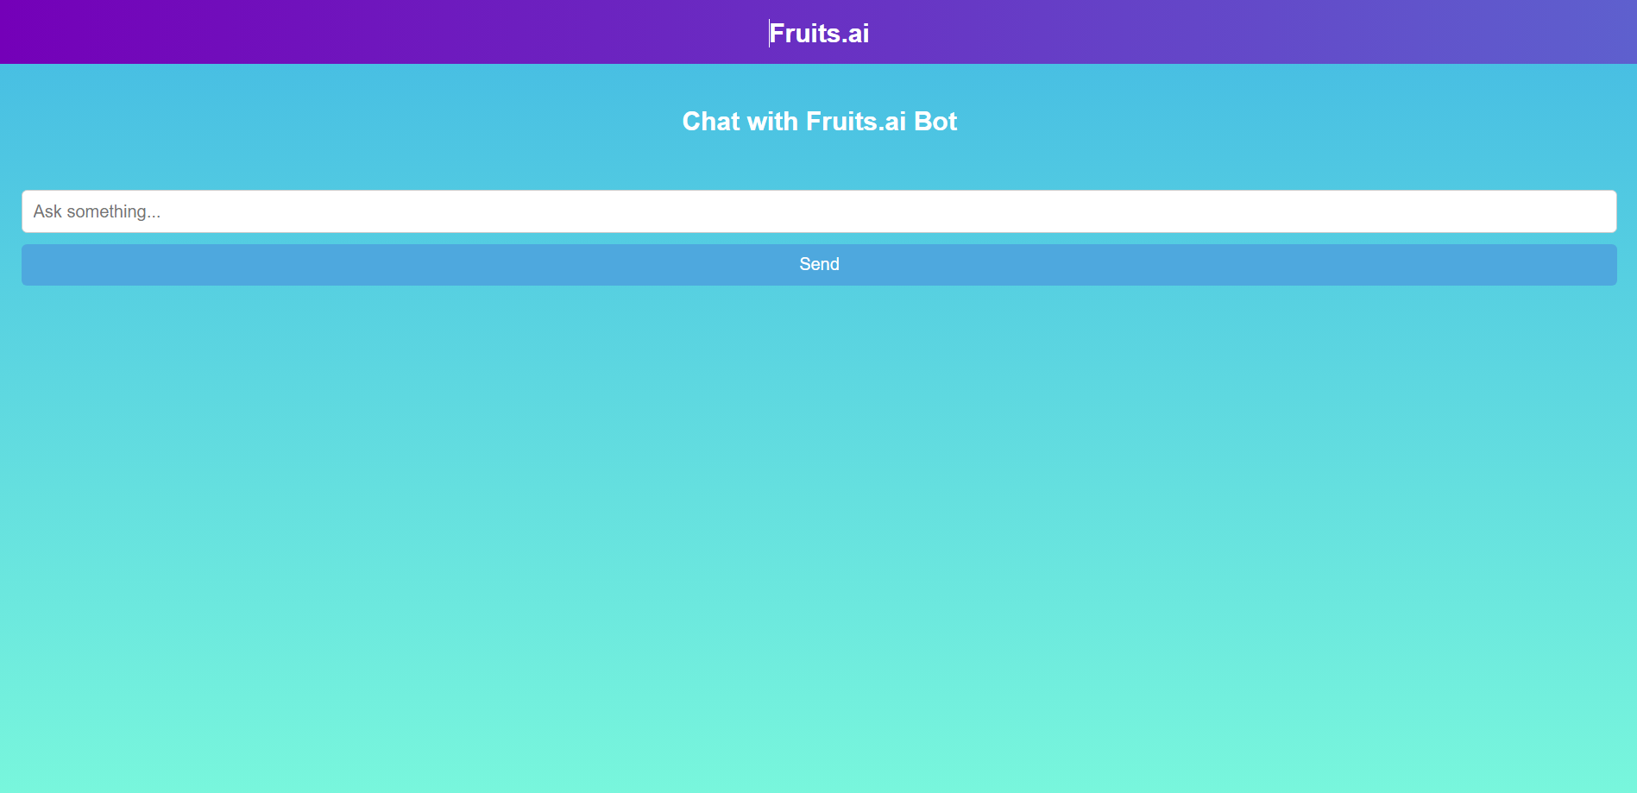

### d. Translator Page

The Translator page offers a multilingual translation feature. Users can select source and target languages from dropdown menus, enter text in a textarea, and click a button to translate the content. The translated text is displayed in a card below the input area, facilitating easy communication in multiple languages.

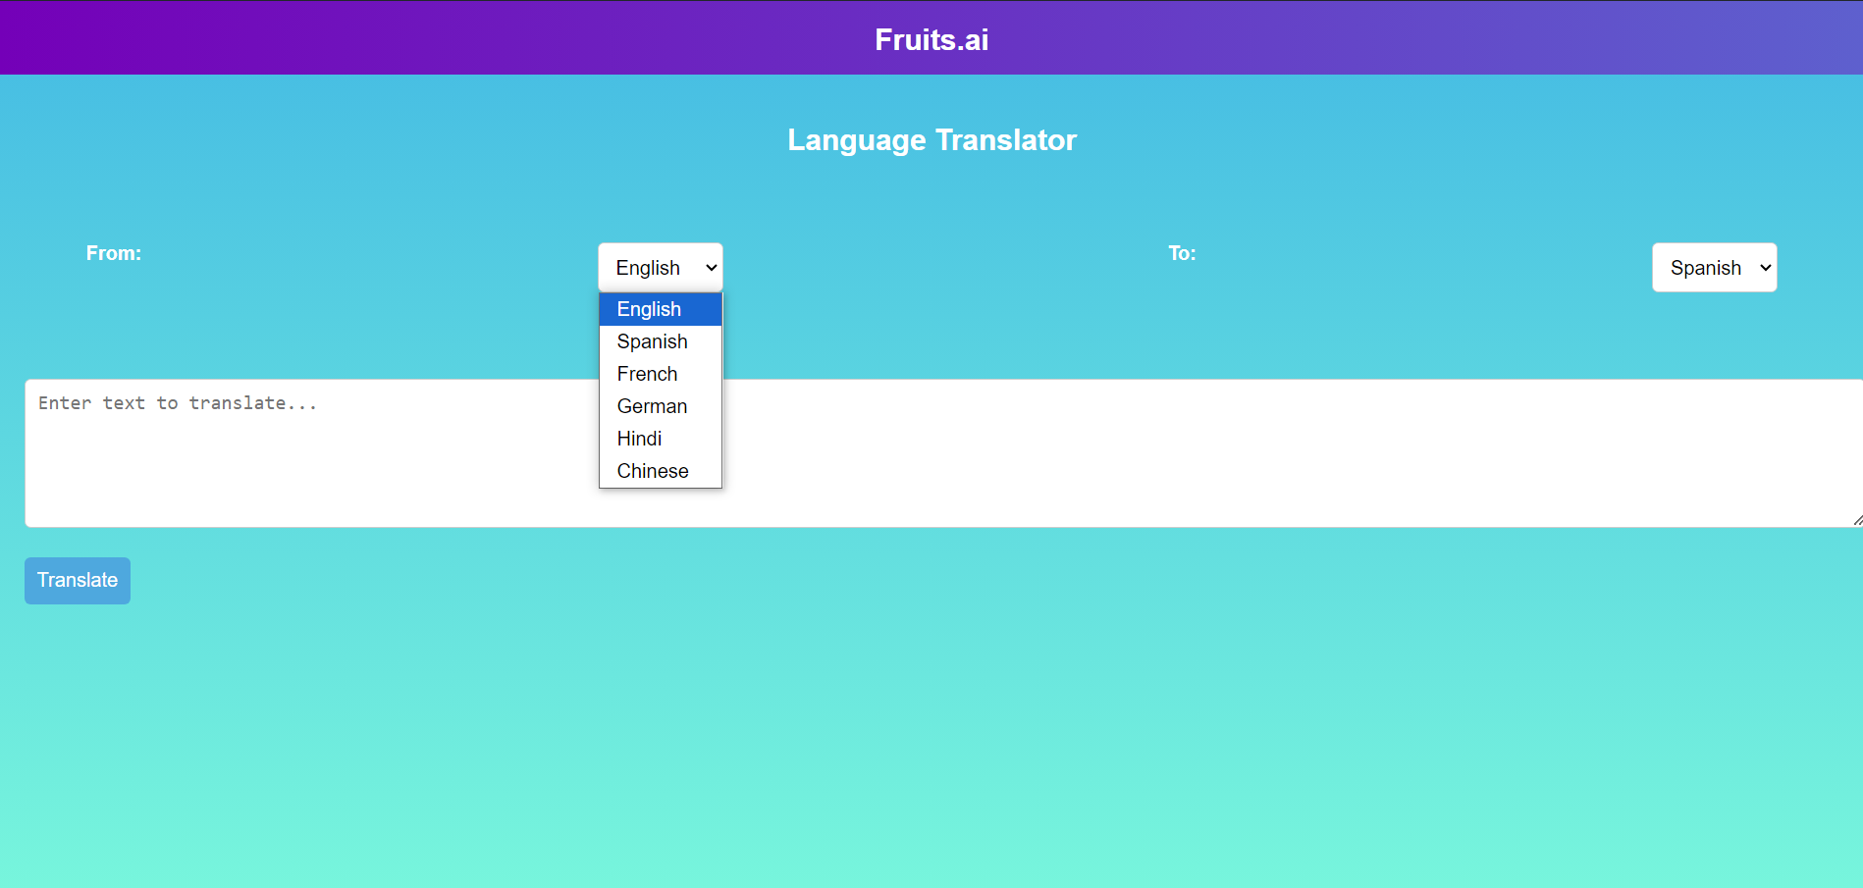

### e. FAQ Page

The FAQ page provides answers to common questions about Fruits.ai. It features a dynamic FAQ section with CRUD operations, allowing users to view, edit, or delete FAQs. The list of FAQs is displayed as dropdowns with smooth animations. Three default FAQs are provided based on the platform's theme, and users can manage these entries through the page.

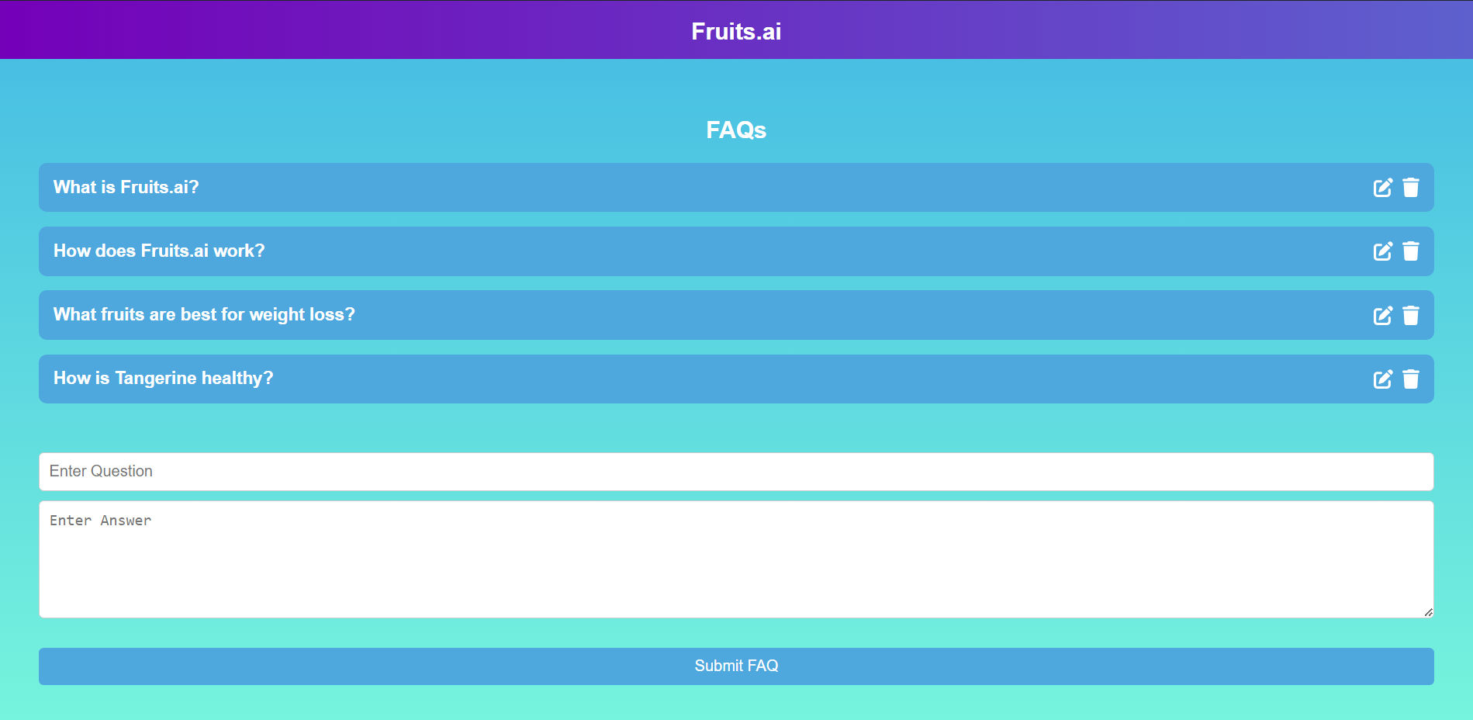

### f. About Page

The About page offers insight into the Fruits.ai project, including its mission, vision, and the team behind it. It provides background information on how the platform was developed and its goals for improving fruit-based dietary choices. This page aims to connect users with the project's values and objectives.

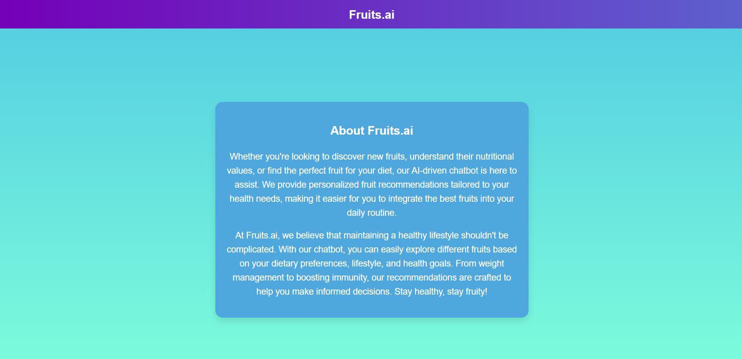

## GitHub Repository

For more details and access to the source code, visit my GitHub repository: [Fruits.ai GitHub Repo](https://github.com/AvinashKumar0923/Fruits.ai/tree/main/fruits-ai-frontend" \t "C:\\Users\\AVINAS~1\\AppData\\Local\\Temp\_new)  
  
or copy and paste the following link in the browser url:

<https://github.com/AvinashKumar0923/Fruits.ai.git>  
  
  
  
Thank You,

Avinash Kumar

2110991887

avinash1887.be21@chitkara.edu.in

Chitkara university,Punjab