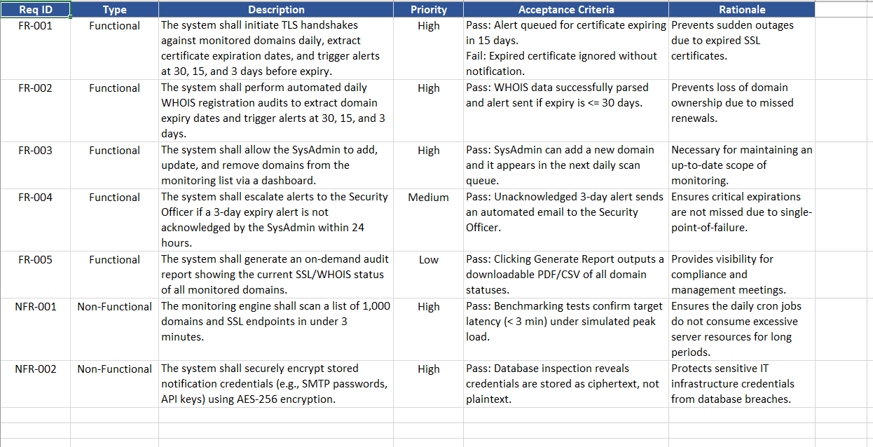
Deliverable 1 (Excel/Word Table): Functional & Non-Functional Requirements Table Deliverable 1
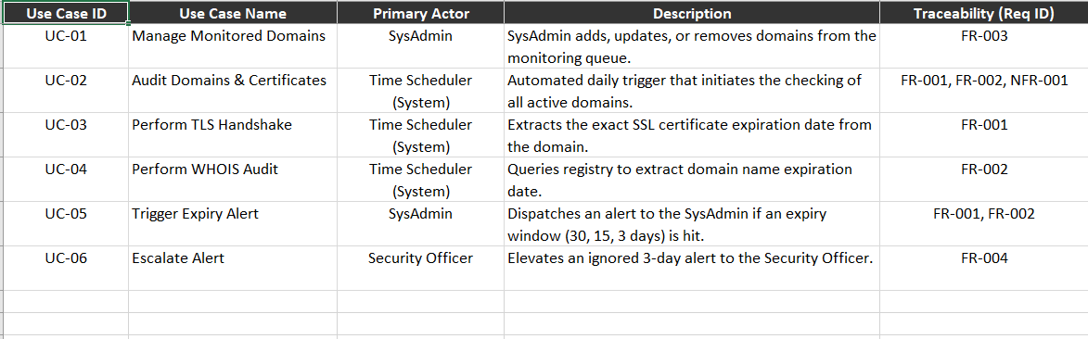
Deliverable 2 (Draw.io PDF): System UML Use-Case Diagram
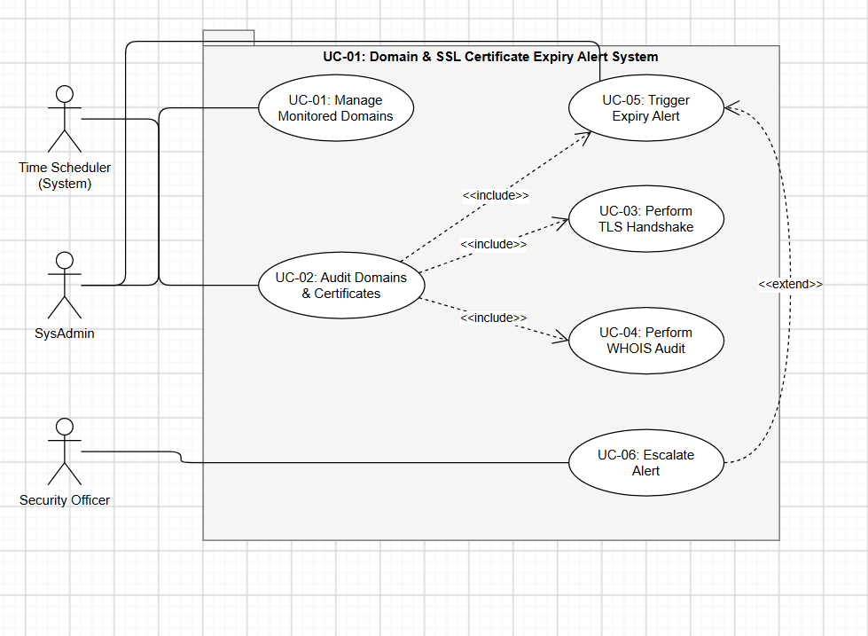
Use-Case Flow Specification Deliverable 3 - Requirements Engineering Lab
Use Case: Audit Domains & Certificates Primary Actor: Time Scheduler (Automated System / Cron Job) Secondary Actors: SysAdmin, Security Officer
Preconditions:
- The monitoring engine is online and connected to the backend database.
- There is at least one active domain registered in the monitoring list.
- The system has unrestricted outbound internet access (no firewall blocks) to reach external WHOIS registries and perform TLS handshakes.
- SMTP or an email API is configured and authenticated to send out notifications.
Postconditions:
- The database records for each scanned domain are updated with the most recent SSL and WHOIS expiration dates.
- If any domain falls within the critical warning windows (30, 15, or 3 days), the respective alert emails are queued and successfully dispatched.
- The system generates an audit log of the entire run, noting any unreachable domains or failed connections for the admin to review on the dashboard.
Main Success Scenario:
- The Time Scheduler kicks off the daily audit process at exactly midnight (00:00 UTC).
- The system pulls the list of all active domains it needs to monitor from the database.
- For every domain in the list, the system runs a TLS handshake to grab the SSL certificate's exact expiration date (<<include>>).
- The system also pings the WHOIS registry to find out when the actual domain registration expires (<<include>>).
- It calculates how many days are remaining for both the SSL cert and the domain registration.
- The system spots a domain where the SSL certificate is expiring in exactly 15 days.
- This triggers the expiry alert process (<<include>>).
- The system drafts an email alert detailing the domain name, the exact expiration date, and the renewal action required.
- It sends this email directly to the SysAdmin's registered address.
- Finally, it logs the audit run as successful and updates the main dashboard statuses.
- The use case finishes.
Alternate Flows:
3a. Domain Unreachable / TLS Handshake Fails
- a. The system tries to perform the TLS handshake, but the domain doesn't respond or the connection times out.
- b. It retries the connection up to 3 times just to rule out a temporary network blip.
- c. If all attempts fail, it updates the domain's status to "Unreachable" in the database.
- d. It immediately fires off a "Downtime/Connection Error" alert to the SysAdmin so they know the server might actually be down.
- e. It skips the WHOIS audit for this specific domain and loops back to check the next domain on the list.
7a. Alert Escalation (<<extend>>)
- a. The system identifies a domain that is expiring in exactly 3 days.
- b. It checks the database logs and notices the SysAdmin never clicked "Acknowledged" on the previous 15-day warning.
- c. This triggers the escalation ladder (<<extend>>).
- d. The system drafts an urgent warning notification and sends it to both the SysAdmin AND the Security Officer to ensure it doesn't get ignored.
- e. It resumes the main success scenario at Step 10 to log the escalation.

