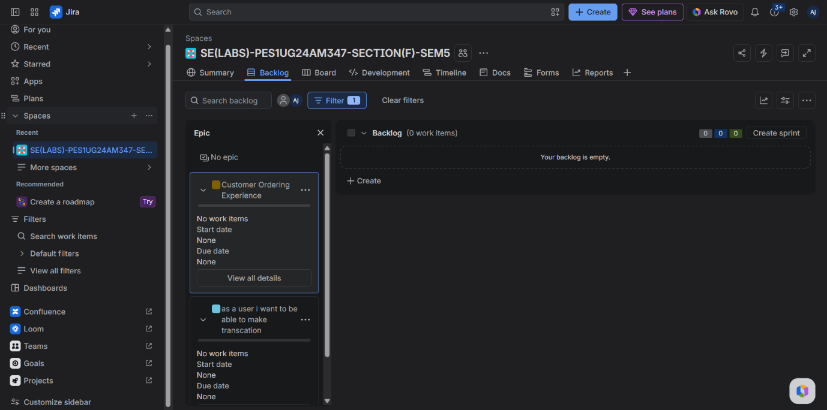
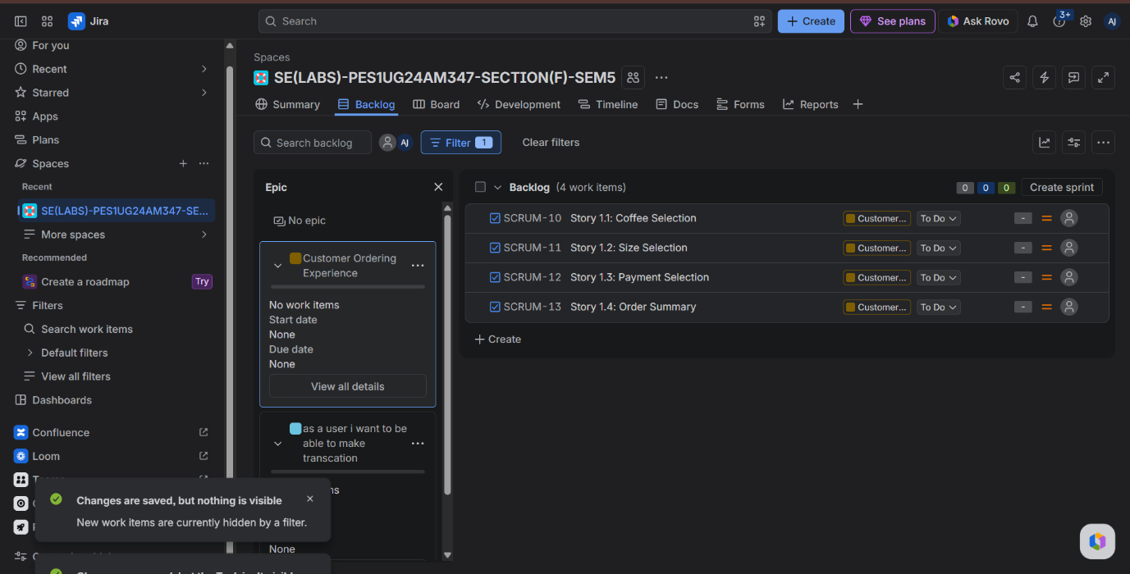
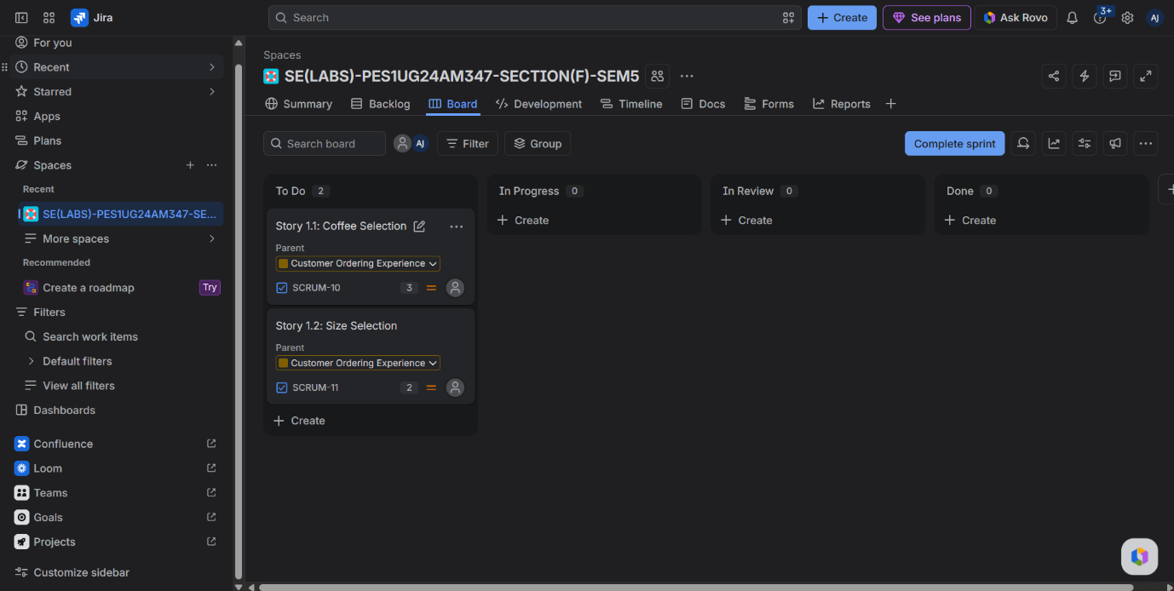
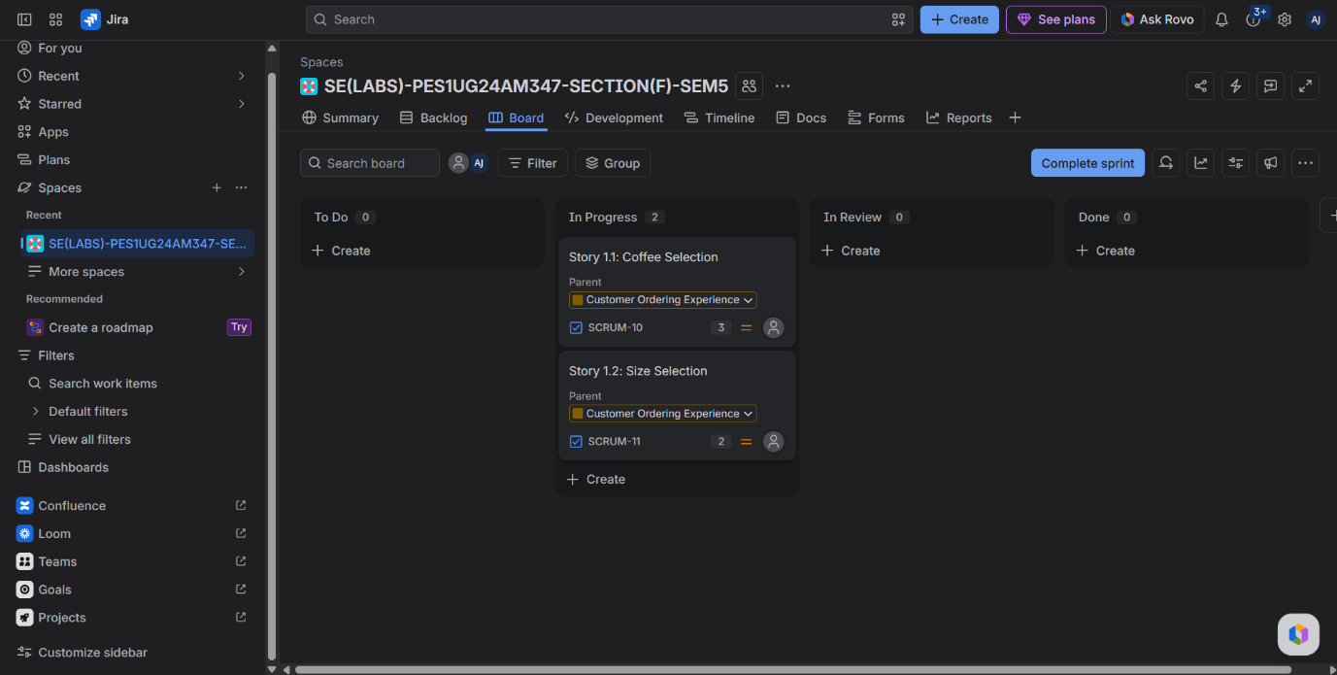
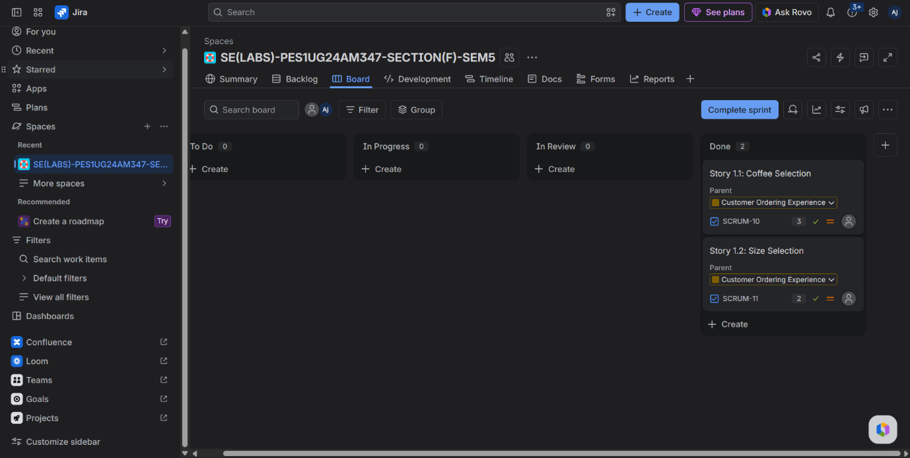
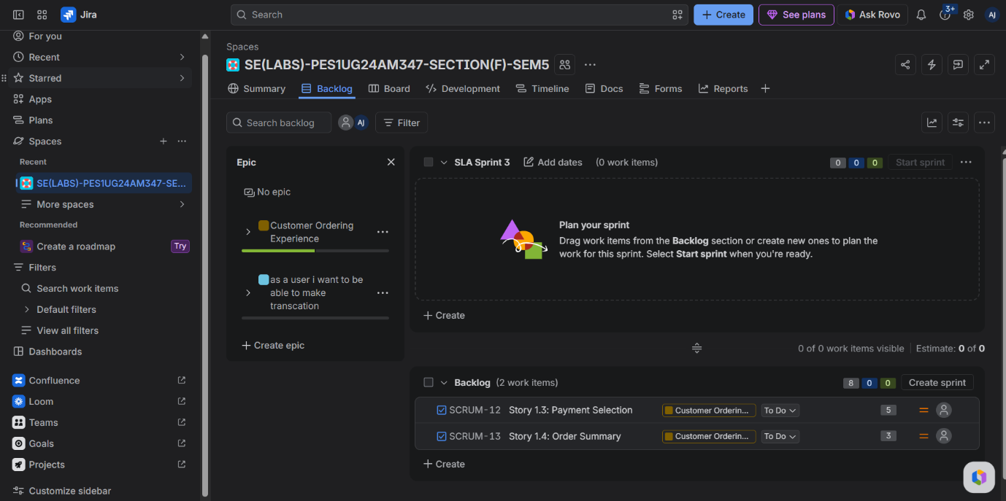
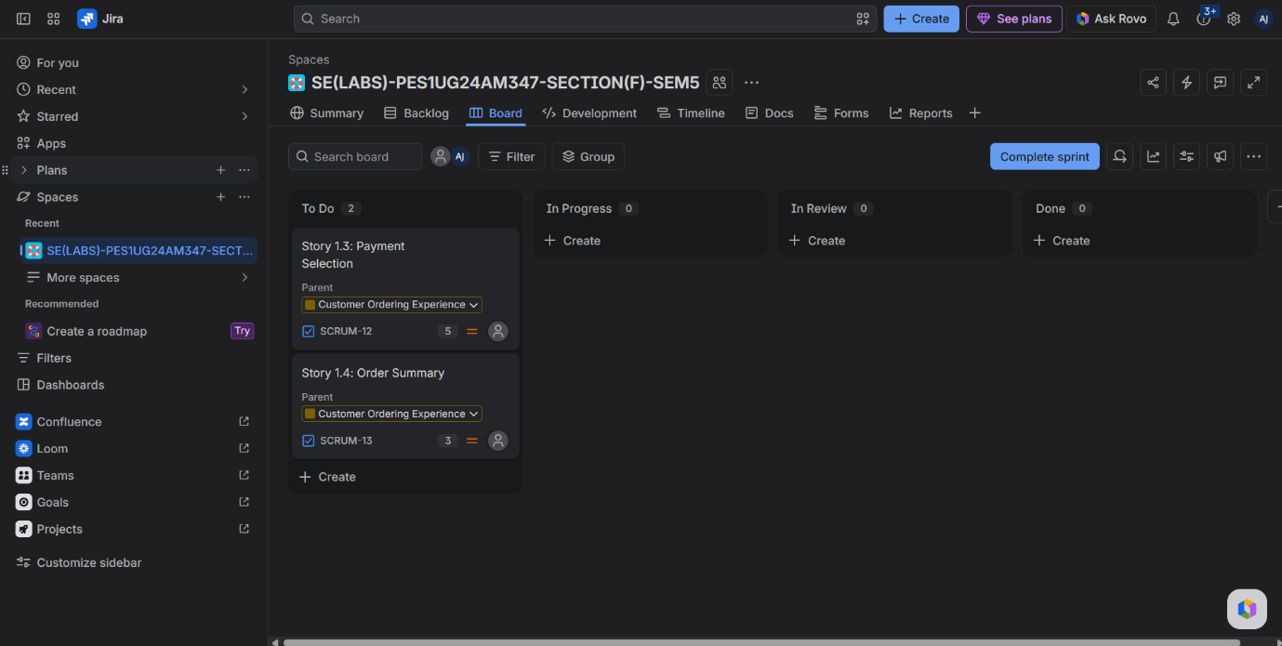
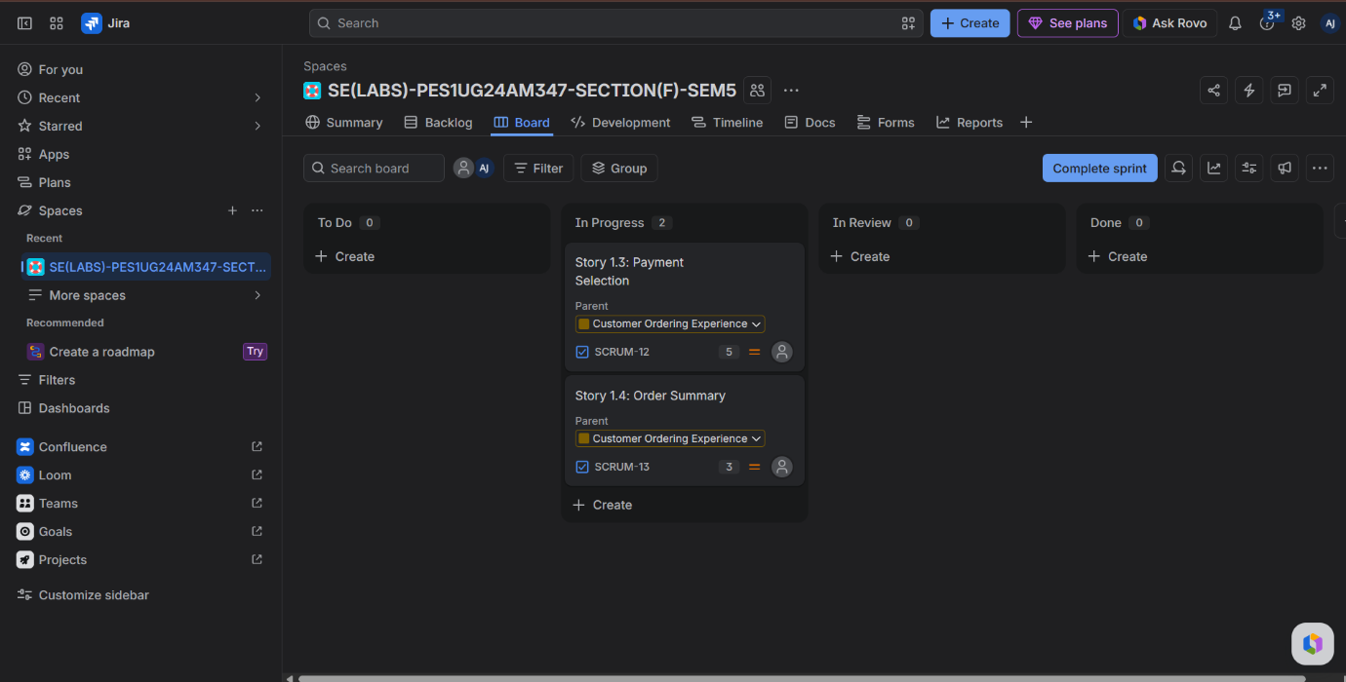
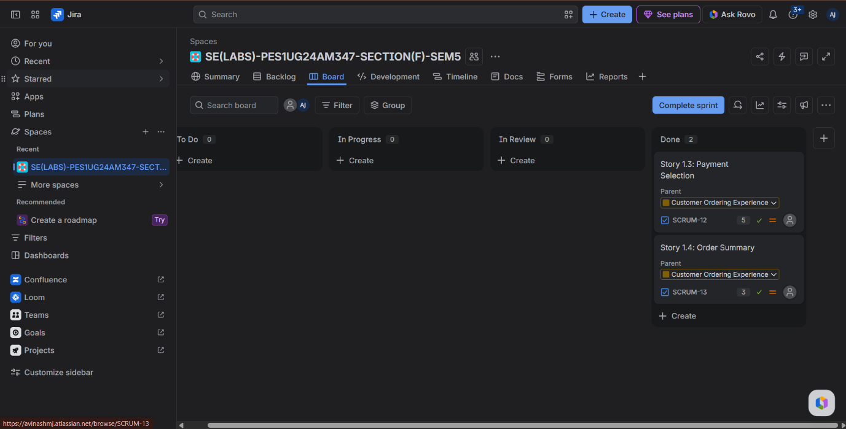
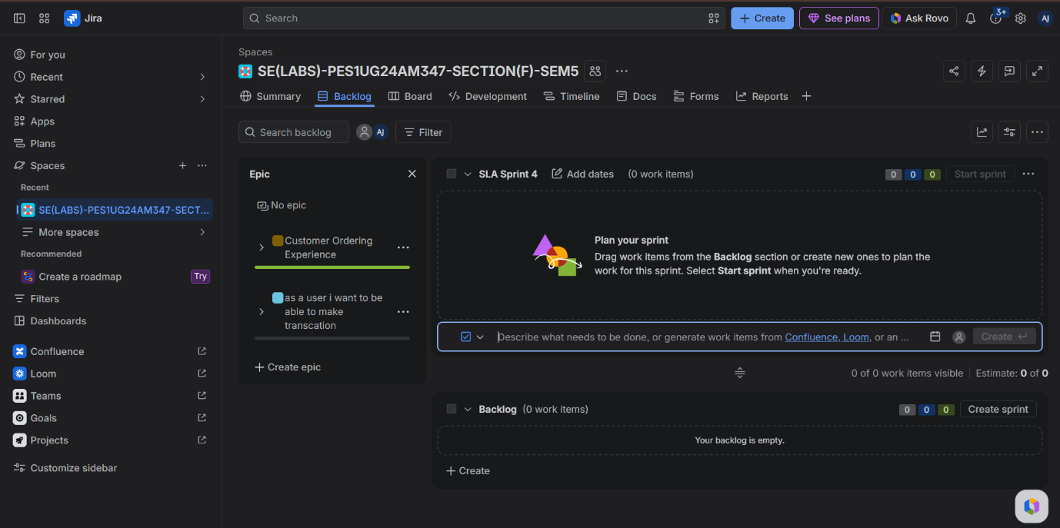
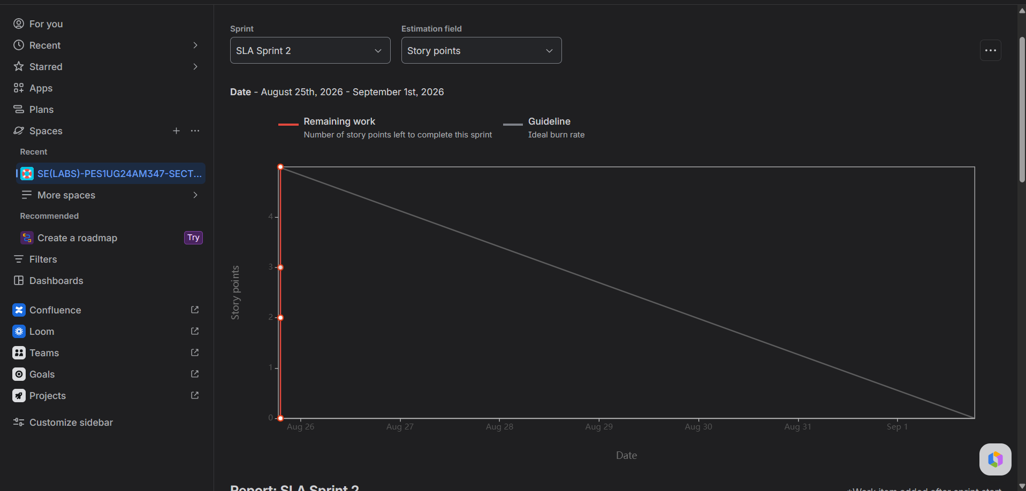
Did your estimations reflect the actual effort?
- Answer: Yes, applying the Fibonacci scale through Planning Poker allowed relative estimation based on complexity and uncertainty rather than raw hours. Simpler configuration tasks were assigned 2–3 points, while more complex transactional flows received 5 points.
Was your backlog well-prioritized?
- Answer: Yes, foundational user requirements (e.g., product selection and size choice) were ranked highest and scheduled into Sprint 1, ensuring core functional value was delivered before secondary transaction features.
How did your simulated sprint align with your plan?
- Answer: The sprint was planned with a defined 1-week timebox and a committed story point capacity. All tasks progressed cleanly across To Do, In Progress, and Done without scope creep.
What insights did the burndown chart give about your team's capacity?
- Answer: The burndown chart compared the actual completion rate against the ideal linear guideline. The sharp drop reflects rapid simulated task completion, illustrating how the chart tracks velocity and identifies whether a team under-committed or over-committed for future sprint planning.

