1. Synopsis

## Introduction:

As the title suggests, the application will be a web-based application for visually impaired persons using IVR- Interactive voice response, thus enabling everyone to control their mail accounts using their voice only and to be able to read, send, and perform all the other useful tasks. The system will prompt the user with voice commands to perform certain action and the user will respond to the same. The main benefit of this system is that the use of keyboard is completely eliminated, the user will have to respond through voice and mouse click only. Now you must be thinking that how will a blind person will see the correct position on the screen for doing mouse clicks. But this system will perform actions based on the clicks only that is left click or right click, it does not depend on the portion of the screen where the cursor is placed before the click giving user the freedom to click blindly anywhere on the screen.

## Literature survey:

Existing systems of today are basically applications that provide accessing and managing of emails benefits to its users via web facilities. Making email widely used communication form. The existing systems do not support any voice commands or audio facilities and therefore it is not suitable for visually challenged people. Also, there are various existing search engine which take request in form of text from user and retrieve the relevant documents from server and responds by displaying it in the form of text which is not possible for visually challenged people .

## Planning of work:

|  |  |  |  |  |  |  |  |  |  |  |  |  |  |  |  |  |  |  |  |  |  |  |  |  |  |  |
| --- | --- | --- | --- | --- | --- | --- | --- | --- | --- | --- | --- | --- | --- | --- | --- | --- | --- | --- | --- | --- | --- | --- | --- | --- | --- | --- |
| Month | Sept | | | | Oct | | | | Nov | | | | Dec | | Feb | | | | Mar | | | | Apr | | | |
| Week  Task Description | 1 | 2 | 3 | 4 | 1 | 2 | 3 | 4 | 1 | 2 | 3 | 4 | 1 | 2 | 1 | 2 | 3 | 4 | 1 | 2 | 3 | 4 | 1 | 2 | 3 | 4 |
| Requirement  Gathering |  |  |  |  |  |  |  |  |  |  |  |  |  |  |  |  |  |  |  |  |  |  |  |  |  |  |
| Requirement  Analysis |  |  |  |  |  |  |  |  |  |  |  |  |  |  |  |  |  |  |  |  |  |  |  |  |  |  |
| Modeling &  Design |  |  |  |  |  |  |  |  |  |  |  |  |  |  |  |  |  |  |  |  |  |  |  |  |  |  |
| Coding |  |  |  |  |  |  |  |  |  |  |  |  |  |  |  |  |  |  |  |  |  |  |  |  |  |  |
| Testing |  |  |  |  |  |  |  |  |  |  |  |  |  |  |  |  |  |  |  |  |  |  |  |  |  |  |
| Execution |  |  |  |  |  |  |  |  |  |  |  |  |  |  |  |  |  |  |  |  |  |  |  |  |  |  |
| Demonstration  and Feedback |  |  |  |  |  |  |  |  |  |  |  |  |  |  |  |  |  |  |  |  |  |  |  |  |  |  |

**Requirement:**

#### Hardware:

* 8gb ram
* I5 processor
* 512gb SSD

#### Software:

* Windows 10 pro
* PyCharm Editor
* Text-to-speech API
* Speech-to-text API

## SRS

### Introduction:

**Purpose**

This document contains the software requirements for the Voice Based Email for Visually Challenged.This project proposes an website, designed specifically for visually challenged people. This web provides a voice based mailing service where they could read and send mail on their own, without any guidance. Here the users have to use certain keywords which will perform certain actions for e.g. Received mails, Send mails. Voice Based Email for Visually Challenged can be used by a blind person to access mails easily and efficiently. Thus reliance of visually impaired on other people for their activities related to mail can be reduced.

# Project Scope:

It can improve the accuracy of message content and it allows to send multiple message to multiple people. Voice mail can allow the message to be easily updated and it can reduce the need of receptionist it can serve as an important medium for business in communication.

## Product features

Following are the features of this project: -

* Communicate with Voice.
* Accuracy
* Send message to multiple people

## Scope of Project:

There is wide future scope of this system many enhancements can be done in the system such as including different languages, including functionality of accessing the deleted mails and spam mails. Also, this system can be enhanced such that it can also send attachments which are more beneficial for visually challenged people. This system can be made available to all regional people who are not educated enough and inclusion of different languages will make this system easily accessible. Further more sign language system can also be integrated with the system to make the system more scalable and robust.

## Limitations:

* Some people cannot use the voice-messaging systems.
* Difficult for people to recall which options they used previously.
* You will get tired of listening to the messages and end up deleting the messages without

listening to them, This causes you to miss the important messages.

## References:

1. Zero to mastery in Python RAKESH K YADAV VAYU EDUCATION OF INDIA 2021
2. https://[www.geeksforgeeks.org/voice-based-android-mail-system- forvisually-](http://www.geeksforgeeks.org/voice-based-android-mail-system-%20%20%20%20%20forvisually-) [impaired](http://www.geeksforgeeks.org/voice-based-android-mail-system-forvisually-impaired)
3. https://[www.opensourceagenda.com/projects/voice-based-email-for-blind](http://www.opensourceagenda.com/projects/voice-based-email-for-blind)
4. Requirement Analysis
5. Detailed Plan

|  |  |  |  |  |  |  |  |  |  |  |  |  |  |  |  |  |  |  |  |  |  |  |  |  |
| --- | --- | --- | --- | --- | --- | --- | --- | --- | --- | --- | --- | --- | --- | --- | --- | --- | --- | --- | --- | --- | --- | --- | --- | --- |
| Semester | **I** | | | | | | | | | | | | **II** | | | | | | | | | | | |
| Month | Sep. | | | Oct. | | | Nov. | | | | Dec. | | Feb. | | | | Mar. | | | Apr. | | | | May |
| week  Task Description | 2 | 3 | 4 | 1 | 2 | 3 | 1 | 2 | 3 | 4 | 1 | 2 | 1 | 2 | 3 | 4 | 1 | 3 | 4 | 1 | 2 | 3 | 4 | 1 |
| Requirement  Gathering |  |  |  |  |  |  |  |  |  |  |  |  |  |  |  |  |  |  |  |  |  |  |  |  |
| Requirement  Analysis |  |  |  |  |  |  |  |  |  |  |  |  |  |  |  |  |  |  |  |  |  |  |  |  |
| Project  Finalization |  |  |  |  |  |  |  |  |  |  |  |  |  |  |  |  |  |  |  |  |  |  |  |  |
| Synopsis |  |  |  |  |  |  |  |  |  |  |  |  |  |  |  |  |  |  |  |  |  |  |  |  |
| Scheduling |  |  |  |  |  |  |  |  |  |  |  |  |  |  |  |  |  |  |  |  |  |  |  |  |
| Modeling |  |  |  |  |  |  |  |  |  |  |  |  |  |  |  |  |  |  |  |  |  |  |  |  |
| Designing |  |  |  |  |  |  |  |  |  |  |  |  |  |  |  |  |  |  |  |  |  |  |  |  |
| Coding |  |  |  |  |  |  |  |  |  |  |  |  |  |  |  |  |  |  |  |  |  |  |  |  |
| Testing |  |  |  |  |  |  |  |  |  |  |  |  |  |  |  |  |  |  |  |  |  |  |  |  |
| Demonstration  and Execution |  |  |  |  |  |  |  |  |  |  |  |  |  |  |  |  |  |  |  |  |  |  |  |  |
| Feedback |  |  |  |  |  |  |  |  |  |  |  |  |  |  |  |  |  |  |  |  |  |  |  |  |

1. Madling Diagrams
2. Data Flow Diagrams

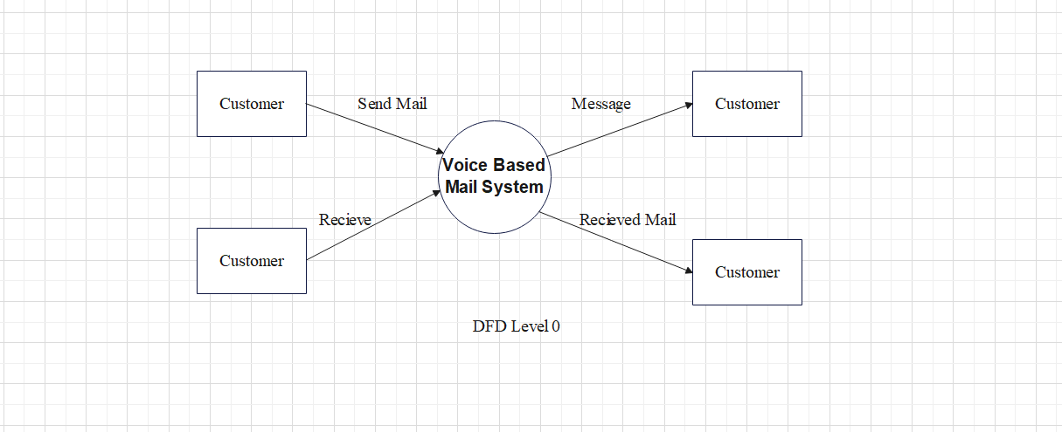

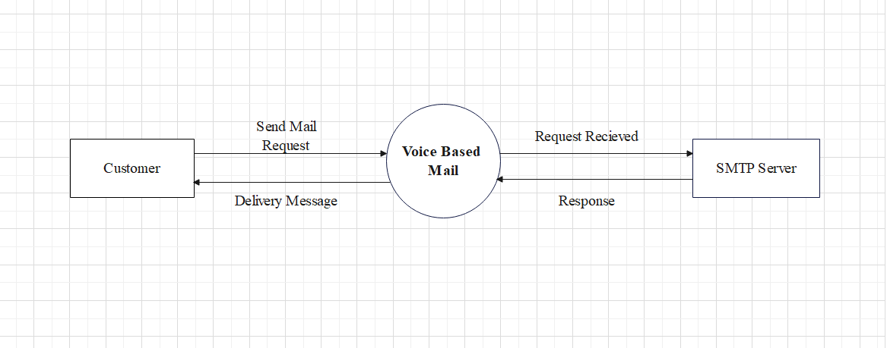

DFD level 1 (for send mail)

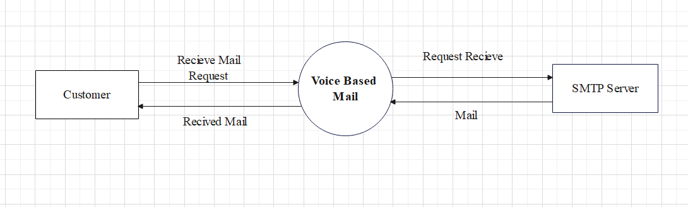

DFD level 1 (for receive mail)

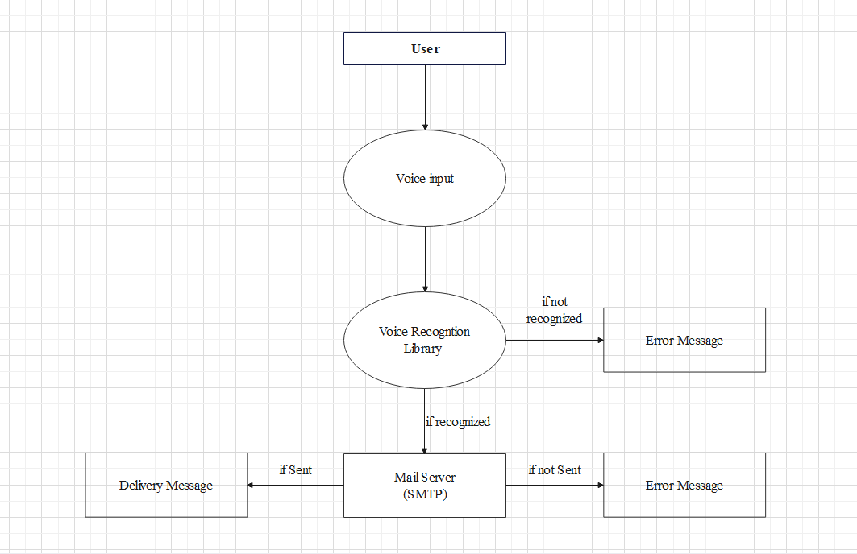

DFD level 2 (for send mail)

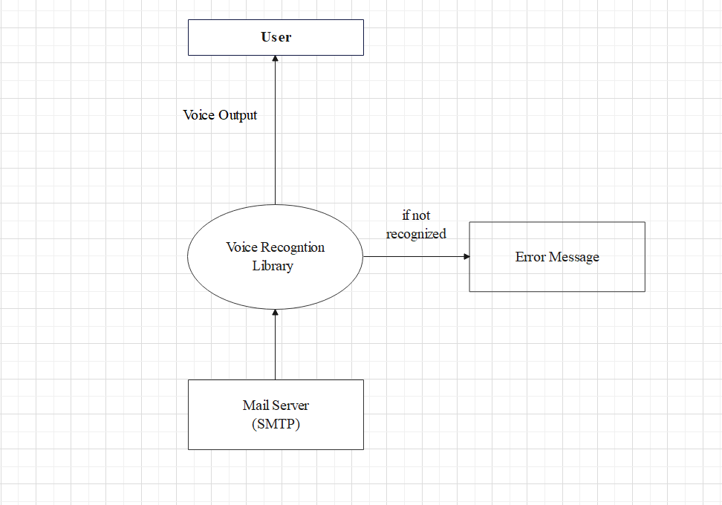

DFD level 2 (for receive mail)

1. Activity Diagram

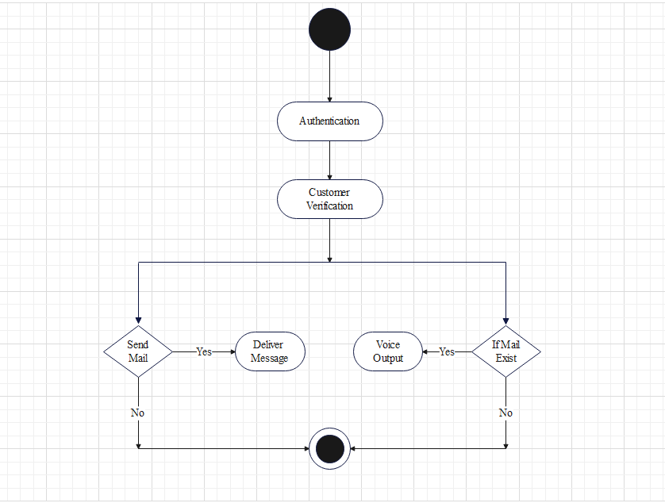

1. Sequence Diagram

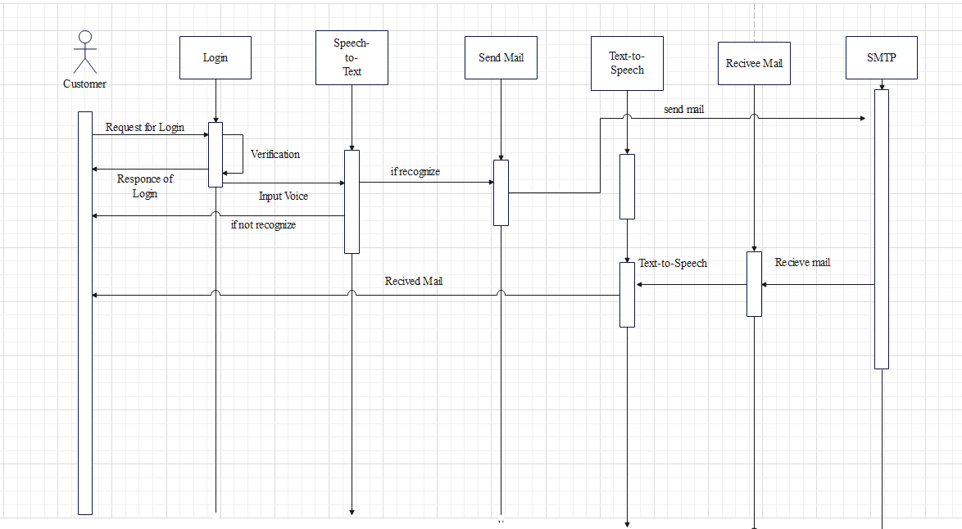

1. ER-Diagram

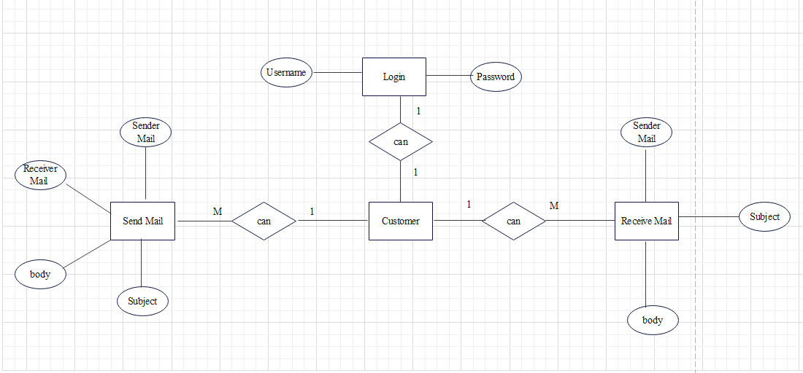

1. Design User Interface

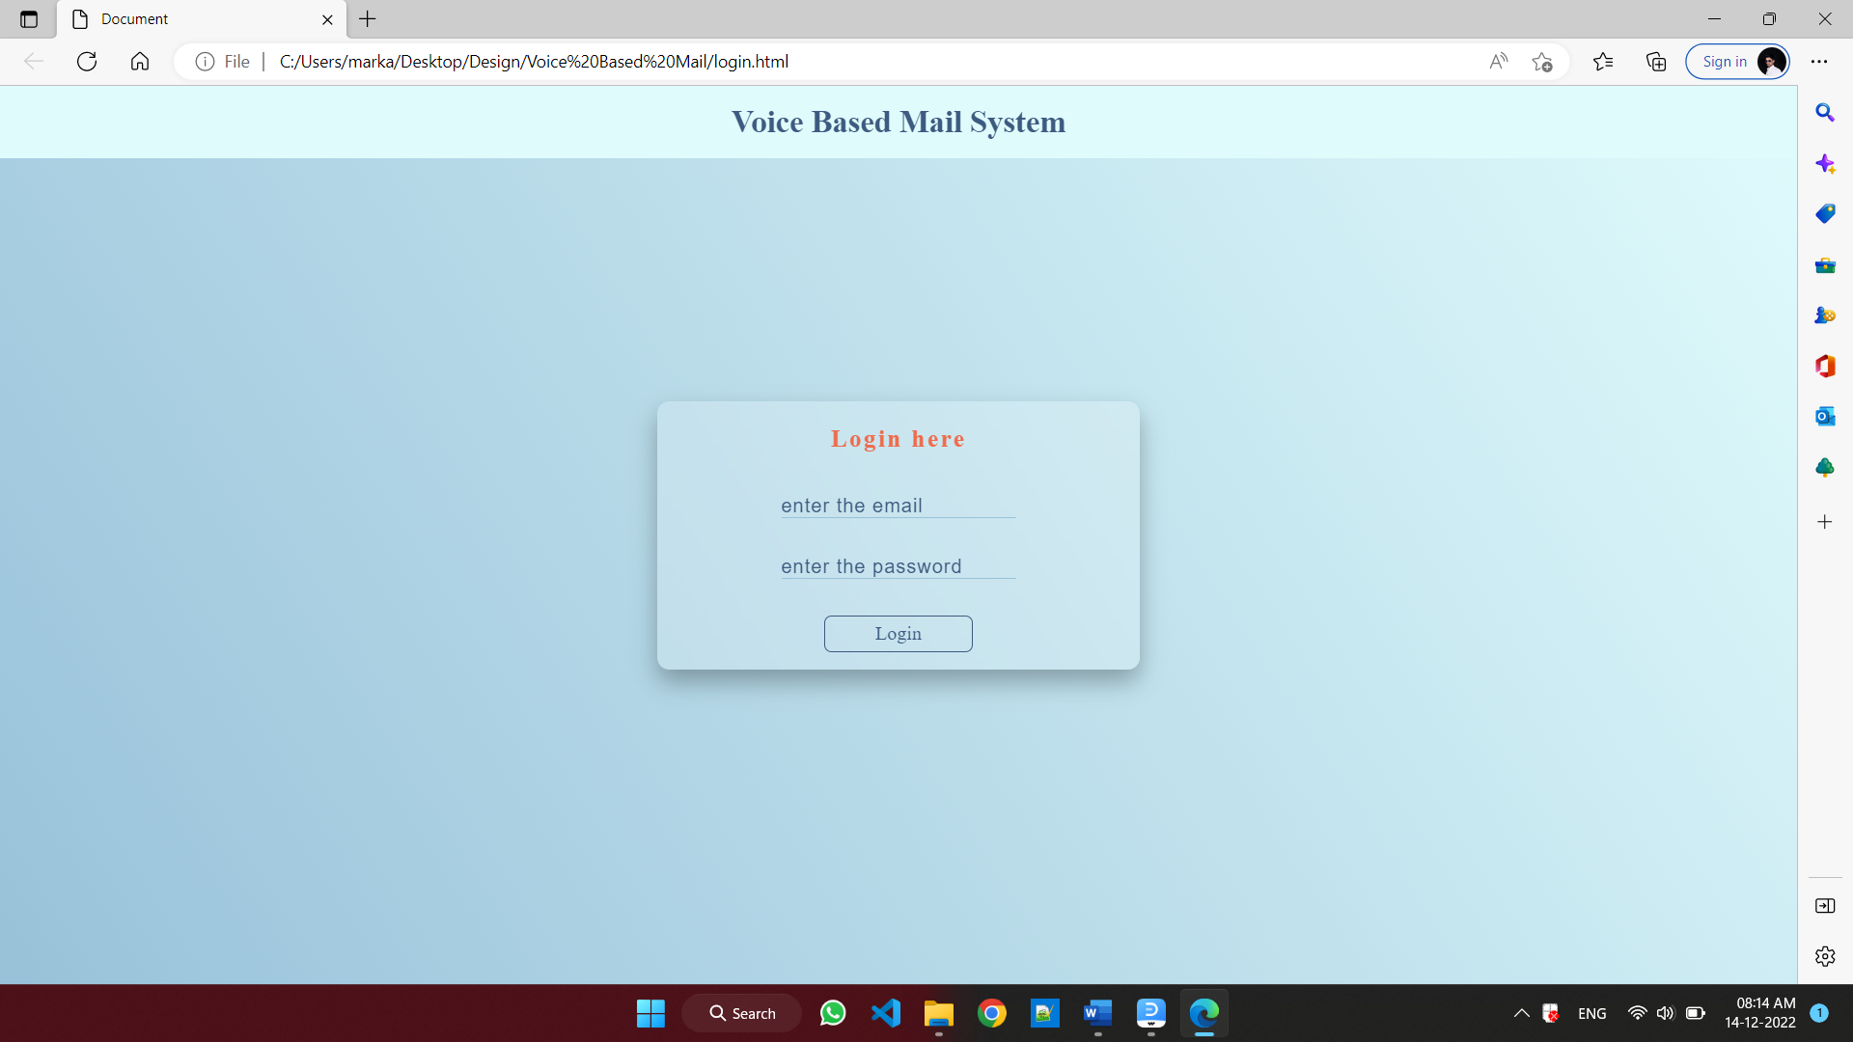

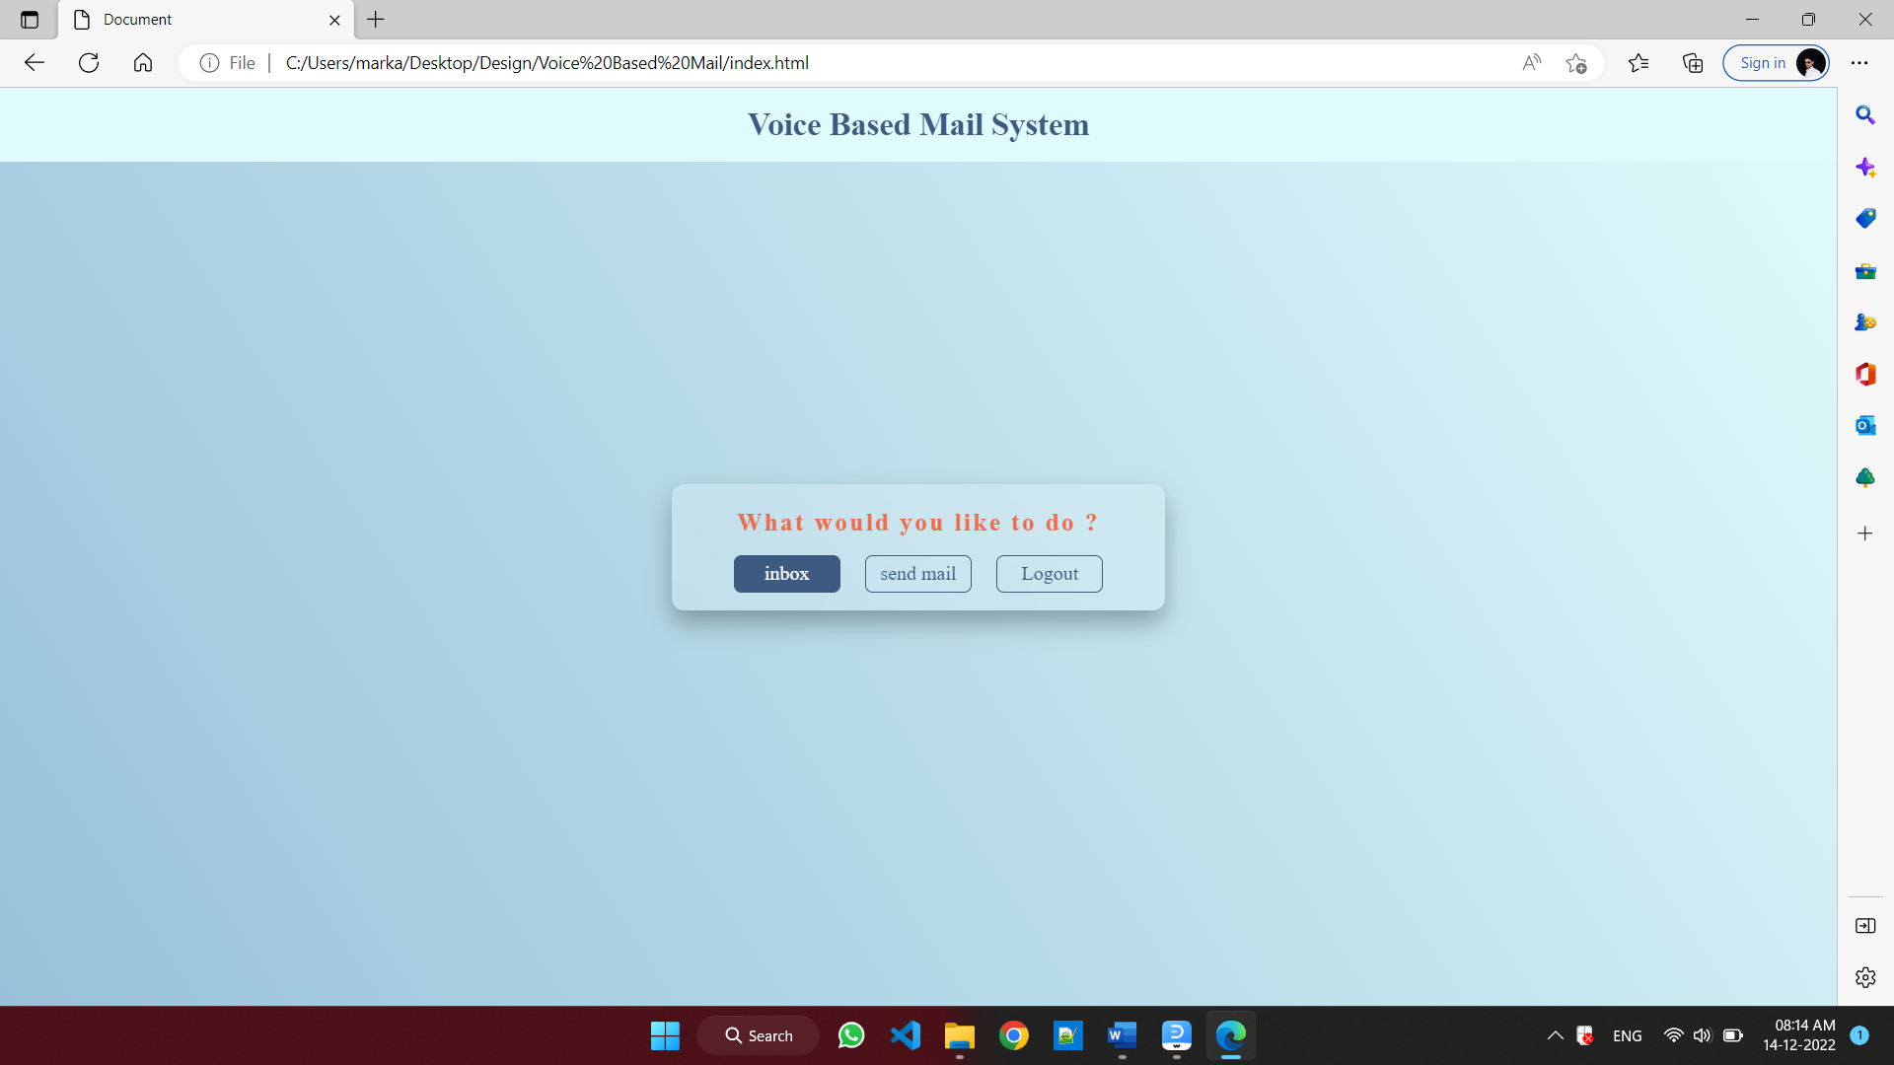

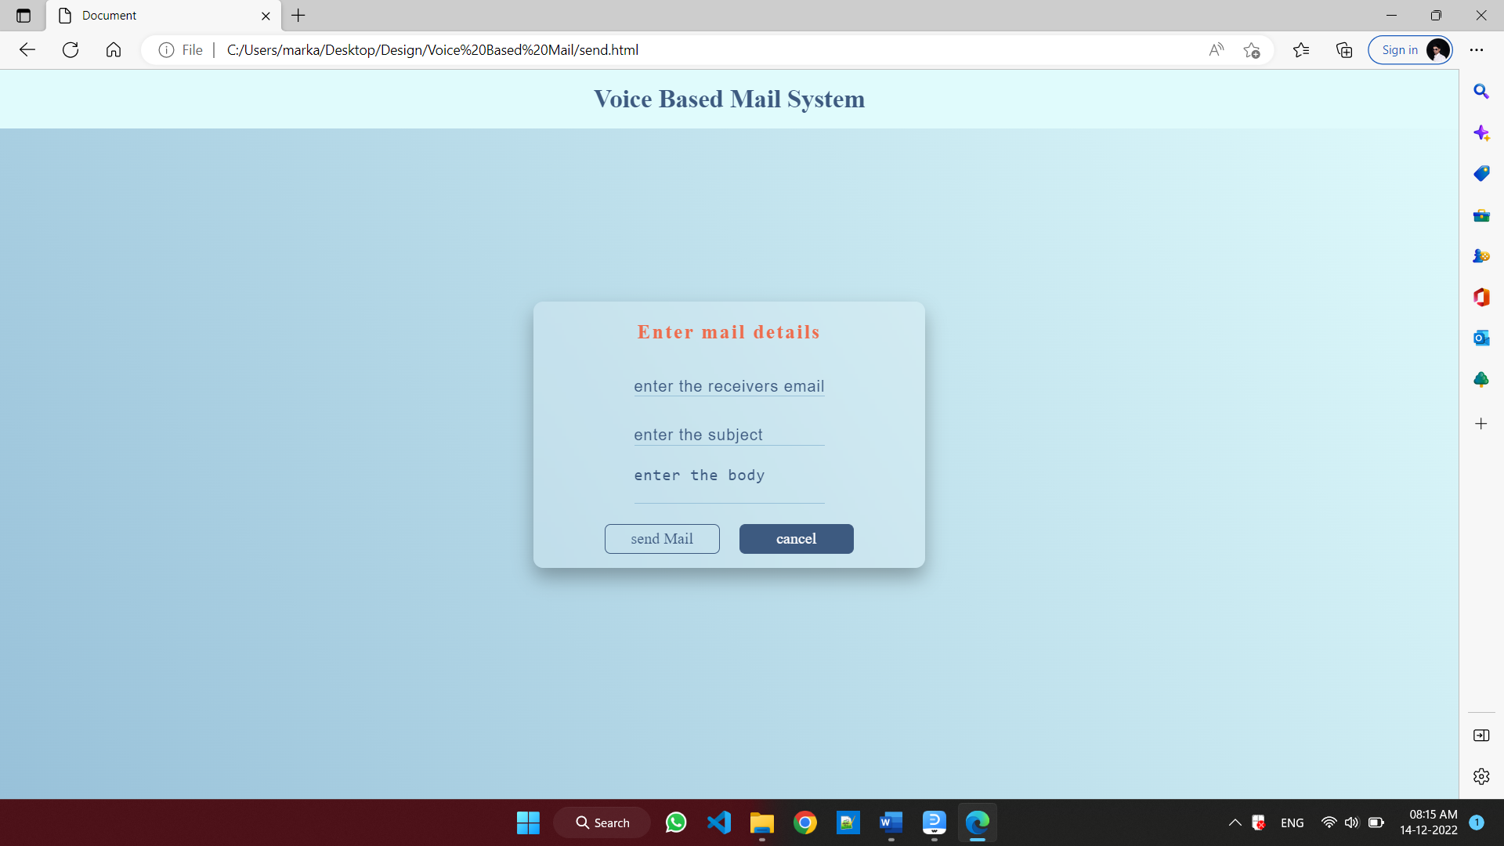

1. Database Design