**A PROJECT REPORT ON**

**Capstone Project Planning**

VOICE BASED MAIL FOR VISUALLY CHALLENGED

**Submitted by**

**Mr. Markad Avinash Ganpat (2111100160)**

**Mr. Momin Faiz Sharif (2011100046)**

**Mr. Thombare Rushikesh Dadaso (2011100045)**

**Ms. Jadhav Ankita Shahaji (2111100234)**

**UNDER THE GUIDANCE OF**

**Ms. Yadav K.V.**

**IN PARTIAL FULFILLMENT OF**

**DIPLOMA IN COMPUTER ENGINEERING MAHARASHTRA STATE BOARD OF TECHNICAL**



**EDUCATION VIDYA PRATISHTHAN’S POLYTECHNIC**



CERTIFICATE

This is to certify that the Capstone Project Planning

“Voice Based Mail For Visually Challenged”

SUBMITTED BY

|  |  |  |
| --- | --- | --- |
| **Sr.no** | **Name** | **Enrollment No.** |
| 1 | Markad Avinash Ganpat | 2111100160 |
| 2 | Momin Faiz Sharif | 2011100046 |
| 3 | Thombare Rushikesh Dadaso | 2011100045 |
| 4 | Jadhav Ankita Shahaji | 2111100234 |

Has been successfully completed as per the requirements of the Maharashtra State Board of Technical Education, Mumbai in partial fulfilment of diploma in Computer Engineering. For the academic year 2022-2023

|  |  |  |  |
| --- | --- | --- | --- |
|  |  |  |  |
|  |  |  |  |

**Ms. Yadav K.V. Prof. Bhuse S.H. Prof. Veer R.A.**

**PROJECT GUIDE HOD PRINCIPAL**

**ACKNOWLEDGEMENT**

After the successful planning of our project, we overcome with a sense of gratitude towards those people, without whose support, guidance and cooperation this would never have been possible.

First and foremost, we would like to thanks our **H.O.D. Mr. Bhuse S. H.** for his valuable guidance which provided us with a perfect path on which we were able to successful planning our ideas.

We heartily like to thank our **Principal Mr. Veer R. A.** for their valuable support. Last but not least we would like to thank all our classmates and parents for their enthusiasm and great ideas.

**Submitted by**

Mr. Markad Avinash Ganpat

Mr. Momin Faiz Sharif

Mr. Thombare Rushikesh Dadaso

Ms. Jadhav Ankita Shahaji

**INDEX**

|  |  |  |  |  |
| --- | --- | --- | --- | --- |
| **Sr.No** |  |  | **Chapter Name** | **Page No** |
| I |  |  | **Introduction** |  |
| 1.1 |  | Introduction of project | 1 |
| 1.2 |  | Problem definition | 1 |
| 1.3 |  | Scope of project | 1 |
| II |  | | **Concepts** |  |
| 2.1 |  | Literature Survey /Comparison with Similar Systems | 2 |
| III |  | | **Requirement Analysis** |  |
| 3.1 |  | Objective of project | 3 |
| 3.2 |  | User Requirement | 3 |
| 3.3 |  | Hardware and software requirement | 3 |
| IV |  | | **System Design and modelling** |  |
| 4.1 |  | UML Diagrams- DFD Level 0 | 04 |
| 4.2 |  | DFD Level 1 | 04 |
| 4.3 |  | DFD Level 2 | 05 |
| 4.4 |  | Activity Diagram | 07 |
| 4.5 |  | Sequence Diagram | 08 |
| 4.6 |  | ER Diagram | 08 |
| 4.7 |  | Use Case | 09 |
| 4.8 |  | Class Diagram | 10 |
| 4.9 |  | Design User Interface | 11 |
| 4.10 |  | Database Design | 13 |
| V |  | | **Future Scope and Limitations** |  |
| 5.2 |  | Future Scope | 14 |
| 5.2 |  | Limitations | 14 |
| VI |  |  | **Biography** | 15 |
|  |  |  | **Apendix** | 16 |

**ABSTRACT**

Mail is considered as one of the most pervasive form of communication. However, all these technologies can be of no use to the people who are visually impaired as all activities that can be performed on the computer are based on visual perception. With the advent of technologies in mobile phones, many technological solutions have been implemented for visually impaired so that they can utilize them, and get benefited by them. Considering it as a key idea application will be built that will help blind people to send and read Mails as ordinary people do. Speech has not been used much in the field of electronics and computers due to the complexity and variety of speech signals and sounds. However, with modern processes, algorithms, and methods, the processing of speech signals easily and recognize the text. The application will not let the user to make the use of keyboard instead will work on text to speech and vice versa to facilitate sending, reading, forwarding and replying to Mails using an android smart phone. The app will be developed this on android platform. Our speech-to-text module directly acquires and converts speech to text. Speech recognition is done via the Internet, connecting to Googles server.

**CHAPTER 1**

**“ Introduction “**

1. **Introduction of project :-**

As the title suggests, the application will be a web-based application for visually impaired persons using IVR- Interactive voice response, thus enabling everyone to control their mail accounts using their voice only and to be able to read, send, and perform all the other useful tasks. The system will prompt the user with voice commands to perform certain action and the user will respond to the same. The main benefit of this system is that the use of keyboard is completely eliminated, the user will have to respond through voice and mouse click only. Now you must be thinking that how will a blind person will see the correct position on the screen for doing mouse clicks. But this system will perform actions based on the clicks only that is left click or right click, it does not depend on the portion of the screen where the cursor is placed before the click giving user the freedom to click blindly anywhere on the screen.

1. **Problem Definition :-**

The project title voice based Mail system is a web based application developed that allows blind people to use Mail system easily. The proposed system focuses on providing the basic functionalities like composing, reading, sending and receiving Mails along with voice based interaction.

1. **Scope Of Project :-**

There is wide future scope of this system many enhancements can be done in the system such as including different languages, including functionality of accessing the deleted mails and spam mails. Also, this system can be enhanced such that it can also send attachments which are more beneficial for visually challenged people. This system can be made available to all regional people who are not educated enough and inclusion of different languages will make this system easily accessible. Further more sign language system can also be integrated with the system to make the system more scalable and robust.

**CHAPATER 2**

**“ Concepts “**

**2.1 Literature Survey /Comparison with Similar System :-**

Existing systems of today are basically applications that provide accessing and managing of Mails benefits to its users via web facilities. Making Mail widely used communication form. The existing systems do not support any voice commands or audio facilities and therefore it is not suitable for visually challenged people. Also, there are various existing search engine which take request in form of text from user and retrieve the relevant documents from server and responds by displaying it in the form of text which is not possible for visually challenged people.

**CAHAPTER 3**

**“ Requirement Analysis ”**

* 1. **Objective of project**

This project aims at developing an Mail system that will help even a naïve, visually impaired person to use the services for communication without previous training. The system does not require the use of keyboard. Instead it will work only on mouse operations and speech conversion to text. This system can also be used by any normal person, for instance, by someone who is unable to read.

* 1. **User Requirement-**

1. Correctness is the degree to which the software performs is required functions.
2. The main moto of the degree performance is that the developed system should perform all the tasks the user has specified.
3. The developed software is user friendly by which the user can understand the software easily.
4. The user wants the software must be maintained properly before accepting the software.
   1. **Hardware and Software Requirements**

**Hardware:**

* + - Processor : Dual Core or above
    - RAM : 2GB or Higher
    - Hard Disk : 20GB

**Software:**

* + - Operating system : Windows any version
    - Database server : MySQL
    - Tool : VSCode Editor
    - Libraries: Text-to-speech API , Speech-to-text API

# CHAPTER 4

**“System Design and modelling”**

**4.0 System Design & Modelling:-**

**4.1. DFD Level - 0**

1. Data Flow Diagrams

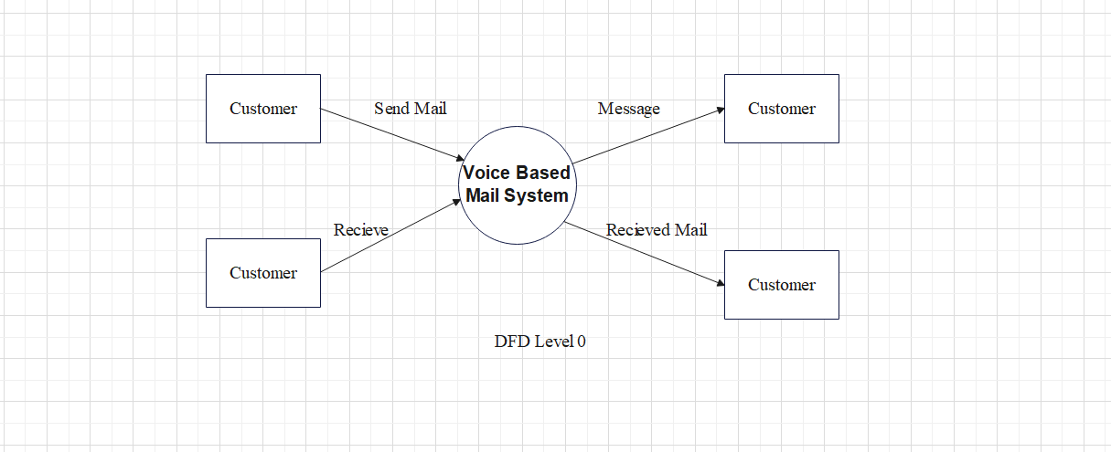

* 1. **DFD Level - 1**

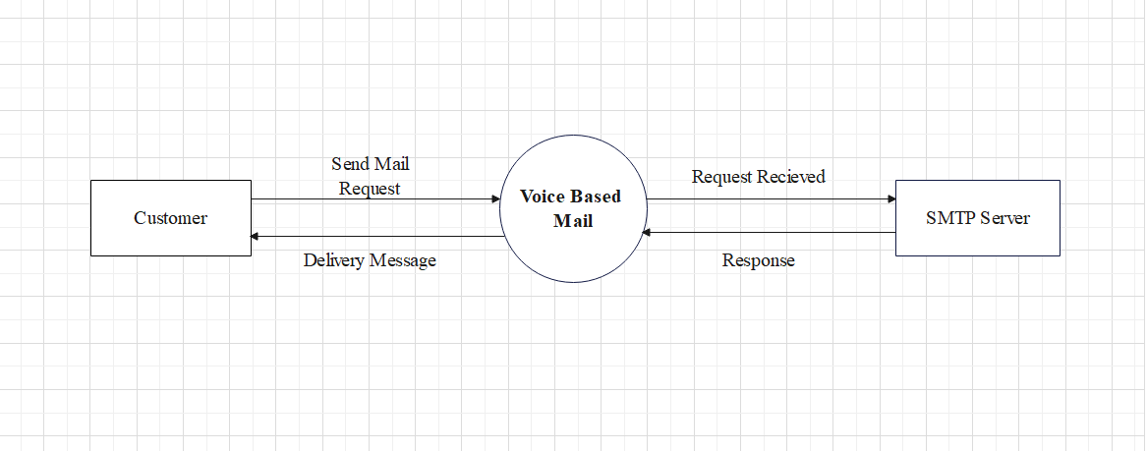

DFD level 1 (for send mail)

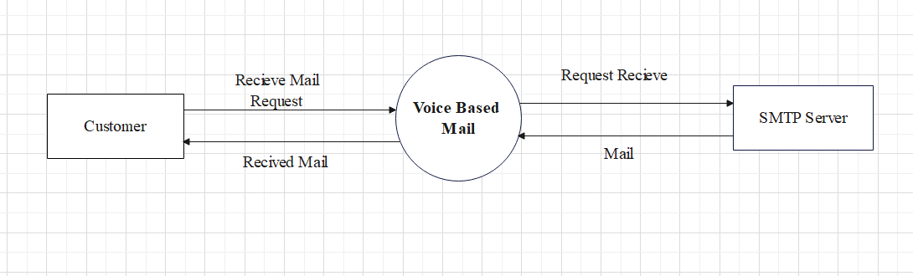

DFD level 1 (for receive mail)

* 1. **DFD Level - 2**

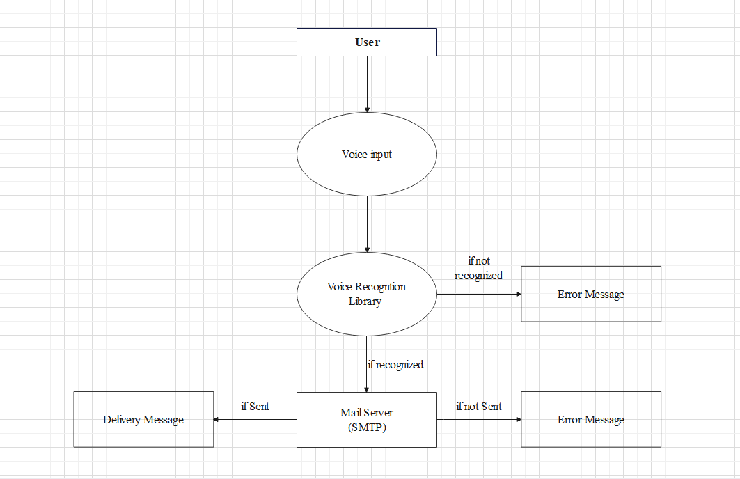

DFD level 2 (for send mail)

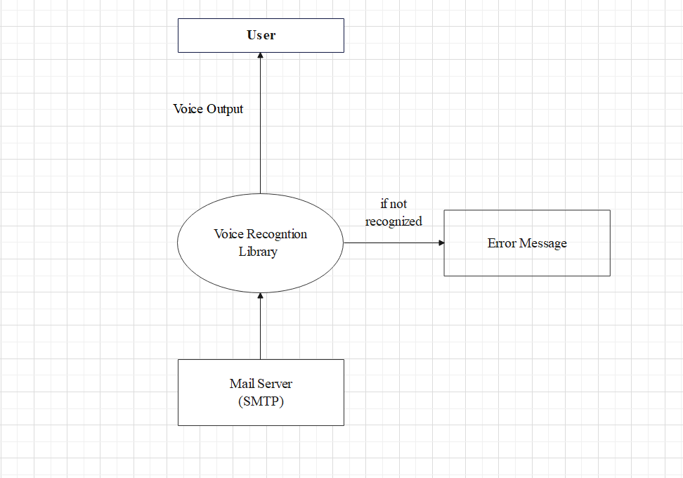

DFD level 2 (for receive mail)

* 1. **Activity Diagram**

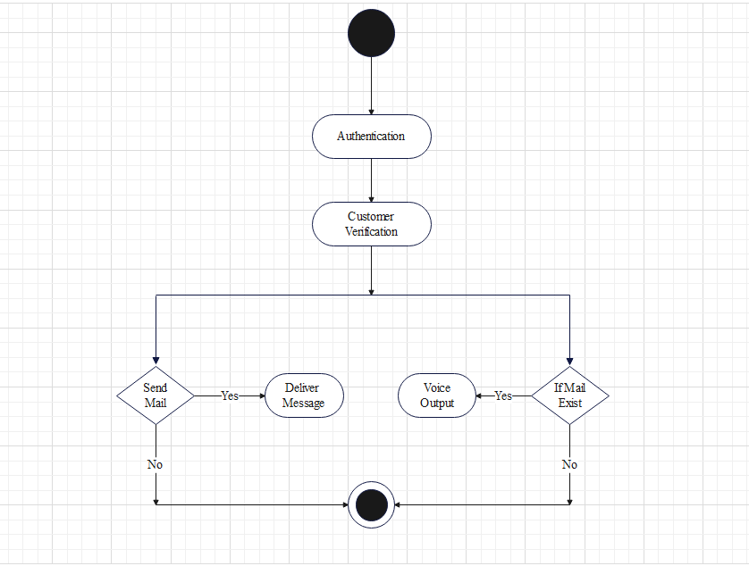

* 1. **Sequence Diagram**

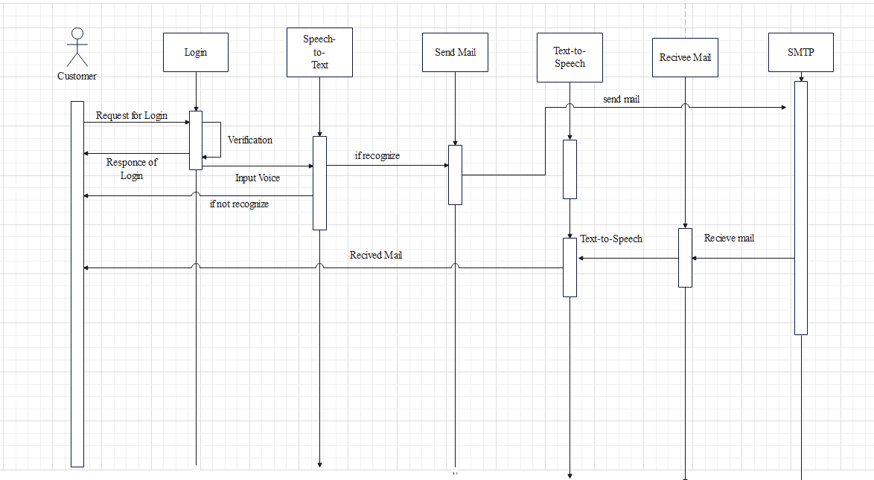

* 1. **ER-Diagram**

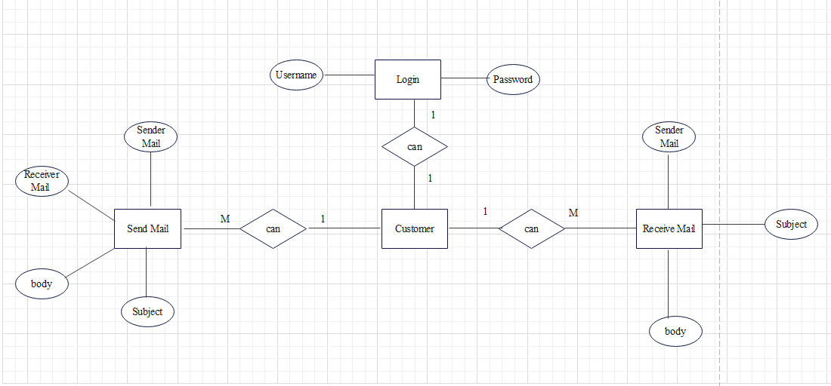

* 1. **Use Case**

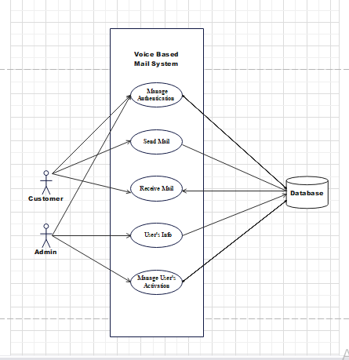

* 1. **Class Diagram**

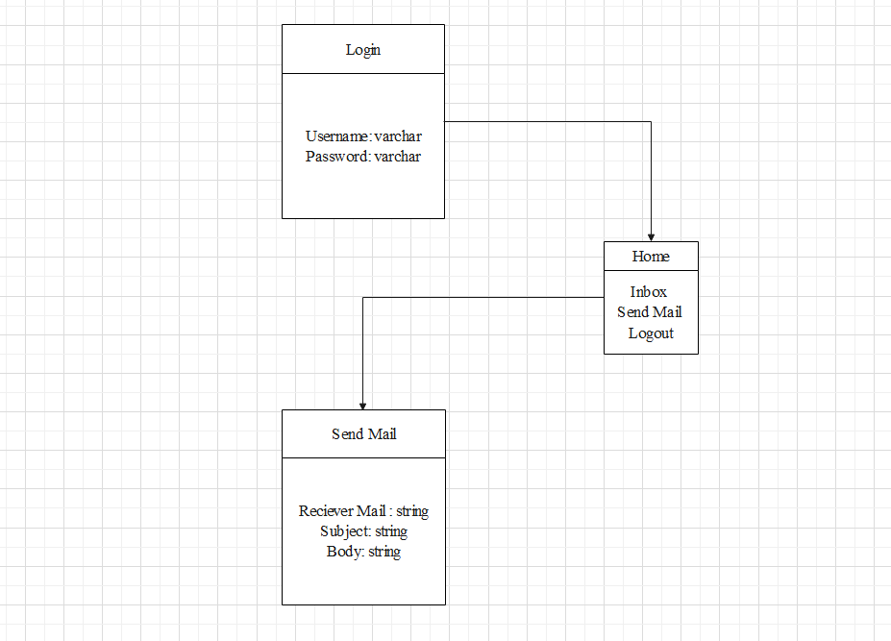

* 1. **Design User Interface**

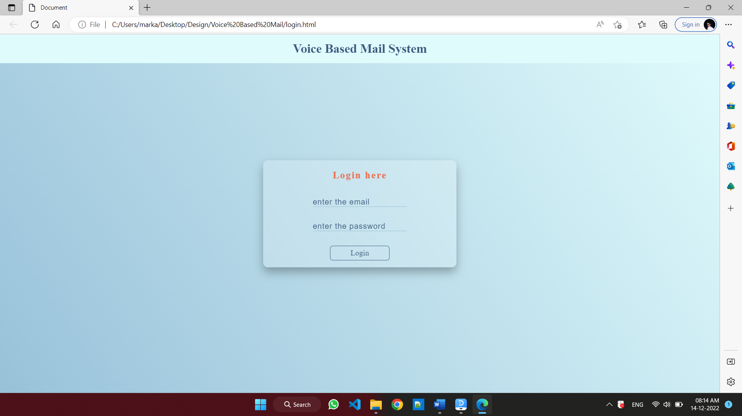

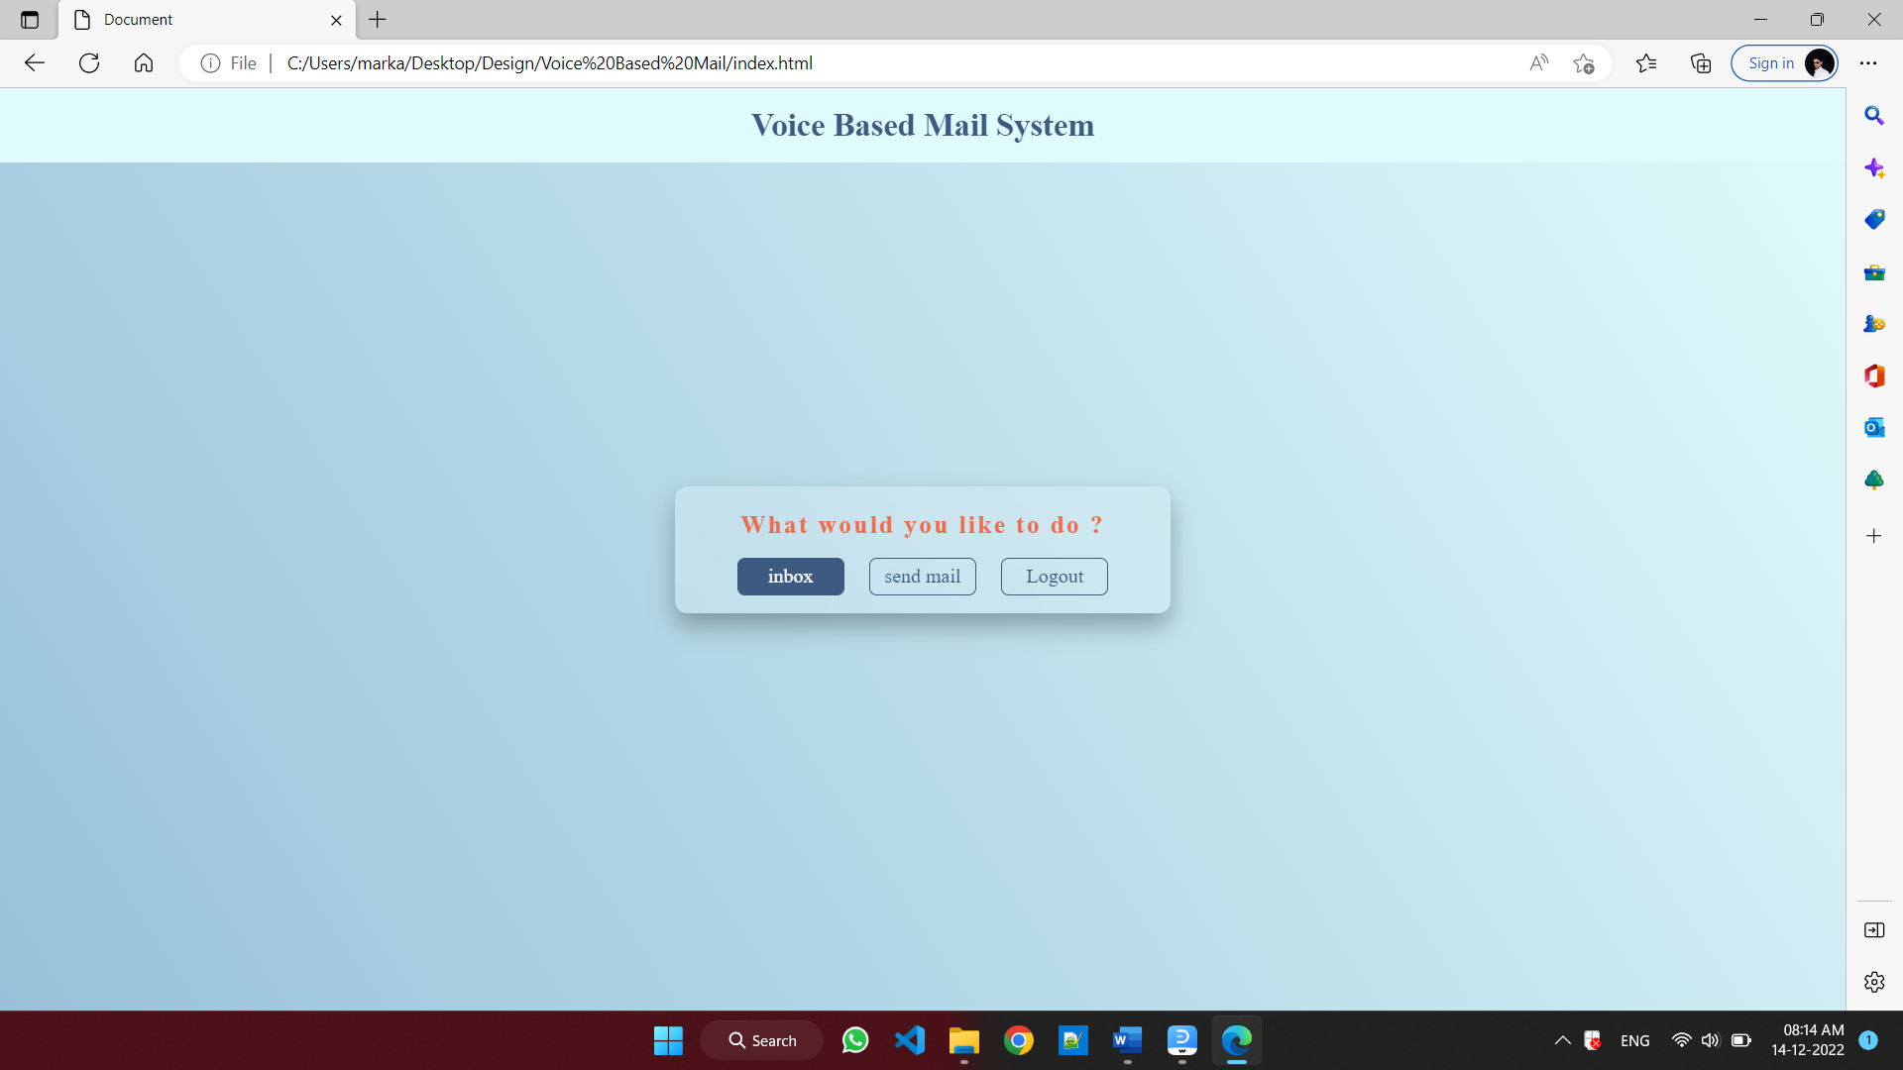

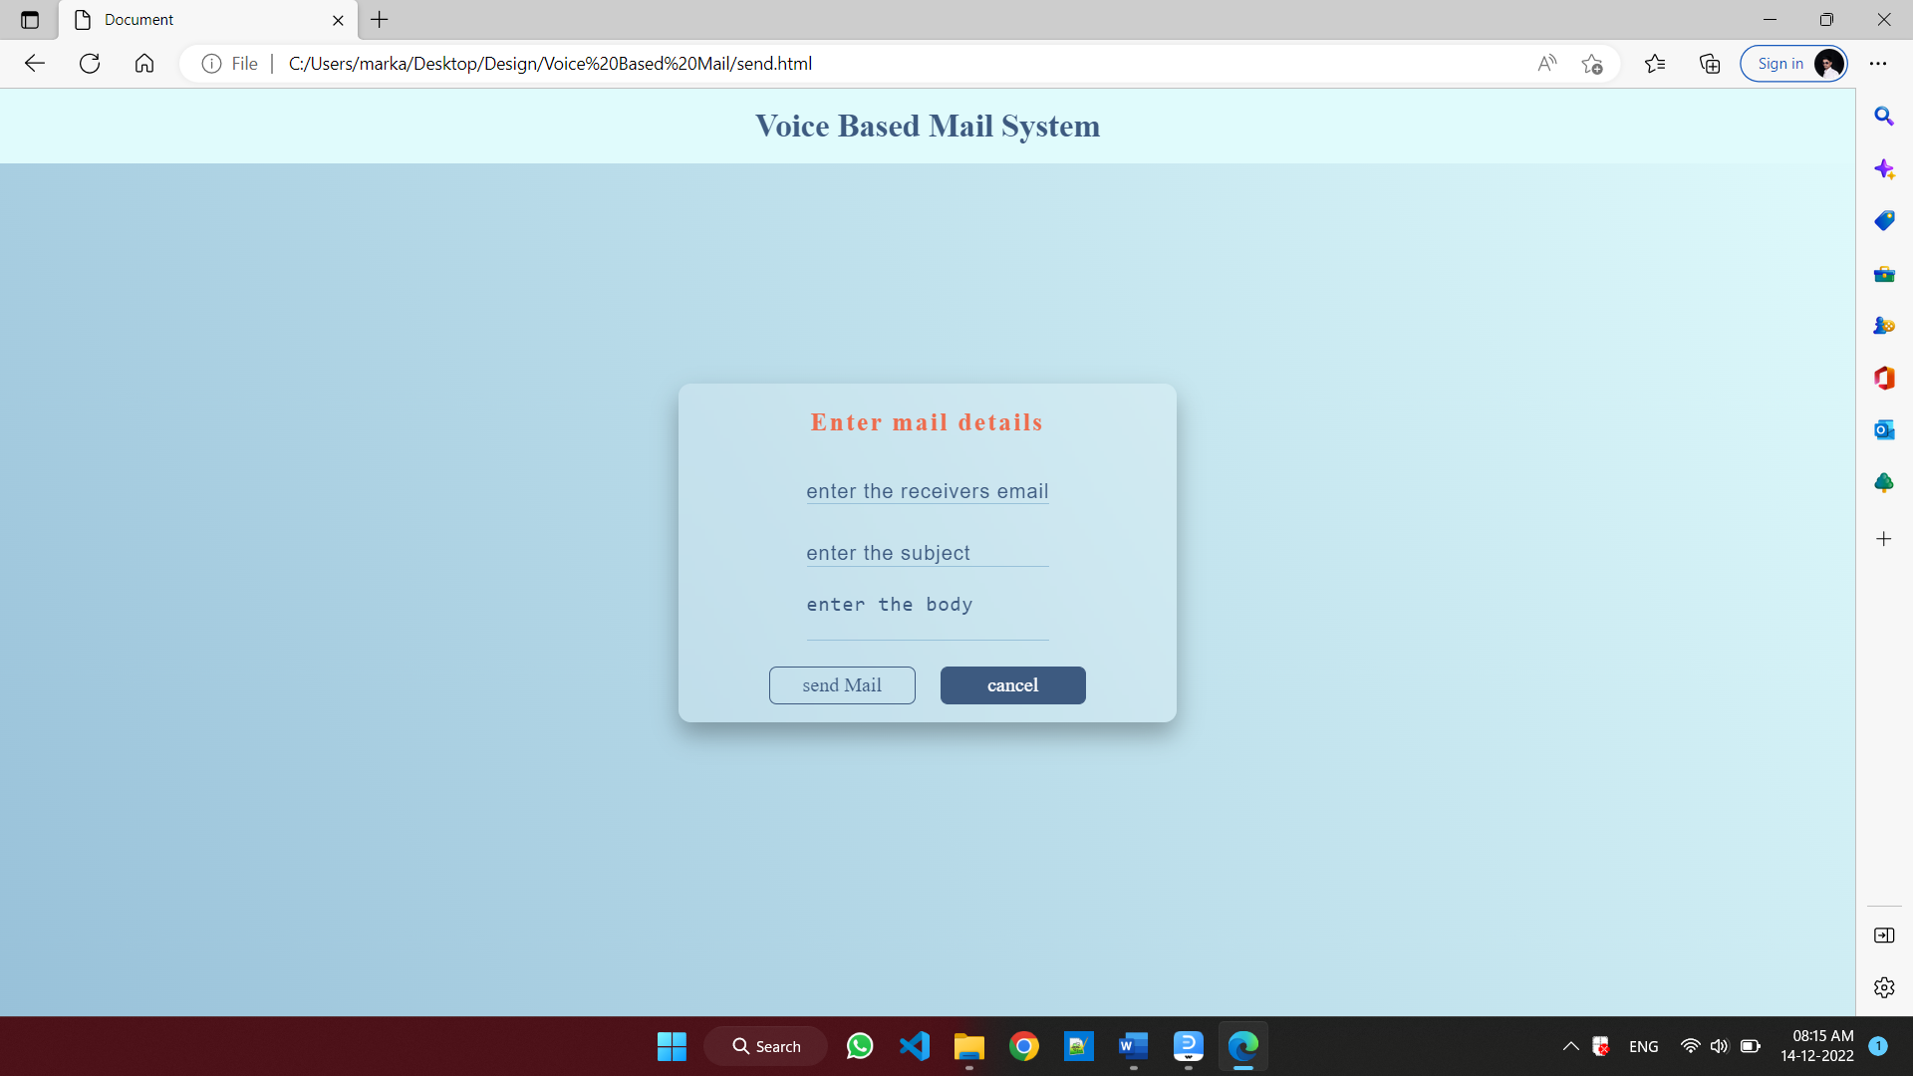

* 1. **Database Design**

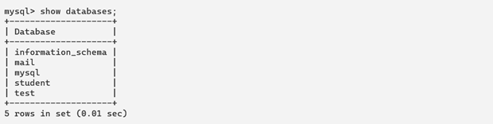

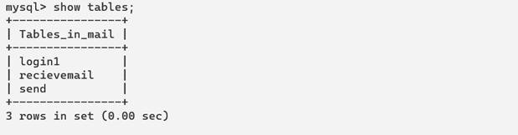

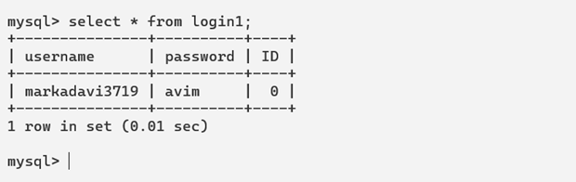

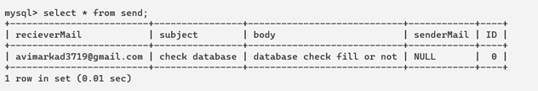

# CHAPTER 5

# “Future Scope and Limitation”

* 1. **Future Scope :**

For the further development of the application , the attachments like images, word documents, audio and video files can be incorporated. Encryption and decryption algorithm can used to protect the username and password that is passed during login. More commands can be used to for different operations like search, mark important, delete, archive, go back, report spam, forward. Automated replying to received mails can be also integrated. The application can be adapted to different languages such that a variety of users can use the application.

* 1. **Limitation :**
* Some people cannot use the voice-messaging systems.
* Difficult for people to recall which options they used previously.
* You will get tired of listening to the messages and end up deleting the messages without
* listening to them, This causes you to miss the important messages.

**CHAPTER 6**

**“Biography”**

* 1. **Books Referred :**
* Sonali Malap,Vaishali Shirke,Mrunali Chalke,Rohan Jain,Sonali Pakhmode.(2016). Voice based Email System for Visually Impaired People presented at IJSRD. .[Online].Available: https://www.scribd.com/doc/299063840/Voice-Based-Email-System-for-Visually-Impaired-People
* Poonam Pate, Zeeshan Tamboli, Harsh Panchal, Diksha Jain.(2017). Voice Based E-mail Application for Blind/Visually Impaired People presented at IJARIIE.[Online].Available: http://ijariie.com/AdminUploadPdf
  1. **Web References :**

1. [**https://www.geeksforgeeks.org/project-idea-voice-based-email-visually-challenged/**](https://www.geeksforgeeks.org/project-idea-voice-based-email-visually-challenged/)
2. [**https://www.researchgate.net/publication/344296191_Voice_based_E-mail_for_the_Visually_Impaired**](https://www.researchgate.net/publication/344296191_Voice_based_E-mail_for_the_Visually_Impaired)

**6.3 Conclusion :**

This project proposes an web, designed specifically for visually challenged people. This web provides a voice based mailing service where they could read and send mail on their own, without any guidance. Here the users have to use certain keywords which will perform certain actions for e.g. Received mails, Send mails, Compose Mail. VMAIL can be used by a blind person to access mails easily and efficiently. Thus reliance of visually impaired on other people for their activities related to mail can be reduced.

**Appendix-B**

**Evaluation Sheet(ESE)**

**For**

**“Capstone Project Planning”**

**Name of the student:-** Mr. Markad Avinash Ganpat

Mr. Momin Faiz Sharif

Mr. Thombare Rushikesh Dadaso

Ms. Jadhav Ankita Shahaji

**Enrollment No:-** 2111100160

2011100046

2011100045

2111100234

**Name of the Program:-**  Computer Engineering **Semester:-** 5-I

**Course Title and Code:-** Capstone Project Planning (22058)

**Title of the Capstone Project:-** Voice Based Mail For Visually Challenged

**A**. **Programme Educational Objectives (PEO)**

PEO 1. Provide socially responsible, environment friendly solutions to Computer engineering related broad-based problems adapting professional ethics.

PEO 2. Adapt state-of-the-art Computer engineering broad-based technologies to work in multi-disciplinary work environments.

PEO 3. Solve broad-based problems individually and as a team member communicating effectively in the world of work.

**B. POs addressed by the Capstone Project**

PO 1. Basic knowledge: Apply knowledge of basic mathematics, sciences and basic engineering to solve the broad-based Computer engineering problem.

PO 2.Discipline knowledge: Apply Computer engineering discipline - specific knowledge to solve core computer engineering related problems.

PO 3. Experiments and practice: Plan to perform experiments and practices to use the results to solve broad-based Computer engineering problems.

PO 4. Engineering tools: Apply relevant Computer technologies and tools with an understanding of the limitations.

PO 5. The engineer and society: Assess societal, health, safety, legal and cultural issues and the consequent responsibilities relevant to practice in field of Computer engineering.

PO 8. Individual and team work: Function effectively as a leader and team member in diverse/ multidisciplinary teams.

PO 9. Communication: Communicate effectively in oral and written form.

PO 10.Life-Long Learning: Engage in independent and life-long learning activities in the context of technological changes in the Computer engineering field.

**C. Program Specification Outcome (PSO)**

1. **Computer Software and Hardware Usages:** Use state-of-the-art technologies for oration and application of computer software and hardware.
2. **Computer Engineering Maintenance:** Maintain computer engineering related software and hardware system.

**D. COs addressed by the capstone project**(Mention only those predominant COs)

1. Write the problem/task specification in existing system related to the occupation.
2. Select, collect and use required information/knowledge to solve the problem/complete the task.
3. Prepare ‘project proposals’ with action plan.

**E. Other learning outcomes achieved through this project**

**1. Unit Outcomes(Cognitive Domain)**

1. Plane to perform experiments and practices to use the results to solve broad-based computer engineering problems.
2. Function effectively as a leader and team member in diverse/multidisciplinary teams.

**2. Practical Outcome(in Psychomotor Domain)**

1. Apply knowledge of basic engineering to solve the broad-based Computer engineering problems.
2. Apply relevant computer technologies and tools with an understanding of the limitations.

**3. Affective Domain Outcomes**

1. Follow precautionary measures.
2. Follow naming conventions.
3. Follow ethical practices.

|  |  |  |  |
| --- | --- | --- | --- |
| **PROGRESSIVE ASSESSMENT(PA) Sheet** | | | |
| Sr  No. | Criteria | Max Marks | Marks Obtained |
| 1. | Problem Identification/Project Title | 10 |  |
| 2. | Industrial survey And Literature Review |
| 3. | Punctuality and overall contribution |
| 4 | Project Diary |
| 5 | Report Writing including documentation | 10 |  |
| 6 | Presentation | 05 |  |
| Total | | 25 |  |

**Signature of Project Guide**