- INTRODUCTION

1.1 OVERVIEW
The agricultural sector, particularly dairy farming and livestock management, has witnessed a significant shift toward technology-driven practices in the twenty-first century. Among the various challenges that persist in this domain, the accurate and consistent identification and classification of livestock animals remains a critical operational need. Cattle and buffaloes, the two most economically significant livestock species in India, share visual similarities that make manual differentiation challenging, especially under variable field conditions such as poor lighting, diverse camera angles, and herd environments.
Image-Based Animal Type Classification refers to the automated process of identifying the type of animal (cattle or buffalo) from a digital photograph using computer vision and deep learning techniques. This project develops such a system using Convolutional Neural Networks (CNN), specifically leveraging the ResNet50 architecture with transfer learning, to achieve high accuracy in binary classification of cattle and buffalo images.
The system is designed as an end-to-end pipeline that accepts an animal image as input, performs preprocessing and feature extraction, classifies the animal using a fine-tuned ResNet50 model, and returns a prediction label along with a confidence score. The results are presented through a web-based dashboard accessible via API, making the system suitable for integration into existing farm management platforms, veterinary applications, and national livestock databases such as the Bharat Pashudhan App (BPA) under the Rashtriya Gokul Mission.
This chapter provides an overview of the project's background, motivation, problem definition, objectives, scope, limitations, and the methodology adopted for system development.

1.2 MOTIVATION
India holds the largest bovine population in the world, with over 300 million cattle and buffaloes contributing significantly to the national dairy economy. The Government of India, through schemes such as the Rashtriya Gokul Mission (RGM), actively promotes the genetic improvement of indigenous cattle and buffalo breeds. A key component of these programs is Animal Type Classification (ATC), which involves evaluating the physical traits and morphological characteristics of animals to identify elite females for breeding programs including Progeny Testing and Pedigree Selection.
Currently, ATC is performed manually by trained livestock inspectors who visually assess parameters such as horn shape, body size, skin texture, udder structure, and facial features. This manual process is time-consuming, inconsistent across different evaluators, and heavily dependent on individual expertise. In regions with large herds or remote geographical locations, the availability of qualified inspectors is limited, creating bottlenecks in the breeding evaluation pipeline.
The rapid advancement of deep learning and computer vision technologies offers a compelling solution to these challenges. Modern CNN architectures such as ResNet50, VGG-16, and EfficientNet have demonstrated near-human accuracy in fine-grained visual recognition tasks. By applying these technologies to livestock classification, it becomes possible to automate the ATC process, reduce subjectivity, improve consistency, and significantly accelerate field assessments. Furthermore, the integration of such a system with mobile applications enables rural farmers and field veterinarians to perform classifications instantly using standard smartphones.
This project is motivated by the dual objective of applying state-of-the-art artificial intelligence to a real-world agricultural problem of national importance, while simultaneously developing a scalable, deployable, and practically useful solution for India's livestock management ecosystem.

1.3 PROBLEM DEFINITION AND OBJECTIVES
1.3.1 Problem Statement
Manual animal type classification of cattle and buffaloes is inherently subjective, prone to inconsistency, and dependent on the availability of domain-experienced personnel. The current evaluation process requires physical presence of trained assessors, who apply qualitative judgments based on visual observation of morphological features. This approach suffers from several critical limitations: inter-evaluator variability causes non-uniform classification outcomes; scaling the process to large herds is resource-intensive; and in low-connectivity rural areas, timely evaluation is often infeasible. These limitations compromise the quality and reliability of data feeding into national breeding programs such as the Rashtriya Gokul Mission, ultimately affecting the genetic improvement objectives.
There exists a clear need for an automated, objective, and scalable solution that can accurately classify cattle and buffaloes from images, provide confidence-based predictions, and integrate with existing livestock management platforms.

1.3.2 Objectives
The project aims to achieve the following specific objectives:
- To develop a deep learning-based image classification system using CNN and the ResNet50 architecture for automated identification of cattle and buffaloes from digital images.
- To implement a comprehensive image preprocessing pipeline incorporating resizing, normalization, noise reduction, and data augmentation techniques to improve model robustness and generalization.
- To apply transfer learning by fine-tuning the ResNet50 model pretrained on ImageNet, enabling high classification performance with a domain-specific dataset.
- To build and deploy a web-based application with a Flask/Django backend and React/Flutter frontend that allows users to upload images and receive real-time predictions with confidence scores.
- To design a database module for storing prediction logs, image metadata, and classification history for audit and analytical purposes.
- To evaluate the system performance using standard metrics including accuracy, precision, recall, F1-score, and confusion matrix analysis.
- To create a scalable and extensible system architecture that can be integrated with mobile applications and national livestock management platforms.

1.4 SCOPE AND LIMITATIONS
1.4.1 Scope
The scope of this project encompasses the design, development, training, testing, and deployment of an image-based binary classification system for cattle and buffaloes. The system operates on digital images obtained through standard cameras or smartphones, making it accessible to farmers and field veterinarians without specialized equipment. The classification system outputs a predicted animal type label (Cattle or Buffalo) along with a probability-based confidence score. The web dashboard provides real-time results, classification history, and performance monitoring capabilities.
The system is designed to support integration with existing livestock management platforms and national agricultural databases. The architecture is modular and extensible, allowing future additions such as breed-level classification, health condition detection, and integration with IoT sensors and CCTV monitoring systems.
1.4.2 Limitations
The current version of the system has the following limitations that define the boundaries of the project:
- The system performs binary classification (cattle vs. buffalo) and does not support multi-breed or multi-species classification in its current form.
- Classification accuracy may be reduced for images with severe occlusion, extreme lighting conditions, very low resolution, or heavily blurred animal features.
- The system requires images where the animal is the primary subject. Full-body or facial images produce the best results; images with multiple animals in close proximity may reduce accuracy.
- The model is trained on a dataset collected primarily from Indian agricultural settings; performance on animals from significantly different geographical regions may vary.
- The system does not currently support video-based real-time classification; it processes static images only.

1.5 METHODOLOGY
The development of this project follows a structured and iterative methodology incorporating best practices from software engineering and machine learning. The overall methodology consists of the following phases:
Phase 1 – Dataset Collection and Preparation: A diverse dataset of cattle and buffalo images was assembled from multiple sources including public repositories, open-source agricultural datasets, farm photography, and camera trap archives. Images representing various breeds, angles, lighting conditions, and environments were included to ensure dataset diversity and model generalization.
Phase 2 – Image Preprocessing: All collected images were subjected to a standardized preprocessing pipeline. Each image was resized to 224×224 pixels to match the ResNet50 input requirements. Pixel values were normalized to the [0, 1] range. Data augmentation techniques including horizontal flipping, random rotation, zoom, brightness adjustment, and shear transformation were applied to artificially expand the dataset and reduce overfitting.
Phase 3 – Model Design and Training: The ResNet50 architecture, pretrained on the ImageNet dataset, was adopted as the feature extraction backbone. Transfer learning was applied by freezing the convolutional layers and training only the custom classification head initially, followed by selective fine-tuning of deeper ResNet50 layers. The classification head consists of a Global Average Pooling layer, a Dense layer with 256 ReLU neurons, a Dropout layer with rate 0.5, and a Softmax output layer with two neurons corresponding to the two classes.
Phase 4 – Model Evaluation: The trained model was evaluated on a held-out test set using accuracy, precision, recall, F1-score, and confusion matrix analysis. Comparative analysis against baseline models was performed to validate the effectiveness of the ResNet50-based approach.
Phase 5 – System Integration and Deployment: The trained model was integrated into a Flask/Django web backend. A REST API was developed for image upload and classification request handling. The web dashboard, built using React, provides an intuitive interface for image upload, result visualization, and classification history management. MySQL/MongoDB was used for persistent storage of prediction logs.
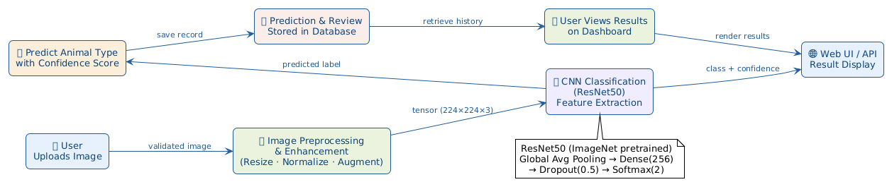
Fig 1.1: Overall System Workflow for Image-Based Animal Type Classification

- LITERATURE SURVEY

This chapter presents a comprehensive review of existing research and published works relevant to image-based animal classification, deep learning for livestock identification, and computer vision applications in agriculture. The survey covers key contributions from 2018 to 2024 and identifies the research gaps that this project addresses.

2.1 DEEP LEARNING FOR ANIMAL AND WILDLIFE CLASSIFICATION
Norouzzadeh et al. [1] presented a seminal study on automatic wildlife recognition using deep learning, demonstrating that CNN models trained on large camera trap datasets could classify 48 species of wildlife with accuracy exceeding 93.8%. Their work established a foundational reference for applying deep learning to automated animal identification and highlighted the importance of large, diverse datasets for achieving high generalization. The study employed ensemble CNNs and underscored the role of data augmentation in improving model robustness.
Khosla et al. [2] explored fine-grained visual classification using deep convolutional networks, demonstrating that discriminative region selection combined with CNN feature extraction significantly improved classification accuracy for visually similar categories. Their insights on part-based annotation and attention mechanisms are directly applicable to livestock classification where distinguishing fine morphological differences (such as horn curvature and ear orientation between cattle and buffalo) is critical.

2.2 LIVESTOCK BODY MEASUREMENT AND COMPUTER VISION
Rahman et al. [7] conducted an extensive survey on computer vision-based sensing technologies for livestock body dimension measurement, reviewing works that use 2D and depth images to extract key physical traits including body length, height, width, and rump angle. The survey covered RGB imaging, depth cameras, and multi-view photogrammetry systems applied to cattle body measurement. A significant finding was that many existing methods depend on controlled imaging environments (fixed backgrounds, optimal lighting) and do not perform well under real-farm conditions with variable poses and occlusions. This limitation reinforces the need for robust preprocessing and data augmentation strategies as implemented in the proposed system.
Sarker and Rahman [6] performed a meta-analysis correlating body traits measured from digital images with actual body weight in beef cattle. Their analysis of multiple studies confirmed that morphological parameters including wither height, hip height, chest depth, and body length have strong correlations with actual weight. The meta-analysis highlighted significant variability across breeds and sexes, suggesting that animal type classification is a prerequisite for accurate downstream biometric analysis. This observation directly motivates the development of an automated cattle-versus-buffalo classifier as a first step in a comprehensive livestock analysis pipeline.

2.3 CNN-BASED CATTLE IDENTIFICATION
Singh and Yadav [5] proposed an automatic cattle identification system using YOLOv5 with mosaic augmentation for muzzle pattern detection. Their comparative analysis demonstrated that YOLOv5-based models could achieve high mean Average Precision (mAP) for cattle muzzle detection, enabling individual animal identification. However, the study focused specifically on identity tracking through muzzle patterns rather than animal-type classification, and the system required high-quality, unobstructed muzzle images. The proposed project addresses a different problem—distinguishing cattle from buffalo based on full-body or facial images—and employs classification rather than detection architecture.
Rodrigues et al. [9] developed a cattle biometric identification system using muzzle pattern images and demonstrated that CNN features could uniquely identify individual animals with high accuracy. Their work confirmed the discriminative power of CNN-extracted features for bovine biometric applications, providing conceptual support for the feature extraction approach adopted in the proposed system.

2.4 MULTI-SPECIES LIVESTOCK CLASSIFICATION
Pan et al. [from research paper] proposed a buffalo breed identification system using self-activated improved CNNs, achieving classification of multiple buffalo breeds including Murrah, Surti, and Nili-Ravi. Their work demonstrated that CNN architectures with custom activation functions and attention mechanisms could distinguish between visually similar buffalo breeds. However, the study was limited to buffalo breeds and did not address the cattle-versus-buffalo type classification problem. The proposed project generalizes the classification to distinguishing between the two most prevalent livestock categories in Indian agriculture.
Abdelrahman et al. [10] provided a comprehensive survey on livestock monitoring using computer vision techniques, covering individual identification, behavior analysis, health condition assessment, and body condition scoring. Their survey confirmed that deep learning approaches consistently outperformed traditional machine learning methods across all livestock monitoring tasks and recommended transfer learning from large-scale models as the most effective strategy for domain-specific applications with limited datasets.

2.5 TRANSFER LEARNING FOR DOMAIN-SPECIFIC CLASSIFICATION
Sharma and Jain [3] investigated livestock image recognition using CNNs and demonstrated that transfer learning from ImageNet significantly reduced training time and improved accuracy compared to training from scratch, even with relatively small domain-specific datasets. Their study recommended ResNet50 and VGG-16 as effective backbone architectures for agricultural image classification tasks, citing their strong feature generalization capabilities. Wang [4] extended this analysis to multiple animal classification scenarios and confirmed that Adam-optimized transfer learning models consistently achieved the best convergence and accuracy.
A review of the literature reveals a clear research gap: while extensive work exists on individual animal identification and body measurement, very few studies specifically address the automated classification of cattle versus buffalo as distinct animal types using a full-stack deployable system. The proposed project fills this gap by developing a complete end-to-end classification system with a practical web interface suitable for deployment in Indian agricultural settings.

2.6 SUMMARY OF LITERATURE SURVEY
Ref. | Paper & Authors | Key Contribution | Research Gap Addressed
[1] PNAS 2018 | Norouzzadeh et al., CNN wildlife classification 48 species | 93.8% accuracy with ensemble CNN on large datasets | Limited to wildlife; no livestock-specific deployment
[5] arXiv 2022 | Singh & Yadav, YOLOv5 cattle muzzle detection | Individual cattle identity via muzzle patterns, high mAP | No cattle vs. buffalo type classification
[7] MDPI 2024 | Rahman et al., Computer vision for livestock body measurement | 2D and depth images for length/height/width measurement | Requires controlled environment; no binary classification
[3] IEEE 2022 | Sharma & Jain, Transfer learning CNN for livestock images | ResNet50 transfer learning outperforms training from scratch | No deployable web system or API integration
Table 2.1: Summary of Literature Survey with Research Gaps

- SOFTWARE REQUIREMENTS SPECIFICATION

This chapter provides a comprehensive Software Requirements Specification (SRS) for the Image-Based Animal Type Classification System. The SRS defines the functional and non-functional requirements, system interfaces, hardware and software dependencies, and the software development life cycle model adopted for the project.

3.1 ASSUMPTIONS AND DEPENDENCIES
The following assumptions have been made during the requirements analysis and system design phases of this project:
- Users of the system will upload clear, adequately lit images of individual animals (cattle or buffalo). The system does not guarantee accurate classification for severely degraded, pixelated, or heavily occluded images.
- The deployment environment provides internet connectivity for accessing the web-based dashboard. Offline mode is not supported in the current version.
- Users uploading images are assumed to have basic digital literacy and access to a device with a camera or image gallery (smartphone, tablet, or desktop computer).
- The server hosting the backend application is assumed to have at least 8 GB RAM, a GPU-enabled environment for model inference, and adequate storage for image and prediction logs.
- The dataset used for training encompasses representative samples of Indian cattle and buffalo breeds under varied conditions. Model performance on breeds or environmental conditions not represented in the training data may be suboptimal.
The system has the following external dependencies:
- TensorFlow/PyTorch framework for model training and inference.
- ResNet50 pretrained weights from the ImageNet repository (available via Keras/PyTorch model libraries).
- Flask or Django web framework for backend API development.
- MySQL or MongoDB for persistent storage of prediction logs and user data.
- React or Flutter for frontend dashboard development.
3.2 FUNCTIONAL REQUIREMENTS
3.2.1 Image Upload Module
The system shall provide a user interface that allows users to upload animal images in JPEG, PNG, or BMP format. The maximum supported image file size shall be 10 MB. The system shall validate the uploaded file format and size before processing. The system shall store the uploaded image securely in the designated storage directory and associate it with a unique session identifier.
3.2.2 Image Preprocessing Module
The system shall automatically preprocess uploaded images prior to classification. Preprocessing shall include: resizing to 224×224 pixels, normalization of pixel values to the [0, 1] range, and optional noise reduction using Gaussian filtering. The system shall support online data augmentation during training and batch preprocessing during inference. Preprocessing shall be completed within two seconds for standard-resolution images.
3.2.3 CNN Classification Module
The system shall classify the preprocessed image using the fine-tuned ResNet50 model and output a predicted class label (Cattle or Buffalo) along with a confidence score expressed as a percentage. The classification module shall return results within five seconds of image submission. The system shall log all classification requests with timestamps, image metadata, and prediction results.
3.2.4 Database Storage Module
The system shall store all prediction records in a relational or document database. Each record shall include: image ID, upload timestamp, image path or base64 encoding, predicted class label, confidence score, and user session information. The system shall support querying and retrieval of historical prediction records by date range, class label, and user session.
3.2.5 Result Dashboard Module
The web dashboard shall display the predicted animal type, confidence score, preprocessed image preview, and classification history. The dashboard shall provide visual indicators (color-coded confidence bars) and allow users to download prediction reports in CSV format. The dashboard shall support real-time updates without requiring manual page refresh.

Req ID | Feature | Description | Priority
FR-01 | Image Upload | Allow users to upload JPEG/PNG/BMP images up to 10 MB | High
FR-02 | Image Preprocessing | Auto resize, normalize, and augment images before classification | High
FR-03 | CNN Classification | Classify animal as Cattle or Buffalo with confidence score | High
FR-04 | Database Storage | Store prediction results with image metadata and timestamps | Medium
FR-05 | Result Dashboard | Display classification result, confidence score, and history | High
Table 3.1: Functional Requirements Summary

3.3 EXTERNAL INTERFACE REQUIREMENTS
3.3.1 User Interfaces
The system shall provide a responsive web-based user interface accessible through standard web browsers (Chrome, Firefox, Safari, Edge). The interface shall include an image upload panel with drag-and-drop support, a result display panel showing the predicted class and confidence score, a historical classification log with filtering and sorting capabilities, and an administrative panel for model monitoring and dataset management. The interface shall be designed following Material Design guidelines to ensure usability and accessibility.
3.3.2 Hardware Interfaces
The system shall support image input from standard digital cameras, smartphones (Android/iOS), and desktop computers. The minimum camera specification for optimal image quality is 8 MP resolution. The server hardware must include a minimum of 8 GB RAM and a GPU with at least 4 GB VRAM for accelerated model inference. A stable internet connection with minimum 1 Mbps bandwidth is required for dashboard access.
3.3.3 Software Interfaces
The system interfaces with the TensorFlow/PyTorch machine learning framework for model execution, OpenCV for image preprocessing operations, Flask/Django REST API for backend communication, MySQL/MongoDB for data persistence, and the web browser's File API for image upload handling. A REST API conforming to OpenAPI Specification 3.0 shall be documented for third-party integration.
3.3.4 Communication Interfaces
Communication between the frontend dashboard and backend API shall use HTTPS with JSON-formatted request and response payloads. Image data shall be transmitted as multipart/form-data in API requests. The API shall implement rate limiting to prevent abuse and ensure fair resource allocation across users.

3.4 NONFUNCTIONAL REQUIREMENTS
3.4.1 Performance Requirements
The system shall classify an uploaded image and return the prediction result within five seconds under standard server load conditions. The web dashboard shall load and become interactive within three seconds on a standard broadband connection. The backend shall support concurrent processing of at least 10 simultaneous classification requests without performance degradation.
3.4.2 Safety Requirements
The system shall validate all user-uploaded files to prevent injection of malicious content. File type validation, size limits, and antivirus scanning shall be applied before processing. The system shall not store sensitive personal information without user consent and shall comply with applicable data protection regulations.
3.4.3 Security Requirements
All API endpoints shall require authentication via JWT tokens for access control. User passwords shall be stored using bcrypt hashing with a minimum work factor of 12. All data transmission shall be encrypted using TLS 1.2 or higher. Admin panel access shall be restricted by IP whitelisting and two-factor authentication.
3.4.4 Software Quality Attributes
The system shall achieve a minimum classification accuracy of 90% on the test dataset. The codebase shall maintain a minimum test coverage of 70%. The API shall maintain 99.5% uptime. The system shall be modular and extensible to support future additions such as breed-level classification and multi-species support without requiring complete redesign.
3.5 SYSTEM REQUIREMENTS
3.5.1 Database Requirements
The system shall use MySQL (version 8.0 or higher) for relational data storage of user accounts, prediction logs, and session metadata. Alternatively, MongoDB (version 5.0 or higher) may be used for document-based storage. The database schema shall include tables/collections for Users, Sessions, Images, and Predictions with appropriate indexing for efficient query performance.
3.5.2 Software Requirements
Component | Technology | Version
Backend Framework | Flask / Django | 2.3+ / 4.2+
AI/ML Framework | TensorFlow / PyTorch | 2.x / 2.x
CNN Architecture | ResNet50 (Keras) | Pretrained ImageNet
Image Processing | OpenCV, Pillow | 4.8+, 10.0+
Frontend | React / Flutter | 18.x / 3.x
Database | MySQL / MongoDB | 8.0+ / 6.0+
Programming Language | Python | 3.10+
API Documentation | Swagger / OpenAPI | 3.0
Version Control | Git / GitHub | Latest
Table 3.2: Software Requirements

3.5.3 Hardware Requirements
Component | Minimum Specification | Recommended
Processor | Intel Core i5 (8th Gen) | Intel Core i7 / AMD Ryzen 7
RAM | 8 GB | 16 GB or higher
GPU | 4 GB VRAM (CUDA) | NVIDIA RTX 3060 or higher
Storage | 256 GB SSD | 512 GB NVMe SSD
Operating System | Ubuntu 20.04 / Windows 10 | Ubuntu 22.04 LTS
Network | 1 Mbps broadband | 10 Mbps or higher
Table 3.3: Hardware Requirements
3.6 SDLC MODEL
The Agile Software Development Life Cycle (SDLC) model was selected for this project due to its iterative and incremental nature, which aligns well with the experimental requirements of machine learning system development. Agile methodology allows for continuous refinement of the model architecture, preprocessing pipeline, and user interface based on intermediate evaluation results. The project was divided into four two-week sprints:
Sprint 1 (Weeks 1–2): Dataset collection, preprocessing pipeline development, and baseline CNN model training. Sprint 2 (Weeks 3–4): ResNet50 fine-tuning, transfer learning optimization, and performance evaluation. Sprint 3 (Weeks 5–6): Backend API development, database integration, and frontend dashboard implementation. Sprint 4 (Weeks 7–8): System integration testing, performance optimization, documentation, and deployment.
The Agile model facilitated rapid prototyping and allowed the team to respond effectively to challenges encountered during model training and system integration, such as dataset imbalance correction and API latency optimization.

- SYSTEM DESIGN

This chapter presents the complete system design for the Image-Based Animal Type Classification System, encompassing the overall system architecture, mathematical model, data flow diagrams, entity relationship diagram, and the full suite of UML diagrams. The design decisions are motivated by the functional and non-functional requirements specified in Chapter 3.

4.1 SYSTEM ARCHITECTURE
The system follows a three-tier client-server architecture comprising a presentation layer, application logic layer, and data layer. The presentation layer consists of the React/Flutter web and mobile dashboard through which users interact with the system. The application logic layer implements the backend RESTful API (Flask/Django), the image preprocessing module, and the CNN inference engine powered by the fine-tuned ResNet50 model. The data layer encompasses the MySQL/MongoDB database for persistent storage of prediction records and user session data, as well as the file storage directory for uploaded images.
The overall data flow in the system can be described as follows: A user (farmer, veterinarian, or system administrator) uploads an animal image through the frontend dashboard. The image is transmitted to the backend API via a multipart HTTP POST request. The backend API receives the image, stores a reference in the database, and passes it to the preprocessing module. The preprocessor resizes, normalizes, and prepares the image tensor, which is then passed to the ResNet50 classification engine. The model generates probability scores for the two classes (Cattle and Buffalo), and the argmax of the softmax output is returned as the predicted class label along with the confidence percentage. The prediction result is stored in the database and transmitted back to the frontend for display.
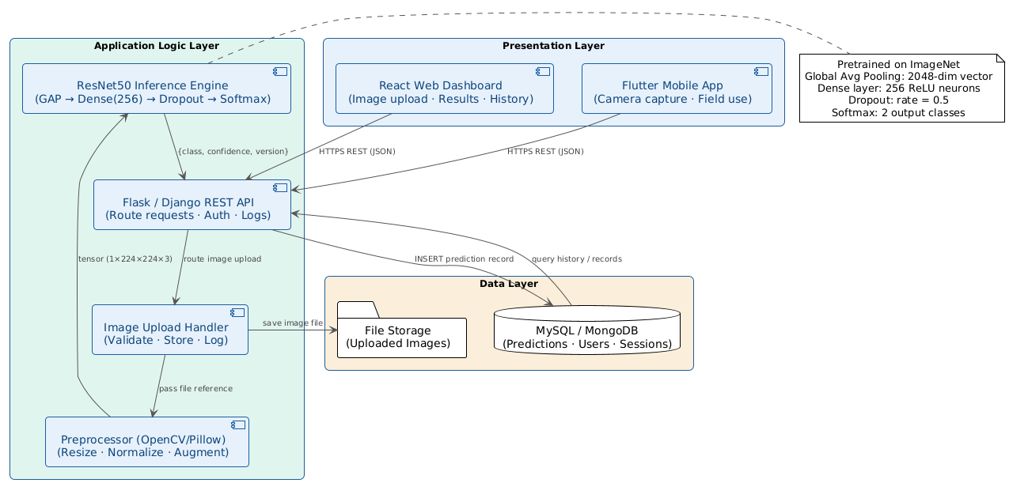
Fig 4.1: System Architecture – Three-Tier Client-Server Model

4.2 MATHEMATICAL MODEL
4.2.1 Convolution Operation
The fundamental operation in a CNN is the convolution, where a learnable filter (kernel) is convolved with the input image to produce a feature map. Given an input image I and a kernel K of dimensions (2m+1) × (2n+1), the convolution output feature map F is defined as:
(F * I)(x, y) = ΣΣ I(x+i, y+j) · K(i, j)
where I represents the input image matrix, K is the convolution kernel, and (x, y) denotes the spatial coordinates. The summation iterates over the kernel indices i and j. Each convolutional layer learns multiple kernels that detect different features such as edges, textures, and shapes at varying levels of abstraction.
4.2.2 Max Pooling
Following convolution, spatial downsampling is performed using Max Pooling, which selects the maximum activation within a local window:
P(x, y) = max{ F(i, j) : (i, j) ∈ window }
Max pooling reduces the spatial dimensions of feature maps, decreasing computational complexity and providing translation invariance to the network.
4.2.3 ReLU Activation Function
The Rectified Linear Unit (ReLU) activation function is applied element-wise after each convolution operation to introduce non-linearity:
ReLU(x) = max(0, x)
ReLU is computationally efficient, does not suffer from the vanishing gradient problem for positive inputs, and accelerates convergence during training. It outputs zero for all negative inputs and passes positive inputs unchanged.
4.2.4 Softmax Output Layer
For the binary classification task, the Softmax function transforms the raw output scores (logits) of the final dense layer into normalized probability scores summing to 1:
Softmax(z_i) = e^(z_i) / Σ_j e^(z_j)
where z_i represents the logit for class i. The Softmax output represents the model's confidence probability that the input image belongs to each class (Cattle or Buffalo). The class with the higher probability is returned as the predicted label.
4.2.5 Binary Cross-Entropy Loss Function
Since the classification is binary (two classes), Binary Cross-Entropy (BCE) is used as the loss function to measure the divergence between the model's predicted probability and the true class label:
L = -[y · log(ŷ) + (1 - y) · log(1 - ŷ)]
where y ∈ {0, 1} is the true class label (0 for Cattle, 1 for Buffalo), and ŷ is the predicted probability output by the Softmax layer. The training objective is to minimize L through backpropagation and gradient descent.
4.2.6 ResNet50 Skip Connection (Residual Learning)
ResNet50 addresses the vanishing gradient problem in very deep networks through residual learning. Each residual block adds a skip connection (shortcut connection) that allows the gradient to flow directly from later layers to earlier layers:
y = F(x, {W_i}) + x
where x is the input to the residual block, F(x, {W_i}) represents the residual mapping learned by the stacked convolutional layers (with weights {W_i}), and y is the output. The addition of x to F(x) creates a shortcut that bypasses the non-linear transformations, enabling effective training of networks with 50 or more layers. When the dimensions of x and F(x) differ, a linear projection W_s is applied: y = F(x, {W_i}) + W_s · x.
4.2.7 Performance Metrics Formulations
The model performance is evaluated using the following classification metrics derived from the confusion matrix entries (TP: True Positive, TN: True Negative, FP: False Positive, FN: False Negative):
Accuracy = (TP + TN) / (TP + TN + FP + FN)
Precision = TP / (TP + FP)
Recall = TP / (TP + FN)
F1-Score = 2 × (Precision × Recall) / (Precision + Recall)
4.3 DATA FLOW DIAGRAM
4.3.1 Level-0 DFD (Context Diagram)
The Level-0 DFD (Context Diagram) represents the system as a single process node interacting with external entities. The external entities are: (1) User (Farmer/Veterinarian), who provides the animal image as input and receives the classification result; (2) Administrator, who provides model updates and receives system logs; and (3) Database, which stores and retrieves prediction records. The central process node is the Image-Based Animal Classification System.
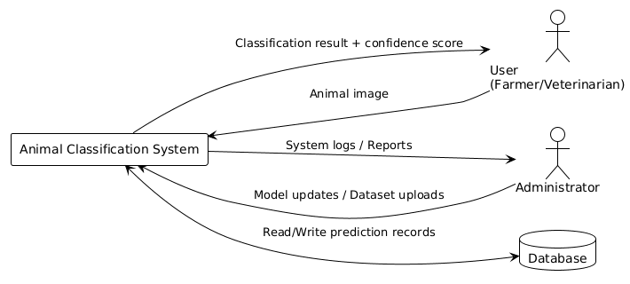
Fig 4.2: Level-0 Data Flow Diagram (Context Diagram)

4.3.2 Level-1 DFD
The Level-1 DFD decomposes the central process into five sub-processes corresponding to the five system modules: (P1) Image Upload and Validation, (P2) Image Preprocessing, (P3) CNN Feature Extraction and Classification, (P4) Prediction Storage, and (P5) Result Display. Data flows between processes include: raw image from P1 to P2, preprocessed image tensor from P2 to P3, prediction result from P3 to P4 and P5, stored record reference from P4 to P5, and final result display from P5 to User.
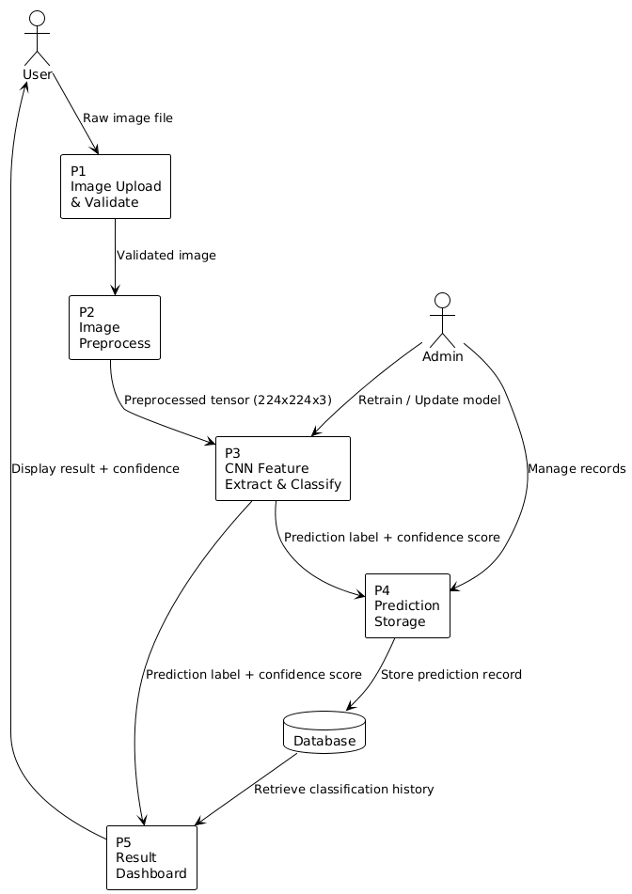
Fig 4.3: Level-1 Data Flow Diagram

4.4 ENTITY RELATIONSHIP DIAGRAM
The Entity Relationship (ER) Diagram models the data entities and their relationships within the system's database schema. The primary entities are: User (attributes: UserID, Name, Email, Password, Role, CreatedAt), Image (attributes: ImageID, FilePath, UploadTimestamp, FileSize, UserID [FK]), Prediction (attributes: PredictionID, ImageID [FK], PredictedClass, ConfidenceScore, ModelVersion, PredictionTimestamp), and Session (attributes: SessionID, UserID [FK], LoginTime, LogoutTime, IPAddress).
Relationships: A User can upload multiple Images (one-to-many). An Image has exactly one Prediction (one-to-one). A User can have multiple Sessions (one-to-many). The Prediction entity references the Image entity through a foreign key relationship.
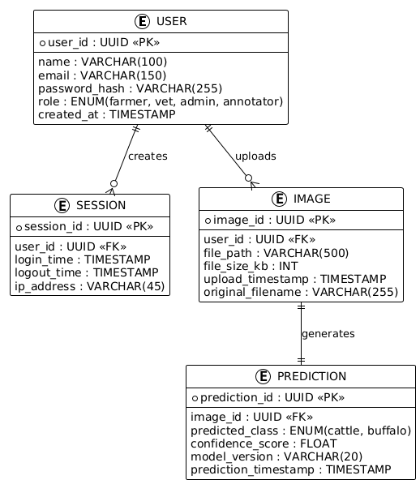
Fig 4.4: Entity Relationship Diagram

4.5 UML DIAGRAMS
4.5.1 Use Case Diagram
The Use Case Diagram identifies the system actors and the use cases they interact with. The primary actors are: Farmer/User (uploads images, views results, views classification history), Veterinarian (same as Farmer/User, additionally annotates images for model improvement), Annotator (annotates and labels images for training dataset curation), and Administrator (manages users, monitors system logs, manages dataset, initiates model retraining). Key use cases include: Upload Image, Request Classification, View Result, Annotate Image, Monitor Logs, Manage Dataset, and Retrain Model. The include relationship connects Upload Image to Request Classification, indicating that classification requires a prior image upload.
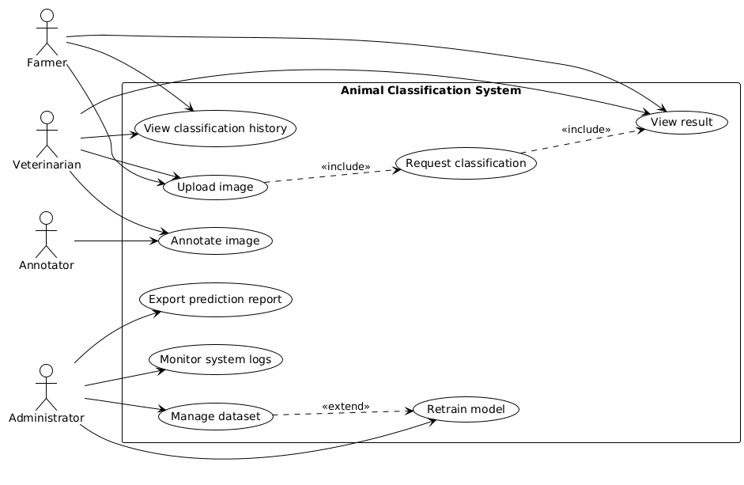
Fig 4.5: Use Case Diagram

4.5.2 Sequence Diagram
The Sequence Diagram illustrates the time-ordered interactions between the system objects for a typical image classification request. The sequence proceeds as follows: (1) User submits an image file through the Frontend interface. (2) Frontend sends a POST /upload request with the image to the Backend API. (3) Backend API stores file metadata in the Database and receives a file reference. (4) Backend API invokes the Preprocessor module with the file reference. (5) Preprocessor returns a preprocessed image tensor to the Backend API. (6) Backend API submits the tensor to the Model Server for inference. (7) Model Server runs the ResNet50 inference and returns confidence scores and model version. (8) Backend API stores the prediction result in the Database. (9) Backend API sends the result back to the Frontend. (10) Frontend displays the classification result and confidence score to the User.
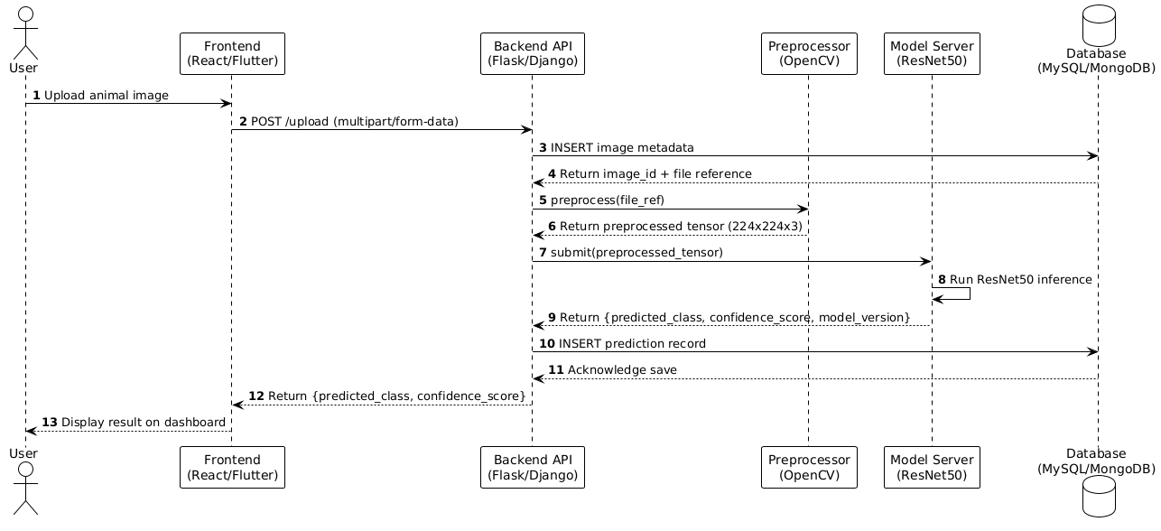
Fig 4.6: Sequence Diagram for Image Classification Request

4.5.3 Activity Diagram
The Activity Diagram models the workflow of the classification process as a series of activities and decision nodes. The flow begins with the Start node, followed by: Upload Image → Validate File Format and Size → [Decision: Valid?] → [No: Display Error, Return to Upload] → [Yes: Preprocess Image] → Resize + Normalize → Augment (if training) → Feed to ResNet50 → Extract Features (GAP Layer) → Dense + Dropout → Softmax Output → Select argmax(Prediction) → Store to Database → Display Result on Dashboard → End.
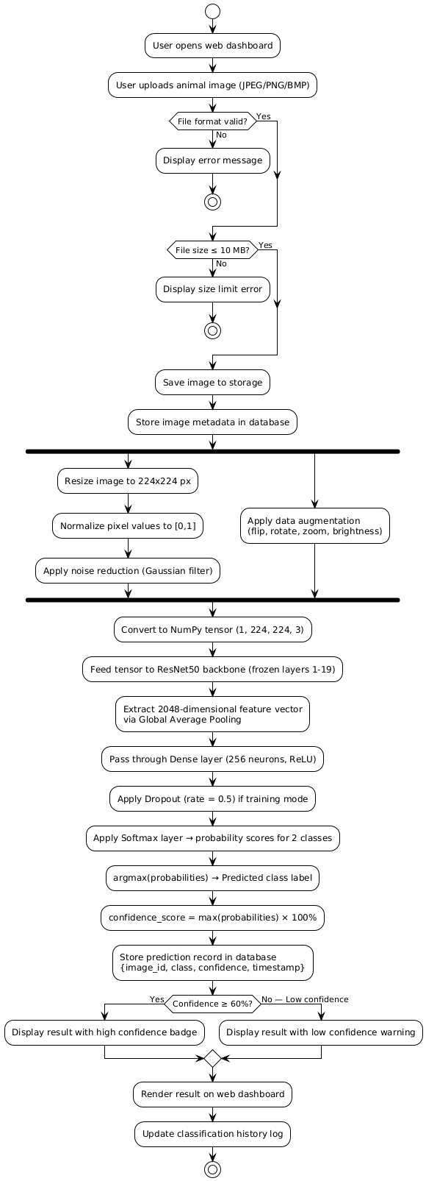
Fig 4.7: Activity Diagram for Classification Workflow

4.5.4 Class Diagram
The Class Diagram describes the object-oriented structure of the system's software components. The primary classes and their relationships are: ImageUploader (attributes: imageFile, fileSize, uploadTimestamp; methods: validateFile(), saveImage(), getFilePath()), Preprocessor (attributes: targetSize, normRange; methods: resize(), normalize(), augment(), returnTensor()), ResNet50Classifier (attributes: modelWeights, confidenceThreshold; methods: loadModel(), predict(), getSoftmaxOutput(), getConfidenceScore()), PredictionLogger (attributes: dbConnection; methods: savePrediction(), getPredictionHistory(), queryByDate()), and DashboardController (attributes: currentSession; methods: displayResult(), renderHistory(), exportReport()). The classes are connected by association relationships reflecting the pipeline flow from upload to display.
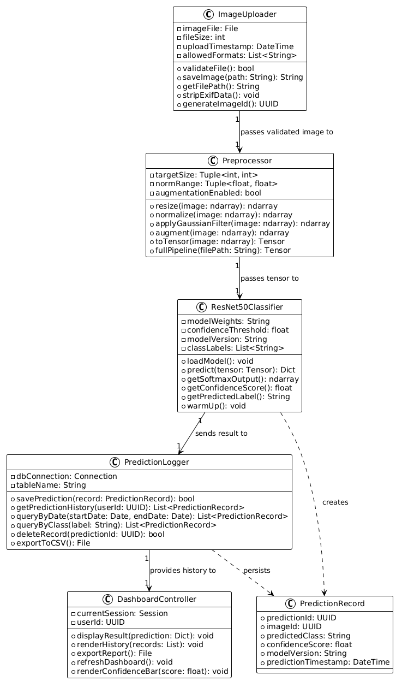
Fig 4.8: Class Diagram
- PROJECT PLAN

This chapter presents the project plan for the Image-Based Animal Type Classification system, covering project estimation, risk management, project schedule, and team organization. The plan was developed using Agile methodology principles and guided the execution of the four project sprints.

5.1 PROJECT ESTIMATE
5.1.1 Reconciled Estimates
The project effort was estimated using the Function Point Analysis method combined with expert judgment from the project team and guide. The total estimated development effort was approximately 480 person-hours spread across eight weeks of development, with an additional 40 hours allocated for documentation and report preparation. The project involves five major functional modules, each contributing approximately 90–100 hours of development effort including design, coding, testing, and debugging.
5.1.2 Project Resources
The project requires the following resources: human resources comprising three software engineering students with expertise in Python, deep learning, and web development; hardware resources including development laptops with GPU support and access to Google Colab Pro for model training; software resources including TensorFlow, OpenCV, Flask, React, MySQL, and associated libraries; and data resources including the cattle and buffalo image dataset assembled from multiple sources. All tools and frameworks used are open-source and freely available, minimizing the project's software licensing cost.

5.2 RISK MANAGEMENT
5.2.1 Risk Identification
The following risks were identified during the planning phase through a structured risk brainstorming session involving the project team and internal guide:
- Dataset insufficiency risk: The available dataset may lack sufficient diversity in breed, angle, lighting, and environment, leading to model overfitting.
- Model accuracy risk: The CNN model may not achieve the target accuracy threshold (90%) on the test dataset due to class imbalance or insufficient training.
- Integration risk: Connecting the trained model with the web backend may encounter compatibility issues between TensorFlow/PyTorch versions and Flask/Django APIs.
- Schedule risk: Delays in dataset collection or model convergence may compress the time available for frontend development and testing.
- Hardware risk: Inadequate GPU resources may significantly slow model training and experimentation cycles.
5.2.2 Risk Analysis
Each identified risk was analyzed for probability and impact using a qualitative risk matrix:
Risk | Probability | Impact | Mitigation Strategy
Dataset insufficiency | Medium | High | Apply aggressive data augmentation; collect additional images from public repositories
Model accuracy below target | Low | High | Fine-tune hyperparameters; try alternative architectures (VGG-16, EfficientNet)
Integration failure | Low | Medium | Use TensorFlow Serving or ONNX for model deployment; maintain versioned API contracts
Schedule delay | Medium | Medium | Maintain sprint buffer; prioritize core modules; defer non-critical features to future scope
Hardware limitation | Medium | Medium | Use Google Colab Pro for training; optimize batch size and model loading
Table 5.1: Risk Identification and Mitigation Summary

5.3 PROJECT SCHEDULE
5.3.1 Project Task Set
The project task set was organized into the following phases aligned with the Agile sprint structure: Phase 1 (Dataset and Preprocessing) – Tasks: dataset collection, image annotation, preprocessing pipeline development, augmentation script implementation. Phase 2 (Model Development) – Tasks: baseline CNN design, ResNet50 transfer learning fine-tuning, hyperparameter optimization, training and validation. Phase 3 (System Development) – Tasks: backend API design and implementation, database schema design, frontend dashboard development, API integration. Phase 4 (Testing and Deployment) – Tasks: unit testing, integration testing, system testing, performance benchmarking, documentation, deployment.
5.3.2 Project Timeline (Gantt Chart Description)
The project timeline spans eight weeks with the following milestones: Week 1-2: Dataset collection complete, preprocessing pipeline operational. Week 3-4: ResNet50 model trained and validated with target accuracy. Week 5-6: Backend API and database integration complete. Week 7-8: Frontend dashboard deployed, system testing complete, documentation submitted.
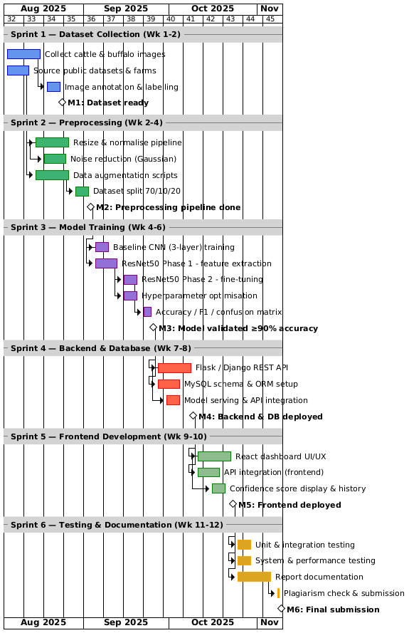
Fig 5.1: Project Schedule – Gantt Chart
5.4 TEAM ORGANIZATION
5.4.1 Team Structure
The project team consists of three students from the Department of Computer Engineering, Ajeenkya D Y Patil School of Engineering, organized under a flat team structure with role assignments:
Project Phase | Avinash Markad (Team Lead) | Dnyaneshwar Tupe | Avadhut Patil
Project Planning & Management | Team coordination, timeline management, task allocation | Requirement analysis, research support | Planning support, documentation assistance
Data Collection | Collect dataset sources and organize data | Collect cattle and buffalo breed images | Collect and verify image quality
Data Annotation | Verify labeled datasets | Label breed categories | Assist in annotation and validation
Data Preprocessing | Support preprocessing pipeline | Image cleaning and augmentation | Resize, normalization, dataset balancing
Machine Learning & Deep Learning | Model integration and training support | CNN model development and training | Feature extraction and preprocessing support
Computer Vision Tasks | Integration with application | Assist in image analysis | Main handling of OpenCV and image processing
Frontend Development | API integration with frontend | UI testing and improvements | Main UI development and design
Backend Development | Main API and backend development | ML model API integration | Backend testing and support
Database Management | Database setup and deployment | Prediction data handling | Dataset organization support
Model Evaluation & Testing | System testing and deployment testing | Accuracy evaluation and confusion matrix analysis | Functional testing and UI testing
Deployment & DevOps | Main deployment and CI/CD handling | Model deployment support | Frontend deployment support
Documentation & Research | Final report compilation and management | Literature survey and technical content | Diagram creation and formatting
Presentation & Viva Preparation | Team presentation management | Explain ML/DL concepts | Explain frontend and preprocessing modules
5.4.2 Management Reporting and Communication
Weekly progress meetings were conducted with the Internal Guide, Dr. Nilesh Mali, to review sprint deliverables, address technical challenges, and plan subsequent sprint activities. Progress was tracked using GitHub project boards with issues assigned to team members. Communication was maintained via WhatsApp group for daily stand-up updates and email for formal milestone reporting.

- PROJECT IMPLEMENTATION

This chapter provides a detailed description of the implementation of each module of the Image-Based Animal Type Classification System. It covers the tools and technologies employed, the algorithm for classification, the CNN workflow, the ResNet50 fine-tuning strategy, and the database integration approach.

6.1 MODULE OVERVIEW
The system is implemented as five interconnected modules that together form the complete classification pipeline. The Image Upload Module handles file reception and validation. The Preprocessing Module standardizes image dimensions, normalizes pixel values, and applies augmentation. The CNN Classification Module extracts deep features using ResNet50 and generates probability scores. The Database Storage Module persists prediction records and image metadata. The Result Dashboard Module renders the classification outcome to the user.

6.2 TOOLS AND TECHNOLOGIES
The implementation utilizes Python 3.10 as the primary programming language for both the machine learning components and the backend API. TensorFlow 2.x with Keras API is used for model definition, training, and inference, providing a high-level interface for ResNet50 fine-tuning. OpenCV 4.8 and Pillow 10.0 are used for image reading, resizing, normalization, and augmentation operations. NumPy and Pandas facilitate numerical computations and dataset management. Matplotlib and Seaborn are used for training curve visualization and confusion matrix plotting. The Flask framework provides the lightweight RESTful backend API for image upload and classification request handling. MySQL 8.0 and SQLAlchemy ORM manage the relational database operations. React 18 provides the interactive web frontend dashboard. Docker and Docker Compose are used for containerized deployment to ensure environment consistency.

6.3 ALGORITHM DETAILS
Algorithm 1: Image-Based Cattle and Buffalo Classification Using ResNet50
Input: Animal image I (uploaded by user)
Output: Predicted class label (Cattle or Buffalo) with confidence score
Step 1: Accept input animal image I from the user interface via HTTP POST request.
Step 2: Validate file format (JPEG/PNG/BMP) and size (≤ 10 MB). Reject invalid files with appropriate error response.
Step 3: Resize image I to 224 × 224 pixels using bilinear interpolation to match ResNet50 input dimensions.
Step 4: Normalize pixel values to the range [0, 1] by dividing each channel value by 255.
Step 5: Apply optional data augmentation (horizontal flip, rotation ±15°, zoom 0.1, brightness ±0.2) if in training mode.
Step 6: Convert the preprocessed image to a NumPy tensor of shape (1, 224, 224, 3) for batch inference.
Step 7: Feed the tensor to the pretrained ResNet50 backbone (weights: ImageNet). Extract intermediate features from layers 1 through 49 (frozen during initial training phase).
Step 8: Pass the output through the Global Average Pooling (GAP) layer to produce a 2048-dimensional feature vector f.
Step 9: Pass f through the Dense layer (256 neurons, ReLU activation): h = ReLU(W₁ · f + b₁).
Step 10: Apply Dropout with rate 0.5 to h during training to prevent overfitting.
Step 11: Pass the output through the Softmax output layer (2 neurons): P = Softmax(W₂ · h + b₂), where P ∈ ℝ² represents the probability scores for Cattle and Buffalo.
Step 12: Determine predicted label: ŷ = argmax(P). Confidence score = max(P) × 100%.
Step 13: Store prediction record {ImageID, PredictedLabel, ConfidenceScore, Timestamp} in the database.
Step 14: Return {PredictedLabel, ConfidenceScore, ImageMetadata} to the frontend for display.

