Task
Q. The condition is I want to access or anyone can access my file with the URL, but the conditions are, Not enable static website hosting , Keep the bucket private, Keep the object private, Links that I have shared will expire in predefined time.
Steps:
Step 1. Sign in to the AWS Management Console with an account that can create IAM policies.

Step 2. Go into S3 Service , Create a General purpose bucket.

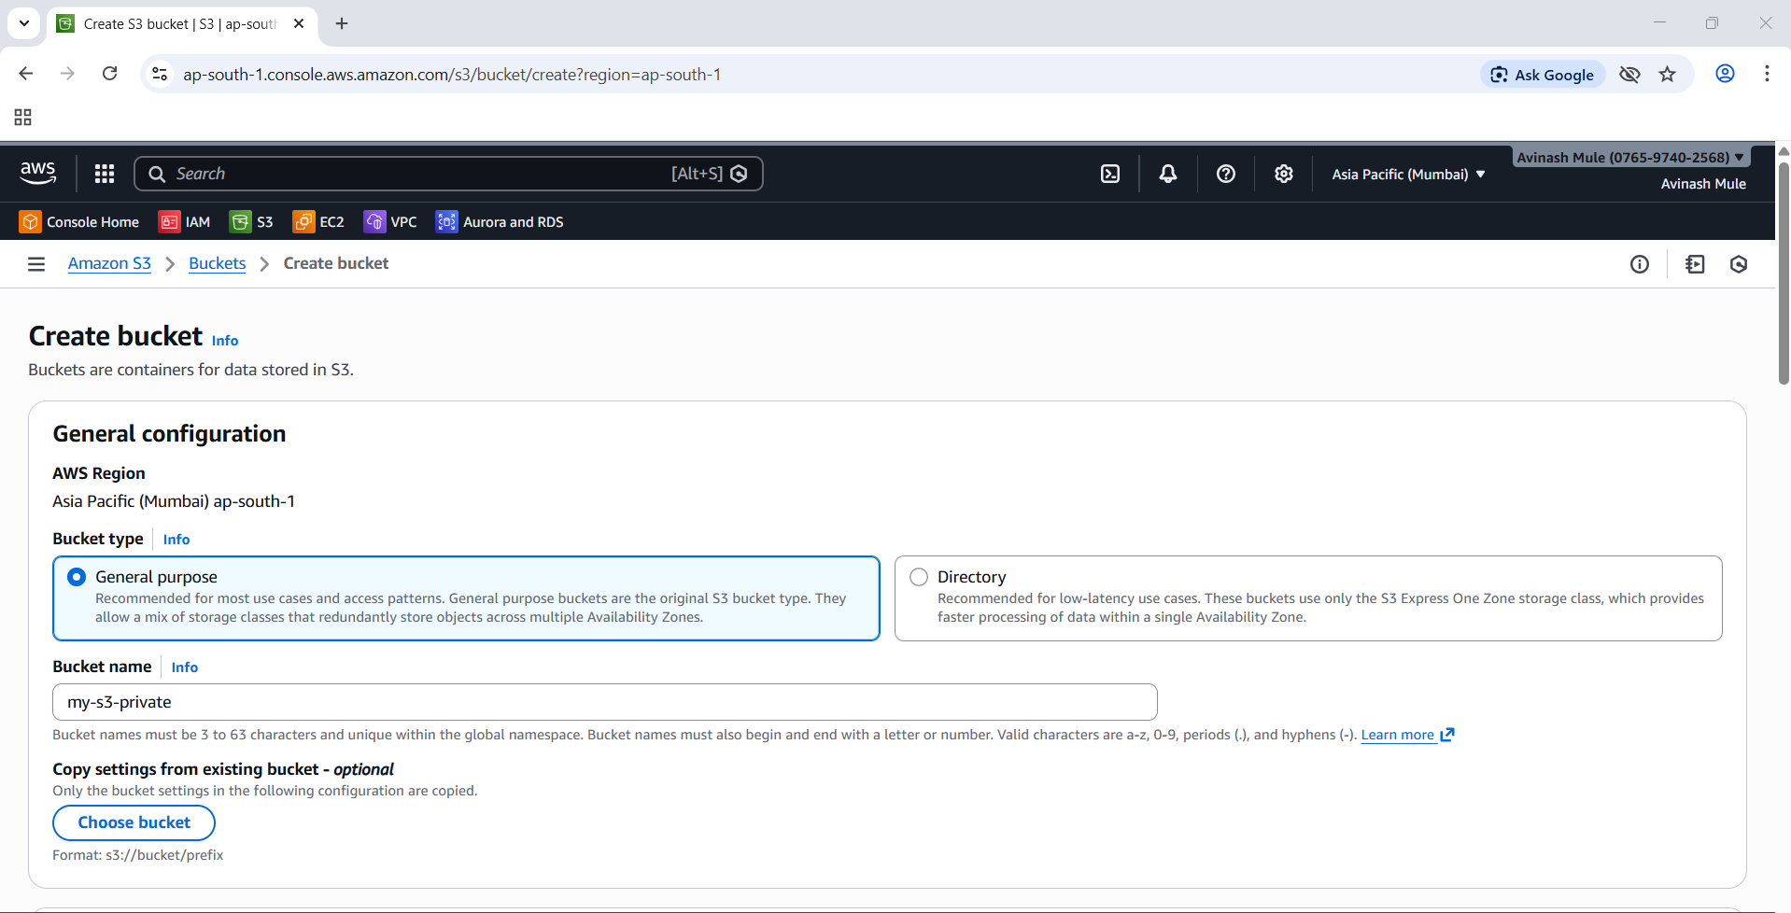

Step 3. Disable Static website hosting,Keep bucket private,keep object private.

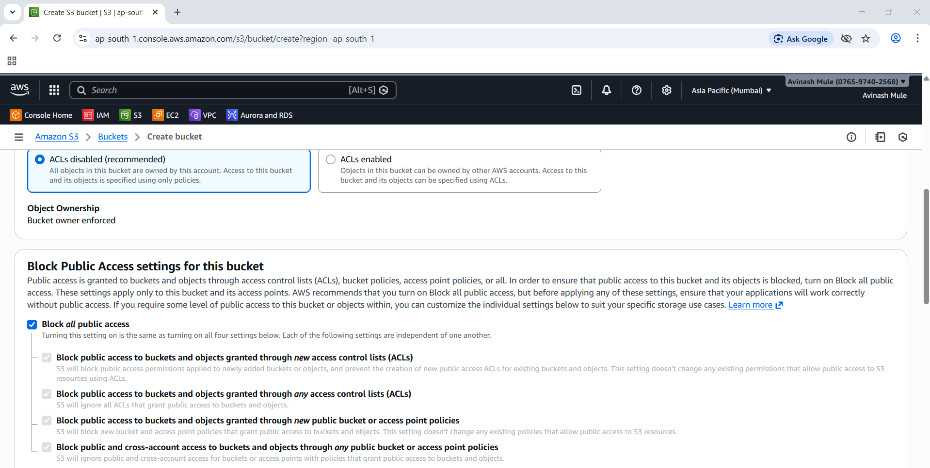

Step 4. Create a bucket. And upload the file in the bucket “my-s3-priva”.

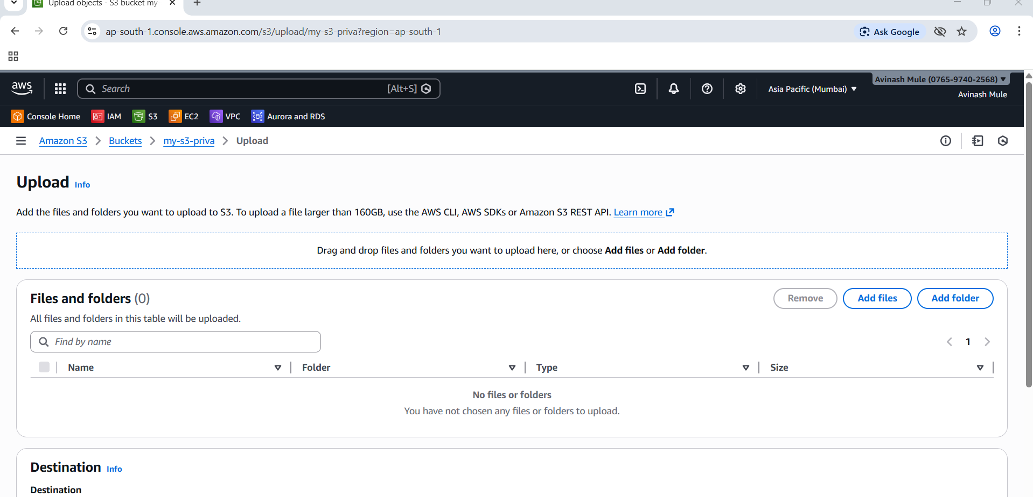

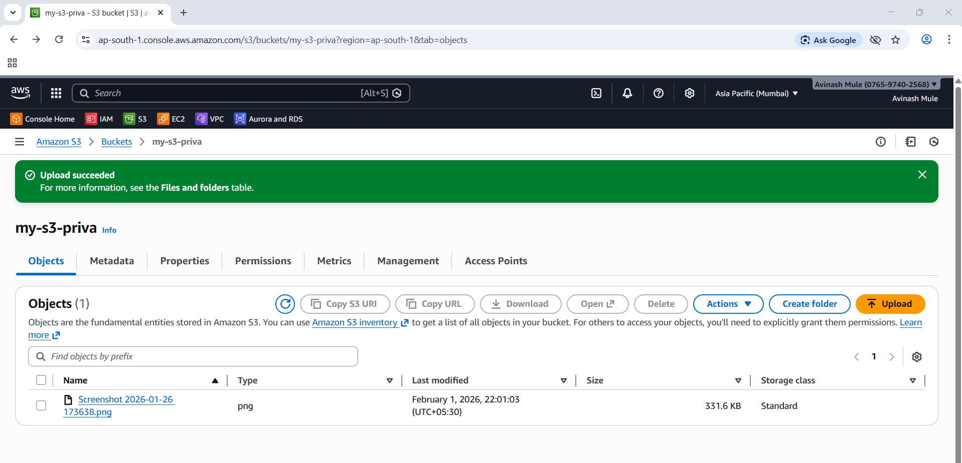
Step 5. Select the object ◊ Click object Actions ◊ Share with a pre-signed URL.

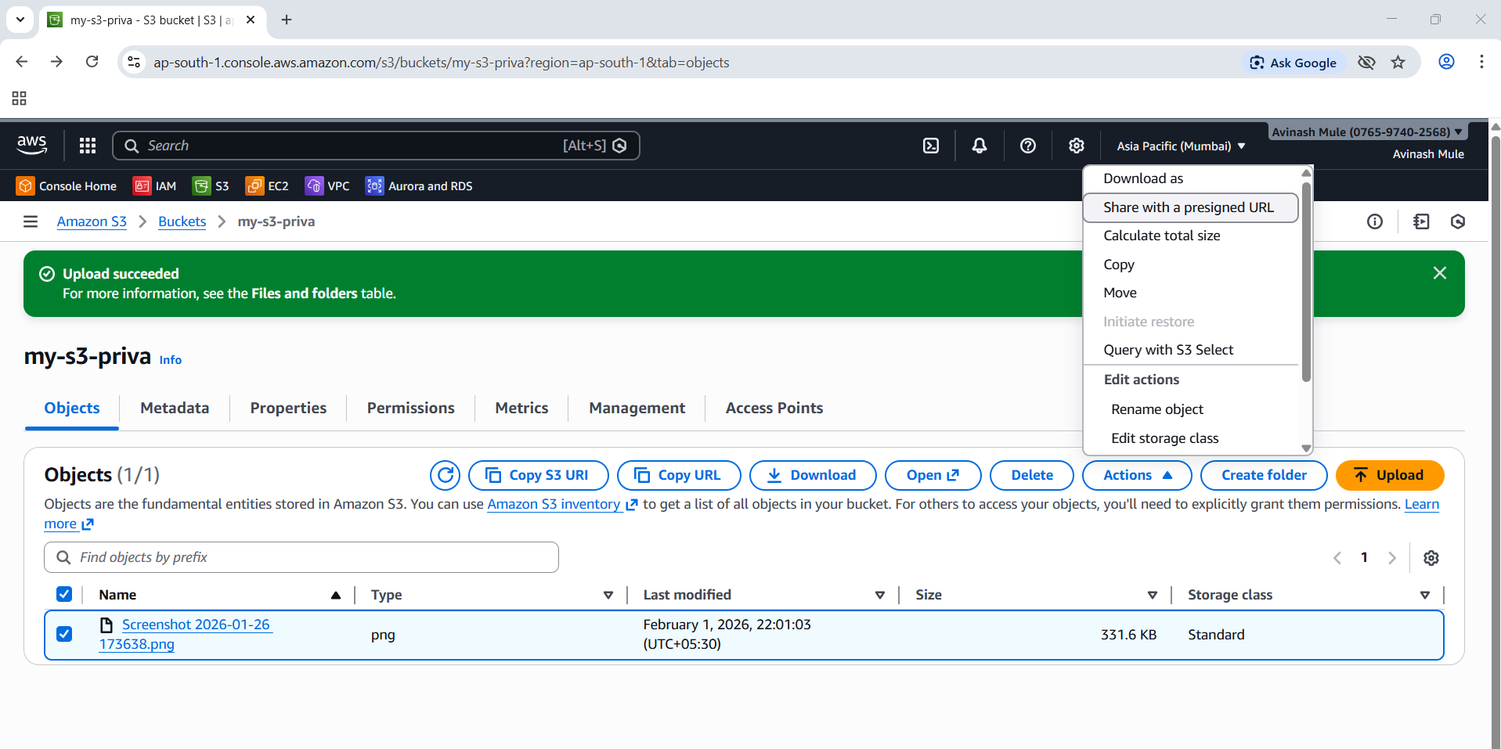

Step 7. A small pop up window open > Choose expiry time > Hours and Minutes.

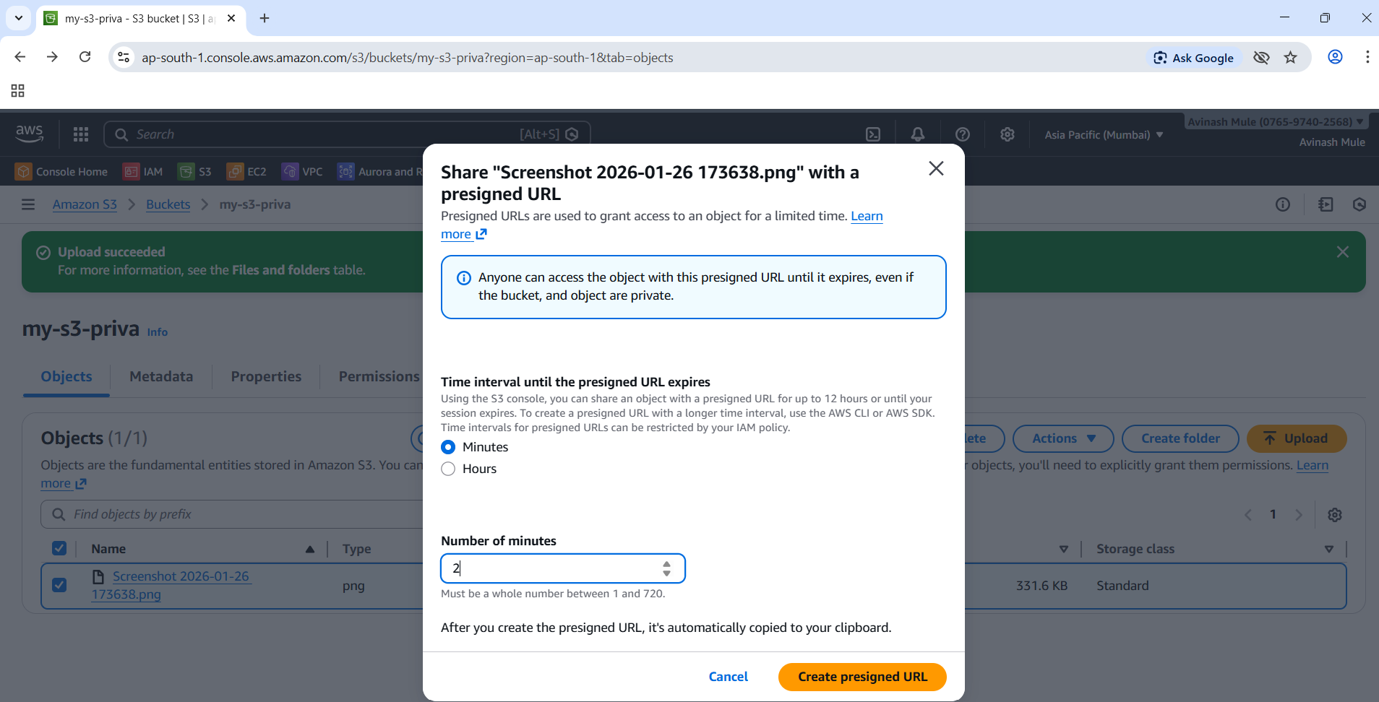

Step 8. Link is generated and copied the generated link.

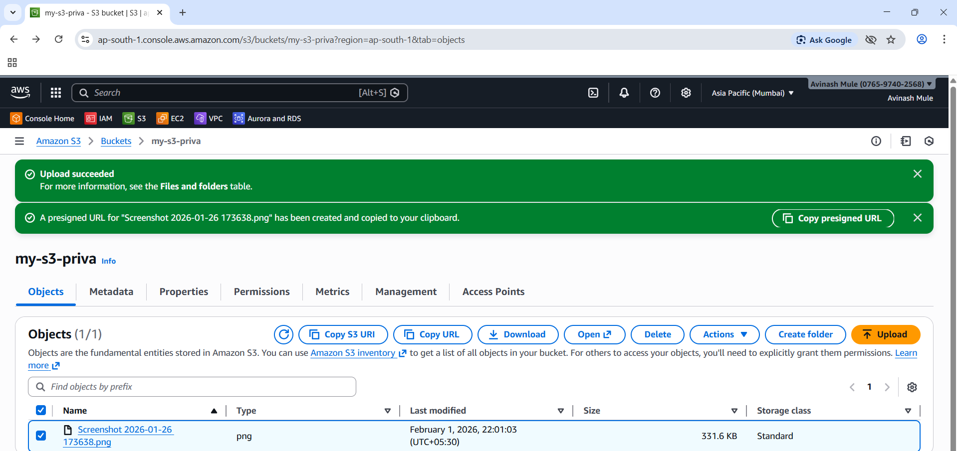

Step 9. Share the link 1. No login / no AWS account needed. File Direct download after hit the link.

Step 10. Check whether the link is active or not after expiry.

