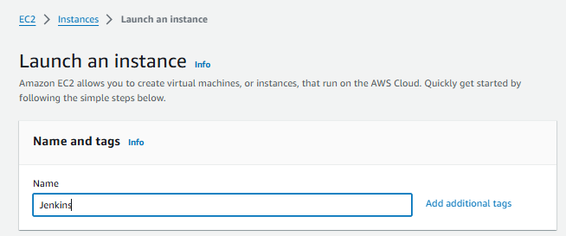

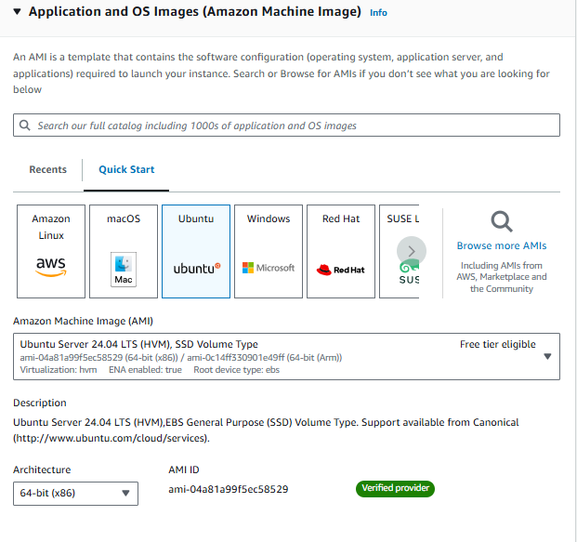

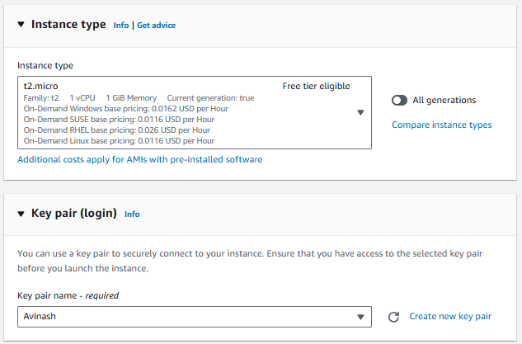

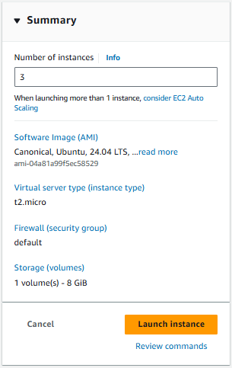

Launch Instance

Instances launched successfully

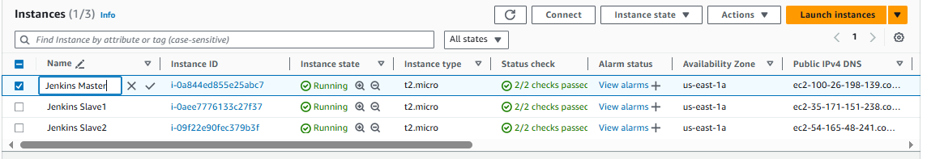

**Installing Jenkins**

1. Get the Key and Jenkins repo

sudo wget -O /usr/share/keyrings/jenkins-keyring.asc <https://pkg.jenkins.io/debian-stable/jenkins.io-2023.key>

echo deb [signed-by=/usr/share/keyrings/jenkins-keyring.asc] https://pkg.jenkins.io/debian-stable binary/ | sudo tee /etc/apt/sources.list.d/jenkins.list > /dev/null

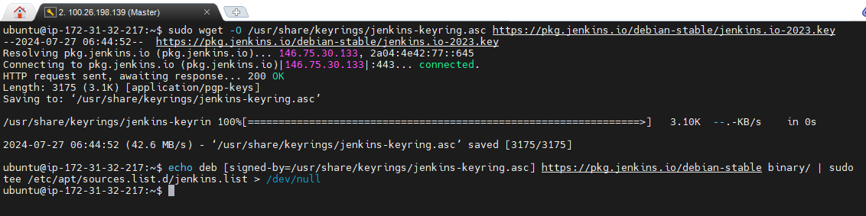

1. Sudo apt update

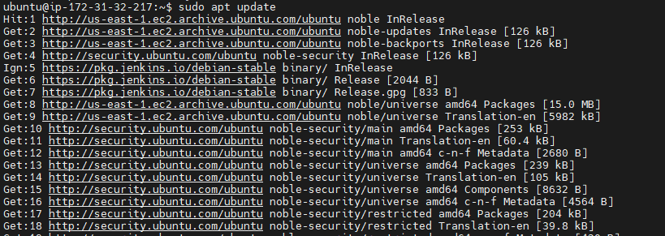

1. Install Jenkins

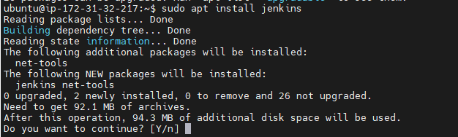

1. Add Jenkins user privileges to sudo without password:

sudo sh -c 'echo jenkins ALL=\(ALL\) NOPASSWD:ALL >> /etc/sudoers'

1. Start Jenkins:

sudo systemctl start jenkins

sudo systemctl enable jenkins

1. Open the firewall:

sudo ufw allow 8080

1. Open Chrome/edge and go to (**See to it that firewall rules on cloud network allows incoming on port 8080**):

<public IP of VM>:8080

1. Unlock Jenkins

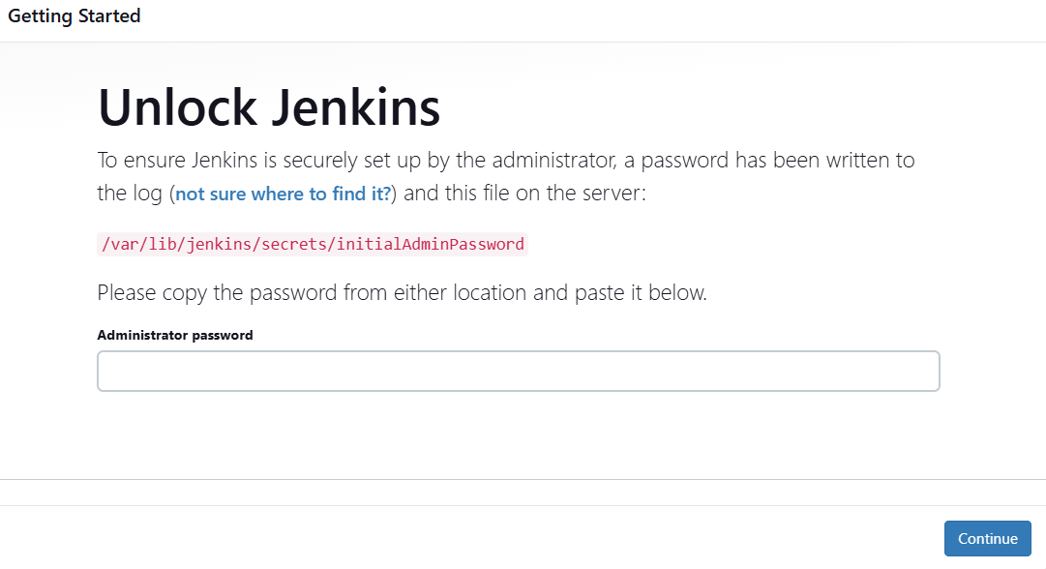

1. In Jenkins, Installed the suggested Plugins

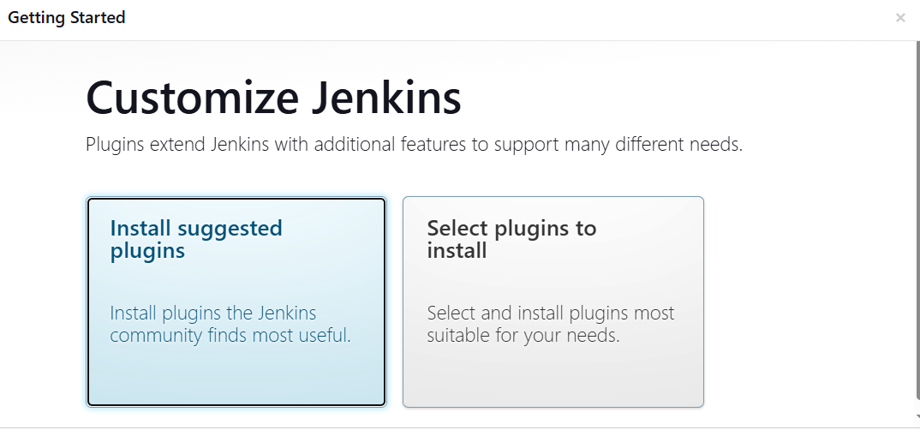

1. Create the Admin user

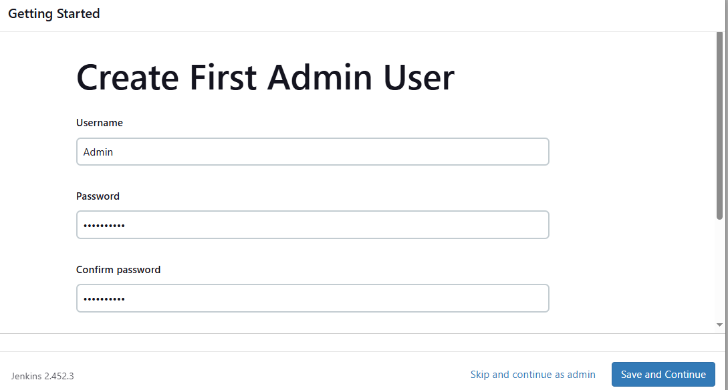

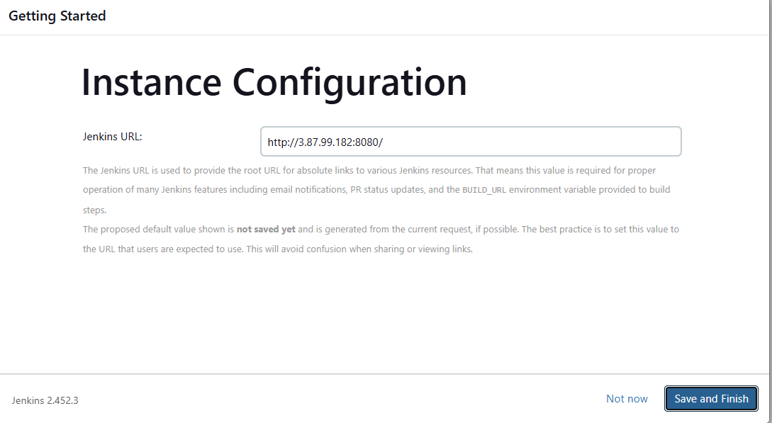

Jenkins Ready

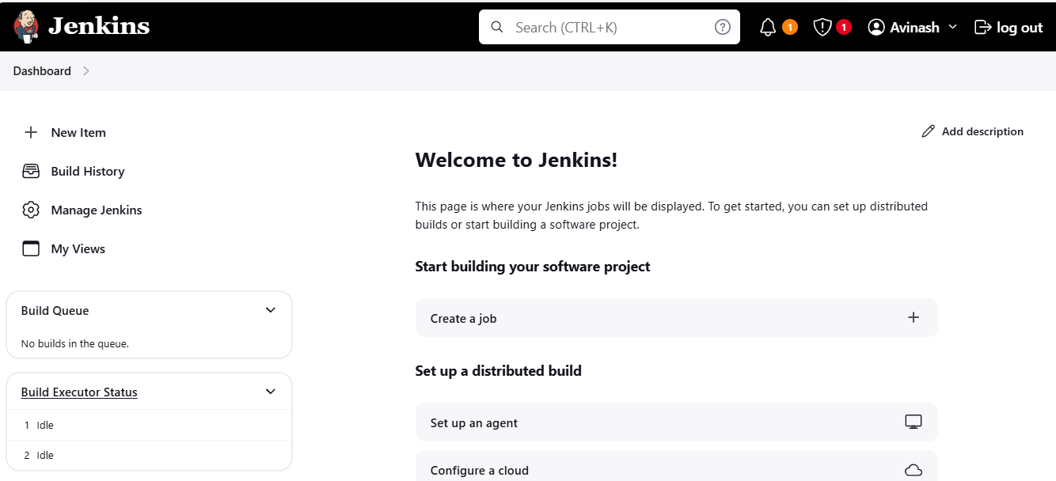

Click on Manage Jenkins and Install the plugin “Build Pipelines”

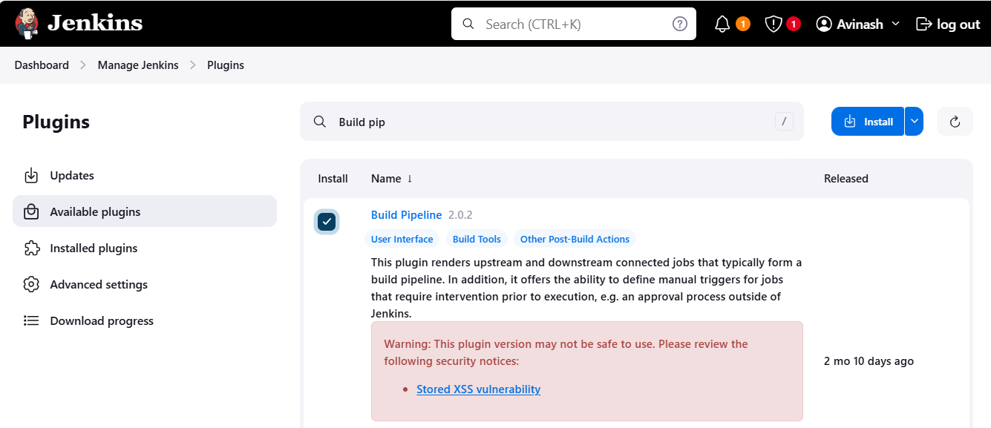

On Worker Node

➢ Login into Worker Node machine and install Java and Maven and create a directory named jenkins

sudo apt update

sudo apt -y upgrade

sudo apt -y install openjdk-11-jdk

sudo apt -y install maven

mkdir Jenkins

Login to Master

Manage Jenkins 🡪 Manage Nodes

