**Honeywell Prowatch APAC:**a) Total records processed [Identity/Badges/Roles] :

* Identities : 53290
* Badges : 57197
* Roles : 114068

b) Time taken by agent : 3 hours 6 minutes

c) Time taken by job server : 1 hour 1 minute  
c) Total time taken by the job : 4 hours 8 minutes

**Total time taken by the Job:**

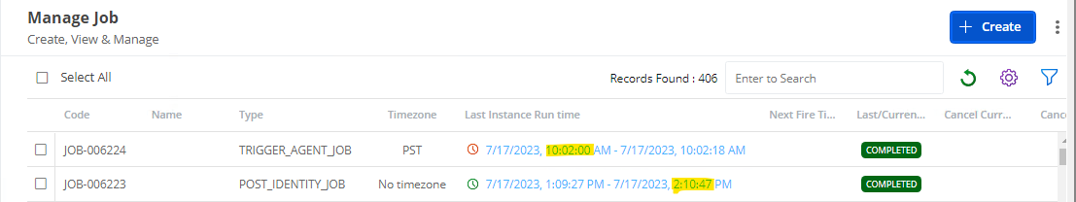

**Time taken and records processed by Agent:**

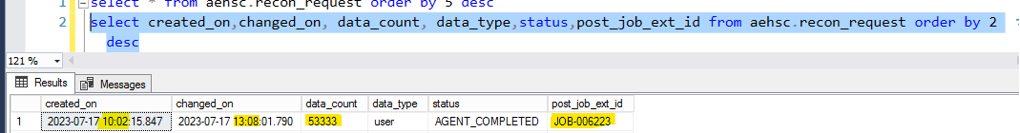

**Records processed by Job server:**

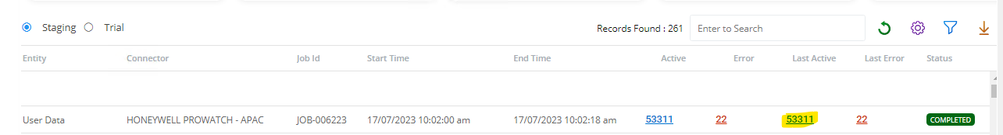

**Records processed to application database:**

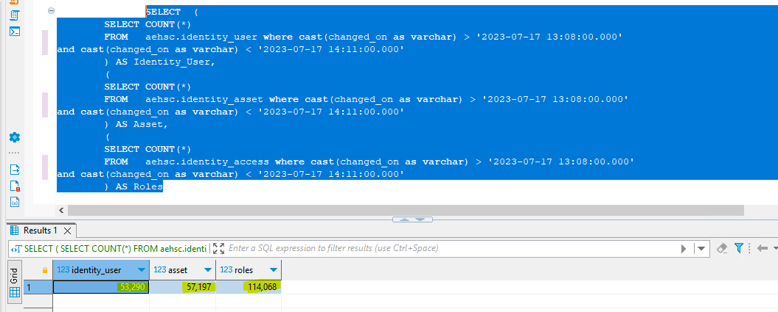

**CPU & Memory Utilization:**

**Agent:**

**The average CPU consumption is 20% whereas the memory utilization is under 1.5 GB**

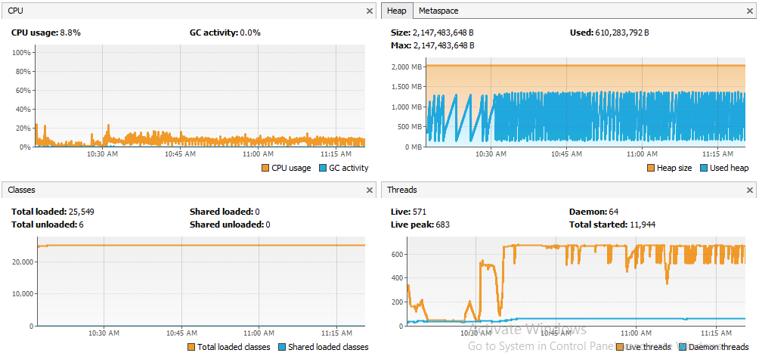

**Job server:**

**The average CPU consumption is 20% whereas the memory utilization is under 4.5 GB**

