1. **Difference between Function and Actions in QTP :**

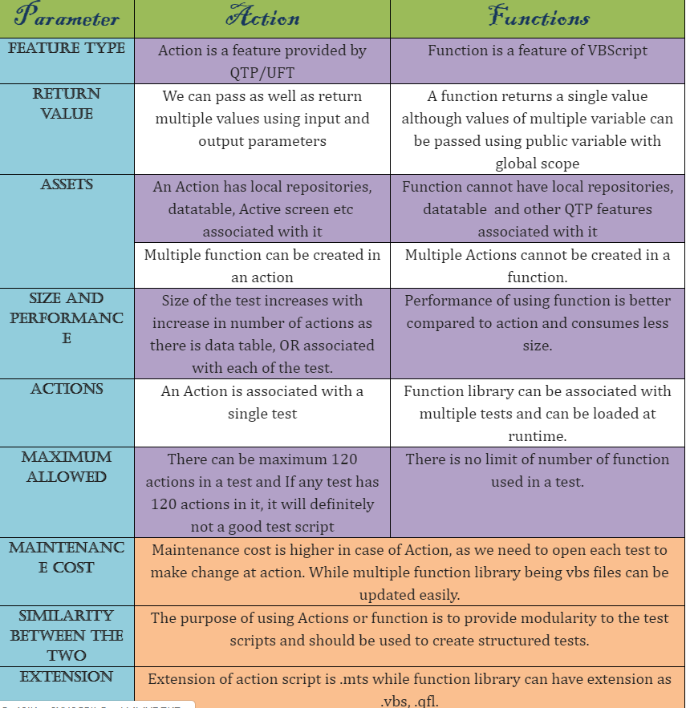

**Ans 2:**

Actions is an accumulation of Vb statements in QTP. It doesn't give back any values. Function collection of Vb articulations in QTP. It returns single value.  
   
We can call works inside functions however we can't call actions inside capacities

By and large functions are spared with ".vbs" extension where as actions will spare with ".mts".

Each actions will have its own particular Data table where as functions does not.

Actions can have a question store related with it while a functions can't. A functions is simply lines of code with a few/none parameters and a solitary return esteem while an activity can have more than one yield parameters.

Actions can contains Protest Vault, Information table, Dynamic screen and so forth though work don't have these components.

Actions is inward to QTP while functions is simply lines of code with a few/none parameters and a solitary return values.

Actions can/can not be reusable though functions are constantly reusable.

Actions Parameter have default values though VB script work don't have any default values.

Actions parameter sort are by value just where VB script functions can be passed by ref.

1. Smart identification? Advantage and disadvantage?

Some time Smart Identification induce to find the wrong Object. Like Consider the following Case,  
1-> In Web Application you recorded for Login and Logout operation in Different actions..  
2-> While your running the Script Instead of Login and Logout, call Logout Action and Login Action.  
3-> Now as our expection Normal Identification will not find the Object.. But if you configured Smart identification to find button then that smart identification might find the Login button as Logout and it will click Login Button in place where you made a script to Click Logout Button..  
  
Simple words,  
Smart identification is nothing but as acting as CID to find a criminal.  
But some time even CID may conclude wrong person as Criminal.

1. How to check specific string exa. “Swapnil” is present in webpage?

*'Check string is exist in webpage*  
  
SystemUtil.CloseProcessByName "iexplore.exe"  
SystemUtil.Run "iexplore.exe", "http://sit-ext-bi.work.iqvia.com/clients/17decnonsynd"  
**wait** 2  
  
text = Browser("Browser").Page("Page").GetROProperty("innertext")  
comptext = "Register"  
  
strmatch = **InStr**(text, comptext)  
**If** strmatch <> 0 **Then**  
    print "true"  
**End** **If**