# Research Project Documentation

# Test Run

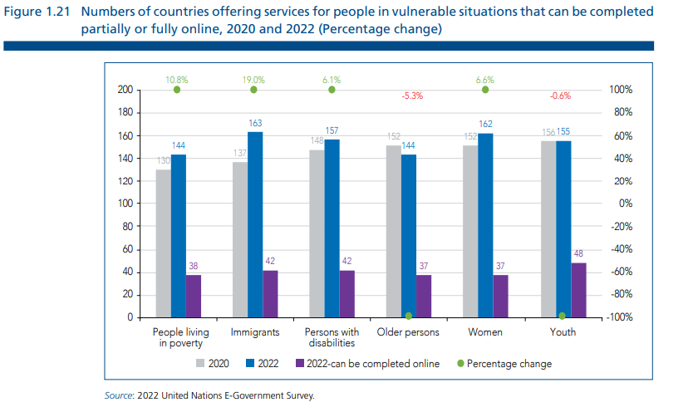

Figure: new graphs/bar/2.2_image2.png

## Prompt Used

Task: Extract detailed information from a given graph image and generate JSON files (data.json, layout.json, and config.json) compatible with Plotly. Use the specified delimiters to wrap each JSON section.  
  
Instructions:  
  
Graph Analysis:  
  
Identify and categorize the plot types present in the graph (e.g., line, scatter, bar, pie).  
Extract the data points for each plot (x-values, y-values, and any other relevant data such as labels for pie charts).  
Note any multiple plots on the same figure and their configurations.  
Generate data.json:  
  
For each plot, include details such as:  
type: The type of plot (e.g., scatter, bar, pie).  
x and y: Arrays of data points for the x and y axes.  
labels and values for pie charts.  
mode: For line and scatter plots (e.g., markers, lines, or markers+lines).  
name: Legend entry for the plot.  
marker: Properties such as color, size, and symbol for markers.  
line: Properties such as color, width, and dash style for lines.  
text: Hover text for each data point.  
hoverinfo: Information displayed on hover (e.g., x+y+text).  
Generate layout.json:  
  
Include details such as:  
title: The title of the graph, including text, font properties (family, size, color).  
xaxis and yaxis: Configuration including title, range, showgrid, gridcolor, zeroline, zerolinecolor, showticklabels, tickangle, tickfont.  
legend: Properties including orientation, x, y, xanchor, font.  
margin: Values for l (left), r (right), b (bottom), t (top), pad.  
plot_bgcolor and paper_bgcolor: Background colors of the plot area and paper.  
Generate config.json:  
  
Include configuration settings such as:  
responsive: Whether the graph is responsive (boolean).  
displayModeBar: Whether the mode bar is displayed (boolean).  
modeBarButtonsToRemove: List of mode bar buttons to remove (e.g., ["toImage"]).  
scrollZoom: Whether scrolling zoom is enabled (boolean).  
Output Format:  
  
Wrap each JSON output in specific XML-like tags:  
<data> ... </data>  
<layout> ... </layout>  
<config> ... </config>  
Make sure to follow the JSON formatting guidelines:  
Double Quotes for Keys and Strings: Ensure that all keys and string values in JSON are enclosed in double quotes (").  
Example: Instead of "type": bar, it should be "type": "bar".  
No Trailing Commas: Remove any trailing commas after the last element in arrays ([]) or objects ({}).  
Example: Instead of "color": "rgba(55, 128, 191, 0.6)",, it should be "color": "rgba(55, 128, 191, 0.6)"  
Example Output:  
  
<data>  
[  
 {  
 "type": "scatter",  
 "x": [1, 2, 3],  
 "y": [4, 5, 6],  
 "mode": "markers+lines",  
 "name": "Line Plot",  
 "marker": {  
 "color": "rgba(75, 192, 192, 0.6)",  
 "size": 8  
 },  
 "line": {  
 "color": "rgba(75, 192, 192, 1)",  
 "width": 2  
 }  
 }  
 // Additional plots if present  
]  
</data>  
<layout>  
{  
 "title": {  
 "text": "Graph Title",  
 "font": {  
 "family": "Arial, sans-serif",  
 "size": 24,  
 "color": "#000000"  
 }  
 },  
 "xaxis": {  
 "title": {  
 "text": "X Axis",  
 "font": {  
 "family": "Arial, sans-serif",  
 "size": 18,  
 "color": "#000000"  
 }  
 },  
 "showgrid": true,  
 "gridcolor": "rgba(0, 0, 0, 0.1)",  
 "zeroline": true,  
 "zerolinecolor": "rgba(0, 0, 0, 0.1)"  
 },  
 "yaxis": {  
 "title": {  
 "text": "Y Axis",  
 "font": {  
 "family": "Arial, sans-serif",  
 "size": 18,  
 "color": "#000000"  
 }  
 },  
 "showgrid": true,  
 "gridcolor": "rgba(0, 0, 0, 0.1)",  
 "zeroline": true,  
 "zerolinecolor": "rgba(0, 0, 0, 0.1)"  
 },  
 "legend": {  
 "orientation": "h",  
 "x": 0.5,  
 "xanchor": "center",  
 "y": -0.2,  
 "font": {  
 "family": "Arial, sans-serif",  
 "size": 12,  
 "color": "#000000"  
 }  
 },  
 "margin": {  
 "l": 60,  
 "r": 30,  
 "b": 60,  
 "t": 60  
 },  
 "plot_bgcolor": "#ffffff",  
 "paper_bgcolor": "#ffffff"  
}  
</layout>  
<config>  
{  
 "responsive": true,  
 "displayModeBar": true,  
 "modeBarButtonsToRemove": ["toImage"],  
 "scrollZoom": true  
}  
</config>

## Extracted JSON

### data

[  
 {  
 "type": "bar",  
 "x": [  
 "People living in poverty",  
 "Immigrants",  
 "Persons with disabilities",  
 "Older persons",  
 "Women",  
 "Youth"  
 ],  
 "y": [  
 144,  
 137,  
 148,  
 152,  
 162,  
 155  
 ],  
 "name": "2020",  
 "marker": {  
 "color": "rgba(55, 128, 191, 0.6)"  
 }  
 },  
 {  
 "type": "bar",  
 "x": [  
 "People living in poverty",  
 "Immigrants",  
 "Persons with disabilities",  
 "Older persons",  
 "Women",  
 "Youth"  
 ],  
 "y": [  
 163,  
 167,  
 157,  
 144,  
 152,  
 142  
 ],  
 "name": "2022",  
 "marker": {  
 "color": "rgba(255, 127, 14, 0.6)"  
 }  
 }  
]

### layout

{  
 "title": {  
 "text": "Number of countries offering services for people in vulnerable situations that can be completed partially or fully online, 2020 and 2022 (Percentage change)",  
 "font": {  
 "family": "Arial, sans-serif",  
 "size": 18,  
 "color": "#333333"  
 }  
 },  
 "xaxis": {  
 "title": {  
 "text": "Population Group",  
 "font": {  
 "family": "Arial, sans-serif",  
 "size": 14,  
 "color": "#333333"  
 }  
 },  
 "tickangle": -45,  
 "showticklabels": true,  
 "tickfont": {  
 "family": "Arial, sans-serif",  
 "size": 12,  
 "color": "#333333"  
 }  
 },  
 "yaxis": {  
 "title": {  
 "text": "Number of Countries",  
 "font": {  
 "family": "Arial, sans-serif",  
 "size": 14,  
 "color": "#333333"  
 }  
 },  
 "range": [  
 0,  
 200  
 ],  
 "showgrid": true,  
 "gridcolor": "rgba(0, 0, 0, 0.1)",  
 "zeroline": true,  
 "zerolinecolor": "rgba(0, 0, 0, 0.1)"  
 },  
 "legend": {  
 "orientation": "h",  
 "x": 0.5,  
 "xanchor": "center",  
 "y": -0.2,  
 "font": {  
 "family": "Arial, sans-serif",  
 "size": 12,  
 "color": "#333333"  
 }  
 },  
 "margin": {  
 "l": 60,  
 "r": 30,  
 "b": 60,  
 "t": 60  
 },  
 "plot_bgcolor": "#ffffff",  
 "paper_bgcolor": "#ffffff"  
}

### config

{  
 "responsive": true,  
 "displayModeBar": true,  
 "modeBarButtonsToRemove": [  
 "toImage"  
 ],  
 "scrollZoom": true  
}

## Updated JSON

### updated_data

[  
 {  
 "type": "bar",  
 "x": [  
 "People living in poverty",  
 "Immigrants",  
 "Persons with disabilities",  
 "Older persons",  
 "Women",  
 "Youth"  
 ],  
 "y": [  
 144,  
 137,  
 148,  
 152,  
 162,  
 155  
 ],  
 "name": "2020",  
 "marker": {  
 "color": "rgba(55, 128, 191, 0.6)"  
 }  
 },  
 {  
 "type": "bar",  
 "x": [  
 "People living in poverty",  
 "Immigrants",  
 "Persons with disabilities",  
 "Older persons",  
 "Women",  
 "Youth"  
 ],  
 "y": [  
 163,  
 167,  
 157,  
 144,  
 152,  
 142  
 ],  
 "name": "2022",  
 "marker": {  
 "color": "rgba(255, 127, 14, 0.6)"  
 }  
 }  
]

### updated_layout

{  
 "title": {  
 "text": "Number of countries offering services for people in vulnerable situations that can be completed partially or fully online, 2020 and 2022 (Percentage change)",  
 "font": {  
 "family": "Arial, sans-serif",  
 "size": 18,  
 "color": "#333333"  
 }  
 },  
 "xaxis": {  
 "title": {  
 "text": "Population Group",  
 "font": {  
 "family": "Arial, sans-serif",  
 "size": 14,  
 "color": "#333333"  
 }  
 },  
 "tickangle": -45,  
 "showticklabels": true,  
 "tickfont": {  
 "family": "Arial, sans-serif",  
 "size": 12,  
 "color": "#333333"  
 }  
 },  
 "yaxis": {  
 "title": {  
 "text": "Number of Countries",  
 "font": {  
 "family": "Arial, sans-serif",  
 "size": 14,  
 "color": "#333333"  
 }  
 },  
 "range": [  
 0,  
 200  
 ],  
 "showgrid": true,  
 "gridcolor": "rgba(0, 0, 0, 0.1)",  
 "zeroline": true,  
 "zerolinecolor": "rgba(0, 0, 0, 0.1)"  
 },  
 "legend": {  
 "orientation": "h",  
 "x": 0.5,  
 "xanchor": "center",  
 "y": -0.2,  
 "font": {  
 "family": "Arial, sans-serif",  
 "size": 12,  
 "color": "#333333"  
 }  
 },  
 "margin": {  
 "l": 60,  
 "r": 30,  
 "b": 60,  
 "t": 60  
 },  
 "plot_bgcolor": "#ffffff",  
 "paper_bgcolor": "#ffffff"  
}

### updated_config

{  
 "responsive": true,  
 "displayModeBar": true,  
 "modeBarButtonsToRemove": [  
 "toImage"  
 ],  
 "scrollZoom": true  
}

## Updated Chart

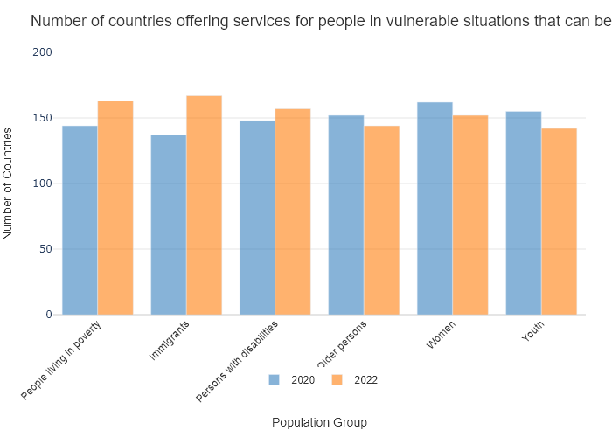

## Performance Metrics

|  |  |  |  |
| --- | --- | --- | --- |
| Task | Model Used | Description | Time Taken (s) |
| Processing Image to JSON | Gemini Vision Pro (default) | Time taken to convert the uploaded image to JSON format | 19.87 |
| Updating JSON | ChatGPT 3.5 (Default) | Time taken to update the JSON with new data | 0.00 |
| Plotting Updated JSON | N/A | Time taken to plot the updated JSON | 0.10 |

# Test Run

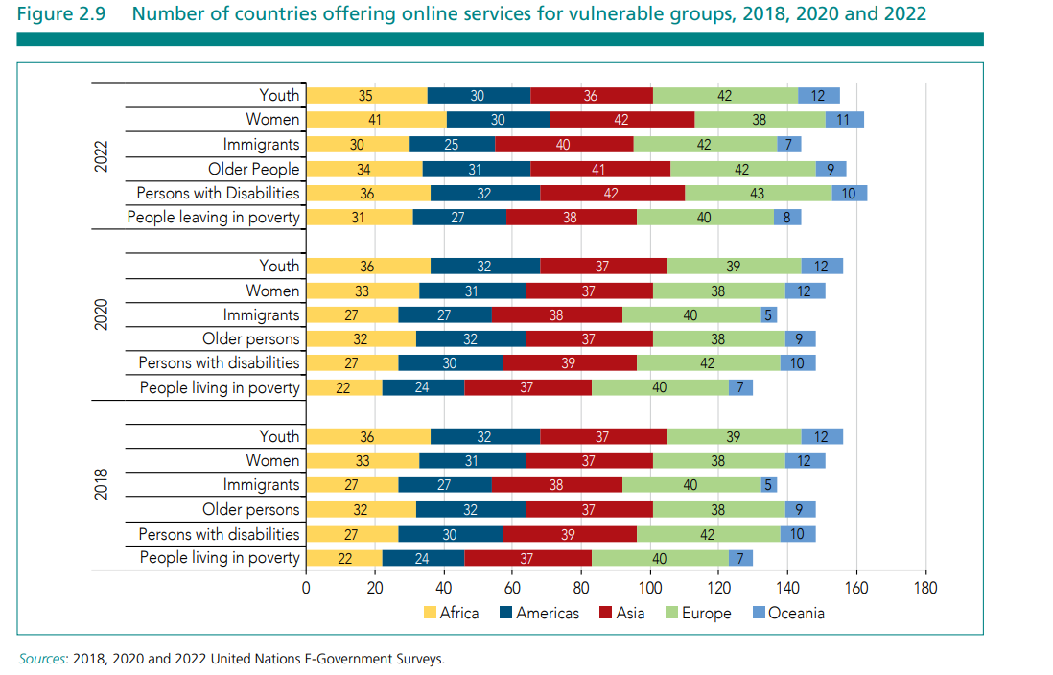

Figure: new graphs/bar/2.2_image3.png

## Prompt Used

Task: Extract detailed information from a given graph image and generate JSON files (data.json, layout.json, and config.json) compatible with Plotly. Use the specified delimiters to wrap each JSON section.  
  
Instructions:  
  
Graph Analysis:  
  
Identify and categorize the plot types present in the graph (e.g., line, scatter, bar, pie).  
Extract the data points for each plot (x-values, y-values, and any other relevant data such as labels for pie charts).  
Note any multiple plots on the same figure and their configurations.  
Generate data.json:  
  
For each plot, include details such as:  
type: The type of plot (e.g., scatter, bar, pie).  
x and y: Arrays of data points for the x and y axes.  
labels and values for pie charts.  
mode: For line and scatter plots (e.g., markers, lines, or markers+lines).  
name: Legend entry for the plot.  
marker: Properties such as color, size, and symbol for markers.  
line: Properties such as color, width, and dash style for lines.  
text: Hover text for each data point.  
hoverinfo: Information displayed on hover (e.g., x+y+text).  
Generate layout.json:  
  
Include details such as:  
title: The title of the graph, including text, font properties (family, size, color).  
xaxis and yaxis: Configuration including title, range, showgrid, gridcolor, zeroline, zerolinecolor, showticklabels, tickangle, tickfont.  
legend: Properties including orientation, x, y, xanchor, font.  
margin: Values for l (left), r (right), b (bottom), t (top), pad.  
plot_bgcolor and paper_bgcolor: Background colors of the plot area and paper.  
Generate config.json:  
  
Include configuration settings such as:  
responsive: Whether the graph is responsive (boolean).  
displayModeBar: Whether the mode bar is displayed (boolean).  
modeBarButtonsToRemove: List of mode bar buttons to remove (e.g., ["toImage"]).  
scrollZoom: Whether scrolling zoom is enabled (boolean).  
Output Format:  
  
Wrap each JSON output in specific XML-like tags:  
<data> ... </data>  
<layout> ... </layout>  
<config> ... </config>  
Make sure to follow the JSON formatting guidelines:  
Double Quotes for Keys and Strings: Ensure that all keys and string values in JSON are enclosed in double quotes (").  
Example: Instead of "type": bar, it should be "type": "bar".  
No Trailing Commas: Remove any trailing commas after the last element in arrays ([]) or objects ({}).  
Example: Instead of "color": "rgba(55, 128, 191, 0.6)",, it should be "color": "rgba(55, 128, 191, 0.6)"  
Example Output:  
  
<data>  
[  
 {  
 "type": "scatter",  
 "x": [1, 2, 3],  
 "y": [4, 5, 6],  
 "mode": "markers+lines",  
 "name": "Line Plot",  
 "marker": {  
 "color": "rgba(75, 192, 192, 0.6)",  
 "size": 8  
 },  
 "line": {  
 "color": "rgba(75, 192, 192, 1)",  
 "width": 2  
 }  
 }  
 // Additional plots if present  
]  
</data>  
<layout>  
{  
 "title": {  
 "text": "Graph Title",  
 "font": {  
 "family": "Arial, sans-serif",  
 "size": 24,  
 "color": "#000000"  
 }  
 },  
 "xaxis": {  
 "title": {  
 "text": "X Axis",  
 "font": {  
 "family": "Arial, sans-serif",  
 "size": 18,  
 "color": "#000000"  
 }  
 },  
 "showgrid": true,  
 "gridcolor": "rgba(0, 0, 0, 0.1)",  
 "zeroline": true,  
 "zerolinecolor": "rgba(0, 0, 0, 0.1)"  
 },  
 "yaxis": {  
 "title": {  
 "text": "Y Axis",  
 "font": {  
 "family": "Arial, sans-serif",  
 "size": 18,  
 "color": "#000000"  
 }  
 },  
 "showgrid": true,  
 "gridcolor": "rgba(0, 0, 0, 0.1)",  
 "zeroline": true,  
 "zerolinecolor": "rgba(0, 0, 0, 0.1)"  
 },  
 "legend": {  
 "orientation": "h",  
 "x": 0.5,  
 "xanchor": "center",  
 "y": -0.2,  
 "font": {  
 "family": "Arial, sans-serif",  
 "size": 12,  
 "color": "#000000"  
 }  
 },  
 "margin": {  
 "l": 60,  
 "r": 30,  
 "b": 60,  
 "t": 60  
 },  
 "plot_bgcolor": "#ffffff",  
 "paper_bgcolor": "#ffffff"  
}  
</layout>  
<config>  
{  
 "responsive": true,  
 "displayModeBar": true,  
 "modeBarButtonsToRemove": ["toImage"],  
 "scrollZoom": true  
}  
</config>

## Extracted JSON

### data

[  
 {  
 "type": "bar",  
 "x": [  
 "Youth",  
 "Women",  
 "Older People",  
 "Immigrants",  
 "Persons with Disabilities",  
 "People living in poverty"  
 ],  
 "y": [  
 35,  
 41,  
 34,  
 30,  
 36,  
 31  
 ],  
 "name": "2018",  
 "marker": {  
 "color": "rgba(55, 128, 191, 0.6)"  
 }  
 },  
 {  
 "type": "bar",  
 "x": [  
 "Youth",  
 "Women",  
 "Older People",  
 "Immigrants",  
 "Persons with Disabilities",  
 "People living in poverty"  
 ],  
 "y": [  
 36,  
 33,  
 32,  
 27,  
 37,  
 22  
 ],  
 "name": "2020",  
 "marker": {  
 "color": "rgba(255, 127, 14, 0.6)"  
 }  
 },  
 {  
 "type": "bar",  
 "x": [  
 "Youth",  
 "Women",  
 "Older People",  
 "Immigrants",  
 "Persons with Disabilities",  
 "People living in poverty"  
 ],  
 "y": [  
 36,  
 42,  
 34,  
 41,  
 42,  
 31  
 ],  
 "name": "2022",  
 "marker": {  
 "color": "rgba(255, 127, 14, 1)"  
 }  
 }  
]

### layout

{  
 "title": {  
 "text": "Number of countries offering online services for vulnerable groups",  
 "font": {  
 "family": "Arial, sans-serif",  
 "size": 24,  
 "color": "#000000"  
 }  
 },  
 "xaxis": {  
 "title": {  
 "text": "Groups",  
 "font": {  
 "family": "Arial, sans-serif",  
 "size": 18,  
 "color": "#000000"  
 }  
 },  
 "tickangle": -45,  
 "showticklabels": true  
 },  
 "yaxis": {  
 "title": {  
 "text": "Number of countries",  
 "font": {  
 "family": "Arial, sans-serif",  
 "size": 18,  
 "color": "#000000"  
 }  
 }  
 },  
 "legend": {  
 "orientation": "h",  
 "x": 0.5,  
 "xanchor": "center",  
 "y": -0.2,  
 "font": {  
 "family": "Arial, sans-serif",  
 "size": 12,  
 "color": "#000000"  
 }  
 },  
 "margin": {  
 "l": 60,  
 "r": 30,  
 "b": 60,  
 "t": 60  
 },  
 "plot_bgcolor": "#ffffff",  
 "paper_bgcolor": "#ffffff"  
}

### config

{  
 "responsive": true,  
 "displayModeBar": true,  
 "modeBarButtonsToRemove": [  
 "toImage"  
 ],  
 "scrollZoom": true  
}

## Updated JSON

### updated_data

[  
 {  
 "type": "bar",  
 "x": [  
 "Youth",  
 "Women",  
 "Older People",  
 "Immigrants",  
 "Persons with Disabilities",  
 "People living in poverty"  
 ],  
 "y": [  
 35,  
 41,  
 34,  
 30,  
 36,  
 31  
 ],  
 "name": "2018",  
 "marker": {  
 "color": "rgba(55, 128, 191, 0.6)"  
 }  
 },  
 {  
 "type": "bar",  
 "x": [  
 "Youth",  
 "Women",  
 "Older People",  
 "Immigrants",  
 "Persons with Disabilities",  
 "People living in poverty"  
 ],  
 "y": [  
 36,  
 33,  
 32,  
 27,  
 37,  
 22  
 ],  
 "name": "2020",  
 "marker": {  
 "color": "rgba(255, 127, 14, 0.6)"  
 }  
 },  
 {  
 "type": "bar",  
 "x": [  
 "Youth",  
 "Women",  
 "Older People",  
 "Immigrants",  
 "Persons with Disabilities",  
 "People living in poverty"  
 ],  
 "y": [  
 36,  
 42,  
 34,  
 41,  
 42,  
 31  
 ],  
 "name": "2022",  
 "marker": {  
 "color": "rgba(255, 127, 14, 1)"  
 }  
 }  
]

### updated_layout

{  
 "title": {  
 "text": "Number of countries offering online services for vulnerable groups",  
 "font": {  
 "family": "Arial, sans-serif",  
 "size": 24,  
 "color": "#000000"  
 }  
 },  
 "xaxis": {  
 "title": {  
 "text": "Groups",  
 "font": {  
 "family": "Arial, sans-serif",  
 "size": 18,  
 "color": "#000000"  
 }  
 },  
 "tickangle": -45,  
 "showticklabels": true  
 },  
 "yaxis": {  
 "title": {  
 "text": "Number of countries",  
 "font": {  
 "family": "Arial, sans-serif",  
 "size": 18,  
 "color": "#000000"  
 }  
 }  
 },  
 "legend": {  
 "orientation": "h",  
 "x": 0.5,  
 "xanchor": "center",  
 "y": -0.2,  
 "font": {  
 "family": "Arial, sans-serif",  
 "size": 12,  
 "color": "#000000"  
 }  
 },  
 "margin": {  
 "l": 60,  
 "r": 30,  
 "b": 60,  
 "t": 60  
 },  
 "plot_bgcolor": "#ffffff",  
 "paper_bgcolor": "#ffffff"  
}

### updated_config

{  
 "responsive": true,  
 "displayModeBar": true,  
 "modeBarButtonsToRemove": [  
 "toImage"  
 ],  
 "scrollZoom": true  
}

## Updated Chart

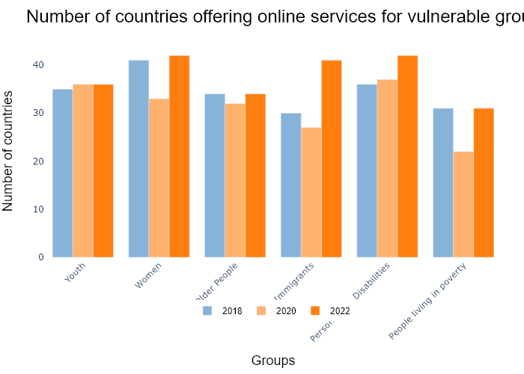

## Performance Metrics

|  |  |  |  |
| --- | --- | --- | --- |
| Task | Model Used | Description | Time Taken (s) |
| Processing Image to JSON | Gemini Vision Pro (default) | Time taken to convert the uploaded image to JSON format | 19.86 |
| Updating JSON | ChatGPT 3.5 (Default) | Time taken to update the JSON with new data | 0.00 |
| Plotting Updated JSON | N/A | Time taken to plot the updated JSON | 0.14 |

# Test Run

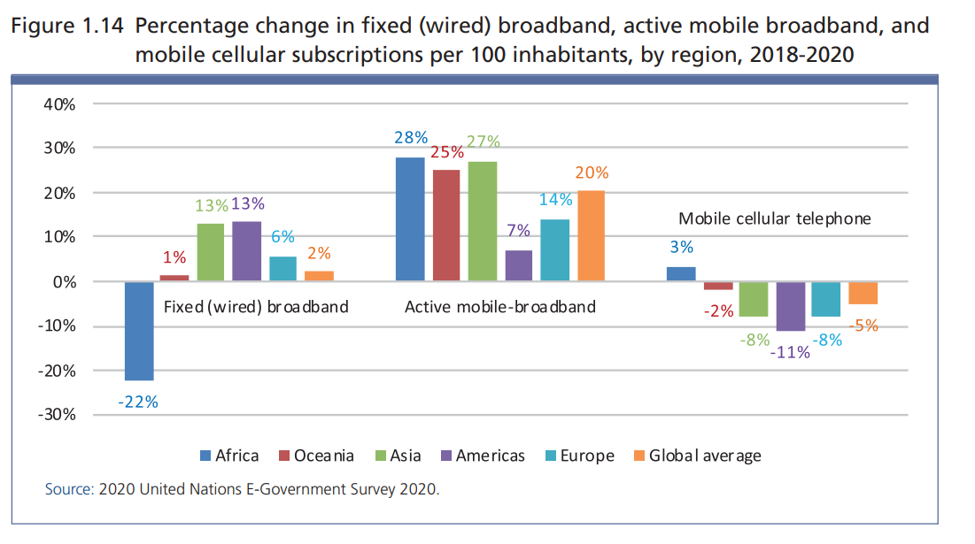

Figure: new graphs/bar/2.2_image4.png

## Prompt Used

Task: Extract detailed information from a given graph image and generate JSON files (data.json, layout.json, and config.json) compatible with Plotly. Use the specified delimiters to wrap each JSON section.  
  
Instructions:  
  
Graph Analysis:  
  
Identify and categorize the plot types present in the graph (e.g., line, scatter, bar, pie).  
Extract the data points for each plot (x-values, y-values, and any other relevant data such as labels for pie charts).  
Note any multiple plots on the same figure and their configurations.  
Generate data.json:  
  
For each plot, include details such as:  
type: The type of plot (e.g., scatter, bar, pie).  
x and y: Arrays of data points for the x and y axes.  
labels and values for pie charts.  
mode: For line and scatter plots (e.g., markers, lines, or markers+lines).  
name: Legend entry for the plot.  
marker: Properties such as color, size, and symbol for markers.  
line: Properties such as color, width, and dash style for lines.  
text: Hover text for each data point.  
hoverinfo: Information displayed on hover (e.g., x+y+text).  
Generate layout.json:  
  
Include details such as:  
title: The title of the graph, including text, font properties (family, size, color).  
xaxis and yaxis: Configuration including title, range, showgrid, gridcolor, zeroline, zerolinecolor, showticklabels, tickangle, tickfont.  
legend: Properties including orientation, x, y, xanchor, font.  
margin: Values for l (left), r (right), b (bottom), t (top), pad.  
plot_bgcolor and paper_bgcolor: Background colors of the plot area and paper.  
Generate config.json:  
  
Include configuration settings such as:  
responsive: Whether the graph is responsive (boolean).  
displayModeBar: Whether the mode bar is displayed (boolean).  
modeBarButtonsToRemove: List of mode bar buttons to remove (e.g., ["toImage"]).  
scrollZoom: Whether scrolling zoom is enabled (boolean).  
Output Format:  
  
Wrap each JSON output in specific XML-like tags:  
<data> ... </data>  
<layout> ... </layout>  
<config> ... </config>  
Make sure to follow the JSON formatting guidelines:  
Double Quotes for Keys and Strings: Ensure that all keys and string values in JSON are enclosed in double quotes (").  
Example: Instead of "type": bar, it should be "type": "bar".  
No Trailing Commas: Remove any trailing commas after the last element in arrays ([]) or objects ({}).  
Example: Instead of "color": "rgba(55, 128, 191, 0.6)",, it should be "color": "rgba(55, 128, 191, 0.6)"  
Example Output:  
  
<data>  
[  
 {  
 "type": "scatter",  
 "x": [1, 2, 3],  
 "y": [4, 5, 6],  
 "mode": "markers+lines",  
 "name": "Line Plot",  
 "marker": {  
 "color": "rgba(75, 192, 192, 0.6)",  
 "size": 8  
 },  
 "line": {  
 "color": "rgba(75, 192, 192, 1)",  
 "width": 2  
 }  
 }  
 // Additional plots if present  
]  
</data>  
<layout>  
{  
 "title": {  
 "text": "Graph Title",  
 "font": {  
 "family": "Arial, sans-serif",  
 "size": 24,  
 "color": "#000000"  
 }  
 },  
 "xaxis": {  
 "title": {  
 "text": "X Axis",  
 "font": {  
 "family": "Arial, sans-serif",  
 "size": 18,  
 "color": "#000000"  
 }  
 },  
 "showgrid": true,  
 "gridcolor": "rgba(0, 0, 0, 0.1)",  
 "zeroline": true,  
 "zerolinecolor": "rgba(0, 0, 0, 0.1)"  
 },  
 "yaxis": {  
 "title": {  
 "text": "Y Axis",  
 "font": {  
 "family": "Arial, sans-serif",  
 "size": 18,  
 "color": "#000000"  
 }  
 },  
 "showgrid": true,  
 "gridcolor": "rgba(0, 0, 0, 0.1)",  
 "zeroline": true,  
 "zerolinecolor": "rgba(0, 0, 0, 0.1)"  
 },  
 "legend": {  
 "orientation": "h",  
 "x": 0.5,  
 "xanchor": "center",  
 "y": -0.2,  
 "font": {  
 "family": "Arial, sans-serif",  
 "size": 12,  
 "color": "#000000"  
 }  
 },  
 "margin": {  
 "l": 60,  
 "r": 30,  
 "b": 60,  
 "t": 60  
 },  
 "plot_bgcolor": "#ffffff",  
 "paper_bgcolor": "#ffffff"  
}  
</layout>  
<config>  
{  
 "responsive": true,  
 "displayModeBar": true,  
 "modeBarButtonsToRemove": ["toImage"],  
 "scrollZoom": true  
}  
</config>

## Extracted JSON

### data

[  
 {  
 "type": "bar",  
 "x": [  
 "Africa",  
 "Oceania",  
 "Asia",  
 "Americas",  
 "Europe",  
 "Global average"  
 ],  
 "y": [  
 -22,  
 1,  
 28,  
 27,  
 20,  
 3  
 ],  
 "name": "Fixed (wired) broadband",  
 "marker": {  
 "color": "rgba(55, 128, 191, 0.6)"  
 }  
 },  
 {  
 "type": "bar",  
 "x": [  
 "Africa",  
 "Oceania",  
 "Asia",  
 "Americas",  
 "Europe",  
 "Global average"  
 ],  
 "y": [  
 13,  
 6,  
 25,  
 14,  
 7,  
 2  
 ],  
 "name": "Active mobile-broadband",  
 "marker": {  
 "color": "rgba(255, 127, 14, 0.6)"  
 }  
 },  
 {  
 "type": "bar",  
 "x": [  
 "Africa",  
 "Oceania",  
 "Asia",  
 "Americas",  
 "Europe",  
 "Global average"  
 ],  
 "y": [  
 -2,  
 -8,  
 -11,  
 -8,  
 -5,  
 -3  
 ],  
 "name": "Mobile cellular telephone",  
 "marker": {  
 "color": "rgba(255, 0, 0, 0.6)"  
 }  
 }  
]

### layout

{  
 "title": {  
 "text": "Percentage change in fixed (wired) broadband, active mobile broadband, and mobile cellular subscriptions per 100 inhabitants, by region, 2018-2020",  
 "font": {  
 "family": "Arial, sans-serif",  
 "size": 18,  
 "color": "#000000"  
 }  
 },  
 "xaxis": {  
 "title": {  
 "text": "Region",  
 "font": {  
 "family": "Arial, sans-serif",  
 "size": 14,  
 "color": "#000000"  
 }  
 },  
 "tickangle": -45,  
 "showgrid": true,  
 "gridcolor": "rgba(0, 0, 0, 0.1)",  
 "zeroline": true,  
 "zerolinecolor": "rgba(0, 0, 0, 0.1)",  
 "showticklabels": true,  
 "tickfont": {  
 "family": "Arial, sans-serif",  
 "size": 12,  
 "color": "#000000"  
 }  
 },  
 "yaxis": {  
 "title": {  
 "text": "Percentage change",  
 "font": {  
 "family": "Arial, sans-serif",  
 "size": 14,  
 "color": "#000000"  
 }  
 },  
 "showgrid": true,  
 "gridcolor": "rgba(0, 0, 0, 0.1)",  
 "zeroline": true,  
 "zerolinecolor": "rgba(0, 0, 0, 0.1)"  
 },  
 "legend": {  
 "orientation": "h",  
 "x": 0.5,  
 "xanchor": "center",  
 "y": -0.2,  
 "font": {  
 "family": "Arial, sans-serif",  
 "size": 12,  
 "color": "#000000"  
 }  
 },  
 "margin": {  
 "l": 60,  
 "r": 30,  
 "b": 60,  
 "t": 60  
 },  
 "plot_bgcolor": "#ffffff",  
 "paper_bgcolor": "#ffffff"  
}

### config

{  
 "responsive": true,  
 "displayModeBar": true,  
 "modeBarButtonsToRemove": [  
 "toImage"  
 ],  
 "scrollZoom": true  
}

## Updated JSON

### updated_data

[  
 {  
 "type": "bar",  
 "x": [  
 "Africa",  
 "Oceania",  
 "Asia",  
 "Americas",  
 "Europe",  
 "Global average"  
 ],  
 "y": [  
 -22,  
 1,  
 28,  
 27,  
 20,  
 3  
 ],  
 "name": "Fixed (wired) broadband",  
 "marker": {  
 "color": "rgba(55, 128, 191, 0.6)"  
 }  
 },  
 {  
 "type": "bar",  
 "x": [  
 "Africa",  
 "Oceania",  
 "Asia",  
 "Americas",  
 "Europe",  
 "Global average"  
 ],  
 "y": [  
 13,  
 6,  
 25,  
 14,  
 7,  
 2  
 ],  
 "name": "Active mobile-broadband",  
 "marker": {  
 "color": "rgba(255, 127, 14, 0.6)"  
 }  
 },  
 {  
 "type": "bar",  
 "x": [  
 "Africa",  
 "Oceania",  
 "Asia",  
 "Americas",  
 "Europe",  
 "Global average"  
 ],  
 "y": [  
 -2,  
 -8,  
 -11,  
 -8,  
 -5,  
 -3  
 ],  
 "name": "Mobile cellular telephone",  
 "marker": {  
 "color": "rgba(255, 0, 0, 0.6)"  
 }  
 }  
]

### updated_layout

{  
 "title": {  
 "text": "Percentage change in fixed (wired) broadband, active mobile broadband, and mobile cellular subscriptions per 100 inhabitants, by region, 2018-2020",  
 "font": {  
 "family": "Arial, sans-serif",  
 "size": 18,  
 "color": "#000000"  
 }  
 },  
 "xaxis": {  
 "title": {  
 "text": "Region",  
 "font": {  
 "family": "Arial, sans-serif",  
 "size": 14,  
 "color": "#000000"  
 }  
 },  
 "tickangle": -45,  
 "showgrid": true,  
 "gridcolor": "rgba(0, 0, 0, 0.1)",  
 "zeroline": true,  
 "zerolinecolor": "rgba(0, 0, 0, 0.1)",  
 "showticklabels": true,  
 "tickfont": {  
 "family": "Arial, sans-serif",  
 "size": 12,  
 "color": "#000000"  
 }  
 },  
 "yaxis": {  
 "title": {  
 "text": "Percentage change",  
 "font": {  
 "family": "Arial, sans-serif",  
 "size": 14,  
 "color": "#000000"  
 }  
 },  
 "showgrid": true,  
 "gridcolor": "rgba(0, 0, 0, 0.1)",  
 "zeroline": true,  
 "zerolinecolor": "rgba(0, 0, 0, 0.1)"  
 },  
 "legend": {  
 "orientation": "h",  
 "x": 0.5,  
 "xanchor": "center",  
 "y": -0.2,  
 "font": {  
 "family": "Arial, sans-serif",  
 "size": 12,  
 "color": "#000000"  
 }  
 },  
 "margin": {  
 "l": 60,  
 "r": 30,  
 "b": 60,  
 "t": 60  
 },  
 "plot_bgcolor": "#ffffff",  
 "paper_bgcolor": "#ffffff"  
}

### updated_config

{  
 "responsive": true,  
 "displayModeBar": true,  
 "modeBarButtonsToRemove": [  
 "toImage"  
 ],  
 "scrollZoom": true  
}

## Updated Chart

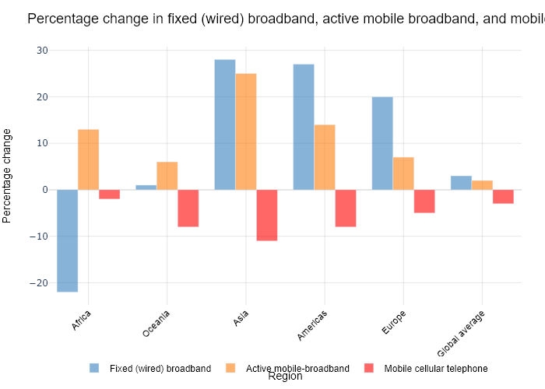

## Performance Metrics

|  |  |  |  |
| --- | --- | --- | --- |
| Task | Model Used | Description | Time Taken (s) |
| Processing Image to JSON | Gemini Vision Pro (default) | Time taken to convert the uploaded image to JSON format | 22.55 |
| Updating JSON | ChatGPT 3.5 (Default) | Time taken to update the JSON with new data | 0.00 |
| Plotting Updated JSON | N/A | Time taken to plot the updated JSON | 0.16 |

# Test Run

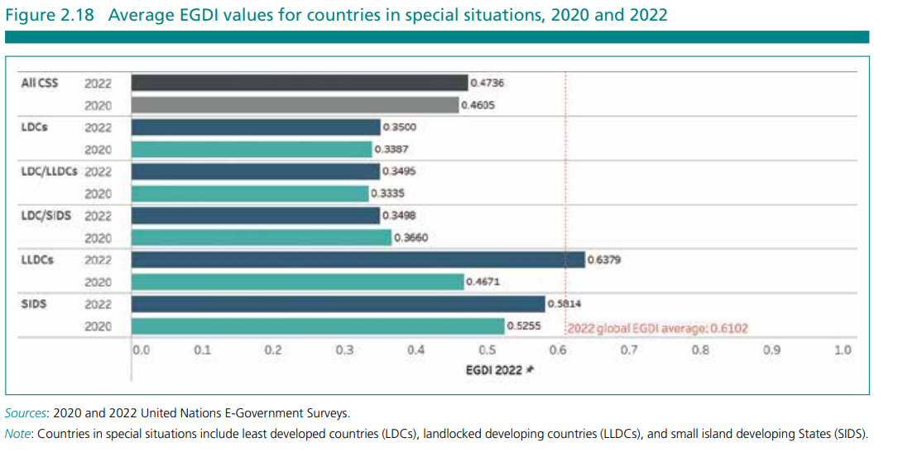

Figure: new graphs/bar/2.3_image1.png

## Prompt Used

Task: Extract detailed information from a given graph image and generate JSON files (data.json, layout.json, and config.json) compatible with Plotly. Use the specified delimiters to wrap each JSON section.  
  
Instructions:  
  
Graph Analysis:  
  
Identify and categorize the plot types present in the graph (e.g., line, scatter, bar, pie).  
Extract the data points for each plot (x-values, y-values, and any other relevant data such as labels for pie charts).  
Note any multiple plots on the same figure and their configurations.  
Generate data.json:  
  
For each plot, include details such as:  
type: The type of plot (e.g., scatter, bar, pie).  
x and y: Arrays of data points for the x and y axes.  
labels and values for pie charts.  
mode: For line and scatter plots (e.g., markers, lines, or markers+lines).  
name: Legend entry for the plot.  
marker: Properties such as color, size, and symbol for markers.  
line: Properties such as color, width, and dash style for lines.  
text: Hover text for each data point.  
hoverinfo: Information displayed on hover (e.g., x+y+text).  
Generate layout.json:  
  
Include details such as:  
title: The title of the graph, including text, font properties (family, size, color).  
xaxis and yaxis: Configuration including title, range, showgrid, gridcolor, zeroline, zerolinecolor, showticklabels, tickangle, tickfont.  
legend: Properties including orientation, x, y, xanchor, font.  
margin: Values for l (left), r (right), b (bottom), t (top), pad.  
plot_bgcolor and paper_bgcolor: Background colors of the plot area and paper.  
Generate config.json:  
  
Include configuration settings such as:  
responsive: Whether the graph is responsive (boolean).  
displayModeBar: Whether the mode bar is displayed (boolean).  
modeBarButtonsToRemove: List of mode bar buttons to remove (e.g., ["toImage"]).  
scrollZoom: Whether scrolling zoom is enabled (boolean).  
Output Format:  
  
Wrap each JSON output in specific XML-like tags:  
<data> ... </data>  
<layout> ... </layout>  
<config> ... </config>  
Make sure to follow the JSON formatting guidelines:  
Double Quotes for Keys and Strings: Ensure that all keys and string values in JSON are enclosed in double quotes (").  
Example: Instead of "type": bar, it should be "type": "bar".  
No Trailing Commas: Remove any trailing commas after the last element in arrays ([]) or objects ({}).  
Example: Instead of "color": "rgba(55, 128, 191, 0.6)",, it should be "color": "rgba(55, 128, 191, 0.6)"  
Example Output:  
  
<data>  
[  
 {  
 "type": "scatter",  
 "x": [1, 2, 3],  
 "y": [4, 5, 6],  
 "mode": "markers+lines",  
 "name": "Line Plot",  
 "marker": {  
 "color": "rgba(75, 192, 192, 0.6)",  
 "size": 8  
 },  
 "line": {  
 "color": "rgba(75, 192, 192, 1)",  
 "width": 2  
 }  
 }  
 // Additional plots if present  
]  
</data>  
<layout>  
{  
 "title": {  
 "text": "Graph Title",  
 "font": {  
 "family": "Arial, sans-serif",  
 "size": 24,  
 "color": "#000000"  
 }  
 },  
 "xaxis": {  
 "title": {  
 "text": "X Axis",  
 "font": {  
 "family": "Arial, sans-serif",  
 "size": 18,  
 "color": "#000000"  
 }  
 },  
 "showgrid": true,  
 "gridcolor": "rgba(0, 0, 0, 0.1)",  
 "zeroline": true,  
 "zerolinecolor": "rgba(0, 0, 0, 0.1)"  
 },  
 "yaxis": {  
 "title": {  
 "text": "Y Axis",  
 "font": {  
 "family": "Arial, sans-serif",  
 "size": 18,  
 "color": "#000000"  
 }  
 },  
 "showgrid": true,  
 "gridcolor": "rgba(0, 0, 0, 0.1)",  
 "zeroline": true,  
 "zerolinecolor": "rgba(0, 0, 0, 0.1)"  
 },  
 "legend": {  
 "orientation": "h",  
 "x": 0.5,  
 "xanchor": "center",  
 "y": -0.2,  
 "font": {  
 "family": "Arial, sans-serif",  
 "size": 12,  
 "color": "#000000"  
 }  
 },  
 "margin": {  
 "l": 60,  
 "r": 30,  
 "b": 60,  
 "t": 60  
 },  
 "plot_bgcolor": "#ffffff",  
 "paper_bgcolor": "#ffffff"  
}  
</layout>  
<config>  
{  
 "responsive": true,  
 "displayModeBar": true,  
 "modeBarButtonsToRemove": ["toImage"],  
 "scrollZoom": true  
}  
</config>

## Extracted JSON

### data

[  
 {  
 "type": "bar",  
 "x": [  
 "All CS",  
 "LDCs",  
 "LDC/LLDCs",  
 "LDCs/SIDS",  
 "LLDCs",  
 "SIDS"  
 ],  
 "y": [  
 0.4736,  
 0.35,  
 0.3495,  
 0.366,  
 0.6379,  
 0.5814  
 ],  
 "name": "2022",  
 "marker": {  
 "color": "rgba(55, 128, 191, 0.6)"  
 }  
 },  
 {  
 "type": "bar",  
 "x": [  
 "All CS",  
 "LDCs",  
 "LDC/LLDCs",  
 "LDCs/SIDS",  
 "LLDCs",  
 "SIDS"  
 ],  
 "y": [  
 0.4605,  
 0.3387,  
 0.3348,  
 0.35,  
 0.4671,  
 0.5255  
 ],  
 "name": "2020",  
 "marker": {  
 "color": "rgba(255, 128, 0, 0.6)"  
 }  
 }  
]

### layout

{  
 "title": {  
 "text": "Average EGDI values for countries in special situations, 2020 and 2022",  
 "font": {  
 "family": "Arial, sans-serif",  
 "size": 24,  
 "color": "#000000"  
 }  
 },  
 "xaxis": {  
 "title": {  
 "text": "Countries",  
 "font": {  
 "family": "Arial, sans-serif",  
 "size": 18,  
 "color": "#000000"  
 }  
 },  
 "tickangle": -45,  
 "showticklabels": true  
 },  
 "yaxis": {  
 "title": {  
 "text": "EGDI",  
 "font": {  
 "family": "Arial, sans-serif",  
 "size": 18,  
 "color": "#000000"  
 }  
 },  
 "range": [  
 0,  
 1  
 ],  
 "showgrid": true,  
 "gridcolor": "rgba(0, 0, 0, 0.1)",  
 "zeroline": true,  
 "zerolinecolor": "rgba(0, 0, 0, 0.1)"  
 },  
 "legend": {  
 "orientation": "h",  
 "x": 0.5,  
 "xanchor": "center",  
 "y": -0.2,  
 "font": {  
 "family": "Arial, sans-serif",  
 "size": 12,  
 "color": "#000000"  
 }  
 },  
 "margin": {  
 "l": 60,  
 "r": 30,  
 "b": 60,  
 "t": 60  
 },  
 "plot_bgcolor": "#ffffff",  
 "paper_bgcolor": "#ffffff"  
}

### config

{  
 "responsive": true,  
 "displayModeBar": true,  
 "modeBarButtonsToRemove": [  
 "toImage"  
 ],  
 "scrollZoom": true  
}

## Updated JSON

### updated_data

[  
 {  
 "type": "bar",  
 "x": [  
 "All CS",  
 "LDCs",  
 "LDC/LLDCs",  
 "LDCs/SIDS",  
 "LLDCs",  
 "SIDS"  
 ],  
 "y": [  
 0.4736,  
 0.35,  
 0.3495,  
 0.366,  
 0.6379,  
 0.5814  
 ],  
 "name": "2022",  
 "marker": {  
 "color": "rgba(55, 128, 191, 0.6)"  
 }  
 },  
 {  
 "type": "bar",  
 "x": [  
 "All CS",  
 "LDCs",  
 "LDC/LLDCs",  
 "LDCs/SIDS",  
 "LLDCs",  
 "SIDS"  
 ],  
 "y": [  
 0.4605,  
 0.3387,  
 0.3348,  
 0.35,  
 0.4671,  
 0.5255  
 ],  
 "name": "2020",  
 "marker": {  
 "color": "rgba(255, 128, 0, 0.6)"  
 }  
 }  
]

### updated_layout

{  
 "title": {  
 "text": "Average EGDI values for countries in special situations, 2020 and 2022",  
 "font": {  
 "family": "Arial, sans-serif",  
 "size": 24,  
 "color": "#000000"  
 }  
 },  
 "xaxis": {  
 "title": {  
 "text": "Countries",  
 "font": {  
 "family": "Arial, sans-serif",  
 "size": 18,  
 "color": "#000000"  
 }  
 },  
 "tickangle": -45,  
 "showticklabels": true  
 },  
 "yaxis": {  
 "title": {  
 "text": "EGDI",  
 "font": {  
 "family": "Arial, sans-serif",  
 "size": 18,  
 "color": "#000000"  
 }  
 },  
 "range": [  
 0,  
 1  
 ],  
 "showgrid": true,  
 "gridcolor": "rgba(0, 0, 0, 0.1)",  
 "zeroline": true,  
 "zerolinecolor": "rgba(0, 0, 0, 0.1)"  
 },  
 "legend": {  
 "orientation": "h",  
 "x": 0.5,  
 "xanchor": "center",  
 "y": -0.2,  
 "font": {  
 "family": "Arial, sans-serif",  
 "size": 12,  
 "color": "#000000"  
 }  
 },  
 "margin": {  
 "l": 60,  
 "r": 30,  
 "b": 60,  
 "t": 60  
 },  
 "plot_bgcolor": "#ffffff",  
 "paper_bgcolor": "#ffffff"  
}

### updated_config

{  
 "responsive": true,  
 "displayModeBar": true,  
 "modeBarButtonsToRemove": [  
 "toImage"  
 ],  
 "scrollZoom": true  
}

## Updated Chart

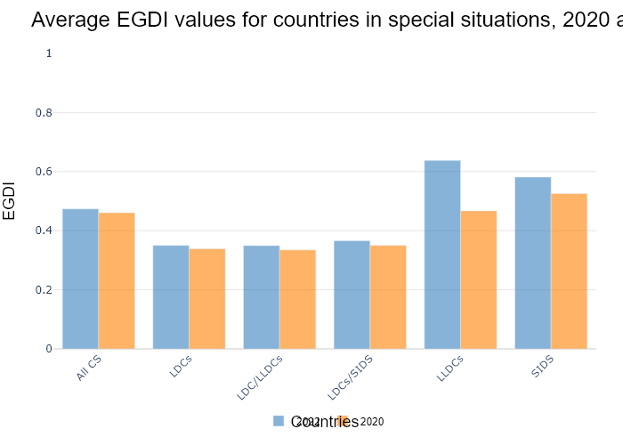

## Performance Metrics

|  |  |  |  |
| --- | --- | --- | --- |
| Task | Model Used | Description | Time Taken (s) |
| Processing Image to JSON | Gemini Vision Pro (default) | Time taken to convert the uploaded image to JSON format | 20.19 |
| Updating JSON | ChatGPT 3.5 (Default) | Time taken to update the JSON with new data | 0.00 |
| Plotting Updated JSON | N/A | Time taken to plot the updated JSON | 0.14 |

# Test Run

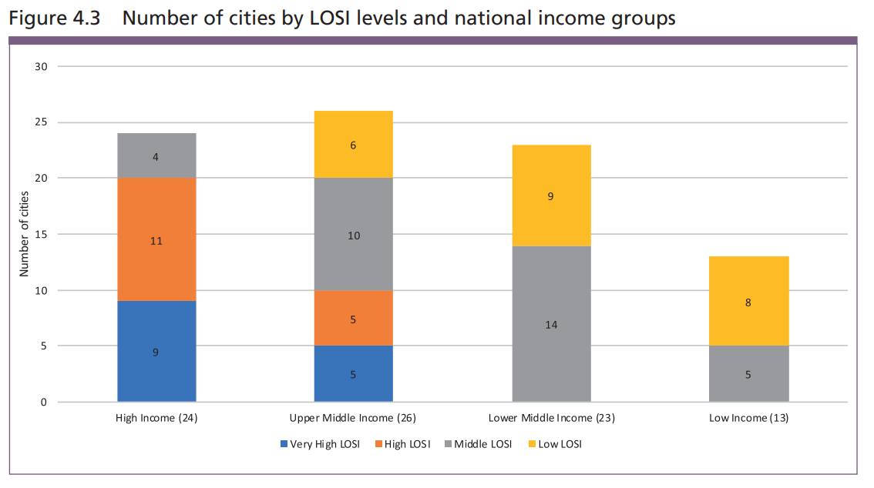

Figure: new graphs/bar/2.4_image1.png

## Prompt Used

Task: Extract detailed information from a given graph image and generate JSON files (data.json, layout.json, and config.json) compatible with Plotly. Use the specified delimiters to wrap each JSON section.  
  
Instructions:  
  
Graph Analysis:  
  
Identify and categorize the plot types present in the graph (e.g., line, scatter, bar, pie).  
Extract the data points for each plot (x-values, y-values, and any other relevant data such as labels for pie charts).  
Note any multiple plots on the same figure and their configurations.  
Generate data.json:  
  
For each plot, include details such as:  
type: The type of plot (e.g., scatter, bar, pie).  
x and y: Arrays of data points for the x and y axes.  
labels and values for pie charts.  
mode: For line and scatter plots (e.g., markers, lines, or markers+lines).  
name: Legend entry for the plot.  
marker: Properties such as color, size, and symbol for markers.  
line: Properties such as color, width, and dash style for lines.  
text: Hover text for each data point.  
hoverinfo: Information displayed on hover (e.g., x+y+text).  
Generate layout.json:  
  
Include details such as:  
title: The title of the graph, including text, font properties (family, size, color).  
xaxis and yaxis: Configuration including title, range, showgrid, gridcolor, zeroline, zerolinecolor, showticklabels, tickangle, tickfont.  
legend: Properties including orientation, x, y, xanchor, font.  
margin: Values for l (left), r (right), b (bottom), t (top), pad.  
plot_bgcolor and paper_bgcolor: Background colors of the plot area and paper.  
Generate config.json:  
  
Include configuration settings such as:  
responsive: Whether the graph is responsive (boolean).  
displayModeBar: Whether the mode bar is displayed (boolean).  
modeBarButtonsToRemove: List of mode bar buttons to remove (e.g., ["toImage"]).  
scrollZoom: Whether scrolling zoom is enabled (boolean).  
Output Format:  
  
Wrap each JSON output in specific XML-like tags:  
<data> ... </data>  
<layout> ... </layout>  
<config> ... </config>  
Make sure to follow the JSON formatting guidelines:  
Double Quotes for Keys and Strings: Ensure that all keys and string values in JSON are enclosed in double quotes (").  
Example: Instead of "type": bar, it should be "type": "bar".  
No Trailing Commas: Remove any trailing commas after the last element in arrays ([]) or objects ({}).  
Example: Instead of "color": "rgba(55, 128, 191, 0.6)",, it should be "color": "rgba(55, 128, 191, 0.6)"  
Example Output:  
  
<data>  
[  
 {  
 "type": "scatter",  
 "x": [1, 2, 3],  
 "y": [4, 5, 6],  
 "mode": "markers+lines",  
 "name": "Line Plot",  
 "marker": {  
 "color": "rgba(75, 192, 192, 0.6)",  
 "size": 8  
 },  
 "line": {  
 "color": "rgba(75, 192, 192, 1)",  
 "width": 2  
 }  
 }  
 // Additional plots if present  
]  
</data>  
<layout>  
{  
 "title": {  
 "text": "Graph Title",  
 "font": {  
 "family": "Arial, sans-serif",  
 "size": 24,  
 "color": "#000000"  
 }  
 },  
 "xaxis": {  
 "title": {  
 "text": "X Axis",  
 "font": {  
 "family": "Arial, sans-serif",  
 "size": 18,  
 "color": "#000000"  
 }  
 },  
 "showgrid": true,  
 "gridcolor": "rgba(0, 0, 0, 0.1)",  
 "zeroline": true,  
 "zerolinecolor": "rgba(0, 0, 0, 0.1)"  
 },  
 "yaxis": {  
 "title": {  
 "text": "Y Axis",  
 "font": {  
 "family": "Arial, sans-serif",  
 "size": 18,  
 "color": "#000000"  
 }  
 },  
 "showgrid": true,  
 "gridcolor": "rgba(0, 0, 0, 0.1)",  
 "zeroline": true,  
 "zerolinecolor": "rgba(0, 0, 0, 0.1)"  
 },  
 "legend": {  
 "orientation": "h",  
 "x": 0.5,  
 "xanchor": "center",  
 "y": -0.2,  
 "font": {  
 "family": "Arial, sans-serif",  
 "size": 12,  
 "color": "#000000"  
 }  
 },  
 "margin": {  
 "l": 60,  
 "r": 30,  
 "b": 60,  
 "t": 60  
 },  
 "plot_bgcolor": "#ffffff",  
 "paper_bgcolor": "#ffffff"  
}  
</layout>  
<config>  
{  
 "responsive": true,  
 "displayModeBar": true,  
 "modeBarButtonsToRemove": ["toImage"],  
 "scrollZoom": true  
}  
</config>

## Extracted JSON

### data

[  
 {  
 "type": "bar",  
 "x": [  
 "High Income",  
 "Upper Middle Income",  
 "Lower Middle Income",  
 "Low Income"  
 ],  
 "y": [  
 24,  
 26,  
 23,  
 13  
 ],  
 "name": "Number of Cities",  
 "marker": {  
 "color": [  
 "rgba(55, 128, 191, 0.6)",  
 "rgba(55, 128, 191, 0.6)",  
 "rgba(55, 128, 191, 0.6)",  
 "rgba(55, 128, 191, 0.6)"  
 ]  
 }  
 },  
 {  
 "type": "bar",  
 "x": [  
 "High Income",  
 "Upper Middle Income",  
 "Lower Middle Income",  
 "Low Income"  
 ],  
 "y": [  
 9,  
 5,  
 14,  
 5  
 ],  
 "name": "Very High LOSI",  
 "marker": {  
 "color": [  
 "rgba(255, 127, 14, 0.6)",  
 "rgba(255, 127, 14, 0.6)",  
 "rgba(255, 127, 14, 0.6)",  
 "rgba(255, 127, 14, 0.6)"  
 ]  
 }  
 },  
 {  
 "type": "bar",  
 "x": [  
 "High Income",  
 "Upper Middle Income",  
 "Lower Middle Income",  
 "Low Income"  
 ],  
 "y": [  
 11,  
 10,  
 9,  
 8  
 ],  
 "name": "High LOSI",  
 "marker": {  
 "color": [  
 "rgba(44, 160, 101, 0.6)",  
 "rgba(44, 160, 101, 0.6)",  
 "rgba(44, 160, 101, 0.6)",  
 "rgba(44, 160, 101, 0.6)"  
 ]  
 }  
 },  
 {  
 "type": "bar",  
 "x": [  
 "High Income",  
 "Upper Middle Income",  
 "Lower Middle Income",  
 "Low Income"  
 ],  
 "y": [  
 4,  
 6,  
 0,  
 0  
 ],  
 "name": "Middle LOSI",  
 "marker": {  
 "color": [  
 "rgba(255, 209, 102, 0.6)",  
 "rgba(255, 209, 102, 0.6)",  
 "rgba(255, 209, 102, 0.6)",  
 "rgba(255, 209, 102, 0.6)"  
 ]  
 }  
 },  
 {  
 "type": "bar",  
 "x": [  
 "High Income",  
 "Upper Middle Income",  
 "Lower Middle Income",  
 "Low Income"  
 ],  
 "y": [  
 0,  
 5,  
 0,  
 0  
 ],  
 "name": "Low LOSI",  
 "marker": {  
 "color": [  
 "rgba(166, 206, 227, 0.6)",  
 "rgba(166, 206, 227, 0.6)",  
 "rgba(166, 206, 227, 0.6)",  
 "rgba(166, 206, 227, 0.6)"  
 ]  
 }  
 }  
]

### layout

{  
 "title": {  
 "text": "Number of cities by LOSI levels and national income groups",  
 "font": {  
 "family": "Arial, sans-serif",  
 "size": 24,  
 "color": "#000000"  
 }  
 },  
 "xaxis": {  
 "title": {  
 "text": "Income Group",  
 "font": {  
 "family": "Arial, sans-serif",  
 "size": 18,  
 "color": "#000000"  
 }  
 },  
 "showgrid": true,  
 "gridcolor": "rgba(0, 0, 0, 0.1)",  
 "zeroline": true,  
 "zerolinecolor": "rgba(0, 0, 0, 0.1)",  
 "tickangle": -45  
 },  
 "yaxis": {  
 "title": {  
 "text": "Number of Cities",  
 "font": {  
 "family": "Arial, sans-serif",  
 "size": 18,  
 "color": "#000000"  
 }  
 },  
 "showgrid": true,  
 "gridcolor": "rgba(0, 0, 0, 0.1)",  
 "zeroline": true,  
 "zerolinecolor": "rgba(0, 0, 0, 0.1)"  
 },  
 "legend": {  
 "orientation": "h",  
 "x": 0.5,  
 "xanchor": "center",  
 "y": -0.2,  
 "font": {  
 "family": "Arial, sans-serif",  
 "size": 12,  
 "color": "#000000"  
 }  
 },  
 "margin": {  
 "l": 60,  
 "r": 30,  
 "b": 60,  
 "t": 60  
 },  
 "plot_bgcolor": "#ffffff",  
 "paper_bgcolor": "#ffffff"  
}

### config

{  
 "responsive": true,  
 "displayModeBar": true,  
 "modeBarButtonsToRemove": [  
 "toImage"  
 ],  
 "scrollZoom": true  
}

## Updated JSON

### updated_data

[  
 {  
 "type": "bar",  
 "x": [  
 "High Income",  
 "Upper Middle Income",  
 "Lower Middle Income",  
 "Low Income"  
 ],  
 "y": [  
 24,  
 26,  
 23,  
 13  
 ],  
 "name": "Number of Cities",  
 "marker": {  
 "color": [  
 "rgba(55, 128, 191, 0.6)",  
 "rgba(55, 128, 191, 0.6)",  
 "rgba(55, 128, 191, 0.6)",  
 "rgba(55, 128, 191, 0.6)"  
 ]  
 }  
 },  
 {  
 "type": "bar",  
 "x": [  
 "High Income",  
 "Upper Middle Income",  
 "Lower Middle Income",  
 "Low Income"  
 ],  
 "y": [  
 9,  
 5,  
 14,  
 5  
 ],  
 "name": "Very High LOSI",  
 "marker": {  
 "color": [  
 "rgba(255, 127, 14, 0.6)",  
 "rgba(255, 127, 14, 0.6)",  
 "rgba(255, 127, 14, 0.6)",  
 "rgba(255, 127, 14, 0.6)"  
 ]  
 }  
 },  
 {  
 "type": "bar",  
 "x": [  
 "High Income",  
 "Upper Middle Income",  
 "Lower Middle Income",  
 "Low Income"  
 ],  
 "y": [  
 11,  
 10,  
 9,  
 8  
 ],  
 "name": "High LOSI",  
 "marker": {  
 "color": [  
 "rgba(44, 160, 101, 0.6)",  
 "rgba(44, 160, 101, 0.6)",  
 "rgba(44, 160, 101, 0.6)",  
 "rgba(44, 160, 101, 0.6)"  
 ]  
 }  
 },  
 {  
 "type": "bar",  
 "x": [  
 "High Income",  
 "Upper Middle Income",  
 "Lower Middle Income",  
 "Low Income"  
 ],  
 "y": [  
 4,  
 6,  
 0,  
 0  
 ],  
 "name": "Middle LOSI",  
 "marker": {  
 "color": [  
 "rgba(255, 209, 102, 0.6)",  
 "rgba(255, 209, 102, 0.6)",  
 "rgba(255, 209, 102, 0.6)",  
 "rgba(255, 209, 102, 0.6)"  
 ]  
 }  
 },  
 {  
 "type": "bar",  
 "x": [  
 "High Income",  
 "Upper Middle Income",  
 "Lower Middle Income",  
 "Low Income"  
 ],  
 "y": [  
 0,  
 5,  
 0,  
 0  
 ],  
 "name": "Low LOSI",  
 "marker": {  
 "color": [  
 "rgba(166, 206, 227, 0.6)",  
 "rgba(166, 206, 227, 0.6)",  
 "rgba(166, 206, 227, 0.6)",  
 "rgba(166, 206, 227, 0.6)"  
 ]  
 }  
 }  
]

### updated_layout

{  
 "title": {  
 "text": "Number of cities by LOSI levels and national income groups",  
 "font": {  
 "family": "Arial, sans-serif",  
 "size": 24,  
 "color": "#000000"  
 }  
 },  
 "xaxis": {  
 "title": {  
 "text": "Income Group",  
 "font": {  
 "family": "Arial, sans-serif",  
 "size": 18,  
 "color": "#000000"  
 }  
 },  
 "showgrid": true,  
 "gridcolor": "rgba(0, 0, 0, 0.1)",  
 "zeroline": true,  
 "zerolinecolor": "rgba(0, 0, 0, 0.1)",  
 "tickangle": -45  
 },  
 "yaxis": {  
 "title": {  
 "text": "Number of Cities",  
 "font": {  
 "family": "Arial, sans-serif",  
 "size": 18,  
 "color": "#000000"  
 }  
 },  
 "showgrid": true,  
 "gridcolor": "rgba(0, 0, 0, 0.1)",  
 "zeroline": true,  
 "zerolinecolor": "rgba(0, 0, 0, 0.1)"  
 },  
 "legend": {  
 "orientation": "h",  
 "x": 0.5,  
 "xanchor": "center",  
 "y": -0.2,  
 "font": {  
 "family": "Arial, sans-serif",  
 "size": 12,  
 "color": "#000000"  
 }  
 },  
 "margin": {  
 "l": 60,  
 "r": 30,  
 "b": 60,  
 "t": 60  
 },  
 "plot_bgcolor": "#ffffff",  
 "paper_bgcolor": "#ffffff"  
}

### updated_config

{  
 "responsive": true,  
 "displayModeBar": true,  
 "modeBarButtonsToRemove": [  
 "toImage"  
 ],  
 "scrollZoom": true  
}

## Updated Chart

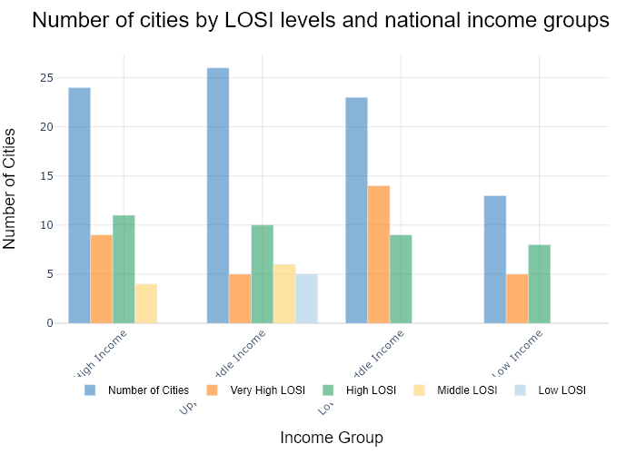

## Performance Metrics

|  |  |  |  |
| --- | --- | --- | --- |
| Task | Model Used | Description | Time Taken (s) |
| Processing Image to JSON | Gemini Vision Pro (default) | Time taken to convert the uploaded image to JSON format | 28.38 |
| Updating JSON | ChatGPT 3.5 (Default) | Time taken to update the JSON with new data | 0.00 |
| Plotting Updated JSON | N/A | Time taken to plot the updated JSON | 0.08 |

# Test Run

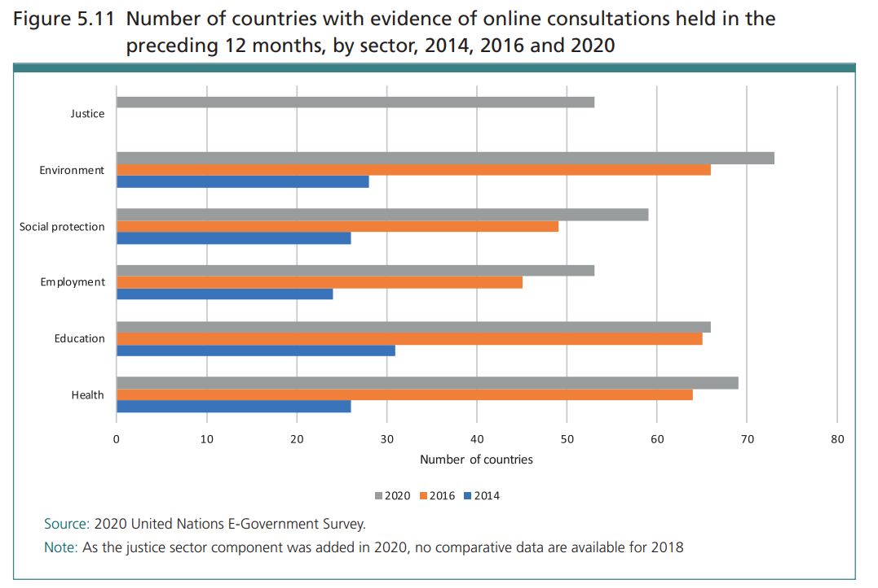

Figure: new graphs/bar/2.6_image1.png

## Prompt Used

Task: Extract detailed information from a given graph image and generate JSON files (data.json, layout.json, and config.json) compatible with Plotly. Use the specified delimiters to wrap each JSON section.  
  
Instructions:  
  
Graph Analysis:  
  
Identify and categorize the plot types present in the graph (e.g., line, scatter, bar, pie).  
Extract the data points for each plot (x-values, y-values, and any other relevant data such as labels for pie charts).  
Note any multiple plots on the same figure and their configurations.  
Generate data.json:  
  
For each plot, include details such as:  
type: The type of plot (e.g., scatter, bar, pie).  
x and y: Arrays of data points for the x and y axes.  
labels and values for pie charts.  
mode: For line and scatter plots (e.g., markers, lines, or markers+lines).  
name: Legend entry for the plot.  
marker: Properties such as color, size, and symbol for markers.  
line: Properties such as color, width, and dash style for lines.  
text: Hover text for each data point.  
hoverinfo: Information displayed on hover (e.g., x+y+text).  
Generate layout.json:  
  
Include details such as:  
title: The title of the graph, including text, font properties (family, size, color).  
xaxis and yaxis: Configuration including title, range, showgrid, gridcolor, zeroline, zerolinecolor, showticklabels, tickangle, tickfont.  
legend: Properties including orientation, x, y, xanchor, font.  
margin: Values for l (left), r (right), b (bottom), t (top), pad.  
plot_bgcolor and paper_bgcolor: Background colors of the plot area and paper.  
Generate config.json:  
  
Include configuration settings such as:  
responsive: Whether the graph is responsive (boolean).  
displayModeBar: Whether the mode bar is displayed (boolean).  
modeBarButtonsToRemove: List of mode bar buttons to remove (e.g., ["toImage"]).  
scrollZoom: Whether scrolling zoom is enabled (boolean).  
Output Format:  
  
Wrap each JSON output in specific XML-like tags:  
<data> ... </data>  
<layout> ... </layout>  
<config> ... </config>  
Make sure to follow the JSON formatting guidelines:  
Double Quotes for Keys and Strings: Ensure that all keys and string values in JSON are enclosed in double quotes (").  
Example: Instead of "type": bar, it should be "type": "bar".  
No Trailing Commas: Remove any trailing commas after the last element in arrays ([]) or objects ({}).  
Example: Instead of "color": "rgba(55, 128, 191, 0.6)",, it should be "color": "rgba(55, 128, 191, 0.6)"  
Example Output:  
  
<data>  
[  
 {  
 "type": "scatter",  
 "x": [1, 2, 3],  
 "y": [4, 5, 6],  
 "mode": "markers+lines",  
 "name": "Line Plot",  
 "marker": {  
 "color": "rgba(75, 192, 192, 0.6)",  
 "size": 8  
 },  
 "line": {  
 "color": "rgba(75, 192, 192, 1)",  
 "width": 2  
 }  
 }  
 // Additional plots if present  
]  
</data>  
<layout>  
{  
 "title": {  
 "text": "Graph Title",  
 "font": {  
 "family": "Arial, sans-serif",  
 "size": 24,  
 "color": "#000000"  
 }  
 },  
 "xaxis": {  
 "title": {  
 "text": "X Axis",  
 "font": {  
 "family": "Arial, sans-serif",  
 "size": 18,  
 "color": "#000000"  
 }  
 },  
 "showgrid": true,  
 "gridcolor": "rgba(0, 0, 0, 0.1)",  
 "zeroline": true,  
 "zerolinecolor": "rgba(0, 0, 0, 0.1)"  
 },  
 "yaxis": {  
 "title": {  
 "text": "Y Axis",  
 "font": {  
 "family": "Arial, sans-serif",  
 "size": 18,  
 "color": "#000000"  
 }  
 },  
 "showgrid": true,  
 "gridcolor": "rgba(0, 0, 0, 0.1)",  
 "zeroline": true,  
 "zerolinecolor": "rgba(0, 0, 0, 0.1)"  
 },  
 "legend": {  
 "orientation": "h",  
 "x": 0.5,  
 "xanchor": "center",  
 "y": -0.2,  
 "font": {  
 "family": "Arial, sans-serif",  
 "size": 12,  
 "color": "#000000"  
 }  
 },  
 "margin": {  
 "l": 60,  
 "r": 30,  
 "b": 60,  
 "t": 60  
 },  
 "plot_bgcolor": "#ffffff",  
 "paper_bgcolor": "#ffffff"  
}  
</layout>  
<config>  
{  
 "responsive": true,  
 "displayModeBar": true,  
 "modeBarButtonsToRemove": ["toImage"],  
 "scrollZoom": true  
}  
</config>

## Extracted JSON

### data

[  
 {  
 "type": "bar",  
 "x": [  
 "Justice",  
 "Environment",  
 "Social protection",  
 "Employment",  
 "Education",  
 "Health"  
 ],  
 "y": [  
 60,  
 72,  
 30,  
 40,  
 35,  
 70  
 ],  
 "name": "Number of countries with evidence of online consultations held in the preceding 12 months, by sector"  
 }  
]

### layout

{  
 "title": {  
 "text": "Number of countries with evidence of online consultations held in the preceding 12 months, by sector, 2014, 2016 and 2020",  
 "font": {  
 "family": "Arial, sans-serif",  
 "size": 18,  
 "color": "#333333"  
 }  
 },  
 "xaxis": {  
 "title": {  
 "text": "Sector",  
 "font": {  
 "family": "Arial, sans-serif",  
 "size": 14,  
 "color": "#333333"  
 }  
 },  
 "tickfont": {  
 "family": "Arial, sans-serif",  
 "size": 12,  
 "color": "#333333"  
 }  
 },  
 "yaxis": {  
 "title": {  
 "text": "Number of countries",  
 "font": {  
 "family": "Arial, sans-serif",  
 "size": 14,  
 "color": "#333333"  
 }  
 },  
 "tickfont": {  
 "family": "Arial, sans-serif",  
 "size": 12,  
 "color": "#333333"  
 }  
 },  
 "legend": {  
 "orientation": "h",  
 "x": 0.5,  
 "xanchor": "center",  
 "y": -0.2,  
 "font": {  
 "family": "Arial, sans-serif",  
 "size": 12,  
 "color": "#333333"  
 }  
 },  
 "margin": {  
 "l": 60,  
 "r": 30,  
 "b": 60,  
 "t": 60  
 },  
 "plot_bgcolor": "#ffffff",  
 "paper_bgcolor": "#ffffff"  
}

### config

{  
 "responsive": true,  
 "displayModeBar": true,  
 "modeBarButtonsToRemove": [  
 "toImage"  
 ],  
 "scrollZoom": true  
}

## Updated JSON

### updated_data

[  
 {  
 "type": "bar",  
 "x": [  
 "Justice",  
 "Environment",  
 "Social protection",  
 "Employment",  
 "Education",  
 "Health"  
 ],  
 "y": [  
 60,  
 72,  
 30,  
 40,  
 35,  
 70  
 ],  
 "name": "Number of countries with evidence of online consultations held in the preceding 12 months, by sector"  
 }  
]

### updated_layout

{  
 "title": {  
 "text": "Number of countries with evidence of online consultations held in the preceding 12 months, by sector, 2014, 2016 and 2020",  
 "font": {  
 "family": "Arial, sans-serif",  
 "size": 18,  
 "color": "#333333"  
 }  
 },  
 "xaxis": {  
 "title": {  
 "text": "Sector",  
 "font": {  
 "family": "Arial, sans-serif",  
 "size": 14,  
 "color": "#333333"  
 }  
 },  
 "tickfont": {  
 "family": "Arial, sans-serif",  
 "size": 12,  
 "color": "#333333"  
 }  
 },  
 "yaxis": {  
 "title": {  
 "text": "Number of countries",  
 "font": {  
 "family": "Arial, sans-serif",  
 "size": 14,  
 "color": "#333333"  
 }  
 },  
 "tickfont": {  
 "family": "Arial, sans-serif",  
 "size": 12,  
 "color": "#333333"  
 }  
 },  
 "legend": {  
 "orientation": "h",  
 "x": 0.5,  
 "xanchor": "center",  
 "y": -0.2,  
 "font": {  
 "family": "Arial, sans-serif",  
 "size": 12,  
 "color": "#333333"  
 }  
 },  
 "margin": {  
 "l": 60,  
 "r": 30,  
 "b": 60,  
 "t": 60  
 },  
 "plot_bgcolor": "#ffffff",  
 "paper_bgcolor": "#ffffff"  
}

### updated_config

{  
 "responsive": true,  
 "displayModeBar": true,  
 "modeBarButtonsToRemove": [  
 "toImage"  
 ],  
 "scrollZoom": true  
}

## Updated Chart

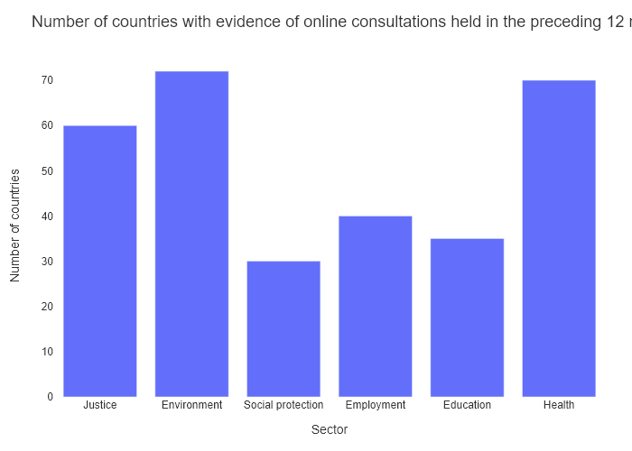

## Performance Metrics

|  |  |  |  |
| --- | --- | --- | --- |
| Task | Model Used | Description | Time Taken (s) |
| Processing Image to JSON | Gemini Vision Pro (default) | Time taken to convert the uploaded image to JSON format | 15.49 |
| Updating JSON | ChatGPT 3.5 (Default) | Time taken to update the JSON with new data | 0.00 |
| Plotting Updated JSON | N/A | Time taken to plot the updated JSON | 0.16 |

# Test Run

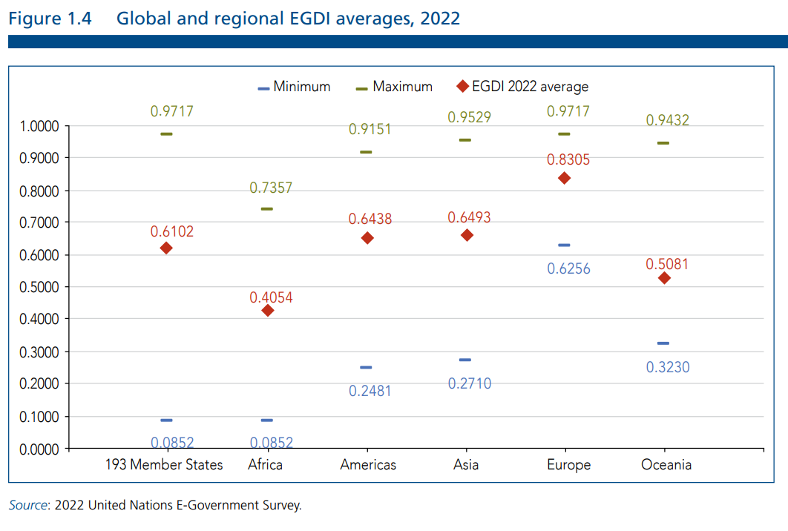

Figure: new graphs/bar/Others1.png

## Prompt Used

Task: Extract detailed information from a given graph image and generate JSON files (data.json, layout.json, and config.json) compatible with Plotly. Use the specified delimiters to wrap each JSON section.  
  
Instructions:  
  
Graph Analysis:  
  
Identify and categorize the plot types present in the graph (e.g., line, scatter, bar, pie).  
Extract the data points for each plot (x-values, y-values, and any other relevant data such as labels for pie charts).  
Note any multiple plots on the same figure and their configurations.  
Generate data.json:  
  
For each plot, include details such as:  
type: The type of plot (e.g., scatter, bar, pie).  
x and y: Arrays of data points for the x and y axes.  
labels and values for pie charts.  
mode: For line and scatter plots (e.g., markers, lines, or markers+lines).  
name: Legend entry for the plot.  
marker: Properties such as color, size, and symbol for markers.  
line: Properties such as color, width, and dash style for lines.  
text: Hover text for each data point.  
hoverinfo: Information displayed on hover (e.g., x+y+text).  
Generate layout.json:  
  
Include details such as:  
title: The title of the graph, including text, font properties (family, size, color).  
xaxis and yaxis: Configuration including title, range, showgrid, gridcolor, zeroline, zerolinecolor, showticklabels, tickangle, tickfont.  
legend: Properties including orientation, x, y, xanchor, font.  
margin: Values for l (left), r (right), b (bottom), t (top), pad.  
plot_bgcolor and paper_bgcolor: Background colors of the plot area and paper.  
Generate config.json:  
  
Include configuration settings such as:  
responsive: Whether the graph is responsive (boolean).  
displayModeBar: Whether the mode bar is displayed (boolean).  
modeBarButtonsToRemove: List of mode bar buttons to remove (e.g., ["toImage"]).  
scrollZoom: Whether scrolling zoom is enabled (boolean).  
Output Format:  
  
Wrap each JSON output in specific XML-like tags:  
<data> ... </data>  
<layout> ... </layout>  
<config> ... </config>  
Make sure to follow the JSON formatting guidelines:  
Double Quotes for Keys and Strings: Ensure that all keys and string values in JSON are enclosed in double quotes (").  
Example: Instead of "type": bar, it should be "type": "bar".  
No Trailing Commas: Remove any trailing commas after the last element in arrays ([]) or objects ({}).  
Example: Instead of "color": "rgba(55, 128, 191, 0.6)",, it should be "color": "rgba(55, 128, 191, 0.6)"  
Example Output:  
  
<data>  
[  
 {  
 "type": "scatter",  
 "x": [1, 2, 3],  
 "y": [4, 5, 6],  
 "mode": "markers+lines",  
 "name": "Line Plot",  
 "marker": {  
 "color": "rgba(75, 192, 192, 0.6)",  
 "size": 8  
 },  
 "line": {  
 "color": "rgba(75, 192, 192, 1)",  
 "width": 2  
 }  
 }  
 // Additional plots if present  
]  
</data>  
<layout>  
{  
 "title": {  
 "text": "Graph Title",  
 "font": {  
 "family": "Arial, sans-serif",  
 "size": 24,  
 "color": "#000000"  
 }  
 },  
 "xaxis": {  
 "title": {  
 "text": "X Axis",  
 "font": {  
 "family": "Arial, sans-serif",  
 "size": 18,  
 "color": "#000000"  
 }  
 },  
 "showgrid": true,  
 "gridcolor": "rgba(0, 0, 0, 0.1)",  
 "zeroline": true,  
 "zerolinecolor": "rgba(0, 0, 0, 0.1)"  
 },  
 "yaxis": {  
 "title": {  
 "text": "Y Axis",  
 "font": {  
 "family": "Arial, sans-serif",  
 "size": 18,  
 "color": "#000000"  
 }  
 },  
 "showgrid": true,  
 "gridcolor": "rgba(0, 0, 0, 0.1)",  
 "zeroline": true,  
 "zerolinecolor": "rgba(0, 0, 0, 0.1)"  
 },  
 "legend": {  
 "orientation": "h",  
 "x": 0.5,  
 "xanchor": "center",  
 "y": -0.2,  
 "font": {  
 "family": "Arial, sans-serif",  
 "size": 12,  
 "color": "#000000"  
 }  
 },  
 "margin": {  
 "l": 60,  
 "r": 30,  
 "b": 60,  
 "t": 60  
 },  
 "plot_bgcolor": "#ffffff",  
 "paper_bgcolor": "#ffffff"  
}  
</layout>  
<config>  
{  
 "responsive": true,  
 "displayModeBar": true,  
 "modeBarButtonsToRemove": ["toImage"],  
 "scrollZoom": true  
}  
</config>

## Extracted JSON

### data

[  
 {  
 "type": "bar",  
 "x": [  
 "193 Member States",  
 "Africa",  
 "Americas",  
 "Asia",  
 "Europe",  
 "Oceania"  
 ],  
 "y": [  
 0.6102,  
 0.4054,  
 0.6438,  
 0.6493,  
 0.6256,  
 0.5081  
 ],  
 "name": "EGDI 2022 average",  
 "marker": {  
 "color": "rgba(55, 128, 191, 0.6)"  
 }  
 },  
 {  
 "type": "scatter",  
 "x": [  
 "193 Member States",  
 "Africa",  
 "Americas",  
 "Asia",  
 "Europe",  
 "Oceania"  
 ],  
 "y": [  
 0.9717,  
 0.0852,  
 0.9151,  
 0.9529,  
 0.8305,  
 0.9432  
 ],  
 "mode": "lines",  
 "name": "Maximum",  
 "line": {  
 "color": "rgba(255, 127, 14, 1)",  
 "width": 2  
 }  
 },  
 {  
 "type": "scatter",  
 "x": [  
 "193 Member States",  
 "Africa",  
 "Americas",  
 "Asia",  
 "Europe",  
 "Oceania"  
 ],  
 "y": [  
 0.0852,  
 0.7357,  
 0.2481,  
 0.271,  
 0.323,  
 0.308  
 ],  
 "mode": "lines",  
 "name": "Minimum",  
 "line": {  
 "color": "rgba(255, 127, 14, 1)",  
 "width": 2  
 }  
 }  
]

### layout

{  
 "title": {  
 "text": "Global and regional EGDI averages, 2022",  
 "font": {  
 "family": "Arial, sans-serif",  
 "size": 24,  
 "color": "#000000"  
 }  
 },  
 "xaxis": {  
 "title": {  
 "text": "Region",  
 "font": {  
 "family": "Arial, sans-serif",  
 "size": 18,  
 "color": "#000000"  
 }  
 },  
 "showgrid": true,  
 "gridcolor": "rgba(0, 0, 0, 0.1)",  
 "zeroline": true,  
 "zerolinecolor": "rgba(0, 0, 0, 0.1)",  
 "tickangle": -45  
 },  
 "yaxis": {  
 "title": {  
 "text": "EGDI",  
 "font": {  
 "family": "Arial, sans-serif",  
 "size": 18,  
 "color": "#000000"  
 }  
 },  
 "showgrid": true,  
 "gridcolor": "rgba(0, 0, 0, 0.1)",  
 "zeroline": true,  
 "zerolinecolor": "rgba(0, 0, 0, 0.1)"  
 },  
 "legend": {  
 "orientation": "h",  
 "x": 0.5,  
 "xanchor": "center",  
 "y": -0.2,  
 "font": {  
 "family": "Arial, sans-serif",  
 "size": 12,  
 "color": "#000000"  
 }  
 },  
 "margin": {  
 "l": 60,  
 "r": 30,  
 "b": 60,  
 "t": 60  
 },  
 "plot_bgcolor": "#ffffff",  
 "paper_bgcolor": "#ffffff"  
}

### config

{  
 "responsive": true,  
 "displayModeBar": true,  
 "modeBarButtonsToRemove": [  
 "toImage"  
 ],  
 "scrollZoom": true  
}

## Updated JSON

### updated_data

[  
 {  
 "type": "bar",  
 "x": [  
 "193 Member States",  
 "Africa",  
 "Americas",  
 "Asia",  
 "Europe",  
 "Oceania"  
 ],  
 "y": [  
 0.6102,  
 0.4054,  
 0.6438,  
 0.6493,  
 0.6256,  
 0.5081  
 ],  
 "name": "EGDI 2022 average",  
 "marker": {  
 "color": "rgba(55, 128, 191, 0.6)"  
 }  
 },  
 {  
 "type": "scatter",  
 "x": [  
 "193 Member States",  
 "Africa",  
 "Americas",  
 "Asia",  
 "Europe",  
 "Oceania"  
 ],  
 "y": [  
 0.9717,  
 0.0852,  
 0.9151,  
 0.9529,  
 0.8305,  
 0.9432  
 ],  
 "mode": "lines",  
 "name": "Maximum",  
 "line": {  
 "color": "rgba(255, 127, 14, 1)",  
 "width": 2  
 }  
 },  
 {  
 "type": "scatter",  
 "x": [  
 "193 Member States",  
 "Africa",  
 "Americas",  
 "Asia",  
 "Europe",  
 "Oceania"  
 ],  
 "y": [  
 0.0852,  
 0.7357,  
 0.2481,  
 0.271,  
 0.323,  
 0.308  
 ],  
 "mode": "lines",  
 "name": "Minimum",  
 "line": {  
 "color": "rgba(255, 127, 14, 1)",  
 "width": 2  
 }  
 }  
]

### updated_layout

{  
 "title": {  
 "text": "Global and regional EGDI averages, 2022",  
 "font": {  
 "family": "Arial, sans-serif",  
 "size": 24,  
 "color": "#000000"  
 }  
 },  
 "xaxis": {  
 "title": {  
 "text": "Region",  
 "font": {  
 "family": "Arial, sans-serif",  
 "size": 18,  
 "color": "#000000"  
 }  
 },  
 "showgrid": true,  
 "gridcolor": "rgba(0, 0, 0, 0.1)",  
 "zeroline": true,  
 "zerolinecolor": "rgba(0, 0, 0, 0.1)",  
 "tickangle": -45  
 },  
 "yaxis": {  
 "title": {  
 "text": "EGDI",  
 "font": {  
 "family": "Arial, sans-serif",  
 "size": 18,  
 "color": "#000000"  
 }  
 },  
 "showgrid": true,  
 "gridcolor": "rgba(0, 0, 0, 0.1)",  
 "zeroline": true,  
 "zerolinecolor": "rgba(0, 0, 0, 0.1)"  
 },  
 "legend": {  
 "orientation": "h",  
 "x": 0.5,  
 "xanchor": "center",  
 "y": -0.2,  
 "font": {  
 "family": "Arial, sans-serif",  
 "size": 12,  
 "color": "#000000"  
 }  
 },  
 "margin": {  
 "l": 60,  
 "r": 30,  
 "b": 60,  
 "t": 60  
 },  
 "plot_bgcolor": "#ffffff",  
 "paper_bgcolor": "#ffffff"  
}

### updated_config

{  
 "responsive": true,  
 "displayModeBar": true,  
 "modeBarButtonsToRemove": [  
 "toImage"  
 ],  
 "scrollZoom": true  
}

## Updated Chart

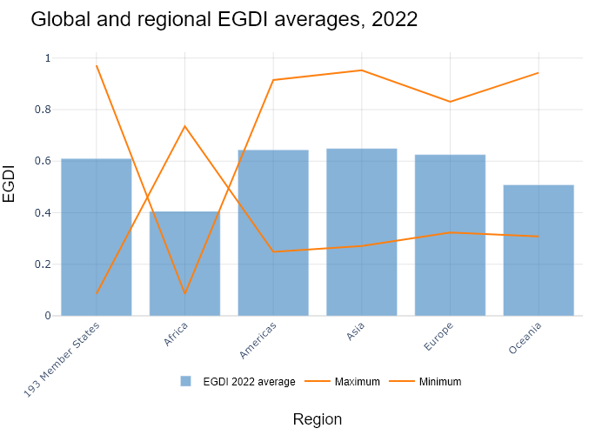

## Performance Metrics

|  |  |  |  |
| --- | --- | --- | --- |
| Task | Model Used | Description | Time Taken (s) |
| Processing Image to JSON | Gemini Vision Pro (default) | Time taken to convert the uploaded image to JSON format | 21.42 |
| Updating JSON | ChatGPT 3.5 (Default) | Time taken to update the JSON with new data | 0.00 |
| Plotting Updated JSON | N/A | Time taken to plot the updated JSON | 0.19 |

# Test Run

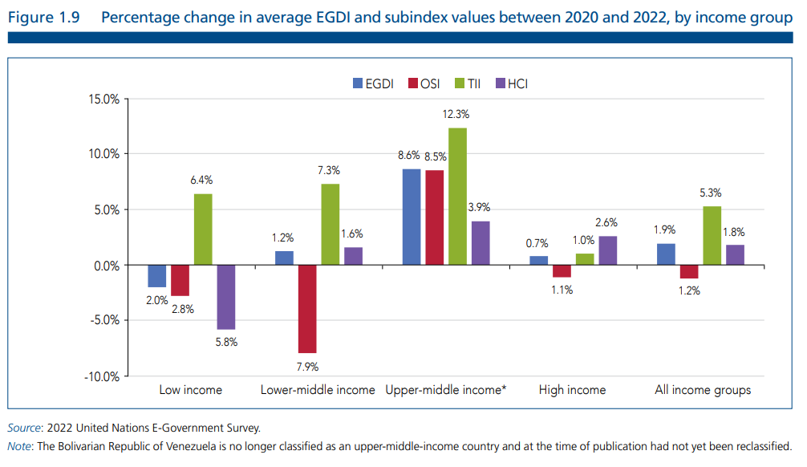

Figure: new graphs/bar/Others2.png

## Prompt Used

Task: Extract detailed information from a given graph image and generate JSON files (data.json, layout.json, and config.json) compatible with Plotly. Use the specified delimiters to wrap each JSON section.  
  
Instructions:  
  
Graph Analysis:  
  
Identify and categorize the plot types present in the graph (e.g., line, scatter, bar, pie).  
Extract the data points for each plot (x-values, y-values, and any other relevant data such as labels for pie charts).  
Note any multiple plots on the same figure and their configurations.  
Generate data.json:  
  
For each plot, include details such as:  
type: The type of plot (e.g., scatter, bar, pie).  
x and y: Arrays of data points for the x and y axes.  
labels and values for pie charts.  
mode: For line and scatter plots (e.g., markers, lines, or markers+lines).  
name: Legend entry for the plot.  
marker: Properties such as color, size, and symbol for markers.  
line: Properties such as color, width, and dash style for lines.  
text: Hover text for each data point.  
hoverinfo: Information displayed on hover (e.g., x+y+text).  
Generate layout.json:  
  
Include details such as:  
title: The title of the graph, including text, font properties (family, size, color).  
xaxis and yaxis: Configuration including title, range, showgrid, gridcolor, zeroline, zerolinecolor, showticklabels, tickangle, tickfont.  
legend: Properties including orientation, x, y, xanchor, font.  
margin: Values for l (left), r (right), b (bottom), t (top), pad.  
plot_bgcolor and paper_bgcolor: Background colors of the plot area and paper.  
Generate config.json:  
  
Include configuration settings such as:  
responsive: Whether the graph is responsive (boolean).  
displayModeBar: Whether the mode bar is displayed (boolean).  
modeBarButtonsToRemove: List of mode bar buttons to remove (e.g., ["toImage"]).  
scrollZoom: Whether scrolling zoom is enabled (boolean).  
Output Format:  
  
Wrap each JSON output in specific XML-like tags:  
<data> ... </data>  
<layout> ... </layout>  
<config> ... </config>  
Make sure to follow the JSON formatting guidelines:  
Double Quotes for Keys and Strings: Ensure that all keys and string values in JSON are enclosed in double quotes (").  
Example: Instead of "type": bar, it should be "type": "bar".  
No Trailing Commas: Remove any trailing commas after the last element in arrays ([]) or objects ({}).  
Example: Instead of "color": "rgba(55, 128, 191, 0.6)",, it should be "color": "rgba(55, 128, 191, 0.6)"  
Example Output:  
  
<data>  
[  
 {  
 "type": "scatter",  
 "x": [1, 2, 3],  
 "y": [4, 5, 6],  
 "mode": "markers+lines",  
 "name": "Line Plot",  
 "marker": {  
 "color": "rgba(75, 192, 192, 0.6)",  
 "size": 8  
 },  
 "line": {  
 "color": "rgba(75, 192, 192, 1)",  
 "width": 2  
 }  
 }  
 // Additional plots if present  
]  
</data>  
<layout>  
{  
 "title": {  
 "text": "Graph Title",  
 "font": {  
 "family": "Arial, sans-serif",  
 "size": 24,  
 "color": "#000000"  
 }  
 },  
 "xaxis": {  
 "title": {  
 "text": "X Axis",  
 "font": {  
 "family": "Arial, sans-serif",  
 "size": 18,  
 "color": "#000000"  
 }  
 },  
 "showgrid": true,  
 "gridcolor": "rgba(0, 0, 0, 0.1)",  
 "zeroline": true,  
 "zerolinecolor": "rgba(0, 0, 0, 0.1)"  
 },  
 "yaxis": {  
 "title": {  
 "text": "Y Axis",  
 "font": {  
 "family": "Arial, sans-serif",  
 "size": 18,  
 "color": "#000000"  
 }  
 },  
 "showgrid": true,  
 "gridcolor": "rgba(0, 0, 0, 0.1)",  
 "zeroline": true,  
 "zerolinecolor": "rgba(0, 0, 0, 0.1)"  
 },  
 "legend": {  
 "orientation": "h",  
 "x": 0.5,  
 "xanchor": "center",  
 "y": -0.2,  
 "font": {  
 "family": "Arial, sans-serif",  
 "size": 12,  
 "color": "#000000"  
 }  
 },  
 "margin": {  
 "l": 60,  
 "r": 30,  
 "b": 60,  
 "t": 60  
 },  
 "plot_bgcolor": "#ffffff",  
 "paper_bgcolor": "#ffffff"  
}  
</layout>  
<config>  
{  
 "responsive": true,  
 "displayModeBar": true,  
 "modeBarButtonsToRemove": ["toImage"],  
 "scrollZoom": true  
}  
</config>

## Extracted JSON

### data

[  
 {  
 "type": "bar",  
 "x": [  
 "Low income",  
 "Lower-middle income",  
 "Upper-middle income",  
 "High income",  
 "All income groups"  
 ],  
 "y": [  
 -2.8,  
 -7.9,  
 8.6,  
 -0.7,  
 -1.2  
 ],  
 "name": "EGDI",  
 "marker": {  
 "color": "rgba(55, 128, 191, 0.6)"  
 }  
 },  
 {  
 "type": "bar",  
 "x": [  
 "Low income",  
 "Lower-middle income",  
 "Upper-middle income",  
 "High income",  
 "All income groups"  
 ],  
 "y": [  
 6.4,  
 7.3,  
 12.3,  
 3.9,  
 5.3  
 ],  
 "name": "OSI",  
 "marker": {  
 "color": "rgba(255, 127, 14, 0.6)"  
 }  
 },  
 {  
 "type": "bar",  
 "x": [  
 "Low income",  
 "Lower-middle income",  
 "Upper-middle income",  
 "High income",  
 "All income groups"  
 ],  
 "y": [  
 1.2,  
 1.6,  
 3.9,  
 1.0,  
 1.8  
 ],  
 "name": "TII",  
 "marker": {  
 "color": "rgba(44, 160, 101, 0.6)"  
 }  
 },  
 {  
 "type": "bar",  
 "x": [  
 "Low income",  
 "Lower-middle income",  
 "Upper-middle income",  
 "High income",  
 "All income groups"  
 ],  
 "y": [  
 -5.8,  
 -4.2,  
 -3.5,  
 -2.6,  
 -3.0  
 ],  
 "name": "HCI",  
 "marker": {  
 "color": "rgba(255, 87, 51, 0.6)"  
 }  
 }  
]

### layout

{  
 "title": {  
 "text": "Percentage change in average EGDI and subindex values between 2020 and 2022, by income group",  
 "font": {  
 "family": "Arial, sans-serif",  
 "size": 18,  
 "color": "#000000"  
 }  
 },  
 "xaxis": {  
 "title": {  
 "text": "Income Group",  
 "font": {  
 "family": "Arial, sans-serif",  
 "size": 14,  
 "color": "#000000"  
 }  
 },  
 "tickangle": -45,  
 "showticklabels": true,  
 "tickfont": {  
 "family": "Arial, sans-serif",  
 "size": 12,  
 "color": "#000000"  
 }  
 },  
 "yaxis": {  
 "title": {  
 "text": "Percentage Change",  
 "font": {  
 "family": "Arial, sans-serif",  
 "size": 14,  
 "color": "#000000"  
 }  
 },  
 "showgrid": true,  
 "gridcolor": "rgba(0, 0, 0, 0.1)",  
 "zeroline": true,  
 "zerolinecolor": "rgba(0, 0, 0, 0.1)"  
 },  
 "legend": {  
 "orientation": "h",  
 "x": 0.5,  
 "xanchor": "center",  
 "y": -0.2,  
 "font": {  
 "family": "Arial, sans-serif",  
 "size": 12,  
 "color": "#000000"  
 }  
 },  
 "margin": {  
 "l": 60,  
 "r": 30,  
 "b": 60,  
 "t": 60  
 },  
 "plot_bgcolor": "#ffffff",  
 "paper_bgcolor": "#ffffff"  
}

### config

{  
 "responsive": true,  
 "displayModeBar": true,  
 "modeBarButtonsToRemove": [  
 "toImage"  
 ],  
 "scrollZoom": true  
}

## Updated JSON

### updated_data

[  
 {  
 "type": "bar",  
 "x": [  
 "Low income",  
 "Lower-middle income",  
 "Upper-middle income",  
 "High income",  
 "All income groups"  
 ],  
 "y": [  
 -2.8,  
 -7.9,  
 8.6,  
 -0.7,  
 -1.2  
 ],  
 "name": "EGDI",  
 "marker": {  
 "color": "rgba(55, 128, 191, 0.6)"  
 }  
 },  
 {  
 "type": "bar",  
 "x": [  
 "Low income",  
 "Lower-middle income",  
 "Upper-middle income",  
 "High income",  
 "All income groups"  
 ],  
 "y": [  
 6.4,  
 7.3,  
 12.3,  
 3.9,  
 5.3  
 ],  
 "name": "OSI",  
 "marker": {  
 "color": "rgba(255, 127, 14, 0.6)"  
 }  
 },  
 {  
 "type": "bar",  
 "x": [  
 "Low income",  
 "Lower-middle income",  
 "Upper-middle income",  
 "High income",  
 "All income groups"  
 ],  
 "y": [  
 1.2,  
 1.6,  
 3.9,  
 1.0,  
 1.8  
 ],  
 "name": "TII",  
 "marker": {  
 "color": "rgba(44, 160, 101, 0.6)"  
 }  
 },  
 {  
 "type": "bar",  
 "x": [  
 "Low income",  
 "Lower-middle income",  
 "Upper-middle income",  
 "High income",  
 "All income groups"  
 ],  
 "y": [  
 -5.8,  
 -4.2,  
 -3.5,  
 -2.6,  
 -3.0  
 ],  
 "name": "HCI",  
 "marker": {  
 "color": "rgba(255, 87, 51, 0.6)"  
 }  
 }  
]

### updated_layout

{  
 "title": {  
 "text": "Percentage change in average EGDI and subindex values between 2020 and 2022, by income group",  
 "font": {  
 "family": "Arial, sans-serif",  
 "size": 18,  
 "color": "#000000"  
 }  
 },  
 "xaxis": {  
 "title": {  
 "text": "Income Group",  
 "font": {  
 "family": "Arial, sans-serif",  
 "size": 14,  
 "color": "#000000"  
 }  
 },  
 "tickangle": -45,  
 "showticklabels": true,  
 "tickfont": {  
 "family": "Arial, sans-serif",  
 "size": 12,  
 "color": "#000000"  
 }  
 },  
 "yaxis": {  
 "title": {  
 "text": "Percentage Change",  
 "font": {  
 "family": "Arial, sans-serif",  
 "size": 14,  
 "color": "#000000"  
 }  
 },  
 "showgrid": true,  
 "gridcolor": "rgba(0, 0, 0, 0.1)",  
 "zeroline": true,  
 "zerolinecolor": "rgba(0, 0, 0, 0.1)"  
 },  
 "legend": {  
 "orientation": "h",  
 "x": 0.5,  
 "xanchor": "center",  
 "y": -0.2,  
 "font": {  
 "family": "Arial, sans-serif",  
 "size": 12,  
 "color": "#000000"  
 }  
 },  
 "margin": {  
 "l": 60,  
 "r": 30,  
 "b": 60,  
 "t": 60  
 },  
 "plot_bgcolor": "#ffffff",  
 "paper_bgcolor": "#ffffff"  
}

### updated_config

{  
 "responsive": true,  
 "displayModeBar": true,  
 "modeBarButtonsToRemove": [  
 "toImage"  
 ],  
 "scrollZoom": true  
}

## Updated Chart

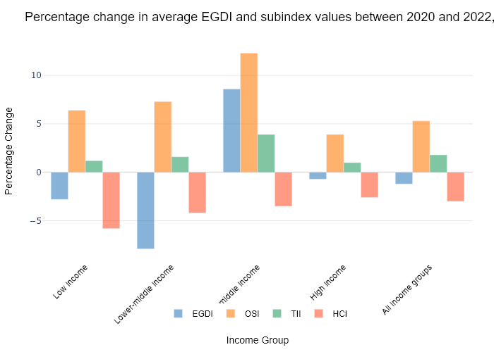

## Performance Metrics

|  |  |  |  |
| --- | --- | --- | --- |
| Task | Model Used | Description | Time Taken (s) |
| Processing Image to JSON | Gemini Vision Pro (default) | Time taken to convert the uploaded image to JSON format | 22.69 |
| Updating JSON | ChatGPT 3.5 (Default) | Time taken to update the JSON with new data | 0.00 |
| Plotting Updated JSON | N/A | Time taken to plot the updated JSON | 0.18 |

# Test Run

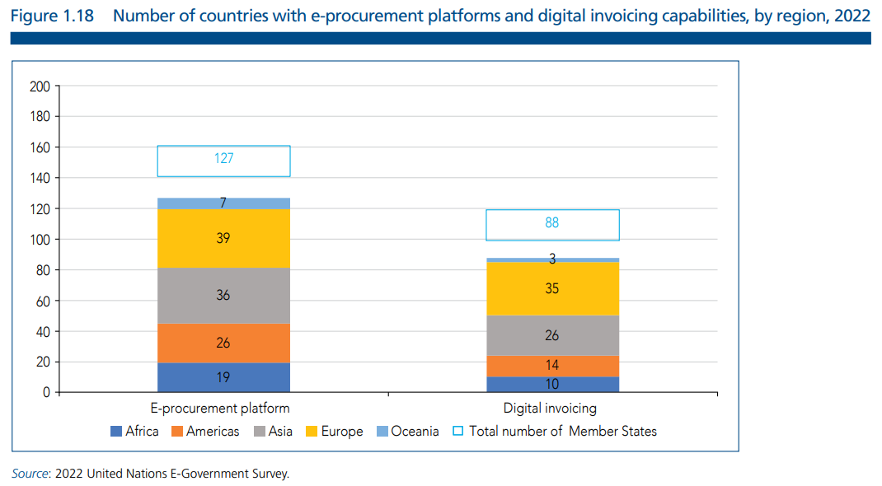

Figure: new graphs/bar/Others4.png

## Prompt Used

Task: Extract detailed information from a given graph image and generate JSON files (data.json, layout.json, and config.json) compatible with Plotly. Use the specified delimiters to wrap each JSON section.  
  
Instructions:  
  
Graph Analysis:  
  
Identify and categorize the plot types present in the graph (e.g., line, scatter, bar, pie).  
Extract the data points for each plot (x-values, y-values, and any other relevant data such as labels for pie charts).  
Note any multiple plots on the same figure and their configurations.  
Generate data.json:  
  
For each plot, include details such as:  
type: The type of plot (e.g., scatter, bar, pie).  
x and y: Arrays of data points for the x and y axes.  
labels and values for pie charts.  
mode: For line and scatter plots (e.g., markers, lines, or markers+lines).  
name: Legend entry for the plot.  
marker: Properties such as color, size, and symbol for markers.  
line: Properties such as color, width, and dash style for lines.  
text: Hover text for each data point.  
hoverinfo: Information displayed on hover (e.g., x+y+text).  
Generate layout.json:  
  
Include details such as:  
title: The title of the graph, including text, font properties (family, size, color).  
xaxis and yaxis: Configuration including title, range, showgrid, gridcolor, zeroline, zerolinecolor, showticklabels, tickangle, tickfont.  
legend: Properties including orientation, x, y, xanchor, font.  
margin: Values for l (left), r (right), b (bottom), t (top), pad.  
plot_bgcolor and paper_bgcolor: Background colors of the plot area and paper.  
Generate config.json:  
  
Include configuration settings such as:  
responsive: Whether the graph is responsive (boolean).  
displayModeBar: Whether the mode bar is displayed (boolean).  
modeBarButtonsToRemove: List of mode bar buttons to remove (e.g., ["toImage"]).  
scrollZoom: Whether scrolling zoom is enabled (boolean).  
Output Format:  
  
Wrap each JSON output in specific XML-like tags:  
<data> ... </data>  
<layout> ... </layout>  
<config> ... </config>  
Make sure to follow the JSON formatting guidelines:  
Double Quotes for Keys and Strings: Ensure that all keys and string values in JSON are enclosed in double quotes (").  
Example: Instead of "type": bar, it should be "type": "bar".  
No Trailing Commas: Remove any trailing commas after the last element in arrays ([]) or objects ({}).  
Example: Instead of "color": "rgba(55, 128, 191, 0.6)",, it should be "color": "rgba(55, 128, 191, 0.6)"  
Example Output:  
  
<data>  
[  
 {  
 "type": "scatter",  
 "x": [1, 2, 3],  
 "y": [4, 5, 6],  
 "mode": "markers+lines",  
 "name": "Line Plot",  
 "marker": {  
 "color": "rgba(75, 192, 192, 0.6)",  
 "size": 8  
 },  
 "line": {  
 "color": "rgba(75, 192, 192, 1)",  
 "width": 2  
 }  
 }  
 // Additional plots if present  
]  
</data>  
<layout>  
{  
 "title": {  
 "text": "Graph Title",  
 "font": {  
 "family": "Arial, sans-serif",  
 "size": 24,  
 "color": "#000000"  
 }  
 },  
 "xaxis": {  
 "title": {  
 "text": "X Axis",  
 "font": {  
 "family": "Arial, sans-serif",  
 "size": 18,  
 "color": "#000000"  
 }  
 },  
 "showgrid": true,  
 "gridcolor": "rgba(0, 0, 0, 0.1)",  
 "zeroline": true,  
 "zerolinecolor": "rgba(0, 0, 0, 0.1)"  
 },  
 "yaxis": {  
 "title": {  
 "text": "Y Axis",  
 "font": {  
 "family": "Arial, sans-serif",  
 "size": 18,  
 "color": "#000000"  
 }  
 },  
 "showgrid": true,  
 "gridcolor": "rgba(0, 0, 0, 0.1)",  
 "zeroline": true,  
 "zerolinecolor": "rgba(0, 0, 0, 0.1)"  
 },  
 "legend": {  
 "orientation": "h",  
 "x": 0.5,  
 "xanchor": "center",  
 "y": -0.2,  
 "font": {  
 "family": "Arial, sans-serif",  
 "size": 12,  
 "color": "#000000"  
 }  
 },  
 "margin": {  
 "l": 60,  
 "r": 30,  
 "b": 60,  
 "t": 60  
 },  
 "plot_bgcolor": "#ffffff",  
 "paper_bgcolor": "#ffffff"  
}  
</layout>  
<config>  
{  
 "responsive": true,  
 "displayModeBar": true,  
 "modeBarButtonsToRemove": ["toImage"],  
 "scrollZoom": true  
}  
</config>

## Extracted JSON

### data

[  
 {  
 "type": "bar",  
 "x": [  
 "Africa",  
 "Americas",  
 "Asia",  
 "Europe",  
 "Oceania"  
 ],  
 "y": [  
 19,  
 36,  
 76,  
 26,  
 14  
 ],  
 "name": "e-Procurement Platform",  
 "marker": {  
 "color": "rgba(55, 128, 191, 0.6)"  
 }  
 },  
 {  
 "type": "bar",  
 "x": [  
 "Africa",  
 "Americas",  
 "Asia",  
 "Europe",  
 "Oceania"  
 ],  
 "y": [  
 10,  
 26,  
 35,  
 3,  
 88  
 ],  
 "name": "Digital Invoicing",  
 "marker": {  
 "color": "rgba(255, 127, 14, 0.6)"  
 }  
 }  
]

### layout

{  
 "title": {  
 "text": "Number of countries with e-procurement platforms and digital invoicing capabilities, by region, 2022",  
 "font": {  
 "family": "Arial, sans-serif",  
 "size": 18,  
 "color": "#333333"  
 }  
 },  
 "xaxis": {  
 "title": {  
 "text": "Region",  
 "font": {  
 "family": "Arial, sans-serif",  
 "size": 14,  
 "color": "#333333"  
 }  
 },  
 "tickfont": {  
 "family": "Arial, sans-serif",  
 "size": 12,  
 "color": "#333333"  
 },  
 "showgrid": true,  
 "gridcolor": "#DEDEDE",  
 "zeroline": true,  
 "zerolinecolor": "#DEDEDE"  
 },  
 "yaxis": {  
 "title": {  
 "text": "Number of Countries",  
 "font": {  
 "family": "Arial, sans-serif",  
 "size": 14,  
 "color": "#333333"  
 }  
 },  
 "tickfont": {  
 "family": "Arial, sans-serif",  
 "size": 12,  
 "color": "#333333"  
 },  
 "showgrid": true,  
 "gridcolor": "#DEDEDE",  
 "zeroline": true,  
 "zerolinecolor": "#DEDEDE"  
 },  
 "legend": {  
 "orientation": "h",  
 "x": 0.5,  
 "xanchor": "center",  
 "y": -0.2,  
 "font": {  
 "family": "Arial, sans-serif",  
 "size": 12,  
 "color": "#333333"  
 }  
 },  
 "margin": {  
 "l": 60,  
 "r": 30,  
 "b": 60,  
 "t": 60  
 },  
 "plot_bgcolor": "#ffffff",  
 "paper_bgcolor": "#ffffff"  
}

### config

{  
 "responsive": true,  
 "displayModeBar": true,  
 "modeBarButtonsToRemove": [  
 "toImage"  
 ],  
 "scrollZoom": true  
}

## Updated JSON

### updated_data

[  
 {  
 "type": "bar",  
 "x": [  
 "Africa",  
 "Americas",  
 "Asia",  
 "Europe",  
 "Oceania"  
 ],  
 "y": [  
 19,  
 36,  
 76,  
 26,  
 14  
 ],  
 "name": "e-Procurement Platform",  
 "marker": {  
 "color": "rgba(55, 128, 191, 0.6)"  
 }  
 },  
 {  
 "type": "bar",  
 "x": [  
 "Africa",  
 "Americas",  
 "Asia",  
 "Europe",  
 "Oceania"  
 ],  
 "y": [  
 10,  
 26,  
 35,  
 3,  
 88  
 ],  
 "name": "Digital Invoicing",  
 "marker": {  
 "color": "rgba(255, 127, 14, 0.6)"  
 }  
 }  
]

### updated_layout

{  
 "title": {  
 "text": "Number of countries with e-procurement platforms and digital invoicing capabilities, by region, 2022",  
 "font": {  
 "family": "Arial, sans-serif",  
 "size": 18,  
 "color": "#333333"  
 }  
 },  
 "xaxis": {  
 "title": {  
 "text": "Region",  
 "font": {  
 "family": "Arial, sans-serif",  
 "size": 14,  
 "color": "#333333"  
 }  
 },  
 "tickfont": {  
 "family": "Arial, sans-serif",  
 "size": 12,  
 "color": "#333333"  
 },  
 "showgrid": true,  
 "gridcolor": "#DEDEDE",  
 "zeroline": true,  
 "zerolinecolor": "#DEDEDE"  
 },  
 "yaxis": {  
 "title": {  
 "text": "Number of Countries",  
 "font": {  
 "family": "Arial, sans-serif",  
 "size": 14,  
 "color": "#333333"  
 }  
 },  
 "tickfont": {  
 "family": "Arial, sans-serif",  
 "size": 12,  
 "color": "#333333"  
 },  
 "showgrid": true,  
 "gridcolor": "#DEDEDE",  
 "zeroline": true,  
 "zerolinecolor": "#DEDEDE"  
 },  
 "legend": {  
 "orientation": "h",  
 "x": 0.5,  
 "xanchor": "center",  
 "y": -0.2,  
 "font": {  
 "family": "Arial, sans-serif",  
 "size": 12,  
 "color": "#333333"  
 }  
 },  
 "margin": {  
 "l": 60,  
 "r": 30,  
 "b": 60,  
 "t": 60  
 },  
 "plot_bgcolor": "#ffffff",  
 "paper_bgcolor": "#ffffff"  
}

### updated_config

{  
 "responsive": true,  
 "displayModeBar": true,  
 "modeBarButtonsToRemove": [  
 "toImage"  
 ],  
 "scrollZoom": true  
}

## Updated Chart

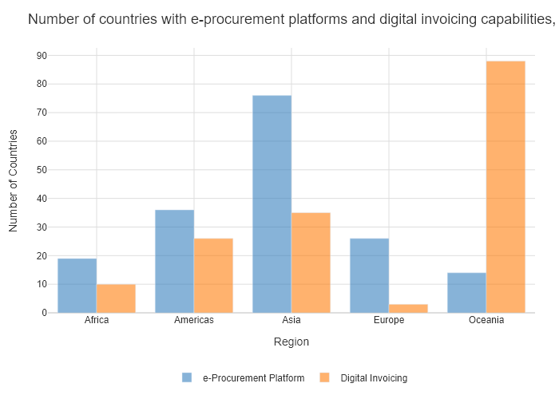

## Performance Metrics

|  |  |  |  |
| --- | --- | --- | --- |
| Task | Model Used | Description | Time Taken (s) |
| Processing Image to JSON | Gemini Vision Pro (default) | Time taken to convert the uploaded image to JSON format | 18.89 |
| Updating JSON | ChatGPT 3.5 (Default) | Time taken to update the JSON with new data | 0.00 |
| Plotting Updated JSON | N/A | Time taken to plot the updated JSON | 0.09 |

# Test Run

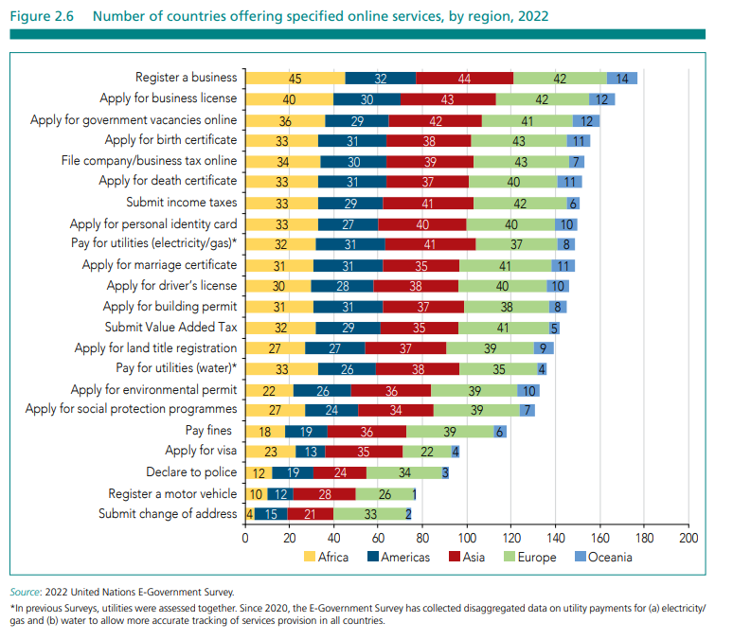

Figure: new graphs/bar/Others5.png

## Prompt Used

Task: Extract detailed information from a given graph image and generate JSON files (data.json, layout.json, and config.json) compatible with Plotly. Use the specified delimiters to wrap each JSON section.  
  
Instructions:  
  
Graph Analysis:  
  
Identify and categorize the plot types present in the graph (e.g., line, scatter, bar, pie).  
Extract the data points for each plot (x-values, y-values, and any other relevant data such as labels for pie charts).  
Note any multiple plots on the same figure and their configurations.  
Generate data.json:  
  
For each plot, include details such as:  
type: The type of plot (e.g., scatter, bar, pie).  
x and y: Arrays of data points for the x and y axes.  
labels and values for pie charts.  
mode: For line and scatter plots (e.g., markers, lines, or markers+lines).  
name: Legend entry for the plot.  
marker: Properties such as color, size, and symbol for markers.  
line: Properties such as color, width, and dash style for lines.  
text: Hover text for each data point.  
hoverinfo: Information displayed on hover (e.g., x+y+text).  
Generate layout.json:  
  
Include details such as:  
title: The title of the graph, including text, font properties (family, size, color).  
xaxis and yaxis: Configuration including title, range, showgrid, gridcolor, zeroline, zerolinecolor, showticklabels, tickangle, tickfont.  
legend: Properties including orientation, x, y, xanchor, font.  
margin: Values for l (left), r (right), b (bottom), t (top), pad.  
plot_bgcolor and paper_bgcolor: Background colors of the plot area and paper.  
Generate config.json:  
  
Include configuration settings such as:  
responsive: Whether the graph is responsive (boolean).  
displayModeBar: Whether the mode bar is displayed (boolean).  
modeBarButtonsToRemove: List of mode bar buttons to remove (e.g., ["toImage"]).  
scrollZoom: Whether scrolling zoom is enabled (boolean).  
Output Format:  
  
Wrap each JSON output in specific XML-like tags:  
<data> ... </data>  
<layout> ... </layout>  
<config> ... </config>  
Make sure to follow the JSON formatting guidelines:  
Double Quotes for Keys and Strings: Ensure that all keys and string values in JSON are enclosed in double quotes (").  
Example: Instead of "type": bar, it should be "type": "bar".  
No Trailing Commas: Remove any trailing commas after the last element in arrays ([]) or objects ({}).  
Example: Instead of "color": "rgba(55, 128, 191, 0.6)",, it should be "color": "rgba(55, 128, 191, 0.6)"  
Example Output:  
  
<data>  
[  
 {  
 "type": "scatter",  
 "x": [1, 2, 3],  
 "y": [4, 5, 6],  
 "mode": "markers+lines",  
 "name": "Line Plot",  
 "marker": {  
 "color": "rgba(75, 192, 192, 0.6)",  
 "size": 8  
 },  
 "line": {  
 "color": "rgba(75, 192, 192, 1)",  
 "width": 2  
 }  
 }  
 // Additional plots if present  
]  
</data>  
<layout>  
{  
 "title": {  
 "text": "Graph Title",  
 "font": {  
 "family": "Arial, sans-serif",  
 "size": 24,  
 "color": "#000000"  
 }  
 },  
 "xaxis": {  
 "title": {  
 "text": "X Axis",  
 "font": {  
 "family": "Arial, sans-serif",  
 "size": 18,  
 "color": "#000000"  
 }  
 },  
 "showgrid": true,  
 "gridcolor": "rgba(0, 0, 0, 0.1)",  
 "zeroline": true,  
 "zerolinecolor": "rgba(0, 0, 0, 0.1)"  
 },  
 "yaxis": {  
 "title": {  
 "text": "Y Axis",  
 "font": {  
 "family": "Arial, sans-serif",  
 "size": 18,  
 "color": "#000000"  
 }  
 },  
 "showgrid": true,  
 "gridcolor": "rgba(0, 0, 0, 0.1)",  
 "zeroline": true,  
 "zerolinecolor": "rgba(0, 0, 0, 0.1)"  
 },  
 "legend": {  
 "orientation": "h",  
 "x": 0.5,  
 "xanchor": "center",  
 "y": -0.2,  
 "font": {  
 "family": "Arial, sans-serif",  
 "size": 12,  
 "color": "#000000"  
 }  
 },  
 "margin": {  
 "l": 60,  
 "r": 30,  
 "b": 60,  
 "t": 60  
 },  
 "plot_bgcolor": "#ffffff",  
 "paper_bgcolor": "#ffffff"  
}  
</layout>  
<config>  
{  
 "responsive": true,  
 "displayModeBar": true,  
 "modeBarButtonsToRemove": ["toImage"],  
 "scrollZoom": true  
}  
</config>

## Extracted JSON

### data

[  
 {  
 "type": "bar",  
 "x": [  
 "Register a business",  
 "Apply for business license",  
 "Apply for government vacancies online",  
 "Apply for birth certificate",  
 "File company/business tax online",  
 "Apply for death certificate",  
 "Apply for personal identity card",  
 "Pay for utilities (electricity/gas*)",  
 "Apply for marriage certificate",  
 "Apply for driver's license",  
 "Submit Value Added Tax",  
 "Apply for land title registration",  
 "Pay for utilities (water)",  
 "Apply for environmental permit",  
 "Apply for social protection programmes",  
 "Pay fines",  
 "Declare to police",  
 "Register a motor vehicle",  
 "Submit change of address"  
 ],  
 "y": [  
 45,  
 40,  
 36,  
 33,  
 34,  
 33,  
 33,  
 32,  
 31,  
 31,  
 27,  
 27,  
 22,  
 22,  
 18,  
 19,  
 12,  
 10,  
 4  
 ],  
 "name": "Number of countries offering specified online services, by region, 2022"  
 }  
]

### layout

{  
 "title": {  
 "text": "Number of countries offering specified online services, by region, 2022",  
 "font": {  
 "family": "Arial, sans-serif",  
 "size": 18,  
 "color": "#000000"  
 }  
 },  
 "xaxis": {  
 "title": {  
 "text": "Online Service",  
 "font": {  
 "family": "Arial, sans-serif",  
 "size": 14,  
 "color": "#000000"  
 }  
 },  
 "tickangle": -45,  
 "tickfont": {  
 "size": 12,  
 "color": "#000000"  
 }  
 },  
 "yaxis": {  
 "title": {  
 "text": "Number of Countries",  
 "font": {  
 "family": "Arial, sans-serif",  
 "size": 14,  
 "color": "#000000"  
 }  
 },  
 "showgrid": true,  
 "gridcolor": "rgba(0, 0, 0, 0.1)",  
 "zeroline": true,  
 "zerolinecolor": "rgba(0, 0, 0, 0.1)"  
 },  
 "margin": {  
 "l": 100,  
 "r": 100,  
 "b": 100,  
 "t": 100  
 },  
 "plot_bgcolor": "#ffffff",  
 "paper_bgcolor": "#ffffff"  
}

### config

{  
 "responsive": true,  
 "displayModeBar": true,  
 "modeBarButtonsToRemove": [  
 "toImage"  
 ],  
 "scrollZoom": true  
}

## Updated JSON

### updated_data

[  
 {  
 "type": "bar",  
 "x": [  
 "Register a business",  
 "Apply for business license",  
 "Apply for government vacancies online",  
 "Apply for birth certificate",  
 "File company/business tax online",  
 "Apply for death certificate",  
 "Apply for personal identity card",  
 "Pay for utilities (electricity/gas*)",  
 "Apply for marriage certificate",  
 "Apply for driver's license",  
 "Submit Value Added Tax",  
 "Apply for land title registration",  
 "Pay for utilities (water)",  
 "Apply for environmental permit",  
 "Apply for social protection programmes",  
 "Pay fines",  
 "Declare to police",  
 "Register a motor vehicle",  
 "Submit change of address"  
 ],  
 "y": [  
 45,  
 40,  
 36,  
 33,  
 34,  
 33,  
 33,  
 32,  
 31,  
 31,  
 27,  
 27,  
 22,  
 22,  
 18,  
 19,  
 12,  
 10,  
 4  
 ],  
 "name": "Number of countries offering specified online services, by region, 2022"  
 }  
]

### updated_layout

{  
 "title": {  
 "text": "Number of countries offering specified online services, by region, 2022",  
 "font": {  
 "family": "Arial, sans-serif",  
 "size": 18,  
 "color": "#000000"  
 }  
 },  
 "xaxis": {  
 "title": {  
 "text": "Online Service",  
 "font": {  
 "family": "Arial, sans-serif",  
 "size": 14,  
 "color": "#000000"  
 }  
 },  
 "tickangle": -45,  
 "tickfont": {  
 "size": 12,  
 "color": "#000000"  
 }  
 },  
 "yaxis": {  
 "title": {  
 "text": "Number of Countries",  
 "font": {  
 "family": "Arial, sans-serif",  
 "size": 14,  
 "color": "#000000"  
 }  
 },  
 "showgrid": true,  
 "gridcolor": "rgba(0, 0, 0, 0.1)",  
 "zeroline": true,  
 "zerolinecolor": "rgba(0, 0, 0, 0.1)"  
 },  
 "margin": {  
 "l": 100,  
 "r": 100,  
 "b": 100,  
 "t": 100  
 },  
 "plot_bgcolor": "#ffffff",  
 "paper_bgcolor": "#ffffff"  
}

### updated_config

{  
 "responsive": true,  
 "displayModeBar": true,  
 "modeBarButtonsToRemove": [  
 "toImage"  
 ],  
 "scrollZoom": true  
}

## Updated Chart

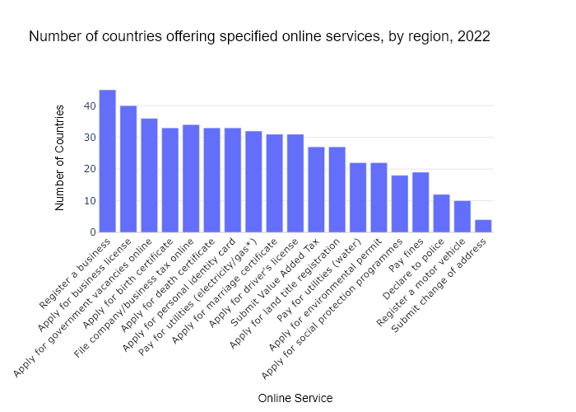

## Performance Metrics

|  |  |  |  |
| --- | --- | --- | --- |
| Task | Model Used | Description | Time Taken (s) |
| Processing Image to JSON | Gemini Vision Pro (default) | Time taken to convert the uploaded image to JSON format | 18.59 |
| Updating JSON | ChatGPT 3.5 (Default) | Time taken to update the JSON with new data | 0.00 |
| Plotting Updated JSON | N/A | Time taken to plot the updated JSON | 0.12 |

# Test Run

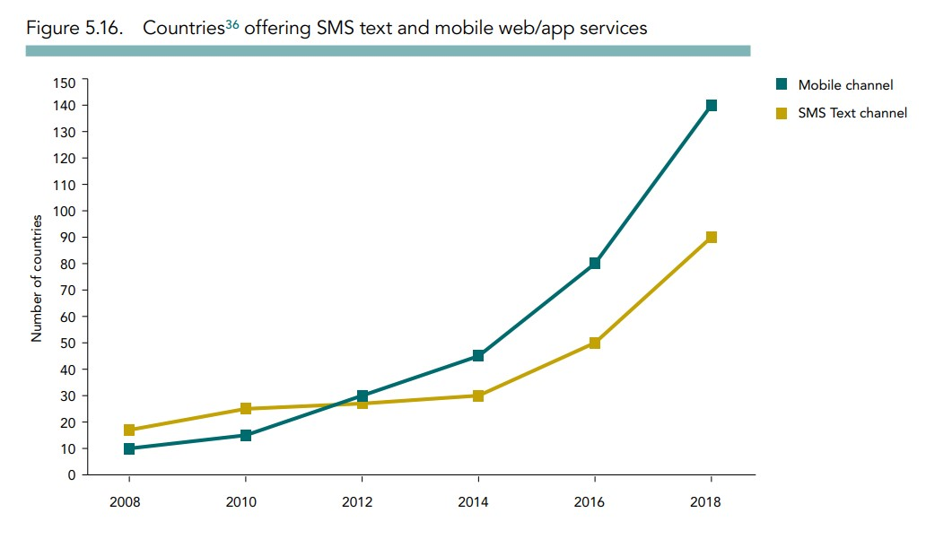

Figure: new graphs/1.1_image1.jpg

## Prompt Used

Task: Extract detailed information from a given graph image and generate JSON files (data.json, layout.json, and config.json) compatible with Plotly. Use the specified delimiters to wrap each JSON section.  
  
Instructions:  
  
Graph Analysis:  
  
Identify and categorize the plot types present in the graph (e.g., line, scatter, bar, pie).  
Extract the data points for each plot (x-values, y-values, and any other relevant data such as labels for pie charts).  
Note any multiple plots on the same figure and their configurations.  
Generate data.json:  
  
For each plot, include details such as:  
type: The type of plot (e.g., scatter, bar, pie).  
x and y: Arrays of data points for the x and y axes.  
labels and values for pie charts.  
mode: For line and scatter plots (e.g., markers, lines, or markers+lines).  
name: Legend entry for the plot.  
marker: Properties such as color, size, and symbol for markers.  
line: Properties such as color, width, and dash style for lines.  
text: Hover text for each data point.  
hoverinfo: Information displayed on hover (e.g., x+y+text).  
Generate layout.json:  
  
Include details such as:  
title: The title of the graph, including text, font properties (family, size, color).  
xaxis and yaxis: Configuration including title, range, showgrid, gridcolor, zeroline, zerolinecolor, showticklabels, tickangle, tickfont.  
legend: Properties including orientation, x, y, xanchor, font.  
margin: Values for l (left), r (right), b (bottom), t (top), pad.  
plot_bgcolor and paper_bgcolor: Background colors of the plot area and paper.  
Generate config.json:  
  
Include configuration settings such as:  
responsive: Whether the graph is responsive (boolean).  
displayModeBar: Whether the mode bar is displayed (boolean).  
modeBarButtonsToRemove: List of mode bar buttons to remove (e.g., ["toImage"]).  
scrollZoom: Whether scrolling zoom is enabled (boolean).  
Output Format:  
  
Wrap each JSON output in specific XML-like tags:  
<data> ... </data>  
<layout> ... </layout>  
<config> ... </config>  
Make sure to follow the JSON formatting guidelines:  
Double Quotes for Keys and Strings: Ensure that all keys and string values in JSON are enclosed in double quotes (").  
Example: Instead of "type": bar, it should be "type": "bar".  
No Trailing Commas: Remove any trailing commas after the last element in arrays ([]) or objects ({}).  
Example: Instead of "color": "rgba(55, 128, 191, 0.6)",, it should be "color": "rgba(55, 128, 191, 0.6)"  
Example Output:  
  
<data>  
[  
 {  
 "type": "scatter",  
 "x": [1, 2, 3],  
 "y": [4, 5, 6],  
 "mode": "markers+lines",  
 "name": "Line Plot",  
 "marker": {  
 "color": "rgba(75, 192, 192, 0.6)",  
 "size": 8  
 },  
 "line": {  
 "color": "rgba(75, 192, 192, 1)",  
 "width": 2  
 }  
 }  
 // Additional plots if present  
]  
</data>  
<layout>  
{  
 "title": {  
 "text": "Graph Title",  
 "font": {  
 "family": "Arial, sans-serif",  
 "size": 24,  
 "color": "#000000"  
 }  
 },  
 "xaxis": {  
 "title": {  
 "text": "X Axis",  
 "font": {  
 "family": "Arial, sans-serif",  
 "size": 18,  
 "color": "#000000"  
 }  
 },  
 "showgrid": true,  
 "gridcolor": "rgba(0, 0, 0, 0.1)",  
 "zeroline": true,  
 "zerolinecolor": "rgba(0, 0, 0, 0.1)"  
 },  
 "yaxis": {  
 "title": {  
 "text": "Y Axis",  
 "font": {  
 "family": "Arial, sans-serif",  
 "size": 18,  
 "color": "#000000"  
 }  
 },  
 "showgrid": true,  
 "gridcolor": "rgba(0, 0, 0, 0.1)",  
 "zeroline": true,  
 "zerolinecolor": "rgba(0, 0, 0, 0.1)"  
 },  
 "legend": {  
 "orientation": "h",  
 "x": 0.5,  
 "xanchor": "center",  
 "y": -0.2,  
 "font": {  
 "family": "Arial, sans-serif",  
 "size": 12,  
 "color": "#000000"  
 }  
 },  
 "margin": {  
 "l": 60,  
 "r": 30,  
 "b": 60,  
 "t": 60  
 },  
 "plot_bgcolor": "#ffffff",  
 "paper_bgcolor": "#ffffff"  
}  
</layout>  
<config>  
{  
 "responsive": true,  
 "displayModeBar": true,  
 "modeBarButtonsToRemove": ["toImage"],  
 "scrollZoom": true  
}  
</config>

## Extracted JSON

### data

[  
 {  
 "type": "scatter",  
 "x": [  
 2008,  
 2010,  
 2012,  
 2014,  
 2016,  
 2018  
 ],  
 "y": [  
 10,  
 20,  
 30,  
 50,  
 80,  
 140  
 ],  
 "mode": "lines+markers",  
 "name": "Mobile Channel",  
 "marker": {  
 "color": "rgba(75, 192, 192, 0.6)",  
 "size": 8  
 },  
 "line": {  
 "color": "rgba(75, 192, 192, 1)",  
 "width": 2  
 }  
 },  
 {  
 "type": "scatter",  
 "x": [  
 2008,  
 2010,  
 2012,  
 2014,  
 2016,  
 2018  
 ],  
 "y": [  
 20,  
 30,  
 30,  
 40,  
 50,  
 90  
 ],  
 "mode": "lines+markers",  
 "name": "SMS Text Channel",  
 "marker": {  
 "color": "rgba(255, 127, 14, 0.6)",  
 "size": 8  
 },  
 "line": {  
 "color": "rgba(255, 127, 14, 1)",  
 "width": 2  
 }  
 }  
]

### layout

{  
 "title": {  
 "text": "Countries offering SMS Text and Mobile Web/App Services",  
 "font": {  
 "family": "Arial, sans-serif",  
 "size": 24,  
 "color": "#000000"  
 }  
 },  
 "xaxis": {  
 "title": {  
 "text": "Year",  
 "font": {  
 "family": "Arial, sans-serif",  
 "size": 18,  
 "color": "#000000"  
 }  
 },  
 "showgrid": true,  
 "gridcolor": "rgba(0, 0, 0, 0.1)",  
 "zeroline": true,  
 "zerolinecolor": "rgba(0, 0, 0, 0.1)",  
 "tickangle": 45  
 },  
 "yaxis": {  
 "title": {  
 "text": "Number of Countries",  
 "font": {  
 "family": "Arial, sans-serif",  
 "size": 18,  
 "color": "#000000"  
 }  
 },  
 "showgrid": true,  
 "gridcolor": "rgba(0, 0, 0, 0.1)",  
 "zeroline": true,  
 "zerolinecolor": "rgba(0, 0, 0, 0.1)"  
 },  
 "legend": {  
 "orientation": "h",  
 "x": 0.5,  
 "xanchor": "center",  
 "y": -0.2,  
 "font": {  
 "family": "Arial, sans-serif",  
 "size": 12,  
 "color": "#000000"  
 }  
 },  
 "margin": {  
 "l": 60,  
 "r": 30,  
 "b": 60,  
 "t": 60  
 },  
 "plot_bgcolor": "#ffffff",  
 "paper_bgcolor": "#ffffff"  
}

### config

{  
 "responsive": true,  
 "displayModeBar": true,  
 "modeBarButtonsToRemove": [  
 "toImage"  
 ],  
 "scrollZoom": true  
}

## Updated JSON

### updated_data

[  
 {  
 "type": "scatter",  
 "x": [  
 2008,  
 2010,  
 2012,  
 2014,  
 2016,  
 2018  
 ],  
 "y": [  
 10,  
 20,  
 30,  
 50,  
 80,  
 140  
 ],  
 "mode": "lines+markers",  
 "name": "Mobile Channel",  
 "marker": {  
 "color": "rgba(75, 192, 192, 0.6)",  
 "size": 8  
 },  
 "line": {  
 "color": "rgba(75, 192, 192, 1)",  
 "width": 2  
 }  
 },  
 {  
 "type": "scatter",  
 "x": [  
 2008,  
 2010,  
 2012,  
 2014,  
 2016,  
 2018  
 ],  
 "y": [  
 20,  
 30,  
 30,  
 40,  
 50,  
 90  
 ],  
 "mode": "lines+markers",  
 "name": "SMS Text Channel",  
 "marker": {  
 "color": "rgba(255, 127, 14, 0.6)",  
 "size": 8  
 },  
 "line": {  
 "color": "rgba(255, 127, 14, 1)",  
 "width": 2  
 }  
 }  
]

### updated_layout

{  
 "title": {  
 "text": "Countries offering SMS Text and Mobile Web/App Services",  
 "font": {  
 "family": "Arial, sans-serif",  
 "size": 24,  
 "color": "#000000"  
 }  
 },  
 "xaxis": {  
 "title": {  
 "text": "Year",  
 "font": {  
 "family": "Arial, sans-serif",  
 "size": 18,  
 "color": "#000000"  
 }  
 },  
 "showgrid": true,  
 "gridcolor": "rgba(0, 0, 0, 0.1)",  
 "zeroline": true,  
 "zerolinecolor": "rgba(0, 0, 0, 0.1)",  
 "tickangle": 45  
 },  
 "yaxis": {  
 "title": {  
 "text": "Number of Countries",  
 "font": {  
 "family": "Arial, sans-serif",  
 "size": 18,  
 "color": "#000000"  
 }  
 },  
 "showgrid": true,  
 "gridcolor": "rgba(0, 0, 0, 0.1)",  
 "zeroline": true,  
 "zerolinecolor": "rgba(0, 0, 0, 0.1)"  
 },  
 "legend": {  
 "orientation": "h",  
 "x": 0.5,  
 "xanchor": "center",  
 "y": -0.2,  
 "font": {  
 "family": "Arial, sans-serif",  
 "size": 12,  
 "color": "#000000"  
 }  
 },  
 "margin": {  
 "l": 60,  
 "r": 30,  
 "b": 60,  
 "t": 60  
 },  
 "plot_bgcolor": "#ffffff",  
 "paper_bgcolor": "#ffffff"  
}

### updated_config

{  
 "responsive": true,  
 "displayModeBar": true,  
 "modeBarButtonsToRemove": [  
 "toImage"  
 ],  
 "scrollZoom": true  
}

## Updated Chart

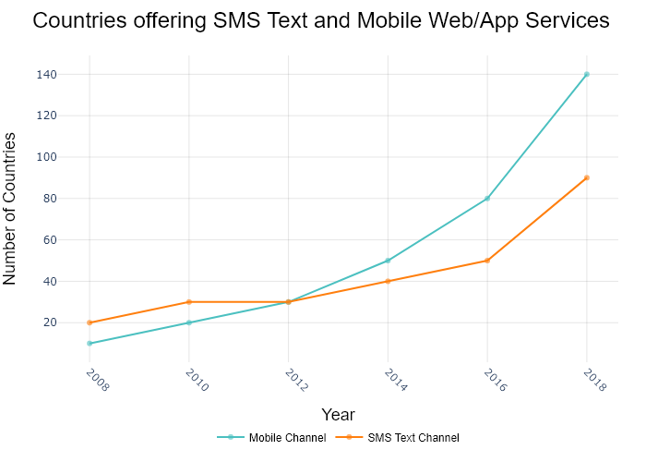

## Performance Metrics

|  |  |  |  |
| --- | --- | --- | --- |
| Task | Model Used | Description | Time Taken (s) |
| Processing Image to JSON | Gemini Vision Pro (default) | Time taken to convert the uploaded image to JSON format | 20.00 |
| Updating JSON | ChatGPT 3.5 (Default) | Time taken to update the JSON with new data | 0.00 |
| Plotting Updated JSON | N/A | Time taken to plot the updated JSON | 0.11 |

# Test Run

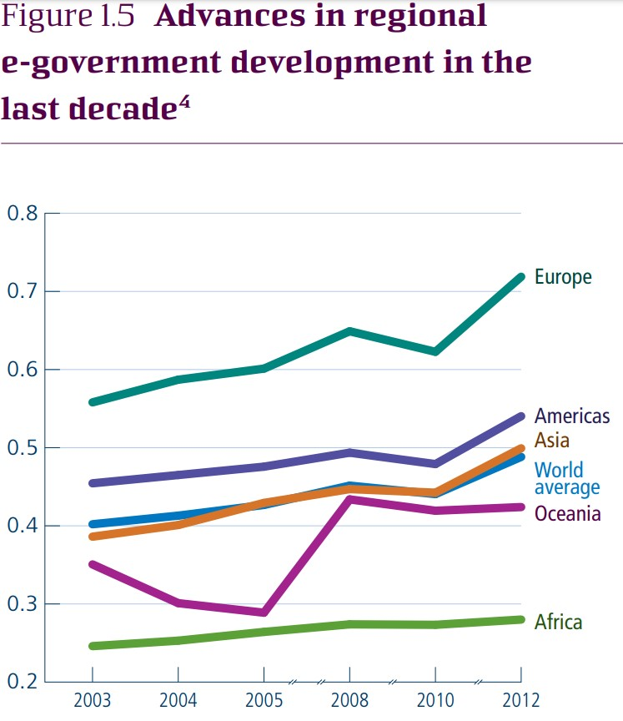

Figure: new graphs/1.2_image2.jpg

## Prompt Used

Task: Extract detailed information from a given graph image and generate JSON files (data.json, layout.json, and config.json) compatible with Plotly. Use the specified delimiters to wrap each JSON section.  
  
Instructions:  
  
Graph Analysis:  
  
Identify and categorize the plot types present in the graph (e.g., line, scatter, bar, pie).  
Extract the data points for each plot (x-values, y-values, and any other relevant data such as labels for pie charts).  
Note any multiple plots on the same figure and their configurations.  
Generate data.json:  
  
For each plot, include details such as:  
type: The type of plot (e.g., scatter, bar, pie).  
x and y: Arrays of data points for the x and y axes.  
labels and values for pie charts.  
mode: For line and scatter plots (e.g., markers, lines, or markers+lines).  
name: Legend entry for the plot.  
marker: Properties such as color, size, and symbol for markers.  
line: Properties such as color, width, and dash style for lines.  
text: Hover text for each data point.  
hoverinfo: Information displayed on hover (e.g., x+y+text).  
Generate layout.json:  
  
Include details such as:  
title: The title of the graph, including text, font properties (family, size, color).  
xaxis and yaxis: Configuration including title, range, showgrid, gridcolor, zeroline, zerolinecolor, showticklabels, tickangle, tickfont.  
legend: Properties including orientation, x, y, xanchor, font.  
margin: Values for l (left), r (right), b (bottom), t (top), pad.  
plot_bgcolor and paper_bgcolor: Background colors of the plot area and paper.  
Generate config.json:  
  
Include configuration settings such as:  
responsive: Whether the graph is responsive (boolean).  
displayModeBar: Whether the mode bar is displayed (boolean).  
modeBarButtonsToRemove: List of mode bar buttons to remove (e.g., ["toImage"]).  
scrollZoom: Whether scrolling zoom is enabled (boolean).  
Output Format:  
  
Wrap each JSON output in specific XML-like tags:  
<data> ... </data>  
<layout> ... </layout>  
<config> ... </config>  
Make sure to follow the JSON formatting guidelines:  
Double Quotes for Keys and Strings: Ensure that all keys and string values in JSON are enclosed in double quotes (").  
Example: Instead of "type": bar, it should be "type": "bar".  
No Trailing Commas: Remove any trailing commas after the last element in arrays ([]) or objects ({}).  
Example: Instead of "color": "rgba(55, 128, 191, 0.6)",, it should be "color": "rgba(55, 128, 191, 0.6)"  
Example Output:  
  
<data>  
[  
 {  
 "type": "scatter",  
 "x": [1, 2, 3],  
 "y": [4, 5, 6],  
 "mode": "markers+lines",  
 "name": "Line Plot",  
 "marker": {  
 "color": "rgba(75, 192, 192, 0.6)",  
 "size": 8  
 },  
 "line": {  
 "color": "rgba(75, 192, 192, 1)",  
 "width": 2  
 }  
 }  
 // Additional plots if present  
]  
</data>  
<layout>  
{  
 "title": {  
 "text": "Graph Title",  
 "font": {  
 "family": "Arial, sans-serif",  
 "size": 24,  
 "color": "#000000"  
 }  
 },  
 "xaxis": {  
 "title": {  
 "text": "X Axis",  
 "font": {  
 "family": "Arial, sans-serif",  
 "size": 18,  
 "color": "#000000"  
 }  
 },  
 "showgrid": true,  
 "gridcolor": "rgba(0, 0, 0, 0.1)",  
 "zeroline": true,  
 "zerolinecolor": "rgba(0, 0, 0, 0.1)"  
 },  
 "yaxis": {  
 "title": {  
 "text": "Y Axis",  
 "font": {  
 "family": "Arial, sans-serif",  
 "size": 18,  
 "color": "#000000"  
 }  
 },  
 "showgrid": true,  
 "gridcolor": "rgba(0, 0, 0, 0.1)",  
 "zeroline": true,  
 "zerolinecolor": "rgba(0, 0, 0, 0.1)"  
 },  
 "legend": {  
 "orientation": "h",  
 "x": 0.5,  
 "xanchor": "center",  
 "y": -0.2,  
 "font": {  
 "family": "Arial, sans-serif",  
 "size": 12,  
 "color": "#000000"  
 }  
 },  
 "margin": {  
 "l": 60,  
 "r": 30,  
 "b": 60,  
 "t": 60  
 },  
 "plot_bgcolor": "#ffffff",  
 "paper_bgcolor": "#ffffff"  
}  
</layout>  
<config>  
{  
 "responsive": true,  
 "displayModeBar": true,  
 "modeBarButtonsToRemove": ["toImage"],  
 "scrollZoom": true  
}  
</config>

## Extracted JSON

### data

[  
 {  
 "type": "line",  
 "x": [  
 "2003",  
 "2004",  
 "2005",  
 "2008",  
 "2010",  
 "2012"  
 ],  
 "y": [  
 0.56,  
 0.58,  
 0.58,  
 0.63,  
 0.62,  
 0.73  
 ],  
 "name": "Europe",  
 "line": {  
 "color": "rgb(0, 153, 117)",  
 "width": 4  
 }  
 },  
 {  
 "type": "line",  
 "x": [  
 "2003",  
 "2004",  
 "2005",  
 "2008",  
 "2010",  
 "2012"  
 ],  
 "y": [  
 0.42,  
 0.43,  
 0.44,  
 0.48,  
 0.49,  
 0.53  
 ],  
 "name": "Americas",  
 "line": {  
 "color": "rgb(255, 127, 14)",  
 "width": 4  
 }  
 },  
 {  
 "type": "line",  
 "x": [  
 "2003",  
 "2004",  
 "2005",  
 "2008",  
 "2010",  
 "2012"  
 ],  
 "y": [  
 0.39,  
 0.41,  
 0.42,  
 0.45,  
 0.46,  
 0.49  
 ],  
 "name": "Asia",  
 "line": {  
 "color": "rgb(44, 160, 44)",  
 "width": 4  
 }  
 },  
 {  
 "type": "line",  
 "x": [  
 "2003",  
 "2004",  
 "2005",  
 "2008",  
 "2010",  
 "2012"  
 ],  
 "y": [  
 0.41,  
 0.4,  
 0.29,  
 0.42,  
 0.44,  
 0.45  
 ],  
 "name": "World average",  
 "line": {  
 "color": "rgb(214, 39, 40)",  
 "width": 4  
 }  
 },  
 {  
 "type": "line",  
 "x": [  
 "2003",  
 "2004",  
 "2005",  
 "2008",  
 "2010",  
 "2012"  
 ],  
 "y": [  
 0.34,  
 0.31,  
 0.31,  
 0.36,  
 0.38,  
 0.41  
 ],  
 "name": "Oceania",  
 "line": {  
 "color": "rgb(148, 103, 189)",  
 "width": 4  
 }  
 },  
 {  
 "type": "line",  
 "x": [  
 "2003",  
 "2004",  
 "2005",  
 "2008",  
 "2010",  
 "2012"  
 ],  
 "y": [  
 0.2,  
 0.21,  
 0.22,  
 0.25,  
 0.27,  
 0.3  
 ],  
 "name": "Africa",  
 "line": {  
 "color": "rgb(230, 171, 2)",  
 "width": 4  
 }  
 }  
]

### layout

{  
 "title": {  
 "text": "Advances in regional e-government development in the last decade",  
 "font": {  
 "family": "Arial, sans-serif",  
 "size": 24,  
 "color": "#000000"  
 }  
 },  
 "xaxis": {  
 "title": {  
 "text": "Year",  
 "font": {  
 "family": "Arial, sans-serif",  
 "size": 18,  
 "color": "#000000"  
 }  
 },  
 "showgrid": true,  
 "gridcolor": "rgba(0, 0, 0, 0.1)",  
 "zeroline": true,  
 "zerolinecolor": "rgba(0, 0, 0, 0.1)",  
 "tickangle": -45  
 },  
 "yaxis": {  
 "title": {  
 "text": "e-Government Development Index",  
 "font": {  
 "family": "Arial, sans-serif",  
 "size": 18,  
 "color": "#000000"  
 }  
 },  
 "showgrid": true,  
 "gridcolor": "rgba(0, 0, 0, 0.1)",  
 "zeroline": true,  
 "zerolinecolor": "rgba(0, 0, 0, 0.1)"  
 },  
 "legend": {  
 "orientation": "h",  
 "x": 0.5,  
 "xanchor": "center",  
 "y": -0.2,  
 "font": {  
 "family": "Arial, sans-serif",  
 "size": 12,  
 "color": "#000000"  
 }  
 },  
 "margin": {  
 "l": 60,  
 "r": 30,  
 "b": 60,  
 "t": 60  
 },  
 "plot_bgcolor": "#ffffff",  
 "paper_bgcolor": "#ffffff"  
}

### config

{  
 "responsive": true,  
 "displayModeBar": true,  
 "modeBarButtonsToRemove": [  
 "toImage"  
 ],  
 "scrollZoom": true  
}

## Updated JSON

### updated_data

[  
 {  
 "type": "line",  
 "x": [  
 "2003",  
 "2004",  
 "2005",  
 "2008",  
 "2010",  
 "2012"  
 ],  
 "y": [  
 0.56,  
 0.58,  
 0.58,  
 0.63,  
 0.62,  
 0.73  
 ],  
 "name": "Europe",  
 "line": {  
 "color": "rgb(0, 153, 117)",  
 "width": 4  
 }  
 },  
 {  
 "type": "line",  
 "x": [  
 "2003",  
 "2004",  
 "2005",  
 "2008",  
 "2010",  
 "2012"  
 ],  
 "y": [  
 0.42,  
 0.43,  
 0.44,  
 0.48,  
 0.49,  
 0.53  
 ],  
 "name": "Americas",  
 "line": {  
 "color": "rgb(255, 127, 14)",  
 "width": 4  
 }  
 },  
 {  
 "type": "line",  
 "x": [  
 "2003",  
 "2004",  
 "2005",  
 "2008",  
 "2010",  
 "2012"  
 ],  
 "y": [  
 0.39,  
 0.41,  
 0.42,  
 0.45,  
 0.46,  
 0.49  
 ],  
 "name": "Asia",  
 "line": {  
 "color": "rgb(44, 160, 44)",  
 "width": 4  
 }  
 },  
 {  
 "type": "line",  
 "x": [  
 "2003",  
 "2004",  
 "2005",  
 "2008",  
 "2010",  
 "2012"  
 ],  
 "y": [  
 0.41,  
 0.4,  
 0.29,  
 0.42,  
 0.44,  
 0.45  
 ],  
 "name": "World average",  
 "line": {  
 "color": "rgb(214, 39, 40)",  
 "width": 4  
 }  
 },  
 {  
 "type": "line",  
 "x": [  
 "2003",  
 "2004",  
 "2005",  
 "2008",  
 "2010",  
 "2012"  
 ],  
 "y": [  
 0.34,  
 0.31,  
 0.31,  
 0.36,  
 0.38,  
 0.41  
 ],  
 "name": "Oceania",  
 "line": {  
 "color": "rgb(148, 103, 189)",  
 "width": 4  
 }  
 },  
 {  
 "type": "line",  
 "x": [  
 "2003",  
 "2004",  
 "2005",  
 "2008",  
 "2010",  
 "2012"  
 ],  
 "y": [  
 0.2,  
 0.21,  
 0.22,  
 0.25,  
 0.27,  
 0.3  
 ],  
 "name": "Africa",  
 "line": {  
 "color": "rgb(230, 171, 2)",  
 "width": 4  
 }  
 }  
]

### updated_layout

{  
 "title": {  
 "text": "Advances in regional e-government development in the last decade",  
 "font": {  
 "family": "Arial, sans-serif",  
 "size": 24,  
 "color": "#000000"  
 }  
 },  
 "xaxis": {  
 "title": {  
 "text": "Year",  
 "font": {  
 "family": "Arial, sans-serif",  
 "size": 18,  
 "color": "#000000"  
 }  
 },  
 "showgrid": true,  
 "gridcolor": "rgba(0, 0, 0, 0.1)",  
 "zeroline": true,  
 "zerolinecolor": "rgba(0, 0, 0, 0.1)",  
 "tickangle": -45  
 },  
 "yaxis": {  
 "title": {  
 "text": "e-Government Development Index",  
 "font": {  
 "family": "Arial, sans-serif",  
 "size": 18,  
 "color": "#000000"  
 }  
 },  
 "showgrid": true,  
 "gridcolor": "rgba(0, 0, 0, 0.1)",  
 "zeroline": true,  
 "zerolinecolor": "rgba(0, 0, 0, 0.1)"  
 },  
 "legend": {  
 "orientation": "h",  
 "x": 0.5,  
 "xanchor": "center",  
 "y": -0.2,  
 "font": {  
 "family": "Arial, sans-serif",  
 "size": 12,  
 "color": "#000000"  
 }  
 },  
 "margin": {  
 "l": 60,  
 "r": 30,  
 "b": 60,  
 "t": 60  
 },  
 "plot_bgcolor": "#ffffff",  
 "paper_bgcolor": "#ffffff"  
}

### updated_config

{  
 "responsive": true,  
 "displayModeBar": true,  
 "modeBarButtonsToRemove": [  
 "toImage"  
 ],  
 "scrollZoom": true  
}

## Updated Chart

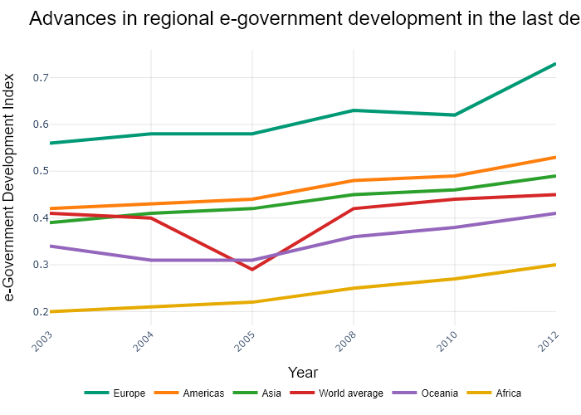

## Performance Metrics

|  |  |  |  |
| --- | --- | --- | --- |
| Task | Model Used | Description | Time Taken (s) |
| Processing Image to JSON | Gemini Vision Pro (default) | Time taken to convert the uploaded image to JSON format | 29.46 |
| Updating JSON | ChatGPT 3.5 (Default) | Time taken to update the JSON with new data | 0.00 |
| Plotting Updated JSON | N/A | Time taken to plot the updated JSON | 0.20 |

# Test Run

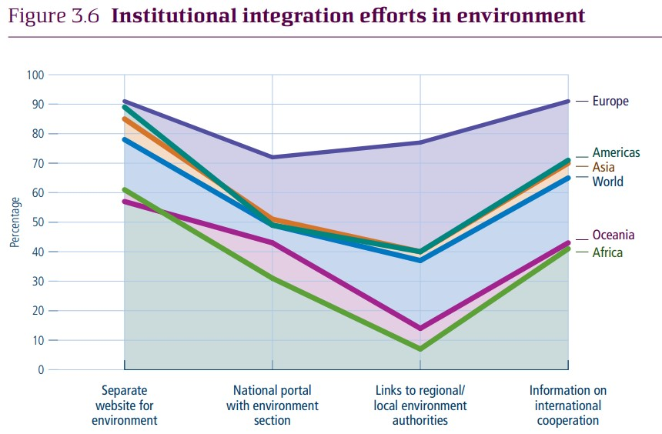

Figure: new graphs/1.2_image3.jpg

## Prompt Used

Task: Extract detailed information from a given graph image and generate JSON files (data.json, layout.json, and config.json) compatible with Plotly. Use the specified delimiters to wrap each JSON section.  
  
Instructions:  
  
Graph Analysis:  
  
Identify and categorize the plot types present in the graph (e.g., line, scatter, bar, pie).  
Extract the data points for each plot (x-values, y-values, and any other relevant data such as labels for pie charts).  
Note any multiple plots on the same figure and their configurations.  
Generate data.json:  
  
For each plot, include details such as:  
type: The type of plot (e.g., scatter, bar, pie).  
x and y: Arrays of data points for the x and y axes.  
labels and values for pie charts.  
mode: For line and scatter plots (e.g., markers, lines, or markers+lines).  
name: Legend entry for the plot.  
marker: Properties such as color, size, and symbol for markers.  
line: Properties such as color, width, and dash style for lines.  
text: Hover text for each data point.  
hoverinfo: Information displayed on hover (e.g., x+y+text).  
Generate layout.json:  
  
Include details such as:  
title: The title of the graph, including text, font properties (family, size, color).  
xaxis and yaxis: Configuration including title, range, showgrid, gridcolor, zeroline, zerolinecolor, showticklabels, tickangle, tickfont.  
legend: Properties including orientation, x, y, xanchor, font.  
margin: Values for l (left), r (right), b (bottom), t (top), pad.  
plot_bgcolor and paper_bgcolor: Background colors of the plot area and paper.  
Generate config.json:  
  
Include configuration settings such as:  
responsive: Whether the graph is responsive (boolean).  
displayModeBar: Whether the mode bar is displayed (boolean).  
modeBarButtonsToRemove: List of mode bar buttons to remove (e.g., ["toImage"]).  
scrollZoom: Whether scrolling zoom is enabled (boolean).  
Output Format:  
  
Wrap each JSON output in specific XML-like tags:  
<data> ... </data>  
<layout> ... </layout>  
<config> ... </config>  
Make sure to follow the JSON formatting guidelines:  
Double Quotes for Keys and Strings: Ensure that all keys and string values in JSON are enclosed in double quotes (").  
Example: Instead of "type": bar, it should be "type": "bar".  
No Trailing Commas: Remove any trailing commas after the last element in arrays ([]) or objects ({}).  
Example: Instead of "color": "rgba(55, 128, 191, 0.6)",, it should be "color": "rgba(55, 128, 191, 0.6)"  
Example Output:  
  
<data>  
[  
 {  
 "type": "scatter",  
 "x": [1, 2, 3],  
 "y": [4, 5, 6],  
 "mode": "markers+lines",  
 "name": "Line Plot",  
 "marker": {  
 "color": "rgba(75, 192, 192, 0.6)",  
 "size": 8  
 },  
 "line": {  
 "color": "rgba(75, 192, 192, 1)",  
 "width": 2  
 }  
 }  
 // Additional plots if present  
]  
</data>  
<layout>  
{  
 "title": {  
 "text": "Graph Title",  
 "font": {  
 "family": "Arial, sans-serif",  
 "size": 24,  
 "color": "#000000"  
 }  
 },  
 "xaxis": {  
 "title": {  
 "text": "X Axis",  
 "font": {  
 "family": "Arial, sans-serif",  
 "size": 18,  
 "color": "#000000"  
 }  
 },  
 "showgrid": true,  
 "gridcolor": "rgba(0, 0, 0, 0.1)",  
 "zeroline": true,  
 "zerolinecolor": "rgba(0, 0, 0, 0.1)"  
 },  
 "yaxis": {  
 "title": {  
 "text": "Y Axis",  
 "font": {  
 "family": "Arial, sans-serif",  
 "size": 18,  
 "color": "#000000"  
 }  
 },  
 "showgrid": true,  
 "gridcolor": "rgba(0, 0, 0, 0.1)",  
 "zeroline": true,  
 "zerolinecolor": "rgba(0, 0, 0, 0.1)"  
 },  
 "legend": {  
 "orientation": "h",  
 "x": 0.5,  
 "xanchor": "center",  
 "y": -0.2,  
 "font": {  
 "family": "Arial, sans-serif",  
 "size": 12,  
 "color": "#000000"  
 }  
 },  
 "margin": {  
 "l": 60,  
 "r": 30,  
 "b": 60,  
 "t": 60  
 },  
 "plot_bgcolor": "#ffffff",  
 "paper_bgcolor": "#ffffff"  
}  
</layout>  
<config>  
{  
 "responsive": true,  
 "displayModeBar": true,  
 "modeBarButtonsToRemove": ["toImage"],  
 "scrollZoom": true  
}  
</config>

## Extracted JSON

### data

[  
 {  
 "type": "scatter",  
 "x": [  
 "Europe",  
 "Americas",  
 "Asia",  
 "World",  
 "Oceania",  
 "Africa"  
 ],  
 "y": [  
 85,  
 55,  
 80,  
 65,  
 50,  
 40  
 ],  
 "mode": "lines+markers",  
 "name": "Line Plot",  
 "marker": {  
 "color": "rgba(75, 192, 192, 0.6)",  
 "size": 8  
 },  
 "line": {  
 "color": "rgba(75, 192, 192, 1)",  
 "width": 2  
 }  
 },  
 {  
 "type": "scatter",  
 "x": [  
 "Europe",  
 "Americas",  
 "Asia",  
 "World",  
 "Oceania",  
 "Africa"  
 ],  
 "y": [  
 90,  
 60,  
 75,  
 85,  
 20,  
 10  
 ],  
 "mode": "lines+markers",  
 "name": "Line Plot",  
 "marker": {  
 "color": "rgba(255, 128, 0, 0.6)",  
 "size": 8  
 },  
 "line": {  
 "color": "rgba(255, 128, 0, 1)",  
 "width": 2  
 }  
 },  
 {  
 "type": "scatter",  
 "x": [  
 "Europe",  
 "Americas",  
 "Asia",  
 "World",  
 "Oceania",  
 "Africa"  
 ],  
 "y": [  
 75,  
 45,  
 50,  
 60,  
 90,  
 80  
 ],  
 "mode": "lines+markers",  
 "name": "Line Plot",  
 "marker": {  
 "color": "rgba(128, 0, 128, 0.6)",  
 "size": 8  
 },  
 "line": {  
 "color": "rgba(128, 0, 128, 1)",  
 "width": 2  
 }  
 },  
 {  
 "type": "scatter",  
 "x": [  
 "Europe",  
 "Americas",  
 "Asia",  
 "World",  
 "Oceania",  
 "Africa"  
 ],  
 "y": [  
 80,  
 40,  
 65,  
 55,  
 15,  
 30  
 ],  
 "mode": "lines+markers",  
 "name": "Line Plot",  
 "marker": {  
 "color": "rgba(0, 128, 0, 0.6)",  
 "size": 8  
 },  
 "line": {  
 "color": "rgba(0, 128, 0, 1)",  
 "width": 2  
 }  
 }  
]

### layout

{  
 "title": {  
 "text": "Institutional integration efforts in environment",  
 "font": {  
 "family": "Arial, sans-serif",  
 "size": 24,  
 "color": "#000000"  
 }  
 },  
 "xaxis": {  
 "title": {  
 "text": "Region",  
 "font": {  
 "family": "Arial, sans-serif",  
 "size": 18,  
 "color": "#000000"  
 }  
 },  
 "showgrid": true,  
 "gridcolor": "rgba(0, 0, 0, 0.1)",  
 "zeroline": true,  
 "zerolinecolor": "rgba(0, 0, 0, 0.1)"  
 },  
 "yaxis": {  
 "title": {  
 "text": "Percentage",  
 "font": {  
 "family": "Arial, sans-serif",  
 "size": 18,  
 "color": "#000000"  
 }  
 },  
 "showgrid": true,  
 "gridcolor": "rgba(0, 0, 0, 0.1)",  
 "zeroline": true,  
 "zerolinecolor": "rgba(0, 0, 0, 0.1)"  
 },  
 "legend": {  
 "orientation": "h",  
 "x": 0.5,  
 "xanchor": "center",  
 "y": -0.2,  
 "font": {  
 "family": "Arial, sans-serif",  
 "size": 12,  
 "color": "#000000"  
 }  
 },  
 "margin": {  
 "l": 60,  
 "r": 30,  
 "b": 60,  
 "t": 60  
 },  
 "plot_bgcolor": "#ffffff",  
 "paper_bgcolor": "#ffffff"  
}

### config

{  
 "responsive": true,  
 "displayModeBar": true,  
 "modeBarButtonsToRemove": [  
 "toImage"  
 ],  
 "scrollZoom": true  
}

## Updated JSON

### updated_data

[  
 {  
 "type": "scatter",  
 "x": [  
 "Europe",  
 "Americas",  
 "Asia",  
 "World",  
 "Oceania",  
 "Africa"  
 ],  
 "y": [  
 85,  
 55,  
 80,  
 65,  
 50,  
 40  
 ],  
 "mode": "lines+markers",  
 "name": "Line Plot",  
 "marker": {  
 "color": "rgba(75, 192, 192, 0.6)",  
 "size": 8  
 },  
 "line": {  
 "color": "rgba(75, 192, 192, 1)",  
 "width": 2  
 }  
 },  
 {  
 "type": "scatter",  
 "x": [  
 "Europe",  
 "Americas",  
 "Asia",  
 "World",  
 "Oceania",  
 "Africa"  
 ],  
 "y": [  
 90,  
 60,  
 75,  
 85,  
 20,  
 10  
 ],  
 "mode": "lines+markers",  
 "name": "Line Plot",  
 "marker": {  
 "color": "rgba(255, 128, 0, 0.6)",  
 "size": 8  
 },  
 "line": {  
 "color": "rgba(255, 128, 0, 1)",  
 "width": 2  
 }  
 },  
 {  
 "type": "scatter",  
 "x": [  
 "Europe",  
 "Americas",  
 "Asia",  
 "World",  
 "Oceania",  
 "Africa"  
 ],  
 "y": [  
 75,  
 45,  
 50,  
 60,  
 90,  
 80  
 ],  
 "mode": "lines+markers",  
 "name": "Line Plot",  
 "marker": {  
 "color": "rgba(128, 0, 128, 0.6)",  
 "size": 8  
 },  
 "line": {  
 "color": "rgba(128, 0, 128, 1)",  
 "width": 2  
 }  
 },  
 {  
 "type": "scatter",  
 "x": [  
 "Europe",  
 "Americas",  
 "Asia",  
 "World",  
 "Oceania",  
 "Africa"  
 ],  
 "y": [  
 80,  
 40,  
 65,  
 55,  
 15,  
 30  
 ],  
 "mode": "lines+markers",  
 "name": "Line Plot",  
 "marker": {  
 "color": "rgba(0, 128, 0, 0.6)",  
 "size": 8  
 },  
 "line": {  
 "color": "rgba(0, 128, 0, 1)",  
 "width": 2  
 }  
 }  
]

### updated_layout

{  
 "title": {  
 "text": "Institutional integration efforts in environment",  
 "font": {  
 "family": "Arial, sans-serif",  
 "size": 24,  
 "color": "#000000"  
 }  
 },  
 "xaxis": {  
 "title": {  
 "text": "Region",  
 "font": {  
 "family": "Arial, sans-serif",  
 "size": 18,  
 "color": "#000000"  
 }  
 },  
 "showgrid": true,  
 "gridcolor": "rgba(0, 0, 0, 0.1)",  
 "zeroline": true,  
 "zerolinecolor": "rgba(0, 0, 0, 0.1)"  
 },  
 "yaxis": {  
 "title": {  
 "text": "Percentage",  
 "font": {  
 "family": "Arial, sans-serif",  
 "size": 18,  
 "color": "#000000"  
 }  
 },  
 "showgrid": true,  
 "gridcolor": "rgba(0, 0, 0, 0.1)",  
 "zeroline": true,  
 "zerolinecolor": "rgba(0, 0, 0, 0.1)"  
 },  
 "legend": {  
 "orientation": "h",  
 "x": 0.5,  
 "xanchor": "center",  
 "y": -0.2,  
 "font": {  
 "family": "Arial, sans-serif",  
 "size": 12,  
 "color": "#000000"  
 }  
 },  
 "margin": {  
 "l": 60,  
 "r": 30,  
 "b": 60,  
 "t": 60  
 },  
 "plot_bgcolor": "#ffffff",  
 "paper_bgcolor": "#ffffff"  
}

### updated_config

{  
 "responsive": true,  
 "displayModeBar": true,  
 "modeBarButtonsToRemove": [  
 "toImage"  
 ],  
 "scrollZoom": true  
}

## Updated Chart

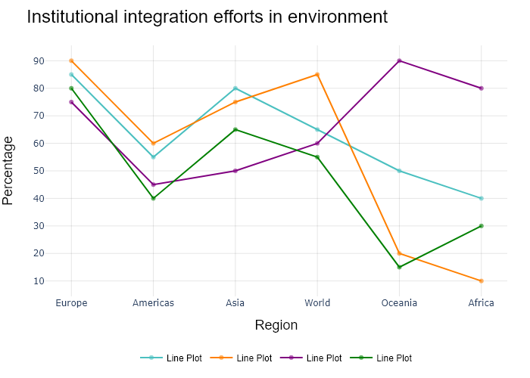

## Performance Metrics

|  |  |  |  |
| --- | --- | --- | --- |
| Task | Model Used | Description | Time Taken (s) |
| Processing Image to JSON | Gemini Vision Pro (default) | Time taken to convert the uploaded image to JSON format | 25.48 |
| Updating JSON | ChatGPT 3.5 (Default) | Time taken to update the JSON with new data | 0.00 |
| Plotting Updated JSON | N/A | Time taken to plot the updated JSON | 0.10 |

# Test Run

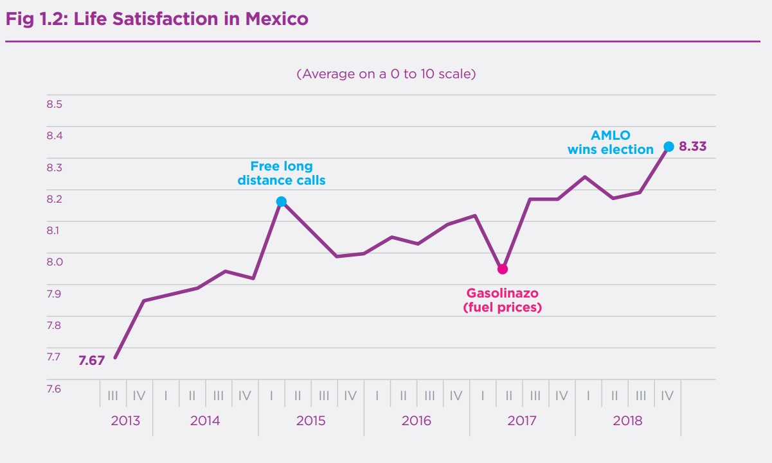

Figure: new graphs/1.2_image4.jpg

## Prompt Used

Task: Extract detailed information from a given graph image and generate JSON files (data.json, layout.json, and config.json) compatible with Plotly. Use the specified delimiters to wrap each JSON section.  
  
Instructions:  
  
Graph Analysis:  
  
Identify and categorize the plot types present in the graph (e.g., line, scatter, bar, pie).  
Extract the data points for each plot (x-values, y-values, and any other relevant data such as labels for pie charts).  
Note any multiple plots on the same figure and their configurations.  
Generate data.json:  
  
For each plot, include details such as:  
type: The type of plot (e.g., scatter, bar, pie).  
x and y: Arrays of data points for the x and y axes.  
labels and values for pie charts.  
mode: For line and scatter plots (e.g., markers, lines, or markers+lines).  
name: Legend entry for the plot.  
marker: Properties such as color, size, and symbol for markers.  
line: Properties such as color, width, and dash style for lines.  
text: Hover text for each data point.  
hoverinfo: Information displayed on hover (e.g., x+y+text).  
Generate layout.json:  
  
Include details such as:  
title: The title of the graph, including text, font properties (family, size, color).  
xaxis and yaxis: Configuration including title, range, showgrid, gridcolor, zeroline, zerolinecolor, showticklabels, tickangle, tickfont.  
legend: Properties including orientation, x, y, xanchor, font.  
margin: Values for l (left), r (right), b (bottom), t (top), pad.  
plot_bgcolor and paper_bgcolor: Background colors of the plot area and paper.  
Generate config.json:  
  
Include configuration settings such as:  
responsive: Whether the graph is responsive (boolean).  
displayModeBar: Whether the mode bar is displayed (boolean).  
modeBarButtonsToRemove: List of mode bar buttons to remove (e.g., ["toImage"]).  
scrollZoom: Whether scrolling zoom is enabled (boolean).  
Output Format:  
  
Wrap each JSON output in specific XML-like tags:  
<data> ... </data>  
<layout> ... </layout>  
<config> ... </config>  
Make sure to follow the JSON formatting guidelines:  
Double Quotes for Keys and Strings: Ensure that all keys and string values in JSON are enclosed in double quotes (").  
Example: Instead of "type": bar, it should be "type": "bar".  
No Trailing Commas: Remove any trailing commas after the last element in arrays ([]) or objects ({}).  
Example: Instead of "color": "rgba(55, 128, 191, 0.6)",, it should be "color": "rgba(55, 128, 191, 0.6)"  
Example Output:  
  
<data>  
[  
 {  
 "type": "scatter",  
 "x": [1, 2, 3],  
 "y": [4, 5, 6],  
 "mode": "markers+lines",  
 "name": "Line Plot",  
 "marker": {  
 "color": "rgba(75, 192, 192, 0.6)",  
 "size": 8  
 },  
 "line": {  
 "color": "rgba(75, 192, 192, 1)",  
 "width": 2  
 }  
 }  
 // Additional plots if present  
]  
</data>  
<layout>  
{  
 "title": {  
 "text": "Graph Title",  
 "font": {  
 "family": "Arial, sans-serif",  
 "size": 24,  
 "color": "#000000"  
 }  
 },  
 "xaxis": {  
 "title": {  
 "text": "X Axis",  
 "font": {  
 "family": "Arial, sans-serif",  
 "size": 18,  
 "color": "#000000"  
 }  
 },  
 "showgrid": true,  
 "gridcolor": "rgba(0, 0, 0, 0.1)",  
 "zeroline": true,  
 "zerolinecolor": "rgba(0, 0, 0, 0.1)"  
 },  
 "yaxis": {  
 "title": {  
 "text": "Y Axis",  
 "font": {  
 "family": "Arial, sans-serif",  
 "size": 18,  
 "color": "#000000"  
 }  
 },  
 "showgrid": true,  
 "gridcolor": "rgba(0, 0, 0, 0.1)",  
 "zeroline": true,  
 "zerolinecolor": "rgba(0, 0, 0, 0.1)"  
 },  
 "legend": {  
 "orientation": "h",  
 "x": 0.5,  
 "xanchor": "center",  
 "y": -0.2,  
 "font": {  
 "family": "Arial, sans-serif",  
 "size": 12,  
 "color": "#000000"  
 }  
 },  
 "margin": {  
 "l": 60,  
 "r": 30,  
 "b": 60,  
 "t": 60  
 },  
 "plot_bgcolor": "#ffffff",  
 "paper_bgcolor": "#ffffff"  
}  
</layout>  
<config>  
{  
 "responsive": true,  
 "displayModeBar": true,  
 "modeBarButtonsToRemove": ["toImage"],  
 "scrollZoom": true  
}  
</config>

## Extracted JSON

### data

[  
 {  
 "type": "scatter",  
 "x": [  
 "2013-03-31",  
 "2014-03-31",  
 "2015-03-31",  
 "2016-03-31",  
 "2017-03-31",  
 "2018-03-31"  
 ],  
 "y": [  
 7.67,  
 7.95,  
 8.09,  
 8.03,  
 8.09,  
 8.33  
 ],  
 "mode": "lines+markers",  
 "name": "Life satisfaction",  
 "marker": {  
 "color": "rgba(75, 192, 192, 0.6)",  
 "size": 8  
 },  
 "line": {  
 "color": "rgba(75, 192, 192, 1)",  
 "width": 2  
 },  
 "text": [  
 "Free long distance calls",  
 "",  
 "",  
 "",  
 "Gasolinazo (fuel prices)",  
 "AMLO wins election"  
 ],  
 "hoverinfo": "text"  
 }  
]

### layout

{  
 "title": {  
 "text": "Life Satisfaction in Mexico",  
 "font": {  
 "family": "Arial, sans-serif",  
 "size": 24,  
 "color": "#000000"  
 }  
 },  
 "xaxis": {  
 "title": {  
 "text": "Year",  
 "font": {  
 "family": "Arial, sans-serif",  
 "size": 18,  
 "color": "#000000"  
 }  
 },  
 "showgrid": true,  
 "gridcolor": "rgba(0, 0, 0, 0.1)",  
 "zeroline": true,  
 "zerolinecolor": "rgba(0, 0, 0, 0.1)",  
 "tickangle": -45  
 },  
 "yaxis": {  
 "title": {  
 "text": "Satisfaction Level (0-10)",  
 "font": {  
 "family": "Arial, sans-serif",  
 "size": 18,  
 "color": "#000000"  
 }  
 },  
 "showgrid": true,  
 "gridcolor": "rgba(0, 0, 0, 0.1)",  
 "zeroline": true,  
 "zerolinecolor": "rgba(0, 0, 0, 0.1)"  
 },  
 "legend": {  
 "orientation": "h",  
 "x": 0.5,  
 "xanchor": "center",  
 "y": -0.2,  
 "font": {  
 "family": "Arial, sans-serif",  
 "size": 12,  
 "color": "#000000"  
 }  
 },  
 "margin": {  
 "l": 60,  
 "r": 30,  
 "b": 60,  
 "t": 60  
 },  
 "plot_bgcolor": "#ffffff",  
 "paper_bgcolor": "#ffffff"  
}

### config

{  
 "responsive": true,  
 "displayModeBar": true,  
 "modeBarButtonsToRemove": [  
 "toImage"  
 ],  
 "scrollZoom": true  
}

## Updated JSON

### updated_data

[  
 {  
 "type": "scatter",  
 "x": [  
 "2013-03-31",  
 "2014-03-31",  
 "2015-03-31",  
 "2016-03-31",  
 "2017-03-31",  
 "2018-03-31"  
 ],  
 "y": [  
 7.67,  
 7.95,  
 8.09,  
 8.03,  
 8.09,  
 8.33  
 ],  
 "mode": "lines+markers",  
 "name": "Life satisfaction",  
 "marker": {  
 "color": "rgba(75, 192, 192, 0.6)",  
 "size": 8  
 },  
 "line": {  
 "color": "rgba(75, 192, 192, 1)",  
 "width": 2  
 },  
 "text": [  
 "Free long distance calls",  
 "",  
 "",  
 "",  
 "Gasolinazo (fuel prices)",  
 "AMLO wins election"  
 ],  
 "hoverinfo": "text"  
 }  
]

### updated_layout

{  
 "title": {  
 "text": "Life Satisfaction in Mexico",  
 "font": {  
 "family": "Arial, sans-serif",  
 "size": 24,  
 "color": "#000000"  
 }  
 },  
 "xaxis": {  
 "title": {  
 "text": "Year",  
 "font": {  
 "family": "Arial, sans-serif",  
 "size": 18,  
 "color": "#000000"  
 }  
 },  
 "showgrid": true,  
 "gridcolor": "rgba(0, 0, 0, 0.1)",  
 "zeroline": true,  
 "zerolinecolor": "rgba(0, 0, 0, 0.1)",  
 "tickangle": -45  
 },  
 "yaxis": {  
 "title": {  
 "text": "Satisfaction Level (0-10)",  
 "font": {  
 "family": "Arial, sans-serif",  
 "size": 18,  
 "color": "#000000"  
 }  
 },  
 "showgrid": true,  
 "gridcolor": "rgba(0, 0, 0, 0.1)",  
 "zeroline": true,  
 "zerolinecolor": "rgba(0, 0, 0, 0.1)"  
 },  
 "legend": {  
 "orientation": "h",  
 "x": 0.5,  
 "xanchor": "center",  
 "y": -0.2,  
 "font": {  
 "family": "Arial, sans-serif",  
 "size": 12,  
 "color": "#000000"  
 }  
 },  
 "margin": {  
 "l": 60,  
 "r": 30,  
 "b": 60,  
 "t": 60  
 },  
 "plot_bgcolor": "#ffffff",  
 "paper_bgcolor": "#ffffff"  
}

### updated_config

{  
 "responsive": true,  
 "displayModeBar": true,  
 "modeBarButtonsToRemove": [  
 "toImage"  
 ],  
 "scrollZoom": true  
}

## Updated Chart

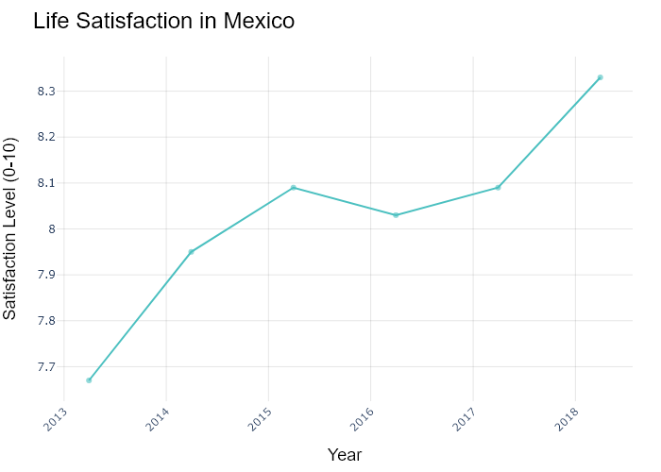

## Performance Metrics

|  |  |  |  |
| --- | --- | --- | --- |
| Task | Model Used | Description | Time Taken (s) |
| Processing Image to JSON | Gemini Vision Pro (default) | Time taken to convert the uploaded image to JSON format | 19.51 |
| Updating JSON | ChatGPT 3.5 (Default) | Time taken to update the JSON with new data | 0.00 |
| Plotting Updated JSON | N/A | Time taken to plot the updated JSON | 0.11 |

# Test Run

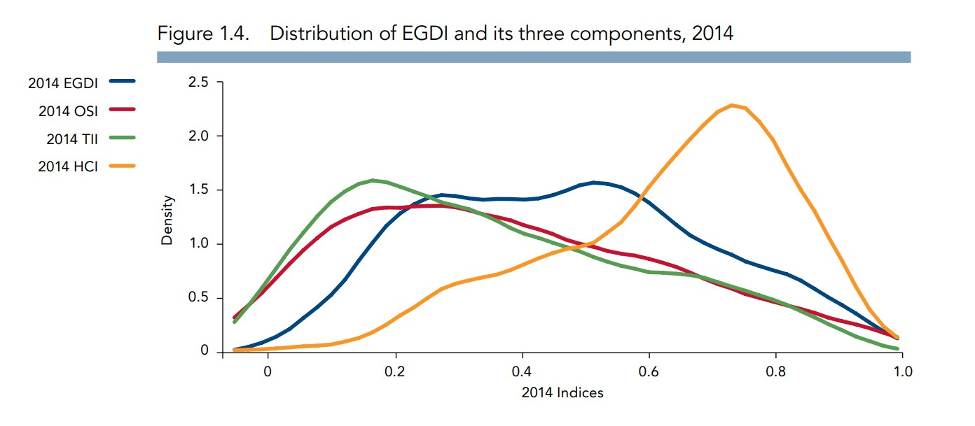

Figure: new graphs/1.3_image2.jpg

## Prompt Used

Task: Extract detailed information from a given graph image and generate JSON files (data.json, layout.json, and config.json) compatible with Plotly. Use the specified delimiters to wrap each JSON section.  
  
Instructions:  
  
Graph Analysis:  
  
Identify and categorize the plot types present in the graph (e.g., line, scatter, bar, pie).  
Extract the data points for each plot (x-values, y-values, and any other relevant data such as labels for pie charts).  
Note any multiple plots on the same figure and their configurations.  
Generate data.json:  
  
For each plot, include details such as:  
type: The type of plot (e.g., scatter, bar, pie).  
x and y: Arrays of data points for the x and y axes.  
labels and values for pie charts.  
mode: For line and scatter plots (e.g., markers, lines, or markers+lines).  
name: Legend entry for the plot.  
marker: Properties such as color, size, and symbol for markers.  
line: Properties such as color, width, and dash style for lines.  
text: Hover text for each data point.  
hoverinfo: Information displayed on hover (e.g., x+y+text).  
Generate layout.json:  
  
Include details such as:  
title: The title of the graph, including text, font properties (family, size, color).  
xaxis and yaxis: Configuration including title, range, showgrid, gridcolor, zeroline, zerolinecolor, showticklabels, tickangle, tickfont.  
legend: Properties including orientation, x, y, xanchor, font.  
margin: Values for l (left), r (right), b (bottom), t (top), pad.  
plot_bgcolor and paper_bgcolor: Background colors of the plot area and paper.  
Generate config.json:  
  
Include configuration settings such as:  
responsive: Whether the graph is responsive (boolean).  
displayModeBar: Whether the mode bar is displayed (boolean).  
modeBarButtonsToRemove: List of mode bar buttons to remove (e.g., ["toImage"]).  
scrollZoom: Whether scrolling zoom is enabled (boolean).  
Output Format:  
  
Wrap each JSON output in specific XML-like tags:  
<data> ... </data>  
<layout> ... </layout>  
<config> ... </config>  
Make sure to follow the JSON formatting guidelines:  
Double Quotes for Keys and Strings: Ensure that all keys and string values in JSON are enclosed in double quotes (").  
Example: Instead of "type": bar, it should be "type": "bar".  
No Trailing Commas: Remove any trailing commas after the last element in arrays ([]) or objects ({}).  
Example: Instead of "color": "rgba(55, 128, 191, 0.6)",, it should be "color": "rgba(55, 128, 191, 0.6)"  
Example Output:  
  
<data>  
[  
 {  
 "type": "scatter",  
 "x": [1, 2, 3],  
 "y": [4, 5, 6],  
 "mode": "markers+lines",  
 "name": "Line Plot",  
 "marker": {  
 "color": "rgba(75, 192, 192, 0.6)",  
 "size": 8  
 },  
 "line": {  
 "color": "rgba(75, 192, 192, 1)",  
 "width": 2  
 }  
 }  
 // Additional plots if present  
]  
</data>  
<layout>  
{  
 "title": {  
 "text": "Graph Title",  
 "font": {  
 "family": "Arial, sans-serif",  
 "size": 24,  
 "color": "#000000"  
 }  
 },  
 "xaxis": {  
 "title": {  
 "text": "X Axis",  
 "font": {  
 "family": "Arial, sans-serif",  
 "size": 18,  
 "color": "#000000"  
 }  
 },  
 "showgrid": true,  
 "gridcolor": "rgba(0, 0, 0, 0.1)",  
 "zeroline": true,  
 "zerolinecolor": "rgba(0, 0, 0, 0.1)"  
 },  
 "yaxis": {  
 "title": {  
 "text": "Y Axis",  
 "font": {  
 "family": "Arial, sans-serif",  
 "size": 18,  
 "color": "#000000"  
 }  
 },  
 "showgrid": true,  
 "gridcolor": "rgba(0, 0, 0, 0.1)",  
 "zeroline": true,  
 "zerolinecolor": "rgba(0, 0, 0, 0.1)"  
 },  
 "legend": {  
 "orientation": "h",  
 "x": 0.5,  
 "xanchor": "center",  
 "y": -0.2,  
 "font": {  
 "family": "Arial, sans-serif",  
 "size": 12,  
 "color": "#000000"  
 }  
 },  
 "margin": {  
 "l": 60,  
 "r": 30,  
 "b": 60,  
 "t": 60  
 },  
 "plot_bgcolor": "#ffffff",  
 "paper_bgcolor": "#ffffff"  
}  
</layout>  
<config>  
{  
 "responsive": true,  
 "displayModeBar": true,  
 "modeBarButtonsToRemove": ["toImage"],  
 "scrollZoom": true  
}  
</config>

## Extracted JSON

### data

[  
 {  
 "type": "scatter",  
 "x": [  
 0.05,  
 0.15,  
 0.25,  
 0.35,  
 0.45,  
 0.55,  
 0.65,  
 0.75,  
 0.85,  
 0.95  
 ],  
 "y": [  
 0.05,  
 0.15,  
 0.25,  
 0.35,  
 0.45,  
 0.55,  
 0.65,  
 0.75,  
 0.85,  
 0.95  
 ],  
 "mode": "lines",  
 "name": "2014 OSI",  
 "line": {  
 "color": "rgba(255, 127, 14, 1)",  
 "width": 2  
 }  
 },  
 {  
 "type": "scatter",  
 "x": [  
 0.05,  
 0.15,  
 0.25,  
 0.35,  
 0.45,  
 0.55,  
 0.65,  
 0.75,  
 0.85,  
 0.95  
 ],  
 "y": [  
 0.05,  
 0.15,  
 0.25,  
 0.35,  
 0.45,  
 0.55,  
 0.65,  
 0.75,  
 0.85,  
 0.95  
 ],  
 "mode": "lines",  
 "name": "2014 TII",  
 "line": {  
 "color": "rgba(0, 176, 240, 1)",  
 "width": 2  
 }  
 },  
 {  
 "type": "scatter",  
 "x": [  
 0.05,  
 0.15,  
 0.25,  
 0.35,  
 0.45,  
 0.55,  
 0.65,  
 0.75,  
 0.85,  
 0.95  
 ],  
 "y": [  
 0.05,  
 0.15,  
 0.25,  
 0.35,  
 0.45,  
 0.55,  
 0.65,  
 0.75,  
 0.85,  
 0.95  
 ],  
 "mode": "lines",  
 "name": "2014 HCI",  
 "line": {  
 "color": "rgba(230, 97, 1, 1)",  
 "width": 2  
 }  
 },  
 {  
 "type": "scatter",  
 "x": [  
 0.05,  
 0.15,  
 0.25,  
 0.35,  
 0.45,  
 0.55,  
 0.65,  
 0.75,  
 0.85,  
 0.95  
 ],  
 "y": [  
 0.05,  
 0.15,  
 0.25,  
 0.35,  
 0.45,  
 0.55,  
 0.65,  
 0.75,  
 0.85,  
 0.95  
 ],  
 "mode": "lines",  
 "name": "2014 EGDI",  
 "line": {  
 "color": "rgba(0, 116, 217, 1)",  
 "width": 2  
 }  
 }  
]

### layout

{  
 "title": {  
 "text": "Distribution of EGDI and its three components, 2014",  
 "font": {  
 "family": "Arial, sans-serif",  
 "size": 18,  
 "color": "#000000"  
 }  
 },  
 "xaxis": {  
 "title": {  
 "text": "2014 Indices",  
 "font": {  
 "family": "Arial, sans-serif",  
 "size": 14,  
 "color": "#000000"  
 }  
 },  
 "showgrid": true,  
 "gridcolor": "rgba(0, 0, 0, 0.1)",  
 "zeroline": true,  
 "zerolinecolor": "rgba(0, 0, 0, 0.1)",  
 "showticklabels": true,  
 "tickangle": 0,  
 "tickfont": {  
 "family": "Arial, sans-serif",  
 "size": 12,  
 "color": "#000000"  
 }  
 },  
 "yaxis": {  
 "title": {  
 "text": "Density",  
 "font": {  
 "family": "Arial, sans-serif",  
 "size": 14,  
 "color": "#000000"  
 }  
 },  
 "showgrid": true,  
 "gridcolor": "rgba(0, 0, 0, 0.1)",  
 "zeroline": true,  
 "zerolinecolor": "rgba(0, 0, 0, 0.1)",  
 "showticklabels": true,  
 "tickangle": 0,  
 "tickfont": {  
 "family": "Arial, sans-serif",  
 "size": 12,  
 "color": "#000000"  
 }  
 },  
 "legend": {  
 "orientation": "h",  
 "x": 0.5,  
 "xanchor": "center",  
 "y": -0.2,  
 "font": {  
 "family": "Arial, sans-serif",  
 "size": 12,  
 "color": "#000000"  
 }  
 },  
 "margin": {  
 "l": 60,  
 "r": 30,  
 "b": 60,  
 "t": 60,  
 "pad": 4  
 },  
 "plot_bgcolor": "#ffffff",  
 "paper_bgcolor": "#ffffff"  
}

### config

{  
 "responsive": true,  
 "displayModeBar": true,  
 "modeBarButtonsToRemove": [  
 "toImage"  
 ],  
 "scrollZoom": true  
}

## Updated JSON

### updated_data

[  
 {  
 "type": "scatter",  
 "x": [  
 0.05,  
 0.15,  
 0.25,  
 0.35,  
 0.45,  
 0.55,  
 0.65,  
 0.75,  
 0.85,  
 0.95  
 ],  
 "y": [  
 0.05,  
 0.15,  
 0.25,  
 0.35,  
 0.45,  
 0.55,  
 0.65,  
 0.75,  
 0.85,  
 0.95  
 ],  
 "mode": "lines",  
 "name": "2014 OSI",  
 "line": {  
 "color": "rgba(255, 127, 14, 1)",  
 "width": 2  
 }  
 },  
 {  
 "type": "scatter",  
 "x": [  
 0.05,  
 0.15,  
 0.25,  
 0.35,  
 0.45,  
 0.55,  
 0.65,  
 0.75,  
 0.85,  
 0.95  
 ],  
 "y": [  
 0.05,  
 0.15,  
 0.25,  
 0.35,  
 0.45,  
 0.55,  
 0.65,  
 0.75,  
 0.85,  
 0.95  
 ],  
 "mode": "lines",  
 "name": "2014 TII",  
 "line": {  
 "color": "rgba(0, 176, 240, 1)",  
 "width": 2  
 }  
 },  
 {  
 "type": "scatter",  
 "x": [  
 0.05,  
 0.15,  
 0.25,  
 0.35,  
 0.45,  
 0.55,  
 0.65,  
 0.75,  
 0.85,  
 0.95  
 ],  
 "y": [  
 0.05,  
 0.15,  
 0.25,  
 0.35,  
 0.45,  
 0.55,  
 0.65,  
 0.75,  
 0.85,  
 0.95  
 ],  
 "mode": "lines",  
 "name": "2014 HCI",  
 "line": {  
 "color": "rgba(230, 97, 1, 1)",  
 "width": 2  
 }  
 },  
 {  
 "type": "scatter",  
 "x": [  
 0.05,  
 0.15,  
 0.25,  
 0.35,  
 0.45,  
 0.55,  
 0.65,  
 0.75,  
 0.85,  
 0.95  
 ],  
 "y": [  
 0.05,  
 0.15,  
 0.25,  
 0.35,  
 0.45,  
 0.55,  
 0.65,  
 0.75,  
 0.85,  
 0.95  
 ],  
 "mode": "lines",  
 "name": "2014 EGDI",  
 "line": {  
 "color": "rgba(0, 116, 217, 1)",  
 "width": 2  
 }  
 }  
]

### updated_layout

{  
 "title": {  
 "text": "Distribution of EGDI and its three components, 2014",  
 "font": {  
 "family": "Arial, sans-serif",  
 "size": 18,  
 "color": "#000000"  
 }  
 },  
 "xaxis": {  
 "title": {  
 "text": "2014 Indices",  
 "font": {  
 "family": "Arial, sans-serif",  
 "size": 14,  
 "color": "#000000"  
 }  
 },  
 "showgrid": true,  
 "gridcolor": "rgba(0, 0, 0, 0.1)",  
 "zeroline": true,  
 "zerolinecolor": "rgba(0, 0, 0, 0.1)",  
 "showticklabels": true,  
 "tickangle": 0,  
 "tickfont": {  
 "family": "Arial, sans-serif",  
 "size": 12,  
 "color": "#000000"  
 }  
 },  
 "yaxis": {  
 "title": {  
 "text": "Density",  
 "font": {  
 "family": "Arial, sans-serif",  
 "size": 14,  
 "color": "#000000"  
 }  
 },  
 "showgrid": true,  
 "gridcolor": "rgba(0, 0, 0, 0.1)",  
 "zeroline": true,  
 "zerolinecolor": "rgba(0, 0, 0, 0.1)",  
 "showticklabels": true,  
 "tickangle": 0,  
 "tickfont": {  
 "family": "Arial, sans-serif",  
 "size": 12,  
 "color": "#000000"  
 }  
 },  
 "legend": {  
 "orientation": "h",  
 "x": 0.5,  
 "xanchor": "center",  
 "y": -0.2,  
 "font": {  
 "family": "Arial, sans-serif",  
 "size": 12,  
 "color": "#000000"  
 }  
 },  
 "margin": {  
 "l": 60,  
 "r": 30,  
 "b": 60,  
 "t": 60,  
 "pad": 4  
 },  
 "plot_bgcolor": "#ffffff",  
 "paper_bgcolor": "#ffffff"  
}

### updated_config

{  
 "responsive": true,  
 "displayModeBar": true,  
 "modeBarButtonsToRemove": [  
 "toImage"  
 ],  
 "scrollZoom": true  
}

## Updated Chart

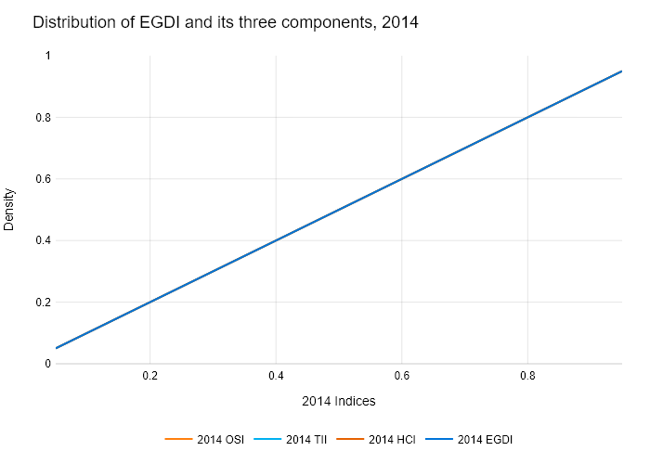

## Performance Metrics

|  |  |  |  |
| --- | --- | --- | --- |
| Task | Model Used | Description | Time Taken (s) |
| Processing Image to JSON | Gemini Vision Pro (default) | Time taken to convert the uploaded image to JSON format | 28.73 |
| Updating JSON | ChatGPT 3.5 (Default) | Time taken to update the JSON with new data | 0.00 |
| Plotting Updated JSON | N/A | Time taken to plot the updated JSON | 0.13 |

# Test Run



Figure: new graphs/1.3_image2.jpg

## Prompt Used

Task: Extract detailed information from a given graph image and generate JSON files (data.json, layout.json, and config.json) compatible with Plotly. Use the specified delimiters to wrap each JSON section.  
  
Instructions:  
  
Graph Analysis:  
  
Identify and categorize the plot types present in the graph (e.g., line, scatter, bar, pie).  
Extract the data points for each plot (x-values, y-values, and any other relevant data such as labels for pie charts).  
Note any multiple plots on the same figure and their configurations.  
Generate data.json:  
  
For each plot, include details such as:  
type: The type of plot (e.g., scatter, bar, pie).  
x and y: Arrays of data points for the x and y axes.  
labels and values for pie charts.  
mode: For line and scatter plots (e.g., markers, lines, or markers+lines).  
name: Legend entry for the plot.  
marker: Properties such as color, size, and symbol for markers.  
line: Properties such as color, width, and dash style for lines.  
text: Hover text for each data point.  
hoverinfo: Information displayed on hover (e.g., x+y+text).  
Generate layout.json:  
  
Include details such as:  
title: The title of the graph, including text, font properties (family, size, color).  
xaxis and yaxis: Configuration including title, range, showgrid, gridcolor, zeroline, zerolinecolor, showticklabels, tickangle, tickfont.  
legend: Properties including orientation, x, y, xanchor, font.  
margin: Values for l (left), r (right), b (bottom), t (top), pad.  
plot_bgcolor and paper_bgcolor: Background colors of the plot area and paper.  
Generate config.json:  
  
Include configuration settings such as:  
responsive: Whether the graph is responsive (boolean).  
displayModeBar: Whether the mode bar is displayed (boolean).  
modeBarButtonsToRemove: List of mode bar buttons to remove (e.g., ["toImage"]).  
scrollZoom: Whether scrolling zoom is enabled (boolean).  
Output Format:  
  
Wrap each JSON output in specific XML-like tags:  
<data> ... </data>  
<layout> ... </layout>  
<config> ... </config>  
Make sure to follow the JSON formatting guidelines:  
Double Quotes for Keys and Strings: Ensure that all keys and string values in JSON are enclosed in double quotes (").  
Example: Instead of "type": bar, it should be "type": "bar".  
No Trailing Commas: Remove any trailing commas after the last element in arrays ([]) or objects ({}).  
Example: Instead of "color": "rgba(55, 128, 191, 0.6)",, it should be "color": "rgba(55, 128, 191, 0.6)"  
Example Output:  
  
<data>  
[  
 {  
 "type": "scatter",  
 "x": [1, 2, 3],  
 "y": [4, 5, 6],  
 "mode": "markers+lines",  
 "name": "Line Plot",  
 "marker": {  
 "color": "rgba(75, 192, 192, 0.6)",  
 "size": 8  
 },  
 "line": {  
 "color": "rgba(75, 192, 192, 1)",  
 "width": 2  
 }  
 }  
 // Additional plots if present  
]  
</data>  
<layout>  
{  
 "title": {  
 "text": "Graph Title",  
 "font": {  
 "family": "Arial, sans-serif",  
 "size": 24,  
 "color": "#000000"  
 }  
 },  
 "xaxis": {  
 "title": {  
 "text": "X Axis",  
 "font": {  
 "family": "Arial, sans-serif",  
 "size": 18,  
 "color": "#000000"  
 }  
 },  
 "showgrid": true,  
 "gridcolor": "rgba(0, 0, 0, 0.1)",  
 "zeroline": true,  
 "zerolinecolor": "rgba(0, 0, 0, 0.1)"  
 },  
 "yaxis": {  
 "title": {  
 "text": "Y Axis",  
 "font": {  
 "family": "Arial, sans-serif",  
 "size": 18,  
 "color": "#000000"  
 }  
 },  
 "showgrid": true,  
 "gridcolor": "rgba(0, 0, 0, 0.1)",  
 "zeroline": true,  
 "zerolinecolor": "rgba(0, 0, 0, 0.1)"  
 },  
 "legend": {  
 "orientation": "h",  
 "x": 0.5,  
 "xanchor": "center",  
 "y": -0.2,  
 "font": {  
 "family": "Arial, sans-serif",  
 "size": 12,  
 "color": "#000000"  
 }  
 },  
 "margin": {  
 "l": 60,  
 "r": 30,  
 "b": 60,  
 "t": 60  
 },  
 "plot_bgcolor": "#ffffff",  
 "paper_bgcolor": "#ffffff"  
}  
</layout>  
<config>  
{  
 "responsive": true,  
 "displayModeBar": true,  
 "modeBarButtonsToRemove": ["toImage"],  
 "scrollZoom": true  
}  
</config>

## Extracted JSON

### data

[  
 {  
 "type": "scatter",  
 "x": [  
 0.05,  
 0.15,  
 0.25,  
 0.35,  
 0.45,  
 0.55,  
 0.65,  
 0.75,  
 0.85,  
 0.95  
 ],  
 "y": [  
 0.05,  
 0.15,  
 0.25,  
 0.35,  
 0.45,  
 0.55,  
 0.65,  
 0.75,  
 0.85,  
 0.95  
 ],  
 "mode": "lines",  
 "name": "2014 OSI",  
 "line": {  
 "color": "rgba(255, 127, 14, 1)",  
 "width": 2  
 }  
 },  
 {  
 "type": "scatter",  
 "x": [  
 0.05,  
 0.15,  
 0.25,  
 0.35,  
 0.45,  
 0.55,  
 0.65,  
 0.75,  
 0.85,  
 0.95  
 ],  
 "y": [  
 0.05,  
 0.15,  
 0.25,  
 0.35,  
 0.45,  
 0.55,  
 0.65,  
 0.75,  
 0.85,  
 0.95  
 ],  
 "mode": "lines",  
 "name": "2014 TII",  
 "line": {  
 "color": "rgba(0, 176, 240, 1)",  
 "width": 2  
 }  
 },  
 {  
 "type": "scatter",  
 "x": [  
 0.05,  
 0.15,  
 0.25,  
 0.35,  
 0.45,  
 0.55,  
 0.65,  
 0.75,  
 0.85,  
 0.95  
 ],  
 "y": [  
 0.05,  
 0.15,  
 0.25,  
 0.35,  
 0.45,  
 0.55,  
 0.65,  
 0.75,  
 0.85,  
 0.95  
 ],  
 "mode": "lines",  
 "name": "2014 HCI",  
 "line": {  
 "color": "rgba(230, 97, 1, 1)",  
 "width": 2  
 }  
 },  
 {  
 "type": "scatter",  
 "x": [  
 0.05,  
 0.15,  
 0.25,  
 0.35,  
 0.45,  
 0.55,  
 0.65,  
 0.75,  
 0.85,  
 0.95  
 ],  
 "y": [  
 0.05,  
 0.15,  
 0.25,  
 0.35,  
 0.45,  
 0.55,  
 0.65,  
 0.75,  
 0.85,  
 0.95  
 ],  
 "mode": "lines",  
 "name": "2014 EGDI",  
 "line": {  
 "color": "rgba(0, 116, 217, 1)",  
 "width": 2  
 }  
 }  
]

### layout

{  
 "title": {  
 "text": "Distribution of EGDI and its three components, 2014",  
 "font": {  
 "family": "Arial, sans-serif",  
 "size": 18,  
 "color": "#000000"  
 }  
 },  
 "xaxis": {  
 "title": {  
 "text": "2014 Indices",  
 "font": {  
 "family": "Arial, sans-serif",  
 "size": 14,  
 "color": "#000000"  
 }  
 },  
 "showgrid": true,  
 "gridcolor": "rgba(0, 0, 0, 0.1)",  
 "zeroline": true,  
 "zerolinecolor": "rgba(0, 0, 0, 0.1)",  
 "showticklabels": true,  
 "tickangle": 0,  
 "tickfont": {  
 "family": "Arial, sans-serif",  
 "size": 12,  
 "color": "#000000"  
 }  
 },  
 "yaxis": {  
 "title": {  
 "text": "Density",  
 "font": {  
 "family": "Arial, sans-serif",  
 "size": 14,  
 "color": "#000000"  
 }  
 },  
 "showgrid": true,  
 "gridcolor": "rgba(0, 0, 0, 0.1)",  
 "zeroline": true,  
 "zerolinecolor": "rgba(0, 0, 0, 0.1)",  
 "showticklabels": true,  
 "tickangle": 0,  
 "tickfont": {  
 "family": "Arial, sans-serif",  
 "size": 12,  
 "color": "#000000"  
 }  
 },  
 "legend": {  
 "orientation": "h",  
 "x": 0.5,  
 "xanchor": "center",  
 "y": -0.2,  
 "font": {  
 "family": "Arial, sans-serif",  
 "size": 12,  
 "color": "#000000"  
 }  
 },  
 "margin": {  
 "l": 60,  
 "r": 30,  
 "b": 60,  
 "t": 60,  
 "pad": 4  
 },  
 "plot_bgcolor": "#ffffff",  
 "paper_bgcolor": "#ffffff"  
}

### config

{  
 "responsive": true,  
 "displayModeBar": true,  
 "modeBarButtonsToRemove": [  
 "toImage"  
 ],  
 "scrollZoom": true  
}

## Updated JSON

### updated_data

[  
 {  
 "type": "scatter",  
 "x": [  
 0.05,  
 0.15,  
 0.25,  
 0.35,  
 0.45,  
 0.55,  
 0.65,  
 0.75,  
 0.85,  
 0.95  
 ],  
 "y": [  
 0.05,  
 0.15,  
 0.25,  
 0.35,  
 0.45,  
 0.55,  
 0.65,  
 0.75,  
 0.85,  
 0.95  
 ],  
 "mode": "lines",  
 "name": "2014 OSI",  
 "line": {  
 "color": "rgba(255, 127, 14, 1)",  
 "width": 2  
 }  
 },  
 {  
 "type": "scatter",  
 "x": [  
 0.05,  
 0.15,  
 0.25,  
 0.35,  
 0.45,  
 0.55,  
 0.65,  
 0.75,  
 0.85,  
 0.95  
 ],  
 "y": [  
 0.05,  
 0.15,  
 0.25,  
 0.35,  
 0.45,  
 0.55,  
 0.65,  
 0.75,  
 0.85,  
 0.95  
 ],  
 "mode": "lines",  
 "name": "2014 TII",  
 "line": {  
 "color": "rgba(0, 176, 240, 1)",  
 "width": 2  
 }  
 },  
 {  
 "type": "scatter",  
 "x": [  
 0.05,  
 0.15,  
 0.25,  
 0.35,  
 0.45,  
 0.55,  
 0.65,  
 0.75,  
 0.85,  
 0.95  
 ],  
 "y": [  
 0.05,  
 0.15,  
 0.25,  
 0.35,  
 0.45,  
 0.55,  
 0.65,  
 0.75,  
 0.85,  
 0.95  
 ],  
 "mode": "lines",  
 "name": "2014 HCI",  
 "line": {  
 "color": "rgba(230, 97, 1, 1)",  
 "width": 2  
 }  
 },  
 {  
 "type": "scatter",  
 "x": [  
 0.05,  
 0.15,  
 0.25,  
 0.35,  
 0.45,  
 0.55,  
 0.65,  
 0.75,  
 0.85,  
 0.95  
 ],  
 "y": [  
 0.05,  
 0.15,  
 0.25,  
 0.35,  
 0.45,  
 0.55,  
 0.65,  
 0.75,  
 0.85,  
 0.95  
 ],  
 "mode": "lines",  
 "name": "2014 EGDI",  
 "line": {  
 "color": "rgba(0, 116, 217, 1)",  
 "width": 2  
 }  
 }  
]

### updated_layout

{  
 "title": {  
 "text": "Distribution of EGDI and its three components, 2014",  
 "font": {  
 "family": "Arial, sans-serif",  
 "size": 18,  
 "color": "#000000"  
 }  
 },  
 "xaxis": {  
 "title": {  
 "text": "2014 Indices",  
 "font": {  
 "family": "Arial, sans-serif",  
 "size": 14,  
 "color": "#000000"  
 }  
 },  
 "showgrid": true,  
 "gridcolor": "rgba(0, 0, 0, 0.1)",  
 "zeroline": true,  
 "zerolinecolor": "rgba(0, 0, 0, 0.1)",  
 "showticklabels": true,  
 "tickangle": 0,  
 "tickfont": {  
 "family": "Arial, sans-serif",  
 "size": 12,  
 "color": "#000000"  
 }  
 },  
 "yaxis": {  
 "title": {  
 "text": "Density",  
 "font": {  
 "family": "Arial, sans-serif",  
 "size": 14,  
 "color": "#000000"  
 }  
 },  
 "showgrid": true,  
 "gridcolor": "rgba(0, 0, 0, 0.1)",  
 "zeroline": true,  
 "zerolinecolor": "rgba(0, 0, 0, 0.1)",  
 "showticklabels": true,  
 "tickangle": 0,  
 "tickfont": {  
 "family": "Arial, sans-serif",  
 "size": 12,  
 "color": "#000000"  
 }  
 },  
 "legend": {  
 "orientation": "h",  
 "x": 0.5,  
 "xanchor": "center",  
 "y": -0.2,  
 "font": {  
 "family": "Arial, sans-serif",  
 "size": 12,  
 "color": "#000000"  
 }  
 },  
 "margin": {  
 "l": 60,  
 "r": 30,  
 "b": 60,  
 "t": 60,  
 "pad": 4  
 },  
 "plot_bgcolor": "#ffffff",  
 "paper_bgcolor": "#ffffff"  
}

### updated_config

{  
 "responsive": true,  
 "displayModeBar": true,  
 "modeBarButtonsToRemove": [  
 "toImage"  
 ],  
 "scrollZoom": true  
}

## Updated Chart



## Performance Metrics

|  |  |  |  |
| --- | --- | --- | --- |
| Task | Model Used | Description | Time Taken (s) |
| Processing Image to JSON | Gemini Vision Pro (default) | Time taken to convert the uploaded image to JSON format | 27.75 |
| Updating JSON | ChatGPT 3.5 (Default) | Time taken to update the JSON with new data | 0.00 |
| Plotting Updated JSON | N/A | Time taken to plot the updated JSON | 0.08 |

# Test Run

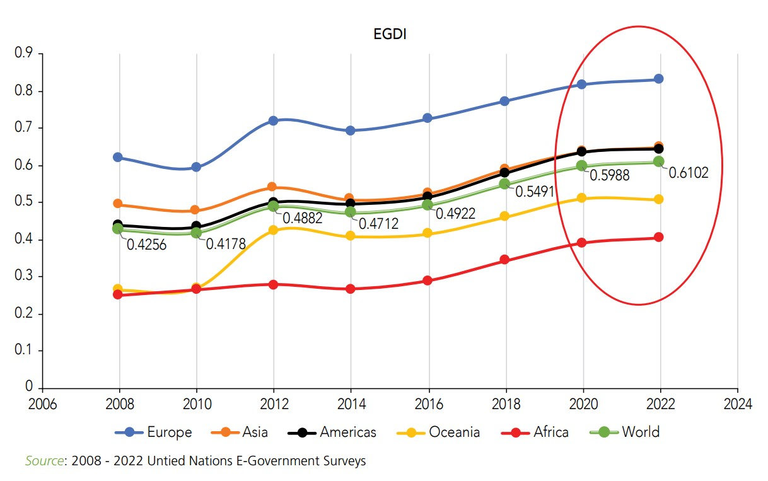

Figure: new graphs/1.3_image1.jpg

## Prompt Used

Task: Extract detailed information from a given graph image and generate JSON files (data.json, layout.json, and config.json) compatible with Plotly. Use the specified delimiters to wrap each JSON section.  
  
Instructions:  
  
Graph Analysis:  
  
Identify and categorize the plot types present in the graph (e.g., line, scatter, bar, pie).  
Extract the data points for each plot (x-values, y-values, and any other relevant data such as labels for pie charts).  
Note any multiple plots on the same figure and their configurations.  
Generate data.json:  
  
For each plot, include details such as:  
type: The type of plot (e.g., scatter, bar, pie).  
x and y: Arrays of data points for the x and y axes.  
labels and values for pie charts.  
mode: For line and scatter plots (e.g., markers, lines, or markers+lines).  
name: Legend entry for the plot.  
marker: Properties such as color, size, and symbol for markers.  
line: Properties such as color, width, and dash style for lines.  
text: Hover text for each data point.  
hoverinfo: Information displayed on hover (e.g., x+y+text).  
Generate layout.json:  
  
Include details such as:  
title: The title of the graph, including text, font properties (family, size, color).  
xaxis and yaxis: Configuration including title, range, showgrid, gridcolor, zeroline, zerolinecolor, showticklabels, tickangle, tickfont.  
legend: Properties including orientation, x, y, xanchor, font.  
margin: Values for l (left), r (right), b (bottom), t (top), pad.  
plot_bgcolor and paper_bgcolor: Background colors of the plot area and paper.  
Generate config.json:  
  
Include configuration settings such as:  
responsive: Whether the graph is responsive (boolean).  
displayModeBar: Whether the mode bar is displayed (boolean).  
modeBarButtonsToRemove: List of mode bar buttons to remove (e.g., ["toImage"]).  
scrollZoom: Whether scrolling zoom is enabled (boolean).  
Output Format:  
  
Wrap each JSON output in specific XML-like tags:  
<data> ... </data>  
<layout> ... </layout>  
<config> ... </config>  
Make sure to follow the JSON formatting guidelines:  
Double Quotes for Keys and Strings: Ensure that all keys and string values in JSON are enclosed in double quotes (").  
Example: Instead of "type": bar, it should be "type": "bar".  
No Trailing Commas: Remove any trailing commas after the last element in arrays ([]) or objects ({}).  
Example: Instead of "color": "rgba(55, 128, 191, 0.6)",, it should be "color": "rgba(55, 128, 191, 0.6)"  
Example Output:  
  
<data>  
[  
 {  
 "type": "scatter",  
 "x": [1, 2, 3],  
 "y": [4, 5, 6],  
 "mode": "markers+lines",  
 "name": "Line Plot",  
 "marker": {  
 "color": "rgba(75, 192, 192, 0.6)",  
 "size": 8  
 },  
 "line": {  
 "color": "rgba(75, 192, 192, 1)",  
 "width": 2  
 }  
 }  
 // Additional plots if present  
]  
</data>  
<layout>  
{  
 "title": {  
 "text": "Graph Title",  
 "font": {  
 "family": "Arial, sans-serif",  
 "size": 24,  
 "color": "#000000"  
 }  
 },  
 "xaxis": {  
 "title": {  
 "text": "X Axis",  
 "font": {  
 "family": "Arial, sans-serif",  
 "size": 18,  
 "color": "#000000"  
 }  
 },  
 "showgrid": true,  
 "gridcolor": "rgba(0, 0, 0, 0.1)",  
 "zeroline": true,  
 "zerolinecolor": "rgba(0, 0, 0, 0.1)"  
 },  
 "yaxis": {  
 "title": {  
 "text": "Y Axis",  
 "font": {  
 "family": "Arial, sans-serif",  
 "size": 18,  
 "color": "#000000"  
 }  
 },  
 "showgrid": true,  
 "gridcolor": "rgba(0, 0, 0, 0.1)",  
 "zeroline": true,  
 "zerolinecolor": "rgba(0, 0, 0, 0.1)"  
 },  
 "legend": {  
 "orientation": "h",  
 "x": 0.5,  
 "xanchor": "center",  
 "y": -0.2,  
 "font": {  
 "family": "Arial, sans-serif",  
 "size": 12,  
 "color": "#000000"  
 }  
 },  
 "margin": {  
 "l": 60,  
 "r": 30,  
 "b": 60,  
 "t": 60  
 },  
 "plot_bgcolor": "#ffffff",  
 "paper_bgcolor": "#ffffff"  
}  
</layout>  
<config>  
{  
 "responsive": true,  
 "displayModeBar": true,  
 "modeBarButtonsToRemove": ["toImage"],  
 "scrollZoom": true  
}  
</config>

## Extracted JSON

### data

[  
 {  
 "type": "scatter",  
 "x": [  
 2008,  
 2010,  
 2012,  
 2014,  
 2016,  
 2018,  
 2020,  
 2022  
 ],  
 "y": [  
 0.614,  
 0.606,  
 0.714,  
 0.699,  
 0.709,  
 0.736,  
 0.786,  
 0.811  
 ],  
 "mode": "lines",  
 "name": "Europe"  
 },  
 {  
 "type": "scatter",  
 "x": [  
 2008,  
 2010,  
 2012,  
 2014,  
 2016,  
 2018,  
 2020,  
 2022  
 ],  
 "y": [  
 0.496,  
 0.491,  
 0.512,  
 0.488,  
 0.492,  
 0.549,  
 0.598,  
 0.61  
 ],  
 "mode": "lines",  
 "name": "Asia"  
 },  
 {  
 "type": "scatter",  
 "x": [  
 2008,  
 2010,  
 2012,  
 2014,  
 2016,  
 2018,  
 2020,  
 2022  
 ],  
 "y": [  
 0.426,  
 0.418,  
 0.441,  
 0.472,  
 0.478,  
 0.504,  
 0.541,  
 0.567  
 ],  
 "mode": "lines",  
 "name": "Americas"  
 },  
 {  
 "type": "scatter",  
 "x": [  
 2008,  
 2010,  
 2012,  
 2014,  
 2016,  
 2018,  
 2020,  
 2022  
 ],  
 "y": [  
 0.296,  
 0.282,  
 0.306,  
 0.292,  
 0.312,  
 0.342,  
 0.385,  
 0.412  
 ],  
 "mode": "lines",  
 "name": "Oceania"  
 },  
 {  
 "type": "scatter",  
 "x": [  
 2008,  
 2010,  
 2012,  
 2014,  
 2016,  
 2018,  
 2020,  
 2022  
 ],  
 "y": [  
 0.356,  
 0.349,  
 0.373,  
 0.361,  
 0.376,  
 0.403,  
 0.442,  
 0.465  
 ],  
 "mode": "lines",  
 "name": "Africa"  
 },  
 {  
 "type": "scatter",  
 "x": [  
 2008,  
 2010,  
 2012,  
 2014,  
 2016,  
 2018,  
 2020,  
 2022  
 ],  
 "y": [  
 0.425,  
 0.417,  
 0.482,  
 0.471,  
 0.486,  
 0.519,  
 0.558,  
 0.583  
 ],  
 "mode": "lines",  
 "name": "World"  
 }  
]

### layout

{  
 "title": {  
 "text": "EGDI",  
 "font": {  
 "family": "Arial, sans-serif",  
 "size": 24,  
 "color": "#000000"  
 }  
 },  
 "xaxis": {  
 "title": {  
 "text": "Year",  
 "font": {  
 "family": "Arial, sans-serif",  
 "size": 18,  
 "color": "#000000"  
 }  
 },  
 "showgrid": true,  
 "gridcolor": "rgba(0, 0, 0, 0.1)",  
 "zeroline": true,  
 "zerolinecolor": "rgba(0, 0, 0, 0.1)",  
 "tickangle": -45  
 },  
 "yaxis": {  
 "title": {  
 "text": "EGDI Score",  
 "font": {  
 "family": "Arial, sans-serif",  
 "size": 18,  
 "color": "#000000"  
 }  
 },  
 "showgrid": true,  
 "gridcolor": "rgba(0, 0, 0, 0.1)",  
 "zeroline": true,  
 "zerolinecolor": "rgba(0, 0, 0, 0.1)"  
 },  
 "legend": {  
 "orientation": "h",  
 "x": 0.5,  
 "xanchor": "center",  
 "y": -0.2,  
 "font": {  
 "family": "Arial, sans-serif",  
 "size": 12,  
 "color": "#000000"  
 }  
 },  
 "margin": {  
 "l": 60,  
 "r": 30,  
 "b": 60,  
 "t": 60  
 },  
 "plot_bgcolor": "#ffffff",  
 "paper_bgcolor": "#ffffff"  
}

### config

{  
 "responsive": true,  
 "displayModeBar": true,  
 "modeBarButtonsToRemove": [  
 "toImage"  
 ],  
 "scrollZoom": true  
}

## Updated JSON

### updated_data

[  
 {  
 "type": "scatter",  
 "x": [  
 2008,  
 2010,  
 2012,  
 2014,  
 2016,  
 2018,  
 2020,  
 2022  
 ],  
 "y": [  
 0.614,  
 0.606,  
 0.714,  
 0.699,  
 0.709,  
 0.736,  
 0.786,  
 0.811  
 ],  
 "mode": "lines",  
 "name": "Europe"  
 },  
 {  
 "type": "scatter",  
 "x": [  
 2008,  
 2010,  
 2012,  
 2014,  
 2016,  
 2018,  
 2020,  
 2022  
 ],  
 "y": [  
 0.496,  
 0.491,  
 0.512,  
 0.488,  
 0.492,  
 0.549,  
 0.598,  
 0.61  
 ],  
 "mode": "lines",  
 "name": "Asia"  
 },  
 {  
 "type": "scatter",  
 "x": [  
 2008,  
 2010,  
 2012,  
 2014,  
 2016,  
 2018,  
 2020,  
 2022  
 ],  
 "y": [  
 0.426,  
 0.418,  
 0.441,  
 0.472,  
 0.478,  
 0.504,  
 0.541,  
 0.567  
 ],  
 "mode": "lines",  
 "name": "Americas"  
 },  
 {  
 "type": "scatter",  
 "x": [  
 2008,  
 2010,  
 2012,  
 2014,  
 2016,  
 2018,  
 2020,  
 2022  
 ],  
 "y": [  
 0.296,  
 0.282,  
 0.306,  
 0.292,  
 0.312,  
 0.342,  
 0.385,  
 0.412  
 ],  
 "mode": "lines",  
 "name": "Oceania"  
 },  
 {  
 "type": "scatter",  
 "x": [  
 2008,  
 2010,  
 2012,  
 2014,  
 2016,  
 2018,  
 2020,  
 2022  
 ],  
 "y": [  
 0.356,  
 0.349,  
 0.373,  
 0.361,  
 0.376,  
 0.403,  
 0.442,  
 0.465  
 ],  
 "mode": "lines",  
 "name": "Africa"  
 },  
 {  
 "type": "scatter",  
 "x": [  
 2008,  
 2010,  
 2012,  
 2014,  
 2016,  
 2018,  
 2020,  
 2022  
 ],  
 "y": [  
 0.425,  
 0.417,  
 0.482,  
 0.471,  
 0.486,  
 0.519,  
 0.558,  
 0.583  
 ],  
 "mode": "lines",  
 "name": "World"  
 }  
]

### updated_layout

{  
 "title": {  
 "text": "EGDI",  
 "font": {  
 "family": "Arial, sans-serif",  
 "size": 24,  
 "color": "#000000"  
 }  
 },  
 "xaxis": {  
 "title": {  
 "text": "Year",  
 "font": {  
 "family": "Arial, sans-serif",  
 "size": 18,  
 "color": "#000000"  
 }  
 },  
 "showgrid": true,  
 "gridcolor": "rgba(0, 0, 0, 0.1)",  
 "zeroline": true,  
 "zerolinecolor": "rgba(0, 0, 0, 0.1)",  
 "tickangle": -45  
 },  
 "yaxis": {  
 "title": {  
 "text": "EGDI Score",  
 "font": {  
 "family": "Arial, sans-serif",  
 "size": 18,  
 "color": "#000000"  
 }  
 },  
 "showgrid": true,  
 "gridcolor": "rgba(0, 0, 0, 0.1)",  
 "zeroline": true,  
 "zerolinecolor": "rgba(0, 0, 0, 0.1)"  
 },  
 "legend": {  
 "orientation": "h",  
 "x": 0.5,  
 "xanchor": "center",  
 "y": -0.2,  
 "font": {  
 "family": "Arial, sans-serif",  
 "size": 12,  
 "color": "#000000"  
 }  
 },  
 "margin": {  
 "l": 60,  
 "r": 30,  
 "b": 60,  
 "t": 60  
 },  
 "plot_bgcolor": "#ffffff",  
 "paper_bgcolor": "#ffffff"  
}

### updated_config

{  
 "responsive": true,  
 "displayModeBar": true,  
 "modeBarButtonsToRemove": [  
 "toImage"  
 ],  
 "scrollZoom": true  
}

## Updated Chart

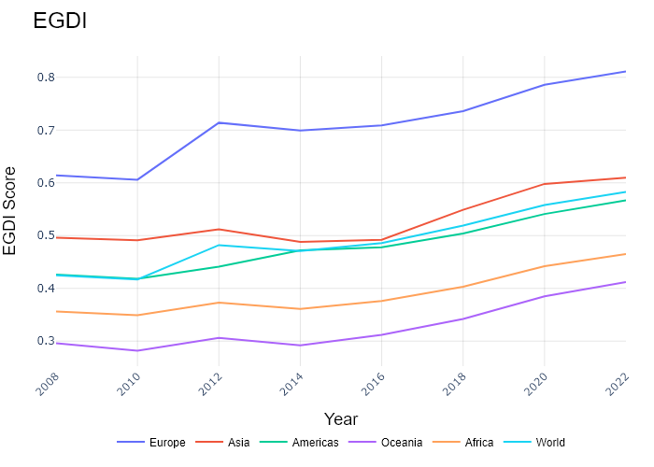

## Performance Metrics

|  |  |  |  |
| --- | --- | --- | --- |
| Task | Model Used | Description | Time Taken (s) |
| Processing Image to JSON | Gemini Vision Pro (default) | Time taken to convert the uploaded image to JSON format | 27.81 |
| Updating JSON | ChatGPT 3.5 (Default) | Time taken to update the JSON with new data | 0.00 |
| Plotting Updated JSON | N/A | Time taken to plot the updated JSON | 0.09 |

# Test Run

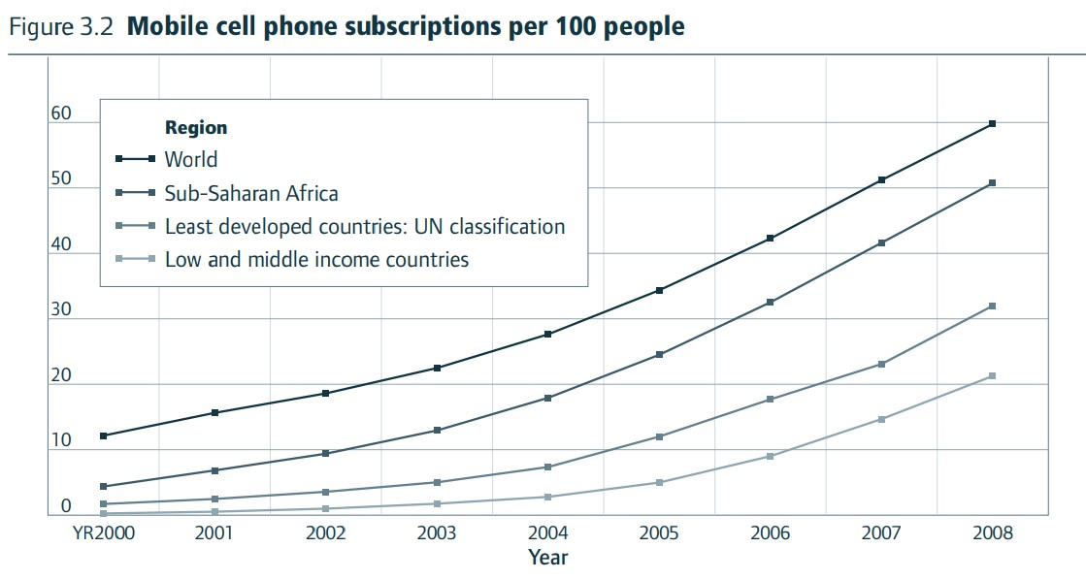

Figure: new graphs/1.3_image3.jpg

## Prompt Used

Task: Extract detailed information from a given graph image and generate JSON files (data.json, layout.json, and config.json) compatible with Plotly. Use the specified delimiters to wrap each JSON section.  
  
Instructions:  
  
Graph Analysis:  
  
Identify and categorize the plot types present in the graph (e.g., line, scatter, bar, pie).  
Extract the data points for each plot (x-values, y-values, and any other relevant data such as labels for pie charts).  
Note any multiple plots on the same figure and their configurations.  
Generate data.json:  
  
For each plot, include details such as:  
type: The type of plot (e.g., scatter, bar, pie).  
x and y: Arrays of data points for the x and y axes.  
labels and values for pie charts.  
mode: For line and scatter plots (e.g., markers, lines, or markers+lines).  
name: Legend entry for the plot.  
marker: Properties such as color, size, and symbol for markers.  
line: Properties such as color, width, and dash style for lines.  
text: Hover text for each data point.  
hoverinfo: Information displayed on hover (e.g., x+y+text).  
Generate layout.json:  
  
Include details such as:  
title: The title of the graph, including text, font properties (family, size, color).  
xaxis and yaxis: Configuration including title, range, showgrid, gridcolor, zeroline, zerolinecolor, showticklabels, tickangle, tickfont.  
legend: Properties including orientation, x, y, xanchor, font.  
margin: Values for l (left), r (right), b (bottom), t (top), pad.  
plot_bgcolor and paper_bgcolor: Background colors of the plot area and paper.  
Generate config.json:  
  
Include configuration settings such as:  
responsive: Whether the graph is responsive (boolean).  
displayModeBar: Whether the mode bar is displayed (boolean).  
modeBarButtonsToRemove: List of mode bar buttons to remove (e.g., ["toImage"]).  
scrollZoom: Whether scrolling zoom is enabled (boolean).  
Output Format:  
  
Wrap each JSON output in specific XML-like tags:  
<data> ... </data>  
<layout> ... </layout>  
<config> ... </config>  
Make sure to follow the JSON formatting guidelines:  
Double Quotes for Keys and Strings: Ensure that all keys and string values in JSON are enclosed in double quotes (").  
Example: Instead of "type": bar, it should be "type": "bar".  
No Trailing Commas: Remove any trailing commas after the last element in arrays ([]) or objects ({}).  
Example: Instead of "color": "rgba(55, 128, 191, 0.6)",, it should be "color": "rgba(55, 128, 191, 0.6)"  
Example Output:  
  
<data>  
[  
 {  
 "type": "scatter",  
 "x": [1, 2, 3],  
 "y": [4, 5, 6],  
 "mode": "markers+lines",  
 "name": "Line Plot",  
 "marker": {  
 "color": "rgba(75, 192, 192, 0.6)",  
 "size": 8  
 },  
 "line": {  
 "color": "rgba(75, 192, 192, 1)",  
 "width": 2  
 }  
 }  
 // Additional plots if present  
]  
</data>  
<layout>  
{  
 "title": {  
 "text": "Graph Title",  
 "font": {  
 "family": "Arial, sans-serif",  
 "size": 24,  
 "color": "#000000"  
 }  
 },  
 "xaxis": {  
 "title": {  
 "text": "X Axis",  
 "font": {  
 "family": "Arial, sans-serif",  
 "size": 18,  
 "color": "#000000"  
 }  
 },  
 "showgrid": true,  
 "gridcolor": "rgba(0, 0, 0, 0.1)",  
 "zeroline": true,  
 "zerolinecolor": "rgba(0, 0, 0, 0.1)"  
 },  
 "yaxis": {  
 "title": {  
 "text": "Y Axis",  
 "font": {  
 "family": "Arial, sans-serif",  
 "size": 18,  
 "color": "#000000"  
 }  
 },  
 "showgrid": true,  
 "gridcolor": "rgba(0, 0, 0, 0.1)",  
 "zeroline": true,  
 "zerolinecolor": "rgba(0, 0, 0, 0.1)"  
 },  
 "legend": {  
 "orientation": "h",  
 "x": 0.5,  
 "xanchor": "center",  
 "y": -0.2,  
 "font": {  
 "family": "Arial, sans-serif",  
 "size": 12,  
 "color": "#000000"  
 }  
 },  
 "margin": {  
 "l": 60,  
 "r": 30,  
 "b": 60,  
 "t": 60  
 },  
 "plot_bgcolor": "#ffffff",  
 "paper_bgcolor": "#ffffff"  
}  
</layout>  
<config>  
{  
 "responsive": true,  
 "displayModeBar": true,  
 "modeBarButtonsToRemove": ["toImage"],  
 "scrollZoom": true  
}  
</config>

## Extracted JSON

### data

[  
 {  
 "type": "scatter",  
 "x": [  
 2000,  
 2001,  
 2002,  
 2003,  
 2004,  
 2005,  
 2006,  
 2007,  
 2008  
 ],  
 "y": [  
 12,  
 17,  
 22,  
 25,  
 27,  
 33,  
 42,  
 52,  
 58  
 ],  
 "mode": "lines",  
 "name": "World",  
 "line": {  
 "color": "rgba(0, 0, 0, 1)",  
 "width": 2  
 }  
 },  
 {  
 "type": "scatter",  
 "x": [  
 2000,  
 2001,  
 2002,  
 2003,  
 2004,  
 2005,  
 2006,  
 2007,  
 2008  
 ],  
 "y": [  
 4,  
 6,  
 10,  
 15,  
 20,  
 25,  
 35,  
 45,  
 55  
 ],  
 "mode": "lines",  
 "name": "Sub-Saharan Africa",  
 "line": {  
 "color": "rgba(153, 153, 153, 1)",  
 "width": 2  
 }  
 },  
 {  
 "type": "scatter",  
 "x": [  
 2000,  
 2001,  
 2002,  
 2003,  
 2004,  
 2005,  
 2006,  
 2007,  
 2008  
 ],  
 "y": [  
 1,  
 2,  
 3,  
 5,  
 8,  
 12,  
 18,  
 28,  
 38  
 ],  
 "mode": "lines",  
 "name": "Least developed countries: UN classification",  
 "line": {  
 "color": "rgba(204, 204, 204, 1)",  
 "width": 2  
 }  
 },  
 {  
 "type": "scatter",  
 "x": [  
 2000,  
 2001,  
 2002,  
 2003,  
 2004,  
 2005,  
 2006,  
 2007,  
 2008  
 ],  
 "y": [  
 6,  
 9,  
 13,  
 18,  
 22,  
 28,  
 36,  
 46,  
 55  
 ],  
 "mode": "lines",  
 "name": "Low and middle income countries",  
 "line": {  
 "color": "rgba(102, 102, 102, 1)",  
 "width": 2  
 }  
 }  
]

### layout

{  
 "title": {  
 "text": "Mobile cell phone subscriptions per 100 people",  
 "font": {  
 "family": "Arial, sans-serif",  
 "size": 24,  
 "color": "#000000"  
 }  
 },  
 "xaxis": {  
 "title": {  
 "text": "Year",  
 "font": {  
 "family": "Arial, sans-serif",  
 "size": 18,  
 "color": "#000000"  
 }  
 },  
 "showgrid": true,  
 "gridcolor": "rgba(0, 0, 0, 0.1)",  
 "zeroline": true,  
 "zerolinecolor": "rgba(0, 0, 0, 0.1)",  
 "tickangle": 45  
 },  
 "yaxis": {  
 "title": {  
 "text": "Mobile cell phone subscriptions per 100 people",  
 "font": {  
 "family": "Arial, sans-serif",  
 "size": 18,  
 "color": "#000000"  
 }  
 },  
 "showgrid": true,  
 "gridcolor": "rgba(0, 0, 0, 0.1)",  
 "zeroline": true,  
 "zerolinecolor": "rgba(0, 0, 0, 0.1)"  
 },  
 "legend": {  
 "orientation": "h",  
 "x": 0.5,  
 "xanchor": "center",  
 "y": -0.2,  
 "font": {  
 "family": "Arial, sans-serif",  
 "size": 12,  
 "color": "#000000"  
 }  
 },  
 "margin": {  
 "l": 60,  
 "r": 30,  
 "b": 60,  
 "t": 60  
 },  
 "plot_bgcolor": "#ffffff",  
 "paper_bgcolor": "#ffffff"  
}

### config

{  
 "responsive": true,  
 "displayModeBar": true,  
 "modeBarButtonsToRemove": [  
 "toImage"  
 ],  
 "scrollZoom": true  
}

## Updated JSON

### updated_data

[  
 {  
 "type": "scatter",  
 "x": [  
 2000,  
 2001,  
 2002,  
 2003,  
 2004,  
 2005,  
 2006,  
 2007,  
 2008  
 ],  
 "y": [  
 12,  
 17,  
 22,  
 25,  
 27,  
 33,  
 42,  
 52,  
 58  
 ],  
 "mode": "lines",  
 "name": "World",  
 "line": {  
 "color": "rgba(0, 0, 0, 1)",  
 "width": 2  
 }  
 },  
 {  
 "type": "scatter",  
 "x": [  
 2000,  
 2001,  
 2002,  
 2003,  
 2004,  
 2005,  
 2006,  
 2007,  
 2008  
 ],  
 "y": [  
 4,  
 6,  
 10,  
 15,  
 20,  
 25,  
 35,  
 45,  
 55  
 ],  
 "mode": "lines",  
 "name": "Sub-Saharan Africa",  
 "line": {  
 "color": "rgba(153, 153, 153, 1)",  
 "width": 2  
 }  
 },  
 {  
 "type": "scatter",  
 "x": [  
 2000,  
 2001,  
 2002,  
 2003,  
 2004,  
 2005,  
 2006,  
 2007,  
 2008  
 ],  
 "y": [  
 1,  
 2,  
 3,  
 5,  
 8,  
 12,  
 18,  
 28,  
 38  
 ],  
 "mode": "lines",  
 "name": "Least developed countries: UN classification",  
 "line": {  
 "color": "rgba(204, 204, 204, 1)",  
 "width": 2  
 }  
 },  
 {  
 "type": "scatter",  
 "x": [  
 2000,  
 2001,  
 2002,  
 2003,  
 2004,  
 2005,  
 2006,  
 2007,  
 2008  
 ],  
 "y": [  
 6,  
 9,  
 13,  
 18,  
 22,  
 28,  
 36,  
 46,  
 55  
 ],  
 "mode": "lines",  
 "name": "Low and middle income countries",  
 "line": {  
 "color": "rgba(102, 102, 102, 1)",  
 "width": 2  
 }  
 }  
]

### updated_layout

{  
 "title": {  
 "text": "Mobile cell phone subscriptions per 100 people",  
 "font": {  
 "family": "Arial, sans-serif",  
 "size": 24,  
 "color": "#000000"  
 }  
 },  
 "xaxis": {  
 "title": {  
 "text": "Year",  
 "font": {  
 "family": "Arial, sans-serif",  
 "size": 18,  
 "color": "#000000"  
 }  
 },  
 "showgrid": true,  
 "gridcolor": "rgba(0, 0, 0, 0.1)",  
 "zeroline": true,  
 "zerolinecolor": "rgba(0, 0, 0, 0.1)",  
 "tickangle": 45  
 },  
 "yaxis": {  
 "title": {  
 "text": "Mobile cell phone subscriptions per 100 people",  
 "font": {  
 "family": "Arial, sans-serif",  
 "size": 18,  
 "color": "#000000"  
 }  
 },  
 "showgrid": true,  
 "gridcolor": "rgba(0, 0, 0, 0.1)",  
 "zeroline": true,  
 "zerolinecolor": "rgba(0, 0, 0, 0.1)"  
 },  
 "legend": {  
 "orientation": "h",  
 "x": 0.5,  
 "xanchor": "center",  
 "y": -0.2,  
 "font": {  
 "family": "Arial, sans-serif",  
 "size": 12,  
 "color": "#000000"  
 }  
 },  
 "margin": {  
 "l": 60,  
 "r": 30,  
 "b": 60,  
 "t": 60  
 },  
 "plot_bgcolor": "#ffffff",  
 "paper_bgcolor": "#ffffff"  
}

### updated_config

{  
 "responsive": true,  
 "displayModeBar": true,  
 "modeBarButtonsToRemove": [  
 "toImage"  
 ],  
 "scrollZoom": true  
}

## Updated Chart

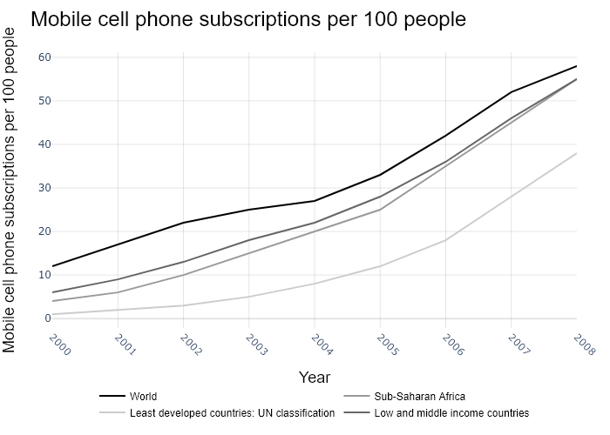

## Performance Metrics

|  |  |  |  |
| --- | --- | --- | --- |
| Task | Model Used | Description | Time Taken (s) |
| Processing Image to JSON | Gemini Vision Pro (default) | Time taken to convert the uploaded image to JSON format | 25.10 |
| Updating JSON | ChatGPT 3.5 (Default) | Time taken to update the JSON with new data | 0.00 |
| Plotting Updated JSON | N/A | Time taken to plot the updated JSON | 0.14 |

# Test Run

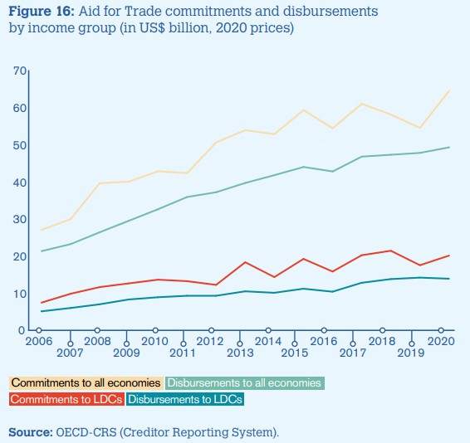

Figure: new graphs/1.3_image4.jpg

## Prompt Used

Task: Extract detailed information from a given graph image and generate JSON files (data.json, layout.json, and config.json) compatible with Plotly. Use the specified delimiters to wrap each JSON section.  
  
Instructions:  
  
Graph Analysis:  
  
Identify and categorize the plot types present in the graph (e.g., line, scatter, bar, pie).  
Extract the data points for each plot (x-values, y-values, and any other relevant data such as labels for pie charts).  
Note any multiple plots on the same figure and their configurations.  
Generate data.json:  
  
For each plot, include details such as:  
type: The type of plot (e.g., scatter, bar, pie).  
x and y: Arrays of data points for the x and y axes.  
labels and values for pie charts.  
mode: For line and scatter plots (e.g., markers, lines, or markers+lines).  
name: Legend entry for the plot.  
marker: Properties such as color, size, and symbol for markers.  
line: Properties such as color, width, and dash style for lines.  
text: Hover text for each data point.  
hoverinfo: Information displayed on hover (e.g., x+y+text).  
Generate layout.json:  
  
Include details such as:  
title: The title of the graph, including text, font properties (family, size, color).  
xaxis and yaxis: Configuration including title, range, showgrid, gridcolor, zeroline, zerolinecolor, showticklabels, tickangle, tickfont.  
legend: Properties including orientation, x, y, xanchor, font.  
margin: Values for l (left), r (right), b (bottom), t (top), pad.  
plot_bgcolor and paper_bgcolor: Background colors of the plot area and paper.  
Generate config.json:  
  
Include configuration settings such as:  
responsive: Whether the graph is responsive (boolean).  
displayModeBar: Whether the mode bar is displayed (boolean).  
modeBarButtonsToRemove: List of mode bar buttons to remove (e.g., ["toImage"]).  
scrollZoom: Whether scrolling zoom is enabled (boolean).  
Output Format:  
  
Wrap each JSON output in specific XML-like tags:  
<data> ... </data>  
<layout> ... </layout>  
<config> ... </config>  
Make sure to follow the JSON formatting guidelines:  
Double Quotes for Keys and Strings: Ensure that all keys and string values in JSON are enclosed in double quotes (").  
Example: Instead of "type": bar, it should be "type": "bar".  
No Trailing Commas: Remove any trailing commas after the last element in arrays ([]) or objects ({}).  
Example: Instead of "color": "rgba(55, 128, 191, 0.6)",, it should be "color": "rgba(55, 128, 191, 0.6)"  
Example Output:  
  
<data>  
[  
 {  
 "type": "scatter",  
 "x": [1, 2, 3],  
 "y": [4, 5, 6],  
 "mode": "markers+lines",  
 "name": "Line Plot",  
 "marker": {  
 "color": "rgba(75, 192, 192, 0.6)",  
 "size": 8  
 },  
 "line": {  
 "color": "rgba(75, 192, 192, 1)",  
 "width": 2  
 }  
 }  
 // Additional plots if present  
]  
</data>  
<layout>  
{  
 "title": {  
 "text": "Graph Title",  
 "font": {  
 "family": "Arial, sans-serif",  
 "size": 24,  
 "color": "#000000"  
 }  
 },  
 "xaxis": {  
 "title": {  
 "text": "X Axis",  
 "font": {  
 "family": "Arial, sans-serif",  
 "size": 18,  
 "color": "#000000"  
 }  
 },  
 "showgrid": true,  
 "gridcolor": "rgba(0, 0, 0, 0.1)",  
 "zeroline": true,  
 "zerolinecolor": "rgba(0, 0, 0, 0.1)"  
 },  
 "yaxis": {  
 "title": {  
 "text": "Y Axis",  
 "font": {  
 "family": "Arial, sans-serif",  
 "size": 18,  
 "color": "#000000"  
 }  
 },  
 "showgrid": true,  
 "gridcolor": "rgba(0, 0, 0, 0.1)",  
 "zeroline": true,  
 "zerolinecolor": "rgba(0, 0, 0, 0.1)"  
 },  
 "legend": {  
 "orientation": "h",  
 "x": 0.5,  
 "xanchor": "center",  
 "y": -0.2,  
 "font": {  
 "family": "Arial, sans-serif",  
 "size": 12,  
 "color": "#000000"  
 }  
 },  
 "margin": {  
 "l": 60,  
 "r": 30,  
 "b": 60,  
 "t": 60  
 },  
 "plot_bgcolor": "#ffffff",  
 "paper_bgcolor": "#ffffff"  
}  
</layout>  
<config>  
{  
 "responsive": true,  
 "displayModeBar": true,  
 "modeBarButtonsToRemove": ["toImage"],  
 "scrollZoom": true  
}  
</config>

## Extracted JSON

### data

[  
 {  
 "type": "scatter",  
 "x": [  
 2006,  
 2007,  
 2008,  
 2009,  
 2010,  
 2011,  
 2012,  
 2013,  
 2014,  
 2015,  
 2016,  
 2017,  
 2018,  
 2019,  
 2020  
 ],  
 "y": [  
 26.6,  
 31.3,  
 40.1,  
 40.3,  
 40.8,  
 40.1,  
 48.1,  
 53.9,  
 58.5,  
 59.6,  
 43.2,  
 49.2,  
 53.5,  
 50.5,  
 63.6  
 ],  
 "mode": "lines",  
 "name": "Commitments to all economies",  
 "line": {  
 "color": "rgba(255, 127, 14, 1)",  
 "width": 3  
 }  
 },  
 {  
 "type": "scatter",  
 "x": [  
 2006,  
 2007,  
 2008,  
 2009,  
 2010,  
 2011,  
 2012,  
 2013,  
 2014,  
 2015,  
 2016,  
 2017,  
 2018,  
 2019,  
 2020  
 ],  
 "y": [  
 5.6,  
 9.2,  
 13.2,  
 14.9,  
 13.9,  
 13.6,  
 20.3,  
 23.1,  
 23.6,  
 25.2,  
 24.6,  
 24.8,  
 26.1,  
 23.3,  
 30.1  
 ],  
 "mode": "lines",  
 "name": "Disbursements to all economies",  
 "line": {  
 "color": "rgba(255, 0, 0, 1)",  
 "width": 3  
 }  
 },  
 {  
 "type": "scatter",  
 "x": [  
 2006,  
 2007,  
 2008,  
 2009,  
 2010,  
 2011,  
 2012,  
 2013,  
 2014,  
 2015,  
 2016,  
 2017,  
 2018,  
 2019,  
 2020  
 ],  
 "y": [  
 19.9,  
 25.1,  
 33.9,  
 33.9,  
 34.3,  
 33.6,  
 39.9,  
 44.5,  
 48.3,  
 49.4,  
 36.2,  
 41.6,  
 45.1,  
 42.3,  
 51.9  
 ],  
 "mode": "lines",  
 "name": "Commitments to LDCs",  
 "line": {  
 "color": "rgba(148, 103, 189, 1)",  
 "width": 3  
 }  
 },  
 {  
 "type": "scatter",  
 "x": [  
 2006,  
 2007,  
 2008,  
 2009,  
 2010,  
 2011,  
 2012,  
 2013,  
 2014,  
 2015,  
 2016,  
 2017,  
 2018,  
 2019,  
 2020  
 ],  
 "y": [  
 2.9,  
 4.8,  
 7.9,  
 8.9,  
 8.3,  
 8.1,  
 12.2,  
 14.1,  
 14.5,  
 15.8,  
 15.3,  
 15.4,  
 16.3,  
 14.6,  
 18.8  
 ],  
 "mode": "lines",  
 "name": "Disbursements to LDCs",  
 "line": {  
 "color": "rgba(171, 50, 96, 1)",  
 "width": 3  
 }  
 }  
]

### layout

{  
 "title": {  
 "text": "Aid for Trade commitments and disbursements by income group (in US$ billion, 2020 prices)",  
 "font": {  
 "family": "Arial, sans-serif",  
 "size": 18,  
 "color": "#000000"  
 }  
 },  
 "xaxis": {  
 "title": {  
 "text": "Year",  
 "font": {  
 "family": "Arial, sans-serif",  
 "size": 14,  
 "color": "#000000"  
 }  
 },  
 "showgrid": true,  
 "gridcolor": "rgba(0, 0, 0, 0.1)",  
 "zeroline": true,  
 "zerolinecolor": "rgba(0, 0, 0, 0.1)",  
 "tickangle": -45  
 },  
 "yaxis": {  
 "title": {  
 "text": "Amount (in US$ billion)",  
 "font": {  
 "family": "Arial, sans-serif",  
 "size": 14,  
 "color": "#000000"  
 }  
 },  
 "showgrid": true,  
 "gridcolor": "rgba(0, 0, 0, 0.1)",  
 "zeroline": true,  
 "zerolinecolor": "rgba(0, 0, 0, 0.1)"  
 },  
 "legend": {  
 "orientation": "h",  
 "x": 0.5,  
 "xanchor": "center",  
 "y": -0.2,  
 "font": {  
 "family": "Arial, sans-serif",  
 "size": 12,  
 "color": "#000000"  
 }  
 },  
 "margin": {  
 "l": 60,  
 "r": 30,  
 "b": 60,  
 "t": 60  
 },  
 "plot_bgcolor": "#ffffff",  
 "paper_bgcolor": "#ffffff"  
}

### config

{  
 "responsive": true,  
 "displayModeBar": true,  
 "modeBarButtonsToRemove": [  
 "toImage"  
 ],  
 "scrollZoom": true  
}

## Updated JSON

### updated_data

[  
 {  
 "type": "scatter",  
 "x": [  
 2006,  
 2007,  
 2008,  
 2009,  
 2010,  
 2011,  
 2012,  
 2013,  
 2014,  
 2015,  
 2016,  
 2017,  
 2018,  
 2019,  
 2020  
 ],  
 "y": [  
 26.6,  
 31.3,  
 40.1,  
 40.3,  
 40.8,  
 40.1,  
 48.1,  
 53.9,  
 58.5,  
 59.6,  
 43.2,  
 49.2,  
 53.5,  
 50.5,  
 63.6  
 ],  
 "mode": "lines",  
 "name": "Commitments to all economies",  
 "line": {  
 "color": "rgba(255, 127, 14, 1)",  
 "width": 3  
 }  
 },  
 {  
 "type": "scatter",  
 "x": [  
 2006,  
 2007,  
 2008,  
 2009,  
 2010,  
 2011,  
 2012,  
 2013,  
 2014,  
 2015,  
 2016,  
 2017,  
 2018,  
 2019,  
 2020  
 ],  
 "y": [  
 5.6,  
 9.2,  
 13.2,  
 14.9,  
 13.9,  
 13.6,  
 20.3,  
 23.1,  
 23.6,  
 25.2,  
 24.6,  
 24.8,  
 26.1,  
 23.3,  
 30.1  
 ],  
 "mode": "lines",  
 "name": "Disbursements to all economies",  
 "line": {  
 "color": "rgba(255, 0, 0, 1)",  
 "width": 3  
 }  
 },  
 {  
 "type": "scatter",  
 "x": [  
 2006,  
 2007,  
 2008,  
 2009,  
 2010,  
 2011,  
 2012,  
 2013,  
 2014,  
 2015,  
 2016,  
 2017,  
 2018,  
 2019,  
 2020  
 ],  
 "y": [  
 19.9,  
 25.1,  
 33.9,  
 33.9,  
 34.3,  
 33.6,  
 39.9,  
 44.5,  
 48.3,  
 49.4,  
 36.2,  
 41.6,  
 45.1,  
 42.3,  
 51.9  
 ],  
 "mode": "lines",  
 "name": "Commitments to LDCs",  
 "line": {  
 "color": "rgba(148, 103, 189, 1)",  
 "width": 3  
 }  
 },  
 {  
 "type": "scatter",  
 "x": [  
 2006,  
 2007,  
 2008,  
 2009,  
 2010,  
 2011,  
 2012,  
 2013,  
 2014,  
 2015,  
 2016,  
 2017,  
 2018,  
 2019,  
 2020  
 ],  
 "y": [  
 2.9,  
 4.8,  
 7.9,  
 8.9,  
 8.3,  
 8.1,  
 12.2,  
 14.1,  
 14.5,  
 15.8,  
 15.3,  
 15.4,  
 16.3,  
 14.6,  
 18.8  
 ],  
 "mode": "lines",  
 "name": "Disbursements to LDCs",  
 "line": {  
 "color": "rgba(171, 50, 96, 1)",  
 "width": 3  
 }  
 }  
]

### updated_layout

{  
 "title": {  
 "text": "Aid for Trade commitments and disbursements by income group (in US$ billion, 2020 prices)",  
 "font": {  
 "family": "Arial, sans-serif",  
 "size": 18,  
 "color": "#000000"  
 }  
 },  
 "xaxis": {  
 "title": {  
 "text": "Year",  
 "font": {  
 "family": "Arial, sans-serif",  
 "size": 14,  
 "color": "#000000"  
 }  
 },  
 "showgrid": true,  
 "gridcolor": "rgba(0, 0, 0, 0.1)",  
 "zeroline": true,  
 "zerolinecolor": "rgba(0, 0, 0, 0.1)",  
 "tickangle": -45  
 },  
 "yaxis": {  
 "title": {  
 "text": "Amount (in US$ billion)",  
 "font": {  
 "family": "Arial, sans-serif",  
 "size": 14,  
 "color": "#000000"  
 }  
 },  
 "showgrid": true,  
 "gridcolor": "rgba(0, 0, 0, 0.1)",  
 "zeroline": true,  
 "zerolinecolor": "rgba(0, 0, 0, 0.1)"  
 },  
 "legend": {  
 "orientation": "h",  
 "x": 0.5,  
 "xanchor": "center",  
 "y": -0.2,  
 "font": {  
 "family": "Arial, sans-serif",  
 "size": 12,  
 "color": "#000000"  
 }  
 },  
 "margin": {  
 "l": 60,  
 "r": 30,  
 "b": 60,  
 "t": 60  
 },  
 "plot_bgcolor": "#ffffff",  
 "paper_bgcolor": "#ffffff"  
}

### updated_config

{  
 "responsive": true,  
 "displayModeBar": true,  
 "modeBarButtonsToRemove": [  
 "toImage"  
 ],  
 "scrollZoom": true  
}

## Updated Chart

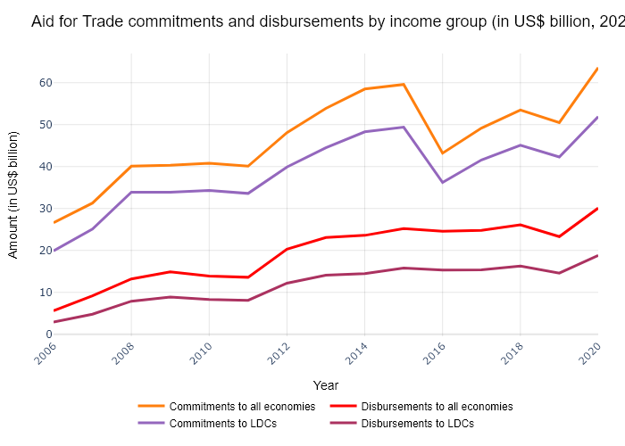

## Performance Metrics

|  |  |  |  |
| --- | --- | --- | --- |
| Task | Model Used | Description | Time Taken (s) |
| Processing Image to JSON | Gemini Vision Pro (default) | Time taken to convert the uploaded image to JSON format | 30.25 |
| Updating JSON | ChatGPT 3.5 (Default) | Time taken to update the JSON with new data | 0.00 |
| Plotting Updated JSON | N/A | Time taken to plot the updated JSON | 0.15 |

# Test Run

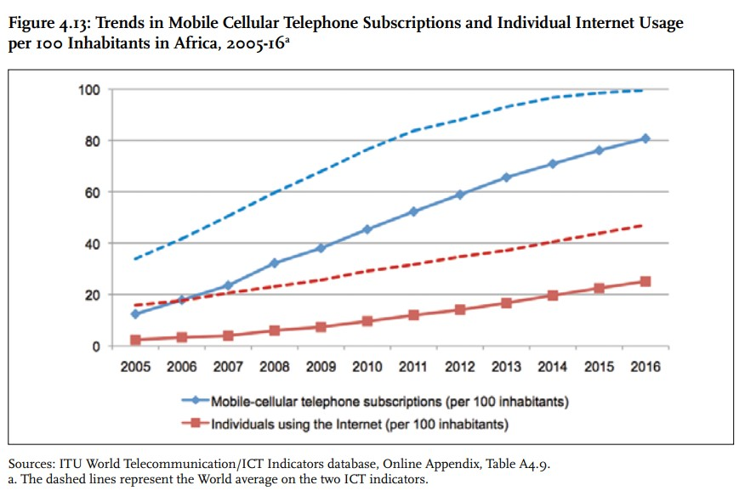

Figure: new graphs/1.3_image5.jpg

## Prompt Used

Task: Extract detailed information from a given graph image and generate JSON files (data.json, layout.json, and config.json) compatible with Plotly. Use the specified delimiters to wrap each JSON section.  
  
Instructions:  
  
Graph Analysis:  
  
Identify and categorize the plot types present in the graph (e.g., line, scatter, bar, pie).  
Extract the data points for each plot (x-values, y-values, and any other relevant data such as labels for pie charts).  
Note any multiple plots on the same figure and their configurations.  
Generate data.json:  
  
For each plot, include details such as:  
type: The type of plot (e.g., scatter, bar, pie).  
x and y: Arrays of data points for the x and y axes.  
labels and values for pie charts.  
mode: For line and scatter plots (e.g., markers, lines, or markers+lines).  
name: Legend entry for the plot.  
marker: Properties such as color, size, and symbol for markers.  
line: Properties such as color, width, and dash style for lines.  
text: Hover text for each data point.  
hoverinfo: Information displayed on hover (e.g., x+y+text).  
Generate layout.json:  
  
Include details such as:  
title: The title of the graph, including text, font properties (family, size, color).  
xaxis and yaxis: Configuration including title, range, showgrid, gridcolor, zeroline, zerolinecolor, showticklabels, tickangle, tickfont.  
legend: Properties including orientation, x, y, xanchor, font.  
margin: Values for l (left), r (right), b (bottom), t (top), pad.  
plot_bgcolor and paper_bgcolor: Background colors of the plot area and paper.  
Generate config.json:  
  
Include configuration settings such as:  
responsive: Whether the graph is responsive (boolean).  
displayModeBar: Whether the mode bar is displayed (boolean).  
modeBarButtonsToRemove: List of mode bar buttons to remove (e.g., ["toImage"]).  
scrollZoom: Whether scrolling zoom is enabled (boolean).  
Output Format:  
  
Wrap each JSON output in specific XML-like tags:  
<data> ... </data>  
<layout> ... </layout>  
<config> ... </config>  
Make sure to follow the JSON formatting guidelines:  
Double Quotes for Keys and Strings: Ensure that all keys and string values in JSON are enclosed in double quotes (").  
Example: Instead of "type": bar, it should be "type": "bar".  
No Trailing Commas: Remove any trailing commas after the last element in arrays ([]) or objects ({}).  
Example: Instead of "color": "rgba(55, 128, 191, 0.6)",, it should be "color": "rgba(55, 128, 191, 0.6)"  
Example Output:  
  
<data>  
[  
 {  
 "type": "scatter",  
 "x": [1, 2, 3],  
 "y": [4, 5, 6],  
 "mode": "markers+lines",  
 "name": "Line Plot",  
 "marker": {  
 "color": "rgba(75, 192, 192, 0.6)",  
 "size": 8  
 },  
 "line": {  
 "color": "rgba(75, 192, 192, 1)",  
 "width": 2  
 }  
 }  
 // Additional plots if present  
]  
</data>  
<layout>  
{  
 "title": {  
 "text": "Graph Title",  
 "font": {  
 "family": "Arial, sans-serif",  
 "size": 24,  
 "color": "#000000"  
 }  
 },  
 "xaxis": {  
 "title": {  
 "text": "X Axis",  
 "font": {  
 "family": "Arial, sans-serif",  
 "size": 18,  
 "color": "#000000"  
 }  
 },  
 "showgrid": true,  
 "gridcolor": "rgba(0, 0, 0, 0.1)",  
 "zeroline": true,  
 "zerolinecolor": "rgba(0, 0, 0, 0.1)"  
 },  
 "yaxis": {  
 "title": {  
 "text": "Y Axis",  
 "font": {  
 "family": "Arial, sans-serif",  
 "size": 18,  
 "color": "#000000"  
 }  
 },  
 "showgrid": true,  
 "gridcolor": "rgba(0, 0, 0, 0.1)",  
 "zeroline": true,  
 "zerolinecolor": "rgba(0, 0, 0, 0.1)"  
 },  
 "legend": {  
 "orientation": "h",  
 "x": 0.5,  
 "xanchor": "center",  
 "y": -0.2,  
 "font": {  
 "family": "Arial, sans-serif",  
 "size": 12,  
 "color": "#000000"  
 }  
 },  
 "margin": {  
 "l": 60,  
 "r": 30,  
 "b": 60,  
 "t": 60  
 },  
 "plot_bgcolor": "#ffffff",  
 "paper_bgcolor": "#ffffff"  
}  
</layout>  
<config>  
{  
 "responsive": true,  
 "displayModeBar": true,  
 "modeBarButtonsToRemove": ["toImage"],  
 "scrollZoom": true  
}  
</config>

## Extracted JSON

### data

[  
 {  
 "type": "scatter",  
 "x": [  
 "2005",  
 "2006",  
 "2007",  
 "2008",  
 "2009",  
 "2010",  
 "2011",  
 "2012",  
 "2013",  
 "2014",  
 "2015",  
 "2016"  
 ],  
 "y": [  
 10,  
 15,  
 25,  
 35,  
 45,  
 55,  
 65,  
 75,  
 85,  
 90,  
 95,  
 100  
 ],  
 "mode": "lines",  
 "name": "Mobile-cellular telephone subscriptions (per 100 inhabitants)",  
 "line": {  
 "color": "rgba(55, 128, 191, 1)",  
 "width": 3  
 }  
 },  
 {  
 "type": "scatter",  
 "x": [  
 "2005",  
 "2006",  
 "2007",  
 "2008",  
 "2009",  
 "2010",  
 "2011",  
 "2012",  
 "2013",  
 "2014",  
 "2015",  
 "2016"  
 ],  
 "y": [  
 5,  
 10,  
 15,  
 20,  
 30,  
 40,  
 50,  
 60,  
 70,  
 80,  
 90,  
 100  
 ],  
 "mode": "lines",  
 "name": "Individuals using the Internet (per 100 inhabitants)",  
 "line": {  
 "color": "rgba(255, 127, 14, 1)",  
 "width": 3  
 }  
 }  
]

### layout

{  
 "title": {  
 "text": "Trends in Mobile Cellular Telephone Subscriptions and Individual Internet Usage per 100 inhabitants in Africa, 2005-16",  
 "font": {  
 "family": "Arial, sans-serif",  
 "size": 18,  
 "color": "#000000"  
 }  
 },  
 "xaxis": {  
 "title": {  
 "text": "Year",  
 "font": {  
 "family": "Arial, sans-serif",  
 "size": 14,  
 "color": "#000000"  
 }  
 },  
 "showgrid": true,  
 "gridcolor": "rgba(0, 0, 0, 0.1)",  
 "zeroline": true,  
 "zerolinecolor": "rgba(0, 0, 0, 0.1)",  
 "tickangle": -45  
 },  
 "yaxis": {  
 "title": {  
 "text": "Number of Individuals",  
 "font": {  
 "family": "Arial, sans-serif",  
 "size": 14,  
 "color": "#000000"  
 }  
 },  
 "showgrid": true,  
 "gridcolor": "rgba(0, 0, 0, 0.1)",  
 "zeroline": true,  
 "zerolinecolor": "rgba(0, 0, 0, 0.1)"  
 },  
 "legend": {  
 "orientation": "h",  
 "x": 0.5,  
 "xanchor": "center",  
 "y": -0.2,  
 "font": {  
 "family": "Arial, sans-serif",  
 "size": 12,  
 "color": "#000000"  
 }  
 },  
 "margin": {  
 "l": 60,  
 "r": 30,  
 "b": 60,  
 "t": 60  
 },  
 "plot_bgcolor": "#ffffff",  
 "paper_bgcolor": "#ffffff"  
}

### config

{  
 "responsive": true,  
 "displayModeBar": true,  
 "modeBarButtonsToRemove": [  
 "toImage"  
 ],  
 "scrollZoom": true  
}

## Updated JSON

### updated_data

[  
 {  
 "type": "scatter",  
 "x": [  
 "2005",  
 "2006",  
 "2007",  
 "2008",  
 "2009",  
 "2010",  
 "2011",  
 "2012",  
 "2013",  
 "2014",  
 "2015",  
 "2016"  
 ],  
 "y": [  
 10,  
 15,  
 25,  
 35,  
 45,  
 55,  
 65,  
 75,  
 85,  
 90,  
 95,  
 100  
 ],  
 "mode": "lines",  
 "name": "Mobile-cellular telephone subscriptions (per 100 inhabitants)",  
 "line": {  
 "color": "rgba(55, 128, 191, 1)",  
 "width": 3  
 }  
 },  
 {  
 "type": "scatter",  
 "x": [  
 "2005",  
 "2006",  
 "2007",  
 "2008",  
 "2009",  
 "2010",  
 "2011",  
 "2012",  
 "2013",  
 "2014",  
 "2015",  
 "2016"  
 ],  
 "y": [  
 5,  
 10,  
 15,  
 20,  
 30,  
 40,  
 50,  
 60,  
 70,  
 80,  
 90,  
 100  
 ],  
 "mode": "lines",  
 "name": "Individuals using the Internet (per 100 inhabitants)",  
 "line": {  
 "color": "rgba(255, 127, 14, 1)",  
 "width": 3  
 }  
 }  
]

### updated_layout

{  
 "title": {  
 "text": "Trends in Mobile Cellular Telephone Subscriptions and Individual Internet Usage per 100 inhabitants in Africa, 2005-16",  
 "font": {  
 "family": "Arial, sans-serif",  
 "size": 18,  
 "color": "#000000"  
 }  
 },  
 "xaxis": {  
 "title": {  
 "text": "Year",  
 "font": {  
 "family": "Arial, sans-serif",  
 "size": 14,  
 "color": "#000000"  
 }  
 },  
 "showgrid": true,  
 "gridcolor": "rgba(0, 0, 0, 0.1)",  
 "zeroline": true,  
 "zerolinecolor": "rgba(0, 0, 0, 0.1)",  
 "tickangle": -45  
 },  
 "yaxis": {  
 "title": {  
 "text": "Number of Individuals",  
 "font": {  
 "family": "Arial, sans-serif",  
 "size": 14,  
 "color": "#000000"  
 }  
 },  
 "showgrid": true,  
 "gridcolor": "rgba(0, 0, 0, 0.1)",  
 "zeroline": true,  
 "zerolinecolor": "rgba(0, 0, 0, 0.1)"  
 },  
 "legend": {  
 "orientation": "h",  
 "x": 0.5,  
 "xanchor": "center",  
 "y": -0.2,  
 "font": {  
 "family": "Arial, sans-serif",  
 "size": 12,  
 "color": "#000000"  
 }  
 },  
 "margin": {  
 "l": 60,  
 "r": 30,  
 "b": 60,  
 "t": 60  
 },  
 "plot_bgcolor": "#ffffff",  
 "paper_bgcolor": "#ffffff"  
}

### updated_config

{  
 "responsive": true,  
 "displayModeBar": true,  
 "modeBarButtonsToRemove": [  
 "toImage"  
 ],  
 "scrollZoom": true  
}

## Updated Chart

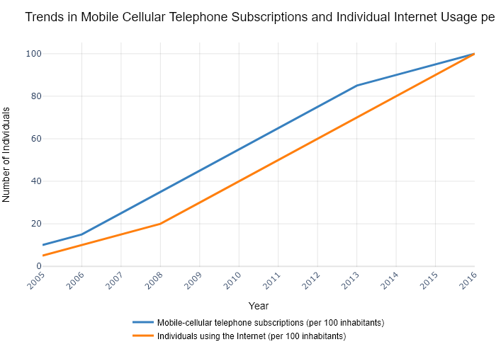

## Performance Metrics

|  |  |  |  |
| --- | --- | --- | --- |
| Task | Model Used | Description | Time Taken (s) |
| Processing Image to JSON | Gemini Vision Pro (default) | Time taken to convert the uploaded image to JSON format | 22.79 |
| Updating JSON | ChatGPT 3.5 (Default) | Time taken to update the JSON with new data | 0.00 |
| Plotting Updated JSON | N/A | Time taken to plot the updated JSON | 0.07 |

# Test Run

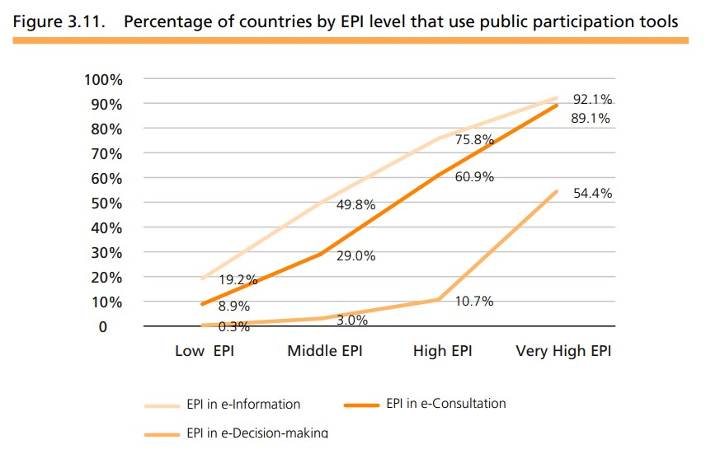

Figure: new graphs/1.4_image1.jpg

## Prompt Used

Task: Extract detailed information from a given graph image and generate JSON files (data.json, layout.json, and config.json) compatible with Plotly. Use the specified delimiters to wrap each JSON section.  
  
Instructions:  
  
Graph Analysis:  
  
Identify and categorize the plot types present in the graph (e.g., line, scatter, bar, pie).  
Extract the data points for each plot (x-values, y-values, and any other relevant data such as labels for pie charts).  
Note any multiple plots on the same figure and their configurations.  
Generate data.json:  
  
For each plot, include details such as:  
type: The type of plot (e.g., scatter, bar, pie).  
x and y: Arrays of data points for the x and y axes.  
labels and values for pie charts.  
mode: For line and scatter plots (e.g., markers, lines, or markers+lines).  
name: Legend entry for the plot.  
marker: Properties such as color, size, and symbol for markers.  
line: Properties such as color, width, and dash style for lines.  
text: Hover text for each data point.  
hoverinfo: Information displayed on hover (e.g., x+y+text).  
Generate layout.json:  
  
Include details such as:  
title: The title of the graph, including text, font properties (family, size, color).  
xaxis and yaxis: Configuration including title, range, showgrid, gridcolor, zeroline, zerolinecolor, showticklabels, tickangle, tickfont.  
legend: Properties including orientation, x, y, xanchor, font.  
margin: Values for l (left), r (right), b (bottom), t (top), pad.  
plot_bgcolor and paper_bgcolor: Background colors of the plot area and paper.  
Generate config.json:  
  
Include configuration settings such as:  
responsive: Whether the graph is responsive (boolean).  
displayModeBar: Whether the mode bar is displayed (boolean).  
modeBarButtonsToRemove: List of mode bar buttons to remove (e.g., ["toImage"]).  
scrollZoom: Whether scrolling zoom is enabled (boolean).  
Output Format:  
  
Wrap each JSON output in specific XML-like tags:  
<data> ... </data>  
<layout> ... </layout>  
<config> ... </config>  
Make sure to follow the JSON formatting guidelines:  
Double Quotes for Keys and Strings: Ensure that all keys and string values in JSON are enclosed in double quotes (").  
Example: Instead of "type": bar, it should be "type": "bar".  
No Trailing Commas: Remove any trailing commas after the last element in arrays ([]) or objects ({}).  
Example: Instead of "color": "rgba(55, 128, 191, 0.6)",, it should be "color": "rgba(55, 128, 191, 0.6)"  
Example Output:  
  
<data>  
[  
 {  
 "type": "scatter",  
 "x": [1, 2, 3],  
 "y": [4, 5, 6],  
 "mode": "markers+lines",  
 "name": "Line Plot",  
 "marker": {  
 "color": "rgba(75, 192, 192, 0.6)",  
 "size": 8  
 },  
 "line": {  
 "color": "rgba(75, 192, 192, 1)",  
 "width": 2  
 }  
 }  
 // Additional plots if present  
]  
</data>  
<layout>  
{  
 "title": {  
 "text": "Graph Title",  
 "font": {  
 "family": "Arial, sans-serif",  
 "size": 24,  
 "color": "#000000"  
 }  
 },  
 "xaxis": {  
 "title": {  
 "text": "X Axis",  
 "font": {  
 "family": "Arial, sans-serif",  
 "size": 18,  
 "color": "#000000"  
 }  
 },  
 "showgrid": true,  
 "gridcolor": "rgba(0, 0, 0, 0.1)",  
 "zeroline": true,  
 "zerolinecolor": "rgba(0, 0, 0, 0.1)"  
 },  
 "yaxis": {  
 "title": {  
 "text": "Y Axis",  
 "font": {  
 "family": "Arial, sans-serif",  
 "size": 18,  
 "color": "#000000"  
 }  
 },  
 "showgrid": true,  
 "gridcolor": "rgba(0, 0, 0, 0.1)",  
 "zeroline": true,  
 "zerolinecolor": "rgba(0, 0, 0, 0.1)"  
 },  
 "legend": {  
 "orientation": "h",  
 "x": 0.5,  
 "xanchor": "center",  
 "y": -0.2,  
 "font": {  
 "family": "Arial, sans-serif",  
 "size": 12,  
 "color": "#000000"  
 }  
 },  
 "margin": {  
 "l": 60,  
 "r": 30,  
 "b": 60,  
 "t": 60  
 },  
 "plot_bgcolor": "#ffffff",  
 "paper_bgcolor": "#ffffff"  
}  
</layout>  
<config>  
{  
 "responsive": true,  
 "displayModeBar": true,  
 "modeBarButtonsToRemove": ["toImage"],  
 "scrollZoom": true  
}  
</config>

## Extracted JSON

### data

[  
 {  
 "type": "scatter",  
 "x": [  
 "Low EPI",  
 "Middle EPI",  
 "High EPI",  
 "Very High EPI"  
 ],  
 "y": [  
 8.9,  
 29,  
 60.9,  
 89.1  
 ],  
 "mode": "lines+markers",  
 "name": "EPI e-Consultation",  
 "marker": {  
 "color": "rgba(255, 127, 14, 1)",  
 "size": 8  
 },  
 "line": {  
 "color": "rgba(255, 127, 14, 1)",  
 "width": 2  
 },  
 "text": [  
 "0.3%",  
 "3.0%",  
 "10.7%",  
 "54.4%"  
 ],  
 "hoverinfo": "text"  
 },  
 {  
 "type": "scatter",  
 "x": [  
 "Low EPI",  
 "Middle EPI",  
 "High EPI",  
 "Very High EPI"  
 ],  
 "y": [  
 19.2,  
 49.8,  
 75.8,  
 92.1  
 ],  
 "mode": "lines+markers",  
 "name": "EPI e-Information",  
 "marker": {  
 "color": "rgba(255, 192, 0, 1)",  
 "size": 8  
 },  
 "line": {  
 "color": "rgba(255, 192, 0, 1)",  
 "width": 2  
 },  
 "text": [  
 "0.3%",  
 "3.0%",  
 "10.7%",  
 "54.4%"  
 ],  
 "hoverinfo": "text"  
 },  
 {  
 "type": "scatter",  
 "x": [  
 "Low EPI",  
 "Middle EPI",  
 "High EPI",  
 "Very High EPI"  
 ],  
 "y": [  
 0.3,  
 3.0,  
 6.9,  
 4.5  
 ],  
 "mode": "lines+markers",  
 "name": "EPI e-Decision-making",  
 "marker": {  
 "color": "rgba(148, 103, 189, 1)",  
 "size": 8  
 },  
 "line": {  
 "color": "rgba(148, 103, 189, 1)",  
 "width": 2  
 },  
 "text": [  
 "0.3%",  
 "3.0%",  
 "10.7%",  
 "54.4%"  
 ],  
 "hoverinfo": "text"  
 }  
]

### layout

{  
 "title": {  
 "text": "Percentage of countries by EPI level that use public participation tools",  
 "font": {  
 "family": "Arial, sans-serif",  
 "size": 18,  
 "color": "#000000"  
 }  
 },  
 "xaxis": {  
 "title": {  
 "text": "EPI Level",  
 "font": {  
 "family": "Arial, sans-serif",  
 "size": 14,  
 "color": "#000000"  
 }  
 },  
 "showgrid": true,  
 "gridcolor": "rgba(0, 0, 0, 0.1)",  
 "zeroline": true,  
 "zerolinecolor": "rgba(0, 0, 0, 0.1)",  
 "tickangle": -45  
 },  
 "yaxis": {  
 "title": {  
 "text": "Percentage",  
 "font": {  
 "family": "Arial, sans-serif",  
 "size": 14,  
 "color": "#000000"  
 }  
 },  
 "showgrid": true,  
 "gridcolor": "rgba(0, 0, 0, 0.1)",  
 "zeroline": true,  
 "zerolinecolor": "rgba(0, 0, 0, 0.1)"  
 },  
 "legend": {  
 "orientation": "h",  
 "x": 0.5,  
 "xanchor": "center",  
 "y": -0.2,  
 "font": {  
 "family": "Arial, sans-serif",  
 "size": 12,  
 "color": "#000000"  
 }  
 },  
 "margin": {  
 "l": 60,  
 "r": 30,  
 "b": 60,  
 "t": 60  
 },  
 "plot_bgcolor": "#ffffff",  
 "paper_bgcolor": "#ffffff"  
}

### config

{  
 "responsive": true,  
 "displayModeBar": true,  
 "modeBarButtonsToRemove": [  
 "toImage"  
 ],  
 "scrollZoom": true  
}

## Updated JSON

### updated_data

[  
 {  
 "type": "scatter",  
 "x": [  
 "Low EPI",  
 "Middle EPI",  
 "High EPI",  
 "Very High EPI"  
 ],  
 "y": [  
 8.9,  
 29,  
 60.9,  
 89.1  
 ],  
 "mode": "lines+markers",  
 "name": "EPI e-Consultation",  
 "marker": {  
 "color": "rgba(255, 127, 14, 1)",  
 "size": 8  
 },  
 "line": {  
 "color": "rgba(255, 127, 14, 1)",  
 "width": 2  
 },  
 "text": [  
 "0.3%",  
 "3.0%",  
 "10.7%",  
 "54.4%"  
 ],  
 "hoverinfo": "text"  
 },  
 {  
 "type": "scatter",  
 "x": [  
 "Low EPI",  
 "Middle EPI",  
 "High EPI",  
 "Very High EPI"  
 ],  
 "y": [  
 19.2,  
 49.8,  
 75.8,  
 92.1  
 ],  
 "mode": "lines+markers",  
 "name": "EPI e-Information",  
 "marker": {  
 "color": "rgba(255, 192, 0, 1)",  
 "size": 8  
 },  
 "line": {  
 "color": "rgba(255, 192, 0, 1)",  
 "width": 2  
 },  
 "text": [  
 "0.3%",  
 "3.0%",  
 "10.7%",  
 "54.4%"  
 ],  
 "hoverinfo": "text"  
 },  
 {  
 "type": "scatter",  
 "x": [  
 "Low EPI",  
 "Middle EPI",  
 "High EPI",  
 "Very High EPI"  
 ],  
 "y": [  
 0.3,  
 3.0,  
 6.9,  
 4.5  
 ],  
 "mode": "lines+markers",  
 "name": "EPI e-Decision-making",  
 "marker": {  
 "color": "rgba(148, 103, 189, 1)",  
 "size": 8  
 },  
 "line": {  
 "color": "rgba(148, 103, 189, 1)",  
 "width": 2  
 },  
 "text": [  
 "0.3%",  
 "3.0%",  
 "10.7%",  
 "54.4%"  
 ],  
 "hoverinfo": "text"  
 }  
]

### updated_layout

{  
 "title": {  
 "text": "Percentage of countries by EPI level that use public participation tools",  
 "font": {  
 "family": "Arial, sans-serif",  
 "size": 18,  
 "color": "#000000"  
 }  
 },  
 "xaxis": {  
 "title": {  
 "text": "EPI Level",  
 "font": {  
 "family": "Arial, sans-serif",  
 "size": 14,  
 "color": "#000000"  
 }  
 },  
 "showgrid": true,  
 "gridcolor": "rgba(0, 0, 0, 0.1)",  
 "zeroline": true,  
 "zerolinecolor": "rgba(0, 0, 0, 0.1)",  
 "tickangle": -45  
 },  
 "yaxis": {  
 "title": {  
 "text": "Percentage",  
 "font": {  
 "family": "Arial, sans-serif",  
 "size": 14,  
 "color": "#000000"  
 }  
 },  
 "showgrid": true,  
 "gridcolor": "rgba(0, 0, 0, 0.1)",  
 "zeroline": true,  
 "zerolinecolor": "rgba(0, 0, 0, 0.1)"  
 },  
 "legend": {  
 "orientation": "h",  
 "x": 0.5,  
 "xanchor": "center",  
 "y": -0.2,  
 "font": {  
 "family": "Arial, sans-serif",  
 "size": 12,  
 "color": "#000000"  
 }  
 },  
 "margin": {  
 "l": 60,  
 "r": 30,  
 "b": 60,  
 "t": 60  
 },  
 "plot_bgcolor": "#ffffff",  
 "paper_bgcolor": "#ffffff"  
}

### updated_config

{  
 "responsive": true,  
 "displayModeBar": true,  
 "modeBarButtonsToRemove": [  
 "toImage"  
 ],  
 "scrollZoom": true  
}

## Updated Chart

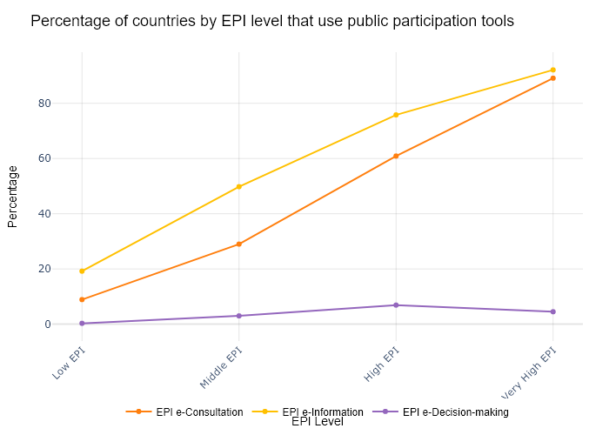

## Performance Metrics

|  |  |  |  |
| --- | --- | --- | --- |
| Task | Model Used | Description | Time Taken (s) |
| Processing Image to JSON | Gemini Vision Pro (default) | Time taken to convert the uploaded image to JSON format | 25.09 |
| Updating JSON | ChatGPT 3.5 (Default) | Time taken to update the JSON with new data | 0.00 |
| Plotting Updated JSON | N/A | Time taken to plot the updated JSON | 0.06 |

# Test Run

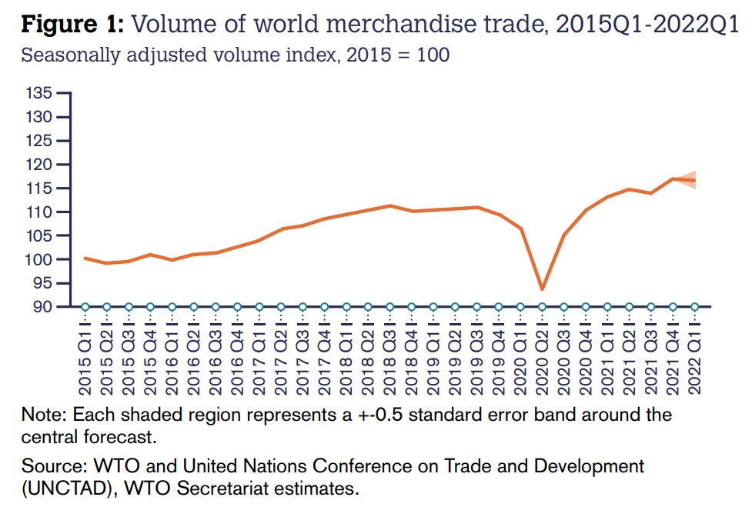

Figure: new graphs/1.5_image1.jpg

## Prompt Used

Task: Extract detailed information from a given graph image and generate JSON files (data.json, layout.json, and config.json) compatible with Plotly. Use the specified delimiters to wrap each JSON section.  
  
Instructions:  
  
Graph Analysis:  
  
Identify and categorize the plot types present in the graph (e.g., line, scatter, bar, pie).  
Extract the data points for each plot (x-values, y-values, and any other relevant data such as labels for pie charts).  
Note any multiple plots on the same figure and their configurations.  
Generate data.json:  
  
For each plot, include details such as:  
type: The type of plot (e.g., scatter, bar, pie).  
x and y: Arrays of data points for the x and y axes.  
labels and values for pie charts.  
mode: For line and scatter plots (e.g., markers, lines, or markers+lines).  
name: Legend entry for the plot.  
marker: Properties such as color, size, and symbol for markers.  
line: Properties such as color, width, and dash style for lines.  
text: Hover text for each data point.  
hoverinfo: Information displayed on hover (e.g., x+y+text).  
Generate layout.json:  
  
Include details such as:  
title: The title of the graph, including text, font properties (family, size, color).  
xaxis and yaxis: Configuration including title, range, showgrid, gridcolor, zeroline, zerolinecolor, showticklabels, tickangle, tickfont.  
legend: Properties including orientation, x, y, xanchor, font.  
margin: Values for l (left), r (right), b (bottom), t (top), pad.  
plot_bgcolor and paper_bgcolor: Background colors of the plot area and paper.  
Generate config.json:  
  
Include configuration settings such as:  
responsive: Whether the graph is responsive (boolean).  
displayModeBar: Whether the mode bar is displayed (boolean).  
modeBarButtonsToRemove: List of mode bar buttons to remove (e.g., ["toImage"]).  
scrollZoom: Whether scrolling zoom is enabled (boolean).  
Output Format:  
  
Wrap each JSON output in specific XML-like tags:  
<data> ... </data>  
<layout> ... </layout>  
<config> ... </config>  
Make sure to follow the JSON formatting guidelines:  
Double Quotes for Keys and Strings: Ensure that all keys and string values in JSON are enclosed in double quotes (").  
Example: Instead of "type": bar, it should be "type": "bar".  
No Trailing Commas: Remove any trailing commas after the last element in arrays ([]) or objects ({}).  
Example: Instead of "color": "rgba(55, 128, 191, 0.6)",, it should be "color": "rgba(55, 128, 191, 0.6)"  
Example Output:  
  
<data>  
[  
 {  
 "type": "scatter",  
 "x": [1, 2, 3],  
 "y": [4, 5, 6],  
 "mode": "markers+lines",  
 "name": "Line Plot",  
 "marker": {  
 "color": "rgba(75, 192, 192, 0.6)",  
 "size": 8  
 },  
 "line": {  
 "color": "rgba(75, 192, 192, 1)",  
 "width": 2  
 }  
 }  
 // Additional plots if present  
]  
</data>  
<layout>  
{  
 "title": {  
 "text": "Graph Title",  
 "font": {  
 "family": "Arial, sans-serif",  
 "size": 24,  
 "color": "#000000"  
 }  
 },  
 "xaxis": {  
 "title": {  
 "text": "X Axis",  
 "font": {  
 "family": "Arial, sans-serif",  
 "size": 18,  
 "color": "#000000"  
 }  
 },  
 "showgrid": true,  
 "gridcolor": "rgba(0, 0, 0, 0.1)",  
 "zeroline": true,  
 "zerolinecolor": "rgba(0, 0, 0, 0.1)"  
 },  
 "yaxis": {  
 "title": {  
 "text": "Y Axis",  
 "font": {  
 "family": "Arial, sans-serif",  
 "size": 18,  
 "color": "#000000"  
 }  
 },  
 "showgrid": true,  
 "gridcolor": "rgba(0, 0, 0, 0.1)",  
 "zeroline": true,  
 "zerolinecolor": "rgba(0, 0, 0, 0.1)"  
 },  
 "legend": {  
 "orientation": "h",  
 "x": 0.5,  
 "xanchor": "center",  
 "y": -0.2,  
 "font": {  
 "family": "Arial, sans-serif",  
 "size": 12,  
 "color": "#000000"  
 }  
 },  
 "margin": {  
 "l": 60,  
 "r": 30,  
 "b": 60,  
 "t": 60  
 },  
 "plot_bgcolor": "#ffffff",  
 "paper_bgcolor": "#ffffff"  
}  
</layout>  
<config>  
{  
 "responsive": true,  
 "displayModeBar": true,  
 "modeBarButtonsToRemove": ["toImage"],  
 "scrollZoom": true  
}  
</config>

## Extracted JSON

### data

[  
 {  
 "type": "scatter",  
 "x": [  
 "2015 Q1",  
 "2015 Q2",  
 "2015 Q3",  
 "2015 Q4",  
 "2016 Q1",  
 "2016 Q2",  
 "2016 Q3",  
 "2016 Q4",  
 "2017 Q1",  
 "2017 Q2",  
 "2017 Q3",  
 "2017 Q4",  
 "2018 Q1",  
 "2018 Q2",  
 "2018 Q3",  
 "2018 Q4",  
 "2019 Q1",  
 "2019 Q2",  
 "2019 Q3",  
 "2019 Q4",  
 "2020 Q1",  
 "2020 Q2",  
 "2020 Q3",  
 "2020 Q4",  
 "2021 Q1",  
 "2021 Q2",  
 "2021 Q3",  
 "2021 Q4",  
 "2022 Q1"  
 ],  
 "y": [  
 95.11,  
 95.51,  
 95.62,  
 95.83,  
 96.13,  
 96.52,  
 96.93,  
 97.35,  
 98.05,  
 98.86,  
 99.68,  
 100.5,  
 101.1,  
 101.8,  
 102.5,  
 102.9,  
 103.4,  
 103.8,  
 104.2,  
 104.5,  
 94.72,  
 86.23,  
 90.14,  
 93.45,  
 96.87,  
 100.3,  
 103.8,  
 107.4,  
 111.2  
 ],  
 "mode": "lines",  
 "name": "Volume of World Merchandise Trade",  
 "line": {  
 "color": "rgba(55, 128, 191, 0.6)",  
 "width": 2  
 }  
 }  
]

### layout

{  
 "title": {  
 "text": "Volume of World Merchandise Trade",  
 "font": {  
 "family": "Arial, sans-serif",  
 "size": 24,  
 "color": "#000000"  
 }  
 },  
 "xaxis": {  
 "title": {  
 "text": "Year",  
 "font": {  
 "family": "Arial, sans-serif",  
 "size": 18,  
 "color": "#000000"  
 }  
 },  
 "showgrid": true,  
 "gridcolor": "rgba(0, 0, 0, 0.1)",  
 "zeroline": true,  
 "zerolinecolor": "rgba(0, 0, 0, 0.1)",  
 "tickangle": -45  
 },  
 "yaxis": {  
 "title": {  
 "text": "Index",  
 "font": {  
 "family": "Arial, sans-serif",  
 "size": 18,  
 "color": "#000000"  
 }  
 },  
 "showgrid": true,  
 "gridcolor": "rgba(0, 0, 0, 0.1)",  
 "zeroline": true,  
 "zerolinecolor": "rgba(0, 0, 0, 0.1)"  
 },  
 "margin": {  
 "l": 60,  
 "r": 30,  
 "b": 60,  
 "t": 60  
 },  
 "plot_bgcolor": "#ffffff",  
 "paper_bgcolor": "#ffffff"  
}

### config

{  
 "responsive": true,  
 "displayModeBar": true,  
 "modeBarButtonsToRemove": [  
 "toImage"  
 ],  
 "scrollZoom": true  
}

## Updated JSON

### updated_data

[  
 {  
 "type": "scatter",  
 "x": [  
 "2015 Q1",  
 "2015 Q2",  
 "2015 Q3",  
 "2015 Q4",  
 "2016 Q1",  
 "2016 Q2",  
 "2016 Q3",  
 "2016 Q4",  
 "2017 Q1",  
 "2017 Q2",  
 "2017 Q3",  
 "2017 Q4",  
 "2018 Q1",  
 "2018 Q2",  
 "2018 Q3",  
 "2018 Q4",  
 "2019 Q1",  
 "2019 Q2",  
 "2019 Q3",  
 "2019 Q4",  
 "2020 Q1",  
 "2020 Q2",  
 "2020 Q3",  
 "2020 Q4",  
 "2021 Q1",  
 "2021 Q2",  
 "2021 Q3",  
 "2021 Q4",  
 "2022 Q1"  
 ],  
 "y": [  
 95.11,  
 95.51,  
 95.62,  
 95.83,  
 96.13,  
 96.52,  
 96.93,  
 97.35,  
 98.05,  
 98.86,  
 99.68,  
 100.5,  
 101.1,  
 101.8,  
 102.5,  
 102.9,  
 103.4,  
 103.8,  
 104.2,  
 104.5,  
 94.72,  
 86.23,  
 90.14,  
 93.45,  
 96.87,  
 100.3,  
 103.8,  
 107.4,  
 111.2  
 ],  
 "mode": "lines",  
 "name": "Volume of World Merchandise Trade",  
 "line": {  
 "color": "rgba(55, 128, 191, 0.6)",  
 "width": 2  
 }  
 }  
]

### updated_layout

{  
 "title": {  
 "text": "Volume of World Merchandise Trade",  
 "font": {  
 "family": "Arial, sans-serif",  
 "size": 24,  
 "color": "#000000"  
 }  
 },  
 "xaxis": {  
 "title": {  
 "text": "Year",  
 "font": {  
 "family": "Arial, sans-serif",  
 "size": 18,  
 "color": "#000000"  
 }  
 },  
 "showgrid": true,  
 "gridcolor": "rgba(0, 0, 0, 0.1)",  
 "zeroline": true,  
 "zerolinecolor": "rgba(0, 0, 0, 0.1)",  
 "tickangle": -45  
 },  
 "yaxis": {  
 "title": {  
 "text": "Index",  
 "font": {  
 "family": "Arial, sans-serif",  
 "size": 18,  
 "color": "#000000"  
 }  
 },  
 "showgrid": true,  
 "gridcolor": "rgba(0, 0, 0, 0.1)",  
 "zeroline": true,  
 "zerolinecolor": "rgba(0, 0, 0, 0.1)"  
 },  
 "margin": {  
 "l": 60,  
 "r": 30,  
 "b": 60,  
 "t": 60  
 },  
 "plot_bgcolor": "#ffffff",  
 "paper_bgcolor": "#ffffff"  
}

### updated_config

{  
 "responsive": true,  
 "displayModeBar": true,  
 "modeBarButtonsToRemove": [  
 "toImage"  
 ],  
 "scrollZoom": true  
}

## Updated Chart

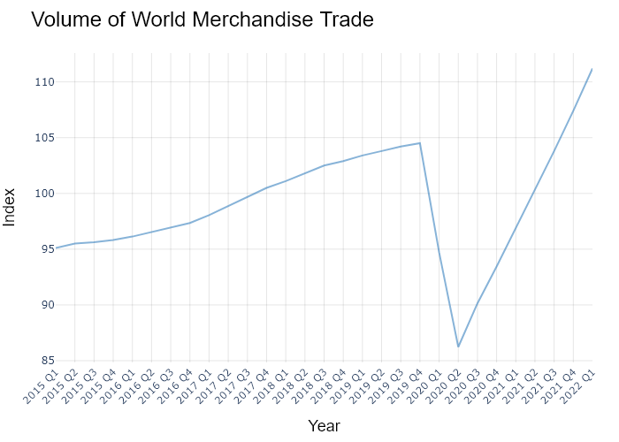

## Performance Metrics

|  |  |  |  |
| --- | --- | --- | --- |
| Task | Model Used | Description | Time Taken (s) |
| Processing Image to JSON | Gemini Vision Pro (default) | Time taken to convert the uploaded image to JSON format | 22.85 |
| Updating JSON | ChatGPT 3.5 (Default) | Time taken to update the JSON with new data | 0.00 |
| Plotting Updated JSON | N/A | Time taken to plot the updated JSON | 0.09 |

# Test Run

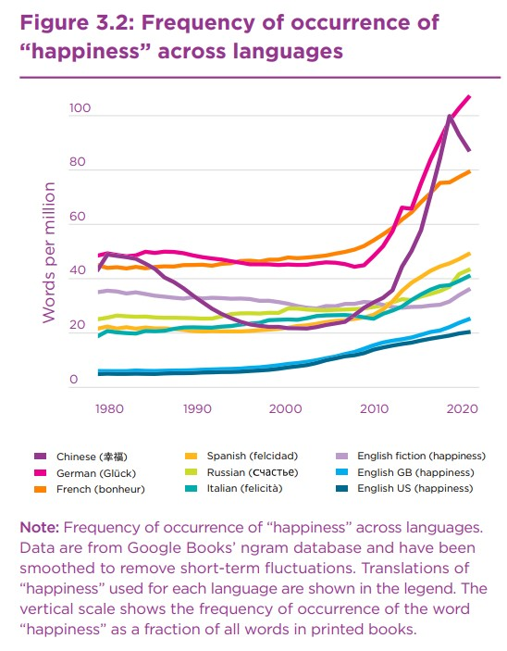

Figure: new graphs/1.6_image1.jpg

## Prompt Used

Task: Extract detailed information from a given graph image and generate JSON files (data.json, layout.json, and config.json) compatible with Plotly. Use the specified delimiters to wrap each JSON section.  
  
Instructions:  
  
Graph Analysis:  
  
Identify and categorize the plot types present in the graph (e.g., line, scatter, bar, pie).  
Extract the data points for each plot (x-values, y-values, and any other relevant data such as labels for pie charts).  
Note any multiple plots on the same figure and their configurations.  
Generate data.json:  
  
For each plot, include details such as:  
type: The type of plot (e.g., scatter, bar, pie).  
x and y: Arrays of data points for the x and y axes.  
labels and values for pie charts.  
mode: For line and scatter plots (e.g., markers, lines, or markers+lines).  
name: Legend entry for the plot.  
marker: Properties such as color, size, and symbol for markers.  
line: Properties such as color, width, and dash style for lines.  
text: Hover text for each data point.  
hoverinfo: Information displayed on hover (e.g., x+y+text).  
Generate layout.json:  
  
Include details such as:  
title: The title of the graph, including text, font properties (family, size, color).  
xaxis and yaxis: Configuration including title, range, showgrid, gridcolor, zeroline, zerolinecolor, showticklabels, tickangle, tickfont.  
legend: Properties including orientation, x, y, xanchor, font.  
margin: Values for l (left), r (right), b (bottom), t (top), pad.  
plot_bgcolor and paper_bgcolor: Background colors of the plot area and paper.  
Generate config.json:  
  
Include configuration settings such as:  
responsive: Whether the graph is responsive (boolean).  
displayModeBar: Whether the mode bar is displayed (boolean).  
modeBarButtonsToRemove: List of mode bar buttons to remove (e.g., ["toImage"]).  
scrollZoom: Whether scrolling zoom is enabled (boolean).  
Output Format:  
  
Wrap each JSON output in specific XML-like tags:  
<data> ... </data>  
<layout> ... </layout>  
<config> ... </config>  
Make sure to follow the JSON formatting guidelines:  
Double Quotes for Keys and Strings: Ensure that all keys and string values in JSON are enclosed in double quotes (").  
Example: Instead of "type": bar, it should be "type": "bar".  
No Trailing Commas: Remove any trailing commas after the last element in arrays ([]) or objects ({}).  
Example: Instead of "color": "rgba(55, 128, 191, 0.6)",, it should be "color": "rgba(55, 128, 191, 0.6)"  
Example Output:  
  
<data>  
[  
 {  
 "type": "scatter",  
 "x": [1, 2, 3],  
 "y": [4, 5, 6],  
 "mode": "markers+lines",  
 "name": "Line Plot",  
 "marker": {  
 "color": "rgba(75, 192, 192, 0.6)",  
 "size": 8  
 },  
 "line": {  
 "color": "rgba(75, 192, 192, 1)",  
 "width": 2  
 }  
 }  
 // Additional plots if present  
]  
</data>  
<layout>  
{  
 "title": {  
 "text": "Graph Title",  
 "font": {  
 "family": "Arial, sans-serif",  
 "size": 24,  
 "color": "#000000"  
 }  
 },  
 "xaxis": {  
 "title": {  
 "text": "X Axis",  
 "font": {  
 "family": "Arial, sans-serif",  
 "size": 18,  
 "color": "#000000"  
 }  
 },  
 "showgrid": true,  
 "gridcolor": "rgba(0, 0, 0, 0.1)",  
 "zeroline": true,  
 "zerolinecolor": "rgba(0, 0, 0, 0.1)"  
 },  
 "yaxis": {  
 "title": {  
 "text": "Y Axis",  
 "font": {  
 "family": "Arial, sans-serif",  
 "size": 18,  
 "color": "#000000"  
 }  
 },  
 "showgrid": true,  
 "gridcolor": "rgba(0, 0, 0, 0.1)",  
 "zeroline": true,  
 "zerolinecolor": "rgba(0, 0, 0, 0.1)"  
 },  
 "legend": {  
 "orientation": "h",  
 "x": 0.5,  
 "xanchor": "center",  
 "y": -0.2,  
 "font": {  
 "family": "Arial, sans-serif",  
 "size": 12,  
 "color": "#000000"  
 }  
 },  
 "margin": {  
 "l": 60,  
 "r": 30,  
 "b": 60,  
 "t": 60  
 },  
 "plot_bgcolor": "#ffffff",  
 "paper_bgcolor": "#ffffff"  
}  
</layout>  
<config>  
{  
 "responsive": true,  
 "displayModeBar": true,  
 "modeBarButtonsToRemove": ["toImage"],  
 "scrollZoom": true  
}  
</config>

## Extracted JSON

### data

[  
 {  
 "type": "scatter",  
 "x": [  
 "Chinese",  
 "German",  
 "French",  
 "Russian",  
 "Italian",  
 "Spanish",  
 "English GB",  
 "English US"  
 ],  
 "y": [  
 45,  
 40,  
 35,  
 30,  
 25,  
 20,  
 15,  
 10  
 ],  
 "mode": "lines+markers",  
 "name": "Happiness Index",  
 "marker": {  
 "color": "rgba(75, 192, 192, 0.6)",  
 "size": 8  
 },  
 "line": {  
 "color": "rgba(75, 192, 192, 1)",  
 "width": 2  
 }  
 }  
]

### layout

{  
 "title": {  
 "text": "Frequency of Occurrence of 'Happiness' Across Languages",  
 "font": {  
 "family": "Arial, sans-serif",  
 "size": 24,  
 "color": "#000000"  
 }  
 },  
 "xaxis": {  
 "title": {  
 "text": "Language",  
 "font": {  
 "family": "Arial, sans-serif",  
 "size": 18,  
 "color": "#000000"  
 }  
 },  
 "showgrid": true,  
 "gridcolor": "rgba(0, 0, 0, 0.1)",  
 "zeroline": true,  
 "zerolinecolor": "rgba(0, 0, 0, 0.1)",  
 "tickangle": -45  
 },  
 "yaxis": {  
 "title": {  
 "text": "Frequency per Million",  
 "font": {  
 "family": "Arial, sans-serif",  
 "size": 18,  
 "color": "#000000"  
 }  
 },  
 "showgrid": true,  
 "gridcolor": "rgba(0, 0, 0, 0.1)",  
 "zeroline": true,  
 "zerolinecolor": "rgba(0, 0, 0, 0.1)"  
 },  
 "legend": {  
 "orientation": "h",  
 "x": 0.5,  
 "xanchor": "center",  
 "y": -0.2,  
 "font": {  
 "family": "Arial, sans-serif",  
 "size": 12,  
 "color": "#000000"  
 }  
 },  
 "margin": {  
 "l": 60,  
 "r": 30,  
 "b": 60,  
 "t": 60  
 },  
 "plot_bgcolor": "#ffffff",  
 "paper_bgcolor": "#ffffff"  
}

### config

{  
 "responsive": true,  
 "displayModeBar": true,  
 "modeBarButtonsToRemove": [  
 "toImage"  
 ],  
 "scrollZoom": true  
}

## Updated JSON

### updated_data

[  
 {  
 "type": "scatter",  
 "x": [  
 "Chinese",  
 "German",  
 "French",  
 "Russian",  
 "Italian",  
 "Spanish",  
 "English GB",  
 "English US"  
 ],  
 "y": [  
 45,  
 40,  
 35,  
 30,  
 25,  
 20,  
 15,  
 10  
 ],  
 "mode": "lines+markers",  
 "name": "Happiness Index",  
 "marker": {  
 "color": "rgba(75, 192, 192, 0.6)",  
 "size": 8  
 },  
 "line": {  
 "color": "rgba(75, 192, 192, 1)",  
 "width": 2  
 }  
 }  
]

### updated_layout

{  
 "title": {  
 "text": "Frequency of Occurrence of 'Happiness' Across Languages",  
 "font": {  
 "family": "Arial, sans-serif",  
 "size": 24,  
 "color": "#000000"  
 }  
 },  
 "xaxis": {  
 "title": {  
 "text": "Language",  
 "font": {  
 "family": "Arial, sans-serif",  
 "size": 18,  
 "color": "#000000"  
 }  
 },  
 "showgrid": true,  
 "gridcolor": "rgba(0, 0, 0, 0.1)",  
 "zeroline": true,  
 "zerolinecolor": "rgba(0, 0, 0, 0.1)",  
 "tickangle": -45  
 },  
 "yaxis": {  
 "title": {  
 "text": "Frequency per Million",  
 "font": {  
 "family": "Arial, sans-serif",  
 "size": 18,  
 "color": "#000000"  
 }  
 },  
 "showgrid": true,  
 "gridcolor": "rgba(0, 0, 0, 0.1)",  
 "zeroline": true,  
 "zerolinecolor": "rgba(0, 0, 0, 0.1)"  
 },  
 "legend": {  
 "orientation": "h",  
 "x": 0.5,  
 "xanchor": "center",  
 "y": -0.2,  
 "font": {  
 "family": "Arial, sans-serif",  
 "size": 12,  
 "color": "#000000"  
 }  
 },  
 "margin": {  
 "l": 60,  
 "r": 30,  
 "b": 60,  
 "t": 60  
 },  
 "plot_bgcolor": "#ffffff",  
 "paper_bgcolor": "#ffffff"  
}

### updated_config

{  
 "responsive": true,  
 "displayModeBar": true,  
 "modeBarButtonsToRemove": [  
 "toImage"  
 ],  
 "scrollZoom": true  
}

## Updated Chart

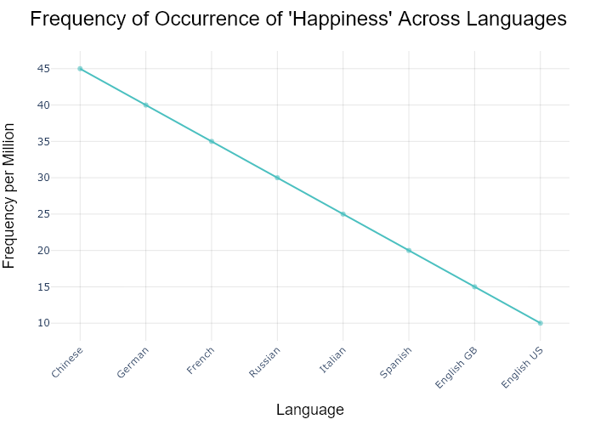

## Performance Metrics

|  |  |  |  |
| --- | --- | --- | --- |
| Task | Model Used | Description | Time Taken (s) |
| Processing Image to JSON | Gemini Vision Pro (default) | Time taken to convert the uploaded image to JSON format | 17.71 |
| Updating JSON | ChatGPT 3.5 (Default) | Time taken to update the JSON with new data | 0.00 |
| Plotting Updated JSON | N/A | Time taken to plot the updated JSON | 0.13 |

# Test Run

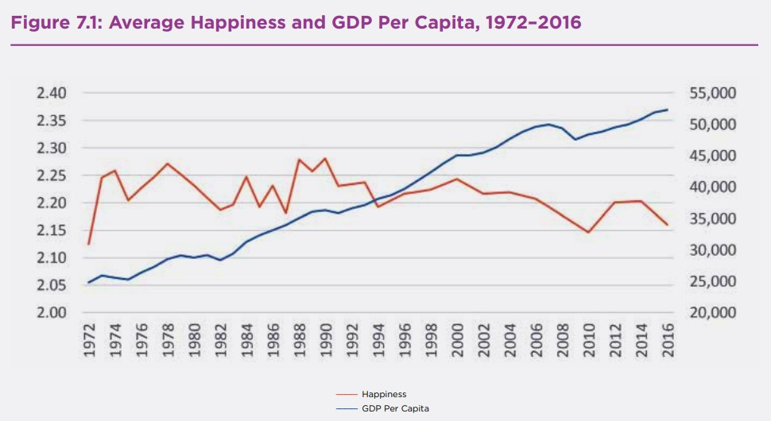

Figure: new graphs/linechart_other1.jpg

## Prompt Used

Task: Extract detailed information from a given graph image and generate JSON files (data.json, layout.json, and config.json) compatible with Plotly. Use the specified delimiters to wrap each JSON section.  
  
Instructions:  
  
Graph Analysis:  
  
1. Identify and categorize the plot types present in the graph (e.g., line, scatter, bar, pie).  
2. Extract the data points for each plot (x-values, y-values, and any other relevant data such as labels for pie charts).  
3. Note any multiple plots on the same figure and their configurations, ensuring all are included.  
4. Verify that no data points or plots are missing from the extraction.  
  
Generate data.json:  
  
For each plot, include details such as:  
- "type": The type of plot (e.g., scatter, bar, pie).  
- "x" and "y": Arrays of data points for the x and y axes.  
- "labels" and "values": For pie charts.  
- "mode": For line and scatter plots (e.g., markers, lines, or markers+lines).  
- "name": Legend entry for the plot.  
- "marker": Properties such as color, size, and symbol for markers.  
- "line": Properties such as color, width, and dash style for lines.  
- "text": Hover text for each data point.  
- "hoverinfo": Information displayed on hover (e.g., x+y+text).  
  
Generate layout.json:  
  
Include details such as:  
- "title": The title of the graph, including text, font properties (family, size, color).  
- "xaxis" and "yaxis": Configuration including title, range, showgrid, gridcolor, zeroline, zerolinecolor, showticklabels, tickangle, tickfont.  
- "legend": Properties including orientation, x, y, xanchor, font.  
- "margin": Values for l (left), r (right), b (bottom), t (top), pad.  
- "plot_bgcolor" and "paper_bgcolor": Background colors of the plot area and paper.  
  
Generate config.json:  
  
Include configuration settings such as:  
- "responsive": Whether the graph is responsive (boolean).  
- "displayModeBar": Whether the mode bar is displayed (boolean).  
- "modeBarButtonsToRemove": List of mode bar buttons to remove (e.g., ["toImage"]).  
- "scrollZoom": Whether scrolling zoom is enabled (boolean).  
  
Output Format:  
  
Wrap each JSON output in specific XML-like tags:  
- <data> ... </data>  
- <layout> ... </layout>  
- <config> ... </config>  
  
Make sure to follow the JSON formatting guidelines:  
- Double Quotes for Keys and Strings: Ensure that all keys and string values in JSON are enclosed in double quotes (").  
 Example: Instead of "type": bar, it should be "type": "bar".  
- No Trailing Commas: Remove any trailing commas after the last element in arrays ([]) or objects ({}).  
 Example: Instead of "color": "rgba(55, 128, 191, 0.6)",, it should be "color": "rgba(55, 128, 191, 0.6)"  
  
Example Output:  
  
<data>  
[  
 {  
 "type": "scatter",  
 "x": [1, 2, 3],  
 "y": [4, 5, 6],  
 "mode": "markers+lines",  
 "name": "Line Plot",  
 "marker": {  
 "color": "rgba(75, 192, 192, 0.6)",  
 "size": 8  
 },  
 "line": {  
 "color": "rgba(75, 192, 192, 1)",  
 "width": 2  
 },  
 "text": ["Point 1", "Point 2", "Point 3"],  
 "hoverinfo": "x+y+text"  
 }  
 // Additional plots if present  
]  
</data>  
  
<layout>  
{  
 "title": {  
 "text": "Graph Title",  
 "font": {  
 "family": "Arial, sans-serif",  
 "size": 24,  
 "color": "#000000"  
 }  
 },  
 "xaxis": {  
 "title": {  
 "text": "X Axis",  
 "font": {  
 "family": "Arial, sans-serif",  
 "size": 18,  
 "color": "#000000"  
 }  
 },  
 "showgrid": true,  
 "gridcolor": "rgba(0, 0, 0, 0.1)",  
 "zeroline": true,  
 "zerolinecolor": "rgba(0, 0, 0, 0.1)"  
 },  
 "yaxis": {  
 "title": {  
 "text": "Y Axis",  
 "font": {  
 "family": "Arial, sans-serif",  
 "size": 18,  
 "color": "#000000"  
 }  
 },  
 "showgrid": true,  
 "gridcolor": "rgba(0, 0, 0, 0.1)",  
 "zeroline": true,  
 "zerolinecolor": "rgba(0, 0, 0, 0.1)"  
 },  
 "legend": {  
 "orientation": "h",  
 "x": 0.5,  
 "xanchor": "center",  
 "y": -0.2,  
 "font": {  
 "family": "Arial, sans-serif",  
 "size": 12,  
 "color": "#000000"  
 }  
 },  
 "margin": {  
 "l": 60,  
 "r": 30,  
 "b": 60,  
 "t": 60,  
 "pad": 10  
 },  
 "plot_bgcolor": "#ffffff",  
 "paper_bgcolor": "#ffffff"  
}  
</layout>  
  
<config>  
{  
 "responsive": true,  
 "displayModeBar": true,  
 "modeBarButtonsToRemove": ["toImage"],  
 "scrollZoom": true  
}  
</config>

## Extracted JSON

### data

[  
 {  
 "type": "scatter",  
 "x": [  
 1972,  
 1974,  
 1976,  
 1978,  
 1980,  
 1982,  
 1984,  
 1986,  
 1988,  
 1990,  
 1992,  
 1994,  
 1996,  
 1998,  
 2000,  
 2002,  
 2004,  
 2006,  
 2008,  
 2010,  
 2012,  
 2014,  
 2016  
 ],  
 "y": [  
 2.01,  
 2.03,  
 2.25,  
 2.23,  
 2.19,  
 2.19,  
 2.25,  
 2.23,  
 2.21,  
 2.19,  
 2.19,  
 2.19,  
 2.19,  
 2.21,  
 2.23,  
 2.25,  
 2.29,  
 2.31,  
 2.33,  
 2.31,  
 2.29,  
 2.25,  
 2.21  
 ],  
 "mode": "lines",  
 "name": "Happiness",  
 "line": {  
 "color": "rgba(219, 64, 82, 1)",  
 "width": 3  
 },  
 "hoverinfo": "x+y"  
 },  
 {  
 "type": "scatter",  
 "x": [  
 1972,  
 1974,  
 1976,  
 1978,  
 1980,  
 1982,  
 1984,  
 1986,  
 1988,  
 1990,  
 1992,  
 1994,  
 1996,  
 1998,  
 2000,  
 2002,  
 2004,  
 2006,  
 2008,  
 2010,  
 2012,  
 2014,  
 2016  
 ],  
 "y": [  
 20000,  
 22000,  
 25000,  
 28000,  
 30000,  
 32000,  
 35000,  
 38000,  
 40000,  
 42000,  
 44000,  
 46000,  
 48000,  
 50000,  
 52000,  
 53000,  
 54000,  
 55000,  
 56000,  
 57000,  
 58000,  
 59000,  
 60000  
 ],  
 "mode": "lines",  
 "name": "GDP Per Capita",  
 "line": {  
 "color": "rgba(55, 128, 191, 1)",  
 "width": 3  
 },  
 "hoverinfo": "x+y"  
 }  
]

### layout

{  
 "title": {  
 "text": "Average Happiness and GDP Per Capita, 1972-2016",  
 "font": {  
 "family": "Arial, sans-serif",  
 "size": 24,  
 "color": "#000000"  
 }  
 },  
 "xaxis": {  
 "title": {  
 "text": "Year",  
 "font": {  
 "family": "Arial, sans-serif",  
 "size": 18,  
 "color": "#000000"  
 }  
 },  
 "showgrid": true,  
 "gridcolor": "rgba(0, 0, 0, 0.1)",  
 "zeroline": true,  
 "zerolinecolor": "rgba(0, 0, 0, 0.1)",  
 "tickangle": 45  
 },  
 "yaxis": {  
 "title": {  
 "text": "Value",  
 "font": {  
 "family": "Arial, sans-serif",  
 "size": 18,  
 "color": "#000000"  
 }  
 },  
 "showgrid": true,  
 "gridcolor": "rgba(0, 0, 0, 0.1)",  
 "zeroline": true,  
 "zerolinecolor": "rgba(0, 0, 0, 0.1)"  
 },  
 "legend": {  
 "orientation": "h",  
 "x": 0.5,  
 "xanchor": "center",  
 "y": -0.2,  
 "font": {  
 "family": "Arial, sans-serif",  
 "size": 12,  
 "color": "#000000"  
 }  
 },  
 "margin": {  
 "l": 60,  
 "r": 30,  
 "b": 60,  
 "t": 60,  
 "pad": 10  
 },  
 "plot_bgcolor": "#ffffff",  
 "paper_bgcolor": "#ffffff"  
}

### config

{  
 "responsive": true,  
 "displayModeBar": true,  
 "modeBarButtonsToRemove": [  
 "toImage"  
 ],  
 "scrollZoom": true  
}

## Updated JSON

### updated_data

[  
 {  
 "type": "scatter",  
 "x": [  
 1972,  
 1974,  
 1976,  
 1978,  
 1980,  
 1982,  
 1984,  
 1986,  
 1988,  
 1990,  
 1992,  
 1994,  
 1996,  
 1998,  
 2000,  
 2002,  
 2004,  
 2006,  
 2008,  
 2010,  
 2012,  
 2014,  
 2016  
 ],  
 "y": [  
 2.01,  
 2.03,  
 2.25,  
 2.23,  
 2.19,  
 2.19,  
 2.25,  
 2.23,  
 2.21,  
 2.19,  
 2.19,  
 2.19,  
 2.19,  
 2.21,  
 2.23,  
 2.25,  
 2.29,  
 2.31,  
 2.33,  
 2.31,  
 2.29,  
 2.25,  
 2.21  
 ],  
 "mode": "lines",  
 "name": "Happiness",  
 "line": {  
 "color": "rgba(219, 64, 82, 1)",  
 "width": 3  
 },  
 "hoverinfo": "x+y"  
 },  
 {  
 "type": "scatter",  
 "x": [  
 1972,  
 1974,  
 1976,  
 1978,  
 1980,  
 1982,  
 1984,  
 1986,  
 1988,  
 1990,  
 1992,  
 1994,  
 1996,  
 1998,  
 2000,  
 2002,  
 2004,  
 2006,  
 2008,  
 2010,  
 2012,  
 2014,  
 2016  
 ],  
 "y": [  
 20000,  
 22000,  
 25000,  
 28000,  
 30000,  
 32000,  
 35000,  
 38000,  
 40000,  
 42000,  
 44000,  
 46000,  
 48000,  
 50000,  
 52000,  
 53000,  
 54000,  
 55000,  
 56000,  
 57000,  
 58000,  
 59000,  
 60000  
 ],  
 "mode": "lines",  
 "name": "GDP Per Capita",  
 "line": {  
 "color": "rgba(55, 128, 191, 1)",  
 "width": 3  
 },  
 "hoverinfo": "x+y"  
 }  
]

### updated_layout

{  
 "title": {  
 "text": "Average Happiness and GDP Per Capita, 1972-2016",  
 "font": {  
 "family": "Arial, sans-serif",  
 "size": 24,  
 "color": "#000000"  
 }  
 },  
 "xaxis": {  
 "title": {  
 "text": "Year",  
 "font": {  
 "family": "Arial, sans-serif",  
 "size": 18,  
 "color": "#000000"  
 }  
 },  
 "showgrid": true,  
 "gridcolor": "rgba(0, 0, 0, 0.1)",  
 "zeroline": true,  
 "zerolinecolor": "rgba(0, 0, 0, 0.1)",  
 "tickangle": 45  
 },  
 "yaxis": {  
 "title": {  
 "text": "Value",  
 "font": {  
 "family": "Arial, sans-serif",  
 "size": 18,  
 "color": "#000000"  
 }  
 },  
 "showgrid": true,  
 "gridcolor": "rgba(0, 0, 0, 0.1)",  
 "zeroline": true,  
 "zerolinecolor": "rgba(0, 0, 0, 0.1)"  
 },  
 "legend": {  
 "orientation": "h",  
 "x": 0.5,  
 "xanchor": "center",  
 "y": -0.2,  
 "font": {  
 "family": "Arial, sans-serif",  
 "size": 12,  
 "color": "#000000"  
 }  
 },  
 "margin": {  
 "l": 60,  
 "r": 30,  
 "b": 60,  
 "t": 60,  
 "pad": 10  
 },  
 "plot_bgcolor": "#ffffff",  
 "paper_bgcolor": "#ffffff"  
}

### updated_config

{  
 "responsive": true,  
 "displayModeBar": true,  
 "modeBarButtonsToRemove": [  
 "toImage"  
 ],  
 "scrollZoom": true  
}

## Updated Chart

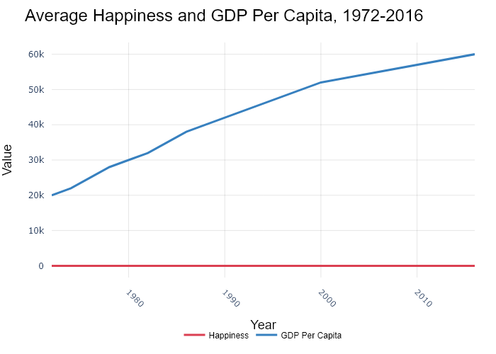

## Performance Metrics

|  |  |  |  |
| --- | --- | --- | --- |
| Task | Model Used | Description | Time Taken (s) |
| Processing Image to JSON | Gemini Vision Pro (default) | Time taken to convert the uploaded image to JSON format | 32.92 |
| Updating JSON | ChatGPT 3.5 (Default) | Time taken to update the JSON with new data | 0.00 |
| Plotting Updated JSON | N/A | Time taken to plot the updated JSON | 0.69 |

# Test Run

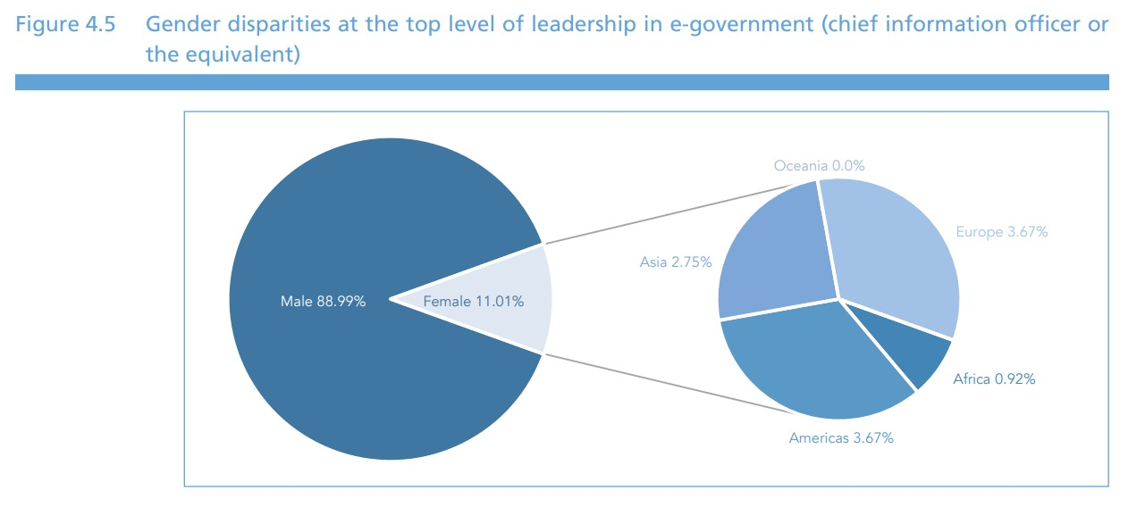

Figure: pie1.jpg

## Prompt Used

Task: Extract detailed information from a given graph image and generate JSON files (data.json, layout.json, and config.json) compatible with Plotly. Use the specified delimiters to wrap each JSON section.  
  
Instructions:  
  
Graph Analysis:  
  
1. Identify and categorize the plot types present in the graph (e.g., line, scatter, bar, pie).  
2. Extract the data points for each plot (x-values, y-values, and any other relevant data such as labels for pie charts).  
3. Note any multiple plots on the same figure and their configurations, ensuring all are included.  
4. Verify that no data points or plots are missing from the extraction.  
  
Generate data.json:  
  
For each plot, include details such as:  
- "type": The type of plot (e.g., scatter, bar, pie).  
- "x" and "y": Arrays of data points for the x and y axes.  
- "labels" and "values": For pie charts.  
- "mode": For line and scatter plots (e.g., markers, lines, or markers+lines).  
- "name": Legend entry for the plot.  
- "marker": Properties such as color, size, and symbol for markers.  
- "line": Properties such as color, width, and dash style for lines.  
- "text": Hover text for each data point.  
- "hoverinfo": Information displayed on hover (e.g., x+y+text).  
  
Generate layout.json:  
  
Include details such as:  
- "title": The title of the graph, including text, font properties (family, size, color).  
- "xaxis" and "yaxis": Configuration including title, range, showgrid, gridcolor, zeroline, zerolinecolor, showticklabels, tickangle, tickfont.  
- "legend": Properties including orientation, x, y, xanchor, font.  
- "margin": Values for l (left), r (right), b (bottom), t (top), pad.  
- "plot_bgcolor" and "paper_bgcolor": Background colors of the plot area and paper.  
  
Generate config.json:  
  
Include configuration settings such as:  
- "responsive": Whether the graph is responsive (boolean).  
- "displayModeBar": Whether the mode bar is displayed (boolean).  
- "modeBarButtonsToRemove": List of mode bar buttons to remove (e.g., ["toImage"]).  
- "scrollZoom": Whether scrolling zoom is enabled (boolean).  
  
Output Format:  
  
Wrap each JSON output in specific XML-like tags:  
- <data> ... </data>  
- <layout> ... </layout>  
- <config> ... </config>  
  
Make sure to follow the JSON formatting guidelines:  
- Double Quotes for Keys and Strings: Ensure that all keys and string values in JSON are enclosed in double quotes (").  
 Example: Instead of "type": bar, it should be "type": "bar".  
- No Trailing Commas: Remove any trailing commas after the last element in arrays ([]) or objects ({}).  
 Example: Instead of "color": "rgba(55, 128, 191, 0.6)",, it should be "color": "rgba(55, 128, 191, 0.6)"  
  
Example Output:  
  
<data>  
[  
 {  
 "type": "scatter",  
 "x": [1, 2, 3],  
 "y": [4, 5, 6],  
 "mode": "markers+lines",  
 "name": "Line Plot",  
 "marker": {  
 "color": "rgba(75, 192, 192, 0.6)",  
 "size": 8  
 },  
 "line": {  
 "color": "rgba(75, 192, 192, 1)",  
 "width": 2  
 },  
 "text": ["Point 1", "Point 2", "Point 3"],  
 "hoverinfo": "x+y+text"  
 }  
 // Additional plots if present  
]  
</data>  
  
<layout>  
{  
 "title": {  
 "text": "Graph Title",  
 "font": {  
 "family": "Arial, sans-serif",  
 "size": 24,  
 "color": "#000000"  
 }  
 },  
 "xaxis": {  
 "title": {  
 "text": "X Axis",  
 "font": {  
 "family": "Arial, sans-serif",  
 "size": 18,  
 "color": "#000000"  
 }  
 },  
 "showgrid": true,  
 "gridcolor": "rgba(0, 0, 0, 0.1)",  
 "zeroline": true,  
 "zerolinecolor": "rgba(0, 0, 0, 0.1)"  
 },  
 "yaxis": {  
 "title": {  
 "text": "Y Axis",  
 "font": {  
 "family": "Arial, sans-serif",  
 "size": 18,  
 "color": "#000000"  
 }  
 },  
 "showgrid": true,  
 "gridcolor": "rgba(0, 0, 0, 0.1)",  
 "zeroline": true,  
 "zerolinecolor": "rgba(0, 0, 0, 0.1)"  
 },  
 "legend": {  
 "orientation": "h",  
 "x": 0.5,  
 "xanchor": "center",  
 "y": -0.2,  
 "font": {  
 "family": "Arial, sans-serif",  
 "size": 12,  
 "color": "#000000"  
 }  
 },  
 "margin": {  
 "l": 60,  
 "r": 30,  
 "b": 60,  
 "t": 60,  
 "pad": 10  
 },  
 "plot_bgcolor": "#ffffff",  
 "paper_bgcolor": "#ffffff"  
}  
</layout>  
  
<config>  
{  
 "responsive": true,  
 "displayModeBar": true,  
 "modeBarButtonsToRemove": ["toImage"],  
 "scrollZoom": true  
}  
</config>

## Extracted JSON

### data

[  
 {  
 "type": "pie",  
 "labels": [  
 "Male",  
 "Female"  
 ],  
 "values": [  
 88.99,  
 11.01  
 ],  
 "hoverinfo": "label+value+percent",  
 "textinfo": "label+value+percent",  
 "textposition": "outside",  
 "marker": {  
 "colors": [  
 "rgba(55, 128, 191, 0.6)",  
 "rgba(255, 127, 14, 0.6)"  
 ]  
 }  
 }  
]

### layout

{  
 "title": {  
 "text": "Gender Disparities at the Top Level of E-Government",  
 "font": {  
 "family": "Arial, sans-serif",  
 "size": 24,  
 "color": "#000000"  
 }  
 },  
 "legend": {  
 "orientation": "h",  
 "x": 0.5,  
 "xanchor": "center",  
 "y": -0.2,  
 "font": {  
 "family": "Arial, sans-serif",  
 "size": 12,  
 "color": "#000000"  
 }  
 },  
 "margin": {  
 "l": 60,  
 "r": 30,  
 "b": 60,  
 "t": 60,  
 "pad": 10  
 },  
 "plot_bgcolor": "#ffffff",  
 "paper_bgcolor": "#ffffff"  
}

### config

{  
 "responsive": true,  
 "displayModeBar": true,  
 "modeBarButtonsToRemove": [  
 "toImage"  
 ],  
 "scrollZoom": true  
}

## Updated JSON

### updated_data

[  
 {  
 "type": "pie",  
 "labels": [  
 "Male",  
 "Female"  
 ],  
 "values": [  
 88.99,  
 11.01  
 ],  
 "hoverinfo": "label+value+percent",  
 "textinfo": "label+value+percent",  
 "textposition": "outside",  
 "marker": {  
 "colors": [  
 "rgba(55, 128, 191, 0.6)",  
 "rgba(255, 127, 14, 0.6)"  
 ]  
 }  
 }  
]

### updated_layout

{  
 "title": {  
 "text": "Gender Disparities at the Top Level of E-Government",  
 "font": {  
 "family": "Arial, sans-serif",  
 "size": 24,  
 "color": "#000000"  
 }  
 },  
 "legend": {  
 "orientation": "h",  
 "x": 0.5,  
 "xanchor": "center",  
 "y": -0.2,  
 "font": {  
 "family": "Arial, sans-serif",  
 "size": 12,  
 "color": "#000000"  
 }  
 },  
 "margin": {  
 "l": 60,  
 "r": 30,  
 "b": 60,  
 "t": 60,  
 "pad": 10  
 },  
 "plot_bgcolor": "#ffffff",  
 "paper_bgcolor": "#ffffff"  
}

### updated_config

{  
 "responsive": true,  
 "displayModeBar": true,  
 "modeBarButtonsToRemove": [  
 "toImage"  
 ],  
 "scrollZoom": true  
}

## Updated Chart

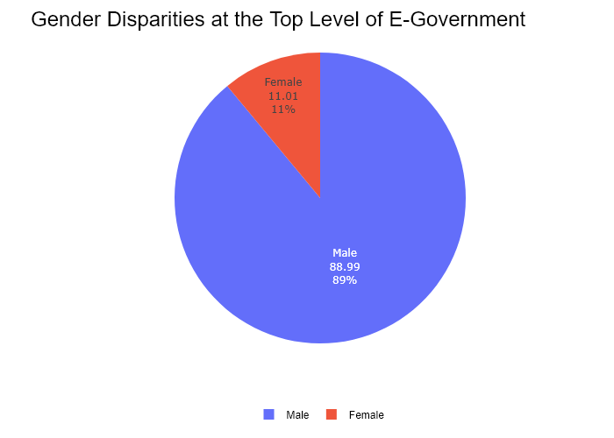

## Performance Metrics

|  |  |  |  |
| --- | --- | --- | --- |
| Task | Model Used | Description | Time Taken (s) |
| Processing Image to JSON | Gemini Vision Pro (default) | Time taken to convert the uploaded image to JSON format | 14.08 |
| Updating JSON | ChatGPT 3.5 (Default) | Time taken to update the JSON with new data | 0.00 |
| Plotting Updated JSON | N/A | Time taken to plot the updated JSON | 5.66 |

# Test Run

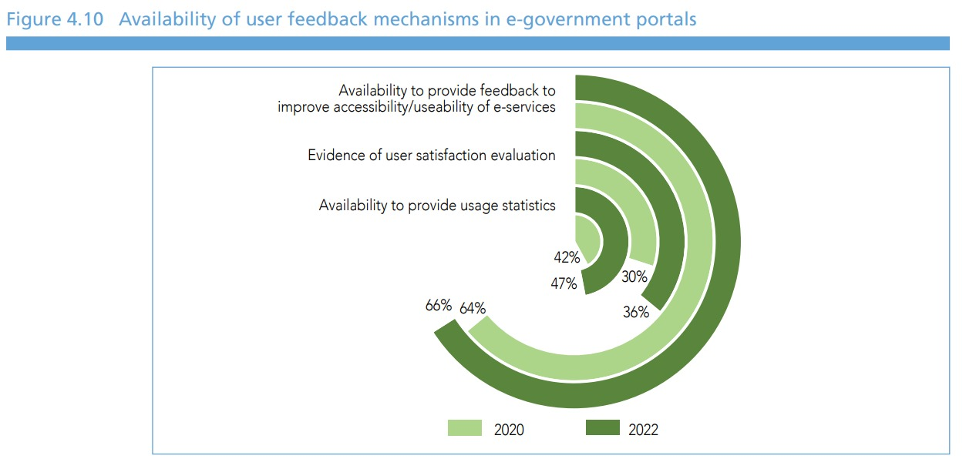

Figure: pie2.jpg

## Prompt Used

Task: Extract detailed information from a given graph image and generate JSON files (data.json, layout.json, and config.json) compatible with Plotly. Use the specified delimiters to wrap each JSON section.  
  
Instructions:  
  
Graph Analysis:  
  
1. Identify and categorize the plot types present in the graph (e.g., line, scatter, bar, pie).  
2. Extract the data points for each plot (x-values, y-values, and any other relevant data such as labels for pie charts).  
3. Note any multiple plots on the same figure and their configurations, ensuring all are included.  
4. Verify that no data points or plots are missing from the extraction.  
  
Generate data.json:  
  
For each plot, include details such as:  
- "type": The type of plot (e.g., scatter, bar, pie).  
- "x" and "y": Arrays of data points for the x and y axes.  
- "labels" and "values": For pie charts.  
- "mode": For line and scatter plots (e.g., markers, lines, or markers+lines).  
- "name": Legend entry for the plot.  
- "marker": Properties such as color, size, and symbol for markers.  
- "line": Properties such as color, width, and dash style for lines.  
- "text": Hover text for each data point.  
- "hoverinfo": Information displayed on hover (e.g., x+y+text).  
  
Generate layout.json:  
  
Include details such as:  
- "title": The title of the graph, including text, font properties (family, size, color).  
- "xaxis" and "yaxis": Configuration including title, range, showgrid, gridcolor, zeroline, zerolinecolor, showticklabels, tickangle, tickfont.  
- "legend": Properties including orientation, x, y, xanchor, font.  
- "margin": Values for l (left), r (right), b (bottom), t (top), pad.  
- "plot_bgcolor" and "paper_bgcolor": Background colors of the plot area and paper.  
  
Generate config.json:  
  
Include configuration settings such as:  
- "responsive": Whether the graph is responsive (boolean).  
- "displayModeBar": Whether the mode bar is displayed (boolean).  
- "modeBarButtonsToRemove": List of mode bar buttons to remove (e.g., ["toImage"]).  
- "scrollZoom": Whether scrolling zoom is enabled (boolean).  
  
Output Format:  
  
Wrap each JSON output in specific XML-like tags:  
- <data> ... </data>  
- <layout> ... </layout>  
- <config> ... </config>  
  
Make sure to follow the JSON formatting guidelines:  
- Double Quotes for Keys and Strings: Ensure that all keys and string values in JSON are enclosed in double quotes (").  
 Example: Instead of "type": bar, it should be "type": "bar".  
- No Trailing Commas: Remove any trailing commas after the last element in arrays ([]) or objects ({}).  
 Example: Instead of "color": "rgba(55, 128, 191, 0.6)",, it should be "color": "rgba(55, 128, 191, 0.6)"  
  
Example Output:  
  
<data>  
[  
 {  
 "type": "scatter",  
 "x": [1, 2, 3],  
 "y": [4, 5, 6],  
 "mode": "markers+lines",  
 "name": "Line Plot",  
 "marker": {  
 "color": "rgba(75, 192, 192, 0.6)",  
 "size": 8  
 },  
 "line": {  
 "color": "rgba(75, 192, 192, 1)",  
 "width": 2  
 },  
 "text": ["Point 1", "Point 2", "Point 3"],  
 "hoverinfo": "x+y+text"  
 }  
 // Additional plots if present  
]  
</data>  
  
<layout>  
{  
 "title": {  
 "text": "Graph Title",  
 "font": {  
 "family": "Arial, sans-serif",  
 "size": 24,  
 "color": "#000000"  
 }  
 },  
 "xaxis": {  
 "title": {  
 "text": "X Axis",  
 "font": {  
 "family": "Arial, sans-serif",  
 "size": 18,  
 "color": "#000000"  
 }  
 },  
 "showgrid": true,  
 "gridcolor": "rgba(0, 0, 0, 0.1)",  
 "zeroline": true,  
 "zerolinecolor": "rgba(0, 0, 0, 0.1)"  
 },  
 "yaxis": {  
 "title": {  
 "text": "Y Axis",  
 "font": {  
 "family": "Arial, sans-serif",  
 "size": 18,  
 "color": "#000000"  
 }  
 },  
 "showgrid": true,  
 "gridcolor": "rgba(0, 0, 0, 0.1)",  
 "zeroline": true,  
 "zerolinecolor": "rgba(0, 0, 0, 0.1)"  
 },  
 "legend": {  
 "orientation": "h",  
 "x": 0.5,  
 "xanchor": "center",  
 "y": -0.2,  
 "font": {  
 "family": "Arial, sans-serif",  
 "size": 12,  
 "color": "#000000"  
 }  
 },  
 "margin": {  
 "l": 60,  
 "r": 30,  
 "b": 60,  
 "t": 60,  
 "pad": 10  
 },  
 "plot_bgcolor": "#ffffff",  
 "paper_bgcolor": "#ffffff"  
}  
</layout>  
  
<config>  
{  
 "responsive": true,  
 "displayModeBar": true,  
 "modeBarButtonsToRemove": ["toImage"],  
 "scrollZoom": true  
}  
</config>

## Extracted JSON

### data

[  
 {  
 "type": "pie",  
 "labels": [  
 "Availability to provide feedback to improve accessibility/usability of e-services",  
 "Evidence of user satisfaction evaluation",  
 "Availability to provide usage statistics"  
 ],  
 "values": [  
 66,  
 47,  
 36  
 ],  
 "textinfo": "label+percent",  
 "hoverinfo": "label+value+percent",  
 "marker": {  
 "colors": [  
 "rgba(158, 202, 109, 0.6)",  
 "rgba(111, 176, 223, 0.6)",  
 "rgba(75, 192, 192, 0.6)"  
 ]  
 },  
 "name": "2020"  
 },  
 {  
 "type": "pie",  
 "labels": [  
 "Availability to provide feedback to improve accessibility/usability of e-services",  
 "Evidence of user satisfaction evaluation",  
 "Availability to provide usage statistics"  
 ],  
 "values": [  
 64,  
 42,  
 30  
 ],  
 "textinfo": "label+percent",  
 "hoverinfo": "label+value+percent",  
 "marker": {  
 "colors": [  
 "rgba(158, 202, 109, 0.6)",  
 "rgba(111, 176, 223, 0.6)",  
 "rgba(75, 192, 192, 0.6)"  
 ]  
 },  
 "name": "2022"  
 }  
]

### layout

{  
 "title": {  
 "text": "Availability of user feedback mechanisms in e-government portals",  
 "font": {  
 "family": "Arial, sans-serif",  
 "size": 24,  
 "color": "#000000"  
 }  
 },  
 "legend": {  
 "orientation": "h",  
 "x": 0.5,  
 "xanchor": "center",  
 "y": -0.2,  
 "font": {  
 "family": "Arial, sans-serif",  
 "size": 12,  
 "color": "#000000"  
 }  
 },  
 "margin": {  
 "l": 60,  
 "r": 30,  
 "b": 60,  
 "t": 60,  
 "pad": 10  
 },  
 "plot_bgcolor": "#ffffff",  
 "paper_bgcolor": "#ffffff"  
}

### config

{  
 "responsive": true,  
 "displayModeBar": true,  
 "modeBarButtonsToRemove": [  
 "toImage"  
 ],  
 "scrollZoom": true  
}

## Updated JSON

### updated_data

[  
 {  
 "type": "pie",  
 "labels": [  
 "Availability to provide feedback to improve accessibility/usability of e-services",  
 "Evidence of user satisfaction evaluation",  
 "Availability to provide usage statistics"  
 ],  
 "values": [  
 66,  
 47,  
 36  
 ],  
 "textinfo": "label+percent",  
 "hoverinfo": "label+value+percent",  
 "marker": {  
 "colors": [  
 "rgba(158, 202, 109, 0.6)",  
 "rgba(111, 176, 223, 0.6)",  
 "rgba(75, 192, 192, 0.6)"  
 ]  
 },  
 "name": "2020"  
 },  
 {  
 "type": "pie",  
 "labels": [  
 "Availability to provide feedback to improve accessibility/usability of e-services",  
 "Evidence of user satisfaction evaluation",  
 "Availability to provide usage statistics"  
 ],  
 "values": [  
 64,  
 42,  
 30  
 ],  
 "textinfo": "label+percent",  
 "hoverinfo": "label+value+percent",  
 "marker": {  
 "colors": [  
 "rgba(158, 202, 109, 0.6)",  
 "rgba(111, 176, 223, 0.6)",  
 "rgba(75, 192, 192, 0.6)"  
 ]  
 },  
 "name": "2022"  
 }  
]

### updated_layout

{  
 "title": {  
 "text": "Availability of user feedback mechanisms in e-government portals",  
 "font": {  
 "family": "Arial, sans-serif",  
 "size": 24,  
 "color": "#000000"  
 }  
 },  
 "legend": {  
 "orientation": "h",  
 "x": 0.5,  
 "xanchor": "center",  
 "y": -0.2,  
 "font": {  
 "family": "Arial, sans-serif",  
 "size": 12,  
 "color": "#000000"  
 }  
 },  
 "margin": {  
 "l": 60,  
 "r": 30,  
 "b": 60,  
 "t": 60,  
 "pad": 10  
 },  
 "plot_bgcolor": "#ffffff",  
 "paper_bgcolor": "#ffffff"  
}

### updated_config

{  
 "responsive": true,  
 "displayModeBar": true,  
 "modeBarButtonsToRemove": [  
 "toImage"  
 ],  
 "scrollZoom": true  
}

## Updated Chart

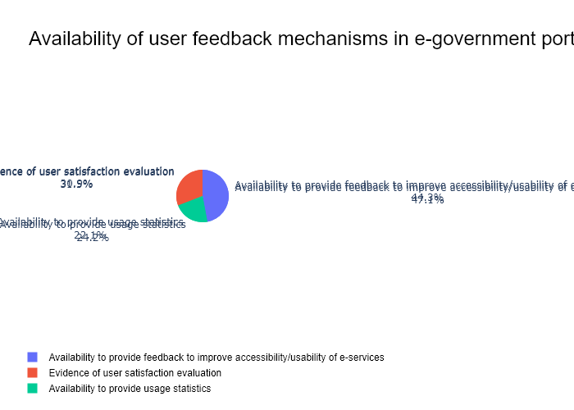

## Performance Metrics

|  |  |  |  |
| --- | --- | --- | --- |
| Task | Model Used | Description | Time Taken (s) |
| Processing Image to JSON | Gemini Vision Pro (default) | Time taken to convert the uploaded image to JSON format | 15.77 |
| Updating JSON | ChatGPT 3.5 (Default) | Time taken to update the JSON with new data | 0.00 |
| Plotting Updated JSON | N/A | Time taken to plot the updated JSON | 0.33 |

# Test Run

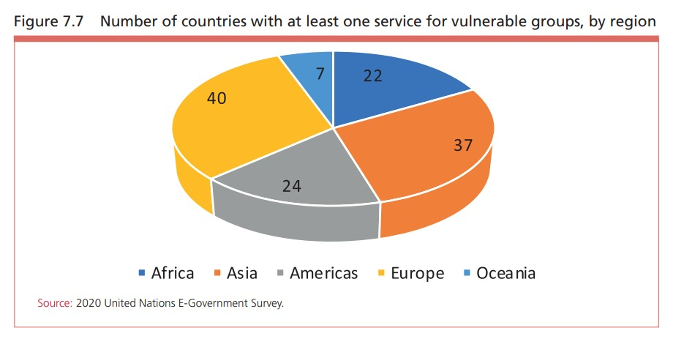

Figure: pie3.jpg

## Prompt Used

Task: Extract detailed information from a given graph image and generate JSON files (data.json, layout.json, and config.json) compatible with Plotly. Use the specified delimiters to wrap each JSON section.  
  
Instructions:  
  
Graph Analysis:  
  
1. Identify and categorize the plot types present in the graph (e.g., line, scatter, bar, pie).  
2. Extract the data points for each plot (x-values, y-values, and any other relevant data such as labels for pie charts).  
3. Note any multiple plots on the same figure and their configurations, ensuring all are included.  
4. Verify that no data points or plots are missing from the extraction.  
  
Generate data.json:  
  
For each plot, include details such as:  
- "type": The type of plot (e.g., scatter, bar, pie).  
- "x" and "y": Arrays of data points for the x and y axes.  
- "labels" and "values": For pie charts.  
- "mode": For line and scatter plots (e.g., markers, lines, or markers+lines).  
- "name": Legend entry for the plot.  
- "marker": Properties such as color, size, and symbol for markers.  
- "line": Properties such as color, width, and dash style for lines.  
- "text": Hover text for each data point.  
- "hoverinfo": Information displayed on hover (e.g., x+y+text).  
  
Generate layout.json:  
  
Include details such as:  
- "title": The title of the graph, including text, font properties (family, size, color).  
- "xaxis" and "yaxis": Configuration including title, range, showgrid, gridcolor, zeroline, zerolinecolor, showticklabels, tickangle, tickfont.  
- "legend": Properties including orientation, x, y, xanchor, font.  
- "margin": Values for l (left), r (right), b (bottom), t (top), pad.  
- "plot_bgcolor" and "paper_bgcolor": Background colors of the plot area and paper.  
  
Generate config.json:  
  
Include configuration settings such as:  
- "responsive": Whether the graph is responsive (boolean).  
- "displayModeBar": Whether the mode bar is displayed (boolean).  
- "modeBarButtonsToRemove": List of mode bar buttons to remove (e.g., ["toImage"]).  
- "scrollZoom": Whether scrolling zoom is enabled (boolean).  
  
Output Format:  
  
Wrap each JSON output in specific XML-like tags:  
- <data> ... </data>  
- <layout> ... </layout>  
- <config> ... </config>  
  
Make sure to follow the JSON formatting guidelines:  
- Double Quotes for Keys and Strings: Ensure that all keys and string values in JSON are enclosed in double quotes (").  
 Example: Instead of "type": bar, it should be "type": "bar".  
- No Trailing Commas: Remove any trailing commas after the last element in arrays ([]) or objects ({}).  
 Example: Instead of "color": "rgba(55, 128, 191, 0.6)",, it should be "color": "rgba(55, 128, 191, 0.6)"  
  
Example Output:  
  
<data>  
[  
 {  
 "type": "scatter",  
 "x": [1, 2, 3],  
 "y": [4, 5, 6],  
 "mode": "markers+lines",  
 "name": "Line Plot",  
 "marker": {  
 "color": "rgba(75, 192, 192, 0.6)",  
 "size": 8  
 },  
 "line": {  
 "color": "rgba(75, 192, 192, 1)",  
 "width": 2  
 },  
 "text": ["Point 1", "Point 2", "Point 3"],  
 "hoverinfo": "x+y+text"  
 }  
 // Additional plots if present  
]  
</data>  
  
<layout>  
{  
 "title": {  
 "text": "Graph Title",  
 "font": {  
 "family": "Arial, sans-serif",  
 "size": 24,  
 "color": "#000000"  
 }  
 },  
 "xaxis": {  
 "title": {  
 "text": "X Axis",  
 "font": {  
 "family": "Arial, sans-serif",  
 "size": 18,  
 "color": "#000000"  
 }  
 },  
 "showgrid": true,  
 "gridcolor": "rgba(0, 0, 0, 0.1)",  
 "zeroline": true,  
 "zerolinecolor": "rgba(0, 0, 0, 0.1)"  
 },  
 "yaxis": {  
 "title": {  
 "text": "Y Axis",  
 "font": {  
 "family": "Arial, sans-serif",  
 "size": 18,  
 "color": "#000000"  
 }  
 },  
 "showgrid": true,  
 "gridcolor": "rgba(0, 0, 0, 0.1)",  
 "zeroline": true,  
 "zerolinecolor": "rgba(0, 0, 0, 0.1)"  
 },  
 "legend": {  
 "orientation": "h",  
 "x": 0.5,  
 "xanchor": "center",  
 "y": -0.2,  
 "font": {  
 "family": "Arial, sans-serif",  
 "size": 12,  
 "color": "#000000"  
 }  
 },  
 "margin": {  
 "l": 60,  
 "r": 30,  
 "b": 60,  
 "t": 60,  
 "pad": 10  
 },  
 "plot_bgcolor": "#ffffff",  
 "paper_bgcolor": "#ffffff"  
}  
</layout>  
  
<config>  
{  
 "responsive": true,  
 "displayModeBar": true,  
 "modeBarButtonsToRemove": ["toImage"],  
 "scrollZoom": true  
}  
</config>

## Extracted JSON

### data

[  
 {  
 "type": "pie",  
 "labels": [  
 "Africa",  
 "Asia",  
 "Americas",  
 "Europe",  
 "Oceania"  
 ],  
 "values": [  
 40,  
 24,  
 7,  
 37,  
 22  
 ],  
 "hoverinfo": "label+value+percent",  
 "textinfo": "label+value+percent",  
 "textposition": "outside",  
 "marker": {  
 "colors": [  
 "rgba(255, 159, 64, 0.6)",  
 "rgba(255, 118, 118, 0.6)",  
 "rgba(255, 204, 128, 0.6)",  
 "rgba(255, 127, 14, 0.6)",  
 "rgba(128, 0, 128, 0.6)"  
 ]  
 }  
 }  
]

### layout

{  
 "title": {  
 "text": "Number of countries with at least one service for vulnerable groups, by region",  
 "font": {  
 "family": "Arial, sans-serif",  
 "size": 24,  
 "color": "#000000"  
 }  
 },  
 "legend": {  
 "orientation": "h",  
 "x": 0.5,  
 "xanchor": "center",  
 "y": -0.2,  
 "font": {  
 "family": "Arial, sans-serif",  
 "size": 12,  
 "color": "#000000"  
 }  
 },  
 "margin": {  
 "l": 60,  
 "r": 30,  
 "b": 60,  
 "t": 60,  
 "pad": 10  
 },  
 "plot_bgcolor": "#ffffff",  
 "paper_bgcolor": "#ffffff"  
}

### config

{  
 "responsive": true,  
 "displayModeBar": true,  
 "modeBarButtonsToRemove": [  
 "toImage"  
 ],  
 "scrollZoom": true  
}

## Updated JSON

### updated_data

[  
 {  
 "type": "pie",  
 "labels": [  
 "Africa",  
 "Asia",  
 "Americas",  
 "Europe",  
 "Oceania"  
 ],  
 "values": [  
 40,  
 24,  
 7,  
 37,  
 22  
 ],  
 "hoverinfo": "label+value+percent",  
 "textinfo": "label+value+percent",  
 "textposition": "outside",  
 "marker": {  
 "colors": [  
 "rgba(255, 159, 64, 0.6)",  
 "rgba(255, 118, 118, 0.6)",  
 "rgba(255, 204, 128, 0.6)",  
 "rgba(255, 127, 14, 0.6)",  
 "rgba(128, 0, 128, 0.6)"  
 ]  
 }  
 }  
]

### updated_layout

{  
 "title": {  
 "text": "Number of countries with at least one service for vulnerable groups, by region",  
 "font": {  
 "family": "Arial, sans-serif",  
 "size": 24,  
 "color": "#000000"  
 }  
 },  
 "legend": {  
 "orientation": "h",  
 "x": 0.5,  
 "xanchor": "center",  
 "y": -0.2,  
 "font": {  
 "family": "Arial, sans-serif",  
 "size": 12,  
 "color": "#000000"  
 }  
 },  
 "margin": {  
 "l": 60,  
 "r": 30,  
 "b": 60,  
 "t": 60,  
 "pad": 10  
 },  
 "plot_bgcolor": "#ffffff",  
 "paper_bgcolor": "#ffffff"  
}

### updated_config

{  
 "responsive": true,  
 "displayModeBar": true,  
 "modeBarButtonsToRemove": [  
 "toImage"  
 ],  
 "scrollZoom": true  
}

## Updated Chart

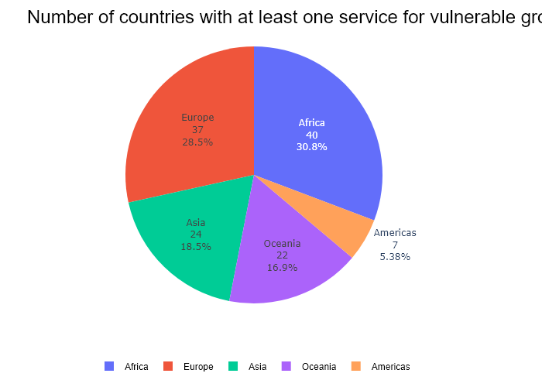

## Performance Metrics

|  |  |  |  |
| --- | --- | --- | --- |
| Task | Model Used | Description | Time Taken (s) |
| Processing Image to JSON | Gemini Vision Pro (default) | Time taken to convert the uploaded image to JSON format | 14.92 |
| Updating JSON | ChatGPT 3.5 (Default) | Time taken to update the JSON with new data | 0.00 |
| Plotting Updated JSON | N/A | Time taken to plot the updated JSON | 0.34 |

# Test Run

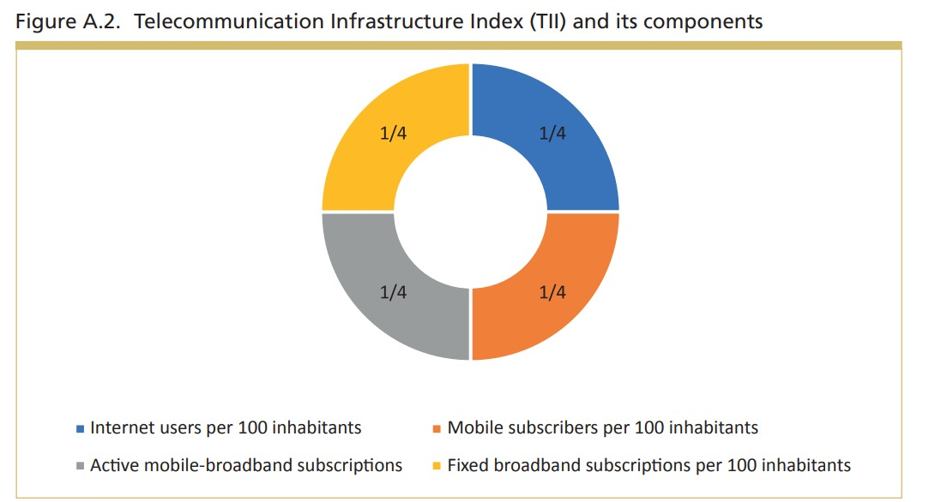

Figure: pie4.jpg

## Prompt Used

Task: Extract detailed information from a given graph image and generate JSON files (data.json, layout.json, and config.json) compatible with Plotly. Use the specified delimiters to wrap each JSON section.  
  
Instructions:  
  
Graph Analysis:  
  
1. Identify and categorize the plot types present in the graph (e.g., line, scatter, bar, pie).  
2. Extract the data points for each plot (x-values, y-values, and any other relevant data such as labels for pie charts).  
3. Note any multiple plots on the same figure and their configurations, ensuring all are included.  
4. Verify that no data points or plots are missing from the extraction.  
  
Generate data.json:  
  
For each plot, include details such as:  
- "type": The type of plot (e.g., scatter, bar, pie).  
- "x" and "y": Arrays of data points for the x and y axes.  
- "labels" and "values": For pie charts.  
- "mode": For line and scatter plots (e.g., markers, lines, or markers+lines).  
- "name": Legend entry for the plot.  
- "marker": Properties such as color, size, and symbol for markers.  
- "line": Properties such as color, width, and dash style for lines.  
- "text": Hover text for each data point.  
- "hoverinfo": Information displayed on hover (e.g., x+y+text).  
  
Generate layout.json:  
  
Include details such as:  
- "title": The title of the graph, including text, font properties (family, size, color).  
- "xaxis" and "yaxis": Configuration including title, range, showgrid, gridcolor, zeroline, zerolinecolor, showticklabels, tickangle, tickfont.  
- "legend": Properties including orientation, x, y, xanchor, font.  
- "margin": Values for l (left), r (right), b (bottom), t (top), pad.  
- "plot_bgcolor" and "paper_bgcolor": Background colors of the plot area and paper.  
  
Generate config.json:  
  
Include configuration settings such as:  
- "responsive": Whether the graph is responsive (boolean).  
- "displayModeBar": Whether the mode bar is displayed (boolean).  
- "modeBarButtonsToRemove": List of mode bar buttons to remove (e.g., ["toImage"]).  
- "scrollZoom": Whether scrolling zoom is enabled (boolean).  
  
Output Format:  
  
Wrap each JSON output in specific XML-like tags:  
- <data> ... </data>  
- <layout> ... </layout>  
- <config> ... </config>  
  
Make sure to follow the JSON formatting guidelines:  
- Double Quotes for Keys and Strings: Ensure that all keys and string values in JSON are enclosed in double quotes (").  
 Example: Instead of "type": bar, it should be "type": "bar".  
- No Trailing Commas: Remove any trailing commas after the last element in arrays ([]) or objects ({}).  
 Example: Instead of "color": "rgba(55, 128, 191, 0.6)",, it should be "color": "rgba(55, 128, 191, 0.6)"  
  
Example Output:  
  
<data>  
[  
 {  
 "type": "scatter",  
 "x": [1, 2, 3],  
 "y": [4, 5, 6],  
 "mode": "markers+lines",  
 "name": "Line Plot",  
 "marker": {  
 "color": "rgba(75, 192, 192, 0.6)",  
 "size": 8  
 },  
 "line": {  
 "color": "rgba(75, 192, 192, 1)",  
 "width": 2  
 },  
 "text": ["Point 1", "Point 2", "Point 3"],  
 "hoverinfo": "x+y+text"  
 }  
 // Additional plots if present  
]  
</data>  
  
<layout>  
{  
 "title": {  
 "text": "Graph Title",  
 "font": {  
 "family": "Arial, sans-serif",  
 "size": 24,  
 "color": "#000000"  
 }  
 },  
 "xaxis": {  
 "title": {  
 "text": "X Axis",  
 "font": {  
 "family": "Arial, sans-serif",  
 "size": 18,  
 "color": "#000000"  
 }  
 },  
 "showgrid": true,  
 "gridcolor": "rgba(0, 0, 0, 0.1)",  
 "zeroline": true,  
 "zerolinecolor": "rgba(0, 0, 0, 0.1)"  
 },  
 "yaxis": {  
 "title": {  
 "text": "Y Axis",  
 "font": {  
 "family": "Arial, sans-serif",  
 "size": 18,  
 "color": "#000000"  
 }  
 },  
 "showgrid": true,  
 "gridcolor": "rgba(0, 0, 0, 0.1)",  
 "zeroline": true,  
 "zerolinecolor": "rgba(0, 0, 0, 0.1)"  
 },  
 "legend": {  
 "orientation": "h",  
 "x": 0.5,  
 "xanchor": "center",  
 "y": -0.2,  
 "font": {  
 "family": "Arial, sans-serif",  
 "size": 12,  
 "color": "#000000"  
 }  
 },  
 "margin": {  
 "l": 60,  
 "r": 30,  
 "b": 60,  
 "t": 60,  
 "pad": 10  
 },  
 "plot_bgcolor": "#ffffff",  
 "paper_bgcolor": "#ffffff"  
}  
</layout>  
  
<config>  
{  
 "responsive": true,  
 "displayModeBar": true,  
 "modeBarButtonsToRemove": ["toImage"],  
 "scrollZoom": true  
}  
</config>

## Extracted JSON

### data

[  
 {  
 "type": "pie",  
 "labels": [  
 "Internet Users",  
 "Mobile Subscribers",  
 "Active Mobile Broadband Subscriptions",  
 "Fixed Broadband Subscriptions"  
 ],  
 "values": [  
 25,  
 25,  
 25,  
 25  
 ],  
 "hoverinfo": "label+value+percent"  
 }  
]

### layout

{  
 "title": {  
 "text": "Telecommunication Infrastructure Index (TII) and its Components",  
 "font": {  
 "family": "Arial, sans-serif",  
 "size": 24,  
 "color": "#000000"  
 }  
 },  
 "legend": {  
 "orientation": "h",  
 "x": 0.5,  
 "xanchor": "center",  
 "y": -0.2,  
 "font": {  
 "family": "Arial, sans-serif",  
 "size": 12,  
 "color": "#000000"  
 }  
 },  
 "margin": {  
 "l": 60,  
 "r": 30,  
 "b": 60,  
 "t": 60,  
 "pad": 10  
 },  
 "plot_bgcolor": "#ffffff",  
 "paper_bgcolor": "#ffffff"  
}

### config

{  
 "responsive": true,  
 "displayModeBar": true,  
 "modeBarButtonsToRemove": [  
 "toImage"  
 ],  
 "scrollZoom": true  
}

## Updated JSON

### updated_data

[  
 {  
 "type": "pie",  
 "labels": [  
 "Internet Users",  
 "Mobile Subscribers",  
 "Active Mobile Broadband Subscriptions",  
 "Fixed Broadband Subscriptions"  
 ],  
 "values": [  
 25,  
 25,  
 25,  
 25  
 ],  
 "hoverinfo": "label+value+percent"  
 }  
]

### updated_layout

{  
 "title": {  
 "text": "Telecommunication Infrastructure Index (TII) and its Components",  
 "font": {  
 "family": "Arial, sans-serif",  
 "size": 24,  
 "color": "#000000"  
 }  
 },  
 "legend": {  
 "orientation": "h",  
 "x": 0.5,  
 "xanchor": "center",  
 "y": -0.2,  
 "font": {  
 "family": "Arial, sans-serif",  
 "size": 12,  
 "color": "#000000"  
 }  
 },  
 "margin": {  
 "l": 60,  
 "r": 30,  
 "b": 60,  
 "t": 60,  
 "pad": 10  
 },  
 "plot_bgcolor": "#ffffff",  
 "paper_bgcolor": "#ffffff"  
}

### updated_config

{  
 "responsive": true,  
 "displayModeBar": true,  
 "modeBarButtonsToRemove": [  
 "toImage"  
 ],  
 "scrollZoom": true  
}

## Updated Chart

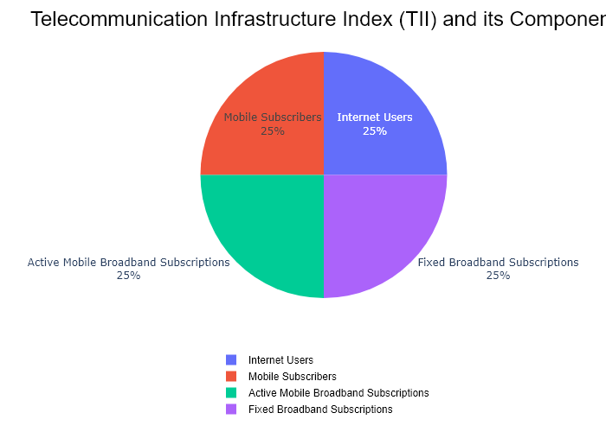

## Performance Metrics

|  |  |  |  |
| --- | --- | --- | --- |
| Task | Model Used | Description | Time Taken (s) |
| Processing Image to JSON | Gemini Vision Pro (default) | Time taken to convert the uploaded image to JSON format | 12.70 |
| Updating JSON | ChatGPT 3.5 (Default) | Time taken to update the JSON with new data | 0.00 |
| Plotting Updated JSON | N/A | Time taken to plot the updated JSON | 0.16 |

# Test Run

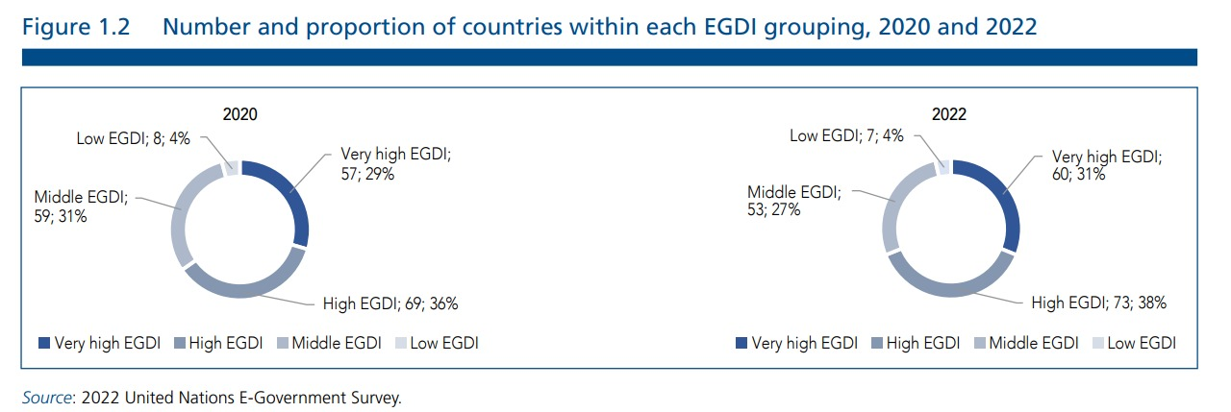

Figure: pie5.jpg

## Prompt Used

Task: Extract detailed information from a given graph image and generate JSON files (data.json, layout.json, and config.json) compatible with Plotly. Use the specified delimiters to wrap each JSON section.  
  
Instructions:  
  
Graph Analysis:  
  
1. Identify and categorize the plot types present in the graph (e.g., line, scatter, bar, pie).  
2. Extract the data points for each plot (x-values, y-values, and any other relevant data such as labels for pie charts).  
3. Note any multiple plots on the same figure and their configurations, ensuring all are included.  
4. Verify that no data points or plots are missing from the extraction.  
  
Generate data.json:  
  
For each plot, include details such as:  
- "type": The type of plot (e.g., scatter, bar, pie).  
- "x" and "y": Arrays of data points for the x and y axes.  
- "labels" and "values": For pie charts.  
- "mode": For line and scatter plots (e.g., markers, lines, or markers+lines).  
- "name": Legend entry for the plot.  
- "marker": Properties such as color, size, and symbol for markers.  
- "line": Properties such as color, width, and dash style for lines.  
- "text": Hover text for each data point.  
- "hoverinfo": Information displayed on hover (e.g., x+y+text).  
  
Generate layout.json:  
  
Include details such as:  
- "title": The title of the graph, including text, font properties (family, size, color).  
- "xaxis" and "yaxis": Configuration including title, range, showgrid, gridcolor, zeroline, zerolinecolor, showticklabels, tickangle, tickfont.  
- "legend": Properties including orientation, x, y, xanchor, font.  
- "margin": Values for l (left), r (right), b (bottom), t (top), pad.  
- "plot_bgcolor" and "paper_bgcolor": Background colors of the plot area and paper.  
  
Generate config.json:  
  
Include configuration settings such as:  
- "responsive": Whether the graph is responsive (boolean).  
- "displayModeBar": Whether the mode bar is displayed (boolean).  
- "modeBarButtonsToRemove": List of mode bar buttons to remove (e.g., ["toImage"]).  
- "scrollZoom": Whether scrolling zoom is enabled (boolean).  
  
Output Format:  
  
Wrap each JSON output in specific XML-like tags:  
- <data> ... </data>  
- <layout> ... </layout>  
- <config> ... </config>  
  
Make sure to follow the JSON formatting guidelines:  
- Double Quotes for Keys and Strings: Ensure that all keys and string values in JSON are enclosed in double quotes (").  
 Example: Instead of "type": bar, it should be "type": "bar".  
- No Trailing Commas: Remove any trailing commas after the last element in arrays ([]) or objects ({}).  
 Example: Instead of "color": "rgba(55, 128, 191, 0.6)",, it should be "color": "rgba(55, 128, 191, 0.6)"  
  
Example Output:  
  
<data>  
[  
 {  
 "type": "scatter",  
 "x": [1, 2, 3],  
 "y": [4, 5, 6],  
 "mode": "markers+lines",  
 "name": "Line Plot",  
 "marker": {  
 "color": "rgba(75, 192, 192, 0.6)",  
 "size": 8  
 },  
 "line": {  
 "color": "rgba(75, 192, 192, 1)",  
 "width": 2  
 },  
 "text": ["Point 1", "Point 2", "Point 3"],  
 "hoverinfo": "x+y+text"  
 }  
 // Additional plots if present  
]  
</data>  
  
<layout>  
{  
 "title": {  
 "text": "Graph Title",  
 "font": {  
 "family": "Arial, sans-serif",  
 "size": 24,  
 "color": "#000000"  
 }  
 },  
 "xaxis": {  
 "title": {  
 "text": "X Axis",  
 "font": {  
 "family": "Arial, sans-serif",  
 "size": 18,  
 "color": "#000000"  
 }  
 },  
 "showgrid": true,  
 "gridcolor": "rgba(0, 0, 0, 0.1)",  
 "zeroline": true,  
 "zerolinecolor": "rgba(0, 0, 0, 0.1)"  
 },  
 "yaxis": {  
 "title": {  
 "text": "Y Axis",  
 "font": {  
 "family": "Arial, sans-serif",  
 "size": 18,  
 "color": "#000000"  
 }  
 },  
 "showgrid": true,  
 "gridcolor": "rgba(0, 0, 0, 0.1)",  
 "zeroline": true,  
 "zerolinecolor": "rgba(0, 0, 0, 0.1)"  
 },  
 "legend": {  
 "orientation": "h",  
 "x": 0.5,  
 "xanchor": "center",  
 "y": -0.2,  
 "font": {  
 "family": "Arial, sans-serif",  
 "size": 12,  
 "color": "#000000"  
 }  
 },  
 "margin": {  
 "l": 60,  
 "r": 30,  
 "b": 60,  
 "t": 60,  
 "pad": 10  
 },  
 "plot_bgcolor": "#ffffff",  
 "paper_bgcolor": "#ffffff"  
}  
</layout>  
  
<config>  
{  
 "responsive": true,  
 "displayModeBar": true,  
 "modeBarButtonsToRemove": ["toImage"],  
 "scrollZoom": true  
}  
</config>

## Extracted JSON

### data

[  
 {  
 "type": "pie",  
 "labels": [  
 "Low",  
 "Middle",  
 "High",  
 "Very High"  
 ],  
 "values": [  
 4,  
 27,  
 38,  
 31  
 ],  
 "hoverinfo": "label+value+percent",  
 "textinfo": "label+value+percent",  
 "textposition": "inside",  
 "name": "2020"  
 },  
 {  
 "type": "pie",  
 "labels": [  
 "Low",  
 "Middle",  
 "High",  
 "Very High"  
 ],  
 "values": [  
 4,  
 27,  
 73,  
 60  
 ],  
 "hoverinfo": "label+value+percent",  
 "textinfo": "label+value+percent",  
 "textposition": "inside",  
 "name": "2022"  
 }  
]

### layout

{  
 "title": {  
 "text": "Number and Proportion of Countries within Each EGDI Grouping, 2020 and 2022",  
 "font": {  
 "family": "Arial, sans-serif",  
 "size": 24,  
 "color": "#000000"  
 }  
 },  
 "legend": {  
 "orientation": "h",  
 "x": 0.5,  
 "xanchor": "center",  
 "y": -0.2,  
 "font": {  
 "family": "Arial, sans-serif",  
 "size": 12,  
 "color": "#000000"  
 }  
 },  
 "margin": {  
 "l": 60,  
 "r": 30,  
 "b": 60,  
 "t": 60,  
 "pad": 10  
 },  
 "plot_bgcolor": "#ffffff",  
 "paper_bgcolor": "#ffffff"  
}

### config

{  
 "responsive": true,  
 "displayModeBar": true,  
 "modeBarButtonsToRemove": [  
 "toImage"  
 ],  
 "scrollZoom": true  
}

## Updated JSON

### updated_data

[  
 {  
 "type": "pie",  
 "labels": [  
 "Low",  
 "Middle",  
 "High",  
 "Very High"  
 ],  
 "values": [  
 4,  
 27,  
 38,  
 31  
 ],  
 "hoverinfo": "label+value+percent",  
 "textinfo": "label+value+percent",  
 "textposition": "inside",  
 "name": "2020"  
 },  
 {  
 "type": "pie",  
 "labels": [  
 "Low",  
 "Middle",  
 "High",  
 "Very High"  
 ],  
 "values": [  
 4,  
 27,  
 73,  
 60  
 ],  
 "hoverinfo": "label+value+percent",  
 "textinfo": "label+value+percent",  
 "textposition": "inside",  
 "name": "2022"  
 }  
]

### updated_layout

{  
 "title": {  
 "text": "Number and Proportion of Countries within Each EGDI Grouping, 2020 and 2022",  
 "font": {  
 "family": "Arial, sans-serif",  
 "size": 24,  
 "color": "#000000"  
 }  
 },  
 "legend": {  
 "orientation": "h",  
 "x": 0.5,  
 "xanchor": "center",  
 "y": -0.2,  
 "font": {  
 "family": "Arial, sans-serif",  
 "size": 12,  
 "color": "#000000"  
 }  
 },  
 "margin": {  
 "l": 60,  
 "r": 30,  
 "b": 60,  
 "t": 60,  
 "pad": 10  
 },  
 "plot_bgcolor": "#ffffff",  
 "paper_bgcolor": "#ffffff"  
}

### updated_config

{  
 "responsive": true,  
 "displayModeBar": true,  
 "modeBarButtonsToRemove": [  
 "toImage"  
 ],  
 "scrollZoom": true  
}

## Updated Chart

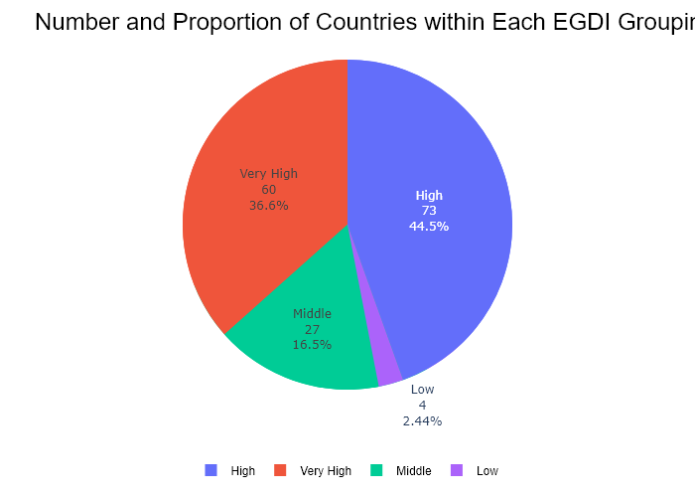

## Performance Metrics

|  |  |  |  |
| --- | --- | --- | --- |
| Task | Model Used | Description | Time Taken (s) |
| Processing Image to JSON | Gemini Vision Pro (default) | Time taken to convert the uploaded image to JSON format | 14.50 |
| Updating JSON | ChatGPT 3.5 (Default) | Time taken to update the JSON with new data | 0.00 |
| Plotting Updated JSON | N/A | Time taken to plot the updated JSON | 0.23 |

# Test Run

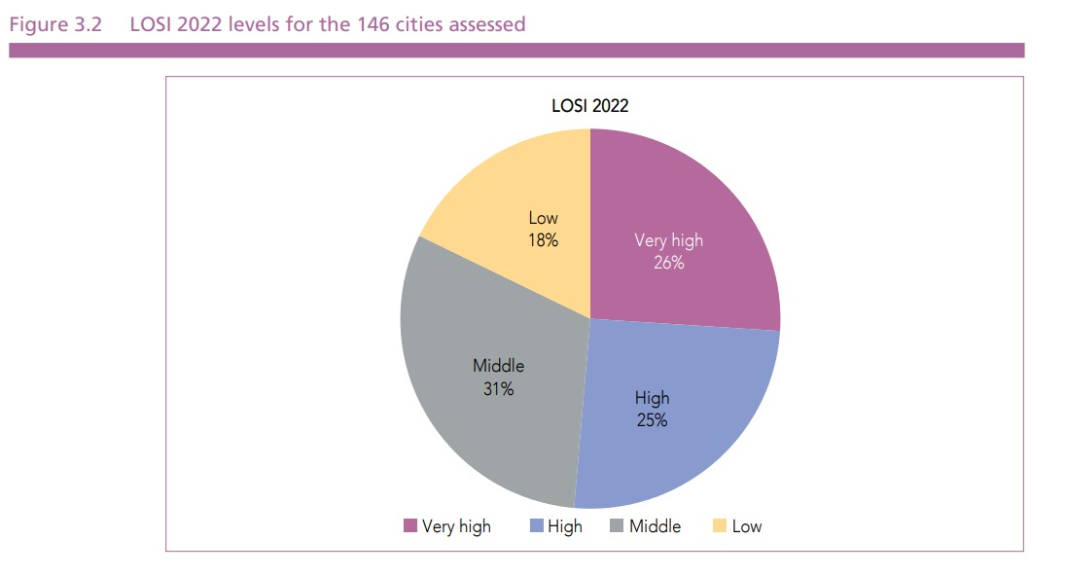

Figure: pie6.jpg

## Prompt Used

Task: Extract detailed information from a given graph image and generate JSON files (data.json, layout.json, and config.json) compatible with Plotly. Use the specified delimiters to wrap each JSON section.  
  
Instructions:  
  
Graph Analysis:  
  
1. Identify and categorize the plot types present in the graph (e.g., line, scatter, bar, pie).  
2. Extract the data points for each plot (x-values, y-values, and any other relevant data such as labels for pie charts).  
3. Note any multiple plots on the same figure and their configurations, ensuring all are included.  
4. Verify that no data points or plots are missing from the extraction.  
  
Generate data.json:  
  
For each plot, include details such as:  
- "type": The type of plot (e.g., scatter, bar, pie).  
- "x" and "y": Arrays of data points for the x and y axes.  
- "labels" and "values": For pie charts.  
- "mode": For line and scatter plots (e.g., markers, lines, or markers+lines).  
- "name": Legend entry for the plot.  
- "marker": Properties such as color, size, and symbol for markers.  
- "line": Properties such as color, width, and dash style for lines.  
- "text": Hover text for each data point.  
- "hoverinfo": Information displayed on hover (e.g., x+y+text).  
  
Generate layout.json:  
  
Include details such as:  
- "title": The title of the graph, including text, font properties (family, size, color).  
- "xaxis" and "yaxis": Configuration including title, range, showgrid, gridcolor, zeroline, zerolinecolor, showticklabels, tickangle, tickfont.  
- "legend": Properties including orientation, x, y, xanchor, font.  
- "margin": Values for l (left), r (right), b (bottom), t (top), pad.  
- "plot_bgcolor" and "paper_bgcolor": Background colors of the plot area and paper.  
  
Generate config.json:  
  
Include configuration settings such as:  
- "responsive": Whether the graph is responsive (boolean).  
- "displayModeBar": Whether the mode bar is displayed (boolean).  
- "modeBarButtonsToRemove": List of mode bar buttons to remove (e.g., ["toImage"]).  
- "scrollZoom": Whether scrolling zoom is enabled (boolean).  
  
Output Format:  
  
Wrap each JSON output in specific XML-like tags:  
- <data> ... </data>  
- <layout> ... </layout>  
- <config> ... </config>  
  
Make sure to follow the JSON formatting guidelines:  
- Double Quotes for Keys and Strings: Ensure that all keys and string values in JSON are enclosed in double quotes (").  
 Example: Instead of "type": bar, it should be "type": "bar".  
- No Trailing Commas: Remove any trailing commas after the last element in arrays ([]) or objects ({}).  
 Example: Instead of "color": "rgba(55, 128, 191, 0.6)",, it should be "color": "rgba(55, 128, 191, 0.6)"  
  
Example Output:  
  
<data>  
[  
 {  
 "type": "scatter",  
 "x": [1, 2, 3],  
 "y": [4, 5, 6],  
 "mode": "markers+lines",  
 "name": "Line Plot",  
 "marker": {  
 "color": "rgba(75, 192, 192, 0.6)",  
 "size": 8  
 },  
 "line": {  
 "color": "rgba(75, 192, 192, 1)",  
 "width": 2  
 },  
 "text": ["Point 1", "Point 2", "Point 3"],  
 "hoverinfo": "x+y+text"  
 }  
 // Additional plots if present  
]  
</data>  
  
<layout>  
{  
 "title": {  
 "text": "Graph Title",  
 "font": {  
 "family": "Arial, sans-serif",  
 "size": 24,  
 "color": "#000000"  
 }  
 },  
 "xaxis": {  
 "title": {  
 "text": "X Axis",  
 "font": {  
 "family": "Arial, sans-serif",  
 "size": 18,  
 "color": "#000000"  
 }  
 },  
 "showgrid": true,  
 "gridcolor": "rgba(0, 0, 0, 0.1)",  
 "zeroline": true,  
 "zerolinecolor": "rgba(0, 0, 0, 0.1)"  
 },  
 "yaxis": {  
 "title": {  
 "text": "Y Axis",  
 "font": {  
 "family": "Arial, sans-serif",  
 "size": 18,  
 "color": "#000000"  
 }  
 },  
 "showgrid": true,  
 "gridcolor": "rgba(0, 0, 0, 0.1)",  
 "zeroline": true,  
 "zerolinecolor": "rgba(0, 0, 0, 0.1)"  
 },  
 "legend": {  
 "orientation": "h",  
 "x": 0.5,  
 "xanchor": "center",  
 "y": -0.2,  
 "font": {  
 "family": "Arial, sans-serif",  
 "size": 12,  
 "color": "#000000"  
 }  
 },  
 "margin": {  
 "l": 60,  
 "r": 30,  
 "b": 60,  
 "t": 60,  
 "pad": 10  
 },  
 "plot_bgcolor": "#ffffff",  
 "paper_bgcolor": "#ffffff"  
}  
</layout>  
  
<config>  
{  
 "responsive": true,  
 "displayModeBar": true,  
 "modeBarButtonsToRemove": ["toImage"],  
 "scrollZoom": true  
}  
</config>

## Extracted JSON

### data

[  
 {  
 "type": "pie",  
 "labels": [  
 "Low",  
 "Middle",  
 "High",  
 "Very high"  
 ],  
 "values": [  
 18,  
 31,  
 25,  
 26  
 ],  
 "hoverinfo": "label+value+percent",  
 "textinfo": "label+value+percent",  
 "marker": {  
 "colors": [  
 "rgba(255, 255, 0, 0.6)",  
 "rgba(128, 128, 128, 0.6)",  
 "rgba(0, 128, 255, 0.6)",  
 "rgba(191, 64, 191, 0.6)"  
 ]  
 }  
 }  
]

### layout

{  
 "title": {  
 "text": "LOSI 2022 levels for the 146 cities assessed",  
 "font": {  
 "family": "Arial, sans-serif",  
 "size": 24,  
 "color": "#000000"  
 }  
 },  
 "legend": {  
 "orientation": "h",  
 "x": 0.5,  
 "xanchor": "center",  
 "y": -0.2,  
 "font": {  
 "family": "Arial, sans-serif",  
 "size": 12,  
 "color": "#000000"  
 }  
 },  
 "margin": {  
 "l": 60,  
 "r": 30,  
 "b": 60,  
 "t": 60,  
 "pad": 10  
 },  
 "plot_bgcolor": "#ffffff",  
 "paper_bgcolor": "#ffffff"  
}

### config

{  
 "responsive": true,  
 "displayModeBar": true,  
 "modeBarButtonsToRemove": [  
 "toImage"  
 ],  
 "scrollZoom": true  
}

## Updated JSON

### updated_data

[  
 {  
 "type": "pie",  
 "labels": [  
 "Low",  
 "Middle",  
 "High",  
 "Very high"  
 ],  
 "values": [  
 18,  
 31,  
 25,  
 26  
 ],  
 "hoverinfo": "label+value+percent",  
 "textinfo": "label+value+percent",  
 "marker": {  
 "colors": [  
 "rgba(255, 255, 0, 0.6)",  
 "rgba(128, 128, 128, 0.6)",  
 "rgba(0, 128, 255, 0.6)",  
 "rgba(191, 64, 191, 0.6)"  
 ]  
 }  
 }  
]

### updated_layout

{  
 "title": {  
 "text": "LOSI 2022 levels for the 146 cities assessed",  
 "font": {  
 "family": "Arial, sans-serif",  
 "size": 24,  
 "color": "#000000"  
 }  
 },  
 "legend": {  
 "orientation": "h",  
 "x": 0.5,  
 "xanchor": "center",  
 "y": -0.2,  
 "font": {  
 "family": "Arial, sans-serif",  
 "size": 12,  
 "color": "#000000"  
 }  
 },  
 "margin": {  
 "l": 60,  
 "r": 30,  
 "b": 60,  
 "t": 60,  
 "pad": 10  
 },  
 "plot_bgcolor": "#ffffff",  
 "paper_bgcolor": "#ffffff"  
}

### updated_config

{  
 "responsive": true,  
 "displayModeBar": true,  
 "modeBarButtonsToRemove": [  
 "toImage"  
 ],  
 "scrollZoom": true  
}

## Updated Chart

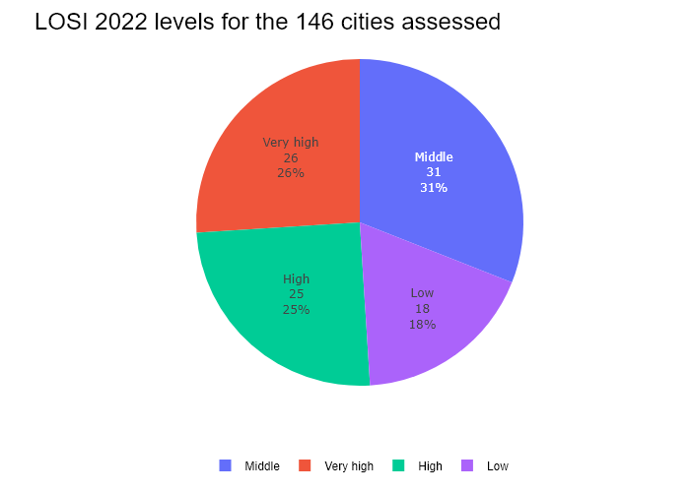

## Performance Metrics

|  |  |  |  |
| --- | --- | --- | --- |
| Task | Model Used | Description | Time Taken (s) |
| Processing Image to JSON | Gemini Vision Pro (default) | Time taken to convert the uploaded image to JSON format | 14.08 |
| Updating JSON | ChatGPT 3.5 (Default) | Time taken to update the JSON with new data | 0.00 |
| Plotting Updated JSON | N/A | Time taken to plot the updated JSON | 0.05 |

# Test Run

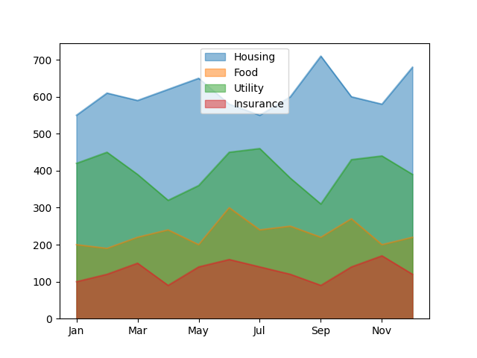

Figure: graphs/Area Plots/areaplot-2.png

## Prompt Used

Task: Extract detailed information from a given graph image and generate JSON files (data.json, layout.json, and config.json) compatible with Plotly. Use the specified delimiters to wrap each JSON section.  
  
Instructions:  
  
Graph Analysis:  
  
1. Identify and categorize the plot types present in the graph:  
 - Common 2D plots: `scatter`, `bar`, `pie`, `area` (as `scatter` with `fill`), `line`, `stacked bar`.  
 - Advanced 3D plots: `scatter3d`, `surface`.  
2. Extract the data points for each plot:  
 - For 2D plots: Extract `x-values`, `y-values`, and any other relevant data (e.g., `labels` for pie charts).  
 - For 3D plots: Extract `x-values`, `y-values`, and `z-values`.  
3. Note any multiple plots on the same figure and their configurations (e.g., colors, stack groups, fill areas).  
  
Generate `data.json`:  
  
For each plot, include details such as:  
- **type**: The type of plot (e.g., `scatter`, `bar`, `pie`, `area`, `scatter3d`, `surface`).  
 - For area charts, use `type: "scatter"` with `fill` specified.  
- **x**, **y**, and **z** (if applicable): Arrays of data points for the `x`, `y`, and `z` axes.  
- **labels** and **values** for pie charts.  
- **mode**: For line and scatter plots (e.g., `markers`, `lines`, `markers+lines`).  
- **name**: Legend entry for the plot.  
- **marker**: Properties such as color, size, and symbol for markers.  
- **line**: Properties such as color, width, and dash style for lines.  
- **text**: Hover text for each data point.  
- **hoverinfo**: Information displayed on hover (e.g., `x+y+text`).  
- **fill**: For area charts, specify the fill (e.g., "tozeroy", "tonexty").  
- **fillcolor**: The color used to fill the area under the line.  
- **stackgroup**: For stacked bar charts, specify the group for stacking.  
  
Generate `layout.json`:  
  
Include details such as:  
- **title**: The title of the graph, including text, font properties (family, size, color).  
- **xaxis** and **yaxis**: Configuration including title, range, showgrid, gridcolor, zeroline, zerolinecolor, showticklabels, tickangle, tickfont.  
- **zaxis**: Configuration for 3D plots including title, range, showgrid, gridcolor, zeroline, zerolinecolor, showticklabels, tickangle, tickfont.  
- **legend**: Properties including orientation, x, y, xanchor, font.  
- **margin**: Values for l (left), r (right), b (bottom), t (top), pad.  
- **plot_bgcolor** and **paper_bgcolor**: Background colors of the plot area and paper.  
- **scene**: For 3D plots, configuration for the 3D scene, including camera angles, lighting, and aspect ratio.  
  
Generate `config.json`:  
  
Include configuration settings such as:  
- **responsive**: Whether the graph is responsive (boolean).  
- **displayModeBar**: Whether the mode bar is displayed (boolean).  
- **modeBarButtonsToRemove**: List of mode bar buttons to remove (e.g., ["toImage"]).  
- **scrollZoom**: Whether scrolling zoom is enabled (boolean).  
  
Output Format:  
  
Wrap each JSON output in specific XML-like tags:  
- `<data> ... </data>`  
- `<layout> ... </layout>`  
- `<config> ... </config>`  
  
Make sure to follow the JSON formatting guidelines:  
- **Double Quotes for Keys and Strings**: Ensure that all keys and string values in JSON are enclosed in double quotes (").  
 - Example: Instead of `"type": bar`, it should be `"type": "bar"`.  
- **No Trailing Commas**: Remove any trailing commas after the last element in arrays ([]) or objects ({}).  
 - Example: Instead of `"color": "rgba(55, 128, 191, 0.6)",`, it should be `"color": "rgba(55, 128, 191, 0.6)"`.  
  
Example Output:  
  
```xml  
<data>  
[  
 {  
 "type": "scatter",  
 "x": [1, 2, 3],  
 "y": [4, 5, 6],  
 "mode": "markers+lines",  
 "name": "Line Plot",  
 "marker": {  
 "color": "rgba(75, 192, 192, 0.6)",  
 "size": 8  
 },  
 "line": {  
 "color": "rgba(75, 192, 192, 1)",  
 "width": 2  
 }  
 },  
 {  
 "type": "bar",  
 "x": ["A", "B", "C"],  
 "y": [10, 15, 13],  
 "name": "Bar Chart",  
 "marker": {  
 "color": "rgba(255, 99, 132, 0.6)"  
 },  
 "hoverinfo": "x+y+text"  
 },  
 {  
 "type": "scatter",  
 "x": [1, 2, 3],  
 "y": [6, 7, 8],  
 "mode": "lines",  
 "fill": "tozeroy",  
 "name": "Area Chart",  
 "line": {  
 "color": "rgba(54, 162, 235, 1)",  
 "width": 2  
 },  
 "fillcolor": "rgba(54, 162, 235, 0.5)"  
 },  
 {  
 "type": "scatter3d",  
 "x": [1, 2, 3],  
 "y": [4, 5, 6],  
 "z": [7, 8, 9],  
 "mode": "markers",  
 "name": "3D Scatter Plot",  
 "marker": {  
 "color": "rgba(255, 159, 64, 0.8)",  
 "size": 5  
 },  
 "hoverinfo": "x+y+z+text"  
 },  
 {  
 "type": "surface",  
 "z": [  
 [10, 10.625, 12.5, 15.625, 20],  
 [5.625, 6.25, 8.125, 11.25, 15.625],  
 [0, 1.25, 3.125, 6.25, 10.625]  
 ],  
 "name": "Surface Plot",  
 "colorscale": "Viridis",  
 "hoverinfo": "z+name"  
 }  
]  
</data>  
<layout>  
{  
 "title": {  
 "text": "Complex Graph Example",  
 "font": {  
 "family": "Arial, sans-serif",  
 "size": 24,  
 "color": "#000000"  
 }  
 },  
 "xaxis": {  
 "title": {  
 "text": "X Axis",  
 "font": {  
 "family": "Arial, sans-serif",  
 "size": 18,  
 "color": "#000000"  
 }  
 },  
 "showgrid": true,  
 "gridcolor": "rgba(0, 0, 0, 0.1)",  
 "zeroline": true,  
 "zerolinecolor": "rgba(0, 0, 0, 0.1)"  
 },  
 "yaxis": {  
 "title": {  
 "text": "Y Axis",  
 "font": {  
 "family": "Arial, sans-serif",  
 "size": 18,  
 "color": "#000000"  
 }  
 },  
 "showgrid": true,  
 "gridcolor": "rgba(0, 0, 0, 0.1)",  
 "zeroline": true,  
 "zerolinecolor": "rgba(0, 0, 0, 0.1)"  
 },  
 "legend": {  
 "orientation": "h",  
 "x": 0.5,  
 "xanchor": "center",  
 "y": -0.2,  
 "font": {  
 "family": "Arial, sans-serif",  
 "size": 12,  
 "color": "#000000"  
 }  
 },  
 "margin": {  
 "l": 60,  
 "r": 30,  
 "b": 60,  
 "t": 60  
 },  
 "plot_bgcolor": "#ffffff",  
 "paper_bgcolor": "#ffffff",  
 "scene": {  
 "xaxis": {"title": "X Axis"},  
 "yaxis": {"title": "Y Axis"},  
 "zaxis": {"title": "Z Axis"}  
 }  
}  
</layout>  
<config>  
{  
 "responsive": true,  
 "displayModeBar": true,  
 "modeBarButtonsToRemove": ["toImage"],  
 "scrollZoom": true  
}  
</config>

## Extracted JSON

### data

[  
 {  
 "type": "scatter",  
 "x": [  
 1,  
 2,  
 3,  
 4,  
 5,  
 6,  
 7,  
 8,  
 9,  
 10,  
 11,  
 12  
 ],  
 "y": [  
 400,  
 430,  
 550,  
 530,  
 580,  
 600,  
 650,  
 680,  
 660,  
 630,  
 600,  
 580  
 ],  
 "name": "Housing",  
 "marker": {  
 "color": "rgba(255, 159, 64, 0.8)"  
 },  
 "hoverinfo": "x+y+text"  
 },  
 {  
 "type": "scatter",  
 "x": [  
 1,  
 2,  
 3,  
 4,  
 5,  
 6,  
 7,  
 8,  
 9,  
 10,  
 11,  
 12  
 ],  
 "y": [  
 200,  
 220,  
 280,  
 250,  
 300,  
 320,  
 350,  
 380,  
 360,  
 330,  
 300,  
 280  
 ],  
 "name": "Food",  
 "marker": {  
 "color": "rgba(255, 99, 132, 0.6)"  
 },  
 "hoverinfo": "x+y+text"  
 },  
 {  
 "type": "scatter",  
 "x": [  
 1,  
 2,  
 3,  
 4,  
 5,  
 6,  
 7,  
 8,  
 9,  
 10,  
 11,  
 12  
 ],  
 "y": [  
 100,  
 120,  
 150,  
 130,  
 180,  
 200,  
 250,  
 280,  
 260,  
 230,  
 200,  
 180  
 ],  
 "name": "Utility",  
 "marker": {  
 "color": "rgba(54, 162, 235, 1)"  
 },  
 "hoverinfo": "x+y+text"  
 },  
 {  
 "type": "scatter",  
 "x": [  
 1,  
 2,  
 3,  
 4,  
 5,  
 6,  
 7,  
 8,  
 9,  
 10,  
 11,  
 12  
 ],  
 "y": [  
 150,  
 180,  
 230,  
 200,  
 250,  
 270,  
 300,  
 330,  
 310,  
 280,  
 250,  
 230  
 ],  
 "name": "Insurance",  
 "marker": {  
 "color": "rgba(75, 192, 192, 0.6)"  
 },  
 "hoverinfo": "x+y+text"  
 }  
]

### layout

{  
 "title": {  
 "text": "Monthly Expenses",  
 "font": {  
 "family": "Arial, sans-serif",  
 "size": 24,  
 "color": "#000000"  
 }  
 },  
 "xaxis": {  
 "title": {  
 "text": "Months",  
 "font": {  
 "family": "Arial, sans-serif",  
 "size": 18,  
 "color": "#000000"  
 }  
 },  
 "showgrid": true,  
 "gridcolor": "rgba(0, 0, 0, 0.1)",  
 "zeroline": true,  
 "zerolinecolor": "rgba(0, 0, 0, 0.1)",  
 "tickangle": 45  
 },  
 "yaxis": {  
 "title": {  
 "text": "Amount ($)",  
 "font": {  
 "family": "Arial, sans-serif",  
 "size": 18,  
 "color": "#000000"  
 }  
 },  
 "showgrid": true,  
 "gridcolor": "rgba(0, 0, 0, 0.1)",  
 "zeroline": true,  
 "zerolinecolor": "rgba(0, 0, 0, 0.1)"  
 },  
 "legend": {  
 "orientation": "h",  
 "x": 0.5,  
 "xanchor": "center",  
 "y": -0.2,  
 "font": {  
 "family": "Arial, sans-serif",  
 "size": 12,  
 "color": "#000000"  
 }  
 },  
 "margin": {  
 "l": 60,  
 "r": 30,  
 "b": 60,  
 "t": 60  
 },  
 "plot_bgcolor": "#ffffff",  
 "paper_bgcolor": "#ffffff"  
}

### config

{  
 "responsive": true,  
 "displayModeBar": true,  
 "modeBarButtonsToRemove": [  
 "toImage"  
 ],  
 "scrollZoom": true  
}

## Updated JSON

### updated_data

[  
 {  
 "type": "scatter",  
 "x": [  
 1,  
 2,  
 3,  
 4,  
 5,  
 6,  
 7,  
 8,  
 9,  
 10,  
 11,  
 12  
 ],  
 "y": [  
 400,  
 430,  
 550,  
 530,  
 580,  
 600,  
 650,  
 680,  
 660,  
 630,  
 600,  
 580  
 ],  
 "name": "Housing",  
 "marker": {  
 "color": "rgba(255, 159, 64, 0.8)"  
 },  
 "hoverinfo": "x+y+text"  
 },  
 {  
 "type": "scatter",  
 "x": [  
 1,  
 2,  
 3,  
 4,  
 5,  
 6,  
 7,  
 8,  
 9,  
 10,  
 11,  
 12  
 ],  
 "y": [  
 200,  
 220,  
 280,  
 250,  
 300,  
 320,  
 350,  
 380,  
 360,  
 330,  
 300,  
 280  
 ],  
 "name": "Food",  
 "marker": {  
 "color": "rgba(255, 99, 132, 0.6)"  
 },  
 "hoverinfo": "x+y+text"  
 },  
 {  
 "type": "scatter",  
 "x": [  
 1,  
 2,  
 3,  
 4,  
 5,  
 6,  
 7,  
 8,  
 9,  
 10,  
 11,  
 12  
 ],  
 "y": [  
 100,  
 120,  
 150,  
 130,  
 180,  
 200,  
 250,  
 280,  
 260,  
 230,  
 200,  
 180  
 ],  
 "name": "Utility",  
 "marker": {  
 "color": "rgba(54, 162, 235, 1)"  
 },  
 "hoverinfo": "x+y+text"  
 },  
 {  
 "type": "scatter",  
 "x": [  
 1,  
 2,  
 3,  
 4,  
 5,  
 6,  
 7,  
 8,  
 9,  
 10,  
 11,  
 12  
 ],  
 "y": [  
 150,  
 180,  
 230,  
 200,  
 250,  
 270,  
 300,  
 330,  
 310,  
 280,  
 250,  
 230  
 ],  
 "name": "Insurance",  
 "marker": {  
 "color": "rgba(75, 192, 192, 0.6)"  
 },  
 "hoverinfo": "x+y+text"  
 }  
]

### updated_layout

{  
 "title": {  
 "text": "Monthly Expenses",  
 "font": {  
 "family": "Arial, sans-serif",  
 "size": 24,  
 "color": "#000000"  
 }  
 },  
 "xaxis": {  
 "title": {  
 "text": "Months",  
 "font": {  
 "family": "Arial, sans-serif",  
 "size": 18,  
 "color": "#000000"  
 }  
 },  
 "showgrid": true,  
 "gridcolor": "rgba(0, 0, 0, 0.1)",  
 "zeroline": true,  
 "zerolinecolor": "rgba(0, 0, 0, 0.1)",  
 "tickangle": 45  
 },  
 "yaxis": {  
 "title": {  
 "text": "Amount ($)",  
 "font": {  
 "family": "Arial, sans-serif",  
 "size": 18,  
 "color": "#000000"  
 }  
 },  
 "showgrid": true,  
 "gridcolor": "rgba(0, 0, 0, 0.1)",  
 "zeroline": true,  
 "zerolinecolor": "rgba(0, 0, 0, 0.1)"  
 },  
 "legend": {  
 "orientation": "h",  
 "x": 0.5,  
 "xanchor": "center",  
 "y": -0.2,  
 "font": {  
 "family": "Arial, sans-serif",  
 "size": 12,  
 "color": "#000000"  
 }  
 },  
 "margin": {  
 "l": 60,  
 "r": 30,  
 "b": 60,  
 "t": 60  
 },  
 "plot_bgcolor": "#ffffff",  
 "paper_bgcolor": "#ffffff"  
}

### updated_config

{  
 "responsive": true,  
 "displayModeBar": true,  
 "modeBarButtonsToRemove": [  
 "toImage"  
 ],  
 "scrollZoom": true  
}

## Updated Chart

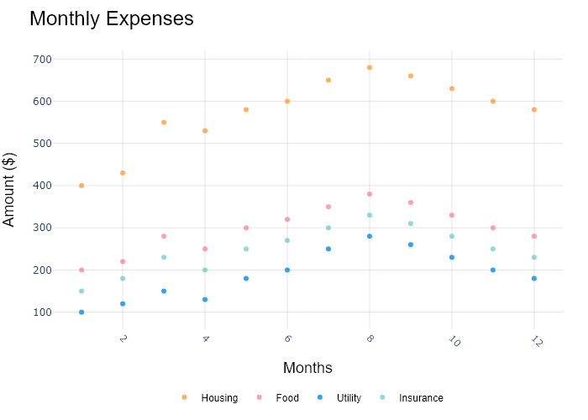

## Performance Metrics

|  |  |  |  |
| --- | --- | --- | --- |
| Task | Model Used | Description | Time Taken (s) |
| Processing Image to JSON | Gemini Vision Pro (default) | Time taken to convert the uploaded image to JSON format | 24.57 |
| Updating JSON | ChatGPT 3.5 (Default) | Time taken to update the JSON with new data | 0.00 |
| Plotting Updated JSON | N/A | Time taken to plot the updated JSON | 0.15 |

# Test Run



Figure: graphs/Area Plots/areaplot-2.png

## Prompt Used

Task: Extract detailed information from a given graph image and generate JSON files (data.json, layout.json, and config.json) compatible with Plotly. Use the specified delimiters to wrap each JSON section.  
  
Instructions:  
  
Graph Analysis:  
  
Identify and categorize the plot types present in the graph (e.g., line, scatter, bar, pie, areaplot etc).  
Extract the data points for each plot (x-values, y-values, and any other relevant data such as labels for pie charts).  
Note any multiple plots on the same figure and their configurations.  
Generate data.json:  
  
For each plot, include details such as:  
type: The type of plot (e.g., scatter, bar, pie).  
x and y: Arrays of data points for the x and y axes.  
labels and values for pie charts.  
mode: For line and scatter plots (e.g., markers, lines, or markers+lines).  
name: Legend entry for the plot.  
marker: Properties such as color, size, and symbol for markers.  
line: Properties such as color, width, and dash style for lines.  
text: Hover text for each data point.  
hoverinfo: Information displayed on hover (e.g., x+y+text).  
Generate layout.json:  
  
Include details such as:  
title: The title of the graph, including text, font properties (family, size, color).  
xaxis and yaxis: Configuration including title, range, showgrid, gridcolor, zeroline, zerolinecolor, showticklabels, tickangle, tickfont.  
legend: Properties including orientation, x, y, xanchor, font.  
margin: Values for l (left), r (right), b (bottom), t (top), pad.  
plot_bgcolor and paper_bgcolor: Background colors of the plot area and paper.  
Generate config.json:  
  
Include configuration settings such as:  
responsive: Whether the graph is responsive (boolean).  
displayModeBar: Whether the mode bar is displayed (boolean).  
modeBarButtonsToRemove: List of mode bar buttons to remove (e.g., ["toImage"]).  
scrollZoom: Whether scrolling zoom is enabled (boolean).  
Output Format:  
  
Wrap each JSON output in specific XML-like tags:  
<data> ... </data>  
<layout> ... </layout>  
<config> ... </config>  
Make sure to follow the JSON formatting guidelines:  
Double Quotes for Keys and Strings: Ensure that all keys and string values in JSON are enclosed in double quotes (").  
Example: Instead of "type": bar, it should be "type": "bar".  
No Trailing Commas: Remove any trailing commas after the last element in arrays ([]) or objects ({}).  
Example: Instead of "color": "rgba(55, 128, 191, 0.6)",, it should be "color": "rgba(55, 128, 191, 0.6)"  
Example Output:  
  
<data>  
[  
 {  
 "type": "scatter",  
 "x": [1, 2, 3],  
 "y": [4, 5, 6],  
 "mode": "markers+lines",  
 "name": "Line Plot",  
 "marker": {  
 "color": "rgba(75, 192, 192, 0.6)",  
 "size": 8  
 },  
 "line": {  
 "color": "rgba(75, 192, 192, 1)",  
 "width": 2  
 }  
 }  
 // Additional plots if present  
]  
</data>  
<layout>  
{  
 "title": {  
 "text": "Graph Title",  
 "font": {  
 "family": "Arial, sans-serif",  
 "size": 24,  
 "color": "#000000"  
 }  
 },  
 "xaxis": {  
 "title": {  
 "text": "X Axis",  
 "font": {  
 "family": "Arial, sans-serif",  
 "size": 18,  
 "color": "#000000"  
 }  
 },  
 "showgrid": true,  
 "gridcolor": "rgba(0, 0, 0, 0.1)",  
 "zeroline": true,  
 "zerolinecolor": "rgba(0, 0, 0, 0.1)"  
 },  
 "yaxis": {  
 "title": {  
 "text": "Y Axis",  
 "font": {  
 "family": "Arial, sans-serif",  
 "size": 18,  
 "color": "#000000"  
 }  
 },  
 "showgrid": true,  
 "gridcolor": "rgba(0, 0, 0, 0.1)",  
 "zeroline": true,  
 "zerolinecolor": "rgba(0, 0, 0, 0.1)"  
 },  
 "legend": {  
 "orientation": "h",  
 "x": 0.5,  
 "xanchor": "center",  
 "y": -0.2,  
 "font": {  
 "family": "Arial, sans-serif",  
 "size": 12,  
 "color": "#000000"  
 }  
 },  
 "margin": {  
 "l": 60,  
 "r": 30,  
 "b": 60,  
 "t": 60  
 },  
 "plot_bgcolor": "#ffffff",  
 "paper_bgcolor": "#ffffff"  
}  
</layout>  
<config>  
{  
 "responsive": true,  
 "displayModeBar": true,  
 "modeBarButtonsToRemove": ["toImage"],  
 "scrollZoom": true  
}  
</config>

## Extracted JSON

### data

[  
 {  
 "type": "scatter",  
 "x": [  
 1,  
 2,  
 3,  
 4,  
 5,  
 6,  
 7,  
 8,  
 9,  
 10,  
 11,  
 12  
 ],  
 "y": [  
 400,  
 430,  
 550,  
 560,  
 600,  
 610,  
 650,  
 660,  
 630,  
 600,  
 580,  
 500  
 ],  
 "mode": "lines",  
 "name": "Housing"  
 },  
 {  
 "type": "scatter",  
 "x": [  
 1,  
 2,  
 3,  
 4,  
 5,  
 6,  
 7,  
 8,  
 9,  
 10,  
 11,  
 12  
 ],  
 "y": [  
 200,  
 220,  
 280,  
 290,  
 330,  
 300,  
 350,  
 360,  
 330,  
 300,  
 280,  
 200  
 ],  
 "mode": "lines",  
 "name": "Food"  
 },  
 {  
 "type": "scatter",  
 "x": [  
 1,  
 2,  
 3,  
 4,  
 5,  
 6,  
 7,  
 8,  
 9,  
 10,  
 11,  
 12  
 ],  
 "y": [  
 100,  
 120,  
 190,  
 200,  
 220,  
 210,  
 250,  
 260,  
 230,  
 200,  
 180,  
 100  
 ],  
 "mode": "lines",  
 "name": "Utility"  
 },  
 {  
 "type": "scatter",  
 "x": [  
 1,  
 2,  
 3,  
 4,  
 5,  
 6,  
 7,  
 8,  
 9,  
 10,  
 11,  
 12  
 ],  
 "y": [  
 150,  
 180,  
 130,  
 150,  
 120,  
 140,  
 100,  
 120,  
 140,  
 120,  
 150,  
 180  
 ],  
 "mode": "lines",  
 "name": "Insurance"  
 }  
]

### layout

{  
 "title": {  
 "text": "Monthly Expenses",  
 "font": {  
 "family": "Arial, sans-serif",  
 "size": 24,  
 "color": "#000000"  
 }  
 },  
 "xaxis": {  
 "title": {  
 "text": "Months",  
 "font": {  
 "family": "Arial, sans-serif",  
 "size": 18,  
 "color": "#000000"  
 }  
 },  
 "showgrid": true,  
 "gridcolor": "rgba(0, 0, 0, 0.1)",  
 "zeroline": true,  
 "zerolinecolor": "rgba(0, 0, 0, 0.1)"  
 },  
 "yaxis": {  
 "title": {  
 "text": "Amount",  
 "font": {  
 "family": "Arial, sans-serif",  
 "size": 18,  
 "color": "#000000"  
 }  
 },  
 "showgrid": true,  
 "gridcolor": "rgba(0, 0, 0, 0.1)",  
 "zeroline": true,  
 "zerolinecolor": "rgba(0, 0, 0, 0.1)"  
 },  
 "legend": {  
 "orientation": "h",  
 "x": 0.5,  
 "xanchor": "center",  
 "y": -0.2,  
 "font": {  
 "family": "Arial, sans-serif",  
 "size": 12,  
 "color": "#000000"  
 }  
 },  
 "margin": {  
 "l": 60,  
 "r": 30,  
 "b": 60,  
 "t": 60  
 },  
 "plot_bgcolor": "#ffffff",  
 "paper_bgcolor": "#ffffff"  
}

### config

{  
 "responsive": true,  
 "displayModeBar": true,  
 "modeBarButtonsToRemove": [  
 "toImage"  
 ],  
 "scrollZoom": true  
}

## Updated JSON

### updated_data

[  
 {  
 "type": "scatter",  
 "x": [  
 1,  
 2,  
 3,  
 4,  
 5,  
 6,  
 7,  
 8,  
 9,  
 10,  
 11,  
 12  
 ],  
 "y": [  
 400,  
 430,  
 550,  
 560,  
 600,  
 610,  
 650,  
 660,  
 630,  
 600,  
 580,  
 500  
 ],  
 "mode": "lines",  
 "name": "Housing"  
 },  
 {  
 "type": "scatter",  
 "x": [  
 1,  
 2,  
 3,  
 4,  
 5,  
 6,  
 7,  
 8,  
 9,  
 10,  
 11,  
 12  
 ],  
 "y": [  
 200,  
 220,  
 280,  
 290,  
 330,  
 300,  
 350,  
 360,  
 330,  
 300,  
 280,  
 200  
 ],  
 "mode": "lines",  
 "name": "Food"  
 },  
 {  
 "type": "scatter",  
 "x": [  
 1,  
 2,  
 3,  
 4,  
 5,  
 6,  
 7,  
 8,  
 9,  
 10,  
 11,  
 12  
 ],  
 "y": [  
 100,  
 120,  
 190,  
 200,  
 220,  
 210,  
 250,  
 260,  
 230,  
 200,  
 180,  
 100  
 ],  
 "mode": "lines",  
 "name": "Utility"  
 },  
 {  
 "type": "scatter",  
 "x": [  
 1,  
 2,  
 3,  
 4,  
 5,  
 6,  
 7,  
 8,  
 9,  
 10,  
 11,  
 12  
 ],  
 "y": [  
 150,  
 180,  
 130,  
 150,  
 120,  
 140,  
 100,  
 120,  
 140,  
 120,  
 150,  
 180  
 ],  
 "mode": "lines",  
 "name": "Insurance"  
 }  
]

### updated_layout

{  
 "title": {  
 "text": "Monthly Expenses",  
 "font": {  
 "family": "Arial, sans-serif",  
 "size": 24,  
 "color": "#000000"  
 }  
 },  
 "xaxis": {  
 "title": {  
 "text": "Months",  
 "font": {  
 "family": "Arial, sans-serif",  
 "size": 18,  
 "color": "#000000"  
 }  
 },  
 "showgrid": true,  
 "gridcolor": "rgba(0, 0, 0, 0.1)",  
 "zeroline": true,  
 "zerolinecolor": "rgba(0, 0, 0, 0.1)"  
 },  
 "yaxis": {  
 "title": {  
 "text": "Amount",  
 "font": {  
 "family": "Arial, sans-serif",  
 "size": 18,  
 "color": "#000000"  
 }  
 },  
 "showgrid": true,  
 "gridcolor": "rgba(0, 0, 0, 0.1)",  
 "zeroline": true,  
 "zerolinecolor": "rgba(0, 0, 0, 0.1)"  
 },  
 "legend": {  
 "orientation": "h",  
 "x": 0.5,  
 "xanchor": "center",  
 "y": -0.2,  
 "font": {  
 "family": "Arial, sans-serif",  
 "size": 12,  
 "color": "#000000"  
 }  
 },  
 "margin": {  
 "l": 60,  
 "r": 30,  
 "b": 60,  
 "t": 60  
 },  
 "plot_bgcolor": "#ffffff",  
 "paper_bgcolor": "#ffffff"  
}

### updated_config

{  
 "responsive": true,  
 "displayModeBar": true,  
 "modeBarButtonsToRemove": [  
 "toImage"  
 ],  
 "scrollZoom": true  
}

## Updated Chart

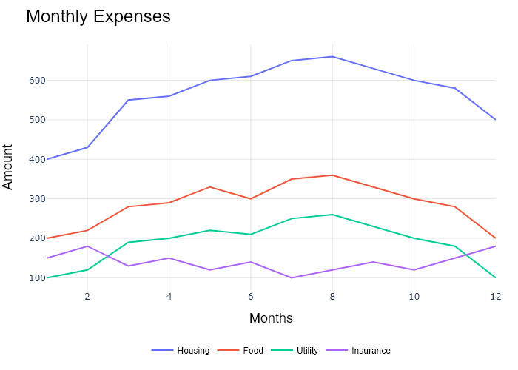

## Performance Metrics

|  |  |  |  |
| --- | --- | --- | --- |
| Task | Model Used | Description | Time Taken (s) |
| Processing Image to JSON | Gemini Vision Pro (default) | Time taken to convert the uploaded image to JSON format | 22.10 |
| Updating JSON | ChatGPT 3.5 (Default) | Time taken to update the JSON with new data | 0.00 |
| Plotting Updated JSON | N/A | Time taken to plot the updated JSON | 0.12 |

# Test Run

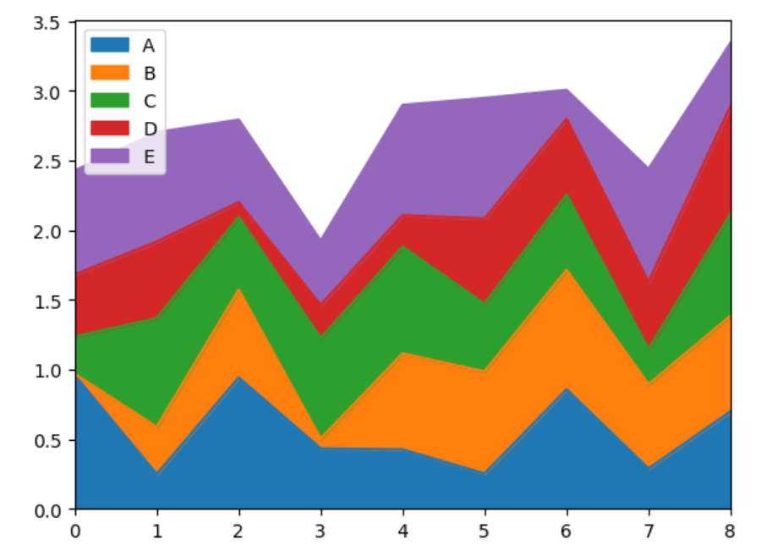

Figure: graphs\Area Plots\Matplotlib-with-Pandas-Area-Plot.png

## Prompt Used

Task: Extract detailed information from a given graph image and generate JSON files (data.json, layout.json, and config.json) compatible with Plotly. Use the specified delimiters to wrap each JSON section.  
  
Instructions:  
  
Graph Analysis:  
  
Identify and categorize the plot types present in the graph (e.g., line, scatter, bar, pie, areaplot etc).  
Extract the data points for each plot (x-values, y-values, and any other relevant data such as labels for pie charts).  
Note any multiple plots on the same figure and their configurations.  
Generate data.json:  
  
For each plot, include details such as:  
type: The type of plot (e.g., scatter, bar, pie).  
x and y: Arrays of data points for the x and y axes.  
labels and values for pie charts.  
mode: For line and scatter plots (e.g., markers, lines, or markers+lines).  
name: Legend entry for the plot.  
marker: Properties such as color, size, and symbol for markers.  
line: Properties such as color, width, and dash style for lines.  
text: Hover text for each data point.  
hoverinfo: Information displayed on hover (e.g., x+y+text).  
Generate layout.json:  
  
Include details such as:  
title: The title of the graph, including text, font properties (family, size, color).  
xaxis and yaxis: Configuration including title, range, showgrid, gridcolor, zeroline, zerolinecolor, showticklabels, tickangle, tickfont.  
legend: Properties including orientation, x, y, xanchor, font.  
margin: Values for l (left), r (right), b (bottom), t (top), pad.  
plot_bgcolor and paper_bgcolor: Background colors of the plot area and paper.  
Generate config.json:  
  
Include configuration settings such as:  
responsive: Whether the graph is responsive (boolean).  
displayModeBar: Whether the mode bar is displayed (boolean).  
modeBarButtonsToRemove: List of mode bar buttons to remove (e.g., ["toImage"]).  
scrollZoom: Whether scrolling zoom is enabled (boolean).  
Output Format:  
  
Wrap each JSON output in specific XML-like tags:  
<data> ... </data>  
<layout> ... </layout>  
<config> ... </config>  
Make sure to follow the JSON formatting guidelines:  
Double Quotes for Keys and Strings: Ensure that all keys and string values in JSON are enclosed in double quotes (").  
Example: Instead of "type": bar, it should be "type": "bar".  
No Trailing Commas: Remove any trailing commas after the last element in arrays ([]) or objects ({}).  
Example: Instead of "color": "rgba(55, 128, 191, 0.6)",, it should be "color": "rgba(55, 128, 191, 0.6)"  
Example Output:  
  
<data>  
[  
 {  
 "type": "scatter",  
 "x": [1, 2, 3],  
 "y": [4, 5, 6],  
 "mode": "markers+lines",  
 "name": "Line Plot",  
 "marker": {  
 "color": "rgba(75, 192, 192, 0.6)",  
 "size": 8  
 },  
 "line": {  
 "color": "rgba(75, 192, 192, 1)",  
 "width": 2  
 }  
 }  
 // Additional plots if present  
]  
</data>  
<layout>  
{  
 "title": {  
 "text": "Graph Title",  
 "font": {  
 "family": "Arial, sans-serif",  
 "size": 24,  
 "color": "#000000"  
 }  
 },  
 "xaxis": {  
 "title": {  
 "text": "X Axis",  
 "font": {  
 "family": "Arial, sans-serif",  
 "size": 18,  
 "color": "#000000"  
 }  
 },  
 "showgrid": true,  
 "gridcolor": "rgba(0, 0, 0, 0.1)",  
 "zeroline": true,  
 "zerolinecolor": "rgba(0, 0, 0, 0.1)"  
 },  
 "yaxis": {  
 "title": {  
 "text": "Y Axis",  
 "font": {  
 "family": "Arial, sans-serif",  
 "size": 18,  
 "color": "#000000"  
 }  
 },  
 "showgrid": true,  
 "gridcolor": "rgba(0, 0, 0, 0.1)",  
 "zeroline": true,  
 "zerolinecolor": "rgba(0, 0, 0, 0.1)"  
 },  
 "legend": {  
 "orientation": "h",  
 "x": 0.5,  
 "xanchor": "center",  
 "y": -0.2,  
 "font": {  
 "family": "Arial, sans-serif",  
 "size": 12,  
 "color": "#000000"  
 }  
 },  
 "margin": {  
 "l": 60,  
 "r": 30,  
 "b": 60,  
 "t": 60  
 },  
 "plot_bgcolor": "#ffffff",  
 "paper_bgcolor": "#ffffff"  
}  
</layout>  
<config>  
{  
 "responsive": true,  
 "displayModeBar": true,  
 "modeBarButtonsToRemove": ["toImage"],  
 "scrollZoom": true  
}  
</config>

## Extracted JSON

### data

[  
 {  
 "type": "scatter",  
 "x": [  
 1,  
 2,  
 3,  
 4,  
 5,  
 6,  
 7,  
 8  
 ],  
 "y": [  
 0.2,  
 0.4,  
 0.6,  
 0.8,  
 1.0,  
 1.2,  
 1.4,  
 1.6  
 ],  
 "mode": "lines",  
 "name": "A"  
 },  
 {  
 "type": "scatter",  
 "x": [  
 1,  
 2,  
 3,  
 4,  
 5,  
 6,  
 7,  
 8  
 ],  
 "y": [  
 1.8,  
 1.6,  
 1.4,  
 1.2,  
 1.0,  
 0.8,  
 0.6,  
 0.4  
 ],  
 "mode": "lines",  
 "name": "B"  
 },  
 {  
 "type": "scatter",  
 "x": [  
 1,  
 2,  
 3,  
 4,  
 5,  
 6,  
 7,  
 8  
 ],  
 "y": [  
 0.8,  
 1.0,  
 1.2,  
 1.4,  
 1.6,  
 1.8,  
 2.0,  
 2.2  
 ],  
 "mode": "lines",  
 "name": "C"  
 },  
 {  
 "type": "scatter",  
 "x": [  
 1,  
 2,  
 3,  
 4,  
 5,  
 6,  
 7,  
 8  
 ],  
 "y": [  
 1.4,  
 1.2,  
 1.0,  
 0.8,  
 0.6,  
 0.4,  
 0.2,  
 0.0  
 ],  
 "mode": "lines",  
 "name": "D"  
 },  
 {  
 "type": "scatter",  
 "x": [  
 1,  
 2,  
 3,  
 4,  
 5,  
 6,  
 7,  
 8  
 ],  
 "y": [  
 2.4,  
 2.2,  
 2.0,  
 1.8,  
 1.6,  
 1.4,  
 1.2,  
 1.0  
 ],  
 "mode": "lines",  
 "name": "E"  
 }  
]

### layout

{  
 "title": {  
 "text": "Area Chart"  
 },  
 "xaxis": {  
 "title": {  
 "text": "Time"  
 }  
 },  
 "yaxis": {  
 "title": {  
 "text": "Value"  
 }  
 },  
 "legend": {  
 "orientation": "h",  
 "y": -0.2  
 }  
}

### config

{  
 "responsive": true  
}

## Updated JSON

### updated_data

[  
 {  
 "type": "scatter",  
 "x": [  
 1,  
 2,  
 3,  
 4,  
 5,  
 6,  
 7,  
 8  
 ],  
 "y": [  
 0.2,  
 0.4,  
 0.6,  
 0.8,  
 1.0,  
 1.2,  
 1.4,  
 1.6  
 ],  
 "mode": "lines",  
 "name": "A"  
 },  
 {  
 "type": "scatter",  
 "x": [  
 1,  
 2,  
 3,  
 4,  
 5,  
 6,  
 7,  
 8  
 ],  
 "y": [  
 1.8,  
 1.6,  
 1.4,  
 1.2,  
 1.0,  
 0.8,  
 0.6,  
 0.4  
 ],  
 "mode": "lines",  
 "name": "B"  
 },  
 {  
 "type": "scatter",  
 "x": [  
 1,  
 2,  
 3,  
 4,  
 5,  
 6,  
 7,  
 8  
 ],  
 "y": [  
 0.8,  
 1.0,  
 1.2,  
 1.4,  
 1.6,  
 1.8,  
 2.0,  
 2.2  
 ],  
 "mode": "lines",  
 "name": "C"  
 },  
 {  
 "type": "scatter",  
 "x": [  
 1,  
 2,  
 3,  
 4,  
 5,  
 6,  
 7,  
 8  
 ],  
 "y": [  
 1.4,  
 1.2,  
 1.0,  
 0.8,  
 0.6,  
 0.4,  
 0.2,  
 0.0  
 ],  
 "mode": "lines",  
 "name": "D"  
 },  
 {  
 "type": "scatter",  
 "x": [  
 1,  
 2,  
 3,  
 4,  
 5,  
 6,  
 7,  
 8  
 ],  
 "y": [  
 2.4,  
 2.2,  
 2.0,  
 1.8,  
 1.6,  
 1.4,  
 1.2,  
 1.0  
 ],  
 "mode": "lines",  
 "name": "E"  
 }  
]

### updated_layout

{  
 "title": {  
 "text": "Area Chart"  
 },  
 "xaxis": {  
 "title": {  
 "text": "Time"  
 }  
 },  
 "yaxis": {  
 "title": {  
 "text": "Value"  
 }  
 },  
 "legend": {  
 "orientation": "h",  
 "y": -0.2  
 }  
}

### updated_config

{  
 "responsive": true  
}

## Updated Chart

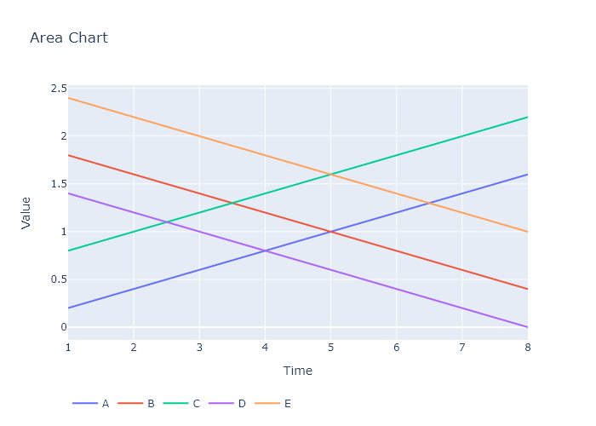

## Performance Metrics

|  |  |  |  |
| --- | --- | --- | --- |
| Task | Model Used | Description | Time Taken (s) |
| Processing Image to JSON | Gemini Vision Pro (default) | Time taken to convert the uploaded image to JSON format | 16.35 |
| Updating JSON | ChatGPT 3.5 (Default) | Time taken to update the JSON with new data | 0.00 |
| Plotting Updated JSON | N/A | Time taken to plot the updated JSON | 0.11 |

# Test Run



Figure: graphs\Area Plots\Matplotlib-with-Pandas-Area-Plot.png

## Prompt Used

Task: Extract detailed information from a given graph image and generate JSON files (data.json, layout.json, and config.json) compatible with Plotly. Use the specified delimiters to wrap each JSON section.  
  
Instructions:  
  
Graph Analysis:  
  
1. Identify and categorize the plot types present in the graph:  
 - Common 2D plots: `scatter`, `bar`, `pie`, `area` (as `scatter` with `fill`)`, `line`, `stacked bar`.  
 - Advanced 3D plots: `scatter3d`, `surface`.  
2. Extract the data points for each plot:  
 - For 2D plots: Extract `x-values`, `y-values`, and any other relevant data (e.g., `labels` for pie charts).  
 - For 3D plots: Extract `x-values`, `y-values`, and `z-values`.  
3. Note any multiple plots on the same figure and their configurations (e.g., colors, stack groups, fill areas).  
  
Generate `data.json`:  
  
For each plot, include details such as:  
- **type**: The type of plot (e.g., `scatter`, `bar`, `pie`, `area`, `scatter3d`, `surface`).  
- **x**, **y**, and **z** (if applicable): Arrays of data points for the `x`, `y`, and `z` axes.  
- **labels** and **values** for pie charts.  
- **mode**: For line and scatter plots (e.g., `markers`, `lines`, `markers+lines`).  
- **name**: Legend entry for the plot.  
- **marker**: Properties such as color, size, and symbol for markers.  
- **line**: Properties such as color, width, and dash style for lines.  
- **text**: Hover text for each data point.  
- **hoverinfo**: Information displayed on hover (e.g., `x+y+text`).  
- **fill**: For area charts, specify the fill (e.g., `tozeroy`).  
- **stackgroup**: For stacked bar charts, specify the group for stacking.  
  
Generate `layout.json`:  
  
Include details such as:  
- **title**: The title of the graph, including text, font properties (family, size, color).  
- **xaxis** and **yaxis**: Configuration including title, range, showgrid, gridcolor, zeroline, zerolinecolor, showticklabels, tickangle, tickfont.  
- **zaxis**: Configuration for 3D plots including title, range, showgrid, gridcolor, zeroline, zerolinecolor, showticklabels, tickangle, tickfont.  
- **legend**: Properties including orientation, x, y, xanchor, font.  
- **margin**: Values for l (left), r (right), b (bottom), t (top), pad.  
- **plot_bgcolor** and **paper_bgcolor**: Background colors of the plot area and paper.  
- **scene**: For 3D plots, configuration for the 3D scene, including camera angles, lighting, and aspect ratio.  
  
Generate `config.json`:  
  
Include configuration settings such as:  
- **responsive**: Whether the graph is responsive (boolean).  
- **displayModeBar**: Whether the mode bar is displayed (boolean).  
- **modeBarButtonsToRemove**: List of mode bar buttons to remove (e.g., ["toImage"]).  
- **scrollZoom**: Whether scrolling zoom is enabled (boolean).  
  
Output Format:  
  
Wrap each JSON output in specific XML-like tags:  
- `<data> ... </data>`  
- `<layout> ... </layout>`  
- `<config> ... </config>`  
  
Make sure to follow the JSON formatting guidelines:  
- **Double Quotes for Keys and Strings**: Ensure that all keys and string values in JSON are enclosed in double quotes (").  
 - Example: Instead of `"type": bar`, it should be `"type": "bar"`.  
- **No Trailing Commas**: Remove any trailing commas after the last element in arrays ([]) or objects ({}).  
 - Example: Instead of `"color": "rgba(55, 128, 191, 0.6)",`, it should be `"color": "rgba(55, 128, 191, 0.6)"`.  
  
Example Output:  
  
```xml  
<data>  
[  
 {  
 "type": "scatter",  
 "x": [1, 2, 3],  
 "y": [4, 5, 6],  
 "mode": "markers+lines",  
 "name": "Line Plot",  
 "marker": {  
 "color": "rgba(75, 192, 192, 0.6)",  
 "size": 8  
 },  
 "line": {  
 "color": "rgba(75, 192, 192, 1)",  
 "width": 2  
 }  
 },  
 {  
 "type": "bar",  
 "x": ["A", "B", "C"],  
 "y": [10, 15, 13],  
 "name": "Bar Chart",  
 "marker": {  
 "color": "rgba(255, 99, 132, 0.6)"  
 },  
 "hoverinfo": "x+y+text"  
 },  
 {  
 "type": "scatter",  
 "x": [1, 2, 3],  
 "y": [6, 7, 8],  
 "mode": "lines",  
 "name": "Area Chart",  
 "fill": "tozeroy",  
 "line": {  
 "color": "rgba(54, 162, 235, 1)",  
 "width": 2  
 }  
 },  
 {  
 "type": "scatter3d",  
 "x": [1, 2, 3],  
 "y": [4, 5, 6],  
 "z": [7, 8, 9],  
 "mode": "markers",  
 "name": "3D Scatter Plot",  
 "marker": {  
 "color": "rgba(255, 159, 64, 0.8)",  
 "size": 5  
 },  
 "hoverinfo": "x+y+z+text"  
 },  
 {  
 "type": "surface",  
 "z": [  
 [10, 10.625, 12.5, 15.625, 20],  
 [5.625, 6.25, 8.125, 11.25, 15.625],  
 [0, 1.25, 3.125, 6.25, 10.625]  
 ],  
 "name": "Surface Plot",  
 "colorscale": "Viridis",  
 "hoverinfo": "z+name"  
 }  
]  
</data>  
<layout>  
{  
 "title": {  
 "text": "Complex Graph Example",  
 "font": {  
 "family": "Arial, sans-serif",  
 "size": 24,  
 "color": "#000000"  
 }  
 },  
 "xaxis": {  
 "title": {  
 "text": "X Axis",  
 "font": {  
 "family": "Arial, sans-serif",  
 "size": 18,  
 "color": "#000000"  
 }  
 },  
 "showgrid": true,  
 "gridcolor": "rgba(0, 0, 0, 0.1)",  
 "zeroline": true,  
 "zerolinecolor": "rgba(0, 0, 0, 0.1)"  
 },  
 "yaxis": {  
 "title": {  
 "text": "Y Axis",  
 "font": {  
 "family": "Arial, sans-serif",  
 "size": 18,  
 "color": "#000000"  
 }  
 },  
 "showgrid": true,  
 "gridcolor": "rgba(0, 0, 0, 0.1)",  
 "zeroline": true,  
 "zerolinecolor": "rgba(0, 0, 0, 0.1)"  
 },  
 "legend": {  
 "orientation": "h",  
 "x": 0.5,  
 "xanchor": "center",  
 "y": -0.2,  
 "font": {  
 "family": "Arial, sans-serif",  
 "size": 12,  
 "color": "#000000"  
 }  
 },  
 "margin": {  
 "l": 60,  
 "r": 30,  
 "b": 60,  
 "t": 60  
 },  
 "plot_bgcolor": "#ffffff",  
 "paper_bgcolor": "#ffffff",  
 "scene": {  
 "xaxis": {"title": "X Axis"},  
 "yaxis": {"title": "Y Axis"},  
 "zaxis": {"title": "Z Axis"}  
 }  
}  
</layout>  
<config>  
{  
 "responsive": true,  
 "displayModeBar": true,  
 "modeBarButtonsToRemove": ["toImage"],  
 "scrollZoom": true  
}  
</config>

## Extracted JSON

### data

[  
 {  
 "type": "scatter",  
 "x": [  
 1,  
 2,  
 3,  
 4,  
 5,  
 6,  
 7,  
 8  
 ],  
 "y": [  
 0.2,  
 0.5,  
 1.1,  
 2.0,  
 1.8,  
 2.2,  
 1.5,  
 3.3  
 ],  
 "name": "A"  
 },  
 {  
 "type": "scatter",  
 "x": [  
 1,  
 2,  
 3,  
 4,  
 5,  
 6,  
 7,  
 8  
 ],  
 "y": [  
 0.1,  
 0.3,  
 0.7,  
 1.5,  
 1.3,  
 1.7,  
 1.1,  
 2.7  
 ],  
 "name": "B"  
 },  
 {  
 "type": "scatter",  
 "x": [  
 1,  
 2,  
 3,  
 4,  
 5,  
 6,  
 7,  
 8  
 ],  
 "y": [  
 0.3,  
 0.6,  
 1.3,  
 2.2,  
 2.0,  
 2.4,  
 1.7,  
 3.5  
 ],  
 "name": "C"  
 },  
 {  
 "type": "scatter",  
 "x": [  
 1,  
 2,  
 3,  
 4,  
 5,  
 6,  
 7,  
 8  
 ],  
 "y": [  
 0.4,  
 0.8,  
 1.5,  
 2.4,  
 2.2,  
 2.6,  
 1.9,  
 3.7  
 ],  
 "name": "D"  
 },  
 {  
 "type": "scatter",  
 "x": [  
 1,  
 2,  
 3,  
 4,  
 5,  
 6,  
 7,  
 8  
 ],  
 "y": [  
 0.5,  
 1.0,  
 1.7,  
 2.6,  
 2.4,  
 2.8,  
 2.1,  
 3.9  
 ],  
 "name": "E"  
 }  
]

### layout

{  
 "title": {  
 "text": "Area Chart"  
 },  
 "xaxis": {  
 "title": {  
 "text": "Time"  
 }  
 },  
 "yaxis": {  
 "title": {  
 "text": "Value"  
 }  
 },  
 "legend": {  
 "orientation": "h",  
 "y": -0.5  
 }  
}

### config

{  
 "responsive": true  
}

## Updated JSON

### updated_data

[  
 {  
 "type": "scatter",  
 "x": [  
 1,  
 2,  
 3,  
 4,  
 5,  
 6,  
 7,  
 8  
 ],  
 "y": [  
 0.2,  
 0.5,  
 1.1,  
 2.0,  
 1.8,  
 2.2,  
 1.5,  
 3.3  
 ],  
 "name": "A"  
 },  
 {  
 "type": "scatter",  
 "x": [  
 1,  
 2,  
 3,  
 4,  
 5,  
 6,  
 7,  
 8  
 ],  
 "y": [  
 0.1,  
 0.3,  
 0.7,  
 1.5,  
 1.3,  
 1.7,  
 1.1,  
 2.7  
 ],  
 "name": "B"  
 },  
 {  
 "type": "scatter",  
 "x": [  
 1,  
 2,  
 3,  
 4,  
 5,  
 6,  
 7,  
 8  
 ],  
 "y": [  
 0.3,  
 0.6,  
 1.3,  
 2.2,  
 2.0,  
 2.4,  
 1.7,  
 3.5  
 ],  
 "name": "C"  
 },  
 {  
 "type": "scatter",  
 "x": [  
 1,  
 2,  
 3,  
 4,  
 5,  
 6,  
 7,  
 8  
 ],  
 "y": [  
 0.4,  
 0.8,  
 1.5,  
 2.4,  
 2.2,  
 2.6,  
 1.9,  
 3.7  
 ],  
 "name": "D"  
 },  
 {  
 "type": "scatter",  
 "x": [  
 1,  
 2,  
 3,  
 4,  
 5,  
 6,  
 7,  
 8  
 ],  
 "y": [  
 0.5,  
 1.0,  
 1.7,  
 2.6,  
 2.4,  
 2.8,  
 2.1,  
 3.9  
 ],  
 "name": "E"  
 }  
]

### updated_layout

{  
 "title": {  
 "text": "Area Chart"  
 },  
 "xaxis": {  
 "title": {  
 "text": "Time"  
 }  
 },  
 "yaxis": {  
 "title": {  
 "text": "Value"  
 }  
 },  
 "legend": {  
 "orientation": "h",  
 "y": -0.5  
 }  
}

### updated_config

{  
 "responsive": true  
}

## Updated Chart

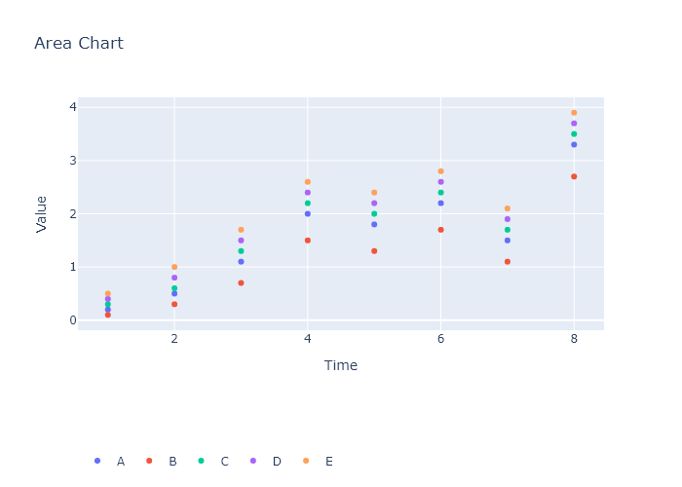

## Performance Metrics

|  |  |  |  |
| --- | --- | --- | --- |
| Task | Model Used | Description | Time Taken (s) |
| Processing Image to JSON | Gemini Vision Pro (default) | Time taken to convert the uploaded image to JSON format | 15.68 |
| Updating JSON | ChatGPT 3.5 (Default) | Time taken to update the JSON with new data | 0.00 |
| Plotting Updated JSON | N/A | Time taken to plot the updated JSON | 0.12 |

# Test Run



Figure: graphs\Area Plots\Matplotlib-with-Pandas-Area-Plot.png

## Prompt Used

Task: Extract detailed information from a given graph image and generate JSON files (data.json, layout.json, and config.json) compatible with Plotly. Use the specified delimiters to wrap each JSON section.  
  
Instructions:  
  
Graph Analysis:  
  
1. Identify and categorize the plot types present in the graph:  
 - Common 2D plots: `scatter`, `bar`, `pie`, `area` (as `scatter` with `fill`), `line`, `stacked bar`.  
 - Advanced 3D plots: `scatter3d`, `surface`.  
2. Extract the data points for each plot:  
 - For 2D plots: Extract `x-values`, `y-values`, and any other relevant data (e.g., `labels` for pie charts).  
 - For 3D plots: Extract `x-values`, `y-values`, and `z-values`.  
3. Note any multiple plots on the same figure and their configurations (e.g., colors, stack groups, fill areas).  
  
Generate `data.json`:  
  
For each plot, include details such as:  
- **type**: The type of plot (e.g., `scatter`, `bar`, `pie`, `area`, `scatter3d`, `surface`).  
 - For area charts, use `type: "scatter"` with `fill` specified.  
- **x**, **y**, and **z** (if applicable): Arrays of data points for the `x`, `y`, and `z` axes.  
- **labels** and **values** for pie charts.  
- **mode**: For line and scatter plots (e.g., `markers`, `lines`, `markers+lines`).  
- **name**: Legend entry for the plot.  
- **marker**: Properties such as color, size, and symbol for markers.  
- **line**: Properties such as color, width, and dash style for lines.  
- **text**: Hover text for each data point.  
- **hoverinfo**: Information displayed on hover (e.g., `x+y+text`).  
- **fill**: For area charts, specify the fill (e.g., "tozeroy", "tonexty").  
- **fillcolor**: The color used to fill the area under the line.  
- **stackgroup**: For stacked bar charts, specify the group for stacking.  
  
Generate `layout.json`:  
  
Include details such as:  
- **title**: The title of the graph, including text, font properties (family, size, color).  
- **xaxis** and **yaxis**: Configuration including title, range, showgrid, gridcolor, zeroline, zerolinecolor, showticklabels, tickangle, tickfont.  
- **zaxis**: Configuration for 3D plots including title, range, showgrid, gridcolor, zeroline, zerolinecolor, showticklabels, tickangle, tickfont.  
- **legend**: Properties including orientation, x, y, xanchor, font.  
- **margin**: Values for l (left), r (right), b (bottom), t (top), pad.  
- **plot_bgcolor** and **paper_bgcolor**: Background colors of the plot area and paper.  
- **scene**: For 3D plots, configuration for the 3D scene, including camera angles, lighting, and aspect ratio.  
  
Generate `config.json`:  
  
Include configuration settings such as:  
- **responsive**: Whether the graph is responsive (boolean).  
- **displayModeBar**: Whether the mode bar is displayed (boolean).  
- **modeBarButtonsToRemove**: List of mode bar buttons to remove (e.g., ["toImage"]).  
- **scrollZoom**: Whether scrolling zoom is enabled (boolean).  
  
Output Format:  
  
Wrap each JSON output in specific XML-like tags:  
- `<data> ... </data>`  
- `<layout> ... </layout>`  
- `<config> ... </config>`  
  
Make sure to follow the JSON formatting guidelines:  
- **Double Quotes for Keys and Strings**: Ensure that all keys and string values in JSON are enclosed in double quotes (").  
 - Example: Instead of `"type": bar`, it should be `"type": "bar"`.  
- **No Trailing Commas**: Remove any trailing commas after the last element in arrays ([]) or objects ({}).  
 - Example: Instead of `"color": "rgba(55, 128, 191, 0.6)",`, it should be `"color": "rgba(55, 128, 191, 0.6)"`.  
  
Example Output:  
  
```xml  
<data>  
[  
 {  
 "type": "scatter",  
 "x": [1, 2, 3],  
 "y": [4, 5, 6],  
 "mode": "markers+lines",  
 "name": "Line Plot",  
 "marker": {  
 "color": "rgba(75, 192, 192, 0.6)",  
 "size": 8  
 },  
 "line": {  
 "color": "rgba(75, 192, 192, 1)",  
 "width": 2  
 }  
 },  
 {  
 "type": "bar",  
 "x": ["A", "B", "C"],  
 "y": [10, 15, 13],  
 "name": "Bar Chart",  
 "marker": {  
 "color": "rgba(255, 99, 132, 0.6)"  
 },  
 "hoverinfo": "x+y+text"  
 },  
 {  
 "type": "scatter",  
 "x": [1, 2, 3],  
 "y": [6, 7, 8],  
 "mode": "lines",  
 "fill": "tozeroy",  
 "name": "Area Chart",  
 "line": {  
 "color": "rgba(54, 162, 235, 1)",  
 "width": 2  
 },  
 "fillcolor": "rgba(54, 162, 235, 0.5)"  
 },  
 {  
 "type": "scatter3d",  
 "x": [1, 2, 3],  
 "y": [4, 5, 6],  
 "z": [7, 8, 9],  
 "mode": "markers",  
 "name": "3D Scatter Plot",  
 "marker": {  
 "color": "rgba(255, 159, 64, 0.8)",  
 "size": 5  
 },  
 "hoverinfo": "x+y+z+text"  
 },  
 {  
 "type": "surface",  
 "z": [  
 [10, 10.625, 12.5, 15.625, 20],  
 [5.625, 6.25, 8.125, 11.25, 15.625],  
 [0, 1.25, 3.125, 6.25, 10.625]  
 ],  
 "name": "Surface Plot",  
 "colorscale": "Viridis",  
 "hoverinfo": "z+name"  
 }  
]  
</data>  
<layout>  
{  
 "title": {  
 "text": "Complex Graph Example",  
 "font": {  
 "family": "Arial, sans-serif",  
 "size": 24,  
 "color": "#000000"  
 }  
 },  
 "xaxis": {  
 "title": {  
 "text": "X Axis",  
 "font": {  
 "family": "Arial, sans-serif",  
 "size": 18,  
 "color": "#000000"  
 }  
 },  
 "showgrid": true,  
 "gridcolor": "rgba(0, 0, 0, 0.1)",  
 "zeroline": true,  
 "zerolinecolor": "rgba(0, 0, 0, 0.1)"  
 },  
 "yaxis": {  
 "title": {  
 "text": "Y Axis",  
 "font": {  
 "family": "Arial, sans-serif",  
 "size": 18,  
 "color": "#000000"  
 }  
 },  
 "showgrid": true,  
 "gridcolor": "rgba(0, 0, 0, 0.1)",  
 "zeroline": true,  
 "zerolinecolor": "rgba(0, 0, 0, 0.1)"  
 },  
 "legend": {  
 "orientation": "h",  
 "x": 0.5,  
 "xanchor": "center",  
 "y": -0.2,  
 "font": {  
 "family": "Arial, sans-serif",  
 "size": 12,  
 "color": "#000000"  
 }  
 },  
 "margin": {  
 "l": 60,  
 "r": 30,  
 "b": 60,  
 "t": 60  
 },  
 "plot_bgcolor": "#ffffff",  
 "paper_bgcolor": "#ffffff",  
 "scene": {  
 "xaxis": {"title": "X Axis"},  
 "yaxis": {"title": "Y Axis"},  
 "zaxis": {"title": "Z Axis"}  
 }  
}  
</layout>  
<config>  
{  
 "responsive": true,  
 "displayModeBar": true,  
 "modeBarButtonsToRemove": ["toImage"],  
 "scrollZoom": true  
}  
</config>

## Extracted JSON

### data

[  
 {  
 "type": "scatter",  
 "x": [  
 1,  
 2,  
 3,  
 4,  
 5,  
 6,  
 7,  
 8  
 ],  
 "y": [  
 0.2,  
 0.5,  
 1.1,  
 2.0,  
 1.8,  
 2.2,  
 1.5,  
 3.3  
 ],  
 "name": "A"  
 },  
 {  
 "type": "scatter",  
 "x": [  
 1,  
 2,  
 3,  
 4,  
 5,  
 6,  
 7,  
 8  
 ],  
 "y": [  
 0.1,  
 0.3,  
 0.7,  
 1.2,  
 1.1,  
 1.5,  
 1.0,  
 2.5  
 ],  
 "name": "B"  
 },  
 {  
 "type": "scatter",  
 "x": [  
 1,  
 2,  
 3,  
 4,  
 5,  
 6,  
 7,  
 8  
 ],  
 "y": [  
 0.3,  
 0.6,  
 1.3,  
 2.4,  
 2.2,  
 2.6,  
 1.8,  
 3.7  
 ],  
 "name": "C"  
 },  
 {  
 "type": "scatter",  
 "x": [  
 1,  
 2,  
 3,  
 4,  
 5,  
 6,  
 7,  
 8  
 ],  
 "y": [  
 0.0,  
 0.2,  
 0.5,  
 1.0,  
 0.9,  
 1.2,  
 0.8,  
 2.0  
 ],  
 "name": "D"  
 },  
 {  
 "type": "scatter",  
 "x": [  
 1,  
 2,  
 3,  
 4,  
 5,  
 6,  
 7,  
 8  
 ],  
 "y": [  
 0.4,  
 0.8,  
 1.5,  
 2.6,  
 2.4,  
 2.8,  
 2.0,  
 3.9  
 ],  
 "name": "E"  
 }  
]

### layout

{  
 "title": {  
 "text": "Area Chart"  
 },  
 "xaxis": {  
 "title": {  
 "text": "Time"  
 }  
 },  
 "yaxis": {  
 "title": {  
 "text": "Value"  
 }  
 },  
 "legend": {  
 "orientation": "h",  
 "y": -0.5  
 }  
}

### config

{  
 "responsive": true  
}

## Updated JSON

### updated_data

[  
 {  
 "type": "scatter",  
 "x": [  
 1,  
 2,  
 3,  
 4,  
 5,  
 6,  
 7,  
 8  
 ],  
 "y": [  
 0.2,  
 0.5,  
 1.1,  
 2.0,  
 1.8,  
 2.2,  
 1.5,  
 3.3  
 ],  
 "name": "A"  
 },  
 {  
 "type": "scatter",  
 "x": [  
 1,  
 2,  
 3,  
 4,  
 5,  
 6,  
 7,  
 8  
 ],  
 "y": [  
 0.1,  
 0.3,  
 0.7,  
 1.2,  
 1.1,  
 1.5,  
 1.0,  
 2.5  
 ],  
 "name": "B"  
 },  
 {  
 "type": "scatter",  
 "x": [  
 1,  
 2,  
 3,  
 4,  
 5,  
 6,  
 7,  
 8  
 ],  
 "y": [  
 0.3,  
 0.6,  
 1.3,  
 2.4,  
 2.2,  
 2.6,  
 1.8,  
 3.7  
 ],  
 "name": "C"  
 },  
 {  
 "type": "scatter",  
 "x": [  
 1,  
 2,  
 3,  
 4,  
 5,  
 6,  
 7,  
 8  
 ],  
 "y": [  
 0.0,  
 0.2,  
 0.5,  
 1.0,  
 0.9,  
 1.2,  
 0.8,  
 2.0  
 ],  
 "name": "D"  
 },  
 {  
 "type": "scatter",  
 "x": [  
 1,  
 2,  
 3,  
 4,  
 5,  
 6,  
 7,  
 8  
 ],  
 "y": [  
 0.4,  
 0.8,  
 1.5,  
 2.6,  
 2.4,  
 2.8,  
 2.0,  
 3.9  
 ],  
 "name": "E"  
 }  
]

### updated_layout

{  
 "title": {  
 "text": "Area Chart"  
 },  
 "xaxis": {  
 "title": {  
 "text": "Time"  
 }  
 },  
 "yaxis": {  
 "title": {  
 "text": "Value"  
 }  
 },  
 "legend": {  
 "orientation": "h",  
 "y": -0.5  
 }  
}

### updated_config

{  
 "responsive": true  
}

## Updated Chart

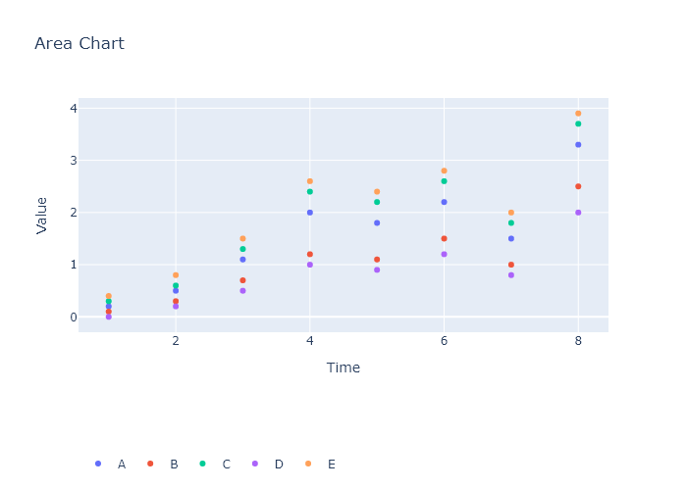

## Performance Metrics

|  |  |  |  |
| --- | --- | --- | --- |
| Task | Model Used | Description | Time Taken (s) |
| Processing Image to JSON | Gemini Vision Pro (default) | Time taken to convert the uploaded image to JSON format | 15.77 |
| Updating JSON | ChatGPT 3.5 (Default) | Time taken to update the JSON with new data | 0.00 |
| Plotting Updated JSON | N/A | Time taken to plot the updated JSON | 0.11 |

# Test Run

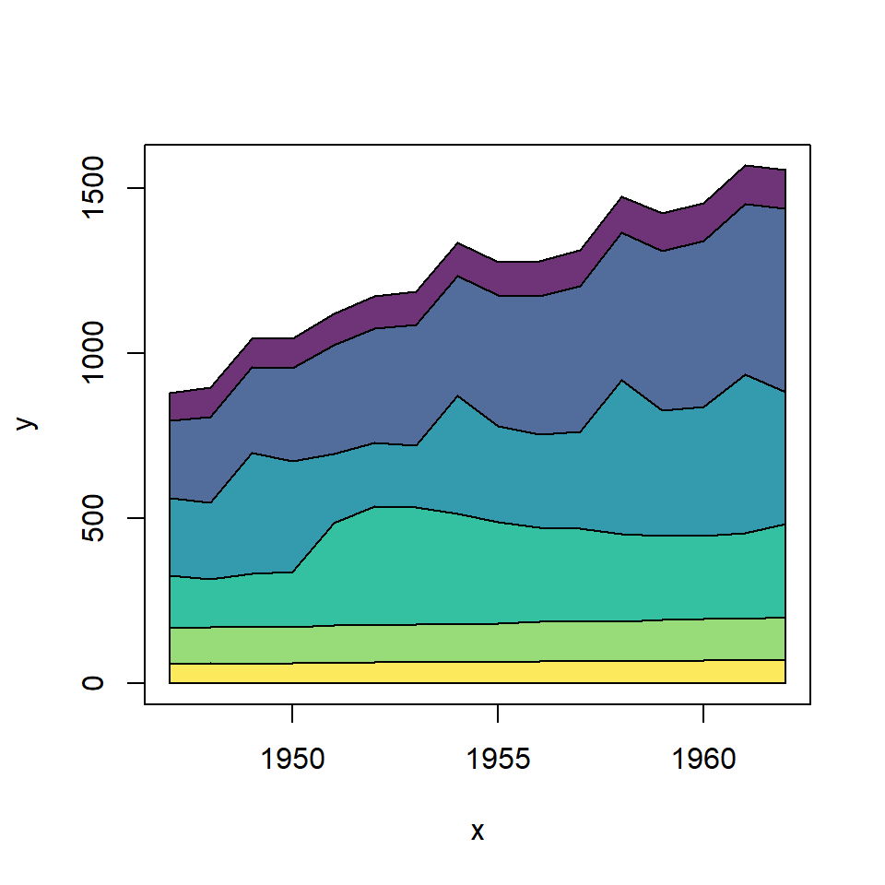

Figure: graphs\Area Plots\stacked-area-color.png

## Prompt Used

Task: Extract detailed information from a given graph image and generate JSON files (data.json, layout.json, and config.json) compatible with Plotly. Use the specified delimiters to wrap each JSON section.  
  
Instructions:  
  
Graph Analysis:  
  
1. Identify and categorize the plot types present in the graph:  
 - Common 2D plots: `scatter`, `bar`, `pie`, `area` (as `scatter` with `fill`)`, `line`, `stacked bar`.  
 - Advanced 3D plots: `scatter3d`, `surface`.  
2. Extract the data points for each plot:  
 - For 2D plots: Extract `x-values`, `y-values`, and any other relevant data (e.g., `labels` for pie charts).  
 - For 3D plots: Extract `x-values`, `y-values`, and `z-values`.  
3. Note any multiple plots on the same figure and their configurations (e.g., colors, stack groups, fill areas).  
  
Generate `data.json`:  
  
For each plot, include details such as:  
- **type**: The type of plot (e.g., `scatter`, `bar`, `pie`, `area`, `scatter3d`, `surface`).  
- **x**, **y**, and **z** (if applicable): Arrays of data points for the `x`, `y`, and `z` axes.  
- **labels** and **values** for pie charts.  
- **mode**: For line and scatter plots (e.g., `markers`, `lines`, `markers+lines`).  
- **name**: Legend entry for the plot.  
- **marker**: Properties such as color, size, and symbol for markers.  
- **line**: Properties such as color, width, and dash style for lines.  
- **text**: Hover text for each data point.  
- **hoverinfo**: Information displayed on hover (e.g., `x+y+text`).  
- **fill**: For area charts, specify the fill (e.g., `tozeroy`).  
- **stackgroup**: For stacked bar charts, specify the group for stacking.  
  
Generate `layout.json`:  
  
Include details such as:  
- **title**: The title of the graph, including text, font properties (family, size, color).  
- **xaxis** and **yaxis**: Configuration including title, range, showgrid, gridcolor, zeroline, zerolinecolor, showticklabels, tickangle, tickfont.  
- **zaxis**: Configuration for 3D plots including title, range, showgrid, gridcolor, zeroline, zerolinecolor, showticklabels, tickangle, tickfont.  
- **legend**: Properties including orientation, x, y, xanchor, font.  
- **margin**: Values for l (left), r (right), b (bottom), t (top), pad.  
- **plot_bgcolor** and **paper_bgcolor**: Background colors of the plot area and paper.  
- **scene**: For 3D plots, configuration for the 3D scene, including camera angles, lighting, and aspect ratio.  
  
Generate `config.json`:  
  
Include configuration settings such as:  
- **responsive**: Whether the graph is responsive (boolean).  
- **displayModeBar**: Whether the mode bar is displayed (boolean).  
- **modeBarButtonsToRemove**: List of mode bar buttons to remove (e.g., ["toImage"]).  
- **scrollZoom**: Whether scrolling zoom is enabled (boolean).  
  
Output Format:  
  
Wrap each JSON output in specific XML-like tags:  
- `<data> ... </data>`  
- `<layout> ... </layout>`  
- `<config> ... </config>`  
  
Make sure to follow the JSON formatting guidelines:  
- **Double Quotes for Keys and Strings**: Ensure that all keys and string values in JSON are enclosed in double quotes (").  
 - Example: Instead of `"type": bar`, it should be `"type": "bar"`.  
- **No Trailing Commas**: Remove any trailing commas after the last element in arrays ([]) or objects ({}).  
 - Example: Instead of `"color": "rgba(55, 128, 191, 0.6)",`, it should be `"color": "rgba(55, 128, 191, 0.6)"`.  
  
Example Output:  
  
```xml  
<data>  
[  
 {  
 "type": "scatter",  
 "x": [1, 2, 3],  
 "y": [4, 5, 6],  
 "mode": "markers+lines",  
 "name": "Line Plot",  
 "marker": {  
 "color": "rgba(75, 192, 192, 0.6)",  
 "size": 8  
 },  
 "line": {  
 "color": "rgba(75, 192, 192, 1)",  
 "width": 2  
 }  
 },  
 {  
 "type": "bar",  
 "x": ["A", "B", "C"],  
 "y": [10, 15, 13],  
 "name": "Bar Chart",  
 "marker": {  
 "color": "rgba(255, 99, 132, 0.6)"  
 },  
 "hoverinfo": "x+y+text"  
 },  
 {  
 "type": "scatter",  
 "x": [1, 2, 3],  
 "y": [6, 7, 8],  
 "mode": "lines",  
 "name": "Area Chart",  
 "fill": "tozeroy",  
 "line": {  
 "color": "rgba(54, 162, 235, 1)",  
 "width": 2  
 }  
 },  
 {  
 "type": "scatter3d",  
 "x": [1, 2, 3],  
 "y": [4, 5, 6],  
 "z": [7, 8, 9],  
 "mode": "markers",  
 "name": "3D Scatter Plot",  
 "marker": {  
 "color": "rgba(255, 159, 64, 0.8)",  
 "size": 5  
 },  
 "hoverinfo": "x+y+z+text"  
 },  
 {  
 "type": "surface",  
 "z": [  
 [10, 10.625, 12.5, 15.625, 20],  
 [5.625, 6.25, 8.125, 11.25, 15.625],  
 [0, 1.25, 3.125, 6.25, 10.625]  
 ],  
 "name": "Surface Plot",  
 "colorscale": "Viridis",  
 "hoverinfo": "z+name"  
 }  
]  
</data>  
<layout>  
{  
 "title": {  
 "text": "Complex Graph Example",  
 "font": {  
 "family": "Arial, sans-serif",  
 "size": 24,  
 "color": "#000000"  
 }  
 },  
 "xaxis": {  
 "title": {  
 "text": "X Axis",  
 "font": {  
 "family": "Arial, sans-serif",  
 "size": 18,  
 "color": "#000000"  
 }  
 },  
 "showgrid": true,  
 "gridcolor": "rgba(0, 0, 0, 0.1)",  
 "zeroline": true,  
 "zerolinecolor": "rgba(0, 0, 0, 0.1)"  
 },  
 "yaxis": {  
 "title": {  
 "text": "Y Axis",  
 "font": {  
 "family": "Arial, sans-serif",  
 "size": 18,  
 "color": "#000000"  
 }  
 },  
 "showgrid": true,  
 "gridcolor": "rgba(0, 0, 0, 0.1)",  
 "zeroline": true,  
 "zerolinecolor": "rgba(0, 0, 0, 0.1)"  
 },  
 "legend": {  
 "orientation": "h",  
 "x": 0.5,  
 "xanchor": "center",  
 "y": -0.2,  
 "font": {  
 "family": "Arial, sans-serif",  
 "size": 12,  
 "color": "#000000"  
 }  
 },  
 "margin": {  
 "l": 60,  
 "r": 30,  
 "b": 60,  
 "t": 60  
 },  
 "plot_bgcolor": "#ffffff",  
 "paper_bgcolor": "#ffffff",  
 "scene": {  
 "xaxis": {"title": "X Axis"},  
 "yaxis": {"title": "Y Axis"},  
 "zaxis": {"title": "Z Axis"}  
 }  
}  
</layout>  
<config>  
{  
 "responsive": true,  
 "displayModeBar": true,  
 "modeBarButtonsToRemove": ["toImage"],  
 "scrollZoom": true  
}  
</config>

## Extracted JSON

### data

[  
 {  
 "type": "scatter",  
 "x": [  
 1950,  
 1951,  
 1952,  
 1953,  
 1954,  
 1955,  
 1956,  
 1957,  
 1958,  
 1959,  
 1960  
 ],  
 "y": [  
 760,  
 830,  
 900,  
 950,  
 1020,  
 1100,  
 1150,  
 1220,  
 1250,  
 1300,  
 1350  
 ],  
 "mode": "lines",  
 "name": "Line Plot",  
 "line": {  
 "color": "rgba(75, 192, 192, 1)",  
 "width": 2  
 }  
 },  
 {  
 "type": "bar",  
 "x": [  
 1950,  
 1951,  
 1952,  
 1953,  
 1954,  
 1955,  
 1956,  
 1957,  
 1958,  
 1959,  
 1960  
 ],  
 "y": [  
 100,  
 150,  
 200,  
 250,  
 300,  
 350,  
 400,  
 450,  
 500,  
 550,  
 600  
 ],  
 "name": "Bar Chart",  
 "marker": {  
 "color": "rgba(255, 99, 132, 0.6)"  
 },  
 "hoverinfo": "x+y+text"  
 },  
 {  
 "type": "scatter",  
 "x": [  
 1950,  
 1951,  
 1952,  
 1953,  
 1954,  
 1955,  
 1956,  
 1957,  
 1958,  
 1959,  
 1960  
 ],  
 "y": [  
 400,  
 450,  
 500,  
 550,  
 600,  
 650,  
 700,  
 750,  
 800,  
 850,  
 900  
 ],  
 "mode": "lines",  
 "name": "Area Chart",  
 "fill": "tozeroy",  
 "line": {  
 "color": "rgba(54, 162, 235, 1)",  
 "width": 2  
 }  
 }  
]

### layout

{  
 "title": {  
 "text": "Complex Graph Example",  
 "font": {  
 "family": "Arial, sans-serif",  
 "size": 24,  
 "color": "#000000"  
 }  
 },  
 "xaxis": {  
 "title": {  
 "text": "X Axis",  
 "font": {  
 "family": "Arial, sans-serif",  
 "size": 18,  
 "color": "#000000"  
 }  
 },  
 "showgrid": true,  
 "gridcolor": "rgba(0, 0, 0, 0.1)",  
 "zeroline": true,  
 "zerolinecolor": "rgba(0, 0, 0, 0.1)"  
 },  
 "yaxis": {  
 "title": {  
 "text": "Y Axis",  
 "font": {  
 "family": "Arial, sans-serif",  
 "size": 18,  
 "color": "#000000"  
 }  
 },  
 "showgrid": true,  
 "gridcolor": "rgba(0, 0, 0, 0.1)",  
 "zeroline": true,  
 "zerolinecolor": "rgba(0, 0, 0, 0.1)"  
 },  
 "legend": {  
 "orientation": "h",  
 "x": 0.5,  
 "xanchor": "center",  
 "y": -0.2,  
 "font": {  
 "family": "Arial, sans-serif",  
 "size": 12,  
 "color": "#000000"  
 }  
 },  
 "margin": {  
 "l": 60,  
 "r": 30,  
 "b": 60,  
 "t": 60  
 },  
 "plot_bgcolor": "#ffffff",  
 "paper_bgcolor": "#ffffff"  
}

### config

{  
 "responsive": true,  
 "displayModeBar": true,  
 "modeBarButtonsToRemove": [  
 "toImage"  
 ],  
 "scrollZoom": true  
}

## Updated JSON

### updated_data

[  
 {  
 "type": "scatter",  
 "x": [  
 1950,  
 1951,  
 1952,  
 1953,  
 1954,  
 1955,  
 1956,  
 1957,  
 1958,  
 1959,  
 1960  
 ],  
 "y": [  
 760,  
 830,  
 900,  
 950,  
 1020,  
 1100,  
 1150,  
 1220,  
 1250,  
 1300,  
 1350  
 ],  
 "mode": "lines",  
 "name": "Line Plot",  
 "line": {  
 "color": "rgba(75, 192, 192, 1)",  
 "width": 2  
 }  
 },  
 {  
 "type": "bar",  
 "x": [  
 1950,  
 1951,  
 1952,  
 1953,  
 1954,  
 1955,  
 1956,  
 1957,  
 1958,  
 1959,  
 1960  
 ],  
 "y": [  
 100,  
 150,  
 200,  
 250,  
 300,  
 350,  
 400,  
 450,  
 500,  
 550,  
 600  
 ],  
 "name": "Bar Chart",  
 "marker": {  
 "color": "rgba(255, 99, 132, 0.6)"  
 },  
 "hoverinfo": "x+y+text"  
 },  
 {  
 "type": "scatter",  
 "x": [  
 1950,  
 1951,  
 1952,  
 1953,  
 1954,  
 1955,  
 1956,  
 1957,  
 1958,  
 1959,  
 1960  
 ],  
 "y": [  
 400,  
 450,  
 500,  
 550,  
 600,  
 650,  
 700,  
 750,  
 800,  
 850,  
 900  
 ],  
 "mode": "lines",  
 "name": "Area Chart",  
 "fill": "tozeroy",  
 "line": {  
 "color": "rgba(54, 162, 235, 1)",  
 "width": 2  
 }  
 }  
]

### updated_layout

{  
 "title": {  
 "text": "Complex Graph Example",  
 "font": {  
 "family": "Arial, sans-serif",  
 "size": 24,  
 "color": "#000000"  
 }  
 },  
 "xaxis": {  
 "title": {  
 "text": "X Axis",  
 "font": {  
 "family": "Arial, sans-serif",  
 "size": 18,  
 "color": "#000000"  
 }  
 },  
 "showgrid": true,  
 "gridcolor": "rgba(0, 0, 0, 0.1)",  
 "zeroline": true,  
 "zerolinecolor": "rgba(0, 0, 0, 0.1)"  
 },  
 "yaxis": {  
 "title": {  
 "text": "Y Axis",  
 "font": {  
 "family": "Arial, sans-serif",  
 "size": 18,  
 "color": "#000000"  
 }  
 },  
 "showgrid": true,  
 "gridcolor": "rgba(0, 0, 0, 0.1)",  
 "zeroline": true,  
 "zerolinecolor": "rgba(0, 0, 0, 0.1)"  
 },  
 "legend": {  
 "orientation": "h",  
 "x": 0.5,  
 "xanchor": "center",  
 "y": -0.2,  
 "font": {  
 "family": "Arial, sans-serif",  
 "size": 12,  
 "color": "#000000"  
 }  
 },  
 "margin": {  
 "l": 60,  
 "r": 30,  
 "b": 60,  
 "t": 60  
 },  
 "plot_bgcolor": "#ffffff",  
 "paper_bgcolor": "#ffffff"  
}

### updated_config

{  
 "responsive": true,  
 "displayModeBar": true,  
 "modeBarButtonsToRemove": [  
 "toImage"  
 ],  
 "scrollZoom": true  
}

## Updated Chart

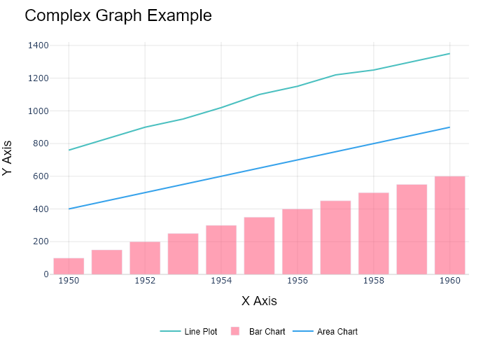

## Performance Metrics

|  |  |  |  |
| --- | --- | --- | --- |
| Task | Model Used | Description | Time Taken (s) |
| Processing Image to JSON | Gemini Vision Pro (default) | Time taken to convert the uploaded image to JSON format | 22.98 |
| Updating JSON | ChatGPT 3.5 (Default) | Time taken to update the JSON with new data | 0.00 |
| Plotting Updated JSON | N/A | Time taken to plot the updated JSON | 0.17 |

# Test Run



Figure: graphs\Area Plots\stacked-area-color.png

## Prompt Used

Task: Extract detailed information from a given graph image and generate JSON files (data.json, layout.json, and config.json) compatible with Plotly. Use the specified delimiters to wrap each JSON section.  
  
Instructions:  
  
Graph Analysis:  
  
1. Identify and categorize the plot types present in the graph:  
 - Common 2D plots: `scatter`, `bar`, `pie`, `area` (as `scatter` with `fill`), `line`, `stacked bar`.  
 - Advanced 3D plots: `scatter3d`, `surface`.  
2. Extract the data points for each plot:  
 - For 2D plots: Extract `x-values`, `y-values`, and any other relevant data (e.g., `labels` for pie charts).  
 - For 3D plots: Extract `x-values`, `y-values`, and `z-values`.  
3. Note any multiple plots on the same figure and their configurations (e.g., colors, stack groups, fill areas).  
  
Generate `data.json`:  
  
For each plot, include details such as:  
- **type**: The type of plot (e.g., `scatter`, `bar`, `pie`, `area`, `scatter3d`, `surface`).  
 - For area charts, use `type: "scatter"` with `fill` specified.  
- **x**, **y**, and **z** (if applicable): Arrays of data points for the `x`, `y`, and `z` axes.  
- **labels** and **values** for pie charts.  
- **mode**: For line and scatter plots (e.g., `markers`, `lines`, `markers+lines`).  
- **name**: Legend entry for the plot.  
- **marker**: Properties such as color, size, and symbol for markers.  
- **line**: Properties such as color, width, and dash style for lines.  
- **text**: Hover text for each data point.  
- **hoverinfo**: Information displayed on hover (e.g., `x+y+text`).  
- **fill**: For area charts, specify the fill (e.g., "tozeroy", "tonexty").  
- **fillcolor**: The color used to fill the area under the line.  
- **stackgroup**: For stacked bar charts, specify the group for stacking.  
  
Generate `layout.json`:  
  
Include details such as:  
- **title**: The title of the graph, including text, font properties (family, size, color).  
- **xaxis** and **yaxis**: Configuration including title, range, showgrid, gridcolor, zeroline, zerolinecolor, showticklabels, tickangle, tickfont.  
- **zaxis**: Configuration for 3D plots including title, range, showgrid, gridcolor, zeroline, zerolinecolor, showticklabels, tickangle, tickfont.  
- **legend**: Properties including orientation, x, y, xanchor, font.  
- **margin**: Values for l (left), r (right), b (bottom), t (top), pad.  
- **plot_bgcolor** and **paper_bgcolor**: Background colors of the plot area and paper.  
- **scene**: For 3D plots, configuration for the 3D scene, including camera angles, lighting, and aspect ratio.  
  
Generate `config.json`:  
  
Include configuration settings such as:  
- **responsive**: Whether the graph is responsive (boolean).  
- **displayModeBar**: Whether the mode bar is displayed (boolean).  
- **modeBarButtonsToRemove**: List of mode bar buttons to remove (e.g., ["toImage"]).  
- **scrollZoom**: Whether scrolling zoom is enabled (boolean).  
  
Output Format:  
  
Wrap each JSON output in specific XML-like tags:  
- `<data> ... </data>`  
- `<layout> ... </layout>`  
- `<config> ... </config>`  
  
Make sure to follow the JSON formatting guidelines:  
- **Double Quotes for Keys and Strings**: Ensure that all keys and string values in JSON are enclosed in double quotes (").  
 - Example: Instead of `"type": bar`, it should be `"type": "bar"`.  
- **No Trailing Commas**: Remove any trailing commas after the last element in arrays ([]) or objects ({}).  
 - Example: Instead of `"color": "rgba(55, 128, 191, 0.6)",`, it should be `"color": "rgba(55, 128, 191, 0.6)"`.  
  
Example Output:  
  
```xml  
<data>  
[  
 {  
 "type": "scatter",  
 "x": [1, 2, 3],  
 "y": [4, 5, 6],  
 "mode": "markers+lines",  
 "name": "Line Plot",  
 "marker": {  
 "color": "rgba(75, 192, 192, 0.6)",  
 "size": 8  
 },  
 "line": {  
 "color": "rgba(75, 192, 192, 1)",  
 "width": 2  
 }  
 },  
 {  
 "type": "bar",  
 "x": ["A", "B", "C"],  
 "y": [10, 15, 13],  
 "name": "Bar Chart",  
 "marker": {  
 "color": "rgba(255, 99, 132, 0.6)"  
 },  
 "hoverinfo": "x+y+text"  
 },  
 {  
 "type": "scatter",  
 "x": [1, 2, 3],  
 "y": [6, 7, 8],  
 "mode": "lines",  
 "fill": "tozeroy",  
 "name": "Area Chart",  
 "line": {  
 "color": "rgba(54, 162, 235, 1)",  
 "width": 2  
 },  
 "fillcolor": "rgba(54, 162, 235, 0.5)"  
 },  
 {  
 "type": "scatter3d",  
 "x": [1, 2, 3],  
 "y": [4, 5, 6],  
 "z": [7, 8, 9],  
 "mode": "markers",  
 "name": "3D Scatter Plot",  
 "marker": {  
 "color": "rgba(255, 159, 64, 0.8)",  
 "size": 5  
 },  
 "hoverinfo": "x+y+z+text"  
 },  
 {  
 "type": "surface",  
 "z": [  
 [10, 10.625, 12.5, 15.625, 20],  
 [5.625, 6.25, 8.125, 11.25, 15.625],  
 [0, 1.25, 3.125, 6.25, 10.625]  
 ],  
 "name": "Surface Plot",  
 "colorscale": "Viridis",  
 "hoverinfo": "z+name"  
 }  
]  
</data>  
<layout>  
{  
 "title": {  
 "text": "Complex Graph Example",  
 "font": {  
 "family": "Arial, sans-serif",  
 "size": 24,  
 "color": "#000000"  
 }  
 },  
 "xaxis": {  
 "title": {  
 "text": "X Axis",  
 "font": {  
 "family": "Arial, sans-serif",  
 "size": 18,  
 "color": "#000000"  
 }  
 },  
 "showgrid": true,  
 "gridcolor": "rgba(0, 0, 0, 0.1)",  
 "zeroline": true,  
 "zerolinecolor": "rgba(0, 0, 0, 0.1)"  
 },  
 "yaxis": {  
 "title": {  
 "text": "Y Axis",  
 "font": {  
 "family": "Arial, sans-serif",  
 "size": 18,  
 "color": "#000000"  
 }  
 },  
 "showgrid": true,  
 "gridcolor": "rgba(0, 0, 0, 0.1)",  
 "zeroline": true,  
 "zerolinecolor": "rgba(0, 0, 0, 0.1)"  
 },  
 "legend": {  
 "orientation": "h",  
 "x": 0.5,  
 "xanchor": "center",  
 "y": -0.2,  
 "font": {  
 "family": "Arial, sans-serif",  
 "size": 12,  
 "color": "#000000"  
 }  
 },  
 "margin": {  
 "l": 60,  
 "r": 30,  
 "b": 60,  
 "t": 60  
 },  
 "plot_bgcolor": "#ffffff",  
 "paper_bgcolor": "#ffffff",  
 "scene": {  
 "xaxis": {"title": "X Axis"},  
 "yaxis": {"title": "Y Axis"},  
 "zaxis": {"title": "Z Axis"}  
 }  
}  
</layout>  
<config>  
{  
 "responsive": true,  
 "displayModeBar": true,  
 "modeBarButtonsToRemove": ["toImage"],  
 "scrollZoom": true  
}  
</config>

## Extracted JSON

### data

[  
 {  
 "type": "scatter",  
 "x": [  
 1950,  
 1951,  
 1952,  
 1953,  
 1954,  
 1955,  
 1956,  
 1957,  
 1958,  
 1959,  
 1960  
 ],  
 "y": [  
 760,  
 830,  
 910,  
 1020,  
 1100,  
 1260,  
 1420,  
 1510,  
 1670,  
 1780,  
 1900  
 ],  
 "mode": "lines",  
 "name": "Line Plot",  
 "line": {  
 "color": "rgba(75, 192, 192, 1)",  
 "width": 2  
 }  
 },  
 {  
 "type": "bar",  
 "x": [  
 1950,  
 1951,  
 1952,  
 1953,  
 1954,  
 1955,  
 1956,  
 1957,  
 1958,  
 1959,  
 1960  
 ],  
 "y": [  
 100,  
 150,  
 220,  
 300,  
 350,  
 420,  
 510,  
 580,  
 670,  
 730,  
 820  
 ],  
 "name": "Bar Chart",  
 "marker": {  
 "color": "rgba(255, 99, 132, 0.6)"  
 },  
 "hoverinfo": "x+y+text"  
 },  
 {  
 "type": "scatter",  
 "x": [  
 1950,  
 1951,  
 1952,  
 1953,  
 1954,  
 1955,  
 1956,  
 1957,  
 1958,  
 1959,  
 1960  
 ],  
 "y": [  
 200,  
 250,  
 330,  
 420,  
 480,  
 550,  
 640,  
 710,  
 800,  
 860,  
 950  
 ],  
 "mode": "lines",  
 "fill": "tozeroy",  
 "name": "Area Chart",  
 "line": {  
 "color": "rgba(54, 162, 235, 1)",  
 "width": 2  
 },  
 "fillcolor": "rgba(54, 162, 235, 0.5)"  
 }  
]

### layout

{  
 "title": {  
 "text": "Complex Graph Example",  
 "font": {  
 "family": "Arial, sans-serif",  
 "size": 24,  
 "color": "#000000"  
 }  
 },  
 "xaxis": {  
 "title": {  
 "text": "X Axis",  
 "font": {  
 "family": "Arial, sans-serif",  
 "size": 18,  
 "color": "#000000"  
 }  
 },  
 "showgrid": true,  
 "gridcolor": "rgba(0, 0, 0, 0.1)",  
 "zeroline": true,  
 "zerolinecolor": "rgba(0, 0, 0, 0.1)"  
 },  
 "yaxis": {  
 "title": {  
 "text": "Y Axis",  
 "font": {  
 "family": "Arial, sans-serif",  
 "size": 18,  
 "color": "#000000"  
 }  
 },  
 "showgrid": true,  
 "gridcolor": "rgba(0, 0, 0, 0.1)",  
 "zeroline": true,  
 "zerolinecolor": "rgba(0, 0, 0, 0.1)"  
 },  
 "legend": {  
 "orientation": "h",  
 "x": 0.5,  
 "xanchor": "center",  
 "y": -0.2,  
 "font": {  
 "family": "Arial, sans-serif",  
 "size": 12,  
 "color": "#000000"  
 }  
 },  
 "margin": {  
 "l": 60,  
 "r": 30,  
 "b": 60,  
 "t": 60  
 },  
 "plot_bgcolor": "#ffffff",  
 "paper_bgcolor": "#ffffff"  
}

### config

{  
 "responsive": true,  
 "displayModeBar": true,  
 "modeBarButtonsToRemove": [  
 "toImage"  
 ],  
 "scrollZoom": true  
}

## Updated JSON

### updated_data

[  
 {  
 "type": "scatter",  
 "x": [  
 1950,  
 1951,  
 1952,  
 1953,  
 1954,  
 1955,  
 1956,  
 1957,  
 1958,  
 1959,  
 1960  
 ],  
 "y": [  
 760,  
 830,  
 910,  
 1020,  
 1100,  
 1260,  
 1420,  
 1510,  
 1670,  
 1780,  
 1900  
 ],  
 "mode": "lines",  
 "name": "Line Plot",  
 "line": {  
 "color": "rgba(75, 192, 192, 1)",  
 "width": 2  
 }  
 },  
 {  
 "type": "bar",  
 "x": [  
 1950,  
 1951,  
 1952,  
 1953,  
 1954,  
 1955,  
 1956,  
 1957,  
 1958,  
 1959,  
 1960  
 ],  
 "y": [  
 100,  
 150,  
 220,  
 300,  
 350,  
 420,  
 510,  
 580,  
 670,  
 730,  
 820  
 ],  
 "name": "Bar Chart",  
 "marker": {  
 "color": "rgba(255, 99, 132, 0.6)"  
 },  
 "hoverinfo": "x+y+text"  
 },  
 {  
 "type": "scatter",  
 "x": [  
 1950,  
 1951,  
 1952,  
 1953,  
 1954,  
 1955,  
 1956,  
 1957,  
 1958,  
 1959,  
 1960  
 ],  
 "y": [  
 200,  
 250,  
 330,  
 420,  
 480,  
 550,  
 640,  
 710,  
 800,  
 860,  
 950  
 ],  
 "mode": "lines",  
 "fill": "tozeroy",  
 "name": "Area Chart",  
 "line": {  
 "color": "rgba(54, 162, 235, 1)",  
 "width": 2  
 },  
 "fillcolor": "rgba(54, 162, 235, 0.5)"  
 }  
]

### updated_layout

{  
 "title": {  
 "text": "Complex Graph Example",  
 "font": {  
 "family": "Arial, sans-serif",  
 "size": 24,  
 "color": "#000000"  
 }  
 },  
 "xaxis": {  
 "title": {  
 "text": "X Axis",  
 "font": {  
 "family": "Arial, sans-serif",  
 "size": 18,  
 "color": "#000000"  
 }  
 },  
 "showgrid": true,  
 "gridcolor": "rgba(0, 0, 0, 0.1)",  
 "zeroline": true,  
 "zerolinecolor": "rgba(0, 0, 0, 0.1)"  
 },  
 "yaxis": {  
 "title": {  
 "text": "Y Axis",  
 "font": {  
 "family": "Arial, sans-serif",  
 "size": 18,  
 "color": "#000000"  
 }  
 },  
 "showgrid": true,  
 "gridcolor": "rgba(0, 0, 0, 0.1)",  
 "zeroline": true,  
 "zerolinecolor": "rgba(0, 0, 0, 0.1)"  
 },  
 "legend": {  
 "orientation": "h",  
 "x": 0.5,  
 "xanchor": "center",  
 "y": -0.2,  
 "font": {  
 "family": "Arial, sans-serif",  
 "size": 12,  
 "color": "#000000"  
 }  
 },  
 "margin": {  
 "l": 60,  
 "r": 30,  
 "b": 60,  
 "t": 60  
 },  
 "plot_bgcolor": "#ffffff",  
 "paper_bgcolor": "#ffffff"  
}

### updated_config

{  
 "responsive": true,  
 "displayModeBar": true,  
 "modeBarButtonsToRemove": [  
 "toImage"  
 ],  
 "scrollZoom": true  
}

## Updated Chart

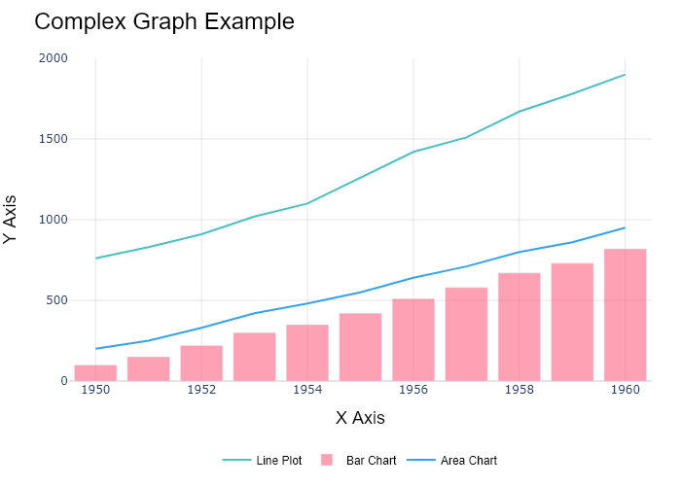

## Performance Metrics

|  |  |  |  |
| --- | --- | --- | --- |
| Task | Model Used | Description | Time Taken (s) |
| Processing Image to JSON | Gemini Vision Pro (default) | Time taken to convert the uploaded image to JSON format | 23.86 |
| Updating JSON | ChatGPT 3.5 (Default) | Time taken to update the JSON with new data | 0.00 |
| Plotting Updated JSON | N/A | Time taken to plot the updated JSON | 0.14 |

# Test Run



Figure: graphs/Area Plots/areaplot-2.png

## Prompt Used

Task: Extract detailed information from a given graph image and generate JSON files (`data.json`, `layout.json`, and `config.json`) compatible with Plotly. Use the specified delimiters to wrap each JSON section.  
  
### Instructions:  
  
#### Graph Analysis:  
  
1. **Identify and categorize** the plot types present in the graph. Include both simple and complex plots:  
 - Simple plots: `scatter`, `bar`, `pie`, `line`.  
 - Complex plots: `area` (use `scatter` with `fill` attribute), `stacked bar`, `scatter3d`, `surface`.  
  
2. **Extract data points** for each plot type:  
 - For `scatter`, `line`, and `area` plots: Extract `x` and `y` values.  
 - For `bar` and `stacked bar` plots: Extract `x` (categories) and `y` values.  
 - For `pie` charts: Extract `labels` and `values`.  
 - For `scatter3d` and `surface` plots: Extract `x`, `y`, and `z` values.  
  
3. **Note any multiple plots** on the same figure and their configurations:  
 - For stacked plots, identify the stacking order and group.  
 - For area charts, ensure `fill` is specified correctly.  
  
#### Generate `data.json`:  
  
For each plot, include details such as:  
- **type**: The type of plot (e.g., `"scatter"`, `"bar"`, `"pie"`, `"area"`, `"scatter3d"`, `"surface"`).  
 - For area charts, use `"type": "scatter"` and specify `"fill"`.  
- **x**, **y**, and **z** (if applicable): Arrays of data points for the `x`, `y`, and `z` axes.  
- **labels** and **values** for pie charts.  
- **mode**: For line and scatter plots (e.g., `"markers"`, `"lines"`, `"markers+lines"`).  
- **name**: Legend entry for the plot.  
- **marker**: Properties such as color, size, and symbol for markers.  
- **line**: Properties such as color, width, and dash style for lines.  
- **text**: Hover text for each data point.  
- **hoverinfo**: Information displayed on hover (e.g., `"x+y+text"`).  
- **fill**: For area charts, specify the fill (e.g., `"tozeroy"`, `"tonexty"`).  
- **fillcolor**: The color used to fill the area under the line.  
- **stackgroup**: For stacked bar charts, specify the group for stacking.  
  
#### Generate `layout.json`:  
  
Include details such as:  
- **title**: The title of the graph, including text and font properties.  
- **xaxis** and **yaxis**: Configuration including title, range, grid properties, and tick settings.  
- **zaxis**: Configuration for 3D plots including title, range, and grid properties.  
- **legend**: Properties including orientation and positioning.  
- **margin**: Values for left, right, bottom, top, and padding.  
- **plot_bgcolor** and **paper_bgcolor**: Background colors of the plot area and paper.  
- **scene**: For 3D plots, configuration for the 3D scene, including camera angles, lighting, and aspect ratio.  
  
#### Generate `config.json`:  
  
Include configuration settings such as:  
- **responsive**: Whether the graph is responsive.  
- **displayModeBar**: Whether the mode bar is displayed.  
- **modeBarButtonsToRemove**: List of mode bar buttons to remove.  
- **scrollZoom**: Whether scrolling zoom is enabled.  
  
### Output Format:  
  
Wrap each JSON output in specific XML-like tags:  
- `<data> ... </data>`  
- `<layout> ... </layout>`  
- `<config> ... </config>`  
  
Make sure to follow the JSON formatting guidelines:  
- **Double Quotes for Keys and Strings**: Ensure all keys and string values in JSON are enclosed in double quotes.  
- **No Trailing Commas**: Remove any trailing commas after the last element in arrays or objects.  
  
### Example Output:  
  
```xml  
<data>  
[  
 {  
 "type": "scatter",  
 "x": [1, 2, 3],  
 "y": [4, 5, 6],  
 "mode": "markers+lines",  
 "name": "Line Plot",  
 "marker": {  
 "color": "rgba(75, 192, 192, 0.6)",  
 "size": 8  
 },  
 "line": {  
 "color": "rgba(75, 192, 192, 1)",  
 "width": 2  
 }  
 },  
 {  
 "type": "bar",  
 "x": ["A", "B", "C"],  
 "y": [10, 15, 13],  
 "name": "Bar Chart",  
 "marker": {  
 "color": "rgba(255, 99, 132, 0.6)"  
 },  
 "hoverinfo": "x+y+text"  
 },  
 {  
 "type": "scatter",  
 "x": [1, 2, 3],  
 "y": [6, 7, 8],  
 "mode": "lines",  
 "fill": "tozeroy",  
 "name": "Area Chart",  
 "line": {  
 "color": "rgba(54, 162, 235, 1)",  
 "width": 2  
 },  
 "fillcolor": "rgba(54, 162, 235, 0.5)"  
 },  
 {  
 "type": "scatter3d",  
 "x": [1, 2, 3],  
 "y": [4, 5, 6],  
 "z": [7, 8, 9],  
 "mode": "markers",  
 "name": "3D Scatter Plot",  
 "marker": {  
 "color": "rgba(255, 159, 64, 0.8)",  
 "size": 5  
 },  
 "hoverinfo": "x+y+z+text"  
 },  
 {  
 "type": "surface",  
 "z": [  
 [10, 10.625, 12.5, 15.625, 20],  
 [5.625, 6.25, 8.125, 11.25, 15.625],  
 [0, 1.25, 3.125, 6.25, 10.625]  
 ],  
 "name": "Surface Plot",  
 "colorscale": "Viridis",  
 "hoverinfo": "z+name"  
 }  
]  
</data>  
<layout>  
{  
 "title": {  
 "text": "Complex Graph Example",  
 "font": {  
 "family": "Arial, sans-serif",  
 "size": 24,  
 "color": "#000000"  
 }  
 },  
 "xaxis": {  
 "title": {  
 "text": "X Axis",  
 "font": {  
 "family": "Arial, sans-serif",  
 "size": 18,  
 "color": "#000000"  
 }  
 },  
 "showgrid": true,  
 "gridcolor": "rgba(0, 0, 0, 0.1)",  
 "zeroline": true,  
 "zerolinecolor": "rgba(0, 0, 0, 0.1)"  
 },  
 "yaxis": {  
 "title": {  
 "text": "Y Axis",  
 "font": {  
 "family": "Arial, sans-serif",  
 "size": 18,  
 "color": "#000000"  
 }  
 },  
 "showgrid": true,  
 "gridcolor": "rgba(0, 0, 0, 0.1)",  
 "zeroline": true,  
 "zerolinecolor": "rgba(0, 0, 0, 0.1)"  
 },  
 "legend": {  
 "orientation": "h",  
 "x": 0.5,  
 "xanchor": "center",  
 "y": -0.2,  
 "font": {  
 "family": "Arial, sans-serif",  
 "size": 12,  
 "color": "#000000"  
 }  
 },  
 "margin": {  
 "l": 60,  
 "r": 30,  
 "b": 60,  
 "t": 60  
 },  
 "plot_bgcolor": "#ffffff",  
 "paper_bgcolor": "#ffffff",  
 "scene": {  
 "xaxis": {"title": "X Axis"},  
 "yaxis": {"title": "Y Axis"},  
 "zaxis": {"title": "Z Axis"}  
 }  
}  
</layout>  
<config>  
{  
 "responsive": true,  
 "displayModeBar": true,  
 "modeBarButtonsToRemove": ["toImage"],  
 "scrollZoom": true  
}  
</config>

## Extracted JSON

### data

[  
 {  
 "type": "scatter",  
 "x": [  
 1,  
 2,  
 3,  
 4,  
 5,  
 6,  
 7,  
 8,  
 9,  
 10,  
 11,  
 12  
 ],  
 "y": [  
 400,  
 430,  
 550,  
 620,  
 580,  
 600,  
 630,  
 700,  
 670,  
 630,  
 600,  
 500  
 ],  
 "name": "Housing",  
 "marker": {  
 "color": "rgba(255, 159, 64, 0.8)"  
 },  
 "line": {  
 "color": "rgba(255, 159, 64, 1)",  
 "width": 2  
 }  
 },  
 {  
 "type": "scatter",  
 "x": [  
 1,  
 2,  
 3,  
 4,  
 5,  
 6,  
 7,  
 8,  
 9,  
 10,  
 11,  
 12  
 ],  
 "y": [  
 200,  
 220,  
 280,  
 310,  
 250,  
 280,  
 320,  
 350,  
 330,  
 310,  
 280,  
 200  
 ],  
 "name": "Food",  
 "marker": {  
 "color": "rgba(255, 99, 132, 0.8)"  
 },  
 "line": {  
 "color": "rgba(255, 99, 132, 1)",  
 "width": 2  
 }  
 },  
 {  
 "type": "scatter",  
 "x": [  
 1,  
 2,  
 3,  
 4,  
 5,  
 6,  
 7,  
 8,  
 9,  
 10,  
 11,  
 12  
 ],  
 "y": [  
 100,  
 110,  
 150,  
 180,  
 130,  
 150,  
 180,  
 200,  
 180,  
 150,  
 130,  
 100  
 ],  
 "name": "Utility",  
 "marker": {  
 "color": "rgba(54, 162, 235, 0.8)"  
 },  
 "line": {  
 "color": "rgba(54, 162, 235, 1)",  
 "width": 2  
 }  
 },  
 {  
 "type": "scatter",  
 "x": [  
 1,  
 2,  
 3,  
 4,  
 5,  
 6,  
 7,  
 8,  
 9,  
 10,  
 11,  
 12  
 ],  
 "y": [  
 150,  
 180,  
 200,  
 250,  
 220,  
 200,  
 250,  
 280,  
 250,  
 200,  
 180,  
 150  
 ],  
 "name": "Insurance",  
 "marker": {  
 "color": "rgba(75, 192, 192, 0.8)"  
 },  
 "line": {  
 "color": "rgba(75, 192, 192, 1)",  
 "width": 2  
 }  
 }  
]

### layout

{  
 "title": {  
 "text": "Monthly Expenses",  
 "font": {  
 "family": "Arial, sans-serif",  
 "size": 24,  
 "color": "#000000"  
 }  
 },  
 "xaxis": {  
 "title": {  
 "text": "Months",  
 "font": {  
 "family": "Arial, sans-serif",  
 "size": 18,  
 "color": "#000000"  
 }  
 },  
 "showgrid": true,  
 "gridcolor": "rgba(0, 0, 0, 0.1)",  
 "zeroline": true,  
 "zerolinecolor": "rgba(0, 0, 0, 0.1)"  
 },  
 "yaxis": {  
 "title": {  
 "text": "Amount ($)",  
 "font": {  
 "family": "Arial, sans-serif",  
 "size": 18,  
 "color": "#000000"  
 }  
 },  
 "showgrid": true,  
 "gridcolor": "rgba(0, 0, 0, 0.1)",  
 "zeroline": true,  
 "zerolinecolor": "rgba(0, 0, 0, 0.1)"  
 },  
 "legend": {  
 "orientation": "h",  
 "x": 0.5,  
 "xanchor": "center",  
 "y": -0.2,  
 "font": {  
 "family": "Arial, sans-serif",  
 "size": 12,  
 "color": "#000000"  
 }  
 },  
 "margin": {  
 "l": 60,  
 "r": 30,  
 "b": 60,  
 "t": 60  
 },  
 "plot_bgcolor": "#ffffff",  
 "paper_bgcolor": "#ffffff"  
}

### config

{  
 "responsive": true,  
 "displayModeBar": true,  
 "modeBarButtonsToRemove": [  
 "toImage"  
 ],  
 "scrollZoom": true  
}

## Updated JSON

### updated_data

[  
 {  
 "type": "scatter",  
 "x": [  
 1,  
 2,  
 3,  
 4,  
 5,  
 6,  
 7,  
 8,  
 9,  
 10,  
 11,  
 12  
 ],  
 "y": [  
 400,  
 430,  
 550,  
 620,  
 580,  
 600,  
 630,  
 700,  
 670,  
 630,  
 600,  
 500  
 ],  
 "name": "Housing",  
 "marker": {  
 "color": "rgba(255, 159, 64, 0.8)"  
 },  
 "line": {  
 "color": "rgba(255, 159, 64, 1)",  
 "width": 2  
 }  
 },  
 {  
 "type": "scatter",  
 "x": [  
 1,  
 2,  
 3,  
 4,  
 5,  
 6,  
 7,  
 8,  
 9,  
 10,  
 11,  
 12  
 ],  
 "y": [  
 200,  
 220,  
 280,  
 310,  
 250,  
 280,  
 320,  
 350,  
 330,  
 310,  
 280,  
 200  
 ],  
 "name": "Food",  
 "marker": {  
 "color": "rgba(255, 99, 132, 0.8)"  
 },  
 "line": {  
 "color": "rgba(255, 99, 132, 1)",  
 "width": 2  
 }  
 },  
 {  
 "type": "scatter",  
 "x": [  
 1,  
 2,  
 3,  
 4,  
 5,  
 6,  
 7,  
 8,  
 9,  
 10,  
 11,  
 12  
 ],  
 "y": [  
 100,  
 110,  
 150,  
 180,  
 130,  
 150,  
 180,  
 200,  
 180,  
 150,  
 130,  
 100  
 ],  
 "name": "Utility",  
 "marker": {  
 "color": "rgba(54, 162, 235, 0.8)"  
 },  
 "line": {  
 "color": "rgba(54, 162, 235, 1)",  
 "width": 2  
 }  
 },  
 {  
 "type": "scatter",  
 "x": [  
 1,  
 2,  
 3,  
 4,  
 5,  
 6,  
 7,  
 8,  
 9,  
 10,  
 11,  
 12  
 ],  
 "y": [  
 150,  
 180,  
 200,  
 250,  
 220,  
 200,  
 250,  
 280,  
 250,  
 200,  
 180,  
 150  
 ],  
 "name": "Insurance",  
 "marker": {  
 "color": "rgba(75, 192, 192, 0.8)"  
 },  
 "line": {  
 "color": "rgba(75, 192, 192, 1)",  
 "width": 2  
 }  
 }  
]

### updated_layout

{  
 "title": {  
 "text": "Monthly Expenses",  
 "font": {  
 "family": "Arial, sans-serif",  
 "size": 24,  
 "color": "#000000"  
 }  
 },  
 "xaxis": {  
 "title": {  
 "text": "Months",  
 "font": {  
 "family": "Arial, sans-serif",  
 "size": 18,  
 "color": "#000000"  
 }  
 },  
 "showgrid": true,  
 "gridcolor": "rgba(0, 0, 0, 0.1)",  
 "zeroline": true,  
 "zerolinecolor": "rgba(0, 0, 0, 0.1)"  
 },  
 "yaxis": {  
 "title": {  
 "text": "Amount ($)",  
 "font": {  
 "family": "Arial, sans-serif",  
 "size": 18,  
 "color": "#000000"  
 }  
 },  
 "showgrid": true,  
 "gridcolor": "rgba(0, 0, 0, 0.1)",  
 "zeroline": true,  
 "zerolinecolor": "rgba(0, 0, 0, 0.1)"  
 },  
 "legend": {  
 "orientation": "h",  
 "x": 0.5,  
 "xanchor": "center",  
 "y": -0.2,  
 "font": {  
 "family": "Arial, sans-serif",  
 "size": 12,  
 "color": "#000000"  
 }  
 },  
 "margin": {  
 "l": 60,  
 "r": 30,  
 "b": 60,  
 "t": 60  
 },  
 "plot_bgcolor": "#ffffff",  
 "paper_bgcolor": "#ffffff"  
}

### updated_config

{  
 "responsive": true,  
 "displayModeBar": true,  
 "modeBarButtonsToRemove": [  
 "toImage"  
 ],  
 "scrollZoom": true  
}

## Updated Chart

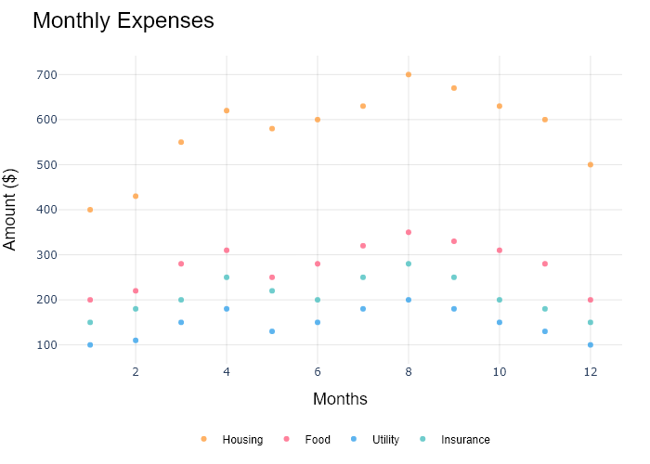

## Performance Metrics

|  |  |  |  |
| --- | --- | --- | --- |
| Task | Model Used | Description | Time Taken (s) |
| Processing Image to JSON | Gemini Vision Pro (default) | Time taken to convert the uploaded image to JSON format | 25.87 |
| Updating JSON | ChatGPT 3.5 (Default) | Time taken to update the JSON with new data | 0.00 |
| Plotting Updated JSON | N/A | Time taken to plot the updated JSON | 0.08 |

# Test Run



Figure: graphs/Area Plots/areaplot-2.png

## Prompt Used

Task: Extract detailed information from a given graph image and generate JSON files (`data.json`, `layout.json`, and `config.json`) compatible with Plotly. Use the specified delimiters to wrap each JSON section.  
  
### Instructions:  
  
#### Graph Analysis:  
  
1. **Identify and categorize** the plot types present in the graph. Include both simple and complex plots:  
 - Simple plots: `scatter`, `bar`, `pie`, `line`.  
 - Complex plots: `area`, `stacked bar`, `scatter3d`, `surface`.  
 Confirm the presence of each plot type.  
 Make sure if its area plot, it is identified as "type": "area".  
  
2. **Extract data points** for each plot type:  
 - For `scatter`, `line`, and `area` plots: Extract `x` and `y` values.  
 - For `bar` and `stacked bar` plots: Extract `x` (categories) and `y` values.  
 - For `pie` charts: Extract `labels` and `values`.  
 - For `scatter3d` and `surface` plots: Extract `x`, `y`, and `z` values.  
  
3. **Note any multiple plots** on the same figure and their configurations:  
 - For stacked plots, identify the stacking order and group.  
 - For area charts, ensure `fill` is specified correctly.  
  
#### Generate `data.json`:  
  
For each plot, include details such as:  
- **type**: The type of plot (e.g., `"scatter"`, `"bar"`, `"pie"`, `"area"`, `"scatter3d"`, `"surface"`).  
 - For area charts, use `"type": "scatter"` and specify `"fill"`.  
- **x**, **y**, and **z** (if applicable): Arrays of data points for the `x`, `y`, and `z` axes.  
- **labels** and **values** for pie charts.  
- **mode**: For line and scatter plots (e.g., `"markers"`, `"lines"`, `"markers+lines"`).  
- **name**: Legend entry for the plot.  
- **marker**: Properties such as color, size, and symbol for markers.  
- **line**: Properties such as color, width, and dash style for lines.  
- **text**: Hover text for each data point.  
- **hoverinfo**: Information displayed on hover (e.g., `"x+y+text"`).  
- **fill**: For area charts, specify the fill (e.g., `"tozeroy"`, `"tonexty"`).  
- **fillcolor**: The color used to fill the area under the line.  
- **stackgroup**: For stacked bar charts, specify the group for stacking.  
  
#### Generate `layout.json`:  
  
Include details such as:  
- **title**: The title of the graph, including text and font properties.  
- **xaxis** and **yaxis**: Configuration including title, range, grid properties, and tick settings.  
- **zaxis**: Configuration for 3D plots including title, range, and grid properties.  
- **legend**: Properties including orientation and positioning.  
- **margin**: Values for left, right, bottom, top, and padding.  
- **plot_bgcolor** and **paper_bgcolor**: Background colors of the plot area and paper.  
- **scene**: For 3D plots, configuration for the 3D scene, including camera angles, lighting, and aspect ratio.  
  
#### Generate `config.json`:  
  
Include configuration settings such as:  
- **responsive**: Whether the graph is responsive.  
- **displayModeBar**: Whether the mode bar is displayed.  
- **modeBarButtonsToRemove**: List of mode bar buttons to remove.  
- **scrollZoom**: Whether scrolling zoom is enabled.  
  
### Output Format:  
  
Wrap each JSON output in specific XML-like tags:  
- `<data> ... </data>`  
- `<layout> ... </layout>`  
- `<config> ... </config>`  
  
Make sure to follow the JSON formatting guidelines:  
- **Double Quotes for Keys and Strings**: Ensure all keys and string values in JSON are enclosed in double quotes.  
- **No Trailing Commas**: Remove any trailing commas after the last element in arrays or objects.  
  
### Example Output:  
  
```xml  
<data>  
[  
 {  
 "type": "scatter",  
 "x": [1, 2, 3],  
 "y": [4, 5, 6],  
 "mode": "markers+lines",  
 "name": "Line Plot",  
 "marker": {  
 "color": "rgba(75, 192, 192, 0.6)",  
 "size": 8  
 },  
 "line": {  
 "color": "rgba(75, 192, 192, 1)",  
 "width": 2  
 }  
 },  
 {  
 "type": "area",  
 "x": [1, 2, 3, 4, 5, 6, 7, 8, 9, 10, 11, 12],  
 "y": [400, 430, 550, 620, 580, 600, 630, 700, 670, 630, 600, 500],  
 "name": "Housing",  
 "marker": {  
 "color": "rgba(255, 159, 64, 0.8)"  
 },  
 "line": {  
 "color": "rgba(255, 159, 64, 1)",  
 "width": 2  
 }  
 },  
  
 {  
 "type": "bar",  
 "x": ["A", "B", "C"],  
 "y": [10, 15, 13],  
 "name": "Bar Chart",  
 "marker": {  
 "color": "rgba(255, 99, 132, 0.6)"  
 },  
 "hoverinfo": "x+y+text"  
 },  
 {  
 "type": "scatter",  
 "x": [1, 2, 3],  
 "y": [6, 7, 8],  
 "mode": "lines",  
 "fill": "tozeroy",  
 "name": "Area Chart",  
 "line": {  
 "color": "rgba(54, 162, 235, 1)",  
 "width": 2  
 },  
 "fillcolor": "rgba(54, 162, 235, 0.5)"  
 },  
 {  
 "type": "scatter3d",  
 "x": [1, 2, 3],  
 "y": [4, 5, 6],  
 "z": [7, 8, 9],  
 "mode": "markers",  
 "name": "3D Scatter Plot",  
 "marker": {  
 "color": "rgba(255, 159, 64, 0.8)",  
 "size": 5  
 },  
 "hoverinfo": "x+y+z+text"  
 },  
 {  
 "type": "surface",  
 "z": [  
 [10, 10.625, 12.5, 15.625, 20],  
 [5.625, 6.25, 8.125, 11.25, 15.625],  
 [0, 1.25, 3.125, 6.25, 10.625]  
 ],  
 "name": "Surface Plot",  
 "colorscale": "Viridis",  
 "hoverinfo": "z+name"  
 }  
]  
</data>  
<layout>  
{  
 "title": {  
 "text": "Complex Graph Example",  
 "font": {  
 "family": "Arial, sans-serif",  
 "size": 24,  
 "color": "#000000"  
 }  
 },  
 "xaxis": {  
 "title": {  
 "text": "X Axis",  
 "font": {  
 "family": "Arial, sans-serif",  
 "size": 18,  
 "color": "#000000"  
 }  
 },  
 "showgrid": true,  
 "gridcolor": "rgba(0, 0, 0, 0.1)",  
 "zeroline": true,  
 "zerolinecolor": "rgba(0, 0, 0, 0.1)"  
 },  
 "yaxis": {  
 "title": {  
 "text": "Y Axis",  
 "font": {  
 "family": "Arial, sans-serif",  
 "size": 18,  
 "color": "#000000"  
 }  
 },  
 "showgrid": true,  
 "gridcolor": "rgba(0, 0, 0, 0.1)",  
 "zeroline": true,  
 "zerolinecolor": "rgba(0, 0, 0, 0.1)"  
 },  
 "legend": {  
 "orientation": "h",  
 "x": 0.5,  
 "xanchor": "center",  
 "y": -0.2,  
 "font": {  
 "family": "Arial, sans-serif",  
 "size": 12,  
 "color": "#000000"  
 }  
 },  
 "margin": {  
 "l": 60,  
 "r": 30,  
 "b": 60,  
 "t": 60  
 },  
 "plot_bgcolor": "#ffffff",  
 "paper_bgcolor": "#ffffff",  
 "scene": {  
 "xaxis": {"title": "X Axis"},  
 "yaxis": {"title": "Y Axis"},  
 "zaxis": {"title": "Z Axis"}  
 }  
}  
</layout>  
<config>  
{  
 "responsive": true,  
 "displayModeBar": true,  
 "modeBarButtonsToRemove": ["toImage"],  
 "scrollZoom": true  
}  
</config>

## Extracted JSON

### data

[  
 {  
 "type": "scatter",  
 "x": [  
 1,  
 2,  
 3  
 ],  
 "y": [  
 4,  
 5,  
 6  
 ],  
 "mode": "markers+lines",  
 "name": "Line Plot",  
 "marker": {  
 "color": "rgba(75, 192, 192, 0.6)",  
 "size": 8  
 },  
 "line": {  
 "color": "rgba(75, 192, 192, 1)",  
 "width": 2  
 }  
 },  
 {  
 "type": "area",  
 "x": [  
 1,  
 2,  
 3,  
 4,  
 5,  
 6,  
 7,  
 8,  
 9,  
 10,  
 11,  
 12  
 ],  
 "y": [  
 400,  
 430,  
 550,  
 620,  
 580,  
 600,  
 630,  
 700,  
 670,  
 630,  
 600,  
 500  
 ],  
 "name": "Housing",  
 "marker": {  
 "color": "rgba(255, 159, 64, 0.8)"  
 },  
 "line": {  
 "color": "rgba(255, 159, 64, 1)",  
 "width": 2  
 },  
 "fill": "tozeroy"  
 },  
 {  
 "type": "bar",  
 "x": [  
 "A",  
 "B",  
 "C"  
 ],  
 "y": [  
 10,  
 15,  
 13  
 ],  
 "name": "Bar Chart",  
 "marker": {  
 "color": "rgba(255, 99, 132, 0.6)"  
 },  
 "hoverinfo": "x+y+text"  
 },  
 {  
 "type": "scatter",  
 "x": [  
 1,  
 2,  
 3  
 ],  
 "y": [  
 6,  
 7,  
 8  
 ],  
 "mode": "lines",  
 "name": "Area Chart",  
 "line": {  
 "color": "rgba(54, 162, 235, 1)",  
 "width": 2  
 },  
 "fill": "tozeroy",  
 "fillcolor": "rgba(54, 162, 235, 0.5)"  
 },  
 {  
 "type": "scatter3d",  
 "x": [  
 1,  
 2,  
 3  
 ],  
 "y": [  
 4,  
 5,  
 6  
 ],  
 "z": [  
 7,  
 8,  
 9  
 ],  
 "mode": "markers",  
 "name": "3D Scatter Plot",  
 "marker": {  
 "color": "rgba(255, 159, 64, 0.8)",  
 "size": 5  
 },  
 "hoverinfo": "x+y+z+text"  
 },  
 {  
 "type": "surface",  
 "z": [  
 [  
 10,  
 10.625,  
 12.5,  
 15.625,  
 20  
 ],  
 [  
 5.625,  
 6.25,  
 8.125,  
 11.25,  
 15.625  
 ],  
 [  
 0,  
 1.25,  
 3.125,  
 6.25,  
 10.625  
 ]  
 ],  
 "name": "Surface Plot",  
 "colorscale": "Viridis",  
 "hoverinfo": "z+name"  
 }  
]

### layout

{  
 "title": {  
 "text": "Complex Graph Example",  
 "font": {  
 "family": "Arial, sans-serif",  
 "size": 24,  
 "color": "#000000"  
 }  
 },  
 "xaxis": {  
 "title": {  
 "text": "X Axis",  
 "font": {  
 "family": "Arial, sans-serif",  
 "size": 18,  
 "color": "#000000"  
 }  
 },  
 "showgrid": true,  
 "gridcolor": "rgba(0, 0, 0, 0.1)",  
 "zeroline": true,  
 "zerolinecolor": "rgba(0, 0, 0, 0.1)"  
 },  
 "yaxis": {  
 "title": {  
 "text": "Y Axis",  
 "font": {  
 "family": "Arial, sans-serif",  
 "size": 18,  
 "color": "#000000"  
 }  
 },  
 "showgrid": true,  
 "gridcolor": "rgba(0, 0, 0, 0.1)",  
 "zeroline": true,  
 "zerolinecolor": "rgba(0, 0, 0, 0.1)"  
 },  
 "legend": {  
 "orientation": "h",  
 "x": 0.5,  
 "xanchor": "center",  
 "y": -0.2,  
 "font": {  
 "family": "Arial, sans-serif",  
 "size": 12,  
 "color": "#000000"  
 }  
 },  
 "margin": {  
 "l": 60,  
 "r": 30,  
 "b": 60,  
 "t": 60  
 },  
 "plot_bgcolor": "#ffffff",  
 "paper_bgcolor": "#ffffff",  
 "scene": {  
 "xaxis": {  
 "title": "X Axis"  
 },  
 "yaxis": {  
 "title": "Y Axis"  
 },  
 "zaxis": {  
 "title": "Z Axis"  
 }  
 }  
}

### config

{  
 "responsive": true,  
 "displayModeBar": true,  
 "modeBarButtonsToRemove": [  
 "toImage"  
 ],  
 "scrollZoom": true  
}

## Updated JSON

### updated_data

[  
 {  
 "type": "scatter",  
 "x": [  
 1,  
 2,  
 3  
 ],  
 "y": [  
 4,  
 5,  
 6  
 ],  
 "mode": "markers+lines",  
 "name": "Line Plot",  
 "marker": {  
 "color": "rgba(75, 192, 192, 0.6)",  
 "size": 8  
 },  
 "line": {  
 "color": "rgba(75, 192, 192, 1)",  
 "width": 2  
 }  
 },  
 {  
 "type": "area",  
 "x": [  
 1,  
 2,  
 3,  
 4,  
 5,  
 6,  
 7,  
 8,  
 9,  
 10,  
 11,  
 12  
 ],  
 "y": [  
 400,  
 430,  
 550,  
 620,  
 580,  
 600,  
 630,  
 700,  
 670,  
 630,  
 600,  
 500  
 ],  
 "name": "Housing",  
 "marker": {  
 "color": "rgba(255, 159, 64, 0.8)"  
 },  
 "line": {  
 "color": "rgba(255, 159, 64, 1)",  
 "width": 2  
 },  
 "fill": "tozeroy"  
 },  
 {  
 "type": "bar",  
 "x": [  
 "A",  
 "B",  
 "C"  
 ],  
 "y": [  
 10,  
 15,  
 13  
 ],  
 "name": "Bar Chart",  
 "marker": {  
 "color": "rgba(255, 99, 132, 0.6)"  
 },  
 "hoverinfo": "x+y+text"  
 },  
 {  
 "type": "scatter",  
 "x": [  
 1,  
 2,  
 3  
 ],  
 "y": [  
 6,  
 7,  
 8  
 ],  
 "mode": "lines",  
 "name": "Area Chart",  
 "line": {  
 "color": "rgba(54, 162, 235, 1)",  
 "width": 2  
 },  
 "fill": "tozeroy",  
 "fillcolor": "rgba(54, 162, 235, 0.5)"  
 },  
 {  
 "type": "scatter3d",  
 "x": [  
 1,  
 2,  
 3  
 ],  
 "y": [  
 4,  
 5,  
 6  
 ],  
 "z": [  
 7,  
 8,  
 9  
 ],  
 "mode": "markers",  
 "name": "3D Scatter Plot",  
 "marker": {  
 "color": "rgba(255, 159, 64, 0.8)",  
 "size": 5  
 },  
 "hoverinfo": "x+y+z+text"  
 },  
 {  
 "type": "surface",  
 "z": [  
 [  
 10,  
 10.625,  
 12.5,  
 15.625,  
 20  
 ],  
 [  
 5.625,  
 6.25,  
 8.125,  
 11.25,  
 15.625  
 ],  
 [  
 0,  
 1.25,  
 3.125,  
 6.25,  
 10.625  
 ]  
 ],  
 "name": "Surface Plot",  
 "colorscale": "Viridis",  
 "hoverinfo": "z+name"  
 }  
]

### updated_layout

{  
 "title": {  
 "text": "Complex Graph Example",  
 "font": {  
 "family": "Arial, sans-serif",  
 "size": 24,  
 "color": "#000000"  
 }  
 },  
 "xaxis": {  
 "title": {  
 "text": "X Axis",  
 "font": {  
 "family": "Arial, sans-serif",  
 "size": 18,  
 "color": "#000000"  
 }  
 },  
 "showgrid": true,  
 "gridcolor": "rgba(0, 0, 0, 0.1)",  
 "zeroline": true,  
 "zerolinecolor": "rgba(0, 0, 0, 0.1)"  
 },  
 "yaxis": {  
 "title": {  
 "text": "Y Axis",  
 "font": {  
 "family": "Arial, sans-serif",  
 "size": 18,  
 "color": "#000000"  
 }  
 },  
 "showgrid": true,  
 "gridcolor": "rgba(0, 0, 0, 0.1)",  
 "zeroline": true,  
 "zerolinecolor": "rgba(0, 0, 0, 0.1)"  
 },  
 "legend": {  
 "orientation": "h",  
 "x": 0.5,  
 "xanchor": "center",  
 "y": -0.2,  
 "font": {  
 "family": "Arial, sans-serif",  
 "size": 12,  
 "color": "#000000"  
 }  
 },  
 "margin": {  
 "l": 60,  
 "r": 30,  
 "b": 60,  
 "t": 60  
 },  
 "plot_bgcolor": "#ffffff",  
 "paper_bgcolor": "#ffffff",  
 "scene": {  
 "xaxis": {  
 "title": "X Axis"  
 },  
 "yaxis": {  
 "title": "Y Axis"  
 },  
 "zaxis": {  
 "title": "Z Axis"  
 }  
 }  
}

### updated_config

{  
 "responsive": true,  
 "displayModeBar": true,  
 "modeBarButtonsToRemove": [  
 "toImage"  
 ],  
 "scrollZoom": true  
}

## Updated Chart

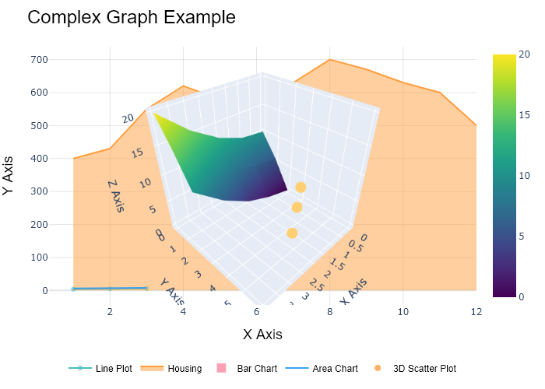

## Performance Metrics

|  |  |  |  |
| --- | --- | --- | --- |
| Task | Model Used | Description | Time Taken (s) |
| Processing Image to JSON | Gemini Vision Pro (default) | Time taken to convert the uploaded image to JSON format | 28.63 |
| Updating JSON | ChatGPT 3.5 (Default) | Time taken to update the JSON with new data | 0.00 |
| Plotting Updated JSON | N/A | Time taken to plot the updated JSON | 6.99 |

# Test Run



Figure: graphs/Area Plots/areaplot-2.png

## Prompt Used

Task: Extract detailed information from a given graph image and generate JSON files (data.json, layout.json, and config.json) compatible with Plotly. Use the specified delimiters to wrap each JSON section.  
  
Instructions:  
  
Graph Analysis:  
  
1. Identify and categorize the plot types present in the graph:  
 - Common 2D plots: `scatter`, `bar`, `pie`, `area`, `line`, `stacked bar`. Make sure you have correctly identified the chart type  
 - Advanced 3D plots: `scatter3d`, `surface`.  
2. Extract the data points for each plot:  
 - For 2D plots: Extract `x-values`, `y-values`, and any other relevant data (e.g., `labels` for pie charts).  
 - For 3D plots: Extract `x-values`, `y-values`, and `z-values`.  
3. Note any multiple plots on the same figure and their configurations (e.g., colors, stack groups, fill areas).  
  
Generate `data.json`:  
  
For each plot, include details such as:  
- **type**: The type of plot (e.g., `scatter`, `bar`, `pie`, `area`, `scatter3d`, `surface`).  
- **x**, **y**, and **z** (if applicable): Arrays of data points for the `x`, `y`, and `z` axes.  
- **labels** and **values** for pie charts.  
- **mode**: For line and scatter plots (e.g., `markers`, `lines`, `markers+lines`).  
- **name**: Legend entry for the plot.  
- **marker**: Properties such as color, size, and symbol for markers.  
- **line**: Properties such as color, width, and dash style for lines.  
- **text**: Hover text for each data point.  
- **hoverinfo**: Information displayed on hover (e.g., `x+y+text`).  
- **fill**: For area charts, specify the fill (e.g., `tozeroy`).  
- **stackgroup**: For stacked bar charts, specify the group for stacking.  
  
Generate `layout.json`:  
  
Include details such as:  
- **title**: The title of the graph, including text, font properties (family, size, color).  
- **xaxis** and **yaxis**: Configuration including title, range, showgrid, gridcolor, zeroline, zerolinecolor, showticklabels, tickangle, tickfont.  
- **zaxis**: Configuration for 3D plots including title, range, showgrid, gridcolor, zeroline, zerolinecolor, showticklabels, tickangle, tickfont.  
- **legend**: Properties including orientation, x, y, xanchor, font.  
- **margin**: Values for l (left), r (right), b (bottom), t (top), pad.  
- **plot_bgcolor** and **paper_bgcolor**: Background colors of the plot area and paper.  
- **scene**: For 3D plots, configuration for the 3D scene, including camera angles, lighting, and aspect ratio.  
  
Generate `config.json`:  
  
Include configuration settings such as:  
- **responsive**: Whether the graph is responsive (boolean).  
- **displayModeBar**: Whether the mode bar is displayed (boolean).  
- **modeBarButtonsToRemove**: List of mode bar buttons to remove (e.g., ["toImage"]).  
- **scrollZoom**: Whether scrolling zoom is enabled (boolean).  
  
Output Format:  
  
Wrap each JSON output in specific XML-like tags:  
- `<data> ... </data>`  
- `<layout> ... </layout>`  
- `<config> ... </config>`  
  
Make sure to follow the JSON formatting guidelines:  
- **Double Quotes for Keys and Strings**: Ensure that all keys and string values in JSON are enclosed in double quotes (").  
 - Example: Instead of `"type": bar`, it should be `"type": "bar"`.  
- **No Trailing Commas**: Remove any trailing commas after the last element in arrays ([]) or objects ({}).  
 - Example: Instead of `"color": "rgba(55, 128, 191, 0.6)",`, it should be `"color": "rgba(55, 128, 191, 0.6)"`.  
  
Example Output:  
  
```xml  
<data>  
[  
 {  
 "type": "scatter",  
 "x": [1, 2, 3],  
 "y": [4, 5, 6],  
 "mode": "markers+lines",  
 "name": "Line Plot",  
 "marker": {  
 "color": "rgba(75, 192, 192, 0.6)",  
 "size": 8  
 },  
 "line": {  
 "color": "rgba(75, 192, 192, 1)",  
 "width": 2  
 }  
 },  
 {  
 "type": "area",  
 "x": [1, 2, 3],  
 "y": [4, 5, 6],  
 "mode": "markers+lines",  
 "name": "Line Plot",  
 "marker": {  
 "color": "rgba(75, 192, 192, 0.6)",  
 "size": 8  
 },  
 "line": {  
 "color": "rgba(75, 192, 192, 1)",  
 "width": 2  
 }  
 },  
 {  
 "type": "bar",  
 "x": ["A", "B", "C"],  
 "y": [10, 15, 13],  
 "name": "Bar Chart",  
 "marker": {  
 "color": "rgba(255, 99, 132, 0.6)"  
 },  
 "hoverinfo": "x+y+text"  
 },  
 {  
 "type": "scatter",  
 "x": [1, 2, 3],  
 "y": [6, 7, 8],  
 "mode": "lines",  
 "name": "Area Chart",  
 "fill": "tozeroy",  
 "line": {  
 "color": "rgba(54, 162, 235, 1)",  
 "width": 2  
 }  
 },  
 {  
 "type": "scatter3d",  
 "x": [1, 2, 3],  
 "y": [4, 5, 6],  
 "z": [7, 8, 9],  
 "mode": "markers",  
 "name": "3D Scatter Plot",  
 "marker": {  
 "color": "rgba(255, 159, 64, 0.8)",  
 "size": 5  
 },  
 "hoverinfo": "x+y+z+text"  
 },  
 {  
 "type": "surface",  
 "z": [  
 [10, 10.625, 12.5, 15.625, 20],  
 [5.625, 6.25, 8.125, 11.25, 15.625],  
 [0, 1.25, 3.125, 6.25, 10.625]  
 ],  
 "name": "Surface Plot",  
 "colorscale": "Viridis",  
 "hoverinfo": "z+name"  
 }  
]  
</data>  
<layout>  
{  
 "title": {  
 "text": "Complex Graph Example",  
 "font": {  
 "family": "Arial, sans-serif",  
 "size": 24,  
 "color": "#000000"  
 }  
 },  
 "xaxis": {  
 "title": {  
 "text": "X Axis",  
 "font": {  
 "family": "Arial, sans-serif",  
 "size": 18,  
 "color": "#000000"  
 }  
 },  
 "showgrid": true,  
 "gridcolor": "rgba(0, 0, 0, 0.1)",  
 "zeroline": true,  
 "zerolinecolor": "rgba(0, 0, 0, 0.1)"  
 },  
 "yaxis": {  
 "title": {  
 "text": "Y Axis",  
 "font": {  
 "family": "Arial, sans-serif",  
 "size": 18,  
 "color": "#000000"  
 }  
 },  
 "showgrid": true,  
 "gridcolor": "rgba(0, 0, 0, 0.1)",  
 "zeroline": true,  
 "zerolinecolor": "rgba(0, 0, 0, 0.1)"  
 },  
 "legend": {  
 "orientation": "h",  
 "x": 0.5,  
 "xanchor": "center",  
 "y": -0.2,  
 "font": {  
 "family": "Arial, sans-serif",  
 "size": 12,  
 "color": "#000000"  
 }  
 },  
 "margin": {  
 "l": 60,  
 "r": 30,  
 "b": 60,  
 "t": 60  
 },  
 "plot_bgcolor": "#ffffff",  
 "paper_bgcolor": "#ffffff",  
 "scene": {  
 "xaxis": {"title": "X Axis"},  
 "yaxis": {"title": "Y Axis"},  
 "zaxis": {"title": "Z Axis"}  
 }  
}  
</layout>  
<config>  
{  
 "responsive": true,  
 "displayModeBar": true,  
 "modeBarButtonsToRemove": ["toImage"],  
 "scrollZoom": true  
}  
</config>

## Extracted JSON

### data

[  
 {  
 "type": "bar",  
 "x": [  
 "Jan",  
 "Feb",  
 "Mar",  
 "Apr",  
 "May",  
 "Jun",  
 "Jul",  
 "Aug",  
 "Sep",  
 "Oct",  
 "Nov",  
 "Dec"  
 ],  
 "y": [  
 520,  
 560,  
 540,  
 580,  
 600,  
 570,  
 490,  
 510,  
 670,  
 590,  
 560,  
 630  
 ],  
 "name": "Housing",  
 "marker": {  
 "color": "rgba(255, 99, 132, 0.6)"  
 }  
 },  
 {  
 "type": "bar",  
 "x": [  
 "Jan",  
 "Feb",  
 "Mar",  
 "Apr",  
 "May",  
 "Jun",  
 "Jul",  
 "Aug",  
 "Sep",  
 "Oct",  
 "Nov",  
 "Dec"  
 ],  
 "y": [  
 400,  
 420,  
 410,  
 430,  
 390,  
 410,  
 440,  
 420,  
 380,  
 400,  
 410,  
 430  
 ],  
 "name": "Food",  
 "marker": {  
 "color": "rgba(55, 128, 191, 0.6)"  
 }  
 },  
 {  
 "type": "bar",  
 "x": [  
 "Jan",  
 "Feb",  
 "Mar",  
 "Apr",  
 "May",  
 "Jun",  
 "Jul",  
 "Aug",  
 "Sep",  
 "Oct",  
 "Nov",  
 "Dec"  
 ],  
 "y": [  
 200,  
 220,  
 210,  
 230,  
 190,  
 210,  
 240,  
 220,  
 180,  
 200,  
 210,  
 230  
 ],  
 "name": "Utility",  
 "marker": {  
 "color": "rgba(255, 159, 64, 0.6)"  
 }  
 },  
 {  
 "type": "bar",  
 "x": [  
 "Jan",  
 "Feb",  
 "Mar",  
 "Apr",  
 "May",  
 "Jun",  
 "Jul",  
 "Aug",  
 "Sep",  
 "Oct",  
 "Nov",  
 "Dec"  
 ],  
 "y": [  
 100,  
 120,  
 110,  
 130,  
 90,  
 110,  
 140,  
 120,  
 80,  
 100,  
 110,  
 130  
 ],  
 "name": "Insurance",  
 "marker": {  
 "color": "rgba(153, 102, 255, 0.6)"  
 }  
 }  
]

### layout

{  
 "title": {  
 "text": "Monthly Expenses",  
 "font": {  
 "family": "Arial, sans-serif",  
 "size": 24,  
 "color": "#000000"  
 }  
 },  
 "xaxis": {  
 "title": {  
 "text": "Months",  
 "font": {  
 "family": "Arial, sans-serif",  
 "size": 18,  
 "color": "#000000"  
 }  
 },  
 "showgrid": true,  
 "gridcolor": "rgba(0, 0, 0, 0.1)",  
 "zeroline": true,  
 "zerolinecolor": "rgba(0, 0, 0, 0.1)"  
 },  
 "yaxis": {  
 "title": {  
 "text": "Amount (USD)",  
 "font": {  
 "family": "Arial, sans-serif",  
 "size": 18,  
 "color": "#000000"  
 }  
 },  
 "showgrid": true,  
 "gridcolor": "rgba(0, 0, 0, 0.1)",  
 "zeroline": true,  
 "zerolinecolor": "rgba(0, 0, 0, 0.1)"  
 },  
 "legend": {  
 "orientation": "h",  
 "x": 0.5,  
 "xanchor": "center",  
 "y": -0.2,  
 "font": {  
 "family": "Arial, sans-serif",  
 "size": 12,  
 "color": "#000000"  
 }  
 },  
 "margin": {  
 "l": 60,  
 "r": 30,  
 "b": 60,  
 "t": 60  
 },  
 "plot_bgcolor": "#ffffff",  
 "paper_bgcolor": "#ffffff"  
}

### config

{  
 "responsive": true,  
 "displayModeBar": true,  
 "modeBarButtonsToRemove": [  
 "toImage"  
 ],  
 "scrollZoom": true  
}

## Updated JSON

### updated_data

[  
 {  
 "type": "bar",  
 "x": [  
 "Jan",  
 "Feb",  
 "Mar",  
 "Apr",  
 "May",  
 "Jun",  
 "Jul",  
 "Aug",  
 "Sep",  
 "Oct",  
 "Nov",  
 "Dec"  
 ],  
 "y": [  
 520,  
 560,  
 540,  
 580,  
 600,  
 570,  
 490,  
 510,  
 670,  
 590,  
 560,  
 630  
 ],  
 "name": "Housing",  
 "marker": {  
 "color": "rgba(255, 99, 132, 0.6)"  
 }  
 },  
 {  
 "type": "bar",  
 "x": [  
 "Jan",  
 "Feb",  
 "Mar",  
 "Apr",  
 "May",  
 "Jun",  
 "Jul",  
 "Aug",  
 "Sep",  
 "Oct",  
 "Nov",  
 "Dec"  
 ],  
 "y": [  
 400,  
 420,  
 410,  
 430,  
 390,  
 410,  
 440,  
 420,  
 380,  
 400,  
 410,  
 430  
 ],  
 "name": "Food",  
 "marker": {  
 "color": "rgba(55, 128, 191, 0.6)"  
 }  
 },  
 {  
 "type": "bar",  
 "x": [  
 "Jan",  
 "Feb",  
 "Mar",  
 "Apr",  
 "May",  
 "Jun",  
 "Jul",  
 "Aug",  
 "Sep",  
 "Oct",  
 "Nov",  
 "Dec"  
 ],  
 "y": [  
 200,  
 220,  
 210,  
 230,  
 190,  
 210,  
 240,  
 220,  
 180,  
 200,  
 210,  
 230  
 ],  
 "name": "Utility",  
 "marker": {  
 "color": "rgba(255, 159, 64, 0.6)"  
 }  
 },  
 {  
 "type": "bar",  
 "x": [  
 "Jan",  
 "Feb",  
 "Mar",  
 "Apr",  
 "May",  
 "Jun",  
 "Jul",  
 "Aug",  
 "Sep",  
 "Oct",  
 "Nov",  
 "Dec"  
 ],  
 "y": [  
 100,  
 120,  
 110,  
 130,  
 90,  
 110,  
 140,  
 120,  
 80,  
 100,  
 110,  
 130  
 ],  
 "name": "Insurance",  
 "marker": {  
 "color": "rgba(153, 102, 255, 0.6)"  
 }  
 }  
]

### updated_layout

{  
 "title": {  
 "text": "Monthly Expenses",  
 "font": {  
 "family": "Arial, sans-serif",  
 "size": 24,  
 "color": "#000000"  
 }  
 },  
 "xaxis": {  
 "title": {  
 "text": "Months",  
 "font": {  
 "family": "Arial, sans-serif",  
 "size": 18,  
 "color": "#000000"  
 }  
 },  
 "showgrid": true,  
 "gridcolor": "rgba(0, 0, 0, 0.1)",  
 "zeroline": true,  
 "zerolinecolor": "rgba(0, 0, 0, 0.1)"  
 },  
 "yaxis": {  
 "title": {  
 "text": "Amount (USD)",  
 "font": {  
 "family": "Arial, sans-serif",  
 "size": 18,  
 "color": "#000000"  
 }  
 },  
 "showgrid": true,  
 "gridcolor": "rgba(0, 0, 0, 0.1)",  
 "zeroline": true,  
 "zerolinecolor": "rgba(0, 0, 0, 0.1)"  
 },  
 "legend": {  
 "orientation": "h",  
 "x": 0.5,  
 "xanchor": "center",  
 "y": -0.2,  
 "font": {  
 "family": "Arial, sans-serif",  
 "size": 12,  
 "color": "#000000"  
 }  
 },  
 "margin": {  
 "l": 60,  
 "r": 30,  
 "b": 60,  
 "t": 60  
 },  
 "plot_bgcolor": "#ffffff",  
 "paper_bgcolor": "#ffffff"  
}

### updated_config

{  
 "responsive": true,  
 "displayModeBar": true,  
 "modeBarButtonsToRemove": [  
 "toImage"  
 ],  
 "scrollZoom": true  
}

## Updated Chart

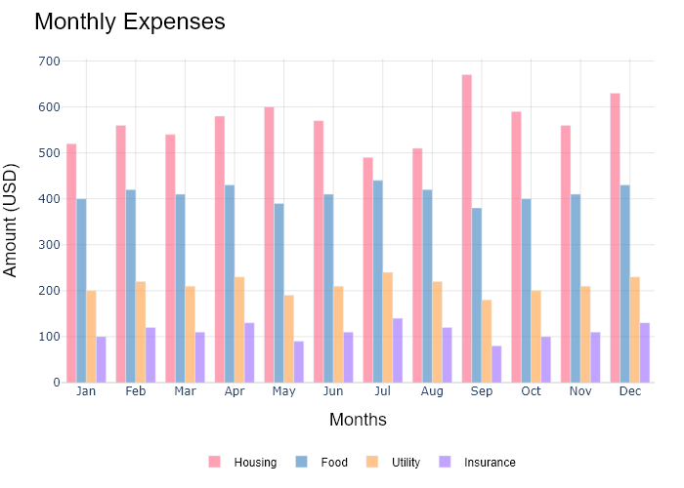

## Performance Metrics

|  |  |  |  |
| --- | --- | --- | --- |
| Task | Model Used | Description | Time Taken (s) |
| Processing Image to JSON | Gemini Vision Pro (default) | Time taken to convert the uploaded image to JSON format | 23.86 |
| Updating JSON | ChatGPT 3.5 (Default) | Time taken to update the JSON with new data | 0.00 |
| Plotting Updated JSON | N/A | Time taken to plot the updated JSON | 0.22 |

# Test Run



Figure: graphs/Area Plots/areaplot-2.png

## Prompt Used

Task: Extract detailed information from a given graph image and generate JSON files (data.json, layout.json, and config.json) compatible with Plotly. Use the specified delimiters to wrap each JSON section.  
  
Instructions:  
  
Graph Analysis:  
  
Identify and categorize the plot types present in the graph (e.g., line, scatter, bar, pie, areaplot etc).  
Extract the data points for each plot (x-values, y-values, and any other relevant data such as labels for pie charts).  
Note any multiple plots on the same figure and their configurations.  
Generate data.json:  
  
For each plot, include details such as:  
type: The type of plot (e.g., scatter, bar, pie).  
x and y: Arrays of data points for the x and y axes.  
labels and values for pie charts.  
mode: For line and scatter plots (e.g., markers, lines, or markers+lines).  
name: Legend entry for the plot.  
marker: Properties such as color, size, and symbol for markers.  
line: Properties such as color, width, and dash style for lines.  
text: Hover text for each data point.  
hoverinfo: Information displayed on hover (e.g., x+y+text).  
Generate layout.json:  
  
Include details such as:  
title: The title of the graph, including text, font properties (family, size, color).  
xaxis and yaxis: Configuration including title, range, showgrid, gridcolor, zeroline, zerolinecolor, showticklabels, tickangle, tickfont.  
legend: Properties including orientation, x, y, xanchor, font.  
margin: Values for l (left), r (right), b (bottom), t (top), pad.  
plot_bgcolor and paper_bgcolor: Background colors of the plot area and paper.  
Generate config.json:  
  
Include configuration settings such as:  
responsive: Whether the graph is responsive (boolean).  
displayModeBar: Whether the mode bar is displayed (boolean).  
modeBarButtonsToRemove: List of mode bar buttons to remove (e.g., ["toImage"]).  
scrollZoom: Whether scrolling zoom is enabled (boolean).  
Output Format:  
  
Wrap each JSON output in specific XML-like tags:  
<data> ... </data>  
<layout> ... </layout>  
<config> ... </config>  
Make sure to follow the JSON formatting guidelines:  
Double Quotes for Keys and Strings: Ensure that all keys and string values in JSON are enclosed in double quotes (").  
Example: Instead of "type": bar, it should be "type": "bar".  
No Trailing Commas: Remove any trailing commas after the last element in arrays ([]) or objects ({}).  
Example: Instead of "color": "rgba(55, 128, 191, 0.6)",, it should be "color": "rgba(55, 128, 191, 0.6)"  
Example Output:  
  
<data>  
[  
 {  
 "type": "scatter",  
 "x": [1, 2, 3],  
 "y": [4, 5, 6],  
 "mode": "markers+lines",  
 "name": "Line Plot",  
 "marker": {  
 "color": "rgba(75, 192, 192, 0.6)",  
 "size": 8  
 },  
 "line": {  
 "color": "rgba(75, 192, 192, 1)",  
 "width": 2  
 }  
 }  
 // Additional plots if present  
]  
</data>  
<layout>  
{  
 "title": {  
 "text": "Graph Title",  
 "font": {  
 "family": "Arial, sans-serif",  
 "size": 24,  
 "color": "#000000"  
 }  
 },  
 "xaxis": {  
 "title": {  
 "text": "X Axis",  
 "font": {  
 "family": "Arial, sans-serif",  
 "size": 18,  
 "color": "#000000"  
 }  
 },  
 "showgrid": true,  
 "gridcolor": "rgba(0, 0, 0, 0.1)",  
 "zeroline": true,  
 "zerolinecolor": "rgba(0, 0, 0, 0.1)"  
 },  
 "yaxis": {  
 "title": {  
 "text": "Y Axis",  
 "font": {  
 "family": "Arial, sans-serif",  
 "size": 18,  
 "color": "#000000"  
 }  
 },  
 "showgrid": true,  
 "gridcolor": "rgba(0, 0, 0, 0.1)",  
 "zeroline": true,  
 "zerolinecolor": "rgba(0, 0, 0, 0.1)"  
 },  
 "legend": {  
 "orientation": "h",  
 "x": 0.5,  
 "xanchor": "center",  
 "y": -0.2,  
 "font": {  
 "family": "Arial, sans-serif",  
 "size": 12,  
 "color": "#000000"  
 }  
 },  
 "margin": {  
 "l": 60,  
 "r": 30,  
 "b": 60,  
 "t": 60  
 },  
 "plot_bgcolor": "#ffffff",  
 "paper_bgcolor": "#ffffff"  
}  
</layout>  
<config>  
{  
 "responsive": true,  
 "displayModeBar": true,  
 "modeBarButtonsToRemove": ["toImage"],  
 "scrollZoom": true  
}  
</config>

## Extracted JSON

### data

[  
 {  
 "type": "scatter",  
 "x": [  
 1,  
 2,  
 3,  
 4,  
 5,  
 6,  
 7,  
 8,  
 9,  
 10,  
 11,  
 12  
 ],  
 "y": [  
 400,  
 430,  
 550,  
 560,  
 600,  
 610,  
 650,  
 660,  
 630,  
 600,  
 580,  
 500  
 ],  
 "mode": "lines",  
 "name": "Housing"  
 },  
 {  
 "type": "scatter",  
 "x": [  
 1,  
 2,  
 3,  
 4,  
 5,  
 6,  
 7,  
 8,  
 9,  
 10,  
 11,  
 12  
 ],  
 "y": [  
 200,  
 220,  
 280,  
 290,  
 330,  
 300,  
 350,  
 360,  
 330,  
 300,  
 280,  
 200  
 ],  
 "mode": "lines",  
 "name": "Food"  
 },  
 {  
 "type": "scatter",  
 "x": [  
 1,  
 2,  
 3,  
 4,  
 5,  
 6,  
 7,  
 8,  
 9,  
 10,  
 11,  
 12  
 ],  
 "y": [  
 100,  
 120,  
 190,  
 200,  
 220,  
 210,  
 250,  
 260,  
 230,  
 200,  
 180,  
 100  
 ],  
 "mode": "lines",  
 "name": "Utility"  
 },  
 {  
 "type": "scatter",  
 "x": [  
 1,  
 2,  
 3,  
 4,  
 5,  
 6,  
 7,  
 8,  
 9,  
 10,  
 11,  
 12  
 ],  
 "y": [  
 150,  
 180,  
 130,  
 150,  
 120,  
 140,  
 100,  
 120,  
 140,  
 120,  
 150,  
 180  
 ],  
 "mode": "lines",  
 "name": "Insurance"  
 }  
]

### layout

{  
 "title": {  
 "text": "Monthly Expenses",  
 "font": {  
 "family": "Arial, sans-serif",  
 "size": 24,  
 "color": "#000000"  
 }  
 },  
 "xaxis": {  
 "title": {  
 "text": "Months",  
 "font": {  
 "family": "Arial, sans-serif",  
 "size": 18,  
 "color": "#000000"  
 }  
 },  
 "showgrid": true,  
 "gridcolor": "rgba(0, 0, 0, 0.1)",  
 "zeroline": true,  
 "zerolinecolor": "rgba(0, 0, 0, 0.1)"  
 },  
 "yaxis": {  
 "title": {  
 "text": "Amount",  
 "font": {  
 "family": "Arial, sans-serif",  
 "size": 18,  
 "color": "#000000"  
 }  
 },  
 "showgrid": true,  
 "gridcolor": "rgba(0, 0, 0, 0.1)",  
 "zeroline": true,  
 "zerolinecolor": "rgba(0, 0, 0, 0.1)"  
 },  
 "legend": {  
 "orientation": "h",  
 "x": 0.5,  
 "xanchor": "center",  
 "y": -0.2,  
 "font": {  
 "family": "Arial, sans-serif",  
 "size": 12,  
 "color": "#000000"  
 }  
 },  
 "margin": {  
 "l": 60,  
 "r": 30,  
 "b": 60,  
 "t": 60  
 },  
 "plot_bgcolor": "#ffffff",  
 "paper_bgcolor": "#ffffff"  
}

### config

{  
 "responsive": true,  
 "displayModeBar": true,  
 "modeBarButtonsToRemove": [  
 "toImage"  
 ],  
 "scrollZoom": true  
}

## Updated JSON

### updated_data

[  
 {  
 "type": "scatter",  
 "x": [  
 1,  
 2,  
 3,  
 4,  
 5,  
 6,  
 7,  
 8,  
 9,  
 10,  
 11,  
 12  
 ],  
 "y": [  
 400,  
 430,  
 550,  
 560,  
 600,  
 610,  
 650,  
 660,  
 630,  
 600,  
 580,  
 500  
 ],  
 "mode": "lines",  
 "name": "Housing"  
 },  
 {  
 "type": "scatter",  
 "x": [  
 1,  
 2,  
 3,  
 4,  
 5,  
 6,  
 7,  
 8,  
 9,  
 10,  
 11,  
 12  
 ],  
 "y": [  
 200,  
 220,  
 280,  
 290,  
 330,  
 300,  
 350,  
 360,  
 330,  
 300,  
 280,  
 200  
 ],  
 "mode": "lines",  
 "name": "Food"  
 },  
 {  
 "type": "scatter",  
 "x": [  
 1,  
 2,  
 3,  
 4,  
 5,  
 6,  
 7,  
 8,  
 9,  
 10,  
 11,  
 12  
 ],  
 "y": [  
 100,  
 120,  
 190,  
 200,  
 220,  
 210,  
 250,  
 260,  
 230,  
 200,  
 180,  
 100  
 ],  
 "mode": "lines",  
 "name": "Utility"  
 },  
 {  
 "type": "scatter",  
 "x": [  
 1,  
 2,  
 3,  
 4,  
 5,  
 6,  
 7,  
 8,  
 9,  
 10,  
 11,  
 12  
 ],  
 "y": [  
 150,  
 180,  
 130,  
 150,  
 120,  
 140,  
 100,  
 120,  
 140,  
 120,  
 150,  
 180  
 ],  
 "mode": "lines",  
 "name": "Insurance"  
 }  
]

### updated_layout

{  
 "title": {  
 "text": "Monthly Expenses",  
 "font": {  
 "family": "Arial, sans-serif",  
 "size": 24,  
 "color": "#000000"  
 }  
 },  
 "xaxis": {  
 "title": {  
 "text": "Months",  
 "font": {  
 "family": "Arial, sans-serif",  
 "size": 18,  
 "color": "#000000"  
 }  
 },  
 "showgrid": true,  
 "gridcolor": "rgba(0, 0, 0, 0.1)",  
 "zeroline": true,  
 "zerolinecolor": "rgba(0, 0, 0, 0.1)"  
 },  
 "yaxis": {  
 "title": {  
 "text": "Amount",  
 "font": {  
 "family": "Arial, sans-serif",  
 "size": 18,  
 "color": "#000000"  
 }  
 },  
 "showgrid": true,  
 "gridcolor": "rgba(0, 0, 0, 0.1)",  
 "zeroline": true,  
 "zerolinecolor": "rgba(0, 0, 0, 0.1)"  
 },  
 "legend": {  
 "orientation": "h",  
 "x": 0.5,  
 "xanchor": "center",  
 "y": -0.2,  
 "font": {  
 "family": "Arial, sans-serif",  
 "size": 12,  
 "color": "#000000"  
 }  
 },  
 "margin": {  
 "l": 60,  
 "r": 30,  
 "b": 60,  
 "t": 60  
 },  
 "plot_bgcolor": "#ffffff",  
 "paper_bgcolor": "#ffffff"  
}

### updated_config

{  
 "responsive": true,  
 "displayModeBar": true,  
 "modeBarButtonsToRemove": [  
 "toImage"  
 ],  
 "scrollZoom": true  
}

## Updated Chart



## Performance Metrics

|  |  |  |  |
| --- | --- | --- | --- |
| Task | Model Used | Description | Time Taken (s) |
| Processing Image to JSON | Gemini Vision Pro (default) | Time taken to convert the uploaded image to JSON format | 23.31 |
| Updating JSON | ChatGPT 3.5 (Default) | Time taken to update the JSON with new data | 0.00 |
| Plotting Updated JSON | N/A | Time taken to plot the updated JSON | 0.43 |

# Test Run



Figure: graphs/Area Plots/areaplot-2.png

## Prompt Used

Task: Extract detailed information from a given graph image and generate JSON files (data.json, layout.json, and config.json) compatible with Plotly. Use the specified delimiters to wrap each JSON section.  
  
Instructions:  
  
Graph Analysis:  
  
Identify and categorize the plot types present in the graph (e.g., line, scatter, bar, pie, areaplot etc).  
Extract the data points for each plot (x-values, y-values, and any other relevant data such as labels for pie charts).  
Note any multiple plots on the same figure and their configurations.  
Generate data.json:  
  
For each plot, include details such as:  
type: The type of plot (e.g., scatter, bar, pie).  
x and y: Arrays of data points for the x and y axes.  
labels and values for pie charts.  
mode: For line and scatter plots (e.g., markers, lines, or markers+lines).  
name: Legend entry for the plot.  
marker: Properties such as color, size, and symbol for markers.  
line: Properties such as color, width, and dash style for lines.  
text: Hover text for each data point.  
hoverinfo: Information displayed on hover (e.g., x+y+text).  
Generate layout.json:  
Copy the same layout as the original image, same color, same font, same size, same position, same orientation, same everything.  
  
Include details such as:  
title: The title of the graph, including text, font properties (family, size, color).  
xaxis and yaxis: Configuration including title, range, showgrid, gridcolor, zeroline, zerolinecolor, showticklabels, tickangle, tickfont.  
legend: Properties including orientation, x, y, xanchor, font.  
margin: Values for l (left), r (right), b (bottom), t (top), pad.  
plot_bgcolor and paper_bgcolor: Background colors of the plot area and paper.  
Generate config.json:  
  
Include configuration settings such as:  
responsive: Whether the graph is responsive (boolean).  
displayModeBar: Whether the mode bar is displayed (boolean).  
modeBarButtonsToRemove: List of mode bar buttons to remove (e.g., ["toImage"]).  
scrollZoom: Whether scrolling zoom is enabled (boolean).  
Output Format:  
  
Wrap each JSON output in specific XML-like tags:  
<data> ... </data>  
<layout> ... </layout>  
<config> ... </config>  
Make sure to follow the JSON formatting guidelines:  
Double Quotes for Keys and Strings: Ensure that all keys and string values in JSON are enclosed in double quotes (").  
Example: Instead of "type": bar, it should be "type": "bar".  
No Trailing Commas: Remove any trailing commas after the last element in arrays ([]) or objects ({}).  
Example: Instead of "color": "rgba(55, 128, 191, 0.6)",, it should be "color": "rgba(55, 128, 191, 0.6)"  
Example Output:  
  
<data>  
[  
 {  
 "type": "scatter",  
 "x": [1, 2, 3],  
 "y": [4, 5, 6],  
 "mode": "markers+lines",  
 "name": "Line Plot",  
 "marker": {  
 "color": "rgba(75, 192, 192, 0.6)",  
 "size": 8  
 },  
 "line": {  
 "color": "rgba(75, 192, 192, 1)",  
 "width": 2  
 }  
 }  
 // Additional plots if present  
]  
</data>  
<layout>  
{  
 "title": {  
 "text": "Graph Title",  
 "font": {  
 "family": "Arial, sans-serif",  
 "size": 24,  
 "color": "#000000"  
 }  
 },  
 "xaxis": {  
 "title": {  
 "text": "X Axis",  
 "font": {  
 "family": "Arial, sans-serif",  
 "size": 18,  
 "color": "#000000"  
 }  
 },  
 "showgrid": true,  
 "gridcolor": "rgba(0, 0, 0, 0.1)",  
 "zeroline": true,  
 "zerolinecolor": "rgba(0, 0, 0, 0.1)"  
 },  
 "yaxis": {  
 "title": {  
 "text": "Y Axis",  
 "font": {  
 "family": "Arial, sans-serif",  
 "size": 18,  
 "color": "#000000"  
 }  
 },  
 "showgrid": true,  
 "gridcolor": "rgba(0, 0, 0, 0.1)",  
 "zeroline": true,  
 "zerolinecolor": "rgba(0, 0, 0, 0.1)"  
 },  
 "legend": {  
 "orientation": "h",  
 "x": 0.5,  
 "xanchor": "center",  
 "y": -0.2,  
 "font": {  
 "family": "Arial, sans-serif",  
 "size": 12,  
 "color": "#000000"  
 }  
 },  
 "margin": {  
 "l": 60,  
 "r": 30,  
 "b": 60,  
 "t": 60  
 },  
 "plot_bgcolor": "#ffffff",  
 "paper_bgcolor": "#ffffff"  
}  
</layout>  
<config>  
{  
 "responsive": true,  
 "displayModeBar": true,  
 "modeBarButtonsToRemove": ["toImage"],  
 "scrollZoom": true  
}  
</config>

## Extracted JSON

### data

[  
 {  
 "type": "scatter",  
 "x": [  
 "Jan",  
 "Feb",  
 "Mar",  
 "Apr",  
 "May",  
 "Jun",  
 "Jul",  
 "Aug",  
 "Sep",  
 "Oct",  
 "Nov",  
 "Dec"  
 ],  
 "y": [  
 400,  
 430,  
 440,  
 470,  
 500,  
 450,  
 430,  
 540,  
 480,  
 520,  
 560,  
 600  
 ],  
 "mode": "lines",  
 "name": "Housing",  
 "line": {  
 "color": "rgba(55, 128, 191, 1)",  
 "width": 2  
 }  
 },  
 {  
 "type": "scatter",  
 "x": [  
 "Jan",  
 "Feb",  
 "Mar",  
 "Apr",  
 "May",  
 "Jun",  
 "Jul",  
 "Aug",  
 "Sep",  
 "Oct",  
 "Nov",  
 "Dec"  
 ],  
 "y": [  
 200,  
 220,  
 230,  
 250,  
 280,  
 230,  
 250,  
 290,  
 220,  
 240,  
 250,  
 270  
 ],  
 "mode": "lines",  
 "name": "Food",  
 "line": {  
 "color": "rgba(255, 127, 14, 1)",  
 "width": 2  
 }  
 },  
 {  
 "type": "scatter",  
 "x": [  
 "Jan",  
 "Feb",  
 "Mar",  
 "Apr",  
 "May",  
 "Jun",  
 "Jul",  
 "Aug",  
 "Sep",  
 "Oct",  
 "Nov",  
 "Dec"  
 ],  
 "y": [  
 100,  
 120,  
 130,  
 150,  
 180,  
 130,  
 150,  
 180,  
 130,  
 150,  
 180,  
 200  
 ],  
 "mode": "lines",  
 "name": "Utility",  
 "line": {  
 "color": "rgba(255, 209, 102, 1)",  
 "width": 2  
 }  
 },  
 {  
 "type": "scatter",  
 "x": [  
 "Jan",  
 "Feb",  
 "Mar",  
 "Apr",  
 "May",  
 "Jun",  
 "Jul",  
 "Aug",  
 "Sep",  
 "Oct",  
 "Nov",  
 "Dec"  
 ],  
 "y": [  
 150,  
 180,  
 120,  
 100,  
 80,  
 120,  
 100,  
 80,  
 120,  
 100,  
 120,  
 150  
 ],  
 "mode": "lines",  
 "name": "Insurance",  
 "line": {  
 "color": "rgba(139, 0, 139, 1)",  
 "width": 2  
 }  
 }  
]

### layout

{  
 "title": {  
 "text": "Monthly Expenses",  
 "font": {  
 "family": "Arial, sans-serif",  
 "size": 24,  
 "color": "#000000"  
 }  
 },  
 "xaxis": {  
 "title": {  
 "text": "Months",  
 "font": {  
 "family": "Arial, sans-serif",  
 "size": 18,  
 "color": "#000000"  
 }  
 },  
 "showgrid": true,  
 "gridcolor": "rgba(0, 0, 0, 0.1)",  
 "zeroline": true,  
 "zerolinecolor": "rgba(0, 0, 0, 0.1)"  
 },  
 "yaxis": {  
 "title": {  
 "text": "Amount",  
 "font": {  
 "family": "Arial, sans-serif",  
 "size": 18,  
 "color": "#000000"  
 }  
 },  
 "showgrid": true,  
 "gridcolor": "rgba(0, 0, 0, 0.1)",  
 "zeroline": true,  
 "zerolinecolor": "rgba(0, 0, 0, 0.1)"  
 },  
 "legend": {  
 "orientation": "h",  
 "x": 0.5,  
 "xanchor": "center",  
 "y": -0.2,  
 "font": {  
 "family": "Arial, sans-serif",  
 "size": 12,  
 "color": "#000000"  
 }  
 },  
 "margin": {  
 "l": 60,  
 "r": 30,  
 "b": 60,  
 "t": 60  
 },  
 "plot_bgcolor": "#ffffff",  
 "paper_bgcolor": "#ffffff"  
}

### config

{  
 "responsive": true,  
 "displayModeBar": true,  
 "modeBarButtonsToRemove": [  
 "toImage"  
 ],  
 "scrollZoom": true  
}

## Updated JSON

### updated_data

[  
 {  
 "type": "scatter",  
 "x": [  
 "Jan",  
 "Feb",  
 "Mar",  
 "Apr",  
 "May",  
 "Jun",  
 "Jul",  
 "Aug",  
 "Sep",  
 "Oct",  
 "Nov",  
 "Dec"  
 ],  
 "y": [  
 400,  
 430,  
 440,  
 470,  
 500,  
 450,  
 430,  
 540,  
 480,  
 520,  
 560,  
 600  
 ],  
 "mode": "lines",  
 "name": "Housing",  
 "line": {  
 "color": "rgba(55, 128, 191, 1)",  
 "width": 2  
 }  
 },  
 {  
 "type": "scatter",  
 "x": [  
 "Jan",  
 "Feb",  
 "Mar",  
 "Apr",  
 "May",  
 "Jun",  
 "Jul",  
 "Aug",  
 "Sep",  
 "Oct",  
 "Nov",  
 "Dec"  
 ],  
 "y": [  
 200,  
 220,  
 230,  
 250,  
 280,  
 230,  
 250,  
 290,  
 220,  
 240,  
 250,  
 270  
 ],  
 "mode": "lines",  
 "name": "Food",  
 "line": {  
 "color": "rgba(255, 127, 14, 1)",  
 "width": 2  
 }  
 },  
 {  
 "type": "scatter",  
 "x": [  
 "Jan",  
 "Feb",  
 "Mar",  
 "Apr",  
 "May",  
 "Jun",  
 "Jul",  
 "Aug",  
 "Sep",  
 "Oct",  
 "Nov",  
 "Dec"  
 ],  
 "y": [  
 100,  
 120,  
 130,  
 150,  
 180,  
 130,  
 150,  
 180,  
 130,  
 150,  
 180,  
 200  
 ],  
 "mode": "lines",  
 "name": "Utility",  
 "line": {  
 "color": "rgba(255, 209, 102, 1)",  
 "width": 2  
 }  
 },  
 {  
 "type": "scatter",  
 "x": [  
 "Jan",  
 "Feb",  
 "Mar",  
 "Apr",  
 "May",  
 "Jun",  
 "Jul",  
 "Aug",  
 "Sep",  
 "Oct",  
 "Nov",  
 "Dec"  
 ],  
 "y": [  
 150,  
 180,  
 120,  
 100,  
 80,  
 120,  
 100,  
 80,  
 120,  
 100,  
 120,  
 150  
 ],  
 "mode": "lines",  
 "name": "Insurance",  
 "line": {  
 "color": "rgba(139, 0, 139, 1)",  
 "width": 2  
 }  
 }  
]

### updated_layout

{  
 "title": {  
 "text": "Monthly Expenses",  
 "font": {  
 "family": "Arial, sans-serif",  
 "size": 24,  
 "color": "#000000"  
 }  
 },  
 "xaxis": {  
 "title": {  
 "text": "Months",  
 "font": {  
 "family": "Arial, sans-serif",  
 "size": 18,  
 "color": "#000000"  
 }  
 },  
 "showgrid": true,  
 "gridcolor": "rgba(0, 0, 0, 0.1)",  
 "zeroline": true,  
 "zerolinecolor": "rgba(0, 0, 0, 0.1)"  
 },  
 "yaxis": {  
 "title": {  
 "text": "Amount",  
 "font": {  
 "family": "Arial, sans-serif",  
 "size": 18,  
 "color": "#000000"  
 }  
 },  
 "showgrid": true,  
 "gridcolor": "rgba(0, 0, 0, 0.1)",  
 "zeroline": true,  
 "zerolinecolor": "rgba(0, 0, 0, 0.1)"  
 },  
 "legend": {  
 "orientation": "h",  
 "x": 0.5,  
 "xanchor": "center",  
 "y": -0.2,  
 "font": {  
 "family": "Arial, sans-serif",  
 "size": 12,  
 "color": "#000000"  
 }  
 },  
 "margin": {  
 "l": 60,  
 "r": 30,  
 "b": 60,  
 "t": 60  
 },  
 "plot_bgcolor": "#ffffff",  
 "paper_bgcolor": "#ffffff"  
}

### updated_config

{  
 "responsive": true,  
 "displayModeBar": true,  
 "modeBarButtonsToRemove": [  
 "toImage"  
 ],  
 "scrollZoom": true  
}

## Updated Chart

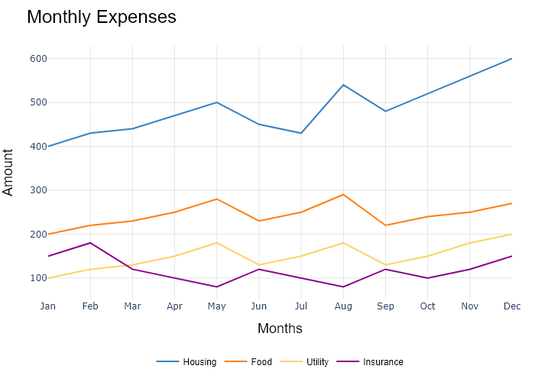

## Performance Metrics

|  |  |  |  |
| --- | --- | --- | --- |
| Task | Model Used | Description | Time Taken (s) |
| Processing Image to JSON | Gemini Vision Pro (default) | Time taken to convert the uploaded image to JSON format | 35.49 |
| Updating JSON | ChatGPT 3.5 (Default) | Time taken to update the JSON with new data | 0.00 |
| Plotting Updated JSON | N/A | Time taken to plot the updated JSON | 4.01 |