# Research Internship

## Input Image: 1711725089132.png

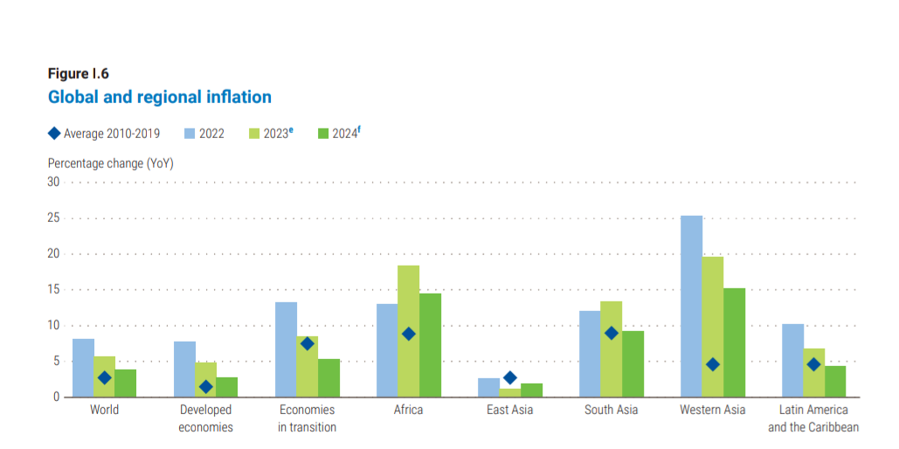

Original JSON:

{'x': [0, 1, 2, 3, 4], 'y': [0, 1, 4, 9, 16]}

Updated JSON:

{'x': [0, 1, 2, 3, 4], 'y': [-0.7782871927096469, 1.421233451100156, 4.712397521759349, 9.973715585356548, 16.811449445502376]}

Updated Chart:

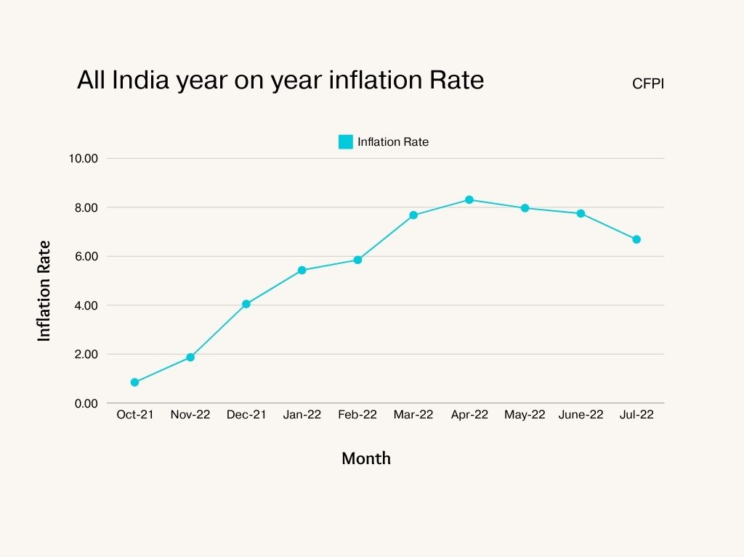

## Input Image: Actual Sales vs. Month (4).png

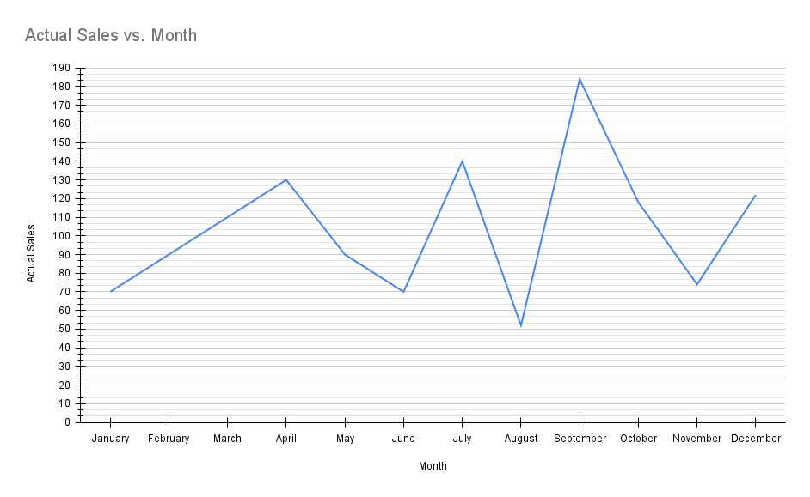

Original JSON:

{'x': [0, 1, 2, 3, 4], 'y': [0, 1, 4, 9, 16]}

Updated JSON:

{'x': [0, 1, 2, 3, 4], 'y': [-0.0793763702737289, 1.458876034785494, 3.0068087585230434, 9.031725141664223, 16.5439733087039]}

Updated Chart:



Date and Time: 2024-06-11 16:26:15

## Input Image: 1711725089132.png



Original JSON:

{'x': [0, 1, 2, 3, 4], 'y': [0, 1, 4, 9, 16]}

Updated JSON:

{'x': [0, 1, 2, 3, 4], 'y': [-0.05940148299042036, 1.078576433328491, 4.808851409604486, 9.41399036350737, 16.44156846674596]}

Updated Chart:



Date and Time: 2024-06-11 16:34:33

## Input Image: 1711725089159.png

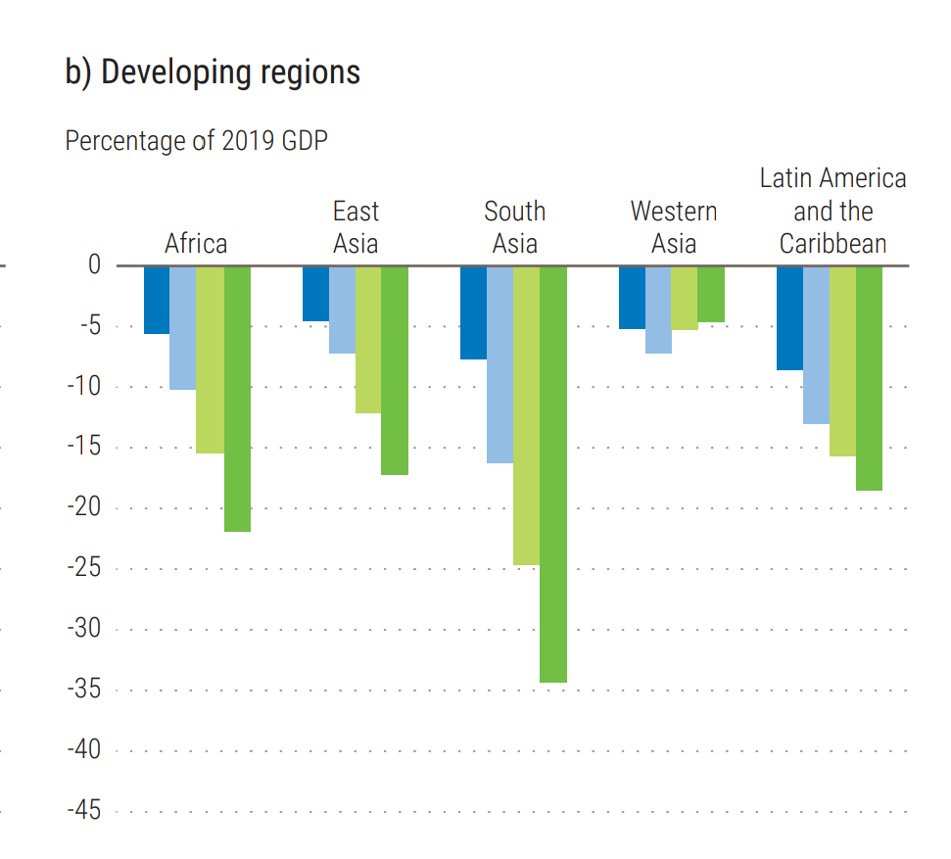

Original JSON:

{'x': [0, 1, 2, 3, 4], 'y': [0, 1, 4, 9, 16]}

Updated JSON:

{'x': [0, 1, 2, 3, 4], 'y': [-0.998035620206364, 1.5547960040491202, 3.982274130236214, 8.824427096515985, 15.012598273015174]}

Updated Chart:



Date and Time: 2024-06-11 16:36:41

## Input Image: A, B and C (1).png

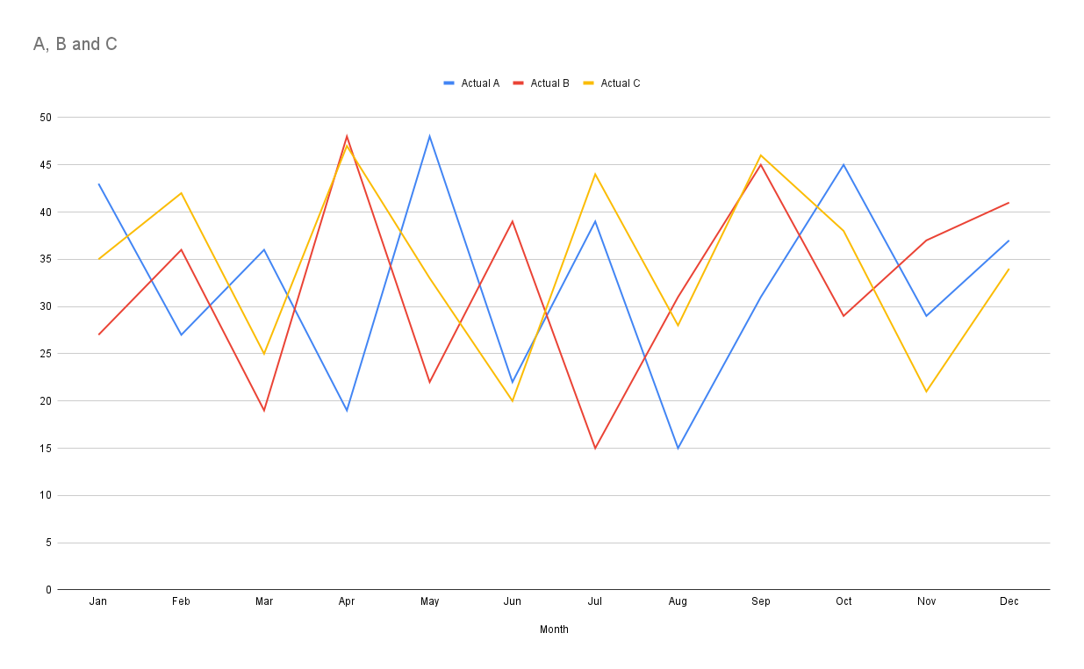

Original JSON:

{'x': [0, 1, 2, 3, 4], 'y': [0, 1, 4, 9, 16]}

Updated JSON:

{'x': [0, 1, 2, 3, 4], 'y': [0.8687664664949835, 1.958976258808305, 3.1545953744750643, 9.880960938405131, 15.52824201875975]}

Updated Chart:



Date and Time: 2024-06-11 16:40:14

## Input Image: 1711725089217.png

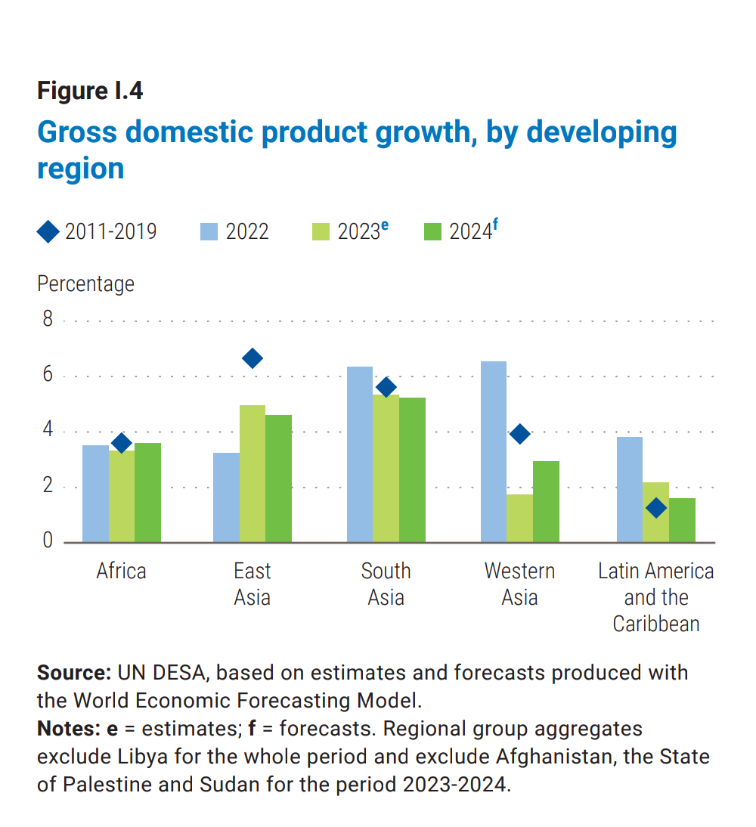

Original JSON:

{'x': [0, 1, 2, 3, 4], 'y': [0, 1, 4, 9, 16]}

Updated JSON:

{'x': [0, 1, 2, 3, 4], 'y': [-0.03779707564716661, 0.3405009645439778, 3.784322195887532, 8.772310326279907, 15.837485697107866]}

Updated Chart:



Date and Time: 2024-06-11 16:55:11

## Input Image: 1711725089217.png



Original JSON:

{'x': [0, 1, 2, 3, 4], 'y': [0, 1, 4, 9, 16]}

Updated JSON:

{'x': [0, 1, 2, 3, 4], 'y': [-0.20816108842788372, 1.6754393810840598, 3.062717994715123, 9.671263197894646, 15.338465875254263]}

Updated Chart:



Date and Time: 2024-06-11 17:05:57

## Input Image: 1711725089132.png



Original JSON:

{'x': [0, 1, 2, 3, 4], 'y': [0, 1, 4, 9, 16]}

Updated JSON:

{'x': [0, 1, 2, 3, 4], 'y': [0.6425932572634974, 1.8580710416376278, 4.584226308344611, 8.56508127464984, 15.43838263818143]}

Updated Chart:



Date and Time: 2024-06-11 17:08:09

## Input Image: 1711725089132.png



Original JSON:

{'x': [0, 1, 2, 3, 4], 'y': [0, 1, 4, 9, 16]}

Updated JSON:

{'x': [0, 1, 2, 3, 4], 'y': [0.02998806704206003, 1.2340360102142305, 3.3007767566383546, 9.49640849313288, 15.32942112138413]}

Updated Chart:



Date and Time: 2024-06-11 17:05:57

## Input Image: 1711725089132.png



Original JSON:

{'x': [0, 1, 2, 3, 4], 'y': [0, 1, 4, 9, 16]}

Updated JSON:

{'x': [0, 1, 2, 3, 4], 'y': [-0.9875741973626735, 1.5239809593336358, 4.671915683867165, 8.998966992557262, 16.51296515463015]}

Updated Chart:



Date and Time: 2024-06-11 17:05:57

## Input Image: 1711725089217.png



Original JSON:

{'x': [0, 1, 2, 3, 4], 'y': [0, 1, 4, 9, 16]}

Updated JSON:

{'x': [0, 1, 2, 3, 4], 'y': [-0.6820084184196138, 0.0824576520129785, 3.3424000322759806, 9.471707371864001, 16.605203446421523]}

Updated Chart:



Date and Time: 2024-06-11 19:57:10

## Input Image: unlabelled.png

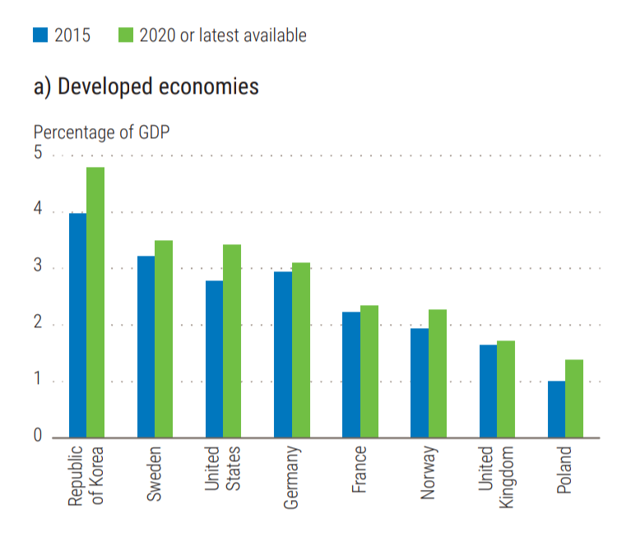

Original JSON:

{'metadata': {'title': 'Percentage of GDP', 'xaxis': {'title': 'Year'}, 'yaxis': {'title': 'Percentage'}}, 'data': [{'name': 'Republic of Korea', 'x': [2015, 2020], 'y': [4.0, 4.9]}, {'name': 'Sweden', 'x': [2015, 2020], 'y': [3.0, 3.3]}, {'name': 'United States', 'x': [2015, 2020], 'y': [2.5, 3.1]}, {'name': 'Germany', 'x': [2015, 2020], 'y': [2.7, 2.9]}, {'name': 'France', 'x': [2015, 2020], 'y': [2.1, 2.3]}, {'name': 'Norway', 'x': [2015, 2020], 'y': [1.8, 2.1]}, {'name': 'United Kingdom', 'x': [2015, 2020], 'y': [1.4, 1.7]}, {'name': 'Poland', 'x': [2015, 2020], 'y': [0.9, 1.3]}]}

Updated JSON:

{'metadata': {'title': 'Percentage of GDP', 'xaxis': {'title': 'Year'}, 'yaxis': {'title': 'Percentage'}}, 'data': [{'name': 'Republic of Korea', 'x': [2015, 2020], 'y': [4.0, 4.9]}, {'name': 'Sweden', 'x': [2015, 2020], 'y': [3.0, 3.3]}, {'name': 'United States', 'x': [2015, 2020], 'y': [2.5, 3.1]}, {'name': 'Germany', 'x': [2015, 2020], 'y': [2.7, 2.9]}, {'name': 'France', 'x': [2015, 2020], 'y': [2.1, 2.3]}, {'name': 'Norway', 'x': [2015, 2020], 'y': [1.8, 2.1]}, {'name': 'United Kingdom', 'x': [2015, 2020], 'y': [1.4, 1.7]}, {'name': 'Poland', 'x': [2015, 2020], 'y': [0.9, 1.3]}]}

Updated Chart:



Date and Time: 2024-06-11 19:59:12

## Input Image: with_label.jpg

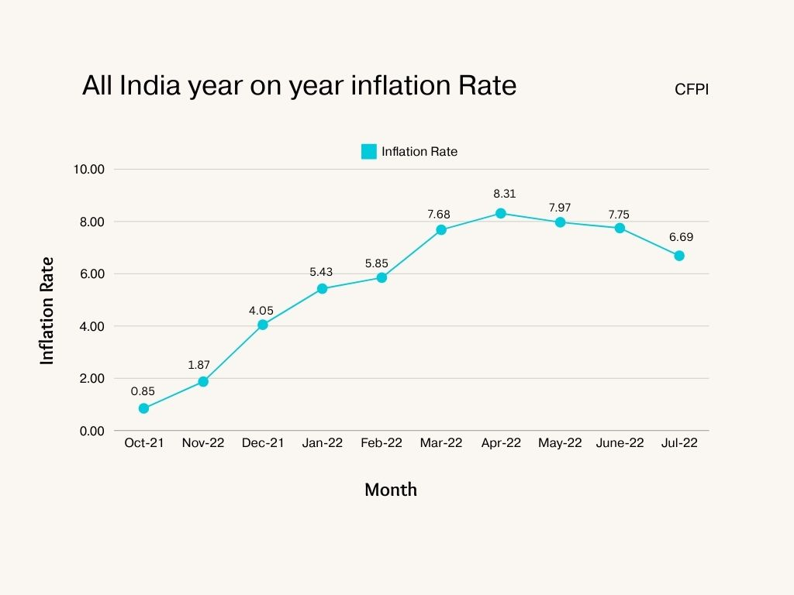

Original JSON:

{'metadata': {'title': 'Inflation Rate Trend', 'xaxis': {'title': 'Month'}, 'yaxis': {'title': 'Inflation Rate (%)'}}, 'data': [{'name': 'Inflation Rate', 'x': ['Oct-21', 'Nov-21', 'Dec-21', 'Jan-22', 'Feb-22', 'Mar-22', 'Apr-22', 'May-22', 'Jun-22', 'Jul-22'], 'y': [0.85, 1.87, 4.05, 5.43, 5.85, 7.6, 8.31, 7.97, 7.75, 6.69]}]}

Updated JSON:

{'metadata': {'title': 'Inflation Rate Trend', 'xaxis': {'title': 'Month'}, 'yaxis': {'title': 'Inflation Rate (%)'}}, 'data': [{'name': 'Inflation Rate', 'x': ['Oct-21', 'Nov-21', 'Dec-21', 'Jan-22', 'Feb-22', 'Mar-22', 'Apr-22', 'May-22', 'Jun-22', 'Jul-22'], 'y': [0.85, 1.87, 4.05, 5.43, 5.85, 7.6, 8.31, 7.97, 7.75, 6.69]}]}

Updated Chart:



Date and Time: 2024-06-11 20:03:40

## Input Image: without_label.jpg



Original JSON:

{'metadata': {'title': 'Inflation Rate', 'xaxis': {'title': 'Month'}, 'yaxis': {'title': 'Inflation Rate'}}, 'data': [{'name': 'Inflation Rate', 'x': ['Oct-21', 'Nov-21', 'Dec-21', 'Jan-22', 'Feb-22', 'Mar-22', 'Apr-22', 'May-22', 'Jun-22', 'Jul-22'], 'y': [1, 2, 4, 5, 6, 7.5, 8, 8, 7.5, 6.5]}]}

Updated JSON:

{'metadata': {'title': 'Inflation Rate', 'xaxis': {'title': 'Month'}, 'yaxis': {'title': 'Inflation Rate'}}, 'data': [{'name': 'Inflation Rate', 'x': ['Oct-21', 'Nov-21', 'Dec-21', 'Jan-22', 'Feb-22', 'Mar-22', 'Apr-22', 'May-22', 'Jun-22', 'Jul-22'], 'y': [1, 2, 4, 5, 6, 7.5, 8, 8, 7.5, 6.5]}]}

Updated Chart:



Date and Time: 2024-06-12 14:15:15

## Input Image: with_label.jpg



Original JSON:

{'metadata': {'title': 'Monthly Inflation Rate', 'xaxis': {'title': 'Month'}, 'yaxis': {'title': 'Inflation Rate'}}, 'data': [{'name': 'Inflation Rate', 'x': ['Oct-21', 'Nov-21', 'Dec-21', 'Jan-22', 'Feb-22', 'Mar-22', 'Apr-22', 'May-22', 'Jun-22', 'Jul-22'], 'y': [0.85, 1.87, 4.05, 5.43, 5.85, 7.6, 8.31, 7.97, 7.75, 6.69]}]}

Updated JSON:

{'metadata': {'title': 'Monthly Inflation Rate', 'xaxis': {'title': 'Month'}, 'yaxis': {'title': 'Inflation Rate'}}, 'data': [{'name': 'Inflation Rate', 'x': ['Oct-21', 'Nov-21', 'Dec-21', 'Jan-22', 'Feb-22', 'Mar-22', 'Apr-22', 'May-22', 'Jun-22', 'Jul-22'], 'y': [0.85, 1.87, 4.05, 5.43, 5.85, 7.6, 8.31, 7.97, 7.75, 6.69]}]}

Updated Chart:



Date and Time: 2024-06-12 16:42:57

## Input Image: with_label.jpg



Original JSON:

{'metadata': {'title': 'Inflation Rate', 'xaxis': {'title': 'Months'}, 'yaxis': {'title': 'Inflation Rate'}}, 'data': [{'name': 'Inflation Rate', 'x': ['Oct-21', 'Nov-21', 'Dec-21', 'Jan-22', 'Feb-22', 'Mar-22', 'Apr-22', 'May-22', 'Jun-22', 'Jul-22'], 'y': [0.85, 1.87, 4.05, 5.43, 5.85, 7.6, 8.31, 7.97, 7.75, 6.69]}]}

Updated JSON:

{'metadata': {'title': 'Inflation Rate', 'xaxis': {'title': 'Months'}, 'yaxis': {'title': 'Inflation Rate'}}, 'data': [{'name': 'Inflation Rate', 'x': ['Oct-21', 'Nov-21', 'Dec-21', 'Jan-22', 'Feb-22', 'Mar-22', 'Apr-22', 'May-22', 'Jun-22', 'Jul-22'], 'y': [0.85, 1.87, 4.05, 5.43, 5.85, 7.6, 8.31, 7.97, 7.75, 6.69]}]}

Updated Chart:

Date and Time: 2024-06-12 16:59:32

## Input Image: with_label.jpg



Original JSON:

{'metadata': {'title': 'Monthly Inflation Rate', 'xaxis': {'title': 'Month'}, 'yaxis': {'title': 'Inflation Rate'}}, 'data': [{'name': 'Inflation Rate', 'x': ['Oct-21', 'Nov-21', 'Dec-21', 'Jan-22', 'Feb-22', 'Mar-22', 'Apr-22', 'May-22', 'Jun-22', 'Jul-22'], 'y': [0.85, 1.87, 4.05, 5.43, 5.85, 7.6, 8.31, 7.97, 7.75, 6.69]}]}

Updated JSON:

{'metadata': {'title': 'Monthly Inflation Rate', 'xaxis': {'title': 'Month'}, 'yaxis': {'title': 'Inflation Rate'}}, 'data': [{'name': 'Inflation Rate', 'x': ['Oct-21', 'Nov-21', 'Dec-21', 'Jan-22', 'Feb-22', 'Mar-22', 'Apr-22', 'May-22', 'Jun-22', 'Jul-22'], 'y': [0.85, 1.87, 4.05, 5.43, 5.85, 7.6, 8.31, 7.97, 7.75, 6.69]}]}

Updated Chart:

Date and Time: 2024-06-12 20:25:42

## Input Image: with_label.jpg



Original JSON:

{'metadata': {'title': 'Monthly Inflation Rates', 'xaxis': {'title': 'Month'}, 'yaxis': {'title': 'Inflation Rate (%)'}}, 'data': [{'name': 'Inflation Rate', 'x': ['Oct-21', 'Nov-21', 'Dec-21', 'Jan-22', 'Feb-22', 'Mar-22', 'Apr-22', 'May-22', 'Jun-22', 'Jul-22'], 'y': [0.85, 1.87, 4.05, 5.43, 5.85, 7.6, 8.31, 7.97, 7.75, 6.69]}]}

Updated JSON:

{'metadata': {'title': 'Monthly Inflation Rates', 'xaxis': {'title': 'Month'}, 'yaxis': {'title': 'Inflation Rate (%)'}}, 'data': [{'name': 'Inflation Rate', 'x': ['Oct-21', 'Nov-21', 'Dec-21', 'Jan-22', 'Feb-22', 'Mar-22', 'Apr-22', 'May-22', 'Jun-22', 'Jul-22'], 'y': [0.85, 1.87, 4.05, 5.43, 5.85, 7.6, 8.31, 7.97, 7.75, 6.69]}]}

Updated Chart:



Date and Time: 2024-06-12 20:29:18

## Input Image: with_label.jpg



Original JSON:

{'metadata': {'title': 'Monthly Inflation Rate', 'xaxis': {'title': 'Month'}, 'yaxis': {'title': 'Inflation Rate (%)'}}, 'data': [{'name': 'Inflation Rate', 'x': ['Oct-21', 'Nov-21', 'Dec-21', 'Jan-22', 'Feb-22', 'Mar-22', 'Apr-22', 'May-22', 'Jun-22', 'Jul-22'], 'y': [0.85, 1.87, 4.05, 5.43, 5.85, 7.6, 8.31, 7.97, 7.75, 6.69]}]}

Updated JSON:

{'metadata': {'title': 'Monthly Inflation Rate', 'xaxis': {'title': 'Month'}, 'yaxis': {'title': 'Inflation Rate (%)'}}, 'data': [{'name': 'Inflation Rate', 'x': ['Oct-21', 'Nov-21', 'Dec-21', 'Jan-22', 'Feb-22', 'Mar-22', 'Apr-22', 'May-22', 'Jun-22', 'Jul-22'], 'y': [0.85, 1.87, 4.05, 5.43, 5.85, 7.6, 8.31, 7.97, 7.75, 6.69]}]}

Updated Chart:



Date and Time: 2024-06-12 22:01:55

## Input Image: with_label.jpg



Original JSON:

{'metadata': {'title': 'Inflation Rate', 'xaxis': {'title': 'Month'}, 'yaxis': {'title': 'Inflation Rate'}}, 'data': [{'name': 'Inflation Rate', 'x': ['Oct-21', 'Nov-21', 'Dec-21', 'Jan-22', 'Feb-22', 'Mar-22', 'Apr-22', 'May-22', 'Jun-22', 'Jul-22'], 'y': [0.85, 1.87, 4.05, 5.43, 5.85, 7.6, 8.31, 7.97, 7.75, 6.69]}]}

Updated JSON:

{'metadata': {'title': 'Inflation Rate', 'xaxis': {'title': 'Month'}, 'yaxis': {'title': 'Inflation Rate'}}, 'data': [{'name': 'Inflation Rate', 'x': ['Oct-21', 'Nov-21', 'Dec-21', 'Jan-22', 'Feb-22', 'Mar-22', 'Apr-22', 'May-22', 'Jun-22', 'Jul-22'], 'y': [0.85, 1.87, 4.05, 5.43, 5.85, 7.6, 8.31, 7.97, 7.75, 6.69]}]}

Updated Chart:



Date and Time: 2024-06-12 22:05:40

## Input Image: with_label.jpg



Original JSON:

{'metadata': {'title': 'Inflation Rate', 'xaxis': {'title': 'Month'}, 'yaxis': {'title': 'Inflation Rate (%)'}, 'legend': {'title': 'Year'}}, 'data': [{'name': '2021', 'x': ['Oct-21', 'Nov-21', 'Dec-21'], 'y': ['0.85', '1.87', '4.05']}, {'name': '2022', 'x': ['Jan-22', 'Feb-22', 'Mar-22', 'Apr-22', 'May-22', 'Jun-22', 'Jul-22'], 'y': ['5.43', '5.85', '7.60', '8.31', '7.97', '7.75', '6.69']}]}

Updated JSON:

{'metadata': {'title': 'Inflation Rate', 'xaxis': {'title': 'Month'}, 'yaxis': {'title': 'Inflation Rate (%)'}, 'legend': {'title': 'Year'}}, 'data': [{'name': '2021', 'x': ['Oct-21', 'Nov-21', 'Dec-21'], 'y': ['0.85', '1.87', '4.05']}, {'name': '2022', 'x': ['Jan-22', 'Feb-22', 'Mar-22', 'Apr-22', 'May-22', 'Jun-22', 'Jul-22'], 'y': ['5.43', '5.85', '7.60', '8.31', '7.97', '7.75', '6.69']}]}

Updated Chart:



Date and Time: 2024-06-12 22:13:57

## Input Image: with_label.jpg



Original JSON:

{  
 "metadata": {  
 "title": "Inflation Rate",  
 "xaxis": {  
 "title": "Month"  
 },  
 "yaxis": {  
 "title": "Rate"  
 }  
 },  
 "data": [  
 {  
 "name": null,  
 "x": [  
 "Oct-21",  
 "Nov-21",  
 "Dec-21",  
 "Jan-22",  
 "Feb-22",  
 "Mar-22",  
 "Apr-22",  
 "May-22",  
 "Jun-22",  
 "Jul-22"  
 ],  
 "y": [  
 0.85,  
 1.87,  
 4.05,  
 5.43,  
 5.85,  
 7.6,  
 8.31,  
 7.97,  
 7.75,  
 6.69  
 ]  
 }  
 ]  
}

Updated JSON:

{  
 "metadata": {  
 "title": "Inflation Rate",  
 "xaxis": {  
 "title": "Month"  
 },  
 "yaxis": {  
 "title": "Rate"  
 }  
 },  
 "data": [  
 {  
 "name": null,  
 "x": [  
 "Oct-21",  
 "Nov-21",  
 "Dec-21",  
 "Jan-22",  
 "Feb-22",  
 "Mar-22",  
 "Apr-22",  
 "May-22",  
 "Jun-22",  
 "Jul-22"  
 ],  
 "y": [  
 0.85,  
 1.87,  
 4.05,  
 5.43,  
 5.85,  
 7.6,  
 8.31,  
 7.97,  
 7.75,  
 6.69  
 ]  
 }  
 ]  
}

Updated Chart:



Date and Time: 2024-06-12 22:16:51

## Input Image: 1.2_image4.jpg

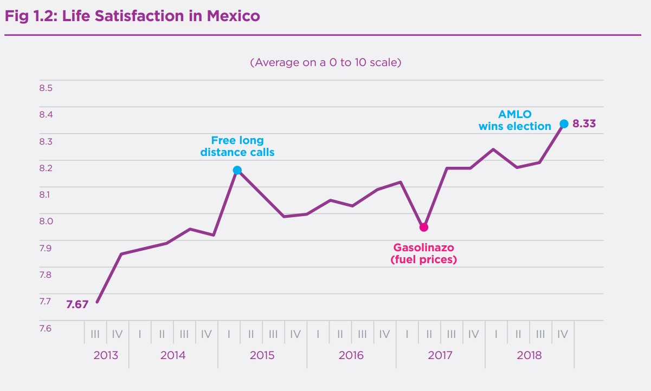

Original JSON:

{  
 "metadata": {  
 "title": "Life Satisfaction in Mexico",  
 "xaxis": {  
 "title": "Quarter"  
 },  
 "yaxis": {  
 "title": "Life Satisfaction"  
 },  
 "legends": [  
 {  
 "name": "Free long distance calls"  
 },  
 {  
 "name": "Gasolinazo (fuel prices)"  
 }  
 ]  
 },  
 "data": [  
 {  
 "name": "Free long distance calls",  
 "x": [  
 "2013 Q3",  
 "2014 Q1",  
 "2014 Q3",  
 "2015 Q1",  
 "2015 Q3",  
 "2016 Q1",  
 "2016 Q3",  
 "2017 Q1",  
 "2017 Q3",  
 "2018 Q1",  
 "2018 Q3"  
 ],  
 "y": [  
 7.67,  
 7.93,  
 7.98,  
 8.12,  
 8.03,  
 8.03,  
 8.05,  
 8.09,  
 8.22,  
 8.22,  
 8.33  
 ]  
 },  
 {  
 "name": "Gasolinazo (fuel prices)",  
 "x": [  
 "2017 Q1"  
 ],  
 "y": [  
 8  
 ]  
 }  
 ]  
}

Updated JSON:

{  
 "metadata": {  
 "title": "Life Satisfaction in Mexico",  
 "xaxis": {  
 "title": "Quarter"  
 },  
 "yaxis": {  
 "title": "Life Satisfaction"  
 },  
 "legends": [  
 {  
 "name": "Free long distance calls"  
 },  
 {  
 "name": "Gasolinazo (fuel prices)"  
 }  
 ]  
 },  
 "data": [  
 {  
 "name": "Free long distance calls",  
 "x": [  
 "2013 Q3",  
 "2014 Q1",  
 "2014 Q3",  
 "2015 Q1",  
 "2015 Q3",  
 "2016 Q1",  
 "2016 Q3",  
 "2017 Q1",  
 "2017 Q3",  
 "2018 Q1",  
 "2018 Q3"  
 ],  
 "y": [  
 7.67,  
 7.93,  
 7.98,  
 8.12,  
 8.03,  
 8.03,  
 8.05,  
 8.09,  
 8.22,  
 8.22,  
 8.33  
 ]  
 },  
 {  
 "name": "Gasolinazo (fuel prices)",  
 "x": [  
 "2017 Q1"  
 ],  
 "y": [  
 8  
 ]  
 }  
 ]  
}

Updated Chart:

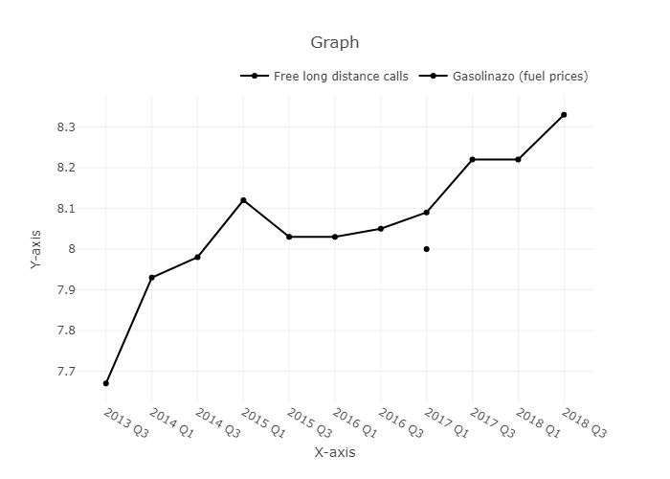

Date and Time: 2024-06-12 23:37:37

## Input Image: without_label.jpg



Original JSON:

{'metadata': {'title': 'Monthly Inflation Rate', 'xaxis': {'title': 'Month'}, 'yaxis': {'title': 'Inflation Rate'}}, 'data': [{'name': 'Inflation Rate', 'x': ['Oct-21', 'Nov-21', 'Dec-21', 'Jan-22', 'Feb-22', 'Mar-22', 'Apr-22', 'May-22', 'Jun-22', 'Jul-22'], 'y': [1, 2, 4, 5, 6, 7.5, 8, 8, 7.5, 6.5]}]}

Updated JSON:

{'metadata': {'title': 'Monthly Inflation Rate', 'xaxis': {'title': 'Month'}, 'yaxis': {'title': 'Inflation Rate'}}, 'data': [{'name': 'Inflation Rate', 'x': ['Oct-21', 'Nov-21', 'Dec-21', 'Jan-22', 'Feb-22', 'Mar-22', 'Apr-22', 'May-22', 'Jun-22', 'Jul-22'], 'y': [1, 2, 4, 5, 6, 7.5, 8, 8, 7.5, 6.5]}]}

Updated Chart:

Date and Time: 2024-06-13 14:28:31

## Input Image: with_label.jpg



Original JSON:

{  
 "metadata": {  
 "title": "Inflation rate",  
 "xaxis": {  
 "title": "Month"  
 },  
 "yaxis": {  
 "title": "Rate"  
 }  
 },  
 "data": [  
 {  
 "name": "Inflation",  
 "x": [  
 "Oct-21",  
 "Nov-21",  
 "Dec-21",  
 "Jan-22",  
 "Feb-22",  
 "Mar-22",  
 "Apr-22",  
 "May-22",  
 "Jun-22",  
 "Jul-22"  
 ],  
 "y": [  
 0.85,  
 1.87,  
 4.05,  
 5.43,  
 5.85,  
 7.6,  
 8.31,  
 7.97,  
 7.75,  
 6.69  
 ]  
 }  
 ]  
}

Updated JSON:

{  
 "metadata": {  
 "title": "Inflation rate",  
 "xaxis": {  
 "title": "Month"  
 },  
 "yaxis": {  
 "title": "Rate"  
 }  
 },  
 "data": [  
 {  
 "name": "Inflation",  
 "x": [  
 "Oct-21",  
 "Nov-21",  
 "Dec-21",  
 "Jan-22",  
 "Feb-22",  
 "Mar-22",  
 "Apr-22",  
 "May-22",  
 "Jun-22",  
 "Jul-22"  
 ],  
 "y": [  
 0.85,  
 1.87,  
 4.05,  
 5.43,  
 5.85,  
 7.6,  
 8.31,  
 7.97,  
 7.75,  
 6.69  
 ]  
 }  
 ]  
}

Updated Chart:

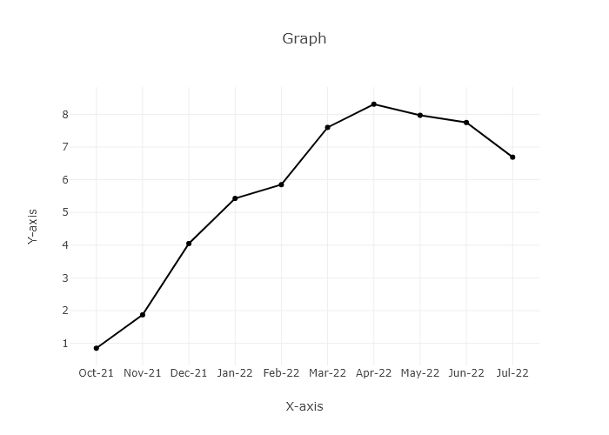

Date and Time: 2024-06-13 14:28:31

## Input Image: with_label.jpg



Original JSON:

{  
 "metadata": {  
 "title": "Inflation Rate over Time",  
 "xaxis": {  
 "title": "Month"  
 },  
 "yaxis": {  
 "title": "Inflation Rate (%)"  
 }  
 },  
 "data": [  
 {  
 "name": "Inflation Rate",  
 "x": [  
 "Oct-21",  
 "Nov-21",  
 "Dec-21",  
 "Jan-22",  
 "Feb-22",  
 "Mar-22",  
 "Apr-22",  
 "May-22",  
 "Jun-22",  
 "Jul-22"  
 ],  
 "y": [  
 0.85,  
 1.87,  
 4.05,  
 5.43,  
 5.85,  
 7.6,  
 8.31,  
 7.97,  
 7.75,  
 6.69  
 ]  
 }  
 ]  
}

Updated JSON:

{  
 "metadata": {  
 "title": "Inflation Rate over Time",  
 "xaxis": {  
 "title": "Month"  
 },  
 "yaxis": {  
 "title": "Inflation Rate (%)"  
 }  
 },  
 "data": [  
 {  
 "name": "Inflation Rate",  
 "x": [  
 "Oct-21",  
 "Nov-21",  
 "Dec-21",  
 "Jan-22",  
 "Feb-22",  
 "Mar-22",  
 "Apr-22",  
 "May-22",  
 "Jun-22",  
 "Jul-22"  
 ],  
 "y": [  
 0.85,  
 1.87,  
 4.05,  
 5.43,  
 5.85,  
 7.6,  
 8.31,  
 7.97,  
 7.75,  
 6.69  
 ]  
 }  
 ]  
}

Updated Chart:



Date and Time: 2024-06-13 14:28:31

## Input Image: with_label.jpg



Original JSON:

{  
 "metadata": {  
 "title": "Inflation Rate over time",  
 "xaxis": {  
 "title": "Month"  
 },  
 "yaxis": {  
 "title": "Inflation Rate"  
 }  
 },  
 "data": [  
 {  
 "name": "Inflation Rate",  
 "x": [  
 "Oct-21",  
 "Nov-21",  
 "Dec-21",  
 "Jan-22",  
 "Feb-22",  
 "Mar-22",  
 "Apr-22",  
 "May-22",  
 "Jun-22",  
 "Jul-22"  
 ],  
 "y": [  
 0.85,  
 1.87,  
 4.05,  
 5.43,  
 5.85,  
 7.6,  
 8.31,  
 7.97,  
 7.75,  
 6.69  
 ]  
 }  
 ]  
}

Updated JSON:

{  
 "metadata": {  
 "title": "Inflation Rate over time",  
 "xaxis": {  
 "title": "Month"  
 },  
 "yaxis": {  
 "title": "Inflation Rate"  
 }  
 },  
 "data": [  
 {  
 "name": "Inflation Rate",  
 "x": [  
 "Oct-21",  
 "Nov-21",  
 "Dec-21",  
 "Jan-22",  
 "Feb-22",  
 "Mar-22",  
 "Apr-22",  
 "May-22",  
 "Jun-22",  
 "Jul-22"  
 ],  
 "y": [  
 0.85,  
 1.87,  
 4.05,  
 5.43,  
 5.85,  
 7.6,  
 8.31,  
 7.97,  
 7.75,  
 6.69  
 ]  
 }  
 ]  
}

Updated Chart:



Date and Time: 2024-06-13 15:13:01

## Input Image: with_label.jpg



Original JSON:

{  
 "metadata": {  
 "title": "Inflation Rate",  
 "xaxis": {  
 "title": "Month"  
 },  
 "yaxis": {  
 "title": "Inflation Rate"  
 }  
 },  
 "data": [  
 {  
 "name": "Inflation Rate",  
 "x": [  
 "Oct-21",  
 "Nov-21",  
 "Dec-21",  
 "Jan-22",  
 "Feb-22",  
 "Mar-22",  
 "Apr-22",  
 "May-22",  
 "Jun-22",  
 "Jul-22"  
 ],  
 "y": [  
 0.85,  
 1.87,  
 4.05,  
 5.43,  
 5.85,  
 7.6,  
 8.31,  
 7.97,  
 7.75,  
 6.69  
 ]  
 }  
 ]  
}

Updated JSON:

{  
 "metadata": {  
 "title": "Inflation Rate",  
 "xaxis": {  
 "title": "Month"  
 },  
 "yaxis": {  
 "title": "Inflation Rate"  
 }  
 },  
 "data": [  
 {  
 "name": "Inflation Rate",  
 "x": [  
 "Oct-21",  
 "Nov-21",  
 "Dec-21",  
 "Jan-22",  
 "Feb-22",  
 "Mar-22",  
 "Apr-22",  
 "May-22",  
 "Jun-22",  
 "Jul-22"  
 ],  
 "y": [  
 0.85,  
 1.87,  
 4.05,  
 5.43,  
 5.85,  
 7.6,  
 8.31,  
 7.97,  
 7.75,  
 6.69  
 ]  
 }  
 ]  
}

Updated Chart:



Date and Time: 2024-06-13 15:34:38

## Input Image: with_label.jpg



Original JSON:

{  
 "metadata": {  
 "title": "Inflation Rate by Month",  
 "xaxis": {  
 "title": "Month"  
 },  
 "yaxis": {  
 "title": "Inflation Rate (%)"  
 }  
 },  
 "data": [  
 {  
 "name": "Inflation Rate",  
 "x": [  
 "Oct-21",  
 "Nov-21",  
 "Dec-21",  
 "Jan-22",  
 "Feb-22",  
 "Mar-22",  
 "Apr-22",  
 "May-22",  
 "Jun-22",  
 "Jul-22"  
 ],  
 "y": [  
 0.85,  
 1.87,  
 4.05,  
 5.43,  
 5.85,  
 7.6,  
 8.31,  
 7.97,  
 7.75,  
 6.69  
 ]  
 }  
 ]  
}

Updated JSON:

{  
 "metadata": {  
 "title": "Inflation Rate by Month",  
 "xaxis": {  
 "title": "Month"  
 },  
 "yaxis": {  
 "title": "Inflation Rate (%)"  
 }  
 },  
 "data": [  
 {  
 "name": "Inflation Rate",  
 "x": [  
 "Oct-21",  
 "Nov-21",  
 "Dec-21",  
 "Jan-22",  
 "Feb-22",  
 "Mar-22",  
 "Apr-22",  
 "May-22",  
 "Jun-22",  
 "Jul-22"  
 ],  
 "y": [  
 0.85,  
 1.87,  
 4.05,  
 5.43,  
 5.85,  
 7.6,  
 8.31,  
 7.97,  
 7.75,  
 6.69  
 ]  
 }  
 ]  
}

Updated Chart:



Date and Time: 2024-06-13 15:50:18

## Input Image: with_label.jpg



Original JSON:

{  
 "metadata": {  
 "title": "Inflation Rate",  
 "xaxis": {  
 "title": "Month"  
 },  
 "yaxis": {  
 "title": "Inflation Rate"  
 }  
 },  
 "data": [  
 {  
 "name": "Inflation Rate",  
 "x": [  
 "Oct-21",  
 "Nov-21",  
 "Dec-21",  
 "Jan-22",  
 "Feb-22",  
 "Mar-22",  
 "Apr-22",  
 "May-22",  
 "Jun-22",  
 "Jul-22"  
 ],  
 "y": [  
 0.85,  
 1.87,  
 4.05,  
 5.43,  
 5.85,  
 7.6,  
 8.31,  
 7.97,  
 7.75,  
 6.69  
 ]  
 }  
 ]  
}

Updated JSON:

{  
 "metadata": {  
 "title": "Inflation Rate",  
 "xaxis": {  
 "title": "Month"  
 },  
 "yaxis": {  
 "title": "Inflation Rate"  
 }  
 },  
 "data": [  
 {  
 "name": "Inflation Rate",  
 "x": [  
 "Oct-21",  
 "Nov-21",  
 "Dec-21",  
 "Jan-22",  
 "Feb-22",  
 "Mar-22",  
 "Apr-22",  
 "May-22",  
 "Jun-22",  
 "Jul-22"  
 ],  
 "y": [  
 0.85,  
 1.87,  
 4.05,  
 5.43,  
 5.85,  
 7.6,  
 8.31,  
 7.97,  
 7.75,  
 6.69  
 ]  
 }  
 ]  
}

Updated Chart:



## Performance Metrics

|  |  |  |  |
| --- | --- | --- | --- |
| Task | Model Used | Description | Time Taken (s) |
| Processing Image to JSON | Gemini Vision Pro | Time taken to convert the uploaded image to JSON format | 19.00 |
| Updating JSON | ChatGPT 3.5 | Time taken to update the JSON with new data | 0.00 |
| Plotting Updated JSON | N/A | Time taken to plot the updated JSON | 6.16 |

Date and Time: 2024-06-13 15:50:18

## Input Image: with_label.jpg



Original JSON:

{  
 "metadata": {  
 "title": "Inflation Rate by Month",  
 "xaxis": {  
 "title": "Month"  
 },  
 "yaxis": {  
 "title": "Inflation Rate"  
 }  
 },  
 "data": [  
 {  
 "name": "Inflation Rate",  
 "x": [  
 "Oct-21",  
 "Nov-21",  
 "Dec-21",  
 "Jan-22",  
 "Feb-22",  
 "Mar-22",  
 "Apr-22",  
 "May-22",  
 "Jun-22",  
 "Jul-22"  
 ],  
 "y": [  
 0.85,  
 1.87,  
 4.05,  
 5.43,  
 5.85,  
 7.6,  
 8.31,  
 7.97,  
 7.75,  
 6.69  
 ]  
 }  
 ]  
}

Updated JSON:

{  
 "metadata": {  
 "title": "Inflation Rate by Month",  
 "xaxis": {  
 "title": "Month"  
 },  
 "yaxis": {  
 "title": "Inflation Rate"  
 }  
 },  
 "data": [  
 {  
 "name": "Inflation Rate",  
 "x": [  
 "Oct-21",  
 "Nov-21",  
 "Dec-21",  
 "Jan-22",  
 "Feb-22",  
 "Mar-22",  
 "Apr-22",  
 "May-22",  
 "Jun-22",  
 "Jul-22"  
 ],  
 "y": [  
 0.85,  
 1.87,  
 4.05,  
 5.43,  
 5.85,  
 7.6,  
 8.31,  
 7.97,  
 7.75,  
 6.69  
 ]  
 }  
 ]  
}

Updated Chart:



## Performance Metrics

|  |  |  |  |
| --- | --- | --- | --- |
| Task | Model Used | Description | Time Taken (s) |
| Processing Image to JSON | Gemini Vision Pro | Time taken to convert the uploaded image to JSON format | 13.69 |
| Updating JSON | ChatGPT 3.5 | Time taken to update the JSON with new data | 0.00 |
| Plotting Updated JSON | N/A | Time taken to plot the updated JSON | 0.11 |

Date and Time: 2024-06-13 16:19:31

## Input Image: with_label.jpg



Original JSON:

{  
 "metadata": {  
 "title": "Inflation Rate",  
 "xaxis": {  
 "title": "Month"  
 },  
 "yaxis": {  
 "title": "Inflation Rate (%)"  
 }  
 },  
 "data": [  
 {  
 "name": "Inflation Rate",  
 "x": [  
 "Oct-21",  
 "Nov-21",  
 "Dec-21",  
 "Jan-22",  
 "Feb-22",  
 "Mar-22",  
 "Apr-22",  
 "May-22",  
 "Jun-22",  
 "Jul-22"  
 ],  
 "y": [  
 0.85,  
 1.87,  
 4.05,  
 5.43,  
 5.85,  
 7.6,  
 8.31,  
 7.97,  
 7.75,  
 6.69  
 ]  
 }  
 ]  
}

Updated JSON:

{  
 "metadata": {  
 "title": "Inflation Rate",  
 "xaxis": {  
 "title": "Month"  
 },  
 "yaxis": {  
 "title": "Inflation Rate (%)"  
 }  
 },  
 "data": [  
 {  
 "name": "Inflation Rate",  
 "x": [  
 "Oct-21",  
 "Nov-21",  
 "Dec-21",  
 "Jan-22",  
 "Feb-22",  
 "Mar-22",  
 "Apr-22",  
 "May-22",  
 "Jun-22",  
 "Jul-22"  
 ],  
 "y": [  
 0.85,  
 1.87,  
 4.05,  
 5.43,  
 5.85,  
 7.6,  
 8.31,  
 7.97,  
 7.75,  
 6.69  
 ]  
 }  
 ]  
}

Updated Chart:



## Performance Metrics

|  |  |  |  |
| --- | --- | --- | --- |
| Task | Model Used | Description | Time Taken (s) |
| Processing Image to JSON | Gemini Vision Pro | Time taken to convert the uploaded image to JSON format | 13.94 |
| Updating JSON | ChatGPT 3.5 | Time taken to update the JSON with new data | 0.00 |
| Plotting Updated JSON | N/A | Time taken to plot the updated JSON | 0.15 |

Date and Time: 2024-06-13 16:33:08

## Input Image: with_label.jpg



Original JSON:

{  
 "metadata": {  
 "title": "Inflation Rate over Time",  
 "xaxis": {  
 "title": "Month"  
 },  
 "yaxis": {  
 "title": "Inflation Rate"  
 }  
 },  
 "data": [  
 {  
 "name": "Inflation Rate",  
 "x": [  
 "Oct-21",  
 "Nov-21",  
 "Dec-21",  
 "Jan-22",  
 "Feb-22",  
 "Mar-22",  
 "Apr-22",  
 "May-22",  
 "Jun-22",  
 "Jul-22"  
 ],  
 "y": [  
 0.85,  
 1.87,  
 4.05,  
 5.43,  
 5.85,  
 7.6,  
 8.31,  
 7.97,  
 7.75,  
 6.69  
 ]  
 }  
 ]  
}

Updated JSON:

{  
 "metadata": {  
 "title": "Inflation Rate over Time",  
 "xaxis": {  
 "title": "Month"  
 },  
 "yaxis": {  
 "title": "Inflation Rate"  
 }  
 },  
 "data": [  
 {  
 "name": "Inflation Rate",  
 "x": [  
 "Oct-21",  
 "Nov-21",  
 "Dec-21",  
 "Jan-22",  
 "Feb-22",  
 "Mar-22",  
 "Apr-22",  
 "May-22",  
 "Jun-22",  
 "Jul-22"  
 ],  
 "y": [  
 0.85,  
 1.87,  
 4.05,  
 5.43,  
 5.85,  
 7.6,  
 8.31,  
 7.97,  
 7.75,  
 6.69  
 ]  
 }  
 ]  
}

Updated Chart:



## Performance Metrics

|  |  |  |  |
| --- | --- | --- | --- |
| Task | Model Used | Description | Time Taken (s) |
| Processing Image to JSON | Gemini Vision Pro | Time taken to convert the uploaded image to JSON format | 12.54 |
| Updating JSON | ChatGPT 3.5 | Time taken to update the JSON with new data | 0.00 |
| Plotting Updated JSON | N/A | Time taken to plot the updated JSON | 0.05 |

Date and Time: 2024-06-13 16:41:36

## Input Image: with_label.jpg



Prompt Used:

You are an expert in reading the line charts. You will be given a line chart and you have to represent the line chart in tabular format, adhering to the following guidelines:   
 1. The table's title will be derived from the chart's title. If no title is provided, it will be based on the labels of the x and y axes, or left as 'NA' if neither is available.   
 2. Identify the the labels on the x-axes and y-axes. If no label is provided name them according to your knowledge.   
 3. Identify the legends in the line chart and label them accordingly. If no legends are provided, they will be named as 'plot1', 'plot2', and so forth.   
 4. Only data points located directly on the x-axes will be considered.   
 5. Consider the steps size of the y-axes and estimate the value of the data point precisely.   
 6. For line charts with dual y-axes, determine whether the line plot corresponds to which y-axes, then extract the value of the data points accordingly.   
 7. Only add numerical values to the table, no units and characters. Example if the value of the data point is 10% then write only 10 in the table.  
 8. If there is only one line consider it as a single plot and any different color point on the line as special marker

Original JSON:

{  
 "metadata": {  
 "title": "Inflation Rate over Time",  
 "xaxis": {  
 "title": "Month"  
 },  
 "yaxis": {  
 "title": "Inflation Rate"  
 }  
 },  
 "data": [  
 {  
 "name": "Inflation Rate",  
 "x": [  
 "Oct-21",  
 "Nov-21",  
 "Dec-21",  
 "Jan-22",  
 "Feb-22",  
 "Mar-22",  
 "Apr-22",  
 "May-22",  
 "Jun-22",  
 "Jul-22"  
 ],  
 "y": [  
 0.85,  
 1.87,  
 4.05,  
 5.43,  
 5.85,  
 7.6,  
 8.31,  
 7.97,  
 7.75,  
 6.69  
 ]  
 }  
 ]  
}

Updated JSON:

{  
 "metadata": {  
 "title": "Inflation Rate over Time",  
 "xaxis": {  
 "title": "Month"  
 },  
 "yaxis": {  
 "title": "Inflation Rate"  
 }  
 },  
 "data": [  
 {  
 "name": "Inflation Rate",  
 "x": [  
 "Oct-21",  
 "Nov-21",  
 "Dec-21",  
 "Jan-22",  
 "Feb-22",  
 "Mar-22",  
 "Apr-22",  
 "May-22",  
 "Jun-22",  
 "Jul-22"  
 ],  
 "y": [  
 0.85,  
 1.87,  
 4.05,  
 5.43,  
 5.85,  
 7.6,  
 8.31,  
 7.97,  
 7.75,  
 6.69  
 ]  
 }  
 ]  
}

Updated Chart:



## Performance Metrics

|  |  |  |  |
| --- | --- | --- | --- |
| Task | Model Used | Description | Time Taken (s) |
| Processing Image to JSON | Gemini Vision Pro | Time taken to convert the uploaded image to JSON format | 14.00 |
| Updating JSON | ChatGPT 3.5 | Time taken to update the JSON with new data | 0.00 |
| Plotting Updated JSON | N/A | Time taken to plot the updated JSON | 0.05 |

Date and Time: 2024-06-13 16:50:16

## Input Image: 1711725089132.png



Prompt Used:

You are an expert in reading the line charts. You will be given a line chart and you have to represent the line chart in tabular format, adhering to the following guidelines:   
 1. The table's title will be derived from the chart's title. If no title is provided, it will be based on the labels of the x and y axes, or left as 'NA' if neither is available.   
 2. Identify the the labels on the x-axes and y-axes. If no label is provided name them according to your knowledge.   
 3. Identify the legends in the line chart and label them accordingly. If no legends are provided, they will be named as 'plot1', 'plot2', and so forth.   
 4. Only data points located directly on the x-axes will be considered.   
 5. Consider the steps size of the y-axes and estimate the value of the data point precisely.   
 6. For line charts with dual y-axes, determine whether the line plot corresponds to which y-axes, then extract the value of the data points accordingly.   
 7. Only add numerical values to the table, no units and characters. Example if the value of the data point is 10% then write only 10 in the table.  
 8. If there is only one line consider it as a single plot and any different color point on the line as special marker

Original JSON:

{  
 "metadata": {  
 "title": "Global and regional inflation",  
 "xaxis": {  
 "title": "Years"  
 },  
 "yaxis": {  
 "title": "Inflation Rate"  
 }  
 },  
 "data": [  
 {  
 "name": "World",  
 "x": [  
 "2010-2019 Average",  
 "2022",  
 "2023",  
 "2024"  
 ],  
 "y": [  
 5,  
 8,  
 5,  
 6  
 ]  
 },  
 {  
 "name": "Developed Economies",  
 "x": [  
 "2010-2019 Average",  
 "2022",  
 "2023",  
 "2024"  
 ],  
 "y": [  
 2,  
 5,  
 4,  
 5  
 ]  
 },  
 {  
 "name": "Economies in transition",  
 "x": [  
 "2010-2019 Average",  
 "2022",  
 "2023",  
 "2024"  
 ],  
 "y": [  
 8,  
 14,  
 8,  
 10  
 ]  
 },  
 {  
 "name": "Africa",  
 "x": [  
 "2010-2019 Average",  
 "2022",  
 "2023",  
 "2024"  
 ],  
 "y": [  
 11,  
 17,  
 14,  
 18  
 ]  
 },  
 {  
 "name": "East Asia",  
 "x": [  
 "2010-2019 Average",  
 "2022",  
 "2023",  
 "2024"  
 ],  
 "y": [  
 2,  
 4,  
 3,  
 4  
 ]  
 },  
 {  
 "name": "South Asia",  
 "x": [  
 "2010-2019 Average",  
 "2022",  
 "2023",  
 "2024"  
 ],  
 "y": [  
 11,  
 14,  
 10,  
 13  
 ]  
 },  
 {  
 "name": "Western Asia and the Caribbean",  
 "x": [  
 "2010-2019 Average",  
 "2022",  
 "2023",  
 "2024"  
 ],  
 "y": [  
 25,  
 21,  
 18,  
 15  
 ]  
 },  
 {  
 "name": "Latin America and the Caribbean",  
 "x": [  
 "2010-2019 Average",  
 "2022",  
 "2023",  
 "2024"  
 ],  
 "y": [  
 9,  
 12,  
 9,  
 11  
 ]  
 }  
 ]  
}

Updated JSON:

{  
 "metadata": {  
 "title": "Global and regional inflation",  
 "xaxis": {  
 "title": "Years"  
 },  
 "yaxis": {  
 "title": "Inflation Rate"  
 }  
 },  
 "data": [  
 {  
 "name": "World",  
 "x": [  
 "2010-2019 Average",  
 "2022",  
 "2023",  
 "2024"  
 ],  
 "y": [  
 5,  
 8,  
 5,  
 6  
 ]  
 },  
 {  
 "name": "Developed Economies",  
 "x": [  
 "2010-2019 Average",  
 "2022",  
 "2023",  
 "2024"  
 ],  
 "y": [  
 2,  
 5,  
 4,  
 5  
 ]  
 },  
 {  
 "name": "Economies in transition",  
 "x": [  
 "2010-2019 Average",  
 "2022",  
 "2023",  
 "2024"  
 ],  
 "y": [  
 8,  
 14,  
 8,  
 10  
 ]  
 },  
 {  
 "name": "Africa",  
 "x": [  
 "2010-2019 Average",  
 "2022",  
 "2023",  
 "2024"  
 ],  
 "y": [  
 11,  
 17,  
 14,  
 18  
 ]  
 },  
 {  
 "name": "East Asia",  
 "x": [  
 "2010-2019 Average",  
 "2022",  
 "2023",  
 "2024"  
 ],  
 "y": [  
 2,  
 4,  
 3,  
 4  
 ]  
 },  
 {  
 "name": "South Asia",  
 "x": [  
 "2010-2019 Average",  
 "2022",  
 "2023",  
 "2024"  
 ],  
 "y": [  
 11,  
 14,  
 10,  
 13  
 ]  
 },  
 {  
 "name": "Western Asia and the Caribbean",  
 "x": [  
 "2010-2019 Average",  
 "2022",  
 "2023",  
 "2024"  
 ],  
 "y": [  
 25,  
 21,  
 18,  
 15  
 ]  
 },  
 {  
 "name": "Latin America and the Caribbean",  
 "x": [  
 "2010-2019 Average",  
 "2022",  
 "2023",  
 "2024"  
 ],  
 "y": [  
 9,  
 12,  
 9,  
 11  
 ]  
 }  
 ]  
}

Updated Chart:

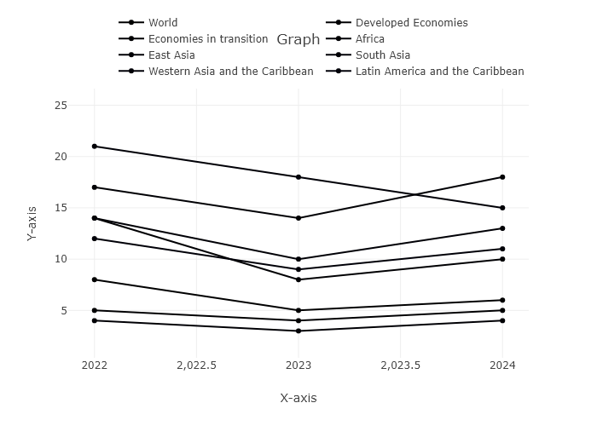

## Performance Metrics

|  |  |  |  |
| --- | --- | --- | --- |
| Task | Model Used | Description | Time Taken (s) |
| Processing Image to JSON | Gemini Vision Pro | Time taken to convert the uploaded image to JSON format | 23.18 |
| Updating JSON | ChatGPT 3.5 | Time taken to update the JSON with new data | 0.00 |
| Plotting Updated JSON | N/A | Time taken to plot the updated JSON | 5.40 |

Date and Time: 2024-06-13 16:57:25

## Input Image: monthly_values_plot.png

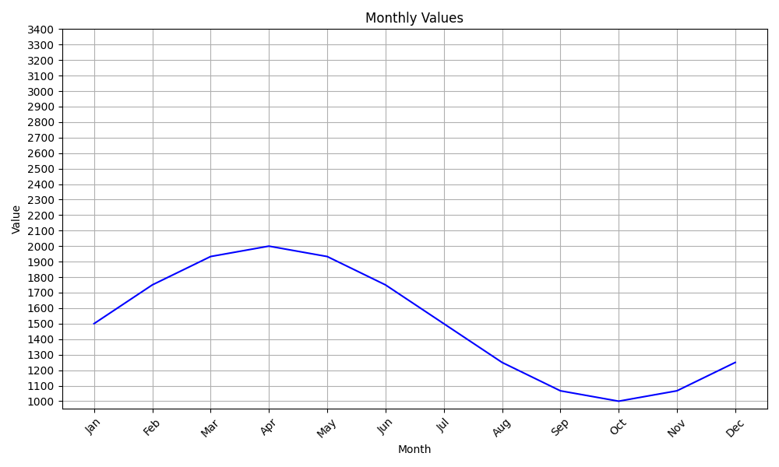

Prompt Used:

You are an expert in reading the line charts. You will be given a line chart and you have to represent the line chart in tabular format, adhering to the following guidelines:   
 1. The table's title will be derived from the chart's title. If no title is provided, it will be based on the labels of the x and y axes, or left as 'NA' if neither is available.   
 2. Identify the the labels on the x-axes and y-axes. If no label is provided name them according to your knowledge.   
 3. Identify the legends in the line chart and label them accordingly. If no legends are provided, they will be named as 'plot1', 'plot2', and so forth.   
 4. Only data points located directly on the x-axes will be considered.   
 5. Consider the steps size of the y-axes and estimate the value of the data point precisely.   
 6. For line charts with dual y-axes, determine whether the line plot corresponds to which y-axes, then extract the value of the data points accordingly.   
 7. Only add numerical values to the table, no units and characters. Example if the value of the data point is 10% then write only 10 in the table.  
 8. If there is only one line consider it as a single plot and any different color point on the line as special marker

Original JSON:

{  
 "metadata": {  
 "title": "Monthly Sales Data",  
 "xaxis": {  
 "title": "Month"  
 },  
 "yaxis": {  
 "title": "Sales"  
 }  
 },  
 "data": [  
 {  
 "name": "plot1",  
 "x": [  
 "NA",  
 "Jan",  
 "Feb",  
 "Mar",  
 "Apr",  
 "May",  
 "Jun",  
 "Jul",  
 "Aug",  
 "Sep",  
 "Oct",  
 "Nov",  
 "Dec"  
 ],  
 "y": [  
 1500,  
 1800,  
 2000,  
 2000,  
 1900,  
 1700,  
 1400,  
 1100,  
 1000,  
 1100,  
 1200,  
 1300  
 ]  
 }  
 ]  
}

Updated JSON:

{  
 "metadata": {  
 "title": "Monthly Sales Data",  
 "xaxis": {  
 "title": "Month"  
 },  
 "yaxis": {  
 "title": "Sales"  
 }  
 },  
 "data": [  
 {  
 "name": "plot1",  
 "x": [  
 "NA",  
 "Jan",  
 "Feb",  
 "Mar",  
 "Apr",  
 "May",  
 "Jun",  
 "Jul",  
 "Aug",  
 "Sep",  
 "Oct",  
 "Nov",  
 "Dec"  
 ],  
 "y": [  
 1500,  
 1800,  
 2000,  
 2000,  
 1900,  
 1700,  
 1400,  
 1100,  
 1000,  
 1100,  
 1200,  
 1300  
 ]  
 }  
 ]  
}

Updated Chart:

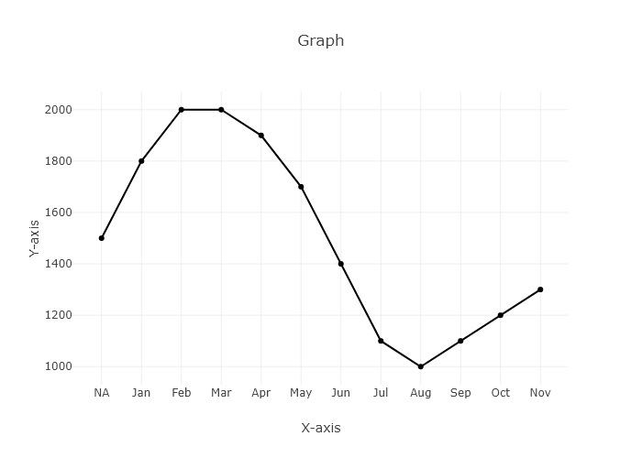

## Performance Metrics

|  |  |  |  |
| --- | --- | --- | --- |
| Task | Model Used | Description | Time Taken (s) |
| Processing Image to JSON | Gemini Vision Pro | Time taken to convert the uploaded image to JSON format | 13.95 |
| Updating JSON | ChatGPT 3.5 | Time taken to update the JSON with new data | 0.00 |
| Plotting Updated JSON | N/A | Time taken to plot the updated JSON | 0.06 |