**Design Document**

**Problem Statement :**

To design a game “Plate of Fire” & Write Code Snippets according to the problem given.

**Design Patterns used to solve the Problem:**

Following are the design Patterns used:

Creational:

1. Singleton Design Pattern.

2. Factory Design Pattern.

Structural:

3. Decorator Design Pattern.

4. Flyweight Design Pattern.

Behavioral:

5. Strategy Design Pattern.

6. State Design Pattern.

**Why I chose above design Patterns:**

Singleton:

As I want to create only single instance of all the characters.

Factory:

As I want to create objects without exposing the creational logic to my main class.

Decorator:

As I want to add new functionality (Power) like Chair in hand & Special Move to an existing object.

Flyweight:

As I want to reuse already existing similar kind object by storing them and decrease memory footprints & increase performance.

Strategy:

As I want to change behavior of objects at the runtime based on different strategy.

State:

As I want to create objects, which represents various states & context object whose behavior varies as its state object change.

**Class Diagram For the problem:**

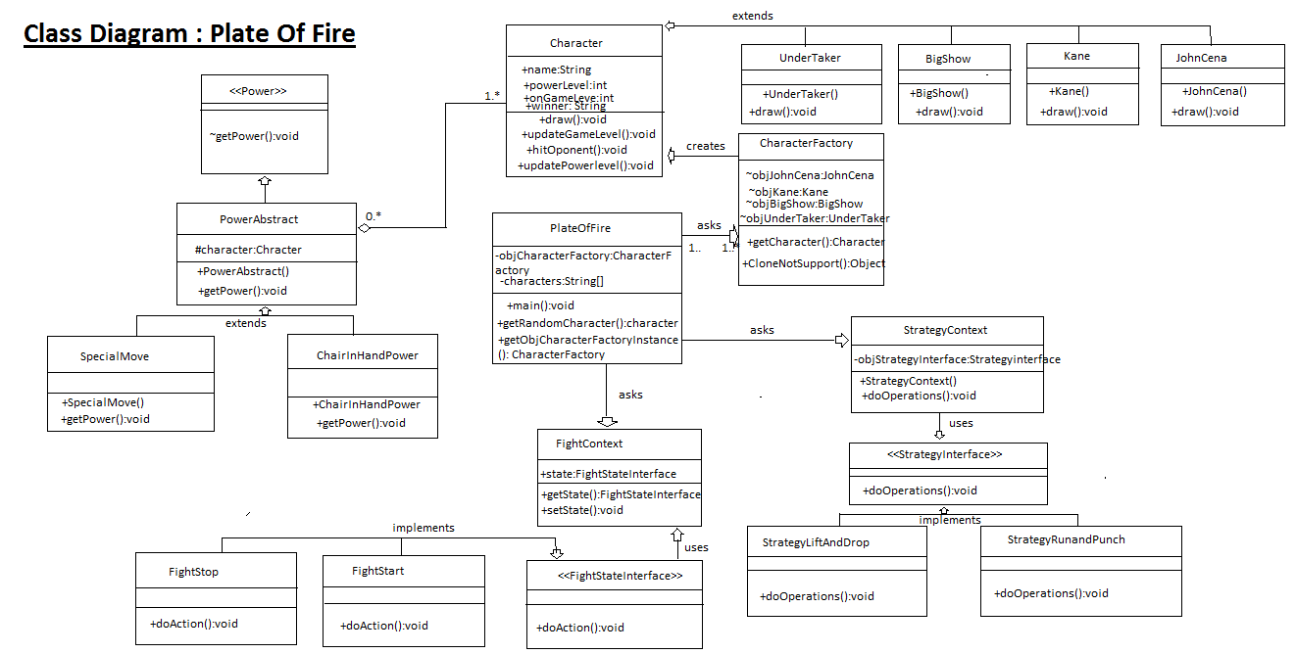

**Rules For the Game:**

1. Players at same level Can Fight.
2. Power level of each player is set to predefine level at the beginning of Fight.
3. If Player uses some decorations like special moves while fighting , its power will be reduced by some amount.
4. If player hits its opponent the its power will be increased.
5. If player gets hit by its opponent then its power will reduce.
6. If player want to quit the game, then he will loose the game.
7. If players power level reaches to zero then player will loose the game.
8. Fight will be done for some fix amount of time.
9. If both opponent’s fight for full match time, then the player with higher power level will be declared as the winner of the match.
10. If the power level reaches to zero of any player then he will losses the game.
11. If the Player wins a Game its Level will be increased.

**Algorithms Plate of Fire:**

Algorithm for fight between random player:

1. Make a list of player at same level.
2. From list using random number generator will pick 2 different player.

Algorithm to Start Fight:

1) Will first check if two players are at same level.

2) If they are not at the same level , no fight can be done.

1. If player at same level then fight can be done.

Algorithm to Increase/Decrease Power level.

1. Set area of both the player.
2. If player hits the opponent’s area, increase it power level by 5.
3. If player get hit by the opponent the decrease its power level by 5
4. If player uses any of the decorators reduce its power by 15.

Algorithm to Declare Winner:

1. Maker listener to both the player in the fight.
2. If the power level reaches to zero of any of the player , Stop the fight & declare opponent as winner.
3. If time of the fight finishes, Check for the power level of the both player, one with high level will be declared as winner.

**References:**

1. Professor Omar Aldawud’s - Notes & presentations.
2. Stack Overflow.
3. Tutorials Point.