Maven is Project Management tool

For building a project you need to compile, run, test, create package of it and then deploy it.

Sometimes you need external libraries. Suppose when you want to connect java code with database you need a connector

Hibernate is a tool or framework which helps you to save data in the database without writing SQL query. (It just illusion lot of things happening behind the scene)

To use hibernate you need libraries of hibernate.

Libraries in java means -> JAR Files

Maven helps to get dependencies.

Maven also provides some plugins.

Maven provides you something called an **archetype** which is templating tool. Suppose you want to web project, so you can do the setup by yourself you can add the configuration or you can use the existing templates and that is called archetype in Maven (**Dependencies**).

You can create your own archetype so that whoever wants to build their project they can use your template.

Dependencies means JAR files so whatever library you want you get it from here

In maven there is one file which called pom.xml (project object model) where you do everything to handle your maven.

Every library(JAR) goes in **three** things, which is called GAV (**Group** **Id**(Unique-> just reverse your domain name like com.avi because your domain name is unique), **Artifact** **ID** (Project Name)**, Version ID**)

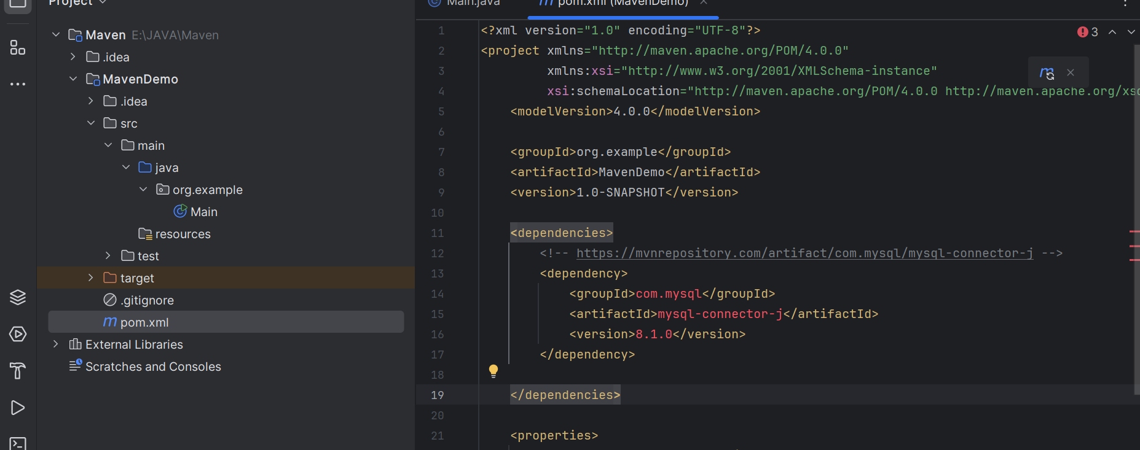

In POM files we simply put our dependencies like above mysql connector.

To configure your maven you have do some changes in this file(POM) ,In Dependencies tag you can mention multiple dependency.

There is Effective POM which is getting created for every Maven project. It will have other configuration as well configuration you have done.

If any one want to work with maven project they will Effective POM file.

**Maven Archetype:** You can create your own template or you can use existing template

**Maven** makes it very, very easyto define your dependencies and to take care of importing transitive dependencies.

**Hibernate** -> Map java bean to a table and I would take care of generating queries for you, so you map a entity to a table and you can tell me what actions to perform and I will generate the queries and perform those actions and this concept is called ORM(Object Relational Mapping)

Hibernate is ORM framework. Java EE standerdised and bought JPA

JPA(Java Persistence API) -> JPA is like a interface it defines how you can map an entity to a table, it defines how you can perform operation on entities and Hibernate is like an implementation of JPA.

Hibernate implements everything that is defined in a JPA.

**ORM is a technique that maps object-oriented models to relational database models.** It enables programmers to use object-oriented constructs from a programming language to interact with databases. In other words**, ORM is a way to use the database as an object-oriented data source.**