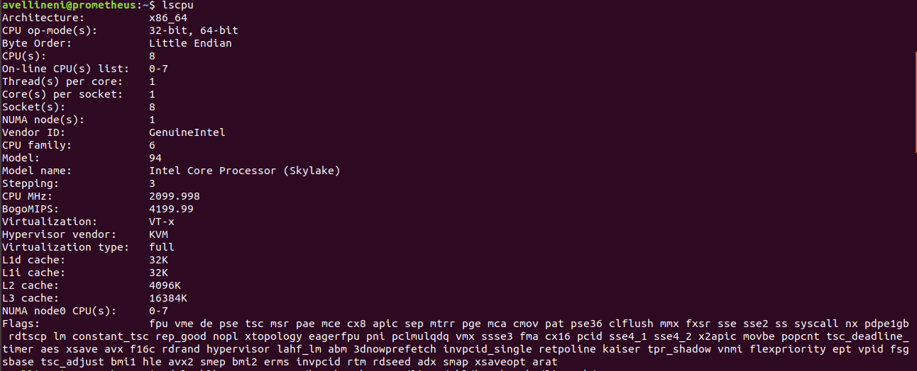

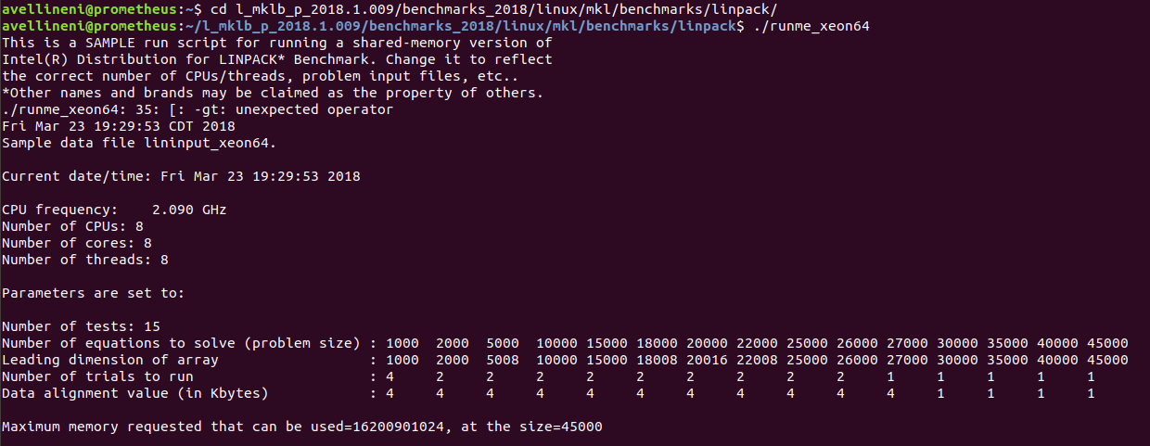

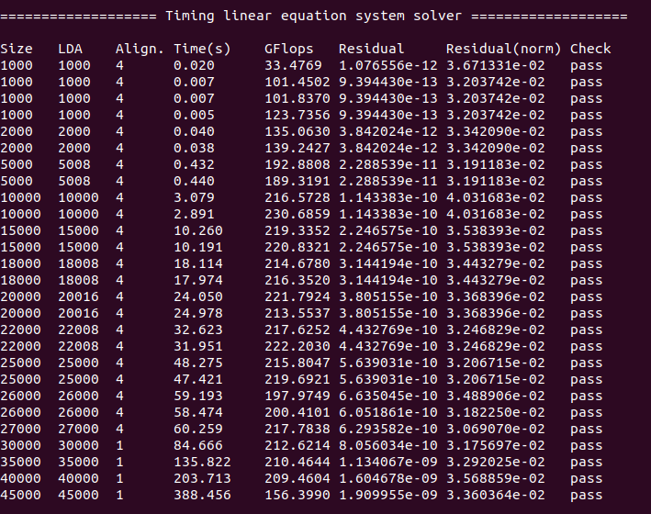

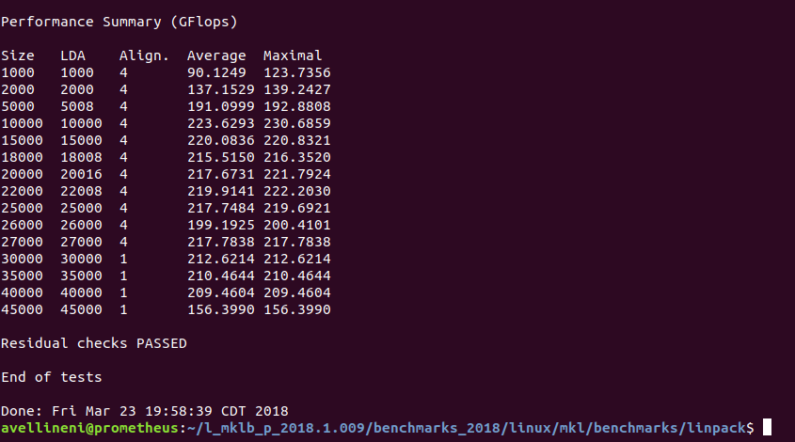

|  |
| --- |
| 3.530016 |
| 3.529643 |
| 3.435257 |
| 3.878215 |
| 3.62515 |
| 3.803454 |
| 3.205368 |
| 3.044258 |
| 3.29695 |
| 3.063322 |
| 3.033044 |
| 2.963704 |

