**Cloud Computing Assignment 1 CWID: A20406657**

**AVINASH VELLINENI**

CPU Benchmark:

All the experiments were done on Prometheus cluster (Intel(R) Xeon(R) CPU E5-2620 v4 @ 2.10GHz).

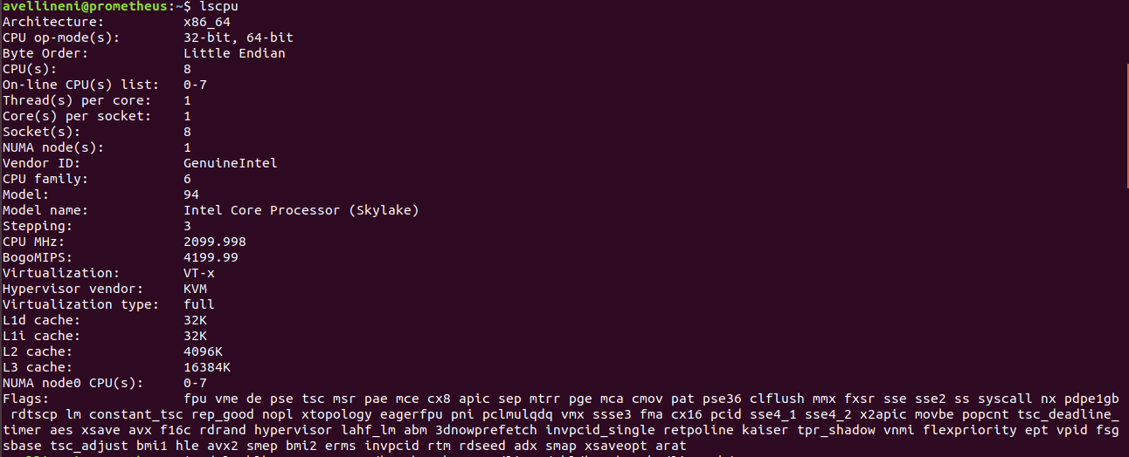

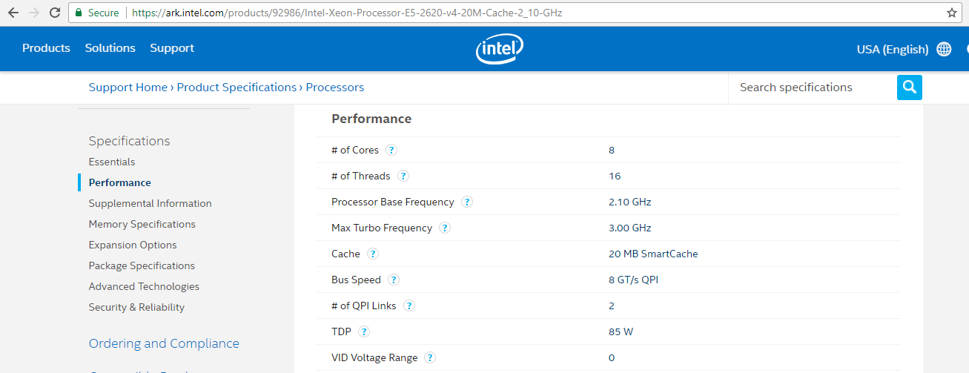

**Measurements were collected for the following specifications:**

**Workload:** 1 trillion arithmetic operations.

**Operations:** quarter precision(QP), half precision(HP), single precision(SP), double precision(DP).

**Concurrency:** 1,2,4 threads.

**Results Measurement:** Giga ops/sec.

Measurement:

|  |  |  |  |  |  |  |
| --- | --- | --- | --- | --- | --- | --- |
| **Workload** | **Concurrency** | **MyCPUBench**  **(Gops/sec)** | **Linpack**  **(Gops/sec)** | **Theoretical**  **(Gops/sec)** | **MyCPUBench**  **Efficiency** | **Linpack**  **Efficiency** |
| **QP** | 1 | 18.887 | **N/A** | 535.04 | 3.530016 | **N/A** |
| **QP** | 2 | 18.885 | **N/A** | 535.04 | 3.529643 | **N/A** |
| **QP** | 4 | 18.38 | **N/A** | 535.04 | 3.435257 | **N/A** |
| **HP** | 1 | 20.75 | **N/A** | 535.04 | 3.878215 | **N/A** |
| **HP** | 2 | 19.396 | **N/A** | 535.04 | 3.62515 | **N/A** |
| **HP** | 4 | 20.35 | **N/A** | 535.04 | 3.803454 | **N/A** |
| **SP** | 1 | 17.15 | **N/A** | 535.04 | 3.205368 | **N/A** |
| **SP** | 2 | 16.288 | **N/A** | 535.04 | 3.044258 | **N/A** |
| **SP** | 4 | 17.64 | **N/A** | 535.04 | 3.29695 | **N/A** |
| **DP** | 1 | 16.39 | 223.62 | 535.04 | 3.063322 | 41.8 |
| **DP** | 2 | 16.228 | 223.62 | 535.04 | 3.033044 | 41.8 |
| **DP** | 4 | 15.857 | 223.62 | 535.04 | 2.963704 | 41.8 |

**Theoretical Calculation:**

**Processor performance =** CPU speed *Number of CPU cores * CPI * Number of CPUs

= 2.09 * 8 * 4 * 8

= 535.04 Gops/sec.

**Linpack Efficiency:**

Efficiency = 223.62/535.04 * 100 = 41.8%

**LINPACK Measurement:**

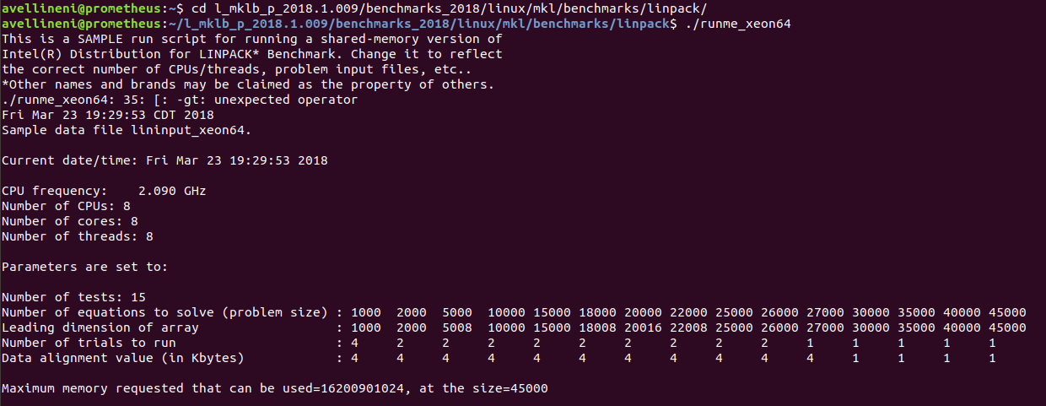

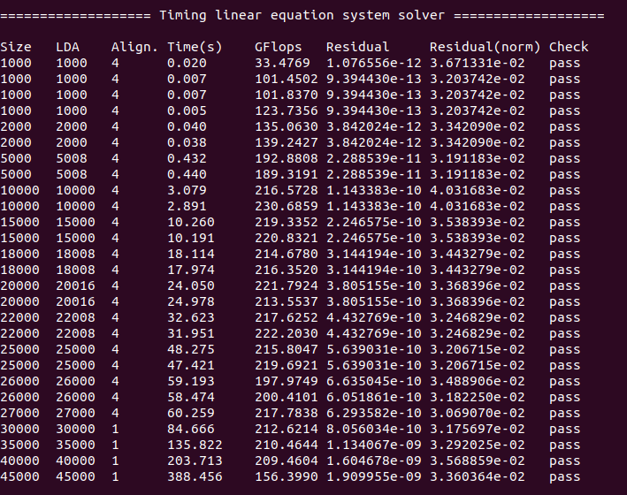

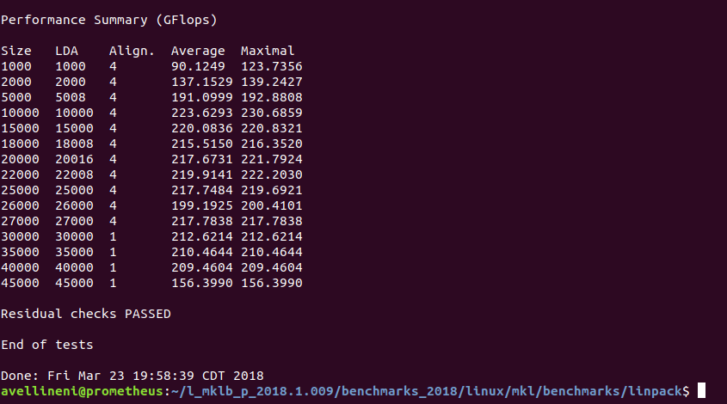

MyCPUBench Efficiency is low compared to theoretical and linpack benchmark performance. The resulting lower performance might be because of other background processes running on the computer and using up the CPU time. Maximum efficiency achieved using MyCPUBench is 3.88% and Maximum efficiency achieved using LINPACK is 41.8%.

Memory Benchmark:

All the experiments were done on Prometheus cluster (Intel(R) Xeon(R) CPU E5-2620 v4 @ 2.10GHz.

**Measurements were collected for the following specifications:**

**Workload:** 1GB data over 100 times.

**Operations:** RWS (Read Write Sequentially), RWR (Read Write Randomly).

**Concurrency:** 1,2,4 threads.

**Block Size:** 1B,1KB,1MB,10MB.

**Results Measurement:** GB /sec,Microsec.

**Theoretical Performance:**

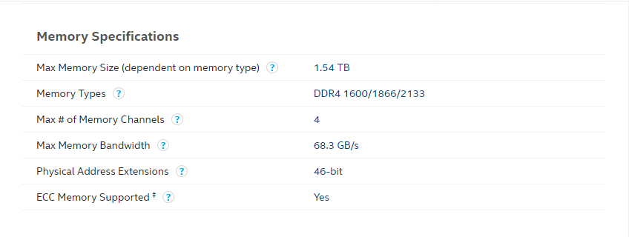

Maximum Bandwidth achieved is **68.3 GB/s.**

<https://ark.intel.com/products/92986/Intel-Xeon-Processor-E5-2620-v4-20M-Cache-2_10-GHz>

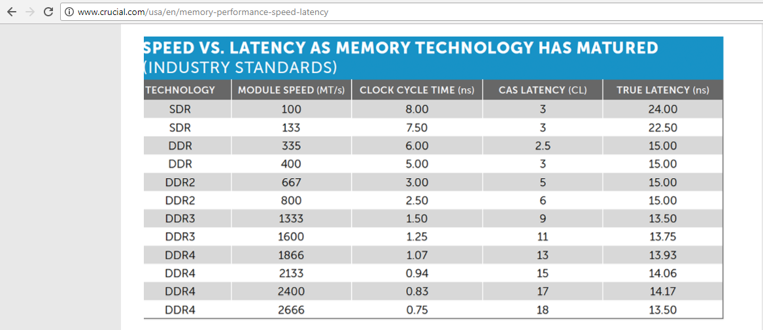



Latency = (1/2.09GHZ) * 13

= .000478 *13 = 0.00622 Microsec.

Measurement:

|  |  |  |  |  |  |  |  |
| --- | --- | --- | --- | --- | --- | --- | --- |
| **Work**  **load** | **Concurrency** | **Block Size** | **MyRAMBench**  **(GB/sec)** | **Pmbw**  **(GB/sec)** | **Theoretical**  **(GB/sec)** | **MyRAMBench**  **Efficiency** | **Pmbw**  **Efficiency** |
| **RWS** | 1 | 1KB | 27.792 | 16.467 | 63.8 | 43.56113 | 24.11 |
| **RWS** | 1 | 1MB | 7.491 | 20.143 | 63.8 | 11.74138 | 29.49 |
| **RWS** | 1 | 10MB | 8.008 | 19.762 | 63.8 | 12.55172 | 28.93 |
| **RWS** | 2 | 1KB | 22.02 | 22.475 | 63.8 | 34.51411 | 32.90 |
| **RWS** | 2 | 1MB | 7.51 | 36.304 | 63.8 | 11.77116 | 53.15 |
| **RWS** | 2 | 10MB | 7.135 | 36.586 | 63.8 | 11.18339 | 53.57 |
| **RWS** | 4 | 1KB | 24.98 | 26.463 | 63.8 | 39.15361 | 38.74 |
| **RWS** | 4 | 1MB | 7.172 | 38.118 | 63.8 | 11.24138 | 55.81 |
| **RWS** | 4 | 10MB | 3.991 | 36.567 | 63.8 | 6.255486 | 53.54 |
| **RWR** | 1 | 1KB | 1.55 | 12.384 | 63.8 | 2.429467 | 18.13 |
| **RWR** | 1 | 1MB | 1.921 | 13.673 | 63.8 | 3.010972 | 20.02 |
| **RWR** | 1 | 10MB | 2.742 | 12.887 | 63.8 | 4.297806 | 18.87 |
| **RWR** | 2 | 1KB | 1.727 | 15.016 | 63.8 | 2.706897 | 21.99 |
| **RWR** | 2 | 1MB | 1.292 | 19.982 | 63.8 | 2.025078 | 29.26 |
| **RWR** | 2 | 10MB | 2.230 | 20.291 | 63.8 | 3.495298 | 29.71 |
| **RWR** | 4 | 1KB | 1.534 | 13.268 | 63.8 | 2.404389 | 19.43 |
| **RWR** | 4 | 1MB | 1.122 | 21.531 | 63.8 | 1.758621 | 31.52 |
| **RWR** | 4 | 10MB | 1.959 | 21.051 | 63.8 | 3.070533 | 30.82 |

|  |  |  |  |  |  |  |  |
| --- | --- | --- | --- | --- | --- | --- | --- |
| **Work**  **load** | **Concurrency** | **Block Size** | **MyRAMBench**  **(Microsec)** | **Pmbw**  **(Microsec)** | **Theoretical**  **(Microsec)** | **MyRAMBench**  **Efficiency** | **Pmbw**  **Efficiency** |
| **RWS** | 1 | 1B | 0.00857 | 0.01164 | 0.00622 | 72.57876 | 53.43643 |
| **RWS** | 2 | 1B | 0.00878 | 0.006589 | 0.00622 | 70.84282 | 94.39976 |
| **RWS** | 4 | 1B | 0.009221 | 0.0082568 | 0.00622 | 67.45472 | 75.33185 |
| **RWR** | 1 | 1B | 0.1065 | 0.0119374 | 0.00622 | 5.840376 | 52.10515 |
| **RWR** | 2 | 1B | 0.5886 | 0.0070053 | 0.00622 | 1.056745 | 88.78992 |
| **RWR** | 4 | 1B | 0.6918 | 0.0093643 | 0.00622 | 0.899104 | 66.42248 |

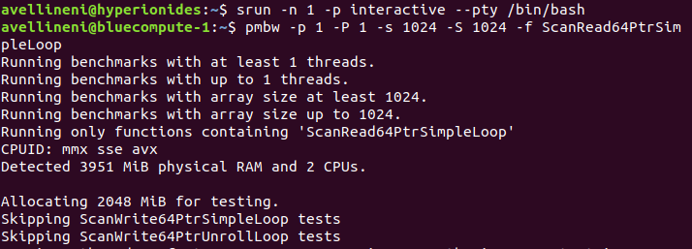

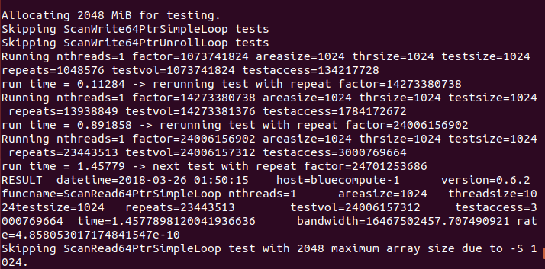

MyRambenchmark throughput obtained is lower than the Pmbw benchmark and the theoretical values. Random Read/Write throughput values are lower compared to the sequential Read/Write values, this is due to movement of disk arm over the hard disk tracks randomly (increases seek time). The maximum throughput achieved by MyRambenchmark is 43.56% and for Pmbw benchmark is 55.81%. MyRAMBenchmark highest latency efficiency is 72.58% and for Pmbw benchmark is 94.40%. Efficiency for random Read/Write on MyRAMbenchmark is low compared Pmbw and theoretical values do to movement of disk head for every 1Byte of data read and write.

Disk Benchmark:

All the experiments were done on Prometheus cluster (Intel(R) Xeon(R) CPU E5-2620 v4 @ 2.10GHz.

Disk type is Micron 5100 PRO 2.5"480GB, SATA,6Gb/s,3D NAND,7mm,1.5DWPD 2.

**Measurements were collected for the following specifications:**

**Workload:** 1GB data over 100 times.

**Operations:** RS (Read Sequentially), RR (Read Randomly), WS (Write Sequentially), WR (Write Randomly).

**Concurrency:** 1,2,4,8,16,32,64,128 threads.

**Block Size:** 1KB,1MB,10MB,100MB.

**Results Measurement:** MB /sec, millisec.

**Theoretical Performance:**

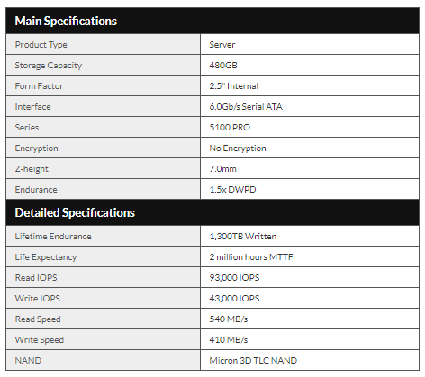

Maximum Performance achieved is **6.0GB/s.**

<https://www.thinkmate.com/product/micron/mtfddak480tcb-1ar1zabyy>

Theoretical read/write latency at 99.9% is 5microseconds.

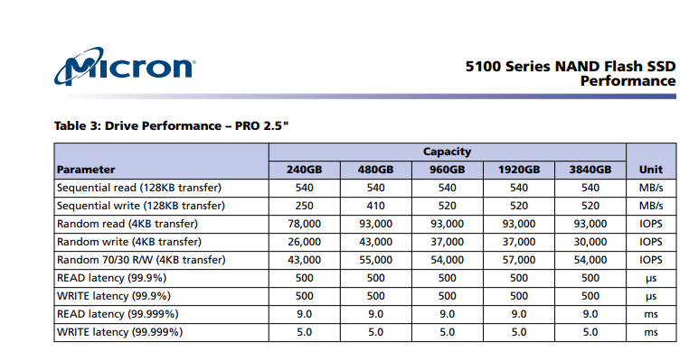

|  |  |  |  |  |  |  |  |
| --- | --- | --- | --- | --- | --- | --- | --- |
| **Work**  **load** | **Concurrency** | **Block Size** | **MyDiskBench**  **(MB/sec)** | **Iozone**  **(MB/sec)** | **Theoretical**  **(MB/sec)** | **MyDiskBench**  **Efficiency** | **Iozone**  **Efficiency** |
| **RS** | 1 | 1MB | 3281.48 | 452.18 | 6000 | 54.69133 | 7.536333 |
| **RS** | 1 | 10MB | 2089.887 | 5129.455 | 6000 | 34.83145 | 85.49092 |
| **RS** | 1 | 100MB | 340.4338 | 2985.789 | 6000 | 5.673897 | 49.76315 |
| **RS** | 2 | 1MB | 1927.834 | 416.927 | 6000 | 32.13057 | 6.948783 |
| **RS** | 2 | 10MB | 259.462 | 2606.957 | 6000 | 4.324367 | 43.44928 |
| **RS** | 2 | 100MB | 23.993 | 3111.611 | 6000 | 0.399883 | 51.86018 |
| **RS** | 4 | 1MB | 1065.882 | 245.718 | 6000 | 17.7647 | 4.0953 |
| **RS** | 4 | 10MB | 107.386 | 227.020 | 6000 | 1.789767 | 3.783667 |
| **RS** | 4 | 100MB | 9.8664 | 242.292 | 6000 | 0.16444 | 4.0382 |
| **WS** | 1 | 1MB | 856.368 | 820.795 | 6000 | 14.2728 | 13.67992 |
| **WS** | 1 | 10MB | 729.989 | 693.699 | 6000 | 12.16648 | 11.56165 |
| **WS** | 1 | 100MB | 263.54 | 948.107 | 6000 | 4.392333 | 15.80178 |
| **WS** | 2 | 1MB | 244.819 | 525.087 | 6000 | 4.080317 | 8.75145 |
| **WS** | 2 | 10MB | 152.266 | 517.818 | 6000 | 2.537767 | 8.6303 |
| **WS** | 2 | 100MB | 21.682 | 412.663 | 6000 | 0.361367 | 6.877717 |
| **WS** | 4 | 1MB | 314.627 | 257.647 | 6000 | 5.243783 | 4.294117 |
| **WS** | 4 | 10MB | 76.72 | 264.335 | 6000 | 1.278667 | 4.405583 |
| **WS** | 4 | 100MB | 7.1153 | 245.477 | 6000 | 0.118588 | 4.091283 |
| **RR** | 1 | 1MB | 1224.734 | 383.541 | 6000 | 20.41223 | 6.39235 |
| **RR** | 1 | 10MB | 2146.74 | 5202.418 | 6000 | 35.779 | 86.70697 |
| **RR** | 1 | 100MB | 340.11 | 3533.458 | 6000 | 5.6685 | 58.89097 |
| **RR** | 2 | 1MB | 652.325 | 300.029 | 6000 | 10.87208 | 5.000483 |
| **RR** | 2 | 10MB | 147.299 | 3346.238 | 6000 | 2.454983 | 55.77063 |
| **RR** | 2 | 100MB | 25.211 | 3149.734 | 6000 | 0.420183 | 52.49557 |
| **RR** | 4 | 1MB | 1052.1468 | 299.134 | 6000 | 17.53578 | 4.985567 |
| **RR** | 4 | 10MB | 106.181 | 286.944 | 6000 | 1.769683 | 4.7824 |
| **RR** | 4 | 100MB | 8.609 | 241.231 | 6000 | 0.143483 | 4.020517 |
| **WR** | 1 | 1MB | 1013.033 | 839.676 | 6000 | 16.88388 | 13.9946 |
| **WR** | 1 | 10MB | 889.286 | 1376.797 | 6000 | 14.82143 | 22.94662 |
| **WR** | 1 | 100MB | 272.287 | 1365.876 | 6000 | 4.538117 | 22.7646 |
| **WR** | 2 | 1MB | 438.414 | 487.508 | 6000 | 7.3069 | 8.125133 |
| **WR** | 2 | 10MB | 215.937 | 640.434 | 6000 | 3.59895 | 10.6739 |
| **WR** | 2 | 100MB | 21.199 | 612.443 | 6000 | 0.353317 | 10.20738 |
| **WR** | 4 | 1MB | 359.255 | 244.477 | 6000 | 5.987583 | 4.074617 |
| **WR** | 4 | 10MB | 91.503 | 189.205 | 6000 | 1.52505 | 3.153417 |
| **WR** | 4 | 100MB | 10.303 | 276.235 | 6000 | 0.171717 | 4.603917 |

|  |  |  |  |  |  |  |  |
| --- | --- | --- | --- | --- | --- | --- | --- |
| **Work**  **load** | **Concurrency** | **Block Size** | **MyDiskBench**  **(msec)** | **Iozone**  **(msec)** | **Theoretical**  **(msec)** | **MyDiskBench**  **Efficiency** | **Iozone**  **Efficiency** |
| **RR** | 1 | 1kB | .000227 | .002711 | 0.5 | 46.4896 | 5.422 |
| **RR** | 2 | 1kB | .000220 | .002699 | 0.5 | 45.056 | 5.398 |
| **RR** | 4 | 1kB | .000226 | .014168 | 0.5 | 46.2848 | 28.336 |
| **RR** | 8 | 1kB | .000248 | .00387 | 0.5 | 50.7904 | 7.74 |
| **RR** | 16 | 1kB | .000264 | .00286 | 0.5 | 54.0672 | 5.72 |
| **RR** | 32 | 1kB | .000236 | .00996 | 0.5 | 48.3328 | 19.92 |
| **RR** | 64 | 1kB | .000252 | .010589 | 0.5 | 51.6096 | 21.178 |
| **RR** | 128 | 1kB | .000293 | .00951 | 0.5 | 60.0064 | 19.02 |
| **WR** | 1 | 1kB | .00017 | .01952 | 0.5 | 34.816 | 39.04 |
| **WR** | 2 | 1kB | .00019 | .00883 | 0.5 | 38.912 | 17.66 |
| **WR** | 4 | 1kB | .00016 | .02238 | 0.5 | 32.768 | 44.76 |
| **WR** | 8 | 1kB | .00016 | .03334 | 0.5 | 32.768 | 66.68 |
| **WR** | 16 | 1kB | .00017 | .02298 | 0.5 | 34.816 | 45.96 |
| **WR** | 32 | 1kB | .00028 | .006995 | 0.5 | 57.344 | 13.99 |
| **WR** | 64 | 1kB | .00020 | .009113 | 0.5 | 40.96 | 18.226 |
| **WR** | 128 | 1kB | .00035 | .008664 | 0.5 | 71.68 | 17.328 |

|  |  |  |  |  |  |  |  |
| --- | --- | --- | --- | --- | --- | --- | --- |
| **Work**  **load** | **Concurrency** | **Block Size** | **MyDiskBench**  **(Iops)** | **Iozone**  **(Iops)** | **Theoretical**  **(Iops)** | **MyDiskBench**  **Efficiency** | **Iozone**  **Efficiency** |
| **RR** | 1 | 1kB | 4405.286 | **4833.23** | 23250 | 18.94747 | 20.78809 |
| **RR** | 2 | 1kB | 4545.455 | **5610.33** | 23250 | 19.55034 | 24.13045 |
| **RR** | 4 | 1kB | 4424.779 | **4118.73** | 23250 | 19.03131 | 17.71497 |
| **RR** | 8 | 1kB | 4032.258 | **2030.23** | 23250 | 17.34305 | 8.732172 |
| **RR** | 16 | 1kB | 3787.879 | **1442.82** | 23250 | 16.29195 | 6.205677 |
| **RR** | 32 | 1kB | 4237.288 | **600.68** | 23250 | 18.22489 | 2.58357 |
| **RR** | 64 | 1kB | 3968.254 | **510.12** | 23250 | 17.06776 | 2.194065 |
| **RR** | 128 | 1kB | 3412.969 | **328.09** | 23250 | 14.67944 | 1.41114 |
| **WR** | 1 | 1kB | 5882.353 | **779.49** | 10750 | 54.71956 | 7.25107 |
| **WR** | 2 | 1kB | 5263.158 | **471.29** | 10750 | 48.95961 | 4.384093 |
| **WR** | 4 | 1kB | 6250 | **373.24** | 10750 | 58.13953 | 3.472 |
| **WR** | 8 | 1kB | 6250 | **225.22** | 10750 | 58.13953 | 2.09507 |
| **WR** | 16 | 1kB | 5882.353 | **150.73** | 10750 | 54.71956 | 1.40214 |
| **WR** | 32 | 1kB | 3571.429 | **90.88** | 10750 | 33.2226 | 0.845395 |
| **WR** | 64 | 1kB | 5000 | **34.16** | 10750 | 46.51163 | 0.317767 |
| **WR** | 128 | 1kB | 2857.143 | **19.113** | 10750 | 26.57807 | 0.177795 |

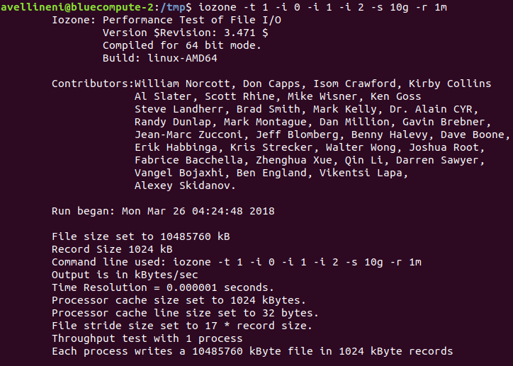

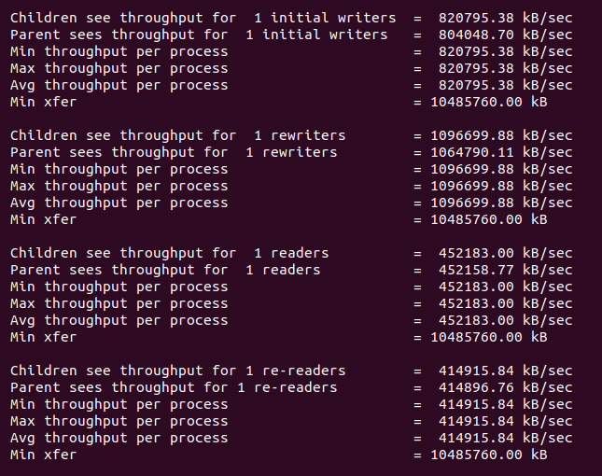

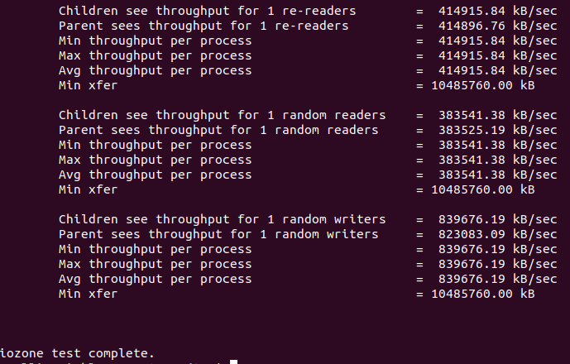

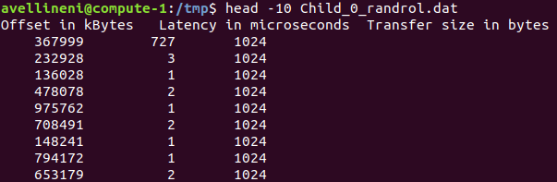

MyDiskBenchmark Read sequential and random operations obtained higher than the write sequential and random operations. Maximum throughput obtained for Sequential/Random read/write operations for MyDiskBenchmark is 54.70% and for Iozone benchmark is 86.7%. Latency efficiency obtained by MyDiskBenchmark is slightly better than the Iozone benchmark. Maximum latency efficiency obtained by MyDiskBenchmark is 71.68% on the other hand Iozone obtained 66.68%. Both the benchmarks obtained slightly lower Iops around 20-50% compared to the theoretical performance.

Network Benchmarking:

All the experiments were done on Prometheus cluster (Intel(R) Xeon(R) CPU E5-2620 v4 @ 2.10GHz.

**Measurements were collected for the following specifications:**

**Workload:** 1GB data over 100 times.

**Operations:** RS (Read Sequentially), RR (Read Randomly), WS (Write Sequentially), WR (Write Randomly).

**Concurrency:** 1,2,4,8 threads.

**Block Size:** 1KB,32KB,1B.

**Results Measurement:** MB /sec, millisec.

Measurement:

|  |  |  |  |  |  |  |  |
| --- | --- | --- | --- | --- | --- | --- | --- |
| **Work**  **load** | **Concurrency** | **Block Size** | **MyNETBench**  **(MB/sec)** | **Iperf**  **(MB/sec)** | **Theoretical**  **(MB/sec)** | **MyNETBench**  **Efficiency** | **Iperf**  **Efficiency** |
| **TCP** | 1 | 1KB | 767.0359 | 564 | 10000 | 7.670359 | 5.64 |
| **TCP** | 1 | 32KB | 2434.177 | 3620 | 10000 | 24.34177 | 36.2 |
| **TCP** | 2 | 1KB | 893.0326 | 580 | 10000 | 8.930326 | 5.8 |
| **TCP** | 2 | 32KB | 2560.531 | 3703 | 10000 | 25.60531 | 37.03 |
| **TCP** | 4 | 1KB | 740.286 | 523 | 10000 | 7.40286 | 5.23 |
| **TCP** | 4 | 32KB | 2501.405 | 3691 | 10000 | 25.01405 | 36.91 |
| **TCP** | 8 | 1KB | 785.081 | 559 | 10000 | 7.85081 | 5.59 |
| **TCP** | 8 | 32KB | 2416.131 | 3726 | 10000 | 24.16131 | 37.26 |
| **UDP** | 1 | 1KB | 301.508 | 561 | 10000 | 3.01508 | 5.61 |
| **UDP** | 1 | 32KB | 2179.502 | 7750 | 10000 | 21.79502 | 77.5 |
| **UDP** | 2 | 1KB | 275.463 | 605 | 10000 | 2.75463 | 6.05 |
| **UDP** | 2 | 32KB | 3146.451 | 7802 | 10000 | 31.46451 | 78.02 |
| **UDP** | 4 | 1KB | 284.091 | 597 | 10000 | 2.84091 | 5.97 |
| **UDP** | 4 | 32KB | 3178.387 | 7844 | 10000 | 31.78387 | 78.44 |
| **UDP** | 8 | 1KB | 262.593 | 588 | 10000 | 2.62593 | 5.88 |
| **UDP** | 8 | 32KB | 2778.32 | 7906 | 10000 | 27.7832 | 79.06 |

|  |  |  |  |  |  |  |  |
| --- | --- | --- | --- | --- | --- | --- | --- |
| **Work**  **load** | **Concurrency** | **Message Size** | **MyNETBench**  **(msec)** | **ping**  **(msec)** | **Theoretical**  **(msec)** | **MyNETBench**  **Efficiency** | **Iperf**  **Efficiency** |
| **TCP** | 1 | 1B | .001207 | .001818 | .009375 | 12.87467 | 19.392 |
| **TCP** | 2 | 1B | .001354 | .001823 | .009375 | 14.44267 | 19.44533 |
| **TCP** | 4 | 1B | .001162 | .001819 | .009375 | 12.39467 | 19.40267 |
| **TCP** | 8 | 1B | .001276 | .001820 | .009375 | 13.61067 | 19.41333 |
| **UDP** | 1 | 1B | .002759 | .001838 | .009375 | 29.42933 | 19.60533 |
| **UDP** | 2 | 1B | .002562 | .001837 | .009375 | 27.328 | 19.59467 |
| **UDP** | 4 | 1B | .002451 | .001849 | .009375 | 26.144 | 19.72267 |
| **UDP** | 8 | 1B | .002566 | .001828 | .009375 | 27.37067 | 19.49867 |

Theoretical Performance:

<https://ark.intel.com/products/60020/Intel-Ethernet-Controller-X540-AT2>

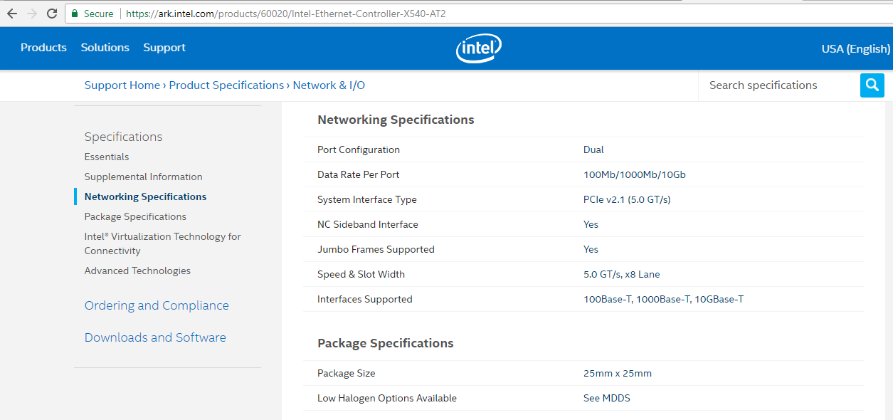

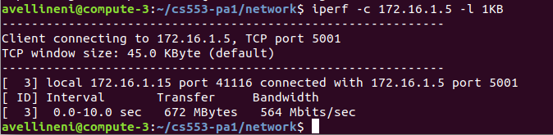

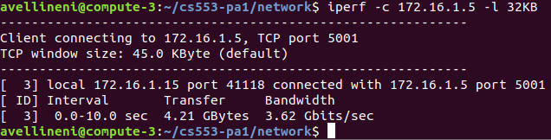

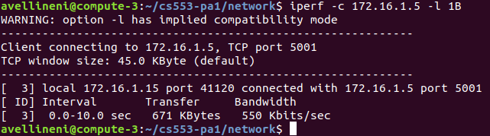

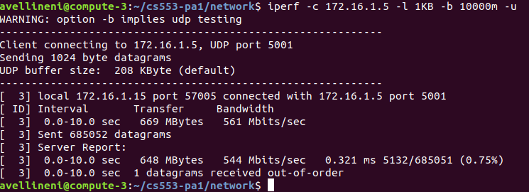

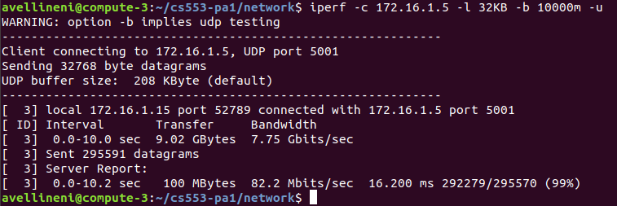

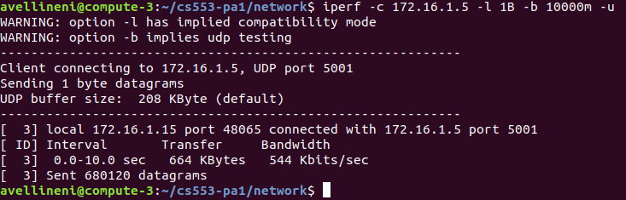

MyNetBenchmark TCP and UPD had lower through put for 1KB block transfer compared to 32K block transfer because more data can be sent with less packets from the client to the server same goes with the iperf benchmark. Maximum efficiency obtained by MyNETBenchmark is 27.78% and the iperf bench mark measured 79.06% this deviation of the efficiency cold be due to multiple clients sending data in the same channel which resulted in the reduced bandwidth. MyNETBenchmark efficiency for latency with 1Byte transfer varies from 12-29.5% while that of Iperf benchmark efficiency is around 19-20%.