**Instructions:**

* Install Oracle VM VirtualBox manager.
* Install Ubuntu OS (platform) on your VirtualBox and ensure XV6 is up and running.
* Open command prompt and run the source code as shown below.

1. Placed the assignment1.c file in desktop.
2. Opened command prompt.
3. Commands:
4. cd Desktop (to get into the desktop directory).
5. gcc assignment1.c -o assignment1 (to compile the assignment1.c source code)
6. . /assignment1 (to execute the source code and create executable or output file).

**Screenshot:**

Commands:

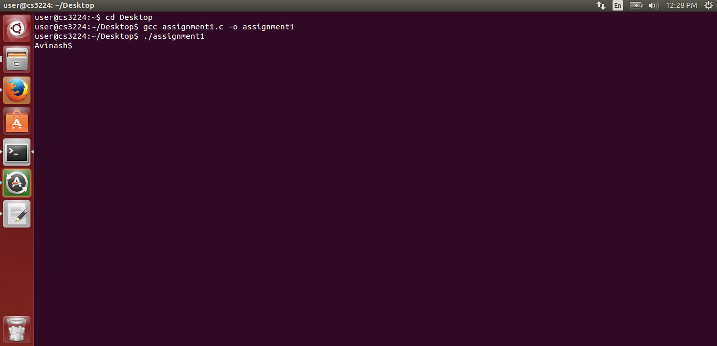

Source and executable file in desktop:

