**File 1:**

**Modified Filename:**  syscall.h

**Original Filename:** originalsyscall.h

**Command:** diff -uw syscall.h originalsyscall.h

**Screenshot:**

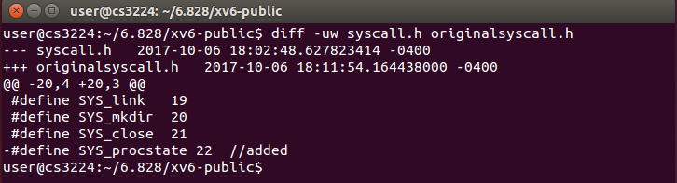

**File 2:**

**Modified Filename:**  defs.h

**Original Filename:** originaldefs.h

**Command:** diff -uw defs.h originaldefs.h

**Screenshot:**

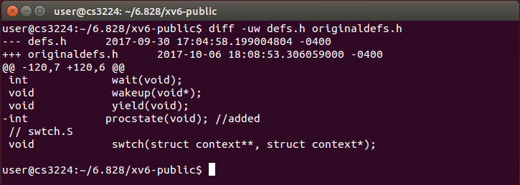

**File 3:**

**Modified Filename:**  user.h

**Original Filename:** originaluser.h

**Command:** diff -uw user.h originaluser.h

**Screenshot:** 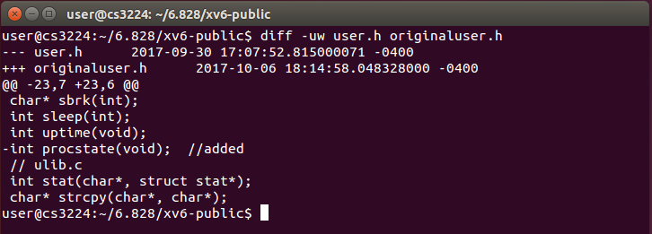

**File 4:**

**Modified Filename:**  sysproc.c

**Original Filename:** originalsysproc.c

**Command:** diff -uw sysproc.c originalsysproc.c

**Screenshot:**

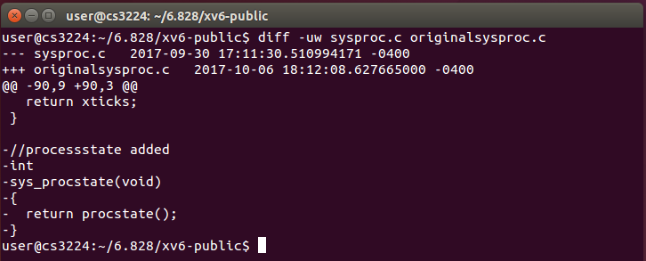

**File 5:**

**Modified Filename:**  usys.S

**Original Filename:** originalusys.S

**Command:** diff -uw usys.S originalusys.S

**Screenshot:** 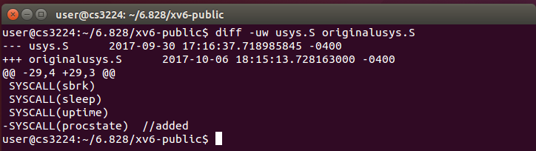

**File 6:**

**Modified Filename:**  syscall.c

**Original Filename:** originalsyscall.c

**Command:** diff -uw syscall.c originalsyscall.c

**Screenshot:** 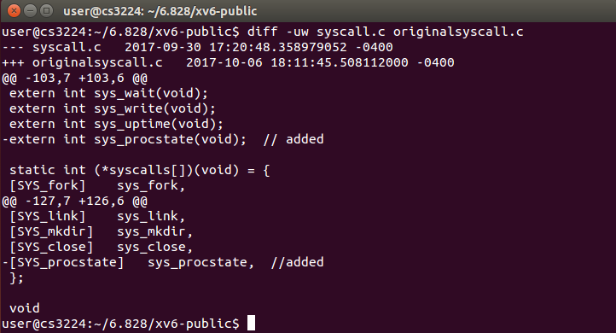

**File 7:**

**Modified Filename:**  proc.c

**Original Filename:** originalproc.c

**Command:** diff -uw proc.c originalproc.c

**Screenshot:**

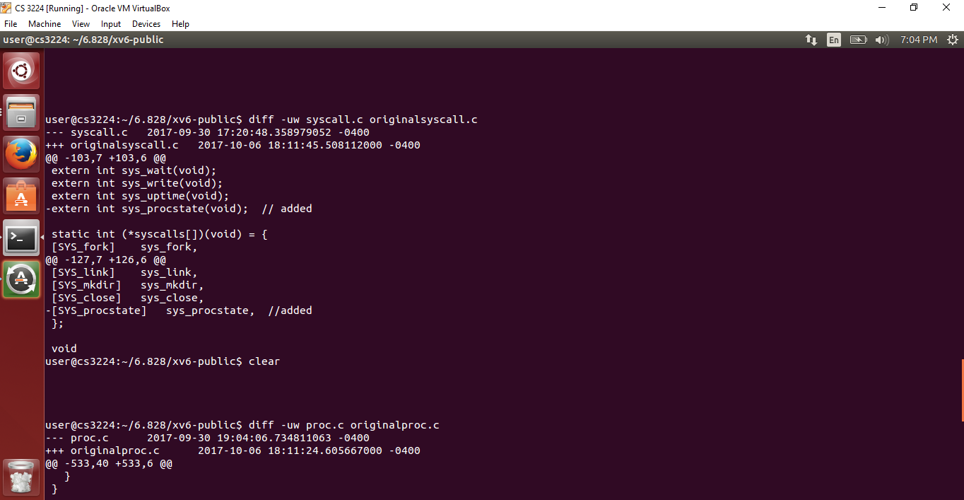

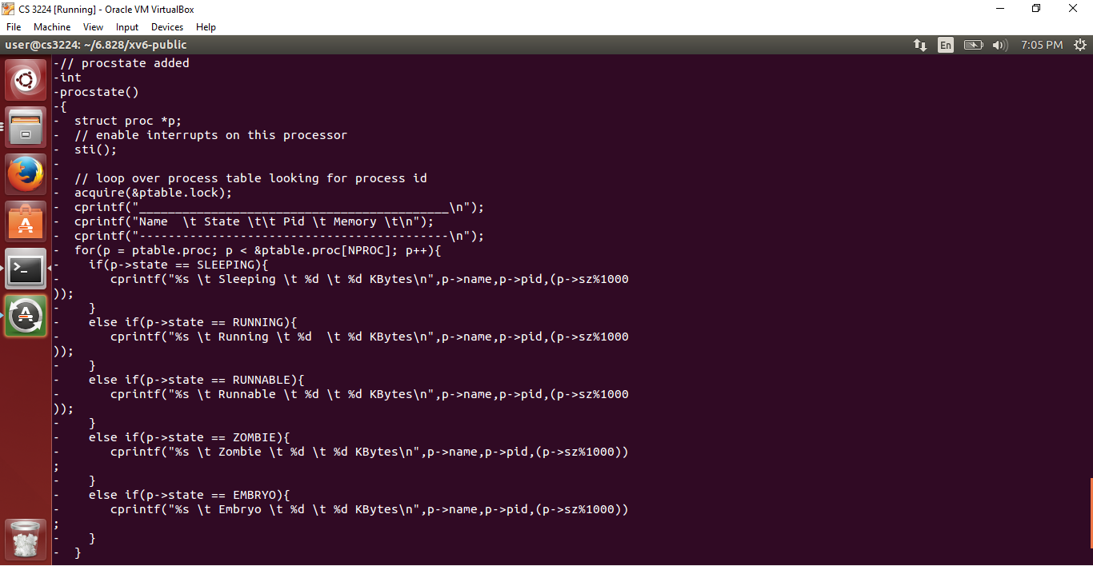

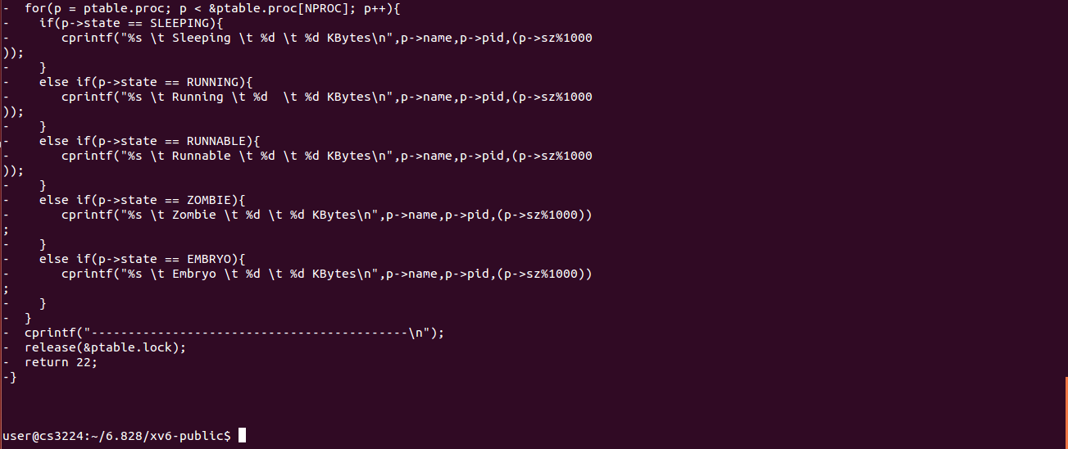

**File 8:**

**Modified Filename:**  Makefile

**Original Filename:** originalMakefile

**Command:** diff -uw Makefile originalMakefile

**Screenshot:**

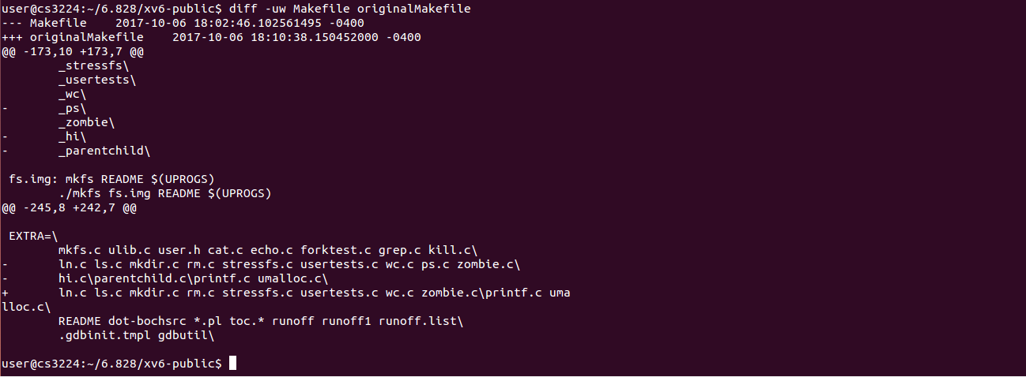

**Extra Files added for Implementation of procstate() systemcall :**

* **ps.c**
* **parentchild.c**