**Test Case:**

* Execute **‘’ps’’** command in the command prompt.

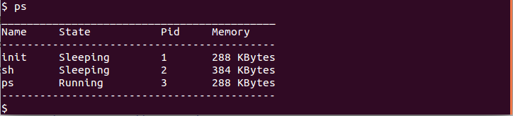

* Execute “**parentchild**” command in the command prompt.

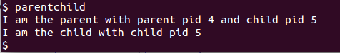

* Execute “**ps**” command again to verify whether the process ids are getting added/updated.

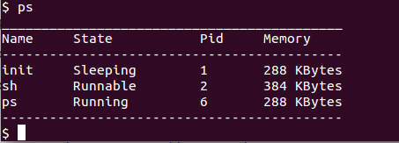

Final Output screen: