Test case1:

Command: echo hi; echo good evening

Comments: Two commands separated by sequence operator

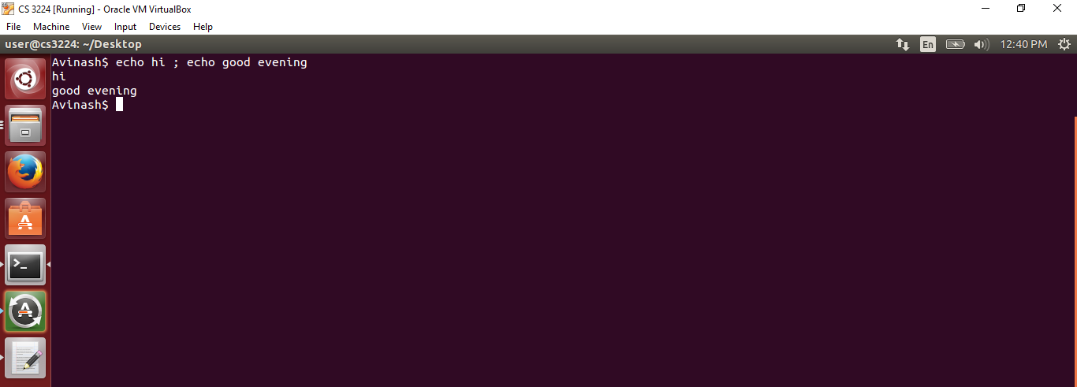

Test case2:

Command: echo hi; ls; pwd

Comments: Three commands separated by sequence operator

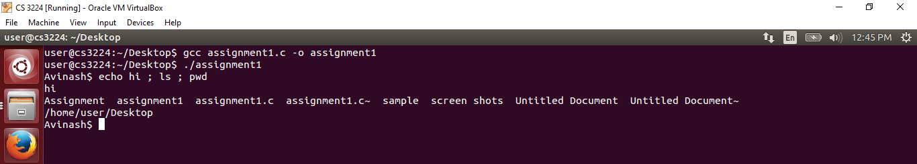

Test case3:

Command: echo hi & pwd

Comments: Two commands separated by parallel operator.

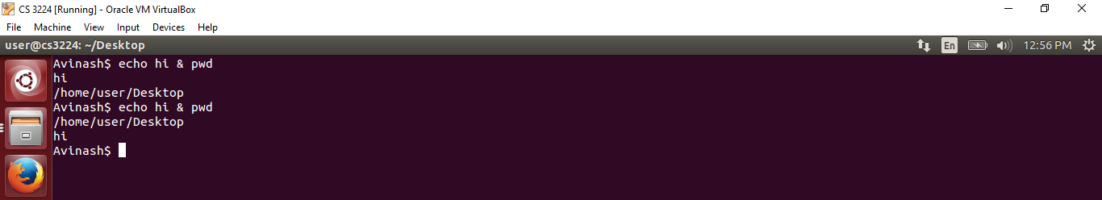

Test case4:

Command: echo hi & pwd; echo hello

Comments: Three commands separated by sequential and parallel operator. (combination of sequential and parallel operator)

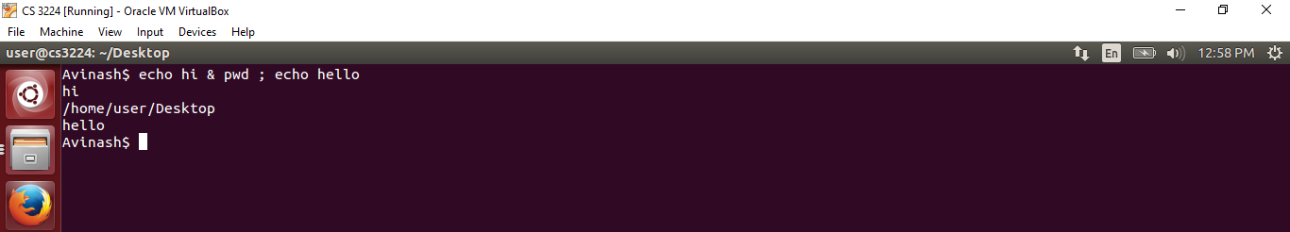

Test case5:

Command: echo hi & pwd & echo good evening

Comments: Three commands separated by parallel operator.

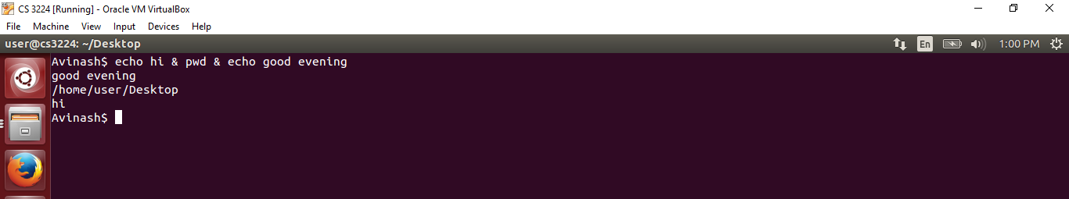

Test case6:

Command: touch temp.txt; ls -1 temp.txt

Comments: Commands separated by sequential operator.

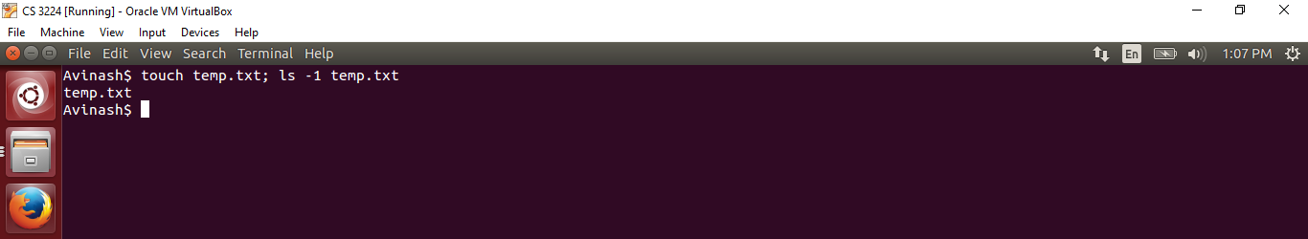

Test case7:

Command: echo “time to sleep”; sleep 10 & echo “sleeping…”; echo “wake up”

Comments: Multiple commands separated by sequential and parallel operators

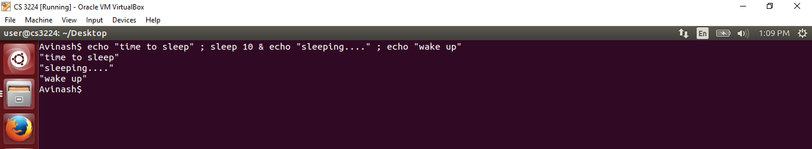

Test case8:

Command: echo hi & pwd; echo sleeping

Comments: Three commands separated by parallel command and sequential command.

