Java installation (JDK 17 or 21 recommended)
Step 1 :- Used this link click here to download java 21 JDK
Verification
- Used java -version to get the java version
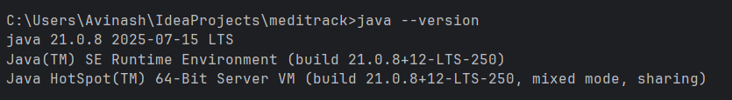
- Used javac -version to get the java version

Setting PATH / JAVA_HOME
- Created a environment variable JAVA_HOME for the jdk-21
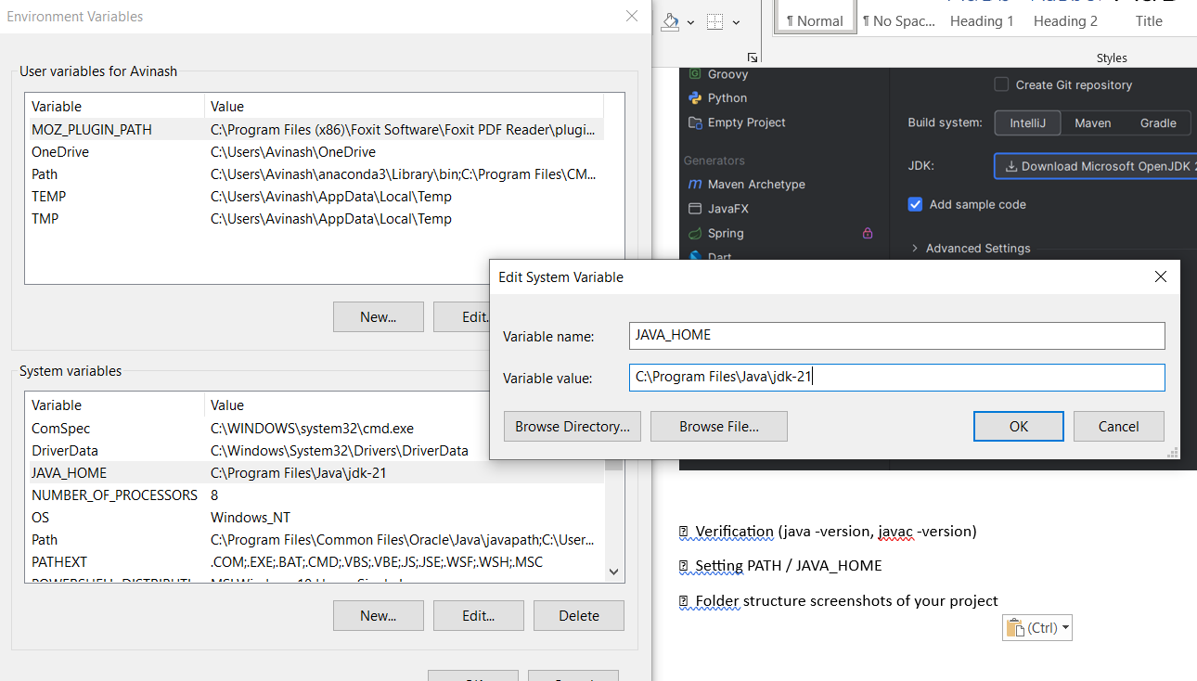
Folder structure screenshots of your project

