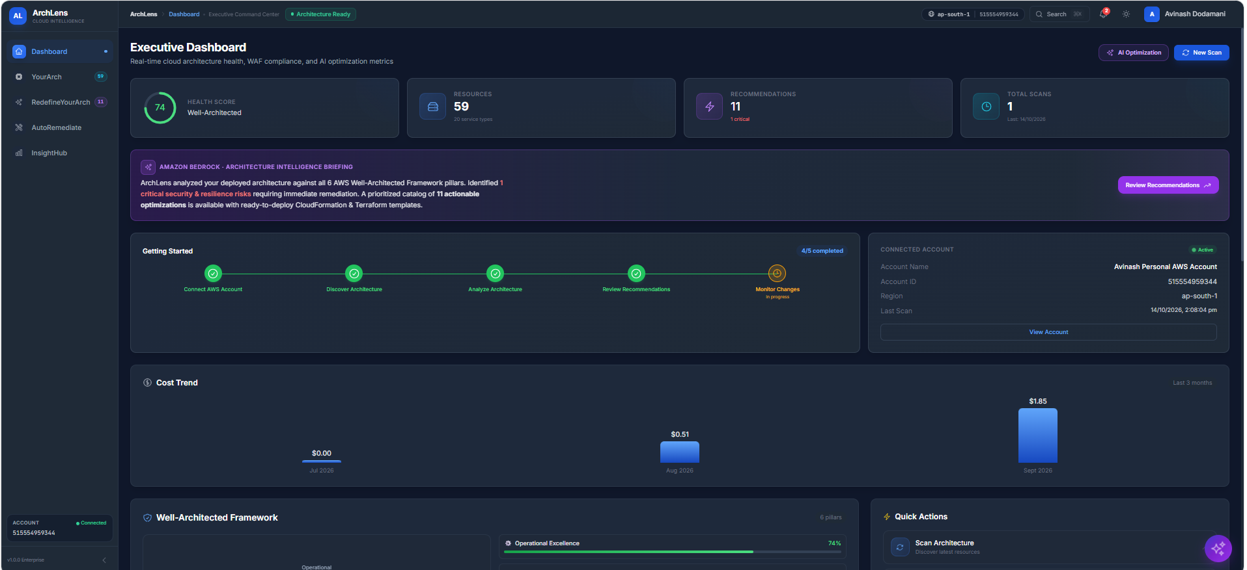

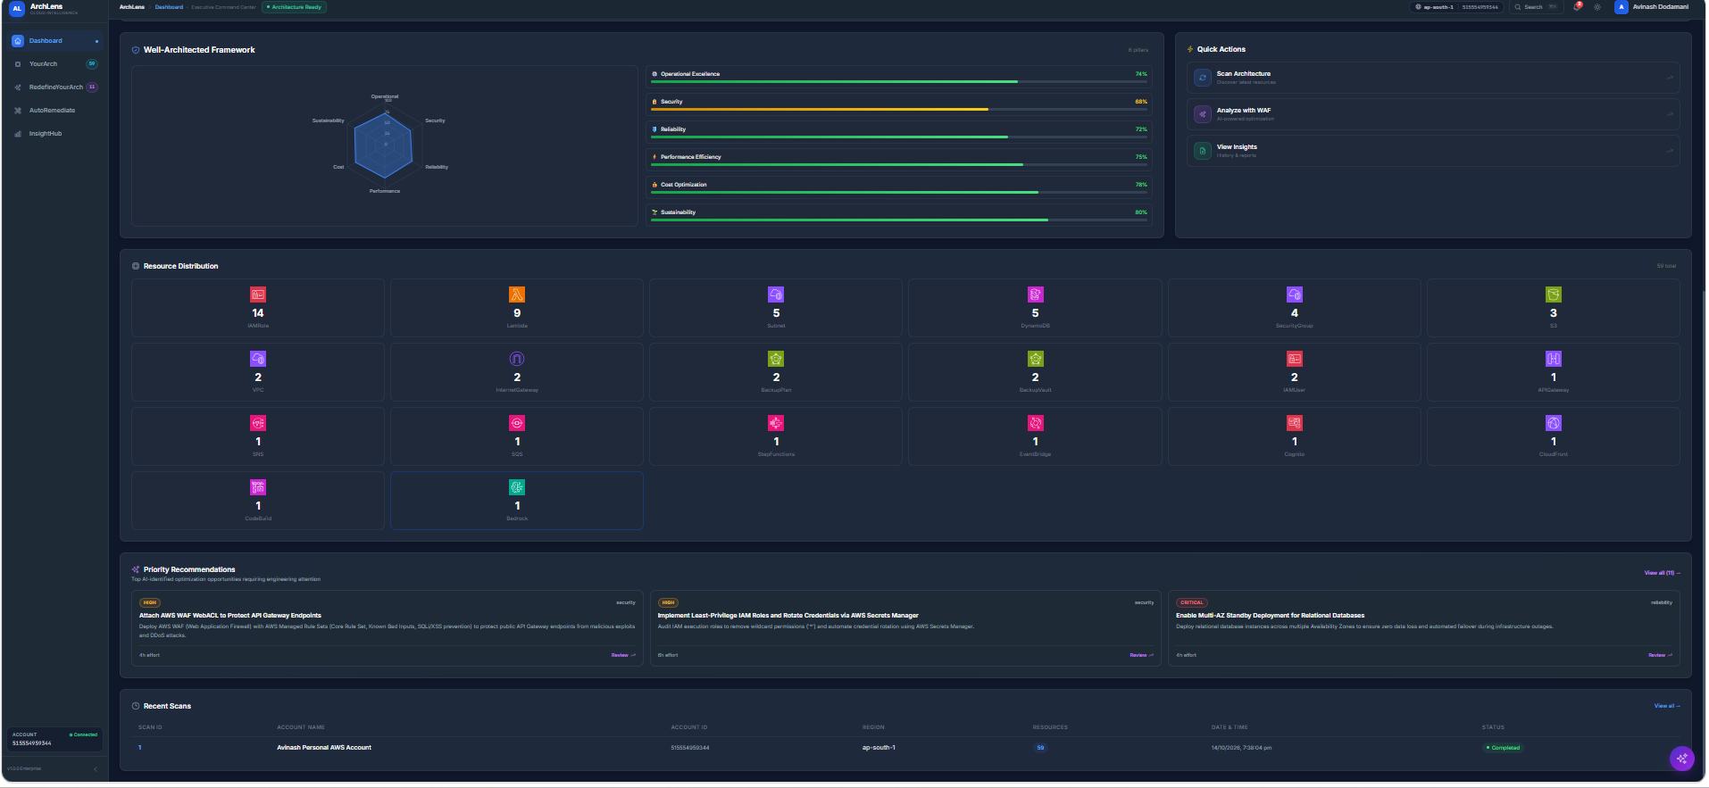

Chatbot is nor working
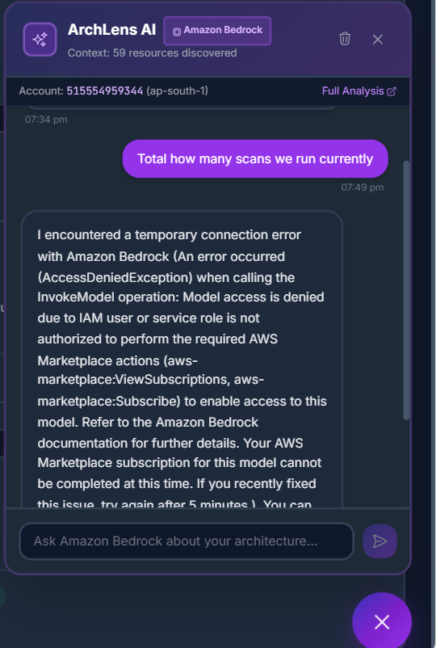

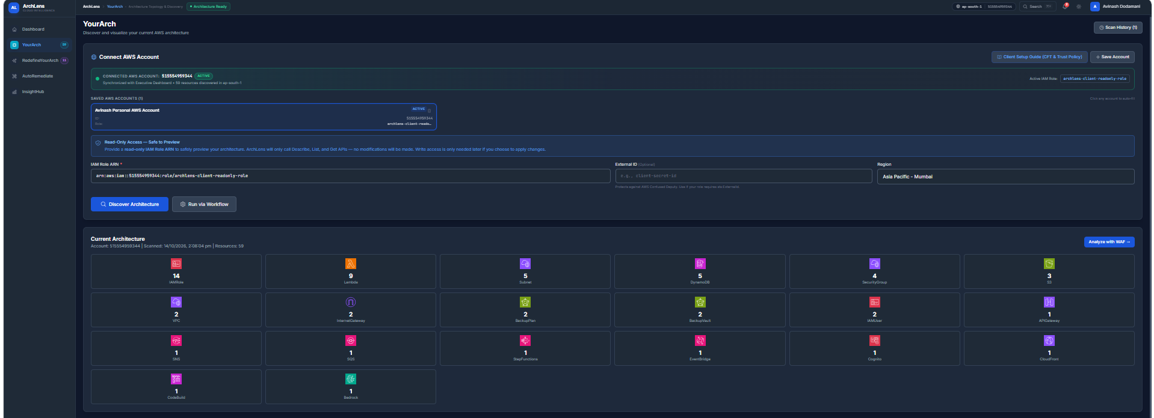

Architecture diagram is not crtly showing
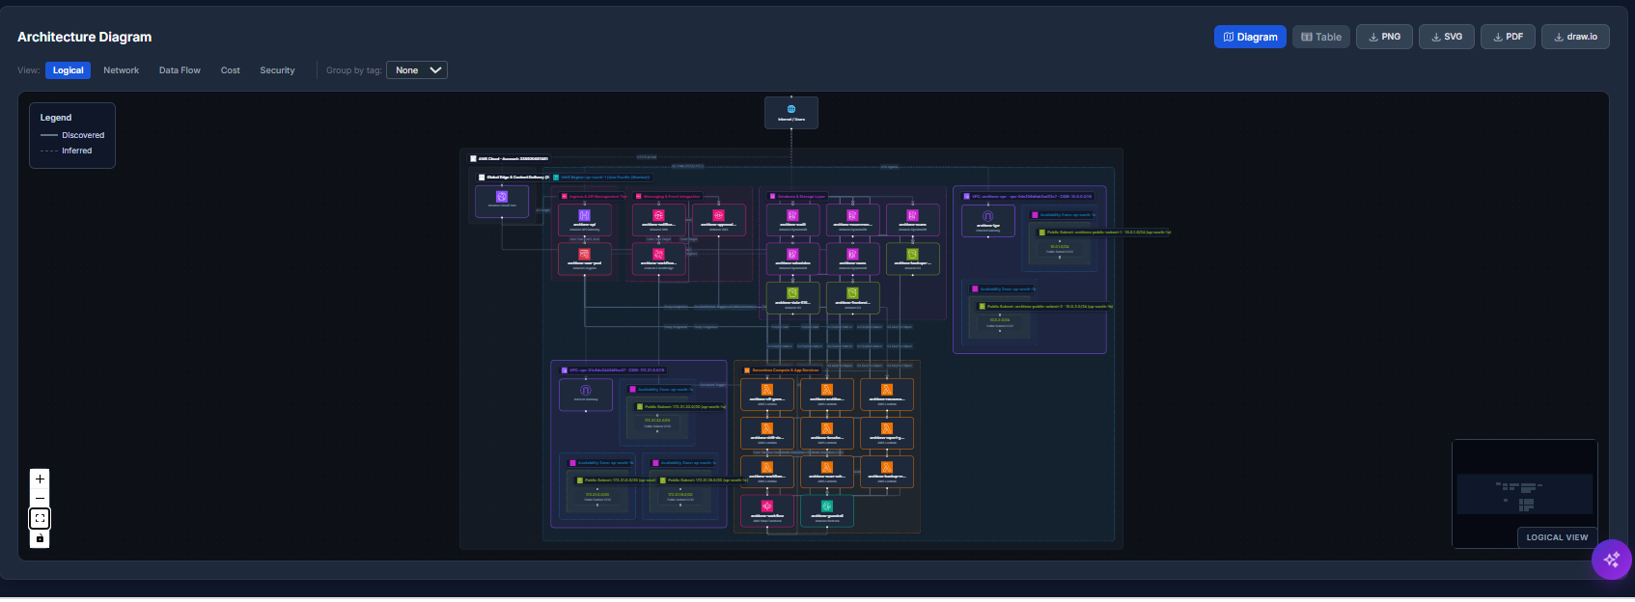
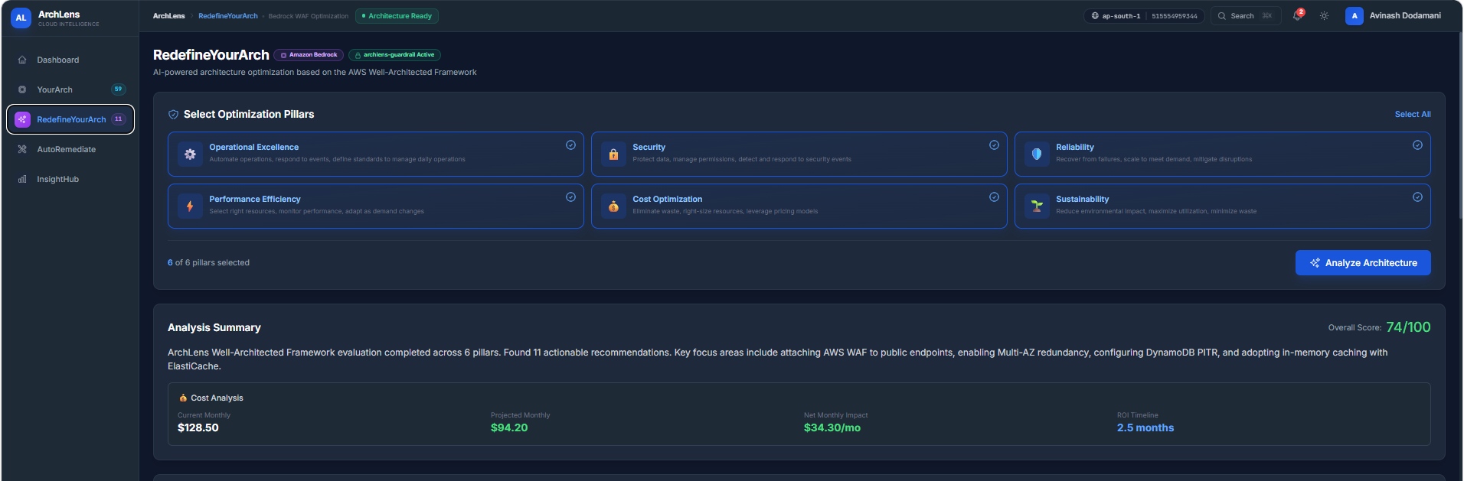

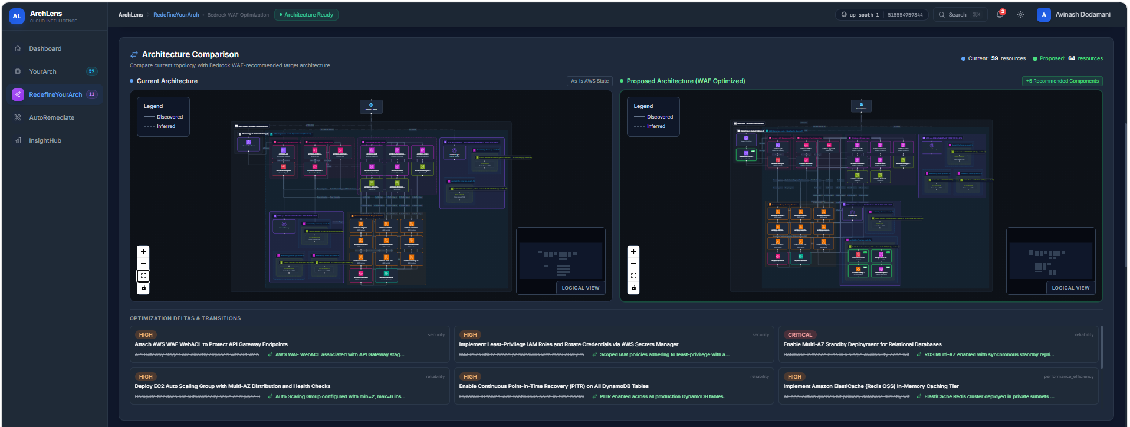

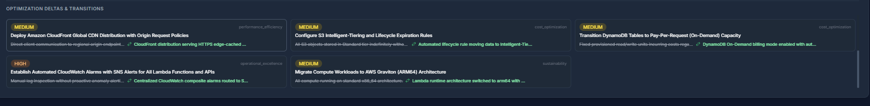

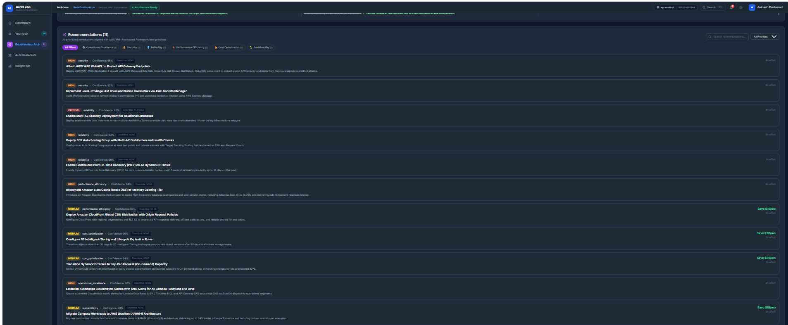

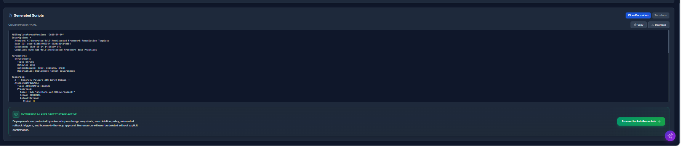

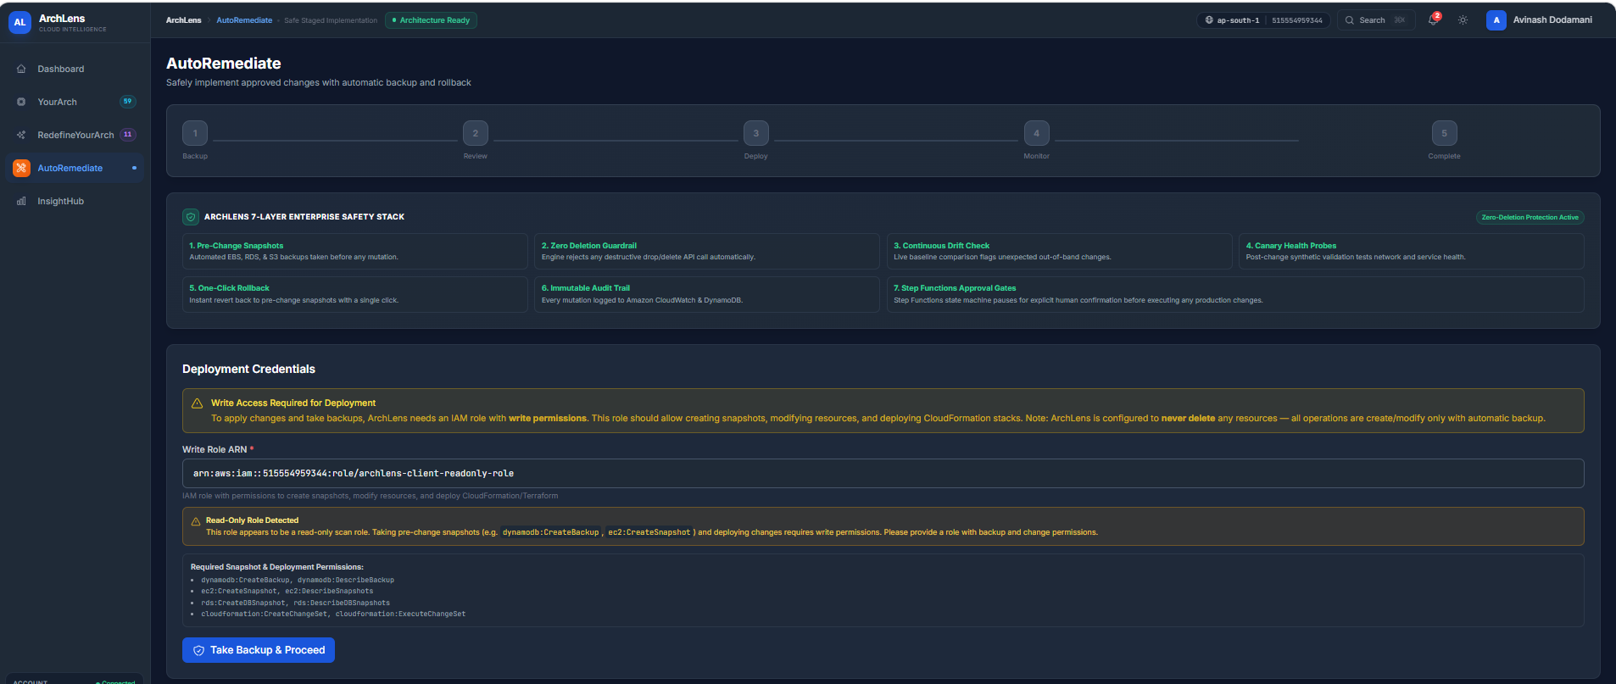

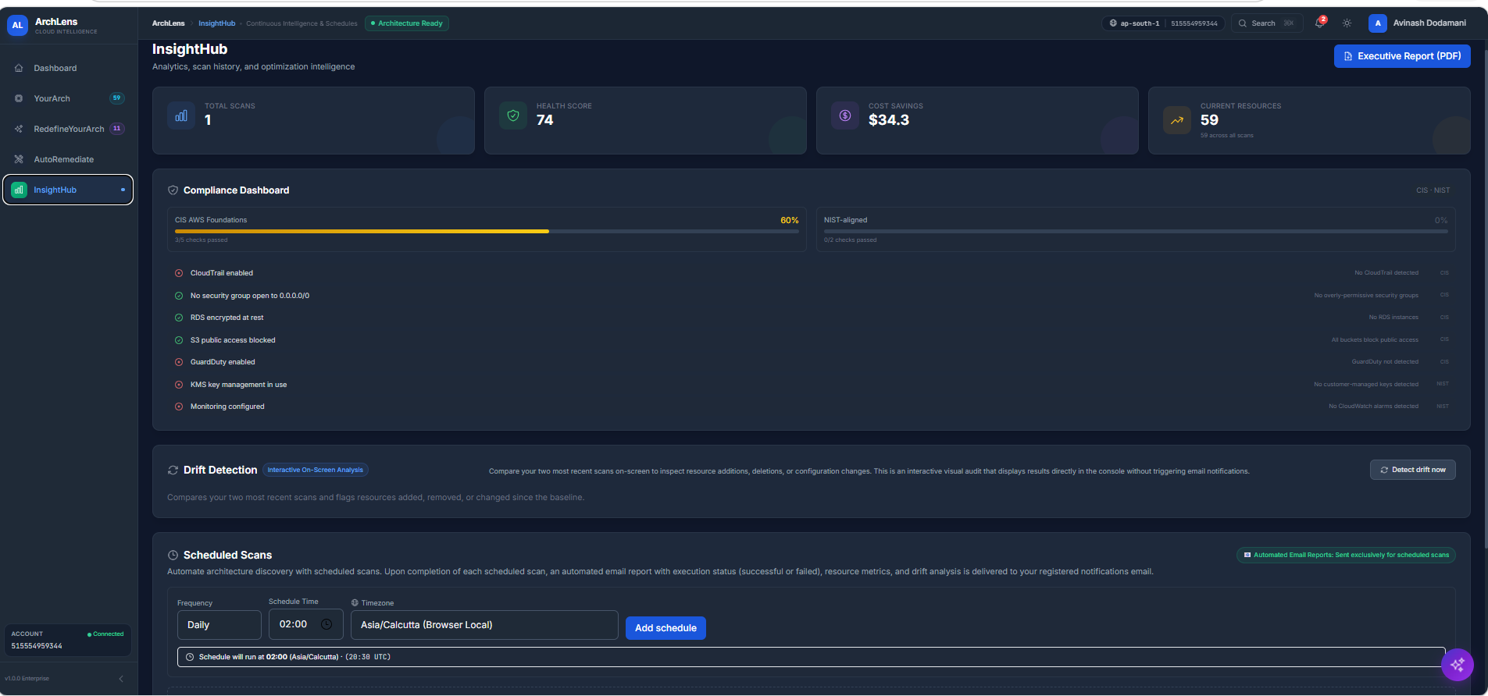

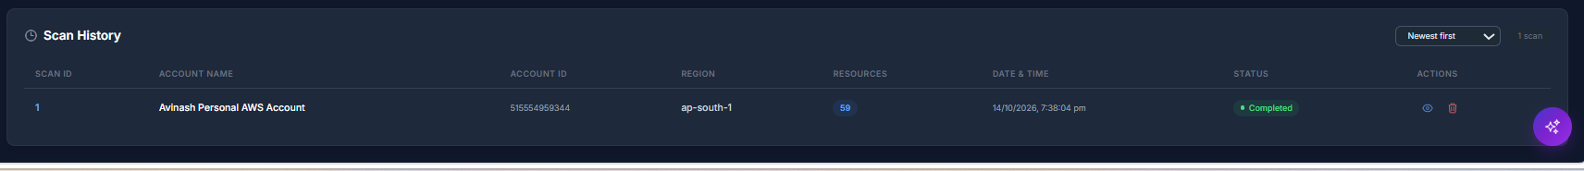

When we change the theme from dark to white the words we can not read properly bcz of colour or something plz check it
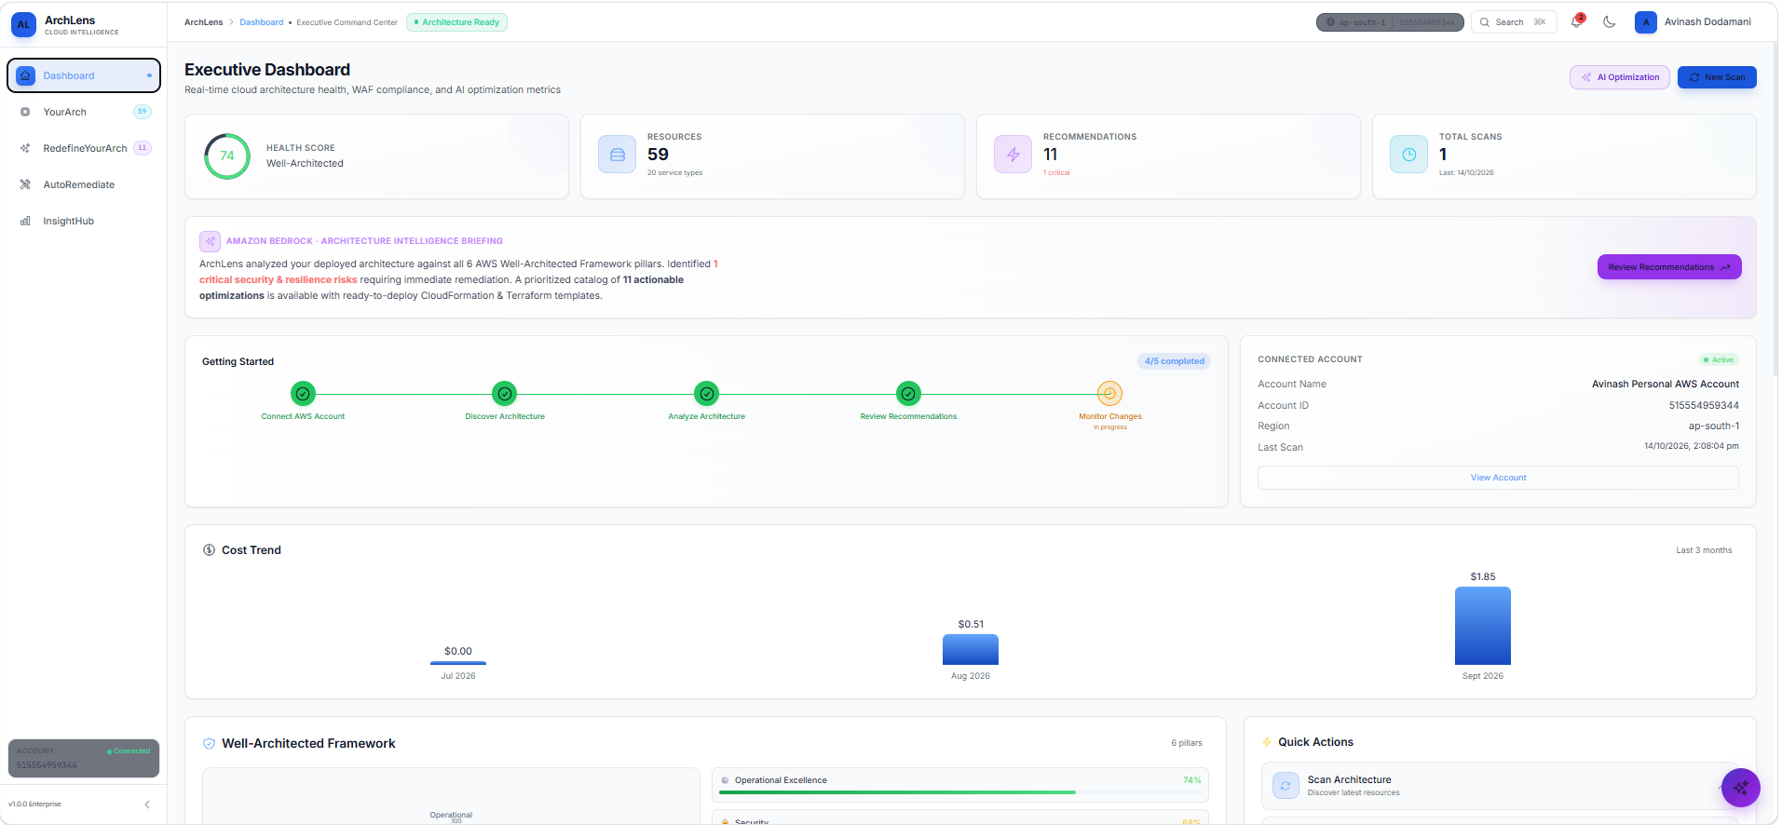

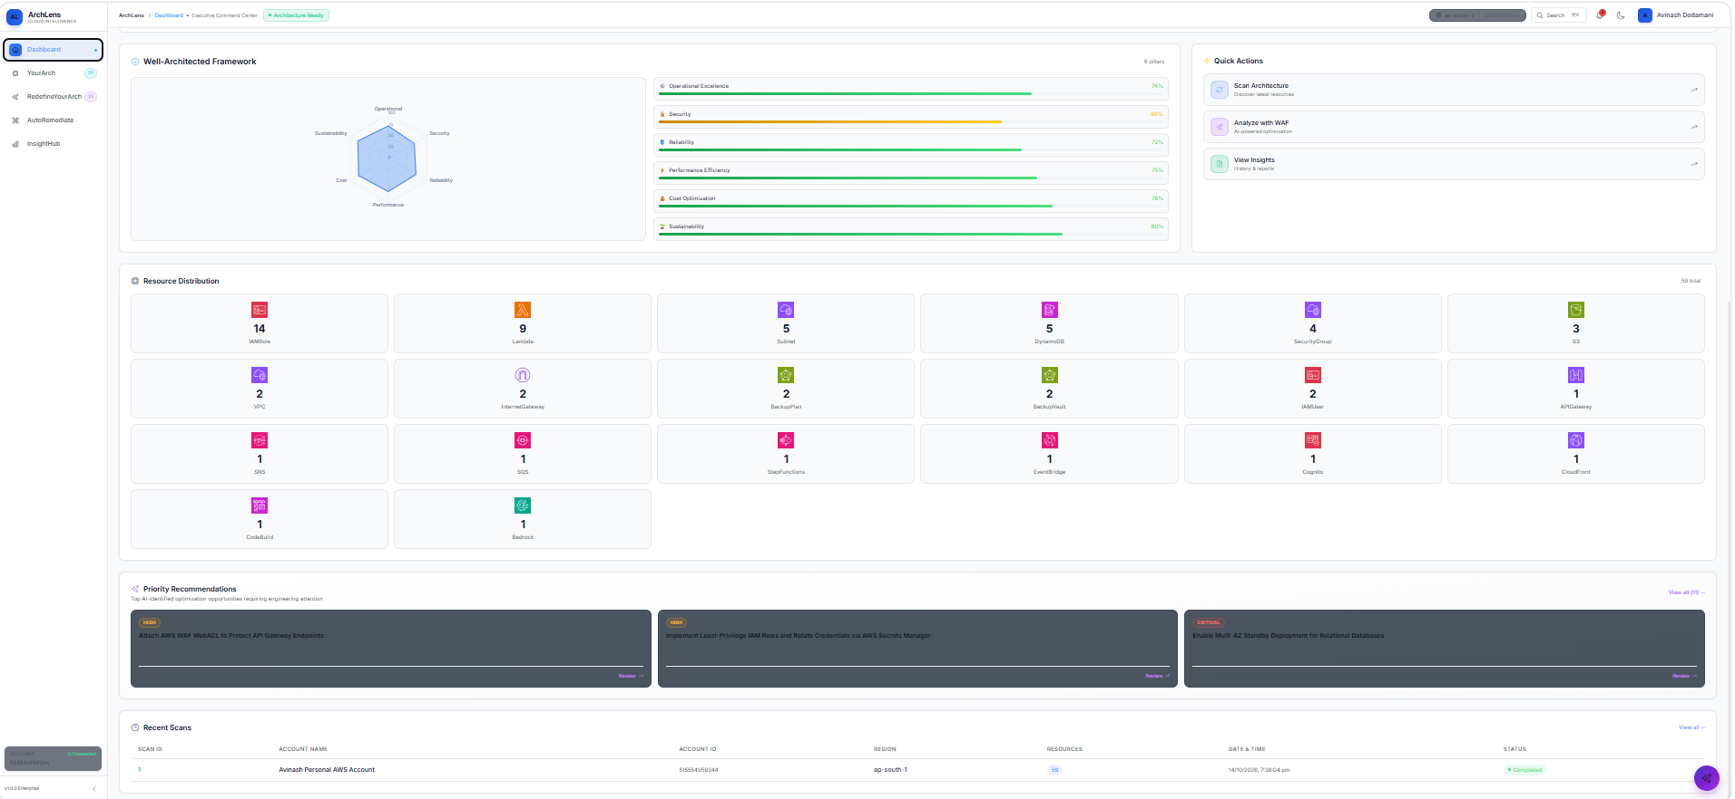

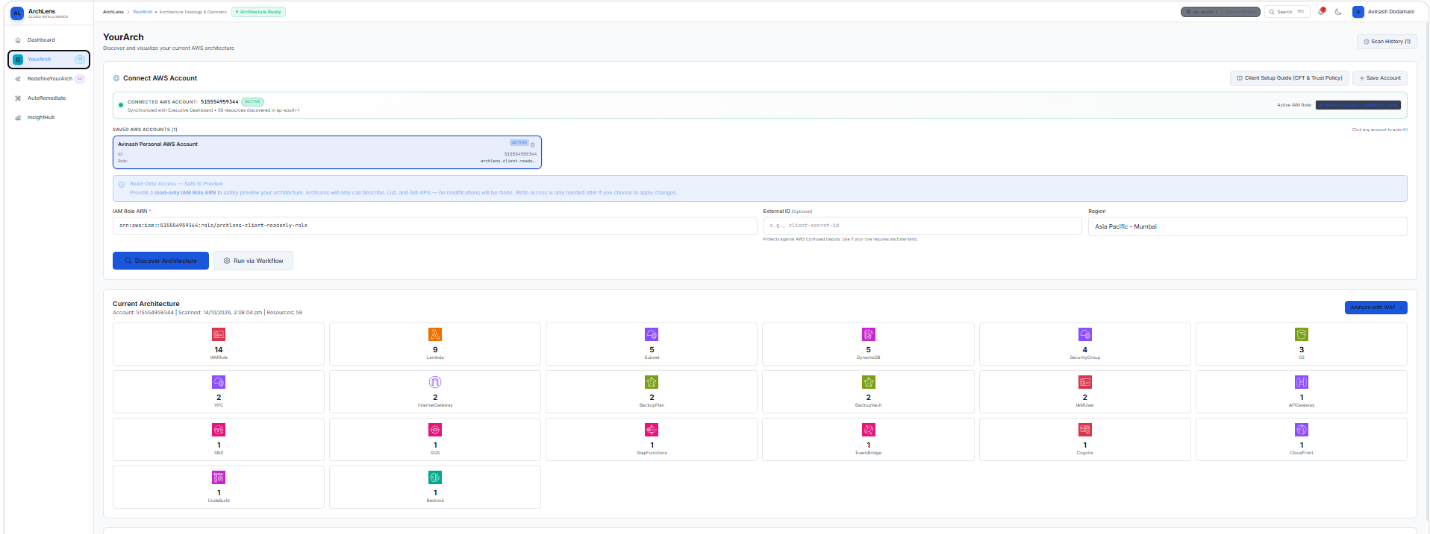

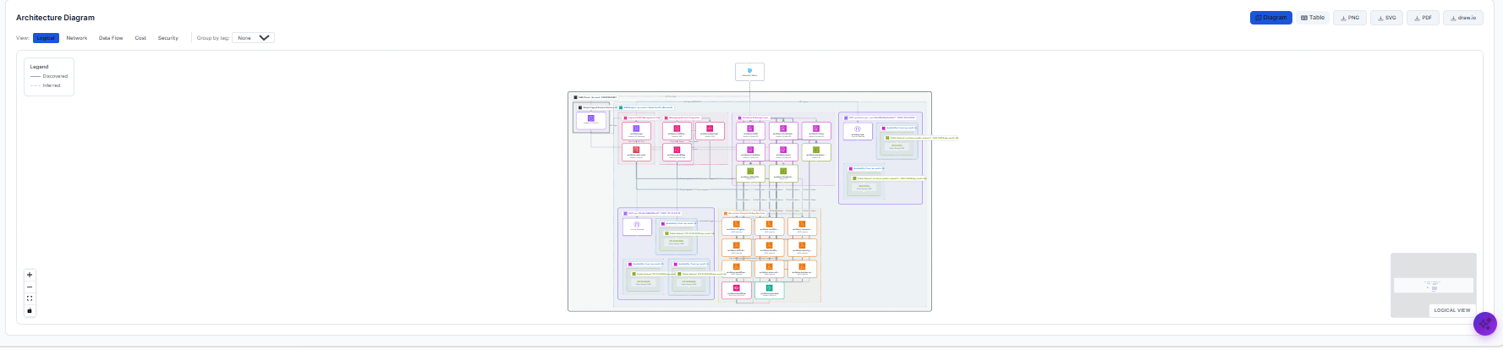

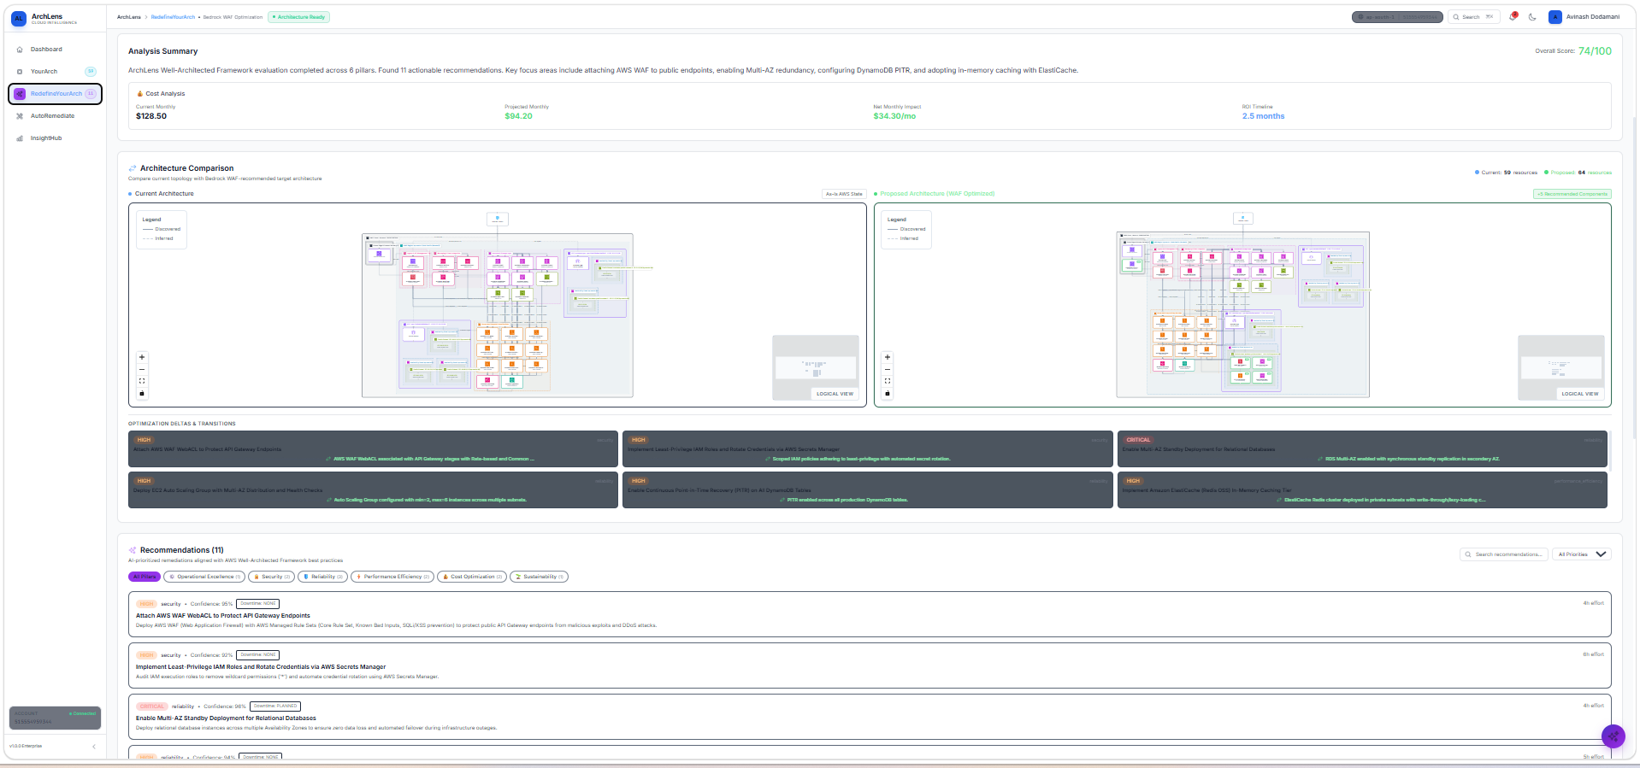

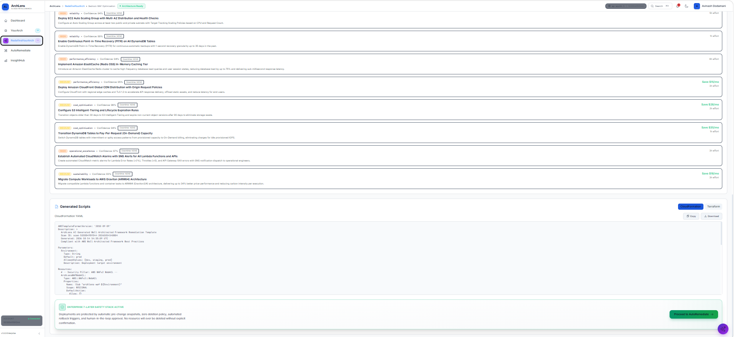

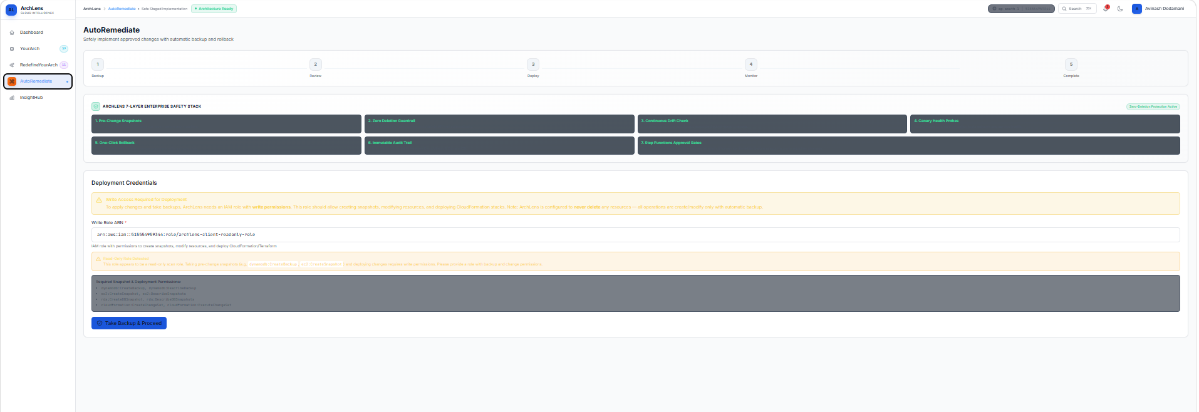

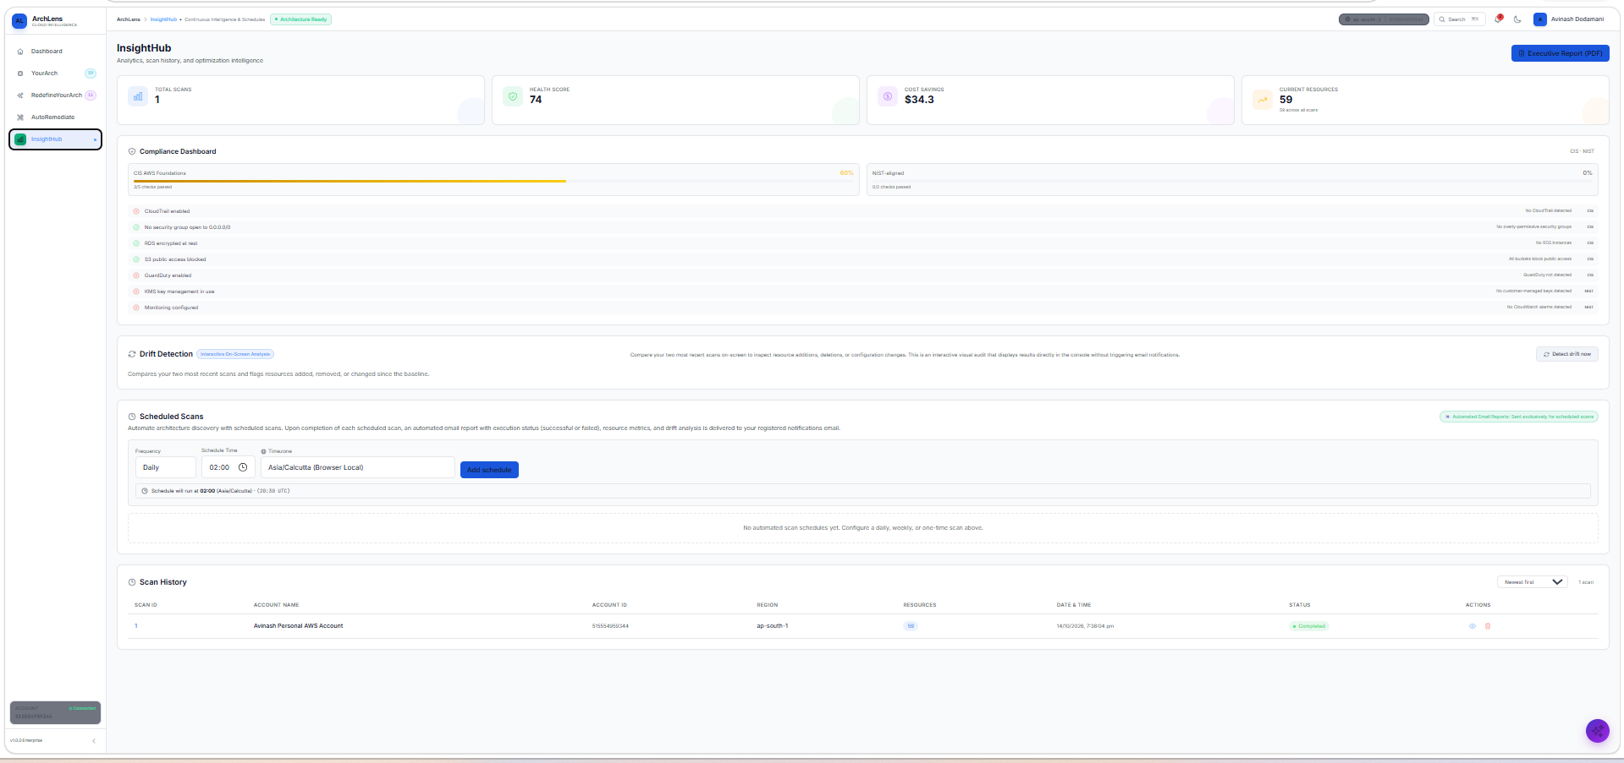

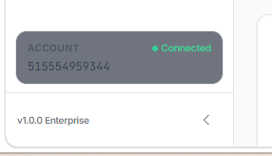

What is v1.0.0 Enterprise if it is not required remove it
Solution I want:
1. The architecture diagram is not correct it is not showing correct traffic flow based on resources available on aws account
2. 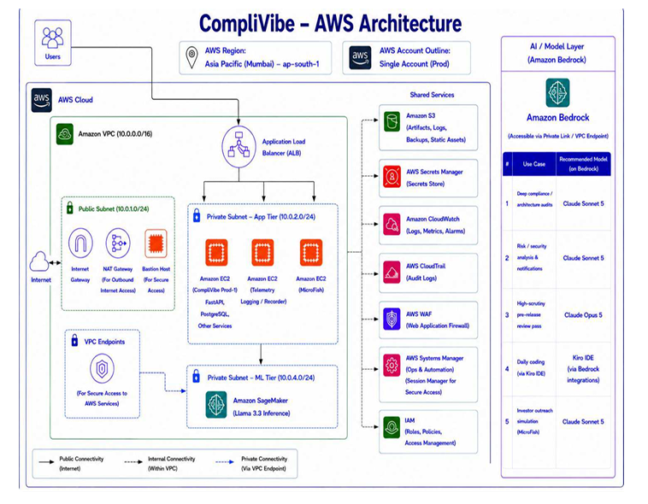And also tell me is the current code how resources are identifying and creating relationships between each other I guess there is something missing bcz of that workflow is showing wrongly main thing is vpc it should understand it then I guess it is easy for to create workflow
4. How it is checking what all are resources available when we provide role arn give me sequence how it is checking
5. How relationship it is building between each services or resources on what basis if there is any wrong currently correct it and it should show correct workflow
6. On what basis bedrock giving suggestions only based on what resources are available or what for example if there is no lb and it is saying create waf and attach it to lb how exaclty it is recommending and also bedrock giving suggestion based on real resources available on aws account or you hardcoded any suggestions in code?
7. If it is giving suggestions after analysing waf pillars then why chatbot is not working is bedrock is working or not
8. Plz check the code througly bcz I need to showcase this archlens to client tomorrow so I need to fix all issues and workflow should show correctly
9. How schedule scan will work it will create schedule in which account in my company account or in client account and current code will work after scheduling scan at particular time or not tell me
10. Client setup guide under yourarch section
is the steps correct as per aws check it and give the steps I correct sequence as per aws so client can understand easily
what is 4th point it not make any sense
what is first point the sentce is not correct right like sign in to in your client account so crt the sentences across the application I guess it is not required to mention client is that crt.?
is 10s you mentioned remove it it is not required right and also cft and terraform is required for this or not tell me..?
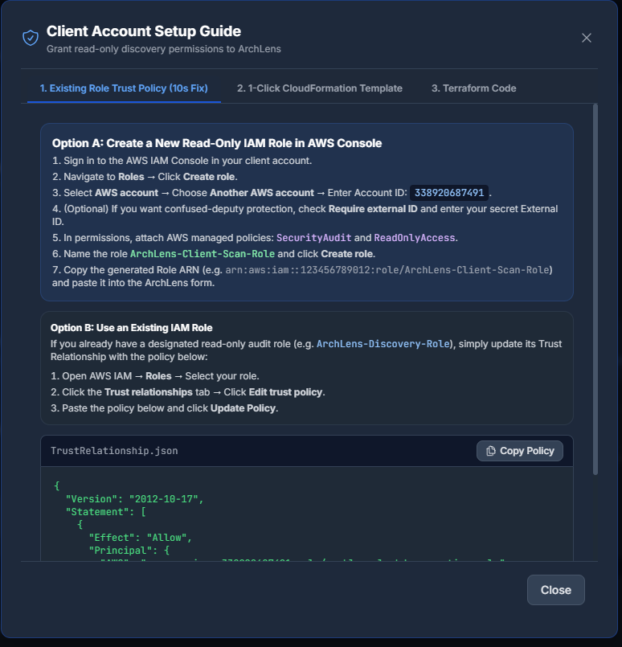

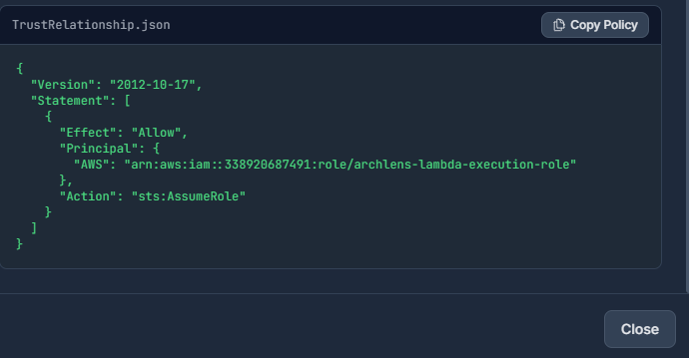

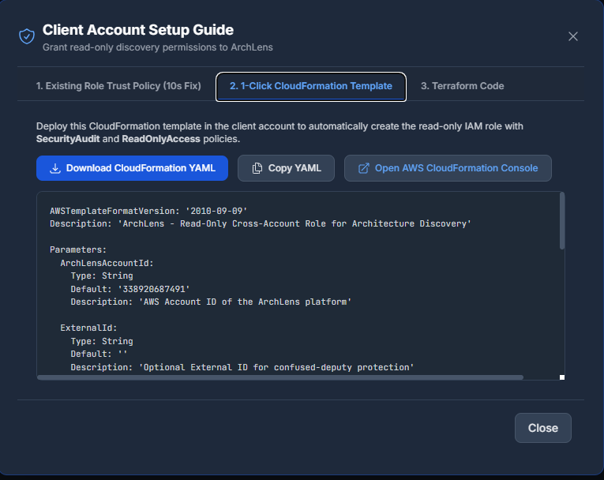

AWSTemplateFormatVersion: '2010-09-09'
Description: 'ArchLens - Read-Only Cross-Account Role for Architecture Discovery'

Parameters:
ArchLensAccountId:
Type: String
Default: '338920687491'
Description: 'AWS Account ID of the ArchLens platform'

ExternalId:
Type: String
Default: ''
Description: 'Optional External ID for confused-deputy protection'

Conditions:
HasExternalId: !Not [!Equals [!Ref ExternalId, '']]

Resources:
ArchLensClientRole:
Type: AWS::IAM::Role
Properties:
RoleName: ArchLens-Client-Scan-Role
Description: 'Allows ArchLens to discover and visualize architecture in this account (read-only)'
AssumeRolePolicyDocument:
Version: '2012-10-17'
Statement:
- Effect: Allow
Principal:
AWS: !Sub 'arn:aws:iam::${ArchLensAccountId}:role/archlens-lambda-execution-role'
Action: 'sts:AssumeRole'
Condition: !If
- HasExternalId
- StringEquals:
sts:ExternalId: !Ref ExternalId
- !Ref 'AWS::NoValue'
ManagedPolicyArns:
- 'arn:aws:iam::aws:policy/SecurityAudit'
- 'arn:aws:iam::aws:policy/ReadOnlyAccess'

Outputs:
RoleArn:
Description: 'Enter this Role ARN in the ArchLens dashboard'
Value: !GetAtt ArchLensClientRole.Arn

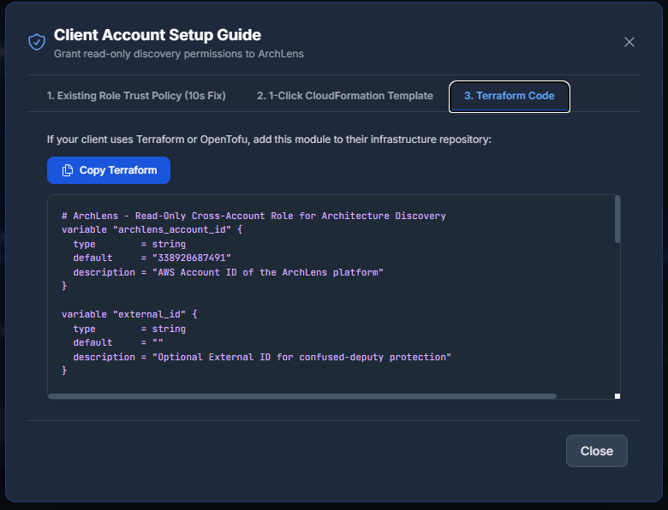

# ArchLens - Read-Only Cross-Account Role for Architecture Discovery
variable "archlens_account_id" {
type = string
default = "338920687491"
description = "AWS Account ID of the ArchLens platform"
}

variable "external_id" {
type = string
default = ""
description = "Optional External ID for confused-deputy protection"
}

data "aws_iam_policy_document" "archlens_trust" {
statement {
effect = "Allow"
actions = ["sts:AssumeRole"]

principals {
type = "AWS"
identifiers = [
"arn:aws:iam::${var.archlens_account_id}:role/archlens-lambda-execution-role"
]
}

dynamic "condition" {
for_each = var.external_id != "" ? [1] : []
content {
test = "StringEquals"
variable = "sts:ExternalId"
values = [var.external_id]
}
}
}
}

resource "aws_iam_role" "archlens_role" {
name = "ArchLens-Client-Scan-Role"
description = "Allows ArchLens to discover and visualize architecture in this account (read-only)"
assume_role_policy = data.aws_iam_policy_document.archlens_trust.json
}

resource "aws_iam_role_policy_attachment" "security_audit" {
role = aws_iam_role.archlens_role.name
policy_arn = "arn:aws:iam::aws:policy/SecurityAudit"
}

resource "aws_iam_role_policy_attachment" "read_only" {
role = aws_iam_role.archlens_role.name
policy_arn = "arn:aws:iam::aws:policy/ReadOnlyAccess"
}

output "archlens_role_arn" {
description = "Enter this Role ARN in the ArchLens dashboard"
value = aws_iam_role.archlens_role.arn
}

