ArchLens – Project Plan Overview

AI-Powered AWS Architecture Visualization & Optimization Platform

Phase 1 Features

1. Secure Authentication
- Email/password registration
- Google and Microsoft SSO integration
- Multi-factor authentication (TOTP)
- Secure session management

2. AWS Account Connection
- Connect up to 10 AWS accounts
- Read-only IAM role setup (guided wizard)
- No AWS credentials stored - uses cross-account roles
- Encrypted storage with AWS KMS

3. Resource Discovery
Automatically discovers and catalogs:
- EC2 instances
- Lambda functions
- RDS databases
- S3 buckets
- VPC networking (subnets, security groups, NAT gateways)
- CloudFront distributions
- DynamoDB tables
- API Gateway APIs
- ECS clusters and services
- Route 53 DNS records

4. Architecture Visualization
- Interactive diagrams with official AWS icons
- Zoom (10% to 400%) and pan controls
- Group resources by VPC, region, or service type
- Click resources to view detailed properties
- Export diagrams as PNG or SVG
- Save custom layouts

5. Dashboard Overview
- Overall architecture health score (0-100)
- AWS Well-Architected Framework pillar scores (radar chart)
- 30-day cost trend chart
- Active recommendations count by priority
- Quick action buttons

6. Security & Compliance
- AES-256 encryption at rest
- TLS 1.2+ encryption in transit
- Comprehensive audit logging (90-day retention)
- Rate limiting protection
- SOC 2 audit-ready

Technology Stack

Component | Technology | Why
Infrastructure | AWS Management Console | Manual setup, visual configuration, no CLI required
Frontend | React + TypeScript | Modern, component-based UI
Visualization | React Flow | High-performance diagram library
Backend | API Gateway + Lambda | Serverless, auto-scaling
Database | DynamoDB | Serverless NoSQL, fast queries
Authentication | Amazon Cognito | Managed auth with OAuth support
CDN | CloudFront | Global edge delivery
Security | AWS WAF | Protection against attacks
Deployment | Manual S3 upload | Simple, no pipeline complexity

Architecture Overview

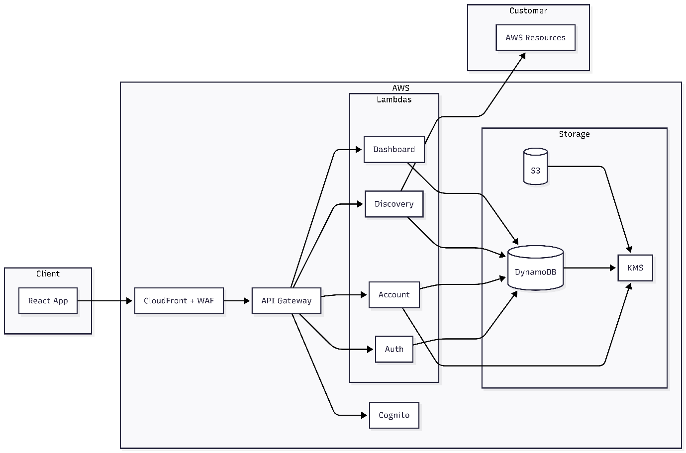

Implementation Plan

Phase Breakdown

Week | Phase | Deliverables
1 | AWS Foundation Setup | KMS keys, DynamoDB tables, S3 buckets
2 | Authentication Setup | Cognito User Pool, OAuth providers, App client
3 | API Layer Setup | API Gateway, IAM roles, Cognito authorizer
4-5 | Lambda Development | Write TypeScript code for all 5 Lambda functions
6 | Lambda Deployment | Upload Lambda code, configure environment variables
7-9 | Frontend Development | React app, Design System, React Flow visualization
10 | Hosting Setup | CloudFront, WAF, S3 deployment
11-12 | Testing & Integration | End-to-end testing, bug fixes, final deployment

Deployment Approach
- AWS Resources: Created manually via AWS Management Console (no CLI/CDK)
- Lambda Code: Written locally in TypeScript, zipped and uploaded to Console
- Frontend: Built locally with React, uploaded to S3 via Console
- No CI/CD Pipeline: Manual deployments for simplicity

Task Summary
- 18 major task groups
- 60+ sub-tasks total
- Detailed console step-by-step instructions

Getting Started

Prerequisites
- AWS Account with appropriate permissions
- Node.js 18+ (for local development)
- Code editor (VS Code recommended)
- Web browser for AWS Console access

Project Structure
ArchLens/
├── frontend/ # React SPA (TypeScript)
├── lambdas/ # Lambda function handlers (TypeScript)
│ ├── auth/
│ ├── account-connection/
│ ├── discovery/
│ ├── visualization/
│ └── dashboard/
└── .kiro/specs/ # Requirements, design, and tasks

Future Roadmap

Phase 2 (Planned)
- AI-powered optimization recommendations
- Cost optimization automation
- Real-time change detection via CloudTrail
- Collaboration features and team workspaces

Phase 3 (Future)
- Multi-cloud support (Azure, GCP)
- Custom compliance frameworks
- Infrastructure drift detection
- Automated remediation workflows

