**Database creation in Oracle 11g**

The below steps are executed and tested in windows 10.

**Step 1:** Install oracle in the system.

**Step 2:**  To check whether the oracle is exists in your machine or not.

* Open command prompt and run this command – **“sqlplus/nolog”** you should be able to see the below message in command prompt.
* **Note:** 
  + **sqlplus** - provides access to utilize **sqlplus,**
  + The "/**nolog**" parameter means "start **sqlplus**, but do not log into a database

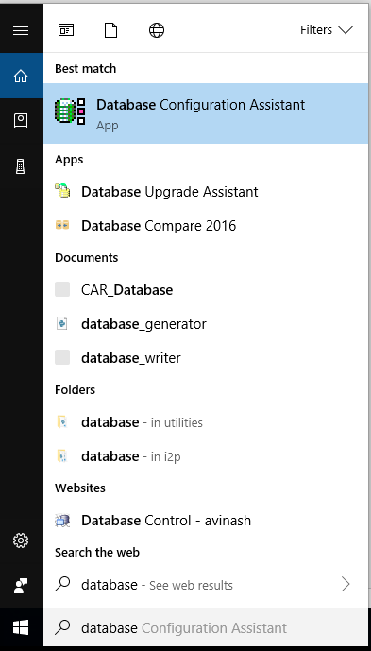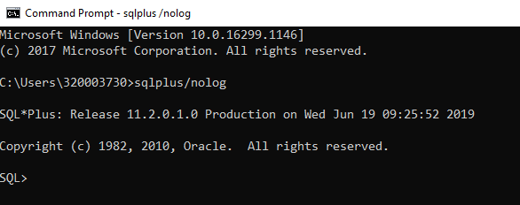

**Step 3:** Go to window search and type “database configuration assistance”. When ever

you complete the oracle installation you will get this database configuration assistance.

Once you click and open the app. below window will open.

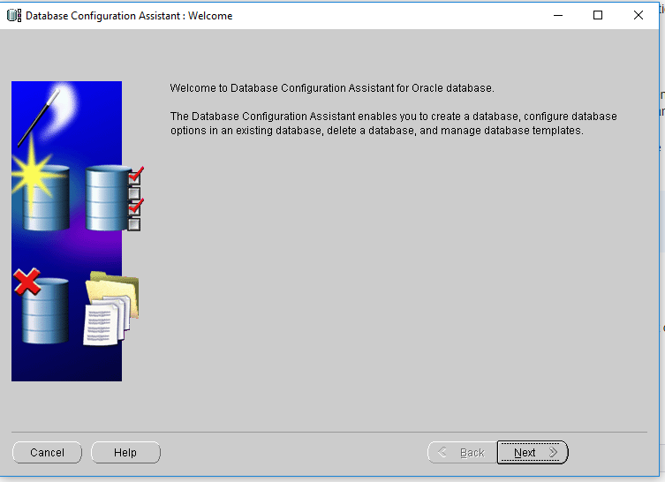

**Step 4:**  Click next

**Step 5:**  Select a create database in the application window and click next

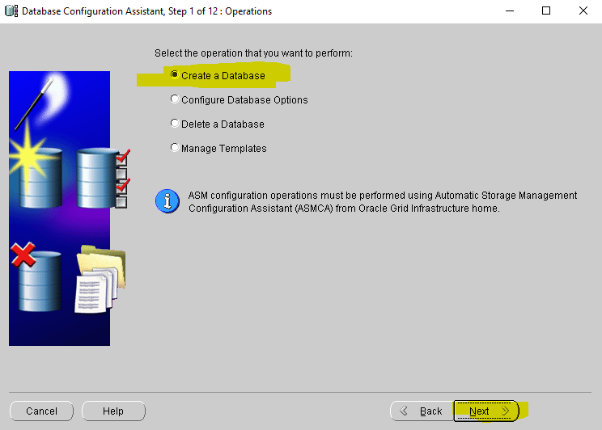

**Step 6:**  Follow the below highlighted steps,

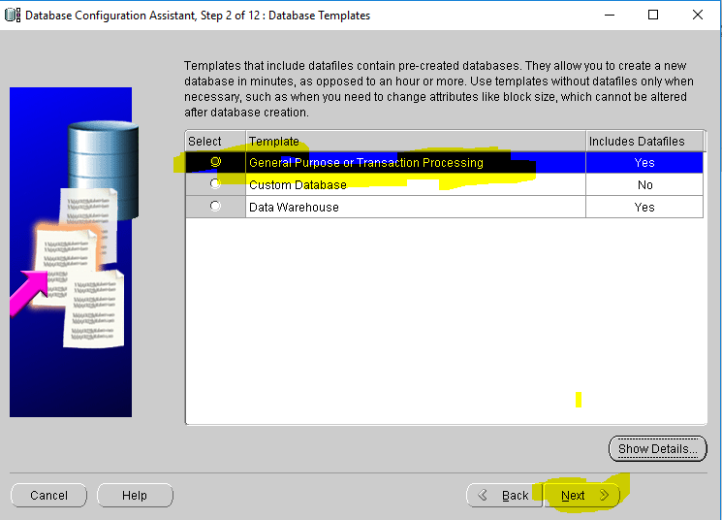

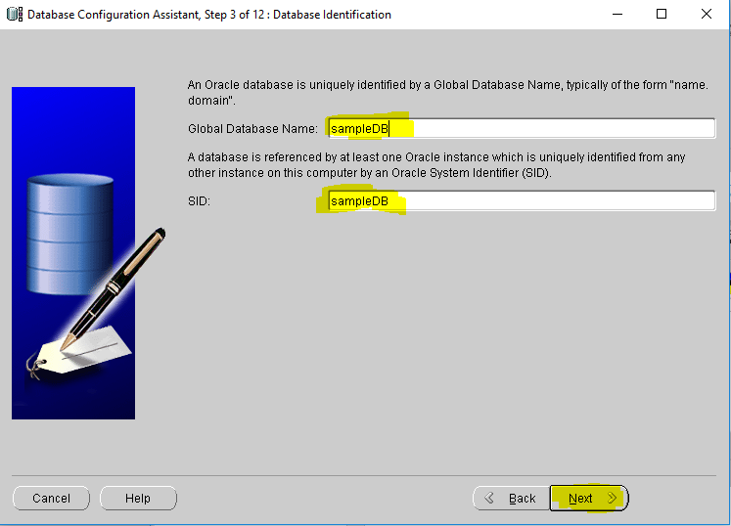

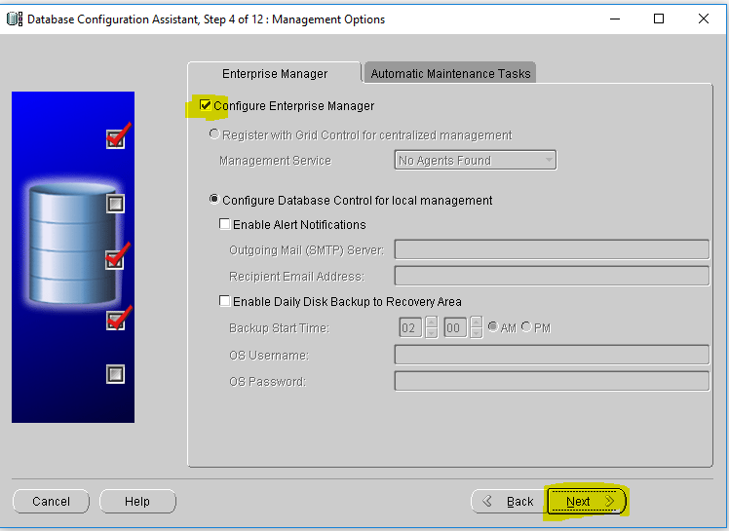

Select use the same administrative password for all accounts (it is up to you whether to use the same or not, but keep a note of all these passwords.)

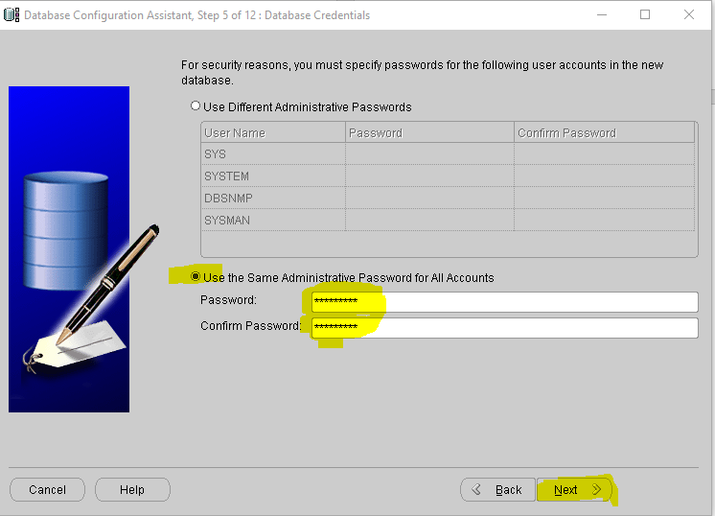

Click next and Yes.

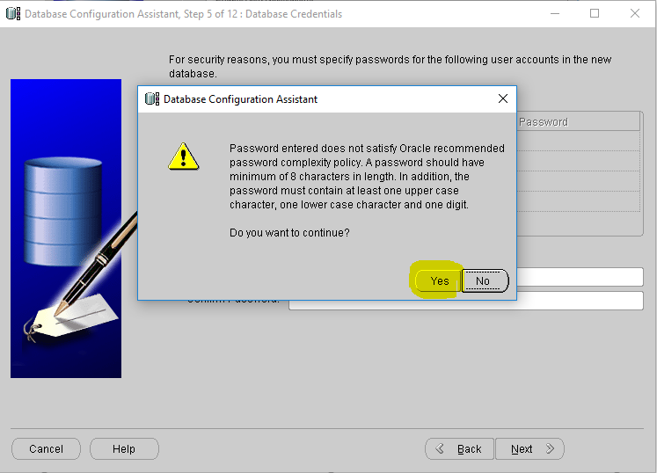

I want to save it to custom location you can save it anywhere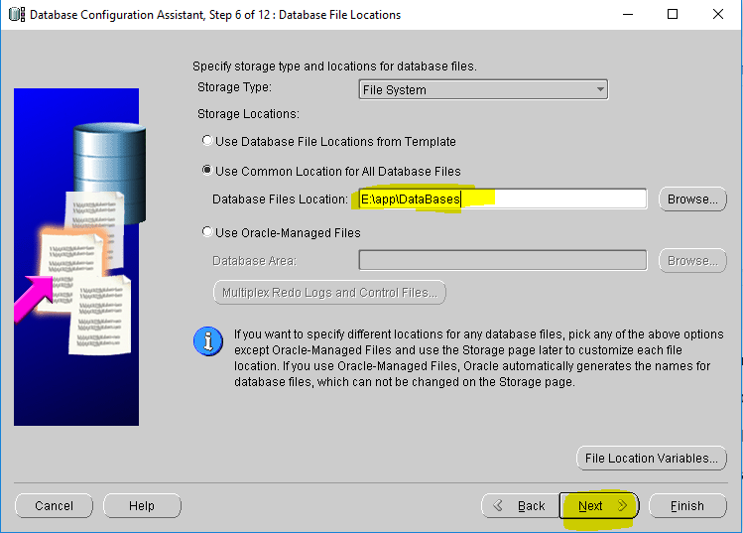

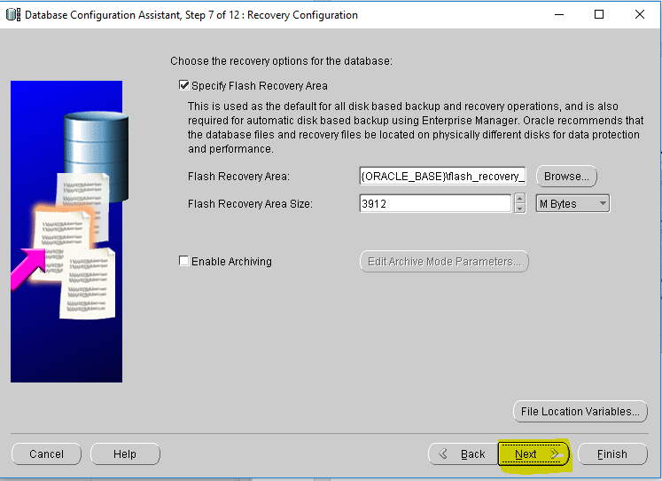

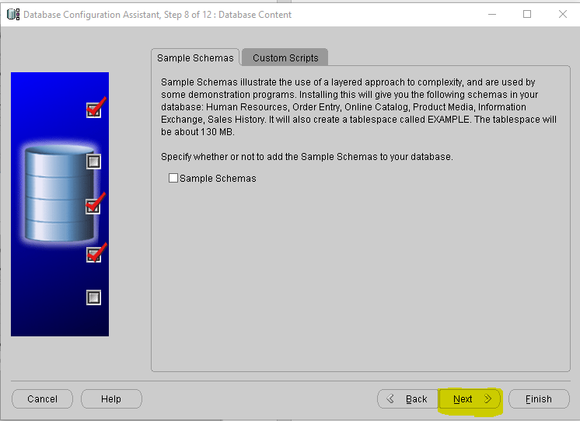

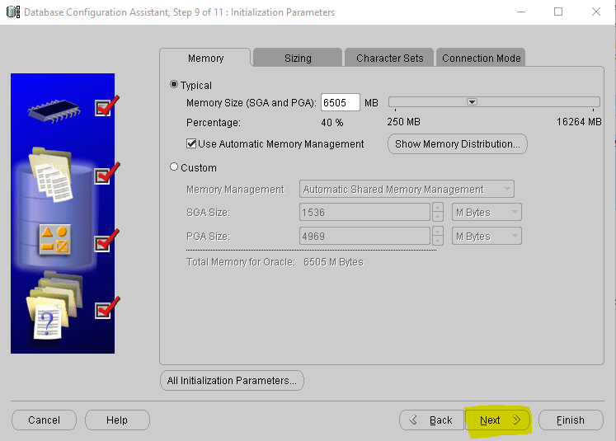

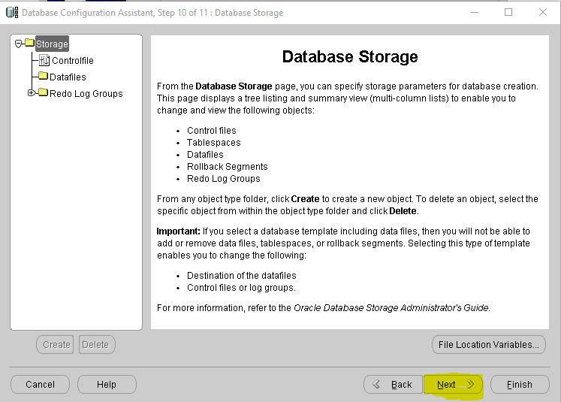

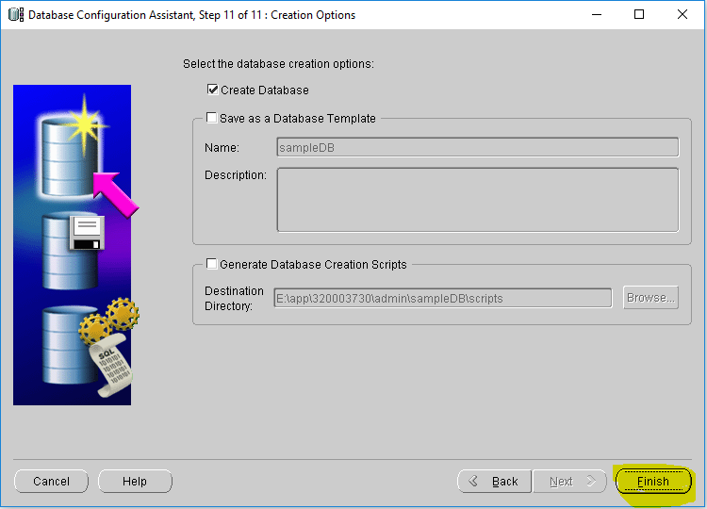

Save the configuration file for future reference.

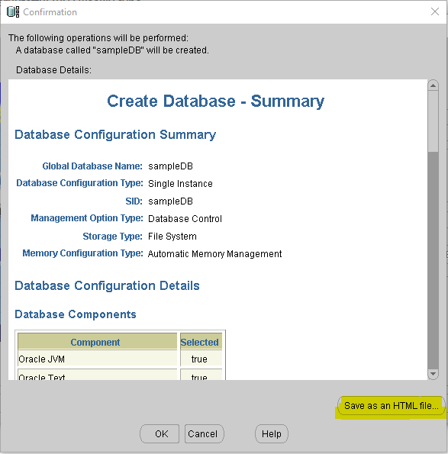

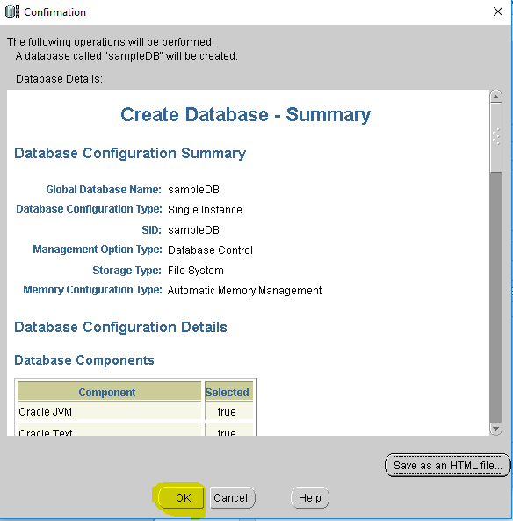

Wait for installation, until it reaches 100%.

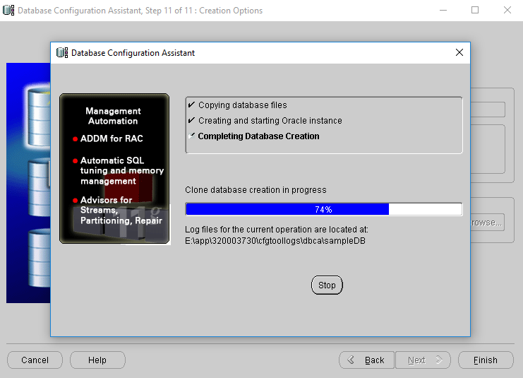

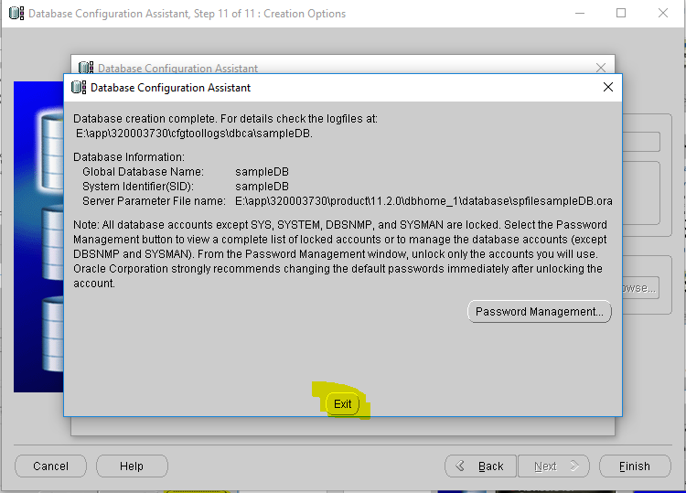

**Step 7:** Now open new command prompt and type

**set oracle_sid = sampleDB**

**Note:** sampleDB - is the name I have given while creation, provide your database name here>

**Step 8:** Now type **sqlplus/nolog** in the same command prompt

Run the below commands

* **conn sys as sysdaba;**
* Enter password: (just hit enter key in the keyboard)
* You should get the below message

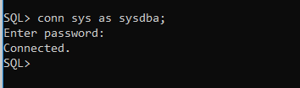

**Step 9:** Now create a user

**Syntax**: create user USERNAME identified by PASSWORD;

**Command**: create user admin identified by admin;

**Step 10:** Give permissions to the created user:

**Syntax**: grant dba to USERNAME

**Command**: grant dba to admin; (admin is the username which I provided in step 9)

**TO Test:**

Open another command prompt. And type

**sqlplus/nolog**

conn admin

Enter password: in my case “admin”

You should get the below output

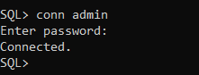

select * from tab;

**Connection in SQL developer:**

