MongoDB Task

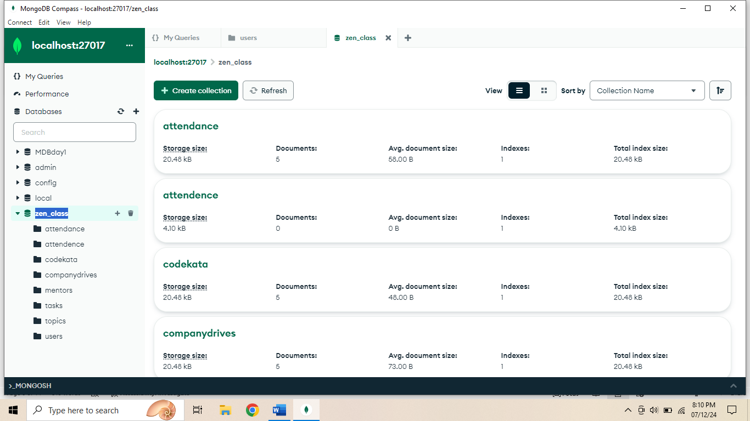

1. **Find all the topics and tasks which are thought in the month of October?**

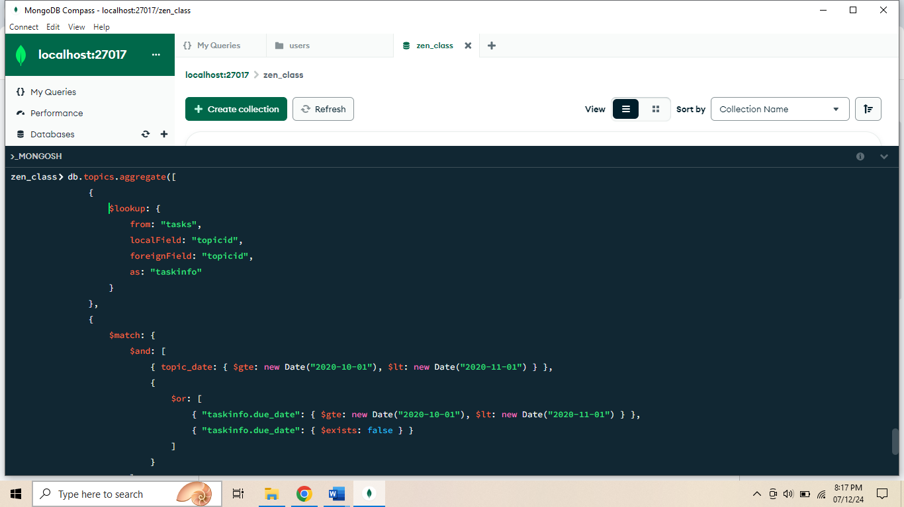

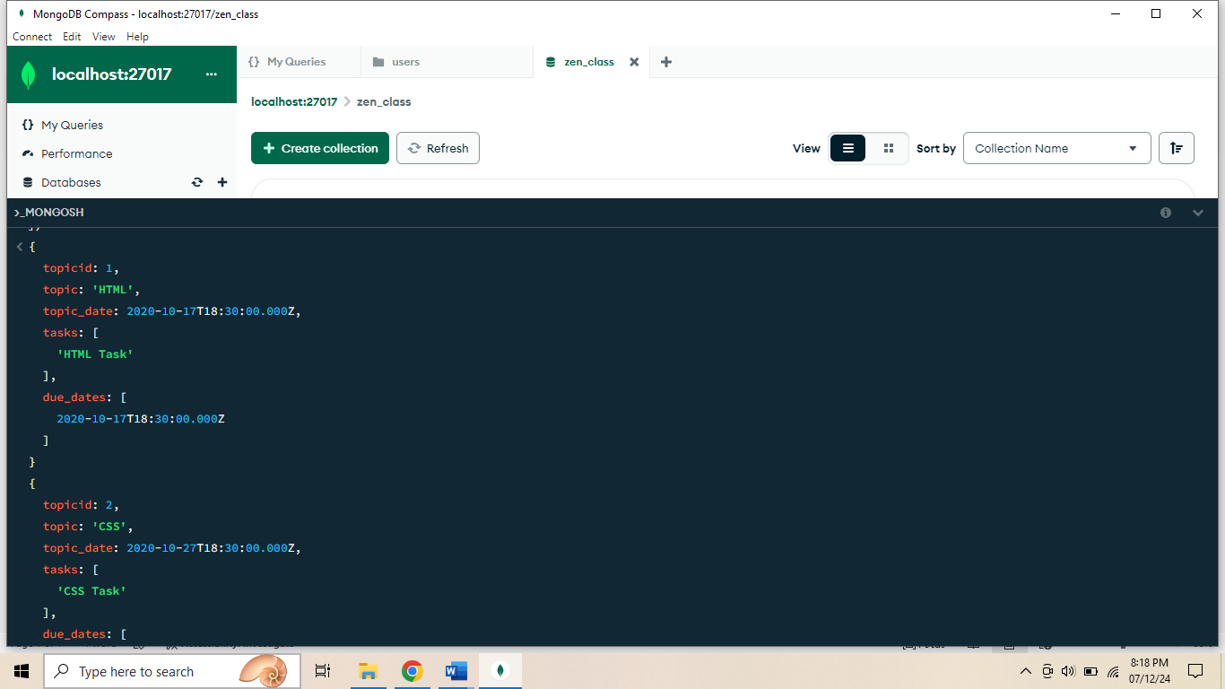

1. **Find all the company drives which appeared between 15 oct-2020 and 31-oct-2020?**

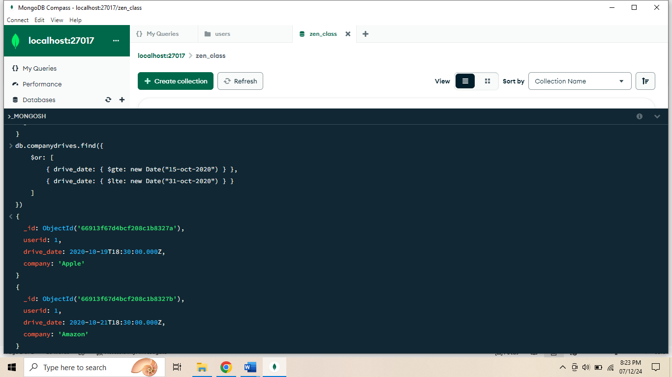

1. **Find all the company drives and students who are appeared for the placement?**

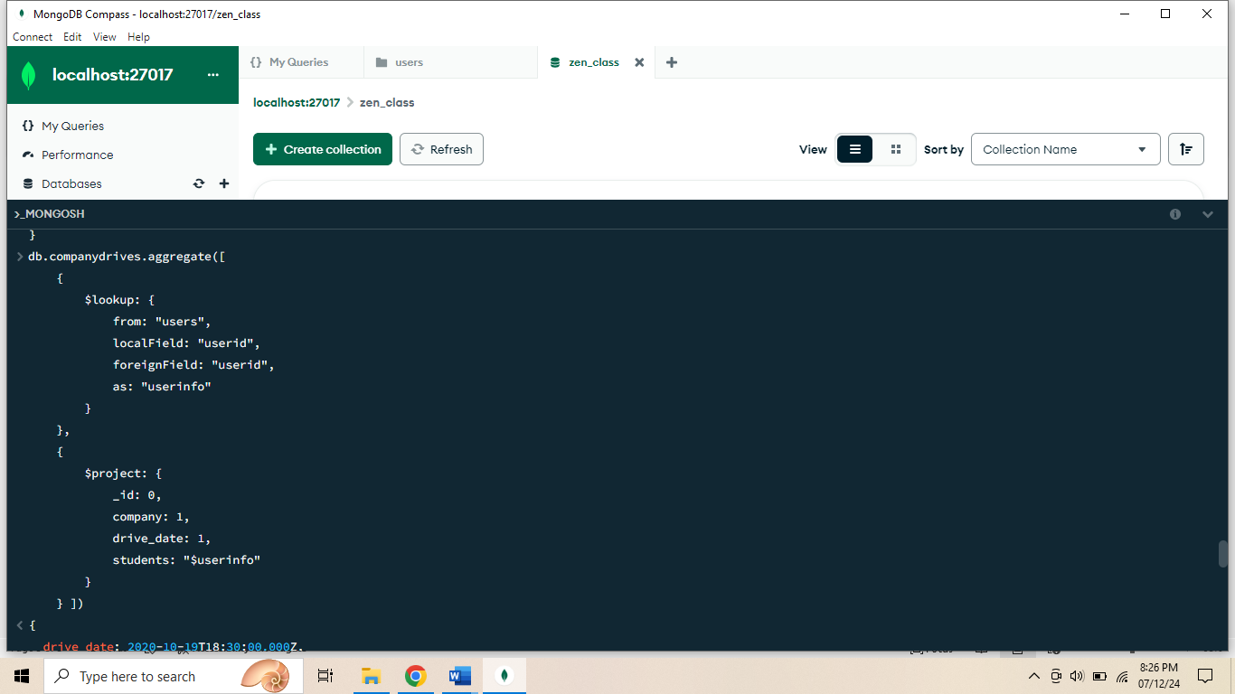

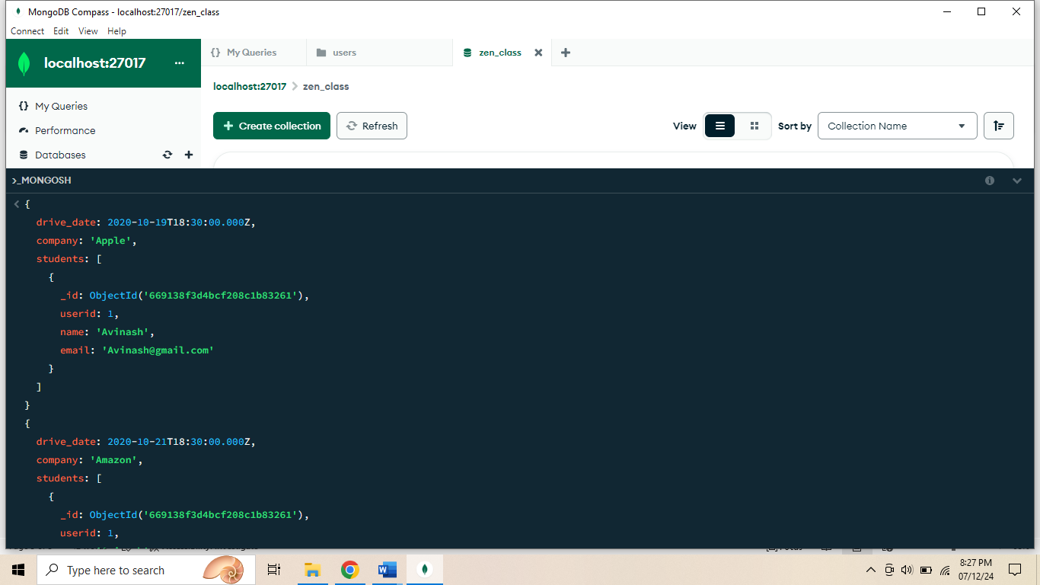

1. **Find the number of problems solved by the user in codekata?**

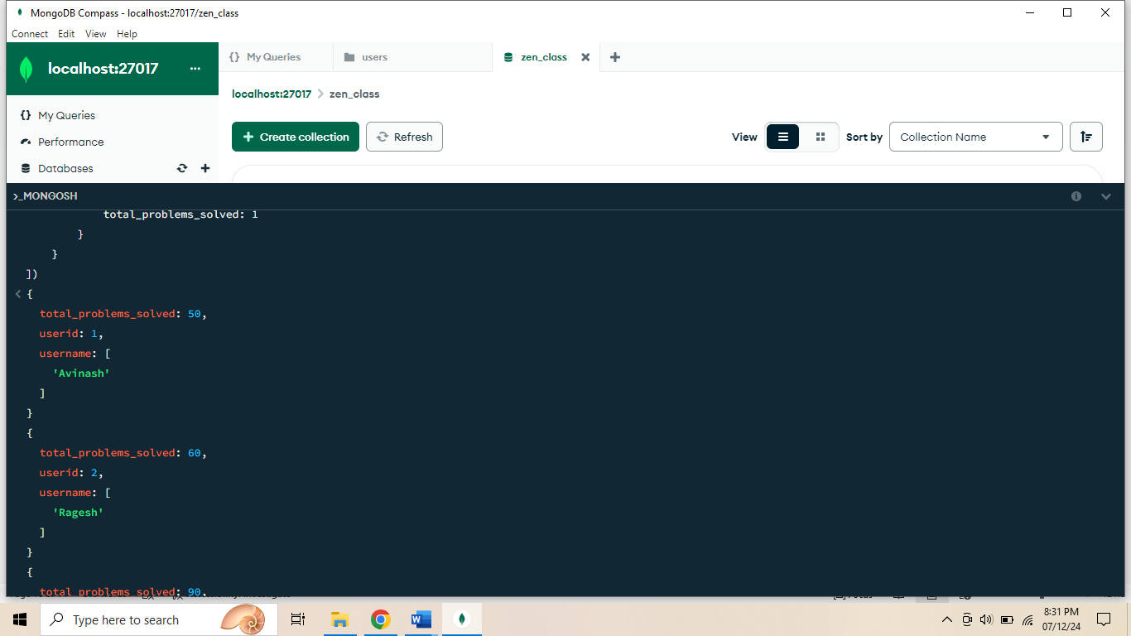

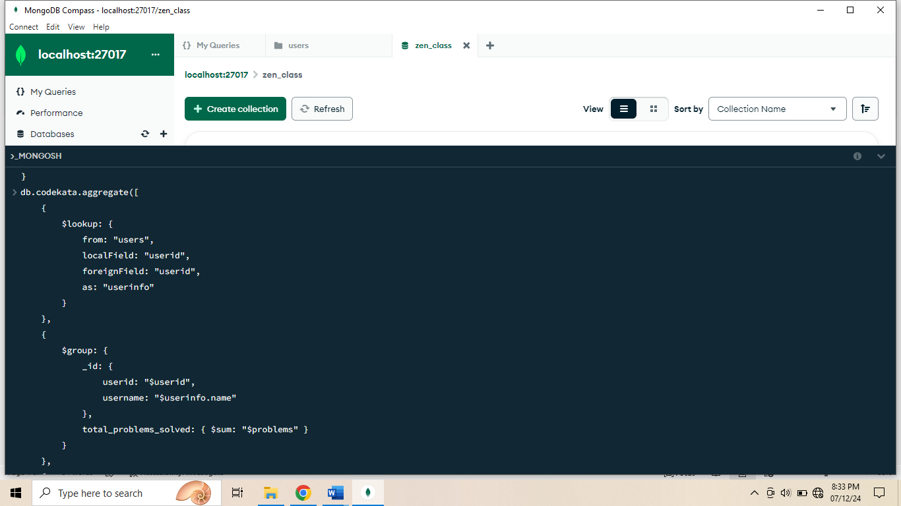

1. **Find all the mentors with who has the mentee's count more than 15?**

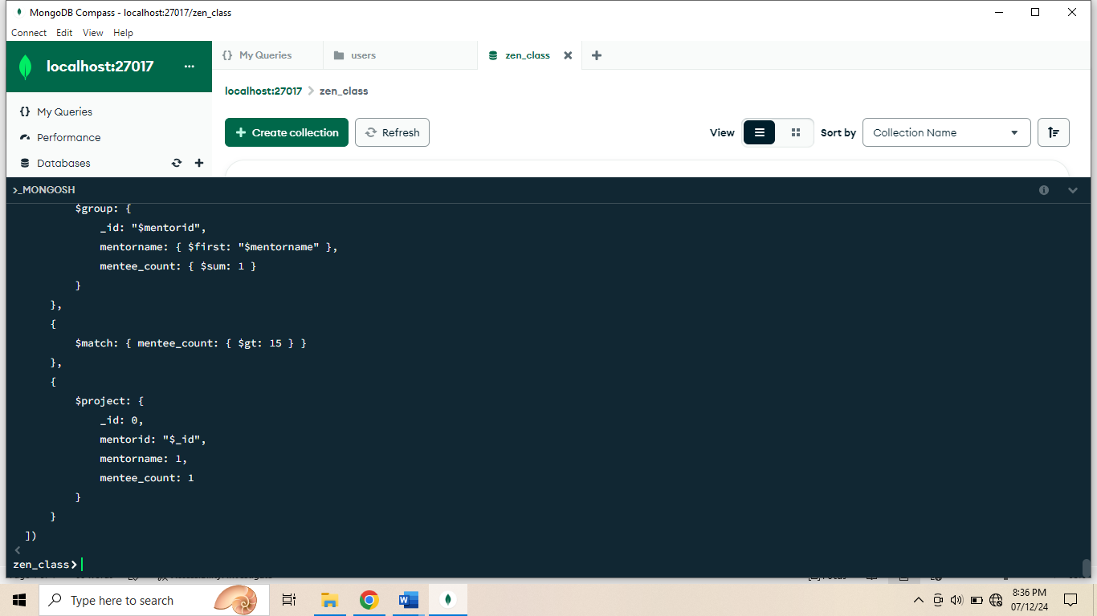

1. **Find the number of users who are absent and task is not submitted between 15 oct-2020 and 31-oct-2020?**

