Phone Home Client Daemon, Performing Zero Touch Provisioning
A practice school report submitted
to
MANIPAL UNIVERSITY

For Partial Fulfillment of the Requirement for the
Award of the Degree
of
BACHELOR OF TECHNOLOGY
in
COMPUTER SCIENCE AND ENGINEERING
by
AVINASH KUMAR 120905532
Under the Guidance of
Mrs. Rajashree Krishna
Assistant Professor Senior Scale, Department of Computer Science and Engineering
and
Mr. Pavan CV
Software Engineer Staff, CDBU Switch, Juniper Networks Pvt. Ltd.
 | DEPARTMENT OF COMPUTER SCIENCE AND ENGINEERING  MANIPAL INSTITUTE OF TECHNOLOGY  (A constituent Institute of MANIPAL UNIVERSITY)  MANIPAL - 576 104, KARNATAKA, INDIA | 

2016
Phone Home Client Daemon, Performing Zero Touch Provisioning
A practice school report submitted
to
MANIPAL UNIVERSITY

For Partial Fulfillment of the Requirement for the
Award of the Degree
of
BACHELOR OF TECHNOLOGY
in
COMPUTER SCIENCE AND ENGINEERING
by
AVINASH KUMAR 120905532
Under the Guidance of
Mrs. Rajashree Krishna
Assistant Professor Senior Scale, Department of Computer Science and Engineering
and
Mr. Pavan CV
Software Engineer Staff, CDBU Switch, Juniper Networks Pvt. Ltd.
DEPARTMENT OF COMPUTER SCIENCE AND ENGINEERING
MANIPAL INSTITUTE OF TECHNOLOGY
(A constituent Institute of MANIPAL UNIVERSITY)
MANIPAL - 576 104, KARNATAKA, INDIA

2016

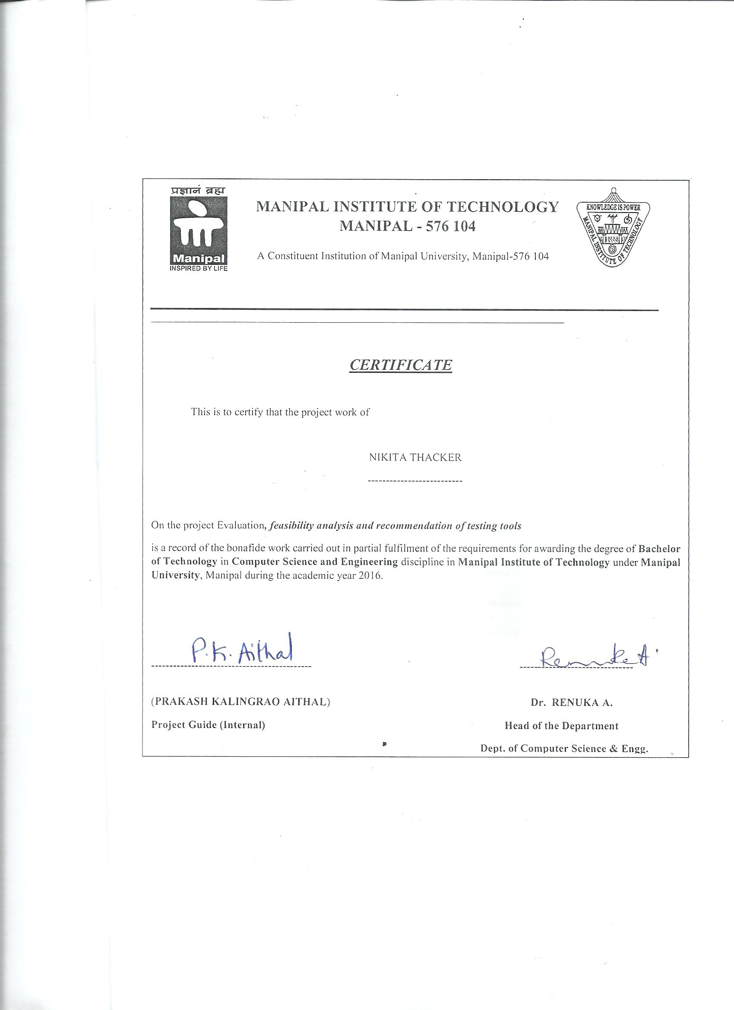

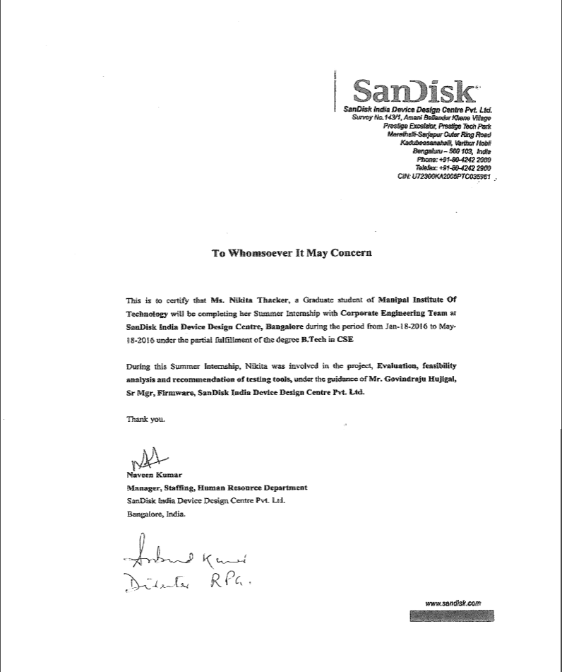

ACKNOWLEDGEMENTS

It has been a privilege to work on my industrial training project at SanDisk India Device Design Center. It would not have been possible without the kind support and help of many individuals and organizations. I would like to extend my sincere thanks and gratitude to all of them.
I am highly indebted to Mrs. LAKSHMI NARASU MALAVALLI PUROSHOTHA (Mentor at SanDisk) for her guidance, constant supervision, support and inspiration for completing the project.
I would like to express my deep sense of gratitude towards Mr. PRAKASH KALINGRAO AITRHAL (MIT Mentor) for his understanding, co-operation and co-ordination which helped me in completion of this project.
I also owe my profound gratitude to Dr. RENUKA A. (HOD, Dept. of CSE, MIT) & Mr. GOVINDARAJU HUJIGAL (Senior Manager, Firmware validation management) for providing the opportunity to work on this project.
My thanks and appreciations also go to my colleagues in developing the project and people who have willingly helped me out with their abilities.

-Nikita Thacker

ABSTRACT

KEYWORDS: Condition coverage, decision coverage, Bullseye, Squish Coco, code instrumentation, regression
Testing and validation is an important part of software development lifecycle. As a part of testing and validation, SanDisk validation team runs number of tests on all the products to ensure high performance standards, quality and reliability. The team generates coverage data for the entire test suite showing various metrics that have been achieved by these tests. These metrics include line coverage, function coverage, condition coverage, decision coverage, etc. There are many tools that can be used to automate this process of generation of coverage reports.
Presently SanDisk uses a tool named Bullseye for this purpose. Bullseye provides very few metrics and functionalities. With evolving market and competition, the company feels there is a need for a tool which provides better functionalities, metrics and features. The new suggested tool for this purpose is Squish Coco.
As a part of my internship, my task is to compare the new suggested tool Squish Coco with the existing Bullseye tool. The project involves detailed comparison on how both the tools differ in code instrumentation, their basic functionalities and other parameters such as effect on performance. The next goal of the project is to deploy this tool in regression ecosystem for a live stream. The project also involves analyzing the code complexity of Squish Coco. The framework present now has scripts for automating the entire process for Bullseye. The project requires automating the entire process for Squish Coco so that it can be easily used in regression ecosystem.

LIST OF FIGURES

Figure |  | Title | Page
1.4 | Squish Coco Process Overview |  | 6
3.2 | Overview of Instrumentation process……………………………………. |  | 12
3.5 | Coverage Browser Screenshot…………………………………………… |  | 15
5.1 | Statement Coverage Comparison………………………………………… |  | 22
5.2 | Branch Coverage Comparison…………………………………………… |  | 23
5.3 | Function Coverage Comparison………………………………………….. |  | 25
5.5 | Decision Coverage Comparison………………………………………….. |  | 26
5.6 | Jump statement instrumentation………………………………………….. |  | 27
5.7 | Switch Case statement Comparison……………………………………… |  | 28

ABBREVIATIONS

I/O | Input/ Output
EPS | Earnings per share
CE | Corporate Engineering
OEM | Original Equipment Manufacturer
SSD | Solid state drive
OS | Operating System
GUI | Graphical User Interface
FW | Firmware
HTML | Hypertext markup language
XML | Extensible markup language
CSV | Comma separated Values

TABLE OF CONTENTS
 |  | Page
ACKNOWLEDGMENTS……………………………………………………... |  | i
ABSTRACT |  | ii
LIST OF FIGURES |  | iii
ABBREVIATIONS |  | iv
CHAPTER 1 | INTRODUCTION
1.1 General………….…...………………………………………………………..1
1.2 About SanDisk…………………………………………………………….….2
1.3 Coverage tools………………………………………………………………...4
1.4 Squish Coco…………………………………………………………………...5
CHAPTER 2 PROBLEMDEFINITION AND OBJECTIVES
3.1 Problem Definition ………………………………………………………….10
3.2 Objectives ………...…………………………………………………………11
CHAPTER 3 BACKGROUND
3.1 Types of testing……………………………………………………………….10
3.2 Code Instrumentation…………………………………………………………11
3.3 Bullseye Code Coverage……………………………………………………...12
3.4 Squish Coco Coverage Scanner………………………………………………13
3.5 Squish Coco Coverage Browser……………………………………………...14
3.6 Metrics………………………………………………………………………...15
CHAPTER 4 METHODOLOGY
4.1 Requirements Gathering……………………………………………………...17
4.2 Analysis………………………………………………………………………18
4.3 System Testing……………………………………………………………….19
4.4 Functional Testing……………………………………………………………19
4.5 Performance Testing………………………………………………………….20
CHAPTER 5 ANALYSIS
5.1 Statement Coverage…………………………………………………………...21
5.2 Branch Coverage……………………………………………………………...22
5.3 Function Coverage…………………………………………………………….24
5.4 Condition Coverage……………………………………………………………25
5.5 Decision Coverage……………………………………………………………...25
5.6 Jump Statement Instrumentation……………………………………………….26
5.7 Miscellaneous Differences……………………………………………………...27
5.8 Testing and Integration………………………………………………………….29

CHAPTER 6 CONCLUSION
6.1 Conclusion……………………………………………………………………….31
CHAPTER 7 REFERENCES
7.1 References……………………………………………………………………….32

CHAPTER 1
INTRODUCTION

  - GENERAL
The software testing life cycle is basically a step-by-step process used for testing any software before it is deemed fit for final production. The different stages in software testing life cycle are carried out in an orderly manner and the final results which are obtained decide if the software is viable as a product or not.
There are various steps involved in software testing life cycle. These steps include reviewing the software design principles and requirements, planning test cases, designing and developing test cases, setting up test environment, executing test cases and reporting. Due to restricted memory and limited I/O interfaces the code developed must be robust, efficient and scalable. Thus a strong testing infrastructure is essential for good firmware development practices.
One important metric used in testing life cycle is test coverage. Test coverage measures the amount of testing performed by a set of tests. Various metrics have been used to denote test coverage. These metrics include line coverage, function coverage, condition coverage, decision coverage, etc. There are various tools that are used in testing ecosystem to provide data for such metrics. SanDisk presently uses a tool called Bullseye for this purpose. With evolving market and competition, the company feels there is a need for a tool which provides better functionalities, metrics and features. The new suggested tool for this purpose is Squish Coco. The project involves detailed analysis of Squish Coco and comparison with Bullseye. The project also involves deploying the tool in regression ecosystem for a live stream project and analyzing features, functionalities, code complexity and other related parameters.

  - ABOUT SANDISK
SanDisk Corporation which has recently been acquired by Western Digital is an American company that plans, develops and manufactures flash memory storage devices and software. After Samsung and Toshiba, SanDisk is the 3rd largest manufacturer of flash memory on the planet. The company headquarters is based in Milpitas, California.
Around October 2015, Western Digital or WD for short agreed to buy SanDisk Corp in a nineteen-billion-dollar deal. The proposed acquisition was cleared by the CCS or Competition Commission of Singapore on the 20th of January 2016.
SanDisk manufacturing units produce storage products used in data storage centres and embedded into smartphones, tablets and other electronic devices. SanDisk’s consumer products are available at three hundred thousand retail stores in more than one hundred countries.
Sanjay Mehrotra is currently leading SanDisk and is the company’s co-founder, president, and chief executive officer. SanDisk which is a Fortune 500 and S&P 500 company is headquartered in Silicon Valley and has design centers, offices, test and assembly plants and NAND flash memory fabs located around the world. The company’s manufacturing facilities are located in various Asian countries like China, Japan and Malaysia. The company has sales, research, operations, and development, and administration in South Korea, Russia, China, France, the United States, Ireland, Germany, India, Israel, Japan, Scotland, Singapore, Spain, Sweden, Taiwan, and the United Arab Emirates. More than half the company’s sales are outside the United States. The company has over eight thousand six hundred employees worldwide and is publicly traded on National Association of Securities Dealers Automated Quotations. As of the month of June 2016, its market capitalization has crossed thirteen billion US dollars.
SanDisk celebrates our cultural diversity through events like the SanDisk International Day at our HQ where employees enjoy everything from music, dance, and traditional dress to an amazing array of cuisines from around the world.
The main objectives of the company are as follows:

    - Execute and exceed Revenue, EPS & Cash Flow Plan
    - Deliver Technology & CE milestones: BiCS2, BiCS3, SSD next generation
    - Enterprise: Solidify OEM position, grow Hyper scale/channel, ramp InfiniFlash
    - Mobile: Drive X3 adoption, develop auto/connected markets and sample 3D product
    - CSS: Continue to grow share and rank as one of Top 3 Suppliers by each Top 4 OEMs
    - Retail: Grow market share globally, increase SSD and new product revenue
    - Deliver highest quality & shortest cycle time for SSD products from Penang & drive automation at factories
    - Drive for successful WD integration
    - Reinforce values, talent development programs & promote gender diversity.
The core values of the company are:
1. Innovation
2. Execute and Exceed
3. Adaptability and Agility
4. Teamwork
5. Adaptability

  - COVERAGE TOOLS
Code coverage measures the extent, degree or percentage of source code that is tested by a particular test suite. A high code coverage program indicates that it has been tested very thoroughly and chances of having software bugs are lower when compared to a program with low code coverage.
There are many metrics that are used to calculate code coverage; some of them being line coverage, function coverage, condition coverage, decision coverage, branch coverage, loop coverage, etc.
Today there are tools present which automate the process of measuring code coverage. These tools are used by both testers and developers. Coverage tools helps in ensuring whether testing has been thoroughly done or not by calculating how much of the source code is tested with respect to different criteria.
As step one, coverage tools first identifies all the parts of the source code that can be instrumented and counted. These elements can be different at different levels. Instrumentation of code is a process of identifying all the coverage items at component test level. After this is identified and code is instrumented, a set of tests are run. This can be done manually or it can be automated using a test execution. The role of the coverage tool then is to find out the coverage items that have been executed and its number. It also identifies sections that have not been tested by any tests. Some coverage tools help in finding out dead code also.
These tools perform runtime analysis and provide different statistics about the line coverage, branch coverage, statement coverage, etc. with the given set of tests executed. With providing statistics, code coverage tools also help in identifying dead code and missing test cases. Examples of such code coverage tools include Bullseye, Squish Coco, JFeature, Jcover, Cobertura, Clover, Code Cover, etc. In this project, tools used and analyzed were Squish Coco and Bullseye.

  - SQUISH COCO
Squish Coco code coverage tool is a complete, cross-platform, cross-compiler tool chain allowing to analyze the test coverage of C, C++, C# and Tcl code. Squish Coco code coverage utilizes source code instrumentation to analyze the applications' source code. No changes to the source code are necessary.
Executing a test suite against an instrumented application produces data that can later be analyzed. This analysis can be used to ensure that complete test coverage is achieved since it finds and highlights untested code sections, finds redundant test cases, finds unreachable code, computes the optimal order of test execution that will maximize the overall code coverage and compares the test coverage of two applications.
The Squish Coco tool can target applications running on Linux, Windows, Mac OS X and other platforms. The programming languages supported are C, C++, C#, Tcl. Squish Coco code coverage can be used at every stage of testing and with every testing method (unit tests, automated tests, manual tests, etc.).
Furthermore, multiple execution reports can be merged to provide advanced analysis. Coverage analysis can be performed at different levels ranging from function coverage to condition/decision coverage.
The process overview of Squish Coco code coverage tool is as shown in Fig. 1.4:
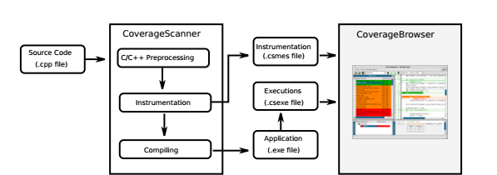
Fig. 1.4 Squish Coco process overview

Squish coco package provides two tools, Coverage Scanner and Coverage Browser.
Coverage Scanner is a Squish Coco tool which is used to instrument Tcl, C/C++ and C# applications. In instrumenting, it instruments all the lines without modifying the original source code that is written underneath and generates an instrumented executable. This instrumented executable is used to track the execution. It tracks whether a condition was evaluated to true or false or whether a line was executed or not, if executed, how many times, etc. All these information is then produced in a report which is generated when the program terminates.
On the other hand, Coverage Browser is a tool which is used to display and manage the execution report that is generated after execution. Unlike coverage scanner it is in the form of a GUI (graphical user interface). Presence of such a GUI makes it easier to view, manage and browse executions. This can be used to find dead and untested code. It also helps in finding out test cases which are redundant and inefficient. Squish coco provides metrics for line coverage, function coverage, condition coverage, decision coverage and branch coverage. Such features and metrics distinguish Squish Coco from other code coverage tools that are present in the market.

CHAPTER 2
PROBLEM DEFINITION AND OBJECTIVES

2.1 PROBLEM DEFINITION
The problem involves analysis of Squish Coco as a code coverage tool and comparing it with the existing Bullseye tool. The given problem can be broken down as following:
    - Deploy Squish coco in FW regression eco system and compare the following with the existing Bullseye tool.
    - Coverage report with Squish coco deployed in the same environment as Bullseye (current setup) for at least one project.
    - Comparison on the basis of coverage metrics used, effectiveness, automated coverage data generation and support to include/exclude code.
    - Performance analysis of the firmware.
    - Code complexity analysis of the firmware.
    - Documentation of the findings.

2.2 OBJECTIVES
The objectives can be classified as follows:
    - Analysis of tools.
- Analysis of test ecosystem
- Analysis of Bullseye
- Analysis of Squish coco
    - Deployment of tools.
- Getting acquainted with the regression ecosystem.
- Deploy Squish coco in FW regression eco system
    - Comparison of results generated.
- Compare the coverage metrics.
- Compare automated coverage data generated and consolidated with the existing Bullseye tool.
- Support to analyze and exclude/include code
    - Analysis of code.
- Evaluation of tool on the basis of performance of firmware.
- Evaluation of tool on the basis of code complexity of firmware.

CHAPTER 3
BACKGROUND

The project involves comparison of two code coverage tools, Squish Coco and Bullseye. Both the tools identify the elements that can be covered. This is also called code instrumentation. Then after executing test cases of a given test suite, it generates a report that states the percentage of coverage items that have been tested. This is the basic working of a coverage tool. To understand the differences between the working of both the tools, it is necessary to have an in depth understanding of code instrumentation, coverage metrics and functionalities and working of both Squish Coco and Bullseye.

3.1 TYPES OF TESTING
Two main categories of software testing are black box testing and white box testing.
Black box testing is a kind of functional testing that tests the system or software without knowing the implementation, design, outline or structure of the system. This kind of testing involves no programming or implementation knowledge. This is just to check that the software or system meets the requirements that are specified during the requirement gathering phase.
The next type of testing is white box testing. It comes under structural testing. This kind of testing involves knowing the implementation, design or structure of the system. It also requires that the tester has programming and implementation knowledge. This type of testing is done to check and validate intricate details of all the functions that are designed to meet specified requirements.

3.2 CODE INSTRUMENTATION
Code instrumentation can be defined as a technique that automatically adds specific code to the source files under analysis. After compilation, execution of the code produces dump data for runtime analysis or component testing.
When it is said that a project is instrumented, it means that few extra lines of code are added to the source files of the project which on execution will provide data for various code coverage metrics. In the context of computer programming, instrumentation refers to an ability to monitor or measure the level of a product's performance, to diagnose errors and to write trace information.
Programmers implement instrumentation in the form of code instructions that monitor specific components in a system (for example, instructions may output logging information to appear on screen). It basically incorporates code tracing, debugging, performance counters and event logs. Code tracing can be defined as receiving informative messages about the execution of an application at run time. Debugging is tracking down and fixing programming errors in an application under development. Performance counters are components that allows to track the performance of an application and event logs are components that allows receiving and tracking major events in the execution of an application.
Source code instrumentation is an important technique for tracing and code coverage but it also has few limitations. It increases the size of the project and also its execution time which is due to source code insertion feature. Instrumentation is also limited by execution coverage. If the program never reaches a particular point of execution, then instrumentation at that point collects no data. The overview of instrumentation process is as shown in Fig. 3.2

Instrumented files
Source files
Instrumentation engine

Code coverage data collection

Fig. 3.2 Overview of instrumentation process.

3.3 BULLSEYE CODE COVERAGE
Bullseye Coverage is a C++ code coverage analyzer used to improve the quality of software in many vital systems. It enables creation of more reliable code and saves time. Bullseye uses source code instrumentation technology which makes it adaptable to many processors and platforms.
Bullseye coverage focuses mainly on two metrics, function coverage and condition/decision coverage. Function coverage gives a quick overview of the entire execution and condition/decision coverage provides high precision and interior details of execution.
Bullseye coverage instruments the source code on which code coverage is enabled. This instrumented executable is used to track the execution. It tracks whether a condition was evaluated to true or false or whether a function was executed or not, etc. When the program is run, it will dump the results into the file pointed by COVFILE environment variable. This file can then be opened by Bullseye coverage browser which shows coverage data for function and condition/decision coverage. With providing coverage data, it also provides some other functionalities such as excluding parts of code from coverage, options for generation of reports, etc. Similar to any other code coverage tool, Bullseye also increases build time, execution time and code size.

3.4 SQUISH COCO COVERAGE SCANNER
Squish Coco basically consists of two tools, Coverage Scanner and Coverage Browser.
Coverage Scanner is a Squish Coco tool which is used to instrument Tcl, C/C++ and C# applications. In instrumenting, it instruments all the lines without modifying the original source code that is written underneath and generates an instrumented executable. This instrumented executable is used to track the execution. It tracks whether a condition was evaluated to true or false or whether a line was executed or not, if executed, how many times, etc. All these information is then produced in a report which is generated when the program terminates.
Squish Coco coverage scanner provides both simple and complex code coverage metrics. It not only provides metrics for statement and function coverage but also for condition, decision and branch coverage. Squish Coco also has options for inserting the test name and its execution status. Presence of such a feature helps in integrating coverage scanner into the testing framework making it easier to generate code coverage information for all the tests that are run within the test suite.
Coverage Scanner acts like a command line tool which can be used in place of a compiler or can act like a wrapper to the native compiler that is used to build and compile the executable. It is basically used to perform three tasks. First it runs the C/C++ preprocessor, then it instruments the source code which was preprocessed and finally compiles and builds the source code using the normal C/C++ compiler.
Coverage Scanner can be easily integrated with any compiler like GNU gcc or GNU g++ or cl.exe for Microsoft Visual Studio or in that case any other standard compiler. Coverage Scanner generates a file of type .csmes which holds the list of all the executions and a copy of the instrumented code that will be needed for analysis.
Coverage Scanner easily suits compilers’ need thereby making it easier to work with most of the compilers. After code instrumentation by Coverage Scanner, the executable produced can be easily run generating an execution report (.csexe file) on program termination. This execution report can then be loaded into the corresponding database and analyzed by Coverage Browser.

3.5 SQUISH COCO COVERAGE BROWSER
The Coverage Browser tool of Squish Coco is used to analyze, view and manage the execution report or. csexe file that is produced when the program finishes execution. Unlike Coverage Scanner, for browsing and managing executions it has a GUI (Graphical User Interface). Presence of such a GUI makes it easier to find dead code and sections of untested codes. Squish Coco Coverage Browser has many other functionalities that ease the task of testing.
It provides many options like browsing through the instrumented code, commenting instrumented source code lines and marking them as manually validated. It also displays the list of executions in a tree view and for every instrumented line, gives a detailed explanation of its state. This explanation includes comments, data for all the coverage metrics and execution state describing whether it was executed or not.
Just like Bullseye, it provides options for exclusion of files and report generation. It allows generation of reports in many formats like HTML, XML, CSV, etc. It can generate statistics per function, per class, per file and per namespace. It has options for comparing coverage for two different versions of the software also. It allows easy switching from one type of coverage metric to other, like it provides options for easily switching from function coverage to condition or line coverage. It also has support for black box testing. It provides coverage of unit testing too. Along with these features it can also provide optimized execution order for the tests that have been run. Optimized execution order tells the order in which the tests have to be run so as to maximize coverage. It also points out at test cases which are redundant. All such features and functionalities differentiate Squish Coco’s Coverage Browser from other coverage browsers and eases the task of testing and validation. Its features are highlighted in Fig. 3.5.

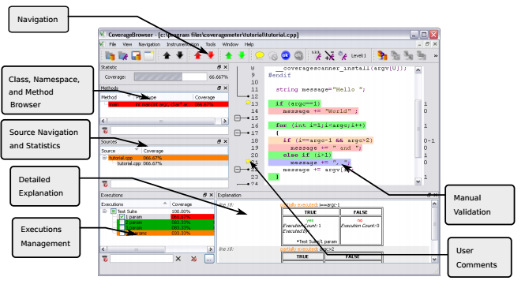
Fig. 3.5 Coverage Browser Screenshot

3.6 METRICS
Metrics are the parameters which define the degree to which a process, system or a software possesses certain property. On a more technical note, metrics are defined as parameters or measures of quantitative evaluation which can be used for estimation, comparison or to track execution performance or production.
Metrics that are used to measure some property of a software, its particulars or specification are called software metrics. Software metrics are used in testing and validation. They indicate the percentage of code that has been tested. Metrics used in software testing are statement coverage, condition coverage, decision coverage, function coverage, path coverage, loop coverage, etc. All these metrics are a part of white box testing. These metrics vary in definition and usage.
Statement coverage is the most basic coverage metric. Complete statement coverage guarantees that all the statements in the source code are executed at least once. In general, it’s a measure of number of statements of the source code that have been executed or covered by the given test suite.
Condition coverage is a code coverage metric or criteria that focuses on the execution of conditions. A condition can be evaluated to either true or false. Depending on the value to which a condition evaluates, the flow of program control can change. Considering this fact, condition coverage becomes an important coverage criterion. Condition coverage is a measure of number of conditions of the source code that have been executed or covered. It considers true and false of a conditional statement as two different conditions.
In computer programming, a decision is defined as a combination of various logical conditions by logical operators. Along with covering individual execution of conditions, it is important to cover whether the entire decision was evaluated to true or false. This is where decision coverage comes into picture. Decision coverage is a coverage metric which guarantees that all possible branches from all decision or control point are executed at least once guaranteeing that all reachable code is executed. Decision coverage can be defined as a measure of number of decisions of the source code that have been executed or covered. Decision coverage is closely related to branch coverage except few differences which are covered in later sections.
Function coverage is a simple coverage metric. It states whether a function is executed or not. It is a measure of number of functions of the source code that have been executed or covered by a given test suite. It is used when the goal is to get an overall coverage of what all modules have been covered during program execution.

CHAPTER 4
METHODOLOGY

In terms of software or firmware development, methodology can be defined as a framework that is used to track the process of development or implementation of an information system. It has various phases with each phase having its own deliverables and milestones.
The implementation of this project was carried out in various phases. These phases include requirements gathering phase, analysis phase, functional testing phase, performance testing phase, system testing phase, and integration and bug fixing phase. The detailed description of all these phases is as given below.

4.1 REQUIREMENTS GATHERING
During the requirements gathering phase the main objective was to understand the SanDisk testing ecosystem. This included understanding the process that is followed for running tests in regression. Along with the process, it also involved understanding the working of various tools that are used in testing. Various technical documents that explained the working of the system and tools were read during this period.
The major part was understanding the working of SanDisk validation package which is used to run all the tests on any given firmware model. It included understanding how the present code coverage tool, Bullseye works and how it is integrated and used in this system. Understanding this will give an overall idea of how to integrate any code coverage tool with the present structure and analyze its working.
Since the project was about analysis and comparison of two code coverage tools and deciding whether the new suggested tool Squish Coco can be used to replace the present Bullseye code coverage tool or not, it was very important to understand the working of Bullseye so that all the features and functionalities can be compared. Collecting information about Bullseye was an important part of requirements gathering phase.
After understanding the basic working and features of Bullseye, next was to understand why there was a need to replace it with a new tool, the functionalities it lacked which are relevant to testing and validation and whether the structure is in need of a new tool with enhanced features, functions and metrics.
The last step of this phase was setting up and integrating the new tool Squish Coco within the SanDisk validation package. It involved licensing, installation and setup of the tool and basic understanding of the working of the tool. This phase included understanding the overall working of Squish coco coverage tool for small projects without going deeper into technical and implementation details.

4.2 ANALYSIS
The second and the largest phase of the project was analysis. Analysis involved detailed analysis of both the tools, Bullseye and Squish Coco, their way of instrumentation, features, metrics and other qualitative and implementation details.
The first step of this phase was in depth understanding of Bullseye code coverage tool. It involved understanding what parts of the code were taken for instrumentation and how they were instrumented, the basic metrics that the tool uses and features it provides. It involved understanding how the tool defines condition coverage, decision coverage and function coverage. It also involved understanding how the tool behaves with other language constructs that change the program control flow such as switch case statements, jump statements, exceptions, etc. Along with these various others features were also explored such as ease of report generation, merging various reports, etc.
The second step of analysis was in depth understanding of the new suggested code coverage tool, Squish Coco. Understanding and exploring Squish Coco code coverage tool was more important and time consuming than understanding Bullseye code coverage tool since Bullseye was already used, analyzed and integrated into the system whereas Squish Coco was a completely new tool. It had a completely different way of instrumenting the source code. As compared to Bullseye, Squish Coco provided many new coverage metrics like statement coverage, branch coverage, etc. Even for the metrics that both the tools provided, their definitions varied. Understanding and exploring the new features of Squish Coco was the most important part of analysis phase. Along with exploring new features, it also involved comparing the behavior of both the tools for features that were common to both the tools.

4.3 SYSTEM TESTING
System testing for firmware, software or hardware can be defined as testing the entire system to ensure that the system performs in accordance with the specified requirements. This type of testing also falls into the category of black box testing since the entire system as a whole is tested without getting involved with the source code that is written underneath.
System testing includes both functional and non- functional testing. Along with testing whether specifications mentioned are met or not, it also includes compatibility testing, usability testing, stress testing, etc.
The given project also comes under the scope of System testing as the entire product, its features and functionalities and system as a whole has to be tested and analyzed without having the knowledge of the source code written underneath. Along with ensuring that the tool meets the required specification, it was equally important to ensure that the tool was compatible with the SanDisk validation system, can handle large amount of code data and other non- functional features. This is where System testing played an important role.

4.4 FUNCTIONAL TESTING
Functional testing can be defined as a black box testing methodology that ensures that all the functionalities of a given system are tested. Function testing ensures that the system performs all the functions that are specified in its requirements.
One of the reason for replacing the old tool was that it lacked few important functionalities. In such a scenario, testing for all the functionalities was important and critical for the project.
The project comes under the scope of functional testing because along with analyzing the tool as a whole, all its functions and features in particular had to be analyzed. Some functions in particular are very important to the testing ecosystem. Along with analyzing the whole tool, it was very necessary to analyze these functions. Such functions include support to exclude/include part of codes, support to merge data that have been collected from various runs, etc.

4.5 PERFORMANCE TETSING
Performance is one of the most important factor to be considered while analyzing the tool. Especially in the case as this, where the tool is used to provide extra data apart from the core functionalities that the firmware is supposed to perform, performance becomes an important factor. Performance of the tool should not become an extra bottleneck for the firmware.
In software engineering, performance testing is in general, a testing practice performed to determine how a system performs in terms of responsiveness and stability under a particular workload. It can also serve to investigate, measure, validate or verify other quality attributes of the system, such as scalability, reliability and resource usage. In this project performance is mainly considered to investigate, measure and validate resource usage, time elapsed being an important factor.
CHAPTER 5
ANALYSIS

The project aimed at understanding and comparing the behavior of two code coverage tools. This requires setup and initial understanding of the working of both the tools.
The project started with understanding of testing and validation ecosystem. In the first phase, I had to understand how the entire process flows. The first step was compiling and building the firmware code in the present system with Bullseye enabled. It included understanding their validation framework which states how to trigger tests on the complied firmware code. On triggering the tests, Bullseye generates a report which includes data for various metrics such as function coverage, condition coverage, etc.
The next step was doing the same procedure for Squish Coco code coverage tool. Squish Coco tool had to be set up and integrated with the present system. Since this was a new tool few basic programs were executed with Squish Coco enabled so as to understand its overall working. On completing this, the next step was to deeply analyze, explore and compare metrics, features and functionalities of both the tools.

5.1 STATEMENT COVERAGE
The first metric that was compared was the simplest, statement coverage. Statement coverage or line coverage is used to ensure whether a given statement was executed or not. Line coverage becomes important in many a cases like identification of dead code (part of the code that can never be reached by a program).

For better understanding consider the screenshot shown below in Fig. 5.1. All the screenshots contain two images, left one being coverage report for Squish Coco and right one being for Bullseye.
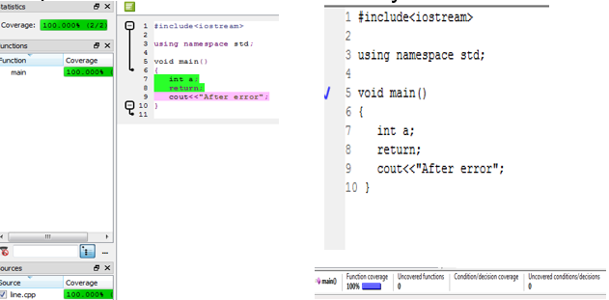
Fig. 5.1 Statement Coverage Comparison
In the above figure, we can notice that line number 9 can never be executed or reached since there is a return statement before that, hence statement 9 being dead code. From Squish Coco report for line coverage, we can easily spot this difference.

5.2 BRANCH COVERAGE
A branch can be defined as any path that is taken by the program control which is different from or deviates from sequential execution of each line of code. Conditional statements like if or loops or jump statements result in branching. Branch coverage is an important code coverage metric but this metric is not provided by Bullseye code coverage tool. Squish Coco provides branch coverage option by instrumenting the end of branch.
Squish Coco marks the end of every branch to ensure that the entire branch has been executed without any exceptions or errors. Such a feature of Squish Coco helps in improvising function coverage and decision coverage. For better understanding, consider the screenshot in Fig. 5.2:
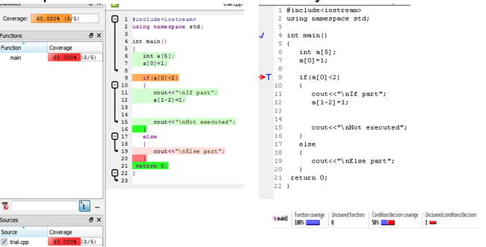
Fig. 5.2 Branch Coverage Comparison
The screenshot contains two images, left one being coverage report for Squish Coco and right one being for Bullseye. In this figure, it can be easily seen that Squish Coco report provides branch coverage by instrumenting line 16 and line 20 marking the end of if branch and else branch. But no such option is available for Bullseye.

5.3 FUNCTION COVERAGE
The third metric that was compared was function coverage owing to the simplicity of the metric. For function coverage, both Bullseye and Squish Coco mark whether the function was executed once or not. This gives an overall understanding of the functionalities and modules that have been covered and those which still needs to be covered. But both the tools differ in implementing this.
Bullseye marks the beginning of the function whereas Squish Coco marks the end of the function to ensure function coverage. Function coverage in Bullseye states that the function was called upon or the function body started executing. It provides no way to figure out whether the function completed execution without errors or not. This drawback can be overcome by Squish Coco since it marks the end of the function. Marking end of the function ensures that the function executed the entire body without exceptions or errors. This feature becomes really important if the source code has exception and exception handling in a large scale.
This difference can also be owed to the fact that Squish Coco provides branch coverage and Bullseye doesn’t. Since the end of a function is an end of a branch, Squish Coco instruments that. Fig. 5.3 depicts how Squish Coco marks line 15 for covering function main () and Bullseye marks line number 4.
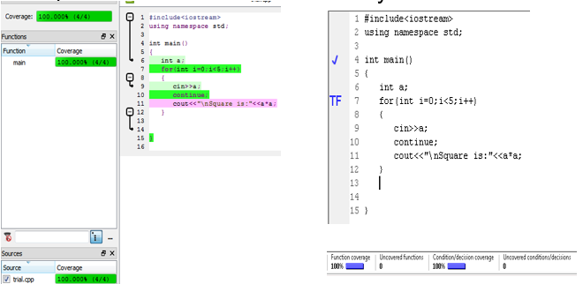
Fig.5.3 Function coverage comparison

5.4 CONDITION COVERAGE
The next metric to be analyzed was condition coverage. Condition coverage measures whether both true and false of a condition were covered at least once or not. Both Squish Coco and Bullseye implement condition coverage in a similar way. There is no such difference between both of them and the way they instrument the code when it comes to condition coverage.

5.5 DECISION COVERAGE
Decision coverage is an additional functionality which indicates whether a decision (combination of conditions) is evaluated to true or false. Decision coverage though being very similar to condition coverage, it is implemented differently in both the tools.
Bullseye provides decision coverage by marking true and false for the decision just as it does for individual conditions. But Squish coco doesn’t provide a feature as such. Instead it marks decision coverage with the help of branch coverage. As Squish Coco provides an option for branch coverage, it instruments the end of every branch. Seeing which branch was executed can help us in understanding whether the decision evaluated to true or false. For better understanding consider the example shown in Fig. 5.5.
Fig. 5.5 Decision coverage example
Here from squish coco report (left side) we can conclude that true of if condition at line number 9 was executed since line 16, which is end of that if branch, is executed. For Bullseye report (right side), we conclude this by observing true written beside line 9.

5.6 JUMP STATEMENT INSTRUMENTATION
Jump statements such as break, continue, return, goto alter the normal path that is being taken by the program. Therefore, instrumenting these statements is very significant.
Bullseye provides no options for instrumenting jump statements whereas Squish Coco instruments all the jump statements. This becomes really important in scenarios such as one shown in the following example in Fig. 5.6:
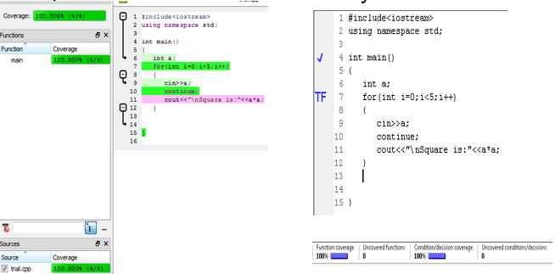
Fig. 5.6 Jump statement instrumentation

The screenshot contains two images, left one being coverage report for Squish Coco and right one being for Bullseye. In the above figure, it can be easily seen that Squish Coco report instruments jump statement, continue in line number 10 is instrumented whereas Bullseye provides no such option.
In this example if jump statement at line number 10 is not marked then it becomes really difficult for the user to figure out why nothing is being printed even though both true and false of the loop are covered.
5.7 MISCELLANEOUS DIFFERENCES
Apart from the differences that are described in the previous sections there were a few differences between Squish Coco and Bullseye which are worthy of being noted.
The first difference is in the way both the code coverage tools handle instrumentation of switch case statements. Bullseye code coverage tool considers the case statement to be a condition and marks it denoting whether the condition in the case evaluated to true or not. On the other hand, Squish Coco code coverage tool considers various cases to be different branches and marks the end of the case to conclude whether the given case was executed or not. For better understanding consider the following example in Fig.5.7:
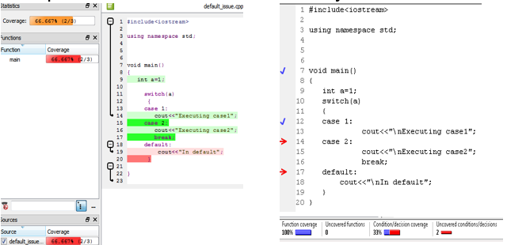
Fig. 5.7 Switch case statement comparison
The screenshot contains two images, left one being coverage report for Squish Coco and right one being for Bullseye. Both the screenshots clearly show the difference between Squish Coco and Bullseye in handling switch case statements.
Along with this, in the above example it can be seen that due to absence of break statement in case 1, case 2 is also executed. There is no option for noting such details in Bullseye report whereas this can easily be noted in Squish Coco report.
One more difference lies in the way both the tools handle ternary operator. In a normal scenario both the tools consider ternary operator as a condition. But in case there is a ternary expression in a return statement then Squish Coco as it instruments return statements, it instruments return in that statement whereas Bullseye instruments the ternary expression.
Squish Coco fails to handle #if defined inside the body of an IF condition.
if((a==0) && (a<7
#if defined (ab)
-3
#endif
))
In cases such as the example shown above, Squish coco generates an error while instrumenting.
Along with the differences in instrumentation that are mentioned in above sections there are many other functional and non -functional differences. These functionalities include exclusion of conditions from instrumentation, exclusion of conditions without modification of source code, comparing two coverage files, test execution order execution, providing optimized test execution order, commenting instrumented lines of code, detailed explanation, etc.

5.8 TESTING AND INTEGRATION
The next step after analysis was testing and integration. Testing involved system testing, functional testing and performance testing.
Before integrating the new tool, it was necessary to check whether that the tool is compatible with the existing framework or not, hence system testing was necessary. System testing involved building various model codes with Squish Coco enabled, removing the bugs arising from building and putting it for regression testing. These steps ensured that the tool is compatible with the building process, SanDisk validation package and regression ecosystem.
Along with system testing, functional testing was also needed. Functional testing, in a way, was carried throughout the project since during the analysis period each of the functionalities were tested and verified. One of the reason for replacing the old tool was that it lacked few important functionalities. In such a scenario, testing for all the functionalities was important and critical for the project.
For all code coverage tools, there is a tradeoff between functionalities provided and performance. Usually a code coverage tool adds extra lines of codes while instrumenting it so the compile time and execution time increases. Therefore, it was really important to ensure that the Squish Coco is not providing extra functionalities at the cost of reduced performance. For this purpose, regression testing was done on various model codes built with Squish Coco enabled. Tests with fixed cycle count were run and time was noted and compared for Bullseye enabled code, Squish Coco enabled code and code with no instrumentation. Another approach that was followed involved fixing the time duration of the test and noting the number of commands executed in that time duration.
For integration and automation, command line arguments were written in a batch script which can be easily executed. Automation involved automating the entire process of triggering the test, generating the instrumentation database and execution report, loading the report, renaming it to avoid over writing and merging the reports generated just as it was done for Bullseye.
CHAPTER 6
CONCLUSION

6.1 CONCLUSION
The overall project of analysis and evaluation of Squish Coco and Bullseye ended with documenting and presenting the findings of the project.
Squish Coco code coverage tool had many advantages over Bullseye code coverage tool when it comes to providing new features and functionalities. Along with that it also provided greater number of coverage metrics and also redefined the existing metrics to cover all the boundary cases.
Squish Coco code coverage tool undoubtedly has advantages over Bullseye but the ease of use, simplicity and the fact that it is already integrated in the system makes Bullseye a tough competitor against Squish Coco.

CHAPTER 7
REFERENCES

7.1 REFERENCES
As reference, documentation available for both Bullseye and Squish coco was used.
- http://doc.froglogic.com/squish-coco/3.3/
- http://www.bullseye.com/coverage.html
- SanDisk proprietary documents

PROJECT DETAILS

Student Details
Student Name | Nikita Thacker
Register Number | 120905242 | Section / Roll No | C/17
Email Address | thacker.nikita@ymail.com | Phone No (M) | 9886687847
Project Details
Project Title | Evaluation, Feasibility analysis and recommendation of testing tools
Project Duration | 4 months | Date of reporting | 18/01/16
Organization Details
Organization Name | SanDisk, a Western Digital brand product
Full postal address with pin code | Sandisk India Device Design Centre Pvt. Ltd.  Survey No.143/1,Amani Bellandur Khane Village  Prestige Excelsior,Prestige Tech Park,  Marathalli-Sarjapur Outer Ring road  Kadubeesanahalli,Varthur Road,  Bangalore-560103  Phone:+91-80-4242-2000  Fax:+91-80-4242-2900
Website address | www.sandisk.in
Supervisor Details
Supervisor Name | Lakshmi Narasu Malavalli Puroshotha
Designation | Manager II, Firmware Validation Management
Full contact address with pin code | Lakshmi Narasu Malavalli Puroshotha,  IN-BNG01-6.C.67,  Sandisk India Device Design Centre Pvt. Ltd.  Survey No.143/1,Amani Bellandur Khane Village  Prestige Excelsior,Prestige Tech Park,  Marathalli-Sarjapur Outer Ring road  Kadubeesanahalli,Varthur Road,  Bangalore-560103
Email address | LakshmiNarasu.MalavalliPurushotha@sandisk.com | Phone No (M) | 9986004402
Internal Guide Details
Faculty Name | Prakash K Aithal
Full contact address with pin code | ASSISTANT PROFESSOR SENIOR SCALE, Dept of Computer Science and Engg, Manipal Institute of Technology, Manipal – 576 104 (Karnataka State), INDIA
Email address
  Prakash.aithal@manipal.edu

