**1.creat own resume in json**

{

"basicInfo": {

"name": "John Doe",

"email": "johndoe@example.com",

"phone": "+1234567890",

"linkedin": "linkedin.com/in/johndoe",

"github": "github.com/johndoe",

"address": "1234 Elm Street, Hometown, Country"

},

"summary": "Experienced software engineer with a passion for developing scalable web applications and working across the full stack. Adept at driving projects to completion and troubleshooting software issues.",

"skills": [

"JavaScript",

"Python",

"React",

"Node.js",

"SQL",

"Docker",

"AWS",

"Git"

],

"experience": [

{

"company": "Tech Solutions Inc.",

"position": "Senior Software Engineer",

"start_date": "January 2020",

"end_date": "Present",

"location": "New York, NY",

"responsibilities": [

"Lead the development of a new transactional system designed to handle millions of users.",

"Optimized existing system performance, improving response time by 30%.",

"Mentored junior developers and led weekly training sessions."

]

},

{

"company": "Web Innovations Ltd.",

"position": "Software Developer",

"start_date": "June 2015",

"end_date": "December 2019",

"location": "San Francisco, CA",

"responsibilities": [

"Developed full-stack web applications aligning with modern technologies and best practices.",

"Collaborated with project managers and other developers to refine project scope and design comprehensive solutions.",

"Regularly evaluated and implemented new programming tools and technologies."

]

}

],

"education": [

{

"institution": "University of Technology",

"degree": "Bachelor of Science in Computer Science",

"start_date": "September 2011",

"end_date": "June 2015",

"location": "Chicago, IL"

}

],

"certifications": [

{

"title": "Certified AWS Solutions Architect",

"issuer": "Amazon Web Services",

"date": "March 2018"

}

],

"projects": [

{

"name": "E-commerce Web Application",

"description": "Designed and implemented a scalable e-commerce platform with a custom content management system.",

"technologies": ["React", "Node.js", "MongoDB"],

"link": "http://exampleprojectlink.com"

}

]

}

**2)difference b/w window ,screen,document in javascript**

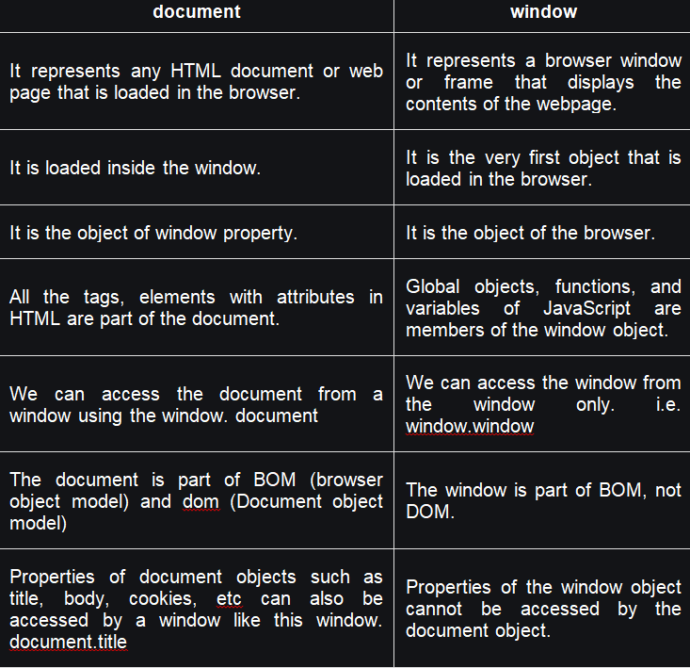

**screen**

The **screen** object contains information about the user's screen and its resolution. Unlike **window**, which deals with the browser window, **screen** focuses on the physical display attributes. This object can be useful for applications that need to understand the environment in which they are displaying content, but it's not used to manipulate the screen directly. Key properties include:

* **Screen size**: Properties like **screen.width** and **screen.height** provide the dimensions of the screen in pixels.
* **Available size**: Properties like **screen.availWidth** and **screen.availHeight** give the amount of space available on the screen, excluding interface features like the Windows taskbar.

**3)Types of for loops**

* for - loops through a block of code a number of times
* for/in - loops through the properties of an object
* for/of - loops through the values of an iterable object
* while - loops through a block of code while a specified condition is true
* do/while - also loops through a block of code while a specified condition is true