**HEALTHY DIET PLAN**

**Project Exhibition -2**

Submitted in partial fulfillment for the award of the degree of

**Masters in Computer Applications**

**In**

**SCSE(School of Computing Science and Engineering)**

Submitted to

**VIT BHOPAL UNIVERSITY (M.P.)**



**Submitted by:**

**VARTIKA SINGH**

**(18MCA10044)**

Under theSupervision of

**DR SOUNTHARAJAN**

**SCHOOL OF COMPUTER SCIENCE & ENGG.**

**VIT BHOPAL UNIVERSITY**

**BHOPAL (M.P.)-466114**

**MAY– 2019**

**DIET PLANS**

(Website)

**INTRODUCTION**

**A healthy body, within a healthy mind**

Being healthy and fit in simple terms means taking good care of the body. We should remember that a healthy mind resides only in a healthy body. Good health of both mind and body helps one maintain the required energy level to achieve success in life. All of us must strive to achieve wholesome health.

Protecting your body from the intake of harmful substances, doing regular exercises, having proper food and sleep are some of the important instances that define a healthy lifestyle. Being fit allows us to perform our activities without being lethargic, restless or tired.

A healthy and fit person is capable of living the life to the fullest, without any major medical or physical issues. Being healthy is not only related to the physical well-being of a person, it also involves the mental stability or the internal peace of a person.

Generally, a healthy diet consists of taking a proper and healthy food which includes eating green and fresh vegetables, fruits, having milk, eggs, minerals, proteins and vitamins essential for a human’s lifestyle. Practicing Yoga including regular exercises in your daily routine also help you maintain your desired fitness, blood sugar and immunity level.

Healthy habits improve your physical appearance, mental stability, ability to perform activities in a better way, which help you lead a stress-free lifestyle, maintaining happy moods, high energy levels, etc. Each individual should take of one’s health on a priority; no single day should be skipped for making efforts on maintaining physical and mental fitness. Being happy is directly related to boosting your mental strength and health, so happiness can be considered as the result as well as the part of a healthy and fit lifestyle.

**Conclusion:** Health is the most important thing that a person should take care of. Leading a healthy lifestyle leads to happiness, success and achievements.

**LANGUAGE ADAPTION**

* **HTML**

**H**-T-M-L are initials that stand for  **H**yper**T**ext  **M**arkup **L**anguage (computer people love initials and acronyms -- you'll be talking acronyms ASAP). Let me break it down for you:

· **Hyper** is the opposite of linear. It used to be that computer programs had to move in a linear fashion. This before this, this before this , and so on. HTML does not hold to that pattern and allows the person viewing the World Wide Web page to go anywhere, any time they want.

· **Text** is what you will use. Real, honest to goodness English letters.

· **Mark up** is what you will do. You will write in plain English and then mark up what you wrote. More to come on that in the next Primer.

· **Language** because they needed something that started with "L" to finish HTML and Hypertext Markup *Louie* didn't flow correctly. Because it's a language , really -- but the language is plain English.

HTML can be embed programs written in a scripting language such as JavaScript which affect the behavior and content of web pages .The World Wide Web Consortium ,maintainer of both the HTML .

* **CSS**

CSS, also known as Cascading Style Sheets, is used to style and control the layout of WebPages. This language is used to define the presentation of HTML elements on a webpage. CSS can be used to define colors, fonts, borders, and the layout of a webpage.

In this article, we will be using Web Matrix. Microsoft Web Matrix is a free tool that allows you to create, customize and publish websites.

Web Matrix gives you a number of different ways that you can create a new web site. You can use an existing open source application such as Word Press, Joomla, Dot Net Nuke or Umbra co, or you can create a site yourself by either coding everything or by using a small, simple template.

## Why use style sheets?

* create a set of web pages with consistent appearance
* easier maintenance – make changes in one place
* separate page structure from page appearance
* ADA compliance
* reduce web page file size
* reduce your reliance on non-standard tags such as <center> and <font>
* **JAVASCRIPT**

It is a scripting language created by Netscape that’s why the default scripting language that Netscape navigator understands is “JavaScript”. JavaScript is scripting language that allows creating of interaction web pages. It allows user entire which are loaded into html form to be processed as required. This emphasis a web site to user’s request . Client site java script is traditionally embedded into standard html program. Java script is embedded between the script/script tags. These tag can be embedded within <head> and </head> or <body> and </body> tags of html program. Java script embedded into an html program because Java Script uses file name .html and HTTP protocol to transport itself from the web server to the client’s browser where the java script executes and process client information.

**FEATURES OF JAVA SCRIPT**

* Interpreted language.
* Easy to learn.
* Procedural capabilities.
* Designed for programming user events.
* Platform independence.
* Architecture neutral.

**Writing JavaScript**

JavaScript code is typically embedded in the HTML, to be interpreted and run by the client's browser. Here are some tips to remember when writing

JavaScript commands.

* + JavaScript code is case sensitive
  + White space between words and tabs are ignored
  + Line breaks are ignored except within a statement
  + JavaScript statements end with a semi- colon ;

**The SCRIPT Tag**

The <SCRIPT> tag alerts a browser that JavaScript code follows. It is

Typically embedded in the HTML.

<SCRIPT language = "JavaScript">

Statements

</SCRIPT>

**SCRIPT Example**

* Open "script_tag.html" in a browser.
* View the Source
* Put the cursor after <! – Enter code below 􀃆 and enter the following:

<SCRIPT language = "JavaScript">

alert ("Welcome to the script tag test page.")

</SCRIPT>

* Save the changes by choosing Save from the File menu
* Then Refresh the browser by clicking the Refresh or Reload button.

**SYSTEM SPECIFICATIONS**

**SOFTWARE REQUIREMENTS**

Windows OS /MAC OS capable of running 32-bit executable.

Common Lisp for Development of the software .

**HARDWARE REQUIREMENTS**

**T**he resulting executable is very small app and requires a low configuration, basically the same as running the common Lisp programming language IDE.

**PROCESSOR**

* Minimum: 745 megahertz (MHz) Pentium processor
* Recommended: 1 gigahertz (GHz) Pentium processor

**RAM**

* Minimum 192 MB
* Recommended 256 MB

**HARD DISK**

* 3 GB of available space required on system drive for installation of jdk.

**DISPLAY**

* Minimum: 800 x 600 256 colors
* Recommended: 1024 x 768 High Color - 16-bit

**OPERATING SYSTEM REQUIREMENTS**

* Microsoft Windows OS/MAC OS capable of running 32bit executable*.*

**SYSTEM DESIGN METHODOLOGIES**

**Systems design** is the process of defining the architecture, modules , interfaces, and data for a system to satisfy specified requirements. Systems design could be seen as the application of systems theory to product development. There is some overlap with the disciplines of system analysis, system architecture and systems engineering.

### Architectural design

The architectural design of a system emphasizes the design of the system architecture that describes the structure, behavior and more views of that system and analysis.

### Logical design

The logical design of a system pertains to an abstract representation of the data flows, inputs and outputs of the system. This is often conducted via modelling, using an over-abstract (and sometimes graphical) model of the actual system. In the context of systems, designs are included. Logical design includes entity-relationship diagrams (ER diagrams).

### Physical design

The physical design relates to the actual input and output processes of the system. This is explained in terms of how data is input into a system, how it is verified/authenticated, how it is processed, and how it is displayed. In physical design, the following requirements about the system are decided.

1. Input requirement,
2. Output requirements,
3. Storage requirements,
4. Processing requirements,
5. System control and backup or recovery.

Put another way, the physical portion of system design can generally be broken down into three sub-tasks:

1. User Interface Design
2. Data Design
3. Process Design

Physical design, in this context, does not refer to the tangible physical design of an information system. To use an analogy, a personal computer's physical design involves input via a keyboard, processing within the CPU, and output via a monitor, printer, etc. It would not concern the actual layout of the tangible hardware, which for a PC would be a monitor, CPU, motherboard, hard drive, modems, video/graphics cards, USB slots.

**CODING ALONG WITH THE SCREENSHOTS**

**Home Page**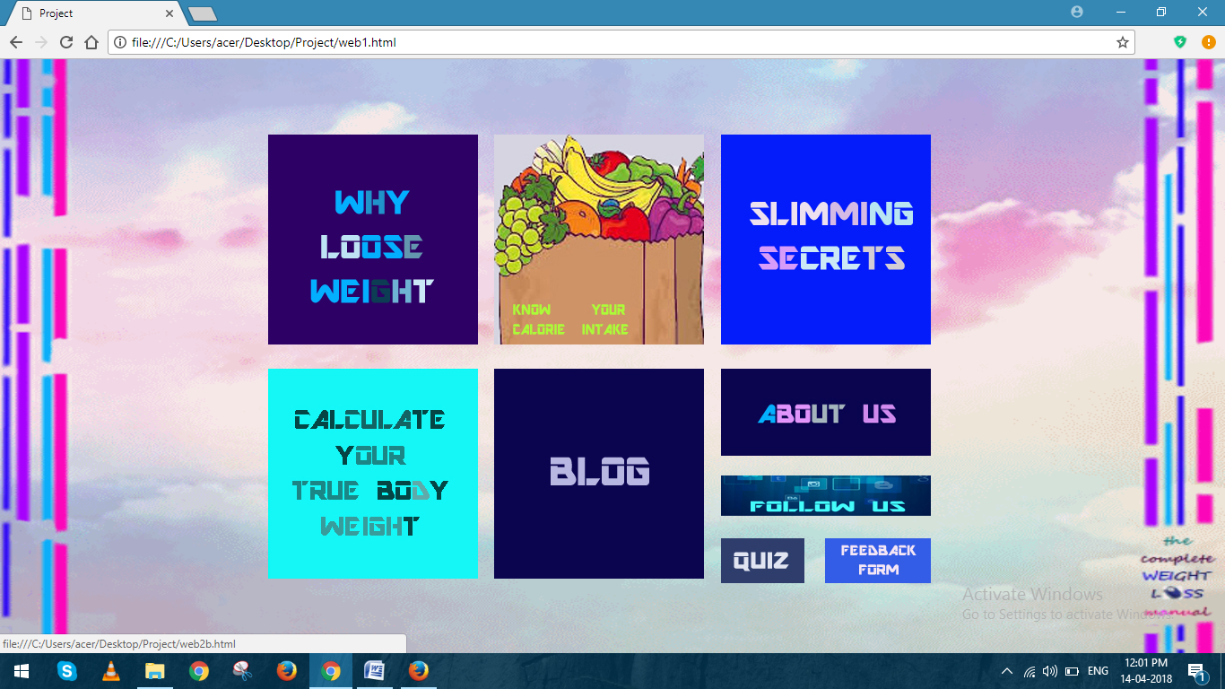

**Coding of home page:**

**<html>**

**<head><title>Project</title>**

**<style type="text/css">**

**.image**

**{**

**position:absolute;**

**top:48%;**

**left:40%;**

**margin-top: -234px;**

**margin-left: -234px;**

**}**

**.image2**

**{**

**position:absolute;**

**top:48%;**

**left:57.5%;**

**margin-top: -234px;**

**margin-left: -234px;**

**}**

**.image3**

**{**

**position:absolute;**

**top:48%;**

**left:75%;**

**margin-top: -234px;**

**margin-left: -234px;**

**}**

**.image1**

**{**

**position:absolute;**

**top:83.5%;**

**left:40%;**

**margin-top: -234px;**

**margin-left: -234px;**

**}**

**.image4**

**{**

**position:absolute;**

**top:83.5%;**

**left:57.5%;**

**margin-top: -234px;**

**margin-left: -234px;**

**}**

**.image5**

**{**

**position:absolute;**

**top:99.5%;**

**left:75%;**

**margin-top: -234px;**

**margin-left: -234px;**

**}**

**.image6**

**{**

**position:absolute;**

**top:83.5%;**

**left:75%;**

**margin-top: -234px;**

**margin-left: -234px;**

**}**

**</style>**

**</head>**

**<body style="background:url(front1.gif);background-repeat:no-repeat;background-size:100% 100%">**

**<div class="image">**

**<a href="web2a.html">**

**<img src="fr1.jpg" onmouseover="src='fr1b.jpg'" onmouseout="src='fr1.jpg'">**

**</a></div>**

**<div class="image1">**

**<a href="web2d.html">**

**<img src="fr4.jpg" onmouseover="src='fr3b.jpg'" onmouseout="src='fr4.jpg'"></a>**

**</div>**

**<div class="image2">**

**<a href="web2b.html">**

**<img src="fr2.jpg" onmouseover="src='fr2b.jpg'" onmouseout="src='fr2.jpg'"></a>**

**</div>**

**<div class="image3">**

**<a href="web2c.html">**

**<img src="fr3.jpg" onmouseover="src='fr4b.jpg'" onmouseout="src='fr3.jpg'"></a>**

**</div>**

**<div class="image4">**

**<a href="web2e.html">**

**<img src="fr5.jpg" onmouseover="src='fr5b.jpg'" onmouseout="src='fr5.jpg'"></a>**

**</div>**

**<div class="image5">**

**<a href="web2f.html">**

**<img src="fr6.jpg"></a>**

**</div>**

**<div class="image6">**

**<a href="web2g.html">**

**<img src="fr7a.jpg"></a>**

**</div>**

**</body>**

**</html>**

**“Why to loose Weight”**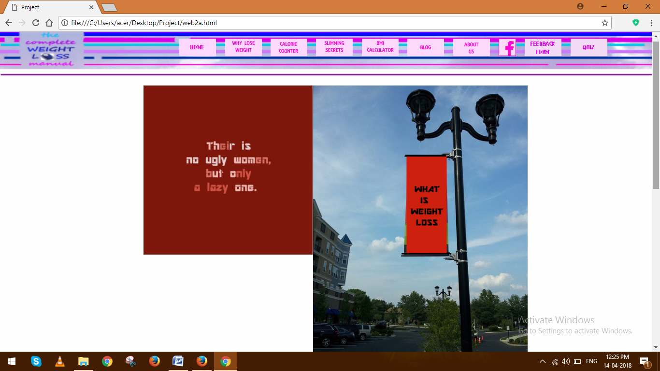

**Coding of Why to Loose Weight page:**

**<html>**

**<head><title>Project</title>**

**<style>**

**.imageh**

**{**

**position:absolute;**

**top:6%;**

**left:39%;**

**margin-top: -18px;**

**margin-left: -155px;**

**}**

**.image**

**{**

**position:absolute;**

**top:6%;**

**left:46%;**

**margin-top: -18px;**

**margin-left: -155px;**

**}**

**.image1**

**{**

**position:absolute;**

**top:6%;**

**left:53%;**

**margin-top: -18px;**

**margin-left: -155px;**

**}**

**.image12**

**{**

**position:absolute;**

**top:6%;**

**left:60%;**

**margin-top: -18px;**

**margin-left: -155px;**

**}**

**.image123**

**{**

**position:absolute;**

**top:6%;**

**left:67%;**

**margin-top: -18px;**

**margin-left: -155px;**

**}**

**.image1234**

**{**

**position:absolute;**

**top:6%;**

**left:74%;**

**margin-top: -18px;**

**margin-left: -155px;**

**}**

**.image12345**

**{**

**position:absolute;**

**top:6%;**

**left:88%;**

**margin-top: -18px;**

**margin-left: -155px;**

**}**

**.image123456**

**{**

**position:absolute;**

**top:6%;**

**left:81%;**

**margin-top: -18px;**

**margin-left: -155px;**

**}**

**.image1234567**

**{**

**position:absolute;**

**top:6%;**

**left:92%;**

**margin-top: -18px;**

**margin-left: -155px;**

**}**

**.image12345678**

**{**

**position:absolute;**

**top:6%;**

**left:99%;**

**margin-top: -18px;**

**margin-left: -155px;**

**}**

**.pch4**

**{**

**position:absolute;**

**top:18%;**

**left:1%;**

**}**

**.pch5**

**{**

**position:absolute;**

**top:88.5%;**

**left:0%;**

**}**

**</style>**

**</head>**

**<body style="background:url(tcwlmff.gif);background-repeat:no-repeat;background-size:100% 100%">**

**<div class="imageh">**

**<a href="web1.html">**

**<img src="homef.jpg">**

**</a>**

**</div>**

**<div class="image">**

**<a href="web2a.html">**

**<img src="wl1f.jpg">**

**</a>**

**</div>**

**<div class="image1">**

**<a href="web2b.html">**

**<img src="wl2f.jpg"></a>**

**</div>**

**<div class="image12">**

**<a href="web2c.html">**

**<img src="wl3f.jpg"></a>**

**</div>**

**<div class="image123">**

**<a href="web2d.html">**

**<img src="wl4f.jpg"></a>**

**</div>**

**<div class="image1234">**

**<a href="web2e.html">**

**<img src="wl5f.jpg"></a>**

**</div>**

**<div class="image12345">**

**<a href="web2f.html">**

**<img src="wl6f.jpg">**

**</a></div>**

**<div class="image123456">**

**<a href="web2g.html">**

**<img src="wl7f.jpg"></a>**

**</div>**

**<div class="image1234567">**

**<a href="feedback1.html">**

**<img src="feedback.jpg"></a>**

**</div>**

**<div class="image12345678">**

**<a href="quiz1.html">**

**<img src="quiz.jpg"></a>**

**</div>**

**<div class="pch5">**

**<img src="tcwlmff1.gif"width="1420" height="80">**

**</div>**

**<div class="pch4">**

**<p><b>Weight loss</b>, in the <b>context of medicine, health, or physical fitness</b>, refers to a <b>reduction of the total body mass, due to a mean loss of fluid, body fat or adipose tissue</b> and/or lean mass, namely bone mineral deposits, muscle, tendon, and other connective tissue. <b>Weight loss can either occur unintentionally due to malnourishment or an underlying disease or arise from a conscious effort to improve an actual or perceived overweight or obese state</b>. "Unexplained" weight loss that is not caused by reduction in calorific intake or exercise is called cachexia and may be a symptom of a serious medical condition. Intentional weight loss is commonly referred to as slimming.<br><br>**

**<b>Unintentional weight loss may result from loss of body fats, loss of body fluids, muscle atrophy, or even a combination of these</b>.It is generally regarded as a medical problem when at least 10% of a person's body weight has been lost in six months or 5% in the last month. Another criterion used for assessing weight that is too low is the body mass index (BMI).However, even lesser amounts of weight loss can be a cause for serious concern in a frail elderly person.<br><br>**

**<b>Intentional weight loss is the loss of total body mass as a result of efforts to improve fitness and health, or to change appearance through slimming.</b> Weight loss in individuals who are overweight or obese can reduce health risks,increase fitness, and may delay the onset of diabetes. <b>It could reduce pain and increase movement in people with osteoarthritis of the knee</b>. Weight loss can lead to a <b>reduction in hypertension (high blood pressure)</b>, however whether this reduces hypertension-related harm is unclear.<br>**

**Weight loss occurs when the body is expending more energy in work and metabolism than it is absorbing from food or other nutrients. It will then use stored reserves from fat or muscle, gradually leading to weight loss. <b>For athletes seeking to improve performance or to meet required weight classification for participation in a sport, it is not uncommon to seek additional weight loss even if they are already at their ideal body weight</b>. Others may be driven to lose weight to achieve an appearance they consider more attractive. .<br>**

**Low-calorie diets are also referred to as balanced percentage diets. Due to their minimal detrimental effects, these types of dietsCalorie restriction in this way has many long-term benefits. After reaching the desired body weight, the calories consumed per day may be increased gradually, without exceeding 2,000 net (i.e. derived by subtracting calories burned by physical activity from calories consumed). Combined with increased physical activity, low-calorie diets are thought to be most effective long-term, unlike crash diets, which can achieve short-term results, at best. Physical activity could greatly enhance the efficiency of a diet. The healthiest weight loss regimen, therefore, is one that consists of a balanced diet and moderate physical activity.**

**</p>**

**</div>**

**</body>**

**</html>**

**Slimming secrets page**

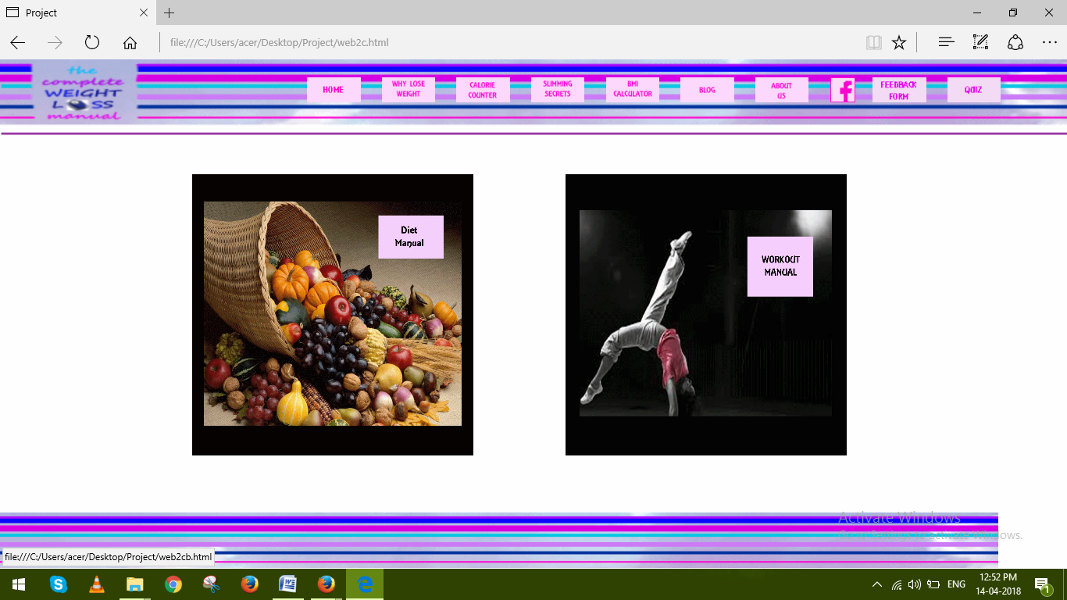

**Coding of slimming secrets page:**

**<html>**

**<head><title>Project</title>**

**<style type="text/css">**

**.image**

**{**

**position:absolute;**

**top:48%;**

**left:39%;**

**margin-top: -234px;**

**margin-left: -234px;**

**}**

**.image2**

**{**

**position:absolute;**

**top:48%;**

**left:57.5%;**

**margin-top: -234px;**

**margin-left: -234px;**

**}**

**.image3**

**{**

**position:absolute;**

**top:48%;**

**left:76%;**

**margin-top: -234px;**

**margin-left: -234px;**

**}**

**.image1**

**{**

**position:absolute;**

**top:87.5%;**

**left:39%;**

**margin-top: -234px;**

**margin-left: -234px;**

**}**

**.image4**

**{**

**position:absolute;**

**top:87.5%;**

**left:57.5%;**

**margin-top: -234px;**

**margin-left: -234px;**

**}**

**.image5**

**{**

**position:absolute;**

**top:105.5%;**

**left:76%;**

**margin-top: -234px;**

**margin-left: -234px;**

**}**

**.image41**

**{**

**position:absolute;**

**top:116%;**

**left:76%;**

**margin-top: -234px;**

**margin-left: -234px;**

**}**

**.image412**

**{**

**position:absolute;**

**top:116%;**

**left:84.5%;**

**margin-top: -234px;**

**margin-left: -234px;**

**}**

**.image6**

**{**

**position:absolute;**

**top:87.5%;**

**left:76%;**

**margin-top: -234px;**

**margin-left: -234px;**

**}**

**</style>**

**</head>**

**<body style="background:url(front1.gif);background-repeat:no-repeat;background-size:100% 100%">**

**<div class="image">**

**<a href="web2a.html">**

**<img src="fr1.jpg" onmouseover="src='fr1b.jpg'" onmouseout="src='fr1.jpg'">**

**</a></div>**

**<div class="image1">**

**<a href="web2d.html">**

**<img src="fr4.jpg" onmouseover="src='fr3b.jpg'" onmouseout="src='fr4.jpg'"></a>**

**</div>**

**<div class="image2">**

**<a href="web2b.html">**

**<img src="fr2.jpg" onmouseover="src='fr2b.jpg'" onmouseout="src='fr2.jpg'"></a>**

**</div>**

**<div class="image3">**

**<a href="web2c.html">**

**<img src="fr3.jpg" onmouseover="src='fr4b.jpg'" onmouseout="src='fr3.jpg'"></a>**

**</div>**

**<div class="image4">**

**<a href="web2e.html">**

**<img src="fr5.jpg" onmouseover="src='fr5b.jpg'" onmouseout="src='fr5.jpg'"></a>**

**</div>**

**<div class="image5">**

**<a href="https://www.facebook.com/Complete-weight-loss-mannual-1827831034143065/">**

**<img src="fr6.jpg" onmouseover="src='fr6c.jpg'" onmouseout="src='fr6.jpg'"></a>**

**</div>**

**<div class="image41">**

**<a href="quiz1.html">**

**<img src="q1.jpg" onmouseover="src='q1b.jpg'" onmouseout="src='q1.jpg'"></a>**

**</div>**

**<div class="image412">**

**<a href="feedback1.html">**

**<img src="fe1.jpg" onmouseover="src='fe2.jpg'" onmouseout="src='fe1.jpg'"></a>**

**</div>**

**<div class="image6">**

**<a href="web2g.html">**

**<img src="fr7a.jpg"></a>**

**</div>**

**</body>**

**</html>**

**Calculate your weight page**

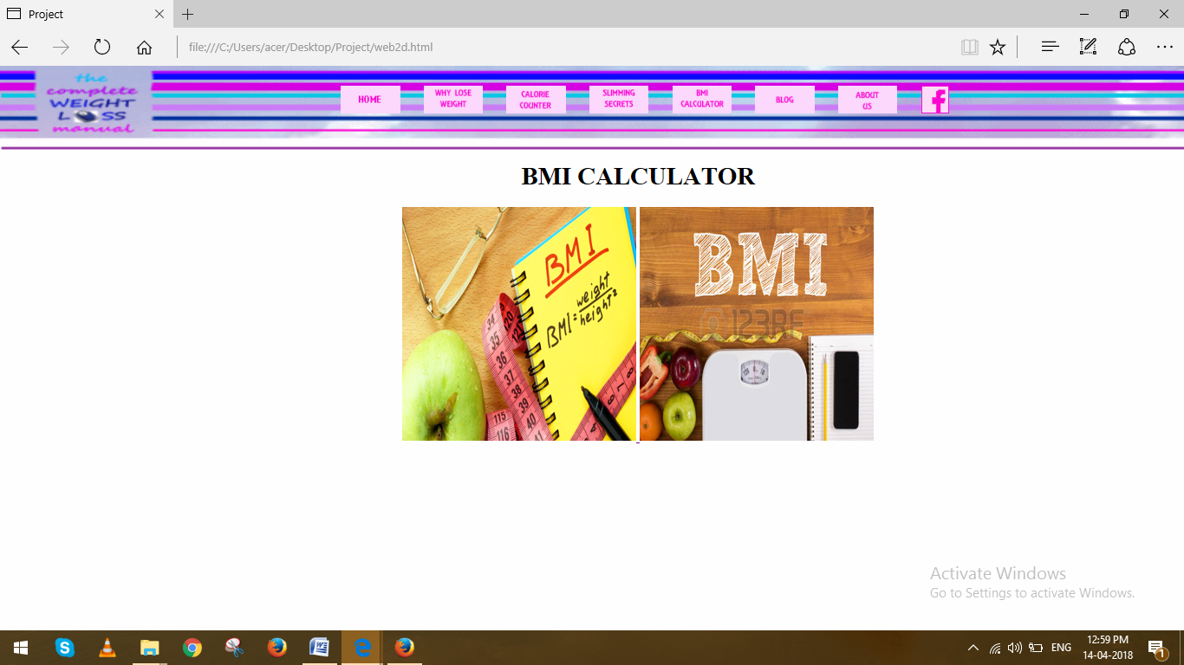

**<html>**

**<head><title>Project</title>**

**<style type="text/css">**

**.image**

**{**

**position:absolute;**

**top:48%;**

**left:39%;**

**margin-top: -234px;**

**margin-left: -234px;**

**}**

**.image2**

**{**

**position:absolute;**

**top:48%;**

**left:57.5%;**

**margin-top: -234px;**

**margin-left: -234px;**

**}**

**.image3**

**{**

**position:absolute;**

**top:48%;**

**left:76%;**

**margin-top: -234px;**

**margin-left: -234px;**

**}**

**.image1**

**{**

**position:absolute;**

**top:87.5%;**

**left:39%;**

**margin-top: -234px;**

**margin-left: -234px;**

**}**

**.image4**

**{**

**position:absolute;**

**top:87.5%;**

**left:57.5%;**

**margin-top: -234px;**

**margin-left: -234px;**

**}**

**.image5**

**{**

**position:absolute;**

**top:105.5%;**

**left:76%;**

**margin-top: -234px;**

**margin-left: -234px;**

**}**

**.image41**

**{**

**position:absolute;**

**top:116%;**

**left:76%;**

**margin-top: -234px;**

**margin-left: -234px;**

**}**

**.image412**

**{**

**position:absolute;**

**top:116%;**

**left:84.5%;**

**margin-top: -234px;**

**margin-left: -234px;**

**}**

**.image6**

**{**

**position:absolute;**

**top:87.5%;**

**left:76%;**

**margin-top: -234px;**

**margin-left: -234px;**

**}**

**</style>**

**</head>**

**<body style="background:url(front1.gif);background-repeat:no-repeat;background-size:100% 100%">**

**<div class="image">**

**<a href="web2a.html">**

**<img src="fr1.jpg" onmouseover="src='fr1b.jpg'" onmouseout="src='fr1.jpg'">**

**</a></div>**

**<div class="image1">**

**<a href="web2d.html">**

**<img src="fr4.jpg" onmouseover="src='fr3b.jpg'" onmouseout="src='fr4.jpg'"></a>**

**</div>**

**<div class="image2">**

**<a href="web2b.html">**

**<img src="fr2.jpg" onmouseover="src='fr2b.jpg'" onmouseout="src='fr2.jpg'"></a>**

**</div>**

**<div class="image3">**

**<a href="web2c.html">**

**<img src="fr3.jpg" onmouseover="src='fr4b.jpg'" onmouseout="src='fr3.jpg'"></a>**

**</div>**

**<div class="image4">**

**<a href="web2e.html">**

**<img src="fr5.jpg" onmouseover="src='fr5b.jpg'" onmouseout="src='fr5.jpg'"></a>**

**</div>**

**<div class="image5">**

**<a href="https://www.facebook.com/Complete-weight-loss-mannual-1827831034143065/">**

**<img src="fr6.jpg" onmouseover="src='fr6c.jpg'" onmouseout="src='fr6.jpg'"></a>**

**</div>**

**<div class="image41">**

**<a href="quiz1.html">**

**<img src="q1.jpg" onmouseover="src='q1b.jpg'" onmouseout="src='q1.jpg'"></a>**

**</div>**

**<div class="image412">**

**<a href="feedback1.html">**

**<img src="fe1.jpg" onmouseover="src='fe2.jpg'" onmouseout="src='fe1.jpg'"></a>**

**</div>**

**<div class="image6">**

**<a href="web2g.html">**

**<img src="fr7a.jpg"></a>**

**</div>**

**</body>**

**</html>**

**Feedback page**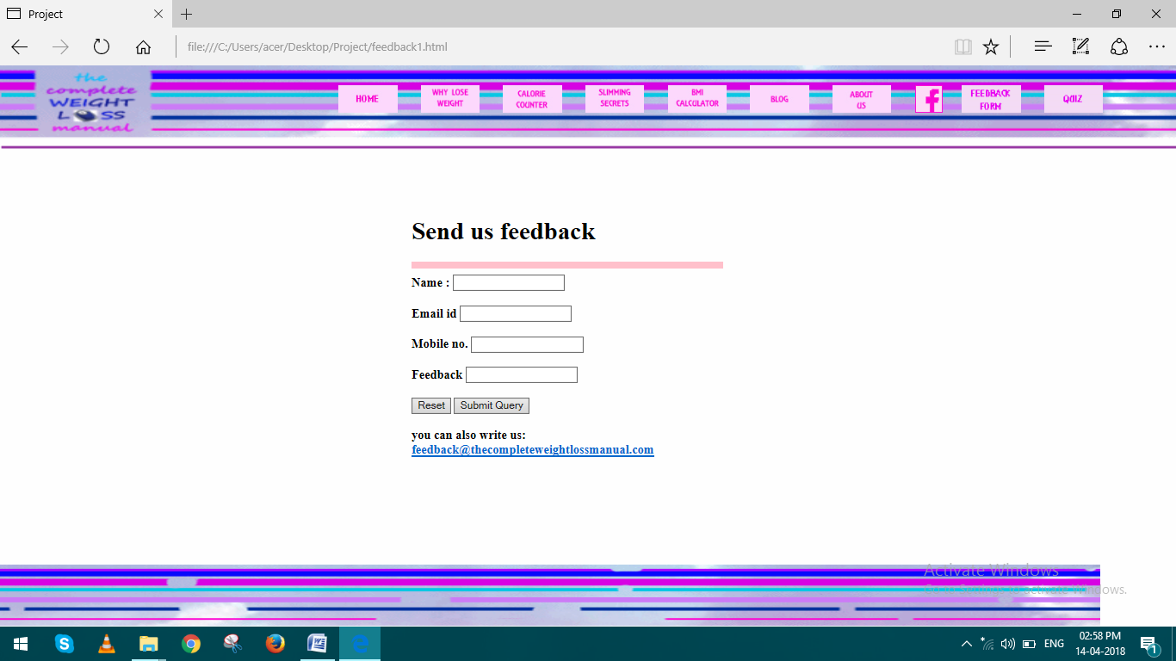

**Coding of Feedback Form Page(index.html)**

**<html>**

**<head><title>Project</title>**

**<script type="text/javascript">**

**function validate()**

**{**

**if(document.myForm.Email.value== "")**

**{**

**alert('please provide your email');**

**document.myForm.Email.focus();**

**return false;**

**}**

**if((document.myForm.Mobile no.value=="")||(document.myForm.Mobile no.value.length!=10))**

**{**

**alert("Please provide a valid mobile no");**

**document.myForm.Mobile.focus();**

**return false;**

**}**

**return true;**

**}**

**function validateEmail()**

**{**

**var emailID=document.myForm.Email.value;**

**atpos=emailID.indexOf("@");**

**if(atpos<1)**

**{**

**alert("please enter correct email id");**

**document.myForm.Email.focus();**

**return false;**

**}**

**return true;**

**}**

**</script>**

**<style>**

**.imageh**

**{**

**position:absolute;**

**top:6%;**

**left:39%;**

**margin-top: -18px;**

**margin-left: -155px;**

**}**

**.image**

**{**

**position:absolute;**

**top:6%;**

**left:46%;**

**margin-top: -18px;**

**margin-left: -155px;**

**}**

**.image1**

**{**

**position:absolute;**

**top:6%;**

**left:53%;**

**margin-top: -18px;**

**margin-left: -155px;**

**}**

**.image12**

**{**

**position:absolute;**

**top:6%;**

**left:60%;**

**margin-top: -18px;**

**margin-left: -155px;**

**}**

**.image123**

**{**

**position:absolute;**

**top:6%;**

**left:67%;**

**margin-top: -18px;**

**margin-left: -155px;**

**}**

**.image1234**

**{**

**position:absolute;**

**top:6%;**

**left:74%;**

**margin-top: -18px;**

**margin-left: -155px;**

**}**

**.image12345**

**{**

**position:absolute;**

**top:6%;**

**left:88%;**

**margin-top: -18px;**

**margin-left: -155px;**

**}**

**.image123456**

**{**

**position:absolute;**

**top:6%;**

**left:81%;**

**margin-top: -18px;**

**margin-left: -155px;**

**}**

**.image1234567**

**{**

**position:absolute;**

**top:6%;**

**left:92%;**

**margin-top: -18px;**

**margin-left: -155px;**

**}**

**.image12345678**

**{**

**position:absolute;**

**top:6%;**

**left:99%;**

**margin-top: -18px;**

**margin-left: -155px;**

**}**

**.pch2**

**{**

**position:absolute;**

**top:24%;**

**left:35%;**

**}**

**.pch5**

**{**

**position:absolute;**

**top:89%;**

**left:0%;**

**}**

**</style>**

**</head>**

**<body style="background:url(tcwlmff.gif);background-repeat:no-repeat;background-size:100% 100%">**

**<div class="imageh">**

**<a href="web1.html">**

**<img src="homef.jpg">**

**</a>**

**</div>**

**<div class="image">**

**<a href="web2a.html">**

**<img src="wl1f.jpg">**

**</a>**

**</div>**

**<div class="image1">**

**<a href="web2b.html">**

**<img src="wl2f.jpg"></a>**

**</div>**

**<div class="image12">**

**<a href="web2c.html">**

**<img src="wl3f.jpg"></a>**

**</div>**

**<div class="image123">**

**<a href="web2d.html">**

**<img src="wl4f.jpg"></a>**

**</div>**

**<div class="image1234">**

**<a href="web2e.html">**

**<img src="wl5f.jpg"></a>**

**</div>**

**<div class="image12345">**

**<a href="web2f.html">**

**<img src="wl6f.jpg">**

**</a></div>**

**<div class="image123456">**

**<a href="web2g.html">**

**<img src="wl7f.jpg"></a>**

**</div>**

**<div class="image1234567">**

**<a href="feedback1.html">**

**<img src="feedback.jpg"></a>**

**</div>**

**<div class="image12345678">**

**<a href="quiz1.html">**

**<img src="quiz.jpg"></a>**

**</div>**

**<div class="pch5">**

**<img src="tcwlmff1.gif"width="1420" height="80">**

**</div>**

**<div class="pch2">**

**<b><h1> Send us feedback</h1></b>**

**<hr width="400" size="7" color="pink">**

**<script type="text/javascript">**

**function allowReset()**

**{**

**return window.confirm("go ahead and clear the form");**

**}**

**function allowSend()**

**{**

**return window.confirm("your data has been received. THANKYOU! " );**

**}**

**</script>**

**<form name="myForm" method="post"enctype="text/plain" action="" onreset="return allowReset()"**

**onsubmit="return allowSend()">**

**<b> Name : </b>**

**<input type="text" name= "name" id="name"/><br><br>**

**<b>Email id</b>**

**<input type="text" name="Email" id="Email" onchange="validateEmail();"/><br><br>**

**<b>Mobile no.</b>**

**<input type="char" name="Mobile no" ="Mobile no" /><br><br>**

**<b>Feedback</b>**

**<input type="text" name="feedback" ="feedback"/><br><br>**

**<b><input type="reset"/>**

**<b><input type="submit" >**

**<br>**

**<br>**

**<b>you can also write us:</b><br>**

**<a href="mailto:completemanualweightloss@gmail.com?Subject=feedback">feedback@thecompleteweightlossmanual.com</a></div></form>**

**</body> </html>**

**CONCLUSION**

The objective of this website to provide all the information about the healthy habits and how to stay fit .

There is always a room for improvement in any website, however efficient the system may be .The important thing is that the system should be flexible enough for future modifications. The system has been factored into different modules to make system adapt to the further changes. Every effort has been made to cover all the user requirements and make it user friendly.

* **Goal Achieved:** The website is able to provide the interface to the users so that he can replicate his desired data.
* **User Friendliness :** Though the most part of the website is supposed to act in the background, effort have been made to make the foreground interaction with user as smooth as possible. Also the integration of the website with inventory management project has been kept in my mind throughout the development phase.

**BIBLIOGRAPHY**

[www.google.com](http://www.google.com)

[www.wikipedia.com](http://www.wikipedia.com)

[www.w3school.com](http://www.w3school.com)

youtube.com