UNIVERSITY OF MORATUWA
Faculty of Information Technology
Software Engineering / Information Technology Project
ITE3965 - Project Phase 1

Software Requirements
Specification
An AI-Based Decision-Support System for Order Batching and Picking Route Optimization
X-Trena

Document Type : Software Requirements Specification (SRS)
Project : Final Year Project
Institution : University of Moratuwa
Faculty : Faculty of Information Technology
Prepared By : P. S. A. A. Seram
Student ID : E2529106
Degree Programme : Bachelor of Information Technology
Academic Year : 2026
Version : v1.0.0
Date : 24-09-2026

Table of Contents
Table of Contents ii
Revision History iv
1. Introduction 1
1.1 Purpose 1
1.2 Document Conventions 3
1.3 Intended Audience and Reading Suggestions 3
1.4 Project Scope 4
1.5 References 5
2. Overall Description 6
2.1 Product Perspective 6
2.2 Product Features 7
2.3 User Classes and Characteristics 8
2.4 Operating Environment 10
2.5 Design and Implementation Constraints 11
2.6 User Documentation 11
2.7 Assumptions and Dependencies 11
3. System Features 12
3.1. Module M1 – Authentication and User Management 12
3.1.1 Description and Priority 12
3.1.2 Stimulus/Response Sequences 12
3.1.3 Functional Requirements 13
3.2. Module M2 – Product and Location Master Data 13
3.2.1 Description and Priority 13
3.2.2 Stimulus/Response Sequences 13
3.2.3 Functional Requirements 13
3.3 Module M3 – Inbound Receiving and AI Storage Recommendation 14
3.3.1 Description and Priority 14
3.3.2 Stimulus/Response Sequences 14
3.3.3 Functional Requirements 14
3.4 Module M4 - Inventory Engine 15
3.4.1 Description and Priority 15
3.4.2 Stimulus/Response Sequences 15
3.4.3 Functional Requirements 15
3.5 Module M5 - Order Intake and Inventory Validation 15
3.5.1 Description and Priority 15
3.5.2 Stimulus/Response Sequences 16
3.5.3 Functional Requirements 16
3.6 Module M6 - Consolidation, Batching, Employee Assignment, and Route Optimization 16
3.6.1 Description and Priority 16
3.6.2 Stimulus/Response Sequences 16
3.6.3 Functional Requirements 17
3.7 Module M7 - Consolidated Picking, Sorting, Packing, and Dispatch 17
3.7.1 Description and Priority 17
3.7.2 Stimulus/Response Sequences 17
3.7.3 Functional Requirements 18
3.8 Module M8 - Dashboards and Reports 18
3.8.1 Description and Priority 18
3.8.2 Stimulus/Response Sequences 18
3.8.3 Functional Requirements 18
3.9 Module M9 - API and Integration Layer 19
3.9.1 Description and Priority 19
3.9.2 Stimulus/Response Sequences 19
3.9.3 Functional Requirements 19
3.10 Use Cases 19
3.10.1 Actors 20
3.10.2 Use Cases and Usage Scenarios 20
3.10.3 Usage Scenario Details 24
4. External Interface Requirements 25
4.1 User Interfaces 25
4.2 Hardware Interfaces 27
4.3 Software Interfaces 27
4.4 Communications Interfaces 29
5. Other Nonfunctional Requirements 30
5.1 Performance Requirements 30
5.2 Safety Requirements 31
5.3 Security Requirements 32
5.4 Software Quality Attributes 33
6. Other Requirements 35
Appendix A: Glossary 36
Appendix B: Analysis Models 36
Appendix C: Issues List 46

Revision History
Version | Date | Author | Description
v1.0.0 | 24-09-2026 | P. S. A. A. Seram | Initial release of the Software Requirements Specification (IEEE Std 830-1998).

- Introduction
  - Purpose
The following document represents the Software Requirements Specification (SRS) for the X-Trena application which will serve as a solution in managing and optimizing the warehouse order picking process, implemented as part of the ITE 3962 Final Year Project. The purpose of this document is to clearly and precisely define the requirements of the system in terms of its functionality, behavior, target users, as well as the constraints that the system must comply with [6]. The objective of this document is to offer an agreement about the suggested system to all concerned parties, including the project supervisor, examiners, developers, testers and warehouse workers.
The following document defines the requirements in plain language and not by simply listing the functionalities of the system. The entire system is divided into nine main modules (M1 to M9) and each of the functional requirements has been assigned a number from FR-001 to FR-025. Besides, the document also provides additional diagrams, workflows, validation rules, and error handling explanations to practically implement the requirements.
As far as the system, X-Trena, is expected to be used daily by warehouse employees who might have no technical skills, the requirements have been stated in terms of a user. Therefore, the document uses simple language and gives detailed explanations when needed. The document focuses on describing in detail what the users will see and do while working with the system. This way, it becomes easier to make sure that the requirements are understood not only by technical people but by the users as well.

Project Background
Modern commerce depends heavily on warehouses. As e-commerce and order-based businesses continue to grow, the warehouse has become the point where customer expectations are either fulfilled or disappointing.
Within warehouse operations, order picking is one of the most expensive and time-consuming activities. It involves walking to storage shelves, collecting the products needed for each order, and transporting them to the packing area. Industry studies estimate that picking accounts for approximately 50–55% of a warehouse’s total operating costs [1]. Therefore, even a small improvement in the picking process can create measurable benefits for the entire business.
However, many small and medium-sized warehouses still use traditional picking methods. Employees often pick one order at a time, walking from rack to rack with a paper list or relying on memory. Since different orders frequently contain products stored in the same locations, workers repeatedly visit the same shelves throughout the day. In a typical batch, a picker may walk around 850 meters, much of which could be avoided by combining multiple orders into a single picking trip.

This repeated movement creates problems beyond physical fatigue. Inventory records may become inaccurate because product movements are not recorded systematically. As a result, negative stock situations can occur, misplaced items become difficult to locate, and orders may be delayed when the system shows stock that is not actually available. Managers also lack reliable data to measure employee productivity and identify inefficiencies.
In effect, the warehouse pays for the same work several times: through unnecessary walking, higher labor costs, inventory errors, delayed orders, and customer dissatisfaction. A more organized picking system such as batch picking supported by real-time inventory tracking can reduce repeated movement, improve stock accuracy, increase productivity, and help warehouses process more orders with the same workforce [2].

The Solution briefly
X-Trena solves this problem with the help of one simple rule: a picker should make no more than one trip for several orders when it is possible with one trip. The system simultaneously considers all orders and combines those goods that are present in different orders into one picking trip. After this, batches are formed about the limitations of the picker, such as weight, volume, and capacity of items [5]. Every batch is assigned to the picker who has the smallest number of tasks for now, and Google's OR-Tools optimization software determines the shortest way through warehouse racks [3, 7].
It leads to certain results. On average, the length of one batch is reduced from 850 m to 520 m; it means that it is decreased by 39%.
X-Trena is responsible for the full process of the goods movement in the warehouse and includes the following activities:
- Receiving goods
- Storage recommendations
- Inventory maintenance
- Negative inventory avoidance
- Customer orders verification
- Batches creation for picking
- Sorting, packing and shipment
In this way, the process of accelerated picking does not affect inventory precision because stock maintenance and order fulfillment occur in a parallel manner.
The key feature of the system is a man-in-the-loop artificial intelligence approach. Artificial intelligence provides recommendations for decision-making in the areas of storage, batches creation and route planning but it does not make autonomous decisions concerning operations. All the decisions must be approved by an operator.
In this way, the system becomes safer and more transparent for employees.
  - Document Conventions
In this SRS, conventions are consistently used throughout to enable traceability, understanding, and verification of each requirement.
Every functional requirement is given a unique number in the form of FR-001 to FR-025 and belongs to one module between M1 to M9. This ensures the traceability from the module description to its diagram and acceptance test.
The module has a priority level which can be either High, Medium, or Low. If there is no priority assigned to the requirement, then it takes priority of the module it belongs to.
Warehouse key terms such as SKU, Batch, Put-Away, Reserve, READY, and BACKORDER are italicized and formally described in Appendix A, Glossary
Each requirement includes the validation rules and error handling. For example, submitting an invoice number for the second time results in the 409 error. Therefore, each requirement is specific and testable.
If some decision is not decided yet, the abbreviation TBD is used. Every TBD is listed in the Issues List (Appendix C).

  - Intended Audience and Reading Suggestions
The SRS document is structured in a manner that makes it easy for different audiences with different objectives to read the parts most relevant to them.
For supervisors and examiners looking for a general understanding of the system, the recommended chapters to read are the Introduction (Chapter 1), Overall Description (Chapter 2), System Features (Chapter 3) and the diagrams found in Appendix B. This is because these chapters describe the purpose and architecture of the system without much technical knowledge.
The developer and tester should read the various modules found in Chapter 3 along with their functional requirements, validation and error handling capabilities. Interface definition (Chapter 4) and Non-functional requirements (Chapter 5) should also be read by them because these chapters define the behavior of the system.
The system users include the warehouse staff who would gain the most from Sections 2 and 3, where the system and its components are described clearly and comprehensibly. Section 2 explains how the system aids in handling processes related to receiving, storage, inventory, picking, packing, and dispatching.
Operation managers need to focus on Section 1.4 that specifies the system scope; Section 3.6 that describes the optimization capabilities; and Section 3.8 that describes the system reporting capabilities. Overall, all of these sections prove how the system can help save money, be more efficient, improve decision making and provide business benefits.
  - Project Scope
X-Trena encompasses the whole life cycle of products in one warehouse facility from the moment they arrive at the facility from a supplier until the moment the customer order is shipped out [4].
Inbound Procedures
Upon arrival, a warehouse worker creates an inbound record specifying the details of the incoming products and the supplier of these products together with the required quantity. Then, the worker compares the real quantity and condition of the products with the record created, and all deviations, such as any missing products, damaged or excess goods, are recorded as a discrepancy.
Afterward, the system suggests the best place for storing the products. Using its artificial intelligence technology, the system assesses the availability of storage spaces considering such aspects as the empty space on the shelves, the type of products, their placement in the warehouse, and picking frequency. Only after this is done, the human employee can confirm the suggested storage place, and the system makes a capacity check.
Inventory Management
X-Trena keeps up-to-date inventory levels for all items on every warehouse. Every update of the inventory is made transactionally upon receiving, moving, reserving, picking, packing, and shipping items.
Available and reserved inventories are kept separately. Any changes to the inventory create an audit entry, and authorized users can see what was done, when it was done, and by which user. Besides, all operations that lead to reduction of inventory under zero are rejected.
Outbound Operations
Orders can either be created manually based on an invoice or imported automatically via REST API from some external online ordering system. All order items are checked against available inventory, and the item receives either the READY or BACKORDER status immediately.
In case the order has the READY status, it is aggregated into picking batches, assigned to warehouse workers, and an optimal route of picking is found. Afterward, the worker collects the items, segregates the aggregated items according to individual orders, packs and ships each order. All operations change the inventory using the same reliable inventory management system.
Optimization
The optimization module represents the key differentiating element of X-Trena. This module finds similarities among order elements, formulates batches with consideration of cart capacity, distributes workloads to the least-loaded staff members, and develops efficient routes using Google OR-Tools [7].

It should be noted that there is a safety mechanism that can be used in case optimization is unavailable or unable to deliver a proper solution. In such a scenario, warehouse workers will be able to complete their work via a manual procedure. Thus, the optimization capabilities will enhance performance but will not impede typical warehouse operations.
Out of Scope
The following elements are not included in X-Trena now:
- Payroll and human resource management.
- Billing.
- Mobile app: the present release is provided only in the form of the web app.
- Autonomous decision making.

  - References
[1] De Koster, R., Le-Duc, T., & Roodbergen, K. J. (2007). Design and control of warehouse order picking: A literature review. European Journal of Operational Research, 182(2), 481-501. https://doi.org/10.1016/j.ejor.2006.07.009
[2] Petersen, C. G., & Aase, G. (2004). A comparison of picking, storage, and routing policies in manual order picking. International Journal of Production Economics, 92(1), 11-19. https://doi.org/10.1016/j.ijpe.2003.09.006
[3] Roodbergen, K. J., & Vis, I. F. A. (2006). A model for warehouse layout. IIE Transactions, 38(10), 799-811. https://doi.org/10.1080/07408170500494566
[4] Gu, J., Goetschalckx, M., & McGinnis, L. F. (2007). Research on warehouse operation: A comprehensive review. European Journal of Operational Research, 177(1), 1-21. https://doi.org/10.1016/j.ejor.2006.02.025
[5] Bartholdi, J. J., & Hackman, S. T. (2019). Warehouse and Distribution Science (Release 0.98). https://www.warehouse-science.com/
[6] IEEE Computer Society. (1998). IEEE Std 830-1998 - IEEE Recommended Practice for Software Requirements Specifications. IEEE. https://standards.ieee.org/ieee/830/1222/
[7] Google. (2026). OR-Tools - Google's Optimization Tools. https://developers.google.com/optimization

- Overall Description
This chapter gives a general overview of the X-Trena system prior to detailing its functionality. It introduces the system through an explanation of four core questions.
First, Product Perspective introduces X-Trena and describes how it operates within the larger context of the warehouse and order management systems.
Second, the Product Features give an overview of the functionalities of X-Trena. The features include inventory management, receiving, storage, order management, picking, packing, shipping, optimization, and reporting.
Third, User Classes and Characteristics outline the individuals who will operate X-Trena along with their duties, skill sets, and operational needs.
Finally, this chapter outlines the Operating Environment, Constraints, Documentation, and Assumptions under which the X-Trena system will operate. These sections identify the technical parameters, constraints, supporting documents, and assumptions that affect the system design.
Chapter 3 details the requirements for each of these functions in testable requirements per module.

Product Perspective
X-Trena is a new, self-contained web application designed for small and medium-sized warehouses. It is not intended to replace an existing digital warehouse system. Instead, it assumes that the warehouse currently relies on paper lists and employee memory and provides its first step toward digital operations.
The system replaces paper-based and memory-based picking with guided, step-by-step screens. These screens help employees complete warehouse activities more consistently while reducing mistakes and improving visibility.
Although X-Trena is self-contained, it interacts with two important external components.

External Online Ordering System
An external online ordering system sends customer orders to X-Trena automatically through a REST API, as defined in FR-011. This allows orders placed through an e-commerce website to enter the warehouse system without requiring an employee to re-enter the order details manually.

Optimization Engine
The optimization engine itself is created as a separate Fast API service written in Python and utilizing Google OR-Tools library. X-Trena provides the engine with data on incoming orders, employees, cart capacities, and warehouses. The engine then provides suggestions in the following areas:
- Picking batches consolidation.
- Employees' allocation.
- Picking routes optimization.
- Warehouse locations suggestions.
Operating the optimization engine as a separate service makes sure that computationally heavy processing is done separately from the web application.

Human-in-the-Loop Design
The optimization engine facilitates human decision-making without making any final decisions on its own. It provides recommendations which have to be verified by an authorized employee for the recommendation to become active within the system.
In this manner, the system ensures the responsibility of the people involved and enables warehouse employees to approve recommendations before they impact inventory or products in any way.

Modular Design
X-Trena consists of nine modules from M1 to M9 and each of these modules performs a particular task in the business. The system has a modular design which makes it possible to upgrade, substitute or enhance parts without changing the entire application.

For instance, the optimization engine could be substituted with another solver and the other modules such as receiving, inventory, order processing, and reporting would remain almost untouched.

Product Features
X-Trena has many interrelated capabilities that facilitate the basic functions of a warehouse. These capabilities assist users in managing products, handling orders, avoiding unnecessary movements, and assessing the performance of the warehouse.

Feature | Description
User Authentication and Access Control | The user logs into the system and gains access based on their role: Administrator, Manager, or Employee.
Master Data Management | The system maintains the product information, SKU, and warehouse locations organized in the warehouse hierarchy.
Inbound Receiving | The employee captures products received from the supplier, verifies their quantities, and receives storage recommendations for suitable locations.
Inventory Management | The system maintains the quantity of stock and locations of products updated with each transaction.
Order Management | The orders are manually entered or received through the external system. The system then validates the stock and identifies available and missing items for fulfilment.
Warehouse Optimization | The system suggests efficient picking batch sizes, employee allocations, carts, and routes to minimize unnecessary walking.
Outbound Picking and Dispatch | The employee picks, sorts, packs, and dispatches the customer orders. The system guarantees the completeness of orders prior to dispatch.
Reports | The manager is able to see the performance of the warehouse, order fulfilment, picking activities, employee movements, and picking efficiencies. Reports can also be exported.
External System Integration | The system allows X-Trena to interface with other systems using the REST/JSON API, particularly the Online Ordering System.

  - User Classes and Characteristics
There are four types of users that work with the application called X-Trena. These users have their own responsibilities, skills and requirements to the interface.

Warehouse Employee
The Warehouse Employee is the primary and ideal type of users that works with the application. The users are not technical users who use X-Trena during the whole working day.
That is why their screens are created for convenience and simplicity. The interface has:
- Limited number of options per one screen.
- Big buttons which are labelled well.
- Guidance by steps.
- Confirmation messages.
- Messages about inability of performing certain actions.
These employees use X-Trena for receiving goods, checking deliveries, storing goods, picking orders, sorting, packing orders and sending orders.

Warehouse Manager
The Warehouse Manager oversees warehouse operations and business information. Managers feel comfortable with forms, tables, dashboards, and operational data.
They can perform more complex tasks such as:
- Checking receiving discrepancies.
- Validating storage suggestions.
- Overseeing batches and employee allocation.
- Reviewing and validating optimization suggestions.
- Tracking inventories and warehouse performance.
- Producing and exporting reports.

Administrator
The Administrator is a sporadic technical user managing system access but not warehouse operations on a day-to-day basis.
The Administrator has the following responsibilities:
- Creating user accounts.
- Allocating roles.
- Editing user data.
- Deactivating accounts.
- Controlling access to the system.
Since administrators rarely use the system, their interface revolves around easy-to-use forms and messages.

Online Ordering System
The Online Ordering System is an automated external client and not a human client. The online ordering system does not have a GUI or looks at screens inside the warehouse but works with X-Trena through REST/JSON API.
- Its technical requirements are:
- A valid set of credentials for authentication.
- Valid API calls.
- Valid JSON.
- Valid order payload.
- HTTP status code handling.
With the above, customer orders will get into X-Trena automatically.

  - Operating Environment
X-Trena is developed for typical working conditions in the office and in the warehouse and does not need any special hardware. A user will be able to work with the application using a modern web browser like Google Chrome, Microsoft Edge, and Mozilla Firefox.
X-Trena is available on the following types of computers and laptops:
- Windows.
- macOS.
- Linux.
Employees would be able to use the system using a computer at the warehouse workstation. Managers would be able to use the system using their office computer or management station.

System Architecture
X-Trena uses modular monolith and vertical slice architecture. It has the following main parts:
- Backend: ASP.NET Core Web API.
- Frontend: React with TypeScript and Vite.
- Database: SQL Server relational database.
- Data access: Entity Framework Core, using 31 entities.
- Optimization service: Python Fast API with Google OR-Tools.
The main web application is responsible for managing all warehouse processes, user interactions, business rules and transaction. The computationally intensive batch optimization process is performed by the separate Python Fast API service. Such approach ensures that the complicated routing and batching calculations do not slow down the main application.

Deployment
All application parts can be built into Docker images and deployed using Docker Compose. The following three main services should be deployed:
- api – runs ASP.NET Core Web API.
- optimization – runs Python Fast API and Google OR-Tools optimization service.
- db – runs or connects to the SQL Server database.

  - Design and Implementation Constraints
A few constraints that must be considered in this project are outlined below. As far as this current solution version goes, X-Trena is a web application; thus, there is no mobile app in the system. The relational database SQL Server is utilized in the application, and all user passwords are stored in hash form and not in plain text.
Stock operations must be done transactionally and recorded into the audit log. The AI makes suggestions only, such as suggestion about where to store the items or where to go when picking the goods but does not perform any operations itself. It should be approved by the user.
This project communicates with other applications through the REST and JSON API. All the above constraints are obligatory requirements and will be evaluated in Chapter 5 and tested in Chapter 3.

User Documentation
Layer 1 - In-built application guidance:
All screens have step-by-step instructions. Each time an employee opens a particular screen, he/she sees a short message explaining the purpose of the screen, information to be inputted there and actions performed after that. For instance: "Input the received quantity and click 'Confirm' to create the inbound receipt."
The input fields contain useful hints, validation messages are presented in easy-to-understand language and confirmation dialogues explain the outcome of a certain action, for instance: "Store 120 pieces into Rack B-03?". Such a guidance is available all the time, which allows the newly hired employee to operate the system with minimum training.
Layer 2 - this SRS:
This document explains the required behaviour of the system in detail, including functions, their validations and error handling procedures. This document is a source of reference for developers, testers and supervisors who have to make sure that the system works as planned.

Assumptions and Dependencies
Assumptions are conditions upon which the project relies. Should these conditions change, parts of the system design might also have to be changed.
The assumptions made regarding the warehouse layout include zones, aisles, racks, shelves and their capacities. The picking carts' capacities are configurable too. This information is important since the calculation of storage recommendations, picking paths and batches would not be possible without it.
X-Trena is assumed to function using one locale and one currency by default. The external Online Ordering System is assumed to provide valid credentials and validly structured JSON data. The API rejects invalid requests in a safe way (FR-011).
X-Trena relies on some external technologies. The optimization service uses Google OR-Tools, while the application uses SQL Server, Entity Framework Core, ASP.NET Core and React.
These dependencies should not lead to the inventory data being invalid. This is why each point of integration includes a safe fallback. The optimization service or API being temporarily unavailable, the warehouse staff should still be able to pick and manage the inventory properly.

System Features
Introduction
This section presents the functional requirements of the product with respect to system features. Every feature denotes one important service offered by X-Trena.
Functional requirements are grouped in nine modules, denoted by M1-M9. Every module denotes one important service performed at the warehouse by the system.

3.1. Module M1 – Authentication and User Management

3.1.1 Description and Priority
Nobody can enter the system without logging in. The Administrator creates users, assigns the roles Administrator, Manager, or Employee, and stores passwords only as hashes.
- Priority: High
- Benefit: 9
- Penalty: 9
- Cost: 2
- Risk: 9

3.1.2 Stimulus/Response Sequences
Stimulus | Response
User logs in with valid credentials | The system issues a JWT.
Administrator opens the Users page | The system displays the user list.
User enters the wrong password | The system returns 401 Unauthorized.
Locked user attempts to log in | The system returns 403 Forbidden.
Administrator enters a duplicate username | The system returns 409 Conflict.

3.1.3 Functional Requirements
FR-001 – Login: The system shall authenticate users and issue a JWT containing their role. Invalid credentials shall return 401, and locked accounts shall return 403. Session expiry: TBD.
FR-002 – User Management: The Administrator shall create users, assign roles, and disable accounts. Usernames shall be unique; duplicate usernames shall return 409. Passwords shall be stored only as hashes.

3.2. Module M2 – Product and Location Master Data

3.2.1 Description and Priority
This module provides the warehouse catalogue. The Manager registers products with their SKU, name, category, weight, and volume. Storage locations are registered using the hierarchy Zone → Aisle → Rack → Shelf → Location, with a maximum capacity for each location.
Storage, orders, picking, and route computation depend on this catalogue.
- Priority: High
- Benefit: 8
- Penalty: 8
- Cost: 3
- Risk: 4

3.2.2 Stimulus/Response Sequences
Stimulus | Response
Manager adds a product | The system validates and saves the product.
Manager adds a storage location | The system validates and saves the location.
Manager enters a duplicate product or location | The system returns 409 Conflict.

3.2.3 Functional Requirements
FR-003 – Products: The system shall register products with unique SKUs. Weight and volume shall be greater than zero; invalid values shall return 422. Unknown products shall return 404.
FR-004 – Locations: The system shall register locations with unique codes and a capacity greater than zero.

3.3 Module M3 – Inbound Receiving and AI Storage Recommendation

3.3.1 Description and Priority
When a supplier delivers goods, the Employee records the receipt and checks the actual quantity. The AI recommends a suitable storage location based on free capacity, nearby products from the same category, and picking frequency.
The Employee must confirm the recommended location before the stock is stored. The AI only provides advice.
- Priority: High
- Benefit: 8
- Penalty: 7
- Cost: 4
- Risk: 3

3.3.2 Stimulus/Response Sequences
Stimulus | Response
Employee records a delivery | The system creates an inbound receipt.
Employee enters the actual quantity | The system records any discrepancy.
Employee asks where to store the goods | The system returns a ranked list of recommendations.
Selected location is full | The system rejects the put-away operation.
Unknown or invalid data is entered | The system returns 404 or 422.

3.3.3 Functional Requirements
FR-005 – Receipt: The system shall create receipts with unique receipt numbers and quantities greater than zero. Duplicate receipt numbers shall return 409.
FR-006 – Verification: The system shall record discrepancies between expected and actual quantities. The discrepancy threshold is TBD and shall generate a manager notification.
FR-007 – Recommendation: The system shall return ranked storage recommendations with reasons and perform a capacity check.
FR-008 – Put-Away: The system shall store goods only after human confirmation and shall reject the operation if the selected location lacks capacity.

3.4 Module M4 - Inventory Engine

3.4.1 Description and Priority
This module keeps inventory accurate. Every stock change, including receiving, picking, and dispatch, is applied as a safe transaction and recorded in an audit log.
Available and reserved stock are tracked separately, and the system never allows stock to become negative.
- Priority: High
- Benefit: 9
- Penalty: 9
- Cost: 3
- Risk: 7

3.4.2 Stimulus/Response Sequences
Stimulus | Response
Any stock movement occurs | The system applies a transactional change and creates an audit record.
A movement would make stock negative | The system rejects it and returns 409 Conflict.

3.4.3 Functional Requirements
FR-009 – Inventory Update: The system shall update inventory transactionally and record an audit entry. If an available-stock reduction would result in a negative quantity, the system shall reject the operation with 409 Conflict.

3.5 Module M5 - Order Intake and Inventory Validation

3.5.1 Description and Priority
Orders enter the system manually from an invoice or automatically through the Online Ordering System API. Each order item is checked against available stock.
Items with sufficient stock are marked READY. Items without sufficient stock are marked BACKORDER.
- Priority: High
- Benefit: 8
- Penalty: 7
- Cost: 3
- Risk: 5

3.5.2 Stimulus/Response Sequences
Stimulus | Response
Manager creates an order | The system validates the invoice and quantities.
Online Ordering System submits an order | The system validates the request payload.
Invalid data is submitted | The system returns 400 or 422.
Duplicate invoice is submitted | The system returns 409 Conflict.
Stock is insufficient | The item is marked BACKORDER.

3.5.3 Functional Requirements
FR-010 – Create Order: The system shall create orders with unique invoice numbers and quantities greater than zero. Duplicate invoices shall return 409, and invalid quantities shall return 422.
FR-011 – Online Order: The system shall validate the API order schema and reject invalid payloads with 400.
FR-012 – Inventory Validation: The system shall mark each order item as READY or BACKORDER. No stock reservation shall occur at this stage.

3.6 Module M6 - Consolidation, Batching, Employee Assignment, and Route Optimization

3.6.1 Description and Priority
This is the smart module of X-Trena. It finds common products in pending orders and combines their quantities into one trip. It creates batches whose weight, volume, and item count fit the cart limits, assigns each batch to the least-busy available Employee, and uses Google OR-Tools to calculate the shortest picking route.
- Priority: High
- Benefit: 9
- Penalty: 6
- Cost: 6
- Risk: 4

3.6.2 Stimulus/Response Sequences
Stimulus | Response
Ready orders are submitted for optimization | The system creates consolidated batches.
A batch exceeds cart capacity | The system splits the batch.
No Employee is available | The system places the batch in a queue.
OR-Tools is unavailable | The system uses the location-code fallback route.

3.6.3 Functional Requirements
FR-013 – Common Items: The system shall identify common products in pending orders and calculate consolidated quantities.
FR-014 – Stock Validation: Consolidated quantities shall not exceed available stock.
FR-015 – Cart Validation: The system shall validate weight, volume, and item-count limits and split batches that exceed them.
FR-016 – Batch Uniqueness: Each generated batch shall have a unique identifier.
FR-017 – Employee Assignment: The system shall assign each batch to the least-loaded available Employee. If no Employee is available, the batch shall be queued.
FR-018 – Route Optimization: The system shall use Google OR-Tools to calculate a route and provide a baseline-versus-optimized comparison. If the solver fails, the system shall use the location-code fallback route.

3.7 Module M7 - Consolidated Picking, Sorting, Packing, and Dispatch

3.7.1 Description and Priority
The Employee follows the planned route and picks the consolidated quantities. In the sorting area, the collected items are divided among the individual orders. Each order is then packed and dispatched.
Every step updates stock through M4, and an order cannot be dispatched without valid packing.
- Priority: High
- Benefit: 8
- Penalty: 8
- Cost: 3
- Risk: 6

3.7.2 Stimulus/Response Sequences
Stimulus | Response
Employee opens a batch | The system displays the picking target list.
Employee records a pick | The system updates inventory or reports a short pick.
Employee allocates items | The allocated total must equal the picked quantity.
Employee packs an order | The system verifies that all items are allocated.
Employee dispatches an order | The system marks it as COMPLETED.

3.7.3 Functional Requirements
FR-019 - Picking Targets: The sum of the picking targets shall equal the required order quantities.
FR-020 - Picking: Picked quantities shall not exceed available stock. An invalid operation shall return 409.
FR-021 - Allocation: The sum of allocated quantities shall equal the picked quantity. Invalid allocation shall return 422.
FR-022 - Packing: The system shall allow packing only when all required items are allocated.
FR-023 - Dispatch: The system shall convert reserved stock to shipped stock and mark the order as COMPLETED.

3.8 Module M8 - Dashboards and Reports

3.8.1 Description and Priority
This module shows managers the warehouse performance, including distance saved, time, workload, utilization, and the baseline-versus-optimized comparison.
Reports can be exported as CSV or PDF.
- Priority: Medium
- Benefit: 6
- Penalty: 4
- Cost: 2
- Risk: 2

3.8.2 Stimulus/Response Sequences
Stimulus | Response
Manager opens the dashboard | The system displays KPI cards and charts.
Manager exports a report | The system generates a CSV or PDF file.
No data is available | The system displays "No data".

3.8.3 Functional Requirements
FR-024 - Reports: The system shall provide reports to Managers, including performance data and baseline-versus-optimized results. An invalid date range shall return 422.

3.9 Module M9 - API and Integration Layer

3.9.1 Description and Priority
This module provides a REST/JSON interface for external systems such as the Online Ordering System. It supports API-credential authentication, request validation, and standard HTTP error codes.
- Priority: Medium
- Benefit: 6
- Penalty: 5
- Cost: 4
- Risk: 6

3.9.2 Stimulus/Response Sequences
Stimulus | Response
External system submits a request | The system authenticates and validates the request.
Valid order data is submitted | The system creates the order.
Invalid credentials are submitted | The system returns 401 Unauthorized.
Invalid data is submitted | The system returns 400 or 422.
Unknown resource is requested | The system returns 404 Not Found.

3.9.3 Functional Requirements
FR-025 – Online Order API: The system shall accept authenticated, valid JSON order payloads from the Online Ordering System and return standard HTTP responses. Schema versioning: TBD.

3.10 Use Cases
This section describes the use cases supported by X-Trena. The Use Case Diagram in Appendix B shows the system actors and the 21 use cases, from UC1 to UC21. Each use case is linked to the relevant functional requirements, while the six usage scenarios describe the main activities performed in the system.

3.10.1 Actors
Actor | Responsibility | Use Cases
Administrator | Manages users and roles. | UC1–UC3
Warehouse Manager | Manages products, locations, inventory, orders, optimization, and reports. | UC4–UC11
Warehouse Employee | Performs receiving, storage, picking, sorting, packing, and dispatch activities. | UC12–UC20
Customer / Online Ordering System | Submits online orders through the API. | UC21

3.10.2 Use Cases and Usage Scenarios
ID | Use Case / Scenario | Actor(s) | Main Activities | Outcome | FR Trace
UC1 / US-01 | Login | Administrator, Warehouse Manager, Warehouse Employee | The user enters valid credentials, and the system authenticates the user. | The user receives access according to their role. | FR-001
UC2 | Manage Users | Administrator | The Administrator creates, edits, disables, and views user accounts. | User accounts are maintained securely. | FR-002
UC3 | Manage Roles | Administrator | The Administrator assigns Administrator, Manager, or Employee roles. | Users receive the correct permissions. | FR-002
UC4 | Manage Products | Warehouse Manager | The Manager registers products with SKU, name, category, weight, and volume. | Product master data is available for warehouse operations. | FR-003
UC5 | Manage Locations | Warehouse Manager | The Manager creates storage locations and assigns capacities. | The warehouse location hierarchy is available for storage and routing. | FR-004
UC6 / US-01 | Manage Inventory | Warehouse Manager, Warehouse Employee | The system updates stock during receiving, put-away, picking, and dispatch. | Inventory remains accurate, transactional, and audited. | FR-009
UC7 | Manage Carts | Warehouse Manager | The Manager defines cart weight, volume, and item-count limits. | Batches can be created according to cart capacity. | FR-015
UC8 | Manage Employees | Warehouse Manager | The Manager views employee availability and workload. | Employees can be assigned to batches according to workload. | FR-002, FR-017
UC9 / US-02 | Manage Orders | Warehouse Manager | The Manager creates orders manually or reviews orders received through the API. | Each order is marked READY or BACKORDER. | FR-010, FR-012
UC10 / US-03 | Run Optimization | Warehouse Manager, Fast API optimization service | The system finds common items, creates cart-compatible batches, assigns employees, and calculates routes using OR-Tools. | Feasible batches, employee assignments, and picking routes are displayed. | FR-013–FR-018
UC11 / US-06 | View Reports | Warehouse Manager | The Manager views distance, time, workload, utilization, and baseline-versus-optimized results. | Reports can be viewed and exported as CSV or PDF. | FR-024
UC12 / US-01 | Receive Goods | Warehouse Employee | The Employee records the supplier, receipt number, expected items, and quantities. | An inbound receipt is created. | FR-005
UC13 / US-01 | Verify Quantity | Warehouse Employee, Warehouse Manager | The Employee records actual quantities and conditions. Discrepancies are recorded for review. | Received quantities are verified and exceptions are identified. | FR-006
UC14 / US-01 | View Storage Recommendation | Warehouse Employee, Fast API service | The system scores suitable storage locations using capacity and product information. | Ranked storage recommendations with reasons are displayed. | FR-007
UC15 / US-01 | Confirm Put-Away | Warehouse Employee | The Employee confirms a storage recommendation. The system checks capacity before moving stock. | Goods are stored at a human-confirmed location and inventory is updated. | FR-008
UC16 / US-04 | View Picking Tasks | Warehouse Employee | The Employee opens an assigned batch and views the location, product, and quantity in route order. | The Employee receives a clear picking task list. | FR-019
UC17 / US-04 | Perform Consolidated Picking | Warehouse Employee | The Employee picks combined quantities for several orders and records the picked items. | Products are picked in one trip, stock is reserved, and shortages are flagged. | FR-020
UC18 / US-05 | Perform Sorting | Warehouse Employee | The Employee divides the consolidated picked quantities among the individual orders. | Allocations are recorded and checked against the picked quantities. | FR-021
UC19 / US-05 | Confirm Packing | Warehouse Employee | The Employee packs each order after confirming that all items have been allocated. | The order is marked as packed when all required items are present. | FR-022
UC20 / US-05 | Confirm Dispatch | Warehouse Employee, Warehouse Manager | The Employee confirms dispatch after valid packing. | Reserved stock becomes shipped stock, and the order is marked COMPLETED. | FR-023
UC21 / US-02 | Submit Order | Customer / Online Ordering System | The external system submits a JSON order through the authenticated REST API. | The order is validated, recorded, and marked READY or BACKORDER. | FR-010–FR-012

3.10.3 Usage Scenario Details
Scenario | Description
US-01: Inbound receiving with AI put-away | The Employee records an inbound receipt, enters the actual quantities, and reviews any discrepancies. The system recommends storage locations with reasons. After the Employee confirms a location, the system checks capacity, stores the goods, updates inventory, and creates an audit record.
US-02: Online order intake and stock check | The Online Ordering System submits an authenticated JSON order. The system validates the payload, creates the order, checks stock, and marks it READY or BACKORDER. Only READY orders can be included in a batch.
US-03: Consolidated batching and route optimization | The Manager selects READY orders. The system identifies common products, calculates consolidated quantities, creates cart-compatible batches, assigns the least-loaded available Employee, and calculates an optimized route using OR-Tools.
US-04: Consolidated picking | The assigned Employee follows the picking list in route order and records the picked quantities. The system checks stock, reserves the items, and flags any shortage.
US-05: Sorting, packing, and dispatch | The Employee sorts the consolidated quantities into individual orders, packs each order, and confirms dispatch. The system verifies completion, reduces inventory, marks the orders COMPLETED, and records the audit trail.
US-06: Reporting | The Manager opens the dashboard, selects a date range, and reviews distance, time, workload, utilization, and baseline-versus-optimized results. The report can be exported as CSV or PDF.

- External Interface Requirements
  - User Interfaces
Login and User Management (M1)
This is where the user gets to interact with X-Trena. This interface provides a login page and the administration page that allows creating new users and assigning roles.
Three roles exist in the system, namely, Administrator, Manager, and Employee. The user can see only the screens and functions needed by their role.
The user logs in using their credentials and hits Enter. The user gets authenticated and a JWT with the user’s role is generated. The Administrator uses the user management grid to add, update, disable and assign roles to users.
Incorrect password causes “Invalid credentials” error with HTTP 401. Disabled accounts cause HTTP 403 Forbidden and HTTP 409 Conflict when there are duplicate username entries.
This interface satisfies FR-001 and FR-002.

Master Data Screens (M2)
The manager is allowed to create and manage warehouse master data through these interfaces, including the products and locations in the warehouse.
The form for the product contains SKU, name, category, weight and volume. Both the weight and volume should have positive values. The location tree has the following levels Zone → Aisle → Rack → Shelf → Location and capacity for each location.
Duplicate SKUs and location codes trigger inline message like “SKU already exists” and HTTP 409 response. If weight and volume values are incorrect, the response code is 422.
This interface satisfies FR-003 and FR-004.

Warehouse Floor Screens (M3, M7)
These are the screens that Employees use on a daily basis for receiving, storage suggestions, picking, sorting, packing, and dispatch.
At the receiving stage, the Employee makes a note of the delivery and notes down the actual quantity. The discrepancy is noted down.
The AI suggestion card shows the ranked list of storage locations and the reasoning behind the suggestion. The Employee should choose either Confirm or Reject. The system will not confirm any recommendation automatically. No stock will move until it is confirmed by a person.
The picking screen shows the location, product, and quantity in the optimized walk order. Sorting, packing, and dispatch are done using other screens with the confirmation buttons. Short pick warning will show up if the quantity picked does not match the required quantity.
The interface satisfies FR-005 to FR-008 and FR-019 to FR-023.

Manager Analytic Screens (M6, M8)
These are the screens that assist in optimization and performance analysis.
Run Optimization screen has batch cards, employees assigned, routes ordered, and comparison between baseline and optimized distance, e.g., 850 meters vs. 520 meters.
The dashboard has KPI cards with distance saved, time, workload, and utilization. There is also date range selection and CSV/PDF exporting buttons. In case Google OR-Tools is not available, the system gives a notification instead of showing an error message.
The interface satisfies FR-013 to FR-018 and FR-024.

API Documentation UI (M9)
This is a Swagger/OpenAPI page containing documentation of the REST endpoints used by external systems.
The developers can browse the endpoints and their schemas as well as make calls to the APIs directly from the page. This will enable the Online Ordering System to have an API contract which is easy to document.
This interface helps fulfil FR-011 and FR-025.

Consistent UI Standards
Similar standards of design are applied on all pages of X-Trena.
The common design includes the presence of a common header which indicates the logged in user along with an option to logout. There is a help button that is consistent throughout the application and errors are displayed in normal language like “Not enough stock — order set to BACKORDER” as opposed to just technical error codes.
Keyboard navigation is available throughout the system enabling the staff to navigate the entire process.

Hardware Interfaces
Client Devices
The X-Trena can be utilized with a regular desktop PC or laptop. Since it is a web-based application, there is no need for specialized hardware or other software.
Any PC equipped with a keyboard, mouse and a modern browser (Chrome, Edge, Firefox, etc.) will be able to interact with the system. As a web-based application, there is no concern about hardware specifications or the operating system installed on the PC.

Barcode Scanner
A barcode scanner connected via USB could be incorporated in the future to speed up product and location search. The device functions as a keyboard and inserts a bar code entered by it into a chosen SKU or Location field.
Being a standard keyboard input, it does not require a dedicated driver. Its inclusion in the current release is yet to be decided (TBD) and noted in Appendix C.

Thermal or Label Printer
Another optional device that could be included in the future is the thermal or label printer for printing picking and dispatch labels. For the communication process between the system and the printer, Windows will make use of the regular printer driver.

Optional Feature: Pending decision in Appendix C.

Software Interfaces
Frontend and Backend
React frontend relates to ASP.NET Core backend. This architecture allows to modify user interface while keeping the main business logic untouched.
Any action made on a screen is followed by an HTTPS request which contains JSON information. Backend handles the request and gives JSON reply. Each request should include a JWT bearer token so that backend could identify the user and his role permissions.
This interface covers all functional requirements.

Backend and SQL Server
Backend stores warehouse information in SQL Server. It is such information as products, locations, receipts, inventory, orders, batches, routes and users.
Backend interacts with the database using Entity Framework Core and 31 entities. Transactions in SQL Server ensure that the stock will not be negative.
This interface covers FR-009.

Backend and Optimization Service
Backend communicates with an independent Python service, which uses Google OR-Tools for calculation of batches and routes of picks.
Information about picking locations, distance, and cart capacities is sent by backend, optimization service returns the route, splits of batches and assignments of employees in JSON format.
The request has a timeout. In case the service fails or doesn’t answer in time, backend uses location-code route as a fallback.
This interface fulfils FR-013 to FR-018.

Backend and Online Ordering System
Online Ordering System communicates with X-Trena using external REST/JSON interface. It allows ordering to come into the system of the warehouse without manual input.
External system sends JSON payload of the order. Backend authenticates the request, checks validity of the data and returns HTTP status code. Successful request is 200, failed request may be 400, 401, 409 or 422 depending on the reason.
This interface fulfils FR-010, FR-011 and FR-012.
Backend and JWT Library
Backend uses Microsoft.AspNetCore. Authentication. JwtBearer and password-hashing library.
When user authenticates, backend returns signed JWT with his role inside. On every subsequent request, authentication middleware verifies token and sets up role permissions.
Passwords are stored only as hash values.
This interface fulfils FR-001, FR-002 and security requirements from Section 5.3.

Backend and CSV/PDF Export Libraries
The backend makes use of export libraries that create CSV and PDF files.
Whenever the manager chooses an export type from the dashboard, the backend creates that file and delivers it to the web browser.
This screen is compatible with FR-024.

  - Communications Interfaces
Web Traffic
HTTPS is used for all requests and responses, so that login tokens and business data are safe during transmission.
Both request and response bodies use JSON. The authentication tokens are sent in the following way in header:
Authorization: Bearer <token>
It helps to meet security requirements of Section 5.3.
REST API Status Codes
The REST API uses standard HTTP status codes to provide consistent interpretation of responses for other systems and frontend.
- 400 - Malformed request.
- 401 - Unauthorized or bad credentials.
- 403 - Forbidden or locked account.
- 404 - Unknow product, location, or resource.
- 409 - Conflict (e.g. duplicate code, invoice, negative stock).
- 422 - Validation failed due to invalid values.

These codes help to implement the error behaviour defined in FR-001 to FR-025.

Optimization Call
HTTP call to the OR-Tools optimization service is made from the backend.
The request has a timeout since the solver could be slow or unavailable. In case of timeout or failure, the fallback route by location codes is used in the backend and "fallback" message is shown in M6.
This helps to implement FR-018 and PERF-1.

Message Format
The message format for all API and service-to-service communications is UTF-8 encoded JSON. This permits the transmission of Unicode information like Sinhala product names between systems.
This satisfies FR-003 and the M9 integration criteria.

Deployment Network
The api, optimization, and db services communicate using an internal Docker Compose network.
Only the API is accessible externally. The database and optimization services are not directly reachable outside the internal network. This decreases the external vulnerability of the system and satisfies the security criteria mentioned in Section 5.3.

Data Transfer Rate and Synchronization
At the pilot scope of approximately 20 users, interactions on pages should take less than 2 seconds, as specified in PERF-3. Route calculations should be completed within less than 5 seconds per batch, as specified in PERF-1.
Reads of the inventory are performed live from SQL Server. At this scope, there is no need for a separate synchronization process.

- Other Nonfunctional Requirements
  - Performance Requirements
PERF-1: Route Optimization Takes Less Than 5 Seconds
The OR-Tools route optimization operation in module M6 shall take less than 5 seconds for a batch of up to 25 picking locations.
It ensures that the warehouse staff is not waiting too long for the optimized route. Larger batches shall be divided into smaller batches using FR-015 prior to the optimization.
It ensures FR-018 and FR-015.

PERF-2: Reduced Picking Distance
The optimal route reduces the picking distance to approximately 520 meters in comparison to the baseline distance of 850 meters. The reduction is by 39%.
A baseline distance and an optimized distance shall be stored for each batch. FR-018 calculates the difference, while FR-024 presents it in reports.
It ensures FR-018 and FR-024.

PERF-3: Responses on a Click Take Less Than 2 Seconds
Every click and form submit action receives a response in less than 2 seconds under a normal office network condition.
This constraint applies to all screens of the system and assists warehouse workers in their work without any interruptions. It defines standards for the size of database queries, HTTP requests, and responses.
This constraint is applicable to all system modules and supports Constraint 6 from Chapter 4.4 Data Transfer Rate and Synchronization.

PERF-4: Concurrency for About 20 Users
The system will continue to function without performance decrease when about 20 employees work simultaneously with it.
This number is based on the planned implementation of the system in one warehouse. The concurrency and transactions in SQL Server should be able to work in this environment.
This constraint supports Functional Requirement FR-009 and reliability constraints in Chapter 5.4.

  - Safety Requirements
Stock Safety
X-Trena will ensure there are no wrong, missing, or negative stock data entries. Inaccurate stock data may result in missing items, wrong orders, overpayments, and the loss of trust in customers.
As per FR-009, the system will not accept any stock movement which results in negative stock and HTTP 409 will be returned. The system shall maintain an audit log entry for all stock modifications to be able to trace stock changes.
Receiving Discrepancies Threshold for Manager Notification - TBD, see Appendix C.
The system will not allow invalid stock movements, negative stock or stock modification without maintaining an audit log entry.

Physical Safety
The system should prevent goods from being stored in a location with insufficient capacity. Loading of shelves/racks to full capacity may become a physical hazard, as well as making products unavailable.
As per FR-008, the system will verify the capacity of the chosen location prior to put-away. In case the location is not sufficiently large, the system will deny the procedure with 409.
This requirement provides for the prevention of unsafe storage operations, rather than their mere reporting after the fact.

Human in the Loop
The AI is not allowed to make decisions concerning the warehouse operations independently. Wrong AI recommendations could lead to incorrect product allocation and unsafe storage.
As per FR-007, the AI may give recommendations regarding storage locations, batch and route selection. However, in accordance with FR-008, this recommendation must be confirmed by a human.
This rule shall be enforced in both M3 interface and M6 planning procedure. Since this is an academic pilot project, no outside safety standards or certifications apply. The software safety measures provided above are the required safety controls.

  - Security Requirements
Passwords Stored Only as Hashed Values
X-Trena will never store passwords in their plain-text form. All passwords will be stored in hashed form only.
This prevents user passwords from being exposed in case unauthorized access is made to the database. The password hashing process will be performed using the authentication and hashing library discussed in Clause 5 of Section 4.3.
This security requirement is fulfilled by FR-001 and FR-002.

JWT and Role-Based Authorization
X-Trena will use JWT authentication and role-based access control for all the protected endpoints.
The system allows three types of roles: Administrator, Manager, and Employee. The endpoints check whether the user is authenticated and has the necessary authorization to execute the desired action.
JWT with the user roles is issued after the user logs in. Middleware checks the validity of the token in each request. Wrong credentials result in the 401 response, and locked accounts in the 403 responses.
This security requirement is fulfilled by FR-001.

Client API Authentication
The Online Ordering System outside will need to authenticate itself before placing orders at X-Trena.
The client should use valid credentials for accessing the API as well as a valid request body. The system should authenticate the client prior to validating and processing the order, according to FR-011.
The signing key should be kept in secure configurations only and never be hard-coded.

Open Security Decisions
Password requirements such as password length are still under discussion. The same goes for session lifetimes. All decisions mentioned above are documented in Appendix C.
Authentication mechanisms are chosen. Numeric values for the security settings are still open. As X-Trena is a pilot project of academic nature, there are no applicable external security or privacy regulations.
  - Software Quality Attributes
Usability
Usability is the key quality attribute since the Warehouse Employees work on the system during the entire day.
The system shall provide screens which consist of simple steps, each screen having one action only, big confirmation buttons, and low training needs. Usability on the daily basis is valued more than easiness of initial learning due to quick work of employees.

Reliability
The system shall keep working even if some external dependency will fail.
Inventory update operations shall be performed transactionally and traced in the audit trail, as defined in FR-009. If Google OR-Tools fails, employees shall be able to proceed with picking according to the alternative route described in FR-018.

Maintainability
X-Trena shall employ a modular monolith design, which consists of nine independent vertical slices, M1-M9.
Every module shall have its own UI, service, and persistence layer path. Thus, a module like M6, Optimization, could be modified independently from M4, Inventory.

Testability
Every functional requirement shall be testable. Every FR-XXX requirement shall describe its validation rules and errors' behaviour.
For instance, FR-021 states that the total allocated quantity should be equal to picked quantity. Otherwise, the system will return 422. Therefore, every requirement may be translated into unit or integration tests.

Interoperability
X-Trena shall interact with an external Online Ordering System via the REST/JSON API described in M9.
An external system shall send orders to the system via the API contract and handle the responses, which are described in FR-011.

Correctness
Business rules shall be enforced mathematically, not manually.
For example:
- The total of allocated quantities shall be equal to picked quantity as per FR-021.
- Batch limit shall be validated as per FR-015.
- The available stock quantity shall be greater than or equal to the quantity to be reduced as per FR-009.

- Other Requirements
Database Requirements
The database of X-Trena should be based on SQL Server. It should consist of 31 entities as specified in the Entity-Relationship Diagram (ERD), Appendix B, such as products, locations, receipts, inventories, orders, batches, routes, and users.
Business logic will stay on the backend side. The optimization and batching rules, for example, the maximum number of picking locations within each batch, equal to 25, should not be implemented as stored procedures. The database will be used for storing and transactions.
It is a support for persistence layer of all modules and requirement FR-009.

Internationalization Requirements
By default, X-Trena will have one locale and one currency.
Date and number formats will be configurable and not hard-coded. Complete support for multiple languages will be TBD and listed in Appendix C.
UTF-8 JSON messages will be used in order to keep the integrity of Sinhala product names as discussed in Section 4.4.

Legal and Ethical Constraints
X-Trena will comply with UoM ITE guidelines.
Only testing data will be saved. Customer data will not be collected except order data which is needed for the pilot only.
Password will be stored hashed according to FR-002. There are no external commercial legal or regulatory standards now.
These constraints are used to support the safety requirements (Section 5.2) and security requirements (Section 5.3).

Reuse Goals
X-Trena will use existing open-source solutions instead of starting development of all components from scratch.
For M6 Google OR-Tools will be used for solving routing, batching and assignment problems. ASP.NET Core, Entity Framework Core, and React will be used as application technologies.
All these technologies are free, platform independent and have no licensing cost.

Other Sections of SRS
SRS contains other sections which will be useful for X-Trena:
- Appendix A – Glossary.
- Appendix B – Analysis Models and Diagrams.
- Appendix C – TBD Decisions.
These appendices define important terms, provide system models, and record decisions that have not yet been finalized.

Appendix A: Glossary
Terms, acronyms, and abbreviations used throughout this SRS are defined below (project-specific terms).
Term | Meaning
SKU | Stock Keeping Unit — a product's unique code
Batch | A group of orders picked together in one trip
Put-Away | Storing received goods at a confirmed location
Pick | Collecting a product from its stored location
Reserve | Setting stock aside for an order/batch (unavailable for other orders)
READY / BACKORDER | Order item status: stock available / insufficient
JWT | JSON Web Token — secure login token with role claims
RBAC | Role-Based Access Control
OR-Tools | Google's free optimization library (routing, bin-packing, assignment)
ERD / DFD / UML | Entity-Relationship / Dataflow / Unified Modelling Language diagrams
TBD | To Be Decided — open decision (see Appendix C)

Appendix B: Analysis Models
All diagrams are A4, 300-DPI, black-and-white PNG exports. Each figure is scaled to fill the A4 page (width and height) and placed on its own page so that no part is cut off:
Figure 1 - Context Diagram (DFD Level 0)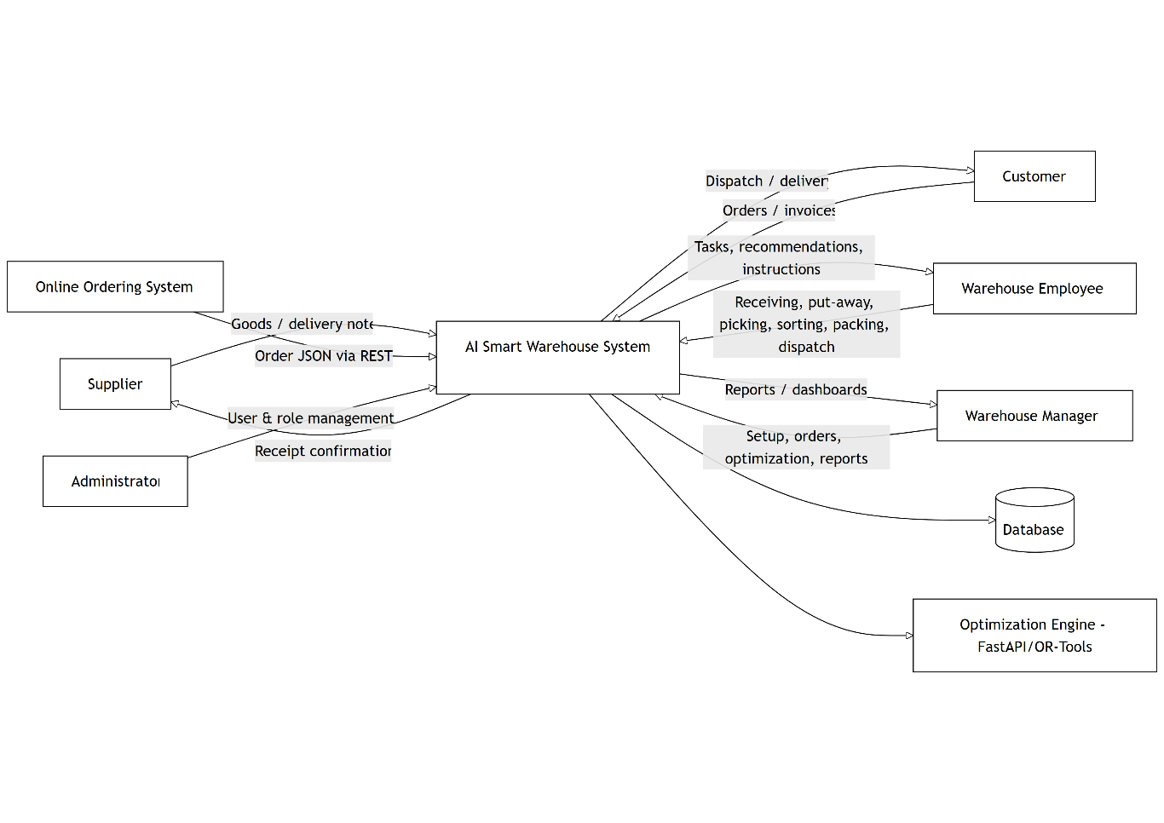
Figure 2 - Component Diagram.
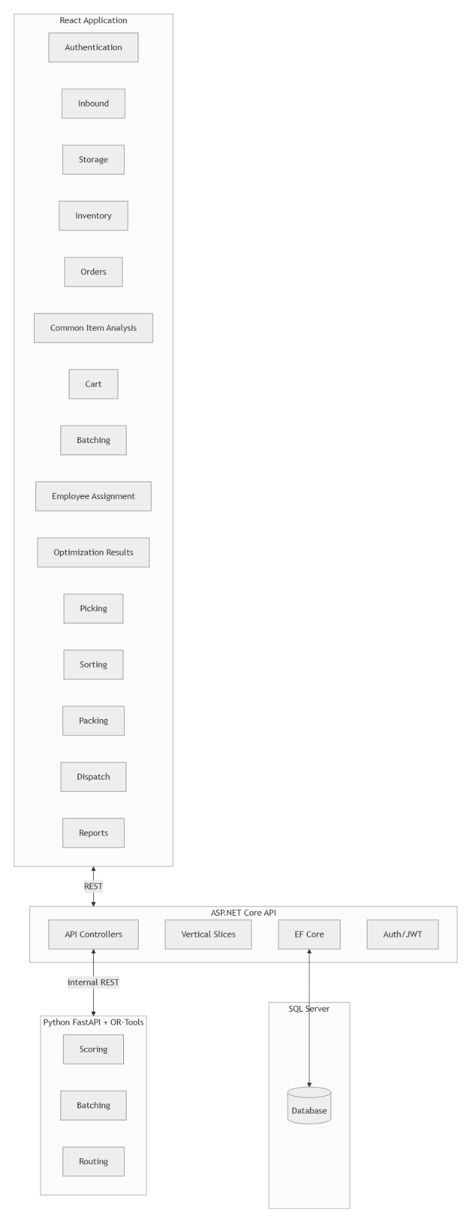
Figure 3 - Deployment Diagram.
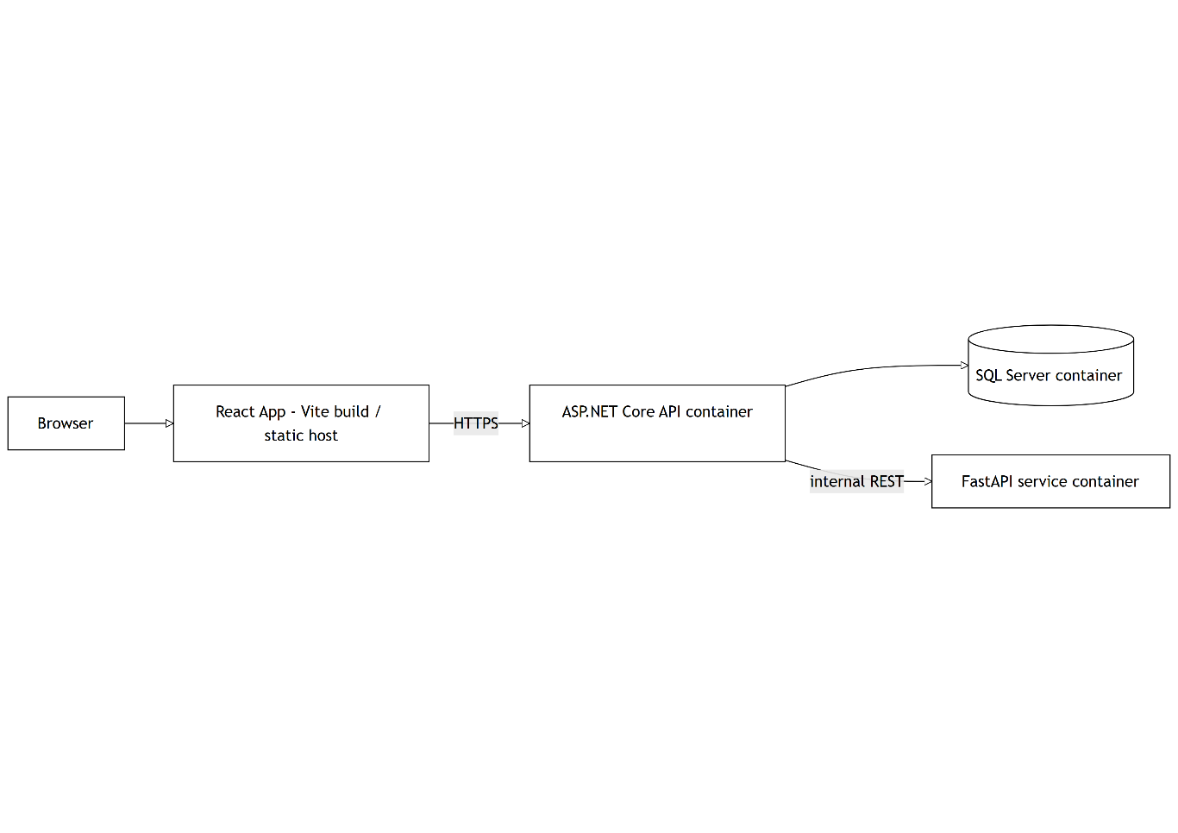
Figure 4 - UML Class Diagram.
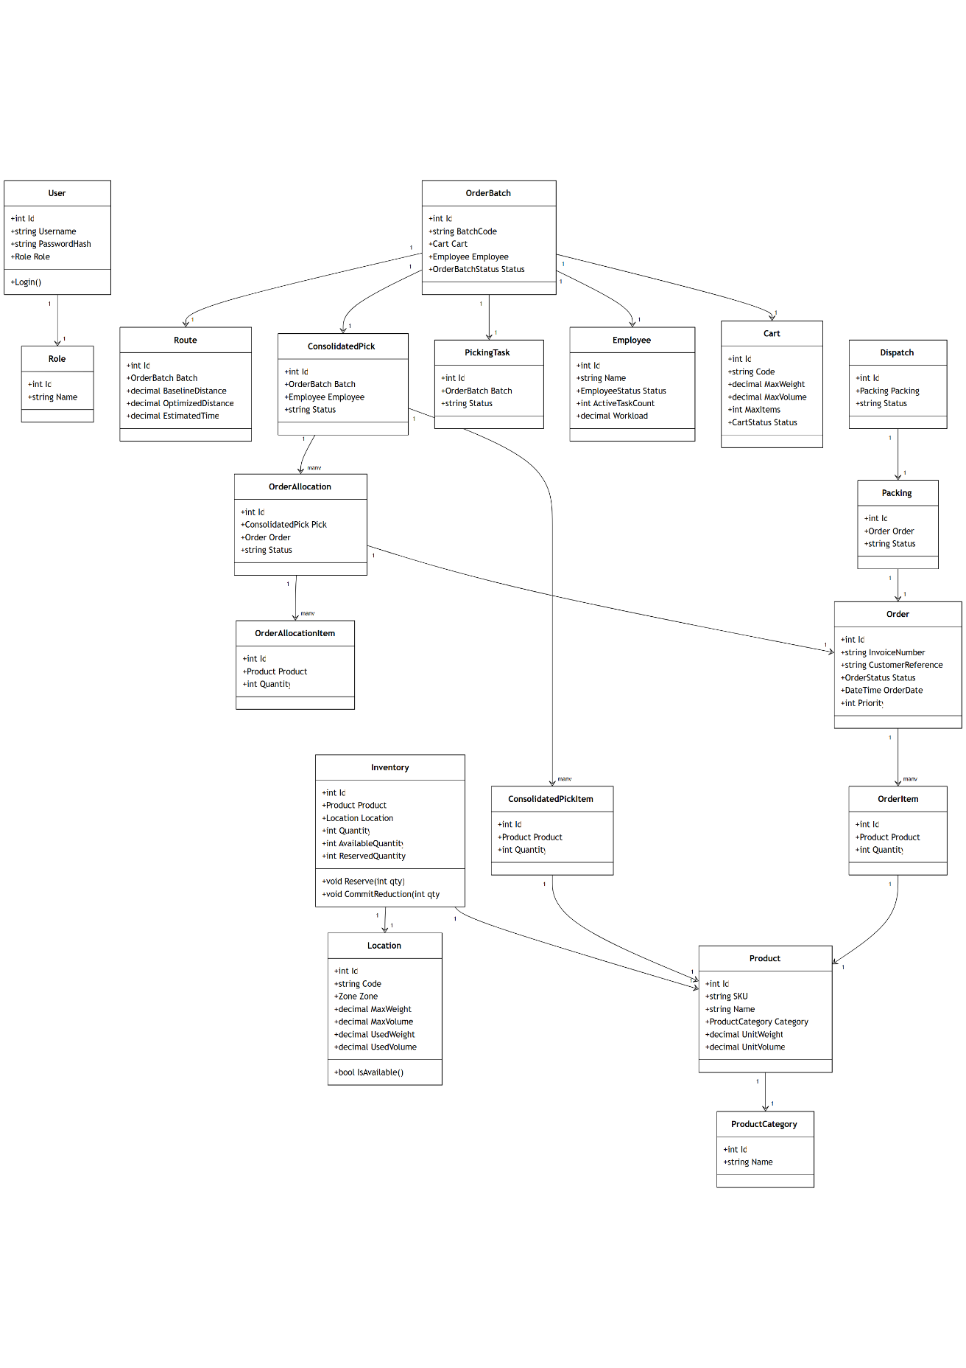
Figure 5 - Entity Relationship Diagram (ERD, 31 entities).

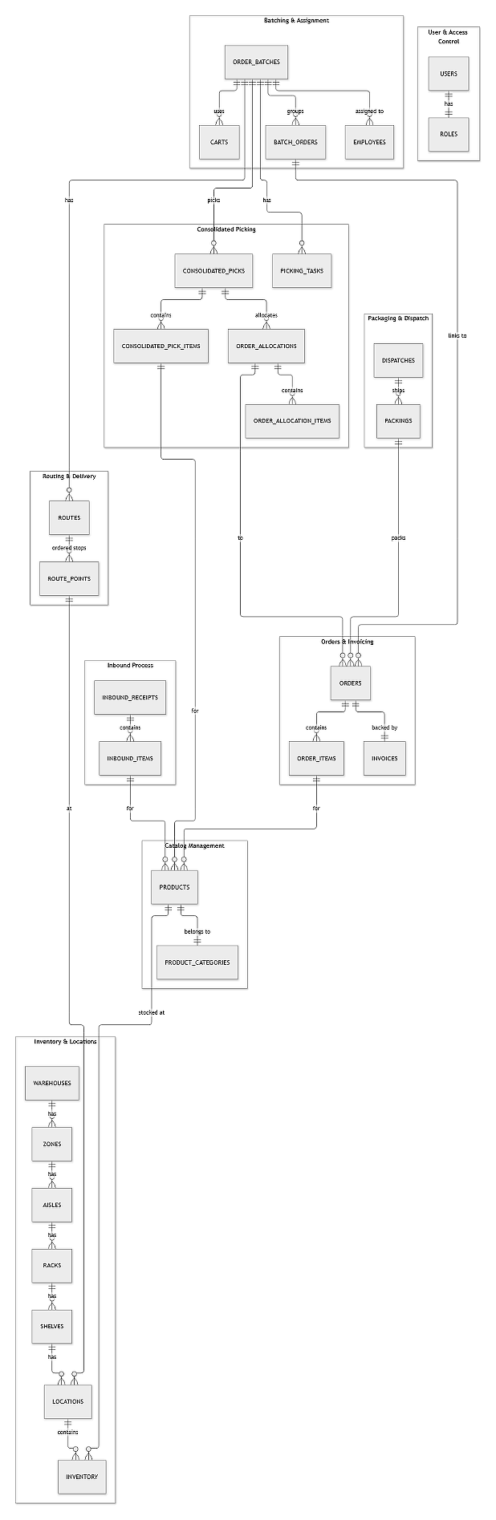
Figure 6 - Use Case Diagram.
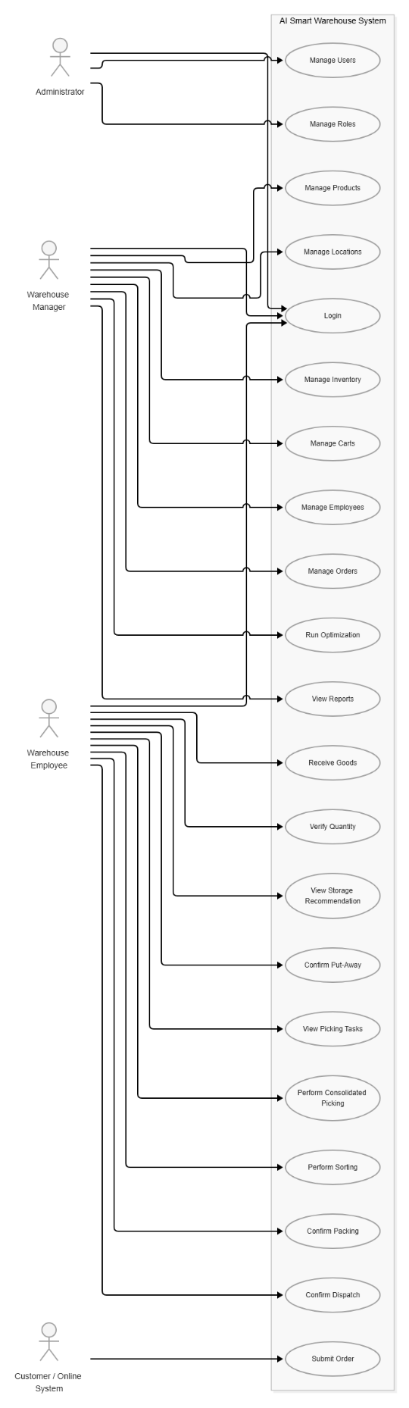
Figure 7 - Data Flow Diagram - Level 1.
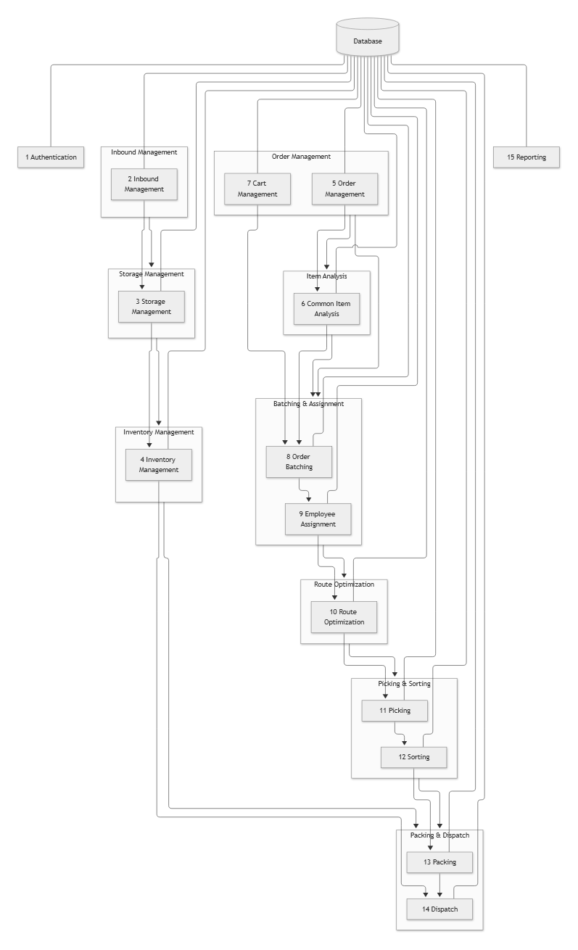
Figure 8 - Overall System Flowchart.
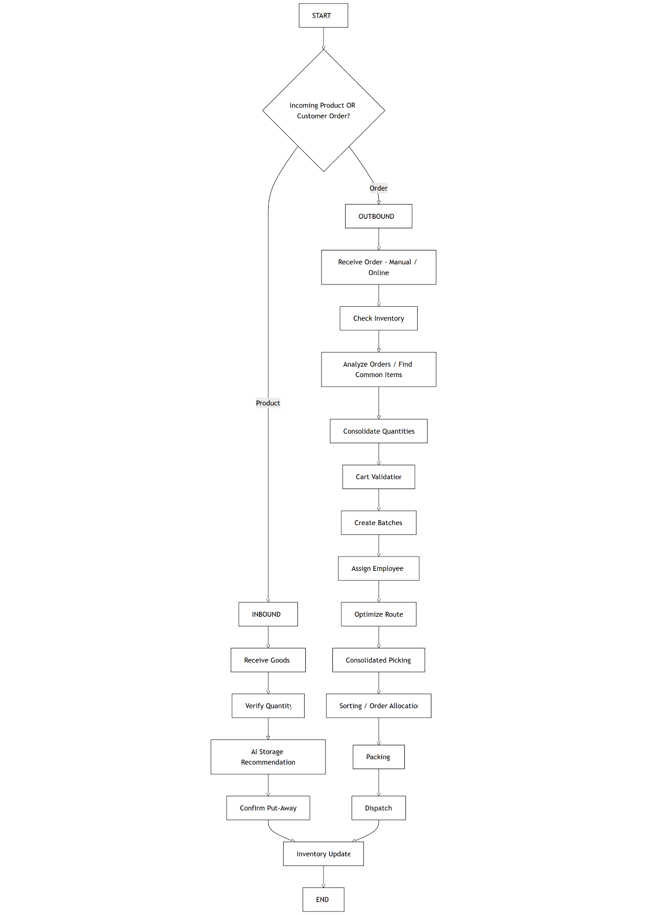
Figure 9 - Complete End-to-End Process (FR-005 to FR-024).
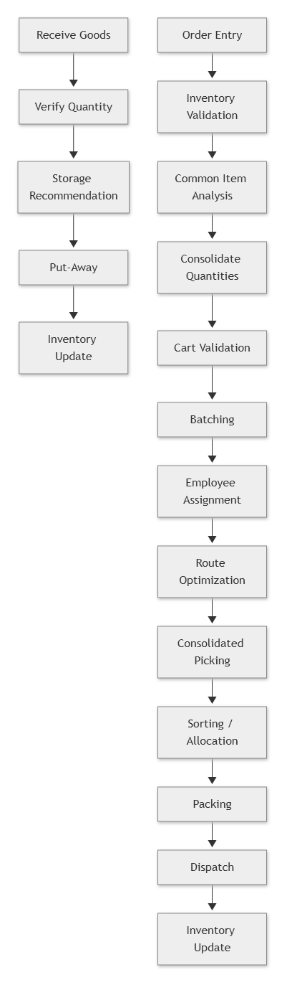
Module-level details for each module (M1 to M9), namely Description and Priority, Stimulus/Response Sequences, and Functional Requirements, are provided in Section 3.

Appendix C: Issues List
Open requirements issue that remain to be resolved – To Be Decided s, pending decisions, needed information, and conflicts awaiting resolution are tracked below and stay updated until sign-off.

No. | Open Issue | Status
1 | Precise scoring weights for FR-007 storage recommendation | Open
2 | Batching algorithm for FR-016 (heuristic vs CP-SAT) + split strategy | Open
3 | Warehouse layout representation for FR-018 (aisle graph vs grid) | Open
4 | OR-Tools timeout policy + fallback confirmation (PE-2) | Open
5 | KPI baseline data collection (manual vs simulation) for FR-024 | Open
6 | FR-025 online-order API payload schema + versioning (M9) | Open
7 | CSV/PDF export formats for FR-024 | Open
8 | Receiving discrepancy threshold for FR-006 manager note | Open
9 | Session lifetime (JWT expiry) and password policy (M1) | Open
10 | Optional barcode scanner / label printer (M7 outbound) | Open/TBD
11 | Revision-history dates, approval signatures, submission date | Pending

