**STAT 652 – STATISTICAL LEARNING**

**Project Report**

***Name: BUI LE LINH***

***Student ID: 301298917***

Contents

1. Introduction 1

2. Dataset 1

3. Methods 1

3.1. Data Exploration and Pre-processing 1

3.2. Model Evaluation Criteria 2

3.3. Statistical Modelling 2

4. Results 3

4.1. Summary of Model Performance 3

4.2. Model Interpretation 4

4.3. Model Checking 5

5. Conclusion 5

5.1. Summary of result 5

5.2. Limitation and Future Research 5

REFERENCES 6

APPENDIX – R CODE 6

# Introduction

The Pima Indians of Arizona have the highest reported prevalence of diabetes of any population in the world [1]. In this analysis, we aim to predict whether a person is tested positive for type 2 diabetes based on several clinical measurements. In addition, we also try to gain insight on the underlying data generating process in this dataset. For that purpose, we will use the Pima Indians Diabetes dataset, which is described in more details in section 2. Section 3 explains methodologies used in our analysis. We interpret and discuss the results in Section 4. In Section 5, We summarize our findings and limitations.

# Dataset

The Pima Indians Diabetes dataset contains diagnostics information of 768 females at least 21 years old and of Pima Indian heritage. Full description of the dataset is available on UCI Machine Learning Repository website [2]. A summary of variables in the dataset is described below:

* *Pregnancies*: Number of times pregnant
* Glucose: Plasma glucose concentration a 2 hours in an oral glucose tolerance test
* *BloodPressure*: Diastolic blood pressure (mm Hg)
* *SkinThickness*: Triceps skin fold thickness (mm)
* *Insulin*: 2-Hour serum insulin (mu U/ml)
* *BMI*: Body mass index (weight in kg/(height in m)^2)
* *DiabetesPedigreeFunction*: Diabetes pedigree function (a synthesis of the diabetes mellitus history in relatives and the genetic relationship of those relatives to the subject)
* *Age*: Age (in years)
* *Outcome*: Whether a subject is tested positive for type 2 diabetes (0-No or 1-Yes)

# Methods

## Data Exploration and Pre-processing

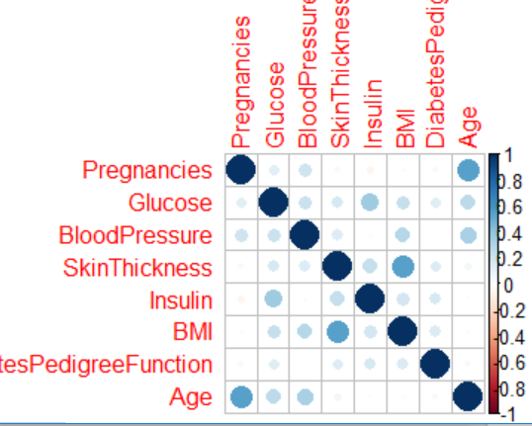We look at several summary statistics to understand the data ranges and check missing vales. *Outcome* only 34.9% is Class 1 (Yes), indicating that the dataset is imbalance. *Glucose*, *BloodPressure*, *SkinThickness*, *Insulin* and *BMI* all contains zero values, which are invalid for these clinical measurements. These values should be treated as missing values. We could simply remove observations with missing values, but that would eliminate about one third of our data. Instead, we will perform imputation for these missing values using median of corresponding variables.

Examining correlation among predictors, we can see a few pairs with high correlation: *Age* and *Pregnancies*, *BMI* and *SkinThickness*, as shown in Figure 3.1.1.

Figure 3.1.1 – Correlation among predictors

For each predictor, we look at the data distribution's differences between the two *Outcome* classes: There does not seem to have noticeable differences in variances between *Outcome* classes, while the mean in class 1 might be higher than in class 0. Plots of such data distributions are shown in Figure 3.1.2 and Figure 3.1.3 in the appendix.

## Model Evaluation Criteria

To evaluate how well a model can predict whether a person is tested positive for type 2 diabetes, we split the dataset into 80% train set and 20% test set using stratified sampling to maintain class ratio in these datasets. We train different statistical models using train set and evaluate the models' performances on the hold-out test set. Since the dataset is imbalance, simple accuracy or misclassification rate is not a suitable evaluation criterion. There are several evaluation criteria we can use for imbalance dataset, such as Kappa, f-score, true positive and true negative rates, and Area Under the Curve (AUC) [2]. In this analysis, we will use AUC as our primary criteria.

## Statistical Modelling

We fit various statistical learning models to predict the *Outcome* variable based on predictors in the dataset. If a model has hyperparameters, the hyperparameters will usually be chosen using 10-fold cross validation.

* **Logistic regression** models the conditional probability of *Outcome* being 1, given the predictors.
* **Ridge logistic regression** is a regularized version of logistic regression with L2 shrinkage penalty.
* **Lasso logistic regression** is another regularized version of logistic regression with L1 shrinkage penalty.
* **Generalized Addictive Model** (GAM) extends logistic regression model by allowing non-linear functions (polynomial, b-splines, natural splines) of predictors, while maintaining additivity. Finding the best basis functions and associated hyperparameters (degrees/degree of freedoms) for all 8 predictors is not trivial because the search space is huge. For each type of non-linear functions, we will use a greedy approach to perform forward-selection for hyperparameters:
  + We start with the simplest model in which there is no transformation for any predictors.
  + We try different degree of freedoms for the first predictor and look at AIC (instead of cross validation to avoid further computation) to choose the best degree of freedom.
  + Keeping the degree of freedom for that predictor, we continue to try different degree of freedoms for the second predictor. The process continues until we select the best degree of freedoms for all 8 predictors.
* **Linear Discriminant Analysis** (LDA) first models the conditional probability of predictors given the response variable *Outcome* and then use Bayes’ theorem to estimate the conditional probability of *Outcome* given the predictors. It assumes that the observations within each class are drawn from a multivariate Gaussian distribution with a class specific mean vector and a covariance matrix that is common to all classes.
* **Quadric Discriminant Analysis** (QDA) is like Linear Discriminant Analysis but it assumes that each class has its own covariance matrix.
* **Decision Tree** consists of a series of splitting rules on predictors to predict *Outcome*.
* **Linear Support Vector Machine** (SVM) aims to find a linear hyper-plane in the original feature space that best separates observations between two classes.
* **Kernel Support Vector Machine** uses a basis function (radial basis function in this case) to enlarge the feature space to capture a non-linear decision boundary in the original feature space.
* **Boosting** involves fitting multiple decision trees sequentially, in which each tree is grown using information from previously grown trees to correct mistakes made by the previous trees.

# Results

## 4.1. Summary of Model Performance

|  |  |
| --- | --- |
| Model | AUC |
| Logistics Regression | 0.8420370 |
| Ridge Regression | 0.8401852 |
| Lasso Regression | 0.8403704 |
| GAM-poly | 0.8761111 |
| GAM-bs | 0.8624074 |
| GAM-ns | 0.8655556 |
| LDA | 0.8409259 |
| QDA | 0.7937037 |
| Linear SVM | 0.8300000 |
| Kernel SVM | 0.8423148 |
| Decision Tree | 0.8193519 |
| Boosting | 0.8427778 |

Model performance in terms of Area Under the Curve (AUC) on test set of various statistical learning models are shown below:

* Ridge regression and Lasso regression's performances are a little worse compared to Logistics Regression. This is probably because the decrease in variance is less than the increase in bias when we make the models less flexible using regularization. In this case, such trade-off is more severe for Lasso which tries to yield a simpler model at the expense of higher bias.
* The performance of Linear Discriminant Analysis is close to Logistics Regression. Quadric Discriminant Analysis has worse performance compared to Linear Discriminant Analysis, suggesting that the quadratic form assumed by QDA may not capture the true relationship compared to the linear forms assumed by LDA and logistic regression, leading to high variance.
* Kernel SVM with radial basis function has higher performance compared to Linear SVM, suggesting that the true decision boundary might be non-linear.
* Decision Tree has quite low performance, which is expected because Decision Tree usually does not possess high prediction accuracy.
* Boosting model also has better performance compared to Decision Tree Logistics Regression because boosting technique usually manages to reduce both bias and variance.
* Generalized Additive Models have superior performance, with polynomial functions result in model having the highest AUC score. This means the smooth combination of non-linear functions in GAM significantly improves the models.

Although Boosting has higher AUC compared to Logistic Regression, the difference is very small. If we only look at the original features, Logistics Regression performs reasonably well compared to other models. However, extending the features with non-linear functions significantly improve AUC. We select **Generalized Additive Model with polynomial function** (GAM-poly)as our best model.

At threshold of 0.5, the GAM-poly model has the following performance on test set: Accuracy of **82.47%**, Sensitivity (True Positive Rate) of **87.00%**, and Specificity (1-False Positive Rate) of **74.07%**. As a comparison, Logistics Regression model only has Accuracy of 79%, Sensitivity of 90% and Specificity of 59.26%.

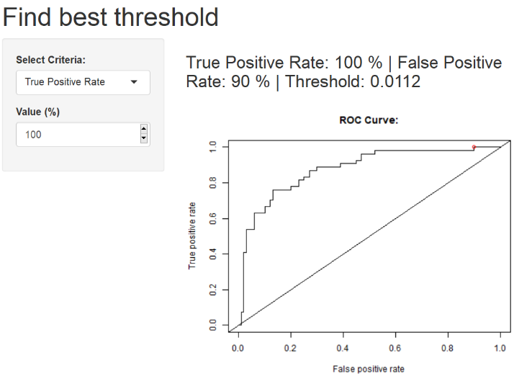We can change the cut-off threshold to achieve a specific level of Sensitivity or Specificity. Receiver Operating Characteristic (ROC) curve plots true positive rate again false positive rate at different thresholds. We implement a simple interactive dashboard with R Shiny to find the best threshold given a specific True Positive or False Positive Rate, as illustrated in Figure 4.1.1. Looking at the ROC curve, we can the trade-off between high True Positive Rate and low False Positive Rate: To achieve 100% True Positive Rate, we would have to accept 90% False Positive Rate, while to achieve almost no False Positive, we would have to accept a very low 2% True Positive Rate. Figure 4.1.1 – ROC curve interactive dashboard

## 4.2. Model Interpretation

The selected polynomial degrees for predictors in GAM-poly model:



We fit the GAM-poly model using all available data and looking at coefficient estimates:

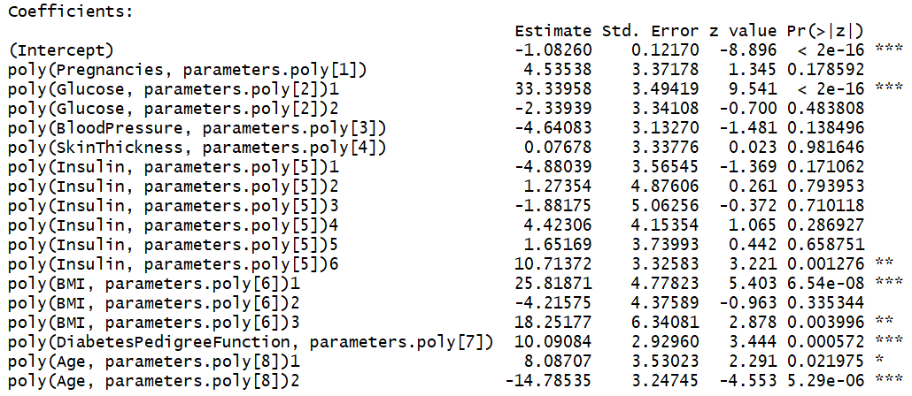

p-values in t-test for the coefficients show that *Glucose*, *Insulin6*, *BMI*, *BMI3*, *DiabetesPedigreeFunction, Age* and *Age*2 are significant, given other variables in the model. Since polynomials in our GAM-poly model are raw instead of orthogonal, we can interpret the coefficients directly. For example, increase *Glucose* by 1 would increase the estimated log-odd of having diabetes by *33.34-2.34*(2*Glucose+1),* given other predictors remain the same. Increase *DiabetesPedigreeFunction* by 1 would increase the estimated log-odd of having diabetes by 10.09, given other predictors remain the same.

## 4.3. Model Checking

Goodness-of-fit (GOF) statistics are often computed as more objective measures of the overall fit of a model. With model containing continuous variables, the Hosmer and Lemeshow test [3] would be an appropriate Goodness of Fit test. Hosmer and Lemeshow test statistics has p-value = 0.67 >> 0.05, suggesting the model fit is not bad. Look at standardized residuals, we can see there are 23 potential outliers (0.046%) with standardized residual beyond 2 and 10 extreme outliers (0.017%) with standardized residual beyond 3. We also identify 55 potential influential observations using several criteria, including Leverage and Cook’s Distance [4].

# Conclusion

## 5.1. Summary of result

In summary, we have analyzed the Pima Indians Diabetes dataset to gain insight on underlying data distribution. We apply different statistical learning techniques to predict whether a person is tested positive for type 2 diabetes based on clinical measurements. Except for Quadric Discriminant Analysis which has very low performance, other models have moderate performance in terms of AUC. Boosting marginally outperforms Logistics Regression, but Boosting is difficult to interpret. Generalized Additive Models have superior performance, with polynomial functions result in model with noticeably higher AUC.

We implement a simple interactive dashboard to understand the trade-off between True Positive Rate and False Positive Rate of the GAM-poly model. The GAM-poly model is also used to interpret the relationship between predictors and the response variable *Outcome*. *Pregnancies*, *Glucose*, *BMI*, *DiabetesPedigreeFunction* are important, given other variables in the model. The model fit is not bad, and we identify 10 extreme outliers and 55 potential influential observations in the dataset.

## 5.2. Limitation and Future Research

There are two main limitations associated with the GAM-poly model that we use in this analysis. First, the approach to find optimal basis function and hyperparameters might be too greedy. We only apply one non-linear functions for all predictors in our generalized addictive models. Perhaps, allowing different basis functions for different predictors would help improve model fit. Second, the model is restricted to be additive and does not consider interaction effect. Such interactions effects can be added manually or fit using multi-dimensional smoothers, such as local regression, or two-dimensional splines [5]. Finally, if the goal is mainly prediction, it might be a good idea to perform model stacking to improve on prediction.

# REFERENCES

1. *Leslie J. Baier, and Robert L. Hanson (2004),* Genetic Studies of the Etiology of Type 2 Diabetes in Pima Indians*, American Diabetes Association*
2. *László A. Jeni, Jeffrey F. Cohn, and Fernando D. Torre1 (2015),* Facing Imbalanced Data Recommendations for the Use of Performance Metrics*, National Center for Biotechnology Information*
3. *Christopher R. Bilder and Thomas M. Loughin*, Analysis of Categorical Variable with R, *Page 293*.
4. *Christopher R. Bilder and Thomas M. Loughin*, Analysis of Categorical Variable with R, *Page 296*.
5. *Robert T. and Trevor H.*, An Introduction to Statistical Learning, *Page 286*.

# APPENDIX – R CODE

**R version:** 3.4.0

**Packages:**

* corrplot
* ggplot2
* caret
* glmnet
* gam
* MASS
* rpart
* e1071
* gbm
* shinyApp

**External codes:**

* multiplot.R: <http://www.cookbook-r.com/Graphs/Multiple_graphs_on_one_page_(ggplot2)/>
* AllGOFTests.R: <http://www.chrisbilder.com/categorical/Chapter5/AllGOFTests.R>
* glmDiagnostics.R: <http://www.chrisbilder.com/categorical/Chapter5/AllGOFTests.R>

**List of R code files:**

* project.Rmd: The main project R markdown file to generate above analyses and charts. The time to knit the code should be about 2-3 minutes. In addition to the R packages, the code also relies on three external R code files listed above for plotting and model diagnosis.
* shinnyApp.R: The main app to run interactive dashboard shown in Figure 4.1.1
  + shinnyApp/ui.R: R file to define UI for the interactive dashboard
  + shinnyApp/server.R: R file to define logic for the interactive dashboard

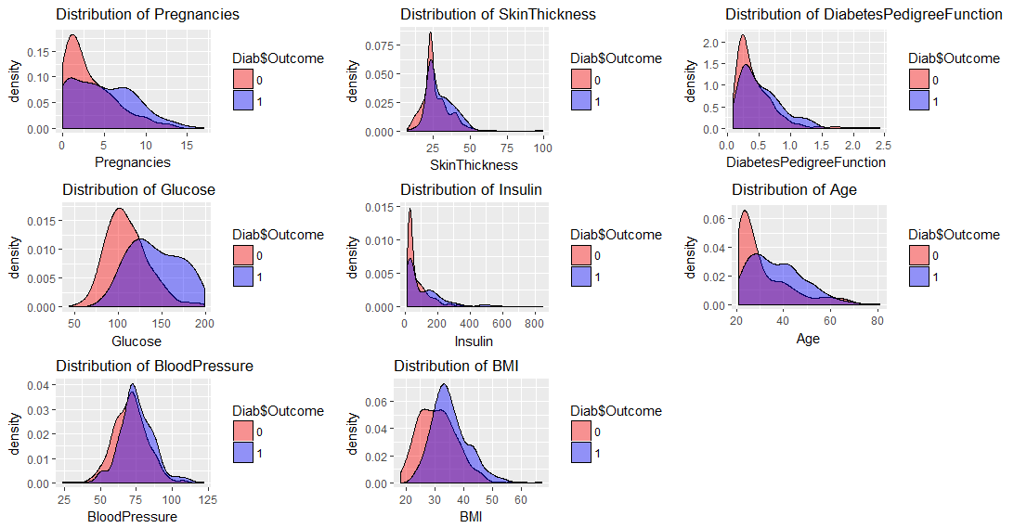

Figure 3.1.2 – Approximated density function for each predictor per *Outcome* class

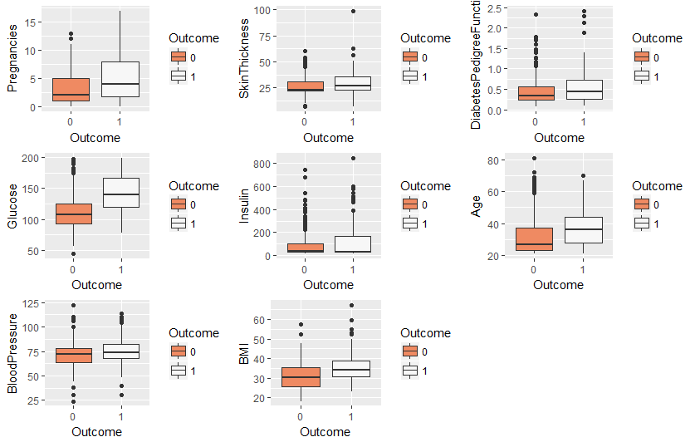

Figure 3.1.3 – Box-plot for each predictor per *Outcome* class

**project.R**

**#Data Pre-processing and Exploration#**

```{r}

#Read data

Diab <- read.csv("pima-diabetes.csv")

summary(Diab)

```

```{r}

#Data Pre-processing

Diab$Glucose[Diab$Glucose==0] <- median(Diab$Glucose)

Diab$BloodPressure[Diab$BloodPressure==0] <- median(Diab$BloodPressure)

Diab$Insulin[Diab$Insulin==0] <- median(Diab$Insulin)

Diab$BMI[Diab$BMI==0] <- median(Diab$BMI)

Diab$SkinThickness[Diab$SkinThickness==0] <- median(Diab$SkinThickness)

Diab2 <- Diab #data used for boosting later since gbm cannot handle factor variable

Diab$Outcome <- as.factor(Diab$Outcome)

```

```{r}

#Correlation Plot

library(corrplot)

corr <- cor(Diab[, -9])

corrplot(corr)

```

```{r}

#Density Function for each predictor ~ Outcome

library(ggplot2)

source('multiplot.R')

p1 <- ggplot(Diab,aes(x=Pregnancies,fill=Diab$Outcome))+geom_density(alpha=0.4)+scale_fill_manual(values=c("red", "blue"))+labs(title="Distribution of Pregnancies")

p2 <- ggplot(Diab,aes(x=Glucose,fill=Diab$Outcome))+geom_density(alpha=0.4)+scale_fill_manual(values=c("red", "blue"))+labs(title="Distribution of Glucose")

p3 <- ggplot(Diab,aes(x=BloodPressure,fill=Diab$Outcome))+geom_density(alpha=0.4)+scale_fill_manual(values=c("red", "blue"))+labs(title="Distribution of BloodPressure")

p4 <- ggplot(Diab,aes(x=SkinThickness,fill=Diab$Outcome))+geom_density(alpha=0.4)+scale_fill_manual(values=c("red", "blue"))+labs(title="Distribution of SkinThickness")

p5 <- ggplot(Diab,aes(x=Insulin,fill=Diab$Outcome))+geom_density(alpha=0.4)+scale_fill_manual(values=c("red", "blue"))+labs(title="Distribution of Insulin")

p6 <- ggplot(Diab,aes(x=BMI,fill=Diab$Outcome))+geom_density(alpha=0.4)+scale_fill_manual(values=c("red", "blue"))+labs(title="Distribution of BMI")

p7 <- ggplot(Diab,aes(x=DiabetesPedigreeFunction,fill=Diab$Outcome))+geom_density(alpha=0.4)+scale_fill_manual(values=c("red", "blue"))+labs(title="Distribution of DiabetesPedigreeFunction")

p8 <- ggplot(Diab,aes(x=Age,fill=Diab$Outcome))+geom_density(alpha=0.4)+scale_fill_manual(values=c("red", "blue"))+labs(title="Distribution of Age")

multiplot(p1, p2, p3, p4, p5, p6, p7, p8, cols=2)

```

```{r}

#Box-plot for each predictor ~ Outcome

p1 <- ggplot(Diab,aes(x=Outcome,y=Pregnancies,fill=Outcome))+geom_boxplot()+scale_fill_brewer(palette="RdBu")

p2 <- ggplot(Diab,aes(x=Outcome,y=Glucose,fill=Outcome))+geom_boxplot()+scale_fill_brewer(palette="RdBu")

p3 <- ggplot(Diab,aes(x=Outcome,y=BloodPressure,fill=Outcome))+geom_boxplot()+scale_fill_brewer(palette="RdBu")

p4 <- ggplot(Diab,aes(x=Outcome,y=SkinThickness,fill=Outcome))+geom_boxplot()+scale_fill_brewer(palette="RdBu")

p5 <- ggplot(Diab,aes(x=Outcome,y=Insulin,fill=Outcome))+geom_boxplot()+scale_fill_brewer(palette="RdBu")

p6 <- ggplot(Diab,aes(x=Outcome,y=BMI,fill=Outcome))+geom_boxplot()+scale_fill_brewer(palette="RdBu")

p7 <- ggplot(Diab,aes(x=Outcome,y=DiabetesPedigreeFunction,fill=Outcome))+geom_boxplot()+scale_fill_brewer(palette="RdBu")

p8 <- ggplot(Diab,aes(x=Outcome,y=Age,fill=Outcome))+geom_boxplot()+scale_fill_brewer(palette="RdBu")

multiplot(p1, p2, p3, p4, p5, p6, p7, p8, cols=2)

```

**#Evaluation Criteria Definition#**

```{r}

#Train-Test Split

set.seed(13)

library(caret)

testset <- createDataPartition(Diab$Outcome, p = 0.2, list = FALSE)

Diab.test <- Diab[testset,]

Diab.train <- Diab[-testset,]

```

```{r}

#AUC

library(ROCR)

caculate_auc <- function(probs) {

pred <- prediction(probs, Diab.test$Outcome)

auc.perf = performance(pred, measure = "auc")

return (auc.perf@y.values[[1]])

}

```

**#Statistical Modelling#**

```{r}

#Logistics Regression

mod.lm <- glm(Outcome ~ ., data = Diab.train, family = binomial(link='logit'))

pred.probs = predict(mod.lm, Diab.test, type="response")

auc.lm <- caculate_auc(pred.probs)

```

```{r}

#Ridge logistics regression

library(glmnet)

X.train <- model.matrix(Outcome ~ ., data = Diab.train)

X.test <- model.matrix(Outcome ~ ., data = Diab.test)

lambdas <- 10^{seq(from=-2,to=5,length=100)}

cv.ridge <- cv.glmnet(X.train, Diab.train$Outcome, alpha = 0, lambda = lambdas, standardize=TRUE, family="binomial")

lambda.best <- cv.ridge$lambda.min

pred.probs <- predict(cv.ridge, s = lambda.best, newx = X.test, type="response")

auc.ridge <- caculate_auc(pred.probs)

```

```{r}

#Lasso logistics regression

lambdas <- 10^{seq(from=-2,to=5,length=100)}

cv.lasso <- cv.glmnet(X.train, Diab.train$Outcome, alpha = 1, lambda = lambdas, standardize=TRUE, family="binomial")

lambda.best <- cv.lasso$lambda.min

pred.probs <- predict(cv.lasso, s = lambda.best, newx = X.test, type="response")

auc.lasso <- caculate_auc(pred.probs)

```

```{r}

#Generalized Addictive Models - Polynomial

library(gam)

choices <- c(1, 2, 3,4,5,6,7,8)

parameters <- c(1,1,1,1,1,1,1,1)

best_aic = mod.lm$aic

for (i in c(1:8)) {

t_parameters <- parameters

for (k in choices) {

t_parameters[i] <- k

mod.gam <- glm(Outcome~poly(Pregnancies, t_parameters[1], raw=T) + poly(Glucose, t_parameters[2], raw=T)

+ poly(BloodPressure, t_parameters[3], raw=T) + poly(SkinThickness, t_parameters[4], raw=T)

+ poly(Insulin, t_parameters[5], raw=T) + poly(BMI, t_parameters[6], raw=T)

+ poly(DiabetesPedigreeFunction, t_parameters[7], raw=T) + poly(Age, t_parameters[8], raw=T),

data=Diab.train, family=binomial(link=logit))

gam.aic <- mod.gam$aic

if (gam.aic < best_aic) {

best_aic <- gam.aic

parameters[i] <- k

}

}

}

parameters.poly <- parameters

mod.gam.poly <- glm(Outcome~poly(Pregnancies, parameters.poly[1]) + poly(Glucose, parameters.poly[2]) + poly(BloodPressure, parameters.poly[3])

+ poly(SkinThickness, parameters.poly[4]) + poly(Insulin, parameters.poly[5]) + poly(BMI, parameters.poly[6])

+ poly(DiabetesPedigreeFunction, parameters.poly[7]) + poly(Age, parameters.poly[8]),

data=Diab.train, family=binomial(link=logit))

pred.probs = predict(mod.gam.poly, Diab.test, type="response")

auc.gam.poly <- caculate_auc(pred.probs)

```

```{r}

#Generalized Addictive Models - B-splines

choices <- c(1, 2, 3,4,5,6,7,8)

parameters <- c(1,1,1,1,1,1,1,1)

best_aic = mod.lm$aic

for (i in c(1:8)) {

t_parameters <- parameters

for (k in choices) {

t_parameters[i] <- k

mod.gam <- gam(Outcome~bs(Pregnancies, t_parameters[1]) + bs(Glucose, t_parameters[2]) + bs(BloodPressure, t_parameters[3])

+ bs(SkinThickness, t_parameters[4]) + bs(Insulin, t_parameters[5]) + bs(BMI, t_parameters[6])

+ bs(DiabetesPedigreeFunction, t_parameters[7]) + bs(Age, t_parameters[8]),

data=Diab.train, family=binomial(link=logit))

gam.aic <- mod.gam$aic

if (gam.aic < best_aic) {

best_aic <- gam.aic

parameters[i] <- k

}

}

}

parameters.bs <- parameters

mod.gam.bs <- gam(Outcome~bs(Pregnancies, parameters.bs[1]) + bs(Glucose, parameters.bs[2]) + bs(BloodPressure, parameters.bs[3])

+ bs(SkinThickness, parameters.bs[4]) + bs(Insulin, parameters.bs[5]) + bs(BMI, parameters.bs[6])

+ bs(DiabetesPedigreeFunction, parameters.bs[7]) + bs(Age, parameters.bs[8]),

data=Diab.train, family=binomial(link=logit))

pred.probs = predict(mod.gam.bs, Diab.test, type="response")

auc.gam.bs <- caculate_auc(pred.probs)

```

```{r}

#Generalized Addictive Models - Natural Splines

choices <- c(1, 2, 3,4,5,6,7,8)

parameters <- c(1,1,1,1,1,1,1,1)

best_aic = mod.lm$aic

for (i in c(1:8)) {

t_parameters <- parameters

for (k in choices) {

t_parameters[i] <- k

mod.gam <- gam(Outcome~ns(Pregnancies, t_parameters[1]) + ns(Glucose, t_parameters[2]) + ns(BloodPressure, t_parameters[3])

+ ns(SkinThickness, t_parameters[4]) + ns(Insulin, t_parameters[5]) + ns(BMI, t_parameters[6])

+ ns(DiabetesPedigreeFunction, t_parameters[7]) + ns(Age, t_parameters[8]),

data=Diab.train, family=binomial(link=logit))

gam.aic <- mod.gam$aic

if (gam.aic < best_aic) {

best_aic <- gam.aic

parameters[i] <- k

}

}

}

parameters.ns <- parameters

mod.gam.ns <- gam(Outcome~ns(Pregnancies, parameters.ns[1]) + ns(Glucose, parameters.ns[2]) + ns(BloodPressure, parameters.ns[3])

+ ns(SkinThickness, parameters.ns[4]) + ns(Insulin, parameters.ns[5]) + ns(BMI, parameters.ns[6])

+ ns(DiabetesPedigreeFunction, parameters.ns[7]) + ns(Age, parameters.ns[8]),

data=Diab.train, family=binomial(link=logit))

pred.probs = predict(mod.gam.ns, Diab.test, type="response")

auc.gam.ns <- caculate_auc(pred.probs)

```

```{r}

#Linear Discriminant Analysis

library(MASS)

mod.lda <- lda(Outcome ~ ., data = Diab.train)

pred.probs = predict(mod.lda, Diab.test, type="response")$posterior[ ,2]

auc.lda <-caculate_auc(pred.probs)

```

```{r}

#Quadric Discriminant Analysis

mod.qda <- qda(Outcome ~ ., data = Diab.train)

pred.probs = predict(mod.qda, Diab.test, type="response")$posterior[ ,2]

auc.qda <- caculate_auc(pred.probs)

```

```{r}

#Decision Tree

library(rpart)

mod.tree <- rpart(Outcome ~ ., data = Diab.train, method = "class")

pred.probs <- predict(mod.tree, Diab.test, type="prob")[,2]

auc.tree <-caculate_auc(pred.probs)

#plot(mod.tree)

#text(mod.tree)

```

```{r}

#Linear Support Vector Machine

library(e1071)

tune.linear <- tune(svm, Outcome ~ ., data = Diab.train, kernel = "linear", probability=TRUE, scale=TRUE,

ranges = list(cost = c(0.001, 0.01, 0.1, 1, 5, 10, 100)))

svm.linear <- tune.linear$best.model

pred.probs <- predict(svm.linear, Diab.test, type="response", probability=TRUE)

pred.probs <- attr(pred.probs,"probabilities")[,2]

auc.svm.linear <- caculate_auc(pred.probs)

```

```{r}

#Kernel Support Vector Machine

tune.radial <- tune(svm, Outcome ~ ., data = Diab.train, kernel = "radial", probability=TRUE, scale=TRUE,

ranges = list(cost = c(0.001, 0.01, 0.1, 1, 5, 10, 100),

gamma = c(0.001, 0.01, 1, 5, 10, 100)))

svm.radial <- tune.radial$best.model

pred.probs <- predict(svm.radial, Diab.test, type="response", probability=TRUE)

pred.probs <- attr(pred.probs,"probabilities")[,2]

auc.svm.radial <-caculate_auc(pred.probs)

```

```{r}

#Boosting

library(gbm)

Diab2.test <- Diab2[testset,]

Diab2.train <- Diab2[-testset,]

n.trees.list <- c(100, 500, 1000, 2000, 5000)

cv.error.list <- rep(NA, length(n.trees.list))

for (i in 1:length(n.trees.list)) {

mod.boost <- gbm(Outcome ~ ., data = Diab2.train, distribution = "bernoulli",

cv.folds = 10, n.trees = n.trees.list[i], shrinkage = 0.01)

cv.error <- mod.boost$cv.error[gbm.perf(mod.boost, plot.it = FALSE, method="cv")]

cv.error.list[i] <- cv.error

}

n.trees.best <- n.trees.list[which.min(cv.error.list)]

pred.probs = predict(mod.boost, Diab2.test, n.trees = n.trees.best, type="response")

auc.boosting <- caculate_auc(pred.probs)

```

**#Model Performance Summary#**

```{r}

#Summary of model performance

models <-c("Logistics Regression", "Ridge Regression", "Lasso Regression",

"GAM-poly", "GAM-bs", "GAM-ns",

"LDA", "QDA",

"Linear SVM", "Kernel SVM", "Decision Tree", "Boosting")

auc.list <-c(auc.lm, auc.ridge, auc.lasso, auc.gam.poly, auc.gam.bs, auc.gam.ns, auc.lda, auc.qda, auc.svm.linear, auc.svm.radial, auc.tree, auc.boosting)

auc.df <- data.frame(models, auc.list)

names(auc.df) <- c("Model", "AUC")

print(auc.df)

```

```{r}

#Confusion Matrix for the best model:

pred.probs = predict(mod.gam.poly, Diab.test, type="response")

pred.label <- ifelse(pred.probs > 0.5, 1, 0)

xtab <- table(pred.label, Diab.test$Outcome)

confusionMatrix(xtab)

```

```{r}

#ROC Curve for the best model:

pred <- prediction(pred.probs, Diab.test$Outcome)

perf <- performance(pred, "tpr", "fpr")

plot(perf)

abline(a=0, b= 1)

title(paste("Logistic Regression - AUC:",round(auc.gam.poly,4)))

```

```{r}

# Save ROC data for interactive dashboard

save(perf, file = "shinyApp/perf.RData")

```

**#Model Interpretation and Diagnosis#**

```{r}

#Model Parameters

print(paste("Degrees", names(Diab.train)[-9], ":", parameters.poly))

mod.fit <- glm(Outcome~poly(Pregnancies, parameters.poly[1]) + poly(Glucose, parameters.poly[2]) + poly(BloodPressure, parameters.poly[3])

+ poly(SkinThickness, parameters.poly[4]) + poly(Insulin, parameters.poly[5]) + poly(BMI, parameters.poly[6])

+ poly(DiabetesPedigreeFunction, parameters.poly[7]) + poly(Age, parameters.poly[8]),

data=Diab, family=binomial(link=logit))

summary(mod.fit)

```

```{r}

# Goodness of fit

source("AllGOFTests.R")

HL <- HLTest(obj=mod.fit, g = 100)

HL

```

```{r}

#Outliers

s.res = rstandard(mod.fit, type="pearson")

s.res.beyond2 <- which(s.res > 2 | s.res < -2)

paste("Number of observations with standardized residual beyond 2:", length(s.res.beyond2))

s.res.beyond3 <- which(s.res > 3 | s.res < -3)

paste("Number of observations with standardized residual beyond 3:", length(s.res.beyond3))

```

```{r}

#Influence

source("glmDiagnostics.R")

influentials <- glmInflDiag(mod.fit = mod.fit, print.output=FALSE, which.plots = FALSE)

paste("Number of influential points:", nrow(influentials))

```

**shinnyApp.R**

library(shiny)

runApp("shinyApp")

#NOTE: If you see an error "cannot coerce type 'S4' to vector of type 'double'", please run the App again and it should work. This seems to be shinyApp issue with some R version.

**shinnyApp/ui.R**

library(shiny)

# Define UI for miles per gallon application

shinyUI(pageWithSidebar(

# Application title

headerPanel("Find best threshold"),

sidebarPanel(

selectInput("variable", "Select Criteria:",

list("True Positive Rate" = "tpr",

"False Positive Rate" = "fpr")),

numericInput("rate", "Value (%)", 100, min = 0, max = 100, step = NA, width = NULL)

),

mainPanel(

h3(textOutput("caption")),

plotOutput("mpgPlot")

)

))

**shinnyApp/server.R**

library(shiny)

#Read ROC data

load("perf.RData")

thresholds <- data.frame(threshold=perf@alpha.values[[1]], fpr=perf@x.values[[1]],

tpr=perf@y.values[[1]])

# function to find best threshold, tpr and fpr based a specific criteria

get_point <- function(variable, rate) {

if (variable=="fpr") {

thresholds2 <- thresholds[order(thresholds$tpr, decreasing=TRUE),]

thresholds_filter <- thresholds2[thresholds2$fpr <= rate,]

rownames(thresholds_filter) <- 1:nrow(thresholds_filter)

best_threshold <- thresholds_filter[1,1]

if (is.infinite(best_threshold)) {best_threshold <- 1}

best_tpr <- thresholds_filter[1,3]

best_fpr <- thresholds_filter[1,2]

return(c(best_threshold, best_tpr, best_fpr))

}

else {

thresholds2 <- thresholds[order(thresholds$fpr, decreasing=FALSE),]

thresholds_filter <- thresholds2[thresholds2$tpr >= rate,]

rownames(thresholds_filter) <- 1:nrow(thresholds_filter)

best_threshold <- thresholds_filter[1,1]

if (is.infinite(best_threshold)) {best_threshold <- 1}

best_tpr <- thresholds_filter[1,3]

best_fpr <- thresholds_filter[1,2]

return(c(best_threshold, best_tpr, best_fpr))

}

}

# Define server logic required to plot

shinyServer(function(input, output) {

# get best threshold, tpr and fpr

currentFib <- reactive({ get_point(input$variable, input$rate/100) })

# Compute the forumla text in a reactive expression

formulaText <- reactive({

text_threshold <- paste("Threshold: ", round(currentFib()[1], 4))

text_tpr <- paste("True Positive Rate: ", round(currentFib()[2]*100,2), "%")

text_fpr <- paste("False Positive Rate: ", round(currentFib()[3]*100,2), "%")

return(paste(text_tpr, text_fpr, text_threshold, sep=" | "))

})

# Return the formula text for printing as a caption

output$caption <- renderText({

formulaText()

})

# Generate a plot

output$mpgPlot <- renderPlot({

plot(perf)

abline(a=0, b= 1)

points(x=currentFib()[3], y=currentFib()[2], type="p", pch=1, col="red", cex=1)

title(paste("ROC Curve:"))

})

})