Use Case Diagram:

How works the application

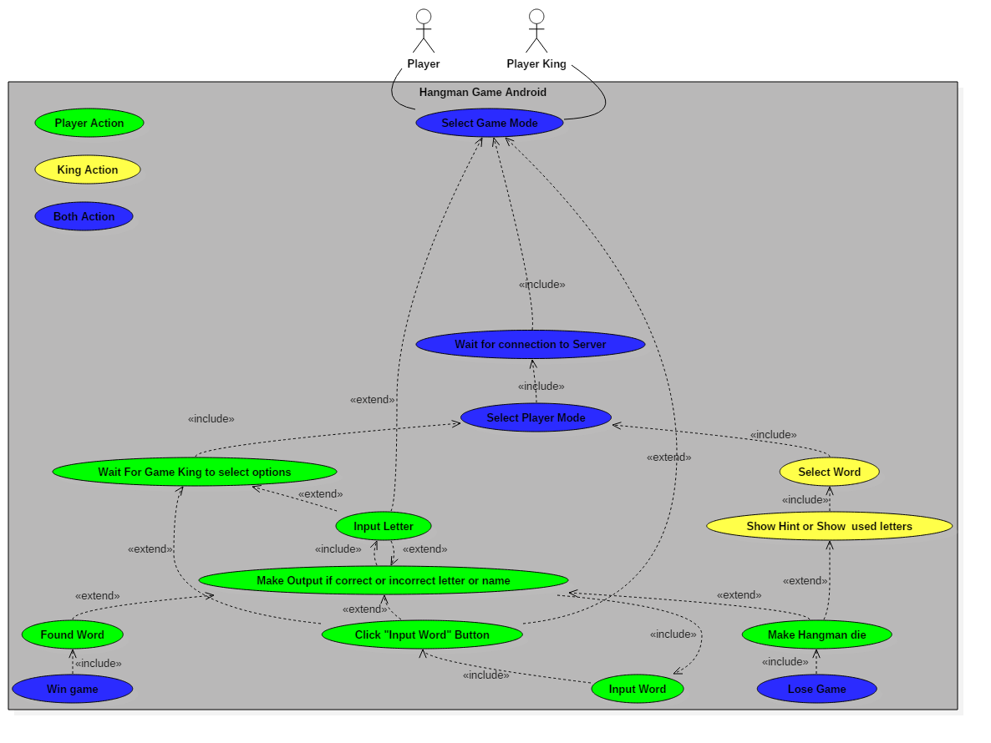

Green are players only actions

Yellow are king only actions

Blue is players and king actions

Class Diagram:

All Application files

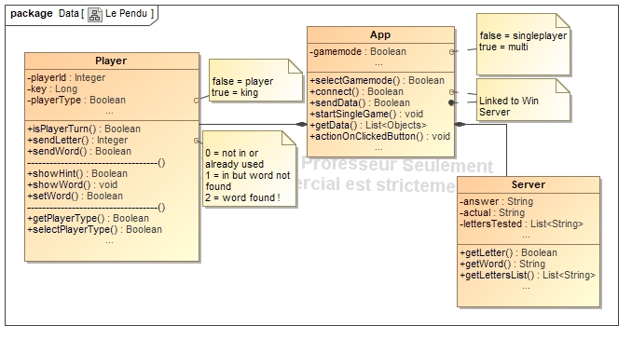

Player is players related methods and variables

App is the main class

Server is for local server while there is no Windows server

Activity : main_activity

App launch activity

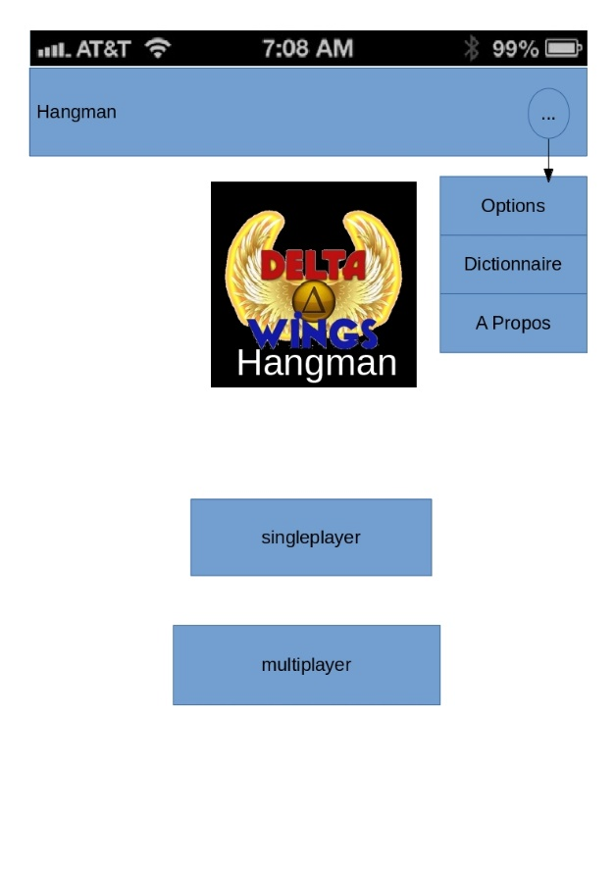

Button btnTopBar

Image logo

Button btnOptions

Button btnDictionary

Button btnAbout

Button btnSingleplayer

Button btnMultiplayer

if click on btnSingleplayer

set mode to singpleplayer

launch local server

launch game_activity

If click on btnTopBar

If state is hidden : Show btnOptions, btnDictionary, btnAbout

Else hide them

If click on btnOptions

Launch options_activity

If click on btnMultiplayer

Launch popup gamemode_selector

If click on btnDictionary

Launch web browser with adress <http://www.dictionary.com/>

If click on btnAbout

Launch about_activity

Popup : gamemodeSelector

Gamemode selection Popup

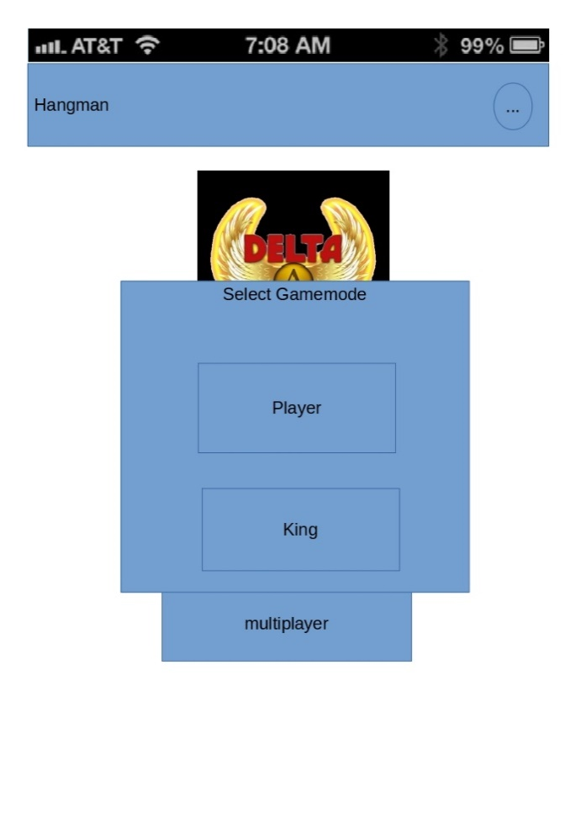

Button btnPlayer

Button btnKing

If click on btnPlayer

Send to server “player uuid, player type”

Wait for response

Launch game_activity

If click on btnKing

Send to server “player uuid, player type”

Wait for response

If response is ok: Launch game_activity

Activity: game_activity

In Game activity

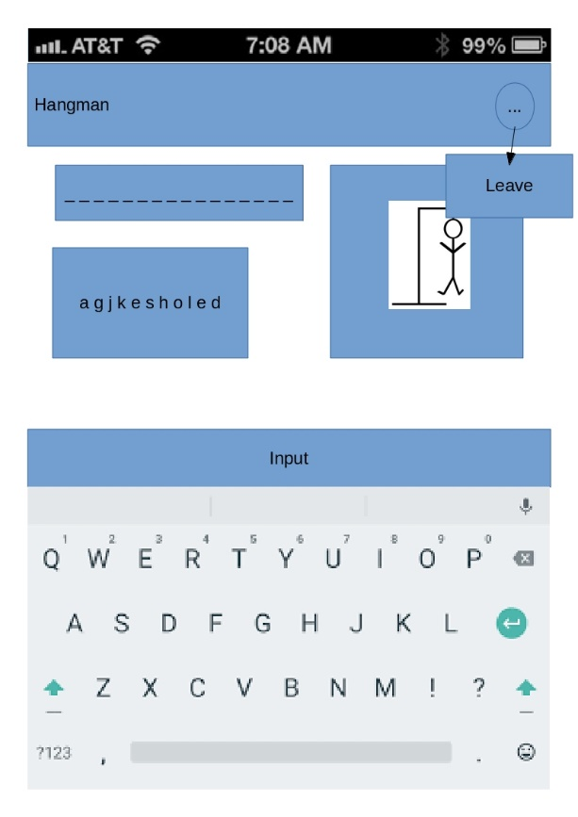

Button btnTopbar

Button btnLeave

TextView word

TextView usedLetters

Image hangman

TextEdit input

If click on keyboard enter

Send to server « player uuid player input »

If click on btnTopbar

Show btnLeave

If click on btnLeave

Launch main_activity

Activity : options_activity

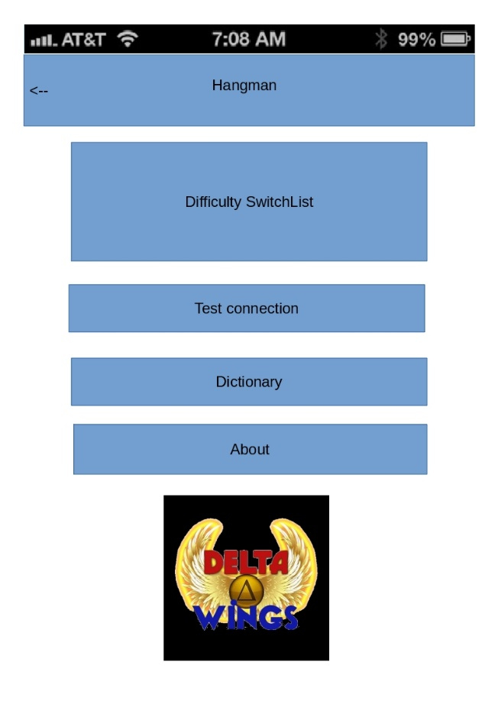Options activity

Button btnReturn

ListView lstDifficulty

Button btnConnection

Button btnDictionary

Button btnAbout

Image imgLogo

If click on btnReturn

Return to last activity

If click on btnConnection

Launch loadingpopup

Test connection to server

If click on btnDicitonary

Launch web browser with adress <http://www.dictionary.com/>

If click on btn About

Launch about_activity

If click on item in lstDifficulty

Set difficulty to item

Activity: about_activity

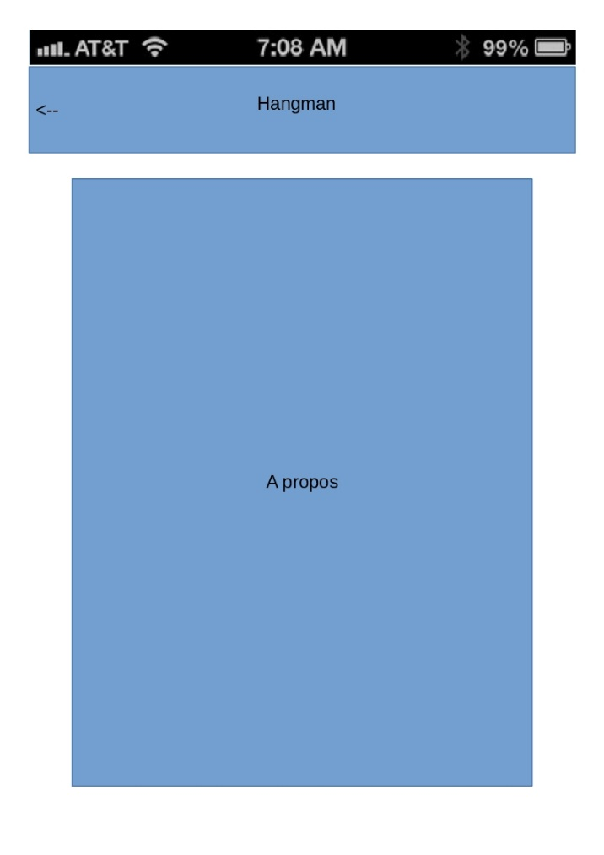A activity to show up who we are

Button btnreturn

TextView text

If click on btnreturn

Return to last activity