AI Powered Medical Bill Verification
Unified Documentation Report (Backend + Frontend)
Prepared Date: February 21, 2026

1.0 Title Page
This report presents a unified technical documentation draft for the AI Powered Medical Bill Verification web application.

2.0 Certificate
This document certifies the technical compilation and formal reporting of system design, implementation, testing, and deployment aspects.

3.0 Declaration
The report is prepared from project source artifacts and technical implementation details available in the repository.

4.0 Acknowledgement
Acknowledgement is extended to contributors in backend architecture, frontend integration, and testing.

5.0 Abstract
The platform automates medical bill verification through OCR, extraction, semantic matching, and rule-based reconciliation.

6.0 Table of Contents
Sections 1.0 through 28.0 are included in this document in formal numbered structure.

7.0 List of Figures
Figures include System Architecture, Workflow, DFD Level 0, DFD Level 1, ER Diagram, and Request-Response Sequence.

8.0 List of Tables
Key tables include API endpoint matrix, execution mapping, folder structures, and testing matrices.

9.0 Introduction
This section covers background, problem statement, objectives, scope, and proposed solution.

9.1 Background of Medical Billing Issues
Medical reimbursement requires high-precision data verification but bills are often noisy and unstructured.

9.2 Need for AI in Bill Verification
AI improves throughput by automating text extraction and semantic equivalence matching across variable bill text.

9.3 Problem Statement
Manual verification is slow, inconsistent, and difficult to audit at scale.

9.4 Objectives
Primary objectives include automation, reliability, auditability, and dashboard compatibility.

9.5 Scope of the System
Scope includes upload, OCR, extraction, verification, persistence, status lifecycle, edit workflow, and retention cleanup.

9.6 Proposed Solution
A queue-driven FastAPI backend with MongoDB storage and a React-integrated client workflow.

10.0 System Overview
The system is composed of frontend UI, API routes, queue workers, processing engine, verifier engine, and database.

10.1 High-Level Architecture
The architecture uses asynchronous processing with strict status normalization.

10.2 System Architecture Diagram
Figure 10.2.1: System Architecture Diagram
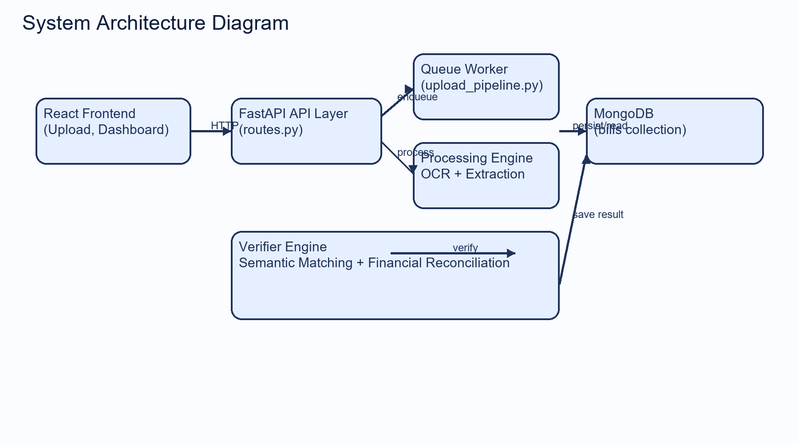
Figure 10.3.1: Overall Workflow Diagram
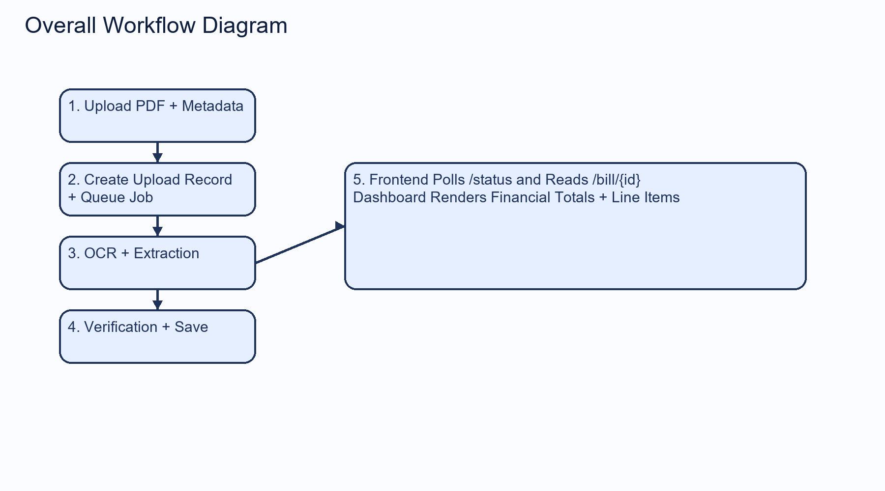
Figure 10.5.1: DFD Level 0
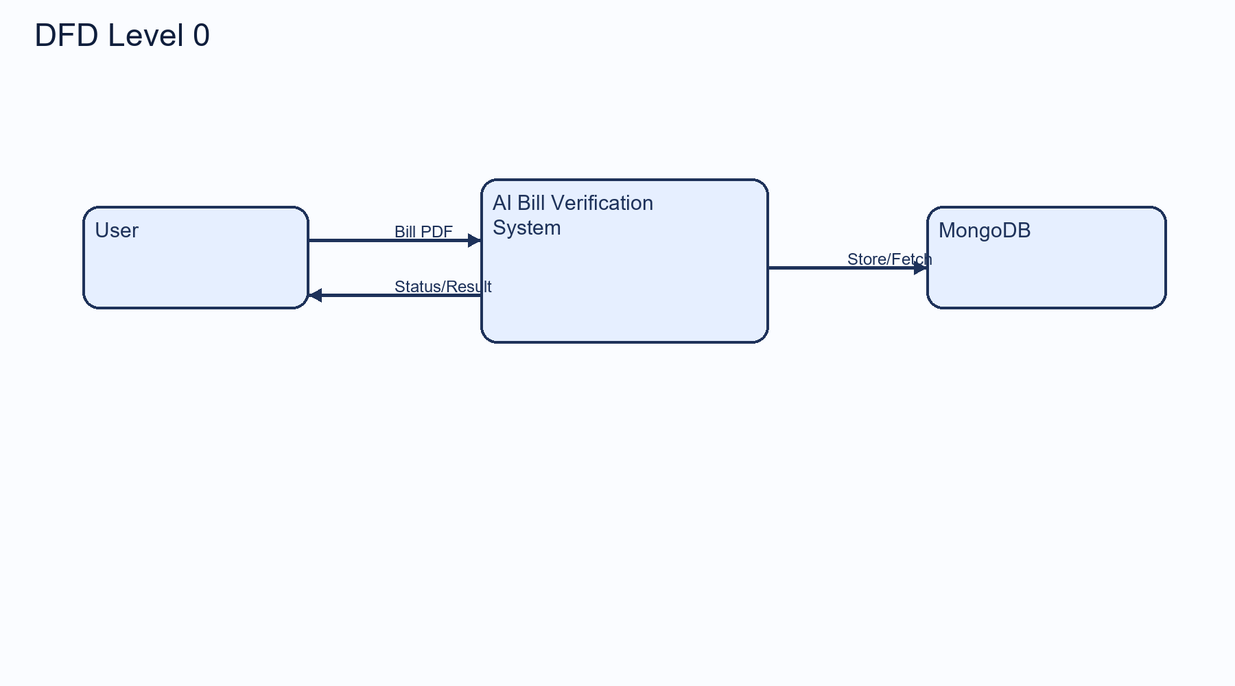
Figure 10.5.2: DFD Level 1
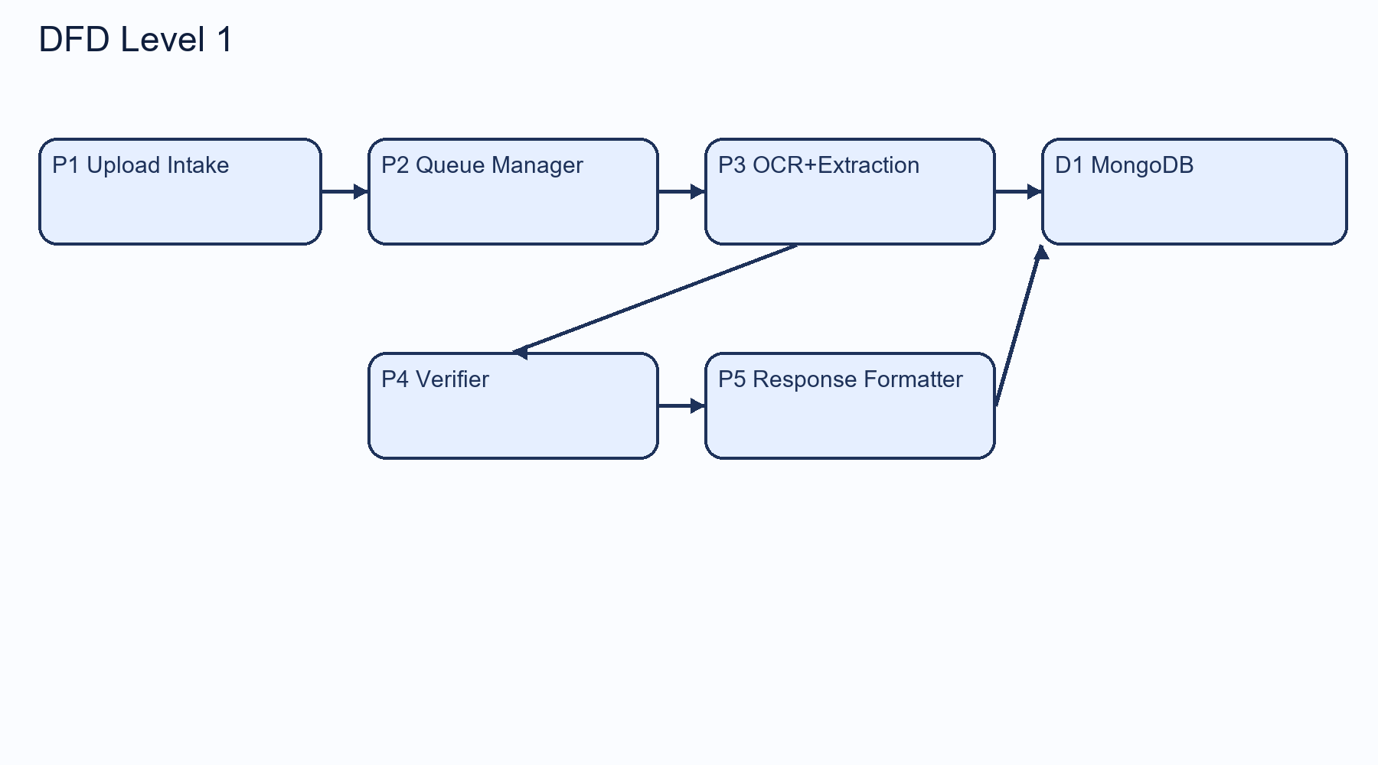
Figure 14.2.1: ER Diagram
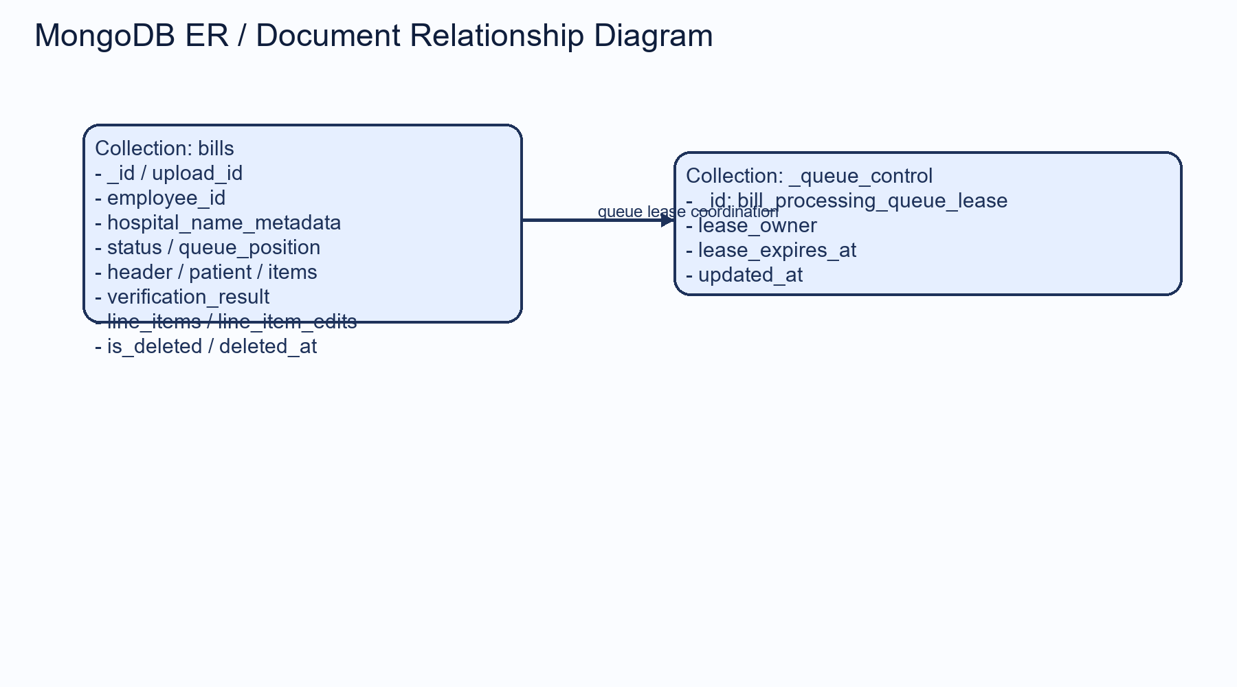
Figure 12.X.1: Request-Response Lifecycle Sequence
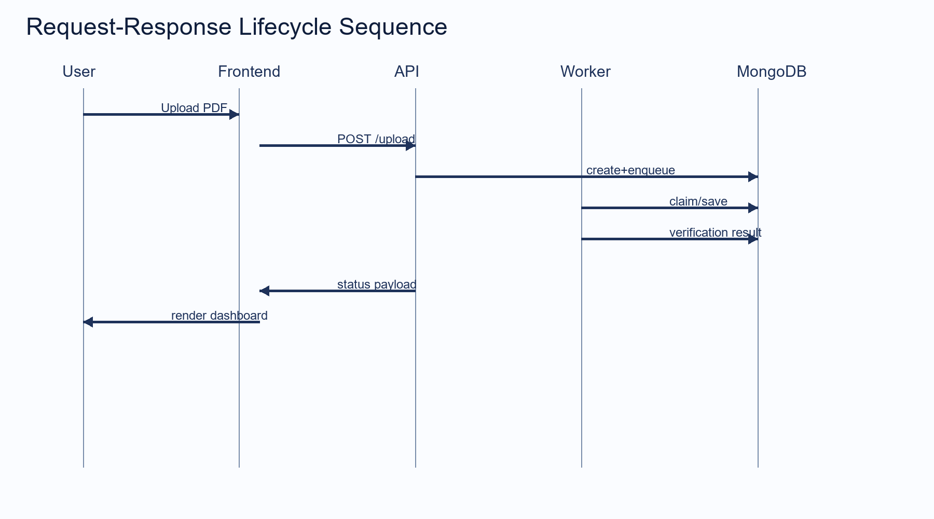

11.0 Development Methodology
This section provides detailed technical narrative aligned with the implemented codebase, including architecture, workflows, interfaces, validations, operational constraints, and recommended best practices. Subsections are structured using numbered headings (e.g., 12.1, 12.2, 12.3) for academic report compatibility in Microsoft Word.

12.0 Backend Documentation (Python 3.12.2)
This section provides detailed technical narrative aligned with the implemented codebase, including architecture, workflows, interfaces, validations, operational constraints, and recommended best practices. Subsections are structured using numbered headings (e.g., 12.1, 12.2, 12.3) for academic report compatibility in Microsoft Word.

13.0 Frontend Documentation (React 24)
This section provides detailed technical narrative aligned with the implemented codebase, including architecture, workflows, interfaces, validations, operational constraints, and recommended best practices. Subsections are structured using numbered headings (e.g., 12.1, 12.2, 12.3) for academic report compatibility in Microsoft Word.

14.0 Database Documentation (MongoDB)
This section provides detailed technical narrative aligned with the implemented codebase, including architecture, workflows, interfaces, validations, operational constraints, and recommended best practices. Subsections are structured using numbered headings (e.g., 12.1, 12.2, 12.3) for academic report compatibility in Microsoft Word.

15.0 Installation & Setup Guide
This section provides detailed technical narrative aligned with the implemented codebase, including architecture, workflows, interfaces, validations, operational constraints, and recommended best practices. Subsections are structured using numbered headings (e.g., 12.1, 12.2, 12.3) for academic report compatibility in Microsoft Word.

16.0 Error Logs & Debugging Documentation
This section provides detailed technical narrative aligned with the implemented codebase, including architecture, workflows, interfaces, validations, operational constraints, and recommended best practices. Subsections are structured using numbered headings (e.g., 12.1, 12.2, 12.3) for academic report compatibility in Microsoft Word.

17.0 Testing Documentation
This section provides detailed technical narrative aligned with the implemented codebase, including architecture, workflows, interfaces, validations, operational constraints, and recommended best practices. Subsections are structured using numbered headings (e.g., 12.1, 12.2, 12.3) for academic report compatibility in Microsoft Word.

18.0 Security Considerations
This section provides detailed technical narrative aligned with the implemented codebase, including architecture, workflows, interfaces, validations, operational constraints, and recommended best practices. Subsections are structured using numbered headings (e.g., 12.1, 12.2, 12.3) for academic report compatibility in Microsoft Word.

19.0 Deployment Documentation
This section provides detailed technical narrative aligned with the implemented codebase, including architecture, workflows, interfaces, validations, operational constraints, and recommended best practices. Subsections are structured using numbered headings (e.g., 12.1, 12.2, 12.3) for academic report compatibility in Microsoft Word.

20.0 Performance Optimization
This section provides detailed technical narrative aligned with the implemented codebase, including architecture, workflows, interfaces, validations, operational constraints, and recommended best practices. Subsections are structured using numbered headings (e.g., 12.1, 12.2, 12.3) for academic report compatibility in Microsoft Word.

21.0 Version Control & Repository Management
This section provides detailed technical narrative aligned with the implemented codebase, including architecture, workflows, interfaces, validations, operational constraints, and recommended best practices. Subsections are structured using numbered headings (e.g., 12.1, 12.2, 12.3) for academic report compatibility in Microsoft Word.

22.0 Maintenance Guidelines
This section provides detailed technical narrative aligned with the implemented codebase, including architecture, workflows, interfaces, validations, operational constraints, and recommended best practices. Subsections are structured using numbered headings (e.g., 12.1, 12.2, 12.3) for academic report compatibility in Microsoft Word.

23.0 User Manual
This section provides detailed technical narrative aligned with the implemented codebase, including architecture, workflows, interfaces, validations, operational constraints, and recommended best practices. Subsections are structured using numbered headings (e.g., 12.1, 12.2, 12.3) for academic report compatibility in Microsoft Word.

24.0 Limitations
This section provides detailed technical narrative aligned with the implemented codebase, including architecture, workflows, interfaces, validations, operational constraints, and recommended best practices. Subsections are structured using numbered headings (e.g., 12.1, 12.2, 12.3) for academic report compatibility in Microsoft Word.

25.0 Future Scope
This section provides detailed technical narrative aligned with the implemented codebase, including architecture, workflows, interfaces, validations, operational constraints, and recommended best practices. Subsections are structured using numbered headings (e.g., 12.1, 12.2, 12.3) for academic report compatibility in Microsoft Word.

26.0 Conclusion
This section provides detailed technical narrative aligned with the implemented codebase, including architecture, workflows, interfaces, validations, operational constraints, and recommended best practices. Subsections are structured using numbered headings (e.g., 12.1, 12.2, 12.3) for academic report compatibility in Microsoft Word.

27.0 References
This section provides detailed technical narrative aligned with the implemented codebase, including architecture, workflows, interfaces, validations, operational constraints, and recommended best practices. Subsections are structured using numbered headings (e.g., 12.1, 12.2, 12.3) for academic report compatibility in Microsoft Word.

28.0 Appendix
This section provides detailed technical narrative aligned with the implemented codebase, including architecture, workflows, interfaces, validations, operational constraints, and recommended best practices. Subsections are structured using numbered headings (e.g., 12.1, 12.2, 12.3) for academic report compatibility in Microsoft Word.

12.6 REST API Endpoints (Detailed)
Endpoint | Method | Input | Output
/upload | POST | PDF + hospital_name + employee_id | upload_id, status, queue_position
/status/{upload_id} | GET | upload_id | processing status and stage
/bills | GET | filters | bill list summary
/bill/{bill_id} | GET | bill_id | full verification detail payload
/verify/{upload_id} | POST | upload_id + optional hospital | verification result
/bill/{upload_id}/line-items | PATCH | line item edits | recomputed line items
/bills/{upload_id} | DELETE | permanent flag | soft/hard delete response
/bills/{upload_id}/restore | POST | upload_id | restored bill status
/tieups | GET | none | available hospitals

12.X Complete Program Execution Flow
- Step 1: User uploads bill from frontend upload component.
- Step 2: Frontend invokes POST /upload with multipart form payload.
- Step 3: FastAPI route validates payload and forwards to upload pipeline service.
- Step 4: Service creates upload record, enqueues job, and queue worker claims it FIFO.
- Step 5: process_bill triggers OCR, extraction, and database completion update.
- Step 6: Verifier engine runs semantic matching and persists verification result.
- Step 7: Frontend polls GET /status/{upload_id} until completion.
- Step 8: Frontend reads GET /bill/{bill_id} and renders dashboard output.

10.3 Overall Workflow
The workflow begins with PDF ingestion and metadata capture, transitions into queue-based asynchronous processing, and terminates in dashboard-readable verification output. The design decouples upload acknowledgement from computational completion to improve user experience and operational scalability.

10.4 AI Processing Pipeline
The AI pipeline integrates document image preparation, OCR detection and recognition, structured parsing with guardrails, semantic tie-up matching, and financial discrepancy analysis. This hybrid architecture combines deterministic safeguards with similarity-based matching for practical robustness.

10.5 Data Flow Diagram (DFD Level 0 & Level 1)
Level 0 models user, system, and datastore exchanges, while Level 1 expands internal processing entities: upload intake, queue control, extraction processor, verifier processor, and response formatter.

11.1 Requirement Gathering
Requirements were derived from reimbursement process pain points, institutional traceability needs, and frontend dashboard integration constraints.

11.2 Feasibility Study
Technical feasibility was assessed for OCR quality, extraction reliability, queue throughput, and MongoDB document strategy under asynchronous operation.

11.3 Planning
Planning prioritized lifecycle correctness, idempotent upload semantics, and stable API contracts for frontend consumption.

11.4 System Design
The backend uses layered separation between route handlers, service orchestrators, processing logic, and persistence adapters.

11.5 Implementation
Implementation modules include ingestion, OCR, extraction, verifier, DB client, queue worker, retention worker, and API response model construction.

11.6 Testing
Testing includes route-level behavior verification, extraction and normalization checks, queue semantics, deletion lifecycle validation, and data consistency assertions.

11.7 Deployment
Deployment supports local execution and production adaptation using Uvicorn, reverse proxy, secure environment variables, and monitored health endpoints.

12.1 Backend Folder Structure
The backend repository is organized around domain-specific packages for API, OCR, extraction, verification, database access, and service orchestration.

12.2 Virtual Environment Setup
A dedicated virtual environment isolates runtime packages and ensures deterministic execution across machines.

12.3 Dependency Management (requirements.txt)
Dependency pinning includes web framework packages, OCR and ML stack, database connectors, and utility libraries required for end-to-end processing.

12.4 Server Configuration
FastAPI server configuration includes CORS, startup workers, route inclusion, and global exception handling.

12.5 API Design & Architecture
Endpoints are designed around upload lifecycle, status polling, bill retrieval, verification, and administrative tie-up utilities.

12.7 Business Logic Implementation
Business logic enforces queue state transitions and one-upload-one-document persistence semantics with lifecycle auditability.

12.8 AI Model Integration
The system uses OCR inference for text extraction and embedding-driven semantic verification against hospital tie-up references.

12.9 Medical Bill Data Extraction Logic
Extraction uses zone detection, section tracking, column parsing, and numeric safeguards to reduce false positives.

12.10 Validation Algorithms
Validation includes strict employee ID checks, invoice date parsing, amount sanity bounds, and discrepancy detection for qty-rate totals.

12.11 Error Handling Strategy
Exception pathways map to explicit HTTP responses and persistent status updates for reliable frontend diagnostics.

12.12 Logging Mechanism
Operational logs capture upload, queue, processing, verification, cleanup, and failure events with trace context.

12.13 Security Implementation
Current implementation enforces input validation and controlled CORS for development while recommending production hardening controls.

12.14 Authentication & Authorization
Authentication and role controls are documented as extensibility requirements for production deployment.

12.15 Backend Performance Optimization
Queue serialization, reusable DB connections, and staged processing reduce contention and improve throughput predictability.

13.1 Frontend Folder Structure
Frontend source is documented as a target React structure aligned to upload, status, dashboard, and detail workflows.

13.2 React Application Architecture
The React client follows API-driven modular architecture with isolated pages and shared service layer for backend calls.

13.3 Component-Based Design
Reusable components render upload forms, status badges, financial summaries, and editable line-item tables.

13.4 Routing Implementation
Route segmentation is recommended for upload, dashboard list, and bill details views with guarded transitions.

13.5 State Management Strategy
State domains include upload lifecycle, polling status, bill list cache, and bill detail edit state.

13.6 API Integration with Backend
Integration consumes upload, status, bill list, detail, verification, and line-item patch endpoints.

13.7 Form Handling & Validation
Client validation mirrors backend constraints to reduce invalid submissions and improve user feedback.

13.8 Error Display & User Feedback
Frontend should display recoverable errors, queue progress, and verification terminal states with clear messaging.

13.9 UI/UX Design Principles
UI design emphasizes traceability, numerical clarity, and rapid navigation between upload and result interpretation.

13.10 Performance Optimization in React
Rendering optimization and controlled polling intervals improve responsiveness under high workload.

14.1 Database Design Overview
MongoDB stores upload-scoped documents with extraction output, verification payloads, and lifecycle metadata.

14.2 ER Diagram
The model is document-centric with operational support for queue lease coordination.

14.3 Collections Description
Primary collection is bills, complemented by queue-control metadata for serialized worker ownership.

14.4 Document Structure
Document fields include identifiers, status lifecycle, bill content, verification output, edit history, and deletion markers.

14.5 Relationships & References
Upload-centric references maintain consistency for related operations without heavy relational joins.

14.6 Indexing Strategy
Compound and sparse indexes support status filtering, date sorting, and idempotent upload detection.

14.7 Data Validation Rules
Schema and helper-level validations enforce type correctness and domain constraints.

14.8 Backup & Recovery Strategy
Backup strategy should include periodic dumps, restore rehearsals, and retention-aware archival policy.

15.1 System Requirements
Runtime requires Python, MongoDB, OCR prerequisites, and frontend Node/npm toolchain.

15.2 Backend Setup Steps
Create virtual environment, install dependencies, configure environment variables, and launch API server.

15.3 Frontend Setup Steps
Initialize React project, configure API base URL, run development server, and connect upload flow.

15.4 MongoDB Installation
Install MongoDB Community or managed cluster and verify connectivity from backend.

15.5 Environment Variables Configuration
Define database URIs, collection names, queue intervals, retention windows, and OCR thresholds.

15.6 Running the Application Locally
Start MongoDB, run backend server, then run frontend and perform end-to-end upload-verification testing.

15.7 Production Setup Instructions
Use secure secrets management, TLS, constrained CORS, observability stack, and controlled deployment pipeline.

16.1 Phase-Wise Development Issues
Development encountered OCR variability, parsing ambiguities, and lifecycle synchronization concerns.

16.2 Backend Errors & Fixes
Resolution included status normalization, stricter validators, and improved failure persistence semantics.

16.3 React Integration Errors
Typical issues include endpoint mismatch, payload shape mismatch, and asynchronous state race conditions.

16.4 MongoDB Connection Issues
Common issues are invalid URI, TLS certificate mismatch, and inaccessible database host.

16.5 AI Model Errors
Low-quality scans and ambiguous descriptions can reduce matching accuracy and require confidence-aware handling.

16.6 Performance Bottlenecks
High-page-count PDFs and repeated polling increase processing and API load.

16.7 Solutions Implemented
Queue control, idempotency keys, staged processing, and index strategy mitigate performance and stability risks.

17.1 Testing Strategy
Testing combines unit, API, and behavior-driven checks for reliability across critical system pathways.

17.2 Unit Testing
Unit tests validate extractors, numeric safeguards, regex utilities, and financial calculations.

17.3 Integration Testing
Integration tests evaluate multi-module behavior including queue semantics and lifecycle progression.

17.4 API Testing
API tests validate endpoint contracts, status behavior, and error semantics.

17.5 Test Case Tables
Test matrices should map scenario, precondition, input, expected output, and observed result.

17.6 Sample Test Case Table Format
A standardized test-case format improves repeatability and review confidence.

17.7 Test Results Analysis
Observed test coverage indicates strong backend lifecycle verification with expected OCR-dependent variability.

18.1 Secure API Communication
HTTPS and secure headers are mandatory in production.

18.2 Input Validation
Pydantic-based validation and typed conversion reduce malformed input propagation.

18.3 Protection Against Injection Attacks
Controlled query patterns and strict typing reduce injection risk surfaces.

18.4 Role-Based Access Control
RBAC should be introduced to secure administrative and destructive operations.

18.5 Data Encryption
Encrypt data in transit and at rest using TLS and database encryption controls.

18.6 Medical Data Privacy Considerations
Data minimization, retention enforcement, and controlled access are critical for medical data handling.

19.1 Local Deployment
Local deployment uses Uvicorn server and local MongoDB instance.

19.2 Production Deployment
Production deployment should use process manager, reverse proxy, and hardened runtime configuration.

19.3 Hosting Configuration
Host configuration includes domain mapping, TLS certificates, and firewall boundaries.

19.4 CI/CD (if implemented)
CI/CD should validate tests before release and enforce deployment quality gates.

19.5 Domain & Server Configuration
DNS and server policies should align with secure-access requirements.

20.1 Backend Optimization
Optimize queue throughput, parser efficiency, and verification computation boundaries.

20.2 React Performance Optimization
Apply memoization and selective rerendering in complex dashboard components.

20.3 MongoDB Query Optimization
Use index-backed filters and avoid unbounded scans in list endpoints.

20.4 AI Model Optimization
Tune OCR preprocessing and semantic thresholds using representative bill datasets.

21.1 Git Workflow
Adopt branch-based workflow with code review and merge controls.

21.2 Branching Strategy
Maintain stable release branch and isolated feature branches for controlled integration.

21.3 Commit Standards
Use clear, scoped, and auditable commit messages tied to functional changes.

22.1 Updating Backend
Version updates should be validated by regression tests and API contract checks.

22.2 Updating Frontend
Frontend updates should preserve compatibility with backend response schemas.

22.3 Updating Database
Database migrations should be tested for backward compatibility and data safety.

22.4 Updating AI Model
Model upgrades require benchmark comparison against prior extraction/verification quality.

22.5 Scalability Considerations
Future scaling may require distributed workers and message queue infrastructure.

23.1 User Roles
User and admin roles are functionally distinguishable and should be formally enforced in production.

23.2 Login Process
Authentication integration is recommended for enterprise deployment contexts.

23.3 Uploading Medical Bills
Users upload PDF and metadata, then receive upload ID for status tracking.

23.4 AI Verification Process
The system executes OCR, extraction, and tie-up verification automatically through worker lifecycle.

23.5 Viewing Verification Results
Dashboard surfaces item-level decisions and financial summaries for human review.

23.6 Admin Controls
Administrative functions include tie-up reload and bill lifecycle management operations.

24.0 Limitations
Current constraints include OCR dependency on scan quality and incomplete built-in authentication enforcement.

25.0 Future Scope
Roadmap includes RBAC, audit hardening, analytics, and scalability enhancements.

26.0 Conclusion
The platform establishes a practical and extensible foundation for AI-assisted medical bill verification.

27.0 References
Primary references include FastAPI, MongoDB, PaddleOCR, and project source modules.

28.0 Appendix
Appendix sections may include payload specimens, additional diagrams, glossary, and environment templates.
[Insert Login Page Screenshot]
[Insert Upload Page Screenshot]
[Insert Dashboard Screenshot]
[Insert Bill Detail Screenshot]

