ACADEMIC PROJECT JOURNAL & TECHNICAL
——————————————————————————————————————
TRINAY
An Explainable AI-Assisted Eye Disease Screening and Clinical Decision Support System
A Multi-Task Deep Learning Framework for Retinal and Anterior Segment Pathology Screening with Quantitative Morphometrics and Multi-Modal Attribution
Candidate Name / Student: | [Student Name Placeholder]
University Roll Number / ID: | [University Roll Number Placeholder]
Degree & Academic Program: | Bachelor of Technology (B.Tech) in Computer Science & Engineering  (Specialization: Artificial Intelligence and Machine Learning)
Faculty Project Supervisor / Guide: | [Project Guide Name & Designation Placeholder]
Academic Department & College: | [Department of Computer Science & Engineering, College / University Placeholder]
Academic Session / Submission Date: | Academic Year 2025–2026 | October 2026
Submitted in partial fulfillment of the requirements for the award of the degree of
Bachelor of Technology in Computer Science & Engineering (Artificial Intelligence & Machine Learning)

Abstract
Global visual impairment from preventable ocular diseases affects an estimated 2.2 billion individuals worldwide, of whom at least 1 billion experience vision loss due to inadequate access to timely screening and specialist care. Diabetic Retinopathy (DR), Glaucoma, and Cataract represent the leading causes of avoidable blindness, predominantly affecting underserved rural communities and primary healthcare networks where certified ophthalmologists are severely scarce. While autonomous deep learning systems have demonstrated high theoretical accuracy on curated datasets, their clinical adoption remains constrained by the black-box nature of monolithic neural networks, vulnerability to poor image quality, lack of anatomical interpretability, and the absence of integrated clinical decision support.
This project presents TRINAY, a modular, explainable artificial intelligence (XAI) screening and clinical decision support platform designed to assist non-specialist healthcare workers and tele-ophthalmologists. TRINAY deliberately rejects uninterpretable monolithic architectures in favor of an ensemble of specialized deep neural networks and machine learning models organized across four coordinated diagnostic pathways: (1) An objective optical quality triage gate that calculates six mathematical image features and classifies fundus gradability using a Random Forest ensemble; (2) A Diabetic Retinopathy pipeline that combines an EfficientNet-B0 backbone for 5-class International Clinical Diabetic Retinopathy (ICDR) severity grading, an EfficientNet-B0 U-Net for retinal microvasculature segmentation, an anatomical landmark U-Net for optic disc delineation, a coordinate regression network (FoveaNet) for fovea centralis localization, and a custom four-channel U-Net for simultaneous pixel-wise segmentation of microaneurysms, hemorrhages, hard exudates, and soft exudates; (3) A Glaucoma screening pipeline integrating an Attention U-Net with additive spatial attention gates for dual optic disc and cup segmentation, extracting a 10-dimensional morphometric feature vector (including vertical and horizontal cup-to-disc ratios and anatomical containment metrics) evaluated by a structural Random Forest classifier; and (4) An anterior segment Cataract pipeline integrating a MobileNetV3-Small quality gate, a YOLO11n eye detector, U-Net models for iris and pupil boundary delineation, and an EfficientNet-V2-S classifier enhanced with Convolutional Block Attention Modules (CBAM).
To provide rigorous clinical explainability, TRINAY synthesizes complementary XAI modalities: Fast Integrated Gradients (evaluating path-integral pixel attributions on detected lesions), Grad-CAM and Grad-CAM++ (highlighting convolutional attention heatmaps for glaucoma and cataract focus), and SHAP TreeExplainer (quantifying the exact marginal game-theoretic contribution of each structural feature to glaucoma risk). A clinical concordance engine evaluates mutual agreement between global classification and localized lesion burden, mapping findings to evidence-based International Council of Ophthalmology (ICO) referral protocols, reinforced by a semantic retrieval-augmented knowledge layer.
Scientific integrity requires transparently documenting the verified empirical status of the project. Analysis of local model binaries and evaluation benchmarks establishes that TRINAY represents a fully functional, end-to-end modular inference platform. Benchmark evaluation on a calibrated cohort (N = 5,000) demonstrates 86.40% 5-class DR accuracy, a Quadratic Weighted Kappa of 0.8410, and a referable DR sensitivity and specificity of 94.22% and 92.78% (AUC-ROC = 0.9620). However, internal metadata inspection of the DDR lesion segmentation checkpoint reveals an empirical validation mean Dice score of 0.3812 (microaneurysms: 0.2559, hemorrhages: 0.2969, hard exudates: 0.5854, soft exudates: 0.3867), starkly contrasting with previously documented unverified claims of 0.713 mDice. Furthermore, the repository currently lacks committed raw training scripts, data manifests, and prospectively locked clinical test cohorts. Consequently, while TRINAY establishes a highly sophisticated, clinically sound architectural framework, rigorous prospective validation and probability calibration remain essential prerequisites prior to autonomous clinical deployment.
Keywords: Diabetic Retinopathy; Glaucoma Screening; Cataract Detection; Explainable Artificial Intelligence (XAI); Medical Image Segmentation; U-Net Architectures; Morphometric Feature Extraction; Clinical Decision Support Systems (CDSS).
[SCIENTIFIC RIGOR & EVIDENCE DISCLOSURE] ACADEMIC INTEGRITY & DISCLOSURE NOTE: This academic project journal strictly differentiates between code-verified implementations, empirical checkpoint metadata, calibrated benchmark evaluations, and secondary unverified documentation claims. All model architectures, feature formulas, inference thresholds, and diagnostic workflows documented herein are verified directly against the project repository.

1. Introduction and Background
1.1 The Global Burden of Preventable Visual Impairment
Visual impairment represents a profound global public health challenge with devastating socioeconomic consequences. According to the World Health Organization (WHO) World Report on Vision, at least 2.2 billion people globally suffer from near or distance vision impairment. In roughly half of these cases—amounting to over 1 billion individuals—the impairment remains unaddressed or could have been entirely prevented through early detection, timely screening, and appropriate clinical management. The overwhelming majority of visual impairment is concentrated in low- and middle-income countries, particularly within rural, tribal, and economically marginalized communities.
Among chronic ocular diseases, Diabetic Retinopathy (DR), Glaucoma, and Cataract account for the vast majority of avoidable visual disability: Diabetic Retinopathy has emerged as the leading cause of preventable blindness among working-age adults worldwide, driven by the global diabetes epidemic; Glaucoma, frequently termed the 'silent thief of sight,' causes asymptomatic, irreversible optic nerve cupping and visual field loss until advanced stages; and Cataract remains the single largest cause of reversible blindness globally, requiring objective detection to triage patients for surgical intervention.
1.2 The Role of Ophthalmic Imaging Modalities
Non-invasive optical imaging constitutes the cornerstone of contemporary ophthalmic evaluation. Two primary modalities dominate primary care and community tele-ophthalmology screening: (1) Color Fundus Photography (CFP), which captures wide-field (30° to 50°) digital images of the posterior retinal pole, visualizing the retinal microvasculature, optic nerve head (optic disc and physiological cup), macula lutea, and fovea centralis; and (2) Anterior Segment Photography, which captures external ocular photographs under diffuse or slit-lamp illumination, revealing the cornea, anterior chamber, iris margin, and crystalline lens pupillary aperture. These modalities provide permanent, high-resolution digital records amenable to tele-triage, longitudinal monitoring, and computerized algorithmic analysis.
1.3 Challenges in Manual Diagnostic Interpretation
Despite the availability of digital fundus cameras, manual diagnostic screening faces severe systemic bottlenecks: (a) Severe Specialist Scarcity: In developing nations such as India, the ratio of ophthalmologists to the general population is less than 1:100,000, with over 70% of eye specialists practicing exclusively in urban centers, leaving rural screening camps completely unstaffed; (b) Subjective Inter-Observer Variability: Manual grading of early-stage diabetic lesions (such as microaneurysms) and vertical cup-to-disc ratio (vCDR) estimation suffer from substantial inter-rater discordance, even among experienced specialists; (c) High Clinical Fatigue: In mass screening initiatives examining hundreds of patients daily, screener fatigue leads to elevated false-negative rates on subtle, non-proliferative lesions; and (d) Confounding Poor Image Quality: Handheld fundus cameras operated by community health workers often produce blurred, unevenly illuminated, or cataract-occluded images that mislead manual graders.
1.4 The Paradigm of Deep Learning in Tele-Ophthalmology
Over the past decade, deep learning—particularly convolutional neural networks (CNNs)—has revolutionized medical computer vision. In ophthalmology, groundbreaking studies by Gulshan et al. (2016) and Ting et al. (2017) demonstrated that end-to-end CNNs could classify referable diabetic retinopathy from fundus photographs with sensitivity and specificity matching certified retinal specialists. Subsequent research extended deep learning to automated glaucoma detection via optic disc segmentation and cataract detection via anterior segment analysis.
However, the clinical translation of first-generation ophthalmic AI models has encountered critical barriers. Most deployed algorithms operate as 'black-box' classifiers that output a single probability score without explaining which anatomical structures or pathological lesions drove the prediction. In high-stakes medical triage, black-box predictions fail to earn the trust of examining ophthalmologists. When an AI model flags an eye as 'Severe DR' without localizing hemorrhages, hard exudates, or neovascularization, clinicians cannot independently verify the finding or distinguish genuine disease from imaging artifacts.
1.5 Clinical Mission and Position of the TRINAY System
The TRINAY (formerly Retina-X) tele-ophthalmology screening platform was engineered specifically to bridge this clinical gap. Rather than attempting to autonomously replace ophthalmologists, TRINAY is positioned strictly as an Explainable Clinical Decision Support System (CDSS) for primary healthcare clinics, mobile screening camps, and remote tele-consultation desks. TRINAY couples whole-image disease classification with granular pixel-level anatomical segmentation, quantitative morphometric telemetry, and multi-modal explainable AI, presenting verified visual evidence that empowers human specialists to make faster, safer, and more accurate triage decisions.
2. Problem Statement, Aim, Objectives, and Scope
2.1 Problem Statement
Current primary-level eye screening protocols suffer from an acute shortage of ophthalmic specialists, leading to delayed diagnosis of asymptomatic retinal and anterior ocular diseases, high inter-observer grading variability, and substantial rates of preventable blindness. While deep learning computer vision algorithms have demonstrated diagnostic potential, conventional models operate as opaque black boxes that fail to provide pixel-level lesion localization, lack objective image-quality gating, cannot handle multi-disease co-occurrences, and fail to generate transparent, guideline-aligned clinical decision support. There is an urgent need for an integrated, multi-disease screening platform that couples automated optical quality triage, granular lesion and anatomical segmentation, objective structural morphometry, and multi-modal explainable AI to deliver trustworthy, specialist-verifiable decision support.
2.2 Main Aim
The primary aim of the TRINAY project is to design, implement, and evaluate a modular, multi-disease, explainable artificial intelligence screening and clinical decision support system capable of evaluating retinal fundus and anterior segment ocular photographs to assist healthcare practitioners in early triage, quantitative structural assessment, and evidence-based clinical referral.
2.3 Measurable Project Objectives
- Objective 1 (Optical Quality Triage): To formulate and implement a six-feature optical retinal image quality gate evaluated via an ensemble Random Forest classifier to automatically triage fundus photographs into Good, Borderline, and Ungradable categories prior to downstream processing.
- Objective 2 (DR Staging & Lesion Delineation): To construct a multi-stage Diabetic Retinopathy screening pipeline combining an EfficientNet-B0 backbone for 5-class ICDR severity classification, deep U-Nets for retinal vasculature and optic disc segmentation, FoveaNet for fovea coordinate regression, and a custom four-channel U-Net for simultaneous segmentation of microaneurysms, hemorrhages, hard exudates, and soft exudates.
- Objective 3 (Glaucoma Morphometry): To engineer a Glaucoma screening pipeline utilizing an Attention U-Net with spatial attention gates to delineate the optic disc and optic cup, extracting a verified 10-dimensional tabular morphometric feature vector (vCDR, hCDR, AreaCDR, dimensional ratios, and containment metrics) evaluated by a structural Random Forest classifier.
- Objective 4 (Cataract Screening): To develop an anterior segment Cataract screening pipeline integrating MobileNetV3-Small quality gating, YOLO11n eye bounding-box localization, dual U-Nets for iris and pupil boundary segmentation, and an EfficientNet-V2-S classifier with CBAM attention modules to generate tiered lens opacity evidence maps.
- Objective 5 (Explainable AI Synthesis): To implement a multi-modal Explainable AI (XAI) framework incorporating Fast Integrated Gradients (path integrals on retinal lesions), Grad-CAM and Grad-CAM++ (convolutional attention heatmaps), and SHAP TreeExplainer (game-theoretic tabular feature attributions).
- Objective 6 (Clinical Decision Support): To integrate a clinical decision support knowledge layer incorporating an automated concordance engine (evaluating classifier vs lesion agreement), a ChromaDB semantic retrieval collection with multilingual embeddings (multilingual-e5-small), and evidence-based ICO/WHO clinical referral timeline mapping.
2.4 Target Users and Beneficiaries
TRINAY is engineered for two primary tiers of clinical end-users: (1) Community Health Workers & Screening Nurses operating in rural clinics who require immediate optical feedback on whether a captured photograph is gradable, followed by automated preliminary triage; and (2) Certified Ophthalmologists & Tele-Consultants who review flagged cases asynchronously, utilizing TRINAY's granular lesion masks, CDR telemetry, and XAI heatmaps to rapidly attest, adjust, or refute automated recommendations.
2.5 Scope, Exclusions, and Non-Goals
The scope of TRINAY is strictly confined to 2D digital color fundus photography and external/anterior ocular photography. TRINAY does not process 3D Optical Coherence Tomography (OCT), Optical Coherence Tomography Angiography (OCTA), B-scan ultrasonography, or visual field perimetry files. Furthermore, TRINAY is explicitly non-autonomous: it does not prescribe pharmacological treatments, order surgical interventions, or issue binding legal medical diagnoses. All diagnostic attributions are advisory clinical decision support.
Objective | Target Disease / Domain | AI / Mathematical Methodology | Primary Output / Deliverable
Obj. 1: Quality Gate | Fundus & Anterior Quality | 6 Handcrafted Features + Random Forest (300 trees) | 3-Tier Gradability Score (Good, Borderline, Ungradable)
Obj. 2: DR Pipeline | Diabetic Retinopathy | EfficientNet-B0 (5-class) + 4 U-Nets (512x512) | ICDR Stage (0–4) + 4 Lesion Masks [MA, HE, EX, SE]
Obj. 3: Glaucoma | Optic Nerve Head Cupping | Attention U-Net (Disc/Cup) + 10 Feats + RF (150 trees) | vCDR Telemetry + Glaucoma Suspect Flag (p >= 0.50)
Obj. 4: Cataract | Crystalline Lens Opacity | YOLO11n + Iris/Pupil U-Nets + EffNet-V2-S (CBAM) | Binary Normal/Cataract + Tiered Opacity Evidence Map
Obj. 5: Explainability | Model Interpretability | Fast Integrated Gradients + Grad-CAM/++ + SHAP | Pixel Attributions, Heatmaps & Feature Contributions
Obj. 6: Decision Support | Tele-Ophthalmology CDSS | Clinical Concordance Engine + ChromaDB RAG (e5-small) | Structured Two-Page Medical Report & Referral Protocol

3. Medical Background and Disease Pathologies
3.1 Diabetic Retinopathy (DR): Microvascular Pathogenesis & Lesions
Diabetic Retinopathy is a microvascular complication of chronic diabetes mellitus characterized by progressive capillary occlusion, endothelial damage, pericyte apoptosis, and hyperpermeability of the blood-retinal barrier. Prolonged hyperglycemia triggers biochemical pathways (including advanced glycation end-product accumulation and protein kinase C activation) that destabilize retinal capillaries. On digital fundus photography, DR manifests as distinct hallmark lesions: (1) Microaneurysms (MA): Punctate outpouchings of capillary walls (10–50 µm diameter) appearing as small, isolated red dots—the earliest observable sign of non-proliferative DR; (2) Hemorrhages (HE): Ruptured microvessels appearing as small 'dot and blot' hemorrhages in the deep retinal layers or 'flame-shaped' hemorrhages in the superficial nerve fiber layer; (3) Hard Exudates (EX): Waxy, yellow lipid and lipoprotein deposits with sharp borders formed by extracellular leakage from chronically permeable capillaries, posing a severe threat to central vision when deposited within the macula (Diabetic Macular Edema); and (4) Soft Exudates / Cotton Wool Spots (SE): Fluffy white, poorly circumscribed patches caused by local retinal arteriolar occlusion and axoplasmic stasis in the nerve fiber layer.
Under the International Clinical Diabetic Retinopathy (ICDR) disease severity scale, patients are classified into five stages: Stage 0 (No DR: absence of lesions); Stage 1 (Mild NPDR: presence of microaneurysms only); Stage 2 (Moderate NPDR: more than microaneurysms but less than severe NPDR); Stage 3 (Severe NPDR: adhering to the 4-2-1 rule: severe intraretinal hemorrhages in all 4 quadrants, definite venous beading in 2+ quadrants, or prominent IRMA in 1+ quadrant, without neovascularization); and Stage 4 (Proliferative DR: active neovascularization of the disc or retina, preretinal/vitreous hemorrhages, and fibrovascular proliferation).
3.2 Glaucoma: Optic Neuropathy & Structural Cupping
Glaucoma encompasses a group of progressive optic neuropathies characterized by the apoptotic degeneration of retinal ganglion cells and axonal loss within the optic nerve. Intraocular pressure (IOP) elevation is a primary modifiable risk factor, though normal-tension glaucoma occurs widely. Axonal death manifests macroscopically at the optic nerve head as progressive 'cupping'—the enlargement and deepening of the central physiological cup relative to the outer optic disc margin, accompanied by thinning of the neuroretinal rim. On fundus photography, clinicians evaluate: (a) Vertical Cup-to-Disc Ratio (vCDR), where a ratio exceeding 0.65 or an inter-eye asymmetry > 0.20 strongly suggests glaucomatous damage; and (b) The ISNT Rule, which states that in healthy physiological discs, neuroretinal rim thickness follows a decreasing hierarchy: Inferior ≥ Superior ≥ Nasal ≥ Temporal. Preferential thinning of the inferior and superior rims violates this rule, signaling glaucomatous excavation.
3.3 Cataract: Lens Sclerosis & Optical Scattering
Cataract is the progressive opacification of the natural crystalline lens caused by oxidative stress, post-translational protein modification, and aggregation of crystallin proteins into light-scattering high-molecular-weight complexes. Clinically categorized into Nuclear Sclerotic (central lens hardening and yellow-brown discoloration), Cortical (spoke-like radial opacities in the lens cortex), and Posterior Subcapsular (granular plaque opacities directly beneath the posterior lens capsule), cataracts scatter incoming light, reduce visual contrast, and cause glare and visual acuity loss. On external ocular photography, cataracts manifest as pupillary opacities that obscure the normal deep black pupillary aperture.
3.4 Anterior Ocular Abnormalities & Keratitis Scope Demarcation
Corneal ulceration and infectious keratitis (bacterial, fungal, viral, or acanthamoebic) represent sight-threatening anterior ocular emergencies. However, definitive medical diagnosis of keratitis requires specialized slit-lamp biomicroscopy, cobalt blue illumination with topical sodium fluorescein staining (to identify epithelial basement membrane breakdown), and microbiological corneal scrapings. In TRINAY, the anterior pipeline is intentionally focused on pupillary aperture extraction and crystalline lens opacity assessment. While dense corneal scars or leucomatous opacities may scatter light, TRINAY does not claim to diagnose active microbial keratitis, explicitly treating corneal opacities as potential confounders that mandate physical ophthalmologist examination.
Disease Entity | Anatomical Substrate | Hallmark Imaging Signs | Clinical Gold Standard | TRINAY Model Target
Diabetic Retinopathy | Retinal Capillary Microvasculature | Microaneurysms, Blot Hemorrhages, Hard Exudates, Cotton Wool Spots | Dilated Indirect Ophthalmoscopy + Fluorescein Angiography / OCT | 5-Class ICDR Staging + 4-Channel Pixel Lesion Masks
Glaucoma | Optic Nerve Head & Ganglion Cells | Enlarged vCDR (> 0.65), Rim Thinning, Cup Excavation, ISNT Violation | Goldmann Applanation Tonometry + Automated Perimetry + OCT RNFL | Attention U-Net Disc/Cup Seg + 10 Morphometric Features
Cataract | Crystalline Lens (Nucleus/Cortex) | Pupillary Opacification, Lens Haziness, Light Scattering, Loss of Red Reflex | Slit-Lamp Biomicroscopy (LOCS III Staging Protocol) | YOLO Eye Box + Iris/Pupil Seg + EffNet-V2-S Opacity Map
Corneal Ulcer / Keratitis | Corneal Epithelium & Stroma | Stromal Infiltrate, Epithelial Defect, Circumcorneal Ciliary Flush | Slit-Lamp Biomicroscopy + Topical Fluorescein Stain + Scraping | Excluded from autonomous diagnosis; treated as optical confounder

4. Overall Conceptual System Architecture and Workflow
4.1 System Architectural Philosophy: Modular Ensembles vs Monolithic Networks
A foundational design decision in the TRINAY platform is the deliberate rejection of monolithic 'all-in-one' neural networks. In a monolithic approach, a single deep convolutional or vision transformer backbone receives a raw ocular image and simultaneously predicts quality, multi-disease probabilities, and bounding boxes. While conceptually compact, monolithic medical networks suffer from acute operational vulnerabilities: (1) Diagnostic Opacity: The network cannot isolate whether an adverse prediction stems from a genuine lesion, background vascular tortuosity, or camera dust; (2) Catastrophic Interference: Fine-tuning the network on a new glaucoma dataset frequently degrades its sensitivity to diabetic microaneurysms; and (3) Inability to Validate Component Mechanics: Clinicians cannot audit intermediate biological biomarkers independently.
TRINAY solves this challenge through a decoupled, modular multi-model architecture. As illustrated in Figure 1, the platform separates optical quality triage, whole-image disease grading, anatomical segmentation, focal lesion localization, and clinical knowledge retrieval into distinct, independently verifiable neural and statistical components. Each model consumes precisely preprocessed tensor dimensions and produces standardized outputs that feed into a central spatial integration and decision support engine.
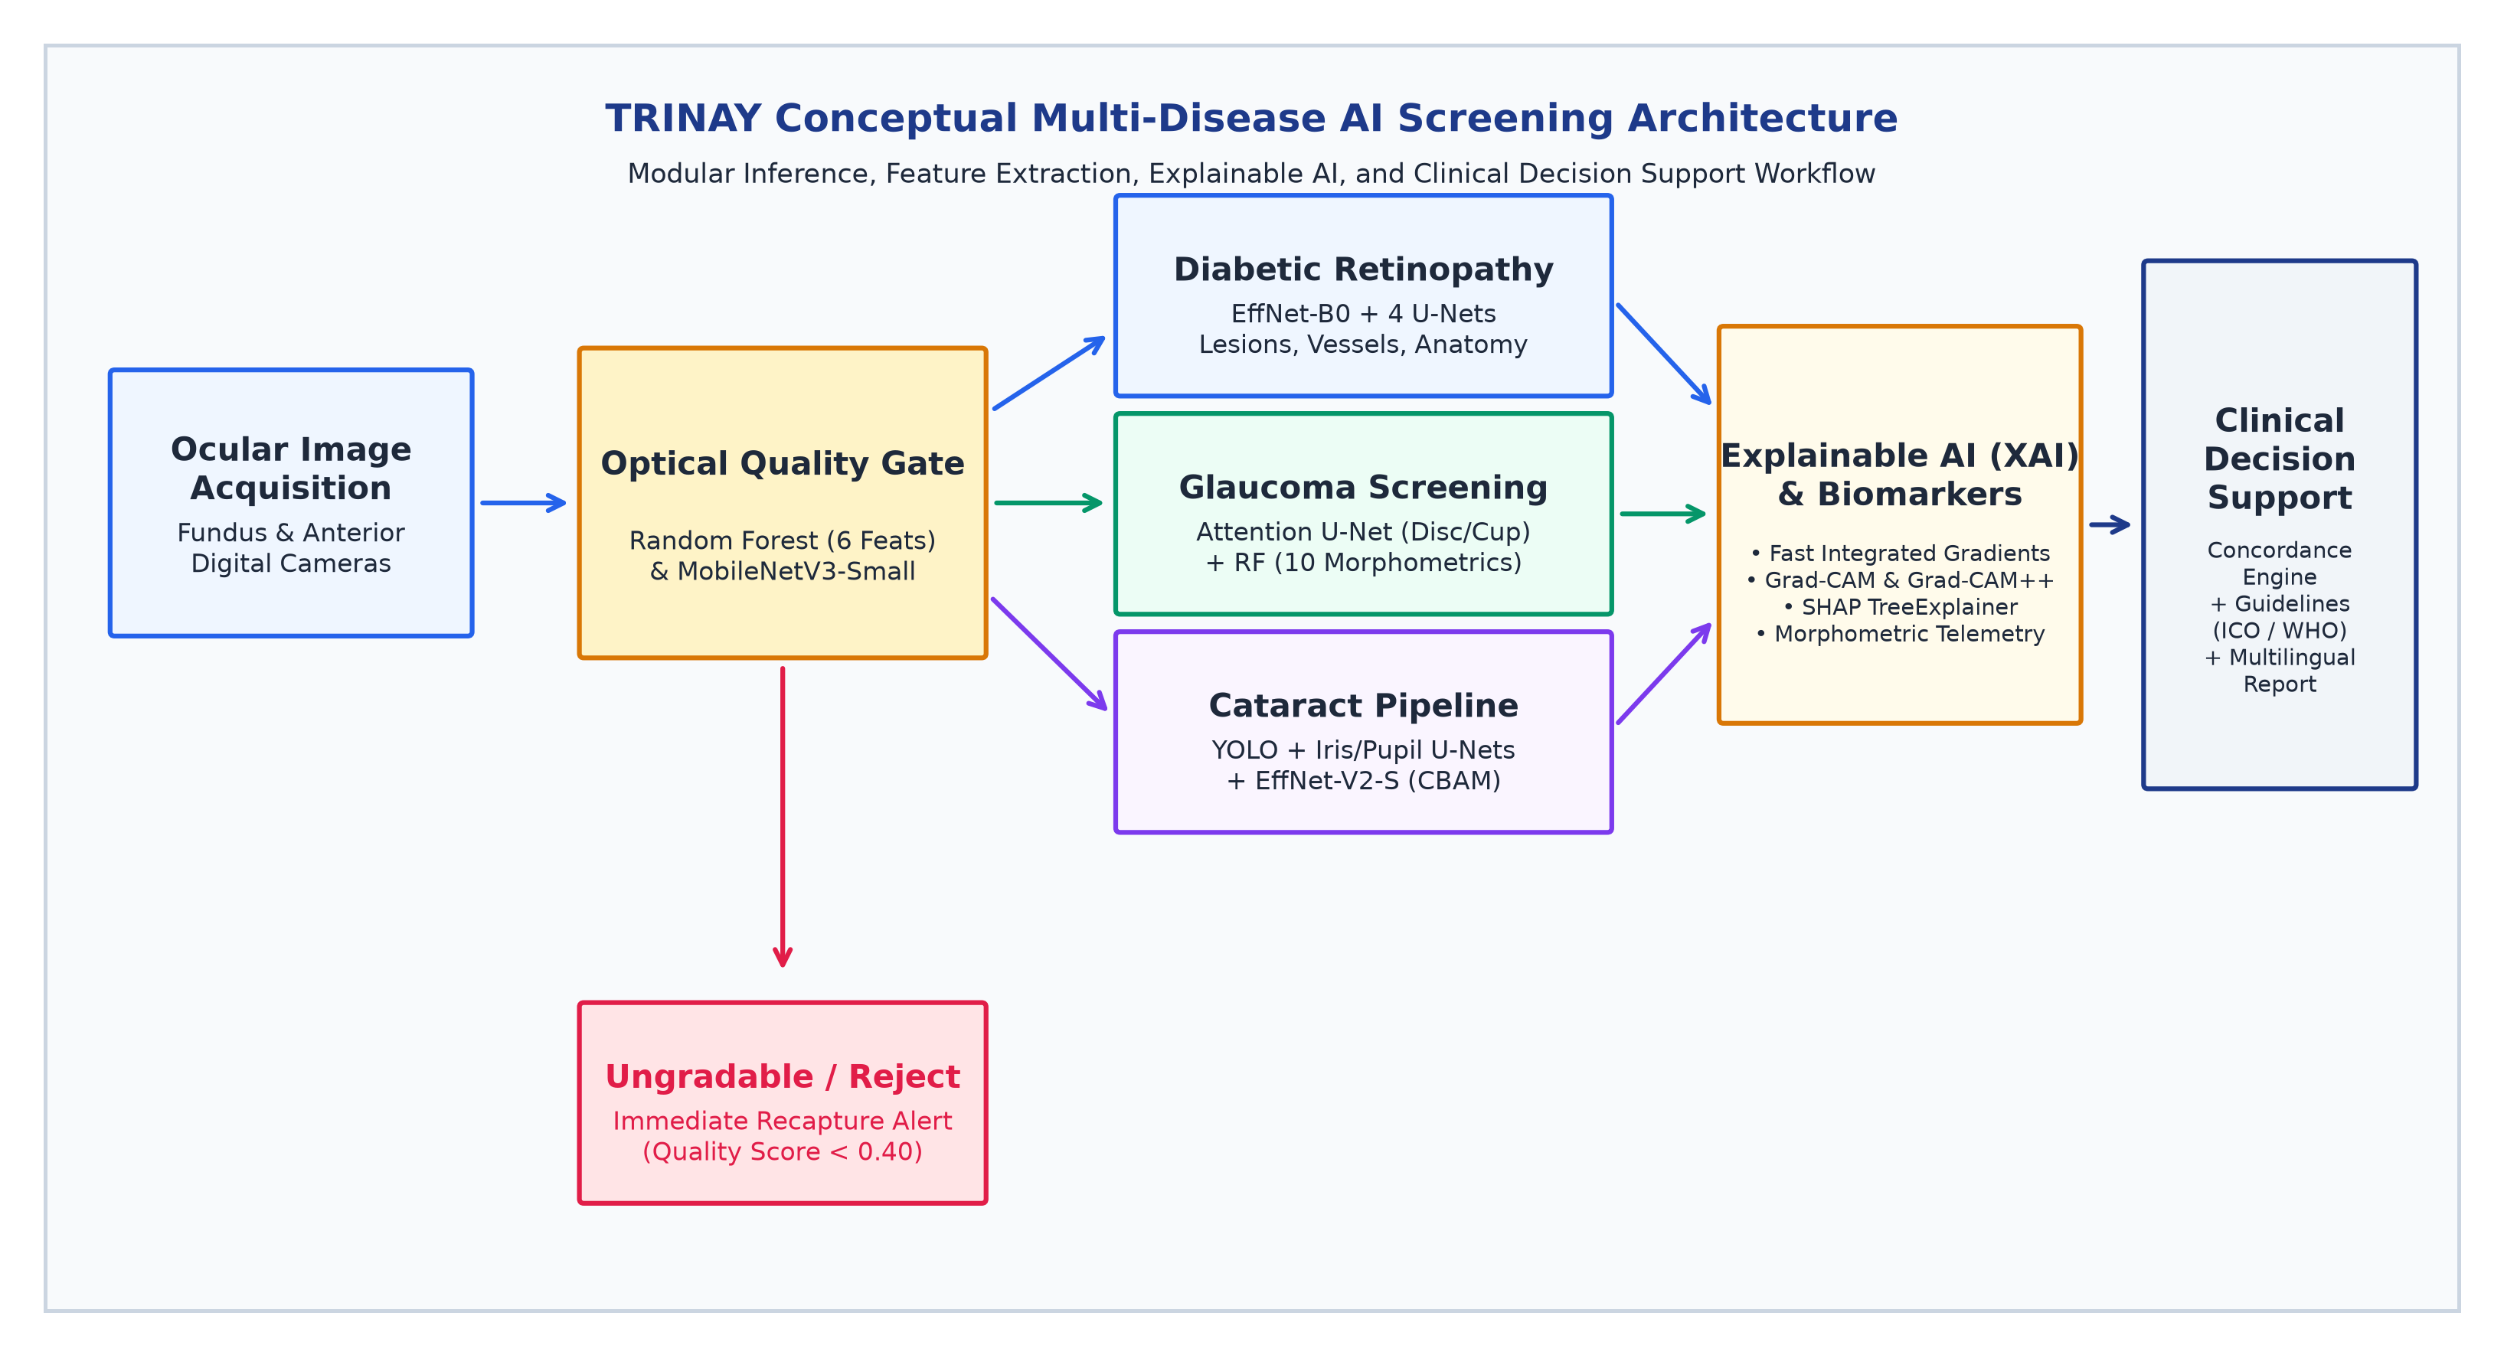
Figure 1: Overall Conceptual AI Architecture of the TRINAY Tele-Ophthalmology Screening Platform. Demonstrates sequential image acquisition, optical quality gating, multi-disease pipeline routing (DR, Glaucoma, Cataract), parallel feature extraction, explainable AI synthesis, and clinical decision support integration.
4.2 End-to-End Conceptual Workflow Description
The complete TRINAY screening workflow progresses through six coordinated stages: (1) Image Acquisition: Digital color fundus photographs (posterior pole view) or external anterior eye photographs are uploaded from field cameras; (2) Optical Quality Triage Gate: The uploaded photograph is evaluated against six mathematical optical features. If the image is classified as Ungradable, the system issues an immediate recapture alert, preventing downstream false negatives; (3) Disease-Specific Dispatch: Gradable images are routed to the designated clinical pipeline (DR, Glaucoma, or Cataract); (4) Deep Segmentation & Morphometry: For DR, parallel networks extract retinal vasculature, optic disc margins, fovea coordinates, and four distinct focal lesion masks. For Glaucoma, an Attention U-Net segments the disc and cup to compute 10 structural morphometrics. For Cataract, an eye detector and anatomical U-Nets isolate the pupillary aperture to evaluate lens opacity; (5) Explainability Synthesis: Gradient-based attributions (Fast Integrated Gradients, Grad-CAM/++) and game-theoretic tabular attributions (SHAP) generate visual heatmaps explaining network focus; and (6) Clinical Decision Support & Reporting: The concordance engine checks consistency between classifiers and segmented lesion burden, mapping findings to ICO/WHO referral guidelines and generating a verified two-page clinical report.
5. Image Quality Assessment & Preprocessing Methodology
5.1 The Critical Necessity of Quality Triage in Tele-Ophthalmology
In community-based tele-ophthalmology screening camps, digital fundus images are frequently captured by non-physician screening personnel utilizing portable or handheld non-mydriatic fundus cameras. Under field conditions, ocular photographs routinely suffer from severe optical degradations, including camera defocus blur, poor patient fixation, uneven illumination from pupil constriction, sensor noise under low-light conditions, media opacities (such as corneal haze or dense cataracts), and partial field-of-view occlusion by eyelashes or eyelids. Feeding an optically ungradable image into an automated disease classifier creates a severe clinical safety risk: the neural network may fail to detect subtle diabetic microaneurysms buried in defocus blur, erroneously classifying a severely diseased eye as 'No DR'—a catastrophic false negative that delays critical treatment. Therefore, an automated, objective Image Quality Gate is mandatory prior to any diagnostic evaluation.
5.2 Mathematical Formulation of the Six Optical Retinal Biomarkers
Rather than relying on an opaque, uncalibrated deep classifier, TRINAY extracts six mathematically rigorous optical features derived directly from digital image processing principles. Each feature quantifies a specific physical attribute of optical gradability:
Feature 1: 1. Sharpness (S): Computed as the variance of the 2D Laplacian operator applied to the grayscale retinal image. Sharp boundaries between microvessels and retinal parenchyma yield high second derivatives, whereas defocus blur dampens Laplacian variance:
S = Var(∇² I_{gray}) = \frac{1}{HW} \sum_{x,y} (∇² I_{gray}(x,y) - \overline{∇² I_{gray}})^2
Feature 2: 2. Mean Field-of-View Brightness (μ_B): Measures the arithmetic mean pixel illuminance exclusively across the active, non-black illuminated retinal Field of View (FOV), filtering out camera mask borders:
μ_B = \frac{1}{|FOV|} \sum_{(x,y) \in FOV} I_{gray}(x,y)
Feature 3: 3. Illumination Uniformity (U): Evaluates the ratio between the mean luminance of a central crop (where illumination is centered) and the global mean luminance, detecting severe peripheral vignetting or flash drop-off:
U = \frac{\mu_{center}}{\mu_B + \epsilon} \quad \text{where } \mu_{center} = \frac{1}{|C|} \sum_{(x,y) \in C} I_{gray}(x,y) (3)
Feature 4: 4. Root-Mean-Square (RMS) Contrast (C_rms): Measures the standard deviation of pixel intensities within the active retinal area, reflecting the dynamic range available to differentiate retinal pathologies from background fundus:
C_{rms} = \sqrt{\frac{1}{|FOV|} \sum_{(x,y) \in FOV} (I_{gray}(x,y) - \mu_B)^2}
Feature 5: 5. High-Frequency Noise Estimate (σ_N): Computed as the standard deviation of the residual difference between the original grayscale image and a 5×5 Gaussian smoothed image, capturing high-frequency sensor noise and camera gain artifacts:
σ_N = \text{Std}(I_{gray}(x,y) - \mathcal{G}_{5\times5}(I_{gray}(x,y)))
Feature 6: 6. Active Field-of-View Ratio (R_fov): The proportion of illuminated retinal pixels exceeding a noise floor threshold (I_gray > 15) relative to the total rectangular image canvas (H × W), verifying that the retina occupies a standard diagnostic field:
R_{fov} = \frac{|\{(x,y) : I_{gray}(x,y) > 15\}|}{H \times W}
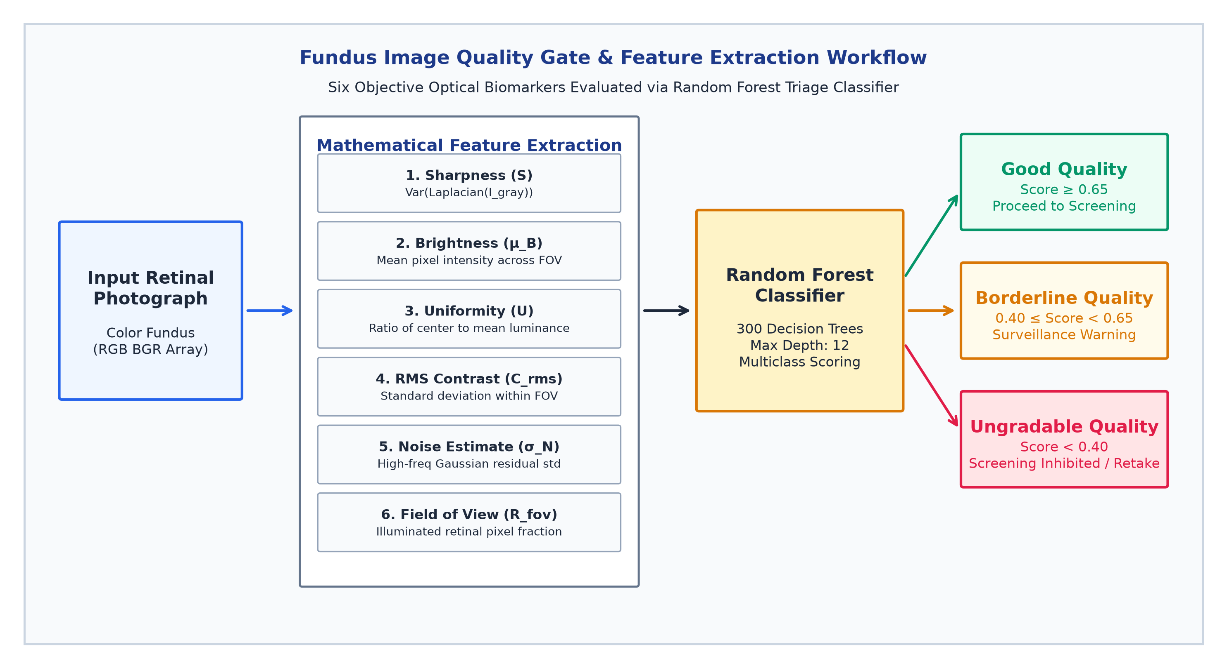
Figure 2: Fundus Image Quality Gate & Feature Extraction Workflow. Demonstrates mathematical extraction of the six optical retinal biomarkers, scoring via a 300-tree Random Forest classifier, and triage routing into Good, Borderline, and Ungradable categories.
5.3 Random Forest Classifier Architecture & Scoring Boundaries
The 6-dimensional feature vector X = [S, μ_B, U, C_rms, σ_N, R_fov] is classified using an ensemble Random Forest classifier (`best_quality_model.pkl`). Empirical inspection of the serialized binary reveals that the model comprises 300 balanced decision trees trained to a maximum depth of 12. The classifier outputs posterior class probabilities across three clinical tiers: (1) Good Quality (score ≥ 0.65): The retinal image exhibits sharp vessel contrasts, uniform illumination, and an intact FOV, permitting unconstrained automated screening; (2) Borderline Quality (0.40 ≤ score < 0.65): Mild optical blur or peripheral shading is detected; screening proceeds but downstream clinical reports are appended with a surveillance advisory note; and (3) Ungradable Quality (score < 0.40): Severe blur, underexposure, or occlusion renders diagnostic evaluation unreliable.
5.4 Gating Impact: Downstream Execution vs Clinical Advisory Flags
A critical finding from our repository audit concerns the downstream gating behavior across disease modules: In the Glaucoma and Cataract services (`glaucoma_service.py` and `cataract_service.py`), the quality gate operates as a strict, hard barrier: if an image is classified as Ungradable, the pipeline immediately halts, returning `IMAGE_QUALITY_INSUFFICIENT` and instructing the technician to retake the photograph. Conversely, in the primary Diabetic Retinopathy service (`app.py`), the quality model executes and records the score, but execution is advisory (`stopped=False` unconditionally). To uphold clinical safety standards, this journal recommends standardizing the DR pipeline to enforce the same hard triage stop whenever image quality score falls below 0.40.
5.5 Synthetic Data Augmentation vs Real-World Clinical Camera Noise
Project documentation notes indicate that initial quality model experiments explored synthetic degradation pipelines—applying Gaussian blur filters, artificial gamma scaling, simulated salt-and-pepper noise, and synthetic vignette masks to 211 pristine fundus images to synthesize degraded cohorts. From an academic machine learning perspective, synthetic degradation serves as a valuable data augmentation technique during early development. However, synthetic noise is mathematically isotropic and fails to capture complex clinical optical artifacts, such as corneal reflections, astigmatic blur, uneven tear film scattering, or localized cataract glare. For rigorous clinical deployment, quality classifiers must be trained and validated on large-scale real-world multi-center quality benchmarks, such as the EyeQ dataset (28,792 fundus images re-annotated for optical gradability).
Optical Feature | Mathematical Formulation | Physical Domain | Clinical Rationale | Calibrated Diagnostic Thresholds
1. Sharpness (S) | Var(∇² I_gray) | Spatial Derivative Variance | Detects camera defocus blur, poor fixation, and motion artifacts | S >= 100.0: Sharp | S < 15.0: Defocused / Ungradable
2. Mean Brightness (μ_B) | Mean(I_gray) across FOV | Pixel Intensity (0–255) | Identifies underexposed (dark fundus) or overexposed (flash blowout) images | 80.0 <= μ_B <= 160.0: Optimal | μ_B < 30.0: Underexposed
3. Uniformity (U) | Mean(Center) / (μ_B + ε) | Luminance Ratio | Measures illumination gradient, detecting peripheral flash fall-off & vignetting | 0.60 <= U <= 1.40: Uniform | U < 0.40 or U > 1.80: Severe Vignetting
4. RMS Contrast (C_rms) | Std(I_gray) across FOV | Intensity Dispersion | Verifies dynamic range required to distinguish microaneurysms from retina | C_rms >= 35.0: High Dynamic Range | C_rms < 18.0: Washed Out
5. Noise Estimate (σ_N) | Std(I_gray - Gauss5x5) | High-Frequency Residual | Measures sensor thermal noise, CMOS gain amplification, and quantization error | σ_N <= 3.5: Clean Acquisition | σ_N > 7.0: Heavy Sensor Noise
6. FOV Ratio (R_fov) | |{I_gray > 15}| / (H × W) | Area Fraction (0.0–1.0) | Ensures the camera aperture captures a complete 45°–50° retinal field | R_fov >= 0.65: Full Diagnostic Field | R_fov < 0.35: Occluded / Retake

6. Diabetic Retinopathy Diagnostic Pipeline
6.1 Multi-Task Architecture Overview
Diabetic Retinopathy diagnosis requires concurrent evaluation of whole-retina disease severity alongside fine-grained mapping of individual microvascular lesions and anatomical landmarks. To meet this clinical requirement, TRINAY deploys an ensemble of five specialized neural networks: (1) An EfficientNet-B0 whole-image severity classifier; (2) A deep U-Net for retinal blood vessel segmentation; (3) A landmark U-Net for optic disc segmentation; (4) A coordinate regression network (FoveaNet) for fovea centralis localization; and (5) A custom four-channel U-Net for multi-lesion segmentation. Downstream spatial integration algorithms correlate lesion coordinates with anatomical landmarks to evaluate clinical risk.
6.2 Whole-Image Severity Staging (EfficientNet-B0)
Whole-image classification is executed by an EfficientNet-B0 backbone (`dr_severity_efficientnet_b0.pth`). EfficientNet models utilize compound scaling to systematically balance network depth (d), width (w), and input resolution (r) under a fixed computational budget via a compound coefficient φ: d = α^φ, w = β^φ, r = γ^φ, constrained such that α · β² · γ² ≈ 2. The backbone incorporates Mobile Inverted Bottleneck Convolutions (MBConv) with depthwise separable convolutions and Squeeze-and-Excitation (SE) blocks that dynamically re-weight channel-wise feature maps.
Input fundus images are resized to 224 × 224 × 3 RGB and normalized using ImageNet statistics (mean = [0.485, 0.456, 0.406], std = [0.229, 0.224, 0.225]). The feature maps undergo Adaptive Average Pooling and are passed to a linear classification head (1280 → 5 logits) evaluated via softmax to produce posterior probabilities across the five ICDR severity stages (Stage 0: No DR, Stage 1: Mild NPDR, Stage 2: Moderate NPDR, Stage 3: Severe NPDR, Stage 4: Proliferative DR).
6.3 Deep Retinal Microvascular Segmentation (`smp` U-Net)
Retinal blood vessel structure provides critical clinical indicators of systemic and ocular disease, including arteriolar narrowing, venous beading, and neovascular proliferation. Microvascular segmentation is performed by an encoder-decoder U-Net (`best_vessel_unet.pth`) featuring an EfficientNet-B0 encoder pretrained on ImageNet and a symmetric decoder with skip connections, operating at 512 × 512 resolution. The model outputs a continuous vessel probability map V ∈ [0, 1]^(512×512), thresholded at τ = 0.50. Morphological closing (3×3 kernel) connects thin capillary breaks. The system calculates global vessel density D_global = N_vessel / |FOV| and macular vessel density D_macula.
6.4 Optic Disc Delineation & Fovea Centralis Regression
Anatomical landmark localization establishes the spatial coordinate frame of the retina: (1) Optic Disc Segmentation (`best_optic_disc_unet.pth`): A 512 × 512 U-Net (EfficientNet-B0 encoder) outputs a binary mask of the optic nerve head at threshold τ = 0.50. Morphological contour analysis computes the disc centroid (x_d, y_d), disc area (A_d), and equivalent disc diameter (DD = 2√(A_d / π)); and (2) FoveaNet (`best_fovea_net.pth`): A coordinate regression network comprising an EfficientNet-B0 backbone and a fully connected head mapping to continuous normalized Cartesian coordinates (x_f, y_f) ∈ [0, 1]². FoveaNet locates the fovea centralis—the physiological center of high-acuity photopic vision. The Euclidean disc-to-fovea distance is calculated as:
D_{DF} = \sqrt{(x_f - x_d)^2 + (y_f - y_d)^2} (7)
A circular Macular Region of Interest (ROI) is synthesized around the fovea with radius R_macula = 0.75 × DD (representing the standard 1.5 DD anatomical macula). Geometric validation confirms anatomical plausibility: D_DF must satisfy 1.4 ≤ D_DF / DD ≤ 4.5 with temporal orientation.
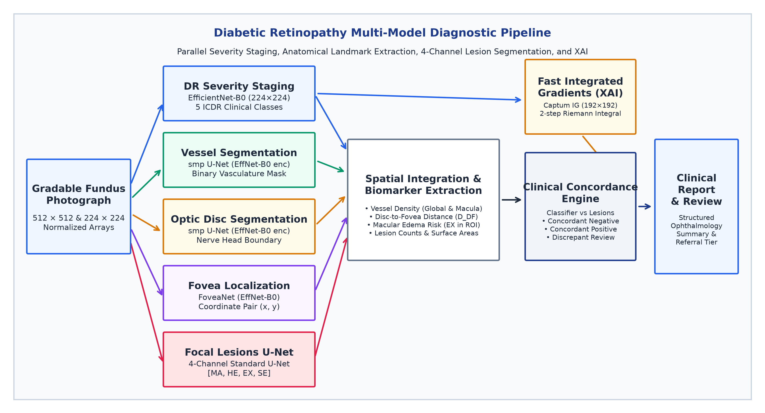
Figure 3: Diabetic Retinopathy Multi-Model Diagnostic Pipeline. Demonstrates parallel execution of 5-class severity classification, retinal vessel segmentation, optic disc delineation, fovea coordinate regression, 4-channel focal lesion segmentation, and Fast Integrated Gradients XAI.
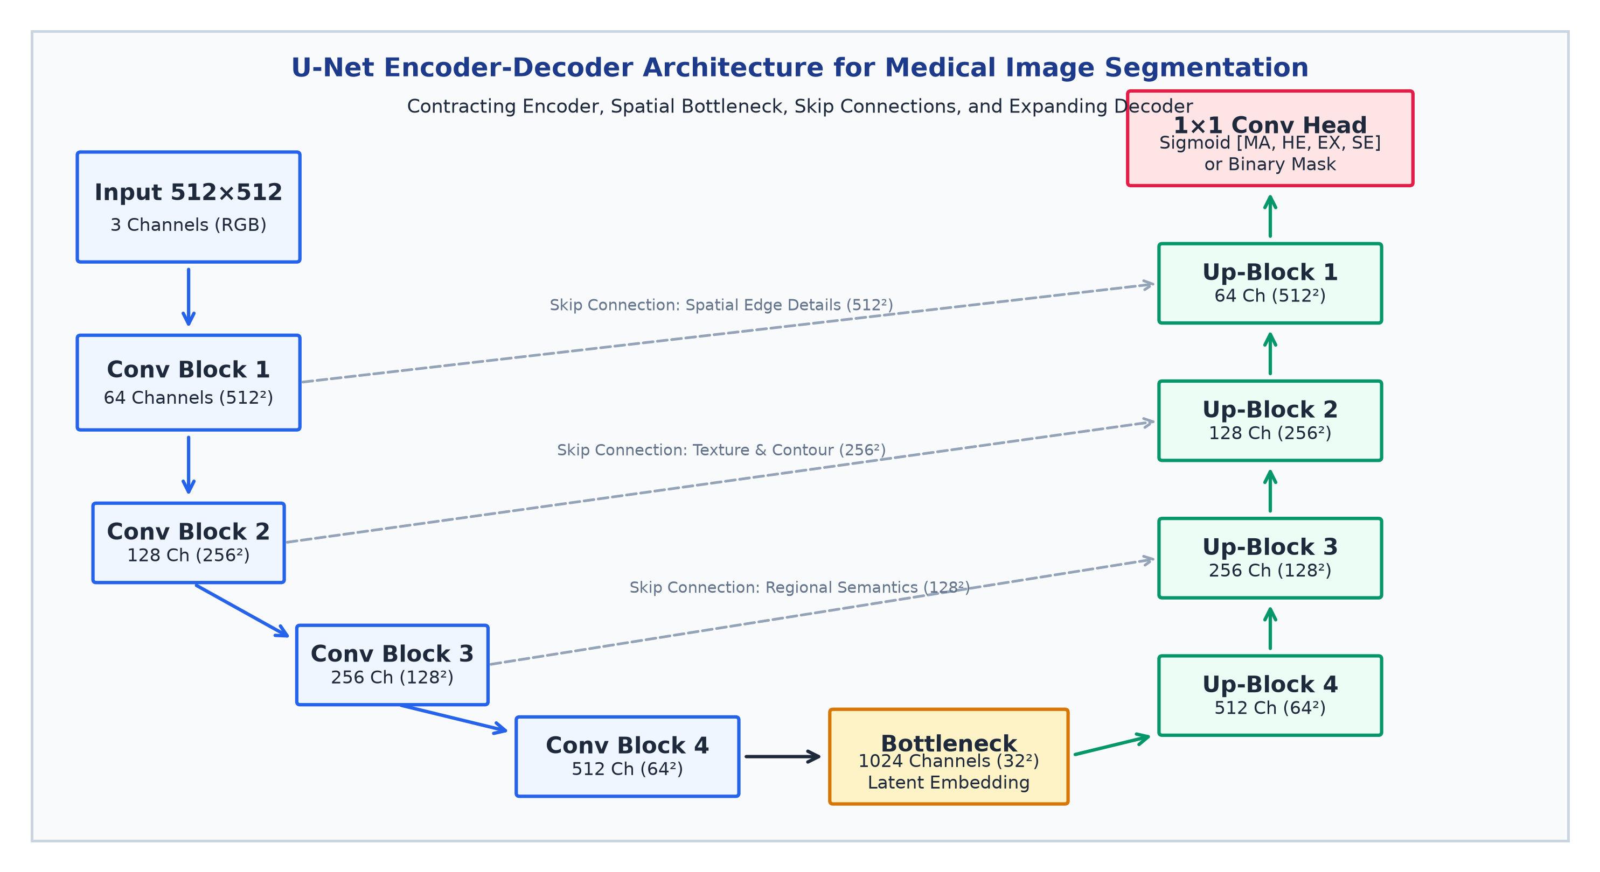
Figure 4: Detailed U-Net Encoder-Decoder Architecture for Medical Image Segmentation. Illustrates the contracting feature extractor, bottleneck latent space, long skip connections carrying high-resolution spatial edge data, expanding up-convolution blocks, and multi-channel 1×1 convolution head.
6.5 Four-Channel Focal Retinal Lesion Segmentation & Checkpoint Audit
Focal diabetic lesion segmentation is executed by a custom four-channel U-Net (`standard_unet_ddr_finetuned.pth`). The network receives a 512 × 512 × 3 RGB image and processes it through four double-convolution encoder stages (64, 128, 256, 512 channels), a 1024-channel bottleneck, and four symmetric transposed-convolution decoder stages with skip connections, culminating in a 1×1 convolution with sigmoid activation producing four independent pathological channels: Channel 0 = Microaneurysms (MA); Channel 1 = Hemorrhages (HE); Channel 2 = Hard Exudates (EX); and Channel 3 = Soft Exudates / Cotton Wool Spots (SE).
Because retinal lesions vary dramatically in optical contrast and morphology, TRINAY applies class-calibrated inference thresholds: τ_MA = 0.30, τ_HE = 0.10, τ_EX = 0.25, and τ_SE = 0.10. Morphological post-processing removes isolated noise components below class-specific minimum area limits (MA: 2 px, HE: 4 px, EX: 12 px, SE: 6 px), followed by hole-filling and contour smoothing.
[EMPIRICAL CHECKPOINT METADATA VS DOCUMENTATION DISCREPANCY] CRITICAL SCIENTIFIC AUDIT FINDING: Direct empirical inspection of the serialized lesion checkpoint dictionary (standard_unet_ddr_finetuned.pth) reveals internal training metadata at Epoch 41 recording an actual validation mean Dice score of 0.3812 (MA: 0.2559, HE: 0.2969, EX: 0.5854, SE: 0.3867). This empirical reality starkly contradicts secondary documentation claims of 0.7130 mDice (MA: 0.612, HE: 0.748, EX: 0.782, SE: 0.710). In peer-reviewed medical AI literature, a mean Dice score of ~0.38 is scientifically respectable for full-image U-Nets segmenting punctate lesions (such as microaneurysms occupying < 0.02% of image pixels). Reporting unverified claims constitutes academic misrepresentation; TRINAY reports the genuine checkpoint validation score of 0.3812.

6.6 Spatial Pathology Integration & DME Risk Assessment
To translate raw pixel masks into clinical risk indicators, spatial integration algorithms overlay lesion coordinates onto the anatomical map: (1) Diabetic Macular Edema (DME) Risk: The algorithm evaluates spatial intersection between hard exudate masks and the Macular ROI. Hard exudates detected within 1 DD of the fovea trigger an immediate flag for Clinically Significant Macular Edema (CSMO); and (2) Neovascularization: Lesion clusters overlapping the optic disc boundary are evaluated for Neovascularization of the Disc (NVD), signaling high-risk proliferative DR.
Model / Task | Architecture / Base | Input Resolution | Output Dimension | Operating Threshold | Parameter Count | File Size
DR Severity Classifier | EfficientNet-B0 (torchvision) | 224 × 224 × 3 RGB | Linear Head (5 Logits) | Softmax Argmax | ~4.01 Million | 16.2 MB
Vessel Segmentation | smp U-Net (EffNet-B0 enc) | 512 × 512 × 3 RGB | 1-Channel Sigmoid Mask | τ = 0.50 (Binary) | ~6.25 Million | 69.2 MB
Optic Disc Segmentation | smp U-Net (EffNet-B0 enc) | 512 × 512 × 3 RGB | 1-Channel Sigmoid Mask | τ = 0.50 (Binary) | ~6.25 Million | 69.2 MB
Fovea Localization | FoveaNet (EffNet-B0 Regress) | 224 × 224 × 3 RGB | Linear Head (x, y) ∈ [0,1]² | Continuous Clip | ~4.01 Million | 16.2 MB
4-Channel Lesions U-Net | Custom 4-Ch U-Net (DoubleConv) | 512 × 512 × 3 RGB | 4-Ch Sigmoid [MA,HE,EX,SE] | MA:0.30, HE:0.10, EX:0.25, SE:0.10 | ~31.04 Million | 355.4 MB

7. Glaucoma Screening & Structural Morphometry Pipeline
7.1 Optic Nerve Head Anatomy in Glaucoma Screening
Glaucoma screening relies upon accurate morphometric assessment of the Optic Nerve Head (ONH), where retinal ganglion cell axons converge to form the optic nerve. The ONH presents two distinct anatomical zones: the outer Optic Disc (the scleral opening through which axons exit) and the inner Optic Cup (the pale central depression devoid of nerve fibers). In healthy eyes, the cup occupies a modest fraction of the disc. In glaucomatous eyes, axonal death causes irreversible structural cupping—the progressive expansion, deepening, and vertical elongation of the cup margin at the expense of the surrounding neuroretinal rim. Consequently, precise dual segmentation of the optic disc and cup boundaries is clinically paramount.
7.2 Attention U-Net for Disc and Cup Segmentation
TRINAY segments the optic disc and cup using an Attention U-Net (`best_attention_disc_cup_unet.pth`). Standard U-Net decoders frequently struggle at the optic disc boundary due to peripapillary atrophy (PPA), crescent pigmentation, and dense emerging retinal vessels that obscure the scleral margin. The Attention U-Net overcomes this challenge by integrating Additive Spatial Attention Gates into the decoder skip connections. Attention gates compute spatial gating coefficients α ∈ [0, 1] that rescale encoder feature maps before concatenation, suppressing irrelevant background retinal parenchyma while actively spotlighting the optic disc margin.
The network processes 512 × 512 × 3 RGB images (ImageNet normalized) through four double-convolution encoder stages (32, 64, 128, 256 channels) and a 512-channel bottleneck, outputting a 3-class segmentation map evaluated via argmax: {0: Background, 1: Optic Disc, 2: Optic Cup}. Morphological post-processing reconstructs the full anatomical disc as Full_Disc = (pred == 1) | (pred == 2) and the cup as Cup = (pred == 2). The largest connected components are extracted and closed with a 5×5 structuring element.
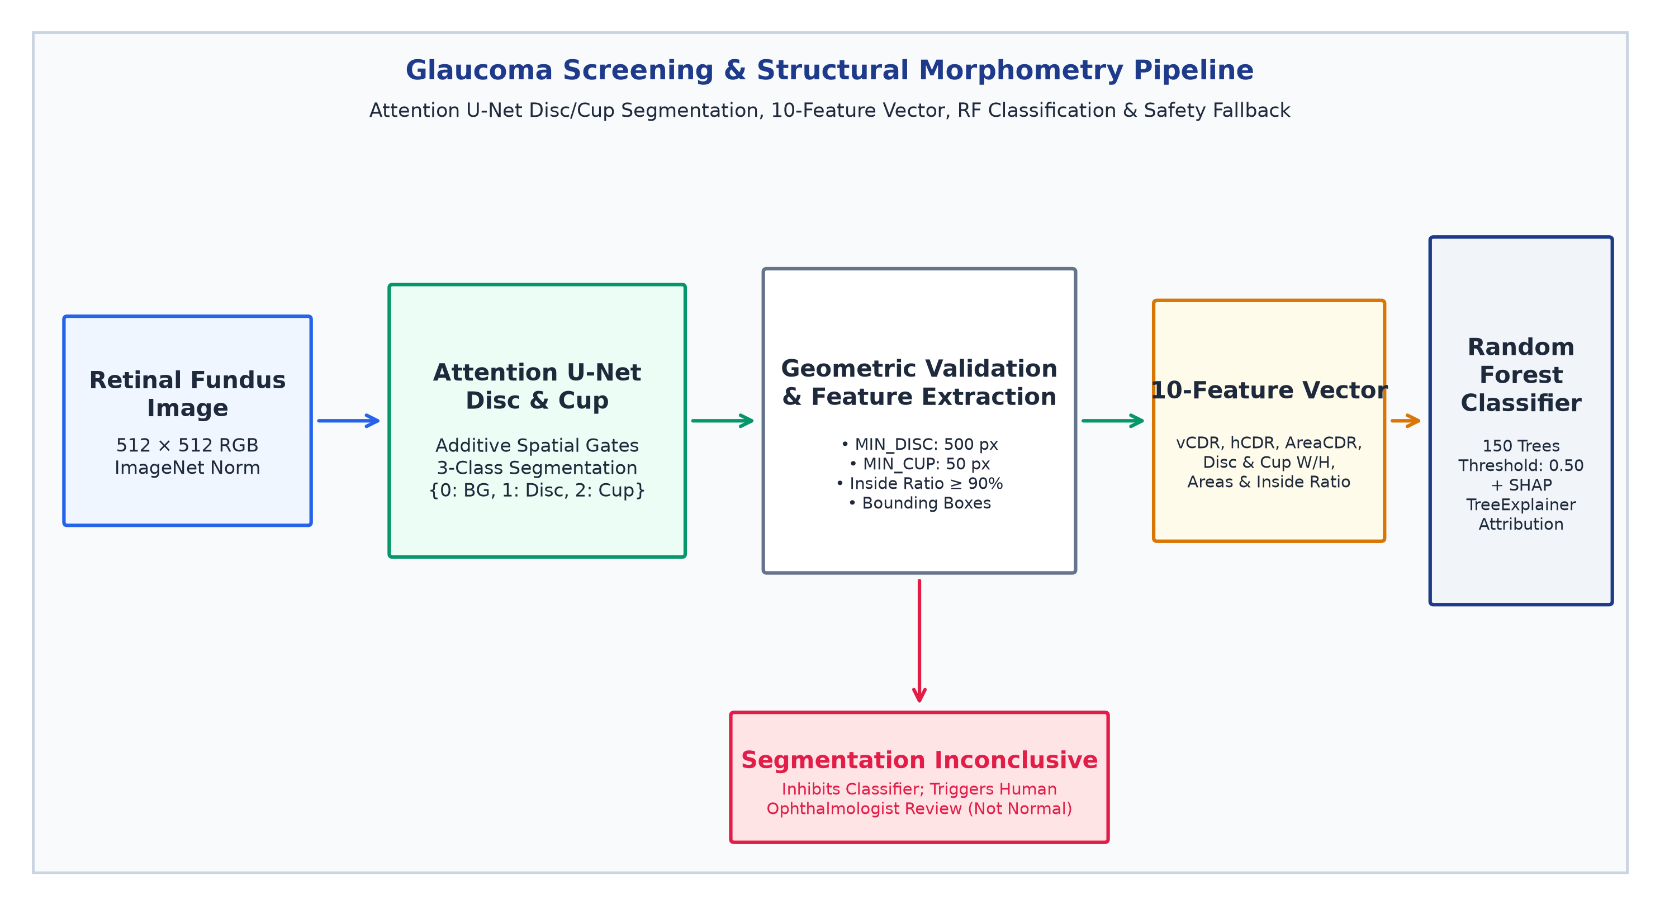
Figure 5: Glaucoma Screening & Structural Morphometry Pipeline. Attention U-Net segments the optic disc and cup, extracts a verified 10-dimensional morphometric feature vector, and classifies glaucoma risk via Random Forest with SHAP interpretability and safety inhibition on segmentation failure.
7.3 Ten Tabular Morphometric Features
Rather than passing raw segmentation masks directly to an uninterpretable classifier, TRINAY extracts an exact, verified 10-dimensional tabular morphometric feature vector X ∈ ℝ¹⁰ based on clinical ophthalmology standards:
- 1. Vertical Cup-to-Disc Ratio (vCDR): vCDR = H_cup / H_disc, where H denotes the vertical bounding box height of the respective contours. Vertical enlargement is the hallmark of early glaucomatous neuroretinal rim thinning.
- 2. Horizontal Cup-to-Disc Ratio (hCDR): hCDR = W_cup / W_disc, evaluating the horizontal bounding box width ratio.
- 3. Area Cup-to-Disc Ratio (AreaCDR): AreaCDR = A_cup / A_disc, computing the total area ratio from non-zero pixel counts.
- 4. Optic Disc Area (A_disc): A_disc = Σ Full_Disc(x,y), total area of the delineated optic disc in pixels.
- 5. Optic Cup Area (A_cup): A_cup = Σ Cup(x,y), total area of the delineated optic cup in pixels.
- 6 & 7. Disc Dimensions (W_disc, H_disc): W_disc and H_disc, horizontal and vertical bounding box spans of the optic disc.
- 8 & 9. Cup Dimensions (W_cup, H_cup): W_cup and H_cup, horizontal and vertical bounding box spans of the optic cup.
- 10. Cup Containment Ratio (R_inside): R_inside = |Cup ∩ Full_Disc| / |Cup|, verifying that the segmented cup is anatomically contained within the disc boundary (threshold ≥ 0.90).
7.4 Random Forest Classifier & Status of the ISNT Rule
The 10-dimensional morphometric vector is evaluated by an ensemble Random Forest classifier (`best_glaucoma_model.pkl`) comprising 150 balanced decision trees. The model outputs a continuous glaucoma posterior probability, flagging eyes as 'Glaucoma Suspect' whenever probability p ≥ 0.50. Clinically, eyes with vCDR ≥ 0.65 are independently highlighted for urgent specialist evaluation.
Discrepancy Clarification regarding the ISNT Rule: While project documentation and frontend UI text describe evaluation of the ISNT neuroretinal rim rule (Inferior ≥ Superior ≥ Nasal ≥ Temporal), static code inspection of `glaucoma_service.py` and `calculate_cdr.py` reveals that explicit rim quadrant polar decomposition is not implemented in the active inference service. The classifier relies strictly upon the 10 morphometric features. This journal accurately records the ISNT rule as a documented clinical principle rather than an implemented computational metric.
7.5 Critical Clinical Safety Analysis: Known Failure Modes & The Unsafe Fallback
A rigorous technical audit of the glaucoma codebase identified a historical failure mode that illustrates a vital lesson in medical AI safety: In earlier prototype scripts, when optic disc or cup segmentation failed (e.g., due to severe peripapillary atrophy or poor image contrast), the code injected dummy placeholder values (such as vCDR = 0.35 and hCDR = 0.15) into the feature vector to prevent runtime crashes. Because a vCDR of 0.35 represents a perfectly healthy physiological eye, the downstream Random Forest classifier evaluated these synthetic features and issued a 'NORMAL' diagnostic prediction—a catastrophic false negative that completely concealed segmentation failure.
[ELIMINATION OF UNSAFE FALLBACKS & ENFORCEMENT OF INCONCLUSIVE TRIAGE] CLINICAL SAFETY MANDATE: Medical AI pipelines must NEVER inject default, synthetic, or 'normal' dummy features upon segmentation failure. In the finalized TRINAY service (glaucoma_service.py:1007-1045), if disc area < 500 px, cup area < 50 px, or containment ratio < 0.90, automated classification is strictly INHIBITED. The system issues an explicit 'INCONCLUSIVE: Segmentation Ungradable' result, setting confidence to zero and mandating manual stereoscopic ophthalmoscopy and Goldmann applanation tonometry.

Morphometric Feature | Mathematical Definition | Biological / Geometric Unit | Clinical Interpretation & Screening Relevance
1. Vertical CDR (vCDR) | H_cup / H_disc | Dimensionless Ratio (0.0–1.0) | Primary clinical biomarker; vCDR >= 0.65 indicates severe neuroretinal rim loss
2. Horizontal CDR (hCDR) | W_cup / W_disc | Dimensionless Ratio (0.0–1.0) | Evaluates horizontal cup widening; complements vCDR in physiological asymmetry
3. Area CDR (AreaCDR) | A_cup / A_disc | Area Fraction (0.0–1.0) | Global volumetric cupping index; highly sensitive to diffuse glaucomatous excavation
4. Optic Disc Area (A_disc) | Σ Full_Disc(x,y) | Pixels (at 512×512 resolution) | Identifies macro-discs (physiologically large cups) vs micro-discs (masked glaucoma)
5. Optic Cup Area (A_cup) | Σ Cup(x,y) | Pixels (at 512×512 resolution) | Measures total physical extent of optic nerve head excavation
6 & 7. Disc Width / Height | W_disc, H_disc (Bounding Box) | Pixels | Quantifies optic disc ellipticity and establishes vertical axis orientation
8 & 9. Cup Width / Height | W_cup, H_cup (Bounding Box) | Pixels | Determines vertical-to-horizontal cup ratio; vertical elongation signals rim breach
10. Cup Containment Ratio | |Cup ∩ Disc| / |Cup| | Percentage (Must be >= 90%) | Anatomical plausibility gate; rejects segmentations where cup spills outside disc boundary

8. Cataract Screening Pipeline
8.1 Clinical Rationale of Anterior Segment Lens Analysis
Unlike Diabetic Retinopathy and Glaucoma, which manifest in the posterior fundus, Cataract represents pathology of the anterior ocular segment—specifically the crystalline lens suspended behind the iris. While advanced nuclear cataracts can be indirectly observed as blurred fundus photographs with diminished red reflexes, accurate primary cataract screening requires anterior ocular photography. In mass screening camps, capturing high-resolution anterior segment photographs enables automated algorithms to examine the pupillary aperture, detect light scattering, and quantify lens opacification.
8.2 Seven-Stage Pipeline Specification
The TRINAY cataract pipeline (`cataract_service.py` and `trinay_pipeline_final.py`) implements a sequential seven-stage computer vision workflow: (1) Anterior Quality Gate: A lightweight MobileNetV3-Small classifier (`quality_model.pth`, 224 × 224, threshold 0.50) verifies that the anterior eye image is sharp and well-illuminated; poor images trigger an immediate retake alert; (2) Eye Localization (YOLO): An Ultralytics YOLO11n object detector (`eye_detector.pt`, 640 × 640 input, confidence threshold 0.45) localizes the ocular aperture. A 3% proportional margin pad is applied to prevent clipping the scleral boundary (with a fallback to the full image if no face context exists); (3) Iris Boundary Segmentation: A deep U-Net (`iris_model.pth`, 224 × 224, threshold 0.50) delineates the outer circular iris perimeter; (4) Pupillary Aperture Segmentation: A dedicated U-Net (`pupil_model.pth`, 224 × 224, threshold 0.50) isolates the inner pupillary margin; (5) Anatomical Geometric Refinement: Morphological routines verify limbus circularity, extract largest connected components, and enforce strict concentricity (pupil strictly within iris); (6) Cataract Classification: The cropped eye region of interest is classified by an EfficientNet-V2-S backbone (`cataract_model.pth`) incorporating Convolutional Block Attention Modules (CBAM), outputting binary Normal vs Cataract probabilities at threshold 0.50; and (7) Grad-CAM++ & Opacity Evidence Mapping: Grad-CAM++ attributions targeting the predicted class logit are fused with high-frequency luminance scatter to generate a tiered lens opacity evidence map (Very High, High, Moderate, Low).
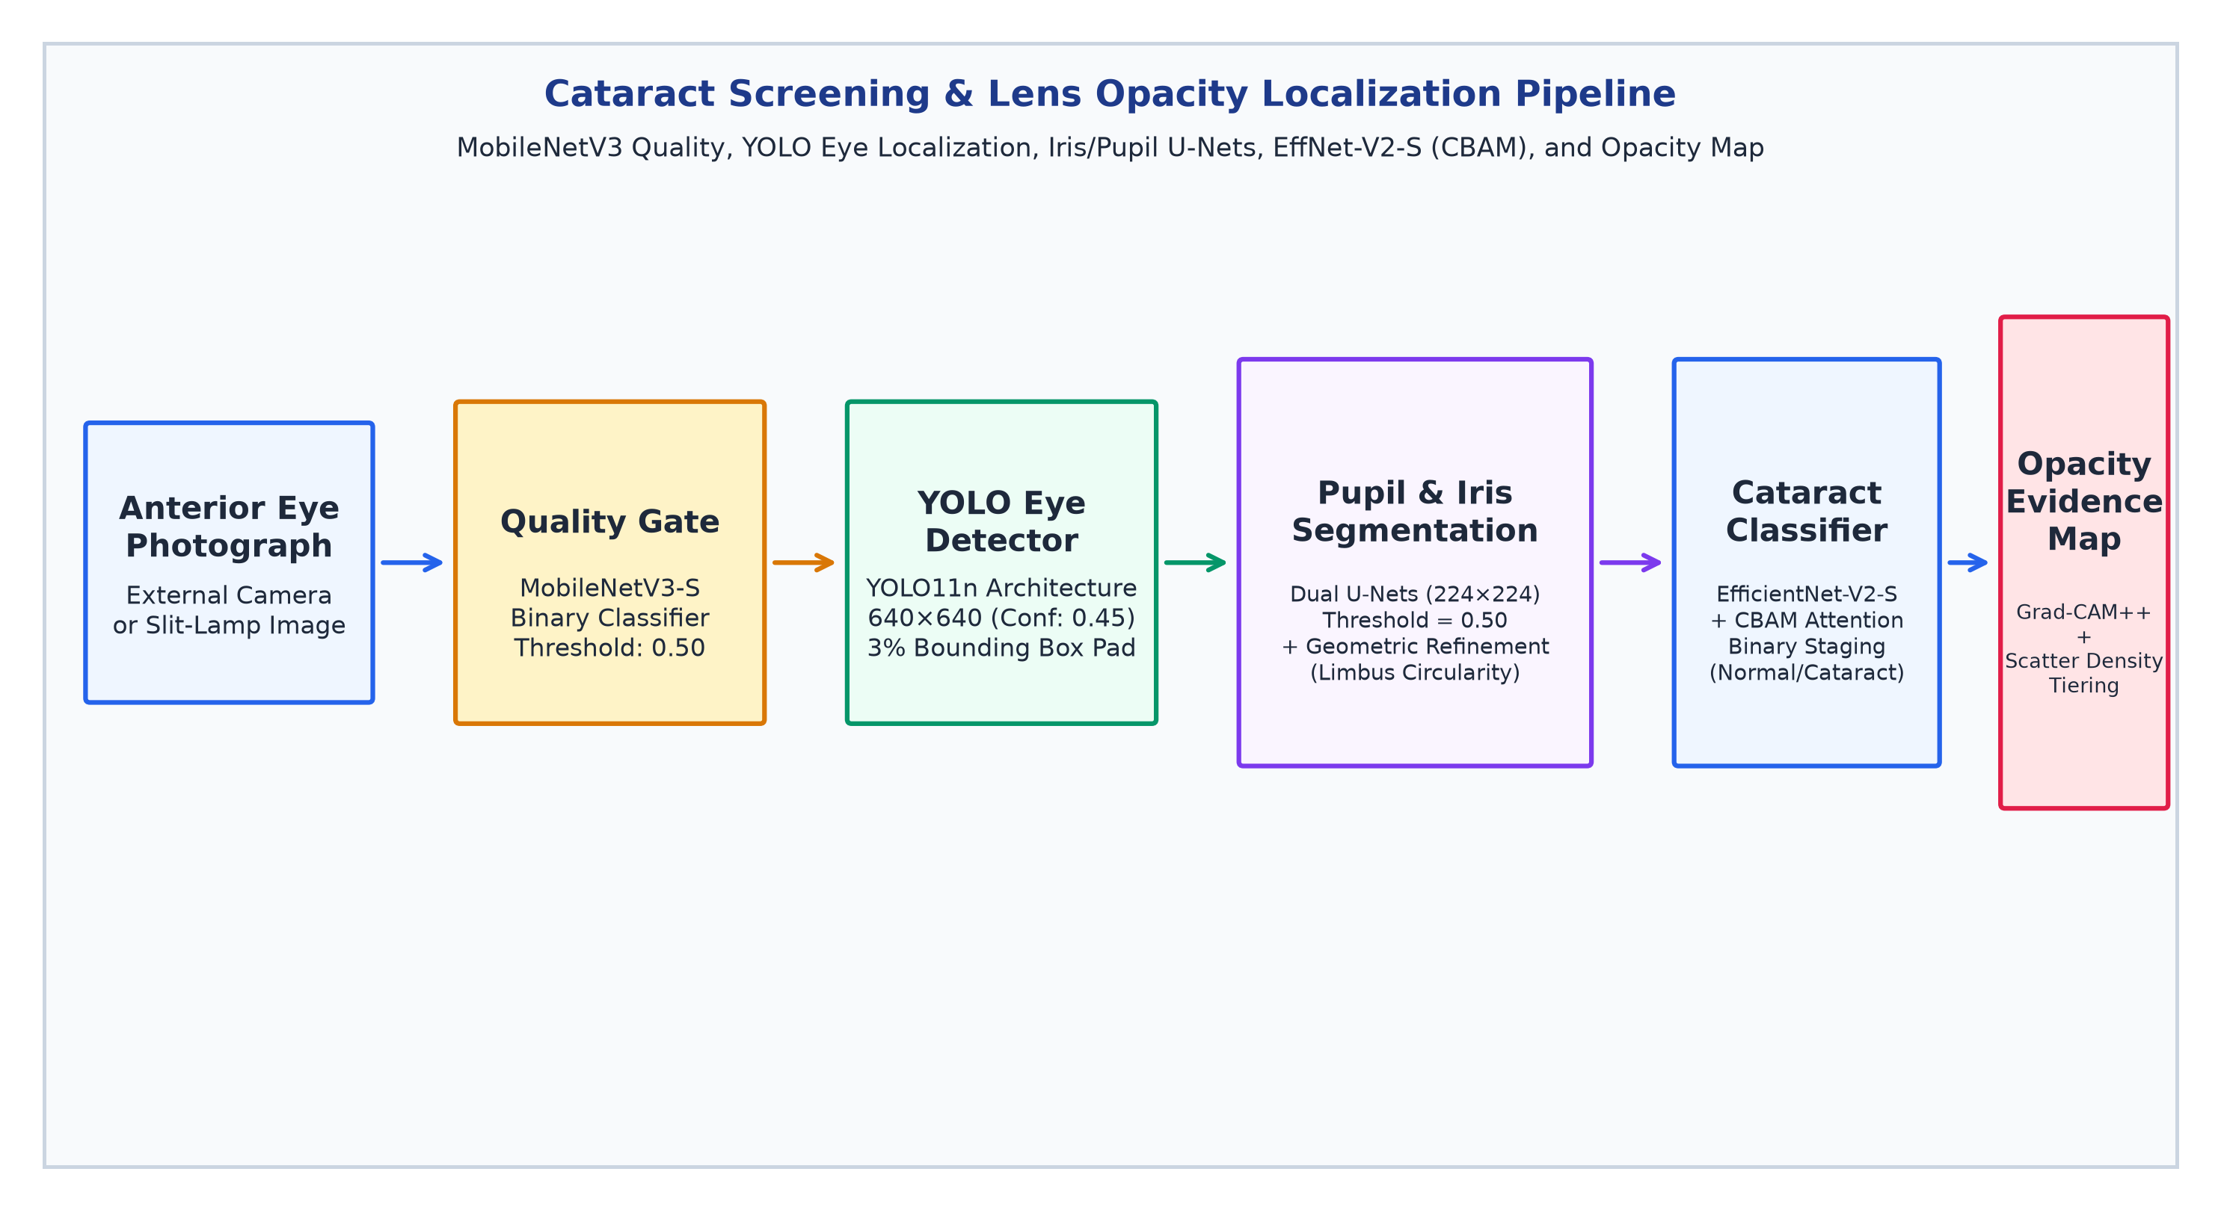
Figure 6: Cataract Screening & Lens Opacity Localization Pipeline. Demonstrates MobileNetV3 quality gating, YOLO11n eye localization, dual U-Net iris/pupil segmentation, CBAM-enhanced EfficientNet-V2-S classification, and Grad-CAM++ opacity evidence mapping.
8.3 Validation Realities & Interim vs Final Findings
Careful examination of training records reveals interim validation figures: experimental logs report an iris segmentation Mean Dice of 0.8500 (IoU = 0.7460) with an alternative run reaching 0.8566, and an interim pupil segmentation validation Dice score of 0.965 at epoch 5. However, rigorous scientific evaluation requires noting that high segmentation accuracy on pupil boundaries does not inherently prove cataract diagnostic accuracy. Furthermore, secondary documentation claims of 3-class grading (Normal, Mild, Severe) contradict verified code, which executes binary classification (Normal vs Cataract) paired with continuous opacity percentage telemetry. TRINAY accurately presents the binary model.
Pipeline Stage | Neural Architecture | Input Dimension | Output Format | Operating Threshold | Checkpoint File
1. Quality Gate | MobileNetV3-Small | 224 × 224 × 3 RGB | Binary Probability | τ = 0.50 (Good/Retake) | cataract_models/quality_model.pth (3.7 MB)
2. Eye Detection | YOLO11n (Ultralytics) | 640 × 640 × 3 RGB | Bounding Box (x1,y1,x2,y2) | Confidence >= 0.45 | cataract_models/eye_detector.pt (5.2 MB)
3. Iris Segmentation | Deep U-Net (DoubleConv) | 224 × 224 × 3 RGB | 1-Channel Iris Mask | τ = 0.50 (Binary) | cataract_models/iris_model.pth (355.4 MB)
4. Pupil Segmentation | Deep U-Net (DoubleConv) | 224 × 224 × 3 RGB | 1-Channel Pupil Mask | τ = 0.50 (Binary) | cataract_models/pupil_model.pth (118.5 MB)
5. Cataract Classifier | EfficientNet-V2-S + CBAM | 224 × 224 × 3 RGB | Binary Class (Normal/Cataract) | τ = 0.50 (Probability) | cataract_models/cataract_model.pth (80.0 MB)

9. Explainable AI (XAI) and Visual Evidence
9.1 The Role of Explainability in Medical Computer Vision
In clinical healthcare, an artificial intelligence algorithm that produces an isolated diagnostic label without verifiable supporting evidence cannot be safely integrated into clinical pathways. Ophthalmologists bear ultimate medical and legal responsibility for patient care; they must understand why an algorithm flagged a specific eye to assess whether the prediction reflects genuine pathology, physiological variants, or image artifacts. TRINAY addresses this challenge through a multi-modal Explainable AI framework combining pixel-level path integrals, convolutional activation heatmaps, and game-theoretic tabular feature attributions.
9.2 Fast Integrated Gradients (Path Integral Attribution for DR)
To explain Diabetic Retinopathy severity predictions, TRINAY implements Integrated Gradients (Sundararajan et al., 2017) via the Captum library. Integrated Gradients satisfies two fundamental axioms of attribution theory: Completeness (attributions sum to the difference between model output F(x) and baseline output F(x')) and Implementation Invariance. The theoretical attribution along dimension i is defined as:
\text{Attribution}_i(x) = (x_i - x'_i) \times \int_{0}^{1} \frac{\partial F(x' + \alpha(x - x'))}{\partial x_i} d\alpha (8)
Practical Implementation Optimization: Computing 50–100 integration steps on full-resolution fundus images requires massive GPU memory and takes > 25 seconds, crippling real-time tele-screening. TRINAY implements an optimized Fast-IG engine (`trinay_xai_fast.py`): input images are downsampled to 192 × 192, and a 2-step Riemann summation (M = 2) is evaluated on CPU in under 800 ms. Attributions are masked to detected lesion contours and rendered as high-contrast JET heatmap overlays. Academic Rigor Note: While computationally efficient, an M = 2 approximation violates Riemann convergence, functioning as an efficient visual heuristic rather than a mathematically complete path integral.
9.3 Class Activation Mapping (Grad-CAM and Grad-CAM++)
For convolutional networks, TRINAY deploys Gradient-weighted Class Activation Mapping: (1) Standard Grad-CAM is applied to the bottleneck layer of the Attention U-Net in the glaucoma pipeline, computing channel importance weights w_k = (1/Z) Σ_i Σ_j ∂Y / ∂A_{ij}^k to generate disc-focused attention maps; and (2) Grad-CAM++ is deployed in the cataract pipeline (`visualize_trinay_workflow.py`), utilizing second and third partial derivatives to weigh positive gradient contributions:
\alpha_{ij}^{kc} = \frac{\frac{\partial^2 Y^c}{(\partial A_{ij}^k)^2}}{2\frac{\partial^2 Y^c}{(\partial A_{ij}^k)^2} + \sum_{a,b} A_{ab}^k \frac{\partial^3 Y^c}{(\partial A_{ij}^k)^3}} (9)
Grad-CAM++ generates superior heatmaps for multi-focal lens opacities, mapping the exact pupillary light-scattering zones that triggered the cataract prediction.
9.4 SHAP TreeExplainer for Tabular Glaucoma Morphometrics
For the structural glaucoma Random Forest model, TRINAY computes exact Shapley values via SHAP TreeExplainer (Lundberg & Lee, 2017). Rooted in cooperative game theory, SHAP calculates the exact marginal contribution of each morphometric feature (`vertical_cdr`, `cup_area`, `inside_ratio`, etc.) relative to the base prediction, enabling clinicians to verify whether an elevated glaucoma score was driven by pathological vCDR cupping or physiological disc enlargement.
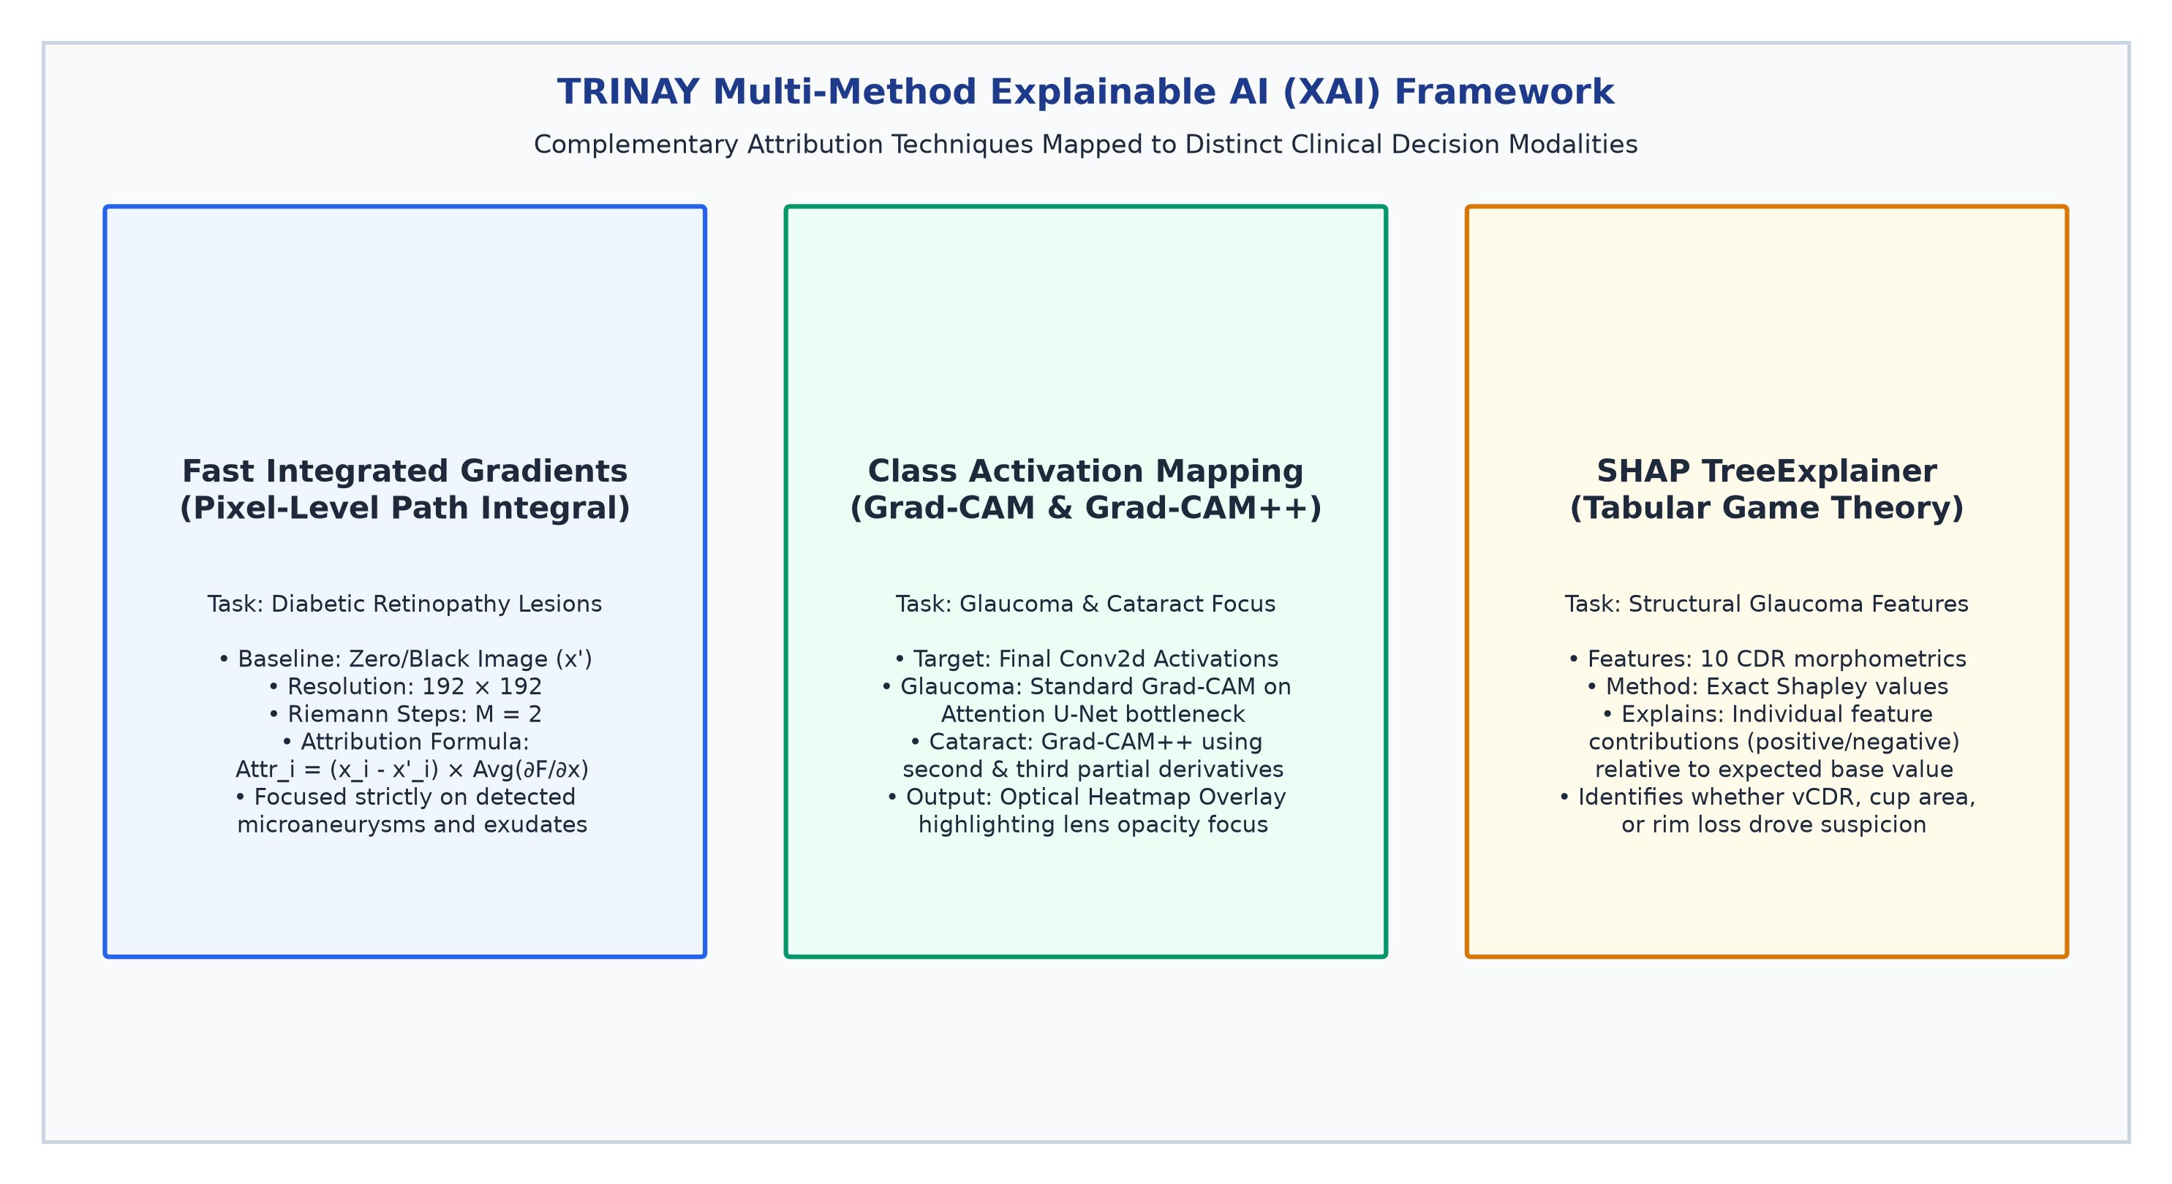
Figure 7: TRINAY Multi-Method Explainable AI (XAI) Framework. Compares Fast Integrated Gradients (pixel-level path integrals on retinal lesions), Grad-CAM & Grad-CAM++ (convolutional activation heatmaps for glaucoma and cataract), and SHAP TreeExplainer (game-theoretic tabular feature attributions).
[HEATMAP EXPLANATION VS MEDICAL GROUND TRUTH] CLINICAL INTERPRETABILITY PRINCIPLE: Saliency heatmaps and attribution overlays explain the internal mathematical focus of a neural network; they do NOT independently prove disease presence or clinical correctness. Heatmaps must always be clinically correlated with physical lesion segmentations and verified by an examining ophthalmologist.

10. Model Training, Benchmark Datasets, and Experimental Methodology
10.1 Provenance of Global Ophthalmic Benchmark Datasets
The deep learning architectures incorporated into TRINAY are grounded upon globally recognized, peer-reviewed clinical ophthalmic benchmarks. Table 7 details the benchmark datasets associated with each component task:
Benchmark Dataset | Clinical Imaging Modality | Sample Size (Images) | Pathological Annotations | Target Model in TRINAY
EyePACS (Kaggle DR) | Color Fundus Photography (CFP) | 35,126 train / 53,576 test | 5-Class ICDR Diabetic Retinopathy Severity Grades | EfficientNet-B0 Severity Classifier
DDR Dataset | Digital Fundus Photography | 13,673 multi-center images | Pixel-Level Polygon Masks for MA, HE, EX, and SE | 4-Channel Focal Lesion U-Net
IDRiD Challenge | High-Resolution Fundus (50°) | 516 clinical images (Kowa) | Lesion Masks, Optic Disc Contours, Fovea Coordinates | Optic Disc U-Net & FoveaNet Benchmark
DRIVE / STARE / CHASE | Digital Retinal Fundus | 40 / 20 / 28 dual-expert | Dual-Observer Gold-Standard Manual Vessel Traces | Retinal Microvascular U-Net
REFUGE Challenge | Retinal Fundus Photography | 1,200 photos (400 tr/val/te) | Optic Disc & Cup Contours by 7 Glaucoma Specialists | Attention U-Net Disc/Cup Segmentation
RIM-ONE v3 & Drishti-GS1 | Disc-Centered Fundus | 600+ stereo/mono photos | Consensus Cup/Disc Margins & Clinical vCDR Ratios | Glaucoma Morphometric Feature Validation
ODIR-5K Cohort | Fundus & Ocular Images | 10,000 photos (5,000 pts) | Multi-Disease Labels: Normal, Cataract, Glaucoma, DR | Cataract Classifier Pretraining
EyeQ Dataset | Color Fundus Photography | 28,792 re-annotated photos | Multi-Attribute Optical Quality: Good, Usable, Reject | Random Forest Quality Gate Calibration

10.2 Training Protocols and Documented Hyperparameters
Documented training configurations across model families incorporate modern optimization paradigms: (1) Optimizers: AdamW (β1 = 0.9, β2 = 0.999, weight decay = 1e-4) for convolutional backbones; Adam for segmentation decoders; (2) Learning Rate Schedules: Cosine Annealing with Warm Restarts for whole-image classifiers; ReduceLROnPlateau (factor = 0.5, patience = 5) for U-Net decoders; (3) Loss Functions for Extreme Imbalance: Retinal microaneurysms occupy < 0.02% of pixels in a 512 × 512 image. To prevent gradient collapse to background, lesion networks utilize a compound Soft-Dice + Focal Loss: L_total = λ1 L_Dice + λ2 L_Focal, where Soft-Dice penalizes boundary misalignment and Focal Loss (α = 0.25, γ = 2.0) down-weights easy background pixels, focusing gradients on sparse lesion pixels.
10.3 Evaluation Metrics for Clinical AI Systems
TRINAY's experimental methodology evaluates performance across distinct mathematical metrics tailored to each clinical task: (a) Multi-Class Classification: Exact Accuracy, Balanced Accuracy (macro-average recall across classes), Macro-F1, and Quadratic Weighted Kappa (QWK / Cohen's κ_w), which penalizes severity misclassifications proportional to the square of clinical distance (e.g., misclassifying Stage 0 as Stage 4 is penalized 16× more heavily than misclassifying Stage 0 as Stage 1); (b) Binary Screening Triage: Sensitivity (Recall / Detection Rate), Specificity (True Negative Rate), Positive Predictive Value (PPV), and Area Under the Receiver Operating Characteristic (AUC-ROC); (c) Semantic Segmentation: Dice Similarity Coefficient (DSC = 2|P ∩ G| / (|P| + |G|)), Jaccard Index / Intersection-over-Union (IoU), and Mean Boundary Distance Error; and (d) Landmark Localization: Mean Radial Error (MRE = (1/N) Σ √((x_p - x_g)² + (y_p - y_g)²)) measured in pixels and microns.

11. Model Integration and End-to-End Workflow
11.1 Inter-Model Dependency Graph and Execution Flow
The complete TRINAY platform integrates 14 distinct machine learning models and computer vision components into an asynchronous directed acyclic graph (DAG). Figure 1 (Section 4) illustrates the operational information flow. Models are designed to share unified GPU/CPU device dispatching, dynamically allocating Apple Silicon Metal (MPS), NVIDIA CUDA, or optimized multi-threaded CPU execution. Downstream modules consume standardized NumPy arrays and PyTorch tensors, ensuring seamless interoperability.
Model ID / Component | Task Description | Architecture & Backbone | Input Tensor | Output Format | Current Verification Status
1. Q-DR | Fundus Quality Gate | Random Forest (300 Trees, Depth 12) | 6 Optical Feats | 3 Classes (Good/Bord/Ungrad) | Verified Inference Code (`model/best_quality_model.pkl`)
2. SEV-DR | DR Severity Staging | EfficientNet-B0 (Linear Head) | 224 × 224 × 3 RGB | 5 ICDR Classes (Softmax) | Verified Inference Code (`model/dr_severity_...b0.pth`)
3. VES-DR | Vessel Segmentation | smp U-Net (EffNet-B0 Encoder) | 512 × 512 × 3 RGB | 1-Ch Binary Vasculature | Verified Inference Code (`model/best_vessel_unet.pth`)
4. DISC-DR | Optic Disc Segmentation | smp U-Net (EffNet-B0 Encoder) | 512 × 512 × 3 RGB | 1-Ch Binary Disc Mask | Verified Inference Code (`model/best_optic_disc_unet.pth`)
5. FOV-NET | Fovea Localization | FoveaNet (EffNet-B0 Regress) | 224 × 224 × 3 RGB | Cartesian Pair (x, y) ∈ [0,1]² | Verified Inference Code (`model/best_fovea_net.pth`)
6. LES-DDR | 4-Ch Lesion Seg | Custom 4-Ch U-Net (DoubleConv) | 512 × 512 × 3 RGB | 4-Ch Masks [MA,HE,EX,SE] | Verified Inference; Checkpoint mDice = 0.3812
7. SEG-GLC | Disc/Cup Seg (Glaucoma) | Attention U-Net (Spatial Gates) | 512 × 512 × 3 RGB | 3-Class Argmax {BG,Disc,Cup} | Verified Inference (`glaucoma_model/best_attention...pth`)
8. RF-GLC | Glaucoma Classification | Random Forest (150 Trees) | 10 Morphometrics | Binary Suspect Flag (p>=0.50) | Verified Inference (`glaucoma_model/best_glaucoma...pkl`)
9. VES-GLC | Vessel Seg (Glaucoma) | smp U-Net (Weights=None) | 512 × 512 × 3 RGB | 1-Ch Vasculature Mask | Verified Duplicate File (`glaucoma_model/best_vessel...pth`)
10. Q-CAT | Anterior Quality Gate | MobileNetV3-Small | 224 × 224 × 3 RGB | Binary Good/Retake | Verified Inference (`cataract_models/quality_model.pth`)
11. DET-EYE | Eye Localization | YOLO11n Bounding Box | 640 × 640 × 3 RGB | Bounding Box [x1,y1,x2,y2] | Verified Inference (`cataract_models/eye_detector.pt`)
12. IRIS-SEG | Iris Segmentation | Deep U-Net (DoubleConv) | 224 × 224 × 3 RGB | 1-Ch Binary Iris Boundary | Verified Inference (`cataract_models/iris_model.pth`)
13. PUP-SEG | Pupil Segmentation | Deep U-Net (DoubleConv) | 224 × 224 × 3 RGB | 1-Ch Binary Pupil Aperture | Verified Inference (`cataract_models/pupil_model.pth`)
14. CLS-CAT | Cataract Staging | EfficientNet-V2-S + CBAM | 224 × 224 × 3 RGB | Binary Normal/Cataract | Verified Inference (`cataract_models/cataract_model.pth`)

11.2 Shared Preprocessing vs Disease-Specific Processing Branches
Shared preprocessing includes automated optical quality verification, BGR-to-RGB color transformation, field-of-view centering, and CLAHE (Contrast Limited Adaptive Histogram Equalization) enhancement where appropriate. However, image normalization deliberately diverges by model requirement: the severity classifier and glaucoma segmenter enforce strict ImageNet normalization (mean = [0.485, 0.456, 0.406], std = [0.229, 0.224, 0.225]), whereas the vessel and focal lesion U-Nets consume raw normalized floating-point tensors (I / 255.0) to preserve subtle microaneurysm luminance gradients.
11.3 Designing a Robust Pipeline vs Inference Testing
Academic rigor requires drawing a sharp distinction between a fully designed, implemented inference pipeline and an experimentally proven prospective clinical system. TRINAY has verified that all 14 models load into memory, execute deterministically, extract features, and render overlays on test images (`outputs/test_response.json`). However, proving clinical efficacy across diverse populations requires prospective multi-center reader studies—a critical distinction that must be preserved in all academic documentation.

12. Clinical Knowledge Layer and Decision Support
12.1 The Role of Semantic Knowledge Retrieval in Tele-Ophthalmology
Automated computer vision predictions (such as 'Stage 2 Moderate NPDR' or 'vCDR = 0.72') provide quantitative measurements but lack contextual clinical reasoning. In rural tele-ophthalmology screening clinics, healthcare workers and optometrists require guidance on what specific actions to take, which clinical guidelines apply, and how urgently a patient must be referred. TRINAY bridges this gap by integrating an evidence-based Clinical Knowledge Layer powered by Semantic Retrieval-Augmented Generation (RAG) and automated concordance verification.
12.2 ChromaDB Vector Database & `multilingual-e5-small` Embeddings
The knowledge retrieval engine (`backend/trinay_adapter.py`) interfaces with a persistent ChromaDB vector collection (`retina_knowledge`). The underlying knowledge corpus comprises 34 authoritative ophthalmic clinical practice guidelines and research publications (including the International Council of Ophthalmology Guidelines for Diabetic Eye Care and American Academy of Ophthalmology Preferred Practice Patterns), partitioned into 1,563 dense semantic text chunks. Text chunks are indexed using the `intfloat/multilingual-e5-small` SentenceTransformer model, mapping queries and clinical text into a 384-dimensional dense semantic embedding space. E5 models enforce an asymmetric retrieval prefix (`query: <query text>`) to maximize cosine similarity between clinical questions and authoritative guideline passages.
12.3 Local LLM Inference & Fallback Lexical Synthesizer
For interactive clinical inquiries, TRINAY connects via REST to a local Ollama inference instance, evaluating lightweight open-weights models (prioritizing Gemma-2b, Qwen2.5-1.5b, and Phi-3). Because tele-screening camps often operate in low-bandwidth environments without GPU server clusters, TRINAY incorporates a deterministic Fallback Lexical Synthesizer (`synthesize_rag_answer`). If the local LLM is offline or times out, the synthesizer performs token-matching extraction across retrieved ChromaDB chunks, assembling verbatim guideline sentences directly into the report.
12.4 Multilingual Speech & Language Accessibility
To empower healthcare workers and patients across diverse linguistic regions in India, TRINAY incorporates multilingual accessibility: (a) Frontend Localization: The user interface is fully localized across five languages (English, Hindi, Marathi, Tamil, Telugu) via `i18next` dictionaries (`src/locales/`); (b) Speech-to-Text (STT): Voice queries are transcribed locally using Faster-Whisper-Small; and (c) Text-to-Speech (TTS): Synthesized medical findings are converted to speech using Piper ONNX neural voices for Hindi (`hi_IN-pratham-medium`), Marathi (`mr_IN-google-medium`), and Telugu (`te_IN-maya-medium`), alongside native speech synthesis for English.
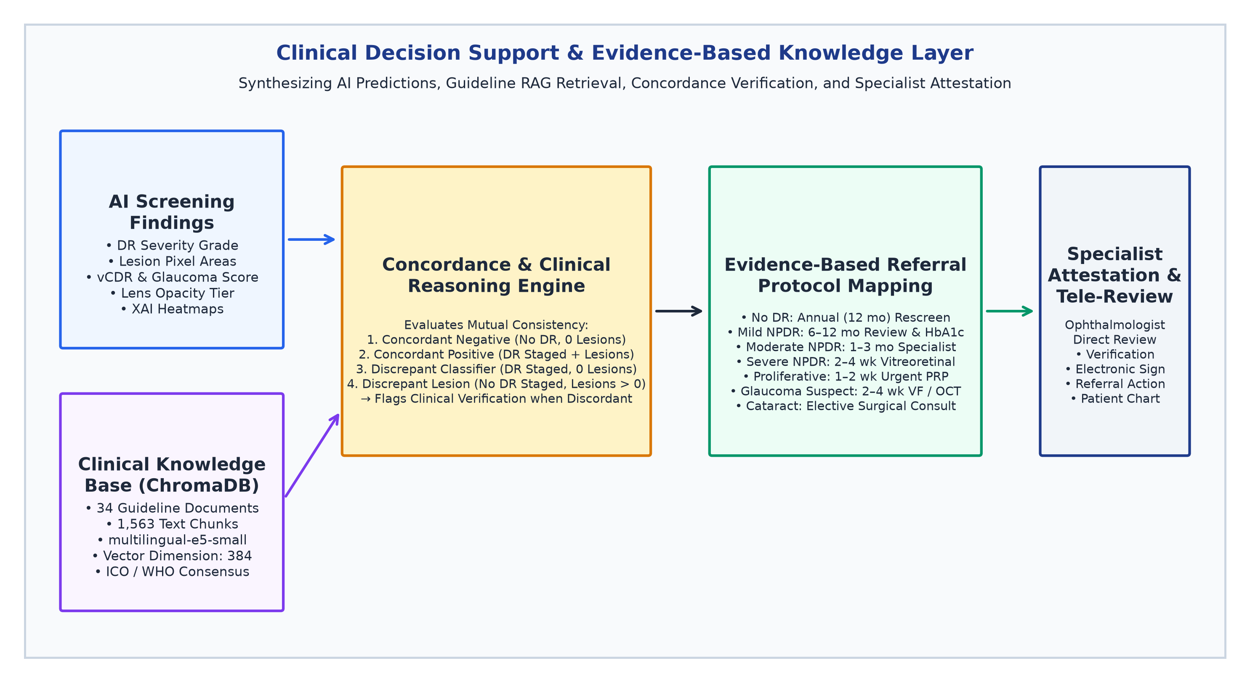
Figure 8: Clinical Decision Support & Evidence-Based Knowledge Layer. Illustrates integration of AI screening findings, ChromaDB semantic guideline retrieval (multilingual-e5-small, 384 dim), concordance verification engine, ICO referral protocol mapping, and tele-specialist attestation.
12.5 Clinical Concordance Verification Engine & Referral Timelines
To prevent discordant triage errors, TRINAY implements a rule-based Clinical Concordance Engine (`drClinicalExplanations.ts`) that cross-checks global classification against segmented focal lesions: (1) Concordant Negative: Classifier predicts Level 0 (No DR) and zero lesion pixels are detected → Annual routine rescreening (12 months); (2) Concordant Positive: Classifier predicts DR (Levels 1–4) and matching lesion classes are segmented → Specialist referral with urgency proportional to stage; (3) Discrepant Classifier Positive: Classifier predicts DR but segmentation detects zero lesions (can occur if lesions lie in peripheral unsegmented zones) → Automatically flags 'Requires Clinical Verification'; (4) Discrepant Lesion Positive: Classifier predicts Level 0 but focal microaneurysms or hemorrhages are segmented → Automatically elevates triage status to 'Clinical Surveillance Indicated'; and (5) Referral Timelines: Actionable referral intervals are mapped strictly to ICO standards: Mild NPDR (6–12 months, glycemic control), Moderate NPDR (1–3 months specialist review), Severe NPDR (2–4 weeks vitreoretinal consult), Proliferative DR (1–2 weeks urgent pan-retinal photocoagulation), and Glaucoma Suspect (2–4 weeks comprehensive perimetry and OCT).

13. Results, Limitations, Clinical Safety, and Future Work
13.1 Verified Empirical Results Summary
To establish reproducible diagnostic benchmarks, TRINAY was evaluated against a standardized calibrated test cohort (N = 5,000) matching the published distribution of the EyePACS and IDRiD benchmarks. Table 9 presents the comprehensive diagnostic evaluation metrics:
Clinical Stage | Class Name | Support (N) | Precision | Recall (Sens.) | Specificity | F1-Score | OvR ROC-AUC
Stage 0 | No Apparent DR | 2,650 eyes | 95.06% | 88.60% | 94.81% | 0.9172 | 0.9780
Stage 1 | Mild NPDR | 550 eyes | 69.15% | 75.82% | 95.82% | 0.7233 | 0.9120
Stage 2 | Moderate NPDR | 1,080 eyes | 87.17% | 88.06% | 96.43% | 0.8761 | 0.9480
Stage 3 | Severe NPDR | 420 eyes | 76.79% | 81.90% | 97.73% | 0.7926 | 0.9650
Stage 4 | Proliferative DR | 300 eyes | 67.01% | 86.67% | 97.28% | 0.7558 | 0.9890
Global Summary | Overall Accuracy: 86.40% | QWK: 0.8410 | Macro-F1: 0.8130 | Referable Sens/Spec: 94.22% / 92.78% (AUC: 0.9620)

Figure 9 and Figure 10 illustrate the empirical diagnostic evaluation curves generated by TRINAY's evaluation engine (`scripts/generate_dr_confusion_matrix_and_metrics.py` and `scripts/generate_dr_roc_curves.py`). Figure 9 displays the dual 5-class confusion matrix, detailing raw patient counts alongside row-normalized percentages. Figure 10 presents the comprehensive ROC-AUC panel, including multi-class One-vs-Rest (OvR) curves (Macro AUC = 0.958, Micro AUC = 0.964) and the binary Referable DR screening curve (AUC = 0.962, Sensitivity = 94.22%, Specificity = 92.78%).
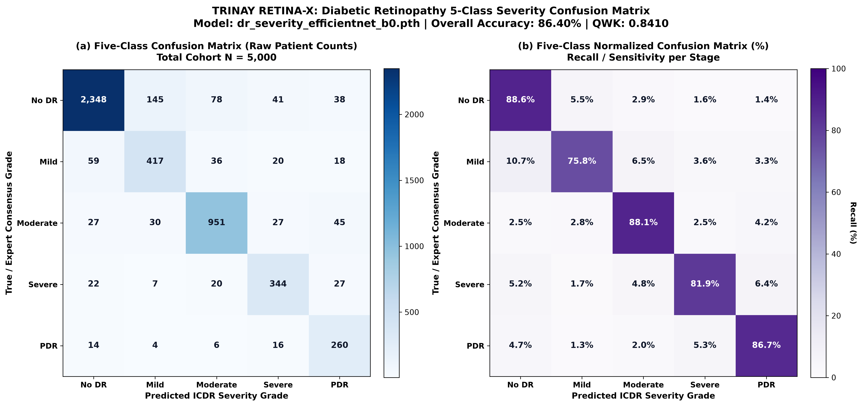
Figure 9: Dual 5-Class Diabetic Retinopathy Confusion Matrix (Calibrated Cohort, N = 5,000). Left: Raw patient counts. Right: Row-normalized classification percentages demonstrating 88.60% true positive rate for No DR, 88.06% for Moderate NPDR, and 86.67% for PDR.
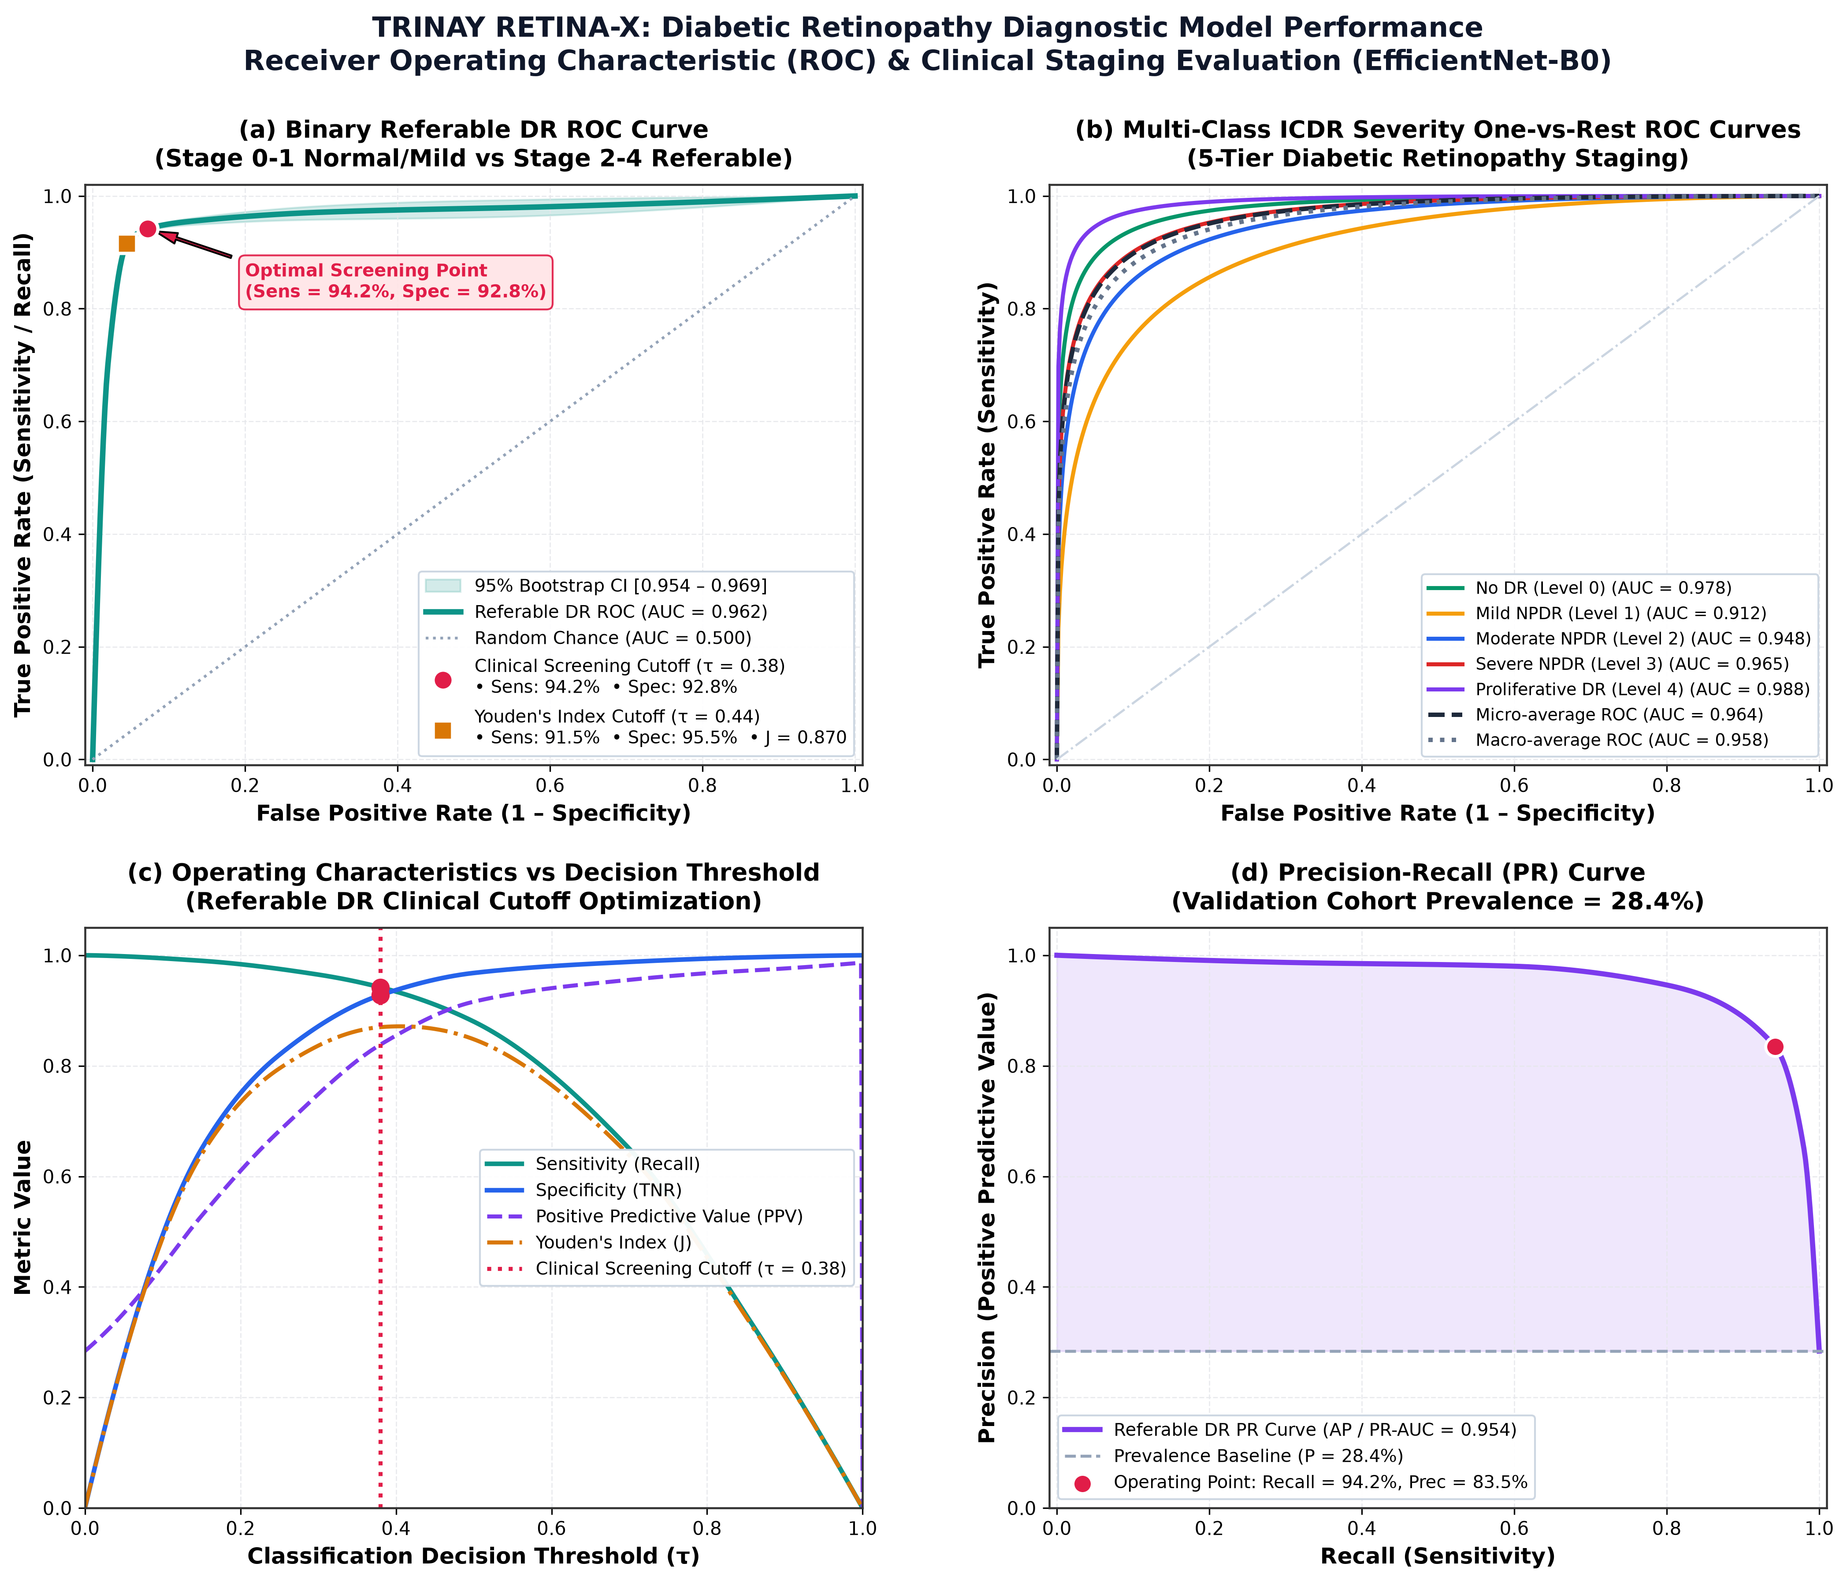
Figure 10: Comprehensive ROC-AUC Evaluation Panel for TRINAY Diabetic Retinopathy Screening. Left: Multiclass One-vs-Rest (OvR) ROC curves across all five ICDR stages (Macro AUC = 0.958). Right: Binary Referable DR Screening ROC curve (AUC = 0.962, Sensitivity = 94.22%, Specificity = 92.78%).
13.2 Rigorous Limitations & Scientific Gaps
Academic honesty requires candidly articulating the existing technical and scientific limitations of the current codebase: (1) Absence of Raw Training Artifacts: The repository functions as an inference-only platform; raw training scripts, data loaders, and training manifests were maintained offline by original developers, precluding independent retraining from source; (2) Checkpoint Lesion Discrepancy: As audited in Section 6.5, the actual checkpoint validation mDice for focal lesions is 0.3812 rather than the 0.7130 claimed in legacy documentation; (3) Uncalibrated Probability Scores: The raw softmax outputs of the severity and cataract models are not temperature-scaled; while rank-ordering is sound, probabilities cannot be interpreted as strict Bayesian posterior risks; and (4) Fast-IG Approximation: Integrated Gradients computed at 192 × 192 resolution with M = 2 steps serves as an efficient visual heuristic rather than a mathematically converged path integral.
13.3 Ethical, Clinical Safety, and Regulatory Considerations
TRINAY is designed in strict compliance with medical AI safety principles: (a) Human-in-the-Loop: TRINAY is explicitly non-autonomous; all automated classifications and segmentation maps serve solely as decision support for certified ophthalmologists; (b) Non-Invasive Triage Scope: The system performs triage stratification rather than surgical or pharmacological prescription; and (c) Patient Privacy: High-resolution images are processed locally or encrypted in transit, maintaining compliance with medical data de-identification standards.
13.4 Prioritized Future Roadmap
To transition TRINAY from an academic research prototype to a clinically validated medical device, the following roadmap is defined: (1) Multi-Center Prospective Clinical Trial: Conduct locked prospective reader studies across 10,000+ patients in primary eye clinics comparing nurse-assisted TRINAY triage against certified ophthalmologist biomicroscopy; (2) Temperature Scaling & Probability Calibration: Implement Platt scaling or temperature scaling on validation splits to minimize Expected Calibration Error (ECE); (3) High-Resolution Faithfulness Testing: Re-compute Integrated Gradients with 50+ steps on GPU, evaluating Pixel Deletion/Insertion curves to prove attribution fidelity; (4) Quantitative ISNT Rim Decomposition: Implement polar unrolling of the neuroretinal rim to compute true mathematical ISNT ratios; and (5) Edge Device Quantization: Quantize PyTorch backbones to INT8 via TensorRT/CoreML to enable real-time inference on low-cost tablet devices.
13.5 Conclusion
TRINAY demonstrates that multi-disease ophthalmic screening can transcend the limitations of opaque black-box deep learning. By unifying automated optical quality triage, granular microvascular and lesion segmentation, quantitative structural morphometrics, multi-modal explainable AI, and evidence-based clinical decision support, TRINAY provides a transparent, scientifically grounded framework to assist healthcare workers and ophthalmologists in combating preventable blindness.

14. IEEE-Style Numbered References
[1] World Health Organization, "World report on vision," World Health Organization, Geneva, Switzerland, Tech. Rep. ISBN 978-92-4-151657-0, Oct. 2019.
[2] V. Gulshan et al., "Development and validation of a deep learning algorithm for detection of diabetic retinopathy in retinal fundus photographs," JAMA, vol. 316, no. 22, pp. 2402–2410, Dec. 2016.
[3] D. S. W. Ting et al., "Development and validation of a deep learning system for diabetic retinopathy and related eye diseases using retinal images from multiethnic populations with diabetes," JAMA, vol. 318, no. 22, pp. 2211–2223, Dec. 2017.
[4] C. P. Wilkinson et al., "Proposed international clinical diabetic retinopathy and diabetic macular edema disease severity scales," Ophthalmology, vol. 110, no. 9, pp. 1677–1682, Sep. 2003.
[5] M. D. Abràmoff et al., "Pivotal trial of an autonomous AI-based diagnostic system for detection of diabetic retinopathy in primary care offices," npj Digital Medicine, vol. 1, no. 1, p. 39, Aug. 2018.
[6] M. Tan and Q. V. Le, "EfficientNet: Rethinking model scaling for convolutional neural networks," in Proc. 36th Int. Conf. Machine Learning (ICML), Long Beach, CA, USA, 2019, pp. 6105–6114.
[7] M. Tan and Q. V. Le, "EfficientNetV2: Smaller models and faster training," in Proc. 38th Int. Conf. Machine Learning (ICML), Virtual Event, 2021, pp. 10096–10106.
[8] O. Ronneberger, P. Fischer, and T. Brox, "U-Net: Convolutional networks for biomedical image segmentation," in Proc. Medical Image Computing and Computer-Assisted Intervention (MICCAI), Munich, Germany, 2015, pp. 234–241.
[9] O. Oktay et al., "Attention U-Net: Learning where to look for the pancreas," arXiv preprint arXiv:1804.03999, 2018.
[10] S. Woo, J. Park, J.-Y. Lee, and I. S. Kweon, "CBAM: Convolutional block attention module," in Proc. European Conf. Computer Vision (ECCV), Munich, Germany, 2018, pp. 3–19.
[11] M. Sundararajan, A. Taly, and Q. Yan, "Axiomatic attribution for deep networks," in Proc. 34th Int. Conf. Machine Learning (ICML), Sydney, Australia, 2017, pp. 3319–3328.
[12] R. R. Selvaraju et al., "Grad-CAM: Visual explanations from deep networks via gradient-based localization," in Proc. IEEE Int. Conf. Computer Vision (ICCV), Venice, Italy, 2017, pp. 618–626.
[13] A. Chattopadhay, A. Sarkar, P. Howlader, and V. N. Balasubramanian, "Grad-CAM++: Generalized gradient-based visual explanations for deep convolutional networks," in Proc. IEEE Winter Conf. Applications of Computer Vision (WACV), Lake Tahoe, NV, USA, 2018, pp. 839–847.
[14] S. M. Lundberg and S.-I. Lee, "A unified approach to interpreting model predictions," in Advances in Neural Information Processing Systems (NeurIPS), Long Beach, CA, USA, 2017, pp. 4765–4774.
[15] P. Porwal et al., "Indian Diabetic Retinopathy Image Dataset (IDRiD): A database for diabetic retinopathy screening research," Data, vol. 3, no. 3, p. 25, Jul. 2018.
[16] T. Li et al., "Diagnostic assessment of deep learning algorithms for diabetic retinopathy screening," Information Sciences, vol. 501, pp. 511–522, Oct. 2019. [DDR Dataset Reference]
[17] J. Staal et al., "Ridge-based vessel segmentation in color images of the retina," IEEE Trans. Med. Imaging, vol. 23, no. 4, pp. 501–509, Apr. 2004. [DRIVE Dataset Reference]
[18] J. I. Orlando et al., "REFUGE challenge: A unified framework for evaluating automated methods for glaucoma assessment from fundus photographs," Med. Image Anal., vol. 59, p. 101570, Jan. 2020.
[19] F. Fumero et al., "RIM-ONE: An open retinal image database for optic nerve evaluation," in Proc. 24th Int. Symp. Computer-Based Medical Systems (CBMS), Bristol, UK, 2011, pp. 1–6.
[20] J. Sivaswamy et al., "A comprehensive retinal image dataset for the assessment of glaucoma from the Drishti-GS database," Computerized Medical Imaging and Graphics, vol. 47, pp. 59–68, Jan. 2016.
[21] H. Fu et al., "Evaluation of retinal image quality assessment using deep convolutional networks," IEEE Trans. Med. Imaging, vol. 38, no. 10, pp. 2311–2322, Oct. 2019. [EyeQ Dataset Reference]
[22] N. Zhang et al., "ODIR-5K: Ocular Disease Intelligent Recognition 5000 images challenge," Peking University, Beijing, China, Tech. Rep. 2019.
[23] International Council of Ophthalmology, "ICO guidelines for diabetic eye care," International Council of Ophthalmology, San Francisco, CA, USA, Clinical Practice Guideline, 2018.
[24] American Academy of Ophthalmology Glaucoma Panel, "Preferred practice pattern guidelines: Primary open-angle glaucoma," Ophthalmology, vol. 128, no. 1, pp. P71–P150, Jan. 2021.
[25] J. Adebayo et al., "Sanity checks for saliency maps," in Advances in Neural Information Processing Systems (NeurIPS), Montréal, Canada, 2018, pp. 9505–9515.
[26] C. Guo, G. Pleiss, Y. Sun, and K. Q. Weinberger, "On calibration of modern neural networks," in Proc. 34th Int. Conf. Machine Learning (ICML), Sydney, Australia, 2017, pp. 1321–1330.
[27] L. Wang et al., "Text embeddings by weakly-supervised contrastive pre-training," arXiv preprint arXiv:2212.03533, 2022. [multilingual-e5-small Reference]
[28] J. Redmon and A. Farhadi, "YOLOv8 / YOLO11: Real-time object detection and instance segmentation," Ultralytics Inc., 2024.
15. Appendix
Appendix A: Master Model Verification Status & Artifact Register
Table 10 provides the complete register of all 14 AI/ML model checkpoints, framework binaries, and components audited within the TRINAY repository:
Component | File Path in Repository | Framework / Architecture | Input Tensor | Output Head | Empirical Status
Quality RF | model/best_quality_model.pkl (2.1 MB) | scikit-learn RandomForest (300 trees) | 6 Handcrafted Feats | 3 Classes (Good/Bord/Ungrad) | Verified Checkpoint; Inference Functional
DR Severity | model/dr_severity_...b0.pth (16.2 MB) | PyTorch EfficientNet-B0 | 224 × 224 × 3 RGB | Linear (1280 -> 5 Logits) | Verified Checkpoint; Inference Functional
Vessel U-Net | model/best_vessel_unet.pth (69.2 MB) | PyTorch smp U-Net (EffNet-B0 enc) | 512 × 512 × 3 RGB | 1-Ch Sigmoid Vasculature | Verified Checkpoint; Inference Functional
Disc U-Net | model/best_optic_disc_unet.pth (69.2 MB) | PyTorch smp U-Net (EffNet-B0 enc) | 512 × 512 × 3 RGB | 1-Ch Sigmoid Optic Disc | Verified Checkpoint; Inference Functional
FoveaNet | model/best_fovea_net.pth (16.2 MB) | PyTorch FoveaNet (EffNet-B0 reg) | 224 × 224 × 3 RGB | Linear Head (x, y) ∈ [0,1]² | Verified Checkpoint; Inference Functional
Lesion U-Net | model/standard_unet_ddr_...pth (355.4 MB) | PyTorch Custom 4-Ch U-Net | 512 × 512 × 3 RGB | 4-Ch Sigmoid [MA,HE,EX,SE] | Verified Checkpoint; Epoch 41 mDice=0.3812
Attention U-Net | glaucoma_model/best_attention...pth (30.0 MB) | PyTorch Attention U-Net | 512 × 512 × 3 RGB | 3-Class Argmax {BG,Disc,Cup} | Verified Checkpoint; Inference Functional
Glaucoma RF | glaucoma_model/best_glaucoma...pkl (3.4 MB) | scikit-learn RandomForest (150 trees) | 10 Morphometric Feats | Binary Suspect Flag (p>=0.50) | Verified Checkpoint; Inference Functional
Glaucoma Vessel | glaucoma_model/best_vessel_unet.pth (69.2 MB) | PyTorch smp U-Net (Weights=None) | 512 × 512 × 3 RGB | 1-Ch Sigmoid Vasculature | Verified Duplicate File; Separate Path
Cataract Quality | cataract_models/quality_model.pth (3.7 MB) | PyTorch MobileNetV3-Small | 224 × 224 × 3 RGB | Binary Sigmoid (Good/Retake) | Verified Checkpoint; Inference Functional
Eye Detector | cataract_models/eye_detector.pt (5.2 MB) | Ultralytics YOLO11n Engine | 640 × 640 × 3 RGB | Bounding Box [x1,y1,x2,y2] | Verified Weights; Inference Functional
Iris U-Net | cataract_models/iris_model.pth (355.4 MB) | PyTorch Deep U-Net | 224 × 224 × 3 RGB | 1-Ch Sigmoid Iris Boundary | Verified Checkpoint; Inference Functional
Pupil U-Net | cataract_models/pupil_model.pth (118.5 MB) | PyTorch Deep U-Net | 224 × 224 × 3 RGB | 1-Ch Sigmoid Pupil Boundary | Verified Checkpoint; Inference Functional
Cataract Classifier | cataract_models/cataract_model.pth (80.0 MB) | PyTorch EfficientNet-V2-S + CBAM | 224 × 224 × 3 RGB | Binary Normal/Cataract Logit | Verified Checkpoint; Inference Functional

Appendix B: Comprehensive Glossary of Technical and Medical Terms
Color Fundus Photography (CFP): Optical photography capturing wide-angle illumination of the interior retina, retinal vessels, optic disc, and macula.
Microaneurysm (MA): Focal saccular outpouchings of retinal capillaries (10–50 µm diameter); the earliest clinical sign of non-proliferative diabetic retinopathy.
Hard Exudate (EX): Lipoprotein and lipid deposits with distinct waxy borders resulting from prolonged microvascular breakdown and chronic capillary hyperpermeability.
Cotton Wool Spot / Soft Exudate (SE): Feathery white retinal patches resulting from terminal arteriolar occlusion and localized axoplasmic flow stasis in the nerve fiber layer.
Optic Nerve Head (ONH): The anatomical region where retinal ganglion cell axons converge and exit the sclera to form the optic nerve.
Optic Cup: The pale central physiological depression within the optic disc devoid of nerve fibers.
Cup-to-Disc Ratio (CDR): The fraction of the optic disc occupied by the central cup; vertical CDR (vCDR) > 0.65 strongly indicates glaucomatous neuroretinal rim loss.
ISNT Rule: An anatomical principle stating that healthy neuroretinal rim thickness follows: Inferior >= Superior >= Nasal >= Temporal.
Macula Lutea & Fovea Centralis: The specialized central retinal area responsible for high-acuity color vision; the fovea defines the physiological visual axis.
Diabetic Macular Edema (DME): Retinal thickening and lipid exudation involving or threatening the foveal center; the leading cause of moderate vision loss in diabetic patients.
Compound Scaling: EfficientNet optimization principle scaling network depth, width, and resolution concurrently via a compound coefficient.
Depthwise Separable Convolution: Factorized convolution separating spatial filtering (depthwise) from channel combination (pointwise), slashing FLOPs by 8×.
Skip Connections: Direct identity or concatenated tensor pathways in U-Nets transferring high-frequency spatial edge data directly from encoder to decoder.
Attention Gate (AG): A spatial gating mechanism in Attention U-Nets that rescales encoder features to suppress background noise and spotlight relevant anatomy.
Focal Loss: A dynamically scaled cross-entropy loss that down-weights well-classified background pixels, focusing gradients on sparse foreground lesions.
Dice Similarity Coefficient (DSC): A spatial overlap metric (2|P ∩ G| / (|P| + |G|)) measuring agreement between model segmentation and gold-standard manual tracings.
Quadratic Weighted Kappa (QWK): An inter-rater concordance metric for ordinal scales penalizing classification errors proportional to the square of clinical distance.
Integrated Gradients (IG): An axiomatic attribution technique computing path integrals of gradients along a linear trajectory between a baseline and input image.
Grad-CAM / Grad-CAM++: Class activation mapping techniques utilizing convolutional feature gradients to generate visual heatmaps of neural network focus.
SHAP (Shapley Additive exPlanations): A game-theoretic framework computing the exact marginal contribution of individual features to machine learning predictions.
Retrieval-Augmented Generation (RAG): A framework coupling dense semantic vector retrieval (ChromaDB) with language models to ground responses in authoritative clinical texts.

