**IOT Based Approach to Reduce Road Accidents**

**AVIRAL VERMA**

National Institute of Technology, Tiruchirappalli

***Abstract:***

The road accident is one of the concerning issues for the current time due to availability of high speed vehicles and good road conditions. Among these accidents, accidents due to flat tires, tire bursting and rash driving are very common. Some of these accidents can be avoided if we are able to monitor tire pressure in real time. Further, the life of tires and vehicles are highly dependent of the driving behaviors of the drivers. Also, rash driving of a driver can be avoided if we are able to analysis his driving behavior through monitoring fluctuation in tire pressure and vehicle acceleration and educate the driver about the same. But the problem is that, in low and mid-range vehicles, there is no facility for real-time monitoring of tire air pressure and the condition of tire, due to high cost of the monitoring system. So, in this project, an IOT based low cost solution has been proposed to the above problem via monitoring of the motion and the tire pressure of a vehicle. In this project, an ESP8266 microcontroller along with a RF receiver module has been used for monitoring tire pressure through pressure sensors (FXTH870xD, a tire air pressure monitoring IC with a built-in RF transmitter) have also been used. The results will be displayed on the dashboard of the vehicle along with alert beeps for the driver and are also published to the interested party via an IOT server for further analysis.

***Introduction:***

Roads are lifelines of a country as they transport a large number of people and goods from one place to another place in one of the most economical ways. Economy of a country is majorly affected by roads. But these gorgeous roads do have very tragic road accidents. Some road accidents occur because of collisions of vehicles, others happen because of flat tires and bursting of tires. Also, in the modern era, accidents because of rash driving are very common.

Moving to our country, there are some facts which justify the aforementioned statements. According to Deccan Herald, in India, 9,748 accidents alone have happened in 2014 because of flat tires. Another story is of Yamuna Expressway. 40% of accidents on this expressway are because of less tire pressure only. Also a survey conducted by Apollo Tyres is that 75% of the people ride on incorrect tire pressure. Not only this, a recent report released by National Crime Research Bureau is that, 1.35 lakh people out of 1.5 lakh people died in road accidents because of delinquent driving in 2016 alone.

To reduce such mishaps, this project proposes to use an IOT based approach to measure air pressure inside tires of a vehicle and also to monitor rash driving of vehicles, in real time. This project proposes to use an ESP8266 MCU, FXTH870xD IC pressure sensors and RF modules along with suitable power source. A brief description of each component is in table 1.

|  |  |  |
| --- | --- | --- |
| Table 1: A brief description of the components used in the proposed project | | |
| Component | Description | Image |
| ESP8266 MCU | ESP8266 MCU is a low cost microcontroller with a built-in Wi-Fi module. It is produced by Espressif Systems in Shanghai, China. This MCU is used to record and send data to both dashboard and IOT servers. | Image result for nodemcu |
| FXTH870xD | FXTH870xD is a tire pressure monitoring sensor IC. This measures air pressure in the range of either 100-450kPa or 100-900kPa or 14-130 PSI. It is 8-bit MCU having 512 RAM and 8K FLASH. Also it can measure acceleration in X, Y and Z direction too. It has 6 ADC converters. Further, the sensor has a built-in RF transmitter module to transmit the sensor readings to a RF receiver. |  |
| RF Receiver | RF Receivers are used for detecting wave signals |  |
| LCD |  | Image result for arduino lcd |
|  |  |  |

The remaining part of this paper is divided into three sections: methodology, design and flow diagram and conclusion

***Methodology***

The basic methodology of the proposed project is to measure two parameters: tire air pressure and vehicle acceleration. For this, an IC FXTH870xD will be used for each tire, which can simultaneously monitor air pressure, temperature and acceleration and transmit the data using wireless RF module to a RF receiver. The RF receiver is connected with an ESP8266 MCU, which will send data to an IOT broker as well as display the data on the vehicle dashboard using an LCD on the dashboard. If the detected pressure is less than the required one, a buzzer will start to beep to alert the driver. Further, the data send to the IOT broker will be plotted and analyzed to access the driver’s driving behavior.

***Design and Flow Diagram***

In this section, a brief description of the design of the proposed project is given. Figure 1 shows the overall block diagram of the proposed system.

|  |
| --- |
|  |
| Figure 1: Flow Diagram of proposed system |

In the First step, four FXTH870xD sensors measure air pressure, vehicle motion and tire temperature of each tire. The analog measured data are converted to digital data by the AD0 unit of the pressure IC. Once the conversion is done, the RF transmitter module of the IC sends the data to an external RF receiver module located outside the tire. This RF module sends the data to central ESP8266 MCU. The MCU processes the data and display the extracted information on the dashboard LCD display. If the recorded pressure is outside the set limits, an alarm will be raised. Further, the pressure and acceleration data will be processed to access the driving behaviour of the driver and the processed data is shared with the interested persons, such as parents, transport company owners, etc, for the training of the driver. This measurement and process cycle is repeated continuously to monitor these parameters in the real time.

Figure 2 shows the basic circuit diagram of the pressure sensor IC FXTH870Xd and RF transmitter, situated inside the tire. This unit is securely mounted inside each tire.

Figure 3 shows the external unit consisting of an ESP8266 microcontroller, an LCD display unit and an RF receiver module.

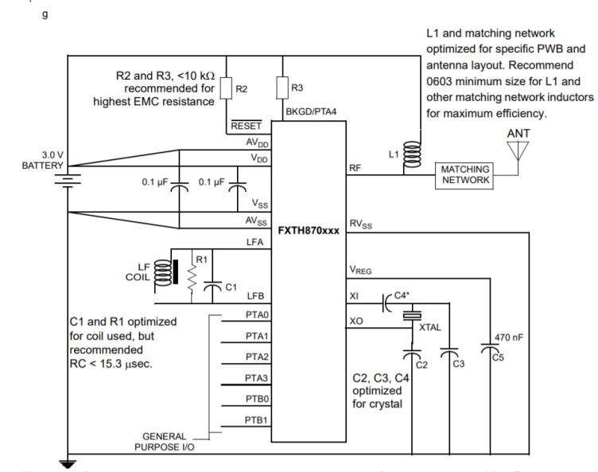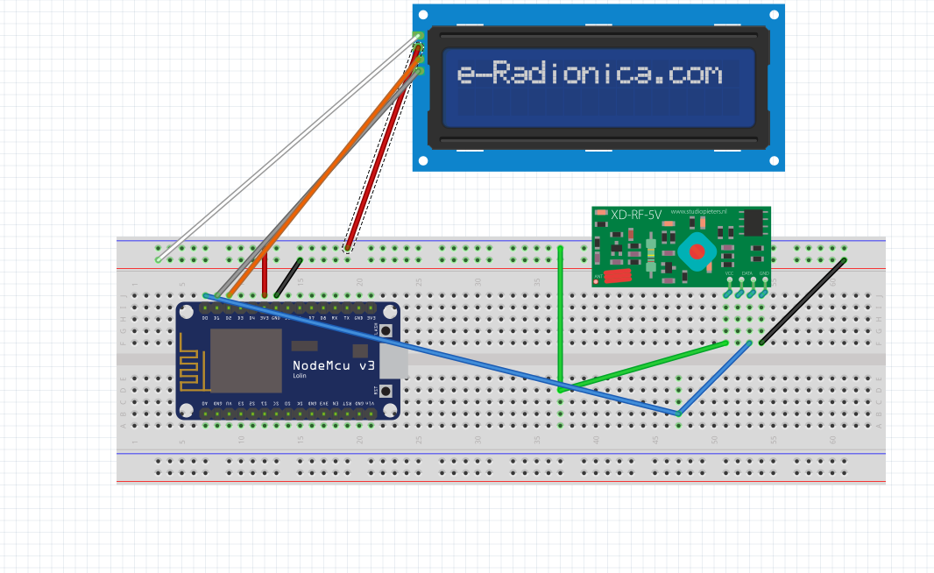

Figure 2: FXTH870Xd and RF transmitter [2] Figure 3: RF receiver with ESP8266

***Conclusion***

This project gives practical implementation of IOT in real life problem of road accidents. Road accidents kill lots of people especially youth. This paper presents the answer to above problem by using IOT Technology as its approach. The methodology, if get implemented, detects various parameters, send them to IOT broker and display them on LCD or any serial monitor for its analysis. Ultimately, the aim of this paper is to reduce accidents and to improve the driving of masses.

References:

1. <https://www.deccanherald.com/content/502920/accidents-due-tyre-bursts-serious.html>
2. <http://www.farnell.com/datasheets/2618548.pdf>