**1. Which are the top three variables in your model which contribute most towards the probability of a lead getting converted?**

|  |
| --- |
| **Column name** |
| 'Total Time Spent on Website' |
| 'Lead Quality' |
| 'What is your current occupation' |

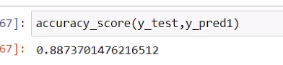

Based on graph we plotted these 3 are most important columns :-

**Total Time Spent on Website:**

Higher the time spent on the website, higher the probability of the lead converting into a customer.

**Lead Source_Reference:**

If the source of the lead is a Reference, then there is a higher probability that the lead would convert.

**What is your current occupation_Student:**

If the lead is already a student, chances are they will not take up another course which is designed for working profession

2. **What are the top 3 categorical/dummy variables in the model which should be focused the most on in order to increase the probability of lead conversion**?

|  |
| --- |
| **Column name** |
| 'Total Time Spent on Website' |
| 'Lead Quality' |
| 'What is your current occupation' |
|  |



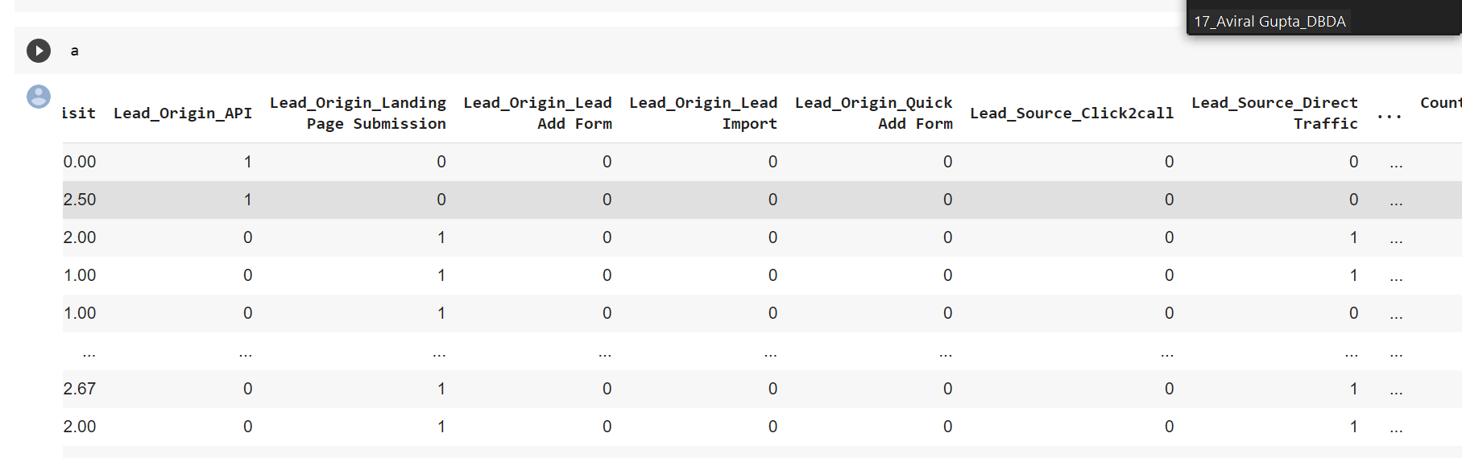

3**. X Education has a period of 2 months every year during which they hire some interns. The sales team, in particular, has around 10 interns allotted to them. So during this phase, they wish to make the lead conversion more aggressive. So they want almost all of the potential leads (i.e. the customers who have been predicted as 1 by the model) to be converted and hence, want to make phone calls to as much of such people as possible. Suggest a good strategy they should employ at this stage.**

As we have use following graphs in our case study

A) heatmap

b)scatterplot

c) pairplot

d)counterplot

e)boxplot

f)histogram

[ as per insights from the graphs we have made following observation]

• The Interns should focus on the customers from country India especially from city Mumbai as from the above dataset we can see the customers from such region has a high lead conversion rate.

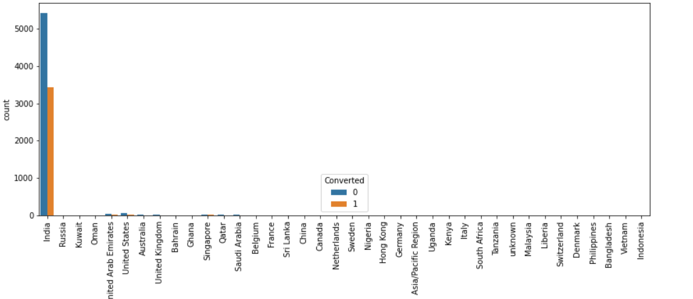

• The interns should focus on who has spent the most amount of time on Total Time Spent on Website as they are most interested and curious about the course.

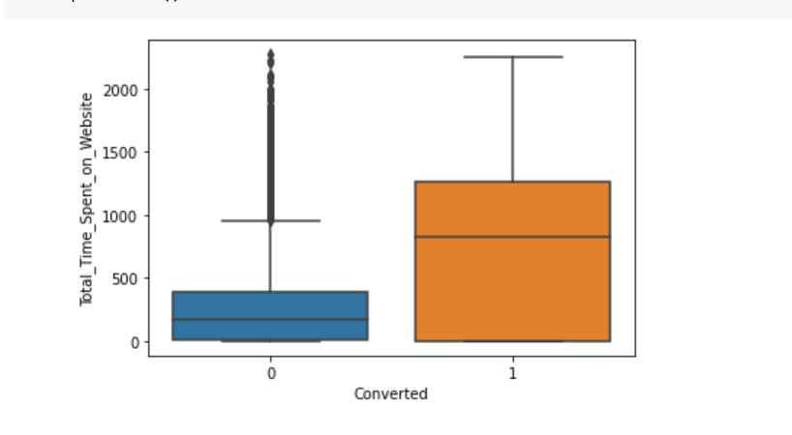

• Interns should also focus on Working Professionals as with the help of these courses they can enhance their skillset.

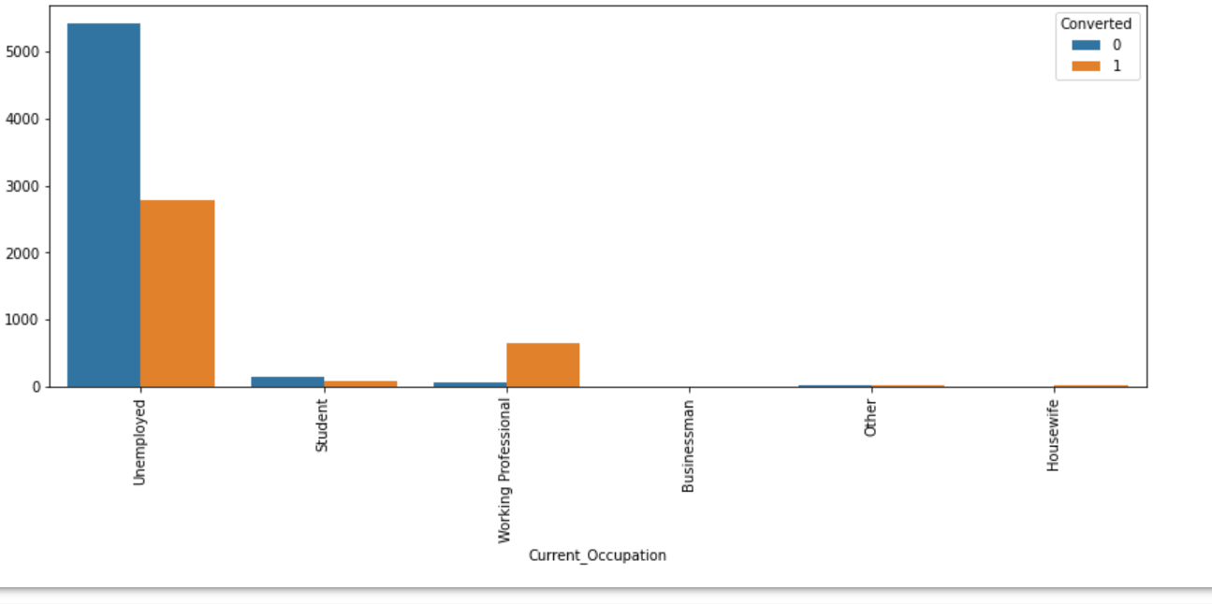

**4. Similarly, at times, the company reaches its target for a quarter before the deadline. During this time, the company wants the sales team to focus on some new work as well. So during this time, the company’s aim is to not make phone calls unless it’s extremely necessary, i.e. they want to minimize the rate of useless phone calls. Suggest a strategy they should employ at this stage.**

• The sales team should not focus on person whose Lead Quality is not High in Relevance as they might be wasting their valuable time.

• They should not focus on Housewife, they might not have a budget to spend on this course as well as it will not be access for them.

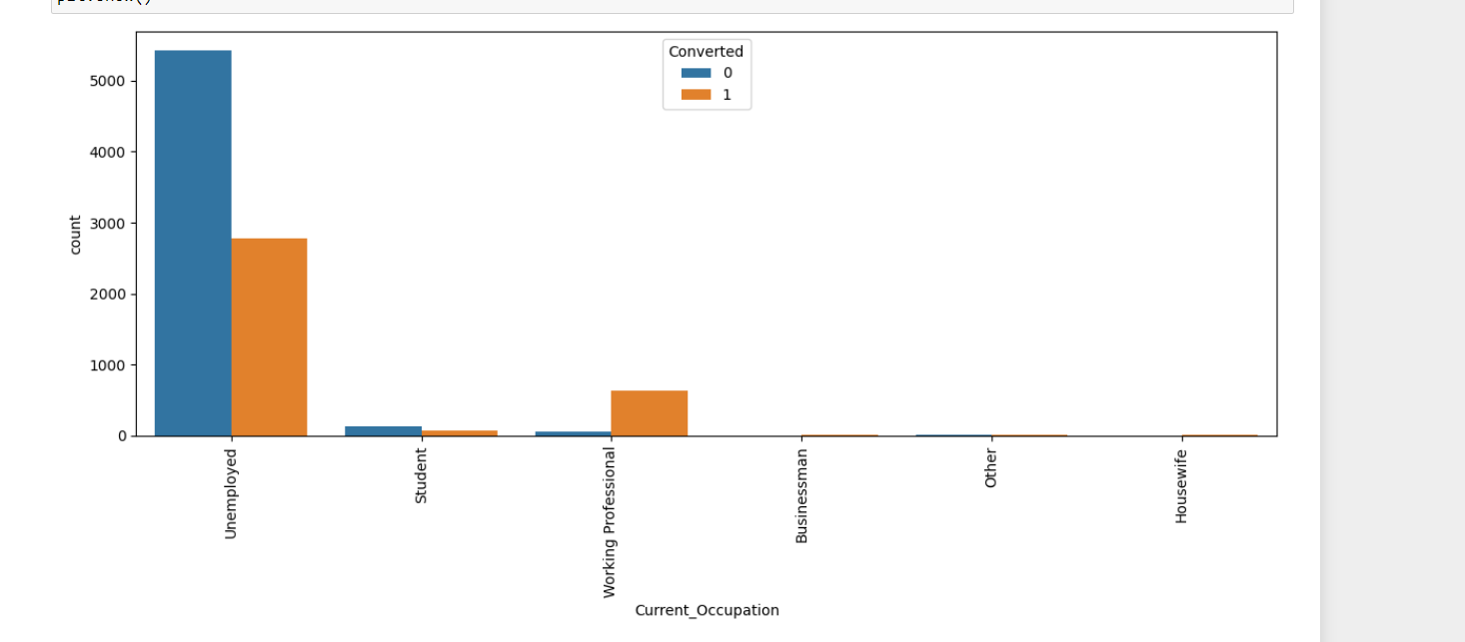

• Sales Team should not focus on clients which are not potential leads in Lead Profiler.

* + Sale team should be more focus on unemployment people

