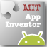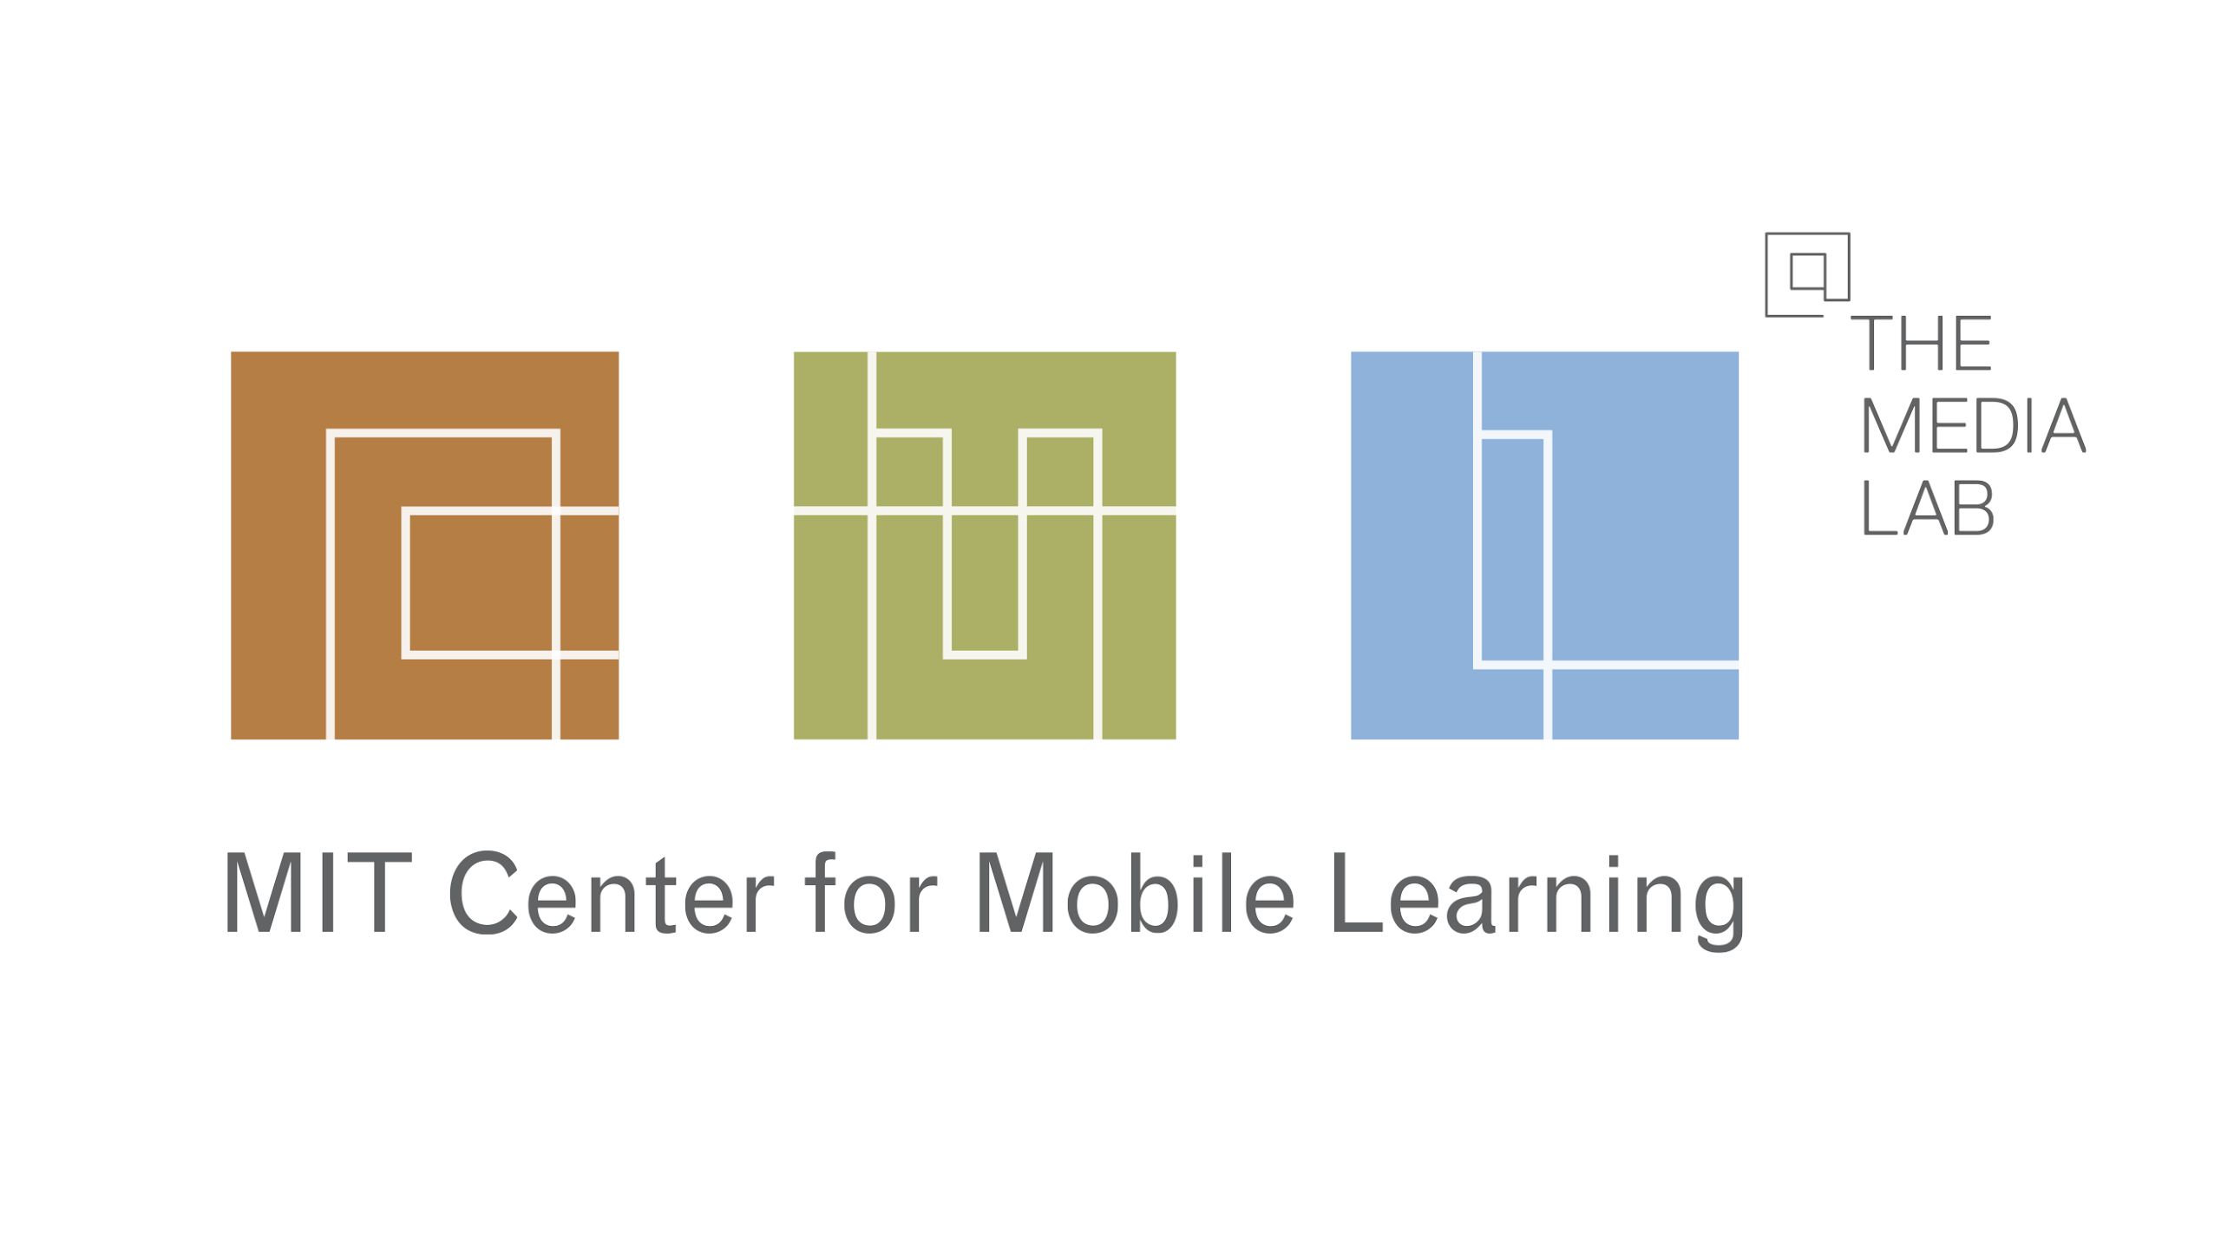

Hello, IT person, unsung hero of education,

Teachers at your school would like to start using a program called App Inventor in your computer labs. Here are some notes on using App Inventor, a web system developed at MIT for programming Android phones and tablets. We have found that every school’s IT set up is a little different, so we made this document to discuss our requirements so you can take the steps needed to make App Inventor work.

We have a few different ways to make App Inventor work. The most common options are discussed in this document, but there may be other ways to get things working, so please check our Troubleshooting site for more help: <http://appinventor.mit.edu/explore/content/troubleshooting.html>

Thank you very much. Your help is critical to getting the students using App Inventor.

## Intro to App Inventor

App Inventor is a web service hosted on MIT’s servers and google App Engine, located at this URL:

[appinventor.mit.edu](http://appinventor.mit.edu)

After the user logs in, the application is hosted at this URL, which also needs to be accessible:

[beta.appinventor.mit.edu](http://beta.appinventor.mit.edu)

The web application will launch the Blocks Editor, a Java Web Start application to run locally in a java runtime, with Java 6 or Java 7. So all the computers will need that, too. We do *not* need a java browser plugin, just a local JRE.

It gets better.

The Blocks Editor needs to communicate to the Android phone, and there are TWO methods to do it. The recommended method is to connect wirelessly, over a WIFI network. The other, older method is to connect over a USB cable. Both have their strengths and weaknesses, depending on your school’s environment.

Wait, it gets *even* better.

App Inventor needs a small local installation, called “AppInventor Setup,” which is used to communicate with the phone hardware. This is required for all use cases. There is also an Android emulator that students and teachers like to use, as it allows students to work and test without an Android device. The emulator comes with AppInventor Setup.

The AppInventor Setup instructions are here: <http://appinventor.mit.edu/explore/install-app-inventor-software.html>

## Connecting to the phone over WIFI

Instructions: <http://appinventor.mit.edu/explore/content/setup-device-wifi.html>

Each android phone will need the app “MIT AICompanion” from the play store or directly loaded. The students or instructor usually handle getting the app. For the app to work, both the computer running the blocks editor and the phone need to be on the same subnet, not separated by any firewall. Both the blocks editor and the app will connect to the server osiris.mit.edu to exchange IP addresses, then they will connect to each other directly over the local network.

The critical piece of getting the WIFI connection to work is having the phones and the computers on the same subnet, with no restriction on connections between network devices. This kind of filter is common in hotels, public WIFI, often, schools.

If your school has security in place that would prevent the computers from connecting directly to the phones over WIFI, a solution we often use is to deploy a wireless access point just for the purpose of App Inventor. We have shared a single network connector by a store-bought router or connection sharing off a laptop. In that case, all of the computers and phones need to connect to that new, custom network during the workshop. That wireless access point is then removed immediately when the workshop is over and students are done using it.

## Connecting to the phone over USB cable

The USB cable connection depends on the local AppInventor Setup package. It contains pieces of the Android debug environment to connect to the Android OS. This will simply work with Google Nexus devices on most computers.

On Windows, device drivers are required to be installed in order to connect to certain phones. The driver is specific to the phone, and needs to be obtained from the phone vendor. For this reason we *highly* recommend the WIFI connect, which does not require any drivers. Google Nexus devices generally work, even on Windows, without extra drivers. On Mac and linux, extra drivers are not necessary for any phone.

The USB method is *not* recommended. Using WIFI connect instead avoids driver issues, but requires network connectivity.

## Full Instructions

The complete instructions for installation are here:

<http://appinventor.mit.edu/explore/content/setup-mit-app-inventor.html>

The requirements are boiled down to a checklist below, which we hope will help you figure out what you actually need to do help us make App Inventor work at your school.

## Checklist for All Features

|  |  |  |  |
| --- | --- | --- | --- |
| Requirement for: | WIFI connect to phone (recommended) | USB cable to phone | Emulator |
| App Inventor Setup Software | X | X | X |
| Java 7 or 8 JRE | X | X | X |
| Browser: Firefox 3.6+ -or- Chrome 4+ -or- Safari 5+ -or- Explorer 7+ | X | X | X |
| Ability to save or directly open Java Web Start jnlp file from the browser | X | X | X |
| Whitelist (browser access)  appinventor.mit.edu  beta.mit.edu  thinkfinity.org | X | X | X |
| Whitelist (port 80)  osiris.mit.edu | X |  |  |
| Direct connection between devices on WIFI, computer and phone. | X |  |  |
| Windows Only: device drivers for specific android devices, as needed. |  | X |  |