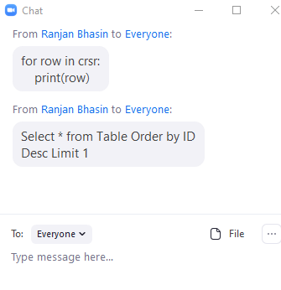

for row in crsr:

print(row)

----------------------------------------------------------

Select \* from Table Order by ID Desc Limit 1

select \* from table