

MINOR -1 PROJECT

SYNOPSIS ON

Low-Light Image Enhancement in C++

Submitted By:

|  |  |  |
| --- | --- | --- |
| Name | Roll No | Branch |
| Sagar Thapliyal | 500107864 | B. Tech. CSE (AIML Hons.) |
| Aviral Khanna | 500108516 | B. Tech. CSE (AIML Hons.) |
| Saksham Siwach | 500107623 | B. Tech. CSE (AIML Hons.) |
| Arshdeep Kaur | 500107135 | B. Tech. CSE (AIML Hons.) |

# Under the Guidance of:

Mrs. Gaytri Bakshi

# School of Computer Science

UNIVERSITY OF PETROLEUM AND ENERGY STUDIES

# Dehradun – 248007 2024

Approved By:

Project Guide Cluster Head

# School of Computer Science

University of Petroleum and Energy Studies, Dehradun

Synopsis Report (2024)

|  |  |
| --- | --- |
| 1. | PROJECT TITLE |
| 2. | INTRODUCTION |
| 3. | ABSTRACT |
| 4. | PROBLEM STATEMENT |
| 5. | OBJECTIVES |
| 6. | METHODOLOGY |
| 8. | DATA FLOW DIAGRAM (DFD) |
| 9. | APPLICATIONS |
| 10. | REFERENCES |

# INTRODUCTION

Image enhancement is an important operation in digital image processing and is used universally and in every field such as computer vision, medical image processing applications, remote sensing and still photography. It aims at enhancement of various techniques on the images so as to make them ready for other processes such as analysis, interpretation and visualization. Hence the need for improved images is evident in a variety of real-life scenarios where the image quality directly influences the subsequent operations including; object recognition, quality assessment, and content analysis among others.

In computer vision for example improving the visual quality of an image is relevant for helping algorithms pick out and recognize objects in an image. Significantly improved pictures of higher contrast, less noise or disturbances in the image and much higher resolutions should result in increased accuracy of the object recognition and thus its classification which is of vital importance for self-driving cars all the way to and including facial recognition. Likewise, in medical imaging, image enhancement is instrumental for visualizing as well as diagnosing disorders from different forms of anatomical scans including X-ray, MRIs and CTs. We believe that increasing the accuracy of these images can lead to better results in diagnosing peculiarities as a result, the health care providers will enjoy improved outcomes (Abdullah-Al-Wahid, 2007)[1].

In this work, emphasis is given into the development of a set of image improvement methods in C++. This is done so that the resultant images can corrected in order to get rid of problems such as low lighting, low contrast, noise, and image blurring. This is well targeted towards enhancing these aspects with the ultimate goal of resulting into images better suited for visualization, interpretation, and subsequent analysis (Yixu Feng, 2024)[4]. Another benefit that originates from this particular goal is the need to implement these improvements without the use of, for example, large external libraries As it will be seen in the next section, this not only offers the developer a good opportunity to come up with efficient algorithms from scratch but also provides the guarantee that the final application will be lightweight in terms of the resources needed to run it as well as easily scalable to different environments.

# ABSTRACT

This project aims to compile a fast image enhancement tool from scratch in C++. The first objective is generally to enhance still images that are affected by low lighting, blur, and noise with the help of different methods. The toolkit will use a variety of strengthening operations including brightness control, contrast enhancement, gamma correction and sharpening of the image. In contrast to numerous techniques that depend on additional libraries and frameworks, this project seeks to develop a C++ solution that is compact and flexible in various contexts, making it ideal for educational and business settings such as academies and industries,

# PROBLEM STATEMENT

Many digital images, particularly those captured in suboptimal conditions such as low-light, suffer from quality issues such as low brightness, inadequate contrast, noise, and blurriness. Such degraded images are less useful for analysis or viewing. While there are existing solutions and number of applications to enhance images, they often rely on external libraries, which may not be practical for lightweight applications or environments with limited resources.

# OBJECTIVES

* To implement a C++ program that can perform a range of image enhancement operations, including brightness adjustment, contrast enhancement, sharpening and smoothening, gamma correction and histogram equalization.
* To develop algorithms that effectively handle different types of degraded images, such as those affected by low light, blurriness, and noise.
* To ensure that the developed solution is lightweight and does not require any external libraries, making it suitable for use in diverse environments, including resource-constrained systems.
* To evaluate the effectiveness of the implemented enhancement techniques using subjective visual assessments.

# METHODOLOGY

* 1. Image Dataset Collection:

Collecting multifarious low-light images from various physical as well as online sources, to use during the testing phase of the project.

* 1. Suitable Format Conversion:

Instead of JPEG/ PNG image formats, we will be using PPM (Portable Pixmap) format. The reason behind using PPM format is due to multiple advantages over other file formats like JPEG or PNG like- its simplicity, easy parsing, easy debugging etc. Moreover, it stores the image data in an uncompressed format, due to which it can maintain the exact pixel values, which is necessary for image processing tasks.

In normal cases, the image exists and is used in either JPEG/ PNG formats. So, while passing the images to the program, we will have to convert the images, first to PPM format.

* 1. Algorithm Design:

Develop mathematical models for each enhancement technique (e.g., brightness adjustment, contrast enhancement, gamma correction). Designing custom convolution kernels for sharpening and noise reduction.

* 1. Implementation in C++:

Implement the designed algorithms using C++. Avoid the use of any external libraries by handling image data directly using standard C++ functionalities (e.g., file I/O and mathematical operations).

* 1. Testing and Evaluation:

Test the implemented algorithms on a dataset of various degraded images (e.g., low-light, blurry, noisy). Evaluate the results using visual inspections and quantitative metrics like Peak Signal-to-Noise Ratio (PSNR) and Structural Similarity Index (SSIM).

* 1. Final Integration:

Integrate all the implemented enhancement techniques into a single toolkit. Provide a user interface for selecting and applying different enhancement techniques to input images.

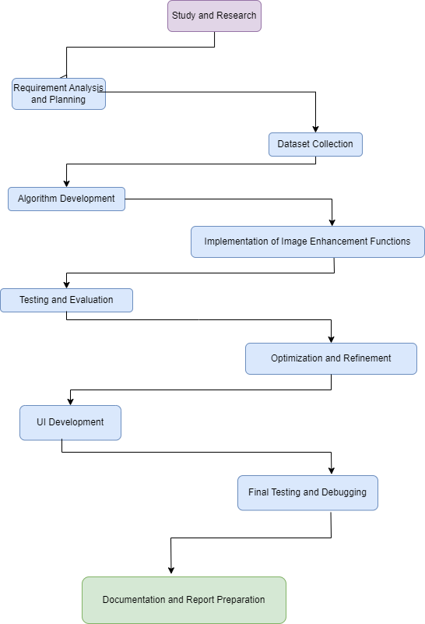

DATA FLOW DIAGRAM (DFD)

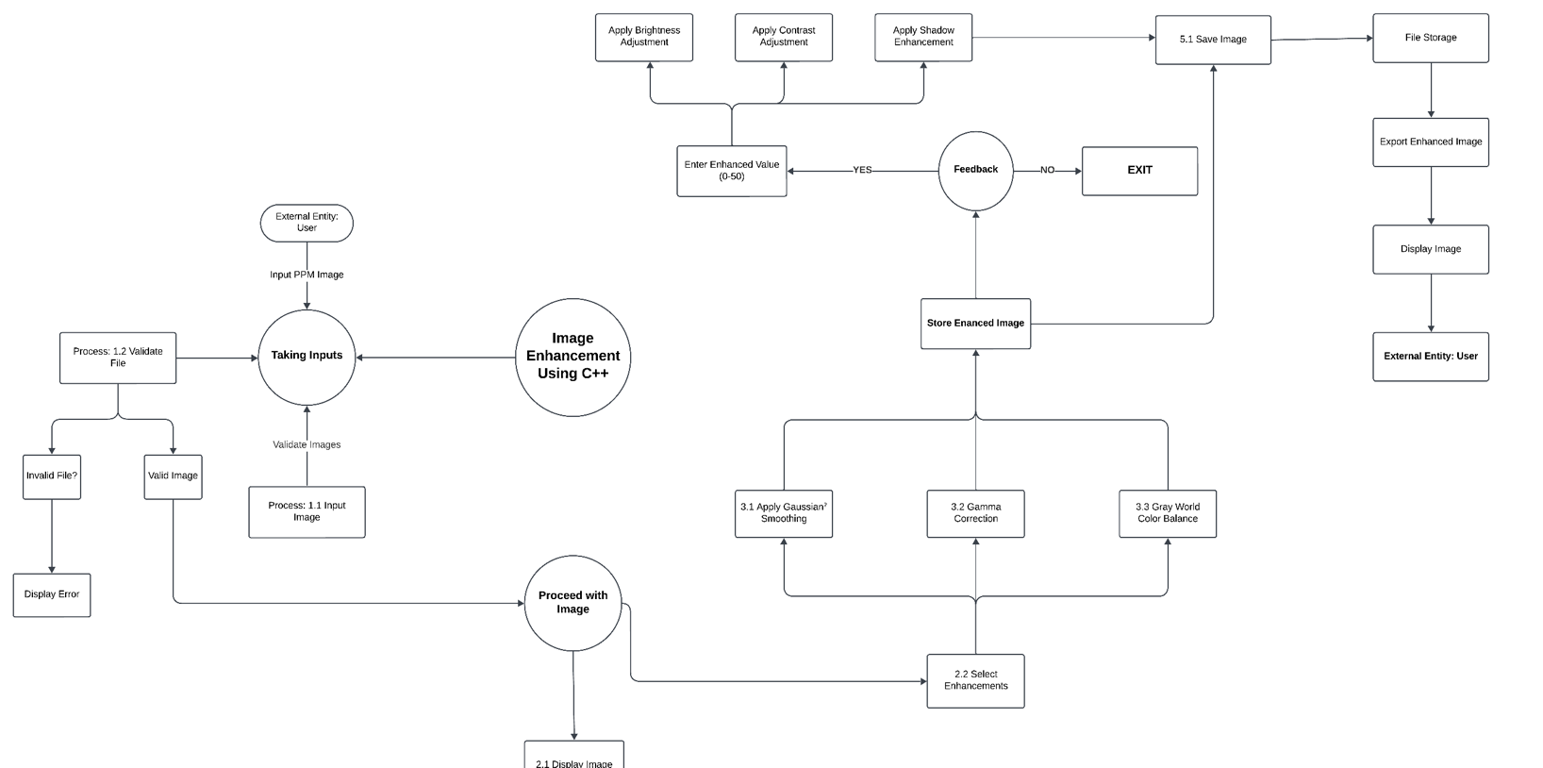

APPLICATIONS

* Low-End Device Users: People using systems with limited resources that demand image enhancement with no overhead of resource-intensive hardware. The light construction of the system makes it compatible with these devices, such that it would fit perfectly within spaces with very limited computation resources.
* Researchers and Developers: These are users who have technical background, especially computer vision, AI, or image processing. They would probably use the system to analyze and optimize their image sets or test techniques of the image enhancement in order to find the most efficient processing and quality results.
* Police and Security Systems – Law enforcement agencies and security personnel that need images of higher resolution to be captured for video-surveillance purposes or are part of the process of evaluating evidence. This type of user shall take the same benefit from the system capabilities to enhance low illumination or otherwise degenerated images to facilitate investigations and surveillance operations by making important details visible.
* Photographers and Visual Artists – Professionals who would polish and fine-tune images within their creative workflow. They most probably would need fine control of brightness, contrast, as well as color balance, and might use the feedback mechanism to adjust images further.

# REFERENCES

1. A Dynamic Histogram Equalization for Image Contrast Enhancement M. Abdullah-Al-Wadud, Md. Hasanul Kabir, M. Ali Akber Dewan, and Oksam Chae, Member, IEEE
2. Deep Color Consistent Network for Low-Light Image Enhancement Zhao Zhang12, Huan Zheng12, Richang Hong12, Mingliang Xu3, Shuicheng Yan4, Meng Wang12 1School of Computer Science and Information

Engineering, Hefei University of Technology, China 2Key Laboratory of Knowledge Engineering with Big Data

(Ministry of Education) & Intelligent Interconnected Systems Laboratory of Anhui Province, Hefei University of Technology, China 3School of Information Engineering, Zhengzhou University, China 4Sea AI Lab (SAIL),

Singapore

1. Low-Light Image Enhancement: A Comparative Review and Prospects WONJUN KIM , (Member, IEEE)

Department of Electrical and Electronics Engineering, Konkuk University, Seoul 05029, South Korea

1. DiffLight: Integrating Content and Detail for Low-light Image Enhancement Yixu Feng1 Shuo Hou1 Haotian Lin1 YuZhu1 PengWu1 WeiDong2 Jinqiu Sun1 Qingsen Yan1† Yanning Zhang1 1Northwestern Polytechnical University 2Xi’an University of Architecture and Technology